# Lab: Regular Expressions

Submit your solutions in the SoftUni judge system at: <https://judge.softuni.org/Contests/1708/Regular-Expressions-Lab>

## Match Full Name

Write a JavaScript function to **match full names** from a list of names and **print** them on the console.

### Writing the Regular Expression

First, write a regular expression to match a valid full name, according to these conditions:

* A valid full name has the following characteristics:
  + It consists of **two words**.
  + Each word **starts** with a **capital letter**.
  + After the first letter, it **only contains lowercase letters afterward**.
  + **Each** of the **two words** should be **at least two letters long**.
  + The **two words** are **separated** by a **single space**.

To help you out, we've outlined several steps:

1. Use an online regex tester like <https://regex101.com/>
2. Check out how to use **character sets** (denoted with square brackets - **"[]"**)
3. Specify that you want **two words** with a space between them (the **space character** '', and **not** any whitespace symbol)
4. For each word, specify that it should begin with an uppercase letter using a **character set**. The desired characters are in a range – **from 'A' to 'Z'**.
5. For each word, specify that what follows the first letter are only **lowercase letters**, one or more – use another character set and the correct **quantifier**.
6. To prevent capturing of letters across new lines, put **"\b"** at the beginning and the end of your regex. This will ensure that what precedes and what follows the match is a word boundary (like a new line).

To check your RegEx, use these values for reference (paste all of them in the **Test String** field):

| **Match ALL of these** | **Match NONE of these** |
| --- | --- |
| Ivan Ivanov | ivan ivanov, Ivan ivanov, ivan Ivanov, IVan Ivanov, Ivan IvAnov, Ivan Ivanov |

By the end, the matches should look something like this:

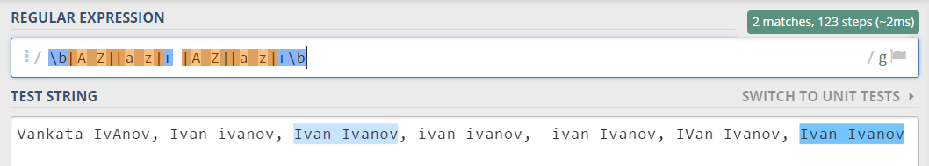

After you've constructed your regular expression, it's time to write the solution in JavaScript.

### Implementing the Solution in JavaScript

Create a new JavaScript file and copy your **regular expression** into a variable:

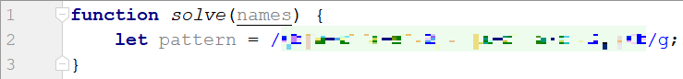

Note: You should put **"/"** before and after the pattern so that it is interpreted as a RegEx pattern. Also, place the **'g'** (global) flag after it, so that you get all the matches in the text.

Now, it's time to **read the input**, **extract the matches** from it and push them into an array. For this we can use **exec()**:

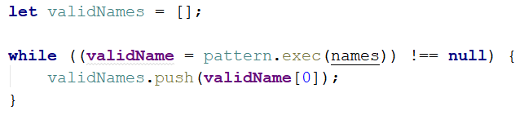

The **exec** method matches the string and the pattern keeps the first index after the match. This way the next time **exec** runs it starts looking after the last match. If there are no more matches, it will return **null**.

We are declaring a variable in the while loop's condition because we need to check every time if there are any more matches.

Now we have an array (**validNames**), which holds all of the valid names in the input. All that is left is to **join** it by **space** and **print** it (do this by using **join()**):



### Examples

| **Input** |
| --- |
| "Ivan Ivanov, Ivan ivanov, ivan Ivanov, IVan Ivanov, Test Testov, Ivan Ivanov" |
| **Output** |
| Ivan Ivanov Test Testov |

## Match Phone Number

Write a regular expression to match a **valid phone number** from **Sofia**. After you find all **valid phones**, **print** them on the console, separated by a **comma and a space ", "**.

### Compose the Regular Expression

A valid number has the following characteristics:

* It starts with **"+359"**
* Then, it is followed by the area code (always **2**)
* After that, it's followed by the **number** itself:
  + The number consists of **7 digits** (separated into **two** **groups** of **3** and **4** **digits** respectively).
* The different **parts** are **separated** by **either a space or a hyphen** (**'-'**).

You can use the following RegEx properties to **help** with the matching:

* Use **quantifiers** to match a **specific number** of **digits**
* Use a **capturing group** to make sure the delimiter is **only one of the allowed characters** **(space or hyphen)** and **not** a **combination** of both (e.g. **+359 2-111 111** has **mixed delimiters**, it is **invalid**). Use a **group backreference** to achieve this.
* Add a **word boundary** at the **end** of the match to avoid **partial matches** (the last example on the right-hand side).
* Ensure that before the **'+'** sign there is either a **space** or the **beginning of the string**.

You can use the following table of values to test your RegEx against:

| **Match ALL of these** | **Match NONE of these** |
| --- | --- |
| +359 2 222 2222  +359-2-222-2222 | 359-2-222-2222, +359/2/222/2222, +359-2 222 2222  +359 2-222-2222, +359-2-222-222, +359-2-222-22222 |

### Implement the Solution in JavaScript

Now it's time to write the solution, so let's start writing!

First, just like in the previous problem, put your RegEx in a variable:



After that, let's make an array of matches using like in the previous exercise:

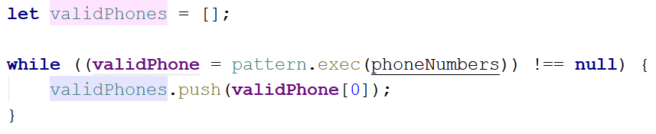

Now let's print **all the matches**, separated by **", "**:



### Examples

| **Input** |
| --- |
| ['+359 2 222 2222,359-2-222-2222, +359/2/222/2222, +359-2 222 2222 +359 2-222-2222, +359-2-222-222, +359-2-222-22222 +359-2-222-2222'] |
| **Output** |
| +359 2 222 2222, +359-2-222-2222 |
| **Input** |
| ['+359 2 357 3351 +359 2 22 2222 +359 2 173 3408 +359-2-789-2584 +359 2 193 3953 +359-2-961-0248 +359-2-789-2584 +359 2 222 222 +360 2 222 2222 +359 2 727 9740 +359-2-854-2280 +359 2 193 3953 +359 2 357 3351 +359 2 558 8560 +359 2 222 222'] |
| **Output** |
| +359 2 357 3351, +359 2 173 3408, +359-2-789-2584, +359 2 193 3953, +359-2-961-0248, +359-2-789-2584, +359 2 727 9740, +359-2-854-2280, +359 2 193 3953, +359 2 357 3351, +359 2 558 8560 |

## Match Dates

Write a program, which matches a date in the format **"dd{separator}MMM{separator}yyyy"**.

### Compose the Regular Expression

Every valid date has the following characteristics:

* Always starts with **two digits**, followed by a **separator**
* After that, it has **one uppercase** and **two lowercase** letters (e.g. **Jan**, **Mar**).
* After that, it has a **separator** and **exactly 4 digits** (for the year).
* The separator could be either of three things: a period (**"."**), a hyphen (**"-"**) or a forward-slash (**"/"**)
* The separator needs to be **the same** for the whole date (e.g. 13**.**03**.**2016 is valid, 13**.**03**/**2016 is **NOT**). Use a **group backreference** to check for this.

You can follow the table below to help with composing your RegEx:

| **Match ALL of these** | **Match NONE of these** |
| --- | --- |
| 13/Jul/1928, 10-Nov-1934, 25.Dec.1937 | 01/Jan-1951, 23/sept/1973, 1/Feb/2016 |

Use **named capturing groups** for the **day**, **month** and **year**.

Since this problem requires more complex RegEx, which includes **named capturing groups**, we'll take a look at how to construct it:

* First off, we don't want anything at the **start** of our date, so we're going to use a **word boundary "\b"**:  
  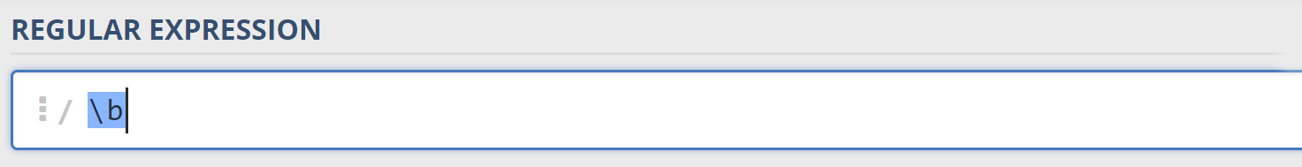
* Next, we're going to match the **day**, by telling our RegEx to match **exactly two digits**,and since we want to **extract** the day from the match later, we’re going to put it in a **capturing group**:  
  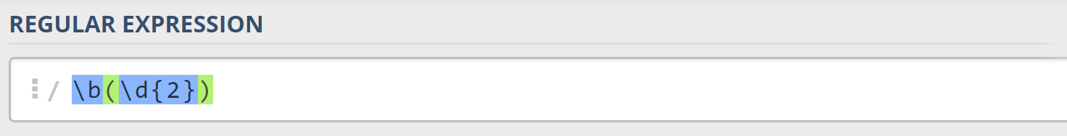  
  We're also going to give our group a **name** since it’s easier to navigate by **group name** than by **group index**:  
  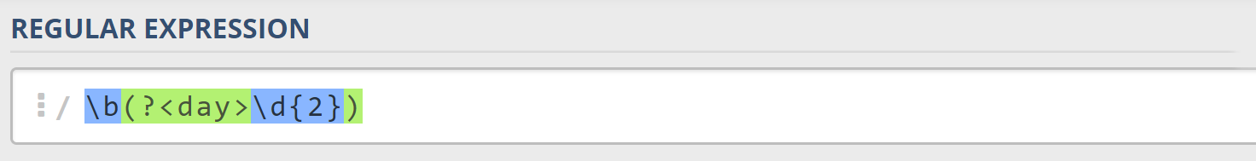
* Next comes the separator – either a **hyphen**, **period,** or **forward slash**. We can use a **character class** for this:  
  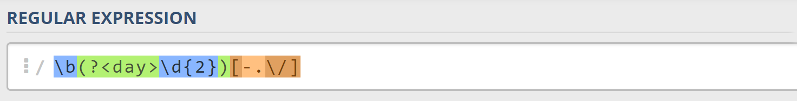  
  Since we want to use the separator we matched here to match the **same separator** further into the date, we're going to put it in a **capturing group**:  
  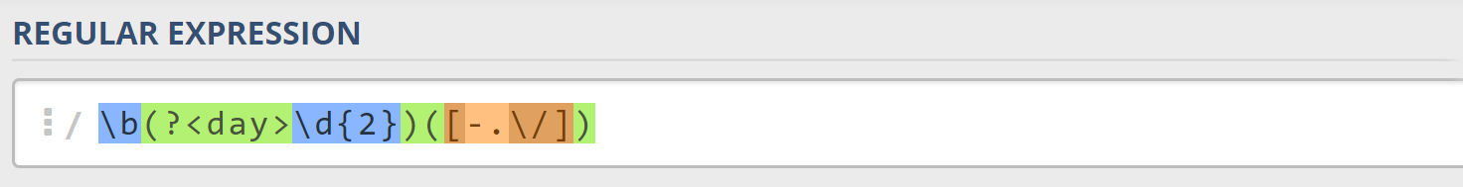
* Next comes the **month**, which consists of a **capital Latin letter** and **exactly two lowercase Latin letters**: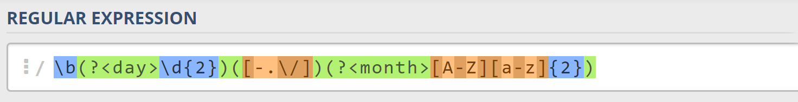
* Next, we're going to match the **same separator** **we matched earlier**. We can use a **backreference** for that:  
  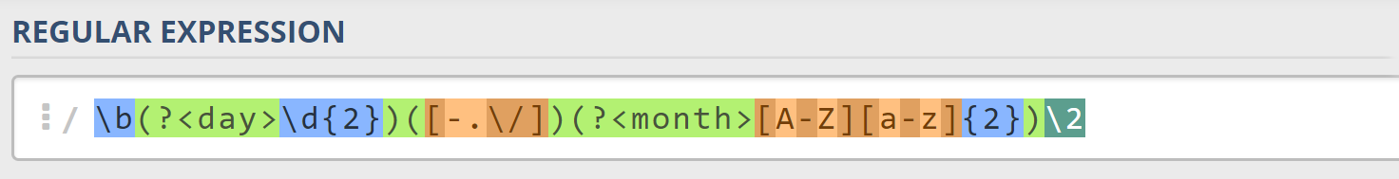
* Next up, we're going to match the year, which consists of **exactly 4 digits**:  
  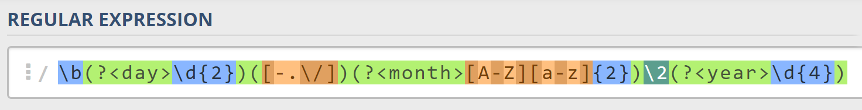
* Finally, since we don't want to match the date if there's anything else **glued to it**, we're going to use another **word boundary** for the end:  
  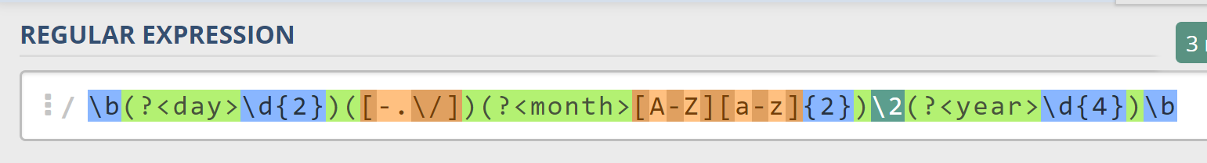

Now it's time to find all the **valid dates** in the input and **print each date** in the following format: **"Day: {day}, Month: {month}, Year: {year}"**, each on a **new line**.

### Implement the Solution in JavaScript

First off, we’re going to put our RegEx in a variable and get the matches from the string:



Next, we're going to **iterate** over every single **element** in the array and **extract** the **day**, **month** and **year** by making new patterns and matching them:

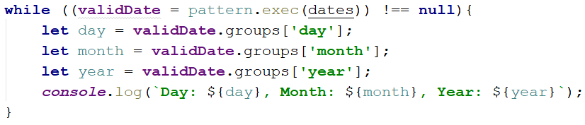

### Examples

| **Input** |
| --- |
| ['13/Jul/1928, 10-Nov-1934, , 01/Jan-1951,f 25.Dec.1937 23/09/1973, 1/Feb/2016'] |
| **Output** |
| Day: 13, Month: Jul, Year: 1928  Day: 10, Month: Nov, Year: 1934  Day: 25, Month: Dec, Year: 1937 |
| **Input** |
| ['1/Jan-1951 23/october/197 11-Dec-2010 18.Jan.2014'] |
| **Output** |
| Day: 11, Month: Dec, Year: 2010  Day: 18, Month: Jan, Year: 2014 |