Installation and Usage  
Guide

1. First you will need:

Java- the project is built on top of the Java platform for now, so it is mandatory  
Cake Interpreter – which is included in the project archive under the STABLE VERSION directory.

1. To start the interpreter:

Open command prompt in the STABLE VERSION directory. Type the command:

“java –jar CakeInterpreter.jar”

This will start the jar and you will be greeted by the working logo of the project.

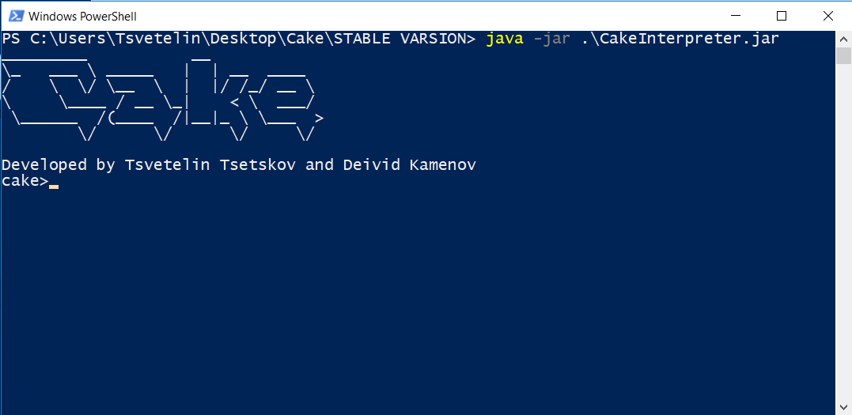

1. Insert command

For now the interpreter has only 3 commands:

* test – prints how an empty runtime looks( i.e the standard library )
* run <path> - runs the file at the specified path(examples can be found at src /examples)
* exit – closes the interpreter