Moderation Analytic Tool Prototyping: Concurrency, Design Review, and Ethics.

COM0142M Advanced Programming
Word count: 2876
Table of Contents
1a. Redesigning for Concurrency 2
1b. Evaluation of GUI design 2
2a. Data Model Design 2
2b. Graphical UI Design 2
3. Social Media Moderation: Reflection on Ethics and Morals 2
References 3
Database Usage 3

1a. Redesigning for Concurrency
Threading is the first-party Python library that allows a developer to introduce concurrency to their software, noted to be "particularly useful when tasks are I/O bound... where much of the time is spent waiting for external resources" according to the documentation. [1] Within the solution developed for this essay, there are multiple potential locations to wrap in threads: including the audit log and background diagram generation, but this essay will focus primarily on the data cleaning process triggered when a user uploads a new CSV file as this is the first action in the user path.

This is likely to be a major part of a user's work flow, and may be executed multiple times a day, and any performance increase here will save the user a not-insignificant amount of time. It is not known currently how large future file uploads will be, and if these aren't accounted for, then large uploads will result in the software locking up during processing. Without utilising formal profiling techniques, it's not currently known if this is the largest bottleneck, or if other areas of the software would find greater benefits from applying these techniques, mist notably during diagram generation.

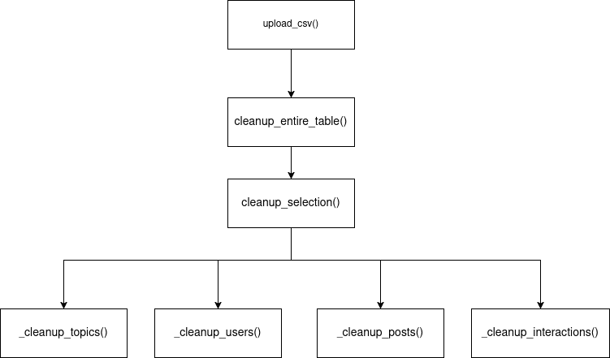Figure 1: Function call flow when a file is uploaded

As seen in Figure 1, data cleaning is automatic, but the runtime is bottlenecked by this process.
While the code already makes use of SQLite transactions [2] to minimise how many times changes are committed to the database, processing itself could be sped up via batching and passing each batch into a thread running the same function.

One suggestion is to modify `cleanup_entire_table()`. Wrapping the function call in timing code as below, we get the following results for each of the provided example CSV files:

import time
start = time.time()
cleanup_report = cleanup_entire_table(conn, imported_table_name, apply=True)
print(f"Cleanup time: {(time.time() - start):.6f} secs")

CSV file | Printed result
TOPICS.CSV | Cleanup time: 0.000368 secs
USERS.CSV | Cleanup time: 0.098706 secs
POSTS.CSV | Cleanup time: 0.105300 secs
INTERACTIONS.CSV | Cleanup time: 0.297269 secs

This shows that almost 300 milliseconds are taken when a 10,000 row table is uploaded, which - if done multiple times throughout the day - will accumulate. To offset this, the function can be adjusted for threading:

threads = []
reports = queue.Queue()
while pks:
# build batch of rows from subset of primary keys
rows = get_rows(pks[0:10])
pks = pks[10:]

# NOTE: `cleanup_selection` now takes `reports` as an outparam
threads.append(
threading.Thread(
target=cleanup_selecton,
args=(conn, table_name, rows, apply=apply, reports)
)
)

# Ensure new thread is started
threads[-1].start()

# Halt to wait for all threads to complete
t.join() for t in threads
return merge_reports(reports)

Here, the data is split into batches of 10, each passed into a thread calling cleanup_selection() which isn't modified from the current implementation. A thread-safe queue [3] object collects the CleanupReport returned from each function call, and a new function merge_reports() (not implemented here) combines these reports into one to be returned to the caller upload_csv() as seen in Figure 1. One design drawback here is that cleanup_selection() now needs to accept the queue as an out parameter, which learncpp defines as "A function parameter that is used only for the purpose of returning information back to the caller" [4], as threads don't allow access to the returned value of the function called.

Development has opted to make use of the first party Queue object as a "multi-producer, multi-consumer queue"[3] as the standard library is often more resiliant than custom code, with over 100 closed issues in the CPython issue tracker as of writing [5]. Another option available is the heapq [7] first party library that implements a priority queue, but without thread safety [8], this was judged to not be appropriate for the current use case.

1b. Evaluation of GUI design
User interaction is at the forefront of the developed solution's design, utilising a number of GUI elements to provide the user with feedback and interplay with the underlying data.

The primary element of this interface is the tabular data that intentionally takes up the majority of the window, mirroring the layout of the data stored within the backing SQLite database. Each of the four tables are emulated by using a Treeview [9] inside a Frame object from the base Tkinter library, and are pinned to the layout using the grid layout as seen in the code snippet below:

frame = ttk.Frame(notebook, padding=8)
treeview = ttk.Treeview(frame, selectmode='extended')
treeview.grid(row=0, column=0, sticky='nsew')
scrollbar = ttk.Scrollbar(frame, orient='vertical', command=treeview.yview)
scrollbar.grid(row=0, column=1, sticky='ns')
treeview.configure(yscrollcommand=scrollbar.set)
frame.columnconfigure(0, weight=1)
frame.rowconfigure(0, weight=1)

As an alternative, generating various charts off of ingested data directly was under consideration, but this was determined to reduce the amount of control the user has over visible data, and charts were instead moved to a secondary screen under a button click.

The second GUI element to be included is the Tkinter Notebook widget [10], visually appearing as a series of tabs above the primary tables. This allowed the interface to not be overcrowded, but still display all the necessary information to the user. This could also be considered a negative due to the inability to cross-reference between multiple views at once, but can easily be overcome as multiple instances of the application can be backed by the same database. This is potentially a source of race condition-based issues that the user should be aware of.

notebook = ttk.Notebook(outer)
notebook.grid(row=1, column=0, sticky='nsew')

The notebook also uses the grid layout, attached itself to the primary window layout. The sticky parameter ensures the notebook expands with the main window, ensuring the treeviews contained within scale appropriately to maximise the amount of content on screen, ensuring a wider view into the stored data and not preventing user productivity.

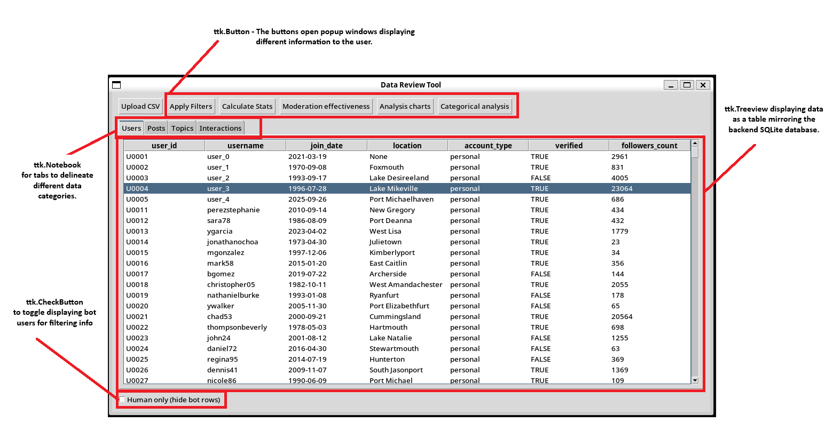Figure 2: Labelled interface of the provided interface

The third GUI feature worth highlighting is how the software handles data analysis. As seen in Figure 2, a number of buttons at the top of the UI trigger various analysis charts to open in other popup windows. This design decision allows the user to utilise their desktop environment's various features, such as split-screen or tiling, to view more data at once, and to not remove the user's view into the tabular data already displayed. This contributes similarly to the notebook above, maximising the amount of data the user can see and allowing for multiple charts and diagrams to be seen at once. As previously raised, displaying charts in the primary window was previously in consideration, but was judged to not be effective. However, an alternative option is to expand the main window so generated charts appear to the right of the table, trading view control and flexibility for a more holistic view.

One edge case that might arise is the user opening every window at once, potentially multiple times, and losing track of what is open. To prevent this, further development would use flags or a bitmask to inform the user if they try and open a window a second time, minimising the amount of cognitive overload required. This would also prevent the user from mixing up newer and older data as the viewer windows don't update when new data is uploaded.

2a. Data Model Design
After considering multiple options for a backing data store, the solution utilised the SQLite library provided as part of the python standard library [11] to store its data. This format was selected as individual database tables could mirror the order of columns in the provided CSV files to ensure no information was lost when importing data, providing a level of reliability that other formats can't provide by default due to the greater amount of pre-processing required.

SQLite was selected over in-process database formats such as mySQL or Postgress as the resulting data store is just a single file instead of relying on arcane backup options to ensure data doesn't get lost, as well as less complexity, all of which is contained in one python file. SQLite states on its own website that it's best suited to data analysis as "People who understand SQL can employ the sqlite3 command-line shell... to analyze large datasets. Raw data can be imported from CSV files..." [10], both of which are reasons that would benefit this applications. It's also worth noting that the database file is a binary file, suggesting the file size should be smaller than a text file such as JSON or XML. SQlite itself advocates its usage "as an application file format in place of XML or JSON or a "pile-of-file"." [13][14]
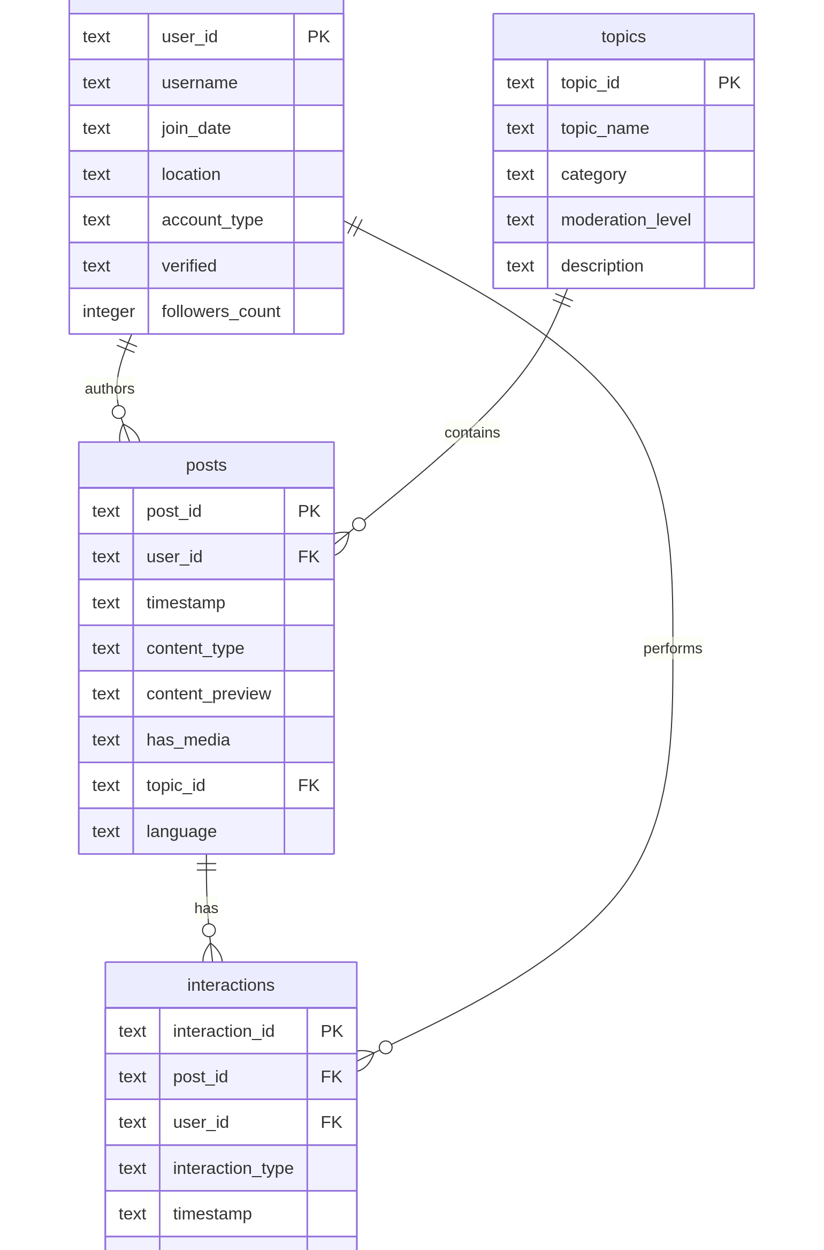Figure 3: UML diagram showing database layout

Another of SQLite's strengths is the SQL query language itself. Any database admin with familiarity with any flavour of SQL can construct a query to build pivot tables or analyse data from just the CLI with only the database file. This can also be considered a disadvantage for two reasons; SQLite does have some quirks [15] in its language compared to other SQL flavours, and not every data analyst is familiar with how SQL works, often relying on python knowledge or other graphical tools. The latter can be offset by the knowledge that any programmer can embed the SQLite library in a program in any language as the source code is a single file of C [16], and bindings exist for most popular languages already.

One other downside to this solution to be aware of is that this prevents any modification to the layouts of the CSV files that get uploaded external to the solution. Raw data needs to be provided in a specific format to be correctly parsed by our program and inserted into the database, which limits its flexibility compared to a JSON solution, which could result in lost data or unexpected errors that the program needs to handle. Further experimentation is required to devise a solution to store additional data fields, such as dynamically adding columns to an existing table.

2b. Graphical UI Design
The software offers the user both statistical and graph-based approaches to filtering data, allowing for a range of data to be displayed as desired. A "Calculate Stats" button shows the user a popup window with the mean and median calculated off of the FollowerCount field, and the "Moderation Effectiveness" button displays a number of statistics and charts, such as a topic heatmap or moderation reporting levels that can be used to verify how problematic a topic is becoming so moderation staff can be better allocated and awareness of an increase in reports around a specific topic can be communicated to prepare staff for higher workloads.

These graphs and statistics are only correct at the time of correlation, and can only be calculated by the provided data. Any data not included within the provided solution won't be recognised, and this can cause a mismatch in the graphs compared to what moderators are observing, and this is a shortcoming that moderation teams should be aware of.

For calculating statistics and handling data, the library of choice was numpy, and pandas was utilised as another method of querying data from the database with faster performance and better handling for time-sequence data over SQLite. These were both also selected for their performance, the former being heavily written in C [17], and the latter relying on the cython "optimising static compiler" [18][19] for better performance than built-in python functionality. Matplotlib was selected as the library of choice for generating charts, embedded into the GUI with a tkinter canvas extension that matplotlib provides [20]. This library was selected for it's comparative levels of control and developer familiarity compared to the less well known Seaborn library. Seaborn is also just a pure-python wrapper around matplotlib according to it's readme: "Seaborn is a Python visualization library based on matplotlib", [21] which adds another level of abstractions around the actual processes happening in the codebase, reducing deeper understanding of processes for the sake of ease.

Throughout the given codebase, one function drives the totality of the Moderation Effectiveness UI, `build_moderation_effectiveness_figure()`, which is called from from block shown in Figure 4 below. Error handling via a try-catch block is ubiquitous throughout this section of the codebase to ensure that all dependancies are present.
Every displayed table is then calculated and drawn within the single canvas `mpl_canvas`. These tables are built up individually, with one example shown in Figure 5, that ensure that all required columns are loaded and populated correctly so as to prevent generating tables that are lacking in any reasonable data to display.
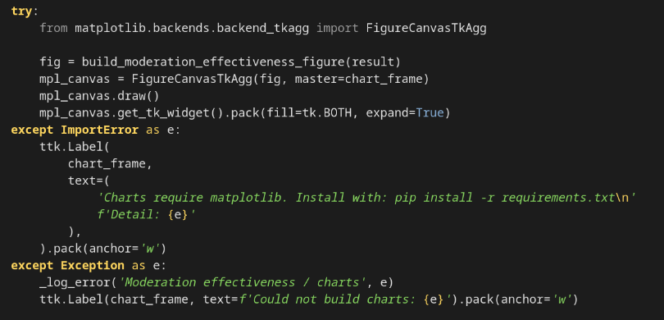Figure 4: code snippet displaying moderation effectiveness UI trigger

Prior to this, uploaded data had gone through the following cleaning process:
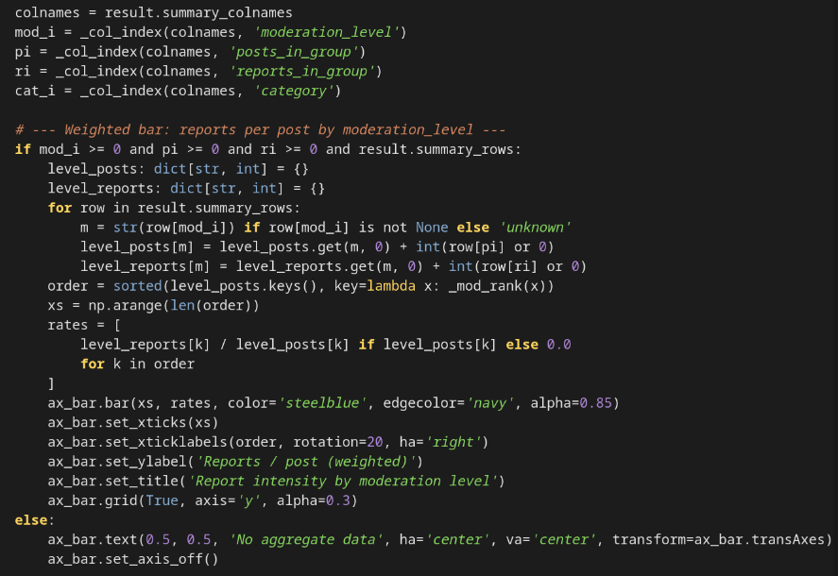Figure 5: Code snippet displaying generation of Weighted Bar chart

- Whitespace trimming
- Case normalisation
- Null-value standardisation.
- Date separation standardisation.
- Type coersion from SQL types to reasonable python types.

Data cleaning was justified to ensure that data was in a standardised form that reduced complexity when parsing and analysing, and ensured results were calculated correctly without further tampering at the table generation stage. One tradeoff here is the difference between a null value and a literal value 0, however these proposed changes should not cause any issues as null values can be treated as a 0 without influencing any calculated results. A portion of the final output can be seen in Figure 6.

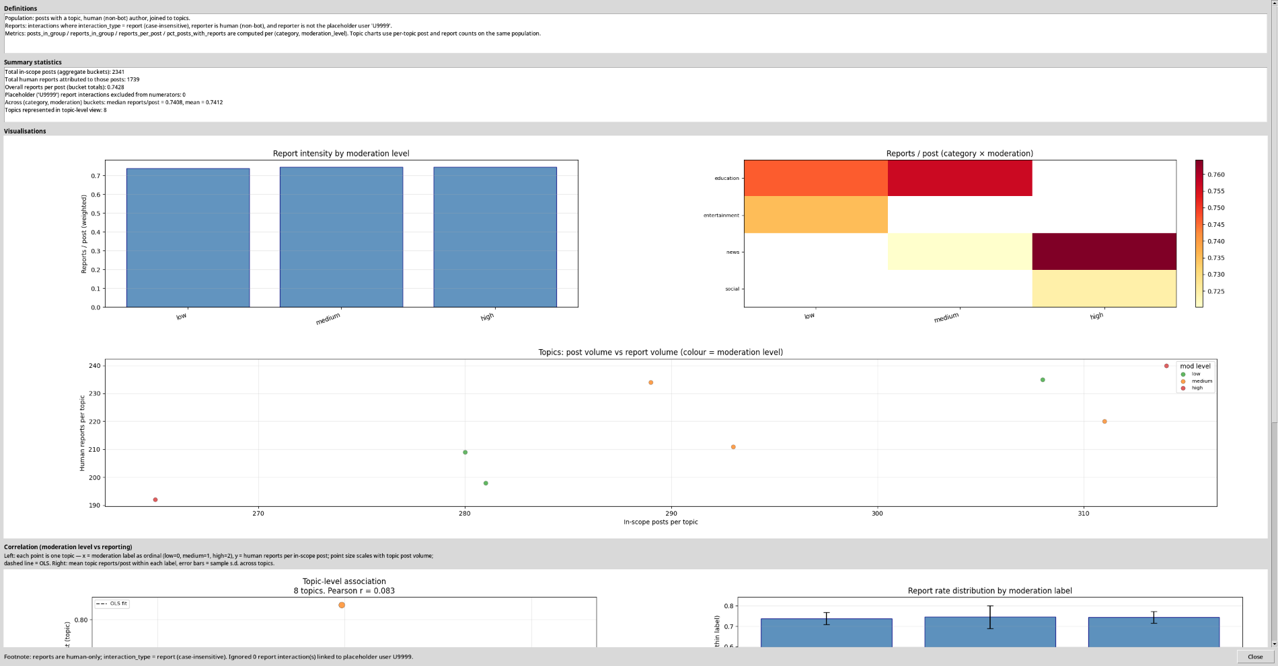Figure 6: Sample screenshot from Moderation Effectiveness UI

3. Social Media Moderation: Reflection on Ethics and Morals
Social media usage has risen rapidly since its inception, with over 2 billion monthly active users in 2019 [22]. To ensure these platforms comply with public safety, internal automated moderation tools have been deployed to maintain a minimum standard of quality, classifying posts using machine learning techniques trained on a "continuously refreshed pool"[23] of flagged posts. [24] in one case to identify hate speech. Artificial intelligence is increasingly appearing in this space [25], although public perception and trust in this technology varies across the political spectrum and familiarity. [26].

Most social media providers aren't suited to moderate content in other languages -- according to leaked Facebook files in 2021, only 9% of users spoke English, but over 87% of the budget was allocated to combating English misinformation [27]. Users often have to resort to appeals to have their content shown, such as the case of a Portuguese breast cancer awareness charity's 2021 posts on Instagram [28], as reported by Meta's oversight board [29]. An argument could be made that the big tech giants are global companies [30] and have a global audience, but as the major players are all based out of the United States, and statistically their users are likely to be from North America or Europe [31], it is assumed that their interest lies with their US-centric users. These companies are all listed on the S&P500, a US stock exchange [32], and it can be assumed that decisions are made to appease their shareholders and keep stock valuation high. One exception to this is China, which blocks all western social media behind its "great firewall" [33][34], instead having its own group of social media platforms moderated in line with censorship across the country [35].

Moderation across platforms is often devoid of context, a claim verified by Joshua Sklar, a former Facebook content moderator, in an interview with TheMarkup: “You’re pretty much viewing these things out of context,” Sklar said. “Say someone did a series of posts of images that spelled out a racial slur. You wouldn’t be able to tell [as a moderator].” [23]. This relies on algorithms to understand the context around sensitive and complex topics, which artificial intelligence struggles with, as pointed out by the Brennan Center for Justice: "Meta’s automated tools time and again fail to account for context, particularly in languages other than English." [36]. This has led to the rise of self-censorship, most notably on TikTok. [37][38] For example, using the term "ghey" to mean "gay", or "unalive" to mean "dead/killed". This has disproportionally affected the LGBTQ+ community, who use self-censored terms to discuss themselves, and educators discussing topics such as World War 2 now have to speak around "the algorithm" [39]. This can lead to individuals in this space considering themselves unwelcome on these platforms, or leaving to find more radical communities where they can express themselves.

In contrast, it can be argued that this isn't a new phenomenon, going back to the LeetSpeak[40] that emerged in the early days of internet message boards, or an internet-driven slang [41] that has evolved for that specific environment, but we can gather that this is something new instead. While social media moderation has been successful in shutting down more extreme views or content, research suggests that self-censorship is on the rise, both by region [42][43] and around specific events [44], driven by the threat of content removal and backlash from those with extreme views on either end of the spectrum. This phenomenon could be eased via more context-aware moderation tools that can reason about a topic as opposed to just parse individual words. While information about the current suite of moderation tools for Tiktok isn't public, deploying a convolutional neural network trained on up to date content [45] and material that can represent more controversial topics, with a priority of recognising appropriate content against inappropriate content.

With the rise of social media came those trying to abuse the system, and moderation tools soon followed, first appearing as early as 2012 [46], and likely earlier, but finding the right balance between content being allowed or removed is a challenging ethical question. Automated systems are inherently flawed, and this often comes back to the training data used.

References

Bibliography
[1] Python Software Foundation, (2025, ), threading — Thread-based parallelism — Python 3.9.0 documentation, docs.python.org. [Online]. Available: https://docs.python.org/3/library/threading.html.

[2] (2015, ), Transaction, Sqlite.org. [Online]. Available: https://sqlite.org/lang_transaction.html.

[3] (2001, ), queue — A synchronized queue class — Python 3.14.4 documentation, Python.org. [Online]. Available: https://docs.python.org/3/library/queue.html.

[4] Alex, (2023, July.31), 12.13 — In and out parameters – Learn C++, Learncpp.com. [Online]. Available: https://www.learncpp.com/cpp-tutorial/in-and-out-parameters/.

[5] CPython, (2025, ), Issues · python/cpython, GitHub. [Online]. Available: https://github.com/python/cpython/issues?q=is%3Aissue%20state%3Aclosed%20Queue.queue. [Accessed: 01 May 2026].

[6] (2019, ), The Competitive Edge: Python Standard Library vs. Custom Code, py4u. [Online]. Available: https://www.py4u.org/python-standard-library/the-competitive-edge-python-standard-library-vs-custom-code/. [Accessed: 01 May 2026].

[7] heapq — Heap queue algorithm — Python 3.14.4 documentation, docs.python.org. [Online]. Available: https://docs.python.org/3/library/heapq.html.

[8] derek, (2016, February.9), Is heapq in Python thread safe?, Stack Overflow. [Online]. Available: https://stackoverflow.com/a/35298560.

[9] (2020, ), Treeview — Tk tutorial 2020 documentation, Readthedocs.io. [Online]. Available: https://tk-tutorial.readthedocs.io/en/latest/tree/tree.html.

[10] (2026, ), tkinter.ttk — Tk themed widgets, Python documentation. [Online]. Available: https://docs.python.org/3/library/tkinter.ttk.html#tkinter.ttk.Notebook. [Accessed: 01 May 2026].

[11] Python Software Foundation, (2024, ), sqlite3 — DB-API 2.0 interface for SQLite databases — Python 3.8.2 documentation, docs.python.org. [Online]. Available: https://docs.python.org/3/library/sqlite3.html.

[12] Appropriate Uses For SQLite, sqlite.org. [Online]. Available: https://sqlite.org/whentouse.html.

[13] SQLite Documentation, sqlite.org. [Online]. Available: https://sqlite.org/docs.html.

[14] (2026, ), SQLite As An Application File Format, Sqlite.org. [Online]. Available: https://sqlite.org/appfileformat.html. [Accessed: 01 May 2026].

[15] (2021, ), Quirks, Caveats, and Gotchas In SQLite, Sqlite.org. [Online]. Available: https://sqlite.org/quirks.html. [Accessed: 01 May 2026].

[16] (2021, ), The SQLite Amalgamation, Sqlite.org. [Online]. Available: https://sqlite.org/amalgamation.html. [Accessed: 01 May 2026].

[17] NumPy, (2021, October.9), numpy/numpy, GitHub. [Online]. Available: https://github.com/numpy/numpy.

[18] Cython: C-Extensions for Python, cython.org. [Online]. Available: https://cython.org.

[19] pandas-dev, (2019, March.11), pandas-dev/pandas, GitHub. [Online]. Available: https://github.com/pandas-dev/pandas.

[20] Embedding in Tk — Matplotlib 3.6.0 documentation, matplotlib.org. [Online]. Available: https://matplotlib.org/stable/gallery/user_interfaces/embedding_in_tk_sgskip.html.

[21] mwaskom, (2019, September.4), mwaskom/seaborn, GitHub. [Online]. Available: https://github.com/mwaskom/seaborn.

[22] E. Ortiz-Ospina, (2019, September.18), The rise of social media, Our World in Data. [Online]. Available: https://ourworldindata.org/rise-of-social-media.

[23] T. Apodaca and N. Uzcátegui-Liggett, (2024, March.1), How Automated Content Moderation Works (Even When It Doesn’t) – The Markup, themarkup.org. [Online]. Available: https://themarkup.org/automated-censorship/2024/03/01/how-automated-content-moderation-works-even-when-it-doesnt-work.

[24] Training AI to detect hate speech in the real world, ai.facebook.com. [Online]. Available: https://ai.meta.com/blog/training-ai-to-detect-hate-speech-in-the-real-world/.

[25] How Facebook uses super-efficient AI models to detect hate speech, ai.meta.com. [Online]. Available: https://ai.meta.com/blog/how-facebook-uses-super-efficient-ai-models-to-detect-hate-speech/.

[26] S. Wang, ‘Factors related to user perceptions of artificial intelligence (AI)-based content moderation on social media’, Computers in Human Behavior, vol. 149, p. 107971, Dec. 2023[Online]. Availablehttps://www.sciencedirect.com/science/article/pii/S0747563223003229.

[27] (2023, ), How Big Tech platforms are neglecting their non-English language users, Global Witness. [Online]. Available: https://globalwitness.org/en/campaigns/digital-threats/how-big-tech-platforms-are-neglecting-their-non-english-language-users/.

[28] Oversight Board | Independent Judgment. Transparency. Legitimacy., www.oversightboard.com. [Online]. Available: https://www.oversightboard.com/decision/IG-7THR3SI1/.

[29] Oversight Board, (2024, April.25), Our Work | Oversight Board, Oversight Board. [Online]. Available: https://www.oversightboard.com/our-work/.

[30] Facebook Office Locations, Meta Careers. [Online]. Available: https://www.metacareers.com/locations.

[31] World Population Review, (2024, ), Social media users by country 2023, worldpopulationreview.com. [Online]. Available: https://worldpopulationreview.com/country-rankings/social-media-users-by-country.

[32] Stock Analysis, (2024, ), A List of All Stocks in the S&P 500 Index, Stock Analysis. [Online]. Available: https://stockanalysis.com/list/sp-500-stocks/.

[33] R. Clayton et al., ‘Ignoring the Great Firewall of China’, 2006[Online]. Availablehttps://www.cl.cam.ac.uk/~rnc1/ignoring.pdf.

[34] Expatriate Healthcare, (2025, September.18), What Social Media is Allowed in China? | Banned Apps & Expat Life, Expatriate Group. [Online]. Available: https://www.expatriatehealthcare.com/what-social-media-is-allowed-in-china/.

[35] (2006, September.25), Media Censorship in China | Council on Foreign Relations, Cfr.org. [Online]. Available: https://www.cfr.org/backgrounders/media-censorship-china.

[36] Oversight board, (2024, September.17), Content Moderation in a New Era for AI and Automation | Oversight Board, The Oversight Board. [Online]. Available: https://www.oversightboard.com/news/content-moderation-in-a-new-era-for-ai-and-automation/.

[37] D. Yates, (2024, ), How do people use self-censorship to avoid having their content suppressed on sites like TikTok? – News Bureau, Illinois.edu. [Online]. Available: https://news.illinois.edu/how-do-people-use-self-censorship-to-avoid-having-their-content-suppressed-on-sites-like-tiktok/.

[38] K. Calhoun and A. Fawcett, ‘“They Edited Out her Nip Nops”: Linguistic Innovation as Textual Censorship Avoidance on TikTok’, Language@Internet, vol. 21, pp. 1–30, Dec. 2023[Online]. Availablehttps://scholarworks.iu.edu/journals/index.php/li/article/view/37371/39943.

[39] (2024, ), Experiences of Censorship on TikTok Across Marginalised Identities, Arxiv.org. [Online]. Available: https://arxiv.org/html/2407.14164v1.

[40](2020, July.28), Leet, Wikipedia. [Online]. Available: https://en.wikipedia.org/wiki/Leet.

[41] (2026, ), Concise Oxford Companion to the English Language, Google Books. [Online]. Available: https://books.google.co.uk/books/about/Concise_Oxford_Companion_to_the_English.html?id=QMsWFsI0YkIC&redir_esc=y. [Accessed: 01 May 2026].

[42] J. L. Gibson and J. L. Sutherland, ‘Keeping Your Mouth Shut: Spiraling Self-Censorship in the United States’, Political Science Quarterly, vol. 138, no. 3, pp. 361–376, Jan. 2023[Online]. Availablehttps://academic.oup.com/psq/article/138/3/361/7192889.

[43] Sławomir Cedzyński, (2025, December.7), Self-Censorship and Rising Censorship in Europe: Why?, Holistic News. [Online]. Available: https://holistic.news/en/self-censorship-and-rising-censorship-in-europe/. [Accessed: 01 May 2026].

[44] (2024, July.12), Surveys reveal rising student and faculty concern about censorship, self-censorship post-October 7, The Foundation for Individual Rights and Expression. [Online]. Available: https://www.fire.org/news/surveys-reveal-rising-student-and-faculty-concern-about-censorship-self-censorship-post. [Accessed: 01 May 2026].

[45] P. Arya et al., ‘MSCMGTB: A Novel Approach for Multimodal Social Media Content Moderation Using Hybrid Graph Theory & Bio-inspired Optimization’, IEEE Access, vol. 12, pp. 73700–73718, Jan. 2024 [Online]. Available: https://doi.org/10.1109/access.2024.3400815 [Accessed: 2 December 2024].

[46] A. Fox, (2019, ), The Evolution of Content Moderation Rules Throughout The Years - Checkstep, Checkstep. [Online]. Available: https://www.checkstep.com/the-evolution-of-content-moderation-rules-throughout-the-years.

Database Usage
- Database used: SQLite, shipped as part of the python standard library
- Version no: Python 3.14.4
- Database population file: database.py. Note, this software will automatically verify if a current database exists and create and generate relevant tables if needed on launching main.py. No other work is required
- As this is SQLite, no localhost is needed. The database generated is in the file `app.db`, defined in ui.py line 41. This file is expected to be found in the same location as where the user is launching the software from.

