1. Executive Summary

2. Introduction
Path-finding is a very common problem in the world of theoretical computer science, explicitly because it’s such a common problem in the real world. In this essay, we take a look at the scenario of a logistics company trying to ascertain the most efficient route between different delivery locations, whilst avoiding traffic congestion through London. To achieve this, we have been provided with a data set of cities and their distances in miles throughout the UK and have decided to process this data utilising both a Simulated Annealing and a Steepest Ascent approach to contrast and compare the shortest paths that these algorithms will generate. This is an example of the infamous Travelling Salesman problem, which has been explored extensively in literature.

We have selected these two algorithms as they optimise for different requirements: Steepest Ascent is a form of hill-walking algorithm that optimises at the local path, resulting in smaller steps between each node on our path, whereas Simulated Annealing will accept a worse local step to try and optimise the path as a whole using a global temperature value that is used to calculate the probability of a single path being chosen.[1]. Otherwise, the two algortithms are very similar, which allows us to narrow down the effectiveness of applying a temperature.

In section 3, we will review other documented uses of a selection of algorithms applied to this problem. In section 4, we will take a critical look into our own solutions, and will finish with a mirroring conclusion in section 5.

3. Literature Review
As previously mentioned, route-finding problems are everywhere. From packets of data in a network request to rail travel across a number of cities.[2]

RFC-9010 was published in April 2021 to specify a new network routing standard for low-power devices to "save signalling and routing state in constrained networks"[2], which prioritises peer-to-peer quality across two nodes in a local network by utilising a Destination-Oriented Directed Acyclic Graph data structure. This has been proven to apply to a number of areas, such as agriculture and smart buildings [3] to allow for better communication amongst lower power devices in a smaller area. This style of graph allows for multi-path routing through a network in such a way so as to always direct toward a given root node despite the path taken. [4]

In a more traditional sense, the travelling salesman problem has been adapted to drones returning to a delivery vehicle, which appears to be a topic of great interest in the early 2020s. One paper [5] proposes an adjustment to the path traversal for drones returning to utilise re-traverse the arcs they or other drones have taken to reduce fuel consumption. In a related proposal, a metaheuristic method "based on the echolocation behaviour of bats" was proposed in 2010 [6] which was expanded on in 2021 [7] by adding random walks to escape local optima.

Lastly, the university of Leeds ran a study into the "bikeability" of London based on data from the London Cycle Hire scheme. They narrowed down a number of heuristics, including comfort and safety, and analysed the top 10000 paths taken to find what affects routes traversed. [8] If we were to view this data through a computer science lens, the natural routes taken by cyclists can be compared to the output from a more optimal pathfinding algorithm such as the Travelling Salesman to optimise journeys to work.

4. Analysis and Evaluation
For our own analysis, we choose to run the Steepest Ascent and Simulated Annealing algorithms. Steepest Ascent is a variation of a hill-climbing algorithm that, at any point in a graph, will compare every possible permutation to decide on the node with the cheapest cost impact to add to the given path. This is a double edged sword, as it optimises locally without any consideration for the global path being built, and while it will generate a valid and reasonable route, the result may not be the most optimal path through the graph. However, this algorithm has been chosen for it's balance between execution speed and the viability of it's total results, especially compared to a more greedy algorithm such as Simple Hill Walking, or Best-First search.

The second algorithm selected for this analysis is Simulated Annealing, which was chosen for it's similarity to Steepest Ascent, but with one key difference. When comparing possible permutations for the next step in the chain, Simulated Annealing utilises a temperature value to decide on the probability of selecting a node instead of solely relying on the best local step to make. This results in the path selected being optimised globally at the cost of not selecting the most optimal edge to follow at any node in the path. This similarity between the theory for these two algorithms mean that we can focus our results on analysing the number of iterations required to reach a result, as well as the lengths of each path generated.

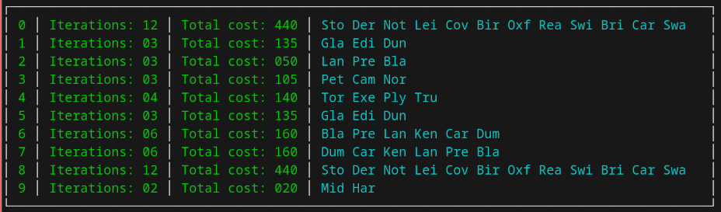Figure 1: Steepest Ascent algorithm results
As we can see from Figure 1, the results of our Steepest Ascent algorithm takes on average 5.3 iterations to come to a result, with a variety of paths of different lengths here represented by the first three letters of every city in the selected path. Notably, two separate runs came to the same conclusion of the furthest path that can be taken in this dataset: runs 0 and 8 have the same path and total cost. A number of paths are very short as there was no route to take after the last node, but despite a number of paths only having 3 cities, there are a range of costs to those paths, with run 2 taking only 50 miles, and the repeated path at runs 1 and 5 taking 135 miles.

It's worth raising that while this result set is not the most notable, a number of interesting results were discovered when running a flawed version of my data set. If we were to look for the largest edge to traverse at each point instead of the smallest, we were finding that our paths were a lot longer, despite costing significantly more -- at the extreme end, one path was observed to have 21 cities in it at a cost of 1315 miles.

Moving on to Figure 2, we see the variance that comes with running Simulated Annealing on the same dataset. This experiment was run with a starting temperature of 120, decreasing the starting point by 10 for every run, against the same min temp of 0.0003 and an alpha of 0.85.

The first thing of note is the variance in length between different paths is a lot larger, as well as the range of costs. Of note is the longest path in run 5, with 13 cities and only a total cost of 490, compared to run 7, with 7 nodes and a higher cost of 545. The cheapest path in run 0 also wasn't the shortest path, at run 9, so the relationship between the length of a path and it's cost isn't immediately obvious, as affected by the temperate applied. Calculating our average number of iterations -- which

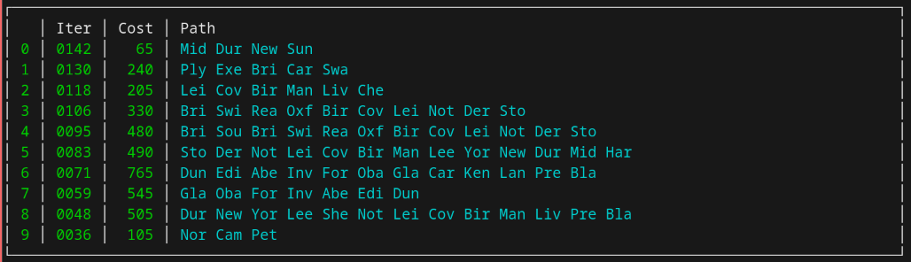Figure 2: Simulated Annealing algorithm results
notably are significantly higher than in our previous algorithm -- we get a result of 88.8 iterations to reach a result.

5. Conclusion
While there are a number of algorithms that have been designed to solve the Travelling Salesman problem, each have their own limitations or tradeoffs. As we can see from our results, the Steepest Ascent algorithm has a preference for locally optimal paths, instead of attempting to reach further distances, whereas Simulated Annealing is able to achieve longer paths at the tradeoff of significantly longer execution time. Previously, we posed the question of if the temperature value had a significant impact on runtime, and our results show that this is the case, but also that applying a temperature of probability to when to select the next node in a graph can result in significantly longer paths on average.

References
[1] “What is Simulated Annealing?,” www.cs.cmu.edu. https://www.cs.cmu.edu/afs/cs.cmu.edu/project/learn-43/lib/photoz/.g/web/glossary/anneal.html
[2] M. Richardson, “Routing for RPL (Routing Protocol for Low-Power and Lossy Networks) Leaves,” Apr. 2021, doi: https://doi.org/10.17487/rfc9010.
[3] H. Kharrufa, H. A. A. Al-Kashoash, and A. H. Kemp, “RPL-Based Routing Protocols in IoT Applications: A Review,” IEEE Sensors Journal, vol. 19, no. 15, pp. 5952–5967, Aug. 2019, doi: https://doi.org/10.1109/jsen.2019.2910881.
[4] K. Kalinowska-Górska and F. Solano Donado, “Constructing Fair Destination-Oriented Directed Acyclic Graphs for Multipath Routing,” Journal of Applied Mathematics, vol. 2014, pp. 1–11, 2014, doi: https://doi.org/10.1155/2014/948521.
‌[5] “The Traveling Salesman Problem with Drones: The Benefits of Retraversing th...: EBSCOhost,” Ebscohost.com, 2023. https://web.p.ebscohost.com/ehost/pdfviewer/pdfviewer?vid=0&sid=3cbb335e-997c-4ff5-84a2-e638612cf522%40redis (accessed Feb. 01, 2026).
[6] X.-S. Yang, “A New Metaheuristic Bat-Inspired Algorithm,” arXiv:1004.4170 [physics], Apr. 2010, Available: https://arxiv.org/abs/1004.4170
‌[7] Y. Saji and M. Barkatou, “A discrete bat algorithm based on Lévy flights for Euclidean traveling salesman problem,” Expert Systems with Applications, vol. 172, p. 114639, Jun. 2021, doi: https://doi.org/10.1016/j.eswa.2021.114639.
[8] R. Beecham, Y. Yang, C. Tait, and R. Lovelace, “Connected bikeability in London: Which localities are better connected by bike and does this matter?,” Environment and planning. B, Urban analytics and city science/Environment & planning. B, Urban analytics and city science, vol. 50, no. 8, pp. 2103–2117, Mar. 2023, doi: https://doi.org/10.1177/23998083231165122.
‌

‌
‌

‌

