1a - Redesigning code for concurrent processing

Threading is the first-party Python library that allows a developer to introduce concurrency to their software, noted to be "particularly useful when tasks are I/O bound... where much of the time is spent waiting for external resources" according to the documentation. [1] Within the solution developed for this essay, there are multiple potential locations to wrap in threads: including the audit log and background diagram generation, but this essay will focus primarily on the data cleaning process triggered when a user uploads a new CSV file as this is the first action in the user path.

This is likely to be a major part of a user's workflow, and may be executed multiple times a day, and any performance increase here will save the user a not-insignificant amount of time. It is not known currently how large future file uploads will be, and if these aren't supported, then large uploads will result in the software locking up while it processes large amounts of data. Without formal profiling, it's not currently known if this is the optimal location to target for performance improvements, as other areas of the program could apply the same threading technique listed below most notably data analysis and diagram generation.

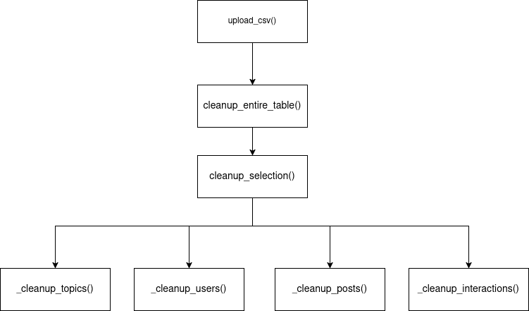Figure 1: Function call stack

As seen in Figure 1, data cleaning is an automatic process, but the runtime is bottlenecked by this process. While the code already makes use of SQLite transactions [2] to minimise how many times changes are committed to the database, processing itself could be sped up via batching and passing each batch into a thread running the same function.

One suggestion is to modify `cleanup_enture_table()` as below:
threads = []
reports = queue.Queue()
while pks:
# build batch of rows from subset of primary keys
rows = get_rows(pks[0:10])
pks = pks[10:]

# NOTE: `cleanup_selection` now takes `reports` as an outparam
threads.append(
threading.Thread(
target=cleanup_selecton,
args=(conn, table_name, rows, apply=apply, reports)
)
)

# Ensure new thread is started
threads[-1].start()

# Halt to wait for all threads to complete
t.join() for t in threads
return merge_reports(reports)

Here, the data is split into batches of 10, each passed into a thread calling cleanup_selection(). A thread-safe queue [3] object collects the CleaupReport returned from each function call, and a new function merge_reports() (not implemented here) combines these reports into one to be returned to the caller `upload_csv()` as seen in Figure 1. One design drawback here is that `cleanup_selection()` now needs to accept the queue as an out parameter, which learncpp defines as "A function parameter that is used only for the purpose of returning information back to the caller" [4], as threads don't allow access to the returned value of the function called.

Development has opted to make use of the first party Queue object as the standard library is often the most "battle tested", with over 1100 resolved issues in the CPython issue tracker as of writing [5], compared to a custom implementation a single developer could provide. Benefits include more a more secure implementation, more portable code across different platforms, and less maintainance cost on the developer [6].

1b - Evaluation of GUI design

User interaction is at the forefront of the developed solution's design, utilising a number of GUI elements to provide the user with feedback and interplay with the underlying data.

The primary element of this interface is the tabular data that intentionally takes up the majority of the window, mirroring the layout of the data stored within the backing SQLite database. Each of the four tables are emulated by using a Treeview [7] inside a Frame object from the base Tkinter library, and are pinned to the layout using the grid layout as seen in the code snippet below:

frame = ttk.Frame(notebook, padding=8)
treeview = ttk.Treeview(frame, selectmode='extended')
treeview.grid(row=0, column=0, sticky='nsew')
scrollbar = ttk.Scrollbar(frame, orient='vertical', command=treeview.yview)
scrollbar.grid(row=0, column=1, sticky='ns')
treeview.configure(yscrollcommand=scrollbar.set)
frame.columnconfigure(0, weight=1)
frame.rowconfigure(0, weight=1)

As an alternative, generating various charts off of ingested data directly was under consideration, but this was determined to reduce the amount of control the user has over visible data, and charts were instead moved to a secondary screen under a button click.

The second GUI element to be included is the Tkinter Notebook widget [8], visually appearing as a series of tabs above the primary tables. This allowed the interface to not be overcrowded, but still display all the necessary information to the user. This could also be considered a negative due to the inability to cross-reference between multiple views at once, but can easily be overcome as multiple instances of the application can be backed by the same database. This is potentially a source of race condition-based issues that the user should be aware of.

notebook = ttk.Notebook(outer)
notebook.grid(row=1, column=0, sticky='nsew')

The notebook also uses the grid layout, attached itself to the primary window layout. The sticky parameter ensures the notebook expands with the main window, ensuring the treeviews contained within scale appropriately to maximise the amount of content on screen, ensuring a wider view into the stored data and not preventing user productivity.

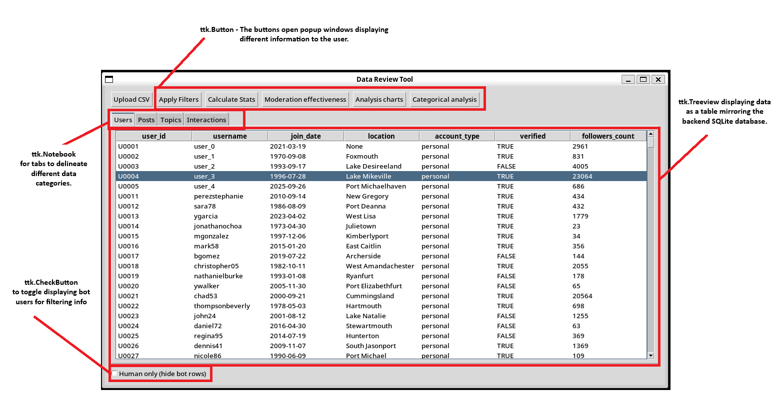Figure 2: Labelled interface of the provided interface

The third GUI feature worth highlighting is how the software handles data analysis. As seen in Figure 2, a number of buttons at the top of the UI trigger various analysis charts to open in other popup windows. This design decision allows the user to utilise their desktop environment's various features, such as split-screen or tiling, to view more data at once, and to not remove the user's view into the tabular data already displayed. This contributes similarly to the notebook above, maximising the amount of data the user can see and allowing for multiple charts and diagrams to be seen at once. As previously raised, displaying charts in the primary window was previously in consideration, but was judged to not be effective. However, further development could provide more charts to display, and another alternative option is to expand the main window so generated charts appear to the right of the table, keeping both halves together but decreasing the amount of control a user has.

