Utilising machine learning techniques to analyse the impact agricultural schemes have on the insect population across environments in the UK.

COM0166M Applied Artificial Intelligence
Word count:

Table of Contents
Executive Summary 2
1. Introduction 2
2. Literature Review 2
3. Research Design 2
4. Experimental Results and Analysis 2
5. Conclusion 2
References 3

Executive Summary

1. Introduction
In recent years, it has been noted that pollinators across the UK have been in decline at an alarming rate across the board[1], with most notably 80% of butterfly species and 175 species of moth decreasing in abundance. This is measured "by the abundance of insects...the diversity of insects...and the distribution of insects"[2] and expert publications are attributing this to a number of factors; including climate change, the use of pesticides, and habitat loss[3]. This has become such a concern over recent years that the UK Department for Environment, Food, and Rural Affairs (henceforth DEFRA) has opened an investigation into the causes and the impact in food production.
One potential route to a solution is in the realm of Machine Learning. This is a subset of the field of Artificial Intelligence that prioritises autonomous learning based on a set of provided data so a machine can make accurate inference about new data.[4] This field has come under the limelight in recent years due to the prevalence of Large Language Models [5] and diffusion models for text and image generation, but specialised neural networks utilising deep learning techniques can be designed for a number of tasks based on the data provided during the learning process, which can be subdivided into 3 different classifications [6]:
- Supervised learning - when "the model is trained on a labeled (sic) dataset" [6] where the data is used for classification purposes, and input during production will be classified against it's closeness to these groups. There are a number of algorithms that fall into this category, one being the Naive Bayes Classifiers algorithm used in email systems to classify spam emails [7][8].
- Unsupervised learning - Algorithms for clustering or grouping of different input data "to categorize data points according to value similarity" [6]. One such example is the K-means clustering algorithm that was originally designed for signal processing [9] but has been adapted for document classification, customer segmentation, and insurance fraud detection [10].
- Reinforcement learning - A method of training a data model "that trains algorithms using a system of reward and punishment" [6] via decision trees that the algorithm dynamically adjusts based on new input. Reinforcement learning has been found in Video Game AI and robotics, where it's used for path detection and non-player character automation, and in self-driving vehicles[11].
For this essay, we have been provided a number of datasets from the Joint Nature Conservation Committee (henceforth JNCC)[12] surrounding trends in insect diversity and the agri-environmental schemes the government have offered to support the UK's insect populations. We intend to extract a limited dataset that reflects the population of various insects and the amount of land covered by these schemes, then use a hill-walking algorithm to detect which other insect population values best predict population changes in bees, then apply linear regression to detect the level of impact that the government schemes have had as a proof of concept, modelling a form of supervised learning.

2. Literature Review
A number of papers have applied artificial intelligence to this problem. One paper published in Autumn 2025 has applied an algorithm to "estimat[e] floral area from images"[13], which can be used to "support large-scale ecological studies and plant-pollinator research". This can lead to better understanding of the factors that contribute to the land thriving, and the features of which that lead to either attracting pollinators or contributing to their continued growth. However, due to it's recency, the FloralArea algorithm[14] appears to be untested in the field.
Due to the changes in climate over the recent decades[15], and it's impact on the natural world[16,17], it's inevitable that the behaviours and habitats of various pollinators will be impacted. Due to this, a group of researchers investigated the behaviours of one species of bee -- specifically foraging -- comparing computer vision and traditional video recording techniques[18]. Through the use of applying linear regression to their results, the researchers were able to find that the only significant factor surrounding the bees selection of flowers to pollinate was the amount of flowers per vegetation, and that no other factors appeared to have a statistically significant impact. While this is a study that should be repeated across multiple locations and times of the year to verify the soundness of it's conclusions, we can infer from the results that encouraging new plant growth would benefit bees and other pollinators, possibly to the point of aiding in expanding their population.
The conclusions and research of these two papers can be used to guide further agri-environmental schemes to better results, aiding in identifying better land to support and exactly what money from funding should go towards; higher densities of flowering plants in areas where bees and other pollinators are found. However, these are not the only areas of growth or reparation that are needed, as laid out in a report from Natural England[19], as areas such as ponds and wetlands also need attending. The results from varying schemes appear to be positive, but requiring further improvements.
There are a number of papers published in recent years applying artificial intelligence to researching the behaviour of a number of insect species, such as applying a pre-trained deep neural network "for stereotypical behaviour identification" of larvae[20], the "development of animal biosensor systems"[21] through use of both a convoluted neural network and a recurrent neural network, and the use of machine learning techniques to "predict agrochemical contamination in bees"[22], all in the last two years, proving that this is an area that researchers are embracing AI to better analyse their findings, all research that would benefit our client in the process of forecasting and evaluating where it's time and money is best spent.
For this type of research, bespoke artificial neural networks are often selected due to their nature of being trained on a dataset and infer conclusions based on new data. This approach has a proven track record in a number of scientific fields, including being able to identify cancers[23], malware on android phones[24], and risks in "post-earthquake transportation network connectivity"[25]. We've also seen other machine learning techniques used, such as linear regression in the number of bees that find different types of flowers appealing[18] and genetic algorithms - which generates new potential solutions to problems modelling itself on genetic crossover and mutation in living organisms[26] - in a number of subfields of medicine.[27]
The question still remains as to why this is. Machine learning allows for more efficient evaluation, allowing for ingestion of large amounts of data that a researcher may not be able to keep all in their head or analyse with manual tooling or pen-and-paper mathematics. With the right skills, scientists can create bespoke models that can help answer the exact problem they're researching, where no pre-existing model exists. The biggest bottleneck is the collection and usefulness of the data input -- more data doesn't always equate to better. There is also the problem of overfitting to be aware of, where a model is overwhelmed with too much data and isn't able to make any usable inferences[28]. There are a number of approaches that can be taken to avoid overfitting, including splitting up the data into a training set and testing set, providing a larger dataset, and modifying the number and size of the layers in the model itself[29].

3. Research Design
For my research software, I intend to build an analysis model using linear regression to detect which factors are the most reliable indicators of the bee population across a 20-year period. I intend to search through our data using a hill-walking algorithm that borrows the concept of a feature mask from genetic algorithms to apply different combinations of the 5 parameters I intend to evaluate -- that being: area of land covered by a government scheme, mean occupancy of hoverflies, abundance of butterflies in both woodland and farmland, and the prevalence of birds across the UK.
I intend to detect the changes across a period of 1992 and 2022 as this timeframe is covered across all the required datasets, although it should be noted that for better results, more granular data would have been preferred. These factors were selected specifically so as to be able to infer the health of the bee population against the population of other species -- if they're thriving, it stands to reason that the bee population should thrive as well, and this is what we want to confirm.
Preprocessing is minimal, as we only need to collate the values from the given time frame from each dataset into a single CSV file. The only issue of note to raise here is that the bird prevalence data pulled from the Habitat Connectivity spreadsheet had missing values due to some data being unavailable in the source. For these rows, we instead substituted in a 0 value, so as to not inadvertently apply an incorrect assumed value and impact our results unfairly.
I intend to manually implement my linear regression algorithm in python due to familiarity and comfort with the core language, implementing a manual slope calculation using the ordinary least squares algorithm, and using the mean square error calculation to measure algorithm performance. This is applied to every permutation of the five regressors, finding the permutation with the smallest R^2 value (read: r squared) as the measure of success.
This approach was selected for numerous reasons; as the dataset was small, I wanted to avoid an approach that may falter under less data, such as a neural network, and as the data was already labelled and classified, any form of classification appeared redundant, such as a k-means algorithm. My selection of hill-walking as a search algorithm also played into this, as I needed to select an algorithm that would fit within my iterative runs of linear regression. Simulated annealing and steepest ascend were both considered but discarded due to their nature of swapping values around to re-compare, as I wanted to ensure that every permutation was evaluated, even if there were redundant checks, to secure the validity of the results.

4. Experimental Results and Analysis
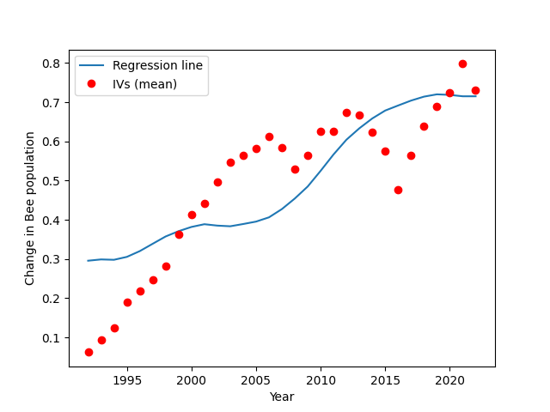Figure 1: Linear regression in change of bee population over time (1992-2022)
After running our results, our findings in Figure 1 appear to show statistically that the mean bee population is increasing over time with regard to the average of the independent values chosen. I would argue that these results are inconclusive when compared against the actual pre-processed data that was fed into this algorithm, as we can observe from the attached file preprocessed_data.csv that the dependant values in column "Pollinating bee mean occupancy" decrease over time. From this, we can deduce that there are no reasonable relation between the health of the bee population and the average of other populations when applying a polynomial regression against this dataset.
However, there are other factors at play here. During our hill-walking, we used the mean square error value (henceforth: MSE) as our fitness value for each iteration, and the below results in Figure 2 show the MSE across each iteration and the mask of independent values that were used. In left-to-right order, the 5 bits in each mask correlate to quantity of land covered in an agri-environmental scheme, hoverfly occupancy, woodland butterfly occupancy, farmland butterfly occupancy, and functional connectivity of birds. For future analysis, different values could be calculated for the fitness function, such as the coefficient (R^2) value of each regression, which would instead show the correctness of that run. Applying a linear regression against each individual datum instead of averaging them may also provide more actionable information, although this would result in a number of graphs that would require manual comparison.
From our result data, we can observe the mask with the minimal MSE value only included the scheme land coverage. If we were to perform this analysis again, this is the one value we would have omitted as the only conclusion we can glean here is that increasing the number amount of land covered by the governmental schemes should result in an increase of bee population health, which is the intention. This doesn't tell us which other insects can be the useful indicators for bee population growth. I also question the validity of this approach overall, as Figure 2 shows us that the only time the MSE decreases is when the mask only has a single independent value enabled.
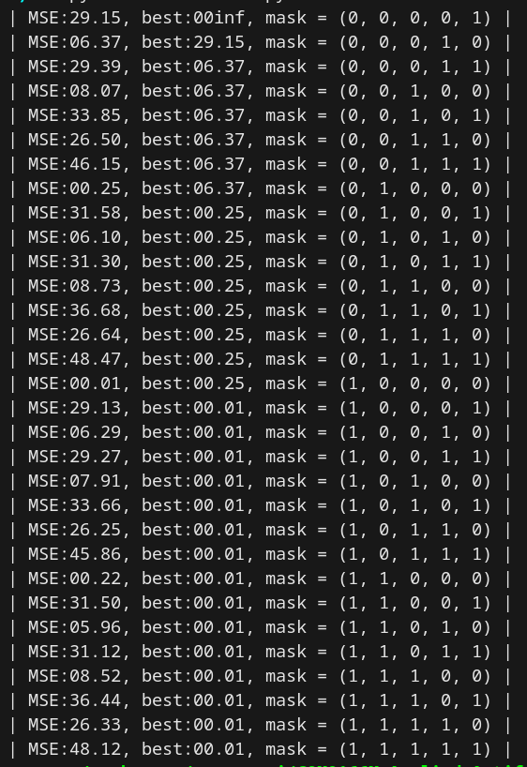Figure 2: mean-square-error and related mask per iteration of hill-walking algorithm

However, with further data, an NGO can use our proof of concept to investigate potential further predictors of bee populations, such as the presence of other insects or plants such as individual flower species. This data can be used to advise on the most efficient directions for spending for best encourage and bolster the population of bees and other pollinators. Similar research has used "meta-regression" to compare the properties of various bee species across the globe to find the effect they have on pollination [30], and when employed alongside our above research, could help encourage bees with more desirable characteristics through natural selection and human intervention.
We can also theorise that while no combination of factors appears to impact the number of bees in an environment, there are some factors that are still notable to look at. We know that hoverflies are the second-most prolific pollinators[31], and our NGO can use this information alongside the previously researched information on flower appeal [18] to develop new approaches to hedgerow design. This approach can also be applied to other ecosystems such as ponds and woodland that are of interest to the governmental schemes.[19].

5. Conclusion
In this essay, we have looked at the reason for the declining population of pollinators across the UK, focussing on the bee population. My literature review revealed multiple papers that had applied machine learning to identify what makes a flower patch appealing to various species of bees, and why machine learning is the right application to this form of problem.
I then applied a polynomial regression model to my dataset to determine any relationship between the population of bees compared to other species across a 20-year time period, finding only inconclusive results that suggest that the approach -- while functional -- may have required either a different collation of data or an adjustment to the approach so as to gather more useful results for our NGO. I applied a hill-walking approach to try to find the most effective combination of independent values, evaluating each permutation by it's minimum square error, but my results showed that we found the lowest MSE results with only applying a single independent variable.
For further development, I would consider comparing a different fitness value for our hill-walking algorithm, such as the coefficient value, to better isolate more relevant results, and remove the scheme coverage value from our pre-collated dataset as that skewed the results and gave us less viable information at the end.
I would advise to use this proof of concept with the aforementioned modifications to identify the best indicators to bee population growth, and use this research as one key element when devising the best allocation of resources to encourage growth or when advising the government during review of any further allocation of their agri-environmental schemes. As resources are being reallocated towards moorland preservation as of 2026 [32], an area that bumblebees already thrive in [33], there are areas of growth still to be identified.

References
[1] T. Luck, “Declaration issued to halt UK insect declines as evidence mounts of national crisis - Bumblebee Conservation Trust,” Bumblebee Conservation Trust, Sep. 12, 2025. https://www.bumblebeeconservation.org/news/declaration-issued-to-halt-uk-insect-declines-as-evidence-mounts-of-national-crisis/
[2] “Insect decline and UK food security - Science, Innovation and Technology Committee,” Parliament.uk, 2023. https://publications.parliament.uk/pa/cm5804/cmselect/cmsctech/326/report.html#heading-1
[3] RHS, “Pollinators: decline in numbers,” Rhs.org.uk, 2021. https://www.rhs.org.uk/wildlife/pollinators-decline-in-numbers
[4] IBM, “What Is Machine learning?,” IBM, Sep. 22, 2021. https://www.ibm.com/think/topics/machine-learning
‌[5] “GPT-3 powers the next generation of apps,” Openai.com, 2021. https://openai.com/index/gpt-3-apps/
[6] IBM, “Types of Machine Learning | IBM,” Ibm.com, Aug. 2024. https://www.ibm.com/think/topics/machine-learning-types
[7] M. Sahami, S. Dumais, D. Heckerman, E. Horvitz, and G. Building, “A Bayesian Approach to Filtering Junk E-Mail.” Available: http://robotics.stanford.edu/users/sahami/papers-dir/spam.pdf Archived: https://web.archive.org/web/20070927171816/http://robotics.stanford.edu/users/sahami/papers-dir/spam.pdf
[8] Wikipedia Contributors, “Naive Bayes classifier,” Wikipedia, Mar. 19, 2025.
[9] ‌S. Lloyd, "Least squares quantization in PCM," in IEEE Transactions on Information Theory, vol. 28, no. 2, pp. 129-137, March 1982, doi: 10.1109/TIT.1982.1056489.
[10] DZone, “10 Interesting Use Cases for the K-Means Algorithm - DZone AI,” dzone.com, May 23, 2019. https://dzone.com/articles/10-interesting-use-cases-for-the-k-means-algorithm
[11] F. Yuwono, G. P. Yen, and J. Christopher, “Self-Driving Car Racing: Application of Deep Reinforcement Learning,” arXiv.org, 2024. https://arxiv.org/abs/2410.22766 (accessed Dec. 07, 2024).
[12] “Who we are | JNCC - Adviser to Government on Nature Conservation,” jncc.gov.uk. https://jncc.gov.uk/about-jncc/who-we-are/
[13] E. I. Amoah, K. White, H. M. Patch, and C. M. Grozinger, “FloralArea: AI-powered algorithm for automated calculation of floral area from flower images to support plant and pollinator research,” PLOS One, vol. 20, no. 9, p. e0332165, Sep. 2025, doi: https://doi.org/10.1371/journal.pone.0332165.
‌[14] eai6, “GitHub - eai6/FloralArea_Web: Gradio Web application for the FloralArea Project,” GitHub, 2025. https://github.com/eai6/FloralArea_Web/ (accessed Mar. 03, 2026).
‌[15] IPCC, “P54/WGI-14 -Changes to the underlying scientific-technical assessment to ensure consistency with the approved SPM These trickle backs will be implemented in the Chapter during copy-editing,” 2021. Available: https://www.ipcc.ch/report/ar6/wg1/downloads/report/IPCC_AR6_WGI_TS.pdf
‌[16] EPA, “Climate impacts on ecosystems | climate change impacts | US EPA,” Epa.gov, Dec. 22, 2016. https://19january2017snapshot.epa.gov/climate-impacts/climate-impacts-ecosystems_.html
[17] European Commission, “Consequences of climate change,” climate.ec.europa.eu, 2024. https://climate.ec.europa.eu/climate-change/consequences-climate-change_en
‌[18] Z. Varga-Szilay, G. Szövényi, and G. Pozsgai, “Flower Visitation through the Lens: Exploring the Foraging Behaviour of Bombus terrestris with a Computer Vision-Based Application,” Insects, vol. 15, no. 9, p. 729, Sep. 2024, doi: https://doi.org/10.3390/insects15090729.
[19] N. England, “Agri-Environment Evidence Annual Report 2024-2025: A summary of recently published project reports - NERR165,” Natural England - Access to Evidence, Nov. 20, 2025. https://publications.naturalengland.org.uk/publication/5557026166669312
[20] F. Laurent et al., “LarvaTagger: Manual and automatic tagging of drosophila larval behaviour,” Bioinformatics, vol. 40, no. 7, Jul. 2024, doi: https://doi.org/10.1093/bioinformatics/btae441.
[21] E. Fazzari, F. Carrara, Fabrizio Falchi, C. Stefanini, and D. Romano, “Using AI to decode the behavioral responses of an insect to chemical stimuli: towards machine-animal computational technologies,” International Journal of Machine Learning and Cybernetics, vol. 15, no. 5, pp. 1985–1994, Nov. 2023, doi: https://doi.org/10.1007/s13042-023-02009-y.
‌[22] Rodrigo Cupertino Bernardes, Lorena Lisbetd Botina, F. Pereira, Kenner Morais Fernandes, M. Augusta, and Gustavo Ferreira Martins, “Toxicological assessment of agrochemicals on bees using machine learning tools,” Journal of Hazardous Materials, vol. 424, pp. 127344–127344, Feb. 2022, doi: https://doi.org/10.1016/j.jhazmat.2021.127344.
[23] “Application of Neural Networks in Diagnosing Cancer Disease Using Demographic Data.” Available: https://www.ijcaonline.org/volume1/number26/pxc387783.pdf
[24] R. Nix and J. Zhang, "Classification of Android apps and malware using deep neural networks," 2017 International Joint Conference on Neural Networks (IJCNN), Anchorage, AK, USA, 2017, pp. 1871-1878, doi: 10.1109/IJCNN.2017.7966078. keywords: {Malware;Androids;Humanoid robots;Feature extraction;Neural networks;Tools},
[25] M. A. Nabian and H. Meidani, “Accelerating Stochastic Assessment of Post-Earthquake Transportation Network Connectivity via Machine-Learning-Based Surrogates,” Trb.org, 2018. https://trid.trb.org/view/1496617 (accessed Mar. 04, 2026).
‌[26] “Introduction to genetic algorithms — GeneticAlgos documentation,” Readthedocs.io, 2022. https://geneticalgos.readthedocs.io/en/latest/introduction.html (accessed Mar. 04, 2026).
‌[27] A. Ghaheri, S. Shoar, M. Naderan, and S. S. Hoseini, “The Applications of Genetic Algorithms in Medicine,” Oman Medical Journal, vol. 30, no. 6, pp. 406–416, Nov. 2015, doi: https://doi.org/10.5001/omj.2015.82.
‌[28] IBM, “What is overfitting?,” Ibm.com, Oct. 15, 2021. https://www.ibm.com/think/topics/overfitting
‌[29] D. C.-E. Lin, “8 Simple Techniques to Prevent Overfitting | Towards Data Science,” Towards Data Science, Jun. 07, 2020. https://towardsdatascience.com/8-simple-techniques-to-prevent-overfitting-4d443da2ef7d/
[30] M. H. Chase, J. M. Fraterrigo, and A. Harmon‐Threatt, “Bee functional traits and their relationship to pollination services depend on many factors: A meta‐regression analysis,” vol. 16, no. 3, pp. 313–323, Apr. 2023, doi: https://doi.org/10.1111/icad.12635.
‌[31] A. Tandon, “How hoverflies quietly sustain ecosystems [Commentary],” Mongabay-India, Jan. 21, 2026. https://india.mongabay.com/2026/01/how-hoverflies-quietly-sustain-ecosystems-commentary/ (accessed Mar. 07, 2026).
‌[32] B. Cooney, “Defra confirms changes to agri-environment schemes in 2026 | ADAS,” ADAS, Feb. 25, 2026. https://adas.co.uk/news/defra-confirms-changes-to-agri-environment-schemes-in-2026/ (accessed Mar. 07, 2026).
[33] “bumblebeeconservation.org.” Accessed: Mar. 07, 2026. [Online]. Available: https://www.gwct.org.uk/media/425210/bumble-bee-moorland-management-factsheet.pdf

