q2a - Design decisions supported by code

After considering multiple options for a backing data store, the provided solution utilised the SQLite library provided as part of the python standard library [1] to store its data. This format was selected as individual database tables could mirror the order of columns in the provided CSV files to ensure no information was lost when importing new input files, providing a level of trust that other formats that would require greater transformations can't provide by default.

SQLite was selected over an in-process database formats such as mySQL or Postgress as the resulting data store is just a single file instead of relying on arcane backup options to ensure data doesn't get lost, as well as less setup complexity. SQLite states on its own website that it's best suited to data analysis as "People who understand SQL can employ the sqlite3 command-line shell... to analyze large datasets. Raw data can be imported from CSV files..." [2], both of which are reasons that would benefit this applications. This also suggests that the database isn't locked to only being used within the provided solution, and with the database file alone, any analysis data can be accessed. It's also worth noting that the database file is a binary file, suggesting the file size should be smaller than a text file such as JSON or XML. SQlite itself advocates its usage "as an application file format in place of XML or JSON or a "pile-of-file"." [3][4]

Another of SQLite's strengths is the SQL query language itself. Any database admin with familiarity with any flavour of SQL can construct a query to build pivot tables or analyse data in other ways from this data store. This can also be considered a disadvantage for two reasons; SQLite does have some quirks [5] in its language compared to other SQL flavours, and not every data analyst is familiar with how SQL works, often relying on python knowledge or other graphical tools. The latter can be offset by the knowledge that any programmer can embed the SQLite library in a program in any language as the source code is a single file of C [6], and bindings exist for most popular languages already.

One other downside to this solution to be aware of is that this prevents any modification to the layouts of the CSV files that get uploaded external to the solution. Raw data needs to be provided in a specific format to be correctly parsed by our program and inserted into the database, which limits its flexibility compared to a JSON solution, which could result in lost data or unexpected errors that the program needs to handle. Further experimentation is required to devise a solution to store additional data fields, such as dynamically adding columns to an existing table.

Q2b - Critical analysis of data analysis in the provided solution

The software offers the user both statistical and graph-based approaches to filtering data, allowing for a range of data to be displayed as desired. A "Calculate Stats" button shows the user a popup window with the mean and median calculated off of the FollowerCount field, and the "Moderation Effectiveness" button displays a number of statistics and charts, such as a topic heatmap or moderation reporting levels that can be used to verify how problematic a topic is becoming so moderation staff can be better allocated and awareness of an increase in reports around a specific topic can be communicated to prepare staff for higher workloads.

These graphs and statistics are only correct at the time of correlation, and can only be calculated by the provided data. Any data not included within the provided solution won't be recognised, and this can cause a mismatch in the graphs compared to what moderators are observing, and this is a shortcoming that moderation teams should be aware of.

For calculating statistics and handling data, the library of choice was numpy, and pandas was utilised as another method of querying data from the database with faster performance and better handling for time-sequence data over SQLite. These were both also selected for their performance, the former being heavily written in C [7], and the latter relying on the cython "optimising static compiler" [8] [9] for better performance than built-in python functionality. Matplotlib was selected as the library of choice for generating charts, embedded into the GUI with a tkinter canvas extension that matplotlib provides [10]. This library was selected for it's comparative levels of control and developer familiarity compared to the less well known Seaborn library. Seaborn is also just a pure-python wrapper around matplotlib according to it's readme: "Seaborn is a Python visualization library based on matplotlib", [11] which adds another level of abstractions around the actual processes happening in the codebase, reducing clarity for the sake of readability.

Throughout the given codebase, one function drives the totality of the Moderation Effectiveness UI, `build_moderation_effectiveness_figure()`, which is called from from block shown in Figure 1 below. Error handling via a try-catch block is ubiquitous throughout this section of the codebase to ensure that all dependancies are present.
Every displayed table is then calculated and drawn within the single canvas `mpl_canvas`. These tables are built up individually, with one example shown in Figure 2, that ensure that all required columns are loaded and populated correctly so as to prevent generating tables that are lacking in any reasonable data to display.
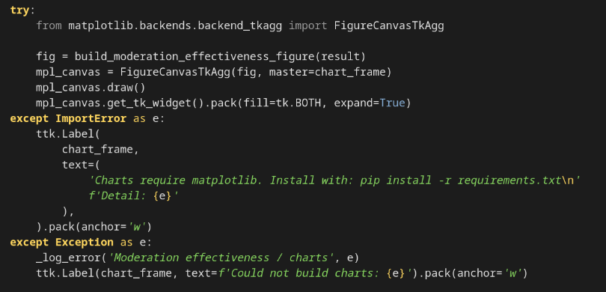Figure 1: code snippet displaying moderation effectiveness UI trigger

Prior to this, uploaded data had gone through the following cleaning process:
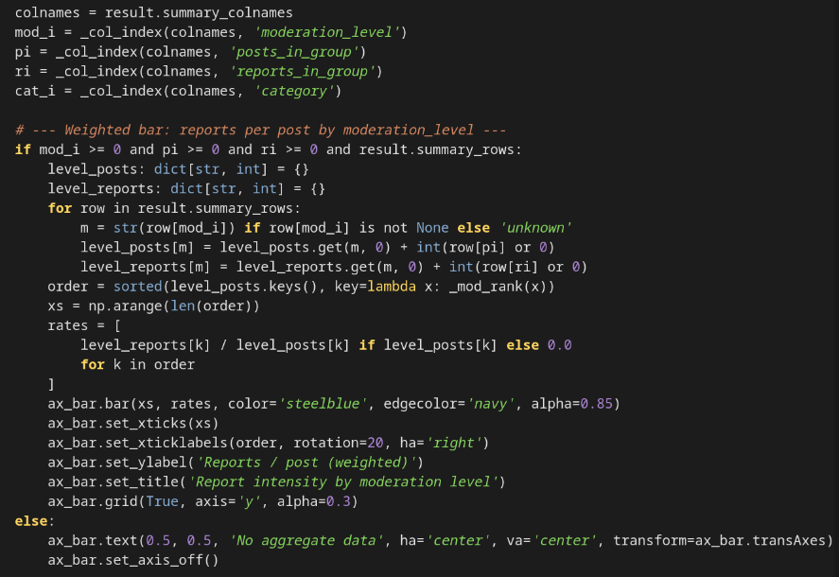Figure 2: Code snippet displaying generation of Weighted Bar chart

- Whitespace trimming
- Case normalisation
- Null-value standardisation.
- Date separation standardisation.
- Type coersion from SQL types to reasonable python types.

Data cleaning was justified to ensure that data was in a standardised form that reduced complexity when parsing and analysing, and ensured results were calculated correctly without further tampering at the table generation stage. A portion of the final output can be seen in Figure 3.

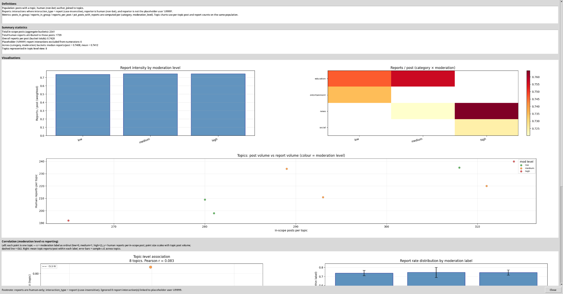Figure 3: Sample screenshot from Moderation Effectiveness UI

