Задание

по WEB приложения

От Илиян Костов

СИТ 2 курс

Група 4 б

Факултетен номер:19621609

**Проектиране на уеб страница за УНИВЕРСИТЕТ**

Картина, която съдържа текст

Описанието е генерирано автоматично

**Релационен модел**

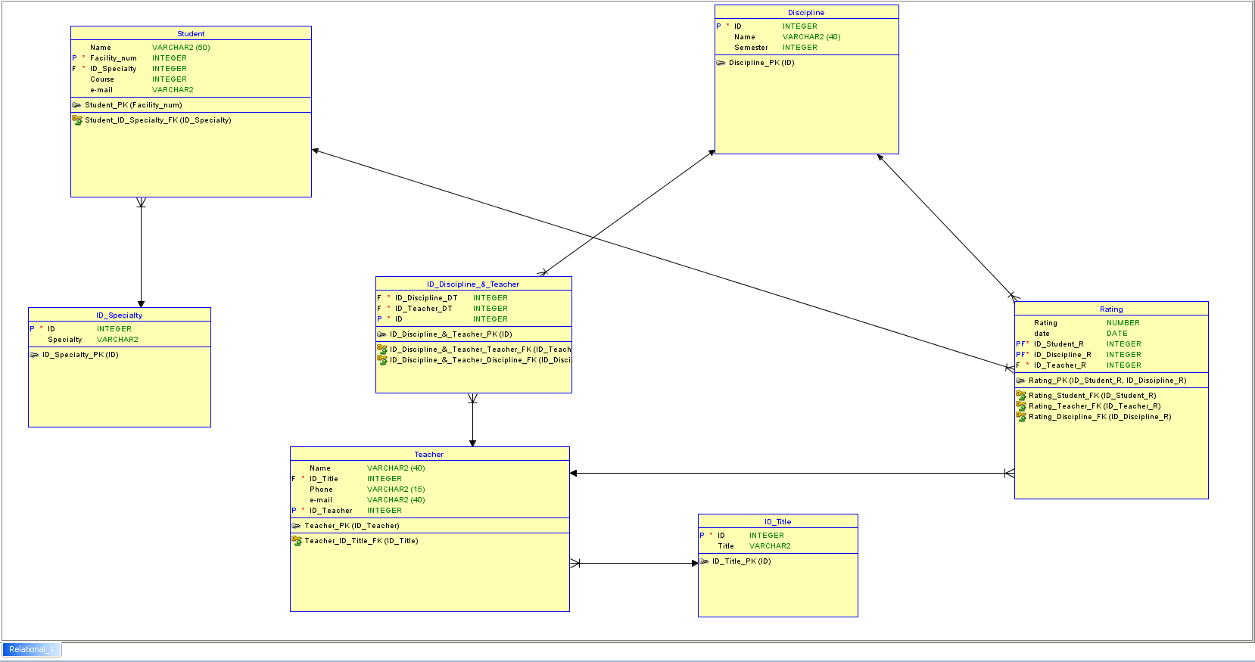

**Логически модел**

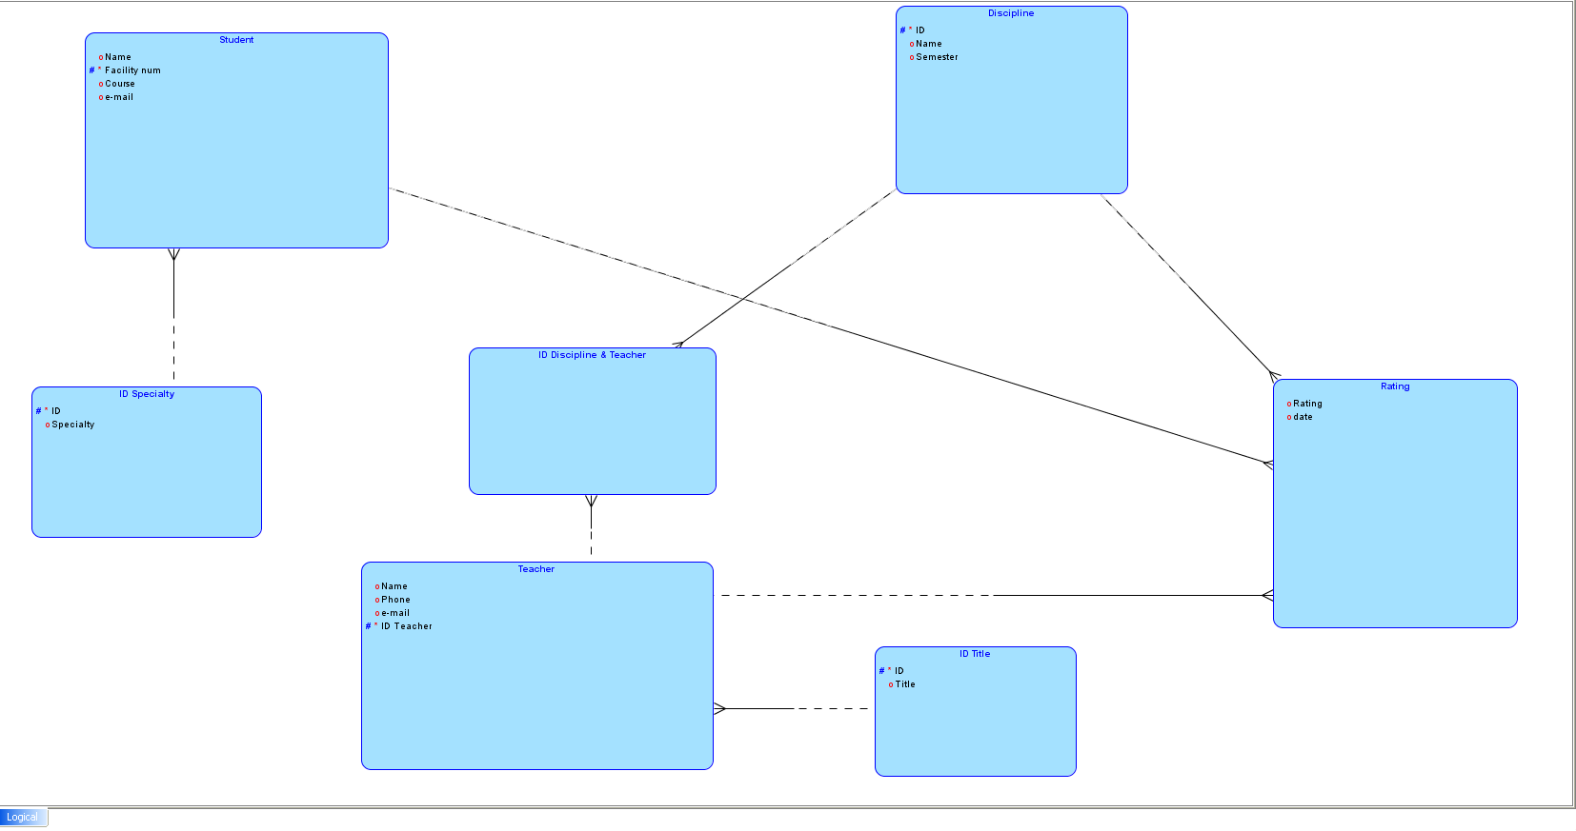

**Config.php**

<?php

if ( ! $dbConn= mysqli_connect('localhost','root','')) {

die("Не може да се осъществи връзка със сървъра");

}

?>

**Create.php**

<?php

include('config.php');

if ( !mysqli_query($dbConn,"CREATE Database IF NOT EXISTS University")) {

die("Не може да се създаде база данни");

}

if (!mysqli_select_db($dbConn,'University')) {

die("Не може да избере базата данни!");

}

if (!mysqli_query($dbConn,"CREATE TABLE IF NOT EXISTS Student ("

. "ST_Name VARCHAR (32) DEFAULT NULL,"

. "Facility_num BIGINT NOT NULL,"

. "SP_FK_Id INT DEFAULT NULL,"

. "Course INT DEFAULT NULL,"

. "ST_Email VARCHAR(32) DEFAULT NULL,"

. "PRIMARY KEY(Facility_num)"

. ")ENGINE=INNODB DEFAULT CHARSET=utf8")) {

die("Не може да се създаде таблица Студент !");

}

if (!mysqli_query($dbConn,"CREATE TABLE IF NOT EXISTS Specialty ("

. "SP_Id INT NOT NULL AUTO_INCREMENT,"

. "SP_Name VARCHAR(40) DEFAULT NULL,"

. "PRIMARY KEY(SP_Id)"

. ")ENGINE=INNODB DEFAULT CHARSET=utf8")) {

die("Не може да се създаде таблица Специалност !");

}

if (!mysqli_query($dbConn,"CREATE TABLE IF NOT EXISTS Teacher ("

. "TCH_Id INT NOT NULL AUTO_INCREMENT,"

. "TCH_Name VARCHAR(50) DEFAULT NULL,"

. "TL_FK_Id INT DEFAULT NULL,"

. "Phone VARCHAR(32) DEFAULT NULL,"

. "TCH_Email VARCHAR(32) DEFAULT NULL,"

. "PRIMARY KEY(TCH_Id)"

. ")ENGINE=INNODB DEFAULT CHARSET=utf8")) {

die("Не може да се създаде таблица Преподавател !");

}

if (!mysqli_query($dbConn,"CREATE TABLE IF NOT EXISTS Title ("

."TL_Id INT NOT NULL AUTO_INCREMENT,"

. "TL_Name VARCHAR(32) DEFAULT NULL,"

. "PRIMARY KEY(TL_Id)"

.")ENGINE=INNODB DEFAULT CHARSET=utf8")) {

die("Не може да се създаде таблица Титла !");

}

if (!mysqli_query($dbConn,"CREATE TABLE IF NOT EXISTS Discipline ("

."DS_Id INT NOT NULL AUTO_INCREMENT,"

. "DS_Name VARCHAR(32) DEFAULT NULL,"

. "Semester INT DEFAULT NULL,"

. "PRIMARY KEY(DS_Id)"

.")ENGINE=INNODB DEFAULT CHARSET=utf8")) {

die("Не може да се създаде таблица Дисциплина !");

}

if (!mysqli_query($dbConn,"CREATE TABLE IF NOT EXISTS Disicpline_Teacher_MM ("

."DS_FK_MM INT NOT NULL,"

. "TCH_FK_MM INT NOT NULL"

.")ENGINE=INNODB DEFAULT CHARSET=utf8")) {

die("Не може да се създаде таблица Дисциплина и преподавател M / M !");

}

if (!mysqli_query($dbConn,"CREATE TABLE IF NOT EXISTS Rating ("

."Grade DOUBLE NOT NULL,"

. " Dates DATE DEFAULT NULL,"

. "ST_FK_R INT NOT NULL,"

. "TCH_FK_R INT NOT NULL,"

. "DS_FK_R INT NOT NULL"

.")ENGINE=INNODB DEFAULT CHARSET=utf8")) {

die("Не може да се създаде таблица Оценки ! ");

}

if (!'FK_ST_PK_SP') {

if (!mysqli_query($dbConn,"ALTER TABLE Student ADD CONSTRAINT FK_ST_PK_SP FOREIGN KEY(SP_FK_Id) REFERENCES Specialty(SP_Id)")) {

die("Не може да се осъществи връзка между таблица студент и специалност !");

}

}

if (!'FK_TCH_PK_TL') {

if (!mysqli_query($dbConn,"ALTER TABLE Teacher ADD CONSTRAINT FK_TCH_PK_TL FOREIGN KEY(TL_FK_Id) REFERENCES Title (TL_Id)")) {

die("Не може да се осъществи връзка между таблица преподавател и титла !");

}

}

if (!'FK_DSTCHMM_PK_TCH') {

if (!mysqli_query($dbConn,"ALTER TABLE Discipline_Teacher_MM ADD CONSTRAINT FK_DSTCHMM_PK_TCH FOREIGN KEY(TCH_FK_MM) REFERENCES Teacher (TCH_Id)")) {

die("Не може да се осъществи връзка между таблица преподавател - дисциплина М/ М и преподавател !");

}

}

if (!'FK_DSTCHMM_PK_DS') {

if (!mysqli_query($dbConn,"ALTER TABLE Discipline_Teacher_MM ADD CONSTRAINT FK_DSTCHMM_PK_DS FOREIGN KEY(DS_FK_MM) REFERENCES Discipline (DS_Id)")) {

die("Не може да се осъществи връзка между таблица преподавател - дисциплина М/ М и дисциплина !");

}

}

if (!'FK_R_PK_ST') {

if (!mysqli_query($dbConn,"ALTER TABLE Rating ADD CONSTRAINT FK_R_PK_ST FOREIGN KEY(ST_FK_R) REFERENCES Student (Facility_num)")) {

die("Не може да се осъществи връзка между таблица оценка и студент !");

}

}

if (!'FK_R_PK_DS') {

if (!mysqli_query($dbConn,"ALTER TABLE Rating ADD CONSTRAINT FK_R_PK_DS FOREIGN KEY(DS_FK_R) REFERENCES Discipline (DS_Id)")) {

die("Не може да се осъществи връзка между таблица оценка и дисциплина !");

}

}

if (!'FK_R_PK_TCH') {

if (!mysqli_query($dbConn,"ALTER TABLE Rating ADD CONSTRAINT FK_R_PK_TCH FOREIGN KEY(TCH_FK_R) REFERENCES Teacher (TCH_Id)")) {

die("Не може да се осъществи връзка между таблица оценка и преподавател !");

}

}

$OUTFILE_ST="D:/XAMPP/Setup/tmp/Student.sql";

$OUTFILE_SP="D:/XAMPP/Setup/tmp/Specialty.sql";

$OUTFILE_TCH="D:/XAMPP/Setup/tmp/Teacher.sql";

$OUTFILE_TL="D:/XAMPP/Setup/tmp/Title.sql";

$OUTFILE_DS="D:/XAMPP/Setup/tmp/Discipline.sql";

$OUTFILE_DS_TCH_MM="D:/XAMPP/Setup/tmp/DS_TCH_MM.sql";

$OUTFILE_R="D:/XAMPP/Setup/tmp/Rating.sql";

mysqli_query($dbConn,"SELECT * FROM Student INTO OUTFILE '$OUTFILE_ST'");

mysqli_query($dbConn,"SELECT * FROM Specialty INTO OUTFILE '$OUTFILE_SP'");

mysqli_query($dbConn,"SELECT * FROM Teacher INTO OUTFILE '$OUTFILE_TCH'");

mysqli_query($dbConn,"SELECT * FROM Title INTO OUTFILE '$OUTFILE_TL'");

mysqli_query($dbConn,"SELECT * FROM Discipline INTO OUTFILE '$OUTFILE_DS'");

mysqli_query($dbConn,"SELECT * FROM Discipline_Teacher_MM INTO OUTFILE '$OUTFILE_DS_TCH_MM'");

mysqli_query($dbConn,"SELECT * FROM Rating INTO OUTFILE '$OUTFILE_R'");

?>

**index.php**

<?php include('create.php'); ?>

<html>

<title>Университет</title>

<head>

<style>

body {

background-color:#C5E2F6;

margin: 0;

}

ul {

list-style-type: none;

margin: 0;

padding: 0;

text-align: center;

border: 3px solid #BCC1E9;

width: 100%;

background-color: #C5E2F6;

position: fixed;

height: 100%;

overflow: auto;

}

li a {

display: block;

color: #000;

padding: 8px 16px;

text-decoration: none;

}

li a.active {

background-color: #4CAF50;

color: white;

}

li a:hover:not(.active) {

background-color: #555;

color: white;

}

.header {

background-color:#0D6DB0

;

color:white;

padding: 20px;

text-align: center;

}

</style>

</head>

<div class="header">

<h1 align="center" >Университет</h1>

</div>

<body>

<ul>

<li>

<a href="input.php" align="justify">Въвеждане</a>

</li>

<li>

<a href="update.php" align="justify">Редактиране</a>

</li>

<li>

<a href="delete.php" align="justify">Изтриване</a>

</li>

<li>

<a href="search.php" align="justify">Търсене</a>

</li>

<li>

<a href="academic_transcript.php" align="justify">Академична справка</a>

</li>

<li>

<a href="average_transcript.php" align="justify">Среден успех за студенти за специалност/курс</a>

</li>

<li>

<a href="average_transcript2.php" align="justify">Среден успех за дисциплини</a>

</li>

<li>

<a href="print.php" align="justify">Извеждане на всички данни</a>

</li>

</ul>

</body>

</html>

**input.php**

<html>

<head>

<style>

body {

background-color:#C5E2F6;

margin: 0;

}

ul {

list-style-type: none;

margin: 0;

padding: 0;

text-align: center;

border: 3px solid #BCC1E9;

width: 100%;

background-color: #C5E2F6;

position: fixed;

height: 100%;

overflow: auto;

}

li a {

display: block;

color: #000;

padding: 8px 16px;

text-decoration: none;

}

li a.active {

background-color: #4CAF50;

color: white;

}

li a:hover:not(.active) {

background-color: #555;

color: white;

}

.header {

background-color:#0D6DB0

;

color:white;

padding: 20px;

text-align: center;

}

</style>

</head>

<div class="header">

<h1 align="center" >Университет</h1>

</div>

<body>

<title>Въвеждане</title>

<div class="header"> <h1 align="center">Въвеждане</h1></div>

<br><br>

<div class="header"><p align="center">В каква секция искате да въведете данни?</p></div>

<br>

<ul>

<li>

<a href="input_student.php" align="justify">Студент</a>

</li>

<li>

<a href="input_specialty.php" align="justify">Специалност</a>

</li>

<li>

<a href="input_teacher.php" align="justify">Преподавател</a>

</li>

<li>

<a href="input_title.php" align="justify">Титла</a>

</li>

<li>

<a href="input_discipline.php" align="justify">Дисциплина</a>

</li>

<li>

<a href="input_rating.php" align="justify">Оценка</a>

</li>

</ul>

</body>

</html>

**Input_student.php**

<?php include('config.php');if (!mysqli_select_db($dbConn,'University')) {

die("Не може да избере базата данни!");

} ?>

<html>

<head>

<style>

body {

background-color:#C5E2F6;

margin: 0;

}

ul {

list-style-type: none;

margin: 0;

padding: 0;

text-align: center;

border: 3px solid #BCC1E9;

width: 100%;

background-color: #C5E2F6;

position: fixed;

height: 100%;

overflow: auto;

}

li a {

display: block;

color: #000;

padding: 8px 16px;

text-decoration: none;

}

li a.active {

background-color: #4CAF50;

color: white;

}

li a:hover:not(.active) {

background-color: #555;

color: white;

}

.header {

background-color:#0D6DB0

;

color:white;

padding: 20px;

text-align: left;

}

</style>

</head>

<body>

<div class="header"> <h1 align="center">Моля въведете данните с<font color="red"> * </font> ! </h1></div>

<form action="#" method="POST">

<br>

Име: <input type="text" name="Name"><font color="red">*</font>

<br>

<br>

Факултетен номер: <input type="text" name="Fac_num"><font color="red">*</font>

<br>

<br>

<label for="Specialty">Специалност:</label>

<select name="Specialty" id="Specialty">

<?php

$res= mysqli_query($dbConn,"SELECT * FROM Specialty");

while($row = mysqli_fetch_assoc($res)) {

$valName=$row['SP_Name'];

$valId=$row['SP_Id'];

echo"<option value=$valId>$valName</option>";

}

?>

</select>

<font color="red">*</font>

<br>

<br>

Курс: <input type="text" name="Course"><font color="red">*</font>

<br>

<br>

Е-mail: <input type="email" name="Email">

<br>

<br>

<input type="submit" name="submit" value="Въведи">

<br>

<br>

<br>

</form>

<?php

if (isset($_POST['submit'])) {

$Email="Няма";

if (!empty($_POST['Name']) && !empty($_POST['Fac_num']) && !empty($_POST['Specialty']) && !empty($_POST['Course'])) {

$Name=$_POST['Name'];

$Fac_n=$_POST['Fac_num'];

$Specialty=$_POST['Specialty'];

$Course=$_POST['Course'];

if (!empty($_POST['Email'])) { $Email=$_POST['Email'];}

if (!mysqli_query($dbConn,"INSERT INTO Student (ST_Name,Facility_num,SP_FK_Id,Course,ST_Email) "

. "Values('$Name',$Fac_n,$Specialty,$Course,'$Email')")) { die("<ul><li>Не могат да се добавят данните</li> <li><a href='index.php'>Начало</a></li></ul> !");

}else { echo"<table border='1' size=25%><tr><th>Студент</th><th>Факултетен номер</th><th>Специалност</th><th>Курс</th><th>Еmail</th></tr>";

$res= mysqli_query($dbConn,"SELECT * FROM Student JOIN Specialty ON (SP_Id = SP_FK_Id)");

while($row = mysqli_fetch_assoc($res)) {

echo"<tr><td>".$row['ST_Name']."</td><td>".$row['Facility_num']."</td><td>".$row['SP_Name']."</td><td>".$row['Course']."</td><td>".$row['ST_Email']."</td></tr>";

}

echo"</table><li><a href='index.php'>Начало</a></li></ul>";

}

}else die("<ul><li>Moля въведете необходимата информация !</li><li><a href='index.php'>Начало</a></li></ul>");

}

?>

</body>

</html>

**Input_specialty.php**

<?php include('config.php');if (!mysqli_select_db($dbConn,'University')) {

die("Не може да избере базата данни!");

} ?>

<html>

<head>

<style>

body {

background-color:#C5E2F6;

margin: 0;

}

ul {

list-style-type: none;

margin: 0;

padding: 0;

text-align: center;

border: 3px solid #BCC1E9;

width: 100%;

background-color: #C5E2F6;

position: fixed;

height: 100%;

overflow: auto;

}

li a {

display: block;

color: #000;

padding: 8px 16px;

text-decoration: none;

}

li a.active {

background-color: #4CAF50;

color: white;

}

li a:hover:not(.active) {

background-color: #555;

color: white;

}

.header {

background-color:#0D6DB0

;

color:white;

padding: 20px;

text-align: left;

}

</style>

</head>

<body>

<div class="header"> <h1 align="center">Моля въведете данните с<font color="red"> * </font> ! </h1></div>

<form action="#" method="POST">

<br>

Специалност: <input type="text" name="Specialty"><font color="red">*</font>

<br>

<br>

<input type="submit" name="submit" value="Въведи">

<br>

<br>

</form>

<?php

if (isset($_POST['submit'])) {

if( !empty($_POST['Specialty'])) { $Specialty=$_POST['Specialty'];

if (!mysqli_query($dbConn,"INSERT INTO Specialty (SP_Id,SP_Name) "

. "Values(SP_Id,'$Specialty')"))

{ die("<ul><li>Не могат да се добавят данните</li><li><a href='index.php'>Начало</a></li></ul> !");

}else { echo"<table border='1' size=25%><tr><th>Номер</th><th>Специалност</th></tr>";

$res= mysqli_query($dbConn,"SELECT * FROM Specialty");

while($row = mysqli_fetch_assoc($res)) {

echo"<tr><td>".$row['SP_Id']."</td><td>".$row['SP_Name']."</td></tr>";

}

echo"</table><ul><li><a href='index.php'>Начало</a></li></ul>";

}

}else die("<ul><li>Moля въведете необходимата информация !</li><li><a href='index.php'>Начало</a></li></ul>");

}

?>

</body>

**</html>**

**Input_teacher.php**

<?php include('config.php');if (!mysqli_select_db($dbConn,'University')) {

die("Не може да избере базата данни!");

} ?>

<html>

<head>

<style>

body {

background-color:#C5E2F6;

margin: 0;

}

ul {

list-style-type: none;

margin: 0;

padding: 0;

text-align: center;

border: 3px solid #BCC1E9;

width: 100%;

background-color: #C5E2F6;

position: fixed;

height: 100%;

overflow: auto;

}

li a {

display: block;

color: #000;

padding: 8px 16px;

text-decoration: none;

}

li a.active {

background-color: #4CAF50;

color: white;

}

li a:hover:not(.active) {

background-color: #555;

color: white;

}

.header {

background-color:#0D6DB0

;

color:white;

padding: 20px;

text-align: left;

}

</style>

</head>

<body>

<div class="header"> <h1 align="center">Моля въведете данните с<font color="red"> * </font> ! </h1></div>

<form action="#" method="POST">

<br>

Име: <input type="text" name="Name"><font color="red">*</font>

<br>

<br>

<label for="Title">Титла:</label>

<select name="Title" id="Title">

<?php

$res= mysqli_query($dbConn,"SELECT * FROM Title");

while($row = mysqli_fetch_assoc($res)) {

$valName=$row['TL_Name'];

$valId=$row['TL_Id'];

echo"<option value=$valId>$valName</option>";

}

?>

</select>

<font color="red">*</font>

<br>

<br>

Телефонен номер: <input type="text" name="Phone">

<br>

<br>

Е-mail: <input type="email" name="Email">

<br>

<br>

<input type="submit" name="submit" value="Въведи">

<br>

<br>

</form>

<?php

if (isset($_POST['submit'])) {

$Email="Няма";

$Phone="Няма";

if (!empty($_POST['Name']) && !empty($_POST['Title'])) {

$Name=$_POST['Name'];

$Title=$_POST['Title'];

if (!empty($_POST['Phone'])) { $Phone=$_POST['Phone'];}

if (!empty($_POST['Email'])) { $Email=$_POST['Email'];}

if (!mysqli_query($dbConn,"INSERT INTO Teacher (TCH_Id,TCH_Name,TL_FK_Id,Phone,TCH_Email) "

. "Values(TCH_Id,'$Name',$Title,'$Phone','$Email')")) { die("<ul><li>Не могат да се добавят данните</li><li><a href='index.php'>Начало</a></li></ul> !");

}else { echo"<table border='1' size=25%><tr><th>Номер</th><th>Преподавател</th><th>Титла</th><th>Тел. номер</th><th>Еmail</th></tr>";

$res= mysqli_query($dbConn,"SELECT * FROM Teacher JOIN Title ON (TL_Id = TL_FK_Id)");

while($row = mysqli_fetch_assoc($res)) {

echo"<tr><td>".$row['TCH_Id']."</td><td>".$row['TCH_Name']."</td><td>".$row['TL_Name']."</td><td>".$row['Phone']."</td><td>".$row['TCH_Email']."</td></tr>";

}

echo"</table><ul><li><a href='index.php'>Начало</a></li></ul>";

}

}else die("<ul><li>Moля въведете необходимата информация !</li><li><a href='index.php'>Начало</a></li></ul>");

}

?>

</body>

</html>

**Input_title.php**

<?php include('config.php');if (!mysqli_select_db($dbConn,'University')) {

die("Не може да избере базата данни!");

} ?>

<html>

<head>

<style>

body {

background-color:#C5E2F6;

margin: 0;

}

ul {

list-style-type: none;

margin: 0;

padding: 0;

text-align: center;

border: 3px solid #BCC1E9;

width: 100%;

background-color: #C5E2F6;

position: fixed;

height: 100%;

overflow: auto;

}

li a {

display: block;

color: #000;

padding: 8px 16px;

text-decoration: none;

}

li a.active {

background-color: #4CAF50;

color: white;

}

li a:hover:not(.active) {

background-color: #555;

color: white;

}

.header {

background-color:#0D6DB0

;

color:white;

padding: 20px;

text-align: left;

}

</style>

</head>

<body>

<div class="header"> <h1 align="center">Моля въведете данните с<font color="red"> * </font> ! </h1></div>

<form action="#" method="POST">

<br>

Титла: <input type="text" name="Title"><font color="red">*</font>

<br>

<br>

<input type="submit" name="submit" value="Въведи">

<br>

<br>

</form>

<?php

if (isset($_POST['submit'])) {

if( !empty($_POST['Title'])) { $Title=$_POST['Title'];

if (!mysqli_query($dbConn,"INSERT INTO Title (TL_Id,TL_Name) "

. "Values(TL_Id,'$Title')"))

{ die("<ul><li>Не могат да се добавят данните</li><li><a href='index.php'>Начало</a></li></ul> !");

}else { echo"<table border='1' size=25%><tr><th>Номер</th><th>Титла</th></tr>";

$res= mysqli_query($dbConn,"SELECT * FROM Title");

while($row = mysqli_fetch_assoc($res)) {

echo"<tr><td>".$row['TL_Id']."</td><td>".$row['TL_Name']."</td></tr>";

}

echo"</table><ul><li><a href='index.php'>Начало</a></li></ul>";

}

}else die("<ul><li>Moля въведете необходимата информация !</li><li><a href='index.php'>Начало</a></li></ul>");

}

?>

</body>

</html>

**Input_Discipline.php**

<?php include('config.php');if (!mysqli_select_db($dbConn,'University')) {

die("Не може да избере базата данни!");

} ?>

<html>

<head>

<style>

body {

background-color:#C5E2F6;

margin: 0;

}

ul {

list-style-type: none;

margin: 0;

padding: 0;

text-align: center;

border: 3px solid #BCC1E9;

width: 100%;

background-color: #C5E2F6;

position: fixed;

height: 100%;

overflow: auto;

}

li a {

display: block;

color: #000;

padding: 8px 16px;

text-decoration: none;

}

li a.active {

background-color: #4CAF50;

color: white;

}

li a:hover:not(.active) {

background-color: #555;

color: white;

}

.header {

background-color:#0D6DB0

;

color:white;

padding: 20px;

text-align: left;

}

</style>

</head>

<body>

<div class="header"> <h1 align="center">Моля въведете данните с<font color="red"> * </font> ! </h1></div>

<form action="#" method="POST">

<br>

Дисциплина: <input type="text" name="Discipline"><font color="red">*</font>

<br>

<br>

Семестър: <input type="text" name="Semester"><font color="red">*</font>

<br>

<br>

<input type="submit" name="submit" value="Въведи">

<br>

<br>

</form>

<?php

if (isset($_POST['submit'])) {

if( !empty($_POST['Discipline']) && !empty($_POST['Semester'])) {

$Discipline=$_POST['Discipline'];

$Semester=$_POST['Semester'];

if (!mysqli_query($dbConn,"INSERT INTO Discipline (DS_Id,DS_Name,Semester) "

. "Values(DS_Id,'$Discipline',$Semester)"))

{ die("<ul><li>Не могат да се добавят данните</li><li><a href='index.php'>Начало</a></li></ul> !");

}else { echo"<table border='1' size=25%><tr><th>Номер</th><th>Дисциплина</th><th>Семестър</th></tr>";

$res= mysqli_query($dbConn,"SELECT * FROM Discipline");

while($row = mysqli_fetch_assoc($res)) {

echo"<tr><td>".$row['DS_Id']."</td><td>".$row['DS_Name']."</td><td>".$row['Semester']."</td></tr>";

}

echo"</table><ul><li><a href='index.php'>Начало</a></li></ul>";

}

}else die("<ul><li>Moля въведете необходимата информация !</li><li><a href='index.php'>Начало</a></li></ul>");

}

?>

</body>

</html>

**Input_rating.php**

<?php include('config.php');if (!mysqli_select_db($dbConn,'University')) {

die("Не може да избере базата данни!");

} ?>

<html>

<head>

<style>

body {

background-color:#C5E2F6;

margin: 0;

}

ul {

list-style-type: none;

margin: 0;

padding: 0;

text-align: center;

border: 3px solid #BCC1E9;

width: 100%;

background-color: #C5E2F6;

position: fixed;

height: 100%;

overflow: auto;

}

li a {

display: block;

color: #000;

padding: 8px 16px;

text-decoration: none;

}

li a.active {

background-color: #4CAF50;

color: white;

}

li a:hover:not(.active) {

background-color: #555;

color: white;

}

.header {

background-color:#0D6DB0

;

color:white;

padding: 20px;

text-align: left;

}

</style>

</head>

<body>

<div class="header"> <h1 align="center">Моля въведете данните с<font color="red"> * </font> ! </h1></div>

<form action="#" method="POST">

<br>

Оценка: <input type="text" name="Grade"><font color="red">*</font>

<br>

<br>

Дата: <input type="date" name="Date"><font color="red">*</font>

<br>

<br>

Факултетен номер на студент: <input type="text" name="Fac_num"><font color="red">*</font>

<br>

<br>

<label for="Discipline">Дисциплина:</label>

<select name="Discipline" id="Discipline">

<?php

$res= mysqli_query($dbConn,"SELECT * FROM Discipline");

while($row = mysqli_fetch_assoc($res)) {

$valName=$row['DS_Name'];

$valId=$row['DS_Id'];

echo"<option value=$valId>$valName</option>";

}

?>

</select>

<font color="red">*</font>

<br>

<br>

Преподавател: <input type="text" name="Teacher"><font color="red">*</font>

<br>

<br>

<input type="submit" name="submit" value="Въведи">

<br>

<br>

</form>

<?php

if (isset($_POST['submit'])) {

if (!empty($_POST['Grade']) && !empty($_POST['Date']) && !empty($_POST['Fac_num']) && !empty($_POST['Discipline'] && !empty($_POST['Teacher']))) {

$rawdate = htmlentities($_POST['Date']);

$flagST=false;

$flagTCH=false;

$flagSTDS=false;

$Grade=$_POST['Grade'];

$Date= date('Y-m-d', strtotime($rawdate));

$Fac_n=$_POST['Fac_num'];

$Discipline=$_POST['Discipline'];

$Teacher=$_POST['Teacher'];

$resTCH= mysqli_query($dbConn,"SELECT * FROM Teacher");

while($row = mysqli_fetch_assoc($resTCH)) {

$valName=$row['TCH_Name'];

$valId=$row['TCH_Id'];

if ($valName == $Teacher) { $Teacher=$valId;$flagTCH=true; }

}

$resST= mysqli_query($dbConn,"SELECT * FROM Student");

while($row = mysqli_fetch_assoc($resST)) {

$valId=$row['Facility_num'];

if ($valId == $Fac_n) { $flagST=true; }

}

if (!$flagTCH || !$flagST ) { die("<ul><li>Преподавател / студент с такова име / фак.номер не съществува </li><li><a href='index.php'>Начало</a></li></ul>!"); }

else {

$res= mysqli_query($dbConn,"SELECT * FROM Rating JOIN Student ON ( Facility_num = ST_FK_R) JOIN Discipline ON ( DS_ID = DS_FK_R) ");

while ($row= mysqli_fetch_assoc($res)) { if ($Fac_n == $row['ST_FK_R'] && $Discipline == $row['DS_FK_R']) $flagSTDS=true; }

if ($flagSTDS) {die("<ul><li>Студент вече има оценка в дадената дисциплина !</li><li><a href='index.php'>Начало</a></li></ul>");}

else {

if (!mysqli_query($dbConn,"INSERT INTO Rating (Grade,Dates,ST_FK_R,TCH_FK_R,DS_FK_R) "

. "Values($Grade,'$Date',$Fac_n,$Teacher,$Discipline)")) { die("<ul><li>Не могат да се добавят данните !</li><li><a href='index.php'>Начало</a></li></ul>");

}else { echo"<table border='1' size=25%><tr><th>Оценка</th><th>Дата</th><th>Студент</th><th>Преподавател</th><th>Дисциплина</th></tr>";

$res= mysqli_query($dbConn,"SELECT * FROM Rating JOIN Student ON (Facility_num = ST_FK_R) JOIN Teacher ON (TCH_Id = TCH_FK_R) JOIN Discipline ON (DS_Id = DS_FK_R) "

. "ORDER BY ST_FK_R");

while($row = mysqli_fetch_assoc($res)) {

echo"<tr><td>".$row['Grade']."</td><td>".$row['Dates']."</td><td>".$row['ST_Name']."</td><td>".$row['TCH_Name']."</td><td>".$row['DS_Name']."</td></tr>";

}

echo"</table><ul><li><a href='index.php'>Начало</a></li></ul>";}

}

}

}else die("<ul><li>Moля въведете необходимата информация !</li><li><a href='index.php'>Начало</a></li></ul>");

}

?>

</body>

</html>

**Update.php**

<html>

<head>

<style>

body {

background-color:#C5E2F6;

margin: 0;

}

ul {

list-style-type: none;

margin: 0;

padding: 0;

text-align: center;

border: 3px solid #BCC1E9;

width: 100%;

background-color: #C5E2F6;

position: fixed;

height: 100%;

overflow: auto;

}

li a {

display: block;

color: #000;

padding: 8px 16px;

text-decoration: none;

}

li a.active {

background-color: #4CAF50;

color: white;

}

li a:hover:not(.active) {

background-color: #555;

color: white;

}

.header {

background-color:#0D6DB0

;

color:white;

padding: 20px;

text-align: center;

}

</style>

</head>

<body>

<title>Редактиране</title>

<div class="header">

<h1 align="center">Редактиране</h1>

</div>

<br><br>

<div class="header">

<p align="center">В каква секция искате да редактирате данни?</p>

</div>

<ul>

<li>

<a href="update_student.php" align="justify">Студент</a>

</li>

<li>

<a href="update_specialty.php" align="justify">Специалност</a>

</li>

<li>

<a href="update_teacher.php" align="justify">Преподавател</a>

</li>

<li>

<a href="update_title.php" align="justify">Титла</a>

</li>

<li>

<a href="update_discipline.php" align="justify">Дисциплина</a>

</li>

<li>

<a href="update_rating.php" align="justify">Оценка</a>

</li>

</ul>

</body>

</html>

**Update_student.php**

<?php include('config.php');if (!mysqli_select_db($dbConn,'University')) {

die("Не може да избере базата данни!");

} ?>

<html>

<head>

<style>

body {

background-color:#C5E2F6;

margin: 0;

}

ul {

list-style-type: none;

margin: 0;

padding: 0;

text-align: center;

border: 3px solid #BCC1E9;

width: 100%;

background-color: #C5E2F6;

position: fixed;

height: 100%;

overflow: auto;

}

li a {

display: block;

color: #000;

padding: 8px 16px;

text-decoration: none;

}

li a.active {

background-color: #4CAF50;

color: white;

}

li a:hover:not(.active) {

background-color: #555;

color: white;

}

.header {

background-color:#0D6DB0

;

color:white;

padding: 20px;

text-align: left;

}

</style>

</head>

<body>

<form action="#" method="POST">

<br>

<div class="header">

<h2 align="center"> Въведете фак. номер на студента, който искате да промените:</h2>

</div>

<br>

<br>

Фак. номер:<input type="text" name="Fac_num">

<br>

<br>

<input type="submit" name="submit" value="Потвърди !">

</form>

<br>

<br>

<?php

if (isset($_POST['submit'])) {

session_start();

$_SESSION['Facility_num']=null;

$flag=false;

$resST= mysqli_query($dbConn,"SELECT * FROM Student");

while($row = mysqli_fetch_assoc($resST)) {

if ($_POST['Fac_num'] == $row['Facility_num']) { $flag=true; $_SESSION['Facility_num'] = $row['Facility_num']; }

}

if (!$flag) {

die("<ul><li>Студент с такъв факултетен номер не съществува</li><li><a href='index.php'>Начало</a></li></ul> !");

}

else {

header('Location: http://localhost/NewPhpProject2/update2_student.php');

}

}

?>

</body>

</html>

Update2_student.php

<?php include('config.php');if (!mysqli_select_db($dbConn,'University')) {

die("Не може да избере базата данни!");

} ?>

<html>

<head>

<style>

body {

background-color:#C5E2F6;

margin: 0;

}

ul {

list-style-type: none;

margin: 0;

padding: 0;

text-align: center;

border: 3px solid #BCC1E9;

width: 100%;

background-color: #C5E2F6;

position: fixed;

height: 100%;

overflow: auto;

}

li a {

display: block;

color: #000;

padding: 8px 16px;

text-decoration: none;

}

li a.active {

background-color: #4CAF50;

color: white;

}

li a:hover:not(.active) {

background-color: #555;

color: white;

}

.header {

background-color:#0D6DB0

;

color:white;

padding: 20px;

text-align: left;

}

</style>

</head>

<body>

<div class="header">

<h2 align="center"> Намерен е въведения студент !</h2>

<h2 align="center">Въведете новите данни </h2>

</div>

<form action="#" method="POST">

<br>

Име:<input type="text" name="Name">

<br>

<br>

<label for="Specialty">Специалност:</label>

<select name="Specialty" id="Specialty">

<?php

$res= mysqli_query($dbConn,"SELECT * FROM Specialty");

while($row = mysqli_fetch_assoc($res)) {

$valName=$row['SP_Name'];

$valId=$row['SP_Id'];

echo"<option value=$valId>$valName</option>";

}

?>

</select>

<br>

<br>

Курс: <input type="text" name="Course">

<br>

<br>

Е-mail: <input type="email" name="Email">

<br>

<br>

<input type="submit" name="submit2" value="Въведи">

<br>

<br>

</form>

<?php

if (isset($_POST['submit2'])) {

session_start();

$Email="Няма";

if (!empty($_POST['Name']) && !empty($_POST['Specialty']) && !empty($_POST['Course'])) {

$Name=$_POST['Name'];

$Specialty=$_POST['Specialty'];

$Course=$_POST['Course'];

$FN=$_SESSION['Facility_num'];

if (!empty($_POST['Email'])) { $Email=$_POST['Email'];}

if (!mysqli_query($dbConn,"UPDATE Student "

. "SET ST_Name ='$Name' , "

. "SP_FK_Id =$Specialty , "

. "Course=$Course , "

. "ST_Email='$Email' "

. "WHERE Facility_num= $FN ")) { die("<ul><li>Не могат да се редактират данните</li><li><a href='index.php'>Начало</a></li></ul> !");

}else { echo"<script>document.body.innerHTML='';</script>"; echo"<ul><li>Редактирането бе успешно!</li><li><a href='index.php'>Начало</a></li></ul>"; }

}else die("<ul><li>Moля въведете необходимата информация !</li><li><a href='index.php'>Начало</a></li></ul>");

unset($_SESSION['Facility_num']);

session_destroy();

}

?>

</body>

</html>

Update_specialty.php

<?php include('config.php');if (!mysqli_select_db($dbConn,'University')) {

die("Не може да избере базата данни!");

} ?>

<html>

<head>

<style>

body {

background-color:#C5E2F6;

margin: 0;

}

ul {

list-style-type: none;

margin: 0;

padding: 0;

text-align: center;

border: 3px solid #BCC1E9;

width: 100%;

background-color: #C5E2F6;

position: fixed;

height: 100%;

overflow: auto;

}

li a {

display: block;

color: #000;

padding: 8px 16px;

text-decoration: none;

}

li a.active {

background-color: #4CAF50;

color: white;

}

li a:hover:not(.active) {

background-color: #555;

color: white;

}

.header {

background-color:#0D6DB0

;

color:white;

padding: 20px;

text-align: left;

}

</style>

</head>

<body>

<form action="#" method="POST">

<br>

<div class="header">

<h2 align="center"> Въведете наименованието на специалността, която искате да промените:</h2>

</div>

<br>

<br>

Наименование:<input type="text" name="Name">

<br>

<br>

<input type="submit" name="submit" value="Потвърди !">

</form>

<br>

<br>

<?php

if (isset($_POST['submit'])) {

session_start();

$_SESSION['Specialty']=null;

$flag=false;

$res= mysqli_query($dbConn,"SELECT * FROM Specialty");

while($row = mysqli_fetch_assoc($res)) {

if ($_POST['Name'] == $row['SP_Name']) { $flag=true; $_SESSION['Specialty']=$row['SP_Id']; }

}

if (!$flag) {

die("<ul><li>Специалност с такова наименование не съществува</li><li><a href='index.php'>Начало</a></li></ul> !");

}

else {

header('Location: http://localhost/NewPhpProject2/update2_specialty.php');

}

}

?>

</body>

</html>

Update2_specialty.php

<?php include('config.php');if (!mysqli_select_db($dbConn,'University')) {

die("Не може да избере базата данни!");

} ?>

<html>

<head>

<style>

body {

background-color:#C5E2F6;

margin: 0;

}

ul {

list-style-type: none;

margin: 0;

padding: 0;

text-align: center;

border: 3px solid #BCC1E9;

width: 100%;

background-color: #C5E2F6;

position: fixed;

height: 100%;

overflow: auto;

}

li a {

display: block;

color: #000;

padding: 8px 16px;

text-decoration: none;

}

li a.active {

background-color: #4CAF50;

color: white;

}

li a:hover:not(.active) {

background-color: #555;

color: white;

}

.header {

background-color:#0D6DB0

;

color:white;

padding: 20px;

text-align: left;

}

</style>

</head>

<body>

<div class="header">

<h2 align="center"> Намерена е въведената специалност !</h2>

<h2 align="center">Въведете новото наименование </h2>

</div>

<form action="#" method="POST">

<br>

Наименование:<input type="text" name="Name">

<br>

<br>

<input type="submit" name="submit2" value="Въведи">

<br>

<br>

</form>

<?php

if (isset($_POST['submit2'])) {

session_start();

if (!empty($_POST['Name'])) {

$Name=$_POST['Name'];

$Id=$_SESSION['Specialty'];

if (!mysqli_query($dbConn,"UPDATE Specialty "

. "SET SP_Name ='$Name' "

. "WHERE SP_Id = $Id ")) { die("<ul><li>Не могат да се редактират данните</li><li><a href='index.php'>Начало</a></li></ul>! ");

}else { echo"<script>document.body.innerHTML='';</script>"; echo"<br><ul><li>Редактирането бе успешно!</li><li><a href='index.php'>Начало</a></li></ul> "; }

}else die("<ul><li>Moля въведете необходимата информация !</li><li><a href='index.php'>Начало</a></li></ul>");

unset($_SESSION['Specialty']);

session_destroy();

}

?>

</body>

</html>

Update_teacher.php

<?php include('config.php');if (!mysqli_select_db($dbConn,'University')) {

die("Не може да избере базата данни!");

} ?>

<html>

<head>

<style>

body {

background-color:#C5E2F6;

margin: 0;

}

ul {

list-style-type: none;

margin: 0;

padding: 0;

text-align: center;

border: 3px solid #BCC1E9;

width: 100%;

background-color: #C5E2F6;

position: fixed;

height: 100%;

overflow: auto;

}

li a {

display: block;

color: #000;

padding: 8px 16px;

text-decoration: none;

}

li a.active {

background-color: #4CAF50;

color: white;

}

li a:hover:not(.active) {

background-color: #555;

color: white;

}

.header {

background-color:#0D6DB0

;

color:white;

padding: 20px;

text-align: left;

}

</style>

</head>

<body>

<form action="#" method="POST">

<br>

<div class="header">

<h2 align="center"> Въведете имената на преподавателя,на който искате да промените:</h2>

</div>

<br>

<br>

Имена:<input type="text" name="Name">

<br>

<br>

<input type="submit" name="submit" value="Потвърди !">

</form>

<br>

<br>

<?php

if (isset($_POST['submit'])) {

session_start();

$_SESSION['Teacher']=null;

$flag=false;

$resTCH= mysqli_query($dbConn,"SELECT * FROM Teacher");

while($row = mysqli_fetch_assoc($resTCH)) {

if ($_POST['Name'] == $row['TCH_Name']) { $flag=true; $_SESSION['Teacher']= $row['TCH_Id']; }

}

if (!$flag) {

die("<ul><li>Преподавател с такова име не съществува</li><li><a href='index.php'>Начало</a></li></ul> !");

}

else {

header('Location: http://localhost/NewPhpProject2/update2_teacher.php');

}

}

?>

</body>

</html>

Update2_teacher.php

<?php include('config.php');if (!mysqli_select_db($dbConn,'University')) {

die("Не може да избере базата данни!");

} ?>

<html>

<head>

<style>

body {

background-color:#C5E2F6;

margin: 0;

}

ul {

list-style-type: none;

margin: 0;

padding: 0;

text-align: center;

border: 3px solid #BCC1E9;

width: 100%;

background-color: #C5E2F6;

position: fixed;

height: 100%;

overflow: auto;

}

li a {

display: block;

color: #000;

padding: 8px 16px;

text-decoration: none;

}

li a.active {

background-color: #4CAF50;

color: white;

}

li a:hover:not(.active) {

background-color: #555;

color: white;

}

.header {

background-color:#0D6DB0

;

color:white;

padding: 20px;

text-align: left;

}

</style>

</head>

<body>

<div class="header">

<h2 align="center"> Намерен е въведения преподавател !</h2>

<h2 align="center">Въведете новите данни </h2>

</div>

<form action="#" method="POST">

<br>

Име:<input type="text" name="Name">

<br>

<br>

<label for="Title">Титла:</label>

<select name="Title" id="Title">

<?php

$res= mysqli_query($dbConn,"SELECT * FROM Title");

while($row = mysqli_fetch_assoc($res)) {

$valName=$row['TL_Name'];

$valId=$row['TL_Id'];

echo"<option value=$valId>$valName</option>";

}

?>

</select>

<br>

<br>

Тел. номер: <input type="text" name="Phone">

<br>

<br>

Е-mail: <input type="email" name="Email">

<br>

<br>

<input type="submit" name="submit2" value="Въведи">

<br>

<br>

</form>

<?php

session_start();

if (isset($_POST['submit2'])) {

$Email="Няма";

$Phone="Няма";

if (!empty($_POST['Name']) && !empty($_POST['Title']) ) {

$Name=$_POST['Name'];

$Title=$_POST['Title'];

$Id=$_SESSION['Teacher'];

if (!empty($_POST['Email'])) { $Email=$_POST['Email'];}

if (!empty($_POST['Phone'])) { $Phone=$_POST['Phone'];}

if (!mysqli_query($dbConn,"UPDATE Teacher "

. "SET TCH_Name ='$Name',"

. "TL_FK_Id =$Title,"

. "Phone='$Phone',"

. "TCH_Email='$Email'"

. "WHERE TCH_Id=$Id ")) { die("<ul><li>Не могат да се редактират данните</li><li><a href='index.php'>Начало</a></li></ul> !");

}else { echo"<script>document.body.innerHTML='';</script>"; echo"<ul><li>Редактирането бе успешно!</li><li><a href='index.php'>Начало</a></li></ul> "; }

}else die("<ul><li>Moля въведете необходимата информация !</li><li><a href='index.php'>Начало</a></li></ul>");

unset($_SESSION['Teacher']);

session_destroy();

}

?>

</body>

</html>

Update_title.php

<?php include('config.php');if (!mysqli_select_db($dbConn,'University')) {

die("Не може да избере базата данни!");

} ?>

<html>

<head>

<style>

body {

background-color:#C5E2F6;

margin: 0;

}

ul {

list-style-type: none;

margin: 0;

padding: 0;

text-align: center;

border: 3px solid #BCC1E9;

width: 100%;

background-color: #C5E2F6;

position: fixed;

height: 100%;

overflow: auto;

}

li a {

display: block;

color: #000;

padding: 8px 16px;

text-decoration: none;

}

li a.active {

background-color: #4CAF50;

color: white;

}

li a:hover:not(.active) {

background-color: #555;

color: white;

}

.header {

background-color:#0D6DB0

;

color:white;

padding: 20px;

text-align: left;

}

</style>

</head>

<body>

<form action="#" method="POST">

<br>

<div class="header">

<h2 align="center"> Въведете наименованието на титлата, която искате да промените:</h2>

</div>

<br>

<br>

Наименование:<input type="text" name="Name">

<br>

<br>

<input type="submit" name="submit" value="Потвърди !">

</form>

<br>

<br>

<?php

if (isset($_POST['submit'])) {

session_start();

$_SESSION['Title']=null;

$flag=false;

$res= mysqli_query($dbConn,"SELECT * FROM Title");

while($row = mysqli_fetch_assoc($res)) {

if ($_POST['Name'] == $row['TL_Name']) { $flag=true; $_SESSION['Title']=$row['TL_Id']; }

}

if (!$flag) {

die("<ul><li>Титла с такова наименование не съществува</li><li><a href='index.php'>Начало</a></li></ul> !");

}

else {

header('Location: http://localhost/NewPhpProject2/update2_title.php');

}

}

?>

</body>

</html>

Update2_title.php

<?php include('config.php');if (!mysqli_select_db($dbConn,'University')) {

die("Не може да избере базата данни!");

} ?>

<html>

<head>

<style>

body {

background-color:#C5E2F6;

margin: 0;

}

ul {

list-style-type: none;

margin: 0;

padding: 0;

text-align: center;

border: 3px solid #BCC1E9;

width: 100%;

background-color: #C5E2F6;

position: fixed;

height: 100%;

overflow: auto;

}

li a {

display: block;

color: #000;

padding: 8px 16px;

text-decoration: none;

}

li a.active {

background-color: #4CAF50;

color: white;

}

li a:hover:not(.active) {

background-color: #555;

color: white;

}

.header {

background-color:#0D6DB0

;

color:white;

padding: 20px;

text-align: left;

}

</style>

</head>

<body>

<div class="header">

<h2 align="center"> Намерена е въведената титла !</h2>

<h2 align="center">Въведете новото наименование </h2>

</div>

<form action="#" method="POST">

<br>

Наименование:<input type="text" name="Name">

<br>

<br>

<input type="submit" name="submit2" value="Въведи">

<br>

<br>

</form>

<?php

if (isset($_POST['submit2'])) {

session_start();

if (!empty($_POST['Name'])) {

$Name=$_POST['Name'];

$Id=$_SESSION['Title'];

if (!mysqli_query($dbConn,"UPDATE Title "

. "SET TL_Name ='$Name' "

. "WHERE TL_Id = $Id ")) { die("<ul><li>Не могат да се редактират данните</li><li><a href='index.php'>Начало</a></li></ul>! ");

}else { echo"<script>document.body.innerHTML='';</script>"; echo"<br><ul><li>Редактирането бе успешно!</li><li><a href='index.php'>Начало</a></li></ul> "; }

}else die("<ul><li>Moля въведете необходимата информация !</li><li><a href='index.php'>Начало</a></li></ul>");

unset($_SESSION['Title']);

session_destroy();

}

?>

</body>

</html>

Update_discipline.php

<?php include('config.php');if (!mysqli_select_db($dbConn,'University')) {

die("Не може да избере базата данни!");

} ?>

<html>

<head>

<style>

body {

background-color:#C5E2F6;

margin: 0;

}

ul {

list-style-type: none;

margin: 0;

padding: 0;

text-align: center;

border: 3px solid #BCC1E9;

width: 100%;

background-color: #C5E2F6;

position: fixed;

height: 100%;

overflow: auto;

}

li a {

display: block;

color: #000;

padding: 8px 16px;

text-decoration: none;

}

li a.active {

background-color: #4CAF50;

color: white;

}

li a:hover:not(.active) {

background-color: #555;

color: white;

}

.header {

background-color:#0D6DB0

;

color:white;

padding: 20px;

text-align: left;

}

</style>

</head>

<body>

<form action="#" method="POST">

<br>

<div class="header">

<h2 align="center"> Въведете наименованието на дисциплината,на която искате да промените:</h2>

</div>

<br>

<br>

Наименование:<input type="text" name="Name">

<br>

<br>

<input type="submit" name="submit" value="Потвърди !">

</form>

<br>

<br>

<?php

if (isset($_POST['submit'])) {

session_start();

$_SESSION['Discipline']=null;

$flag=false;

$resDS= mysqli_query($dbConn,"SELECT * FROM Discipline");

while($row = mysqli_fetch_assoc($resDS)) {

if ($_POST['Name'] == $row['DS_Name']) { $flag=true; $_SESSION['Discipline']=$row['DS_Id']; }

}

if (!$flag) {

die("<ul><li>Дисциплина с такова име не съществува</li><li><a href='index.php'>Начало</a></li></ul> !");

}

else {

header('Location: http://localhost/NewPhpProject2/update2_discipline.php');

}

}

?>

</body>

</html>

Update2_discipline.php

<?php include('config.php');if (!mysqli_select_db($dbConn,'University')) {

die("Не може да избере базата данни!");

} ?>

<html>

<head>

<style>

body {

background-color:#C5E2F6;

margin: 0;

}

ul {

list-style-type: none;

margin: 0;

padding: 0;

text-align: center;

border: 3px solid #BCC1E9;

width: 100%;

background-color: #C5E2F6;

position: fixed;

height: 100%;

overflow: auto;

}

li a {

display: block;

color: #000;

padding: 8px 16px;

text-decoration: none;

}

li a.active {

background-color: #4CAF50;

color: white;

}

li a:hover:not(.active) {

background-color: #555;

color: white;

}

.header {

background-color:#0D6DB0

;

color:white;

padding: 20px;

text-align: left;

}

</style>

</head>

<body>

<div class="header">

<h2 align="center"> Намерена е въведената дисциплина !</h2>

<h2 align="center">Въведете новото наименование </h2>

</div>

<form action="#" method="POST">

<br>

Наименование:<input type="text" name="Name">

<br>

<br>

Семестър: <input type="text" name="Semester">

<br>

<br>

<input type="submit" name="submit2" value="Въведи">

<br>

<br>

</form>

<?php

if (isset($_POST['submit2'])) {

session_start();

if (!empty($_POST['Name']) && !empty($_POST['Semester']) ) {

$Name=$_POST['Name'];

$Semester=$_POST['Semester'];

$Id=$_SESSION['Discipline'];

if (!mysqli_query($dbConn,"UPDATE Discipline "

. "SET DS_Name ='$Name',"

. "Semester=$Semester "

. "WHERE DS_Id =$Id ")) { die("<ul><li>Не могат да се редактират данните</li><li><a href='index.php'>Начало</a></li></ul> !");

}else { echo"<script>document.body.innerHTML='';</script>"; echo"<ul><li>Редактирането бе успешно!</li><li><a href='index.php'>Начало</a></li></ul>"; }

}else die("<ul><li>Moля въведете необходимата информация !</li><li><a href='index.php'>Начало</a></li></ul>");

unset($_SESSION['Discipline']);

session_destroy();

}

?>

</body>

</html>

Update_rating.php

<?php include('config.php');if (!mysqli_select_db($dbConn,'University')) {

die("Не може да избере базата данни!");

} ?>

<html>

<head>

<style>

body {

background-color:#C5E2F6;

margin: 0;

}

ul {

list-style-type: none;

margin: 0;

padding: 0;

text-align: center;

border: 3px solid #BCC1E9;

width: 100%;

background-color: #C5E2F6;

position: fixed;

height: 100%;

overflow: auto;

}

li a {

display: block;

color: #000;

padding: 8px 16px;

text-decoration: none;

}

li a.active {

background-color: #4CAF50;

color: white;

}

li a:hover:not(.active) {

background-color: #555;

color: white;

}

.header {

background-color:#0D6DB0

;

color:white;

padding: 20px;

text-align: left;

}

</style>

</head>

<body>

<form action="#" method="POST">

<br>

<div class="header">

<h2 align="center"> Въведете фак. номер на студента и наименованието на дисциплината, на които искате да промените оценкaтa:</h2>

</div>

<br>

<br>

Фак. номер:<input type="text" name="Fac_num">

<br>

<br>

Наименование:<input type="text" name="DS_Name">

<br>

<br>

<input type="submit" name="submit" value="Потвърди !">

</form>

<br>

<br>

<?php

if (isset($_POST['submit'])) {

session_start();

$_SESSION['Fac_num']=null;

$_SESSION['Discipline']=null;

$flagST=false;

$flagDS=false;

$flagSTDS=true;

$resST= mysqli_query($dbConn,"SELECT * FROM Student");

while($row = mysqli_fetch_assoc($resST)) {

if ($_POST['Fac_num'] == $row['Facility_num']) { $flagST=true; $_SESSION['Fac_num']=$_POST['Fac_num']; }

}

if (!$flagST) {

die("<ul><li>Студент с такъв факултетен номер не съществува</li></ul> !");

}

$resDS= mysqli_query($dbConn,"SELECT * FROM Discipline");

while($row = mysqli_fetch_assoc($resDS)) {

if ($_POST['DS_Name'] == $row['DS_Name']) { $flagDS=true; $_SESSION['Discipline']=$row['DS_Id']; }

}

if (!$flagDS) {

die("<ul><li>Дисциплина с такова име не съществува</li><li><a href='index.php'>Начало</a></li></ul> !");

}

$res= mysqli_query($dbConn,"SELECT * FROM Rating JOIN Student ON ( Facility_num = ST_FK_R) JOIN Discipline ON ( DS_ID = DS_FK_R) ");

while ($row= mysqli_fetch_assoc($res)) { if ($_POST['Fac_num'] == $row['ST_FK_R'] && $_SESSION['Discipline'] != $row['DS_FK_R']) $flagSTDS=false; }

if (!$flagSTDS) {die("<ul><li>Не съществува оценка в дисциплина на този студент ! </li><li><a href='index.php'>Начало</a></li></ul> !");}

else if ($flagST && $flagDS && $flagSTDS)

{

header('Location: http://localhost/NewPhpProject2/update2_rating.php');

}

}

?>

</body>

</html>

Update2_rating.php

<?php include('config.php');if (!mysqli_select_db($dbConn,'University')) {

die("Не може да избере базата данни!");

} ?>

<html>

<head>

<style>

body {

background-color:#C5E2F6;

margin: 0;

}

ul {

list-style-type: none;

margin: 0;

padding: 0;

text-align: center;

border: 3px solid #BCC1E9;

width: 100%;

background-color: #C5E2F6;

position: fixed;

height: 100%;

overflow: auto;

}

li a {

display: block;

color: #000;

padding: 8px 16px;

text-decoration: none;

}

li a.active {

background-color: #4CAF50;

color: white;

}

li a:hover:not(.active) {

background-color: #555;

color: white;

}

.header {

background-color:#0D6DB0

;

color:white;

padding: 20px;

text-align: left;

}

</style>

</head>

<body>

<div class="header">

<h2 align="center"> Намерена е въведената оценка !</h2>

<h2 align="center">Въведете новите данни </h2>

</div>

<form action="#" method="POST">

<br>

Оценка:<input type="text" name="Grade">

<br>

<br>

Дата: <input type="date" name="Date"><font color="red">*</font>

<br>

<br>

Преподавател: <input type="text" name="Teacher"><font color="red">*</font>

<br>

<br>

<input type="submit" name="submit2" value="Въведи">

<br>

<br>

</form>

<?php

if (isset($_POST['submit2'])) {

session_start();

if (!empty($_POST['Grade']) && !empty($_POST['Date']) && !empty($_POST['Teacher'])) {

$Grade=$_POST['Grade'];

$rawdate = htmlentities($_POST['Date']);

$Date= date('Y-m-d', strtotime($rawdate));

$Fac_num=$_SESSION['Fac_num'];

$Discipline=$_SESSION['Discipline'];

$Teacher;

$TeacherN=$_POST['Teacher'];

$flagTCH=false;

$resTCH= mysqli_query($dbConn,"SELECT * FROM Teacher");

while($row = mysqli_fetch_assoc($resTCH)) {

$valName=$row['TCH_Name'];

$valId=$row['TCH_Id'];

if ($valName == $TeacherN) { $Teacher=$valId;$flagTCH=true; }

}

if (!$flagTCH) { die("<ul><li>Преподавател с такова име не съществува</li><li><a href='index.php'>Начало</a></li></ul> !"); }

else {

if (!mysqli_query($dbConn,"UPDATE Rating "

. "SET Grade =$Grade,"

. "Dates ='$Date',"

. "TCH_FK_R=$Teacher "

. "WHERE ST_FK_R=$Fac_num AND DS_FK_R= $Discipline ")) { die("<ul><li>Не могат да се редактират данните</li><li><a href='index.php'>Начало</a></li></ul> !");

}else { echo"<ul><li>Редактирането бе успешно!</li><li><a href='index.php'>Начало</a></li></ul> "; }

}

}else die("<ul><li>Moля въведете необходимата информация !</li><li><a href='index.php'>Начало</a></li></ul>");

unset($_SESSION['Fac_num']);

unset($_SESSION['Discipline']);

session_destroy();

}

?>

</body>

</html>

Delete.php

<html>

<head>

<style>

body {

background-color:#C5E2F6;

margin: 0;

}

ul {

list-style-type: none;

margin: 0;

padding: 0;

text-align: center;

border: 3px solid #BCC1E9;

width: 100%;

background-color: #C5E2F6;

position: fixed;

height: 100%;

overflow: auto;

}

li a {

display: block;

color: #000;

padding: 8px 16px;

text-decoration: none;

}

li a.active {

background-color: #4CAF50;

color: white;

}

li a:hover:not(.active) {

background-color: #555;

color: white;

}

.header {

background-color:#0D6DB0

;

color:white;

padding: 20px;

text-align: center;

}

</style>

</head>

<body>

<title>Изтриване</title>

<div class="header">

<h1 align="center">Редактиране</h1>

</div>

<br><br>

<div class="header">

<p align="center">В каква секция искате да изтриете данни?</p>

</div>

<ul>

<li>

<a href="delete_student.php" align="justify">Студент</a>

</li>

<li>

<a href="delete_specialty.php" align="justify">Специалност</a>

</li>

<li>

<a href="delete_teacher.php" align="justify">Преподавател</a>

</li>

<li>

<a href="delete_title.php" align="justify">Титла</a>

</li>

<li>

<a href="delete_discipline.php" align="justify">Дисциплина</a>

</li>

<li>

<a href="delete_rating.php" align="justify">Оценка</a>

</li>

</ul>

</body>

</html>

Delete_specialty.php

<?php include('config.php');if (!mysqli_select_db($dbConn,'University')) {

die("Не може да избере базата данни!");

} ?>

<html>

<head>

<style>

body {

background-color:#C5E2F6;

margin: 0;

}

ul {

list-style-type: none;

margin: 0;

padding: 0;

text-align: center;

border: 3px solid #BCC1E9;

width: 100%;

background-color: #C5E2F6;

position: fixed;

height: 100%;

overflow: auto;

}

li a {

display: block;

color: #000;

padding: 8px 16px;

text-decoration: none;

}

li a.active {

background-color: #4CAF50;

color: white;

}

li a:hover:not(.active) {

background-color: #555;

color: white;

}

.header {

background-color:#0D6DB0

;

color:white;

padding: 20px;

text-align: left;

}

</style>

</head>

<body>

<form action="#" method="POST">

<br>

<div class="header">

<h2 align="center"> Въведете наименованието на специалността, която искате да изтриете:</h2>

</div>

<br>

<br>

Наименование:<input type="text" name="Name">

<br>

<br>

<input type="submit" name="submit" value="Потвърди !">

</form>

<br>

<br>

<?php

if (isset($_POST['submit'])) {

$Name=null;

$res= mysqli_query($dbConn,"SELECT * FROM Specialty");

while($row = mysqli_fetch_assoc($res)) {

if ($_POST['Name'] == $row['SP_Name']) { $Name=$row['SP_Id']; }

}

if (!$Name) {

die("<ul><li>Специалност с такова наименование не съществува</li><li><a href='index.php'>Начало</a></li></ul> !");

}

else {

if (!mysqli_query($dbConn,"DELETE FROM Specialty WHERE SP_Id = $Name ")) { die("<ul><li>Не може да се изтрие специалност !</li><li><a href='index.php'>Начало</a></li></ul>");}

else echo"<ul><li>Изтриването бе успешно !</li><li><a href='index.php'>Начало</a></li></ul>";

}

}

?>

<br>

<br><br>

</body>

</html>

Delete_student.php

<?php include('config.php');if (!mysqli_select_db($dbConn,'University')) {

die("Не може да избере базата данни!");

} ?>

<html>

<head>

<style>

body {

background-color:#C5E2F6;

margin: 0;

}

ul {

list-style-type: none;

margin: 0;

padding: 0;

text-align: center;

border: 3px solid #BCC1E9;

width: 100%;

background-color: #C5E2F6;

position: fixed;

height: 100%;

overflow: auto;

}

li a {

display: block;

color: #000;

padding: 8px 16px;

text-decoration: none;

}

li a.active {

background-color: #4CAF50;

color: white;

}

li a:hover:not(.active) {

background-color: #555;

color: white;

}

.header {

background-color:#0D6DB0

;

color:white;

padding: 20px;

text-align: left;

}

</style>

</head>

<body>

<form action="#" method="POST">

<br>

<div class="header">

<h2 align="center"> Въведете фак. номер на студента, който искате да изтриете:</h2>

</div>

<br>

<br>

Фак. номер:<input type="text" name="Fac_num">

<br>

<br>

<input type="submit" name="submit" value="Потвърди !">

</form>

<br>

<br>

<?php

if (isset($_POST['submit'])) {

$flag=false;

$FN=$_POST['Fac_num'];

$resST= mysqli_query($dbConn,"SELECT * FROM Student");

while($row = mysqli_fetch_assoc($resST)) {

if ($_POST['Fac_num'] == $row['Facility_num']) { $flag=true; }

}

if (!$flag) {

die("<ul><li>Студент с такъв факултетен номер не съществува</li><li><a href='index.php'>Начало</a></li></ul> !");

}

else {

if (!mysqli_query($dbConn,"DELETE FROM Student WHERE Facility_num = $FN ")) { die("<ul><li>Не може да се изтрие студент !</li><li><a href='index.php'>Начало</a></li></ul>");}

if (!mysqli_query($dbConn,"DELETE FROM Rating WHERE ST_FK_R = $FN ")) { die("<ul><li>Не може да се изтрие оценка !</li><li><a href='index.php'>Начало</a></li></ul>");}

else echo"<ul><li>Изтриването успешно!</li><li><a href='index.php'>Начало</a></li></ul>";

}

}

?>

<br>

<br><br>

</body>

</html>

Delete_teacher.php

<?php include('config.php');if (!mysqli_select_db($dbConn,'University')) {

die("Не може да избере базата данни!");

} ?>

<html>

<head>

<style>

body {

background-color:#C5E2F6;

margin: 0;

}

ul {

list-style-type: none;

margin: 0;

padding: 0;

text-align: center;

border: 3px solid #BCC1E9;

width: 100%;

background-color: #C5E2F6;

position: fixed;

height: 100%;

overflow: auto;

}

li a {

display: block;

color: #000;

padding: 8px 16px;

text-decoration: none;

}

li a.active {

background-color: #4CAF50;

color: white;

}

li a:hover:not(.active) {

background-color: #555;

color: white;

}

.header {

background-color:#0D6DB0

;

color:white;

padding: 20px;

text-align: left;

}

</style>

</head>

<body>

<form action="#" method="POST">

<br>

<div class="header">

<h2 align="center"> Въведете имената на преподавателя, който искате да изтриете:</h2>

</div>

<br>

<br>

Имена:<input type="text" name="Name">

<br>

<br>

<input type="submit" name="submit" value="Потвърди !">

</form>

<br>

<br>

<?php

if (isset($_POST['submit'])) {

$flag=false;

$Name=$_POST['Name'];

$res= mysqli_query($dbConn,"SELECT * FROM Teacher");

while($row = mysqli_fetch_assoc($res)) {

if ($_POST['Name'] == $row['TCH_Name']) { $flag=true; }

}

if (!$flag) {

die("<ul><li>Преподавател с такова име не съществува</li><li><a href='index.php'>Начало</a></li></ul> !");

}

else {

if (!mysqli_query($dbConn,"DELETE FROM Teacher WHERE TCH_Name = '$Name' ")) { die("<ul><li>Не може да се изтрие преподавател !</li><li><a href='index.php'>Начало</a></li></ul>");}

else echo"<ul><li>Изтриването бе успешно</li><li><a href='index.php'>Начало</a></ul> !";

}

}

?>

<br>

<br><br>

</body>

</html>

Delete_title.php

<?php include('config.php');if (!mysqli_select_db($dbConn,'University')) {

die("Не може да избере базата данни!");

} ?>

<html>

<head>

<style>

body {

background-color:#C5E2F6;

margin: 0;

}

ul {

list-style-type: none;

margin: 0;

padding: 0;

text-align: center;

border: 3px solid #BCC1E9;

width: 100%;

background-color: #C5E2F6;

position: fixed;

height: 100%;

overflow: auto;

}

li a {

display: block;

color: #000;

padding: 8px 16px;

text-decoration: none;

}

li a.active {

background-color: #4CAF50;

color: white;

}

li a:hover:not(.active) {

background-color: #555;

color: white;

}

.header {

background-color:#0D6DB0

;

color:white;

padding: 20px;

text-align: left;

}

</style>

</head>

<body>

<form action="#" method="POST">

<br>

<div class="header">

<h2 align="center"> Въведете наименованието на титлата, която искате да изтриете:</h2>

</div>

<br>

<br>

Титла:<input type="text" name="Name">

<br>

<br>

<input type="submit" name="submit" value="Потвърди !">

</form>

<br>

<br>

<?php

if (isset($_POST['submit'])) {

$Name=null;

$res= mysqli_query($dbConn,"SELECT * FROM Title");

while($row = mysqli_fetch_assoc($res)) {

if ($_POST['Name'] == $row['TL_Name']) { $Name=$row['TL_Id']; }

}

if (!$Name) {

die("<ul><li>Титла с такова наименование не съществува</li><li><a href='index.php'>Начало</a></li></ul> !");

}

else {

if (!mysqli_query($dbConn,"DELETE FROM Title WHERE TL_Id = $Name ")) { die("<ul><li>Не може да се изтрие титла !</li><li><a href='index.php'>Начало</a></li> </ul>");}

else echo"<ul><li>Изтриването бе успешно !</li><li><a href='index.php'>Начало</a></li></ul>";

}

}

?>

<br>

<br><br>

</body>

</html>

Delete_discipline.php

<?php include('config.php');if (!mysqli_select_db($dbConn,'University')) {

die("Не може да избере базата данни!");

} ?>

<html>

<head>

<style>

body {

background-color:#C5E2F6;

margin: 0;

}

ul {

list-style-type: none;

margin: 0;

padding: 0;

text-align: center;

border: 3px solid #BCC1E9;

width: 100%;

background-color: #C5E2F6;

position: fixed;

height: 100%;

overflow: auto;

}

li a {

display: block;

color: #000;

padding: 8px 16px;

text-decoration: none;

}

li a.active {

background-color: #4CAF50;

color: white;

}

li a:hover:not(.active) {

background-color: #555;

color: white;

}

.header {

background-color:#0D6DB0

;

color:white;

padding: 20px;

text-align: left;

}

</style>

</head>

<body>

<form action="#" method="POST">

<br>

<div class="header">

<h2 align="center"> Въведете наименованието на дисциплината, който искате да изтриете:</h2>

</div>

<br>

<br>

Наименование:<input type="text" name="Name">

<br>

<br>

<input type="submit" name="submit" value="Потвърди !">

</form>

<br>

<br>

<?php

if (isset($_POST['submit'])) {

$flag=false;

$Name=$_POST['Name'];

$res= mysqli_query($dbConn,"SELECT * FROM Discipline");

while($row = mysqli_fetch_assoc($res)) {

if ($_POST['Name'] == $row['DS_Name']) { $flag=true; }

}

if (!$flag) {

die("<ul><li>Дисциплина с такова наименование не съществува</li></ul> !");

}

else {

if (!mysqli_query($dbConn,"DELETE FROM Discipline WHERE DS_Name = '$Name' ")) { die("<ul><li>Не може да се изтрие дисциплина !</li><li><a href='index.php'>Начало</a></li> </ul>");}

else echo"<ul><li>Изтриването бе успешно</li><li><a href='index.php'>Начало</a></ul> !";

}

}

?>

<br>

<br><br>

</body>

</html>

Delete_rating.php

<?php include('config.php');if (!mysqli_select_db($dbConn,'University')) {

die("Не може да избере базата данни!");

} ?>

<html>

<head>

<style>

body {

background-color:#C5E2F6;

margin: 0;

}

ul {

list-style-type: none;

margin: 0;

padding: 0;

text-align: center;

border: 3px solid #BCC1E9;

width: 100%;

background-color: #C5E2F6;

position: fixed;

height: 100%;

overflow: auto;

}

li a {

display: block;

color: #000;

padding: 8px 16px;

text-decoration: none;

}

li a.active {

background-color: #4CAF50;

color: white;

}

li a:hover:not(.active) {

background-color: #555;

color: white;

}

.header {

background-color:#0D6DB0

;

color:white;

padding: 20px;

text-align: left;

}

</style>

</head>

<body>

<form action="#" method="POST">

<br>

<div class="header">

<h2 align="center"> Въведете фак. номер на студента и наименованието на дисциплината, на които искате да изтриете оценката:</h2>

</div>

<br>

<br>

Фак. номер:<input type="text" name="Fac_num">

<br>

<br>

Наименование:<input type="text" name="DS_Name">

<br>

<br>

<input type="submit" name="submit" value="Потвърди !">

</form>

<br>

<br>

<?php

if (isset($_POST['submit'])) {

$flagST=null;

$flagDS=null;

$flagSTDS=true;

$resST= mysqli_query($dbConn,"SELECT * FROM Student");

while($row = mysqli_fetch_assoc($resST)) {

if ($_POST['Fac_num'] == $row['Facility_num']) { $flagST=$_POST['Fac_num']; }

}

if (!$flagST) {

die("<ul><li>Студент с такъв факултетен номер не съществува</li><li><a href='index.php'>Начало</a></li></ul> !");

}

$resDS= mysqli_query($dbConn,"SELECT * FROM Discipline");

while($row = mysqli_fetch_assoc($resDS)) {

if ($_POST['DS_Name'] == $row['DS_Name']) { $flagDS=$row['DS_Id']; }

}

if (!$flagDS) {

die("<ul><li>Дисциплина с такова име не съществува</li><li><a href='index.php'>Начало</a></li></ul> !");

}

$res= mysqli_query($dbConn,"SELECT * FROM Rating JOIN Student ON ( Facility_num = ST_FK_R) JOIN Discipline ON ( DS_ID = DS_FK_R) ");

while ($row= mysqli_fetch_assoc($res)) { if ($_POST['Fac_num'] == $row['ST_FK_R'] && $flagDS != $row['DS_FK_R']) $flagSTDS=false;

else if ($_POST['Fac_num'] == $row['ST_FK_R'] && $flagDS == $row['DS_FK_R']) {$flagSTDS=true;break;}

}

if (!$flagSTDS) {die("<ul><li>Не съществува оценка в дисциплина на този студент ! </li><li><a href='index.php'>Начало</a></li></ul> !");}

else if ($flagST && $flagDS && $flagSTDS)

{

if(!mysqli_query($dbConn,"DELETE FROM Rating WHERE ST_FK_R = $flagST AND DS_FK_R= $flagDS ")) {

die("<ul><li>Не могат да се изтрият данните ! </li><li><a href='index.php'>Начало</a></li></ul>");

}

else echo"<ul><li>Изтриването бе успешно !</li><li><a href='index.php'>Начало</a></li></ul>";

}

}

?>

</body>

</html>

Print.php

<?php include('config.php');if (!mysqli_select_db($dbConn,'University')) {

die("Не може да избере базата данни!");

} ?>

<html>

<head>

<style>

body {

background-color:#C5E2F6;

margin: 0;

}

ul {

list-style-type: none;

margin: 0;

padding: 0;

text-align: center;

border: 3px solid #BCC1E9;

width: 100%;

background-color: #C5E2F6;

position: fixed;

height: 100%;

overflow: auto;

}

li a {

display: block;

color: #000;

padding: 8px 16px;

text-decoration: none;

}

li a.active {

background-color: #4CAF50;

color: white;

}

li a:hover:not(.active) {

background-color: #555;

color: white;

}

.header {

background-color:#0D6DB0

;

color:white;

padding: 20px;

text-align: left;

}

</style>

</head>

<body>

<ul>

<fieldset>

<li>

<h2 align="left">Студенти</h2>

<?php

echo"<table border='1' size=25% align='left'><tr><th>Студент</th><th>Факултетен номер</th><th>Специалност</th><th>Курс</th><th>Еmail</th></tr>";

$res= mysqli_query($dbConn,"SELECT * FROM Student JOIN Specialty ON (SP_Id = SP_FK_Id)");

while($row = mysqli_fetch_assoc($res)) {

echo"<tr><td>".$row['ST_Name']."</td><td>".$row['Facility_num']."</td><td>".$row['SP_Name']."</td><td>".$row['Course']."</td><td>".$row['ST_Email']."</td></tr>";

}

echo"</table>";

?>

</li>

<li>

<h2 align="center">Специалности</h2>

<?php

echo"<table border='1' size=25% align='center'><tr><th>Номер</th><th>Дисциплина</th></tr>";

$res= mysqli_query($dbConn,"SELECT * FROM Specialty");

while($row = mysqli_fetch_assoc($res)) {

echo"<tr><td>".$row['SP_Id']."</td><td>".$row['SP_Name']."</td></tr>";

}

echo"</table>";

?>

</li>

<li>

</fieldset>

<br>

<br>

<fieldset>

<h2 align="left">Преподаватели</h2>

<?php

echo"<table border='1' size=25% align='left'><tr><th>Номер</th><th>Преподавател</th><th>Титла</th><th>Тел. номер</th><th>Еmail</th></tr>";

$res= mysqli_query($dbConn,"SELECT * FROM Teacher JOIN Title ON (TL_Id = TL_FK_Id)");

while($row = mysqli_fetch_assoc($res)) {

echo"<tr><td>".$row['TCH_Id']."</td><td>".$row['TCH_Name']."</td><td>".$row['TL_Name']."</td><td>".$row['Phone']."</td><td>".$row['TCH_Email']."</td></tr>";

}

echo"</table>";

?>

</li>

<li>

<h2 align="center">Титли</h2>

<?php

echo"<table border='1' size=25% align='center'><tr><th>Номер</th><th>Титла</th></tr>";

$res= mysqli_query($dbConn,"SELECT * FROM Title");

while($row = mysqli_fetch_assoc($res)) {

echo"<tr><td>".$row['TL_Id']."</td><td>".$row['TL_Name']."</td></tr>";

}

echo"</table>";

?>

</li>

<li>

</fieldset>

<br>

<br>

<fieldset>

<h2 align="left">Дисциплини</h2>

<?php

echo"<table border='1' size=25% align='left'><tr><th>Номер</th><th>Дисциплина</th><th>Семестър</th></tr>";

$res= mysqli_query($dbConn,"SELECT * FROM Discipline");

while($row = mysqli_fetch_assoc($res)) {

echo"<tr><td>".$row['DS_Id']."</td><td>".$row['DS_Name']."</td><td>".$row['Semester']."</td></tr>";

}

echo"</table>";

?>

</li>

<li>

<h2 align="center">Оценки</h2>

<?php

echo"<table border='1' size=25% align='center'><tr><th>Оценка</th><th>Дата</th><th>Студент</th><th>Преподавател</th><th>Дисциплина</th></tr>";

$res= mysqli_query($dbConn,"SELECT * FROM Rating JOIN Student ON (Facility_num = ST_FK_R) JOIN Teacher ON (TCH_Id = TCH_FK_R) JOIN Discipline ON (DS_Id = DS_FK_R) "

. "ORDER BY ST_FK_R ");

while($row = mysqli_fetch_assoc($res)) {

echo"<tr><td>".$row['Grade']."</td><td>".$row['Dates']."</td><td>".$row['ST_Name']."</td><td>".$row['TCH_Name']."</td><td>".$row['DS_Name']."</td></tr>";

}

echo"</table>";

echo"";

?>

</li>

<li><a href='index.php'>Начало</a></li>

</ul>

</fieldset>

<br>

<br>

</body>

</html>

Search.php

<?php include('config.php');if (!mysqli_select_db($dbConn,'University')) {

die("Не може да избере базата данни!");

} ?>

<html>

<head>

<style>

body {

background-color:#C5E2F6;

margin: 0;

}

ul {

list-style-type: none;

margin: 0;

padding: 0;

text-align: center;

border: 3px solid #BCC1E9;

width: 100%;

background-color: #C5E2F6;

position: fixed;

height: 100%;

overflow: auto;

}

li a {

display: block;

color: #000;

padding: 8px 16px;

text-decoration: none;

}

li a.active {

background-color: #4CAF50;

color: white;

}

li a:hover:not(.active) {

background-color: #555;

color: white;

}

.header {

background-color:#0D6DB0

;

color:white;

padding: 20px;

text-align: left;

}

</style>

</head>

<body>

<fieldset>

<form action="#" method="POST">

<h2 align="center"> Въведете фак. номер на студента и наименованието на дисциплината:</h2>

<br>

<br>

Фак. номер:<input type="text" name="Fac_num">

<br>

<br>

Наименование:<input type="text" name="DS_Name">

<br>

<br>

<input type="submit" name="submit" value="Потвърди !">

</form>

</fieldset>

<br>

<br>

<?php

if (isset($_POST['submit'])) {

$Fac_n=$_POST['Fac_num'];

$Discipline=$_POST['DS_Name'];

$flagST=false;

$flagDS=false;

$flagFOUND=false;

$DS_Id=null;

$resST= mysqli_query($dbConn,"SELECT * FROM Student");

while($row = mysqli_fetch_assoc($resST)) {

if ($_POST['Fac_num'] == $row['Facility_num']) { $flagST=true; }

}

if (!$flagST) {

die("<ul><li>Студент с такъв факултетен номер не съществува</li><li><a href='index.php'>Начало</a></li></ul> !");

}

$resDS= mysqli_query($dbConn,"SELECT * FROM Discipline");

while($row = mysqli_fetch_assoc($resDS)) {

if ($_POST['DS_Name'] == $row['DS_Name']) {$DS_Id=$row['DS_Id']; $flagDS=true; }

}

$resR= mysqli_query($dbConn,"SELECT * FROM RATING JOIN STUDENT ON ( Facility_num = ST_FK_R) WHERE Facility_num= $Fac_n ");

while($row = mysqli_fetch_assoc($resR)) {

if ($row['DS_FK_R'] == $DS_Id) { $flagFOUND=true; }

}

if (!$flagDS) {

die("<ul><li>Дисциплина с такова име не съществува !</li><li><a href='index.php'>Начало</a></li></ul>");

}

if (!$flagFOUND) {

die("<ul><li>Студент няма оценка в такава дисциплина !</li><li><a href='index.php'>Начало</a></li></ul>");

}

else if ($flagST && $flagDS && $flagFOUND )

{

echo"<script>document.body.innerHTML='';</script>";

echo"<div class='header'><h2 align='center'> Резултат</h2></div>";

echo"<ul><li>";

echo"<table border='1' size=25%><tr><th>Студент</th><th>Дисциплина</th><th>Оценка</th></tr>";

$res= mysqli_query($dbConn,"SELECT * FROM Rating JOIN Student "

. "ON ( Facility_num = ST_FK_R) JOIN Discipline ON ( DS_Id = DS_FK_R ) WHERE Facility_num = $Fac_n AND DS_Name='$Discipline' ");

while($row = mysqli_fetch_assoc($res)) {

echo"<tr><td>".$row['ST_Name']."</td><td>".$row['DS_Name']."</td><td>".$row['Grade']."</td></tr>";

}

echo"</li> <li><a href='index.php'>Начало</a></li> </ul>";

echo"</table>";

}

}

?>

</body>

</html>

Academic_transcript.php

<?php include('config.php');if (!mysqli_select_db($dbConn,'University')) {

die("Не може да избере базата данни!");

} ?>

<html>

<head>

<style>

body {

background-color:#C5E2F6;

margin: 0;

}

ul {

list-style-type: none;

margin: 0;

padding: 0;

text-align: left;

border: 3px solid #BCC1E9;

width: 100%;

background-color: #C5E2F6;

position: fixed;

height: 100%;

overflow: auto;

}

li a {

display: block;

color: #000;

padding: 8px 16px;

text-decoration: none;

}

li a.active {

background-color: #4CAF50;

color: white;

}

li a:hover:not(.active) {

background-color: #555;

color: white;

}

.header {

background-color:#0D6DB0

;

color:white;

padding: 20px;

text-align: left;

}

</style>

</head>

<body>

<div class="header">

<h2 align="center">Академична справка</h2>

</div>

<br>

<ul>

<?php

$res= mysqli_query($dbConn,"SELECT * FROM Student JOIN Specialty ON ( SP_Id = SP_FK_Id ) ");

echo"<ul type='disk'>";

while ($row=mysqli_fetch_assoc($res)) {

$FN=$row['Facility_num'];

echo"<br><li><fieldset><li> Име: ".$row['ST_Name']." <br> Факултетен номер: ".$row['Facility_num']." <br> Специалност: ".$row['SP_Name']." <br>Курс: ".$row['Course']

. " <br>Email: ".$row["ST_Email"]."</li><br><hr>";

$res_DS_R= mysqli_query($dbConn,"SELECT * FROM Student JOIN Rating ON ( Facility_num = ST_FK_R) JOIN Discipline ON ( DS_Id = DS_FK_R) WHERE Facility_num=$FN");

while ($row_DS_R= mysqli_fetch_assoc($res_DS_R)) {

echo"<br><li>Дисциплина: ".$row_DS_R['DS_Name']."<br>Oценка: ".$row_DS_R['Grade']."</li>";

}

echo"</fieldset>";

}

// echo"<li><a href='index.php'>Начало</a></li></ul>";

?>

</ul>

<br>

</body>

</html>

Average_transcript.php

<?php include('config.php');if (!mysqli_select_db($dbConn,'University')) {

die("Не може да избере базата данни!");

} ?>

<html>

<head>

<style>

body {

background-color:#C5E2F6;

margin: 0;

}

ul {

list-style-type: none;

margin: 0;

padding: 0;

text-align: center;

border: 3px solid #BCC1E9;

width: 100%;

background-color: #C5E2F6;

position: fixed;

height: 100%;

overflow: auto;

}

li a {

display: block;

color: #000;

padding: 8px 16px;

text-decoration: none;

}

li a.active {

background-color: #4CAF50;

color: white;

}

li a:hover:not(.active) {

background-color: #555;

color: white;

}

.header {

background-color:#0D6DB0

;

color:white;

padding: 20px;

text-align: left;

}

</style>

</head>

<body>

<div class="header">

<h2 align="center">Среден успех за студенти за специалност / курс , подредени в намаляващ ред</h2>

</div>

<br>

<?php

$res= mysqli_query($dbConn,"SELECT SP_Name,Course,ROUND(AVG(GRADE),2) AS avrg

FROM Rating JOIN Student

ON ( Facility_num = ST_FK_R) JOIN Specialty ON ( SP_Id = SP_FK_Id ) GROUP BY Course,SP_Name

ORDER BY Course DESC , SP_Id DESC ");

echo"<table border='1' size=25%><tr><th>Специалност</th><th>Курс</th><th>Среден успех</th></tr>";

while($row = mysqli_fetch_assoc($res)) {

echo"<tr><td>".$row['SP_Name']."</td><td>".$row['Course']."</td><td>".$row['avrg']."</td></tr>";

}

echo"</table>";

?>

<br>

<ul><li>

<a href="index.php">Назад</a>

</li></ul>

</body>

</html>

Average_transcript2.php

<?php include('config.php');if (!mysqli_select_db($dbConn,'University')) {

die("Не може да избере базата данни!");

} ?>

<html>

<head>

<style>

body {

background-color:#C5E2F6;

margin: 0;

}

ul {

list-style-type: none;

margin: 0;

padding: 0;

text-align: center;

border: 3px solid #BCC1E9;

width: 100%;

background-color: #C5E2F6;

position: fixed;

height: 100%;

overflow: auto;

}

li a {

display: block;

color: #000;

padding: 8px 16px;

text-decoration: none;

}

li a.active {

background-color: #4CAF50;

color: white;

}

li a:hover:not(.active) {

background-color: #555;

color: white;

}

.header {

background-color:#0D6DB0

;

color:white;

padding: 20px;

text-align: left;

}

</style>

</head>

<body>

<div class="header">

<h2 align="center">Среден успех за дисциплини</h2>

</div>

<br>

<?php

$res= mysqli_query($dbConn,"SELECT DS_Name , ROUND(AVG(Grade)) AS avrg FROM Rating "

. "JOIN Discipline ON ( DS_Id = DS_FK_R ) GROUP BY DS_Name "

. "ORDER BY DS_Name ");

echo"<table border='1' size=25%><tr><th>Дисциплина</th><th>Среден успех</th></tr>";

while($row = mysqli_fetch_assoc($res)) {

echo"<tr><td>".$row['DS_Name']."</td><td>".$row['avrg']."</td></tr>";

}

echo"</table>";

?>

<br>

<ul><li>

<a href="index.php">Назад</a>

</li></ul>

</body>

</html>

Примерни данни :



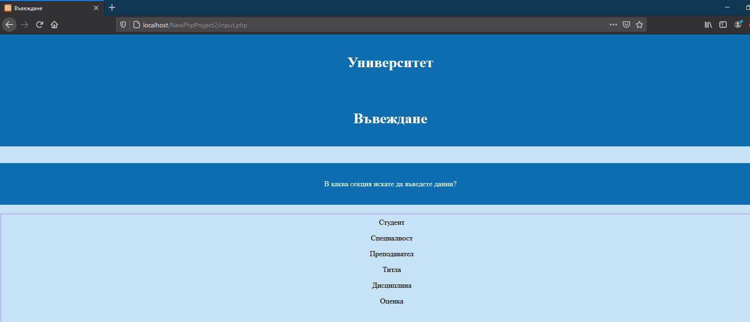

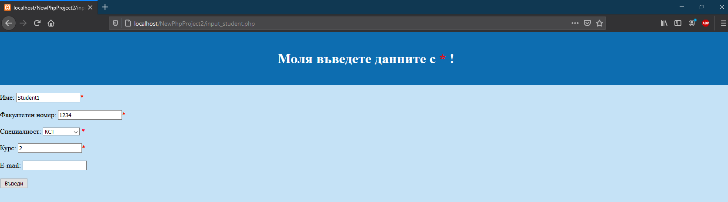

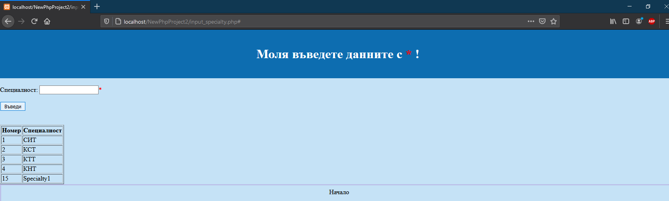



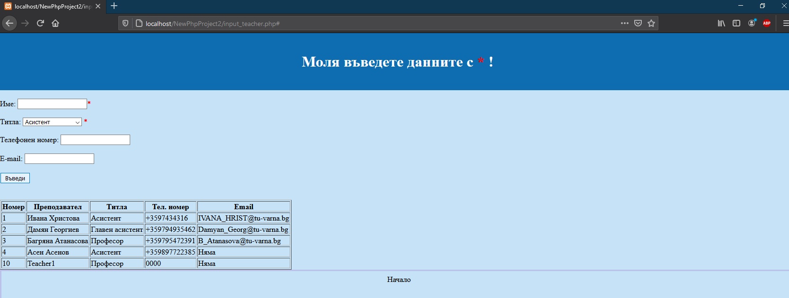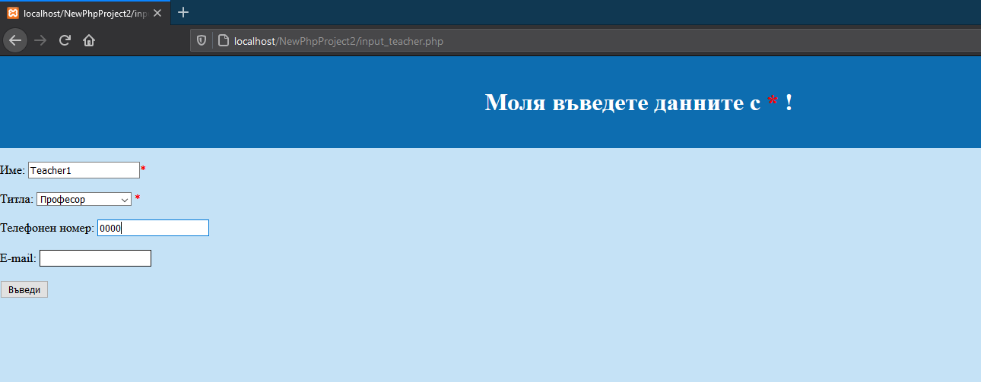

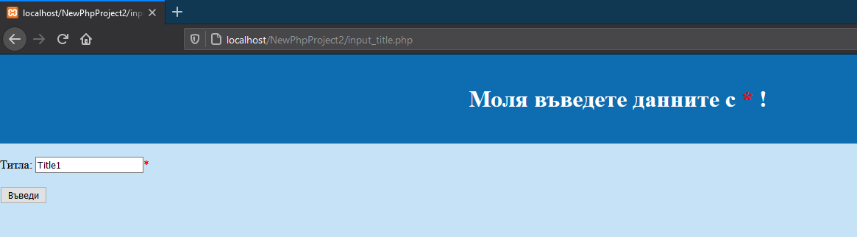

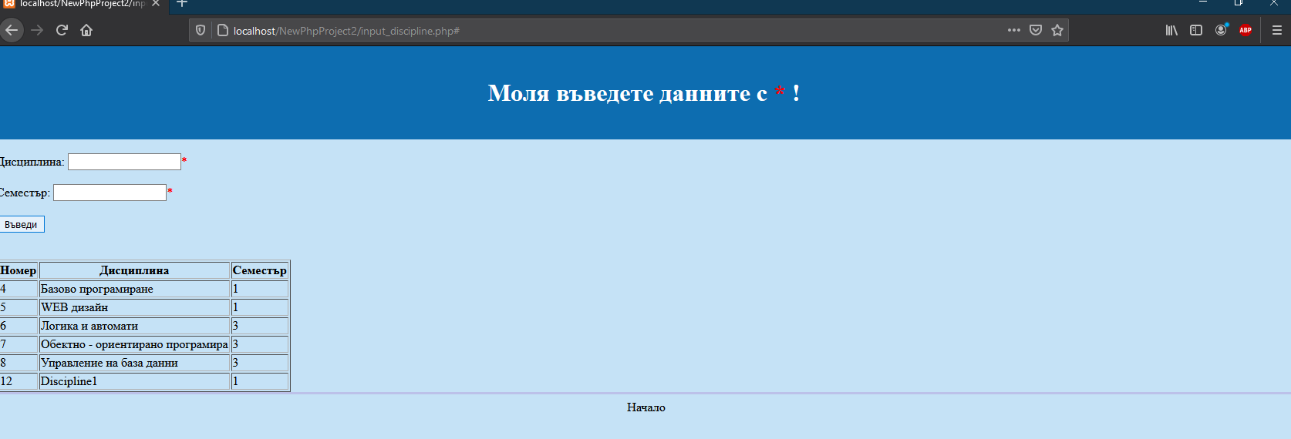Картина, която съдържа текст

Описанието е генерирано автоматичноКартина, която съдържа текст

Описанието е генерирано автоматично

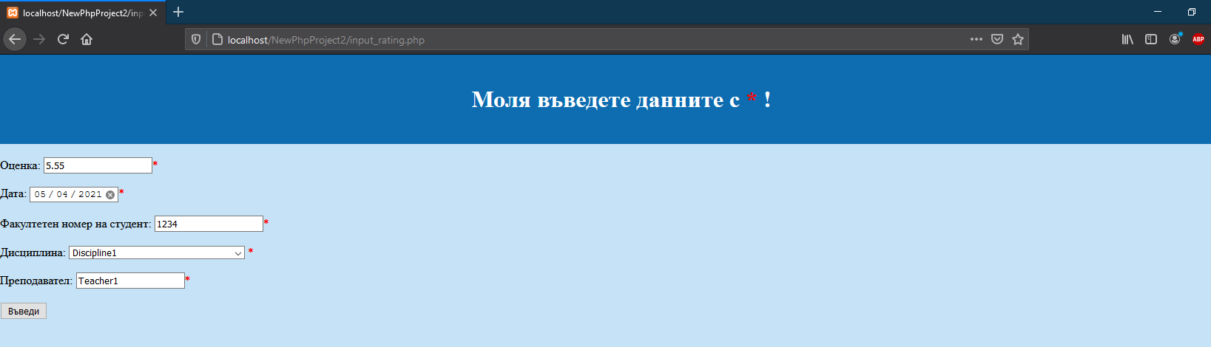

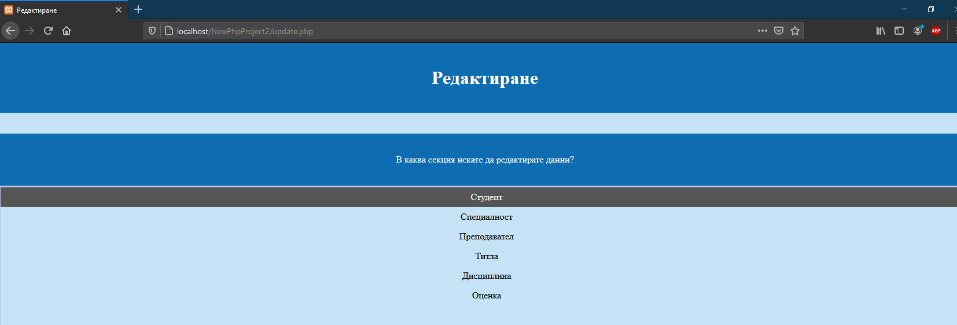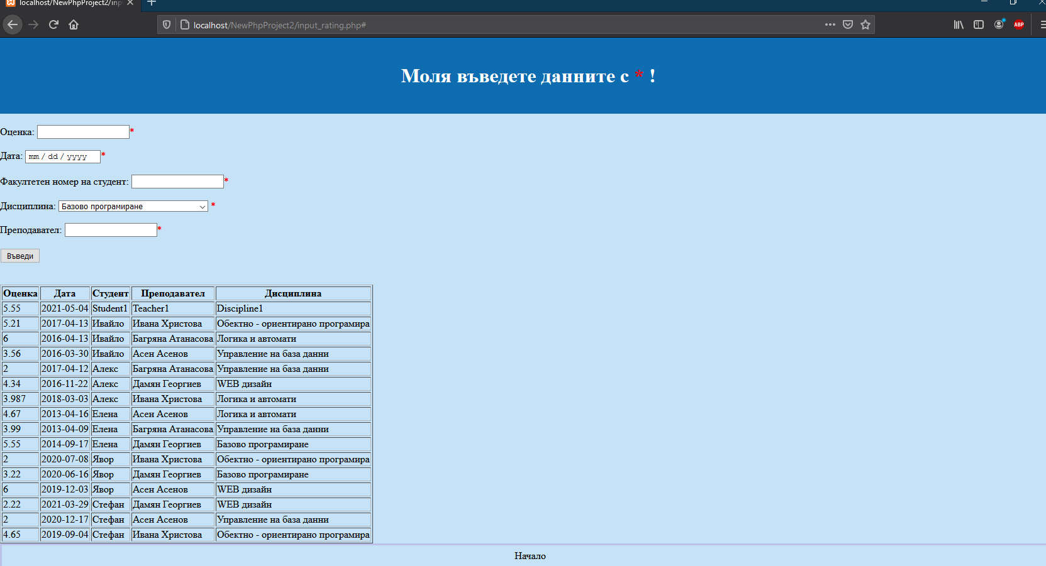

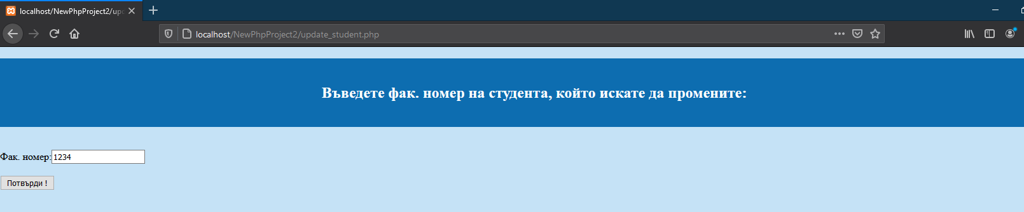

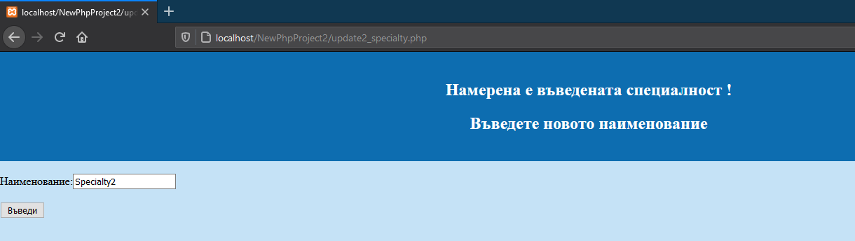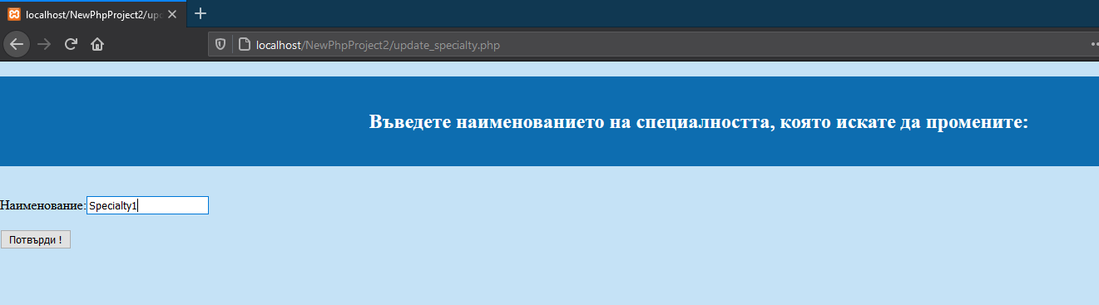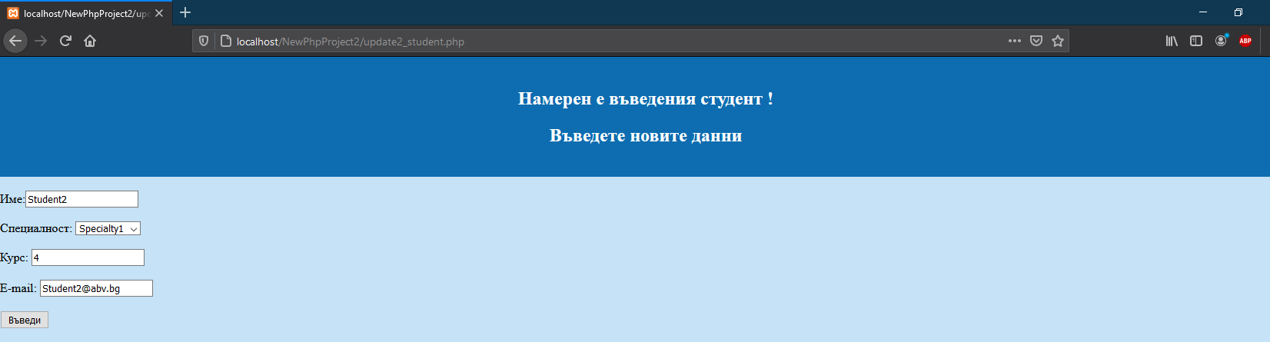

Картина, която съдържа текст

Описанието е генерирано автоматично

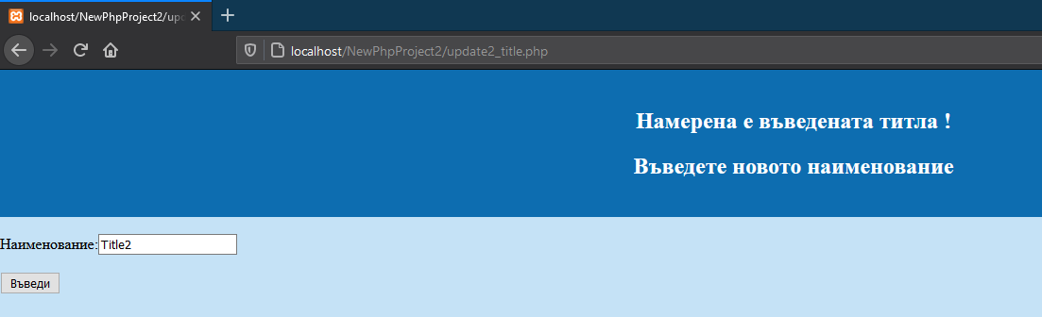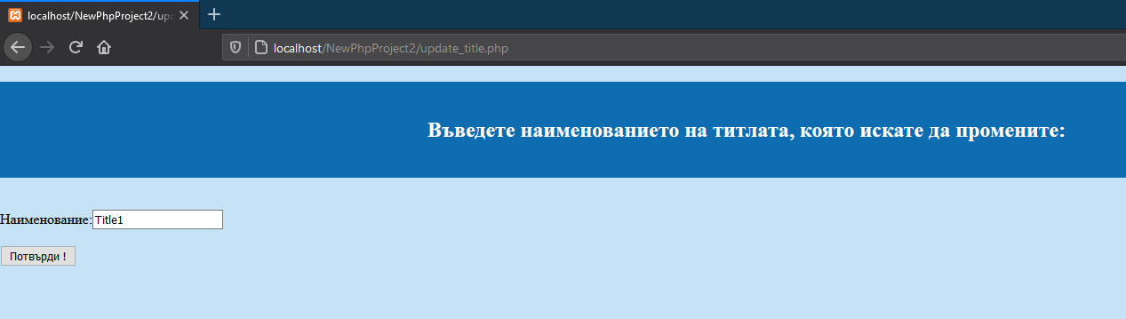Картина, която съдържа текст

Описанието е генерирано автоматично

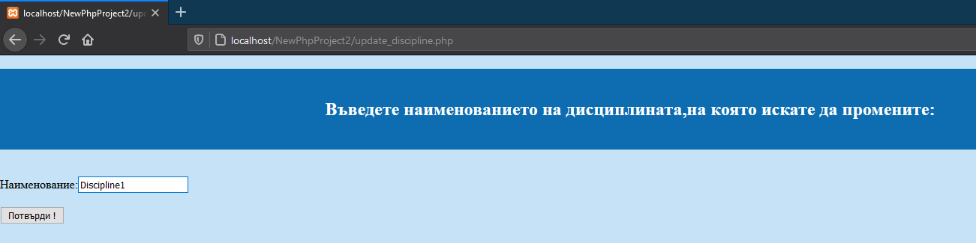

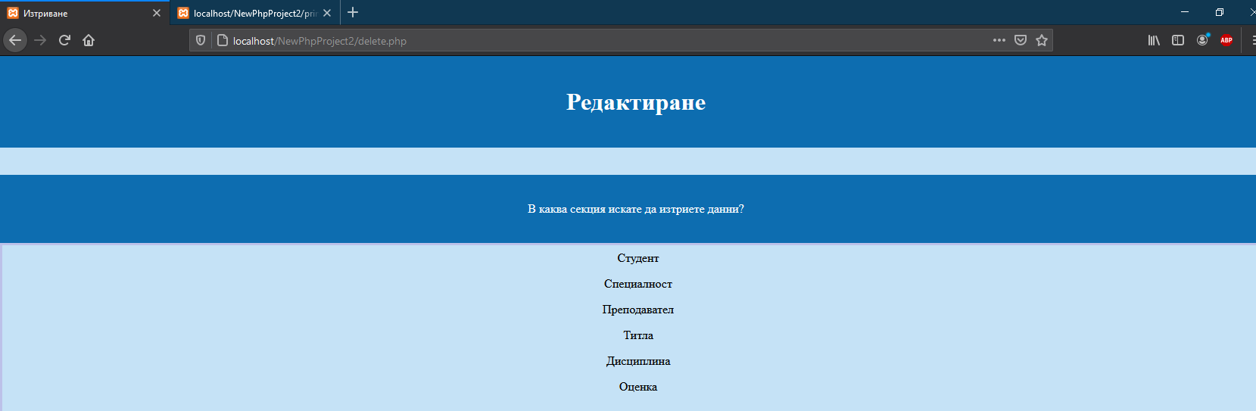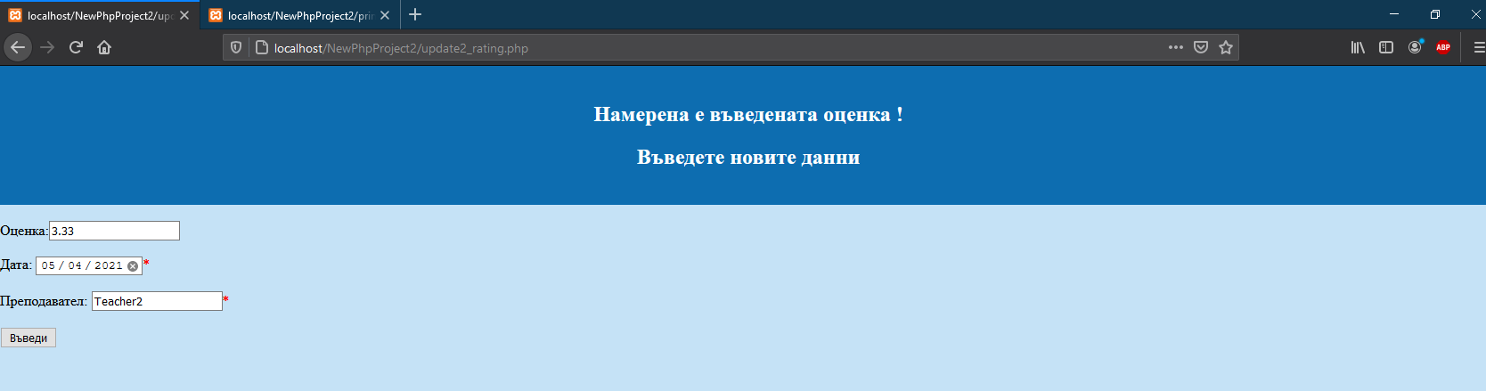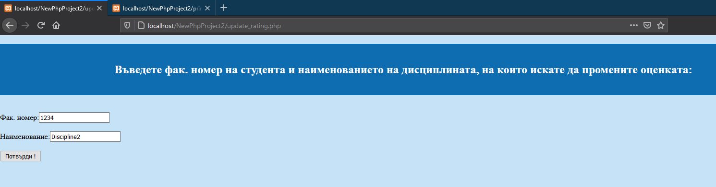Картина, която съдържа текст

Описанието е генерирано автоматично

Картина, която съдържа текст

Описанието е генерирано автоматично

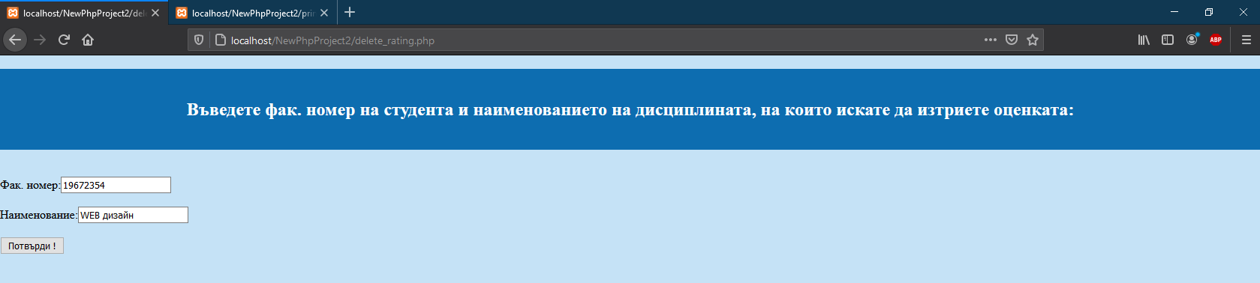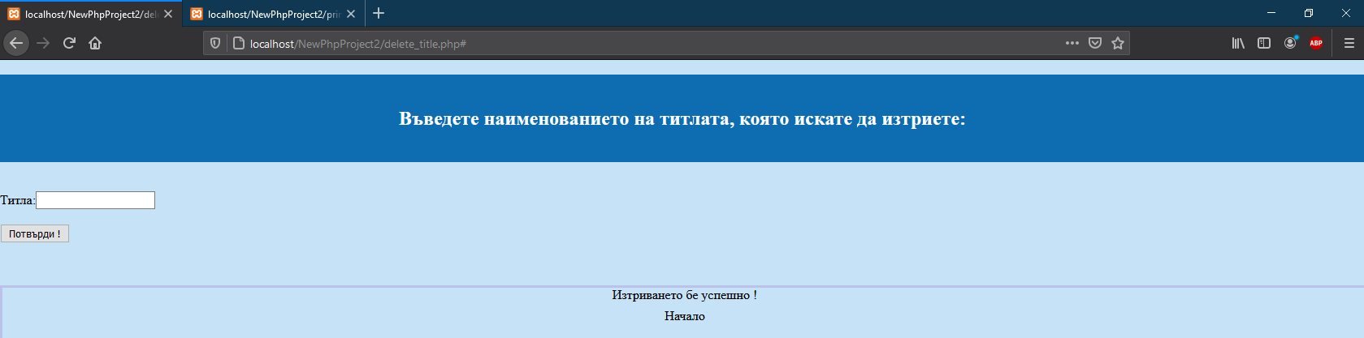

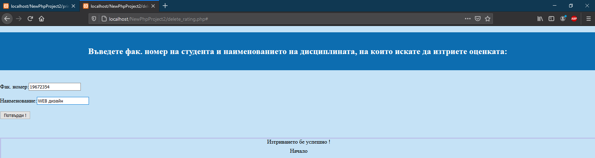

Картина, която съдържа текст

Описанието е генерирано автоматично

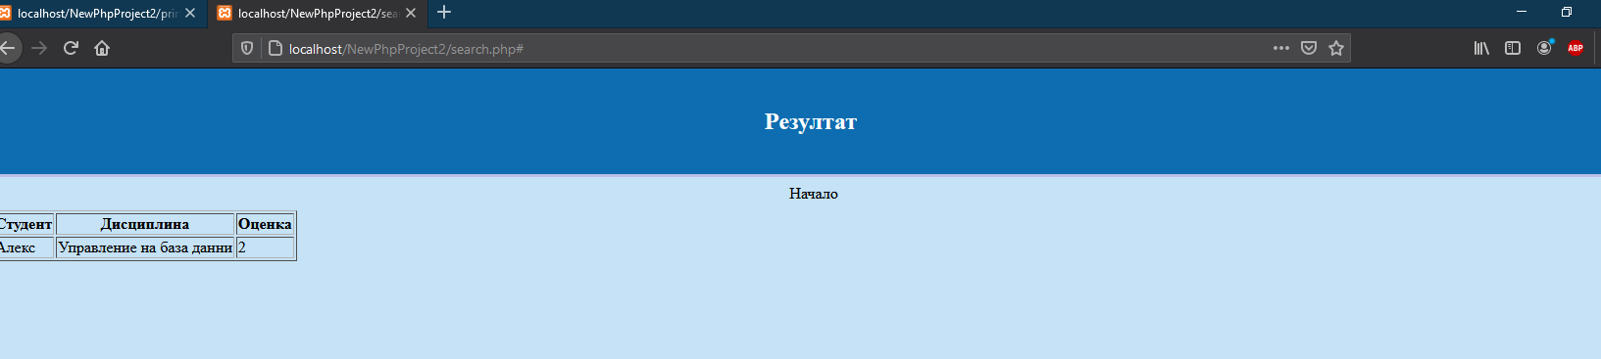

Картина, която съдържа текст

Описанието е генерирано автоматично

Картина, която съдържа текст

Описанието е генерирано автоматично

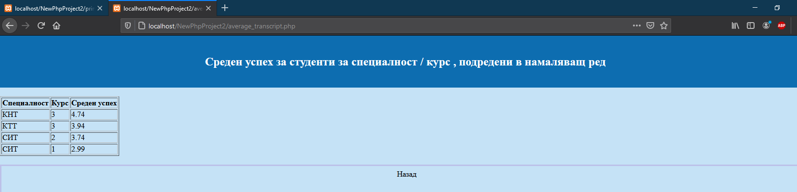

Картина, която съдържа маса

Описанието е генерирано автоматичноКартина, която съдържа текст, екранна снимка, лаптоп

Описанието е генерирано автоматично