plotting DC motor characteristics for different values of w 1
dc= DCmotor();
E=[];
for w=0:250:1000
dc.emf(w);
E=[E,dc.emf(w)];
end
sE=numel(E);
lw=2;
Ua=0:0.01:10;

plotting DC motor characteristics for different values of w
for i=1:1:sE
Ia=(Ua-E(1,i))/dc.Ra;
plot(Ua,Ia,'linewidth',lw)
grid;
xlabel('U [V]');
ylabel('I [A]');
title('DC motor characteristic')
ylim([0 0.8]);
xlim([0 10]);
hold on
end
sp=SolarPanel(1.271, 0.69);
I = sp.current(Ua);
plot(Ua, I, '-k','linewidth',lw)
hold off
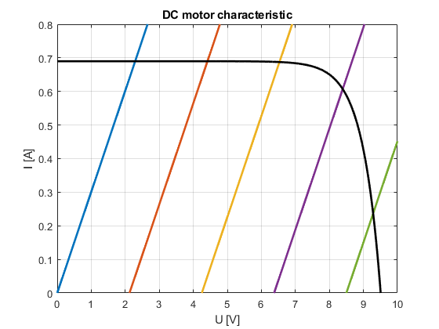
Published with MATLAB® R2017b

