addpath './DCmotor'
addpath './SolarPanel'
addpath './Track'
WorkingPointGUI();
function WorkingPointGUI
% Add the UI components
hs = addcomponents;
plotwp();
% Make figure visible after adding components
hs.fig.Visible = 'on';
function hs = addcomponents
% Add components, save handles in a struct
hs.fig = figure('Visible','off',...
'Tag','fig',...
'SizeChangedFcn',@resizeui);
hs.lblIsc = uicontrol(hs.fig,...
'Style','text',...
'String','Short circuit current [A]');
hs.txtIsc = uicontrol(hs.fig,...
'Style','edit',...
'String','0.69',...
'Callback',@plotwp,...
'Tag','text');
hs.lblVo = uicontrol(hs.fig,...
'Style','text',...
'String','Peak voltage offset [V]');
hs.txtVo = uicontrol(hs.fig,...
'Style','edit',...
'String','-0.1',...
'Callback',@plotwp,...
'Tag','text');
hs.ax = axes('Parent',hs.fig,...
'Units','pixels',...
'Tag','ax');
end
function plotwp(hObject,event)
Isc = str2double(get(hs.txtIsc,'String'));
Vo = str2double(get(hs.txtVo,'String'));
U = 0:0.01:10;
sp = SolarPanel(1.271, Isc);
I = sp.current(U);
UI = [U;I]';
P = sp.current(U).*U;
UP = [U;P]';
[Pp,Np] = max(UP(:,2));
Uwp = UP(Np,1)+Vo;
Pwp = sp.current(Uwp).*Uwp;
Iwp = sp.current(Uwp);
plot(U,I, 'Color', [0 0.25 1]);
hold on
plot(U,P, 'Color', [0.5 0.75 1]);
plot([Uwp,Uwp], [Pwp,Iwp], 'ro');
line([Uwp Uwp], [0 Pp+1], 'Color', [0.5 0.5 0.5]);
M = DCmotor();
Wp = (Uwp - M.Ra.*Iwp)./M.Ke; % Peak angular velocity
Im=(U-M.emf(Wp))./M.Ra;
plot(U,Im, 'Color', [1 0 0.25])
axis([0 10 0 Pp+0.2])
title('Solar panel and motor characteristics')
xlabel('Voltage [V]')
ylabel('Current [A] / Power [W]')
legend('Solar Panel Current','Solar Panel Power',num2str([Pwp,Iwp],'Peak power (%.2f W) and current (%.2f A)'),num2str(Uwp,'Peak voltage (%.2f V)'),num2str(Wp,'Motor current @ %.1f rad/s'),'location','NorthWest');
grid on
hold off
end
function resizeui(hObject,event)
% Get figure width and height
figwidth = hs.fig.Position(3);
figheight = hs.fig.Position(4);
edge = 10;
% Set textbox position
sheight = 20;
sgap = 5;
swidth = (figwidth - 2 * edge - sgap*3)/4;
sbottomedge = edge;
sleftedge = edge;
hs.lblIsc.Position = [sleftedge sbottomedge swidth sheight];
hs.txtIsc.Position = [sleftedge+1*(swidth+sgap) sbottomedge swidth sheight];
hs.lblVo.Position = [sleftedge+2*(swidth+sgap) sbottomedge swidth sheight];
hs.txtVo.Position = [sleftedge+3*(swidth+sgap) sbottomedge swidth sheight];
% Set axes position
axtray = 40;
axheight = figheight - 2 * edge - sheight - 2 * axtray;
axbottomedge = max(0,edge + sheight + edge + axtray);
axleftedge = edge + axtray;
axwidth = max(0,figwidth - 2 * edge - axtray);
hs.ax.Position = [axleftedge axbottomedge axwidth axheight];
end
end
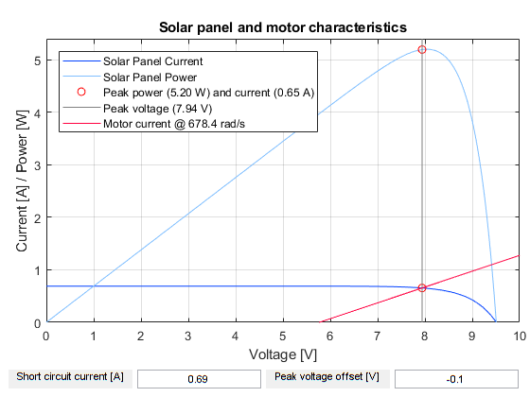
Published with MATLAB® R2017b

