Parse excel data 1
Define constant parameters 1
Calculate m using best fit curve 1
Plot! 1
Error calc 3

Parse excel data
data = xlsread('readings.xlsx');
shortCircuit = isnan(data);
a_Isc = data(shortCircuit,:);
Isc = mean(a_Isc(:,2))
data(shortCircuit,:) = [];
Isc =
0.3600

Define constant parameters
Is=1*10^(-8); %%Reverse saturation current [A]
N=16; %%Amount of solar cells
k=1.38*10^(-23); %%Boltzmann constant [J/K]
q=1.6*10^(-19); %%charge of an electron [As]
T=300; %%Temperature [K]
Ur=(k*T)/q; %%Thermal voltage [V]

Calculate m using best fit curve
fun = @(m)(Isc - Is.*(exp(data(:,1)./(m.*Ur.*N))-1)-data(:,2));
m = lsqnonlin(fun,1)
Local minimum found.
Optimization completed because the size of the gradient is less than
the default value of the optimality tolerance.
m =
1.2710

Plot!
sp = SolarPanel(m,Isc);
f1 = figure('Name','Solar panel characteristics','NumberTitle','off');
subplot(2,1,1)
hold on
axis([0 10 0 floor(Isc*10)/10+0.1])
U = 0:0.1:10;
I = sp.current(U);
plot(U,I)
plot(data(:,1),data(:,2),'x')
title('Current over voltage')
xlabel('Voltage (V)');
ylabel('Current (A)');
hold off;
power = data(:,1).*data(:,2);
subplot(2,1,2)
hold on
axis([0 10 0 3])
U = 0:0.1:10;
I = sp.current(U);
plot(U,I.*U)
title('Power over voltage')
xlabel('Voltage (V)')
ylabel('Power (W)')
plot(data(:,1),power, 'x')
hold off;
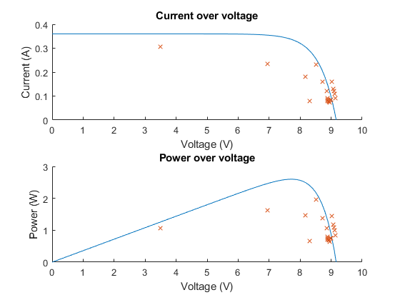

Error calc
[act,err] = error(data(:,1),data(:,2),Isc)
errder = error_derivative(data(:,1),data(:,2),Isc)
varNames = {'Voltage','Current','DiodeFactor','DiodeFactorError_MinMax','DiodeFactorError_Derivative'};
T = table(data(:,1),data(:,2),act,err,errder,'VariableNames',varNames)
function [actual,err] = error(volt,amp,ampsc)
Is=1*10^(-8); %%Reverse saturation current [A]
N=16; %%Amount of solar cells
k=1.38*10^(-23); %%Boltzmann constant [J/K]
q=1.6*10^(-19); %%charge of an electron [As]
T=300; %%Temperature [K]
Ur=(k*T)/q; %%Thermal voltage [V]
Vmin = volt - (volt.*0.005 + 0.01);
Vmax = volt + (volt.*0.005 + 0.01);
Imin = amp - (amp.*0.015 + 0.0001);
Imax = amp + (amp.*0.015 + 0.0001);
Iscmin = ampsc - (ampsc*0.015 + 0.0001);
Iscmax = ampsc + (ampsc*0.015 + 0.0001);
Mmin = Vmin./(Ur.*N.*log((Iscmin-Imin)./Is+1));
Mmax = Vmax./(Ur.*N.*log((Iscmax-Imax)./Is+1));
actual = (Mmin + Mmax)./2;
err = (Mmax - Mmin)./2;
end
function err = error_derivative(volt,amp,Isc)
syms I m U;
Ur=0.0259; % Thermal voltage [V]
Is=1*10^(-8); % Reverse saturation current [A]
N=16; % Amount of solar cells
eqn = I == Isc - Is*(exp(U/(m*Ur*N))-1);
eqn = solve(eqn,m);
du = diff(eqn,U);
di = diff(eqn,I);
Verr = (volt.*0.005 + 0.01);
Ierr = (amp.*0.015 + 0.0001);
U = volt;
I = amp;
eval(eqn);
err = Verr.*eval(du) + Ierr.*eval(di);
end

