Slope polynomial 1
Track function 1

Slope polynomial
t = 0:0.01:0.8;
y = [-25/16 15/8 0 0];
f = figure('Name','Track height and slope','NumberTitle','off');
subplot(2,3,[1,4])
plot(t,polyval(y,t));
legend('y = (-25/16)t^3+(15/8)t^2');
title('Slope polynomial');
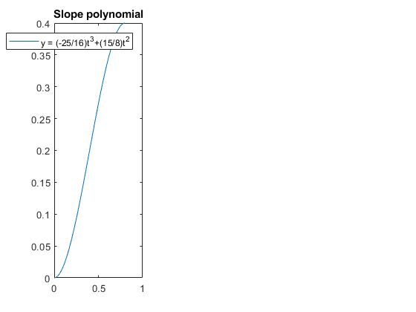

Track function
trackLength = 7;
track = Track(3,2.2, 0.4);
subplot(2,3,[2,3])
fplot(@(x) track.height(x),[0,trackLength]);
ylim([0 0.5]);
pbaspect([7 0.5 1]) %sets aspect ratio of image to same scale on both axes
xlabel('position (m)');
ylabel('height (m)');
title('Track height');
subplot(2,3,[5,6])
fplot(@(x) track.slope(x),[0,trackLength]);
ylim([0 inf]);
xlabel('position (m)');
ylabel('slope (radians)');
title('Track slope');
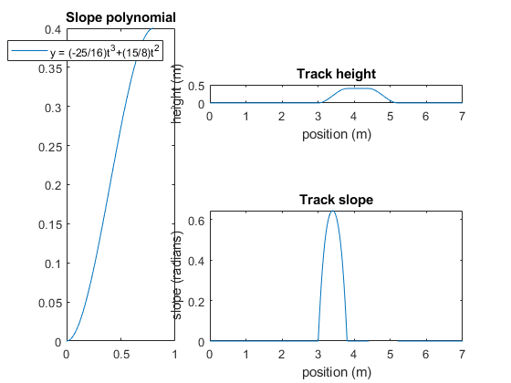
Published with MATLAB® R2017b

