Step1: Create xero account on Xero Developer (visit on "https://developer.xero.com/")
Step2: Add new app and config it: (Remember only need an App, Should only create an app, and choose many xero oranisation to work)
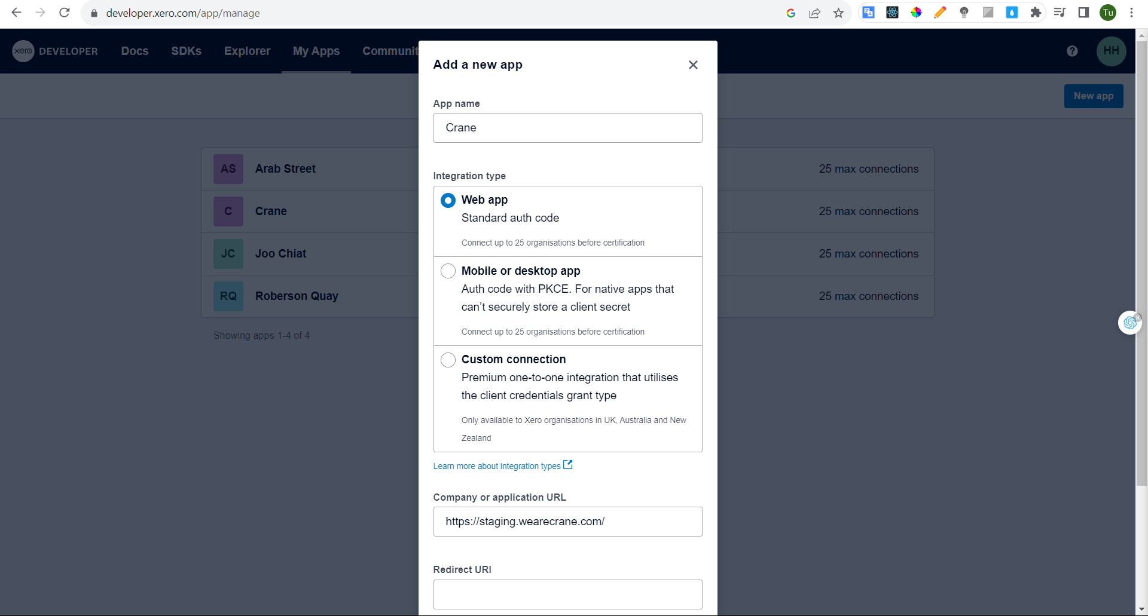
Step3: Go to site admin → Create new xero
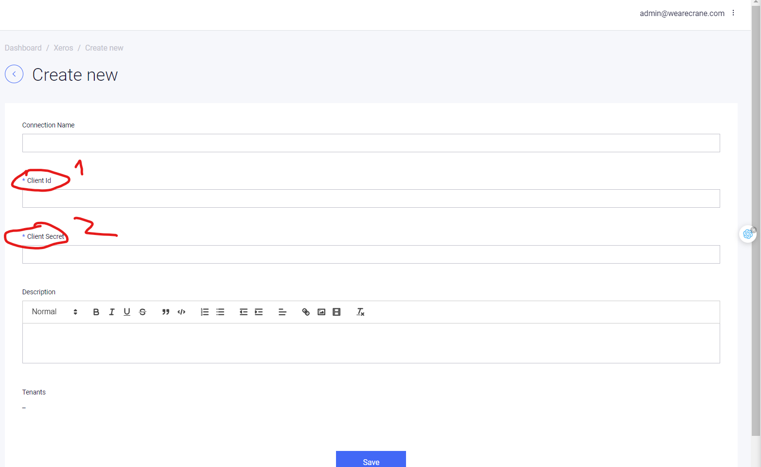
Add client_id , and client_secret (The same from staging config)
After goto .env local file update real value for it.
With real value get in here:
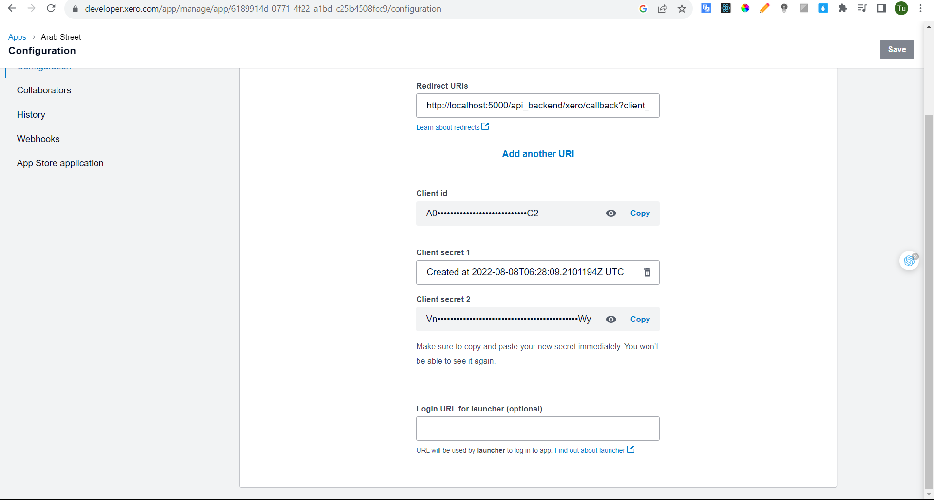
→ Click save
Step4: Click connect

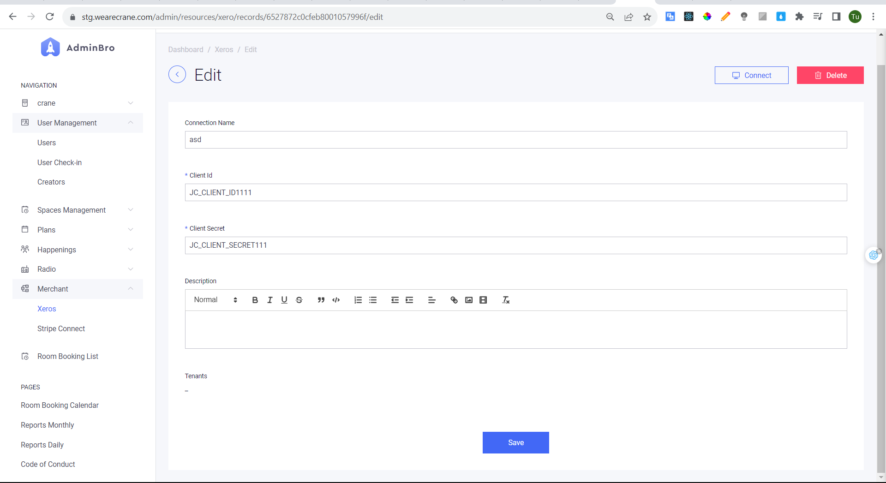
Step5: In xero login connect, Choose xero organisation to connect
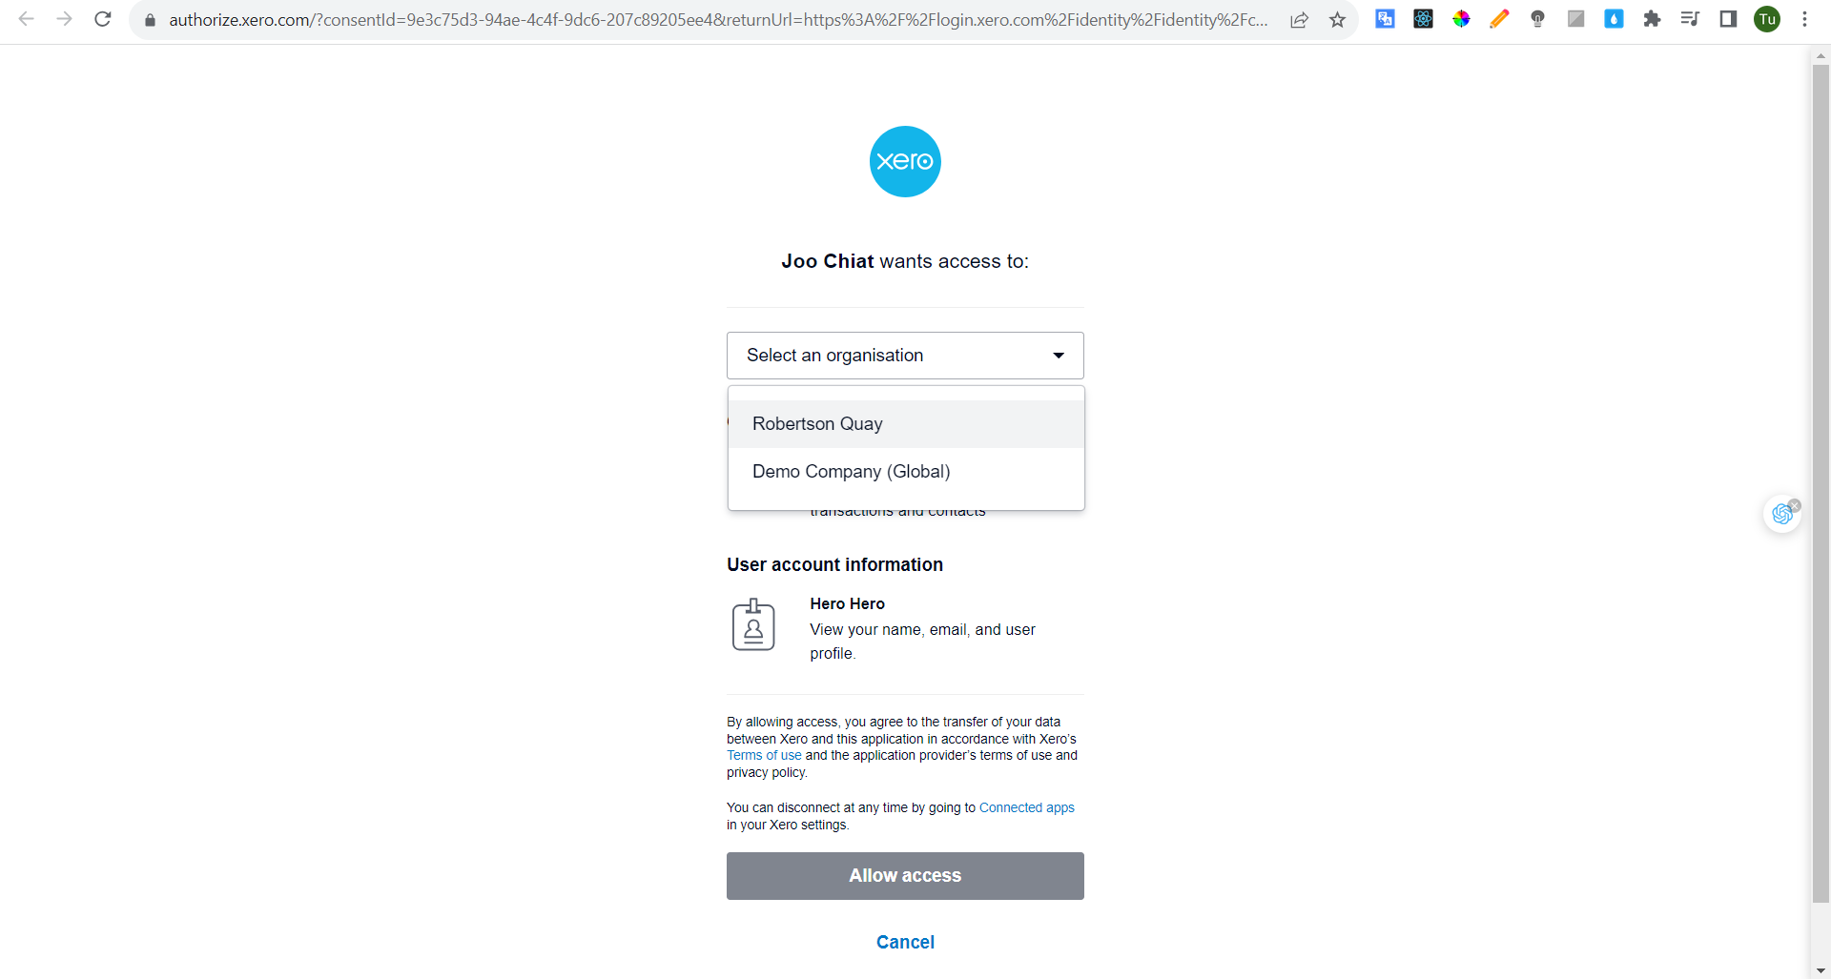
- After connect complete start some config:
+ Choose location for this xero
Step 6: Go to xero.com and start config (visit on https://go.xero.com/app/!G0DWd/dashboard)
- Step 6.1: Config bank account

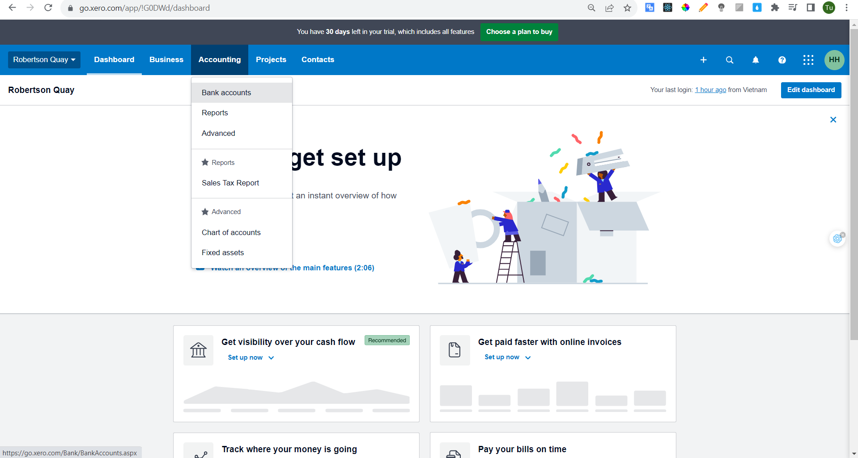
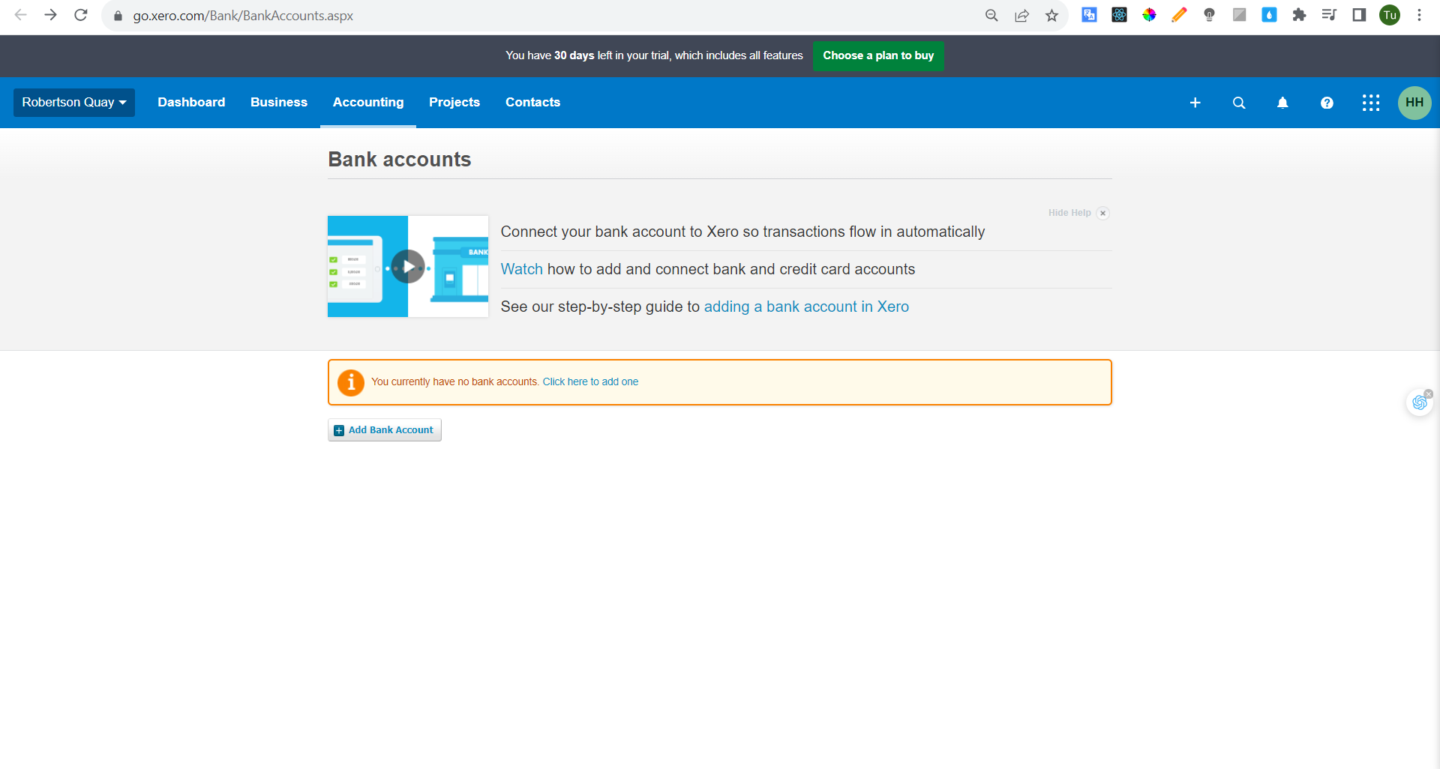
- Search HSBC bank

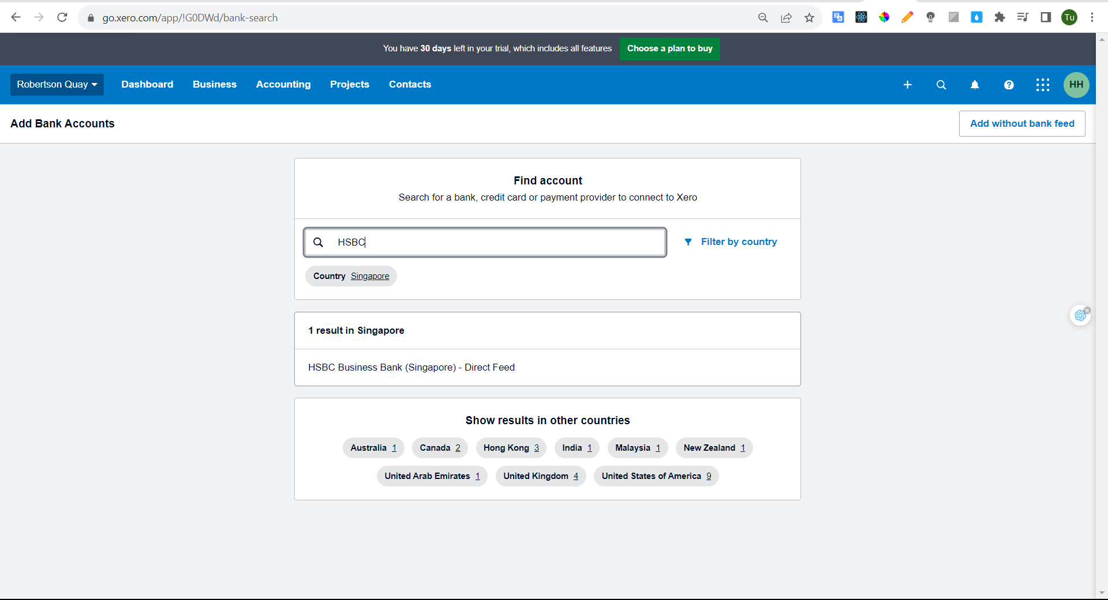
- Start create bank-account (Remember all config contry must is singapore)
- Step 6.2: Copy bank account id and go to admin-site and paste to bank account id field

Step 7: Crearte Stripe Contact Id:
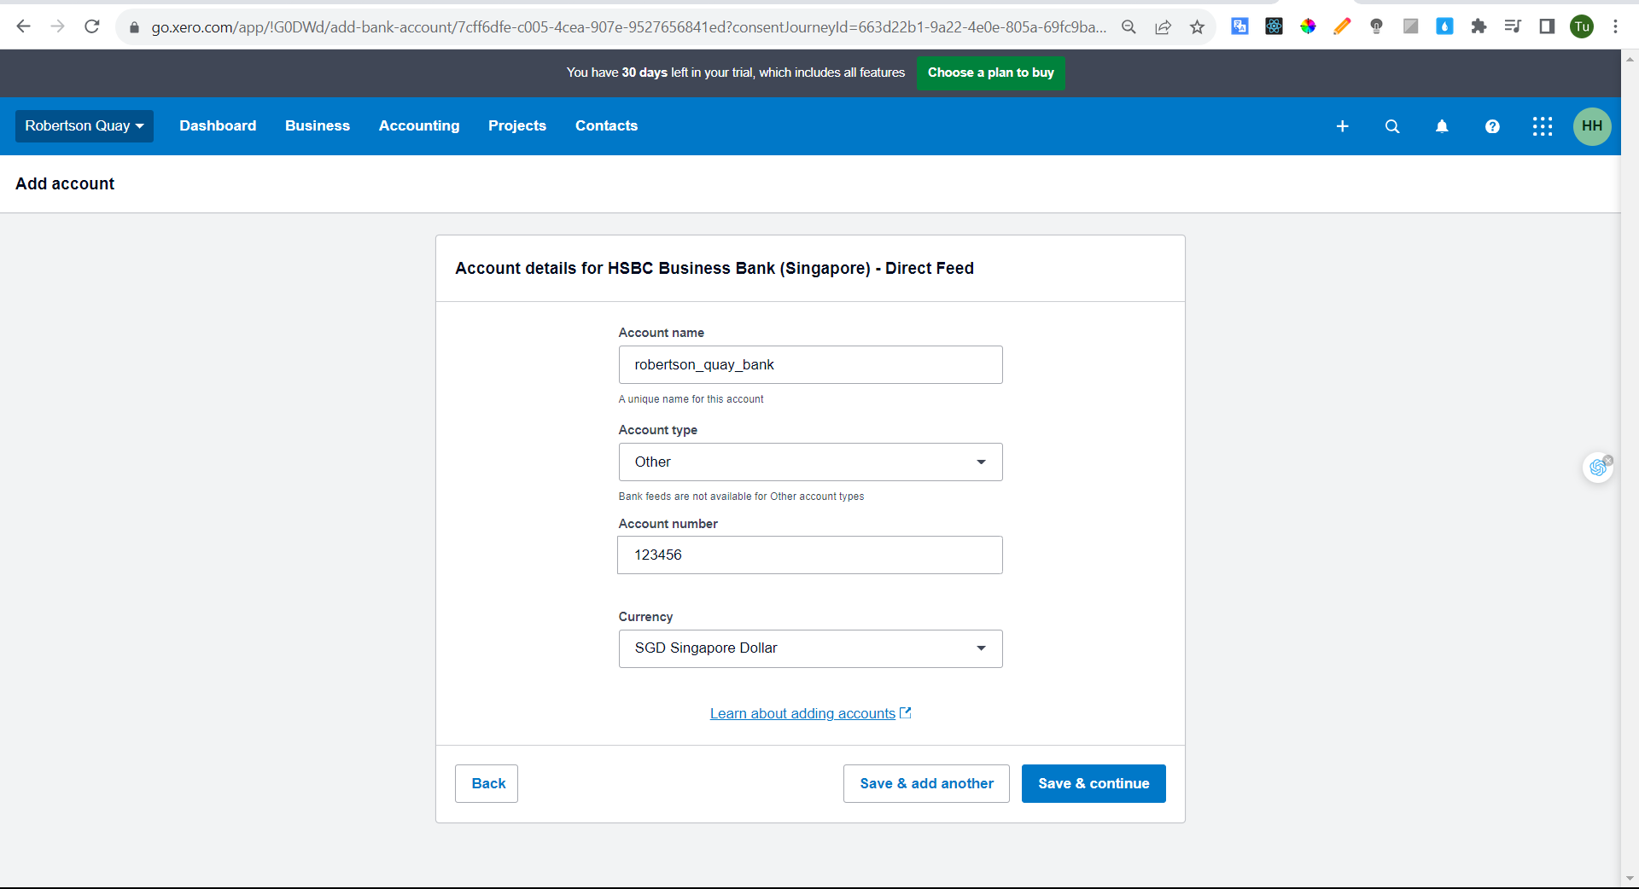
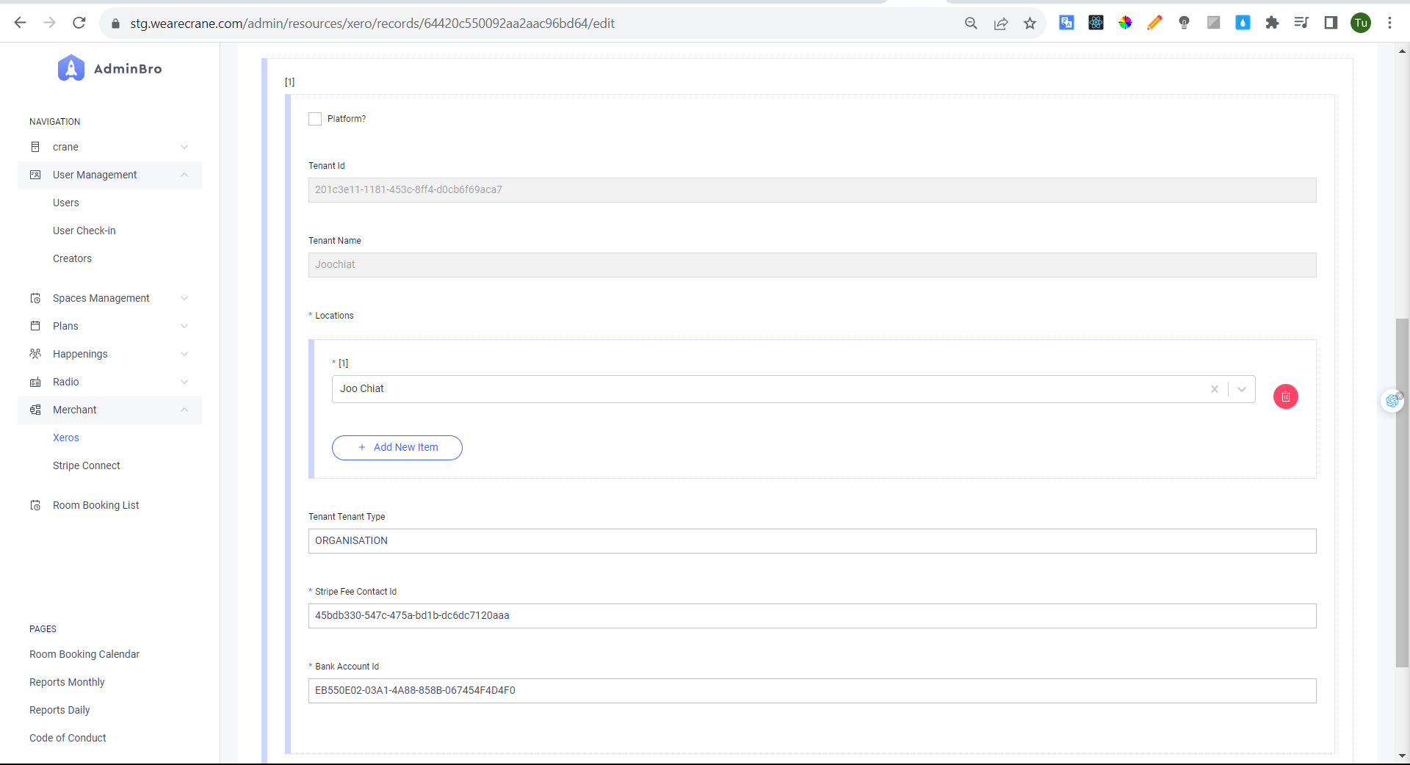
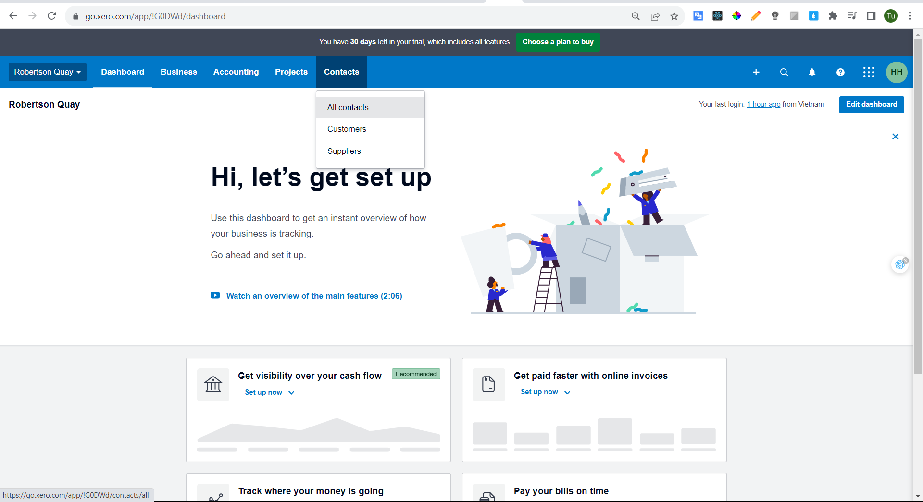
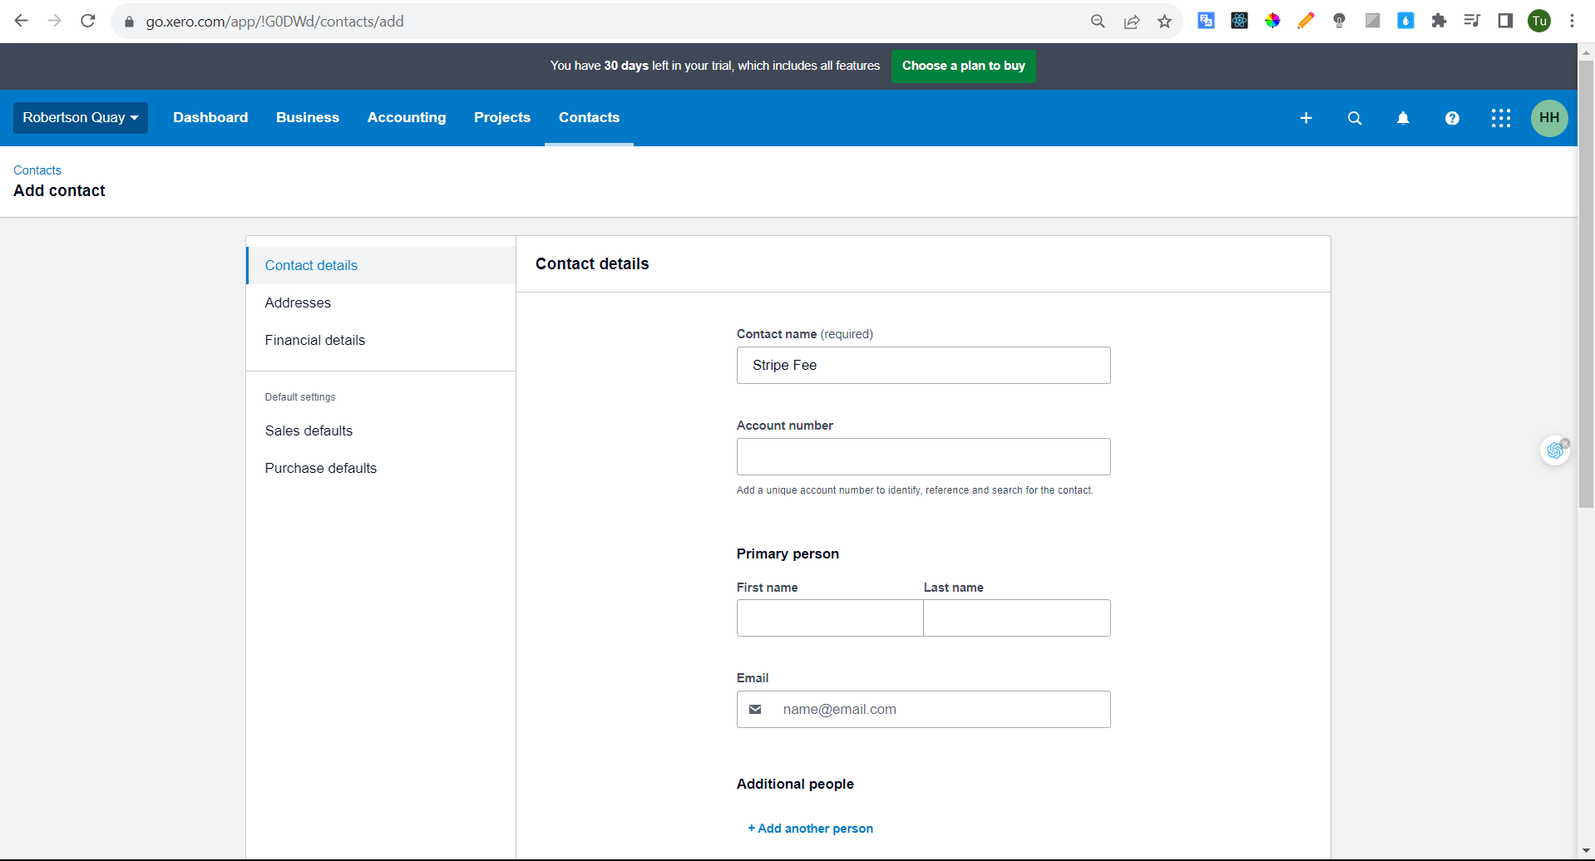
- Step 7-1: Copy stripe fee id and pass to xero stripe admin config

- Step 8: Config chart of account:
See document and update (https://docs.google.com/spreadsheets/d/1F17dD8dnsgCXsuW_ofb6B5PskcICHBXR/edit#gid=70368809)
