IC TRAINING CENTER VIET NAM
FUNDAMENTAL IC DESIGN AND VERIFICATION COURSE


FINAL PROJECT
TIMER IP DESIGN SPECIFICATION

Student: TU DO NHAT HAO
Class: IC32
Instructor: VU NGOC TUYEN

Contents
LIST OF TABLES 3
LIST OF FIGURES 3
1.Overview 4
1.1. Introduction 4
1.2. Main features 4
1.3. Block diagram 5
1.4. Interface signals 5
2.Register Specification 6
2.1. Register Summary 6
2.2. Timer Control Register (TCR) 6
3. Functional Description 11
3.1. APB slave 11
3.2. Register 13
3.3. Interrupt 21
3.4. Counter control 23
3.5. Counter 25
4. History 27

LIST OF TABLES
Table 1: Interface signals of timer IP 5
Table 2: Register Summary 6
Table 3. Timer Control Register (TCR) 6
Table 4. Timer Data Register 0 (TDR0) 8
Table 5. Timer Data Register 1 (TDR1) 8
Table 6. Timer Compare Register 0 (TCMP0) 9
Table 7. Timer Compare Register 1 (TCMP1) 9
Table 8. Timer Interrupt Enable Register (TIER) 9
Table 9. Timer Interrupt Status Register (TISR) 10
Table 10. Timer Halt Control Status Register (THCSR) 11

LIST OF FIGURES
Figure 1: block diagram of Timer IP 5
Figure 2. APB Slave timing 12
Figure 3. APB slave logic diagram 13
Figure 4. TCR register timing 14
Figure 5. TCR register logic diagram 14
Figure 6. TCMP0 register and TCMP1 register timing 15
Figure 7. TCMP0 and TCMP1 register logic diagram 18
Figure 8. TDR0 and TDR1 register timing 18
Figure 9. TDR0 and TDR1 register block diagram 19
Figure 10. TIER, TISR and THCSR registers timing 20
Figure 11. TIER, TISR and THCSR registers block diagram 21
Figure 12. Other control signals timing 22
Figure 13. Other control signals block diagram 22
Figure 14. error signal timing 23
Figure 15. error signal block diagram 23
Figure 16. read transfer timing 24
Figure 17. read transfer block diagram 24
Figure 18. Interrupt timing 25
Figure 19. Interrupt block diagram 26
Figure 20. Counter control timing 27
Figure 21. Counter control block diagram 28
Figure 22. Counter timing 29
Figure 23. Counter block diagram 29

1.Overview

1.1. Introduction
- Timer is an essential module for every chip.
- This is used to generate accurate timing interval or controlling the timing of various operations within the circuit.
- Timer can be used in various application: pulse generation, delay generation, event generation, PWM generation, interrupt generation,…
- In this project, a timer module is customized from CLINT module of industrial RISC-V architecture. It is used to generate interrupt based on user settings.
- The spec of CLINT can be referred at:
17. Core Local Interrupt (CLINT) — Chromite M SoC Manual 0.11.0 documentation

1.2. Main features
The timer has following features:
- 64-bit count up
- 12-bit address
- Register set is configured via APB bus (IP is APB slave)
- Support wait state (1 cycle) and error handling
- Support byte access
- Support halt (stop) in debug mode
- Timer uses active low async reset
- Counter can be counted based on system clock or divided up to 256
- Support timer interrupt (can be enabled or disabled)

1.3. Block diagram
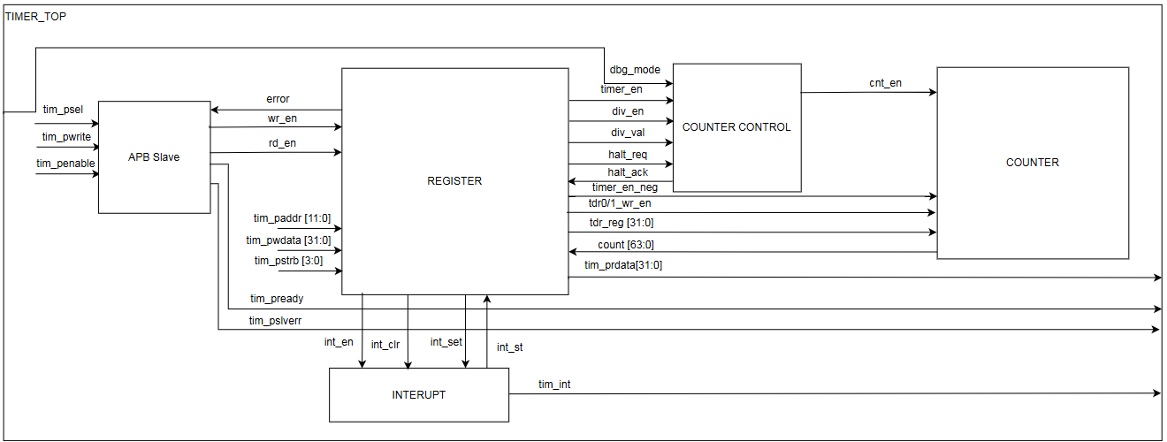
Figure 1: block diagram of Timer IP
- APB slave: Create the write enable, read enable, error response signal.
- Register: Responsible for write data to registers and read back data from them, transfer control signal to other block.
- Interrupt: Can be temporarily halt the counter.
- Counter control: Used to change counting mode and debug mode.
- Counter: Used to count.

1.4. Interface signals
Table 1: Interface signals of timer IP
Signal name | Width | Direction | Description
sys_clk | 1
sys_rst_n | 1
tim_psel | 1
tim_pwrite | 1
tim_penable | 1
tim_paddr | 12
tim_pwdata | 32
tim_prdata | 32
tim_pstrb | 4
tim_pready | 1
tim_pslverr | 1
tim_int | 1
dbg_mode | 1 |  | For simple, testbench should not change dbg_mode after timer_en is HIGH

2.Register Specification

2.1. Register Summary
Table 2: Register Summary
Offset | Abbreviation | Register name
0x00 | TCR | Timer Control Register
0x04 | TDR0 | Timer Data Register 0
0x08 | TDR1 | Timer Data Register 1
0x0C | TCMP0 | Timer Compare Register 0
0x10 | TCMP1 | Timer Compare Register 1
0x14 | TIER | Timer Interrupt Enable Register
0x18 | TISR | Timer Interrupt Status Register
0x1C | THCSR | Timer Halt Control Status Register
Others | Reserved

2.2. Timer Control Register (TCR)
Offset address: 0x0
Reset value: 0x0000_0000
31 | 30 | 29 | 28 | 27 | 26 | 25 | 24 | 23 | 22 | 21 | 20 | 19 | 18 | 17 | 16
Reserved

15 | 14 | 13 | 12 | 11 | 10 | 9 | 8 | 7 | 6 | 5 | 4 | 3 | 2 | 1 | 0
Reserved |  |  |  | DIV_VAL[3:0] |  |  |  | Reserved |  |  |  |  |  | DIV_  EN | TIM_  EN
 |  |  |  | rw |  |  |  |  |  |  |  |  |  | rw | rw

Table 3. Timer Control Register (TCR)
Bit | Name | Type | Default value | Description
31:12 | Reserved | - | 20’h0 | Reserved
11:8 | DIV_VAL[3:0] | RW | 4’b0001 | Counter control mode setting:  - 4’b0000: Counting speed is not divided  - 4’b0001: Counting speed is divided by 2 (default)  - 4’b0010: Counting speed is divided by 4  - 4’b0011: Counting speed is divided by 8  - 4’b0100: Counting speed is divided by 16  - 4’b0101: Counting speed is divided by 32  - 4’b0110: Counting speed is divided by 64  - 4’b0111: Counting speed is divided by 128  - 4’b1000: Counting speed is divided by 256  - Others: reserved,  When setting the prohibit value, div_val is NOT changed.  Note: user must not change div_val while timer_en is HIGH. Access is “error response” in this case.  Access is “error response” when setting prohibit value to div_val.
7:2 | Reserved | - | 6’b0 | Reserved
1 | DIV_EN | RW | 1’b0 | Counter control mode enable.  - 0: Disabled. Counter counts with normal speed based on system clock.  - 1: Enabled. The counting speed of counter is controlled based on div_val  Note: user must not change div_val while timer_en is HIGH. Access is “error response” in this case.
0 | TIM_EN | RW | 1’b0 | Timer enable.  - 0: Disabled. Counter does not count.  - 1: Enabled. Counter start counting.  Note: timer_en changes from H->L will initialize TDR0/1 to their initial value.

Offset address: 0x04
Reset value: 0x0000_0000
31 | 30 | 29 | 28 | 27 | 26 | 25 | 24 | 23 | 22 | 21 | 20 | 19 | 18 | 17 | 16
TDR0
rw | rw | rw | rw | rw | rw | rw | rw | rw | rw | rw | rw | rw | rw | rw | rw

15 | 14 | 13 | 12 | 11 |  | 10 | 9 |  | 8 |  | 7 | 6 | 5 | 4 | 3 | 2 | 1 | 0
TDR0
rw | rw | rw | rw | rw | rw |  |  | rw |  | rw | rw | rw | rw | rw | rw | rw | rw | rw

Table 4. Timer Data Register 0 (TDR0)
Bit | Name | Type | Default value | Description
31:0 | TDR0 | RW | 32’h0000_0000 | Lower 32-bit of 64-bit counter.  Value of this register is cleared to initial value when timer_en changes from H->L.

Offset address: 0x08
Reset value: 0x0000_0000
31 | 30 | 29 | 28 | 27 | 26 | 25 | 24 | 23 | 22 | 21 | 20 | 19 | 18 | 17 | 16
TDR1
rw | rw | rw | rw | rw | rw | rw | rw | rw | rw | rw | rw | rw | rw | rw | rw

15 | 14 | 13 | 12 | 11 |  | 10 | 9 |  | 8 |  | 7 | 6 | 5 | 4 | 3 | 2 | 1 | 0
TDR1
rw | rw | rw | rw | rw | rw |  |  | rw |  | rw | rw | rw | rw | rw | rw | rw | rw | rw

Table 5. Timer Data Register 1 (TDR1)
Bit | Name | Type | Default value | Description
31:0 | TDR1 |  |  | Upper 32-bit of 64-bit counter.  Value of this register is cleared to initial value when timer_en changes from H->L.

Offset address: 0x0C
Reset value: 0xFFFF_FFFF
31 | 30 | 29 | 28 | 27 | 26 | 25 | 24 | 23 | 22 | 21 | 20 | 19 | 18 | 17 | 16
TCMP0
rw | rw | rw | rw | rw | rw | rw | rw | rw | rw | rw | rw | rw | rw | rw | rw

15 | 14 | 13 | 12 | 11 |  | 10 | 9 |  | 8 |  | 7 | 6 | 5 | 4 | 3 | 2 | 1 | 0
TCMP0
rw | rw | rw | rw | rw | rw |  |  | rw |  | rw | rw | rw | rw | rw | rw | rw | rw | rw

Table 6. Timer Compare Register 0 (TCMP0)
Bit | Name | Type | Default value | Description
31:0 | TCMP0 | RW | 32’hFFFF_FFFF | Lower 32-bit of 64-bit compare value.  Interrupt pending bit is asserted when counter value is equal to compare value.

Offset address: 0x10
Reset value: 0xFFFF_FFFF
31 | 30 | 29 | 28 | 27 | 26 | 25 | 24 | 23 | 22 | 21 | 20 | 19 | 18 | 17 | 16
TCMP1
rw | rw | rw | rw | rw | rw | rw | rw | rw | rw | rw | rw | rw | rw | rw | rw

15 | 14 | 13 | 12 | 11 |  | 10 | 9 |  | 8 |  | 7 | 6 | 5 | 4 | 3 | 2 | 1 | 0
TCMP1
rw | rw | rw | rw | rw | rw |  |  | rw |  | rw | rw | rw | rw | rw | rw | rw | rw | rw

Table 7. Timer Compare Register 1 (TCMP1)
Bit | Name | Type | Default value | Description
31:0 | TCMP1 | RW | 32’hFFFF_FFFF | Upper 32-bit of 64-bit compare value.  Interrupt pending bit is asserted when counter value is equal to compare value.

Offset address: 0x14
Reset value: 0x0000_0000
31 | 30 | 29 | 28 | 27 | 26 | 25 | 24 | 23 | 22 | 21 | 20 | 19 | 18 | 17 | 16
Reserved

15 | 14 | 13 | 12 | 11 |  | 10 | 9 |  | 8 |  | 7 | 6 | 5 | 4 | 3 | 2 | 1 | 0
Reserved |  |  |  |  |  |  |  |  |  |  |  |  |  |  |  |  |  | INT_  EN
 |  |  |  |  |  |  |  |  |  |  |  |  |  |  |  |  |  | rw

Table 8. Timer Interrupt Enable Register (TIER)
Bit | Name | Type | Default value | Description
31:1 | Reserved | - | 31’b0 | Reserved
0 | INT_EN | RW | 1’b0 | Timer interrupt enable  0: Timer interrupt is disabled  1: Timer interrupt is enabled  When this bit is 0, no timer interrupt is output.  When this bit is 1, timer interrupt pending bit can be output  (interrupt pending bit is set when counter value is equals to  compare value).  Clearing this bit to 0 while interrupt is asserting will mask the  interrupt to 0 but does not affect the interrupt pending bit  (TISR.int_st bit).

Offset address: 0x18
Reset value: 0x0000_0000
31 | 30 | 29 | 28 | 27 | 26 | 25 | 24 | 23 | 22 | 21 | 20 | 19 | 18 | 17 | 16
Reserved

15 | 14 | 13 | 12 | 11 |  | 10 | 9 |  | 8 |  | 7 | 6 | 5 | 4 | 3 | 2 | 1 | 0
Reserved |  |  |  |  |  |  |  |  |  |  |  |  |  |  |  |  |  | INT  _ST
 |  |  |  |  |  |  |  |  |  |  |  |  |  |  |  |  |  | rw1c

Table 9. Timer Interrupt Status Register (TISR)
Bit | Name | Type | Default value | Description
31:1 | Reserved | - | 31’b0 | Reserved
0 | INT_ST | RW1C | 1’b0 | Timer interrupt trigger condition status bit (interrupt pending bit)  0: the interrupt trigger condition does not occur.  1: the interrupt trigger condition occurred.  Write 1 when this bit is 1 to clear it to 0.  Write 0 when this bit is 1 has no effect  Write to this bit when it is 0 has no effect.  Note1: When interrupt trigger condition occurred (counter  reached compare value), counter continues to count normally.  Note2: the clearance condition has highest priority.

Offset address: 0x1C
Reset value: 0x0000_0000
31 | 30 | 29 | 28 | 27 | 26 | 25 | 24 | 23 | 22 | 21 | 20 | 19 | 18 | 17 | 16
Reserved

15 | 14 | 13 | 12 | 11 |  | 10 | 9 |  | 8 |  | 7 | 6 | 5 | 4 | 3 | 2 | 1 | 0
Reserved |  |  |  |  |  |  |  |  |  |  |  |  |  |  |  |  | HALT  _ACK | HALT  _REQ
 |  |  |  |  |  |  |  |  |  |  |  |  |  |  |  |  | ro | rw

Table 10. Timer Halt Control Status Register (THCSR)
Bit | Name | Type | Default value | Description
31:2 | Reserved | - | 31’b0 | Reserved
1 | HALT_ACK | RO | 1’b0 | Timer halt acknowledge  0: timer is NOT halted  1: timer is halted  Timer accepts the halt request only in debug mode, indicates by  debug_mode input signal
0 | HALT_REQ | RW | 1’b0 | Timer halt request  0: no halt req.  1: timer is requested to halt.

3. Functional Description

3.1. APB slave
The timer IP has an APB slave to receive settings from user. This APB slave has below features:
- 12-bit width address
- 32-bit width read/write data
- Support wait state and error response

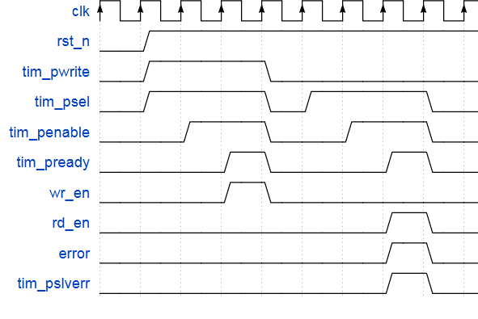
Figure 2. APB Slave timing
- tim_pready is asserted when tim_psel, tim_penable is High and wait 1 cycle. It informs that Slave is ready to receive data from Master.
- wr_en is a pulse and is asserted when psel, penable, pwrite is High. It indicates that there’s a write command. This signal is sent to register module to store data into the registers.
- rd_en is a pulse and is asserted when psel, penable is High and pwrite is Low. It indicates that there’s a read command. This signal is sent to register module to take data from registers.
- pslverr is asserted when pready, error is High. It indicates that Slave responses error to Master.

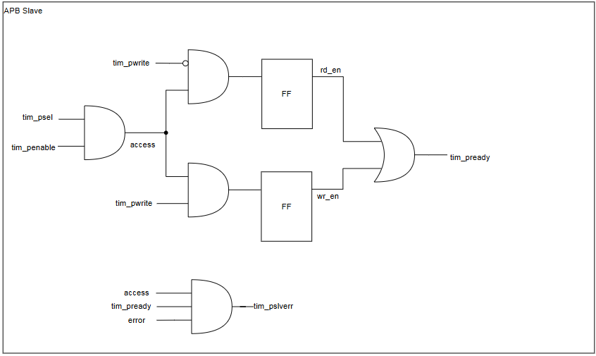
Figure 3. APB slave logic diagram

- When psel, penable is High, access phase occurs and access is High.
- During access phase, the transfer extends 1 cycle and when wait_cnt = 1, pready is High.
- After pready is High, if pwrite = 1, it is write transfer and wr_en is High, else it is read transfer and rd_en is High.

3.2. Register
The timer IP has the register to store, readback data and tranfers control signal to other modules. The register has below features:
- Read/write to reserved area is RAZ/WI (read as zero, write ignored).
- Support byte access and 32-bit transfer.
- Support error handling for some prohibited access.
- When error occurs, data is not written into register bit/fields.

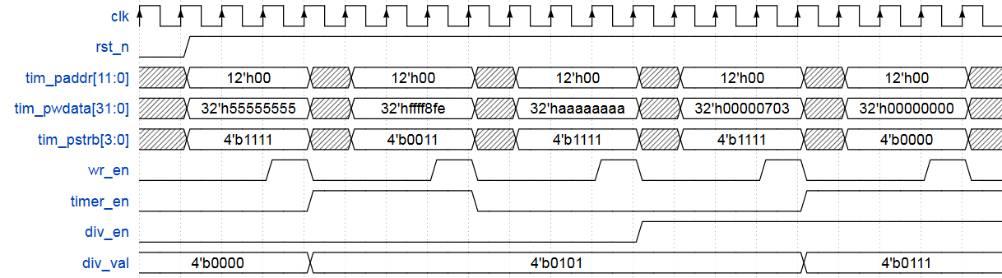
Figure 4. TCR register timing
- timer_en is asserted when write wdata[0] = 1 to address 0x00. It indicates that timer is enable to count.
- div_en is asserted when write wdata[1] = 1 to address 0x00 and timer_en is Low. It indicates that counter is in the control mode.
- div_val has the same value of wdata[11:8] when write it to address 0x00 and timer_en is Low. It is the speed of counter in the control mode.

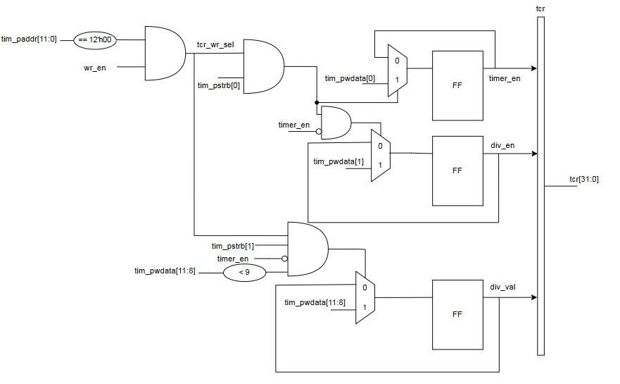
Figure 5. TCR register logic diagram

- When wr_en is High and address is 0x00, tcr_wr_sel = 1.
- tcr_wr_sel and wdata[0] is High, timer_en is High.
- tcr_wr_sel, wdata[1] is High, timer_en is Low, div_en is High.
- tcr_wr_sel, wdata[11:8] is less than 9, timer_en is Low, div_val is same as wdata[11:8].
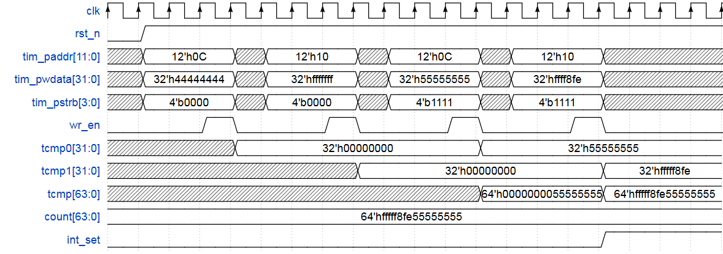
Figure 6. TCMP0 register and TCMP1 register timing
- When wr_en is High, address is 0x0C, tcmp0 is same as wdata.
- When wr_en is High, address is 0x10, tcmp1 is same as wdata.
- tcmp0 is lower 32-bit of tcmp and tcmp1 is upper 32-bit of tcmp.
- Whenever tcmp is same as counter’s value, int_set is High.
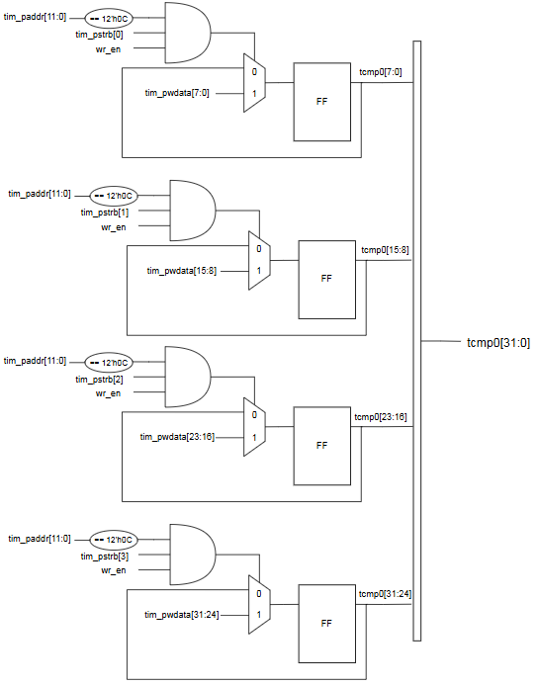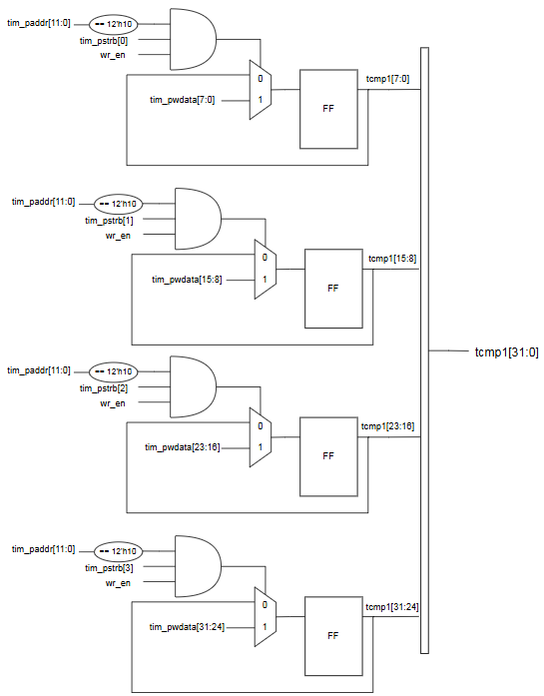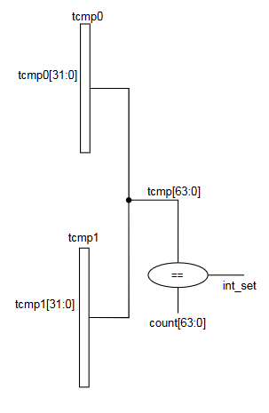
Figure 7. TCMP0 and TCMP1 register logic diagram
- paddr = 0x0C & wr_en = 1, tcmp0 = wdata.
- paddr = 0x0C & wr_en = 1, tcmp0 = wdata.
- tcmp = {tcmp1,tcmp0}.
- tcmp = count, int_set = 1.
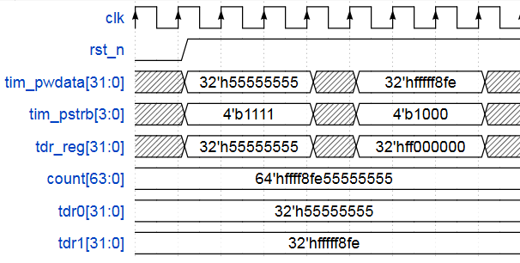
Figure 8. TDR0 and TDR1 register timing
- pstrb indicates which byte lanes to update during the transfer. pstrb[n] correspond to pwdata[8n+7+8n].
- When write wdata[0] = 1 to address 0x14, int_en is High. It indicates that timer interrupt is enable.
- tisr[0] is same as int_st. It indicates that timer pending bit is asserted.
- tdr0 is lower 32-bit of counter’s value and tdr1 is upper 32-bit of counter’s value.
- timer_en_neg is asserted when timer_en is from H -> L. This signal is trasnfered to counter control module to reset the counter’s value to 0.
- tdr0/1_wr_en is asserted when the write transaction to address 0x18 and 0x1C occurs. It indicates that user can set up initial value for the counter.
- int_clr is asserted when write wdata[0] = 1 to address 0x18. It indicates that user can reset counter’s value.

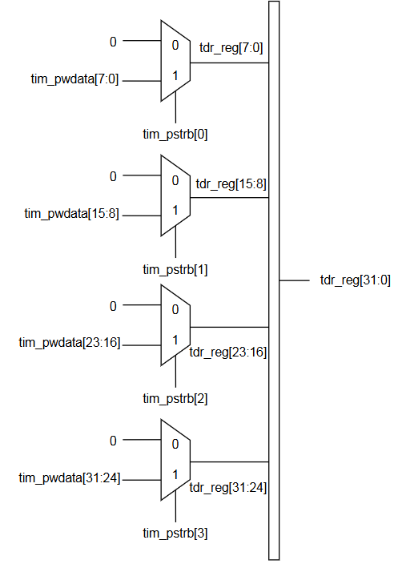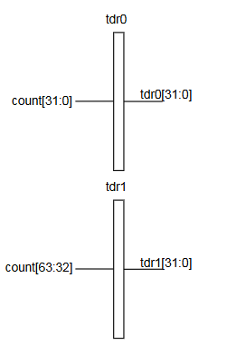
Figure 9. TDR0 and TDR1 register block diagram

- wr_en = 1 & paddr = 0x08, tdr1 is High.
- wr_en = 1 & paddr = 0x04, tdr0 is High.
- pstrb[n] = 1, wdata[8n+7:8n] = tim_pwdata[8n+7:8n].
- wr_en = 1 & paddr = 0x14, int_en = wdata[0].
- timer_en_neg = !timer_en & timer_en_pre.
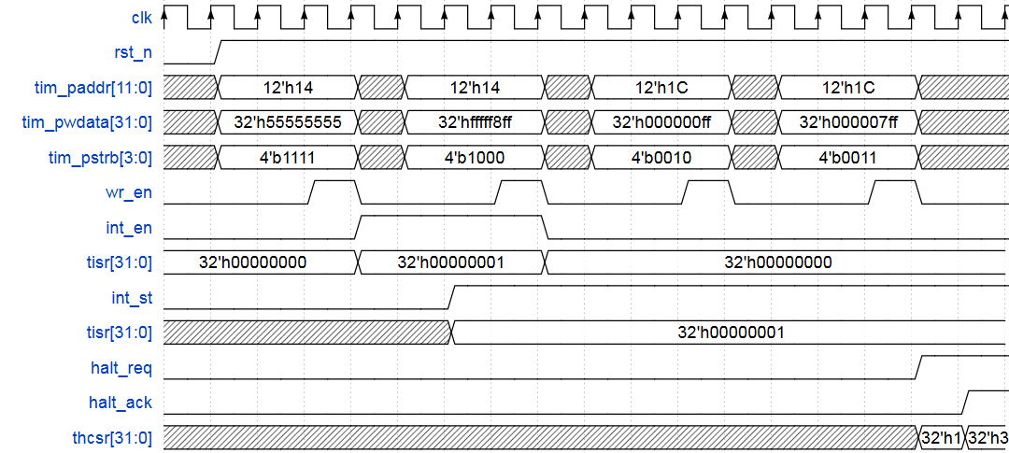
Figure 10. TIER, TISR and THCSR registers timing
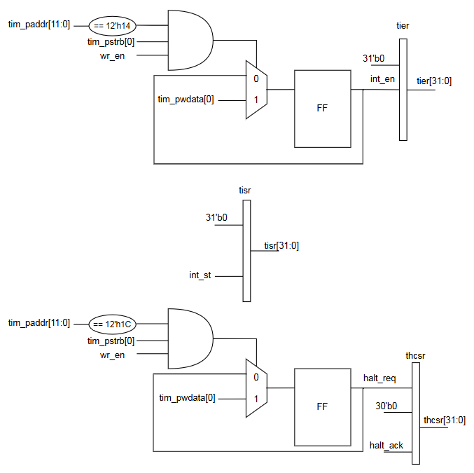
Figure 11. TIER, TISR and THCSR registers block diagram
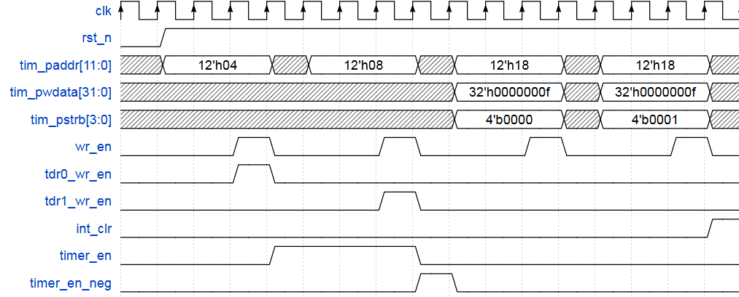
Figure 12. Other control signals timing
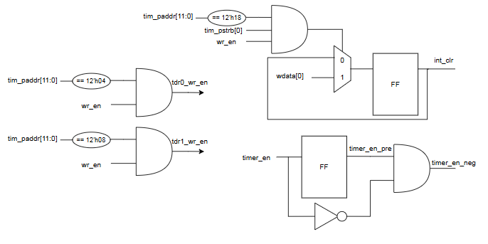
Figure 13. Other control signals block diagram
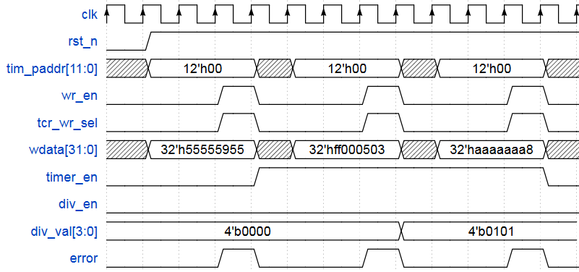
Figure 14. error signal timing
- When write div_val > 4’b1000 to address 0x00, error is High.
- When timer_en is High, changing div_val and div_en is prohibited, error is High.
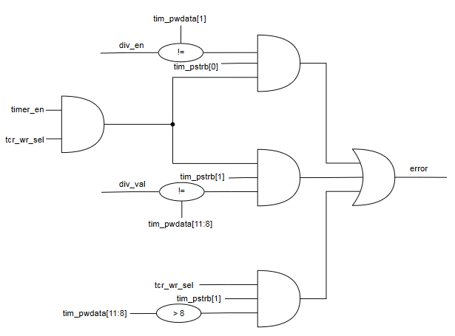
Figure 15. error signal block diagram
- tcr_wr_sel = 1 & wdata[11:8] > 8, error = 1.
- timer_en = 1 & tcr_wr_sel = 1 & div_val != wdata[11:8], error = 1.
- timer_en = 1 & tcr_wr_sel = 1 & div_en != wdata[1], error = 1.
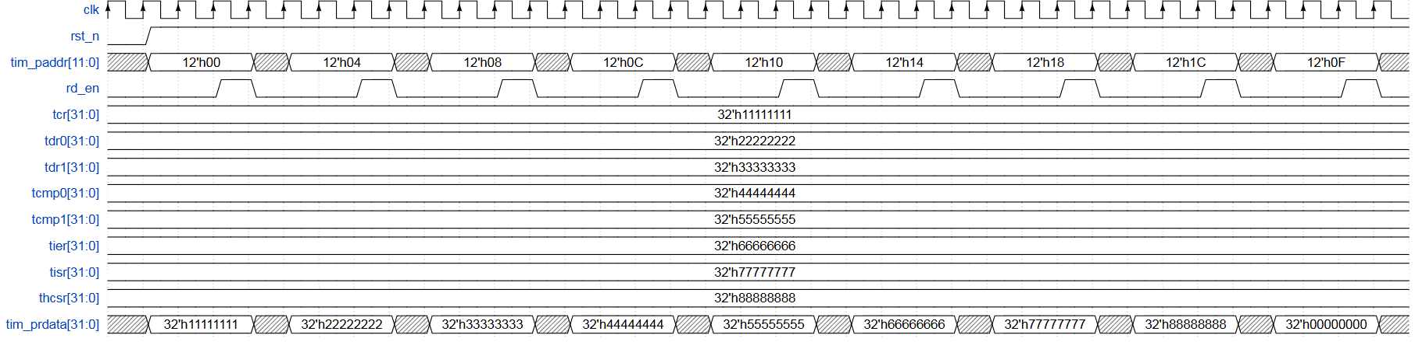
Figure 16. read transfer timing
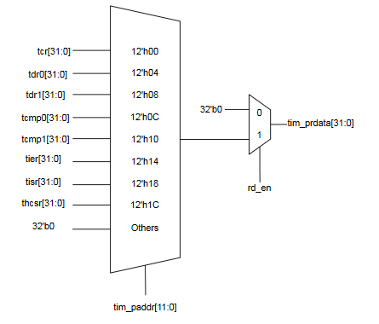
Figure 17. read transfer block diagram

3.3. Interrupt
This timer IP has an interrupt to temporarily halt the counter. The interrupt has some below features:
- Timer interrupt (tim_int) is asserted (set) when interrupt is enabled and counter’s value matches
(equal) the compare value.
- Once asserted, the timer interrupt (tim_int) remains unchange until it is cleared by writing 1 to
TISR.int_st bit or the interrupt is disabled.
- Clearing TIER.int_en to 0 while interrupt is asserting will mask the interrupt to 0 but does not affect the interrupt pending bit (TISR.int_st bit).
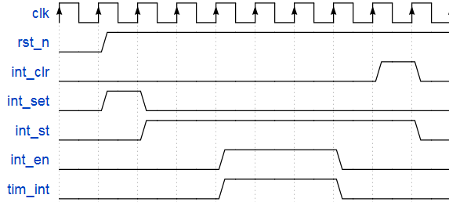
Figure 18. Interrupt timing
- When counter’s value matches compared vale, int_st is High.
- When wrire wdata[0] = 1 to interrupt module, int_st is Low.
- When timer interrupt is enable and timer pending bit is High, tim_int is High.
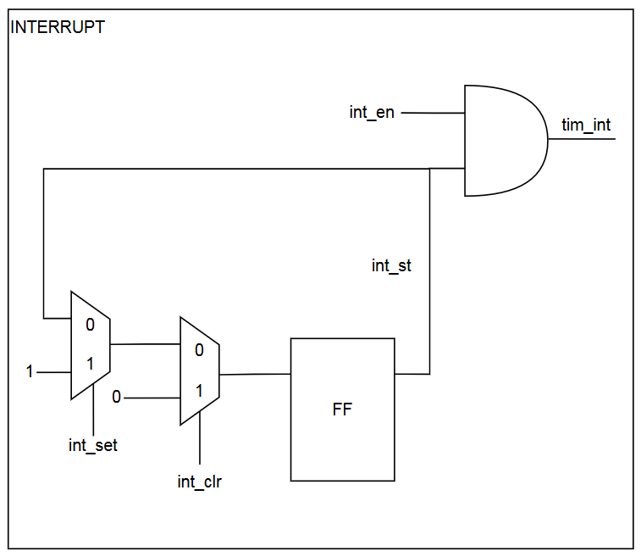
Figure 19. Interrupt block diagram
- int_set = 1, int_st = 1.
- int_clr = 1, int_st = 0.
- int_st = 1, int_en = 1, tim_int = 1.

3.4. Counter control
The timer IP has a counter control to receive control signals from registers module and use them for controlling counter module. The counter control module has below features:
- Generate pulse to halt counter for debug.
- Use div_val to control speed of the counter.
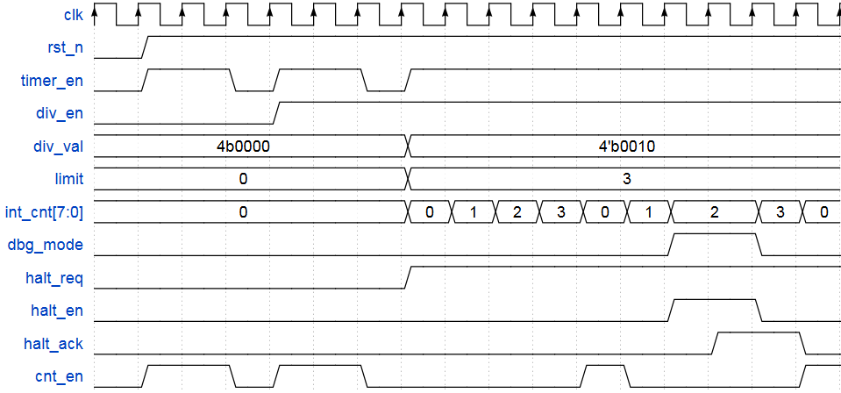
Figure 20. Counter control timing
- halt_en is asserted when dbg_mode, halt_req is High. It indicates that counter is stopped.
- halt_ack is asserted after halt_en is High. It indicates that timer is acknowledge halt request.
- cnt_en is a pulse and it is asserted when halt_en is Low, timer_en is High. It indicates that counter start counting.
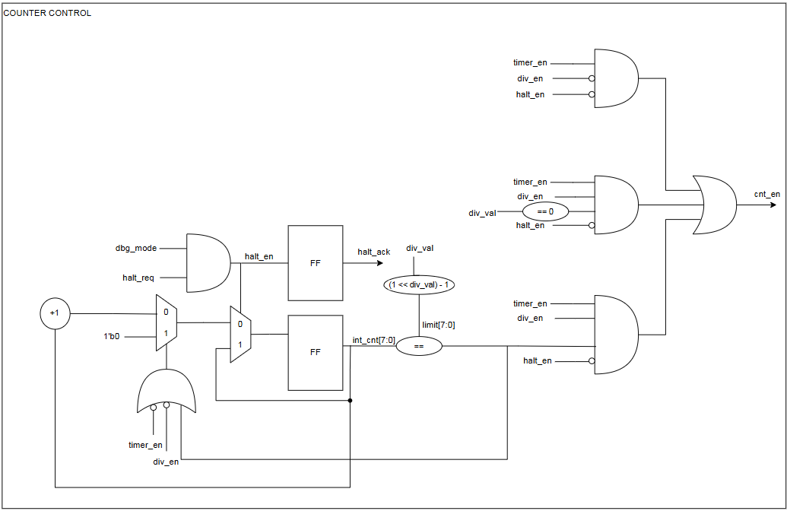
Figure 21. Counter control block diagram
- timer_en = 1, halt_en = 0, div_en = 0, cnt_en = 1.
- timer_en = 1, halt_en = 0, div_en = 1, div_val = 0, cnt_en = 1.
- timer_en = 1, halt_en = 0, div_en = 1, div_val !=0, int_cnt = limit, cnt_en = 1.

3.5. Counter
This timer IP has counter module. This counter module has below features:
- User can set initial value for the counter.
- Counter resets when timer_en changes from H->L.
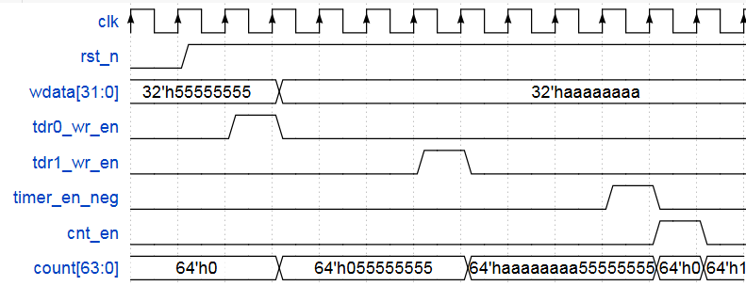
Figure 22. Counter timing
- When tdr0/1_wr_en is High, the set value is tranfered to counter.
- When timer_en_neg is High, counter’ s value is cleared to 0.
- When cnt_en is High, counter’s value add 1.
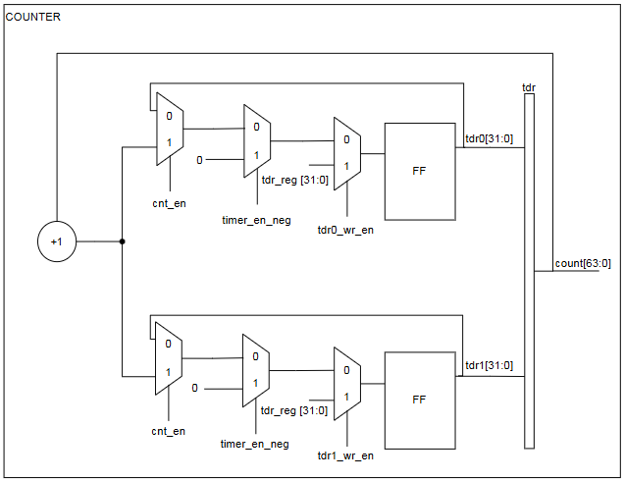
Figure 23. Counter block diagram
- tdr0/1_wr_en = 1, count = wdata.
- timer_en_neg = 1, count = 0.
- cnt_en = 1, count++.

4. History
Date | Version | Description | Author
 | 1.0 | Newly created | <Your name>

