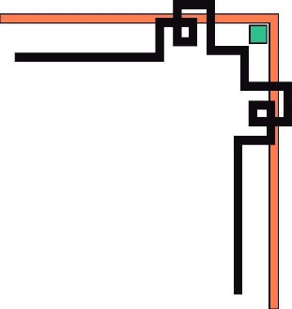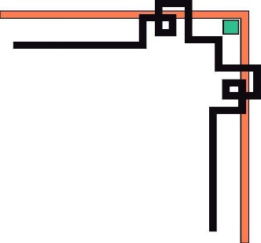

**HO CHI MINH UNIVERSITY OF TECHNOLOGY AND EDUCATION**

**FACULTY FOR HIGH QUALITY TRAINING**

**🕯✡🕮🕮✡🕯**



**SPECIALIZED ESSAY**

**MOVIE’S REVIEW AND TICKET**

**Mentor: D.Sc. Lê Văn Vinh**

**Student Name: Student ID**

**Tôn Nữ Như Quỳnh 17110214**

**Nguyễn Ngọc Tú Duyên 17110116**

**Ho Chi Minh, November 5th 2020**

COMMENTARY OF MENTOR

Ho Chi Minh, November..….. 2020

D.Sc. Lê Văn Vinh

COMMENTARY OF REVIEWER

Ho Chi Minh, December ..….. 2019

D.Sc. Lê Văn Vinh

|  |  |
| --- | --- |
| HCM University of Technology and Education  **FACULTY FOR HIGH QUALITY TRAINING**  ⎯⎯⎯⎯⎯⎯⎯⎯⎯⎯⎯⎯⎯ | **SOCIALIST REPUBLIC OF VIETNAM**  **Independence – Freedom - Happiness**  ⎯⎯⎯⎯⎯⎯⎯⎯⎯ |

**OUTLINE OF SPECIALIZED ESSAY**

Name of student: Tôn Nữ Như Quỳnh Student ID: 17110214

Name of student: Nguyễn Ngọc Tú Duyên Student ID: 17110116

Major: Software Engineer.

Topic name: Analysis, design, contruction of movie’s review and ticket system.

Mentor: D.Sc. Lê Văn Vinh.

**Content:**

*Theory:*

* Research about microservices architechture.
* Research about authentication & authorization in microservices.
* Research technologies for an e-commerce system.

*Practice:* Apply to contruction of restaurant supply chain management system.

**Execution time** from 09/09/2020 to 08/12/2020

Signature of student:

Signature of student:

|  |  |
| --- | --- |
|  | Ho Chi Minh, December 9th 2019 |
| HEAD OF INFORMATION TECHNOLOGY | MENTOR |
| (Name and signature) | (Name and signature) |

ASSURANCE

We assure that this project is our own implementation. We do not copy, use any material or source code of others without specifying the source. We assume responsibility for violations.

*Ho Chi Minh,* December 9th 2020

Tôn Nữ Như Quỳnh Nguyễn Ngọc Tú Duyên

MANY THANKS

In this fact, there are no successes that are not associated with support or assistance, whether more or less, directly or indirectly by others. Now I would like to send this sincere thanks to D.Sc. Lê Văn Vinh, who has supported and transmitted motivation to us in the process of choosing topics, instructions and comments. Although we do not ask much, but when asking the teacher for help, it is the motivation for us to complete the course, without the instructions and practical experiences of the teacher, I think the article This report will be difficult to complete and completed on time. Once again, I would like to thank the teacher.

We would like to send our thanks to our fellow students who provided useful information and knowledge to help us improve our topic. We would also like to thank M.S. Nguyễn Minh Đạo, who directly guided us to complete this project. We will not be able to complete without the guidance of the master. Due to lack of experience in designing and building software that applies this relatively new process, it is possible that during construction process, there are many errors and problems, so please understand.

Due to limited time, with limited knowledge and many other worries, there is an inevitable problem, so I look forward to receiving your valuable suggestions for my knowledge. more complete later. We sincerely thank you.

Ho Chi Minh, December 9th 2019

Tôn Nữ Như Quỳnh Nguyễn Ngọc Tú Duyên

TABLE OF CONTENT

COMMENTARY OF MENTOR 2

COMMENTARY OF REVIEWER 3

ASSURANCE 5

MANY THANKS 6

TABLE OF CONTENT 1

LIST OF TABLES 4

LIST OF FIGURES 6

CHAPTER 1. OBJECTIVE OF PROJECT 9

1.1. Current Status Survey 9

1.2. Current systems 9

1.2.1. IMDb.com 9

1.2.1.1. Introduction 9

1.2.1.2. Browse information about movie 10

1.2.1.3. User Reviews 11

1.2.2. Moveek 12

1.2.2.1. Introduction 12

1.2.2.2. Website functionality 12

1.2.2.3. Function of review 14

1.2.2.4. Book ticket 16

1.2.2.5. Diary 16

1.3. System analysis design 17

1.3.1. Document Management System 17

1.3.2. Actor of system 19

1.3.3. Usecase Diagram 23

1.3.4. Usecase Description 24

1.3.4.1. Functional requirements of “Guest” 24

1.3.4.2. Functional requirements of “Authorized user” 28

1.3.4.3. Functional requirements of “Unauthorized user” 43

1.3.4.4. Functional requirements of “Admin” 54

1.3.4.5. Functional requirements of “Super Admin” 64

1.3.5. Non-functional Requirement 73

1.3.5.1. Usability of website 73

1.3.5.2. Reliability of website 73

1.3.5.3. Availability of website 74

1.3.5.4. Security of website 74

1.3.5.5. Durability of website 74

1.3.5.6. Ability of website 74

1.3.6. Entity Relation Diagram (ERD) 75

CHAPTER 2. SOFTWARE PROCESS 77

CHAPTER 3. DESIGN 79

1. 79

2. 79

1. 79

2. 79

1. 79

2. 79

2. 79

3. 79

3.1. Architechture 79

1. 79

2. 79

2.1. 79

3.2. Component 79

3.3. Class Diagram 80

3.3.1. Class diagram description of “CinemaChain_API” 81

3.3.1.1. Class “Cinema” 84

3.3.1.2. Class “Cinema Chain” 84

3.3.1.3. Class “City” 85

3.3.1.4. Class “MoviesInCinemaChain” 85

3.3.1.5. Class “Order” 85

3.3.1.6. Class “Room” 86

3.3.1.7. Class “RoomType” 86

3.3.1.8. Class “ScreenFormat” 86

3.3.1.9. Class “Seat” 87

3.3.1.10. Class “SeatsInOrder” 87

3.3.1.11. Class “SeatType” 88

3.3.1.12. Class “SeatTypeInChain” 88

3.3.1.13. Class “Showtime” 88

3.3.1.14. Class “CheckoutInfo” 89

3.3.2. Class diagram description of “MovieReviewsAndTickets_API” 89

3.3.2.1. Class “User” 92

3.3.2.2. Class “Account” 92

3.3.2.3. Classs “Cast” 92

3.3.2.4. Class “Cinema” 92

3.3.2.5. Class “CinemaChain” 93

3.3.2.6. Class “Genre” 93

3.3.2.7. Class “Language” 93

3.3.2.8. Class “Movie” 94

3.3.2.9. Class “MovieLike” 95

3.3.2.10. Class “MovieStatus” 95

3.3.2.11. Class “Order” 95

3.3.2.12. Class “Review” 95

3.3.2.13. Class “ReviewLike” 96

3.3.2.14. Class “Role” 96

3.3.2.15. Class “SeatsInOrder” 97

3.4. Sequence Diagram 97

3.4.1. Login 97

3.4.2. Add Movie 98

3.4.3. Write Review/Rate 99

3.4.4. Book Ticket 100

CHAPTER 4. AUTHENTICATION AND AUTHORIZATION 103

3. 103

3. 103

3. 103

3. 103

4. 103

4.1. Overview 103

4.1.1. onolithic architecture 103

4.1.2. Microservices architecture 104

4.1.2.1. JSON Web Token 105

4.1.2.2. Opaque Token 106

4.1.2.3. OAuth 2 107

4.1.2.4. Authentication, authorization at gateway service 108

4.1.2.5. Authentication, authorization at all services 109

4.1.2.6. Access Control 110

4.2. Solutions for project 115

4.2.1. Json web token 115

4.2.2. Authentication and Authorization achitechture 116

4.2.3. Access control 116

CHAPTER 5. SYSTEM DETAILS 117

5.1.1. Overview 117

5.1.2. Design 117

5.1.2.1. Architechture 117

5.1.2.2. Database 118

5.1.2.3. Interface 119

5.1.2.4. Use case diagram 120

5.1.2.5. Sequence diagram 120

5.1.3. Technologies 125

5.2. Mobile Electronic Ecommerce 125

5.3. Electronic Commerce Website 126

5.4. Operation Management System 127

5.5. Store Management System 128

CHAPTER 6. TECHNOLOGIES 129

CONCLUSIONS 130

1. Results 130

2. Advantages 130

3. Disadvantages 130

4. Development strategy 130

REFERENCES 132

# LIST OF FIGURES

Figure 1.2.1.2.1. Machine Ocha POS 8

Figure 1.2.1.2.2. Function Ocha Pos 8

Figure 1.2.1.3.1. Machine Ocha Boss 9

Figure 1.2.1.3.2. Function Ocha Boss 9

Figure 1.2.2.1.1. Machine KiotViet 11

Figure 1.2.2.2.1. Overview website functionality 11

Figure 1.2.2.2.2. Function KiotViet on website 12

Figure 1.2.2.3.1. Sales screen 12

Figure 1.2.2.3.2. Function KiotViet on sales screen 13

Figure 1.2.2.4.1. Function KiotViet on sell app 14

Figure 1.2.2.5.1. Function KiotViet on app management 15

Figure 1.2.3.1.1. Introduction suno 16

Figure 1.2.3.2.1. Function Suno application 17

Figure 2.1. Roadmap of project 25

Figure 3.1.1. Overview of architectural design for system 26

Figure 3.2.1. Overview of component design for system 26

Figure 4.1.1.1. Monolithic vs Microservices 27

Figure 4.1.2.1. Lifecycle of request in microservices 29

Figure 4.1.2.1.1. Json web token structure 30

Figure 4.1.2.4.1. Authentication & Authorization at Gateway API 32

Figure 4.1.2.4.2. Authentication & Authorization at Gateway API diagram 33

Figure 4.1.2.5.1. Authentication & Authorization at all services diagram 34

Figure 4.1.2.6.1. Role-Based Access Control 35

Figure 4.1.2.6.2. Policy-Based Access Control 36

Figure 5.1.2.1.1. Architechture of Document Management System 39

Figure 5.1.2.2.1. Entity relationship diagram for Document Management System 40

Figure 5.1.2.2.2. Database diagram for Document Management System 40

Figure 5.1.2.3.1. Main screen of Document management System 41

Figure 5.1.2.3.2. Login screen for Document Management System 41

Figure 5.1.2.3.3. Edit screen for Document Management System 41

Figure 5.1.2.4.1. Use case diagram for Document Management System 42

Figure 5.1.2.5.1. Sequence diagram for View Post Detail of Document Management System 42

Figure 5.1.2.5.2. Sequence diagram for Login of Document Management System 43

Figure 5.1.2.5.3. Sequence diagram for Create Post of Document Management System 44

Figure 5.2.1. Use case diagram for Mobile Electronic Commerce 45

Figure 5.3.1. Use case diagram for Electronic Commerce Website 46

Figure 5.4.1. Use case diagram for Operation Management System 46

Figure 5.5.1. Use case diagram for Store Management System 47

# 

# CHAPTER 1. OBJECTIVE OF PROJECT

## Current Status Survey

﻿﻿Sometimes you see a movie coming out and find it interesting, but don't know if its content is right for you? Want reviews from people who have seen it? Or you simply want to know what the movie is about before taking the time to watch.

Besides expanding functions such as buying tickets through the website, it will save time buying at theaters and have the opportunity to buy tickets with satisfactory show times and seats…

The idea of a community that shares views on film and art as appropriate to social needs.

## Current systems

### IMDb.com

#### Introduction

Surely anyone, if you've ever visited famous online movie-watching websites in the country such as: phimmoi.net, xemtvhd.com, banhtv.com, vuviphim.com, hdonline.vn, ... then surely you have see IMDb Score. So have you ever wondered how the role of IMDb Score influences movies?

IMDb is an online website that synthesizes a lot of comments and reviews from many different sources. The IMDb acts as a library, where detailed information about famous cinematic works is stored. IMDb gives its exact rating scale for each movie. This scale is used by many online movie websites to evaluate the quality of a movie.

#### Browse information about movie

Overview:

You can quickly search and view trailers, ratings, actors, and storylines. In addition, you can read reviews by reviewers and users. Now, you can decide if you want to watch that movie or search for another movie to watch instead.

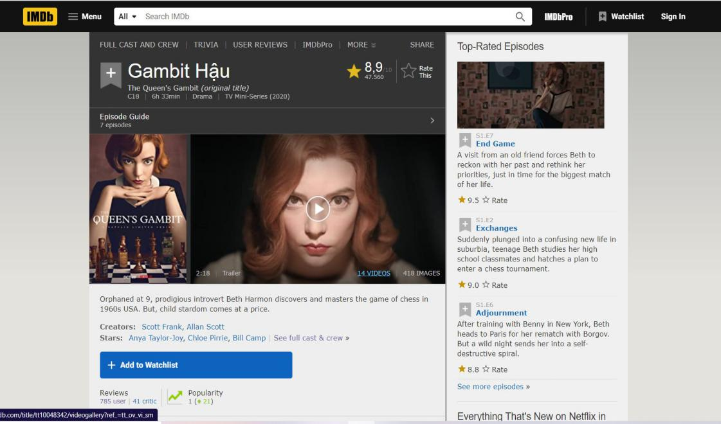

**Figure 1.2.1.2.1.** Movie’s information

#### User Reviews

Overview:

You can see everyone's rating of the movie as well as the rate score. In addition, upon successful registration of a member account of the site, we can leave a comment. We can choose whether or not this review will reveal content.

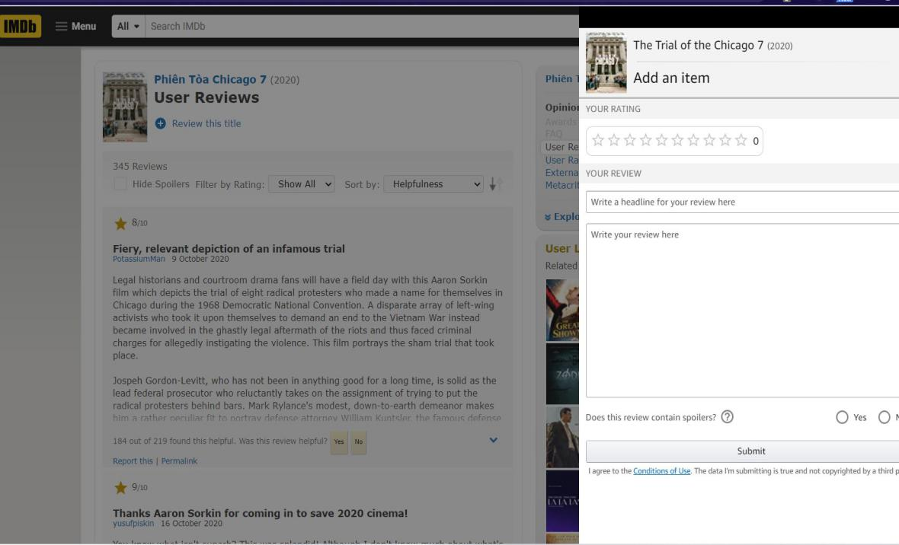

**Figure 1.2.1.3.1.** User Reviews

### Moveek

#### Introduction

Moveek.com is an information site providing articles introducing and evaluating films shown in theaters across the country. In addition, Moveek also redistributes products and services of partners (theaters) on the website Moveek.com.

Services are understood to include: movie tickets at co-operative theaters; corn - water or other foods provided by cooperative theaters; and items related to film promotion provided by the affiliated cinemas.

#### Website functionality

Overview:

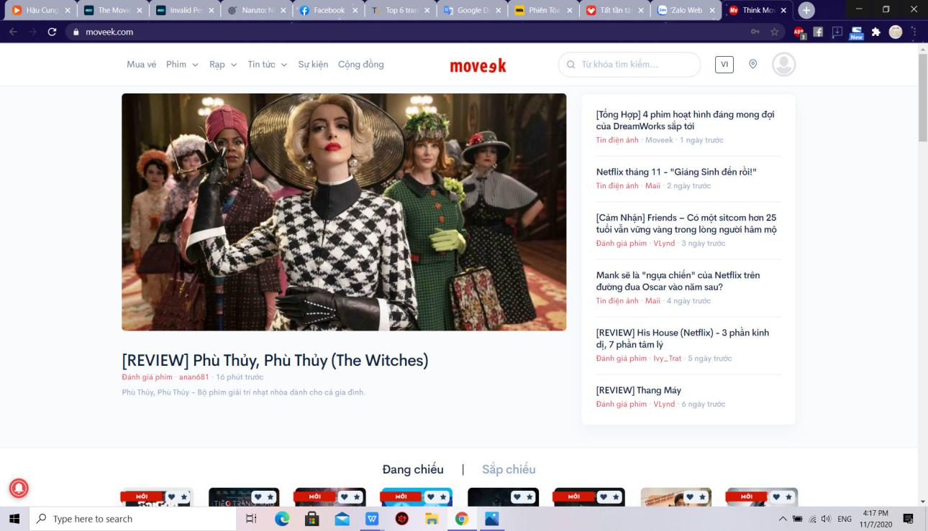

**Figure 1.2.2.2.1.** Overview website functionality

Home interface and functions:

* Book ticket: are movie tickets at movie theaters that Moveek cooperates. Customers can only purchase tickets online for theaters where Moveek has announced its Online Booking Partnership.
* Movie: see movie showtimes, list of movies is filtered by current, upcoming show..
* Cinema: list of theaters by region in cluster theaters working with moveek
* Information: Synthesize articles about movies, audience reviews, and related videos..

#### Function of review

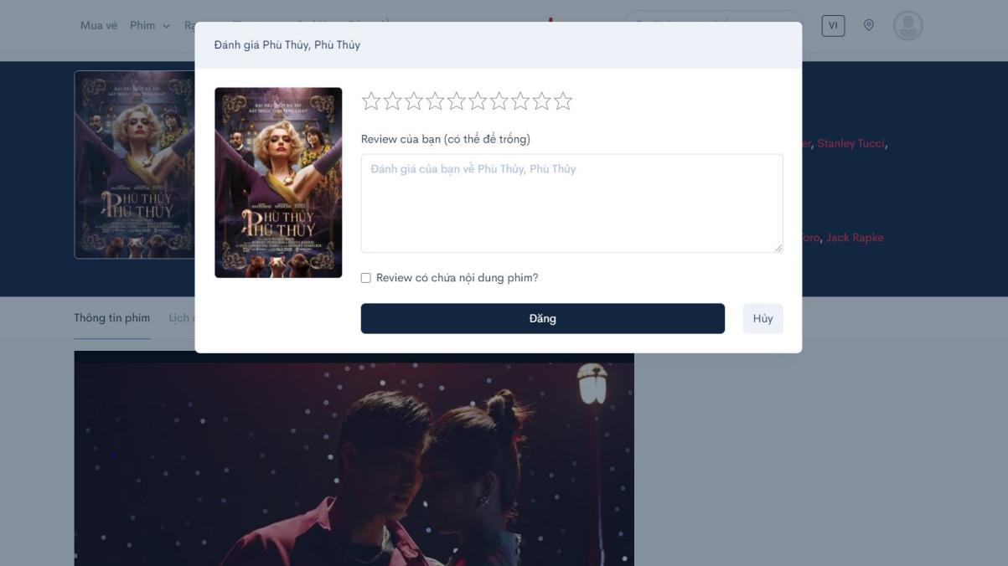

**Figure 1.2.2.3.1.** Review screen

You can see everyone's rating of the movie as well as the rate score. In addition, upon successful registration of a member account of the site, we can leave a comment. We can choose whether or not this review will reveal content.

#### Book ticket

Customers can only purchase tickets online for theaters where Moveek has announced its Online Booking Partnership.

Customers can buy tickets and choose seats just like when buying tickets at the theater

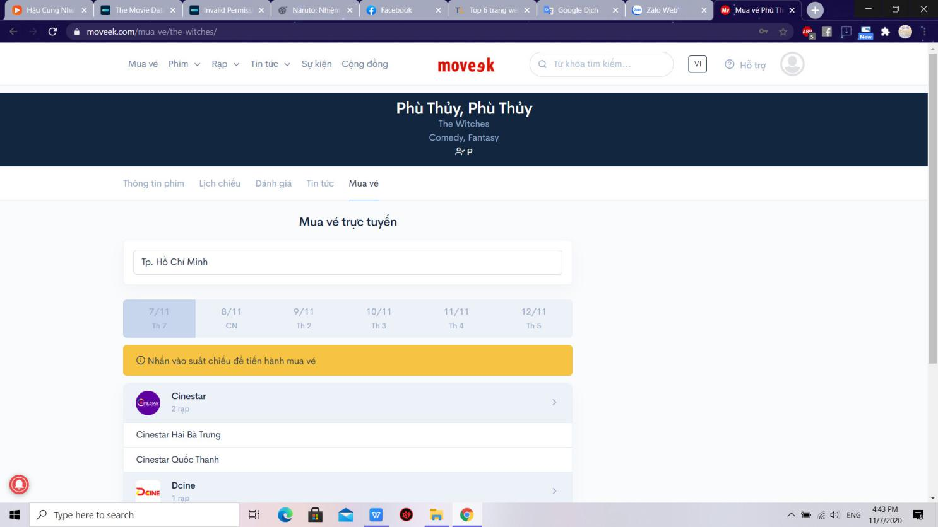

**Figure 1.2.2.4.1.** Function Book ticket

#### Diary

When you click like any movie, your favorite movies will be added to diary.

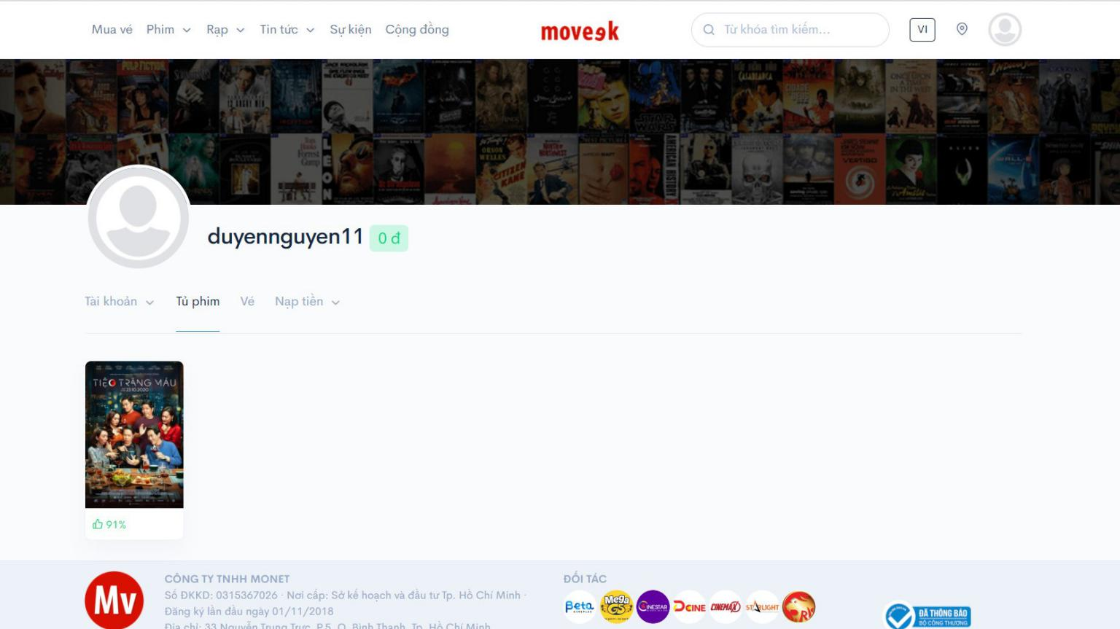

**Figure 1.2.2.5.1.** Diary

## System analysis design

With the results of collecting and examining the current systems, we will build an easy-to-use website that is decentralized to admin and users.

### Actor of system

Based on the description of the problem, we can identify the main actors of the system statistics are as follows:

- Super Admin: Use the system with the highest privileges. People who perform the functions of system administration, accounts, client, decentralizing for management, interface management. Super Administration functions in this system must be logged.

- Admin: Under Super Admin's control. Has movie management and user management rights, view statistic. Administration functions in this system must be logged.

- Unauthorized User: Can view showtimes, view reviews, search movie cinemas and book tickets

- Authorized User: Inheriting all functions of Unauthorized User. Need to login to manage account, write reviews, like / unlike movies, view booking history.

- Guest: Inheriting all functions of Unauthorized User. Can sign up for an account.

- Cinema Chain API:

Main functions:

SuperAdmin’s function

|  |  |  |
| --- | --- | --- |
|  | Function name | Description |
| 1 | Add Admin | Register Admin account for employees. |
| 2 | Delete Admin | Delete Admin account from website. |
| 3 | Block Admin | Block Admin account when suspended or disciplined. |
| 4 | UnBlock Admin | Unblock Admin account to continue operating the site. |
| 5 | Add cinema chain | Add cinema chain to website. |
| 6 | Delete cinema chain | Delete cinema chain from website. |
| 7 | Update cinema’s information | Update detailed information about the chain of cinemas such as location, quantity.. |

**Table 1-** SuperAdmin function

Admin’s function

|  |  |  |
| --- | --- | --- |
|  | Function name | Description |
| 1 | Login | Enter username and password. Validation matches data. If available, the system will allow login to perform functions in the system. |
| 2 | Add Movie | Add movie and and classification to website. |
| 3 | Delete Movie | Delete movie from website. |
| 4 | Update movie’s cast | Update movie’s cast information |
| 5 | Update movie’s detail | Update detailed information about the movie such as datetime, trailers… |
| 6 | Block user | Block user account when suspended or disciplined. |
| 7 | Unblock user | Unblock Admin account to continue operating the site. |
| 8 | Update cinema’s information | Update detailed information about the chain of cinemas such as location, quantity.. |
| 9 | View statistics | See website analytics such as visits, interactions, ticket purchases.. |

**Table 2-** Admin function

Unauthorized User’s function

|  |  |  |
| --- | --- | --- |
|  | Function name | Description |
| 1 | View movies in theaters | See information about movies being shown in cinemas. |
| 2 | View upcoming movies | See information about upcoming movies in cinemas. |
| 3 | View movie’s detail | View detailed movie information such as genre, actor, and screen time. |
| 4 | Search movies | Search for movies by keywords. |
| 5 | Search cinemas | Search for cinemas by keywords. |
| 6 | View cinema | •The website navigates to the cinemas screen and displays a list of cinemas located in user’s city. |
| 7 | View cinema chain | Information about theaters is divided by regions for users to find easily |
| 8 | View cinema’s detail | Cinema information such as address, ticket price... |

Authorized User’s function

|  |  |  |
| --- | --- | --- |
|  | Function name | Description |
| 1 | Login | Enter username and password. Validation matches data. If available, the system will allow login to perform functions in the system. |
| 2 | Logout | Log out of the website |
| 3 | View movie’s detail | View detailed movie information such as genre, actor, and screen time. |
| 4 | Search movies | Search for movies by keywords. |
| 5 | Search cinemas | Search for cinemas by keywords. |
| 6 | View cinema | •The website navigates to the cinemas screen and displays a list of cinemas located in user’s city. |
| 7 | View cinema chain | Information about theaters is divided by regions for users to find easily |
| 8 | View cinema’s detail | Cinema information such as address, ticket price... |

Guest function

|  |  |  |
| --- | --- | --- |
|  | Function name | Description |
| 1 | Register | Create an account as role “User”. |

### Document Management System

This system will manage all documents, drawings, detailed description of the entire system, helping newcomers in construction and development can read and understand the system quickly and easily. In addition, this system will make maintenance and upgrades a breeze, or for transferring technology to a new team more easily and quickly.

Super Admin functions:

* + - Add/Delete/Block/Unblock admin.
    - Add/Delete cinema chain.
    - Update cinema’s information.
    - Implementing the functions of Admin and User.

Admin functions:

* + - Delete/Block/Unblock User
    - Add/Delete movie.
    - Update movie’s cast
    - Update movie’s details
    - View Statistics

Guest functions:

* + - Register

Cinema chain API functions:

* + - View movie’s showtimes
    - Book ticket

Unauthorized User functions:

* + - View movies in theaters
    - View upcoming movies
    - View movie’s detail
    - Search movies.
    - Search cinemas
    - View cinema
    - View cinema chain
    - View cinema’s detail

Authorized User functions:

* + - Login
    - Logout
    - Reset password
    - Update profile
    - Change password
    - Like/Unlike a movie
    - Write review and rate
    - View watchlist
    - Edit review
    - Delete review
    - Like or dislike a review
    - View order history

### Usecase Diagram

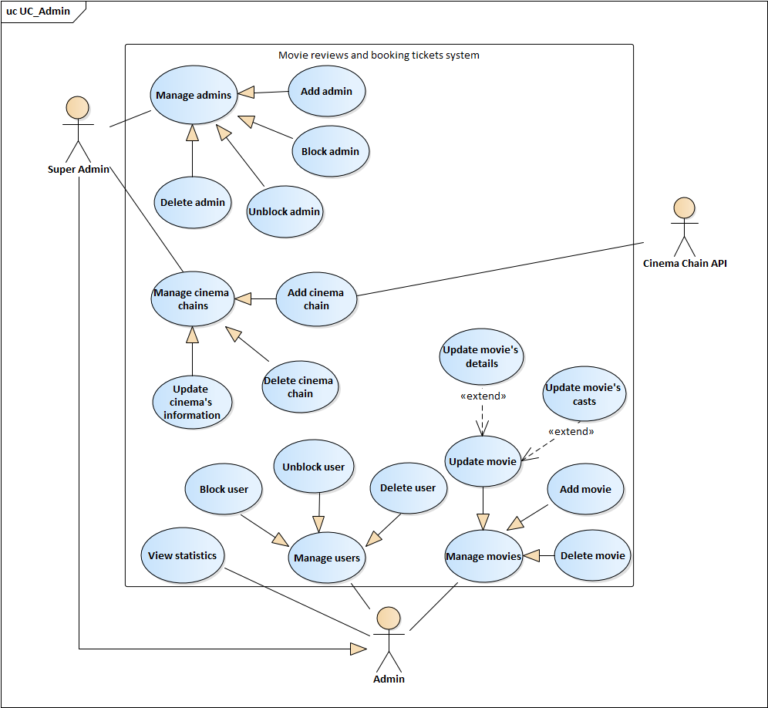

Image 1- Usecase diagram for Admin

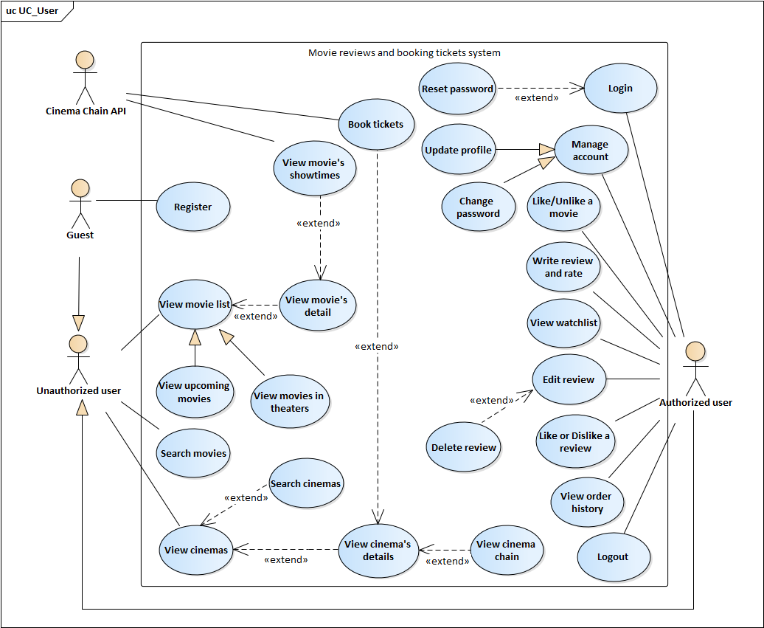

Image 2- Usecase diagram for User

### Usecase Description

#### Functional requirements of “Guest”

* + - * 1. Use case “Register”

|  |  |  |  |
| --- | --- | --- | --- |
| **USE CASE – MRABTW_UC_01** | | | |
| **Use Case No.** | MRABTW_UC_01 | **Use case version** | 1.0 |
| **Use case name** | Register | | |
| **Author** | Tôn Nữ Như Quỳnh | | |
| **Date** | 14/09/2020 | **Priority** | High |
| **Actor:**   * Unauthorized user (Guest)   **Summary:**   * Allows guest to create an account as role “User”.   **Goal:**   * Guest becomes authorized user of the website with role as “User”.   **Triggers:**   * Guest who haven’t registered an account to the website. * Guest click on “Register” in the Login popup   **Preconditions:**   * Guest who doesn’t have an account.   **Post conditions:**   * Succeeded: Guest is logged in to the website as role “User” * Failed: Cannot create account.   **Main Success Scenario:**   |  |  |  | | --- | --- | --- | | **Step** | **Actor Action** | **System Response** | | 1 | Guest clicks “Register” on the right side of the navigation bar.  [Alternative 1] | The website navigate to the register screen. | | 2 | Guest types his/her email, username, passwords | [Exception 1], [Exception 2] | | 3 | Guest clicks “Tạo tài khoản”  [Alternative 2] | Notification appears above the register form “Tạo tài khoản thành công” and the website navigates back to home page.  [Exception 3] |   **Alternative Scenario:**   |  |  |  | | --- | --- | --- | | **Step** | **Actor Action** | **System Response** | | 1 | Guest clicks “Register” at the bottom of Login popup |  | | 2 | Guest types “Enter” | The register form will be submitted and the website will validate the input fields. |   **Exceptions:**   |  |  |  | | --- | --- | --- | | **No** | **Actor Action** | **System Response** | | 1 | Guest leaves username, passwords or empty. | Errors appear under the empty inputs “Không được bỏ trống trường này”. | | 2 | Password and confirm password don’t match | Error appears under the Confirm password input “Các mật khẩu không trùng khớp”. | | 3 | Reused email or username | Errors on the top of email or username input “Đã được sử dụng”. |   **Relationships:**  **Business Rules:**   * Username: cannot be left empty and cannot be reused. * Email: cannot be left empty and cannot be reused. * Password and Confirm password: cannot be left empty and must match with each other. | | | |

Specification of usecase 1- Register

#### Functional requirements of “Authorized user”

* + - * 1. Use case “Login”

|  |  |  |  |
| --- | --- | --- | --- |
| **USE CASE – MRABTW_UC_02** | | | |
| **Use Case No.** | MRABTW_UC_02 | **Use case version** | 1.0 |
| **Use case name** | Login | | |
| **Author** | Tôn Nữ Như Quỳnh | | |
| **Date** | 14/09/2020 | **Priority** | High |
| **Actor:**   * Authorized user   **Summary:**   * Allows Authorized user to login to the website.   **Goal:**   * User with authorization is logged in to the website with specific role.   **Triggers:**   * Users need to log in the website for some specific functions. * User click “Login” on the navigation bar.   **Preconditions:**   * User haven’t logged in to the website.   **Post conditions:**   * Succeeded: User is logged in to the website with specific role. * Failed: Error “Invalid user”.   **Main Success Scenario:**   |  |  |  | | --- | --- | --- | | **Step** | **Actor Action** | **System Response** | | 1 | Authorized user clicks “Login” on the right side of the navigation bar | The website shows the popup “Login” in the middle of the screen | | 2 | Authorized user types his/her name and password on the login form | [Exception 1] | | 3 | Authorized user clicks “Login”  [Alternative 1] | The popup disappears. On the right side of the navigation bar there will be the username of user  [Exception 2] |   **Alternative Scenario:**   |  |  |  | | --- | --- | --- | | **Step** | **Actor Action** | **System Response** | | 1 | Authorized user types “Enter” | The login form will be submitted and the website will validate the username and password |   **Exceptions:**   |  |  |  | | --- | --- | --- | | **No** | **Actor Action** | **System Response** | | 1 | Authorized user leaves username or password or both fields empty | Errors appear under the username or password input “Please fill out this field” | | 2 | Invalid username and password | Error appears on the top of login form “Invalid user” |   **Relationships:**  **Business Rules:**   * Username: cannot be left empty. * Password: cannot be left empty. | | | |

Specification of usecase 2-Login

* + - * 1. Use case “Reset password”

|  |  |  |  |
| --- | --- | --- | --- |
| **USE CASE – MRABTW_UC_03** | | | |
| **Use Case No.** | MRABTW_UC_03 | **Use case version** | 1.0 |
| **Use case name** | Reset password | | |
| **Author** | Tôn Nữ Như Quỳnh | | |
| **Date** | 14/09/2020 | **Priority** | Low |
| **Actor:**   * Authorized user   **Summary:**   * Allows authorized user who forgot password to make a new password for his/her account.   **Goal:**   * Authorized user logins to the website with the new password.   **Triggers:**   * Authorized user forgot his/her password and clicks “Forgot password?” in the Login popup.   **Preconditions:**   * Authorized user haven’t logged in to the website.   **Post conditions:**   * Succeeded: User can login to the website with the new password. * Failed: User cannot login to the website with the new password.   **Main Success Scenario:**   |  |  |  | | --- | --- | --- | | **Step** | **Actor Action** | **System Response** | | 1 | Authorized user clicks “Login” on the right side of the navigation bar. | The Login popup appears at the center of the screen. | | 2 | Authorized user clicks “Forgot password?” at the right corner above the password input in the login form | The website navigate to reset password page. | | 3 | Authorized user types his/her registered email and clicks “Quên mật khẩu" | [Exception 1]  [Exception 2] | | 4 | Authorized user checks email and goes to the reset password link the website has sent. |  | | 5 | Authorized user types new password and confirm password. | [Exception 3] | | 6 | Authorized user clicks “Đặt lại mật khẩu” | Notification appears above the form “Đặt lại mật khẩu thành công” and the website navigates back to home page.  [Exception 4] |   **Alternative Scenario:**  **Exceptions:**   |  |  |  | | --- | --- | --- | | **No** | **Actor Action** | **System Response** | | 1 | User leaves email empty. | Error appears under the empty inputs “Không được bỏ trống trường này”. | | 2 | User types email that does not exist | Error appears above the empty input “Tài khoản này không tồn tại”. | | 3 | Password and confirm password don’t match | Error appears under the Confirm password input “Các mật khẩu không trùng khớp”. | | 4 | Reused password | Errors on the top of password input “Đã được sử dụng”. |   **Relationships:** MRABTW_UC_02  **Business Rules:**   * Email: cannot be left empty and need existing. * Password and Confirm password: cannot be left empty and must match with each other. | | | |

Specification of usecase 3- Reset password

* + - * 1. Use case “Like a movie”

|  |  |  |  |
| --- | --- | --- | --- |
| **USE CASE – MRABTW_UC_04** | | | |
| **Use Case No.** | MRABTW_UC_04 | **Use case version** | 1.0 |
| **Use case name** | Like a movie | | |
| **Author** | Tôn Nữ Như Quỳnh | | |
| **Date** | 15/09/2020 | **Priority** | Normal |
| **Actor:**   * Authorized user.   **Summary:**   * Allows user to like a movie and add this movie to his/her watchlist.   **Goal:**   * The heart symbol of the movie from gray turns to red and the movie will be added to the watchlist of user.   **Triggers:**   * User clicks the heart symbol of a movie in the movie list.   **Preconditions:**   * There’s no precondition for this usecase.   **Post conditions:**   * Succeeded: The heart symbol of the movie from gray turns to red. * Failed: The heart symbol of the movie doesn’t turns to red, no movie added to watchlist.   **Main Success Scenario:**   |  |  |  | | --- | --- | --- | | **STEP** | **Actor Action** | **System Response** | | 1 | User clicks the heart symbol of a movie in the movie list screen  [Alternative 1]  [Alternative 2] | The heart symbol of the movie from gray turns to red. The movie is added to user’s watchlist |   **Alternative Scenario:**   |  |  |  | | --- | --- | --- | | **No** | **Actor Action** | **System Response** | | 1 | User clicks the heart symbol of the movie in movie details screen |  | | 2 | User hasn’t logged in to the website | Popup login disappears |   **Exceptions:**  **Relationships:**  **Business Rules:**   * Unauthorized user will need authorization to like a movie. | | | |

Specification of usecase 4- Like a movie

* + - * 1. Use case “Write a review and rate”

|  |  |  |  |
| --- | --- | --- | --- |
| **USE CASE – MRABTW_UC_05** | | | |
| **Use Case No.** | MRABTW_UC_05 | **Use case version** | 1.0 |
| **Use case name** | Write a review and rate | | |
| **Author** | Tôn Nữ Như Quỳnh | | |
| **Date** | 15/09/2020 | **Priority** | Normal |
| **Actor:**   * Authorized user.   **Summary:**   * Allows user to rate and write view for a movie.   **Goal:**   * User’s review and rating for a movie will be displayed in the review list of that movie.   **Triggers:**   * User clicks “Đánh giá” in the movie details screen.   **Preconditions:**   * The website is in the movie details screen.   **Post conditions:**   * Succeeded: User’s review and rating for a movie will be displayed in the review list of that movie. * Failed: Cannot add review.   **Main Success Scenario:**   |  |  |  | | --- | --- | --- | | **STEP** | **Actor Action** | **System Response** | | 1 | User clicks “Đánh giá” in the movie details screen. | Popup Review will be displayed at the center of movie detail screen. | | 2 | User rates and types review and ticks “Review có tiết lộ nội dung?” if the review contains spoilers | [Exception 1] | | 3 | User clicks “Đăng” | User’s review and rating for a movie will be displayed in the review list of that movie.  [Alternative 1] |   **Alternative Scenario:**   |  |  |  | | --- | --- | --- | | **No** | **Actor Action** | **System Response** | | 1 | User hasn’t logged in to the website | Popup Login will be displayed |   **Exceptions:**   |  |  |  | | --- | --- | --- | | **No** | **Actor Action** | **System Response** | | 1 | User writes a review but leaves the rating empty | Error in the Review form “Không được để trống” |   **Relationships:** MRABTW_UC_  **Business Rules:**   * Rating: cannot be left empty if the review input has content. * Review: can be left empty if user already rates the movie. * User needs authorization to post a review. | | | |

Specification of usecase 5- Write a review and rate

* + - * 1. Use case “Like or Dislike a review”

|  |  |  |  |
| --- | --- | --- | --- |
| **USE CASE – MRABTW_UC_06** | | | |
| **Use Case No.** | MRABTW_UC_06 | **Use case version** | 1.0 |
| **Use case name** | Like or Dislike a review | | |
| **Author** | Tôn Nữ Như Quỳnh | | |
| **Date** | 15/09/2020 | **Priority** | Normal |
| **Actor:**   * Authorized user.   **Summary:**   * Allows user to like or dislike a review.   **Goal:**   * The like (dislike) button below the review will be displayed in green (red for dislike).   **Triggers:**   * User clicks like or dislike button below the review.   **Preconditions:**   * The website is in the movie details screen.   **Post conditions:**   * Succeeded: The like (dislike) button below the review will be displayed in green (red for dislike).   **Main Success Scenario:**   |  |  |  | | --- | --- | --- | | **STEP** | **Actor Action** | **System Response** | | 1 | User clicks on the like (dislike) button below the review. | The like (dislike) button below the review will be displayed in green (red for dislike). The number counting likes or dislikes next to the button will be updated.  [Alternative 1] |   **Alternative Scenario:**   |  |  |  | | --- | --- | --- | | **No** | **Actor Action** | **System Response** | | 1 | User hasn’t logged in to the website | Popup Login will be displayed |   **Exceptions:**  **Relationships:** MRABTW_UC_  **Business Rules:**   * User cannot like and dislike a review at the same time. * Unauthorized user when clicks on like/dislike button will need authorization to like or dislike a review. | | | |

Specification of usecase 6- Like/Dislike a review

* + - * 1. Use case “Log out”

|  |  |  |  |
| --- | --- | --- | --- |
| **USE CASE – MRABTW_UC_07** | | | |
| **Use Case No.** | MRABTW_UC_07 | **Use case version** | 1.0 |
| **Use case name** | Log out | | |
| **Author** | Tôn Nữ Như Quỳnh | | |
| **Date** | 16/09/2020 | **Priority** | Normal |
| **Actor:**   * Authorized user   **Summary:**   * Allows user to log out of the website.   **Goal:**   * User logs out of the website becoming unauthorized user.   **Triggers:**   * User clicks “Logout” in the menu on the right side of the website’s navigation bar.   **Preconditions:**   * User has already logged in to the website.   **Post conditions:**   * Succeeded: User log out of the website becoming unauthorized user.   **Main Success Scenario:**   |  |  |  | | --- | --- | --- | | **STEP** | **Actor Action** | **System Response** | | 1 | User clicks “Logout” in the menu on the right side of the website’s navigation bar | The website navigates to the home page, username at the right side of the navigation bar disappears |   **Alternative Scenario:**  **Exceptions:**  **Relationships:**  **Business Rules:** | | | |

Specification of usecase 7-Log out

* + - * 1. Use case “Update profile”

|  |  |  |  |
| --- | --- | --- | --- |
| **USE CASE – MRABTW_UC_08** | | | |
| **Use Case No.** | MRABTW_UC_08 | **Use case version** | 1.0 |
| **Use case name** | Update profile | | |
| **Author** | Tôn Nữ Như Quỳnh | | |
| **Date** | 16/09/2020 | **Priority** | Normal |
| **Actor:**   * Authorized user.   **Summary:**   * Allows user to change their profile’s information.   **Goal:**   * The changes user make in their profile will be saved.   **Triggers:**   * User clicks “Quản lý tài khoản” in the menu on the right side of the navigation’s bar.   **Preconditions:**   * User has logged in to the website.   **Post conditions:**   * Succeeded: The website notifies “Cập nhật thành công”. * Failed: The website shows error.   **Main Success Scenario:**   |  |  |  | | --- | --- | --- | | **STEP** | **Actor Action** | **System Response** | | 1 | User clicks “Quản lý tài khoản” in the menu on the right side of the navigation’s bar | The website navigates to the user’s profile screen to display user’s information. | | 2 | User types into those inputs which user want to change | [Exception 1] | | 3 | User clicks “Cập nhật” | The website saves changes into the database and shows message “Cập nhật thành công” |   **Alternative Scenario:**  **Exceptions:**   |  |  |  | | --- | --- | --- | | **No** | **Actor Action** | **System Response** | | 1 | User doesn’t type correct phone number format | Displays error above phone number input “Invalid phone number format” |   **Relationships:**  **Business Rules:**   * User cannot change username and email input. * Fullname, Region, Phone number could be left empty. * The profile image input cannot browse other file format except image. | | | |

Specification of usecase 8- Update profile

* + - * 1. Use case “Change password”

|  |  |  |  |
| --- | --- | --- | --- |
| **USE CASE – MRABTW_UC_09** | | | |
| **Use Case No.** | MRABTW_UC_09 | **Use case version** | 1.0 |
| **Use case name** | Change password | | |
| **Author** | Tôn Nữ Như Quỳnh | | |
| **Date** | 16/09/2020 | **Priority** | Normal |
| **Actor:**   * Authorized user.   **Summary:**   * Allows user to changes his/her account’s password.   **Goal:**   * User’s new password will be saved into database and user can log in to the website by the new password.   **Triggers:**   * User clicks “Quản lý tài khoản” in the menu on the right side of the navigation’s bar, open the tab “Đổi mật khẩu” in profile screen.   **Preconditions:**   * User has logged in to the website.   **Post conditions:**   * Succeeded: The website shows message “Đổi mật khẩu thành công”. * Failed: The website shows error.   **Main Success Scenario:**   |  |  |  | | --- | --- | --- | | **STEP** | **Actor Action** | **System Response** | | 1 | User clicks “Quản lý tài khoản” in the menu on the right side of the navigation’s bar, open the tab “Đổi mật khẩu” in profile screen | The website navigates to the user’s profile screen then open tab “Đổi mật khẩu” | | 2 | User types the required inputs: Current password, New password, Confirm password | [Exception 1]  [Exception 2] | | 3 | User clicks “Đổi mật khẩu” | The website saves changes into the database and shows message “Đổi mật khẩu thành công”  [Exception 3] |   **Alternative Scenario:**  **Exceptions:**   |  |  |  | | --- | --- | --- | | **No** | **Actor Action** | **System Response** | | 1 | User leaves required inputs empty | Errors appear above those input “Không được bỏ trống trường này” | | 2 | New password and confirm password don’t match | Error appears above Confirm password input “Mật khẩu không trùng khớp” | | 3 | Current password isn’t correct | Shows message “Mật khẩu hiện tại không đúng”. |   **Relationships:**  **Business Rules:**   * New password and Confirm password must match. * The required inputs: Current password, New password, Confirm password must be filled for user to be able to submit form. | | | |

Specification of usecase 9- Change password

* + - * 1. Use case “View Watchlist”

|  |  |  |  |
| --- | --- | --- | --- |
| **USE CASE – MRABTW_UC_10** | | | |
| **Use Case No.** | MRABTW_UC_10 | **Use case version** | 1.0 |
| **Use case name** | View Watchlist | | |
| **Author** | Tôn Nữ Như Quỳnh | | |
| **Date** | 16/09/2020 | **Priority** | Normal |
| **Actor:**   * Authorized user.   **Summary:**   * Allows user to view the list of movies he/she has rated and liked.   **Goal:**   * The website navigates to the watchlist screen and displays a list of movies he/she has rated and liked.   **Triggers:**   * User clicks “Tủ phim” in the menu on the right side of the navigation’s bar.   **Preconditions:**   * User has logged in to the website.   **Post conditions:**   * Succeeded: The website navigates to the watchlist screen and displays a list of movies he/she has rated and liked.   **Main Success Scenario:**   |  |  |  | | --- | --- | --- | | **STEP** | **Actor Action** | **System Response** | | 1 | User clicks “Tủ phim” in the menu on the right side of the navigation’s bar. | The website navigates to the watchlist screen and displays a list of movies he/she has rated and liked. |   **Alternative Scenario:**  **Exceptions:**  **Relationships:**  **Business Rules:** | | | |

Specification of usecase 10- View Watchlist

* + - * 1. Use case “View Order history”

|  |  |  |  |
| --- | --- | --- | --- |
| **USE CASE – MRABTW_UC_11** | | | |
| **Use Case No.** | MRABTW_UC_11 | **Use case version** | 1.0 |
| **Use case name** | View Order history | | |
| **Author** | Tôn Nữ Như Quỳnh | | |
| **Date** | 16/09/2020 | **Priority** | Normal |
| **Actor:**   * Authorized user.   **Summary:**   * Allows user to view the list of orders he/she has made.   **Goal:**   * The website navigates to the order history screen and displays a list of orders user has made.   **Triggers:**   * User clicks “Lịch sử mua vé” in the menu on the right side of the navigation’s bar.   **Preconditions:**   * User has logged in to the website.   **Post conditions:**   * Succeeded: The website navigates to to the order history screen and displays a list of orders user has made.   **Main Success Scenario:**   |  |  |  | | --- | --- | --- | | **STEP** | **Actor Action** | **System Response** | | 1 | User clicks “Lịch sử mua vé” in the menu on the right side of the navigation’s bar. | The website navigates to to the order history screen and displays a list of orders user has made. |   **Alternative Scenario:**  **Exceptions:**  **Relationships:**  **Business Rules:** | | | |

Specification of usecase 11- View Order history

* + - * 1. Use case “Edit Review”

|  |  |  |  |
| --- | --- | --- | --- |
| **USE CASE – MRABTW_UC_12** | | | |
| **Use Case No.** | MRABTW_UC_12 | **Use case version** | 1.0 |
| **Use case name** | Edit Review | | |
| **Author** | Tôn Nữ Như Quỳnh | | |
| **Date** | 17/09/2020 | **Priority** | Normal |
| **Actor:**   * Authorized user.   **Summary:**   * Allows user to edit the review he/she wrote.   **Goal:**   * The changes will be saved to database and the review will be updated according to changes.   **Triggers:**   * User clicks “Đánh giá” in the movie details screen.   **Preconditions:**   * User has logged in to the website. * User is in the movie details screen of the movie for which user rated and wrote a review.   **Post conditions:**   * Succeeded: The changes user make will be saved to database and the review will be updated according to changes. * Failed: The review won’t be updated according to changes user make.   **Main Success Scenario:**   |  |  |  | | --- | --- | --- | | **STEP** | **Actor Action** | **System Response** | | 1 | User clicks “Đánh giá” in the movie details screen.  [Alternative 1] | Popup Review will be displayed at the center of movie detail screen and shows user’s review and rating of the movie | | 2 | User changes the rating, review or checkbox “Review có tiết lộ nội dung?” | [Exception 1] | | 3 | User clicks “Đăng” | User’s review for the movie will be updated in the review list of that movie. |   **Alternative Scenario:**   |  |  |  | | --- | --- | --- | | **No** | **Actor Action** | **System Response** | | 1 | User clicks “Chỉnh sửa” button below her/his review in the review list in movie’s details screen |  |   **Exceptions:**   |  |  |  | | --- | --- | --- | | **No** | **Actor Action** | **System Response** | | 1 | User writes a review but leaves the rating empty | Error in the Review form “Không được để trống” |   **Relationships:**  **Business Rules:**   * User can only edit his/her review. * Rating: cannot be left empty if the review input has content. * Review: can be left empty if user already rates the movie. | | | |

Specification of usecase 12- Edit Review

* + - * 1. Use case “Delete Review”

|  |  |  |  |
| --- | --- | --- | --- |
| **USE CASE – MRABTW_UC_13** | | | |
| **Use Case No.** | MRABTW_UC_13 | **Use case version** | 1.0 |
| **Use case name** | Delete review | | |
| **Author** | Tôn Nữ Như Quỳnh | | |
| **Date** | 17/09/2020 | **Priority** | Normal |
| **Actor:**   * Authorized user.   **Summary:**   * Allows user to delete his/her review for a movie.   **Goal:**   * The review will be deleted from database and disappear from the review list in movie’s details screen.   **Triggers:**   * User clicks “Đánh giá” in the movie details screen. * User clicks “Xóa review” button in the Review popup.   **Preconditions:**   * User has logged in to the website. * User is in the movie details screen of the movie for which user rated and wrote a review.   **Post conditions:**   * Succeeded: The website shows message “Xóa thành công” and the review will disappear from the review list in movie’s details screen. * Failed: The review won’t be deleted from the website.   **Main Success Scenario:**   |  |  |  | | --- | --- | --- | | **STEP** | **Actor Action** | **System Response** | | 1 | User clicks “Đánh giá” in the movie details screen. | Popup Review will be displayed at the center of movie detail screen and shows user’s review and rating of the movie | | 2 | User clicks “Xóa review” button in the Review popup.  [Alternative 1] | Confirm dialog appears “Bạn có chắc muốn xóa review này?” | | 3 | User clicks “Yes”  [Alternative 2] | The website shows message “Xóa thành công” and the review will disappear from the review list in movie’s details screen. |   **Alternative Scenario:**   |  |  |  | | --- | --- | --- | | **No** | **Actor Action** | **System Response** | | 1 | User clicks “Xóa review” button below her/his review in the review list in movie’s details screen |  | | 2 | User clicks “No” | The Confirm dialog disappears. |   **Exceptions:**  **Relationships:** MRABTW_UC_12  **Business Rules:**   * User can only delete his/her review. | | | |

Specification of usecase 13- Delete Review

#### Functional requirements of “Unauthorized user”

* + - * 1. Use case “View upcoming movies”

|  |  |  |  |
| --- | --- | --- | --- |
| **USE CASE – MRABTW_UC_14** | | | |
| **Use Case No.** | MRABTW_UC_14 | **Use case version** | 1.0 |
| **Use case name** | View upcoming movies | | |
| **Author** | Tôn Nữ Như Quỳnh | | |
| **Date** | 15/09/2020 | **Priority** | High |
| **Actor:**   * Unauthorized user.   **Summary:**   * Allows user to view upcoming movies.   **Goal:**   * The website displays a list of upcoming movies.   **Triggers:**   * User clicks “Sắp chiếu” option in the menu “Phim” of navigation bar.   **Preconditions:**   * There’s no precondition for this use case.   **Post conditions:**   * Succeeded: The website directs to the movie list screen.   **Main Success Scenario:**   |  |  |  | | --- | --- | --- | | **STEP** | **Actor Action** | **System Response** | | 1 | User clicks “Sắp chiếu” option in the menu “Phim” of navigation bar | The website directs to the movie list screen displaying upcoming movies.  [Exception 1] |   **Alternative Scenario:**  **Exceptions:**   |  |  |  | | --- | --- | --- | | **No** | **Actor Action** | **System Response** | | 1 |  | The website displays “Không có phim sắp chiếu” |   **Relationships:**  **Business Rules:** | | | |

Specification of usecase 14- View upcoming movies

* + - * 1. Use case “View movies in theaters”

|  |  |  |  |
| --- | --- | --- | --- |
| **USE CASE – MRABTW_UC_15** | | | |
| **Use Case No.** | MRABTW_UC_15 | **Use case version** | 1.0 |
| **Use case name** | View movies in theaters | | |
| **Author** | Tôn Nữ Như Quỳnh | | |
| **Date** | 15/09/2020 | **Priority** | Normal |
| **Actor:**   * Unauthorized user.   **Summary:**   * Allows user to view movies now playing in theaters.   **Goal:**   * The website displays a list of movies on theaters.   **Triggers:**   * User clicks “Đang chiếu” option in the menu “Phim” of navigation bar.   **Preconditions:**   * There’s no precondition for this use case.   **Post conditions:**   * Succeeded: The website directs to the movie list screen.   **Main Success Scenario:**   |  |  |  | | --- | --- | --- | | **STEP** | **Actor Action** | **System Response** | | 1 | User clicks “Đang chiếu” option in the menu “Phim” of navigation bar | The website directs to the movie list screen displaying movies that are playing at the theaters.  [Exception 1] |   **Alternative Scenario:**  **Exceptions:**   |  |  |  | | --- | --- | --- | | **No** | **Actor Action** | **System Response** | | 1 |  | The website displays “Không có phim đang chiếu” |   **Relationships:**  **Business Rules:** | | | |

Specification of usecase 15- View movies in theaters

* + - * 1. Use case “View movie details”

|  |  |  |  |
| --- | --- | --- | --- |
| **USE CASE – MRABTW_UC_16** | | | |
| **Use Case No.** | MRABTW_UC_16 | **Use case version** | 1.0 |
| **Use case name** | View movie details | | |
| **Author** | Tôn Nữ Như Quỳnh | | |
| **Date** | 15/09/2020 | **Priority** | Normal |
| **Actor:**   * Unauthorized user.   **Summary:**   * Allows user to view details of a movie.   **Goal:**   * The website displays movie’s details.   **Triggers:**   * User clicks on a movie in the movie list screen.   **Preconditions:**   * There’s no precondition for this use case.   **Post conditions:**   * Succeeded: The website directs to the movie’s details screen.   **Main Success Scenario:**   |  |  |  | | --- | --- | --- | | **STEP** | **Actor Action** | **System Response** | | 1 | User clicks on a movie in the movie list screen | The website directs to the movie’s details screen displaying movie’s information, showtimes, reviews. |   **Alternative Scenario:**   |  |  |  | | --- | --- | --- | | **No** | **Actor Action** | **System Response** | | 1 | User clicks on a movie in the movie list in home page |  |   **Exceptions:**  **Relationships:**  **Business Rules:** | | | |

Specification of usecase 16- View movie details

* + - * 1. Use case “View movie’s showtimes”

|  |  |  |  |
| --- | --- | --- | --- |
| **USE CASE – MRABTW_UC_17** | | | |
| **Use Case No.** | MRABTW_UC_17 | **Use case version** | 1.0 |
| **Use case name** | View movie’s showtimes | | |
| **Author** | Tôn Nữ Như Quỳnh | | |
| **Date** | 15/09/2020 | **Priority** | Normal |
| **Actor:**   * Unauthorized user.   **Summary:**   * Allows user to view the movie’s showtimes at theaters that are located in the user’s city.   **Goal:**   * The website displays the movie’s showtimes in specific cinemas.   **Triggers:**   * User clicks “Lịch chiếu” in the movie details screen.   **Preconditions:**   * The website is in the movie details screen.   **Post conditions:**   * Succeeded: The website displays the movie’s showtimes in every cinema located at user’s city.   **Main Success Scenario:**   |  |  |  | | --- | --- | --- | | **STEP** | **Actor Action** | **System Response** | | 1 | User clicks the tab “Lịch chiếu” in the movie details screen. | Displays a list of cinema chains | | 2 | User clicks on a cinema chain | Display a list of cinemas located in user’s city | | 3 | User clicks on a cinema in the list | Displays a list of showtimes of the movie in that cinema |   **Alternative Scenario:**  **Exceptions:**  **Relationships:** MRABTW_UC_16  **Business Rules:**   * The showtime which is already passed will has color gray. | | | |

Specification of usecase 17- View movie's showtimes

* + - * 1. Use case “Book tickets”

|  |  |  |  |
| --- | --- | --- | --- |
| **USE CASE – MRABTW_UC_18** | | | |
| **Use Case No.** | MRABTW_UC_18 | **Use case version** | 1.0 |
| **Use case name** | Book tickets | | |
| **Author** | Nguyễn Ngọc Tú Duyên | | |
| **Date** | 21/10/2020 | **Priority** | Normal |
| **Actor:**   * Unauthorized user, Authorized user.   **Summary:**   * Allows user to book the movie’s tickets from cinemas that are cooperate with “Movie Review and Tickets ”.   **Goal:**   * User can book the movie’s tickets valid as tickets purchased at cinema.   **Triggers:**   * User clicks “Mua vé” in the hompage screen.   **Preconditions:**  **Post conditions:**   * Succeeded: User can book the movie’s tickets from cinemas that are cooperate with “Movie Review and Tickets ”.   **Main Success Scenario:**   |  |  |  | | --- | --- | --- | | **STEP** | **Actor Action** | **System Response** | | 1 | User clicks the tab “Mua vé” in the homepage screen. | Displays a list of movies | | 2 | User clicks on a movie in list | Display a list of area | | 3 | User clicks on a area and day to choose the cinema | Displays a list of showtimes of the movie in that cinema | | 4 | User clicks on a showtime in list | Display a list of rows and countdown booking seat time | | 5 | User chooses seat number in list then clicks “Tiếp tục” | Display CheckoutUI | | 6 | User fills in information form then clicks on “Thanh toán” | Display Stripe payment gateway | | 8 | User fills in form then clicks on “Tiếp Tục” | Display suscessful ticket booking form and show Tickets’s information |   **Alternative Scenario:**   |  |  |  | | --- | --- | --- | | **No** | **Actor Action** | **System Response** | | 1 | User fills in form in Stripe payment gateway then clicks on “Tiếp Tục” | Return the error message "Thanh toán không thành công”. | | 2 | User has unpaid before the countdown deadline | Return the message “Hết thời gian giữ ghế. Hãy thực hiện lại đơn hàng của bạn trong 5 phút” and show “Đặt lại” button. |   **Exceptions:**  **Relationships:**  **Business Rules:** | | | |

Specification of usecase 18- Book tickets

* + - * 1. Use case “Search movie”

|  |  |  |  |
| --- | --- | --- | --- |
| **USE CASE – MRABTW_UC_19** | | | |
| **Use Case No.** | MRABTW_UC_19 | **Use case version** | 1.0 |
| **Use case name** | Search movie | | |
| **Author** | Tôn Nữ Như Quỳnh | | |
| **Date** | 15/09/2020 | **Priority** | Normal |
| **Actor:**   * Unauthorized user.   **Summary:**   * Allows user to search movies matching the keyword.   **Goal:**   * The website navigates to the search screen and displays list of movies matching the search keyword.   **Triggers:**   * User types “Enter” after typing a search string or clicks the search symbol next to the search input.   **Preconditions:**   * User is in the home page of the website where the search bar is.   **Post conditions:**   * Succeeded: The website navigates to the search screen and displays list of movies matching the search keyword.   **Main Success Scenario:**   |  |  |  | | --- | --- | --- | | **STEP** | **Actor Action** | **System Response** | | 1 | User types the search keyword into the search input in home page and clicks the search symbol on the right side of the input  [Alternative 1] | The website navigates to the search screen and displays list of movies matching the search keyword.  [Alternative 2] |   **Alternative Scenario:**   |  |  |  | | --- | --- | --- | | **No** | **Actor Action** | **System Response** | | 1 | User types “Enter” after typing the search string |  | | 2 |  | Displays “Không tìm thấy phim” |   **Exceptions:**  **Relationships:**  **Business Rules:** | | | |

Specification of usecase 19- Search movie

* + - * 1. Use case “View Cinemas”

|  |  |  |  |
| --- | --- | --- | --- |
| **USE CASE – MRABTW_UC_20** | | | |
| **Use Case No.** | MRABTW_UC_20 | **Use case version** | 1.0 |
| **Use case name** | View Cinemas | | |
| **Author** | Tôn Nữ Như Quỳnh | | |
| **Date** | 15/09/2020 | **Priority** | Normal |
| **Actor:**   * Unauthorized user.   **Summary:**   * Allows user to view cinemas located in user’s city.   **Goal:**   * The website navigates to the cinemas screen and displays a list of cinemas located in user’s city.   **Triggers:**   * User clicks “Rạp phim” button on the left side of the navigation bar.   **Preconditions:**   * There’s no precondition for this usecase.   **Post conditions:**   * Succeeded: The website navigates to the cinemas screen and displays list of cinemas located in user’s city.   **Main Success Scenario:**   |  |  |  | | --- | --- | --- | | **STEP** | **Actor Action** | **System Response** | | 1 | User clicks “Rạp phim” button on the left side of the navigation bar | The website navigates to the cinemas screen and displays list of cinemas located in user’s city. |   **Alternative Scenario:**  **Exceptions:**  **Relationships:**  **Business Rules:** | | | |

Specification of usecase 20- View Cinemas

* + - * 1. Use case “Search cinema”

|  |  |  |  |
| --- | --- | --- | --- |
| **USE CASE – MRABTW_UC_21** | | | |
| **Use Case No.** | MRABTW_UC_21 | **Use case version** | 1.0 |
| **Use case name** | Search cinema | | |
| **Author** | Tôn Nữ Như Quỳnh | | |
| **Date** | 16/09/2020 | **Priority** | Normal |
| **Actor:**   * Unauthorized user.   **Summary:**   * Allows user to search for cinemas located in user’s city that matches the search keyword.   **Goal:**   * The website displays a list of cinemas matching the search keyword.   **Triggers:**   * User types “Enter” after typing a search string or clicks the search symbol next to the search input.   **Preconditions:**   * The website is at the cinema list screen.   **Post conditions:**   * Succeeded: The website displays a list of cinemas located in user’s city that matches the search keyword.   **Main Success Scenario:**   |  |  |  | | --- | --- | --- | | **STEP** | **Actor Action** | **System Response** | | 1 | User types search keywords into the search input in the cinema list screen then clicks the search symbol on the right side of the input  [Alternative 1] | The cinema list screen displays a list of cinemas located in user’s city that matches the search keyword.  [Alternative 2] |   **Alternative Scenario:**   |  |  |  | | --- | --- | --- | | **No** | **Actor Action** | **System Response** | | 1 | User types “Enter” after typing the search string |  | | 2 |  | Displays “Không tìm thấy rạp” |   **Exceptions:**  **Relationships:** MRABTW_UC_20  **Business Rules:** | | | |

Specification of usecase 21- Search Cinema

* + - * 1. Use case “View cinema details”

|  |  |  |  |
| --- | --- | --- | --- |
| **USE CASE – MRABTW_UC_22** | | | |
| **Use Case No.** | MRABTW_UC_22 | **Use case version** | 1.0 |
| **Use case name** | View cinema details | | |
| **Author** | Tôn Nữ Như Quỳnh | | |
| **Date** | 16/09/2020 | **Priority** | Normal |
| **Actor:**   * Unauthorized user.   **Summary:**   * Allows user to view cinema’s details.   **Goal:**   * The website navigates to the cinema’s detail screen and displays cinema’s information.   **Triggers:**   * User clicks on a cinema in the cinema list screen.   **Preconditions:**   * The website is in the cinema list screen.   **Post conditions:**   * Succeeded: The website navigates to the cinema’s detail screen and displays cinema’s information.   **Main Success Scenario:**   |  |  |  | | --- | --- | --- | | **STEP** | **Actor Action** | **System Response** | | 1 | User clicks on a cinema in the cinema list screen | The website navigates to the cinema’s detail screen and displays cinema’s information includes: details, map, showtimes. |   **Alternative Scenario:**  **Exceptions:**  **Relationships:** View Cinemas (MRABTW_UC_20), Book tickets (MRABTW_UC_18), View cinema chain (MRABTW_UC_23)  **Business Rules:** | | | |

Specification of usecase 22- View cinema details

* + - * 1. Use case “View cinema chain”

|  |  |  |  |
| --- | --- | --- | --- |
| **USE CASE – MRABTW_UC_23** | | | |
| **Use Case No.** | MRABTW_UC_23 | **Use case version** | 1.0 |
| **Use case name** | View cinema chain | | |
| **Author** | Tôn Nữ Như Quỳnh | | |
| **Date** | 16/09/2020 | **Priority** | Normal |
| **Actor:**   * Unauthorized user.   **Summary:**   * Allows user to view the cinema chain that the cinema belongs to.   **Goal:**   * The website navigates to the cinema chain screen and displays cinemas in that cinema chain.   **Triggers:**   * User clicks the cinema chain’s name below the name of the cinema in the cinema’s details screen   **Preconditions:**   * The website is in the cinema’s details screen.   **Post conditions:**   * Succeeded: The website navigates to the cinema chain screen and displays cinemas in that cinema chain.   **Main Success Scenario:**   |  |  |  | | --- | --- | --- | | **STEP** | **Actor Action** | **System Response** | | 1 | User clicks the cinema chain’s name below the cinema’s name in the cinema details screen | The website navigates to the cinema chain screen and displays cinemas in that cinema chain |   **Alternative Scenario:**  **Exceptions:**  **Relationships:** View cinema details (MRABTW_UC_22)  **Business Rules:** | | | |

Specification of usecase 23- View cinema chain

#### Functional requirements of “Admin”

* + - * 1. Use case “Add movie”

|  |  |  |  |
| --- | --- | --- | --- |
| **USE CASE – MRABTW_UC_24** | | | |
| **Use Case No.** | MRABTW_UC_24 | **Use case version** | 1.0 |
| **Use case name** | Add movie | | |
| **Author** | Nguyễn Ngọc Tú Duyên | | |
| **Date** | 12/10/2020 | **Priority** | Normal |
| **Actor:**   * Admin   **Summary:**   * Allows Admin to add a new movie for the website.   **Goal:**   * New movie being added to the database.   **Triggers:**   * Admin enters the “Quản lý phim” page. * Admin clicks “Thêm phim”.   **Preconditions:**   * Admin has logged in to website as Admin or Super Admin.   **Post conditions:**   * Success: website shows message “Thêm phim thành công”. * Failed: website shows message “Thêm phim không thành công”.   **Main Success Scenario:**   |  |  |  | | --- | --- | --- | | **STEP** | **Actor Action** | **System Response** | | 1 | Admin clicks “Thêm phim” button at the left side of the movie list table in the “Quản lý phim” page | The website directs to the “Thêm phim” page, displays a list of upcoming movies. | | 2 | Admin clicks at the plus button of a movie | Dialog “Thêm phim” appears to show user the movie’s details | | 3 | Admin enters the empty fields and modifies some movie’s details | [Exception 1]  [Exception 2] | | 4 | Admin clicks “Lưu” | Dialog “Thêm phim” disappears, a green message appears on the top right corner of the screen “Thêm phim thành công”  [Exception 3] |   **Alternative Scenario:**  **Exceptions:**   |  |  |  | | --- | --- | --- | | **No** | **Actor Action** | **System Response** | | 1 | Admin leaves required fields empty | Error appears under the empty input “Không được bỏ trống trường này”. The “Lưu” button stays disabled. | | 2 | Admin enters wrong format for the “Poster”, “Backdrop” or “Trailer” input | Error appears under the input “Url không hợp lệ!” | | 3 | The movie already exists in the database | Dialog “Thêm phim” disappears, a red message appears on the top right corner of the screen “Phim đã được thêm rồi!” |   **Relationships:**  **Business Rules:**   * “Tựa gốc”, “Tựa việt”, “Ngôn ngữ”, “Thể loại”, “Trạng thái”, “Thời gian”, “Ngày chiếu” inputs: cannot be left empty. * “Poster”, “Backdrop”, “Trailer” inputs: have to be url. | | | |

Specification of usecase 24- Add movie

* + - * 1. Use case “Update movie’s details”

|  |  |  |  |
| --- | --- | --- | --- |
| **USE CASE – MRABTW_UC_25** | | | |
| **Use Case No.** | MRABTW_UC_25 | **Use case version** | 1.0 |
| **Use case name** | Update movie’s details | | |
| **Author** | Nguyễn Ngọc Tú Duyên | | |
| **Date** | 13/10/2020 | **Priority** | Normal |
| **Actor:**   * Admin   **Summary:**   * Allows Admin to update the movie’s details.   **Goal:**   * Changes Admin has made will be saved into the database.   **Triggers:**   * Admin enters the “Quản lý phim” page. * Admin clicks the edit icon of a movie and picks the “Chi tiết phim”option.   **Preconditions:**   * Admin has logged in to website as an Admin or Super Admin.   **Post conditions:**   * Success: website shows message “Cập nhật phim thành công”. * Failed: website shows message “Cập nhật phim không thành công”.   **Main Success Scenario:**   |  |  |  | | --- | --- | --- | | **STEP** | **Actor Action** | **System Response** | | 1 | Admin clicks the edit icon of a movie | A dropdown menu with two options: “Chi tiết phim” và “Diễn viên” is displayed | | 2 | Admin clicks “Chi tiết phim” | Dialog “Cập nhật phim” appears to show user the movie’s details | | 3 | Admin modifies the desired fields | [Exception 1]  [Exception 2] | | 4 | Admin clicks “Lưu” | Dialog “Cập nhật phim” disappears, a green message appears on the top right corner of the screen “Cập nhật phim thành công”  [Exception 3] |   **Alternative Scenario:**  **Exceptions:**   |  |  |  | | --- | --- | --- | | **No** | **Actor Action** | **System Response** | | 1 | Admin leaves required fields empty | Error appears under the empty input “Không được bỏ trống trường này”. The “Lưu” button stays disabled. | | 2 | Admin enters wrong format for the “Poster”, “Backdrop” or “Trailer” input | Error appears under the input “Url không hợp lệ!” | | 3 |  | Dialog “Thêm phim” disappears, a red message appears on the top right corner of the screen “Cập nhật phim không thành công!” |   **Relationships:**  **Business Rules:**   * “Tựa gốc”, “Tựa việt”, “Ngôn ngữ”, “Thể loại”, “Trạng thái”, “Thời gian”, “Ngày chiếu” inputs: cannot be left empty. * “Poster”, “Backdrop”, “Trailer” inputs: have to be url. | | | |

Specification of usecase 25- Update movie's details

* + - * 1. Use case “Update movie’s casts”

|  |  |  |  |
| --- | --- | --- | --- |
| **USE CASE – MRABTW_UC_26** | | | |
| **Use Case No.** | MRABTW_UC_26 | **Use case version** | 1.0 |
| **Use case name** | Update movie’s casts | | |
| **Author** | Nguyễn Ngọc Tú Duyên | | |
| **Date** | 13/10/2020 | **Priority** | Normal |
| **Actor:**   * Admin   **Summary:**   * Allows Admin to update the movie’s details.   **Goal:**   * Changes Admin has made for the movie’s casts will be saved into the database.   **Triggers:**   * Admin enters the “Quản lý phim” page. * Admin clicks the edit icon of a movie and picks the “Diễn viên”option.   **Preconditions:**   * Admin has logged in to website as an Admin or Super Admin.   **Post conditions:**   * Success: website shows message “Cập nhật phim thành công”. * Failed: website shows message “Cập nhật phim không thành công”.   **Main Success Scenario:**   |  |  |  | | --- | --- | --- | | **STEP** | **Actor Action** | **System Response** | | 1 | Admin clicks the edit icon of a movie | A dropdown menu with two options: “Chi tiết phim” và “Diễn viên” is displayed | | 2 | Admin clicks “Diễn viên” option | Dialog “Diễn viên của phim” appears to show user the movie’s details | | 3 | Admin picks a cast in the list to edit  [Alternative 1]  [Alternative 2] | Name and character of the picked actor will be displayed in the input. Button “Thêm diễn viên” will be changed to “Cập nhật” | | 4 | Admin modifies the required input | [Exception 1]  [Exception 2] | | 5 | Admin clicks “Cập nhật”  [Alternative 3]  [Alternative 4] | The cast is updated in the cast list. A green message appears above the cast list “Đã cập nhật thay đổi” | | 6 | Admin clicks “Lưu” button | Dialog “Cập nhật phim” disappears, a green message appears on the top right corner of the screen “Cập nhật phim thành công”.  [Exception 3] |   **Alternative Scenario:**   |  |  |  | | --- | --- | --- | | **No** | **Actor Action** | **System Response** | | 1 | Admin doesn’t pick a cast to edit but instead, Admin types the input to add a new cast. |  | | 2 | Admin clicks the X icon to delete a cast off the list. | The picked cast is deleted from the cast list. | | 3 | Admin clicks “Thêm diễn viên” | The new cast appears in the cast list. A green message appears above the cast list “Đã thêm diễn viên”  [Exception 5] |   **Exceptions:**   |  |  |  | | --- | --- | --- | | **No** | **Actor Action** | **System Response** | | 1 | Admin leaves required fields empty | Error appears under the empty input “Không được bỏ trống trường này”. The “Cập nhật” button stays disabled. | | 2 | Admin enters wrong format for the “Poster”, “Backdrop” or “Trailer” input | Error appears under the input “Url không hợp lệ!” | | 3 |  | Dialog “Diễn viên của phim” disappears, a red message appears on the top right corner of the screen “Cập nhật phim không thành công!” | | 4 | Admin add an existed actor to the list | A red text appears above the “Tên diễn viên” input: “Diễn viên đã có rồi” |   **Relationships:**  **Business Rules:**   * “Tên diễn viên”, “Nhân vật” inputs: cannot be left empty. | | | |

Specification of usecase 26- Update movie's cast

* + - * 1. Use case “Delete movie”

|  |  |  |  |
| --- | --- | --- | --- |
| **USE CASE – MRABTW_UC_27** | | | |
| **Use Case No.** | MRABTW_UC_27 | **Use case version** | 1.0 |
| **Use case name** | Delete movie | | |
| **Author** | Nguyễn Ngọc Tú Duyên | | |
| **Date** | 13/10/2020 | **Priority** | Normal |
| **Actor:**   * Admin   **Summary:**   * Allows Admin to delete a movie.   **Goal:**   * The movie and its reference data will be deleted from the website   **Triggers:**   * Admin enters the “Quản lý phim” page. * Admin clicks the delete icon of a movie.   **Preconditions:**   * Admin has logged in to website as an Admin or Super Admin.   **Post conditions:**   * Success: website shows message “Xóa phim thành công”. * Failed: website shows message “Xóa phim không thành công”.   **Main Success Scenario:**   |  |  |  | | --- | --- | --- | | **STEP** | **Actor Action** | **System Response** | | 1 | Admin clicks the delete icon of a movie | A confirm box in the top middle corner of the screen will be displayed: “Bạn có chắc muốn xóa phim này không?” | | 2 | Admin clicks “Yes” option  [Alternative 1] | A green message appears on the top right corner of the screen “Xóa phim thành công”. The movie is disappeared from the movie list  [Exception 1] |   **Alternative Scenario:**   |  |  |  | | --- | --- | --- | | **No** | **Actor Action** | **System Response** | | 1 | Admin picks “No” option | The confirm dialog disappeared |   **Exceptions:**   |  |  |  | | --- | --- | --- | | **No** | **Actor Action** | **System Response** | | 1 |  | A red message appears on the top right corner of the screen “Cập nhật phim không thành công!” |   **Relationships:**  **Business Rules:**   * When Admin deletes a movie, the movie’s information and its reference data: casts, reviews will be deleted. The deleted movie will also disappear from watchlists of the website’s users | | | |

Specification of usecase 27- Delete movie

* + - * 1. Use case “Block user”

|  |  |  |  |
| --- | --- | --- | --- |
| **USE CASE – MRABTW_UC_28** | | | |
| **Use Case No.** | MRABTW_UC_28 | **Use case version** | 1.0 |
| **Use case name** | Block user | | |
| **Author** | Nguyễn Ngọc Tú Duyên | | |
| **Date** | 13/10/2020 | **Priority** | Normal |
| **Actor:**   * Admin   **Summary:**   * Allows Admin to block a user.   **Goal:**   * The blocked user will not be able to log in to the website.   **Triggers:**   * Admin enters the “Quản lý người dùng” page. * Admin clicks the block icon of a user in the user list.   **Preconditions:**   * User has logged in to website as an Admin or Super Admin.   **Post conditions:**   * Success: website shows message “Block tài khoản thành công”. * Failed: website shows message “Block tài khoản không thành công”.   **Main Success Scenario:**   |  |  |  | | --- | --- | --- | | **STEP** | **Actor Action** | **System Response** | | 1 | Admin clicks the block icon of a user | A confirm box in the top middle corner of the screen will be displayed: “Bạn có chắc muốn khóa tài khoản (username) này không?” | | 2 | Admin clicks “Yes” option  [Alternative 1] | A green message appears on the top right corner of the screen “Block tài khoản thành công”. The user status from the tick icon changed to the ban icon  [Exception 1] |   **Alternative Scenario:**   |  |  |  | | --- | --- | --- | | **No** | **Actor Action** | **System Response** | | 1 | Admin picks “No” option | The confirm dialog disappeared |   **Exceptions:**   |  |  |  | | --- | --- | --- | | **No** | **Actor Action** | **System Response** | | 1 |  | A red message appears on the top right corner of the screen “Block tài khoản không thành công” |   **Relationships:**  **Business Rules:**   * An admin can only block an account with role user. Super admin can block both user and admin role. | | | |

Specification of usecase 28- Block user

* + - * 1. Use case “Unblock user”

|  |  |  |  |
| --- | --- | --- | --- |
| **USE CASE – MRABTW_UC_29** | | | |
| **Use Case No.** | MRABTW_UC_29 | **Use case version** | 1.0 |
| **Use case name** | Unblock user | | |
| **Author** | Nguyễn Ngọc Tú Duyên | | |
| **Date** | 13/10/2020 | **Priority** | Normal |
| **Actor:**   * Admin   **Summary:**   * Allows Admin to unblock an account.   **Goal:**   * The blocked user will be unblocked and be able to login the website.   **Triggers:**   * Admin enters the “Quản lý người dùng” page. * Admin clicks the unblock icon of an account in the user list.   **Preconditions:**   * Admin has logged in to website as an Admin or Super Admin.   **Post conditions:**   * Success: website shows message “Block tài khoản thành công”. * Failed: website shows message “Block tài khoản không thành công”.   **Main Success Scenario:**   |  |  |  | | --- | --- | --- | | **STEP** | **Actor Action** | **System Response** | | 1 | Admin clicks the block icon of a user | A confirm box in the top middle corner of the screen will be displayed: “Bạn có chắc muốn kích hoạt tài khoản (username) này không?” | | 2 | Admin clicks “Yes” option  [Alternative 1] | A green message appears on the top right corner of the screen “Kích hoạt tài khoản thành công”. The user status from the ban icon changes to the tick icon.  [Exception 1] |   **Alternative Scenario:**   |  |  |  | | --- | --- | --- | | **No** | **Actor Action** | **System Response** | | 1 | Admin picks “No” option | The confirm dialog disappeared |   **Exceptions:**   |  |  |  | | --- | --- | --- | | **No** | **Actor Action** | **System Response** | | 1 |  | A red message appears on the top right corner of the screen “Kích hoạt tài khoản không thành công” |   **Relationships:**  **Business Rules:**   * An admin can only unblock an account with role user. Super admin can unblock both user and admin role. | | | |

Specification of usecase 29- Unblock user

* + - * 1. Use case “Delete user”

|  |  |  |  |
| --- | --- | --- | --- |
| **USE CASE – MRABTW_UC_30** | | | |
| **Use Case No.** | MRABTW_UC_30 | **Use case version** | 1.0 |
| **Use case name** | Delete user | | |
| **Author** | Nguyễn Ngọc Tú Duyên | | |
| **Date** | 13/10/2020 | **Priority** | Normal |
| **Actor:**   * Admin   **Summary:**   * Allows Admin to delete an account.   **Goal:**   * The accounts and its reference data will be deleted from the website   **Triggers:**   * Admin enters the “Quản lý tài khoản” page. * Admin clicks the delete icon of an account.   **Preconditions:**   * User has logged in to website as an Admin or Super Admin.   **Post conditions:**   * Success: website shows message “Xóa tài khoản thành công”. * Failed: website shows message “Xóa tài khoản không thành công”.   **Main Success Scenario:**   |  |  |  | | --- | --- | --- | | **STEP** | **Actor Action** | **System Response** | | 1 | Admin clicks the delete icon of an account | A confirm box in the top middle corner of the screen will be displayed: “Bạn có chắc muốn xóa người dùng này? Dữ liệu hoạt động của tài khoản này sẽ mất hết” | | 2 | Admin clicks “Yes” option  [Alternative 1] | A green message appears on the top right corner of the screen “Xóa tài khoản thành công”. The account is disappeared from the account list  [Exception 1] |   **Alternative Scenario:**   |  |  |  | | --- | --- | --- | | **No** | **Actor Action** | **System Response** | | 1 | Admin picks “No” option | The confirm dialog disappeared |   **Exceptions:**   |  |  |  | | --- | --- | --- | | **No** | **Actor Action** | **System Response** | | 1 |  | A red message appears on the top right corner of the screen “Xóa tài khoản không thành công” |   **Relationships:**  **Business Rules:**   * An admin can only delete the account with role user. Super admin can delete both user and admin role. * When an account is deleted, its reference data: reviews it has posted, movie it has liked and rated will also be deleted. | | | |

Specification of usecase 30- Delete user

#### Functional requirements of “Super Admin”

* + - * 1. Use case “Add cinema chain”

|  |  |  |  |
| --- | --- | --- | --- |
| **USE CASE – MRABTW_UC_31** | | | |
| **Use Case No.** | MRABTW_UC_31 | **Use case version** | 1.0 |
| **Use case name** | Add cinema chain | | |
| **Author** | Nguyễn Ngọc Tú Duyên | | |
| **Date** | 13/10/2020 | **Priority** | Normal |
| **Actor:**   * Super admin   **Summary:**   * Allows Super admin to add a cinema chain to the website.   **Goal:**   * The cinema chain and its cinemas will be added to the database.   **Triggers:**   * Super admin enters the “Quản lý chuỗi rạp” page. * Super admin picks a cinema chain and then clicks “Thêm chuỗi rạp”.   **Preconditions:**   * User has logged in to website as a Super Admin.   **Post conditions:**   * Success: website shows message “Thêm chuỗi rạp thành công”. * Failed: website shows message “Chuỗi rạp đã có trong hệ thống”.   **Main Success Scenario:**   |  |  |  | | --- | --- | --- | | **STEP** | **Actor Action** | **System Response** | | 1 | Super admin picks a cinema chain in the dropdown menu. Then, user clicks “Thêm chuỗi rạp” button | A green message appears on the top right corner of the screen “Thêm chuỗi rạp thành công”. The new cinema chain appears in the list  [Exception 1] |   **Alternative Scenario:**  **Exceptions:**   |  |  |  | | --- | --- | --- | | **No** | **Actor Action** | **System Response** | | 1 | Super admin add an already existed cinema chain | A red message appears on the top right corner of the screen “Chuỗi rạp đã có trong hệ thống” |   **Relationships:**  **Business Rules:**   * When a cinema chain is added, the cinema chain’s information and its cinemas in the chain will be added to the database. | | | |

Specification of usecase 31- Add cinema chain

* + - * 1. Use case “Update cinema’s information”

|  |  |  |  |
| --- | --- | --- | --- |
| **USE CASE – MRABTW_UC_32** | | | |
| **Use Case No.** | MRABTW_UC_32 | **Use case version** | 1.0 |
| **Use case name** | Update cinema’s information | | |
| **Author** | Nguyễn Ngọc Tú Duyên | | |
| **Date** | 13/10/2020 | **Priority** | Normal |
| **Actor:**   * Super admin   **Summary:**   * Allows Super admin to update cinema’s information.   **Goal:**   * The changes Super admin has made will be saved into the database.   **Triggers:**   * Super admin enters the “Quản lý chuỗi rạp” page. * Super admin picks a cinema chain, and then clicks the edit icon of a cinema from that chain.   **Preconditions:**   * User has logged in to website as a Super Admin.   **Post conditions:**   * Success: website shows message “Cập nhật thông tin rạp thành công!”. * Failed: website shows message “Cập nhật thông tin rạp không thành công!”.   **Main Success Scenario:**   |  |  |  | | --- | --- | --- | | **STEP** | **Actor Action** | **System Response** | | 1 | Super admin picks a cinema chain in the cinema chain list | A list of cinemas from that chain appears | | 2 | Super admin clicks the edit icon of a cinema | A dialog “Cập nhật thông tin rạp” appears at the middle of the screen. | | 3 | Super admin modifies the desired inputs | [Exception 1] | | 4 | Super admin clicks “Lưu” button | Dialog disappears, a green message appears on the top right corner of the screen “Cập nhật thông tin rạp thành công!”.  [Exception 2] |   **Alternative Scenario:**  **Exceptions:**   |  |  |  | | --- | --- | --- | | **No** | **Actor Action** | **System Response** | | 1 | Super admin leaves the required inputs empty | Message appears beneath the empty input “Không được bỏ trống trường này” | | 2 |  | Dialog disappears, a red message appears on the top right corner of the screen “Cập nhật thông tin rạp không thành công!”. |   **Relationships:**  **Business Rules:**   * All the inputs in the “Cập nhật thông tin rạp” cannot be left empty. | | | |

Specification of usecase 32- Update cinema's information

* + - * 1. Use case “Delete cinema chain”

|  |  |  |  |
| --- | --- | --- | --- |
| **USE CASE – MRABTW_UC_33** | | | |
| **Use Case No.** | MRABTW_UC_33 | **Use case version** | 1.0 |
| **Use case name** | Delete cinema chain | | |
| **Author** | Nguyễn Ngọc Tú Duyên | | |
| **Date** | 13/10/2020 | **Priority** | Normal |
| **Actor:**   * Super admin   **Summary:**   * Allows Super admin to delete the cinema chain.   **Goal:**   * The deleted cinema chain will be disappeared from database and the cinema chain list.   **Triggers:**   * Super admin enters the “Quản lý chuỗi rạp” page. * Super admin clicks the garbage icon in a cinema chain.   **Preconditions:**   * User has logged in to website as a Super Admin.   **Post conditions:**   * Success: website shows message “Xóa cụm rạp thành công!”. * Failed: website shows message “Xóa cụm rạp không thành công!”.   **Main Success Scenario:**   |  |  |  | | --- | --- | --- | | **STEP** | **Actor Action** | **System Response** | | 1 | Super admin clicks the delete icon of an account | A confirm box in the top middle corner of the screen will be displayed: “Bạn có chắc muốn xóa cụm rạp này không?” | | 2 | Super admin clicks “Yes” option  [Alternative 1] | A green message appears on the top right corner of the screen “Xóa cụm rạp thành công”. The cinema chain is disappeared from the cinema chain list  [Exception 1] |   **Alternative Scenario:**   |  |  |  | | --- | --- | --- | | **No** | **Actor Action** | **System Response** | | 1 | Super admin picks “No” option | The confirm dialog disappeared |   **Exceptions:**   |  |  |  | | --- | --- | --- | | **No** | **Actor Action** | **System Response** | | 1 |  | A red message appears on the top right corner of the screen “Xóa cụm rạp không thành công” |   **Relationships:**  **Business Rules:**   * When a cinema chain is deleted, all the cinema data of the chain will also be deleted. | | | |

Specification of usecase 33- Delete cinema chain

* + - * 1. Usecase “Add Admin”

|  |  |  |  |
| --- | --- | --- | --- |
| **USE CASE – MRABTW_UC_31** | | | |
| **Use Case No.** | MRABTW_UC_31 | **Use case version** | 1.0 |
| **Use case name** | Add Admin | | |
| **Author** | Nguyễn Ngọc Tú Duyên | | |
| **Date** | 13/10/2020 | **Priority** | Normal |
| **Actor:**   * Super admin   **Summary:**   * Allows Super admin to add a Admin to the website.   **Goal:**   * The Admin will be added to the database.   **Triggers:**   * Super admin enters the “Quản lý Users” page. * Super admin clicks “Thêm Admin”.   **Preconditions:**   * User has logged in to website as a Super Admin.   **Post conditions:**   * Success: Admin account shows up in the list of users. * Failed: Admin account does not show up in the list of users .   **Main Success Scenario:**   |  |  |  | | --- | --- | --- | | **STEP** | **Actor Action** | **System Response** | | 1 | Super admin clicks “Thêm Admin” button | A form Add Admin is displayed | | 2 | Super admin fill in the information | A green message appears on the top right corner of the screen “Thêmtài khoản Admin thành công”. The new Admin account appears in the list  [Exception 1] |   **Alternative Scenario:**  **Exceptions:**   |  |  |  | | --- | --- | --- | | **No** | **Actor Action** | **System Response** | | 1 | Super admin add an already existed Admin | A red message appears on the top of form “Email đã được sử dụng” |   **Relationships:**  **Business Rules:**   * When a Admin account is added, the admin account’s information will be added to the database. | | | |

Specification of usecase 34- Add Admin

* + - * 1. Use case “Delete Admin”

|  |  |  |  |
| --- | --- | --- | --- |
| **USE CASE – MRABTW_UC_35** | | | |
| **Use Case No.** | MRABTW_UC_35 | **Use case version** | 1.0 |
| **Use case name** | Delete admin | | |
| **Author** | Nguyễn Ngọc Tú Duyên | | |
| **Date** | 13/10/2020 | **Priority** | Normal |
| **Actor:**   * Super admin   **Summary:**   * Allows Super admin to delete the admin.   **Goal:**   * The deleted admin will be disappeared from database and the user list.   **Triggers:**   * Super admin enters the “Quản lý Users” page. * Super admin clicks the garbage icon in a admin account.   **Preconditions:**   * User has logged in to website as a Super Admin.   **Post conditions:**   * Success: website shows message “Xóa tài khoản rạp thành công!”. * Failed: website shows message “Xóa tài khoản không thành công!”.   **Main Success Scenario:**   |  |  |  | | --- | --- | --- | | **STEP** | **Actor Action** | **System Response** | | 1 | Super admin clicks the delete icon of an account | A confirm box in the top middle corner of the screen will be displayed: “Bạn có chắc muốn xóa tài khoản (username) không? Dữ liệu hoạt động của tài khoản này sẽ mất hết” | | 2 | Super admin clicks “Yes” option  [Alternative 1] | A green message appears on the top right corner of the screen “Xóa tài khoản thành công”. The admin account is disappeared from the users list  [Exception 1] |   **Alternative Scenario:**   |  |  |  | | --- | --- | --- | | **No** | **Actor Action** | **System Response** | | 1 | Super admin picks “No” option | The confirm dialog disappeared |   **Exceptions:**   |  |  |  | | --- | --- | --- | | **No** | **Actor Action** | **System Response** | | 1 |  | A red message appears on the top right corner of the screen “Xóa tài khoản không thành công” |   **Relationships:**  **Business Rules:**   * When a admin account is deleted, all the data of the account will also be deleted. | | | |

Specification of usecase 35- Delete Admin

* + - * 1. Use case “Block admin”

|  |  |  |  |
| --- | --- | --- | --- |
| **USE CASE – MRABTW_UC_36** | | | |
| **Use Case No.** | MRABTW_UC_36 | **Use case version** | 1.0 |
| **Use case name** | Block user | | |
| **Author** | Nguyễn Ngọc Tú Duyên | | |
| **Date** | 13/10/2020 | **Priority** | Normal |
| **Actor:**   * Super Admin   **Summary:**   * Allows Super Admin to block a user.   **Goal:**   * The blocked admin will not be able to log in to the website.   **Triggers:**   * Super Admin enters the “Quản lý người dùng” page. * Super Admin clicks the block icon of a Admin in the user list.   **Preconditions:**   * User has logged in to website as an Super Admin.   **Post conditions:**   * Success: website shows message “Block tài khoản thành công”. * Failed: website shows message “Block tài khoản không thành công”.   **Main Success Scenario:**   |  |  |  | | --- | --- | --- | | **STEP** | **Actor Action** | **System Response** | | 1 | Super Admin clicks the block icon of a Admin | A confirm box in the top middle corner of the screen will be displayed: “Bạn có chắc muốn khóa tài khoản (username) này không?” | | 2 | Super Admin clicks “Yes” option  [Alternative 1] | A green message appears on the top right corner of the screen “Block tài khoản thành công”. The user status from the tick icon changed to the ban icon  [Exception 1] |   **Alternative Scenario:**   |  |  |  | | --- | --- | --- | | **No** | **Actor Action** | **System Response** | | 1 | Admin picks “No” option | The confirm dialog disappeared |   **Exceptions:**   |  |  |  | | --- | --- | --- | | **No** | **Actor Action** | **System Response** | | 1 |  | A red message appears on the top right corner of the screen “Block tài khoản không thành công” |   **Relationships:**  **Business Rules:**   * Super admin can block both user and admin role. | | | |

Specification of usecase 36- Block Admin

* + - * 1. Use case “Unblock Admin”

|  |  |  |  |
| --- | --- | --- | --- |
| **USE CASE – MRABTW_UC_37** | | | |
| **Use Case No.** | MRABTW_UC_37 | **Use case version** | 1.0 |
| **Use case name** | Unblock Admin | | |
| **Author** | Nguyễn Ngọc Tú Duyên | | |
| **Date** | 13/10/2020 | **Priority** | Normal |
| **Actor:**   * Super Admin   **Summary:**   * Allows Super Admin to unblock an Admin account.   **Goal:**   * The blocked admin will be unblocked and be able to login the website.   **Triggers:**   * Super admin enters the “Quản lý người dùng” page. * Super admin clicks the unblock icon of an account in the user list.   **Preconditions:**   * User has logged in to website as an Super Admin.   **Post conditions:**   * Success: website shows message “Block tài khoản thành công”. * Failed: website shows message “Block tài khoản không thành công”.   **Main Success Scenario:**   |  |  |  | | --- | --- | --- | | **STEP** | **Actor Action** | **System Response** | | 1 | Super Admin clicks the block icon of a admin | A confirm box in the top middle corner of the screen will be displayed: “Bạn có chắc muốn kích hoạt tài khoản (username) này không?” | | 2 | Super Admin clicks “Yes” option  [Alternative 1] | A green message appears on the top right corner of the screen “Kích hoạt tài khoản thành công”. The user status from the ban icon changes to the tick icon.  [Exception 1] |   **Alternative Scenario:**   |  |  |  | | --- | --- | --- | | **No** | **Actor Action** | **System Response** | | 1 | Admin picks “No” option | The confirm dialog disappeared |   **Exceptions:**   |  |  |  | | --- | --- | --- | | **No** | **Actor Action** | **System Response** | | 1 |  | A red message appears on the top right corner of the screen “Kích hoạt tài khoản không thành công” |   **Relationships:**  **Business Rules:**   * Super admin can unblock both user and admin role. | | | |

Specification of usecase 37- Unblock Admin

### Non-functional Requirement

#### Usability of website

Attractive interface, convenient and easy for users

#### Reliability of website

- User’s data is saved permanently in database

- Password is hashed in database

#### Availability of website

When users need to use the website, they are always ready.

#### Security of website

On average, only admins are allowed to add product information to the system and access employee information and manage personnel.

#### Durability of website

Easy to manage and maintain

#### Ability of website

Currently only developed on website platforms

### Entity Relation Diagram (ERD)

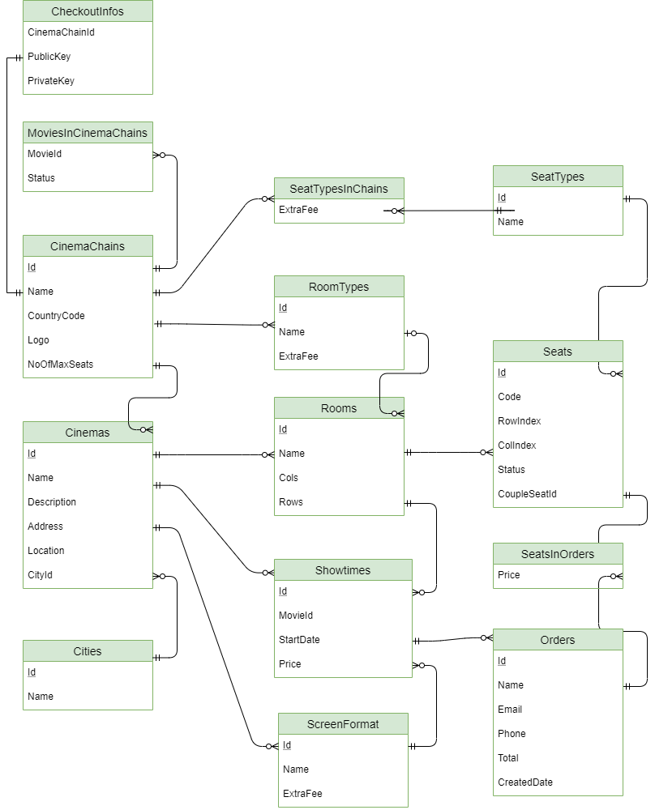

Image 3- CinemaChainAPI

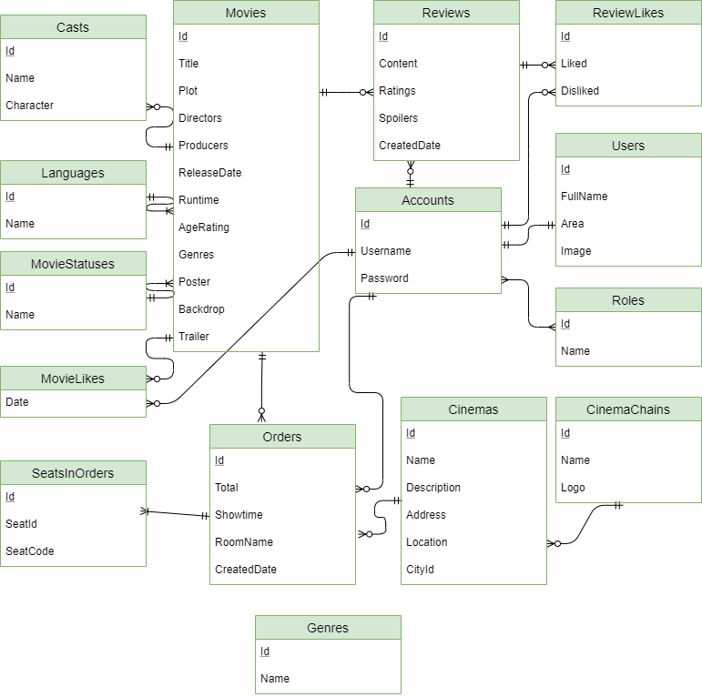

Image 4- MovieReviews&TicketAPI

# 

# CHAPTER 2. SOFTWARE PROCESS

Project is developed using Spiral model. It is a combination of waterfall model and iterative model, helps to adopt software development elements of multiple process models for the software project based on unique risk patterns ensuring efficient development process.

Each phase of spiral model in software engineering begins with a design goal and ends with the client reviewing the progress.

Our team decided to choose the Waterfall model for the following reasons:

- Changes may require at any time

- Development is fast and features are added in a systematic way

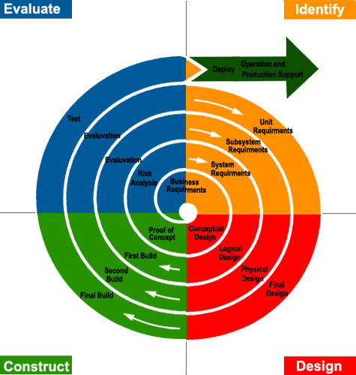

Image 5- Spiral Model

# CHAPTER 3. DESIGN



## Architechture

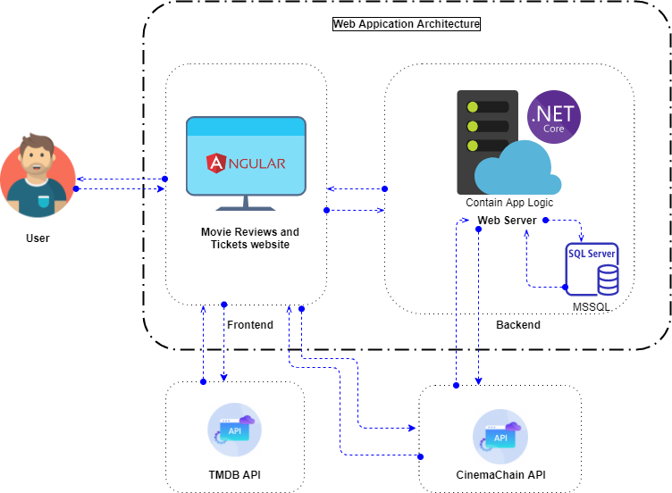

**Figure 3.1.1.** Overview of architectural design for system



## Component



Image 6- CinemaChain Component Diagram



Image 7-MovieReviewsAndTickets Component Diagram

## Class Diagram



### Class diagram description of “CinemaChain_API”

|  |  |  |
| --- | --- | --- |
| **Class Name** | **Map properties with Conceptual diagram** | **Class Description** |
| Cinema | Cinema | Used to save cinema properties: id, name, description, address, location, cinema chain id that it belongs to, city id |
| CinemaChain | CinemaChain | Used to save cinema chain properties: id, name, country code, logo, the maximum number of seats |
| City | City | Used to save city properties: Id and Name of city |
| MoviesInCinemaChain | MoviesInCinemaChain | Used to save movie in cinema chain properties: movie id, cinema chain id that it belongs to, status of movie |
| Room | Room | Used to save room of cinema properties: room id, room name, number of columns and rows, cinema id that it belongs to, room type id that it belongs to |
| RoomType | RoomType | Used to save room type of cinema properties: room type id, room type name, extra fee of room type |
| ScreenFormat | ScreenFormat | Used to save screen format of cinema properties: screen format id, screen format name, extra fee of screen format, cinema chain id that it belongs to |
| Seat | Seat | Used to save seat of cinema properties: seat id, seat code, seat column/row index, room id that it belongs to, if it was a double seat there would be a foreign key pointing to itself, seat type id that it belongs to |
| SeatsInOrder | SeatsInOrder | Used to save seats in order of cinema properties: order id that it belongs to, seat id that it belongs to, price of seat in order |
| SeatType | SeatType | Used to save seat type of cinema properties: seat type id, seat type name |
| SeatTypeInChain | SeatTypeInChain | Used to save seat type of cinema properties: seat type id that it belongs to, cinema chain id that it belongs to, extra fee of seat type in chain |
| ShowTime | ShowTime | Used to save showtime properties: showtime id, movie id, cinema id that it belongs to, room id that it belongs to, cinema screen id that it belongs to, start date of showtime, price of showtime |
| Order | Order | Used to save order properties: order id, name of the customer creating the order, email of the customer creating the order, phone of the customer creating the order, show time id that it belongs to, total price of order, create date of order |
| CheckoutInfo | CheckoutInfo | Used to save checkout info properties: cinema chain id that it belongs to, public key of stripe checkout, private key of stripe checkout |

#### Class “Cinema”

|  |  |  |  |
| --- | --- | --- | --- |
| Property | Type | Access level | Description |
| Id | int | public | Cinema Id |
| Name | string | public | Cinema Name |
| Description | string | public | Description of cinema |
| Address | string | public | Address of cinema |
| Location | string | public | Location of cinema |
| CinemaChainId | CinemaChain | public | Cinema chain id that cinema belongs to |
| CityId | City | public | City id that cinema belongs to |

#### Class “Cinema Chain”

|  |  |  |  |
| --- | --- | --- | --- |
| Property | Type | Access level | Description |
| Id | int | public | Cinema chain Id |
| Name | string | public | Cinema chain Name |
| CountryCode | string | public | Country code of cinema chain |
| Logo | string | public | Logo of cinema chain |
| NoOfMaxSeats | ushort | public | Number of max seats in cinema chain |

#### Class “City”

|  |  |  |  |
| --- | --- | --- | --- |
| Property | Type | Access level | Description |
| Id | int | public | City Id |
| Name | string | public | City Name |

#### Class “MoviesInCinemaChain”

|  |  |  |  |
| --- | --- | --- | --- |
| Property | Type | Access level | Description |
| MovieId | Movie | public | Movie id belongs to cinema chain |
| CinemaChainId | CinemaChain | public | Cinema chain id |
| Status | byte | public | Status of movie in cinema chain: 0 is in theater, 1: in comming, 2: have no showtime schedule yet |

#### Class “Order”

|  |  |  |  |
| --- | --- | --- | --- |
| Property | Type | Access level | Description |
| Id | int | public | Order id belongs to cinema chain |
| Name | string | public | Name of customer in order |
| Email | string | public | Email of customer in order |
| Phone | string | public | Phone number of customer in order |
| ShowtimeId | Showtime | public | Showtime id in order |
| Total | decimal | public | Total order price |
| CreatedDate | DateTime | public | Create date of order |

#### Class “Room”

|  |  |  |  |
| --- | --- | --- | --- |
| Property | Type | Access level | Description |
| Id | int | public | Room id |
| Name | string | public | Room name |
| Cols | int | public | Number of columns in room |
| Rows | int | public | Number of rows in room |
| CinemaId | Cinema | public | Cinema id that room belongs to |
| RoomTypeId | int? | public | Room type id that room belongs to |

#### Class “RoomType”

|  |  |  |  |
| --- | --- | --- | --- |
| Property | Type | Access level | Description |
| Id | int | public | Room type id |
| Name | string | public | Room type name |
| ExtraFee | decimal | public | Extra fee of room type |
| CinemaChainId | CinemaChain | public | Cinema chain id that room type belongs to |

#### Class “ScreenFormat”

|  |  |  |  |
| --- | --- | --- | --- |
| Property | Type | Access level | Description |
| Id | int | public | Screen format id |
| Name | string | public | Screen format name |
| ExtraFee | decimal | public | Extra fee of screen format |
| CinemaChainId | CinemaChain | public | Cinema chain id that screen format belongs to |

#### Class “Seat”

|  |  |  |  |
| --- | --- | --- | --- |
| Property | Type | Access level | Description |
| Id | int | public | Seat id |
| Code | string | public | Seat code |
| RowIndex | int | public | Row index of seat |
| ColIndex | int | public | Col index of seat |
| RoomId | Room | public | Room id that seat belongs to |
| SeatTypeId | SeatType | public | Seat type id that seat belongs to |
| CoupleSeatA | Seat | public | Couple seat that point to seat |
| CoupleSeatId | int? | public | Couple seat id |
| CoupleSeatB | Seat | public | Couple seat that point to seat |

#### Class “SeatsInOrder”

|  |  |  |  |
| --- | --- | --- | --- |
| Property | Type | Access level | Description |
| OrderId | Order | public | Order id that seats in order belongs to |
| SeatId | Seat | public | Seat id that seat seats in order belongs to |
| Price | decimal | public | Total seat price in order |

#### Class “SeatType”

|  |  |  |  |
| --- | --- | --- | --- |
| Property | Type | Access level | Description |
| Id | int | public | Seat type id |
| Name | string | public | Seat type name |

#### Class “SeatTypeInChain”

|  |  |  |  |
| --- | --- | --- | --- |
| Property | Type | Access level | Description |
| SeatTypeId | SeatType | public | Seat type id that seat type in chain belongs to |
| CinemaChainId | CinemaChain | public | Cinema chain id that seat type in chain belongs to |
| ExtraFee | decimal | public | Extra fee of seat in cinema chain |

#### Class “Showtime”

|  |  |  |  |
| --- | --- | --- | --- |
| Property | Type | Access level | Description |
| Id | int | public | Showtime id |
| MovieId | int | public | Movie id of showtime |
| CinemaId | Cinema | public | Cinema id that showtime belongs to |
| RoomId | Room | public | Room id that showtime belongs to |
| ScreenFormatId | ScreenFormat | public | Screen format id that showtime belongs to |
| StartDate | DateTime | public | Start date of showtime |
| Price | decimal | public | Price of showtime |

#### Class “CheckoutInfo”

|  |  |  |  |
| --- | --- | --- | --- |
| Property | Type | Access level | Description |
| CinemaChainId | CinemaChain | public | Cinema chain id that checkout info belongs to |
| PublicKey | string | public | Public key of stripe checkout |
| PrivateKey | string | public | Public key of stripe checkout |

### Class diagram description of “MovieReviewsAndTickets_API”

|  |  |  |
| --- | --- | --- |
| **Class Name** | **Map properties with Conceptual diagram** | **Class Description** |
| User | User | Used to save user properties: user id, user full name, user area, user image, account id that it belongs to |
| Account | Account | Used to save account properties |
| Cast | Cast | Used to save cast properties: movie id that it belongs to, cast name, character of cast |
| Cinema | Cinema | Used to save cinema properties: cinema id, cinema name, cinema discription, cinema address, cinema location, cinema chain id that it belongs to, city id of cinema |
| CinemaChain | CinemaChain | Used to save room of cinema chain properties: cinema chain id, cinema chain name, cinema chain logo, number of max seats in cinema chain |
| Genre | Genre | Used to save genre properties: genre id, genre name |
| Language | Language | Used to save language properties: language id, language name |
| Movie | Movie | Used to save movie properties: movie id, movie original title, movie title, movie plot, movie directors, movie producers, movie release date, movie runtime, movie age rating, movie genres, movie poster, movie backdrop, movie trailer, language id that it belongs to, movie status id that it belongs to |
| MovieLike | MovieLike | Used to save movie like properties: account id that it belongs to, movie id that it belongs to, date that user liked |
| MovieStatus | MovieStatus | Used to save movie status properties: movie status id, movie status name |
| Order | Order | Used to save order properties: order id, order total, order showtime, order room name, order created date, account id that it belongs to, cinema id that it belongs to, movie id that it belongs to, extra fee of seat type in chain |
| Review | Review | Used to save review properties: revview id, review content, review ratings, review spoilers, review created date, movie id that it belongs to, account id that it belongs to |
| ReviewLike | ReviewLike | Used to save review like properties: account id that it belongs to, review id that it belongs to, review liked, review disliked |
| Role | Role | Used to save role properties |
| SeatsInOrder | SeatsInOrder | Used to save review like properties: order id that it belongs to, seat id in order, seat code in order |

#### Class “User”

|  |  |  |  |
| --- | --- | --- | --- |
| Property | Type | Access level | Description |
| Id | int | public | User id |
| FullName | string | public | User full name |
| Area | string | public | User area |
| Image | byte[] | public | User profile picture |
| AccountId | Account | public | Each user has an account id |

#### Class “Account”

|  |  |  |  |
| --- | --- | --- | --- |
| Property | Type | Access level | Description |
| User | User | public | Get user data |

#### Classs “Cast”

|  |  |  |  |
| --- | --- | --- | --- |
| Property | Type | Access level | Description |
| MovieId | Movie | public | Movie id that cast belongs to |
| Name | string | public | Name of actor |
| Character | string | public | Name of actor in movie |

#### Class “Cinema”

|  |  |  |  |
| --- | --- | --- | --- |
| Property | Type | Access level | Description |
| Id | int | public | Cinema id |
| Name | string | public | Cinema name |
| Description | string | public | Description of cinema |
| Address | string | public | Address of cinema |
| Location | string | public | Location of cinema |
| CinemaChainId | CinemaChain | public | Cinema chain id that cinema belongs to |
| CityId | int | public | City id of cinema |

#### Class “CinemaChain”

|  |  |  |  |
| --- | --- | --- | --- |
| Property | Type | Access level | Description |
| Id | int | public | Cinema chain id |
| Name | string | public | Cinema chain name |
| Logo | string | public | Cinema chain logo |
| NoOfMaxSeats | ushort | public | Number of max seats in cinema chain |

#### Class “Genre”

|  |  |  |  |
| --- | --- | --- | --- |
| Property | Type | Access level | Description |
| Id | byte | public | Genre id |
| Name | string | public | Genre name |

#### Class “Language”

|  |  |  |  |
| --- | --- | --- | --- |
| Property | Type | Access level | Description |
| Id | int | public | Language id |
| Name | string | public | Language name |

#### Class “Movie”

|  |  |  |  |
| --- | --- | --- | --- |
| Property | Type | Access level | Description |
| Id | int | public | Movie id |
| OriginalTitle | string | public | Original title of movie |
| Title | string | public | Title of movie |
| Plot | string | public | Plot of movie |
| Directors | string | public | Directors of movie |
| Producers | string | public | Producers of movie |
| ReleaseDate | DateTime | public | Release date of movie |
| Runtime | ushort | public | Movie length |
| AgeRating | string | public | Age rating of movie |
| Genres | Int[] | public | Genres of movie |
| Poster | string | public | Poster of movie |
| Backdrop | string | public | Backdrop of movie |
| Trailer | string | public | Trailer of movie |
| LanguageId | Language | public | Language id that movie belongs to |
| MovieStatusId | MovieStatus | public | Movie status id that movie belongs to |

#### Class “MovieLike”

|  |  |  |  |
| --- | --- | --- | --- |
| Property | Type | Access level | Description |
| AccountId | Account | public | Account id that movie like belongs to |
| MovieId | Movie | public | Movie id that movie like belongs to |

#### Class “MovieStatus”

|  |  |  |  |
| --- | --- | --- | --- |
| Property | Type | Access level | Description |
| Id | byte | public | Movie status id |
| Name | string | public | Movie status name |

#### Class “Order”

|  |  |  |  |
| --- | --- | --- | --- |
| Property | Type | Access level | Description |
| Id | int | public | Order id |
| Total | decimal | public | Total price of order |
| Showtime | DateTime | public | Showtime in order |
| RoomName | string | public | Room name in order |
| AccountId | Account | public | Account id that order belongs to |
| CinemaId | Cinema | public | Cinema id that order belongs to |
| MovieId | Movie | public | Movie id that order belongs to |

#### Class “Review”

|  |  |  |  |
| --- | --- | --- | --- |
| Property | Type | Access level | Description |
| Id | int | public | Review id |
| Content | string | public | Content of review |
| Ratings | byte | public | Rating for movie |
| Spoilers | bool | public | Review content reveal content or not |
| CreatedDate | DateTime | public | Created date of review |
| MovieId | Movie | public | Movie id that review belongs to |
| AccountId | Account | public | Account id that review belongs to |

#### Class “ReviewLike”

|  |  |  |  |
| --- | --- | --- | --- |
| Property | Type | Access level | Description |
| ReviewId | Review | public | Review id that review like belongs to |
| AccountId | Account | public | Account id that review like belongs to |
| Liked | bool | public | Review like |
| DisLike | bool | public | Review dislike |

#### Class “Role”

|  |  |  |  |
| --- | --- | --- | --- |
| Property | Type | Access level | Description |
| Id | Review | public | Role id |
| Name | Account | public | Role name |

#### Class “SeatsInOrder”

|  |  |  |  |
| --- | --- | --- | --- |
| Property | Type | Access level | Description |
| OrderId | Order | public | Order id that seats in order belongs to |
| SeatId | Seat | public | Seat id that seats in order belongs to |
| SeatCode | string | public | Seat code in order |

## Sequence Diagram

### Login



Image 8- Sequence Login

### Add Movie



Image 9- Sequence Add Movie

### Write Review/Rate



Image 10- Sequence Write Review/Rate

### Book Ticket



Image 11-Sequence Book Ticket

# CHAPTER 5. SYSTEM DETAILS



## Document Management System

### Overview

This system will manage all documents, drawings, detailed description of the entire system, helping newcomers in construction and development can read and understand the system quickly and easily.

In addition, this system will make maintenance and upgrades a breeze, or for transferring technology to a new team more easily and quickly.

### Design

#### Architechture

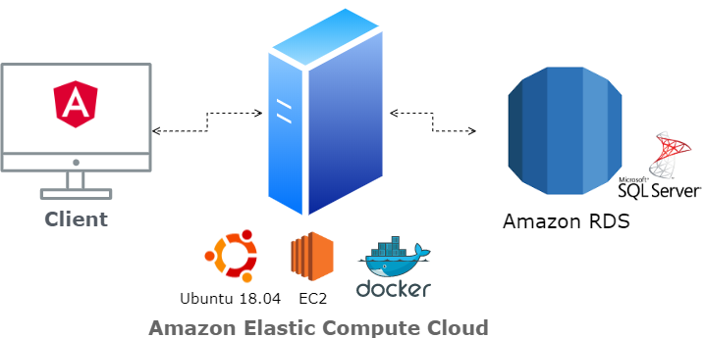

**Figure 5.1.2.1.1.** Architechture of Document Management System

#### Database

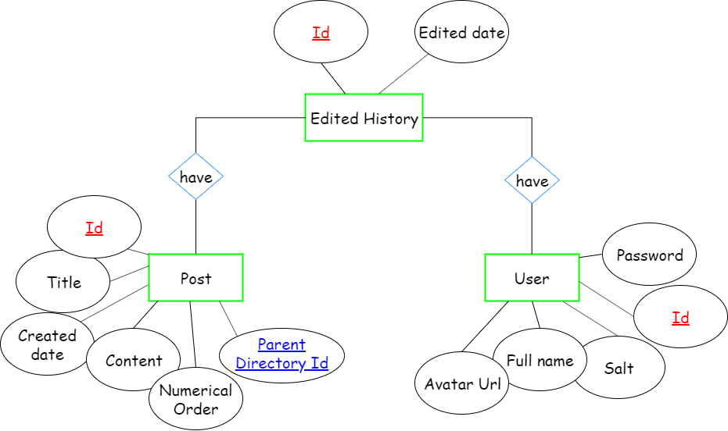

**Figure 5.1.2.2.1.** Entity relationship diagram for Document Management System

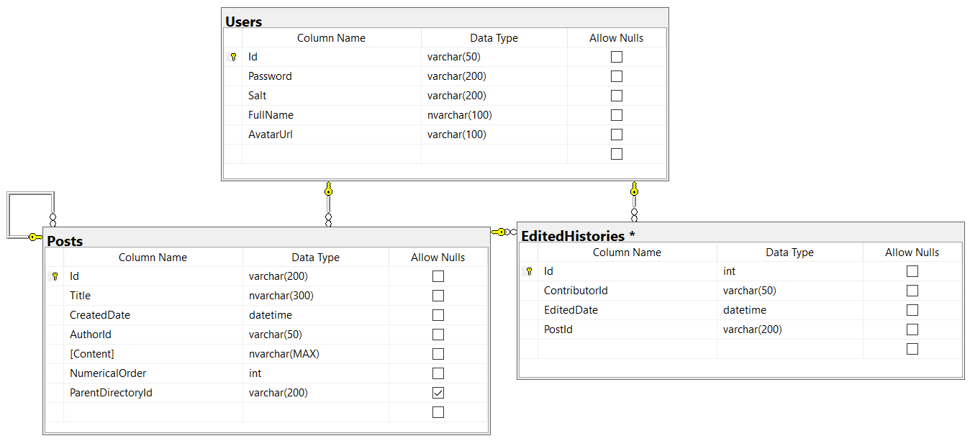

**Figure 5.1.2.2.2.** Database diagram for Document Management System

#### Interface

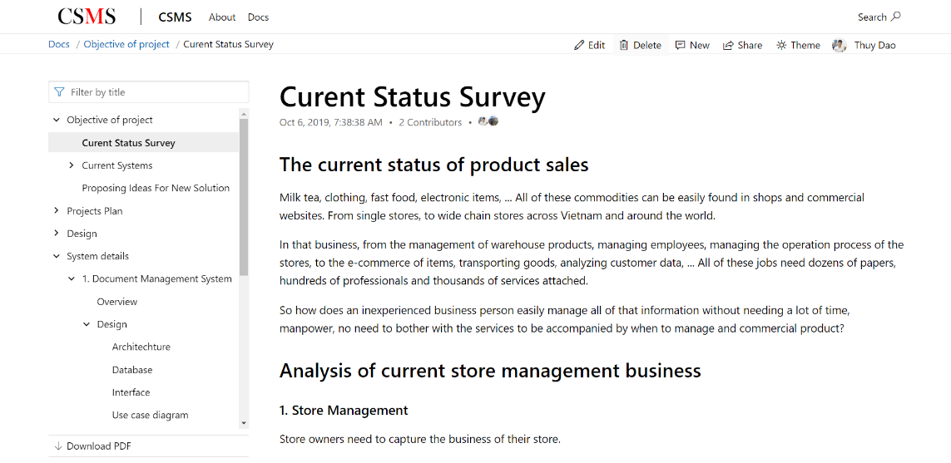

**Figure 5.1.2.3.1.** Main screen of Document management System

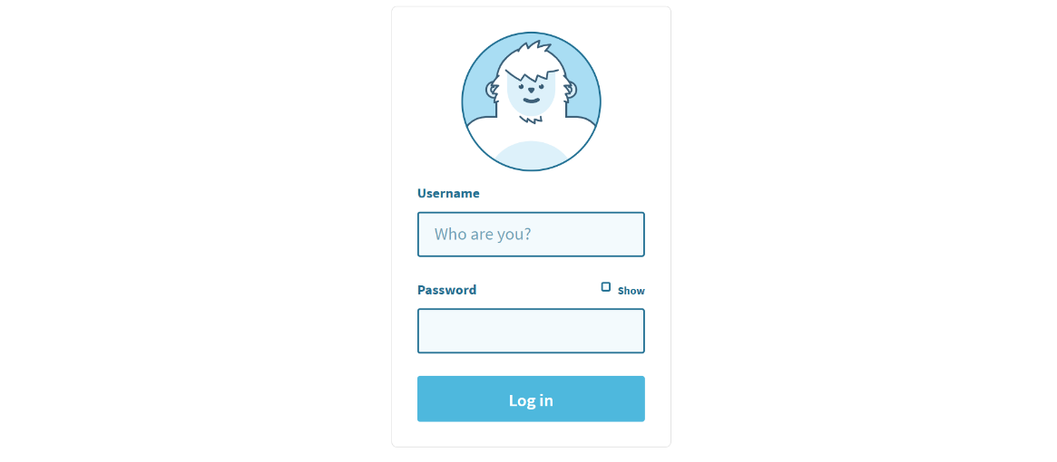

**Figure 5.1.2.3.2.** Login screen for Document Management System

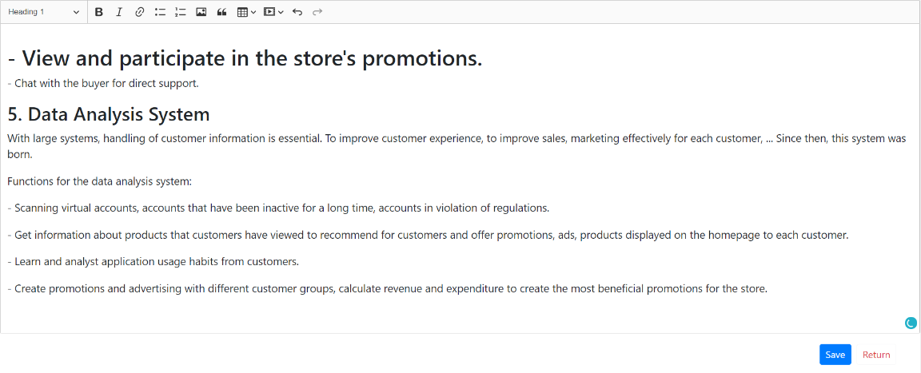

**Figure 5.1.2.3.3.** Edit screen for Document Management System

#### Use case diagram

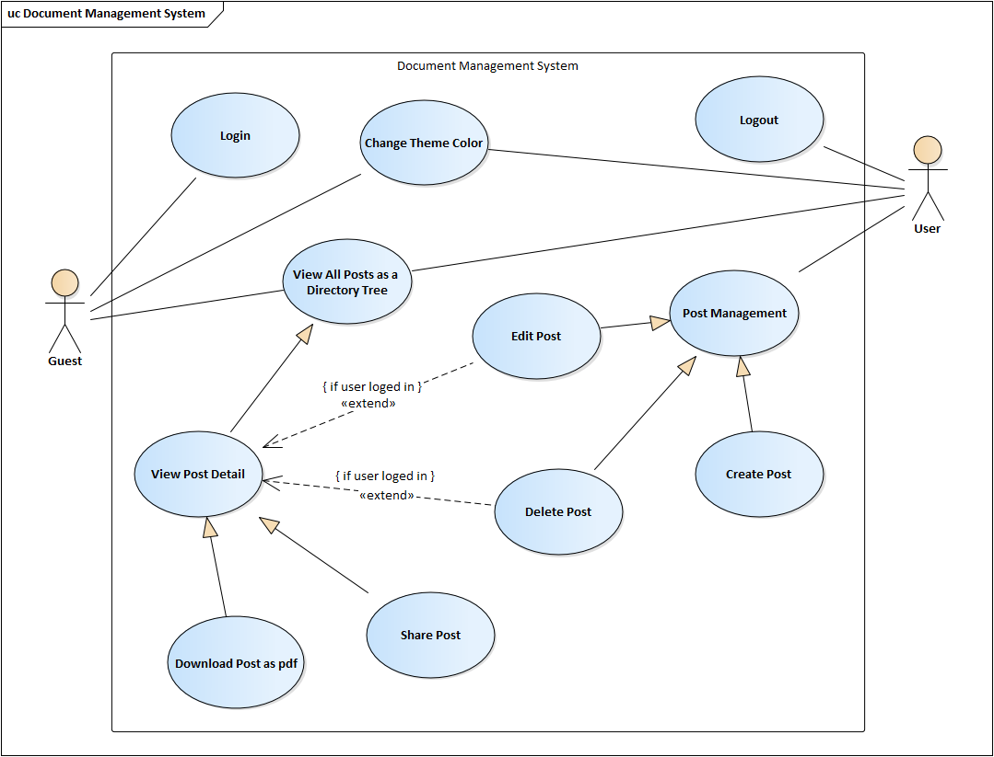

**Figure 5.1.2.4.1.** Use case diagram for Document Management System

#### Sequence diagram

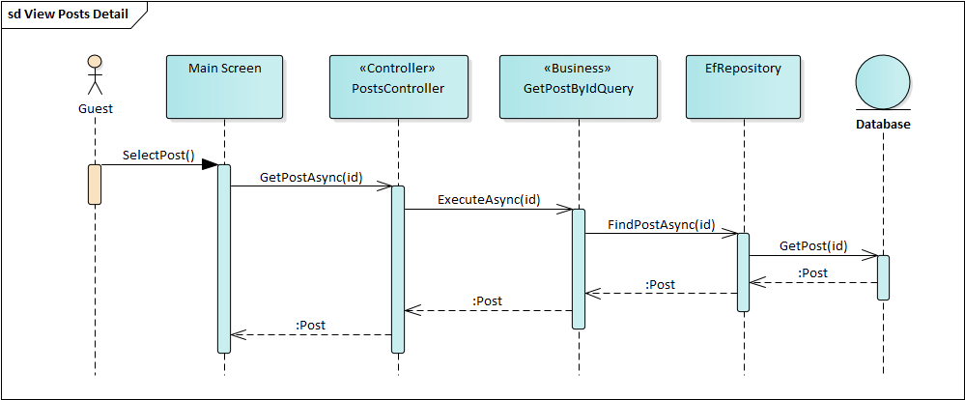

**Figure 5.1.2.5.1.** Sequence diagram for View Post Detail of Document Management System

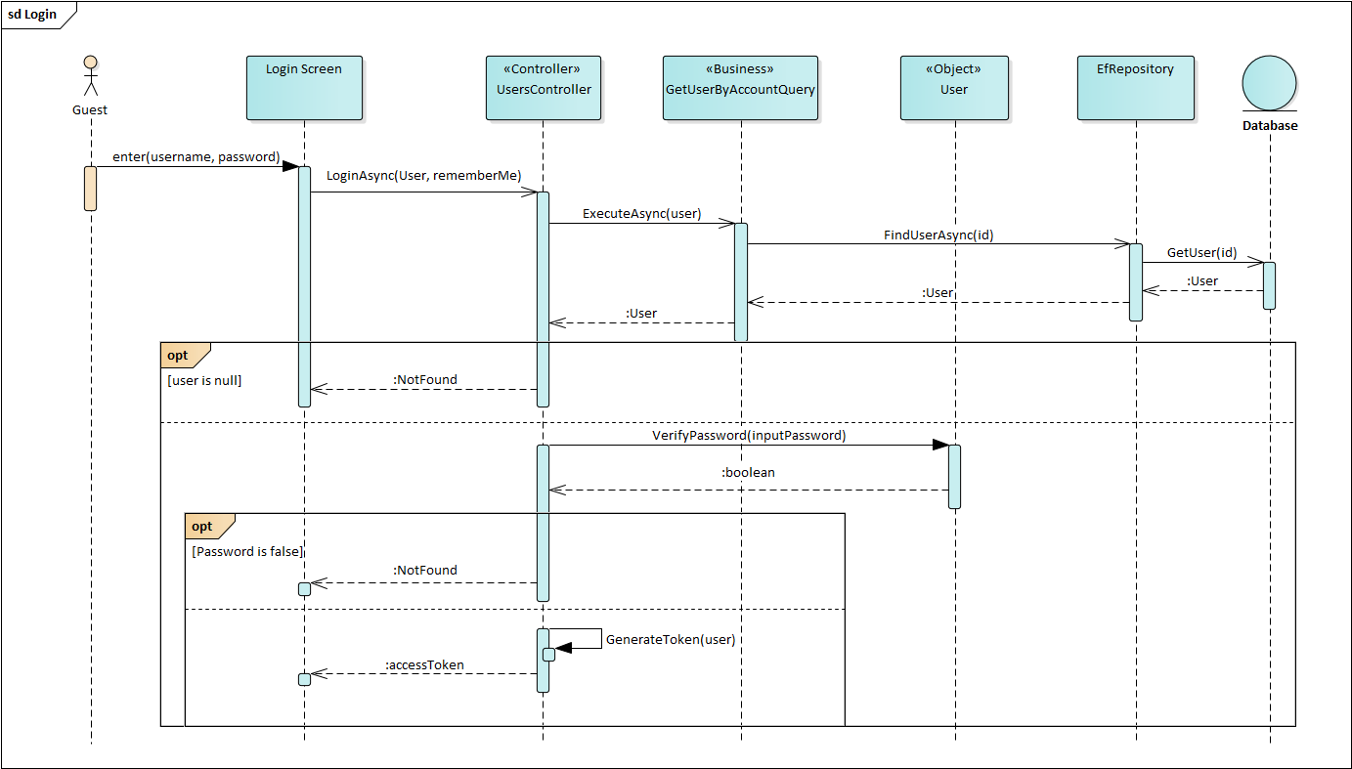

**Figure 5.1.2.5.2.** Sequence diagram for Login of Document Management System

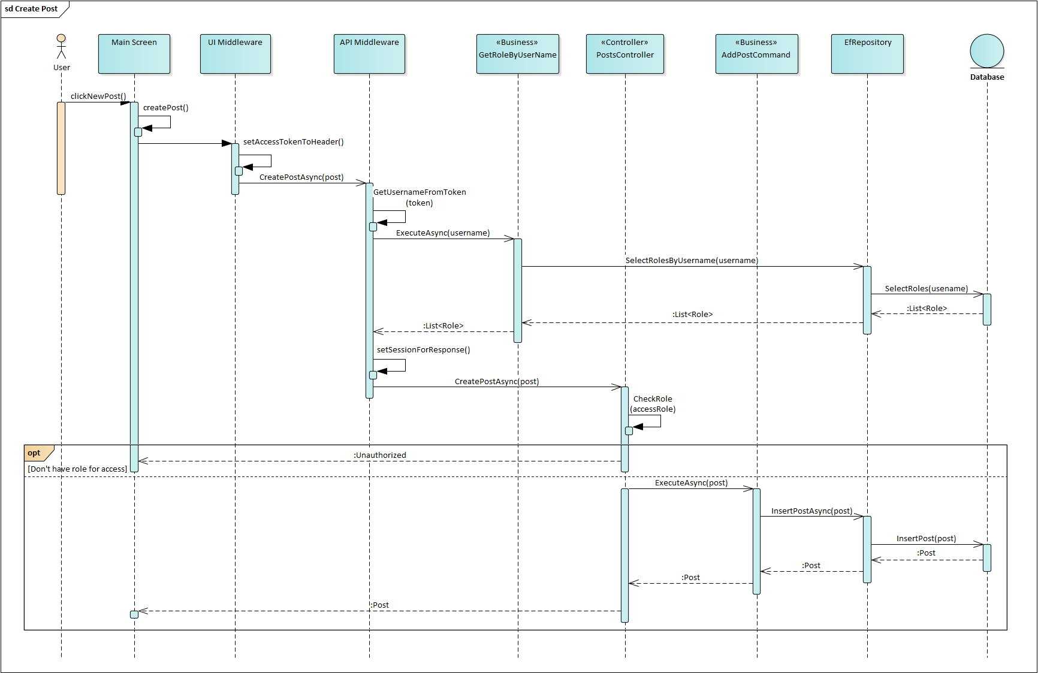

**Figure 5.1.2.5.3.** Sequence diagram for Create Post of Document Management System

### Technologies

In this system, the technologies include:

* User interface using Angular 8.3.2.
* Backend using ASP.NET Core 3.0.
* Database using Microsoft SQL Server 2017.

Operation:

* Database: Amazon Relational Database Service.
* Frontend and backend using Docker container and deploy to Amazon Elastic Compute Cloud (EC2) with Ubuntu 18.04.
* Docker hub address: <https://hub.docker.com/r/thuydx9598/csms.dms>
* Source code: <https://github.com/thuydx9598/csms>

# CHAPTER 6. TECHNOLOGIES

In the project, the technologies will use which is listed in the table below:

**Table 6.1.** Technologies for project

|  |  |
| --- | --- |
| System Architechture | Microservices |
| Docker |
| Transmission Protocol | REST API |
| JSON Web Token |
| User Interface | Angular |
| System Technologies | ASP.NET Core API |
| Entity Framework Core |
| Databases | Microsoft SQL Server |
| Services | SendGrid (Email Sender) |
| Twilio (SMS message) |
| Stripe (Payment Gateway) |
| Thirdly Party | TMDB ( The Movie Database API) |
| Ipinfo.io ( Get Location) |

# CONCLUSIONS

## Results

The project is 90% complete, providing an overview of the architecture and system design. From there, we have an overview for the operation of the store chain management system. Thereby we have a knowledge about the scale and complexity of a large system as well as the security, development and expansion of a commercial project.

## Advantages

* Solve the disadvantages of the current system.
* Building a comprehensive platform architecture on many platforms.
* Solve security issues for a commercial system using microservices architecture.
* Applying research knowledge to build a document management system for the project, thereby applying the theoretical knowledge studied and the basis for building services for the system.

## Disadvantages

* Not surveyed the functionality with actual users yet.
* Performance has not been assessed with the curent security solutions.
* Lack of practical experience in building system architecture.
* Performance has not been compared to a monolithic architecture.

## Development strategy

* Actual survey of functions given to real users.
* analyze, evaluate and compare performance using microservices architecture compared to monolithic architecture.
* Analyze, evaluate and compare the authorization and authentication selected.
* Continue to conplete the project and apply it to stores to keep updating system and fixing bugs.

# REFERENCES

[1] https://moveek.com/

[2]https://www.imdb.com/