**1.**

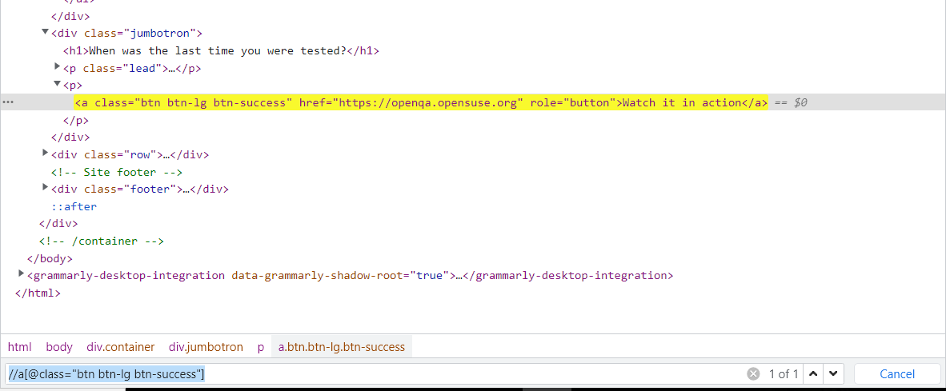

//a[@class="btn btn-lg btn-success"]

**2. Find list elements by Xpath ”Home/Documentation/Download/Contact”**

//ul[@class="nav nav-justified"]

**3. Find an elements using regex**

**Preceding**

- //li/preceding::*

**Preceding-sibling**

* //li/preceding-sibling::* Graphical user interface, text, application

  Description automatically generated

**Following**

**Following sibling**

**Select parent of node “li”**

* //li/..

**Index[]**

* //li[3]

**@attribute**

* //div/div/ul//@href

**Contains**

**And**

* //li[@class="active"] |//div[@class="jumbotron"]

