**Section IV Writing**

1. **Directions:** Suppose an international conference to be held in your university is recruiting volunteers for it. Write a letter to the committee
2. apply for the position, and
3. request an interview

**Do not** sign your own name at the end of the letter. Use "Li Ming" instead.

You do not need to write the address.

**参考范文**

Dear Sir or Madam:

It is my privilege to learn that ***you have a strong passion for recruiting volunteers for an international conference*** currently. Today I, as one of the applicants, am writing this letter to apply for it and tell you a couple of my qualifications for it.

To begin with, I can speak a couple of foreign languages fluently, ranging from English to French and to Japanese, which is significant and indispensable for communicating with foreign experts. To continue, I have rich experience of being volunteers, which can facilitate broadening the horizon about it. Simultaneously, I am convinced that I have potentials to face up to any challenge and conquer it, which is a must for it as well.

I do hope that you will find the application above conducive and practical, and feel free to contact me for the further information about me, hoping you everything goes well.

**或者**：I would appreciate it much if my application were taken into your favorable account, and I am looking forward to your prompt reply, hoping you everything goes well.

Yours sincerely,

Li Ming

**48. Directions:** Write an essay based on the following chart. In your writing, you should

1) interpret the chart and

2) give your comments.

You should write at least 150 words. Write your essay on ANSWER SHEET. (15 points)

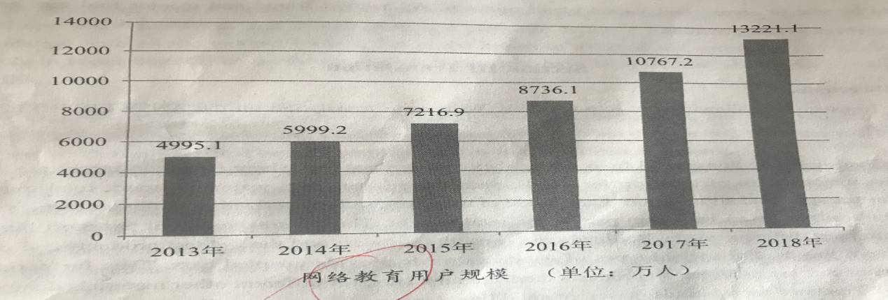

What is demonstrated in the chart illustrate clearly that some remarkable change regarding ***the users of online/internet education*** has occurred during the period between 2013 and 2018. To be specific, the number of them jumped up to amazingly 132211 in 2018 from roughly 87361 in 2016, while the number climbed from approximately 49951 in 2013 to 92169 in 2015.

Simple as this chart seems, the primary reasons behind it are diverse. To begin with, ***internet education may bring huge benefits and great convenience to our daily life***. Therefore, it is widely popular with individuals in ever-mounting numbers. To continue, ***there are various and rich resources online available./there is an obvious improvement in the infrastructure about online education.*** Thus, majorities of folks would award priority to choosing it. Simultaneously, it seems that ***its style*** is one of the factors to trigger this phenomenon.

Overall, I do believe that this momentum about ***the novel learning mode*** will be maintained. Although I am not sure what will come of this trend, it would have a great and profound impact upon our education.