

<SYSTEM>
Definition

Lapland UAS
School of Technology

<Author/Authors>
Version 0.01

Document draft based on applied parts to publication “IEEE Recommended Practice for Software Requirements specifications”, IEEE std 830-1998.

VERSION HISTORY

Version no. | Date | Actions | Author
0.01 | 7.1.2008 | First version of the document base. | M. Mielikäinen
0.02 | 8.1.2008 | Added the interface- and printout parts as well as the version history. | M. Mielikäinen
0.02e | 29.1.2008 | Preliminary English version. | T.Valtanen
Table of contents:

1 INTRODUCTION 4
1.1 Purpose of the document 4
1.2 Objective 4
1.3 Terms and abbreviations 4
1.4 Start materials and references 4
1.5 Overview on the document 4
2 BUSINESS PROCESSES 5
2.1 Current state 5
2.2 Target state 5
3 GENERAL DESCRIPTION 6
3.1 Environment 6
3.2 General functional requirements 6
3.2.1 System interfaces 6
3.2.2 User interfaces 6
3.2.3 Equipment interfaces 7
3.2.4 Software interfaces 7
3.2.5 Communication interfaces 8
3.2.6 Limitations of the memory 8
3.2.7 Operating 8
4 FEATURES 9
4.1 Upkeeping the account of the client 9
4.1.1 Opening a new account 9
5 USERS 10
5.1 User1 (e.g. basic user or a student etc.) 10
5.2 User2 (e.g. administrator) 10
5.3 User3 (e.g. main user) 10
6 CONCEPTS AND DATA STORAGES 11
6.1 Concepts 11
6.1.1 Enterprise 11
6.1.2 Person 11
6.2 Databases 11
6.3 Other data storages 12
7 LIMITATIONS 13
7.1 Regulations 13
7.2 Equipment limitations 13
7.3 Interfaces to other applications 13
7.4 Parallel operations 13
7.5 Verifications 13
7.6 Hig level language requirementst 13
7.7 Handshake protocols 14
7.8 Reliability requirements 14
7.9 Criticality 14
7.10 Safety and information security 14
7.11 Assumptions and dependencies 14
7.12 Portability- and compatibility requirements 14
8 SPECIAL REQUIREMENTS 15
8.1 External interfaces 15
8.1.1 Requirements for the operation 15
8.2 Performance requiements 15
9 ASSUMPTIONS AND DEPENDENCIES 16
9.1 Regulations 16
10 CONTINUATION DEVELOPMENT THOUGHTS 17
11 OPEN TOPICS 18
APPENDIX 19

- INTRODUCTION

Purpose of the document
The reason and forthcoming reading audience of the document will be described.

Objective
The following will be described
- The product should be built on a project name and stated that whom the product will be made for
- What will be done by using the product, and what will not
- What advantage the product grants the client, and what upgrades the product brings to the operation
- What objectives for the development will be set

Terms and abbreviations
All definitions, terms and abbreviations will be provided as a list, so that the client and the supplier are able to ”talk the same language”.

Start material and references
A complete list of materials, dates, author and version numbers, which can be used as a start point of development (for example, pre-definitions obtained from the client). Point out also from where this particular document can be found.

Overview on the document
Description of what the final document will hold and how this particular document has been written.

- BUSINESS PROCESSES

Current state
The current procedure of the organization will be described by using graphical process models (processes and sub-processes). For this UML sequence graphs or QPR Process guide’s supported description method can be applied to.

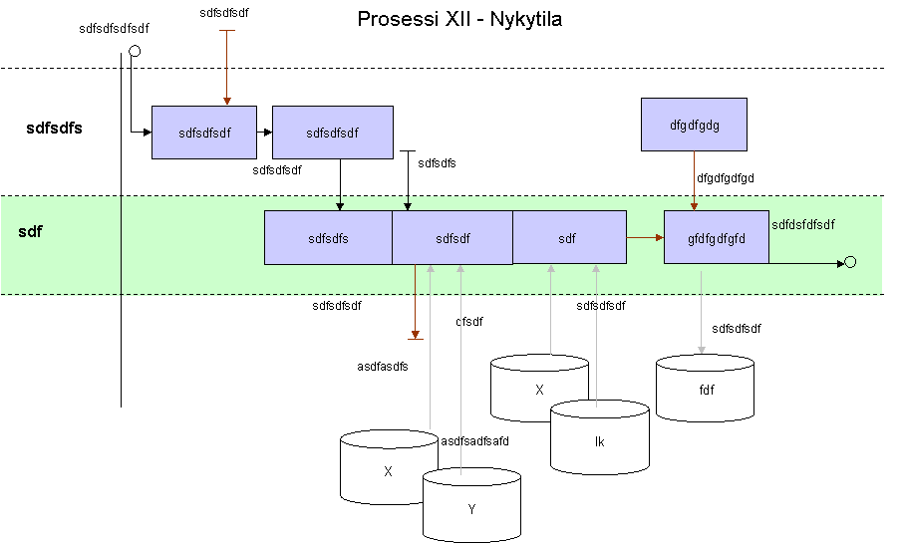

Target state
The forthcoming operation manner will be described, when the system has been built and is supporting the operation processes of the company. The processes and the sub-processes. The descriptions to be done by using graphical models, just as in the previous part.

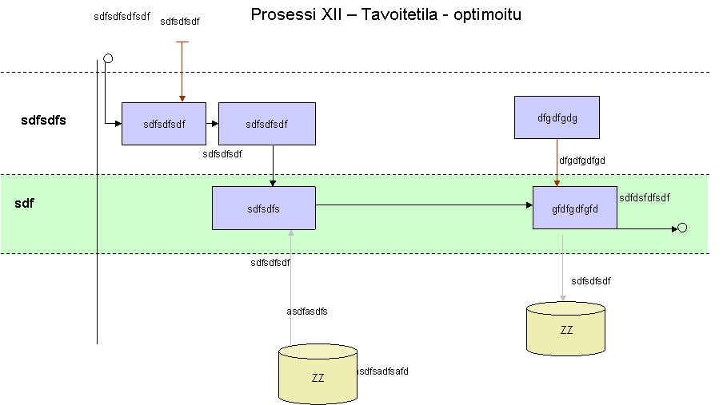
- GENERAL DESCRIPTION

Environment
The description of current products and user groups, which interact with the system being built. Description of interfaces both graphically and verbally.
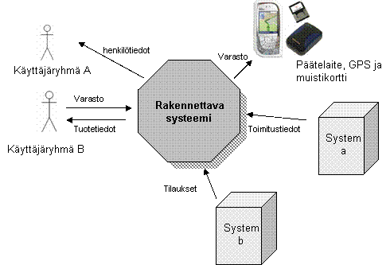
- User groups
- Communication interfaces
- Transitive information

A simplified example.
(Also e.g., UML / Component diagram.)

The verbal description here is rough. In the following chapter 3.2, the components in the environment model will be presented.

General functionall requirements

System interfaces
Name every system, which is shown in the environment model. Explain their general use as well as the use considering the system being built.

User interfaces
In the chapter all requirements set for the user interfaces will be described, which will affect the interactivity between the user and the system. Headline every part separately and create a model below. All requirements presented here are valid throughout the whole system, unless otherwise stated. If there are numerous requirements, a separate requirements list can be used, which will be placed in the appendix.

Below there are a few examples of the general requirements set for user interfaces.

The lay-out-standards for the windows
Many organizations are using an interface layout standard. If such a standard exists, it should be attached to the document.

Hotkey operations
For advanced use, the client can hope for hotkeys, which in such a case will be defined here.

Error messages
The client can still request that all the error messages of the system would be either long and would include guidance, or extremely short messages including, for example, only the phone number of the user support.

Ease of use
If such a requirement is placed, it should have a measure. Such type of requirements can be already written down in the project plan during the project planning phase. They can also be written in this document.

Equipment interfaces
Name every device, which is shown in the environment model. Describe their general use as well as the use considering the system being built.

Obtain an interface description of the device or interface. In the interface description there could be for example: the number of ports, port address, IN-/OUTPUT, protocols etc. or the specifications of the equipment supplier.

Place the interface description in the appendix and reference to it in this document. This way the material is ready when the planning is about to begin.

Software interfaces
In the software interface –chapter the software products, which are required to be used, will be described. The client may have placed requirements for example for the database management system, operations system or even mathematics software. Every presented software interface requirement should be justified. Also every required product should have the following information: name, abbreviation, version number of the specification, version number of the software and the location of the software. Place the specification in the appendix and reference to it in this document.

Communication interfaces
In the chapter the communication interfaces will be described, e.g. the protocols of the Local Area Network. Typically the description has been already made, so it should be obtained and attached to the definition and reference to it in this document. This way the information has already been obtained for the planning phase.

Limitations of the memory
Describe the limitations set for the memory, for example, the size of the system RAM.

Operating
Describe the actions required from the user, e.g. for formatting the device or system, and the requirements to secure or recover the system.

- FEATURES
The chapter includes a list of operations, all on their main and sub-groups. A sub-group includes the use case description. An example below.

Upkeeping the account of the client
Describe the operation generally. Attach also a graphical use case model.

Opening a new account
The topic of the chapter is the name of the use case. Make an own chapter from each use case.
- USERS
The chapter includes a list of roles (user types), each of them as their own headline. These are already been described in the environment model. An example below:

User1 (e.g. Basic user or student etc.)
Basic user
Level of education
Experience
Technical knowledge
Number
Basic responsibilities
Limitations

User2 (e.g. Administrator)
Administrator
Level of education
Experience
Technical knowledge
Number
Basic responsibilities
Limitations

User3 (e.g. Main user)
Main
Level of education
Experience
Technical knowledge
Number
Basic responsibilities
Limitations
- CONCEPTS AND DATA STORAGES

Concepts
The concepts will be described as a concept model (for example, CDM from the designer) as well as in text form into tables.

Physical model (includes data types, also the decisions upon the product has been done) will be placed on planning documents.
For example:

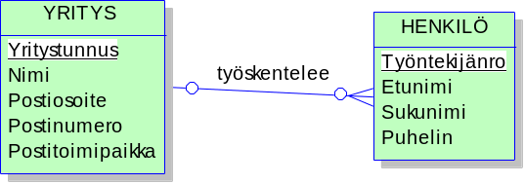

Enterprise

Field | Description | Example data
Enterprise ID | Individual ID of the enterprise | 123456-8
Name | Name of the enterprise | Oy Yritys Ab
Post address | Post address of the enterprise
…

Person
Field | Description | Example data
…

Databases
Each database to be built should be described, including a name (project name) and a short description of its contents. The final placement of concepts/tables to the databases will be done in the planning phase.

If there are databases behind the interface, they can be described here.

Other data storages
Other data storages will be described, e.g. log files, error logs, xml –files etc. on a principled level (name, description, content).
- USER INTERFACE
In the chapter the user interface will be described with both pictures and control tables. Each user interface picture as its own topic, so that they can also be included in the table of contents, to make it easier to be searched for.

Navigation map
A graphical map of navigation, for example:

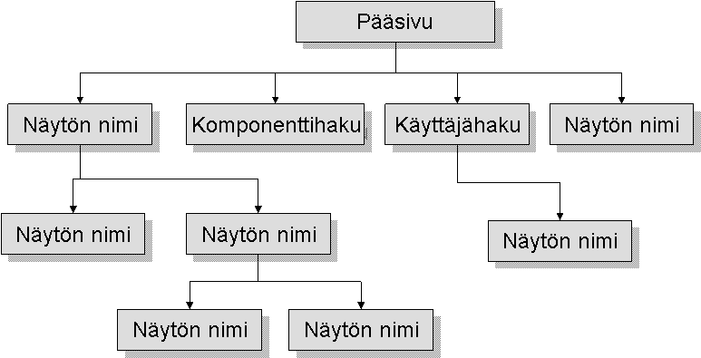

Logging in (for example)
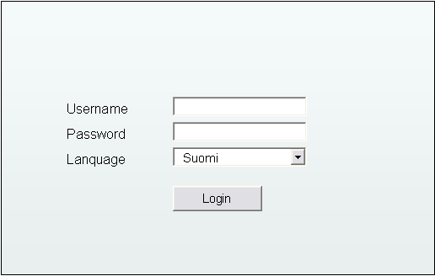

Field | Description | Control | Mandatority
Username | Username | Text field | Yes
Password | Password, masked | Text field | Yes
Lanquage | Usable languages in the system. Default value Finnish. | Drop down menu | Yes
Login | After the check the user will be transferred according to the selection of language to an appropriate front page. Login display will be closed. | Push button

- PRINTOUTS
In the chapter the reports and other (e.g. the display’s) printouts will be described.

Reports
The following subtitles will deal with the contents of the reoprts and there will also be an example of a report (can also be in the appendix). Possible format requirements should be noted.

Report 1

Report 2

Other printouts
The printouts can also be e.g. graphs printed to the display etc. Describe each as their own subtitle.
- LIMITATIONS
The purpose of the chapter is to point out and gather different planning limitations for this particular phase. Typically there are more limitations in e.g. embedded systems.

Regulations
All common laws, standards, guides, rules, royalties, licenses, patents etc. which have any meaning to the development of the system will be described.

Equipment limitations
E.g. clock frequencies, electronic limitations of signals (increase limitations, timings, latencies etc.) will be described. These will be solved in the definition phase, after which they are ready for planning.

Interfaces to other applications
For example clock frequencies, electronic limitations of signals (increase limitations, timings, latencies etc.) will be described. These will be solved in the definition phase, after which they are ready for planning.

Parallel operations
Requirements, which are aimed at parallel operations will be described.
For example in a device there is an operation being executed and at the same time data is being transferred from place to another. It can be that a same operation is being executed without data transfer. What will happen, if in a multitasking system there are multiple processes running?

Verifications
Verificatoins e.g. for the inputs will be described. Such could be e.g. the verification of the form of a social security number and a validity check by a software or a CheckSum after a data transfer.

High level language requirements
Requirements for programming languages will be described. High level languages are e.g. C++. C and Java. (low level languages are for example Assembly or straight bit codes)

Handshake protocols
Requirements for hand shake protocols will be described, e.g. ACK-NACK, XON-XOFF.

Reliability requirements
Requirements for the system’s reliability will be described. For example, the use time of the device is guaranteed and it doesn’t shut down without a warning. Before shutting down, the data is saved.

Criticality
Parts with are extremely critical will be described, e.g. if there is a malfunction in the device, how does it work. (Critical when it comes to airplane industry or life support systems in the hospitals)

Safety and information security
Parts which are set with special information security requirements, will be described. E.g. a password will be encrypted to the database, secured connections, PIN-code checks etc. As an example from safety: is a device able prevent the network jam on its own etc.

Assumptions and dependencies
In this chapter requirements, assumptions and dependencies to the operating environment will be described. Such can be e.g. if the database has a deadlock or is unable to function, can one continue the use of program safely.

Portability and compatibility requirements
In the chapter requirements for versions and their operation environment changes will be described. E.g. this software can read documents made on version 3.0 or newer. Previous versions are not supported or the client at the moment uses Windows XP, but is planning to transfer gradually to Windows Vista.

- SPECIAL REQUIREMENTS
XXXX

External interfaces
Obtain an interface description from each system that is related to the system being built, and place them as appendix and reference to them here. An interface description should include:
- Name of the target
- Use
- Source of the incoming data and the target of the outgoing data
- IN-, OUT- ja IN/OUT-parameters:
  - Example information
  - Value range and accuracy
  - Unit (euros or dollars, seconds or hours)
  - Timing
  - Relation to other parameters
- Format of the display/window, resolution
- Format of the information (e.g. date)
- Format of the commands
- Shutdown messages

Requirements for the operation
Describe special requirements under the subtitle e.g. for handling the parameter data of the interface. For example, how the system should react to a certain parameter value.
In the chapter also formulae and transformations in handling the parameters should be included.

Performance requirements
Describe the set performance requirements for the system.. For example some certain latency of a search should be less than half a second or the system should cope with a peak of more than 2000 simultaneous users.
- ASSUMPTIONS AND DEPENDENCIES
In the chapter the requirements, assumptions and dependencies for the operating environment will be described. Such could be for example, if the database is on a deadlock or unable to function, can one continue using the software safely.

Regulations
General laws, standards, guides, rules, royalties, licenses, patents etc shall be described, which have…

- CONTINUATION DEVELOPMENT THOUGHTS
Possible ideas that rose up during the definition phase will be written down for continuation development afterwards.
- OPEN TOPICS
Free form chapter for the notes of the work group.

APPENDIX
For example, interface descriptions, separate parts from the document (for example, user interface of process description etc.), requirement management list etc..

