CLOSING REPORT
POLESTAR

- Project descriptions and outputs.
To create a prototype interactive wed based campus map, with an intuitive user interface that would allow both new students and visitors to navigate to rooms in all five of the Rantavitikka Campus buildings. Polestar was designed to highlight rooms in A,B,C,D & E buildings simply by entering a room number. Alternatively the use may browse each floor in a selected building.
Create a front end administration login that would allow databases and web server files to be updated without using the back end of the Apache web server and MySQL database.
Create documentation to allow easy modification and administration of the Polestar prototype by a later team of development engineers.

- General estimate

 | Group | 1
 | Project | Polestar
Phase | Hours planned | Hours realized
Specification | 6 | 3
System design | 12 | 5,25
Implementation | 46 | 53,75
Testing | 46 | 0
Management | 30 | 27,5
TOTAL | 140 | 89,5

The reason for my estimates of development running over was because development and testing were performed at the same time, it was difficult and meaningless to separate the two.
The time for testing software was the largest discrepancy from the planned work amounts. In this project there was only one engineer to write code, therefore he was tasked with testing his own code, which considering the type of web system, probably resulted in the fastest turnaround time. Each feature could be tested with each new line of code on the USBwebserver application and Tu made good progress using this immediate test cycle.

- Work amounts

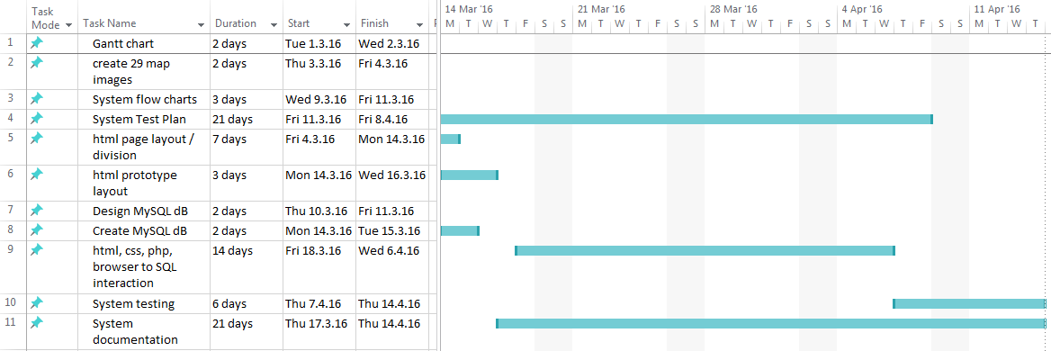

The time for testing software was the largest discrepancy from the planned work amounts. In this project there was only one engineer to write code, therefore he was tasked with testing his own code, which considering the type of web system, probably resulted in the fastest turnaround time. Each feature could be tested with each new line of code on the USBwebserver application and Tu made good progress with this immediate test cycle.
The wen interface to database interaction with jQuery and ajax was scheduled to be completed 7 April, however this was not the case. I had allocated plenty of time to the project, more than was available on the course and due the time demands of other subjects studied, our one engineer didn’t have enough free time outside of class to complete all of the web admin coding. This pointed to a lack of experience on my part, not taking into account the time demands on students in the third year of a batchelor´s degree.

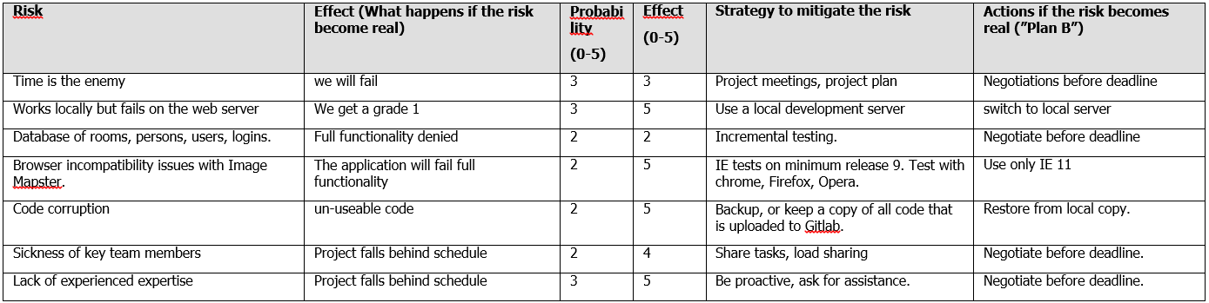
If we look at the Risk Analysis document written 1 March, we can see that time was the number one risk. However I hadn´t singled out database admin as a high risk. As project manager I should have highlighted this feature as a possible non deliverable earlier. Team members hit by sickness or time off also came to play a part. Tu had to miss one week in April, for an embassy visit to renew his visa. There was no workaround for this. Also I had health problems in May hence this report was delivered late.

- Personnel
Persons and their assignments

Tu was assigned the entire USBwebserver coding. This included database design, and all code to search the database for room number and teaching staff name. Tu was also responsible for integrating the application Image Mapster, which provided the room highlighting function. This was required when a successful search returned a room number, Polestar used this integrated functionality to highlight the room on the map.
Artem was assigned the tasks of preparing the floor map with Photoshop, and creating the html coords with the web application Easy Imagemap Generator. Artem also created the Polestar front-end user interface.
I was assigned the task of project manager. My task was to plan, monitor and document the project and necessary resources as it progressed. Ultimately writing the project documentation deliverables upon completion of the project.

- Experiences in tools and methods used
Usability to an assignment
Tu had the heaviest workload and greatest psychological pressure. It is due to his skill and commitment to coding that the project was a success. No one else in the team had the necessary skills in phpmyadmin to make the database function. Once Polestar room and lecturer seach functionality had been proven, Tu uploaded the USBwebserver code to the pLab online Beta server, without issue.
Artem did fine work with Photoshop, especially with the E building floor maps ”graffiti’d” with electricians ”free hand” green lines were perfectly erased. His use of Easy Imagemap Generator created accurate cordinates for floor map boundaries. He then used the html coords with the application Image Mapster to highlight a particular room plan once it had been successfully found with the Polestar search function.
Artem used photoshop with floor maps to ensure high contrast and color schemes, then processed the floor map files with Easy ImageMap application to create html polygon coords. Artem also created the Polestar front-end user interface.
As project manager I had very little previous experience of developing web applications. My previous experience in industry was creating network services that served network nodes, they had no end user interaction. My experience in industry of project managers was one of a certain lack of finess and heavy handedness. With the two motivated engineers in the Polestar team management was limited to just one fifteen minute team meeting each week, resulting in a brief two page work follow up report.
External influences and distractions were something that I wanted to shield my team from. Therefore when the floor maps for E building were un-available, I tasked myself with gaining them. Without E building the campus map would be 20% incomplete, something that I felt may be wrongly considered by others, as a failure of the team. I decided to make direct contact with the Physiotherapy department. Ultimately the E building floor maps were secured, all be it on paper with free hand markings made by electricians in green ink. Photoshop erased the green ink and the direct contact approach circumnavigated the geopolitical situation at LapinAMK.

- Experiences in interest groups
In the LapinAMK Physiotherapy school in Borealis II, or E building, lecturers tested the user interface without issue. The response to a room number search highlighted in pink on the floorplan was one of pleasant surprise. There were no complaints except “Why didn’t we have this before?”
The Vice Rector, 4th floor C building was very impressed with the interactive campus map. He would give the url to visiting guests so that they could navigate to his office. The most impressive feature was the price tag, with no budget used to create the prototype. He believed that the no cost prototype was a “fair exchange” for the Polestar team of IT students receiving a grade 5 assessment. “An all-round win-win student development project.”
Customer, quality, professionals…
- Reusable solutions
The Polestar application is completely re-usable. Both the code and the documentation could be extended and embellished in future projects. The project could be extended to add new buildings and campuses.

- Quality objective realisations
The integration of the application Image Mapster was completely successful. The room flor plan highlighting worked without exception. The room highlighting was probably the most appealing feature of the interactive map. All users found it to be very agreeable.
The failure to provide a web based back end to the data base was the only no deliverable. Lack of experience was the main problem. I as project manager failed to understand the complexity of such a feature. Thus when our programmer started to research the coding, it was soon evident that there was insufficient time. Combined with a forced embassy visit for visa renewal Tu´s available time for this task was insufficient.
Realizing the floor maps for E building was a major success for the team. It made the difference between handing over a partial solution, and delivering an interactive web based map for the whole Rantavitikka Campus.
Documentation including instructions to add further rooms aided the manageability of Polestar by allowing map expansion without using development personnel, thus reducing the overall cost of ownership.

- Summary of the experiences
In the world of the project manager there is no substitute for experience. The non-deliverable feature, the web based database back end, was a result of no previous experience. A more seasoned project manager would have assessed the coding experience of his team and pushed back on higher management and refused to add the feature to the project until more revenue or time was allocated.
Minimum management processes for the production personnel bore fruit. Limiting team meetings to fifteen minutes per week reduced the management over head on engineers allowing them more time to produce quality functioning code. Code functioning without issue was the end goal for the whole project. If I ever need to build a similar project with relational database design, jQuery and ajax methodology, I know where to find two capable engineers.

