Project meeting

Project name: Polestar
Group
Project members: Andrew, Tu Vu, Artem
Date 15.03.2016
Present: Andrew, Tu Vu, Artem.

- General status of the project
The application is has a map based UI. Tu has design an ingenious left pane floor level selector/indicator, and right pane displaying the selected floor map. Tu is currently designing the javascript that will provide this functionality.
Artem has completed the first floor plan polished in Photoshop. The remaining to follow before April 1st.
Andrew is documenting and researching the test tool called AcidTest. This tool tests html code for standards adherence. This will give the first indication of browser compatibility.
- Shedule
Currently the project is on schedule with the exception of task 3, system flow charts, due 12 March. This is an admin task for the project manager, Andrew. He will need to consult with Tu before they can be drawn up in Word or Visio. It does not impede the current work flow.
- Work amounts

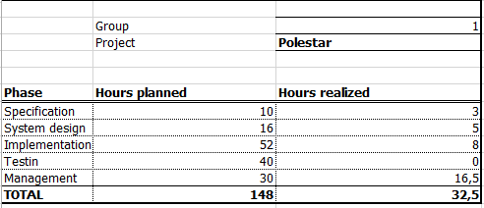

Difficult to assess if all tasks are on time. Will watch to see how long each a floor plan in photoshop takes. Javascript to select floor plan from left pane is technically challenging. Will look for additional expertise next week if it proves to be a tough nut to crack.

- Situation of the previous tasks
No previous.
- Personal tasks for the next period
Artem, continue with photoshop polishing the floor plans.
Tu Vu, continue designing javascript to select floor plan from left pain building floor level. If the code fails, then describe the type of expertise required for external assistance.
Andrew, System flow diagram. Acid test application to test html compliance. Install and test.
- Changes
None.

- Risks and problems
Risk Analysis suggests that working from home with laptops may be the best policy because of the current electrical power issues that we are experiencing in Rovaniemi.

- Next meeting
22.03.2016 plab. 09:00 “coffee pause”.

- Actions
See section 5. No ad hoc actions.

Task | Person responsible | Deadline | Status
Javascript floor plan selection  Else describe expert assistance required. | Tu Vu | 22.03.2016 | OK
Photoshop floor plans, contunue | Artem | 1.04.2014 | OK
System Flow chart, AcidTest. | Andrew | 22.03.2016 | OK

