

Polestar
Web Based Interactive Campus Map

Lapland UAS
School of Technology

Andrew Russell
Version 0.03

Document draft based on applied parts to publication “IEEE Recommended Practice for Software Requirements specifications”, IEEE std 830-1998.

VERSION HISTORY

Version no. | Date | Actions | Author
0.01 | 6.04.2016 | Specs | Andrew Russell
0.02 | 03.05.2016 | diagrams | Andrew Russell
0.03 | 30.05.2016 | diagrams, time estimates, corrections | Andrew Russell
Table of contents:

1 INTRODUCTION 4
1.1 Purpose of the document 4
1.2 Objective 4
2 BUSINESS PROCESSES 5
2.1 Current state 5
2.2 Target state 6
3 GENERAL DESCRIPTION 7
3.1 Environment 7
3.2 General functionall requirements 7
3.2.1 System interfaces 7
3.2.2 User interfaces 7
3.2.3 Equipment interfaces 7
3.2.4 Communication interfaces 8
4 FEATURES 9
4.1 Graphical Diagram of Campus Buildings. 9
4.2 Lecturer Office Search 9
5 USERS 10
5.1 User1 (e.g. Basic user or student etc.) 10
5.2 User2 (e.g. Administrator) 10
6 CONCEPTS AND DATA STORAGES 11
6.1 Databases 11
7 USER INTERFACE 12
7.1 Handshake protocols 12
7.2 Portability and compatibility requirements 13

- INTRODUCTION

Purpose of the document
To inform development team of the current state of the project in terms of software development.

Objective
The following will be described.
The project will be developed as a prototype which will be used by pLab as the starting point for their final web based interactive campus map that has been commissioned by LapinAMK.

- BUSINESS PROCESSES

Current state
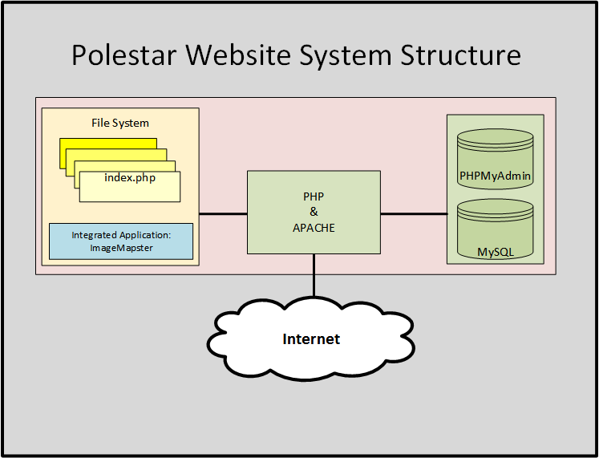

The javascript code that retrieves floor maps from the database is currently non-functional. The processes involved will be described and the component parts assigned to the whole team instead of just one developer. If the issue cannot be defeated by the divide and conquer technique, then it we be escalated to professional support before 12 April 2016.

Target state
The current state lacks a user login to allow web admin database management without using the phpmyadmin backend. Ideally a front end login script would make the application more manageable. We had estimate that a further 3 weeks of coding would allow this feature to be realized, however due to having only one programmer and limited experience, the time has been recalculated as 4 weeks of a full time project during the summer vacation study program.

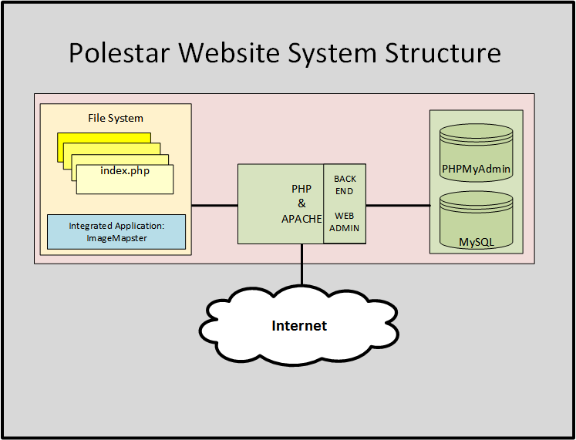
- GENERAL DESCRIPTION

Environment
USB WebServer with a 3rd party application Image Map Star that allows rooms to be high-lighted on the map when selected. The website is coded using html, javascript, php and jQuery/AJAX.

General functionall requirements

System interfaces
Apache web server, SQLite database, phpMyadmin. SQLite is used to build a database of buildings, rooms and teachers. Thus a three table database is used to facilitate all search features.

User interfaces
Web browser with interactive icons and search input box.

Ease of use
The application has been used by fellow students and staff with no formal IT training. We are confident that from out tests with non IT staff, that the interface is intuitive.

Equipment interfaces
Ethernet LAN interface 100Mb or better.

Communication interfaces
Ethernet LAN interface 100Mb or better.

- FEATURES

Graphical Diagram of Campus Buildings.
Campus is comprised of 4 main buildings, A,B,C,D & E block. Each building should highlight when selected on the map. The window pain is split 30% / 70% between floor level on the left and floor map on the right.

Lecturer Office Search
Lecturer office search allows users to enter the name into the search box and the interactive map returns the correct building floor and highlighted office of the member of staff.

Room Search
Room number search, returns the building floor map with the room highlighted in pink.
- USERS
The chapter includes a list of roles (user types), each of them as their own headline. These are already been described in the environment model. An example below:

User1 (e.g. Basic user or student etc.)
Basic user
Level of education | literate
Experience
Technical knowledge
Number | Non
Basic responsibilities
Limitations | Non

User2 (e.g. Administrator)
Administrator
Level of education
Experience
Technical knowledge
Number
Basic responsibilities | MySQLite admin.
Limitations

- CONCEPTS AND DATA STORAGES

Databases
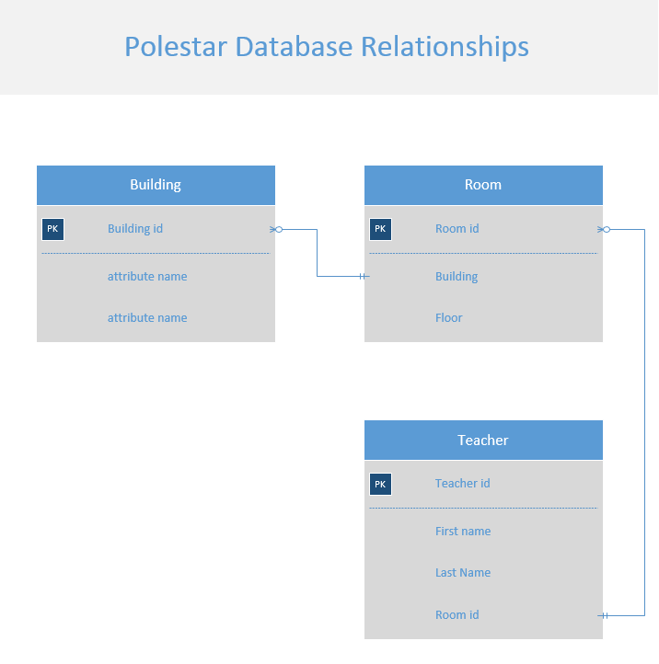

- USER INTERFACE

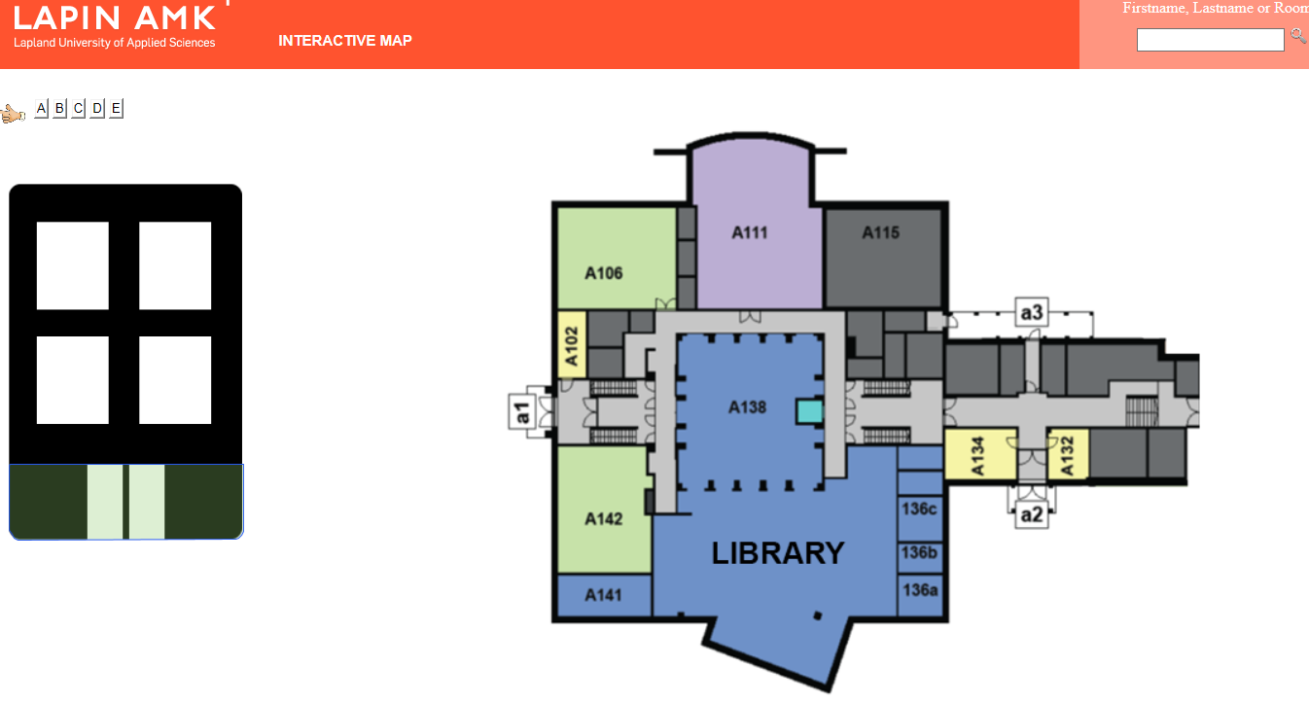

The user interface has a search box to find room numbers on the campus map, ot teacher surname to find the teacher´s office.

Handshake protocols

The Polestar web application uses http for all of its web communications. Thus http is able to switch between reliable connection orientated TCP which is acknowledged communication, and connectionless UDP communication without acknowledgment of receipt. IP (Internet Protocol) is connectionless, and relies on the encapsulated protocol such as TCP, or application to provide reliable communication. IP addressing uses a subnet mask which is used to add granularity to the size of subnets and to add hierarchy to the overall network.

Portability and compatibility requirements
Polestar will run on any web server.

