User stories

User story 1

For the user, I wanted to create a vehicle simulator that could simulate the current situation of urban traffic. Users can add roads, traffic lights and a variety of vehicles to the city. As for the result, the user can get to run the simulator and monitor the traffic. Priority 1, takes 2 days.

User story 2

As for the user, I want to set up a function that allows the user to enter the speed of the vehicle and simulate it on the simulator. The range of vehicle speed is given. Priority 2, takes 1 day.

User story 3

For the user, I want to add a feature that allows the user to save changes made by the user. The user can name the saved file for reloading at any time. Priority 2, takes 3 days.

User story 4

As for the user, I would like to add a function allows the users to reframe whatever the user created and save all the changes. Users can stop the entire simulation and do some editing of the city.

Priority 1, takes 4 day.

User story 5

For the user, I need to make sure that the cars don't crash into each other.Priority 1, 3 days.

Developer stories

Developer story 1

Because developers need to provide a variety of vehicles, roads, and traffic lights for users to layout. Priority 1, 2 days. For the test, abstract the vehicle class and call a method to move the vehicle.

Developer story 2

Because developers need to set different speeds so that users can see the difference. Priority 2, only 1 day. In the test, change the number of cars on the road as the vehicle rate changes

Developer story 3

Because the developer needs to allow the user to save the changes made by the user, the saved content can be reloaded later. Priority 2, takes 3 days. For the testing, save the data as a csv file and read the file whenever needed.

Developer story 4

When the user wants to edit the city and save all the changes, the developer needs to terminate the emulator. Priority 1, 4 days. For tests, stop the entire emulator and save the current state, then change the mode to edit mode.

Developer story 5

Because the developers need to calculate the distance between the vehicles and arrange the vehicle rates according to the distance to avoid collisions. Priority 1, 3 days. During the test, the length of the existing road and the length of the vehicle are calculated to determine the maximum speed.

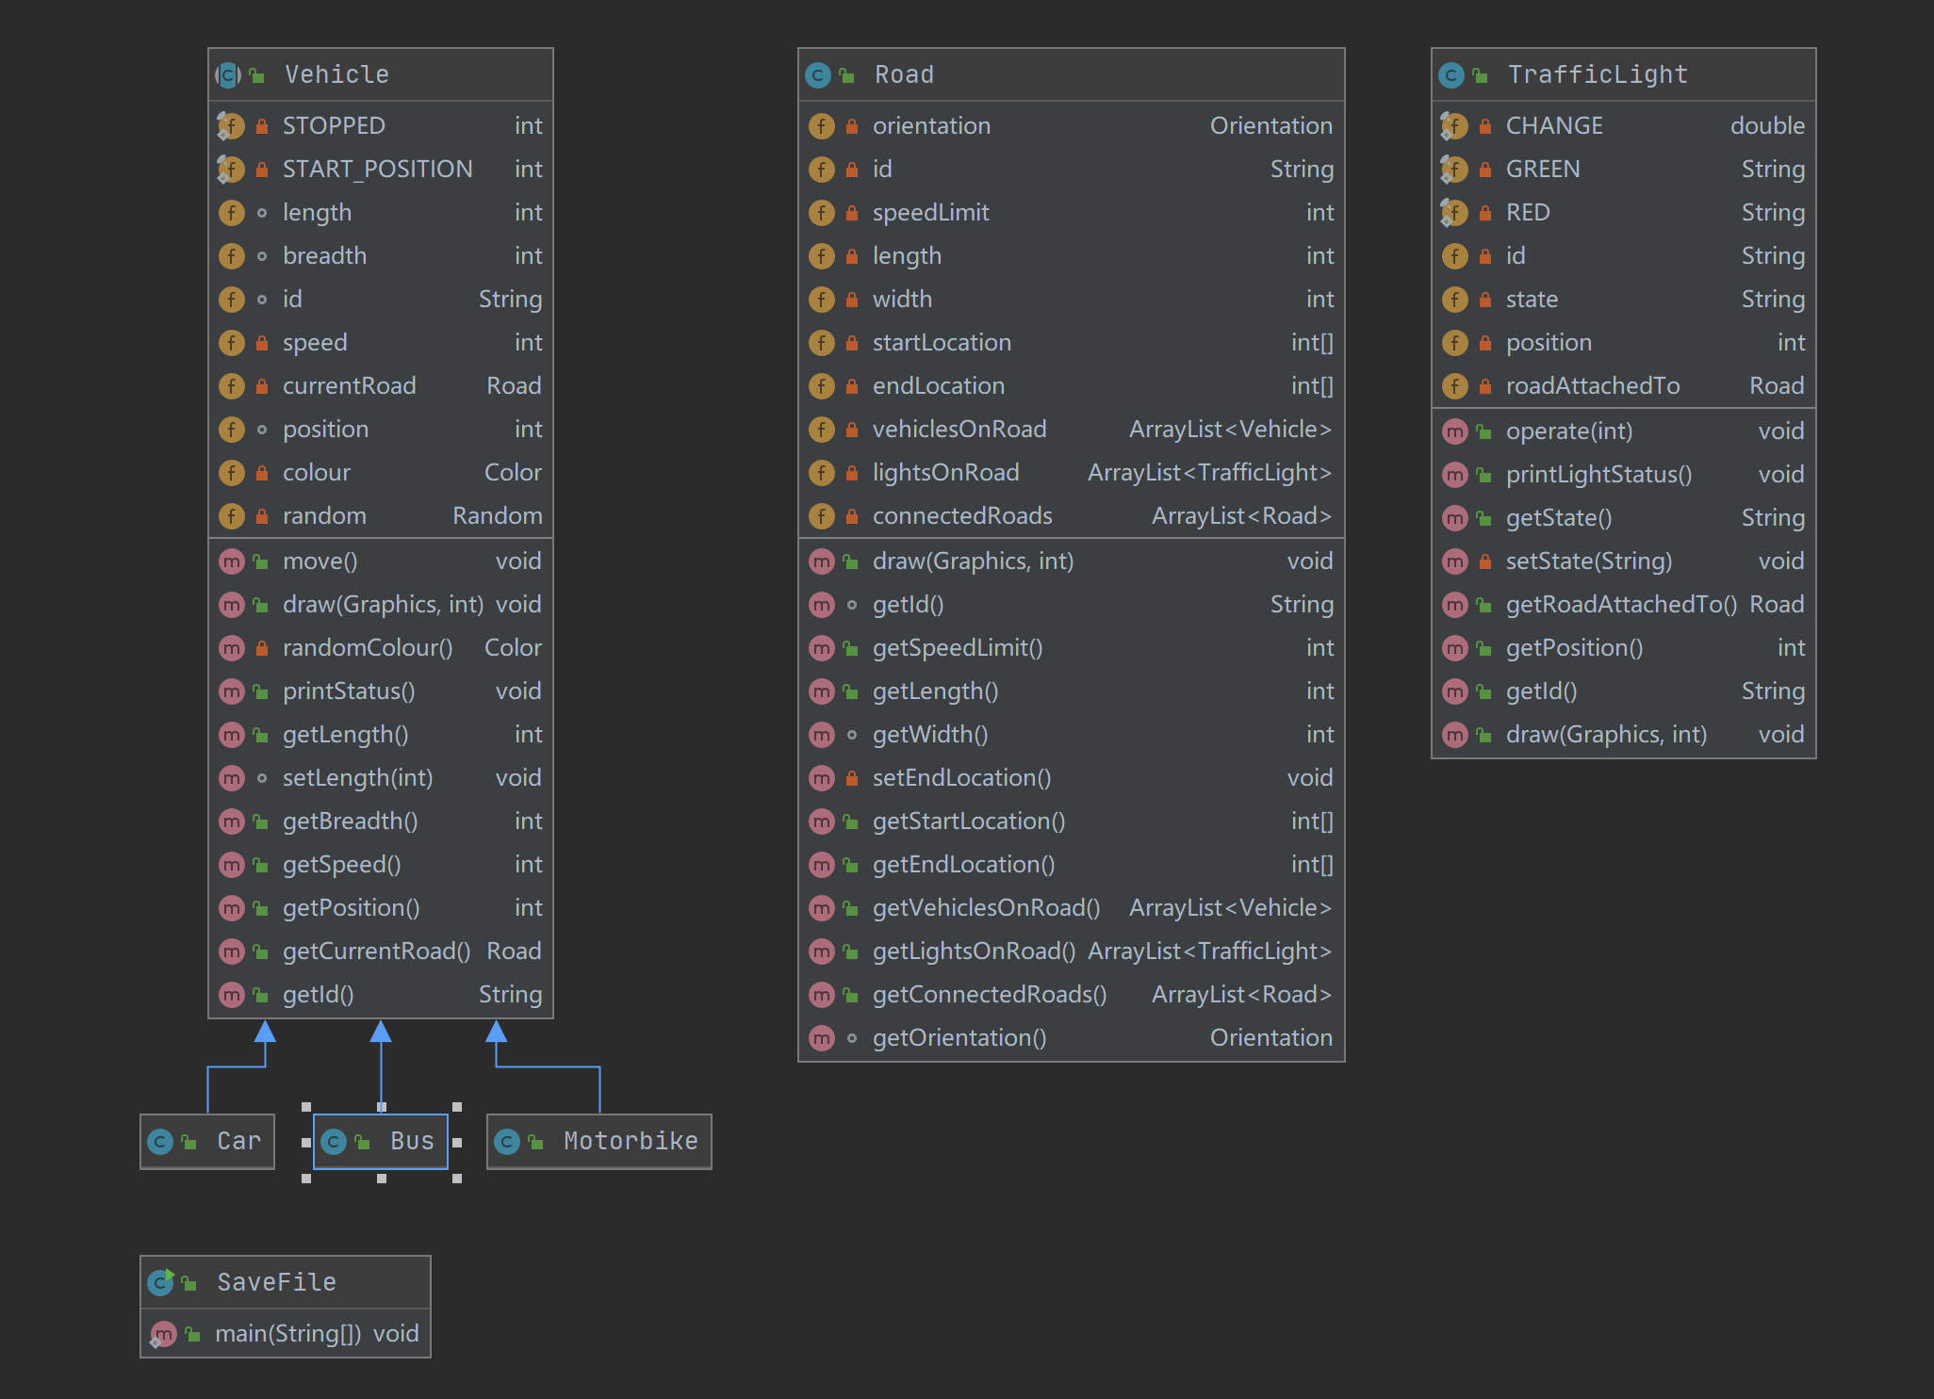

Github