According to agaricus-lepiota.names, I choose these attributes:

* odor=NOT(almond.OR.anise.OR.none) **odor=a OR *l* OR n**
* spore-print-color=green **spcolor=r**
* odor=none.AND.stalk-surface-below-ring=scaly.AND. (stalk-color-above-ring=NOT.brown) **odor = n AND ssbelow = y AND scabove != n**
* habitat=leaves.AND.cap-color=white

OR population=clustered.AND.cap_color=white

**habitat = *l* AND ccolor =w OR popnum = c AND ccolor = w**

**PCA**

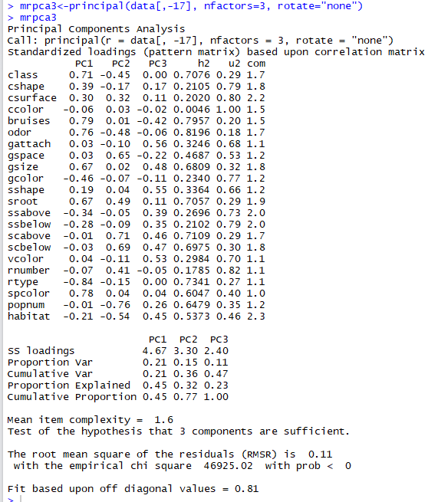

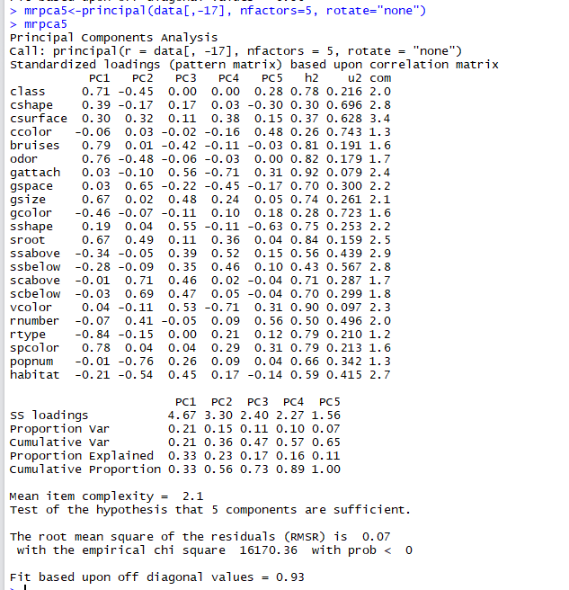

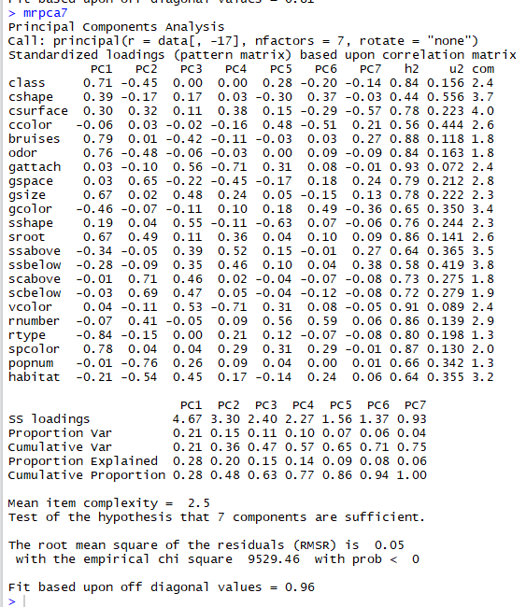

**analysis cluster的三种方法为：KNN \Kmeans\pam ，团簇选择参数为 3 /5/ 7，结果如下**

**KNN：**

**Training 70%：**

**K = 3**

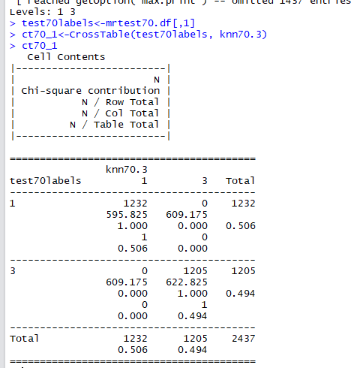

**K=5:**

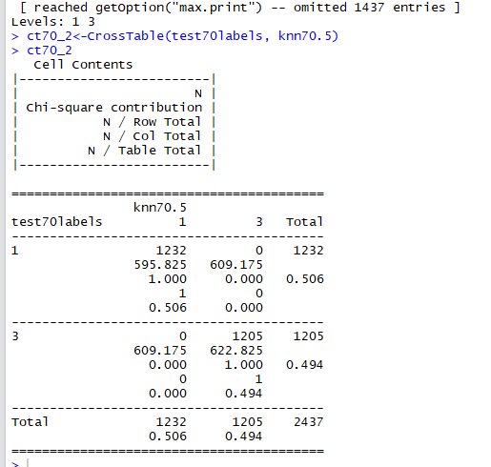

**K=7**

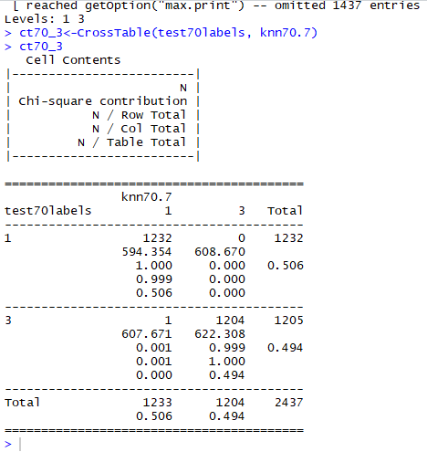

**Training 60%**

**K=3**

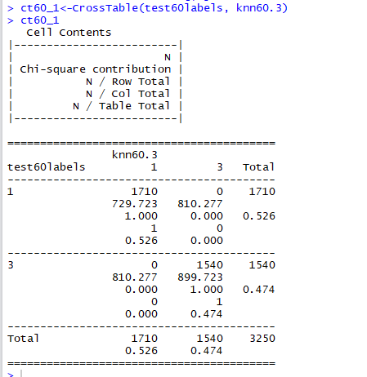

**K=5**

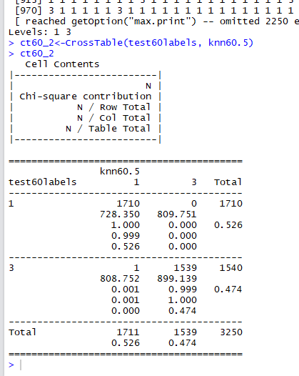

**K=7:**

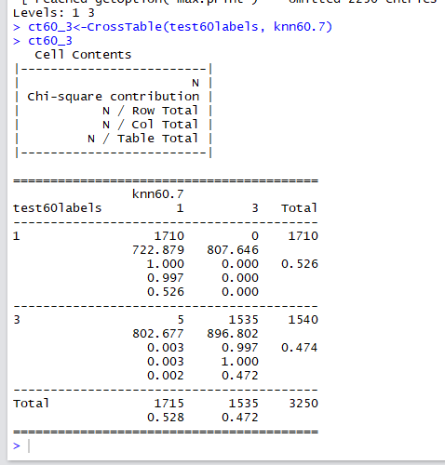

**Training 50%:**

**K=3**

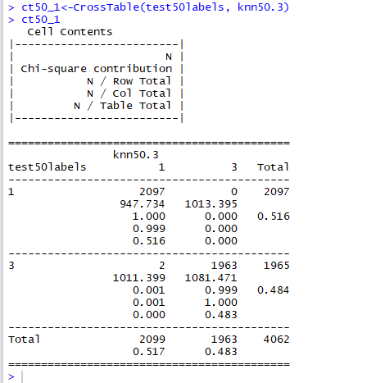

**K=5**

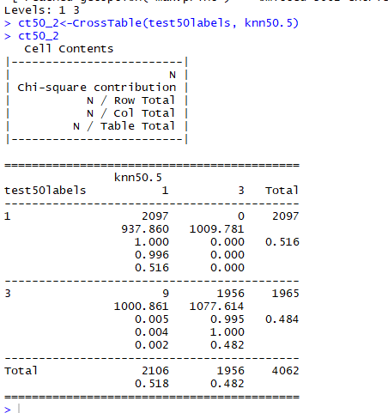

**K=7**

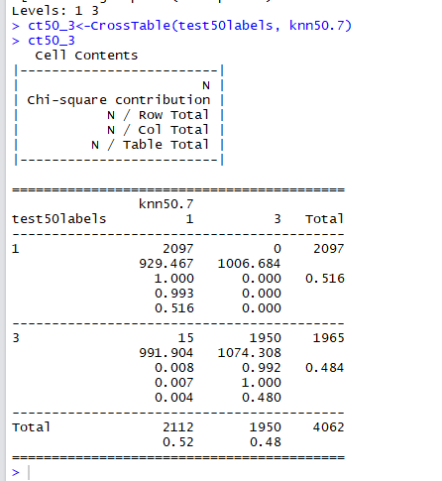

**Kmeans:**

**K=3**

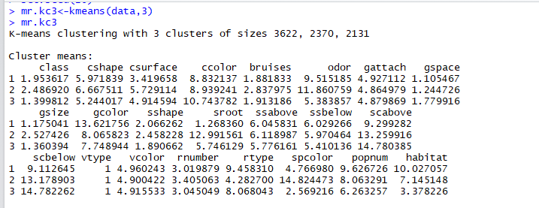

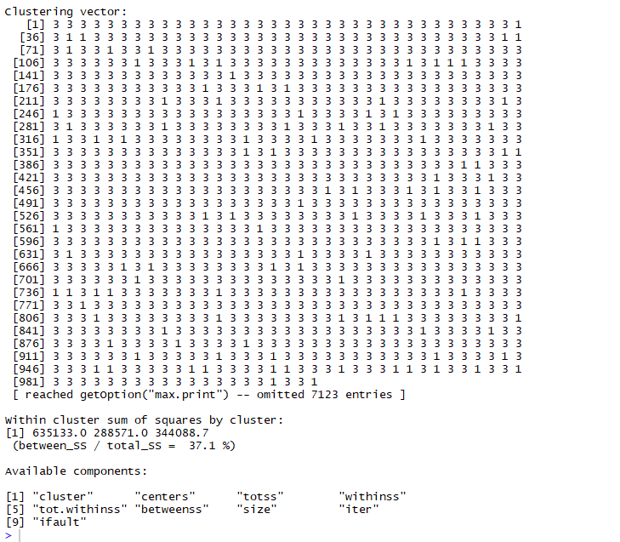

**K=5**

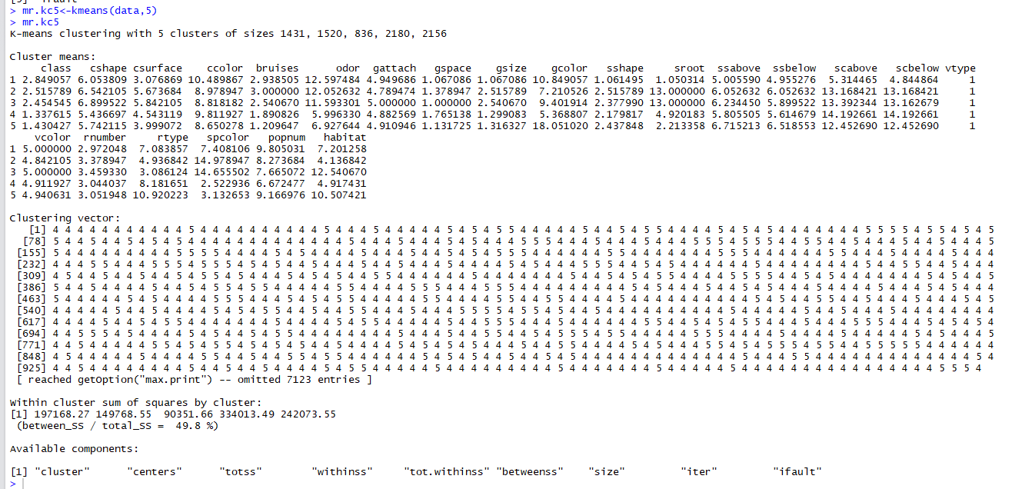

**K=7**

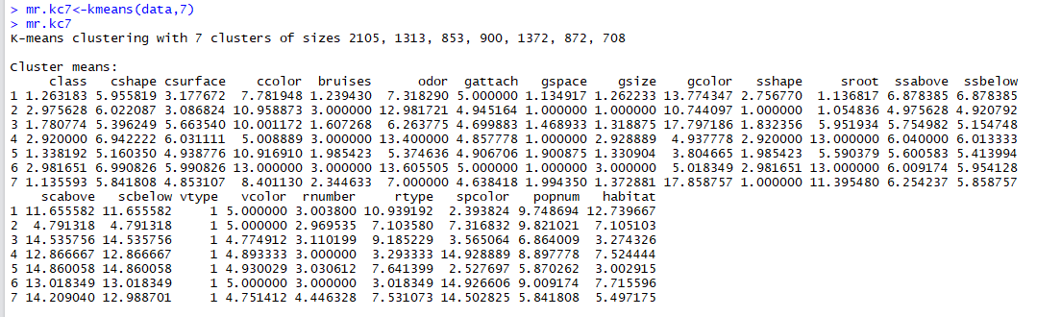

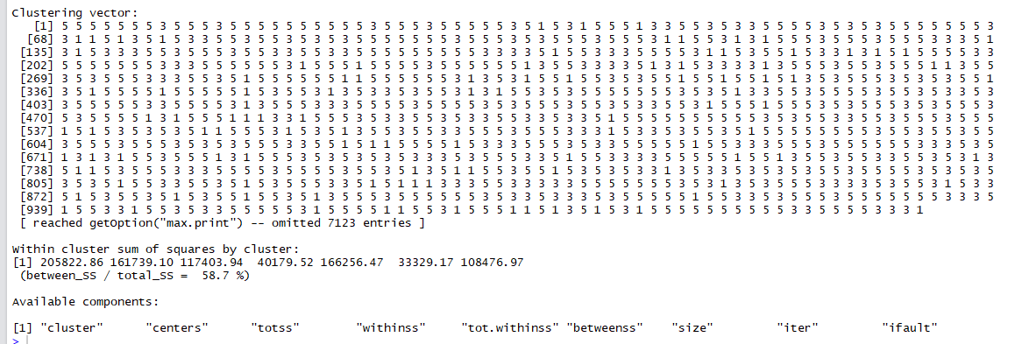

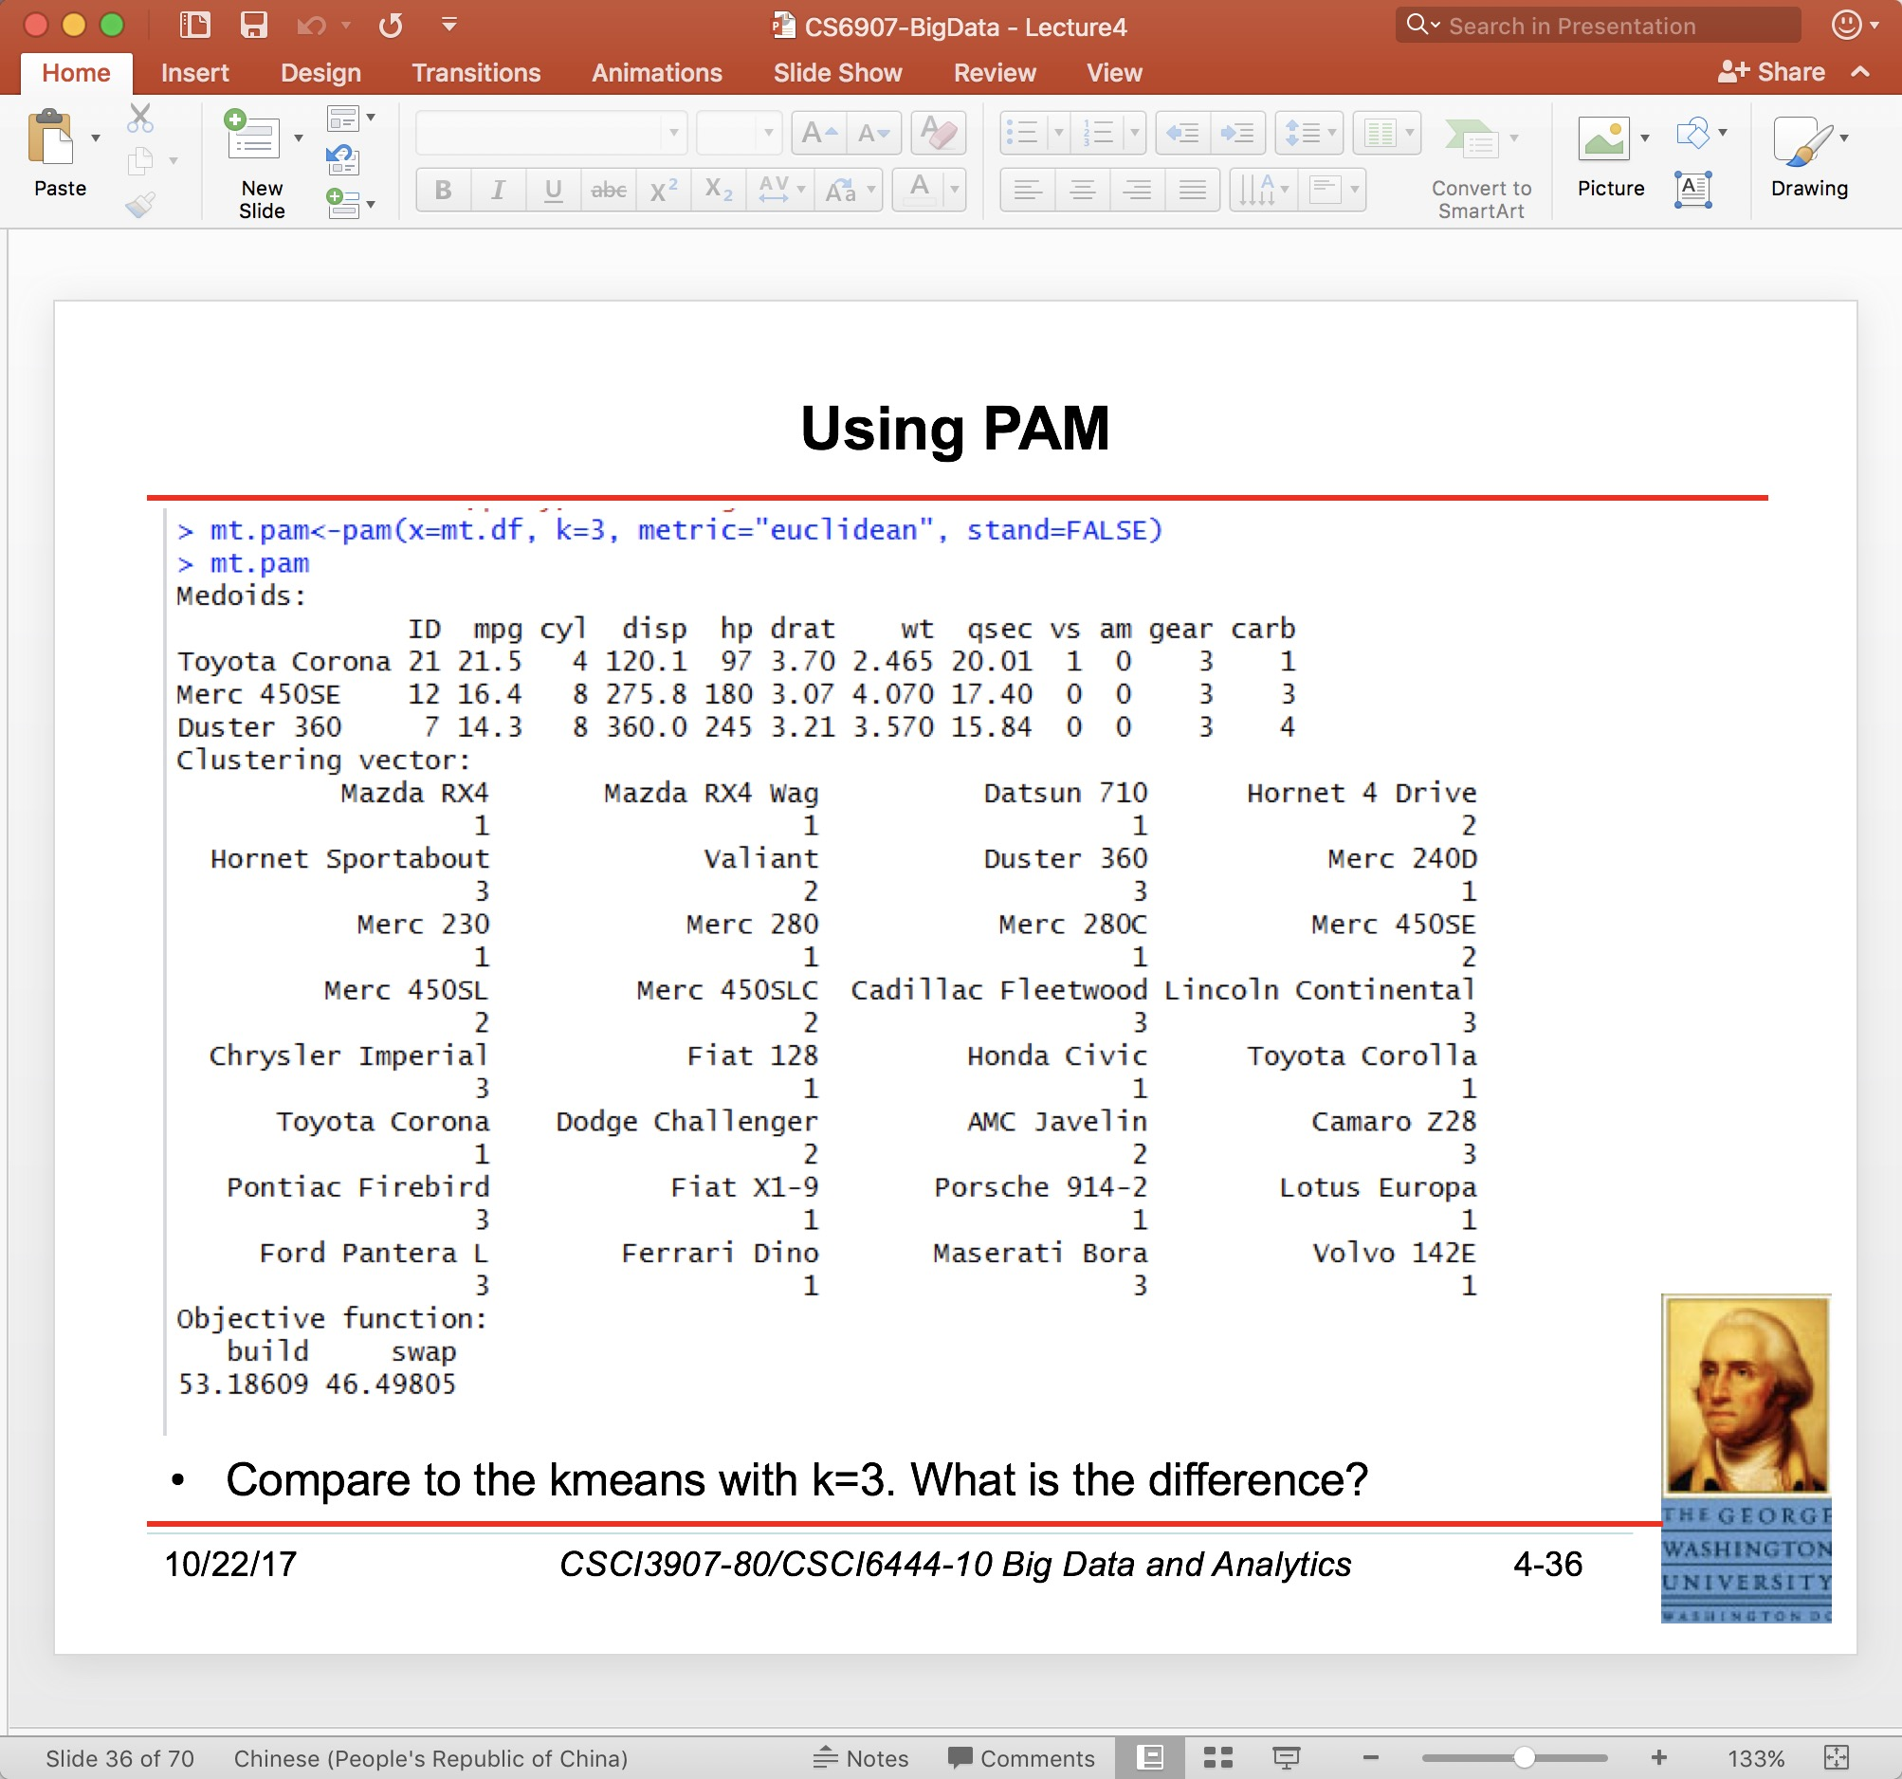

**k=3:**

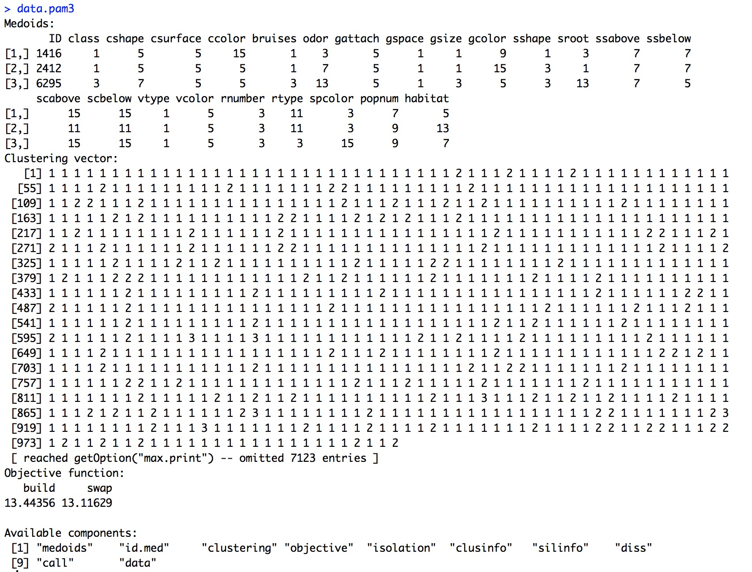

**k=5:**

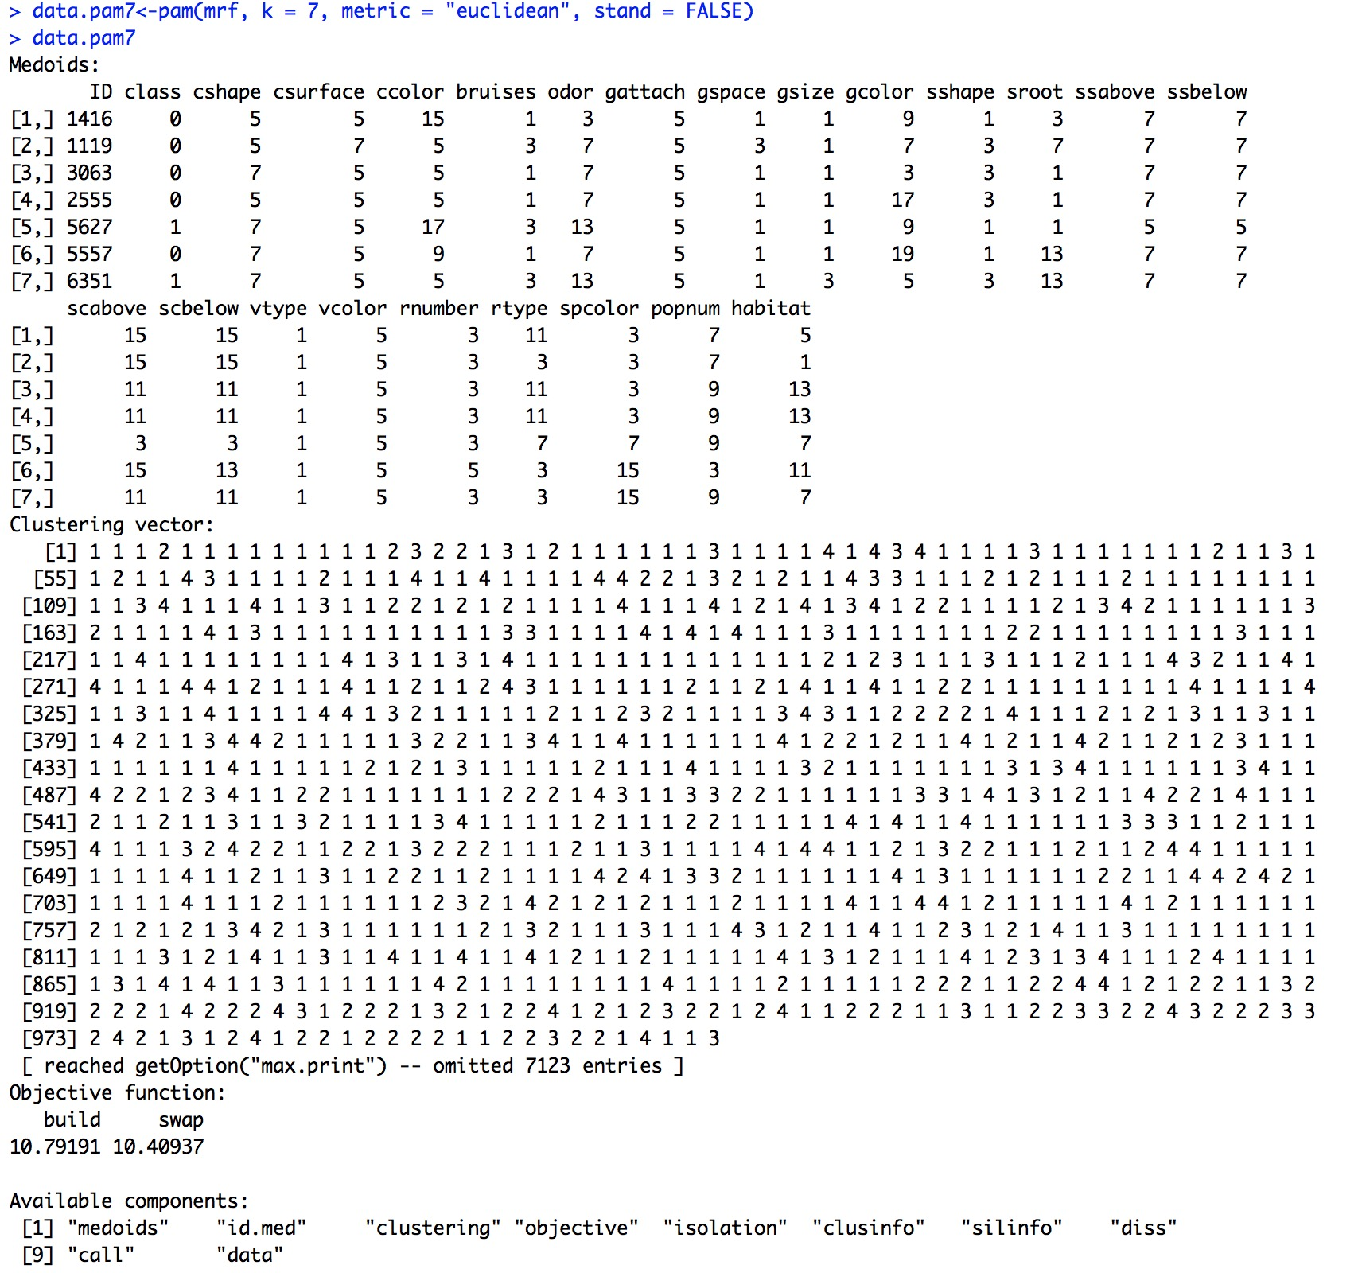

**k=7:**

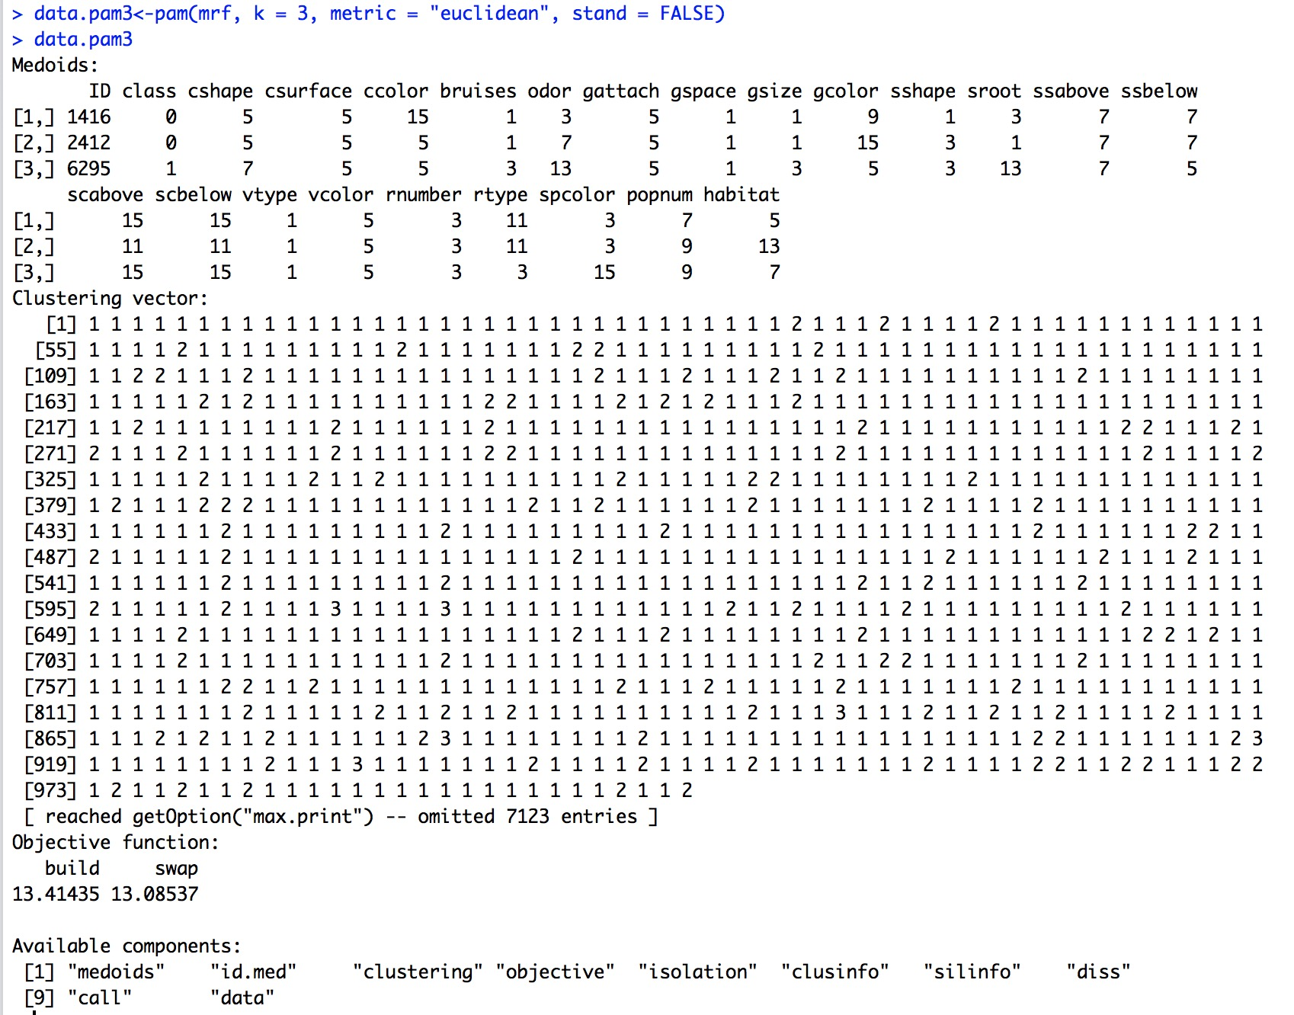

**LM：**

**Training70：**

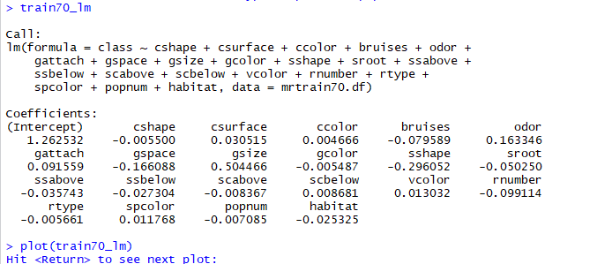



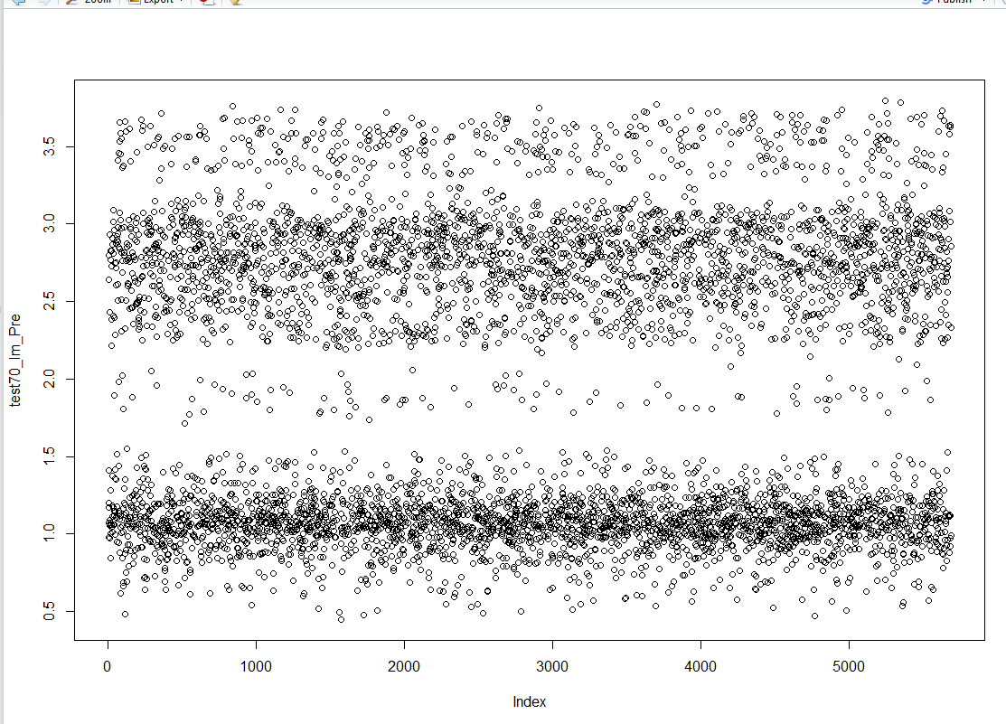

**Training 60：**

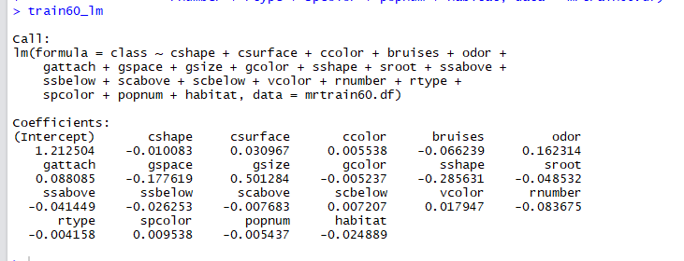

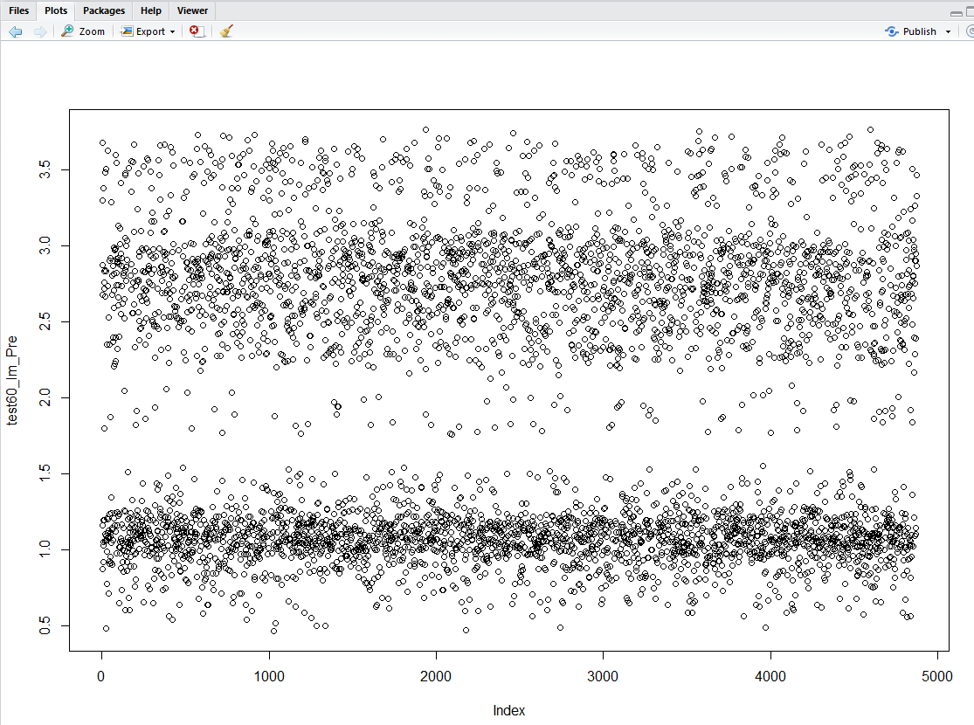

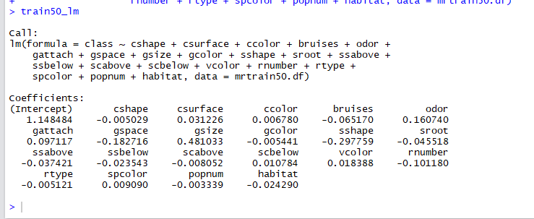

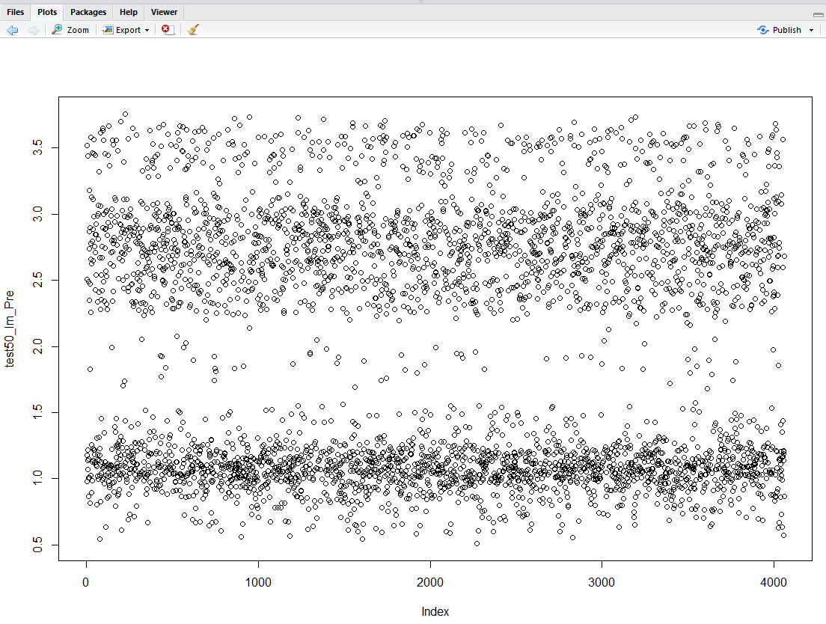

**GLM：**

**Training70：**

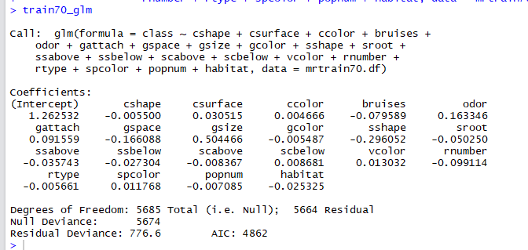



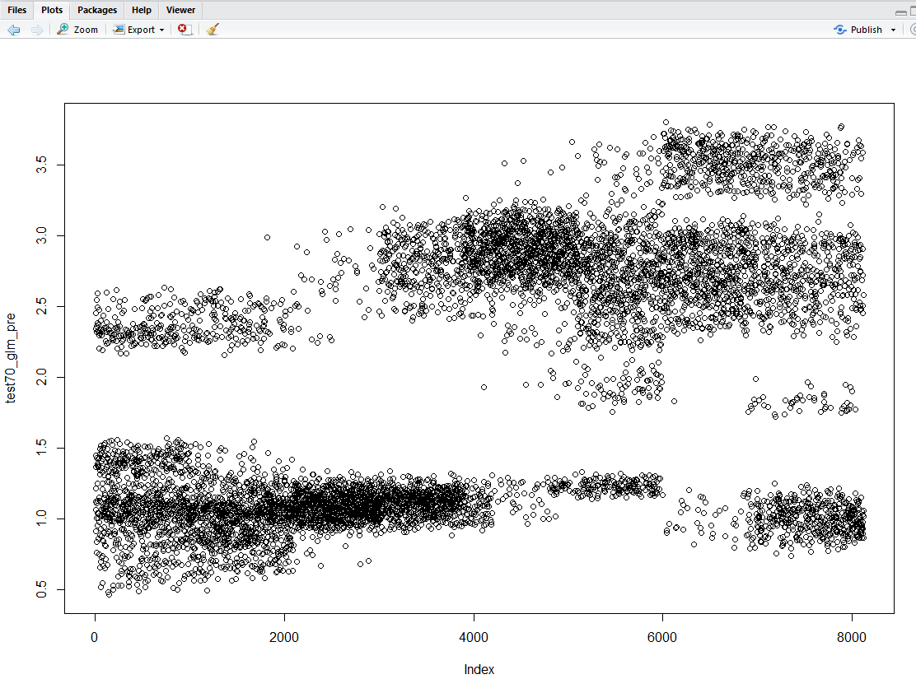

**Training60：**

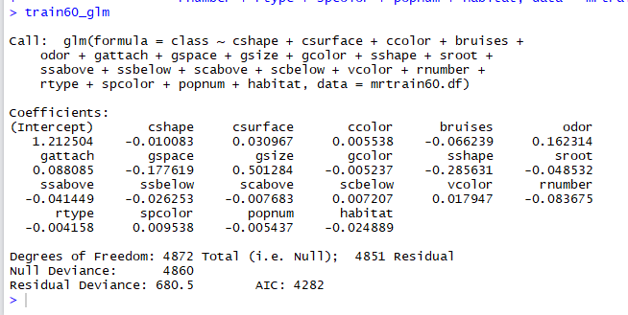

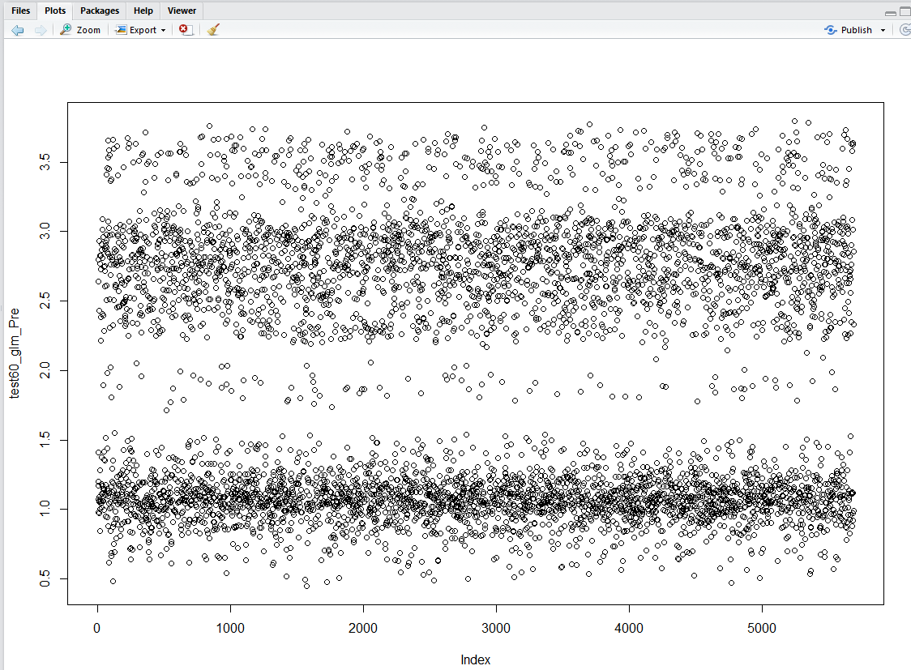

**Training50%**

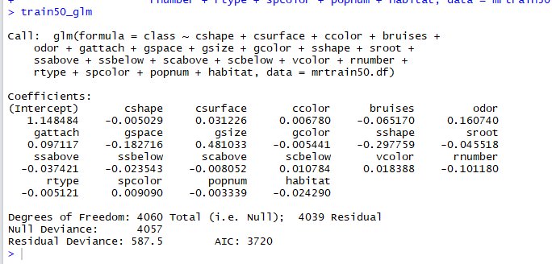

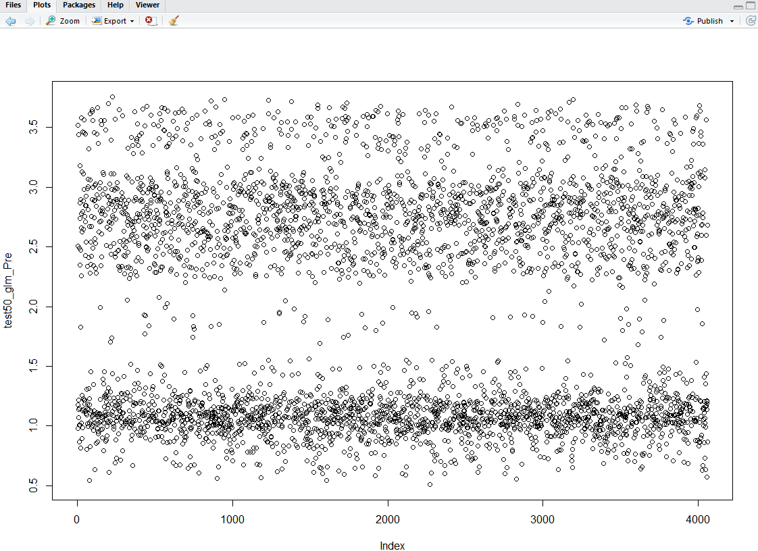

**LM和GLM的plot（training）如下图：**

**以glm plot train50 为例：**

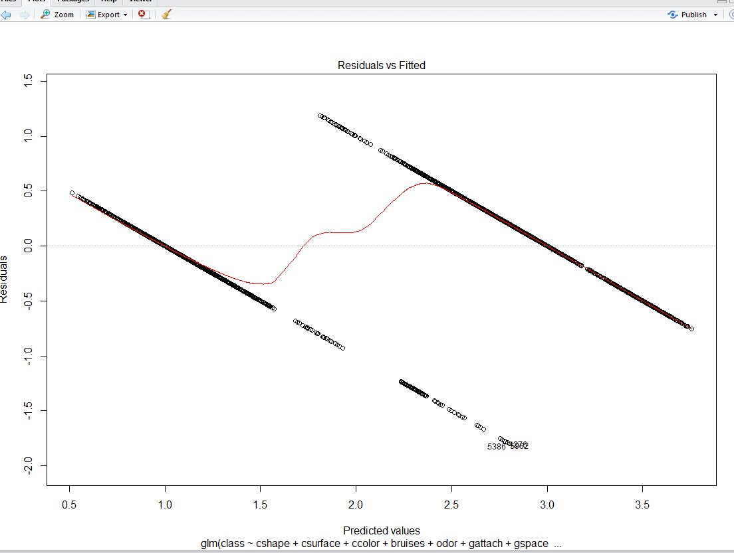

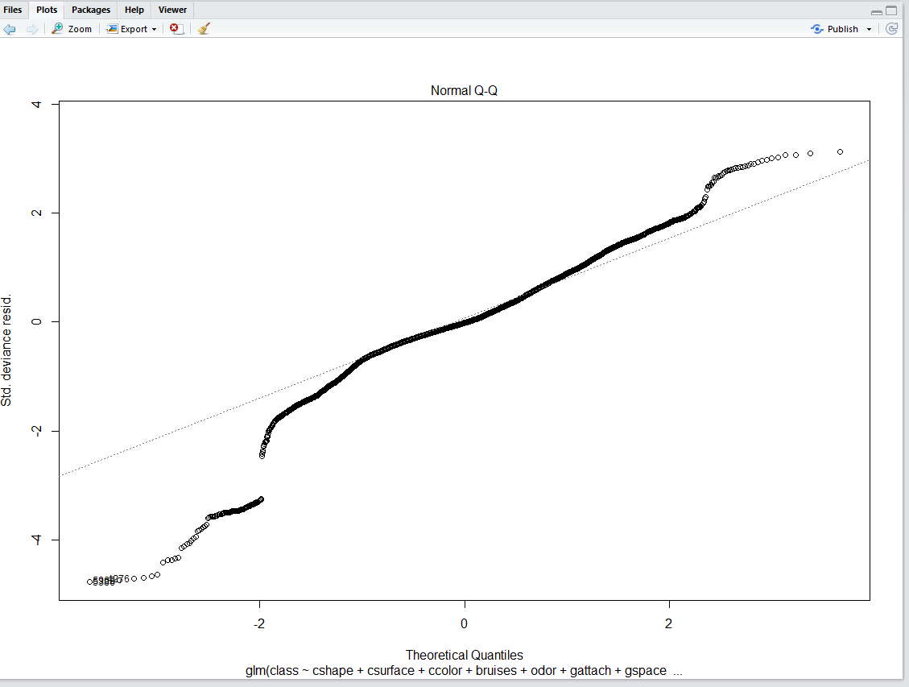

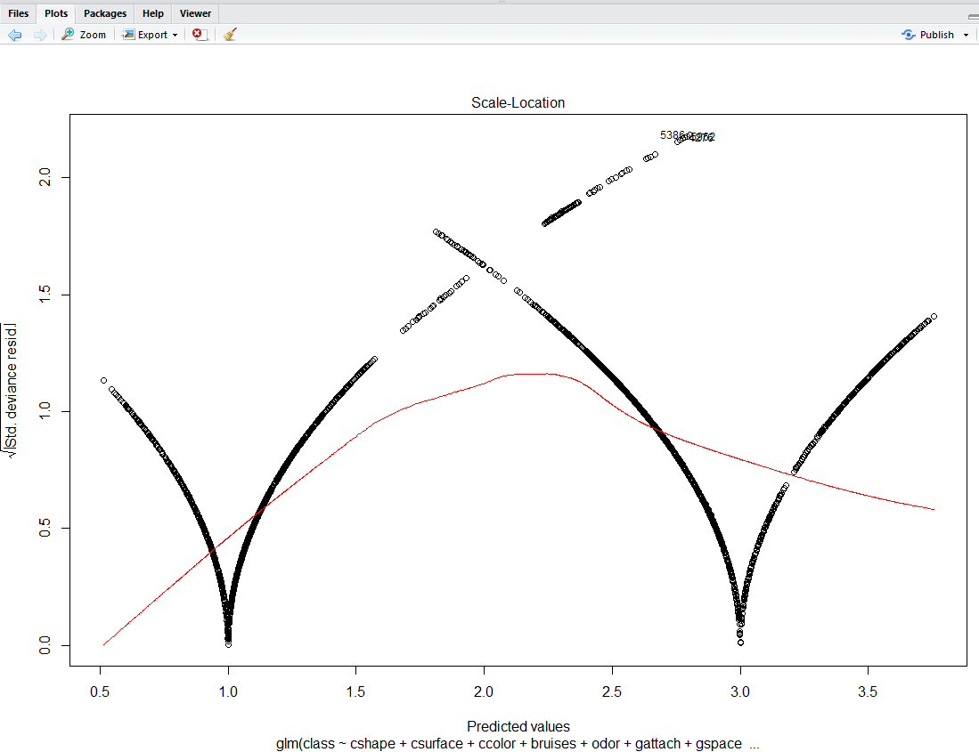

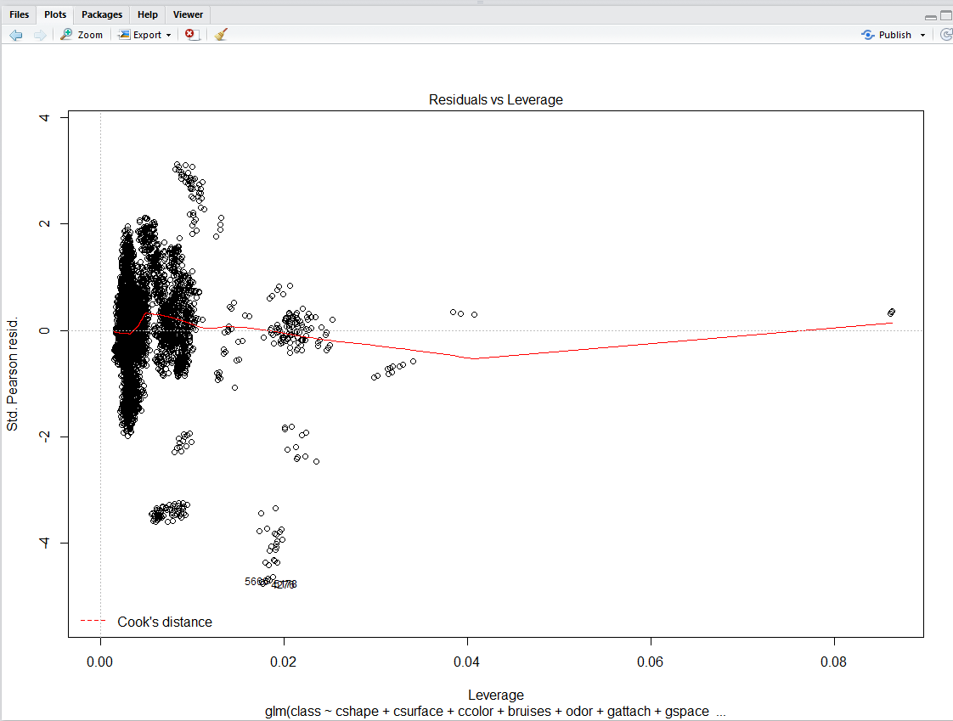

**SVM：**

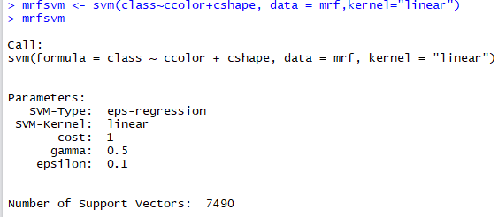

**附：代码**

**install.packages("readr")**

**install.packages("psych")**

**install.packages('NbClust')**

**install.packages("caret")**

**install.packages('corrplot')**

**install.packages("fpc", dependencies=T)**

**install.packages('MASS')**

**install.packages("e1071")**

**install.packages("party")**

**install.packages('car')**

**install.packages("class")**

**install.packages("descr")**

**install.packages("ggplot2")**

**install.packages("cluster")**

**library(cluster)**

**library(party)**

**library(e1071)**

**library(MASS)**

**library(fpc)**

**library(NbClust)**

**library(readr)**

**library(psych)**

**library(caret)**

**library(corrplot)**

**library(car)**

**library(class)**

**library(descr)**

**rm(list=ls())**

**mr<- read.csv('./data/agaricus-lepiota.data')**

**View(mr)**

**summary(mr)**

**describe(mr)**

**str(mr)**

**mr.df<-as.data.frame(mr)**

**mr.df**

**names(mr)<-c("class","cshape","csurface","ccolor","bruises","odor","gattach","gspace","gsize","gcolor","sshape","sroot","ssabove","ssbelow","scabove","scbelow","vtype","vcolor","rnumber","rtype","spcolor","popnum","habitat")**

**summary(mr)**

**mr**

**#Draw the attribution**

**#corrplot(cor(data), type = "lower", method = "number")**

**pairs(class~sshape+sroot,data = mr)**

**plot(class~ sshape+sroot,data = mr)**

**#Choose the proper attribution**

**mrf<-as.data.frame(mr,stringAsFactors=FALSE)**

**mrf[,c(1,23)]<-sapply(mrf[,c(1,23)],as.character)**

**mrf$class[mrf$class=='e']<-0**

**mrf$class[mrf$class=='p']<-1**

**mrf**

**mrf[,c(2,23)]<-sapply(mrf[,c(2,23)],as.character)**

**mrf$cshape[mrf$cshape=='b']<-1**

**mrf$cshape[mrf$cshape=='c']<-3**

**mrf$cshape[mrf$cshape=='x']<-5**

**mrf$cshape[mrf$cshape=='f']<-7**

**mrf$cshape[mrf$cshape=='k']<-9**

**mrf$cshape[mrf$cshape=='s']<-11**

**mrf[,c(3,23)]<-sapply(mrf[,c(3,23)],as.character)**

**mrf$csurface[mrf$csurface=='f']<-1**

**mrf$csurface[mrf$csurface=='g']<-3**

**mrf$csurface[mrf$csurface=='y']<-5**

**mrf$csurface[mrf$csurface=='s']<-7**

**mrf[,c(4,23)]<-sapply(mrf[,c(4,23)],as.character)**

**mrf$ccolor[mrf$ccolor=='c']<-1**

**mrf$ccolor[mrf$ccolor=='b']<-3**

**mrf$ccolor[mrf$ccolor=='g']<-5**

**mrf$ccolor[mrf$ccolor=='n']<-5**

**mrf$ccolor[mrf$ccolor=='r']<-7**

**mrf$ccolor[mrf$ccolor=='p']<-9**

**mrf$ccolor[mrf$ccolor=='u']<-11**

**mrf$ccolor[mrf$ccolor=='e']<-13**

**mrf$ccolor[mrf$ccolor=='w']<-15**

**mrf$ccolor[mrf$ccolor=='y']<-17**

**mrf[,c(5,23)]<-sapply(mrf[,c(5,23)],as.character)**

**mrf$bruises[mrf$bruises=='t']<-1**

**mrf$bruises[mrf$bruises=='f']<-3**

**#mrf**

**mrf[,c(6,23)]<-sapply(mrf[,c(6,23)],as.character)**

**mrf$odor[mrf$odor=='a']<-1**

**mrf$odor[mrf$odor=='l']<-3**

**mrf$odor[mrf$odor=='p']<-5**

**mrf$odor[mrf$odor=='n']<-7**

**mrf$odor[mrf$odor=='c']<-9**

**mrf$odor[mrf$odor=='y']<-11**

**mrf$odor[mrf$odor=='f']<-13**

**mrf$odor[mrf$odor=='m']<-15**

**mrf$odor[mrf$odor=='s']<-17**

**mrf[,c(7,23)]<-sapply(mrf[,c(7,23)],as.character)**

**mrf$gattach[mrf$gattach=='a']<-1**

**mrf$gattach[mrf$gattach=='d']<-3**

**mrf$gattach[mrf$gattach=='f']<-5**

**mrf$gattach[mrf$gattach=='n']<-7**

**mrf[,c(8,23)]<-sapply(mrf[,c(8,23)],as.character)**

**mrf$gspace[mrf$gspace=='c']<-1**

**mrf$gspace[mrf$gspace=='w']<-3**

**mrf$gspace[mrf$gspace=='d']<-5**

**mrf[,c(9,23)]<-sapply(mrf[,c(9,23)],as.character)**

**mrf$gsize[mrf$gsize=='b']<-1**

**mrf$gsize[mrf$gsize=='n']<-3**

**mrf[,c(10,23)]<-sapply(mrf[,c(10,23)],as.character)**

**mrf$gcolor[mrf$gcolor=='k']<-1**

**mrf$gcolor[mrf$gcolor=='n']<-3**

**mrf$gcolor[mrf$gcolor=='b']<-5**

**mrf$gcolor[mrf$gcolor=='h']<-7**

**mrf$gcolor[mrf$gcolor=='g']<-9**

**mrf$gcolor[mrf$gcolor=='r']<-11**

**mrf$gcolor[mrf$gcolor=='o']<-13**

**mrf$gcolor[mrf$gcolor=='p']<-15**

**mrf$gcolor[mrf$gcolor=='u']<-17**

**mrf$gcolor[mrf$gcolor=='e']<-19**

**mrf$gcolor[mrf$gcolor=='w']<-21**

**mrf$gcolor[mrf$gcolor=='y']<-23**

**mrf[,c(11,23)]<-sapply(mrf[,c(11,23)],as.character)**

**mrf$sshape[mrf$sshape=='e']<-1**

**mrf$sshape[mrf$sshape=='t']<-3**

**mrf[,c(12,23)]<-sapply(mrf[,c(12,23)],as.character)**

**mrf$sroot[mrf$sroot=='b']<-1**

**mrf$sroot[mrf$sroot=='c']<-3**

**mrf$sroot[mrf$sroot=='u']<-5**

**mrf$sroot[mrf$sroot=='e']<-7**

**mrf$sroot[mrf$sroot=='z']<-9**

**mrf$sroot[mrf$sroot=='r']<-11**

**mrf$sroot[mrf$sroot=='?']<-13**

**mrf**

**mrf[,c(13,23)]<-sapply(mrf[,c(13,23)],as.character)**

**mrf$ssabove[mrf$ssabove=='f']<-1**

**mrf$ssabove[mrf$ssabove=='y']<-3**

**mrf$ssabove[mrf$ssabove=='k']<-5**

**mrf$ssabove[mrf$ssabove=='s']<-7**

**mrf[,c(14,23)]<-sapply(mrf[,c(14,23)],as.character)**

**mrf$ssbelow[mrf$ssbelow=='f']<-1**

**mrf$ssbelow[mrf$ssbelow=='y']<-3**

**mrf$ssbelow[mrf$ssbelow=='k']<-5**

**mrf$ssbelow[mrf$ssbelow=='s']<-7**

**mrf[,c(15,23)]<-sapply(mrf[,c(15,23)],as.character)**

**mrf$scabove[mrf$scabove=='n']<-1**

**mrf$scabove[mrf$scabove=='b']<-3**

**mrf$scabove[mrf$scabove=='c']<-5**

**mrf$scabove[mrf$scabove=='g']<-7**

**mrf$scabove[mrf$scabove=='o']<-9**

**mrf$scabove[mrf$scabove=='p']<-11**

**mrf$scabove[mrf$scabove=='e']<-13**

**mrf$scabove[mrf$scabove=='w']<-15**

**mrf$scabove[mrf$scabove=='y']<-17**

**mrf[,c(16,23)]<-sapply(mrf[,c(16,23)],as.character)**

**mrf$scbelow[mrf$scbelow=='n']<-1**

**mrf$scbelow[mrf$scbelow=='b']<-3**

**mrf$scbelow[mrf$scbelow=='c']<-5**

**mrf$scbelow[mrf$scbelow=='g']<-7**

**mrf$scbelow[mrf$scbelow=='o']<-9**

**mrf$scbelow[mrf$scbelow=='p']<-11**

**mrf$scbelow[mrf$scbelow=='e']<-13**

**mrf$scbelow[mrf$scbelow=='w']<-15**

**mrf$scbelow[mrf$scbelow=='y']<-17**

**mrf[,c(17,23)]<-sapply(mrf[,c(17,23)],as.character)**

**mrf$vtype[mrf$vtype=='p']<-1**

**mrf$vtype[mrf$vtype=='u']<-3**

**mrf[,c(18,23)]<-sapply(mrf[,c(18,23)],as.character)**

**mrf$vcolor[mrf$vcolor=='n']<-1**

**mrf$vcolor[mrf$vcolor=='o']<-3**

**mrf$vcolor[mrf$vcolor=='w']<-5**

**mrf$vcolor[mrf$vcolor=='y']<-7**

**mrf[,c(19,23)]<-sapply(mrf[,c(19,23)],as.character)**

**mrf$rnumber[mrf$rnumber=='n']<-1**

**mrf$rnumber[mrf$rnumber=='o']<-3**

**mrf$rnumber[mrf$rnumber=='t']<-5**

**mrf[,c(20,23)]<-sapply(mrf[,c(20,23)],as.character)**

**mrf$rtype[mrf$rtype=='c']<-1**

**mrf$rtype[mrf$rtype=='e']<-3**

**mrf$rtype[mrf$rtype=='f']<-5**

**mrf$rtype[mrf$rtype=='l']<-7**

**mrf$rtype[mrf$rtype=='n']<-9**

**mrf$rtype[mrf$rtype=='p']<-11**

**mrf$rtype[mrf$rtype=='s']<-13**

**mrf$rtype[mrf$rtype=='z']<-15**

**mrf[,c(21,23)]<-sapply(mrf[,c(21,23)],as.character)**

**mrf$spcolor[mrf$spcolor=='k']<-1**

**mrf$spcolor[mrf$spcolor=='n']<-3**

**mrf$spcolor[mrf$spcolor=='b']<-5**

**mrf$spcolor[mrf$spcolor=='h']<-7**

**mrf$spcolor[mrf$spcolor=='r']<-9**

**mrf$spcolor[mrf$spcolor=='o']<-11**

**mrf$spcolor[mrf$spcolor=='u']<-13**

**mrf$spcolor[mrf$spcolor=='w']<-15**

**mrf$spcolor[mrf$spcolor=='y']<-17**

**mrf[,c(22,23)]<-sapply(mrf[,c(22,23)],as.character)**

**mrf$popnum[mrf$popnum=='a']<-1**

**mrf$popnum[mrf$popnum=='c']<-3**

**mrf$popnum[mrf$popnum=='n']<-5**

**mrf$popnum[mrf$popnum=='s']<-7**

**mrf$popnum[mrf$popnum=='v']<-9**

**mrf$popnum[mrf$popnum=='y']<-11**

**mrf[,23]<-sapply(mrf[,23],as.character)**

**mrf$habitat[mrf$habitat=='g']<-1**

**mrf$habitat[mrf$habitat=='l']<-3**

**mrf$habitat[mrf$habitat=='m']<-5**

**mrf$habitat[mrf$habitat=='p']<-7**

**mrf$habitat[mrf$habitat=='u']<-9**

**mrf$habitat[mrf$habitat=='w']<-11**

**mrf$habitat[mrf$habitat=='d']<-13**

**mrf**

**#Preparing the training data**

**set.seed(4)**

**fitControl <- trainControl(method = "repeatedcv",**

**number = 10,**

**repeats = 10)**

**write.csv(mrf,"./data/processedData.csv",row.names = FALSE)**

**processeddata = read.csv('processedData.csv')**

**summary(processeddata)**

**data<-as.data.frame(processeddata)**

**data[is.na(data)]<-0**

**na.omit(data)**

**View(data)**

**mrf=data**

**mrpca7<-principal(data[,-17],nfactors = 7, rotate = "none")**

**mrpca7**

**mrpca5<-principal(data[,-17], nfactors=5, rotate="none")**

**mrpca5**

**mrpca3<-principal(data[,-17], nfactors=3, rotate="none")**

**mrpca3**

**data.pam3<-pam(mrf, k = 3, metric = "euclidean", stand = FALSE)**

**data.pam3**

**data.pam5<-pam(mrf, k = 5, metric = "euclidean", stand = FALSE)**

**data.pam5**

**data.pam7<-pam(mrf, k = 7, metric = "euclidean", stand = FALSE)**

**data.pam7**

**train70.df<-sample(nrow(mrf),0.7*nrow(mrf))**

**mrtrain70.df<-mrf[train70.df,]**

**mrtest70.df<-mrf[-train70.df,]**

**train70labels<-mrtrain70.df[,1]**

**table(mrtrain70.df$class)**

**table(mrtest70.df$class)**

**library(class)**

**knn70.3 <- knn(train=mrtrain70.df, test=mrtest70.df, cl=train70labels, 3)**

**knn70.3**

**test70labels<-mrtest70.df[,1]**

**ct70_1<-CrossTable(test70labels, knn70.3)**

**ct70_1**

**knn70.5 <- knn(train=mrtrain70.df, test=mrtest70.df, cl=train70labels, 5)**

**knn70.5**

**ct70_2<-CrossTable(test70labels, knn70.5)**

**ct70_2**

**knn70.7 <- knn(train=mrtrain70.df, test=mrtest70.df, cl=train70labels, 7)**

**knn70.7**

**ct70_3<-CrossTable(test70labels, knn70.7)**

**ct70_3**

**train60.df<-sample(nrow(mrf),0.6*nrow(mrf))**

**mrtrain60.df<-mrf[train60.df,]**

**mrtest60.df<-mrf[-train60.df,]**

**train60labels<-mrtrain60.df[,1]**

**knn60.3 <- knn(train=mrtrain60.df, test=mrtest60.df, cl=train60labels, 3)**

**#knn60.3**

**test60labels<-mrtest60.df[,1]**

**ct60_1<-CrossTable(test60labels, knn60.3)**

**ct60_1**

**knn60.5 <- knn(train=mrtrain60.df, test=mrtest60.df, cl=train60labels, 5)**

**knn60.5**

**ct60_2<-CrossTable(test60labels, knn60.5)**

**ct60_2**

**knn60.7 <- knn(train=mrtrain60.df, test=mrtest60.df, cl=train60labels, 7)**

**knn60.7**

**ct60_3<-CrossTable(test60labels, knn60.7)**

**ct60_3**

**#table(mrtrain60.df$class)**

**#table(mrtest60.df$class)**

**train50.df<-sample(nrow(mrf),0.5*nrow(mrf))**

**mrtrain50.df<-mrf[train50.df,]**

**mrtest50.df<-mrf[-train50.df,]**

**train50labels<-mrtrain50.df[,1]**

**knn50.3 <- knn(train=mrtrain50.df, test=mrtest50.df, cl=train50labels, 3)**

**#knn50.3**

**test50labels<-mrtest50.df[,1]**

**ct50_1<-CrossTable(test50labels, knn50.3)**

**ct50_1**

**knn50.5 <- knn(train=mrtrain50.df, test=mrtest50.df, cl=train50labels, 5)**

**knn50.5**

**ct50_2<-CrossTable(test50labels, knn50.5)**

**ct50_2**

**knn50.7 <- knn(train=mrtrain50.df, test=mrtest50.df, cl=train50labels, 7)**

**knn50.7**

**ct50_3<-CrossTable(test50labels, knn50.7)**

**ct50_3**

**#table(mrtrain50.df$class)**

**#table(mrtest50.df$class)**

**train70 = na.omit(mrtrain70.df)**

**train70**

**library(ggplot2)**

**set.seed(20)**

**mr.kc3<-kmeans(data,3)**

**mr.kc3**

**#mr.kc3$center**

**#mr.kc3$cluster <- as.factor(mr.kc3$cluster)**

**#ggplot(data, aes(class, cshape, color = data$cluster)) + geom_point()**

**mr.kc5<-kmeans(data,5)**

**mr.kc5**

**mr.kc5$center**

**mr.kc7<-kmeans(data,7)**

**mr.kc7**

**mr.kc7$center**

**#table(mrtrain70.df$class)**

**#table(mrtest70.df$class)**

**#View(mrtrain60.df)**

**#summary(mrtrain60.df)**

**#View(mrtest60.df)**

**myFormula_70 <- mrtrain70.df$class ~ mrtrain70.df$sshape+mrtrain70.df$sroot**

**mr_70_ctree <- ctree(myFormula_70,data=mrtrain70.df)**

**mrtrain70.df$class**

**table(predict(mr_70_ctree), mrtrain70.df$class)**

**plot(mr_70_ctree,type="simple")**

**testPred <- predict(mr_70_ctree, newdata = mrtest70.df)**

**View(testPred)**

**length(testPred)**

**length(mrtest70.df$class)**

**length(mrtrain70.df$class)**

**table(testPred)**

**sms_60_classifier <- naiveBayes(mrtrain60.df,mrtrain60.df[,1])**

**sms_60_predictions<-predict(sms_60_classifier,mrtest60.df)**

**myFormula_60 <- mrtrain60.df$class ~ mrtrain60.df$sshape+mrtrain60.df$sroot**

**mr_60_ctree <- ctree(myFormula_60,data=mrtrain60.df)**

**table(predict(mr_60_ctree), mrtrain60.df$class)**

**plot(mr_60_ctree,type="simple")**

**predict(mr_60_ctree)**

**testPred <- predict(mr_60_ctree, newdata = mrtest60.df)**

**table(testPred)**

**sms_50_classifier <- naiveBayes(mrtrain50.df,mrtrain50.df[,1])**

**sms_50_predictions<-predict(sms_50_classifier,mrtest50.df)**

**myFormula_50 <- mrtrain50.df$class ~ mrtrain50.df$sshape+mrtrain50.df$sroot**

**mr_50_ctree <- ctree(myFormula_50,data=mrtrain50.df)**

**table(predict(mr_50_ctree), mrtrain50.df$class)**

**plot(mr_50_ctree,type="simple")**

**predict(mr_50_ctree)**

**testPred <- predict(mr_50_ctree, newdata = mrtest50.df)**

**table(testPred)**

**mrf_lm <- lm(data$class ~ data$cshape+data$csurface+data$ccolor+data$bruises+data$odor+**

**data$gattach+data$gspace+data$gsize+data$gcolor+data$sshape+data$sroot+**

**data$ssabove+data$ssbelow+data$scabove+data$scbelow+data$vcolor+**

**data$rnumber+data$rtype+data$spcolor+data$popnum+data$habitat, data = mrf)**

**mrf_lm**

**confint(mrf_lm)**

**#plot(mrf_lm)**

**#vif(mrCollinear)**

**train70_lm <- lm( class ~ cshape + csurface + ccolor + bruises + odor+**

**gattach + gspace + gsize + gcolor + sshape + sroot +**

**ssabove + ssbelow + scabove + scbelow + vcolor+**

**rnumber + rtype + spcolor + popnum + habitat, data = mrtrain70.df)**

**train70_lm**

**plot(train70_lm)**

**test70_lm_Pre <- predict(train70_lm, data = mrtest70.df)**

**test70_lm_Pre**

**plot(test70_lm_Pre)**

**train60_lm <- lm( class ~ cshape + csurface + ccolor + bruises + odor+**

**gattach + gspace + gsize + gcolor + sshape + sroot +**

**ssabove + ssbelow + scabove + scbelow + vcolor+**

**rnumber + rtype + spcolor + popnum + habitat, data = mrtrain60.df)**

**train60_lm**

**test60_lm_Pre <- predict(train60_lm, data = mrtest60.df)**

**test60_lm_Pre**

**plot(test60_lm_Pre)**

**train50_lm <- lm(class ~ cshape + csurface + ccolor + bruises + odor+**

**gattach + gspace + gsize + gcolor + sshape + sroot +**

**ssabove + ssbelow + scabove + scbelow + vcolor+**

**rnumber + rtype + spcolor + popnum + habitat, data = mrtrain50.df)**

**train50_lm**

**test50_lm_Pre <- predict(train50_lm, data = mrtest50.df)**

**test50_lm_Pre**

**plot(test50_lm_Pre)**

**mrf_glm <- glm(data$class ~ data$cshape+data$csurface+data$ccolor+data$bruises+data$odor+**

**data$gattach+data$gspace+data$gsize+data$gcolor+data$sshape+data$sroot+**

**data$ssabove+data$ssbelow+data$scabove+data$scbelow+data$vcolor+**

**data$rnumber+data$rtype+data$spcolor+data$popnum+data$habitat, family=gaussian, data = mrf)**

**mrf_glm**

**train70_glm <- glm(class ~ cshape + csurface + ccolor + bruises + odor+**

**gattach + gspace + gsize + gcolor + sshape + sroot +**

**ssabove + ssbelow + scabove + scbelow + vcolor+**

**rnumber + rtype + spcolor + popnum + habitat, data = mrtrain70.df)**

**train70_glm**

**test70_glm_Pre <- predict(train70_glm, data = mrtest70.df)**

**test70_glm_Pre**

**plot(test70_glm_pre)**

**train60_glm <- glm(class ~ cshape + csurface + ccolor + bruises + odor+**

**gattach + gspace + gsize + gcolor + sshape + sroot +**

**ssabove + ssbelow + scabove + scbelow + vcolor+**

**rnumber + rtype + spcolor + popnum + habitat, data = mrtrain60.df)**

**train60_glm**

**test60_glm_Pre <- predict(train70_glm, data = mrtest60.df)**

**test60_glm_Pre**

**plot(test60_glm_Pre)**

**train50_glm <- glm(class ~ cshape + csurface + ccolor + bruises + odor+**

**gattach + gspace + gsize + gcolor + sshape + sroot +**

**ssabove + ssbelow + scabove + scbelow + vcolor+**

**rnumber + rtype + spcolor + popnum + habitat, data = mrtrain50.df)**

**train50_glm**

**plot(train50_glm)**

**test50_glm_Pre <- predict(train50_glm, data = mrtest50.df)**

**test50_glm_Pre**

**plot(test50_glm_Pre)**

**#points(mrtest50.df$class, test50_glm_Pre,col = "blue", pch =4)**

**data(mrf)**

**attach(mrf)**

**mrfsvm <- svm(class~ccolor+cshape, data = mrf,kernel="linear")**

**mrfsvm**