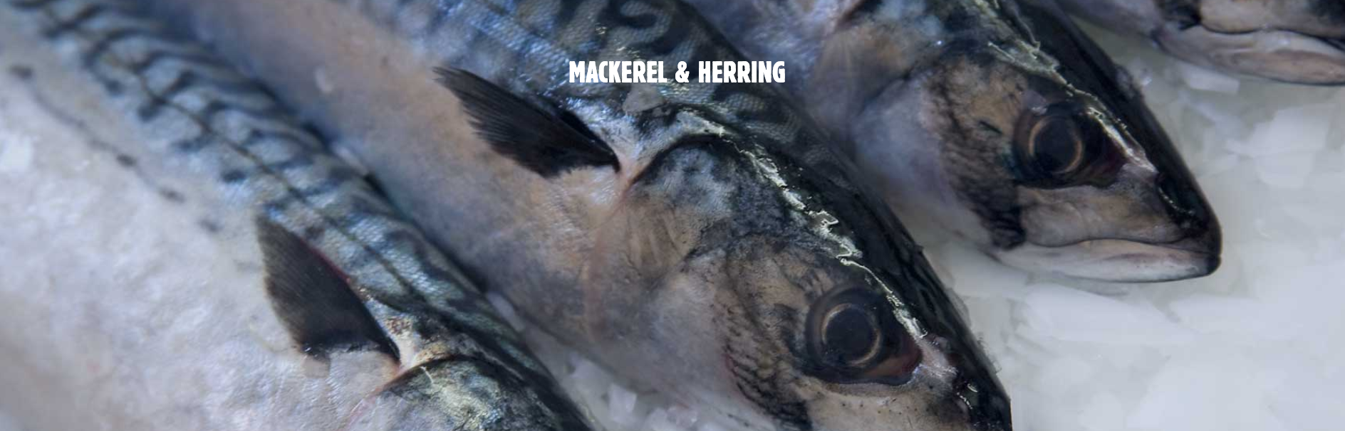

As we all know, in the past 100 years, the climate has warmed and the temperature of seawater has risen is an indisputable fact. Every day there is frustrating new evidence that climate change is adversely affecting life.  
  
Fishermen friends, the Beihai fishing grounds on which we depend may also leave due to the migration of many fisheries, all the way north, looking for a temperature more suitable for their survival, and no longer exist.  
  
This is really a serious topic. This week, our team analyzed the trend of fish school changes in the next 50 years, and the situation is not optimistic. If nothing is done, maybe we will all be unemployed in less than 30 years!  
  
Since 2000, the average surface temperature of Beihai fishing grounds has increased by nearly 1 degree Celsius, and the upward trend is becoming increasingly significant and faster. It is worth mentioning that this sea is melting faster than almost anywhere else! This has to worry our research team.  
  
Where will the fish go in the next 50 years?  
  
After our big data simulation analysis and prediction, we speculated that 25 years later, our fishermen in Scotland will no longer be able to enjoy fishing on the land belonging to our homeland and get rich income. Herring and Mackerel will go northward all the way across Shetland to Iceland, and they will continue to reside in the northernmost Arctic Ocean, farther and farther from our Scotland.  
  
You know, for more than 100,000 years, the central Arctic Ocean has been completely covered by ice, so that the idea of ​​fishing seems ridiculous. This was still the case until 20 years ago. However, as human fossil fuel emissions heat up. Today, as much as 40% of the central Arctic Ocean is open water in summer. It may be possible to attract ships soon, and by then, the Arctic fishing grounds may become the next North Sea fishing grounds.  
  
In order to cope with this possible crisis, our research team evaluated and analyzed various options, and from this we found the best feasible solution.

**North Atlantic Fisheries May not Exist in 30 Years**



**North Atlantic Fisheries May not Exist in 30 Years**

Our Approach

First of all, we discussed the feasibility of relocation. As the school of fish moves northward, fishermen friends will need to pay more time and cost to reach the place where the school of fish gathers. Moving north to shorten the sailing distance seems to be a good thing Choice, but then face a certain relocation cost, when the relocation cost is higher than a limit, this strategy will not be able to obtain benefits in a short time. Another solution is to add fresh-keeping refrigeration equipment to enable fishing vessels to better maintain the freshness of fish when sailing over long distances and increase the value of fish after they arrive at the port. Because the freshness of fish without refrigeration treatment decreases rapidly, the refrigeration The overhead of the equipment is more appropriate, so after deriving from our model, this is a good method.  
  
Although the acceleration of global warming is something we do not want to see, it really affects the economic life of this people. The northward migration of fish schools in the North Sea area caused by the rising ocean temperature is more serious. We recommend that friends in related areas do it in advance. Be prepared and plan your business model in advance, hoping to be able to face the changes brought about by the environment smoothly.