1/ A function is a block of organized, reusable code that is used to perform a single, related action. You can pass data, known as parameters, into a function.

A function can return data as a result.

Python gives you many built-in functions like print(), etc. but you can also create your own functions. These functions are called user-defined functions.

Once we have defined a function, we can call (or invoke) it   
as many times as we like

***Syntax***

Function blocks begin with the keyword def followed by the function name and parentheses ()

Any input parameters or arguments should be placed within these parentheses. You can also define parameters inside these parentheses.

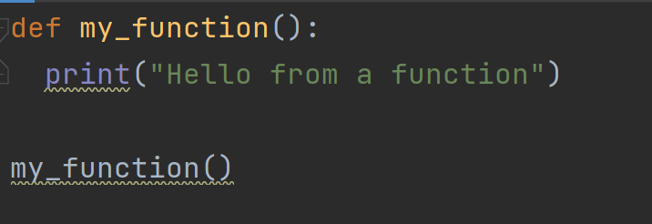

Function is used when in the program there is a block of code that is used many times, using function to shorten the program as well as the coding time.

2.

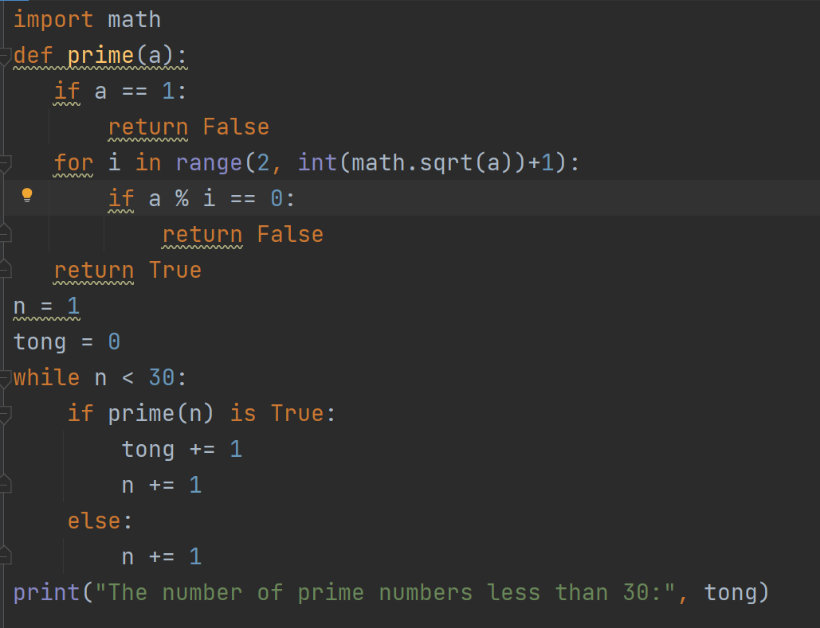

4/

