**CRMotion**

**DEMO FOR DEV**

|  |  |  |
| --- | --- | --- |
| **Ngày update** | **Người update** | **Note** |
| 2018/12/11 | LinhHN | **Tạo mới** |

1. **Setup Environment**
2. Git clone source code dự án「crm-base」[tại đây](https://gitlab.gnext.asia/vnext/source): (<https://gitlab.gnext.asia/vnext/source>)
3. Git checkout branch develop
4. Thực hiện theo các bước [tại đây](https://gitlab.gnext.asia/vnext/source/blob/master/README.md) để cài đặt môi trường bằng Vagrant
5. **Install crm-base**

Truy cập <https://crm-training.local/install.php> thực hiện lần lượt các step

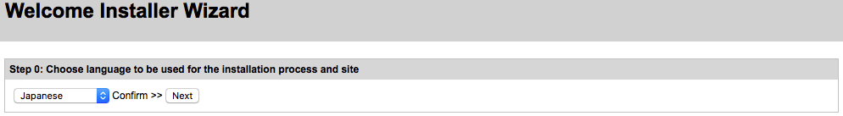

1. **Step 1**

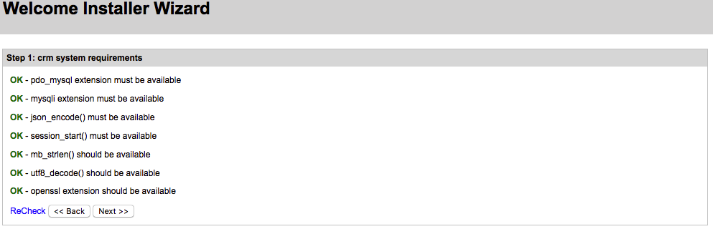

1. **Step 2**

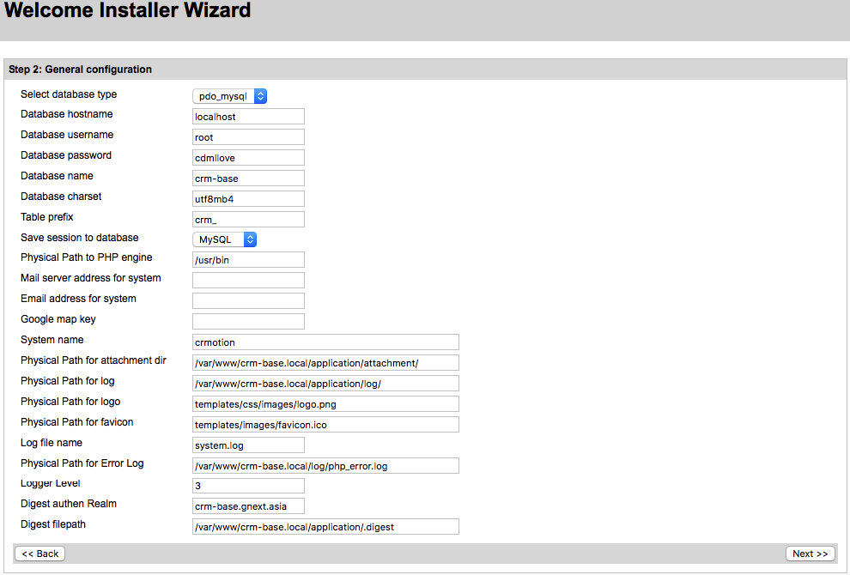

1. **Step 3**

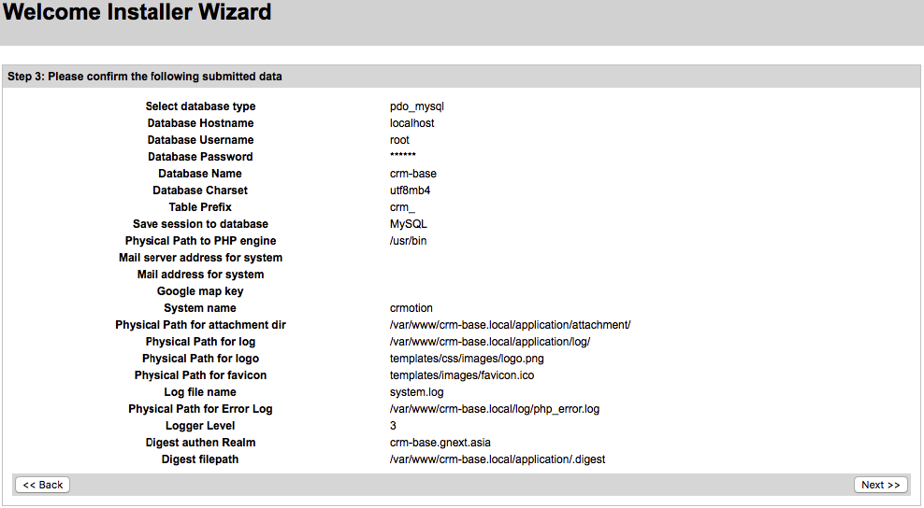

1. **Step 4**

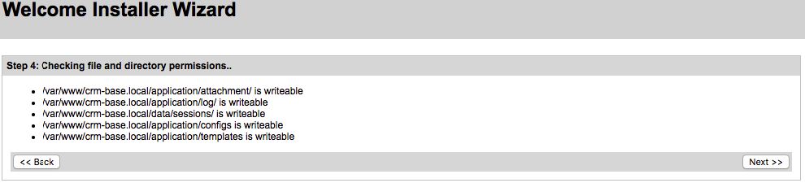

1. **Step 5**

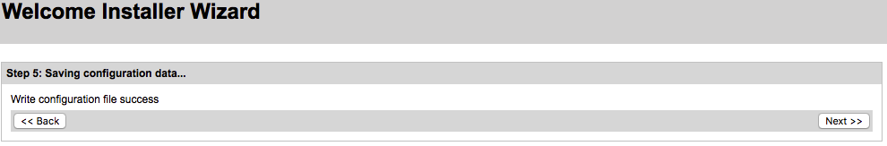

1. **Step 6**

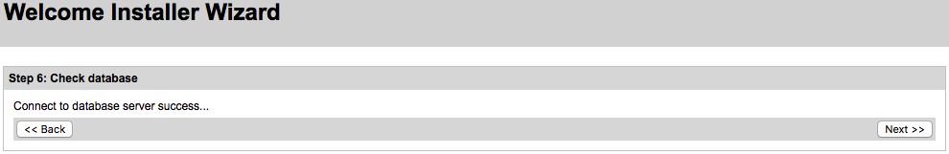

1. **Step 7**

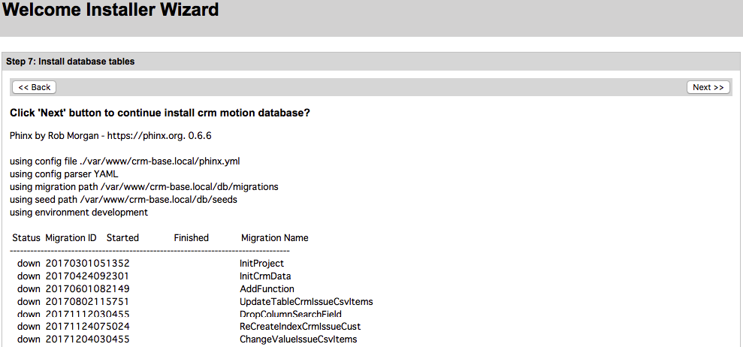

1. **Login**

*Username: admin*

*Password: 123456*

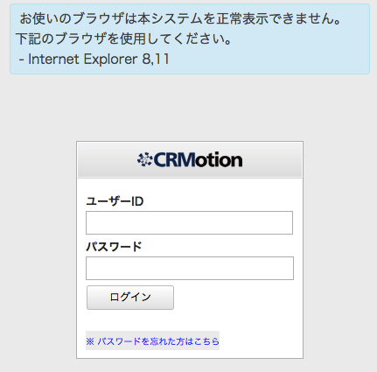

1. **Setting new password**

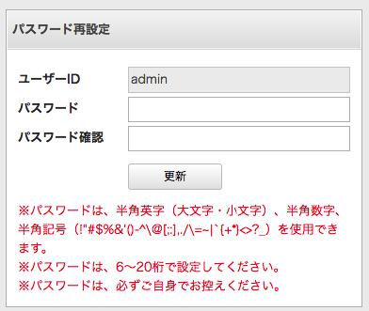

1. **Setup new module**
2. **Run SQL để thêm module 「Books」**

**insert** **into** crm_module **values** (null, '1', 'a1b2c3d4', 'Books', 'books', '1', **now**(), 'Books', 'core', '0', '0', '1', '1');

1. **Run SQL để thêm quyền truy cập module 「Books」**

**insert** **into** crm_permission **values** (null, 'module_tab_books', '※モュール閲覧', null, null, **now**(), **now**(), '0', null, null, 'books', 1);

1. **Set quyền truy cập module 「Books」**

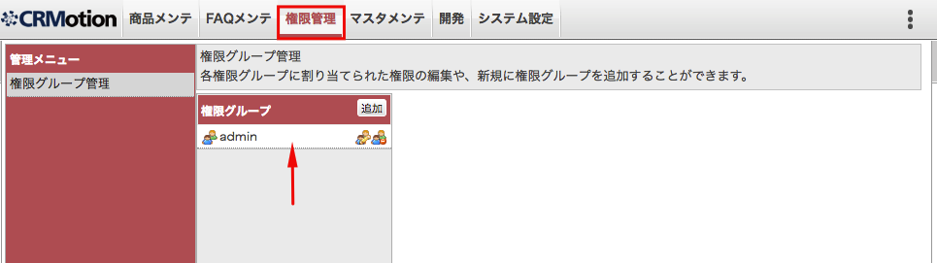

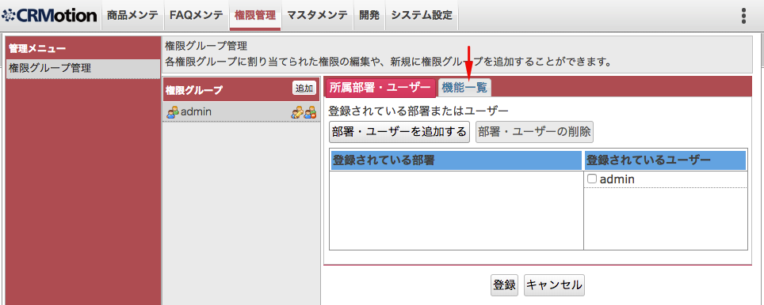

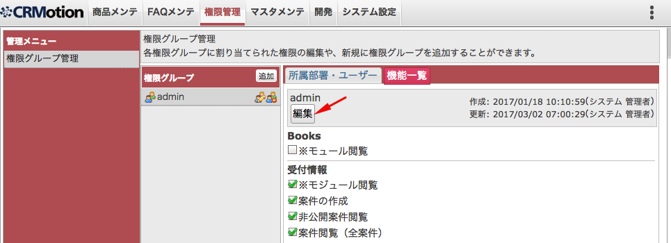

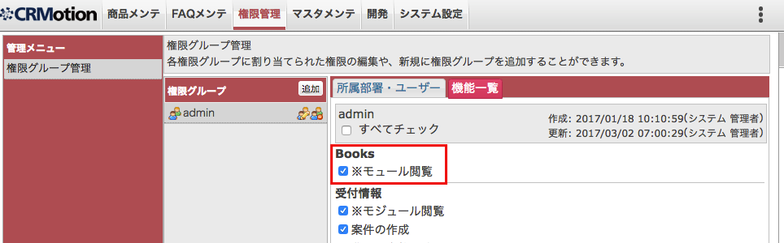

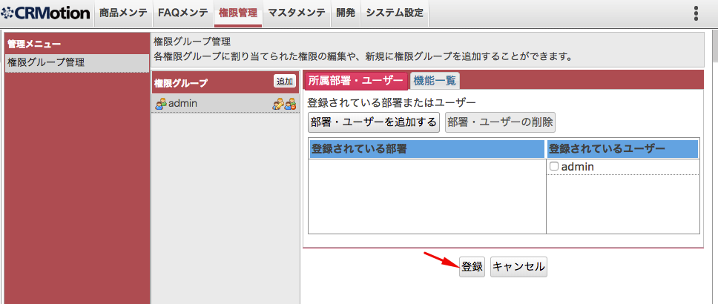

1. **Phát triển module 「Books」**
2. **Run SQL tạo table 「crm_books」**

**CREATE** **TABLE** `crm_books` (

`book_id` **int**(11) **NOT** NULL **AUTO_INCREMENT**,

`book_code` **varchar**(32) **DEFAULT** NULL,

`book_title` **varchar**(256) **DEFAULT** NULL,

`book_author` **varchar**(256) **DEFAULT** NULL,

`book_publish_date` **date** **DEFAULT** NULL,

`book_price` **varchar**(16) **DEFAULT** NULL,

`book_content` **text**,

`book_content_search` **text**,

`book_created_datetime` **datetime** **DEFAULT** NULL,

`book_creator_code` **varchar**(32) **DEFAULT** NULL,

`book_creator_name` **varchar**(256) **DEFAULT** NULL,

`book_updated_datetime` **datetime** **DEFAULT** NULL,

`book_updater_code` **varchar**(32) **DEFAULT** NULL,

`book_updater_name` **varchar**(256) **DEFAULT** NULL,

`book_is_deleted` **tinyint**(1) **DEFAULT** '0',

**PRIMARY** **KEY** (`book_id`)

);

1. **Tạo thư mục và file**

|  |
| --- |
|  |

1. **Hiển thị module 「Books」**

* Edit file 「*application/modules/books/controllers/IndexController.php*」

**<?php**

**class** **Books_IndexController** **extends** **Vlib_Controller_Action**

{

**public** **function** **indexAction**()

{

}

}

* Edit file 「*application/modules/books/languages/lang-ja.php*」

**<?php**

**return** [

];

* Edit file 「*application/modules/books/config/config.ini*」

**[config]**

* Kết quả

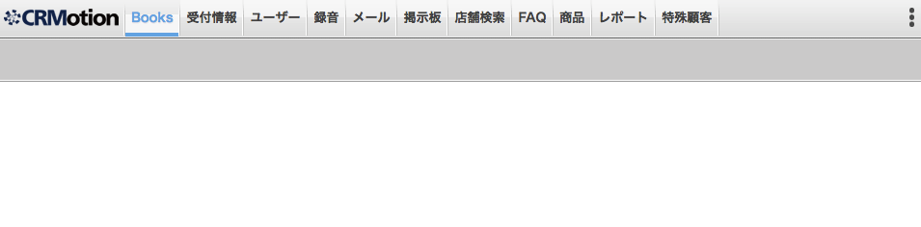

1. **Tạo giao diện màn hình module 「Books」**

* Edit file 「*application/modules/books/views/scripts/index/index.phtml*」

**<div** class="module-sub-menu"**>**

**<div** class="button-menu"**>**

**<div** class="fleft"**>**

**<a** id="add" class="w56" onclick="Books.showOverlay();"**>**

**<span** class="icon add"**></span>**

**<span** class="font-size-11"**>**作成**</span>**

**</a>**

**</div>**

**</div>**

**</div>**

**<div** class="clear"**></div>**

**<div** class=""**>**

**<form** id="form_books" method="POST"**>**

**<table** class="table-item"**>**

**<colgroup>**

**<col** class="w80"**>**

**<col** class="w400"**>**

**<col** class="w80"**>**

**<col** class=""**>**

**</colgroup>**

**<tr>**

**<th>**コード**</th>**

**<td>**

**<input** type="text" id="" name="book[book_code]" class="w390" style="ime-mode: inactive;" value=""**/>**

**</td>**

**<th>**タイトル**</th>**

**<td>**

**<input** type="text" id="" name="book[book_title]" class="w389" style="ime-mode: active;" value=""**/>**

**</td>**

**</tr>**

**<tr>**

**<th>**著者**</th>**

**<td>**

**<input** type="text" id="" name="book[book_author]" class="w390" style="ime-mode: active;" value=""**/>**

**</td>**

**<th>**内容**</th>**

**<td>**

**<input** type="text" id="" name="book[book_content]" class="w389" style="ime-mode: active;" value=""**/>**

**</td>**

**</tr>**

**</table>**

**</form>**

**</div>**

**<div** class="clear"**></div>**

**<div** class="text-center mar-t10"**>**

**<input** class="w80" type="button" value="検索実行" onclick="Books.search();"**>**

**<input** class="w80" type="button" value="クリア" onclick="Books.clear();"**>**

**</div>**

**<div** class="clear"**></div>**

**<div** id="list_books" class="mar-t10"**>**

**<?php** **echo** $this->render('index/list.phtml');**?>**

**</div>**

* Append vào cuối file script dưới để include file css

**<?php**

$this->headLink()->appendStylesheet(

$this->baseUrl('templates/books/css/books.css?v='.$this->releaseVersion)

);

* Edit file 「*public/templates/books/css/books.css*」

**.font-size-11** {

font-size: 11px;

}

**.table-item** {

border-collapse: collapse;

padding: 0;

margin: 0 0 5px 0;

width: 100%;

}

**.table-item** **th**,

**.table-item** **td** {

border: 1px solid #9e9e9e;

padding: 1px 2px;

height: 22px;

line-height: 22px;

}

**.table-item** **th** {

background: #c9c9c9;

font-weight: bold;

}

* Thêm parameter 「minifycss=1」 vào URL để minify script css
* Reload browser sẽ có kết quả

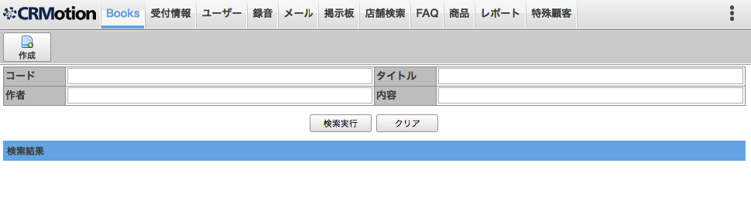

1. **Show overlay tạo mới**

* Edit file 「*application/modules/books/views/scripts/index/index.phtml*」

Thêm event click cho button 「作成」

**<a** id="add" class="w56" onclick="Books.showOverlay();"**>**

**<span** class="icon add"**></span>**

**<span** class="font-size-11"**>**作成**</span>**

**</a>**

Append vào cuối file script dưới để include file js

$this->headScript()->appendFile(

$this->baseUrl('templates/books/js/base.js?v='.$this->releaseVersion)

);

$this->headScript()->appendFile(

$this->baseUrl('templates/books/js/Books.js?v='.$this->releaseVersion)

);

* Edit file 「*application/modules/books/views/scripts/index/overlay.phtml*」

**<form** name="frm_book" id="frm_book" method="post" enctype="multipart/form-data"**>**

**<table** class="table-item"**>**

**<colgroup>**

**<col** class="w100"**/>**

**<col** class="w200"**/>**

**<col** class="w100"**/>**

**<col** class="w199"**/>**

**</colgroup>**

**<tr>**

**<th>**ID**</th>**

**<td>**

**<div** class="w195 text-ellipsis"**>**

**<?php** **echo** $this->escape($this->aryBook['book_id'] ?? "");**?>**

**</div>**

**</td>**

**<th>**コード**</th>**

**<td>**

**<input** type="text" id="book_code" name="book[book_code]"

class="w189 **<?php** **echo** ($this->aryBook['book_code'] ?? "") === "" ? "pink" : "";**?>**"

style="ime-mode: inactive;" onchange="BaseController.checkValidate(this);"

value="**<?php** **echo** $this->escape($this->aryBook['book_code'] ?? "");**?>**"**/>**

**</td>**

**</tr>**

**<tr>**

**<th>**タイトル**</th>**

**<td** colspan="3"**>**

**<input** type="text" id="book_title" name="book[book_title]"

class="w489 **<?php** **echo** ($this->aryBook['book_title'] ?? "") === "" ? "pink" : "";**?>**"

style="ime-mode: active;" onchange="BaseController.checkValidate(this);"

value="**<?php** **echo** $this->escape($this->aryBook['book_title'] ?? "");**?>**"**/>**

**</td>**

**</tr>**

**<tr>**

**<th>**著者**</th>**

**<td** colspan="3"**>**

**<input** type="text" id="book_author" name="book[book_author]"

class="w489"

style="ime-mode: active;"

value="**<?php** **echo** $this->escape($this->aryBook['book_author'] ?? "");**?>**"**/>**

**</td>**

**</tr>**

**<tr>**

**<th>**発行日**</th>**

**<td>**

**<input** type="text" id="book_publish_date" name="book[book_publish_date]"

class="w190"

style="ime-mode: inactive;"

value="**<?php** **echo** $this->escape($this->aryBook['book_publish_date'] ?? "");**?>**"**/>**

**</td>**

**<th>**値段**</th>**

**<td>**

**<input** type="text" id="book_price" name="book[book_price]"

class="w189 **<?php** **echo** ($this->aryBook['book_price'] ?? "") === "" ? "pink" : "";**?>**"

style="ime-mode: inactive;" onchange="BaseController.checkValidate(this);"

value="**<?php** **echo** $this->escape($this->aryBook['book_price'] ?? "");**?>**"**/>**

**</td>**

**</tr>**

**<tr>**

**<th>**内容**</th>**

**<td** colspan="3"**>**

**<textarea** id="book_content" name="book[book_content]"

class="w487"

style="ime-mode: active;" onchange="BaseController.checkValidate(this);"

rows="5"**><?php** **echo** $this->escape($this->aryBook['book_content'] ?? "");**?></textarea>**

**</td>**

**</tr>**

**</table>**

**</form>**

**<?php** $id = $this->aryBook['book_id'] ?? "";**?>**

**<div** class="text-center mar-t10 mar-b5"**>**

**<input** type="button" value="登録" onclick="Books.save('**<?php** **echo** $id;**?>**');"**/>**

**<?php** **if** ($id) :**?>**

**<input** type="button" value="削除" onclick="Books.**delete**('**<?php** **echo** $id;**?>**');"**/>**

**<?php** **endif**;**?>**

**<input** type="button" value="キャンセル" onclick="Books.cancelOverlay();"**/>**

**</div>**

* Edit file 「*public/templates/books/js/base.js*」

**function** **BaseController**()

{

this.**setConfirm** = **function** (autoClose){

this.autoClose = autoClose;

};

this.**getConfirm** = **function** (){

**return** this.autoClose;

};

this.**showOverlay** = **function**(height,width,id,title,html,minHeight) {

**if**(**typeof** minHeight == 'undefined'){

minHeight = 65;

}

**var** configObj = {

autoOpen: false,

draggable: true,

position: 'center',

closeOnEscape: true,

height: height,

width: width,

minHeight:minHeight,

resizable: false,

id: id,

title: title,

modal: true,

html: html

};

openDialog(configObj, {

**close** : **function**() {

},

**open** : **function**(event, ui) {

'';

}

});

**$**( "#dialog-" + configObj.id ).bind("dialogbeforeclose", **function**(){

**if**(!BaseController.getConfirm()) **if**(!confirm('オーバーレイを閉じてよろしいですか。'))

**return** false;

BaseController.setConfirm(false);

**$**( "#dialog-" + configObj.id ).unbind("dialogbeforeclose");

});

**$**('#'+id).focus();

};

this.**cancelOverlay** = **function**(idOverlay) {

**var** configObj = {

id: idOverlay

};

**if**(!BaseController.getConfirm()) **if**(!confirm('キャンセルしてもよろしいですか。'))

**return** false;

BaseController.setConfirm(false);

**$**( "#dialog-" + configObj.id ).unbind("dialogbeforeclose");

closeDialog(configObj);

};

this.**trimString** = **function**(str) {

str = str+'';

**if**( str != null && str != undefined){

**return** str.replace(/^[\s\u3000]+|[\s\u3000]+$/g, '');

}

**return** '';

};

this.**checkValidate** = **function**(el) {

**var** inputValue = this.trimString(el.value);

**if** (el.type == 'checkbox') {

**var** p = el.parentNode.parentNode;

**var** countCheck = **$**(p).find("input[type='checkbox']:checked").length;

**if** (countCheck > 0) {

**$**(p).removeClass('pink');

} **else** {

**$**(p).addClass('pink');

}

**return** false;

}

**if** (el.type == 'radio') {

setTimeout(**function**(){

**var** p = el.parentNode.parentNode;

**var** name = **$**(el).attr("name");

**if** (**$**(p).find('input:radio[name="'+name+'"]').is(':checked')) {

**$**(p).removeClass('pink');

} **else** {

**$**(p).addClass('pink');

}

**return** false;

}, 100);

}

**if**(inputValue != ''){

**$**(el).removeClass('pink');

}**else**{

**$**(el).val(inputValue);

**$**(el).addClass('pink');

}

};

this.**datepicker** = **function**(id){

**typeof** id === 'string' ? **$**(id).datepicker({

defaultDate: null,

changeMonth: true,

changeYear: true,

showOtherMonths: true,

selectOtherMonths: true,

numberOfMonths: 1,

**beforeShowDay**:**function**(date){

**var** text = date.getFullYear()+'';

**if**(date.getMonth()<9)text += '0';

text+=(date.getMonth()+1)+'';

**if**(date.getDate()<10)text += '0';

text+=date.getDate();

**if**(date.getDay() == 0){

**return** [true, 'date-sunday', ''];

}

**if**(date.getDay() == 6){

**return** [true, 'date-saturday', ''];

}

**return** [true, '', ''];

}

}) : null;

};

this.**showMessageAndRedirect** = **function** (obj){

**var** msg = obj.errorMsg ? obj.errorMsg : 'There is an error!';

alert(msg);

**if**( obj.urlRedirect ){

window.location = obj.urlRedirect;

}

};

}

**var** BaseController = **new** BaseController();

* Edit file 「*public/templates/books/js/book.js*」

**var** Books = {

ERROR_MESSAGE: "エラーが発生しました。",

SAVE_SUCCESS: '登録しました。',

DELETE_SUCCESS: '削除しました。',

isClicked: false,

**showOverlay** : **function** (id){

**if**(Books.isClicked) {

**return** false;

}

Books.isClicked = true;

**var** url = ROOT_URL + '/index.php/books/index/showoverlay';

**var** params = {

id: !id ? "" : id

};

**$**.ajax(

{

type: "POST",

url: url,

data: params,

dataType: 'json',

**success**: **function**(data) {

Books.cbShowOverlay(data, params);

}

}

);

},

**cbShowOverlay** : **function** (data, params) {

**try** {

**if** (data.intIsOk == 1) {

BaseController.showOverlay(data.height, data.width, 'ovl_books', data.title, data.html);

BaseController.datepicker("#book_publish_date");

} **else** {

BaseController.showMessageAndRedirect(data);

}

Books.isClicked = false;

} **catch**(e) {

alert(Books.ERROR_MESSAGE);

Books.isClicked = false;

}

},

**cancelOverlay**: **function**() {

**if** (!confirm('キャンセルしてもよろしいですか。')) {

**return** false;

}

BaseController.setConfirm(true);

BaseController.cancelOverlay('ovl_books');

BaseController.setConfirm(false);

}

};

* Edit file 「*application/modules/books/controllers/IndexController.php*」

Khởi tạo các object cần dùng trong controller

**private** $aryConfig;

**private** $bizBooks;

**public** **function** **init**()

{

$this->aryConfig = **Vlib_Module_Config**::getConfig('books');

$this->bizBooks = **new** **Books_Models_Biz_Books**();

}

Bổ sung action show overlay tạo mới

**public** **function** **disableRender**()

{

$this->_helper->layout()->disableLayout();

$this->_helper->viewRenderer->setNoRender(true);

}

**public** **function** **showoverlayAction**()

{

$this->_logger->debugIn();

$this->disableRender();

$intIsOk = **Vlib_Constant**::**VLIB_OK**;

$errorMsg = "";

$aryBook = [];

$id = $this->_request->getParam('id');

**if** ($id) {

$intIsOk = $this->bizBooks->getOneBook($aryBook, $id);

}

$this->view->aryBook = $aryBook;

$aryResponse = [

'intIsOk' => $intIsOk,

'title' => !$id ? "新規" : "編集",

'errorMsg' => $errorMsg,

'width' => 600,

'height' => "auto",

'html' => $this->view->render(

'index/overlay.phtml'

)

];

$this->getResponse()->setBody(**Zend_Json**::encode($aryResponse));

$this->_logger->debugOut();

}

* Edit file 「*application/modules/books/models/biz/Books.php*」

**<?php**

**class** **Books_Models_Biz_Books** **extends** **Vlib_Models_Biz_Abstract**

{

**protected** $aryConfig;

**protected** $dbBooks;

**public** **function** **__construct**()

{

parent::__construct();

$this->aryConfig = **Vlib_Module_Config**::getConfig('books');

$this->dbBooks = **new** **Books_Models_Dbtable_Books**();

}

**public** **function** **getOneBook**(&$aryBook = [], $id = null)

{

$this->_logger->debugIn();

**if** (!$id) {

$this->_logger->debugOut();

**return** **Vlib_Constant**::**VLIB_OK**;

}

$aryWhere = ['book_id' => $id];

$aryData = [];

$intIsOk = $this->dbBooks->getList(

$aryData, $aryWhere

);

$aryBook = **reset**($aryData);

$this->_logger->debugOut();

**return** $intIsOk;

}

}

* Edit file 「*application/modules/books/models/dbtable/Books.php*」

**<?php**

**class** **Books_Models_Dbtable_Books** **extends** **Vlib_Models_Dbtable_Abstract**

{

**const** **TABLE_NAME** = 'books';

**public** **function** **getList**(&$aryResult = [], $aryConditions = [],

$aryPaging = null, $aryField = ['*'], $order = []

)

{

$this->_logger->debugIn();

$where = $this->buildCondition($aryConditions);

**try** {

$sqlStament = $this->_db->select()

->from($this->__(self::**TABLE_NAME**), $aryField)

->where($where);

$sqlStament->order($order);

**if** (null === $aryPaging) {

$aryResult = $this->_db->fetchAll($sqlStament);

} **else** {

$this->pagging(

$aryResult, $sqlStament, $aryPaging['page'],

$aryPaging['rows'], null

);

}

$this->_logger->sql($sqlStament->__toString(), **VLIB_SELECT**);

} **catch** (**Zend_Db_Exception** $e) {

$zException = $e->getTrace();

$this->_logger->sql(

$e->getMessage() . PHP_EOL . $zException[0]['args'][0],

$this->__(self::**TABLE_NAME**), [], **VLIB_SELECT**

);

**return** **Vlib_Constant**::**VLIB_ERR_DB_EXCEPTION**;

}

$this->_logger->debugOut();

**return** **Vlib_Constant**::**VLIB_OK**;

}

**public** **function** **buildCondition**($aryConditions = [])

{

$where = $this->_db->quoteInto(' book_is_deleted = ?', 0);

**if** (!**empty**($aryConditions)) {

**foreach** ($aryConditions **as** $field => $value) :

**if** ((**string**)$value === "") {

**continue**;

}

**switch** ($field) {

**case** 'book_title':

**case** 'book_author':

**case** 'book_content':

$where .= $this->_db->quoteInto(

" AND $field LIKE ? ", "%".$value."%"

);

**break**;

**default** :

$where .= $this->_db->quoteInto(

" AND $field = ? ", $value

);

**break**;

}

**endforeach**;

}

**return** $where;

}

}

* Thêm parameter 「minifyjs=1」 vào URL để minify script js

Reload browser, click button 「作成」sẽ có kết quả

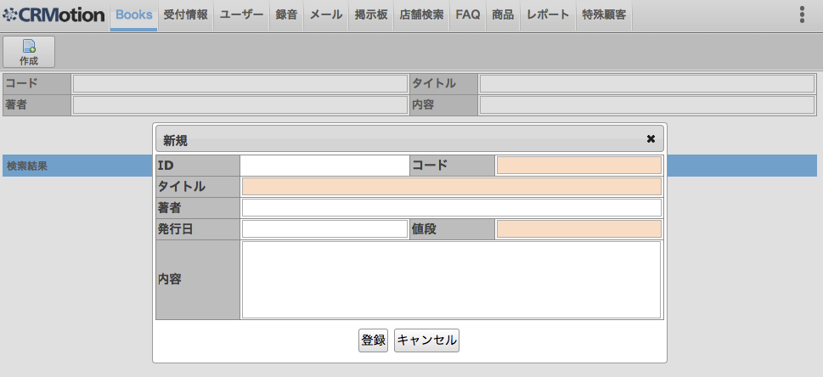

1. **Tạo mới**

* Edit file 「*public/templates/books/js/book.js*」

Bổ sung ajax save

**save**: **function**(id) {

**if** (Books.isClicked) {

**return** false;

}

Books.isClicked = true;

**var** url = ROOT_URL + '/index.php/books/index/save';

**var** params = {

book_id: !id ? "" : id

};

**var** strUrl = {

url: url,

type: 'POST',

data: params,

dataType: 'json',

**success**: **function**(data) {

Books.cbSave(data);

}

};

**$**('#frm_book').ajaxForm(strUrl);

**$**('#frm_book').submit();

},

**cbSave**: **function**(data) {

**try** {

**if** (data.intIsOk == 1) {

BaseController.setConfirm(true);

BaseController.cancelOverlay('ovl_books');

BaseController.setConfirm(false);

SettingUser.alertMsg(Books.SAVE_SUCCESS);

Books.isClicked = false;

Books.pagi

ng('1');

} **else** {

alert(data.errorMsg);

Books.isClicked = false;

}

} **catch** (e) {

alert(Constant.ERROR_MESSAGE);

Books.isClicked = false;

}

}

* Edit file 「*application/modules/books/controllers/IndexController.php*」

Bổ sung action save

**public** **function** **saveAction**()

{

$this->_logger->debugIn();

$this->disableRender();

$aryParams = $this->_request->getParams();

$id = $this->_request->getParam('book_id');

$errorMsg = "";

$aryData = $aryParams['book'] ?? [];

$form = **new** **Books_Forms_Books**($aryParams);

**if** ($form->isValid($aryData)) {

$intIsOk = $this->bizBooks->saveBook($aryData, $id);

} **else** {

$objErrors = $form->getMessages();

$errorMsg = $this->bizBooks->getErrorMessages($objErrors);

$intIsOk = **Vlib_Constant**::**VLIB_ERR_VALIDATION**;

}

$aryResponse = [

'intIsOk' => $intIsOk,

'errorMsg' => $errorMsg

];

$this->getResponse()->setBody(**Zend_Json**::encode($aryResponse));

$this->_logger->debugOut();

}

* Edit file 「*application/modules/books/forms/Books.php*」

Validate dữ liệu nhập

**<?php**

**class** **Books_Forms_Books** **extends** **Zend_Form**

{

**private** $db;

**private** $aryParams;

**public** **function** **__construct**($aryParams = [])

{

$this->db = **new** **Vlib_Models_Table**();

$this->aryParams = $aryParams;

$this->addElement($this->input_empty(

'book_code',

'BOOK_CODE_EMPTY'

));

$this->addElement($this->input_alphabet_format(

'book_code',

'BOOK_CODE_ALPHABET_FORMAT'

));

$this->addElement($this->record_exists(

'book_code',

'BOOK_CODE_EXISTS'

));

$this->addElement($this->input_empty(

'book_title',

'BOOK_TITLE_EMPTY'

));

$this->addElement($this->input_empty(

'book_price',

'BOOK_PRICE_EMPTY'

));

$this->addElement($this->input_number_format(

'book_price',

'BOOK_PRICE_NUMBER_FORMAT'

));

$this->addElement($this->input_date_format(

'book_publish_date',

'BOOK_PUBLISH_DATE_FORMAT'

));

$_translate = **Zend_Registry**::get('Zend_Translate');

$this->setTranslator($_translate);

}

**protected** **function** **input_date_format**($name, $messenger = '')

{

$element = $this->getElement($name);

!$element ? $element = **new** **Zend_Form_Element_Text**($name)

: null;

$validator = **new** **Zend_Validate_Date**(['format' => 'Y/m/d']);

$validator->setMessage($messenger);

$element->addValidator($validator, true);

**return** $element;

}

**protected** **function** **input_number_format**($name, $messenger = '')

{

$element = $this->getElement($name);

!$element ? $element = **new** **Zend_Form_Element_Text**($name) : null;

$element->addValidator(

'regex', false,

['/^([0-9]*)$/']

);

$element->getValidator('regex')

->setMessage($messenger);

**return** $element;

}

**protected** **function** **input_alphabet_format**($name, $messenger = '')

{

$element = $this->getElement($name);

!$element ? $element = **new** **Zend_Form_Element_Text**($name) : null;

$element->addValidator(

'regex', false,

['/^([a-z0-9]*)$/i']

);

$element->getValidator('regex')

->setMessage($messenger);

**return** $element;

}

**protected** **function** **input_empty**($name, $messenger = '')

{

$element = $this->getElement($name);

!$element ? $element = **new** **Zend_Form_Element_Text**($name)

: null;

$element->setRequired(true)

->addValidator(

'NotEmpty', true,

['messages' => ['isEmpty' => $messenger]]

);

**return** $element;

}

**protected** **function** **record_exists**($name, $messenger = '')

{

$element = $this->getElement($name);

!$element ? $element = **new** **Zend_Form_Element_Text**($name)

: null;

$where = "book_is_deleted = 0";

$id = $this->aryParams['book_id'] ?? "";

**if** ($id) {

$where .= " AND book_id != {$id}";

}

$validator = **new** **Zend_Validate_Db_NoRecordExists**([

'table' => $this->db->__('books'),

'field' => 'book_code',

'exclude' => $where

]);

$validator->setMessage($messenger);

$element->addValidator($validator, true);

**return** $element;

}

}

* Edit file 「*application/modules/books/languageslang-ja.php*」

Bổ sung message

'BOOK_CODE_EMPTY' => 'コードを入力してください。',

'BOOK_TITLE_EMPTY' => 'タイトルを入力してください。',

'BOOK_PRICE_EMPTY' => '値段を入力してください。',

'BOOK_PUBLISH_DATE_FORMAT' => '発行日には日付をyyyy/mm/ddの形式で入力してください。（例：2018/04/01）',

'BOOK_PRICE_NUMBER_FORMAT' => '値段は半角数字で入力してください。',

'BOOK_CODE_ALPHABET_FORMAT' => 'コードは半角英数字で入力してください。',

'BOOK_CODE_EXISTS' => '入力したコードは登録済です。',

'EMPTY_SEARCH_CONDITIONS' => '条件を指定して検索してください。'

* Edit file 「*application/modules/books/models/biz/Books.php*」

Bổ sung function build & save

**public** **function** **saveBook**($aryParams = [], $id = null)

{

$this->_logger->debugIn();

**if** (**empty**($aryParams)) {

$this->_logger->debugOut();

**return** **Vlib_Constant**::**VLIB_ERR_VALIDATION**;

}

$aryData = $this->buildData($aryParams, $id);

**if** (!$id) {

$intIsOk = $this->dbBooks->insertBook(

$aryData, $id

);

} **else** {

$intIsOk = $this->dbBooks->updateBook(

$aryData, $id

);

}

$this->_logger->debugOut();

**return** $intIsOk;

}

**public** **function** **buildData**($aryParams = [], $id = null)

{

$this->_logger->debugIn();

$aryData['book_code']

= $aryParams['book_code'] ?? "";

$aryData['book_title']

= $aryParams['book_title'] ?? "";

$aryData['book_author']

= $aryParams['book_author'] ?? "";

$aryData['book_publish_date']

= ($aryParams['book_publish_date'] ?? "") !== "" ? $aryParams['book_publish_date'] : null;

$aryData['book_price']

= $aryParams['book_price'] ?? null;

$aryData['book_content']

= $aryParams['book_content'] ?? "";

$aryData['book_content_search']

= $this->_objTextCommon->convertSearchField(

$aryData['book_content']

);

**if** (!$id) {

$aryData['book_creator_code'] = $this->_aryMemberSession->member_code;

$aryData['book_creator_name'] = $this->_aryMemberSession->member_family_name

." ".$this->_aryMemberSession->member_first_name;

$aryData['book_created_datetime'] = **date**('Y-m-d H:i:s');

}

$aryData['book_updater_code'] = $this->_aryMemberSession->member_code;

$aryData['book_updater_name'] = $this->_aryMemberSession->member_family_name

." ".$this->_aryMemberSession->member_first_name;

$aryData['book_updated_datetime'] = **date**('Y-m-d H:i:s');

$this->_logger->debugOut();

**return** $aryData;

}

**public** **function** **getErrorMessages**($objectErrors)

{

$this->_logger->debugIn();

$return = [];

**foreach** ($objectErrors **as** $messages) {

**is_array**($messages) ? $return[] = **@implode**(PHP_EOL, $messages)

: null;

}

$this->_logger->debugOut();

**return** **@implode**(PHP_EOL, $return);

}

* Edit file 「*application/modules/books/models/dbtable/Books.php*」

Thêm function insert & update db

**public** **function** **insertBook**($aryParams = [], &$newId = null)

{

$this->_logger->debugIn();

**try** {

$this->insertTable(

$this->__(self::**TABLE_NAME**), $aryParams, $newId

);

} **catch** (**Zend_Db_Exception** $e) {

$this->catchException($e, [], **VLIB_INSERT**);

$this->_logger->debugOut();

**return** **Vlib_Constant**::**VLIB_ERR_DB_EXCEPTION**;

}

$this->_logger->debugOut();

**return** **Vlib_Constant**::**VLIB_OK**;

}

**public** **function** **updateBook**($aryParams = [], $id = null)

{

$this->_logger->debugIn();

**if** (!$id) {

$this->_logger->debugOut();

**return** **Vlib_Constant**::**VLIB_ERR_VALIDATION**;

}

$where = $this->_db->quoteInto(

' book_id = ?', $id

);

**try** {

$this->updateLimitOne(

$this->__(self::**TABLE_NAME**), $aryParams, $where

);

$this->logSql();

} **catch** (**Zend_Db_Exception** $e) {

$this->catchException($e, [], **VLIB_UPDATE**);

$this->_logger->debugOut();

**return** **Vlib_Constant**::**VLIB_ERR_DB_EXCEPTION**;

}

$this->_logger->debugOut();

**return** **Vlib_Constant**::**VLIB_OK**;

}

1. **List search**

* Edit file 「*application/modules/books/views/scripts/index/index.phtml*」

Thêm event click cho button 「検索実行」 và 「クリア」

**<input** class="w80" type="button" value="検索実行" onclick="Books.search();"**>**

**<input** class="w80" type="button" value="クリア" onclick="Books.clear();"**>**

* Edit file 「*public/templates/books/js /Books.js*」

Bổ sung ajax search

**search**: **function**() {

**var** data = {

page: 1,

flagSearch: 1

};

Books.list(data);

},

**paging**: **function**(page) {

**var** data = {

page: !page ? 1 : page,

flagSearch: 0

};

Books.list(data);

},

**list**: **function** (params) {

**if**(Books.isClicked) {

**return** false;

}

Books.isClicked = true;

**var** url = ROOT_URL + '/index.php/books/index/list';

**var** data = params;

**var** ajaxSetup = {

url: url,

type: 'POST',

data: data,

dataType: 'json',

**success**: **function**(data) {

Books.cbList(data);

}

};

**$**('#form_books').ajaxForm(ajaxSetup);

**$**('#form_books').submit();

},

**cbList**: **function**(data) {

**try** {

**if** (data.intIsOk == 1) {

**$**("#list_books").html(data.html);

} **else** {

alert(data.errorMsg);

}

Books.isClicked = false;

} **catch** (e) {

alert(Books.ERROR_MESSAGE);

Books.isClicked = false;

}

},

* Edit file 「*application/modules/books/config/config.ini*」

Bổ sung config

rows_page = 10

* Edit file 「*application/modules/books/controllers/IndexController.php*」

Bổ sung action list

**public** **function** **listAction**()

{

$this->_logger->debugIn();

$intIsOk = **Vlib_Constant**::**VLIB_OK**;

$this->disableRender();

$errorMsg = "";

$aryParams = $this->_request->getParams();

$flagSearch = $aryParams['flagSearch'] ?? 0;

$aryCondition = $aryParams['book'] ?? [];

**if** ($flagSearch && !**count**(**array_filter**($aryCondition, 'strlen'))) {

$errorMsg = $this->view->translate('EMPTY_SEARCH_CONDITIONS');

$intIsOk = **Vlib_Constant**::**VLIB_ERR_VALIDATION**;

}

$aryResult = [];

**if** ($intIsOk == **Vlib_Constant**::**VLIB_OK**) {

$intIsOk = $this->bizBooks->getListBooks($aryResult, $aryParams);

}

$this->view->aryResult = $aryResult;

$aryResponse = [

'intIsOk' => $intIsOk,

'errorMsg' => $errorMsg,

'html' => $this->view->render(

'index/list.phtml'

)

];

$this->getResponse()->setBody(**Zend_Json**::encode($aryResponse));

$this->_logger->debugOut();

}

* Edit file 「*application/modules/books/models/biz/Books.php*」

Bổ sung function search

**public** **function** **getListBooks**(&$aryResult = [], $aryParams = [])

{

$this->_logger->debugIn();

$objSession = **new** **Zend_Session_Namespace**('books');

$aryPaging = [

'page' => $aryParams['page'] ?? 1,

'rows' => $this->aryConfig['rows_page'] ?? 10

];

$aryCondition = $aryParams['book'] ?? [];

$flagSearch = $aryParams['flagSearch'] ?? 0;

**if** (!$flagSearch) {

$aryCondition = $objSession->searchConditions;

} **else** {

$objSession->searchConditions = $aryCondition;

}

$aryResult = [];

$this->_logger->debugOut();

**return** $this->dbBooks->getList($aryResult, $aryCondition, $aryPaging);

}

* Edit file 「*application/modules/books/views/scripts/index/list.phtm*」

**<?php**

$aryBooks = $this->aryResult['rows_set'] ?? [];

**?>**

**<div** class="title-head systemColor"**>**

**<div** class="fleft"**>**検索結果**</div>**

**<?php** **echo** $this->render('index/paging.phtml');**?>**

**</div>**

**<div** class="page-list"**>**

**<table** class="table-item"**>**

**<colgroup>**

**<col** class="w200"**>**

**<col** class="w350"**>**

**<col** class="w200"**>**

**<col** class="w150"**>**

**<col** class=""**>**

**</colgroup>**

**<tr>**

**<th>**コード**</th>**

**<th>**タイトル**</th>**

**<th>**著者**</th>**

**<th>**値段**</th>**

**<th></th>**

**</tr>**

**<?php** **if** (**count**($aryBooks)) : **?>**

**<?php** **foreach** ($aryBooks **as** $book) : **?>**

**<tr>**

**<td>**

**<div** class="w195 text-ellipsis"**>**

**<?php** **echo** $this->escape($book['book_code'] ?? "");**?>**

**</div>**

**</td>**

**<td>**

**<div** class="w345 text-ellipsis"**>**

**<?php** **echo** $this->escape($book['book_title'] ?? "");**?>**

**</div>**

**</td>**

**<td>**

**<div** class="w195 text-ellipsis"**>**

**<?php** **echo** $this->escape($book['book_author'] ?? "");**?>**

**</div>**

**</td>**

**<td>**

**<div** class="w145 text-ellipsis"**>**

**<?php** **echo** $this->escape($book['book_price'] ?? "");**?>**

**</div>**

**</td>**

**<td** class="text-center"**>**

**<input** type="button" class="h20" value="編集" onclick="Books.showOverlay('**<?php** **echo** $this->escape($book['book_id'] ?? "");**?>**');"**/>**

**</td>**

**</tr>**

**<?php** **endforeach**; **?>**

**<?php** **else** : **?>**

**<tr>**

**<td** colspan="5" class="text-center"**>**検索結果が有りません。**</td>**

**</tr>**

**<?php** **endif**; **?>**

**</table>**

**</div>**

**<div** class="clear"**></div>**

* Edit file 「*application/modules/books/views/scripts/index/paging.phtm*」

**<?php**

$aryBooks = $this->aryResult['rows_set'] ?? [];

$total = $this->aryResult['total_rows'] ?? 0;

$page = $this->aryResult['current_page'] ?? 1;

$totalPage = $this->aryResult['total_pages'] ?? 0;

$start = $this->aryResult['start_row'] ?? 0;

$end = $this->aryResult['end_row'] ?? 0;

**if** ($page > 1) {

$prevPage = "on";

$icons = "paging";

$goFirst = "first";

$goBack = "prev";

$funcPrev = "onclick = Books.paging("

. ($page - 1) . ")";

$funcPrevEnd = "onclick = Books.paging(1)";

} **else** {

$prevPage = "off";

$funcPrev = "";

$funcPrevEnd = "";

$icons = "paging";

$goFirst = "first";

$goBack = "prev";

}

**if** ($page < $totalPage) {

$nextPage = "on";

$icon = "paging";

$goNext = "next";

$goLast = "last";

$funcNext = "onclick = Books.paging("

. ($page + 1) . ")";

$funcNextEnd = "onclick = Books.paging("

. $totalPage . ")";

} **else** {

$nextPage = "off";

$funcNext = "";

$funcNextEnd = "";

$icon = "paging";

$goNext = "next";

$goLast = "last";

}

**?>**

**<?php** **if** (**count**($aryBooks) > 0) : **?>**

**<div** id="pagging" class="pagging"**>**

**<div** class="page-list"**>**

**<div** class="item"**>**

**<div** class="basic-page-title mar-r10"**>**

**<?php** **echo** $start; **?>**

-

**<?php** **echo** $end; **?>**

/ **<?php** **echo** $total; **?>**

**</div>**

**<a** **<?php** **echo** $funcPrevEnd; **?>**

class="**<?php** **echo** $prevPage **?>**"**>**

**<span** class="**<?**= $icons; **?>** **<?**= $goFirst; **?>**"**></span>**

**</a>**

**<a** **<?php** **echo** $funcPrev; **?>**

class="**<?php** **echo** $prevPage **?>**"**>**

**<span** class="**<?**= $icons; **?>** **<?**= $goBack; **?>**"**></span>**

**</a>**

**<a** **<?php** **echo** $funcNext; **?>**

class="**<?php** **echo** $nextPage **?>**"**>**

**<span** class="**<?**= $icon; **?>** **<?**= $goNext; **?>**"**></span>**

**</a>**

**<a** **<?php** **echo** $funcNextEnd; **?>**

class="**<?php** **echo** $nextPage **?>**"**>**

**<span** class="**<?**= $icon; **?>** **<?**= $goLast; **?>**"**></span>**

**</a>**

**</div>**

**</div>**

**</div>**

**<?php** **endif**; **?>**

* Edit file 「*public/templates/books/css/Books.css*」

**.page-list** **.item** {

display: inline-flex !important;

}

**a.on** **.paging** {

margin: 2px 0 1px 0;

width: 16px;

height: 16px;

background: transparent **url(../../css/images/icons.png)** no-repeat;

_background: transparent **url(../../css/images/icons.gif)** no-repeat;

text-indent: 99999px;

overflow: hidden;

display: block;

}

**a.off** **.paging** {

width: 16px;

height: 16px;

background: transparent **url(../../css/images/icons2.png)** no-repeat;

opacity: 0.2;

filter: **alpha(opacity=50)**;

overflow: hidden;

display: block;

_background: transparent **url(../../css/images/icons2.gif)** no-repeat !important;

_display: block;

margin: 2px 0 1px 0;

text-indent: 99999px;

}

**a.off** **.paging.first** {

background-position: 0 -2202px !important;

cursor: default;

}

**a.on** **.paging.first** {

background-position: -160px -368px !important;

cursor: pointer;

}

**a.off** **.paging.prev** {

background-position: 1px -2274px !important;

cursor: default;

}

**a.on** **.paging.prev** {

background-position: -209px -368px !important;

cursor: pointer;

}

**a.off** **.paging.next** {

background-position: -1px -2250px !important;

cursor: default;

}

**a.on** **.paging.next** {

background-position: -192px -368px !important;

cursor: pointer;

}

**a.off** **.paging.last** {

background-position: 0 -2226px !important;

cursor: default;

}

**a.on** **.paging.last** {

background-position: -176px -368px !important;

cursor: pointer;

}

1. **Xoá**

* Edit file 「*public/templates/books/js /Books.js*」

Bổ sung ajax xoá

**delete**: **function** (id) {

**if** (!confirm('削除してもよろしいですか。')) {

**return** false;

}

**if** (**Books**.isClicked) {

**return** false;

}

**Books**.isClicked = true;

**var** url = **ROOT_URL** + '/index.php/books/index/delete';

**var** data = {

**book_id**: !id ? "" : id

};

$.ajax({

**url**: url,

type: 'POST',

data: data,

dataType: 'json',

success: **function**(data) {

**Books**.cbDelete(data);

}

});

},

cbDelete: **function**(data) {

**try** {

**if** (data.intIsOk == 1) {

**BaseController**.setConfirm(true);

**BaseController**.cancelOverlay('ovl_books');

**BaseController**.setConfirm(false);

**SettingUser**.alertMsg(**Books**.**DELETE_SUCCESS**);

**Books**.isClicked = false;

**Books**.paging('1');

}

} **catch** (e) {

alert(**Books**.**ERROR_MESSAGE**);

**Books**.isClicked = false;

}

}

* Edit file 「*application/modules/books/controllers/IndexController.php*」

Bổ sung action xoá

**public** **function** **deleteAction**()

{

$this->_logger->debugIn();

$this->disableRender();

$id = $this->_request->getParam('book_id');

$intIsOk = $this->bizBooks->deleteBook($id);

$aryResponse = [

'intIsOk' => $intIsOk

];

$this->getResponse()->setBody(**Zend_Json**::encode($aryResponse));

$this->_logger->debugOut();

}

* Edit file 「*application/modules/books/models/biz/Books.php*」

**public** **function** **deleteBook**($id = "")

{

$this->_logger->debugIn();

$aryData = ['book_is_deleted' => 1];

$intIsOk = $this->dbBooks->updateBook($aryData, $id);

$this->_logger->debugOut();

**return** $intIsOk;

}