Code Example:
https://framework.zend.com/manual/1.12/en/zend.db.table.html
https://framework.zend.com/manual/1.12/en/zend.db.table.html#zend.db.table.fetch-all.select
https://framework.zend.com/manual/1.12/en/zend.db.table.html#zend.db.table.insert
https://framework.zend.com/manual/1.12/en/zend.db.table.html#zend.db.table.delete
https://framework.zend.com/manual/1.12/en/zend.db.table.html#zend.db.table.update
https://framework.zend.com/manual/1.12/en/zend.db.select.html#zend.db.select.building.join

API:
https://framework.zend.com/apidoc/1.12/index.html

1. zend_db_table
là giao diện hướng đối tượng cho . cung cấp các phương thức và các hoạt động phổ biến ở bảng

nó implement Table Data Gateway pattent. và cũng implement Row Data G
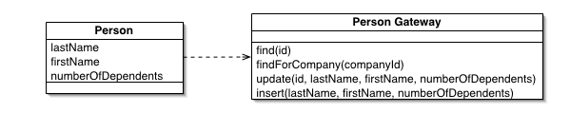

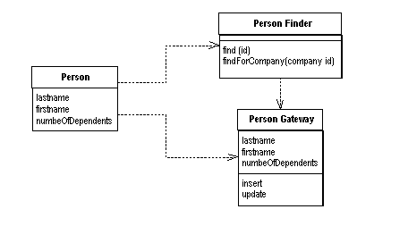

Su dung zend de tao lop cu the: Zend_Db_Table
xác định table class; Zend_Db_Table_Abstract
xác định table name và sch: $_name = , _schema
xác định table primary key: $_primary
overide table:
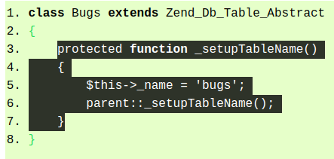

_setupDatabaseAdapter(): set database ở project
_setupTableName(): có thể set tên class để làm tên table
_setupMetadata(): set tên schema nếu nó có dạng schema.t
describeTable(): gọi để lấy thông tin meta, $_col để lấy thông tin cột
_setupPrimaryKey() : thông qua describeTable

Khởi tạo bảng
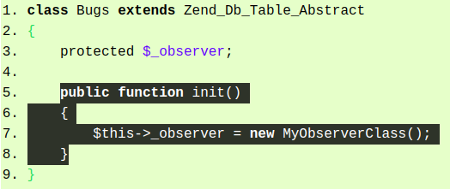

insert row:
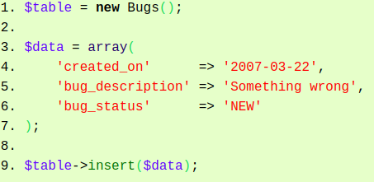

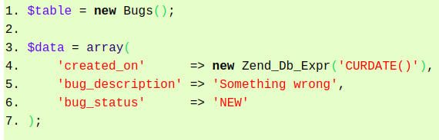

Table with auto increment
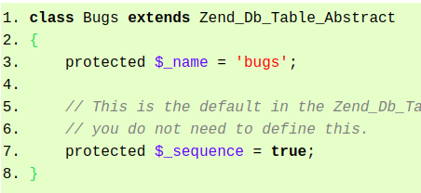

Update row
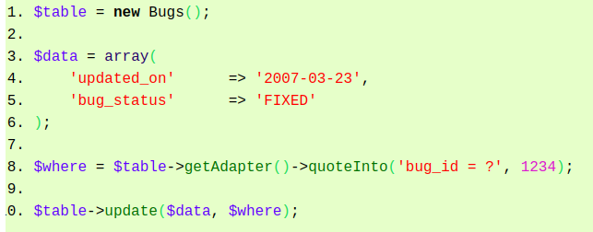
delete row
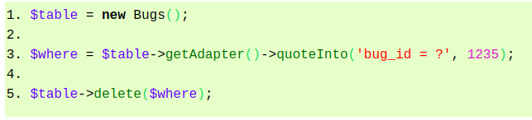

find row by id
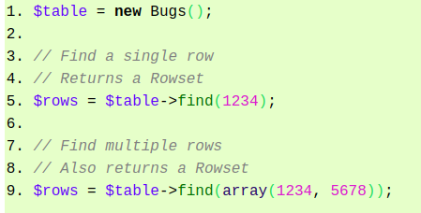

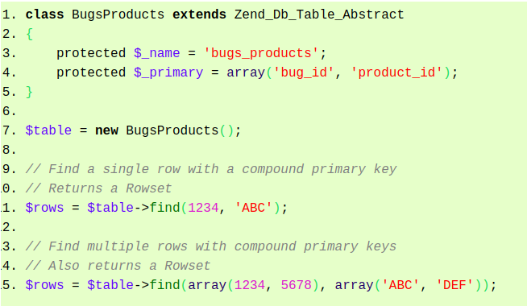

Query
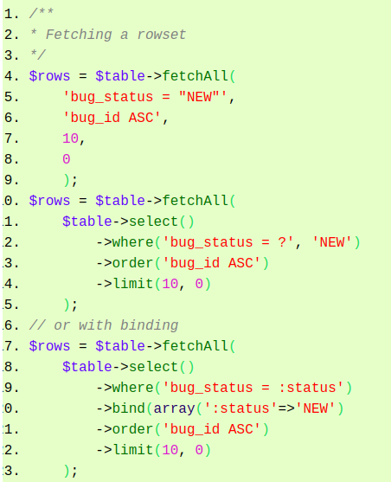

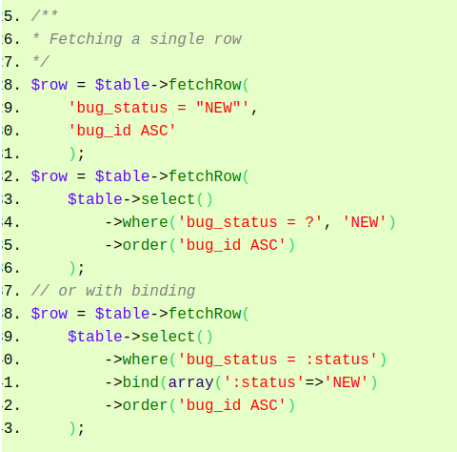

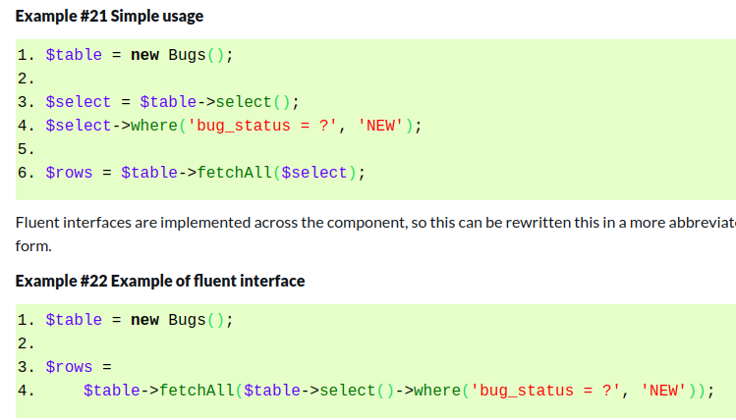

Lấy thông tin bảng

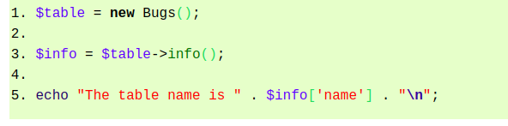

The keys of the array returned by the info() method are described below:
- name => the name of the table.
- cols => an array, naming the columns of the table.
- primary => an array, naming the columns in the primary key.
- metadata => an associative array, mapping column names to information about the columns. This is the information returned by the describeTable() method.
- rowClass => the name of the concrete class used for Row objects returned by methods of this table instance. This defaults to Zend_Db_Table_Row.
- rowsetClass => the name of the concrete class used for Rowset objects returned by methods of this table instance. This defaults to Zend_Db_Table_Rowset.
- referenceMap => an associative array, with information about references from this table to any parent tables. See this chapter.
- dependentTables => an array of class names of tables that reference this table. See this chapter.
- schema => the name of the schema (or database or tablespace) for this table.

Join
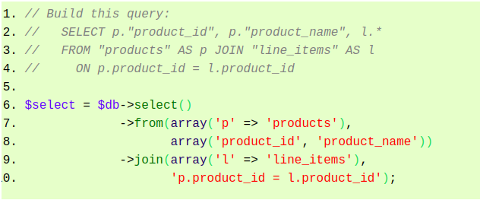
INNER JOIN with the join(table, join, [columns]) or joinInner(table, join, [columns]) methods.

LEFT JOIN with the joinLeft(table, condition, [columns]) method.

RIGHT JOIN with the joinRight(table, condition, [columns]) method.

FULL JOIN with the joinFull(table, condition, [columns]) method.

CROSS JOIN with the joinCross(table, [columns]) method.

NATURAL JOIN with the joinNatural(table, [columns]) method.

Select
