**MINISTRY OF EDUCATION AND TRAINING**

**FPT UNIVERSITY**

Capstone Project Document

**Maid Services**

|  |  |
| --- | --- |
| **Group 13** | |
| **Group member** | Bùi Tiến Tuân - Leader - SE60824  Mạnh Quang Tuyến - Member - SE60890  Trương Hải Đăng - Member - SE60841 **(Droped out)**  Nguyễn Tấn Công - Member - SE60920 |
| **Supervisor** | Mr. Nguyễn Trọng Tài |
| **Ext. Supervisor** | N/A |
| **Capstone Project code** | MS |

- Ho Chi Minh City, December 2014-

***ACKNOWLEDGEMENTS***

Later.

# Table of Contents

Table of Contents 3

List of Tables 6

List of Figures 8

Definitions, Acronyms, and Abbreviations 11

1 Introduction 12

1.1 Project Information 12

1.2 Introduction 12

1.3 Current Existence Method 12

1.4 System Overview 12

1.5 Role and Responsibility 12

2 Software Project Management Plan 13

2.1 Problem Definition 13

2.1.1 Name of this Capstone Project 13

2.1.2 Problem Abstract 13

2.1.3 Project Overview 13

2.2 Project organization 14

2.2.1 Software Process Model 14

2.2.2 Roles and responsibilities 15

2.2.3 Tools and Techniques 16

2.3 Project Management Plan 17

2.3.1 Task 17

2.3.2 Task Sheet: Assignment and Timetable 21

2.3.3 All Meeting Minutes 21

2.4 Coding Convention 21

3 Software Requirement Specification 21

3.1 User Requirement Specification 21

3.1.1 Guest requirement 21

3.1.2 Staff requirement 21

3.1.3 Customer requirement 22

3.1.4 Maid mediator requirement 22

3.1.5 Webmaster requirement 23

3.1.6 System requirement 23

3.2 System Requirement Specification 23

3.2.1 External Interface Requirement 23

3.2.2 Functional Requirement 25

3.2.3 Non-functional Requirement 119

3.3 Entity Relationship Diagram 121

3.3.1 Diagram 121

3.3.2 Data Dictionary 122

4 Software Design Description 123

4.1 Design Overview 123

4.2 System Architectural Design 123

4.3 Component Diagram 123

4.4 Detailed Description of Components 125

4.4.1 Class Diagram 125

4.4.2 Class Diagram Explanation 125

4.4.3 Sequence Diagram 135

4.5 User Interface Design 136

4.5.1 Webmaster Interface Design 136

4.6 Database Design 138

4.6.1 Physical Database Design 138

4.6.2 Data Dictionary 141

4.7 Algorithms 147

4.7.1 Overview 147

4.7.2 Implement 147

4.7.3 Detail 147

5 System Implementation & Test 148

5.1 Introduction 148

5.1.1 System Overview 148

5.1.2 Test Approach 149

5.2 Test Plan 149

5.2.1 Features to be tested 149

5.2.2 Features not to be tested 149

5.3 Module Test Case 150

6 Software User’s Manual 190

6.1 Installation Guide 190

6.1.1 Setting up environment at server site 190

6.2 User Guide 191

6.2.1 Login 191

# List of Tables

Table 3: Roles and Responsibility Details 15

Table 4: Task 18

Table 5: Entity Data Dictionary 140

Table 6: Login 190

# List of Figures

Figure 1 - Waterfall model 11

Figure 2: Task Sheet and Assignment 18

Figure 3: System Overview Use Case 22

Figure 88: Component Diagram 121

Figure 89: Class Diagram 122

Figure 94: <Player> Map diagram 133

Figure 153: Webmaster Home Page 134

Figure 154: Physcial Database Diagram 137

Figure 170: Login Image 188

# Definitions, Acronyms, and Abbreviations

|  |  |  |
| --- | --- | --- |
| **No.** | **Abbreviation & Acronym** | **Definition** |
| 1 | CPS | Computer Product Suggestion |
| 2 | OS | Operation System |
| 3 | Admin | Administrator |
| 4 | API | Application Programming Interface |
| 5 | HTTP | Hyper Text Transfer Protocol |

# Introduction

## Project Information

* **Project name:** Maid Services
* **Project Code:** MS-Website
* **Product Type:** Web-based Application
* **Start Date:** September 9, 2014
* **End Date:** December 20, 2014

## Introduction

Currently, most of job centers supply maid service with many functions such as posting maid’s information, maid searching by criteria (expected salary, age, experiences …) but the customers can’t post their private requests and give rating, comment about the maid that they have recruited. Moreover, maid’s information is not detailed and complete. The system can’t match and suggest the maid to the customer, negotiation and signing the contract are time-consuming.

## Current Existence Method

later

## System Overview

Later

## Role and Responsibility

|  |  |  |
| --- | --- | --- |
| **Role and Responsibilities** | **Full name** | **E-mail** |
| Instructor | Nguyễn Trọng Tài | taint@fpt.edu.vn |
| Leader | Bùi Tiến Tuân | tuanbtse60824@fpt.edu.vn |
| Member | Mạnh Quang Tuyến | tuyenmqse60890@fpt.edu.vn |
| Member | Trương Hải Đăng (drop out) | dangthse60841@fpt.edu.vn |
| Member | Nguyễn Tấn Công | congntse60920@fpt.edu.vn |

# Software Project Management Plan

## Problem Definition

### Name of this Capstone Project

* The system is for maid and the people who are searching for maid.
* The language is Vietnamese.
* The end product includes: the website and documents involved with the system.

### Problem Abstract

Nowadays, the demand of playing sports for relaxing after work, studying...more and more decrease especially playing badminton sports. Moreover, there are not many websites supporting for badminton players, badminton court owners and badminton trainers to rent courts, manage courts, manage badminton classes…

This website system is developed and focus on target users are badminton sport fans who want to rent badminton courts for playing; bosses of badminton courts who want to provide for sport fan renting court services; badminton trainers who want to apply teaching jobs; trainees who want to join to badminton course to improve their abilities

### Project Overview

#### The Current System

There are have many website about work such as http://timviec.com, timviecnhanh.com, vietnamworks.com …. But they have some problem:

* **Advantages:** Provider many information about works in Vietnam.
* **Disadvantages:**
  + There is so much information.
  + There is no centralized information about Maid.

#### The Proposed System

Our site focuses on those who are busy with their works so they need to find maids to help them with household chores and the maids who are searching for jobs. Maids can quickly find job for themselves and it also makes it easy for people who are in need of finding maids to choose and recruit. With small amount of money, the website can connect those two together. The maids are people who don’t have much knowledge about IT, so our purpose is to create a website with ease of use and simple.

There are three main users whom the website interacts with including:

* **Maid representation:** Because of the lack of knowledge in IT, they can ask someone has knowledge to become their representation and register for them. Manage requested job, Search jobs, Apply job, View maid statistic.
* **Customer:** Manage recruitment, View customer statistic, Comment, Search maids, Rating, Apply maid.
* **Staff:** Can help maid to register and post info in place of them. Manage post time, Confirm request, Manage fee.

#### Boundaries of the System

* The system is for maid and the people who are searching for maid.
* The language is Vietnamese.
* The end product includes: the website and documents involved with the system.

#### Development Environment

##### Hardware requirements

**For Server**

|  |  |  |
| --- | --- | --- |
| Windows | Minimum Requirements | Recommended |
| Internet Connection | 4Mbps | 8 Mbps |
| Operating System | Window Server 2008 | Window Server 2012 |
| Computer Processor | Intel® Core 2 Duo | Intel® Core(TM) i5 CPU , M 460 @ 2.53GHz |
| Computer Memory | 1GB RAM | 3GB or more |

##### Software requirements

* Microsoft Windows 7: Operating System.
* SQL Server 2008 R2: used for managing the database for system.
* StarUML 5.0: designing models and diagrams tools.
* Visual Studio 2012: used to implement website and web service.
* Google Code & TortoiseSVN: used for source control.

## Project organization

### Software Process Model

With the schedule of weekly reports for every stage, the software will be developed by using waterfall model it is very simple and require minimal resource for implementation. With waterfall model, developing process will include six main phases:

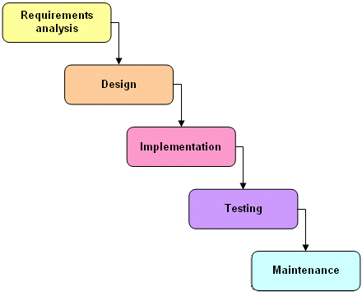

Figure 1 - Waterfall model

* **Requirement analysis and software definition**: The first phase is also the most important phase of the process which may cause great effect to other phases. This phase includes gathering as much as possible requirements from customer, or other information source like World Wide Web, and producing a most detail and accurate software definition.
* **System design**: This phase is fundamental for implementation phase. Based on customer’s requirements to create logical modules, and definite their inter relations. Using algorithm and diagram to describe implementation of those modules.
* **Implementation**: This phase consists of actually constructing the product as per the design specification(s) developed in the previous step. Typically, this step is performed by a development team consisting of programmers, interface designers and other specialists, using tools such as compilers, debuggers, interpreters and media editors.
* Testing:
  + **System implementation and Unit testing**: Developing software modules follow detail designs, and doing unit testing for each module.
  + **Integration and System testing**: Testing output, performance in modules integrating process, and retests all functions of whole system.
  + **User acceptance testing**: A proper execution of all the preceding stages ensures an application as per the provided requirements and most importantly, it ensures a satisfied client.
* **System deployment and maintenance**: After testing completely, the software is handle over client, developing team will respond for maintenance of the system.

### Roles and responsibilities

|  |  |  |  |
| --- | --- | --- | --- |
| **No** | **Full name** | **Role in Group** | **Responsibilities** |
| **1** | Nguyễn Trọng Tài | Project manager | * Specify user requirement * Control the development process * Give out technique and business analysis support |
| **2** | Bùi Tiến Tuân | Team Leader, BA, DEV, Tester | * Managing process * Assign task for team member * Designing database * Clarifying requirements * Prepare documents * GUI Design * Create test plan * Coding * Testing |
| **3** | Mạnh Quang Tuyến | Team Member, BA, DEV, Tester | * Designing database * Clarifying requirements * Prepare documents * GUI Design * Create test plan * Coding * Testing |
| **4** | Trương Hải Đăng | Team Member, BA, DEV, Tester | * Designing database * Clarifying requirements * Prepare documents * GUI Design * Create test plan * Coding * Testing |
| **5** | Nguyễn Tấn Công | Team Member, BA, DEV, Tester | * Designing database * Clarifying requirements * Prepare documents * GUI Design * Create test plan * Coding * Testing |

Table 3: Roles and Responsibility Details

### Tools and Techniques

#### For Development

* Front-end technologies: HTML5, CSS3, JavaScript, jQuery, AJAX.
* Back-end: ASP .NET MVC4, Entity Framework.
* Data Management System: SQL Server 2008 R2.
* IDE: Visual Studio 2012
* System design tool: StartUML
* IIS: web server

#### For Management

-Process and code tracking: Team Foundation Server.

-Tortoise SVN: Document version control and tracking.

## Project Management Plan

### Task

|  |  |  |  |  |  |  |  |
| --- | --- | --- | --- | --- | --- | --- | --- |
| **#** | **Task** | **Description** | **Output** | **Deliverables** | **Resource Needed** | **Dependencies and Constraints** | **Risk** |
| 1 | Creating Software Requirements Specification (SRS) | Creating SRS | SRS document | SRS document before 18/09/2014 | 4 people for 4 days |  | Lack of experience in getting requirement. |
| 2 | Designing Database | Creating conceptual, logical and physical database. | Database Design and Database script | Design Database before 25/09/2014 | 3 person for 3 days | Depends on the completion of SRS | May not cover all business rules, causing the database design to be inappropriate or must be changed by customers’ requirements. |
| 3 | Creating Software Design Description (SDD) | Design the system in an Object Oriendted Programming. | Architecture design, detailed design, diagrams and design specification | SDD before 30/09/2014 | 4 people for 4 days | Depends on the completion of SRS | Choosing inappropriate architecture and design patterns, causing the system hard to maintain, or wasting coding efforts. |
| 4 | Layout Designing | Create the main GUI for layout | HTML layout, Javascript and CSS files | Complete before 30/09/2013 | 2 person for 1 week |  | There is no professional designers in team. |
| 5 | Create Coding | Map the architecture design into source code, create the project solution files and common classes, and implement common functions. | .Net MVC4 project and solution file contain coding |  | 1 person for 3 days | Dependent on Architecture design and SRS |  |
| 6 | Coding | Implement the system based on the requirements. | Source code of the project, unit test reports | Executable programs and source code before 03/11/2014 | 4 people for 5 weeks | Depends on the completion of SRS, SDD, Database design, Coding framework | Unit test may not be performed thoroughly, it draws needing more efforts in system test phase. |
| 7 | Test Plan | Make a plan for testing | Test plan document | Test plan before 10/11/2014 |  |  |  |
| 8 | System Test | Perform system test for the system. | System test report | Software Test Documentation before 20/11/2014 | 3 people for 4 days | When Coding is finished | There is no professional testers in team. Developers are also do system testing, this may draws compromise. |
| 9 | User Guide | Create User manual document | Report 6 | Report 6 before 06/12/2014 | 3 people for 1 days |  | Unclear document may cause ambigious understanding. |
| 10 | Input Initial Data | Collect and input initial data for the system before release. | Initial data |  | 3 people for 3 days | When coding and system test are finished |  |
| 11 | Deployment | Deploy the system on server. | Running website with domain and hosting | Full Project | 2 people for 3 days | When Coding and system test are finished, initial data is inputted. | The owner host lacks of supporting in some components such as database engine. |

Table 4: Task

### Task Sheet: Assignment and Timetable

Chụp hình MS_project

Figure 2: Task Sheet and Assignment

### All Meeting Minutes

Refer to Meeting Minutes folder.

## Coding Convention

C#: Using to develop BSF-website.

Summary:

* Naming Convention.
* Indentation.
* Declaration.
* Code Examples.

All “Code Conventions for the C# Programming Language, by Microsoft

<http://msdn.microsoft.com/en-us/library/ff926074.aspx>

# Software Requirement Specification

## User Requirement Specification

### Guest requirement

To satisfy the demand of guest, system has these functions:

* **Register Account:** guest need to register to become member.
* **Login:** when guest have account they can login with username and password.
* **Search:** guest can search information about jobs, before they determine become a member.
* **View JobRequest:** view JobRequest details.
* **View Recruitment:** view Recruitment details.
  + 1. **Authenticated User requirement**

After logging in, user becomes authenticated user and has these functions:

* **View Profile:** user can view profile.
* **Log out:** user can log out .
* **View JobRequest:** view JobRequest details.
* **View Recruitment:** view Recruitment details.
* **View Notifications:** view Notifications when system sends.
* **View Statistic:** view personal statistic.
* **Search:** guest can search information about jobs, before they determine become a member.

### Staff requirement

A person: to manage the maid’s request, fee and allow maid to post request.

* **Manage post time**: staff manage maid’s request post time.
* **View post time**: staff can allow customer and maid the time that maid’s request posted.
* **Manage fee**: staff can manage the customer’s fee, maid’s fee
* **Confirm request**: staff can allow the maid’s request to post to the website.
* **View Requests Statistic:** User can view all statistic of request in year.
* **View Income Statistic:** User can view all statistic of income in year.
* **Active Job Request:** Staff can choose of list job request not active, Staff choose one of them was paid money by maid.
* **Active Recruitment:** Staff can choose of list recruitment not active, staff choose one of them was paid money online by paypal from customer.
* **Approve Job Request:** staff to approve job request to public it on website
* **Manage Job Request:** staff view all jobrequests that is not active
* **Manage Recruitment:** staff view all recruitments that is not active
* **Manage Applied Job Request:** staff view all applied jobrequests
* **View Maid Manager Statistic:** staff to view personal statistic as maid
* **Add Maid:** User add maid for management
* **View Maid:** User to view a maid’s detail
* **Edit Maid:** Useredit a maid’s info
* **Public Job Request:** User to public a job request for customer to apply.
* **Hide Job Request:** User to hide a job request and can’t be applied by any customer.
* **Extend Job Request:** User to extend job request.
* **Edit Job Request:** User to edit job request.
* **Post Job Request:** User to post job request.

### Customer requirement

A person: They can hire maid and do all function by Customer roll.

* **Apply Job Request:** Customer use a them Recruitment have status “Waiting” to Apply a JobRequest have status “Waiting” too.
* **Comment Job Request:** When customer applied a JobRequest, they can comment for this JobRequest if Maid come back and tell to staff Approved this Job**.**
* **Rate Job Request:** When customer applied a JobRequest, they can rate for this JobRequest if Maid come back and tell to staff Approved this Job.
* **Edit Customer Profile:** customer to edit profile.
* **Extend Recruitment:** customer to extend recruitment.
* **Hide Recruitment:** Customer to hide a recruitment and can’t be seen by any one.
* **Public Recruitment:** Customer to public a job request for customer to apply.
* **Post Recruitment:** Customer to post job request
* **Edit Recruitment:** Customer to edit recruitment
* **Pay:** Customer will pay online by Paypal for them Recruitment
* **View Customer Statistic:** Customer to view personal statistic as customer.

### Maid mediator requirement

A person: This is a role mediator of maid. They help maid post job request and add Maid.

* **View Maid Manager Statistic**: User to view personal statistic as maid.
* **Add Maid:** User add maid for management
* **View Maid:** User to view a maid’s detail
* **Edit Maid:** Useredit a maid’s info
* **Public Job Request:** User to public a job request for customer to apply.
* **Hide Job Request:** User to hide a job request and can’t be applied by any customer.
* **Extend Job Request:** User to extend job request.
* **Edit Job Request:** User to edit job request.
* **Post Job Request:** User to post job request.

### Webmaster requirement

A person: This is admin of system. They can mange user, config and run algorithm.

* **Add Staff:** User to add maid for management.
* **Manage User:** user to view a maid’s detail
* **Ban Account:** User will ban account
* **Unban Account:** User will active account
* **View Requests Statistic:** View statistic of all request of MS-Website in year
* **View Income Statistic:** View statistic of all income of MS-Website in year
* **Manage Number of Kmean:** Change number K of Kmean algorithm. K same number of group.
* **Manage Number of Weeks:** Change maximum week when user post a JoRequest or Recruiment in to MS-Website.
* **Manage Job Request Price:** Change price when a new JobRequest post to MS-Website.
* **Manage Recruitment Price:** Change price when a new Recruitment post to MS-Website.

### System requirement

A person: this is a system, automatic run some function.

* **Suggests:** system automatically suggest JobRequest for customer when they post a recruitment on MS-Website
* **Send SMS:** Notify for Maid, Customer, Maid Mediator or Staff when Customer apply JobRequest of Maid
* **Send Notifications:** Notify for Maid, Customer, Maid Mediator or Staff when Customer apply JobRequest of Maid. Notify for all Staff when customer report about payment.

## System Requirement Specification

### External Interface Requirement

#### User Interface

* The general interface of website is simple and simplifies user interfaces.
* The design is simple and monochrome is more prefer.
* The layout of information in page is showing simple but full of functions.
* The error, warning and notification messages must be simple, neat, and easy to understand. Error warning does not discomfort to the user.
* The working layout of user is spacious.
* Member can contact with manager and admin easily.

#### Hardware Interface

There is no extra hardware interfaces are needed. The system will use the standard hardware and data communications resources of a standard computer.

#### Software Interface

Browser: Chrome, Firefox

#### Communication Protocol

* Thien Nam website uses HTTP/HTTPS protocol for communication with the web browser and the web server. In addition, TCP/IP network protocol for communication with HTTP protocol

### Functional Requirement

#### System Overview Use Case

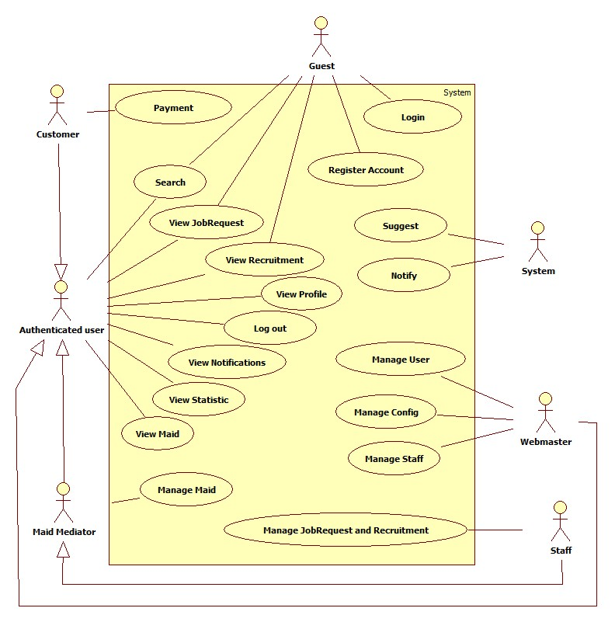

Figure 3: System Overview Use Case

#### List of Use Case

##### <Guest> Register

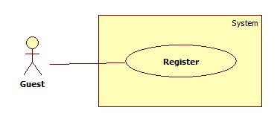

|  |  |  |  |  |
| --- | --- | --- | --- | --- |
| **USE CASE SPECIFICATION** | | | | |
| **Use-case No.** | UC001 | **Use-case Version** | | 1.0 |
| **Use-case Name** | Register | | | |
| **Author** | CongNT | | | |
| **Date** | 21/09/2014 | **Priority** | High | |
| **Actor:** Guest  **Summary:** This use case allows guest to create an account in website system.  **Goal:**  It helps guest to create an account on website.  **Trigger:** Click on the “Đăng ký” button to register on home page  **Pre-conditions:**   * Page is loaded successfully * Register page will be shown   **Post conditions:**   * Success: Register successfully, guest will have an account in system and will be logged into system. * Failure: Show message error.   **Main Success Scenario:**   |  |  | | --- | --- | | Actor Action | System Response | | 1. Click on “Đăng ký” button home page 2. Input right information about username, email, password, full name, phone, role 3. Click on the “Đăng ký” button | 2. System redirect to register page for guest, contain a register form :   * Tên tài khoản [Username: textbox ] * Mật khẩu [Password : textbox] * Nhập lại mật khẩu [Repassword : textbox] * Địa chỉ email [Email: textbox]   In format: /^([a-zA-Z0-9_\.\-])+\@(([a-zA-Z0-9\-])+\.)+([a-zA-Z0-9]{2,4})+$/ .   * Họ và tên [Fullname : textbox] * Điện thoại[Phone : textbox] * Vai trò[Role : dropdownlist] * Đăng ký[button]  1. Validate valid username, password, email, phone 2. Redirect to login page |   **Alternative Scenario:**   |  |  | | --- | --- | | Actor Action | System Response | | 1. Click on the “MaidService” icon. | 1. Back to home page |   **Exceptions:**   |  |  | | --- | --- | | Actor Action | System Response | | 1. “Tên đăng nhập” is emtpy 2. “”Mật khẩu” is empty 3. “Nhập lại mật khẩu” if different with “Mật khẩu” 4. “Điện thoại” is empty or not a numberic value 5. “Họ và tên” is empty 6. “Email” is empty or not correct type [abc@abc.abc](mailto:abc@abc.abc) 7. “Tên đăng nhập” is already have in database | 1. Display message: “Vui lòng nhập tên đăng nhập” 2. Display message: “Vui lòng nhập mật khẩu” 3. Display message: “Mật khẩu không trùng khớp” 4. Display message: “Vui lòng nhập số” 5. Display message: “Vui lòng nhập họ và tên” 6. Display message: “Vui lòng nhập đúng định dạng [abc@abc.abc](mailto:abc@abc.abc)” 7. Display message: “Tên đăng nhập đã tồn tại” |   **Relationships:** N/A  **Business Rules:** When register an account, username have to input username, email, password, phone.   * If username is already have in database or empty, an error message will be displayed. * If password is empty, an error message will be displayed. * If confirm password is not the same as password, an error message will be displayed. * If phone is empty or not a numberic value, an error message will be displayed. | | | | |

##### <Guest> Login

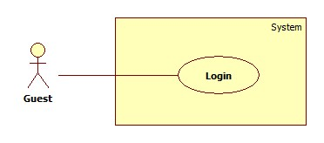

|  |  |  |  |  |
| --- | --- | --- | --- | --- |
| **USE CASE SPECIFICATION** | | | | |
| **Use-case No.** | UC002 | **Use-case Version** | | 1.0 |
| **Use-case Name** | Login | | | |
| **Author** | CongNT | | | |
| **Date** | 21/09/2014 | **Priority** | High | |
| **Actor:** Guest  **Summary:** This use case allow guest to login the website  **Goal:** Guest become a member of the website  **Trigger:** Click on the “Đăng nhập” button to login on home page  **Pre-conditions:**   * Page is loaded successfully * The login page will shown   **Post conditions:**   * Success: Login successfully, guest will have a role in system and can use more function of system. * Failure: Show message error   **Main Success Scenario:**   |  |  | | --- | --- | | Actor Action | System Response | | 1. Click on “Đăng nhập” button home page 2. Input right information about username, password 3. Click on the “Đăng nhập” button | 1. System redirect to login page for guest, contain a login form :  * Tên tài khoản [Username: textbox ] * Mật khẩu [Password : textbox] * Đăng nhập [button]  1. Redirect to login successful page |   **Alternative Scenario:**   |  |  | | --- | --- | | Actor Action | System Response | | 1. Click on the “MaidService” icon. | 1. Back to home page |   **Exceptions:**   |  |  | | --- | --- | | Actor Action | System Response | | 1. “Tên đăng nhập”,”Mật khẩu” ,” is empty 2. “Tên đăng nhập”,”Mật khẩu” ,” is incorrect 3. “Tên đăng nhập” is IsActive(false) | 1. Display message “Vui lòng nhập tên đăng nhập” or “Vui lòng nhập mật khẩu” 2. Display message “Tên đăng nhập hoặc mật khẩu không đúng, vui lòng thử lại” 3. Display message “Tên đăng nhập đã bị khóa” |   **Relationships:** N/A  **Business Rules:** User must input username, password. The username and password must unique and have in database and the username is not blocked. If the username is blocked or not unique or not have in database, an error message is displayed. | | | | |

##### <Authenticated user > Search

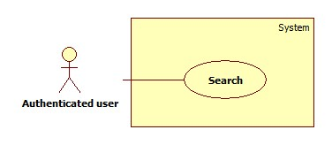

|  |  |  |  |  |
| --- | --- | --- | --- | --- |
| **USE CASE SPECIFICATION** | | | | |
| **Use-case No.** | UC003 | **Use-case Version** | | 1.0 |
| **Use-case Name** | Search | | | |
| **Author** | CongNT | | | |
| **Date** | 21/09/2014 | **Priority** | High | |
| **Actor:** Guest, Customer, Maid Mediator, Staff, Webmaster.  **Summary:** This use case allow guest can search information on the website  **Goal:** Guest can search information by search job  **Trigger:** Fill in “Tìm kiếm” textbox, then click on “Tìm kiếm” button  **Pre-conditions:**   * Page is loaded successfully * The search page will shown   **Post conditions:**   * Success: Search successfully, the system will shown search result * Failure:   **Main Success Scenario:**   |  |  | | --- | --- | | Actor Action | System Response | | 1. Fill in “Tìm kiếm” text box 2. Click on “Tìm kiếm” button | 1. System redirect to search page for guest and show search results |   **Alternative Scenario:**   |  |  | | --- | --- | | Actor Action | System Response | | 1. Click on the “MaidService” icon | 1. Back to home page |   **Exceptions:**   |  |  | | --- | --- | | Actor Action | System Response | |  |  |   **Relationships:** N/A  **Business Rules:** All of role can search but search results are different in some roles:   * If user is a guest, search results are jobrequests and recruitments. * If user is a staff, customer or webmaster, search results are jobrequests and recruitments. * If user is a maid mediator, search results are jobrequests. | | | | |

##### < Authenticated user >Advance Search

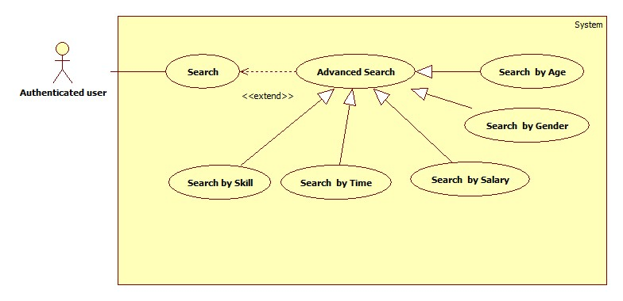

###### <Authenticated user> Search by Age

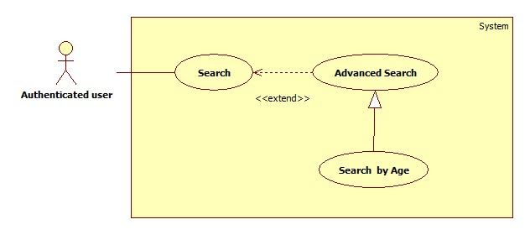

|  |  |  |  |  |
| --- | --- | --- | --- | --- |
| **USE CASE SPECIFICATION** | | | | |
| **Use-case No.** | UC004 | **Use-case Version** | | 1.0 |
| **Use-case Name** | Search by age | | | |
| **Author** | CongNT | | | |
| **Date** | 21/09/2014 | **Priority** | High | |
| **Actor:** Guest, Customer, Maid Mediator, Staff, Webmaster.  **Summary:** This use case allow guest can search information by age  **Goal:** Guest can search information by search age  **Trigger:** Click on age radio button on website  **Pre-conditions:**   * Page is loaded successfully * The search page will shown   **Post conditions:**   * Success: Search successfully, the system will shown search result * Failure:   **Main Success Scenario:**   |  |  | | --- | --- | | Actor Action | System Response | | 1. Fill in “Tìm kiếm” text box 2. Click on “Tìm kiếm” button 3. Click on “25-30” or “30-35” or “35-40” link | 1. System redirect to search page for guest 2. Show the result suitable for each link |   **Alternative Scenario:**   |  |  | | --- | --- | | Actor Action | System Response | | 1. Click on the “MaidService” icon. | 1. Back to home page |   **Exceptions:**   |  |  | | --- | --- | | Actor Action | System Response | |  |  |   **Relationships:** Search by age is generated with AdvancedSearch and AdvancedSearch is extended to Search  **Business Rules:** All of role can search but search results are different in some roles:   * If user is a guest, search results are jobrequests and recruitments. * If user is a staff, customer or webmaster, search results are jobrequests and recruitments. * If user is a maid mediator, search results are jobrequests. | | | | |

###### <Authenticated user> Search by Skill

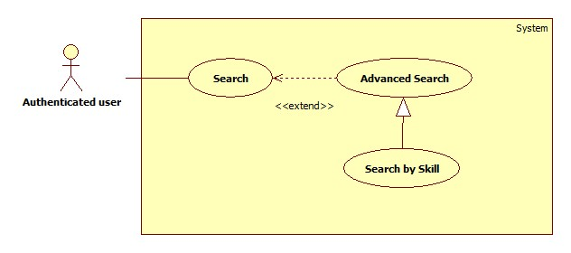

|  |  |  |  |  |
| --- | --- | --- | --- | --- |
| **USE CASE SPECIFICATION** | | | | |
| **Use-case No.** | UC005 | **Use-case Version** | | 1.0 |
| **Use-case Name** | Search by skill | | | |
| **Author** | CongNT | | | |
| **Date** | 21/09/2014 | **Priority** | High | |
| **Actor:** Guest, Customer, Maid Mediator, Staff, Webmaster.  **Summary:** This use case allow guest can search information by skill  **Goal:** Guest can search information by search skill  **Trigger:** Click on skill radio button on website  **Pre-conditions:**   * Page is loaded successfully * The search page will shown   **Post conditions:**   * Success: Search successfully, the system will shown search result * Failure:   **Main Success Scenario:**   |  |  | | --- | --- | | Actor Action | System Response | | 1. Fill in “Tìm kiếm” text box 2. Click on “Tìm kiếm” button 3. Click on skill radio button of skill | 1. System redirect to search page 2. Show the result suitable for each button |   **Alternative Scenario:**   |  |  | | --- | --- | | Actor Action | System Response | | 1. Click on the “MaidService” icon. | 1. Back to home page |   **Exceptions:**   |  |  | | --- | --- | | Actor Action | System Response | |  |  |   **Relationships:** Search by skill is generated with AdvancedSearch and AdvancedSearch is extended to Search  **Business Rules:** All of role can search but search results are different in some roles:   * If user is a guest, search results are jobrequests and recruitments. * If user is a staff or webmaster, search results are jobrequests and recruitments. * If user is a maid mediator, search results are recruitment. * If user is a customer, search results are jobrequests. | | | | |

###### <Authenticated user> Search by Gender

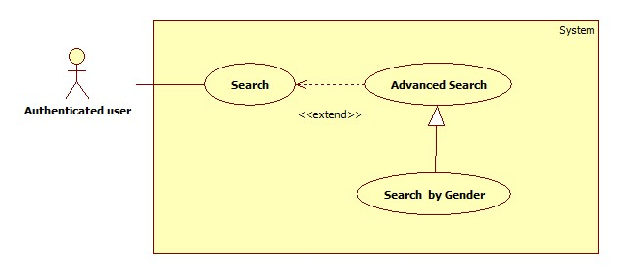

|  |  |  |  |  |
| --- | --- | --- | --- | --- |
| **USE CASE SPECIFICATION** | | | | |
| **Use-case No.** | UC006 | **Use-case Version** | | 1.0 |
| **Use-case Name** | Search by gender | | | |
| **Author** | CongNT | | | |
| **Date** | 21/09/2014 | **Priority** | High | |
| **Actor:** Guest, Customer, Maid Mediator, Staff, Webmaster.  **Summary:** This use case allow guest can search information by gender  **Goal:** Guest can search information by search name  **Trigger:** Click on gender radio button on website  **Pre-conditions:**   * Page is loaded successfully * The search page will shown   **Post conditions:**   * Success: Search successfully, the system will shown search result * Failure:   **Main Success Scenario:**   |  |  | | --- | --- | | Actor Action | System Response | | 1. Fill in “Tìm kiếm” text box 2. Click on “Tìm kiếm” button 3. Click on “Nam” or “Nữ” link | 1. System redirect to search page for guest 2. Show the result suitable for each link |   **Alternative Scenario:**   |  |  | | --- | --- | | Actor Action | System Response | | 1. Click on the “MaidService” icon. | 1. Back to home page |   **Exceptions:**   |  |  | | --- | --- | | Actor Action | System Response | |  |  |   **Relationships:** Search by gender is generated with AdvancedSearch and AdvancedSearch is extended to Search  **Business Rules:** All of role can search but search results are different in some roles:   * If user is a guest, search results are jobrequests and recruitments. * If user is a staff, customer or webmaster, search results are jobrequests and recruitments. * If user is a maid mediator, search results are jobrequests. | | | | |

###### <Authenticated user> Search by Salary

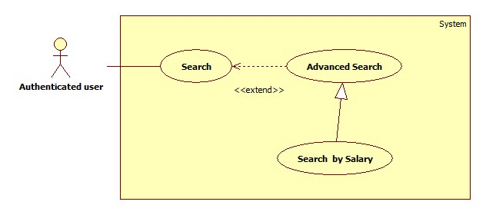

|  |  |  |  |  |
| --- | --- | --- | --- | --- |
| **USE CASE SPECIFICATION** | | | | |
| **Use-case No.** | UC007 | **Use-case Version** | | 1.0 |
| **Use-case Name** | Search by salary | | | |
| **Author** | CongNT | | | |
| **Date** | 21/09/2014 | **Priority** | High | |
| **Actor:** Guest, Customer, Maid Mediator, Staff, Webmaster.  **Summary:** This use case allow guest can search information by salary  **Goal:** Guest can search information by search salary  **Trigger:** Click on salary radio button on website  **Pre-conditions:**   * Page is loaded successfully * The search page will shown   **Post conditions:**   * Success: Search successfully, the system will shown search result * Failure:   **Main Success Scenario:**   |  |  | | --- | --- | | Actor Action | System Response | | 1. Fill in “Tìm kiếm” text box 2. Click on “Tìm kiếm” button 3. Click on “Dưới 3 triệu” or “3-5 triệu” or “trên 5 triệu” link | 1. System redirect to search page for guest 2. Show the result suitable for each link |   **Alternative Scenario:**   |  |  | | --- | --- | | Actor Action | System Response | | 1. Click on the “MaidService” icon. | 1. Back to home page |   **Exceptions:**   |  |  | | --- | --- | | Actor Action | System Response | |  |  |   **Relationships:** Search by salary is generated with AdvancedSearch and AdvancedSearch is extended to Search  **Business Rules:** All of role can search but search results are different in some roles:   * If user is a guest, search results are jobrequests and recruitments. * If user is a staff, customer or webmaster, search results are jobrequests and recruitments. * If user is a maid mediator, search results are jobrequests. | | | | |

###### <Authenticated user> Search by Time

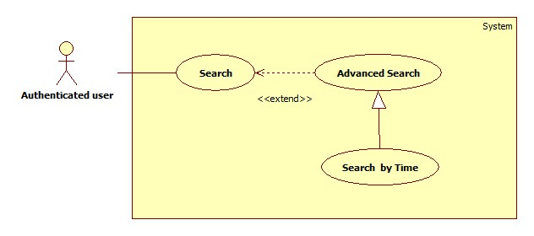

|  |  |  |  |  |
| --- | --- | --- | --- | --- |
| **USE CASE SPECIFICATION** | | | | |
| **Use-case No.** | UC008 | **Use-case Version** | | 1.0 |
| **Use-case Name** | Search by time | | | |
| **Author** | CongNT | | | |
| **Date** | 21/09/2014 | **Priority** | High | |
| **Actor:** Guest, Customer, Maid Mediator, Staff, Webmaster.  **Summary:** This use case allow guest can search information by time  **Goal:** Guest can search information by search time  **Trigger:** Click on time radio button on website  **Pre-conditions:**   * Page is loaded successfully * The search page will shown   **Post conditions:**   * Success: Search successfully, the system will shown search result * Failure:   **Main Success Scenario:**   |  |  | | --- | --- | | Actor Action | System Response | | 1. Fill in “Tìm kiếm” text box 2. Click on “Tìm kiếm” button 3. Click on “Cách đây 1 ngày” or “Cách đây 3 ngày” or “Cách đây 5 ngày” or “Cách đây 7 ngày” or “Cách đây 14 ngày” or “Cách đây 30 ngày” link | 1. System redirect to search page for guest 2. Show the result suitable for each link |   **Alternative Scenario:**   |  |  | | --- | --- | | Actor Action | System Response | | 1. Click on the “MaidService” icon. | 1. Back to home page |   **Exceptions:**   |  |  | | --- | --- | | Actor Action | System Response | |  |  |   **Relationships:** Search by time is generated with AdvancedSearch and AdvancedSearch is extended to Search  **Business Rules:** All of role can search but search results are different in some roles:   * If user is a guest, search results are jobrequests and recruitments. * If user is a staff, customer or webmaster, search results are jobrequests and recruitments. * If user is a maid mediator, search results are jobrequests. | | | | |

##### <Authenticated user> View JobRequest

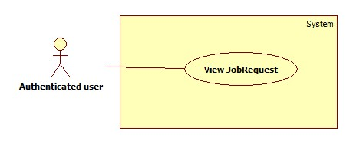

|  |  |  |  |  |
| --- | --- | --- | --- | --- |
| **USE CASE SPECIFICATION** | | | | |
| **Use-case No.** | UC009 | **Use-case Version** | | 1.0 |
| **Use-case Name** | View jobrequest | | | |
| **Author** | CongNT | | | |
| **Date** | 21/09/2014 | **Priority** | High | |
| **Actor:** Staff, Customer, Maid Mediator, Webmaster  **Summary:** This use case allow to view jobrequest  **Goal:** User can view jobrequest detail  **Trigger:** Click on title jobrequest link  **Pre-conditions:**   * Page is loaded successfully * User login to website successful   **Post conditions:**   * Success: Login successfully * Failure:   **Main Success Scenario:**   |  |  | | --- | --- | | Actor Action | System Response | | 1. Login to website 2. Click title jobrequest link | 1. System redirect home page 2. System redirect jobrequest detail page. |   **Alternative Scenario:**   |  |  | | --- | --- | | Actor Action | System Response | | 1. Click on the “MaidService” icon. | 1. Back to home page |   **Exceptions:**   |  |  | | --- | --- | | Actor Action | System Response | |  |  |   **Relationships:** N/A  **Business Rules:**   * If user log in as customer, user must click “Người tìm việc” tab, then click title jobrequest link. * If user is a guest or login as a staff, maid mediator, webmaster, user click title jobrequest link. | | | | |

##### <Authenticated user> View Recruitment

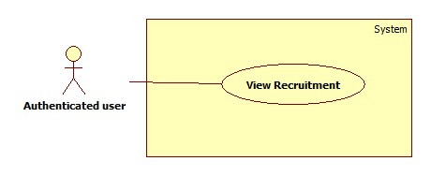

|  |  |  |  |  |
| --- | --- | --- | --- | --- |
| **USE CASE SPECIFICATION** | | | | |
| **Use-case No.** | UC010 | **Use-case Version** | | 1.0 |
| **Use-case Name** | View recruitment | | | |
| **Author** | CongNT | | | |
| **Date** | 21/09/2014 | **Priority** | High | |
| **Actor:** Staff, Customer, Maid Mediator, Webmaster, Guest  **Summary:** This use case allow to view jobrequest  **Goal:** User can view recruitment detail  **Trigger:** Click on title recruitment link  **Pre-conditions:**   * Page is loaded successfully * User login to website successful   **Post conditions:**   * Success: Login successfully * Failure:   **Main Success Scenario:**   |  |  | | --- | --- | | Actor Action | System Response | | 1. Login to website 2. Click “Việc tìm người” tab 3. Click title recruitment link | 1. System redirect home page 2. System redirect recruitment page. 3. System redirect recruitment detail page. |   **Alternative Scenario:**   |  |  | | --- | --- | | Actor Action | System Response | | 1. Click on the “MaidService” icon. | 1. Back to home page |   **Exceptions:**   |  |  | | --- | --- | | Actor Action | System Response | |  |  |   **Relationships:** N/A  **Business Rules:**   * If user log in as a staff, maid mediator, webmaster, user must click “Việc tìm người” tab, then click title recruitment link. * If user is a guest or login as a customer user click title recruitment link. | | | | |

##### <Authenticated user> View Profile

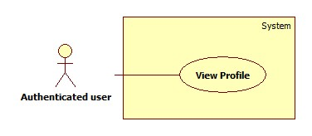

|  |  |  |  |  |
| --- | --- | --- | --- | --- |
| **USE CASE SPECIFICATION** | | | | |
| **Use-case No.** | UC011 | **Use-case Version** | | 1.0 |
| **Use-case Name** | View Profile | | | |
| **Author** | CongNT | | | |
| **Date** | 21/09/2014 | **Priority** | High | |
| **Actor:** Staff, Customer, Maid Mediator, Webmaster  **Summary:** This use case allow user to see his/her profile  **Goal:** User can see his/her profile  **Trigger:** Click on title jobrequest link  **Pre-conditions:**   * Page is loaded successfully * User login as to website successful   **Post conditions:**   * Success: Login successfully, user can see his/her profile * Failure:   **Main Success Scenario:**   |  |  | | --- | --- | | Actor Action | System Response | | 1. Login to website 2. Click name link | 1. System redirect home page 2. System redirect personal profile page |   **Alternative Scenario:**   |  |  | | --- | --- | | Actor Action | System Response | | 1. Click on the “Đăng xuất” button. | 1. Clear session and back to home page |   **Exceptions:**   |  |  | | --- | --- | | Actor Action | System Response | | 1. Click on the “MaidService” icon. | 1. Back to home page |   **Relationships:** N/A  **Business Rules:**   * If login as a staff, then click name link,website will redirect to staff’s profile page. Staff could see profile of all members. * If login as a maid mediator, then click name link,website will redirect to maid mediator’s profile page. * If login as a customer, then click name link,website will redirect to customer’s profile page. * If login as a webmaster, then click name link,website will redirect to config page. | | | | |

##### <Authenticated user> Log out

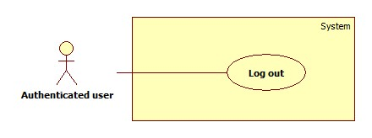

|  |  |  |  |  |
| --- | --- | --- | --- | --- |
| **USE CASE SPECIFICATION** | | | | |
| **Use-case No.** | UC012 | **Use-case Version** | | 1.0 |
| **Use-case Name** | Log out | | | |
| **Author** | CongNT | | | |
| **Date** | 21/09/2014 | **Priority** | High | |
| **Actor:** Staff, Customer, Maid Mediator, Webmaster  **Summary:** This use case allow to log out website  **Goal:** User can log out website  **Trigger:** Click on log out button  **Pre-conditions:**   * Page is loaded successfully * User login to website successful   **Post conditions:**   * Success: Login successfully * Failure:   **Main Success Scenario:**   |  |  | | --- | --- | | Actor Action | System Response | | 1. Login to website 2. Click log out | 1. System redirect home page 2. System redirect home page and clear session. |   **Alternative Scenario:**   |  |  | | --- | --- | | Actor Action | System Response | | 1. Click on the “MaidService” icon. | 1. Back to home page |   **Exceptions:**   |  |  | | --- | --- | | Actor Action | System Response | |  |  |   **Relationships:** N/A  **Business Rules:** User must log in to website. | | | | |

##### <Authenticated user> View Notifications

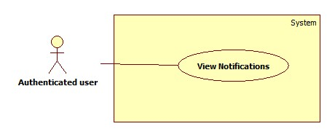

|  |  |  |  |  |
| --- | --- | --- | --- | --- |
| **USE CASE SPECIFICATION** | | | | |
| **Use-case No.** | UC013 | **Use-case Version** | | 1.0 |
| **Use-case Name** | View notifications | | | |
| **Author** | CongNT | | | |
| **Date** | 21/09/2014 | **Priority** | High | |
| **Actor:** Staff, Customer, Maid Mediator, Webmaster  **Summary:** This use case allow to view notifications  **Goal:** User can view notifications  **Trigger:** Click on title icon notifications link  **Pre-conditions:**   * Page is loaded successfully * User login to website successful   **Post conditions:**   * Success: Login successfully * Failure:   **Main Success Scenario:**   |  |  | | --- | --- | | Actor Action | System Response | | 1. Login to website 2. Click icon notifications link | 1. System redirect home page 2. System redirect notifications page. |   **Alternative Scenario:**   |  |  | | --- | --- | | Actor Action | System Response | | 1. Click on the “MaidService” icon. | 1. Back to home page |   **Exceptions:**   |  |  | | --- | --- | | Actor Action | System Response | |  |  |   **Relationships:** N/A  **Business Rules:**   * If user log in as a staff, notifications show that jobrequests or recruitments is not active or is not paid, so staff have to active those jobrequests or recruitments. * If user log in as a customer or maid mediator, notifications show that your recruitmenst or jobrequests are applied. | | | | |

##### <Webmaster> Add Staff

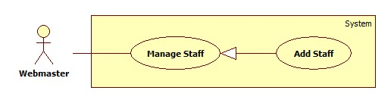

|  |  |  |  |  |
| --- | --- | --- | --- | --- |
| **USE CASE SPECIFICATION** | | | | |
| **Use-case No.** | UC014 | **Use-case Version** | | 1.0 |
| **Use-case Name** | Add staff | | | |
| **Author** | TuanBT | | | |
| **Date** | 24/09/2014 | **Priority** | High | |
| **Actor:** Webmaster  **Summary:** Webmaster add a user role Staff. A new staff only have username and password.  **Goal:** Make a new user directive.  **Trigger:**Webmater click on “Thêm nhân viên”  **Pre-conditions:**   * User must login with Admin role. * Register page will be shown   **Post conditions:**   * Success: Reload this page * Failure: Show message error   **Main Success Scenario:**   |  |  | | --- | --- | | Actor Action | System Response | | 1. Webmaster click “Thêm nhân viên” at his profile page.  3. Webmaster fill and click “Thêm nhân viên” button. | 2. The page show 3 input username, password, re-password.  4. Page is reload.  [Exception 1] [Exception 2] |   **Alternative Scenario:**   |  |  | | --- | --- | | Actor Action | System Response | |  |  |   **Exceptions:**   |  |  | | --- | --- | | Actor Action | System Response | | [Exception 1]  1. Input “Tên đăng ký” is missing  [Exception 1]  1. Input “Mật khẩu” is missing or password not match with input “Nhập lại mật khẩu” | 2. Show error “Vui lòng nhập tên đăng nhập”  2. Show error “Mật khẩu không trùng khớp” |   **Relationships:** Add staff is generalization of manage staff  **Business Rules:** N/A | | | | |

##### <Staff> View Staff Statistic

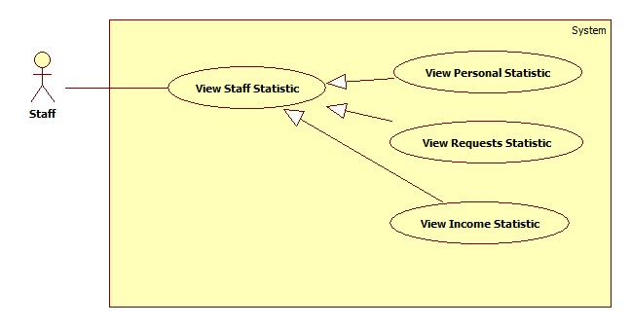

###### <Staff> View Requests Statistic

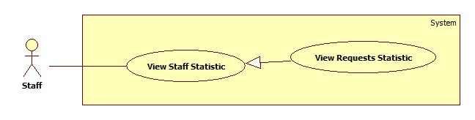

|  |  |  |  |  |
| --- | --- | --- | --- | --- |
| **USE CASE SPECIFICATION** | | | | |
| **Use-case No.** | UC018 | **Use-case Version** | | 1.0 |
| **Use-case Name** | View Requests Statistic | | | |
| **Author** | CongNT | | | |
| **Date** | 21/09/2014 | **Priority** | High | |
| **Actor:** Staff, Webmaster  **Summary:** This use case allow staff see requests statistic  **Goal:** Staff can see requests statistic  **Trigger:** Click on “Các yêu cầu” link  **Pre-conditions:**   * Page is loaded successfully * User login as staff successful   **Post conditions:**   * Success: Login successfully, the statistic will be shown * Failure:   **Main Success Scenario:**   |  |  | | --- | --- | | Actor Action | System Response | | 1. Login as a staff 2. Click name link 3. Click “Thống kê” link 4. Click “Các yêu cầu” link | 1. System redirect home page 2. System redirect personal profile page 3. System redirect personal statistic page and show personal statistic. 4. System redirect personal statistic page and show personal statistic. |   **Alternative Scenario:**   |  |  | | --- | --- | | Actor Action | System Response | | 1. Click on the “Đăng xuất” button. 2. Click on maid service icon | 1. Clear session and back to home page 2. Redirect to home page |   **Exceptions:**   |  |  | | --- | --- | | Actor Action | System Response | | 1. System fail to load data | 1. Show message “Hệ thống đang bảo trì” |   **Relationships:** View Request Statistic is generated with View Staff Statistic  **Business Rules:** User login as a staff. | | | | |

###### <Staff> View Income Statistic

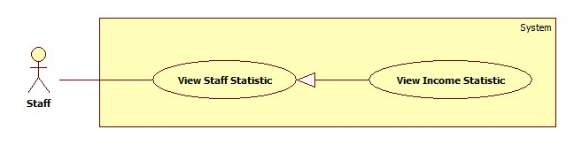

|  |  |  |  |  |
| --- | --- | --- | --- | --- |
| **USE CASE SPECIFICATION** | | | | |
| **Use-case No.** | UC019 | **Use-case Version** | | 1.0 |
| **Use-case Name** | View Income Statistic | | | |
| **Author** | CongNT | | | |
| **Date** | 21/09/2014 | **Priority** | High | |
| **Actor:** Staff, Webmaster  **Summary:** This use case allow staff see income statistic  **Goal:** Staff can see income statistic  **Trigger:** Click on “Doanh thu” link  **Pre-conditions:**   * Page is loaded successfully * User login as staff successful   **Post conditions:**   * Success: Login successfully, the income statistic will be shown * Failure:   **Main Success Scenario:**   |  |  | | --- | --- | | Actor Action | System Response | | 1. Login as a staff 2. Click name link 3. Click “Thống kê” link 4. Click “Doanh thu” link | 1. System redirect home page 2. System redirect personal profile page 3. System redirect personal statistic page and show personal statistic. 4. System redirect income statistic page and show personal statistic. |   **Alternative Scenario:**   |  |  | | --- | --- | | Actor Action | System Response | | 1. Click on the “Đăng xuất” button. 2. Click on maid service icon | 1. Clear session and back to home page 2. Redirect to home page |   **Exceptions:**   |  |  | | --- | --- | | Actor Action | System Response | | 1. System fail to load data | 1. Show message “Hệ thống đang bảo trì” |   **Relationships:** View Income Statistic is generated with View Staff Statistic  **Business Rules:** User login as a staff | | | | |

##### <Webmaster> Banned Account

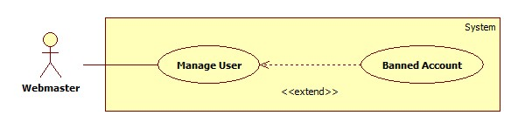

|  |  |  |  |  |
| --- | --- | --- | --- | --- |
| **USE CASE SPECIFICATION** | | | | |
| **Use-case No.** | UC016 | **Use-case Version** | | 1.0 |
| **Use-case Name** | Bannned Account | | | |
| **Author** | TuanBT | | | |
| **Date** | 24/09/2014 | **Priority** | High | |
| **Actor:** Webmaster  **Summary:** Webmaster will banned account.  **Goal:**  Banned Account.  **Trigger:** Webmaster click “Khóa tài khoản”  **Pre-conditions:**   * User must login with Admin role * Banned Account page will be shown   **Post conditions:**   * Success: Reload this page. Button will change to “Kích hoạt” * Failure: Do not reload page   **Main Success Scenario:**   |  |  | | --- | --- | | Actor Action | System Response | | 1. Webmaster click “Khóa tài khoản” menu, then click “Khóa” button. | 2. Reload page and change button to “Kích hoạt” |   **Alternative Scenario:**   |  |  | | --- | --- | | Actor Action | System Response | |  |  |   **Exceptions:**   |  |  | | --- | --- | | Actor Action | System Response | |  |  |   **Relationships:** Banned Account extend of manage user  **Business Rules:** N/A | | | | |

##### <Webmaster> Active Account

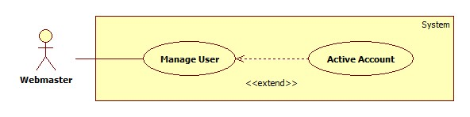

|  |  |  |  |  |
| --- | --- | --- | --- | --- |
| **USE CASE SPECIFICATION** | | | | |
| **Use-case No.** | UC017 | **Use-case Version** | | 1.0 |
| **Use-case Name** | Active Account | | | |
| **Author** | TuanBT | | | |
| **Date** | 24/09/2014 | **Priority** | High | |
| **Actor:** Webmaster  **Summary:** Webmaster will active account.  **Goal:** Active account.  **Trigger:** Webmaster click “Kích hoạt”  **Pre-conditions:**   * User must login with Admin role * Active Account page will be shown   **Post conditions:**   * Success: Reload this page. Button will change to “Khóa” * Failure: Do not reload page   **Main Success Scenario:**   |  |  | | --- | --- | | Actor Action | System Response | | 1. Webmaster click “Khóa tài khoản” menu, then click “Kích hoạt” button. | 2. Reload page and change button to “Khóa” |   **Alternative Scenario:**   |  |  | | --- | --- | | Actor Action | System Response | |  |  |   **Exceptions:**   |  |  | | --- | --- | | Actor Action | System Response | |  |  |   **Relationships:** Active Account extend of Manage acount  **Business Rules:** N/A | | | | |

##### <Webmaster> View Request Statistic

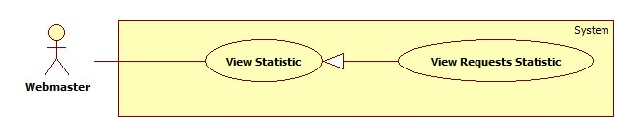

|  |  |  |  |  |
| --- | --- | --- | --- | --- |
| **USE CASE SPECIFICATION** | | | | |
| **Use-case No.** | UC018 | **Use-case Version** | | 1.0 |
| **Use-case Name** | View requests Statistic | | | |
| **Author** | TuanBT | | | |
| **Date** | 24/09/2014 | **Priority** | High | |
| **Actor:** Webmaster  **Summary:** View statistic of all request of MS-Website in year.  **Goal:**  View statistic  **Trigger:** Webmaster click “Thống kê”  **Pre-conditions:**   * User must login with Admin role * Statistic page will be shown   **Post conditions:**   * Success: Show statistic chart * Failure: Do not show chart   **Main Success Scenario:**   |  |  | | --- | --- | | Actor Action | System Response | | 1. Webmaster click “Thống kê” menu then click “Các yêu cầu” link. | 2. Show statistic chart. |   **Alternative Scenario:**   |  |  | | --- | --- | | Actor Action | System Response | |  |  |   **Exceptions:**   |  |  | | --- | --- | | Actor Action | System Response | |  |  |   **Relationships:** View Request Statistic is generalization of View Statistic  **Business Rules:** N/A | | | | |

##### <Webmaster> View Income Statistic

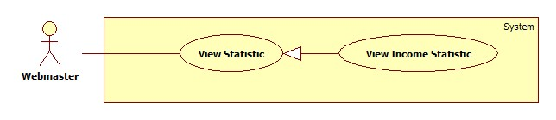

|  |  |  |  |  |
| --- | --- | --- | --- | --- |
| **USE CASE SPECIFICATION** | | | | |
| **Use-case No.** | UC019 | **Use-case Version** | | 1.0 |
| **Use-case Name** | View Income Statistic | | | |
| **Author** | TuanBT | | | |
| **Date** | 24/09/2014 | **Priority** | High | |
| **Actor:** Webmaster  **Summary:** View statistic of all request of MS-Website in year.  **Goal:**  View statistic  **Trigger:** Webmaster click “Thống kê”  **Pre-conditions:**   * User must login with Admin role * Statistic page will be shown   **Post conditions:**   * Success: Show statistic chart * Failure: Do not show chart   **Main Success Scenario:**   |  |  | | --- | --- | | Actor Action | System Response | | 1. Webmaster click “Thống kê” menu then click “Doanh thu” link. | 2. Show statistic chart. |   **Alternative Scenario:**   |  |  | | --- | --- | | Actor Action | System Response | |  |  |   **Exceptions:**   |  |  | | --- | --- | | Actor Action | System Response | |  |  |   **Relationships:** View Income Statistic is generalization of View Statistic  **Business Rules:** N/A | | | | |

##### <System> Suggest JobRequest

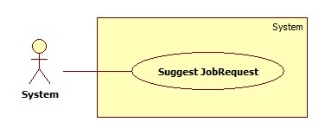

|  |  |  |  |  |
| --- | --- | --- | --- | --- |
| **USE CASE SPECIFICATION** | | | | |
| **Use-case No.** | UC021 | **Use-case Version** | | 1.0 |
| **Use-case Name** | Suggest JobRequest | | | |
| **Author** | TuanBT | | | |
| **Date** | 24/09/2014 | **Priority** | High | |
| **Actor:** System  **Summary:** system automatically suggest JobRequest for customer when they post a recruitment on MS-Website.  **Goal:**  The use case will help MS-Website suggest JobRequest for customer when they post a recruitment.  **Trigger:**   * Click [Đăng yêu cầu tuyển việc] button. * Fill all data. * Click [Đăng yêu cầu] button.   **Pre-conditions:**   * Post an invalid recruitment.   **Post conditions:**   * Success: Suggested JobRequests list will appear. * Failure: Nothing is displayed at suggesting field.   **Main Success Scenario:**   |  |  | | --- | --- | | Actor Action | System Response | | 1. User click on the [Đăng yêu cầu tuyển việc] button.   [Alternative 1] | 1. Show suggested JobRequests list.   [Exception 1] |   **Alternative Scenario:**   |  |  | | --- | --- | | Actor Action | System Response | | 1. User click on the [Đăng yêu cầu] button. | 1. Show suggested JobRequests list. |   **Exceptions:**   |  |  | | --- | --- | | Actor Ation | System Response | | 1. System fail to load data | 1. Show suggested JobRequests list |   **Relationships:** N/A  **Business Rules:**  When customer posts a Recruitment, the system will use Kmean Algorithms to put this Recruitment in a group. The system will show up to 10 JobRequests with status “Waiting” and isActive is True in the same group. The JobRequests list will be arranged in order of descending by distance from the center point of that group. | | | | |

##### <System> Send SMS

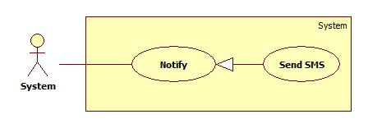

|  |  |  |  |  |
| --- | --- | --- | --- | --- |
| **USE CASE SPECIFICATION** | | | | |
| **Use-case No.** | UC022 | **Use-case Version** | | 1.0 |
| **Use-case Name** | Send SMS | | | |
| **Author** | TuanBT | | | |
| **Date** | 24/09/2014 | **Priority** | Normal | |
| **Actor:** System  **Summary:** Notify for Maid, Customer, Maid Mediator or Staff when Customer apply JobRequest of Maid.  **Goal:**  Send SMS for Maid, Customer, Maid Mediator or Staff when Customer apply JobRequest of Maid. System know when accept a job.  **Trigger:** Both Customer and Maid post an invalid recruitment and job request. Customer must apply successful JobRequest.  **Pre-conditions:**   * Apply success.   **Post conditions:**   * Success: Send SMS * Failure: Don’t send SMS   **Main Success Scenario:**   |  |  | | --- | --- | | Actor Action | System Response | | 1. Customer apply JobRequest of Maid | 1. Send SMS   [Exception 1] |   **Alternative Scenario:**   |  |  | | --- | --- | | Actor Action | System Response | | N/A | N/A |   **Exceptions:**   |  |  | | --- | --- | | Actor Action | System Response | | 1. Number is blank | 1. No |   **Relationships:** Send SMS is generalization of Notification  **Business Rules:** System will send SMS, help maid, customer, Maid mediator or staff know when request of them apply. | | | | |

##### <System> Send Notifications

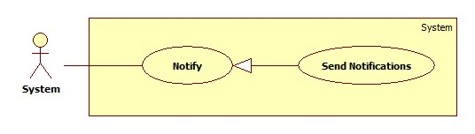

|  |  |  |  |  |
| --- | --- | --- | --- | --- |
| **USE CASE SPECIFICATION** | | | | |
| **Use-case No.** | UC023 | **Use-case Version** | | 1.0 |
| **Use-case Name** | Send Notifications | | | |
| **Author** |  | | | |
| **Date** | 24/09/2014 | **Priority** | Normal | |
| **Actor:** System  **Summary:** Notify for Maid, Customer, Maid Mediator or Staff when Customer apply JobRequest of Maid. Notify for all Staff when customer report about payment.  **Goal:**  Help user know what happen with them.  **Trigger:** Both Customer and Maid post an invalid recruitment and job request. Customer must apply successful JobRequest.  **Pre-conditions:**   * User must login into MS-Website.   **Post conditions:**   * Success: Notification show at notify page of User was send Notification. * Failure: Do not show notification.   **Main Success Scenario:**   |  |  | | --- | --- | | Actor Action | System Response | | 1. Customer apply JobRequest of Maid | 1. Send SMS |   **Alternative Scenario:**   |  |  | | --- | --- | | Actor Action | System Response | | N/A | N/A |   **Exceptions:**   |  |  | | --- | --- | | Actor Action | System Response | |  |  |   **Relationships:** Send notificatrion is generalization of Notifier  **Business Rules:** System will send notification, help maid, customer, Maid mediator or staff know when request of them apply. | | | | |

##### <Customer> View JobRequest

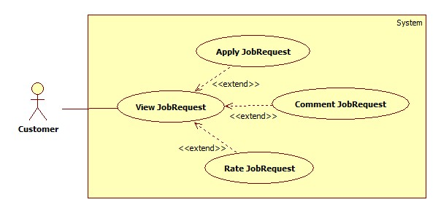

###### <Customer> Apply JobRequest

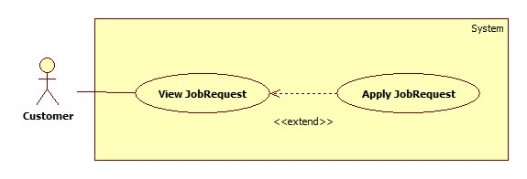

|  |  |  |  |  |
| --- | --- | --- | --- | --- |
| **USE CASE SPECIFICATION** | | | | |
| **Use-case No.** | UC024 | **Use-case Version** | | 1.0 |
| **Use-case Name** | Apply JobRequest | | | |
| **Author** | TuanBT | | | |
| **Date** | 24/09/2014 | **Priority** | High | |
| **Actor:** Customer  **Summary:** Customer use a them Recruitment have status “Waiting” to Apply a JobRequest have status “Waiting” too.  **Goal:**  Apply JobRequest.  **Trigger:** Click button “Thuê"  **Pre-conditions:**   * User must login with Customer role   **Post conditions:**   * Success: Reload page. Name of Customer show at status line. * Failure: Show error “Thuê thất bại”   **Main Success Scenario:**   |  |  | | --- | --- | | Actor Action | System Response | | 1. Customer click a JobRequest have status “Waiting”, then click “Thuê” button.  3. Choose a Recruitment from list Radio button. Then click “Đồng ý” button | 2. Show modal “Xin chọn một đơn tuyển việc”.  4. Show status “Đã được thuê”.  [Exception1] |   **Alternative Scenario:**   |  |  | | --- | --- | | Actor Action | System Response | | [Alternative 1]  1. Customer click a Recruitment in Profile page. Recruitment in tab “Chờ thuê”.  3. Customer click one of them.  5. Click “Thuê” button  7. Click “Chấp nhận” button. | 2. System show some JobRequest in “Những việc có thể hợp” box.  4. System show “Chi tiết yêu cầu công việc” page.  6. System show modal “Xác nhận thuê”.  8. Show status “Đã được thuê”.  [Exception1] |   **Exceptions:**   |  |  | | --- | --- | | Actor Action | System Response | | [Exception 1]  1. Customer click “Chấp nhận” from modal. | 2. Show error “Công việc đã được thuê bởi khách hàng khác” |   **Relationships:** Apply JobRequest is extend of View JobRequest  **Business Rules:**  JobRequest must have status “Waiting”. Have two cases when applying JobRequest: Choose a JobRequest from suggestion of system in Recruitment detail, choose JobRequest from Index or Search. In first case, system automatic choose current Recruitment to apply suggested JobRequest. The second case, customer have to choose one of Recruitments List, if they don’t have any Recruitment, they must post a recruitment.  Sometime this JobRequest is applied by another customer or expired by that time. Customer can not apply JobRequest and receive an error. | | | | |

###### <Customer> Comment JobRequest

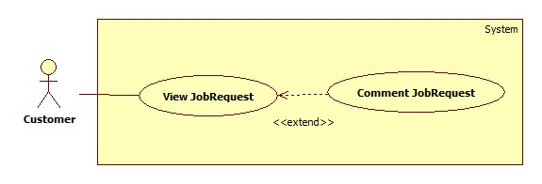

|  |  |  |  |  |
| --- | --- | --- | --- | --- |
| **USE CASE SPECIFICATION** | | | | |
| **Use-case No.** | UC025 | **Use-case Version** | | 1.0 |
| **Use-case Name** | Comment JobRequest | | | |
| **Author** | TuanBT | | | |
| **Date** | 24/09/2014 | **Priority** | High | |
| **Actor:** Customer  **Summary:** When customer applied a JobRequest, they can comment for this JobRequest if Maid come back and tell to staff Approved this Job.  **Goal:**  Comment JobRequest.  **Trigger:** Fill input comment.  **Pre-conditions:**   * User must login with Admin role * Status of JobRequest is Approved   **Post conditions:**   * Success: one line comment show. * Failure: No comment.   **Main Success Scenario:**   |  |  | | --- | --- | | Actor Action | System Response | | 1. Click a jobRequest in “Đã nhận” tab. This JobRequest must have status “Đã hoàn tất”  3. Fill comment input, then click “Đăng” button. | 2. Show box “Nhận xét của người đã thuê”.  4. One line comment is show. |   **Alternative Scenario:**   |  |  | | --- | --- | | Actor Action | System Response | |  |  |   **Exceptions:**   |  |  | | --- | --- | | Actor Action | System Response | |  |  |   **Relationships:** Comment JobRequest is extend of View JobRequest  **Business Rules:** JobRequest must have Approved status which means “Đã hoàn tất”, customer can only comment on this JobReuest. | | | | |

###### <Customer> Rate JobRequest

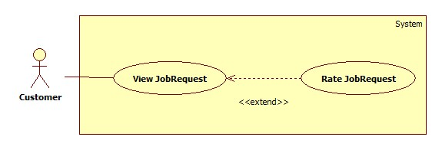

|  |  |  |  |  |
| --- | --- | --- | --- | --- |
| **USE CASE SPECIFICATION** | | | | |
| **Use-case No.** | UC026 | **Use-case Version** | | 1.0 |
| **Use-case Name** | Rate JobRequest | | | |
| **Author** | TuanBT | | | |
| **Date** | 24/09/2014 | **Priority** | High | |
| **Actor:** Customer  **Summary:** When customer applied a JobRequest, they can rate for this JobRequest if Maid come back and tell to staff Approved this Job.  **Goal:**  Rate JobRequest.  **Trigger:** Click choose star. Then click “Chấm điểm” button.  **Pre-conditions:**   * User must login with Admin role * Status of JobRequest is Approved   **Post conditions:**   * Success: Star show in rating line. * Failure: No rate.   **Main Success Scenario:**   |  |  | | --- | --- | | Actor Action | System Response | | 1. Click a jobRequest in “Đã nhận” tab. This JobRequest must have status “Đã hoàn tất”  3. Choose number star, then click “Chấm điểm” button. | 2. Show box “Nhận xét của người đã thuê”.  4. Rate of JobRequest be shown. |   **Alternative Scenario:**   |  |  | | --- | --- | | Actor Action | System Response | |  |  |   **Exceptions:**   |  |  | | --- | --- | | Actor Action | System Response | |  |  |   **Relationships:** Rate JobRequest is extend of View JobRequest  **Business Rules:** JobRequest must have Approved status which mean “Đã hoàn tất”, customer can only Rate on this JobReuest. | | | | |

##### <Customer> View Profile

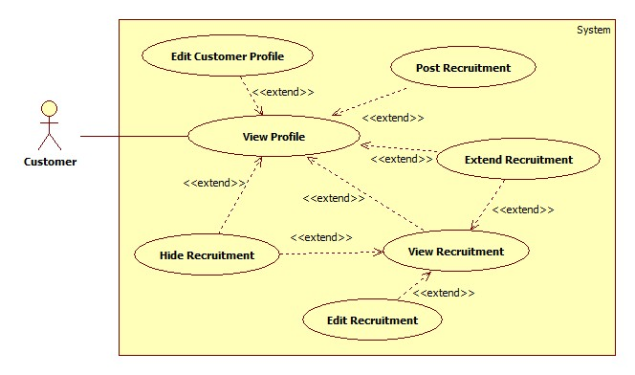

###### <Customer> Edit Customer Profile

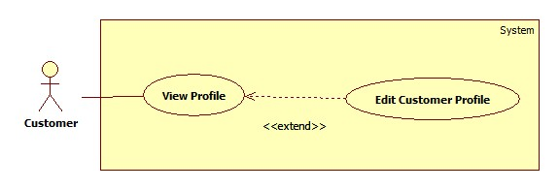

|  |  |  |  |  |
| --- | --- | --- | --- | --- |
| **USE CASE SPECIFICATION** | | | | |
| **Use-case No.** | UC027 | **Use-case Version** | | 1.0 |
| **Use-case Name** | Edit Customer Profile | | | |
| **Author** | TuanBT | | | |
| **Date** | 24/09/2014 | **Priority** | High | |
| **Actor:** Customer  **Summary:** This use case allow customer to edit profile  **Goal:** Customer can edit profile  **Trigger:** User clicks “Sửa thông tin cá nhân” link in personal profile page  **Pre-conditions:**   * Page is loaded successfully * User login as customer successful   **Post conditions:**   * Success: Edit profile successfully, profile detail is updated in database * Failure: Show error message   **Main Success Scenario:**   |  |  | | --- | --- | | Actor Action | System Response | | 1. Login as a customer 2. Click the name link 3. Click “Sửa thông tin cá nhân” link 4. Fill all the fields 5. Click “Cập nhật thông tin” button | 1. System redirects to homepage 2. System redirects to personal profile page 3. System redirects to profile editing page displaying following fields with info of the job request accordingly:  * Họ và tên [FullName: textbox] * Số điện thoại [Phone: textbox] * Email [Email: textbox] * Địa chỉ [Address: textbox] * Ảnh đại diện [Image uploading] * “Cập nhật thông tin” button  1. System redirects to personal profile page with updated info |   **Alternative Scenario:**   |  |  | | --- | --- | | Actor Action | System Response | | 1. Click on the “Đăng xuất” button. | 1. Clear session and back to home page |   **Exceptions:**   |  |  | | --- | --- | | Actor Action | System Response | | 1. “Họ và tên” is empty 2. “Số điện thoại” is empty or char inputted 3. “Email” is empty or wrong format | 1. Show message “Vui lòng nhập tên người quản lý” 2. Show message “Vui lòng nhập số” 3. Show message “Vui lòng nhập đúng định dạng abc@abc.ab” |   **Relationships:** Is an extension of View Profile  **Business Rules:** This use caseis only available for customer. After logging in, user clicks the name link to go to personal profile page. User clicks “Sửa thông tin cá nhân” link to go to profile editing page. User edit the info then click “Cập nhật thông tin” button to complete the editing process. Data is updated in database, system redirects back to personal profile page and the info are updated. | | | | |

###### <Customer> Extend Recruitment

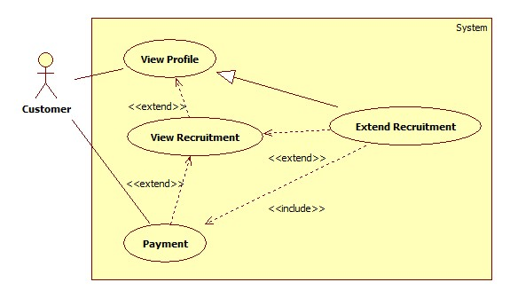

|  |  |  |  |  |
| --- | --- | --- | --- | --- |
| **USE CASE SPECIFICATION** | | | | |
| **Use-case No.** | UC028 | **Use-case Version** | | 1.0 |
| **Use-case Name** | Extend Recruitment | | | |
| **Author** | TuanBT | | | |
| **Date** | 24/09/2014 | **Priority** | High | |
| **Actor:** Customer  **Summary:** This use case allow customer to extend recruitment  **Goal:** Customer can extend job request  **Trigger:** User clicks “Gia hạn” button  **Pre-conditions:**   * Page is loaded successfully * User login as customer successful   **Post conditions:**   * Success: Extend Recruitment successfully, Recruitment’s expired date is updated in database and status changes from “Expired” to “Waiting” * Failure: Show error message   **Main Success Scenario:**   |  |  | | --- | --- | | Actor Action | System Response | | 1. Login as a customer 2. Click the name link 3. Click a maid name link in maids list 4. Choose a job request in tab except “Hết hạn” or “Chờ thuê” tabs. Then click “Gia hạn” button. 5. Choose week, then Click Paypal button. | 1. System redirects to homepage 2. System redirects to personal profile page 3. System redirects to maid profile page 4. A modal pops up with a dropdown list for user to choose the extending time 5. System redirects to Paypal page |   **Alternative Scenario:**   |  |  | | --- | --- | | Actor Action | System Response | | 1. Click on the “Đăng xuất” button. | 1. Clear session and back to home page |   **Exceptions:**   |  |  | | --- | --- | | Actor Action | System Response | | 1. Recruitment was applied | 1. Show alert message “Yêu cầu đã thuê” |   **Relationships:** Is an extension of View Profile  **Business Rules:** This use caseis only available for customer. After logging in, user clicks the name link to go to personal profile page. “Gia hạn” button can oly show in Recruitment have status “Hết hạn” or “Đang chờ người làm”. Customer have to has account paypal to pay. | | | | |

###### <Customer> Hide Recruitment

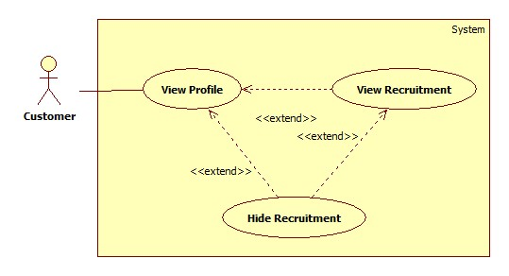

|  |  |  |  |  |
| --- | --- | --- | --- | --- |
| **USE CASE SPECIFICATION** | | | | |
| **Use-case No.** | UC029 | **Use-case Version** | | 1.0 |
| **Use-case Name** | Hide Recruitment | | | |
| **Author** | TuanBT | | | |
| **Date** | 24/09/2014 | **Priority** | High | |
| **Actor:** Customer  **Summary:** This use case allow customer to hide a recruitment and can’t be seen by any one  **Goal:** User can hide a job request  **Trigger:** User clicks “Tạm ẩn” button  **Pre-conditions:**   * Page is loaded successfully * User login as cutomer successfully   **Post conditions:**   * Success: Hide job request successfully, status of job request is changed from “Waiting” to “Hide” * Failure: Show error message   **Main Success Scenario:**   |  |  | | --- | --- | | Actor Action | System Response | | 1. Login as a staff or maid mediator 2. Click name link 3. Click a recruitment in tab “Đang chờ” 4. Click “Tạm ẩn” button | 1. System redirect home page 2. System redirect personal profile page 3. System redirects to recruitment detail page and displays “Tình trạng: Tạm ẩn” |   **Alternative Scenario:**   |  |  | | --- | --- | | Actor Action | System Response | | 1. Click on the “Đăng xuất” button. | 1. Clear session and back to home page |   **Exceptions:**   |  |  | | --- | --- | | Actor Action | System Response | | 1. Job request does not exist | 1. Show error message |   **Relationships:** Is an extension of View Profile and View Recruitment  **Business Rules:** This use caseis only available for customer. In “Đang chờ” tab which only contains recruitment with “Waiting” status in database, user can click on a recruitment (not recruitment’s name link) then the button “Tạm ẩn” will be displayed, user can also click on job request’s name link to go to recruitment detail page and the button “Tạm ẩn” will be displayed too. Be noticed that only recruitment in “Đang chờ” tab (with status “Waiting” in database) have this function. User clicks “Tạm ẩn” button to hide the recruitment, the status of the recruitment will be changed from “Waiting” to “Hide” in database and it’s also moved to “Tạm ẩn” tab in customer profile page. Now the recruitment can’t be applied. | | | | |

###### <Customer> Public Recruitment

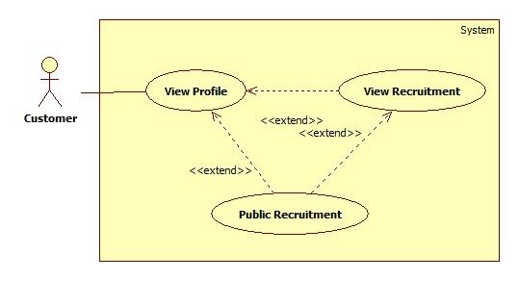

|  |  |  |  |  |
| --- | --- | --- | --- | --- |
| **USE CASE SPECIFICATION** | | | | |
| **Use-case No.** | UC030 | **Use-case Version** | | 1.0 |
| **Use-case Name** | Public Recruitment | | | |
| **Author** | TuanBT | | | |
| **Date** | 24/09/2014 | **Priority** | High | |
| **Actor:** Customer  **Summary:** This use case allow customer to public a job request for customer to apply  **Goal:** User can public a recruitment  **Trigger:** User clicks “Công khai” button  **Pre-conditions:**   * Page is loaded successfully * User login as customer successfully   **Post conditions:**   * Success: Public customer successfully, status of customer is changed from “Hide” to “Waiting” * Failure: Show error message   **Main Success Scenario:**   |  |  | | --- | --- | | Actor Action | System Response | | 1. Login as a customer 2. Click name link 3. Click a Recruitment in tab “Tạm ẩn” 4. Click “Công khai” button | 1. System redirect home page 2. System redirect personal profile page 3. System redirects to Recruitment detail page and displays “Tình trạng: Đang chờ” |   **Alternative Scenario:**   |  |  | | --- | --- | | Actor Action | System Response | | 1. Click on the “Đăng xuất” button. | 1. Clear session and back to home page |   **Exceptions:**   |  |  | | --- | --- | | Actor Action | System Response | | 1. Job request does not exist | 1. Show error message |   **Relationships:** Is an extension of View Profile and View Recruitment  **Business Rules:** This use caseis only available for customer. In “Tạm ẩn” tab which only contains recruitment with “Hide” status in database, user can click on a recruitment (not job request’s name link) then the button “Công khai” will be displayed, user can also click on job request’s name link to go to recruitment detail page and the button “Công khai” will be displayed too. Be noticed that only recruitment in “Tạm ẩn” tab (with status “Hide” in database) have this function. User clicks “Công khai” button to public the recruitment, the status of the recruitment will be changed from “Hide” to “Waiting” in database and it’s also moved to “Đang chờ” tab in maid profile page. Now the recruitment is ready for customers to apply. | | | | |

###### <Customer> Post Recruitment

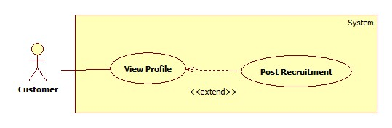

|  |  |  |  |  |
| --- | --- | --- | --- | --- |
| **USE CASE SPECIFICATION** | | | | |
| **Use-case No.** | UC031 | **Use-case Version** | | 1.0 |
| **Use-case Name** | Post Recruitment | | | |
| **Author** | TuanBT | | | |
| **Date** | 24/09/2014 | **Priority** | High | |
| **Actor:** Customer  **Summary:** This use case allow customer to post job request  **Goal:** Customer can post job request  **Trigger:** User clicks “Đăng yêu cầu tuyển việc” link in personal profile page  **Pre-conditions:**   * Page is loaded successfully * User login as customer successful   **Post conditions:**   * Success: Post recruitment successfully, new recruitment and skill reference are added to database * Failure: Show error message   **Main Success Scenario:**   |  |  | | --- | --- | | Actor Action | System Response | | 1. Login as a customer 2. Click the name link 3. Click “Đăng yêu cầu tuyển việc” link 4. Fill all the fields 5. Click “Đăng yêu cầu” button | 1. System redirects to homepage 2. System redirects to personal profile page 3. System redirect post jobrequest page with following fields  * Tiêu đề [Title: dropdownlist] * Các kỹ năng [SkillRefId: textbox] * Thời hạn đăng [PostTime: textbox] * “Đăng yêu cầu” button  1. System redirects to new recruitment’s detail page |   **Alternative Scenario:**   |  |  | | --- | --- | | Actor Action | System Response | | 1. Click on the “Đăng xuất” button. | 1. Clear session and back to home page |   **Exceptions:**   |  |  | | --- | --- | | Actor Action | System Response | | 1. “Tiêu đề” is empty 2. “Các kỹ năng” is empty | 1. Show message “Vui lòng nhập tiêu đề” 2. Show message “Vui lòng chọn kĩ năng” |   **Relationships:** Is an extension of View Profile  **Business Rules:** This use caseis only available for Customer. User clicks on “Đăng yêu cầu tuyển việc” link to go to request adding page which displays all required fields for a recruitment to be created. With “Thời hạn đăng”, customer can only choose max number week of system and each week customer will be subtract a money from system. | | | | |

###### <Customer> Edit Recruitment

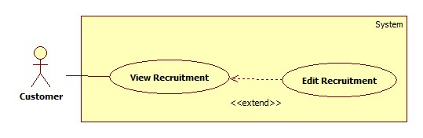

|  |  |  |  |  |
| --- | --- | --- | --- | --- |
| **USE CASE SPECIFICATION** | | | | |
| **Use-case No.** | UC032 | **Use-case Version** | | 1.0 |
| **Use-case Name** | Edit Recruitment | | | |
| **Author** | TuanBT | | | |
| **Date** | 24/09/2014 | **Priority** | High | |
| **Actor:** Customer  **Summary:** This use case allow customer to edit recruitment  **Goal:** Customer can edit recruiment  **Trigger:** User click “Sửa thông tin tuyển người giúp việc” link in recruitment detail page  **Pre-conditions:**   * Page is loaded successfully * User login as customer successful   **Post conditions:**   * Success: Edit recruitment successfully, job request’s detail and skill reference’s detail are updated in database * Failure: Show error message   **Main Success Scenario:**   |  |  | | --- | --- | | Actor Action | System Response | | 1. Login as a customer  3. Click the name link  5. Click a job request link in “Chưa kích hoạt” tab  7. Click “Sửa thông tin tuyển người giúp việc” link  9. Fill all the fields  11. Click “Sửa yêu cầu” button | 2. System redirects to homepage  4. System redirects to personal profile page  6. System redirects to job request detail page  8. System redirects to job request editing page displaying following fields with info of the job request accordingly:   * Tiêu đề [Title: dropdownlist] * Các kỹ năng [SkillRefId: textbox] * “Sửa yêu cầu” button   10. System redirects to edited job request’s detail page |   **Alternative Scenario:**   |  |  | | --- | --- | | Actor Action | System Response | | 1. Click on the “Đăng xuất” button. | 1. Clear session and back to home page |   **Exceptions:**   |  |  | | --- | --- | | Actor Action | System Response | | 1. Recruitment is active  3. “Tiêu đề” is empty  5. “Các kỹ năng” is empty | 2. Show alert message “Yêu cầu đã hết hạn cho sửa”  4. Show message “Vui lòng nhập tiêu đề”  6. Show message “Vui lòng chọn kĩ năng” |   **Relationships:** Is an extension of View Recruitment  **Business Rules:** This use caseis only available for customer. In “Chưa kích hoạt” tab click a recruitment link to go to job request detail page. Click “Sửa thông tin tuyển người giúp việc” link to go to recruitment editing page. User edit the info then click “Sửa yêu cầu” button to complete the editing process. Only inactive recruitment have this function, so if the user click “Sửa thông tin tuyển người giúp việc” link of active recruitment, the alert message “Yêu cầu đã hết hạn cho sửa” will be displayed. | | | | |

##### <Customer> Pay

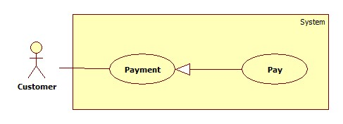

|  |  |  |  |  |
| --- | --- | --- | --- | --- |
| **USE CASE SPECIFICATION** | | | | |
| **Use-case No.** | UC033 | **Use-case Version** | | 1.0 |
| **Use-case Name** | Pay | | | |
| **Author** | TuanBT | | | |
| **Date** | 24/09/2014 | **Priority** | High | |
| **Actor:** Customer  **Summary:** Customer will pay online by Paypal for them Recruitment.  **Goal:**  Pay online by Paypal.  **Trigger:** Post success a Recruitment.  **Pre-conditions:**   * User must login with Admin role * Paypal button will be shown   **Post conditions:**   * Success: Status of Recruitment change to Watting mean “Đang chờ người làm”. * Failure: Button Paypal not hide.   **Main Success Scenario:**   |  |  | | --- | --- | | Actor Action | System Response | | 1. Click Paypal button.  3. Do pay money. | 2. System redirect to Paypal Page.  4. Button Paypal hide, status of Recruitment change to “Đang chờ người làm”.  [Exception 1] |   **Alternative Scenario:**   |  |  | | --- | --- | | Actor Action | System Response | | [Alternative 1]  1. Customer click a Recruitment form “Hết hạn” tab in Profile page. Then Click “Gia hạn” button.  3. Click Paypal button.  5. Do pay money.  [Alternative 2]  1. Customer click title a Recruitment from “Hết hạn” tab in Profile page.  3. Click “Gia hạn” button.  5. Do pay money. | 2. System show “Gia hạn đơn tuyển việc” modal.  4. System redirect to Paypal page.  6. Button Paypal hide, status of Recruitment change to “Đang chờ người làm”.  [Exception 1]  2. System redirect to “Tin tìm người giúp việc” page.  4. System redirect to Paypal page.  6. Button Paypal hide, status of Recruitment change to “Đang chờ người làm”.  [Exception 1] |   **Exceptions:**   |  |  | | --- | --- | | Actor Action | System Response | | [Exception 1]  1. Paypal page not return MS-Website. | 2. Paypal button not Hide. |   **Relationships:** Pay is generalization Payment  **Business Rules:** Recruitment must have paypal account to pay. If the payment process is not successful because whatever resons is, Customer can click “Ấn vào đây” in “Nếu bạn đã thanh toán?” Box in “Tin tìm người giúp việc” page, to contact Staff. After that, Staff must go to website to check if that Recruitment is paid or not. If it is paid, Staff goes to management page to active this Recruitment. | | | | |

##### <Customer> View Customer Statistic

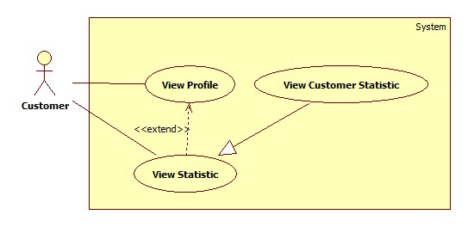

|  |  |  |  |  |
| --- | --- | --- | --- | --- |
| **USE CASE SPECIFICATION** | | | | |
| **Use-case No.** | UC034 | **Use-case Version** | | 1.0 |
| **Use-case Name** | View Customer Statistic | | | |
| **Author** | TuanBT | | | |
| **Date** | 24/09/2014 | **Priority** | High | |
| **Actor:** Customer  **Summary:** This use case allow customer to view personal statistic as customer  **Goal:** Customer can view personal statistic  **Trigger:** User clicks “Thống kê” link in personal profile page  **Pre-conditions:**   * Page is loaded successfully * User login as customer successful   **Post conditions:**   * Success: Personal Statistic page is loaded successfully * Failure: Show error message   **Main Success Scenario:**   |  |  | | --- | --- | | Actor Action | System Response | | 1. Login as a customer  3. Click the name link  5. Click “Thống kê” link | 2. System redirects to homepage  4. System redirects to personal profile page  6. System redirects to personal statistic page |   **Alternative Scenario:**   |  |  | | --- | --- | | Actor Action | System Response | | 1. Click on the “Đăng xuất” button. | 1. Clear session and back to home page |   **Exceptions:**   |  |  | | --- | --- | | Actor Action | System Response | | 1. User hasn’t posted any recruitment | 1. The statistic diagram is not displayed |   **Relationships:** Is a generalization of View Statistic  **Business Rules:** This use caseis only available for customer. User clicks “Thống kê” link to go to personal statistic page. The statistic circle diagram is displayed and is divided into parts according to the number of recruitment of each status (Each status has one color). When user moves the mouse to a part of he diagram, the number of recruitment of that status will be displayed. If the user hasn’t post any recruitment yet, the diagram will not appear. | | | | |

##### <Staff, Maid Mediator> Manage Maid

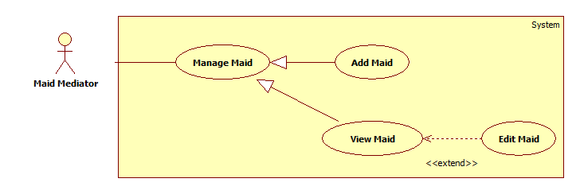

###### <Staff, Maid Mediator> Add Maid

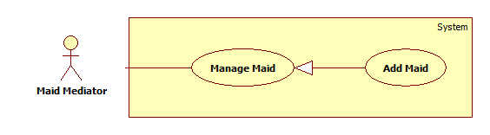

|  |  |  |  |  |
| --- | --- | --- | --- | --- |
| **USE CASE SPECIFICATION** | | | | |
| **Use-case No.** | UC035 | **Use-case Version** | | 1.0 |
| **Use-case Name** | Add maid | | | |
| **Author** | TuyenMQ | | | |
| **Date** | 21/09/2014 | **Priority** | High | |
| **Actor:** Staff, Maid Mediator  **Summary:** This use case allow maid mediator or staff to add maid for management.  **Goal:** Maid mediator orstaff can add maid  **Trigger:** User clicks button “Thêm người giúp việc” at the top of maids list in profile page  **Pre-conditions:**   * Page is loaded successfully * User login as maid mediator or staff successful   **Post conditions:**   * Success: Add maid successfully, new maid is added to database * Failure: Show error message   **Main Success Scenario:**   |  |  | | --- | --- | | Actor Action | System Response | | 1. Login as a maid mediator or staff 2. Click name link 3. Click “Thêm người giúp việc” button 4. Fill all the fields 5. Click “Hoàn tất thêm người giúp việc” button | 1. System redirects to home page 2. System redirects to personal profile page 3. System redirects to add maid page with following fields:  * Họ và tên [MaidName: textbox] * Kinh nghiệm [Experience: dropdownlist] * Số điện thoại [Phone: textbox] * Ngày sinh [BirthDate: textbox] * Giới tính [Gender: dropdownlist] * Biết tiếng [LanguageEnglish: checkbox, LanguageChina: checkbox, LanguageJapanese: checkbox, LanguageKorean: checkbox] * Nguyên quán [Hometown: dropdownlist] * Đang sống tại [Address: dropdownlist] * Kết hôn [Married: dropdownlist] * Giới thiệu bản thân [Description: textbox] * “Hoàn tất thêm người giúp việc” button.  1. System redirects to personal profile page |   **Alternative Scenario:**   |  |  | | --- | --- | | Actor Action | System Response | | 1. Click on the “Đăng xuất” button. | 1. Clear session and back to homepage |   **Exceptions:**   |  |  | | --- | --- | | Actor Action | System Response | | 1. “Họ và tên” is empty 2. “Số điện thoại” is empty or not a numberic value 3. “Ngày sinh” is empty | 1. Show message “Vui lòng nhập tên người giúp việc” 2. Show message “Vui lòng nhập số” 3. Show message “Vui lòng chọn ngày sinh” |   **Relationships:** Is a generalization of Manage Maid  **Business Rules:** This use caseis only available for maid mediator and staff, so user must log in as one of these two roles. After logging in, user clicks the name link to go to personal profile page and there is a list of maids whom the user is managing. User click “Thêm người giúp việc” button on the top of the list to add a new maid to manage. System redirects to maid creating page with fields requiring user’s inputs to complete the info of the new maid. There are 3 mandatory fields: “Họ và tên”, “Số điện thoại”, “Ngày sinh” so user must not let these fields empty or the error message is shown. After filling all the info field, user can click “Hoàn tất thêm người giúp việc” button to complete the maid adding process. After that, the system redirects back to personal profile page and the new added maid will be displayed at the bottom of the maids list. | | | | |

###### <Authenticated user> View Maid

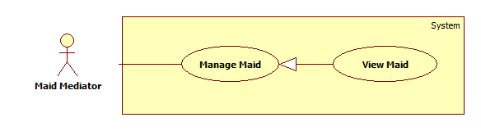

|  |  |  |  |  |
| --- | --- | --- | --- | --- |
| **USE CASE SPECIFICATION** | | | | |
| **Use-case No.** | UC036 | **Use-case Version** | | 1.0 |
| **Use-case Name** | View maid | | | |
| **Author** | TuyenMQ | | | |
| **Date** | 21/09/2014 | **Priority** | High | |
| **Actor:** Authenticated user (Staff, Maid Mediator, Customer, Admin)  **Summary:** This use case allow logged user to view a maid’s detail.  **Goal:** User can view a maid’s detail.  **Trigger:** User clicks the name link of a maid.  **Pre-conditions:**   * Page is loaded successfully * User login successfully   **Post conditions:**   * Success: Maid detail page is displayed * Failure: Show error message   **Main Success Scenario:**   |  |  | | --- | --- | | Actor Action | System Response | | 1. Login as Staff 2. Click the name link 3. Click a maid name in maids list | 1. System redirects to personal page 2. System redirects to maid profile page |   **Alternative Scenario:**   |  |  | | --- | --- | | Actor Action | System Response | | 1. Click on the “Đăng xuất” button. | 1. Clear session and back to homepage |   **Exceptions:**   |  |  | | --- | --- | | Actor Action | System Response | | 1. Maid does not exist | 1. Show error message |   **Relationships:** Is a generalization of Manage Maid  **Business Rules:** This use caseis available for any role except guest, so user must log in to view a maid’s detail. As customer, user can search a job request or go to personal profile page and click on a job request in recommended list of a “Waiting” recruitment or in tab “Đã thuê” to go to job request detail page. There is a name link of a maid whom the job request belongs to, click on that link to go to maid detail page which displays the info of that maid. As admin, user can only search a job request and then do the same as customer. As staff or maid mediator, just simply click on a maid name link in the maids list. | | | | |

###### <Staff, Maid Mediator> Edit Maid

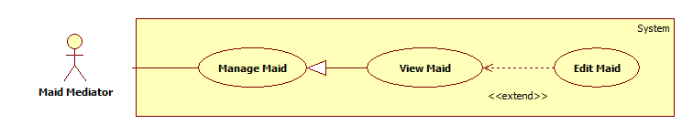

|  |  |  |  |  |
| --- | --- | --- | --- | --- |
| **USE CASE SPECIFICATION** | | | | |
| **Use-case No.** | UC037 | **Use-case Version** | | 1.0 |
| **Use-case Name** | Edit maid | | | |
| **Author** | TuyenMQ | | | |
| **Date** | 21/09/2014 | **Priority** | High | |
| **Actor:** Staff, Maid Mediator  **Summary:** This use case allow staff edit a maid’s info  **Goal:** User can edit info of a maid  **Trigger:** User clicks “Sửa thông tin người giúp việc” link in maid profile page  **Pre-conditions:**   * Page is loaded successfully * User login as staff or maid mediator successful   **Post conditions:**   * Success: Edit maid’s info successfully and save to database * Failure: Show error message   **Main Success Scenario:**   |  |  | | --- | --- | | Actor Action | System Response | | 1. Login as a staff or maid mediator 2. Click name link 3. Click maid name link in maids list 4. Click “Sửa thông tin người giúp việc” link 5. Fill all the field 6. Click “Cập nhật thông tin” button | 1. System redirect home page 2. System redirect personal profile page 3. System redirect maid profile page 4. System redirect add maid page with following fields which displays the maid’s info accordingly:  * Họ và tên [MaidName: textbox] * Kinh nghiệm [Experience: dropdownlist] * Số điện thoại [Phone: textbox] * Ngày sinh [BirthDate: textbox] * Giới tính [Gender: dropdownlist] * Biết tiếng [LanguageEnglish: checkbox, LanguageChina: checkbox, LanguageJapanese: checkbox, LanguageKorean: checkbox] * Nguyên quán [Hometown: dropdownlist] * Đang sống tại [Address: dropdownlist] * Kết hôn [Married: dropdownlist] * Giới thiệu bản thân [Description: textbox] * Ảnh đại diện [Image uploading] * “Cập nhật thông tin” button.  1. System redirects to maid profile page |   **Alternative Scenario:**   |  |  | | --- | --- | | Actor Action | System Response | | 1. Click on the “Đăng xuất” button. | 1. Clear session and back to home page |   **Exceptions:**   |  |  | | --- | --- | | Actor Action | System Response | | 1. “Họ và tên” is empty 2. “Số điện thoại” is empty or not a numberic value 3. “Ngày sinh” is empty | 1. Show message “Vui lòng nhập tên người giúp việc” 2. Show message “Vui lòng nhập số” 3. Show message “Vui lòng chọn ngày sinh” |   **Relationships:** Is an extension of View Maid  **Business Rules:** This use caseis only available for maid mediator and staff, so user must log in as one of these two roles. After logging in, user clicks the name link to go to personal profile page and there is a list of maids whom the user is managing. Click a maid name to go to maid profile page. Click on the “Sửa thông tin người giúp việc” link to go to maid editing page displaying fields with the info of that maid for editing. User can edit those info then click “Cập nhật thông tin” button to complete editing process. The system redirects to the edited maid’s profile page and the all info are updated. | | | | |

##### <Staff, Maid Mediator> Public Job Request

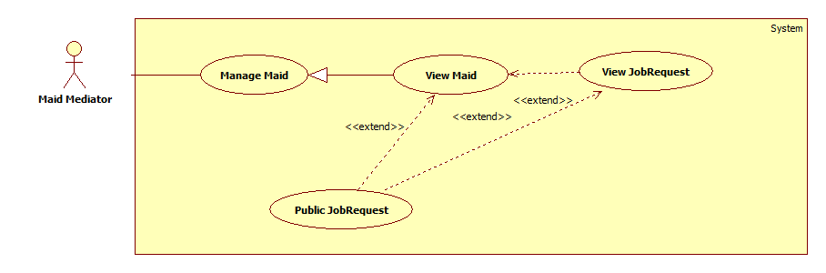

|  |  |  |  |  |
| --- | --- | --- | --- | --- |
| **USE CASE SPECIFICATION** | | | | |
| **Use-case No.** | UC038 | **Use-case Version** | | 1.0 |
| **Use-case Name** | Public Job Request | | | |
| **Author** | TuyenMQ | | | |
| **Date** | 21/09/2014 | **Priority** | High | |
| **Actor:** Staff, Maid Mediator  **Summary:** This use case allow staff or maid mediator to public a job request for customer to apply  **Goal:** User can public a job request  **Trigger:** User clicks “Công khai” button  **Pre-conditions:**   * Page is loaded successfully * User login as staff or maid mediator successfully   **Post conditions:**   * Success: Public job request successfully, status of job request is changed from “Hide” to “Waiting” * Failure: Show error message   **Main Success Scenario:**   |  |  | | --- | --- | | Actor Action | System Response | | 1. Login as a staff or maid mediator 2. Click name link 3. Click a job request in tab “Tạm ẩn” 4. Click “Công khai” button | 1. System redirect home page 2. System redirect personal profile page 3. System redirects to job request detail page and displays “Tình trạng: Đang chờ” |   **Alternative Scenario:**   |  |  | | --- | --- | | Actor Action | System Response | | 1. Click on the “Đăng xuất” button. | 1. Clear session and back to home page |   **Exceptions:**   |  |  | | --- | --- | | Actor Action | System Response | | 1. Job request does not exist | 1. Show error message |   **Relationships:** Is an extension of View Maid and View Job Request  **Business Rules:** This use caseis only available for maid mediator and staff, so user must log in as one of these two roles. After logging in, user clicks the name link to go to personal profile page and there is a list of maids whom the user is managing. Click a maid name to go to maid profile page. There are five tabs which represent five statuses of job request. In “Tạm ẩn” tab which only contains job request with “Hide” status in database, user can click on a job request (not job request’s name link) then the button “Công khai” will be displayed, user can also click on job request’s name link to go to job request detail page and the button “Công khai” will be displayed too. Be noticed that only job requests in “Tạm ẩn” tab (with status “Hide” in database) have this function. User clicks “Công khai” button to public the job request, the status of the job request will be changed from “Hide” to “Waiting” in database and it’s also moved to “Đang chờ” tab in maid profile page. Now the job request is ready for customers to apply. | | | | |

##### <Staff, Maid Mediator> Hide Job Request

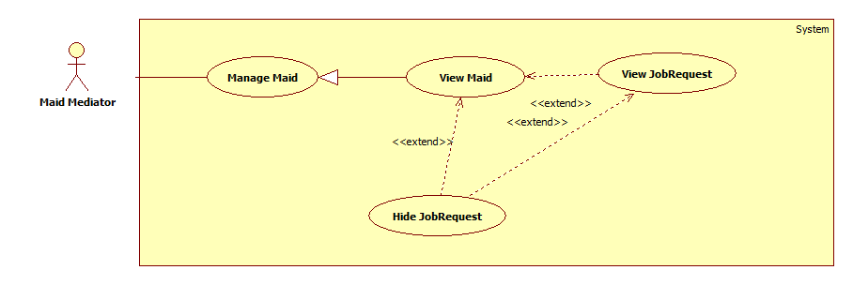

|  |  |  |  |  |
| --- | --- | --- | --- | --- |
| **USE CASE SPECIFICATION** | | | | |
| **Use-case No.** | UC039 | **Use-case Version** | | 1.0 |
| **Use-case Name** | Hide Job Request | | | |
| **Author** | TuyenMQ | | | |
| **Date** | 21/09/2014 | **Priority** | High | |
| **Actor:** Staff, Maid Mediator  **Summary:** This use case allow staff or maid mediator to hide a job request and can’t be applied by any customer  **Goal:** User can hide a job request  **Trigger:** User clicks “Tạm ẩn” button  **Pre-conditions:**   * Page is loaded successfully * User login as staff or maid mediator successfully   **Post conditions:**   * Success: Hide job request successfully, status of job request is changed from “Waiting” to “Hide” * Failure: Show error message   **Main Success Scenario:**   |  |  | | --- | --- | | Actor Action | System Response | | 1. Login as a staff or maid mediator  2. Click name link  4. Click a job request in tab “Đang chờ”  6. Click “Tạm ẩn” button | 3. System redirect home page  5. System redirect personal profile page  7. System redirects to job request detail page and displays “Tình trạng: Tạm ẩn” |   **Alternative Scenario:**   |  |  | | --- | --- | | Actor Action | System Response | | 1. Click on the “Đăng xuất” button. | 1. Clear session and back to home page |   **Exceptions:**   |  |  | | --- | --- | | Actor Action | System Response | | 1. Job request does not exist | 1. Show error message |   **Relationships:** Is an extension of View Maid and View Job Request  **Business Rules:** This use caseis only available for maid mediator and staff, so user must log in as one of these two roles. After logging in, user clicks the name link to go to personal profile page and there is a list of maids whom the user is managing. Click a maid name to go to maid profile page. There are five tabs which represent five statuses of job request. In “Đang chờ” tab which only contains job request with “Waiting” status in database, user can click on a job request (not job request’s name link) then the button “Tạm ẩn” will be displayed, user can also click on job request’s name link to go to job request detail page and the button “Tạm ẩn” will be displayed too. Be noticed that only job requests in “Đang chờ” tab (with status “Waiting” in database) have this function. User clicks “Tạm ẩn” button to hide the job request, the status of the job request will be changed from “Waiting” to “Hide” in database and it’s also moved to “Tạm ẩn” tab in maid profile page. Now the job request can’t be applied. | | | | |

##### <Staff, MaidMediator> Extend Job Request

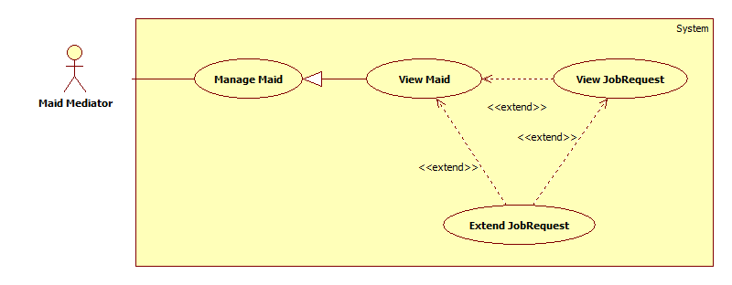

|  |  |  |  |  |
| --- | --- | --- | --- | --- |
| **USE CASE SPECIFICATION** | | | | |
| **Use-case No.** | UC040 | **Use-case Version** | | 1.0 |
| **Use-case Name** | Extend Job Request | | | |
| **Author** | TuyenMQ | | | |
| **Date** | 21/09/2014 | **Priority** | High | |
| **Actor:** Staff, Maid Mediator  **Summary:** This use case allow staff or maid mediator to extend job request  **Goal:** Staff or maid mediator can extend job request  **Trigger:** User clicks “Gia hạn” button  **Pre-conditions:**   * Page is loaded successfully * User login as staff or maid mediator successful   **Post conditions:**   * Success: Extend job request successfully, job request’s expired date is updated in database and status changes from “Expired” to “Waiting” * Failure: Show error message   **Main Success Scenario:**   |  |  | | --- | --- | | Actor Action | System Response | | 1. Login as a staff or maid mediator 2. Click the name link 3. Click a maid name link in maids list 4. Choose a job request in any tab except “Được nhận” and “Hoàn tất” tabs 5. Click “Gia hạn” button 6. Click “Đồng ý” button | 1. System redirects to homepage 2. System redirects to personal profile page 3. System redirects to maid profile page 4. A modal pops up with a dropdown list for user to choose the extending time 5. System redirects to extended job request’s detail page |   **Alternative Scenario:**   |  |  | | --- | --- | | Actor Action | System Response | | 1. Click on the “Đăng xuất” button. | 1. Clear session and back to home page |   **Exceptions:**   |  |  | | --- | --- | | Actor Action | System Response | | 1. Job request was applied | 1. Show alert message “Công việc đã được thuê” |   **Relationships:** Is an extension of View Profile  **Business Rules:** This use caseis only available for maid mediator and staff, so user must log in as one of these two roles. After logging in, user clicks the name link to go to personal profile page. User clicks a maid name link in the maids list to go to maid profile list. User choose a job request from any tab except “Được nhận” and “Hoàn tất” tabs then click “Gia hạn” button which appears afterward. A modal pops up and user choose the extending time from the dropdown list then click “Đồng ý” button to complete the process. Job request’s expired time is updated and status changes from “Expired” (if job request’s status is “Expired”) to “Waiting” in database. The system redirects to that job request’s detail page and the extended job request moves from “Hết hạn” tab to “Đang chờ” tab in maid profile page. | | | | |

##### <Staff, MaidMediator> Edit JobRequest

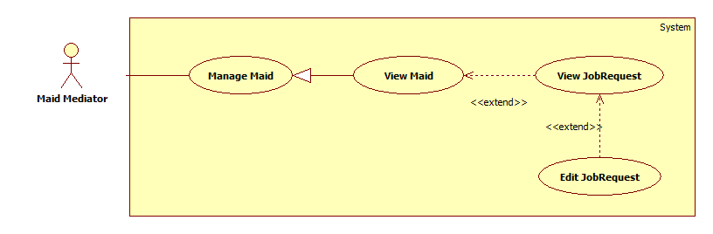

|  |  |  |  |  |
| --- | --- | --- | --- | --- |
| **USE CASE SPECIFICATION** | | | | |
| **Use-case No.** | UC041 | **Use-case Version** | | 1.0 |
| **Use-case Name** | Edit JobRequest | | | |
| **Author** | TuyenMQ | | | |
| **Date** | 21/09/2014 | **Priority** | High | |
| **Actor:** Staff, Maid Mediator  **Summary:** This use case allow staff or maid mediator to edit job request  **Goal:** Staff or maid mediator can edit job request  **Trigger:** User click “Sửa yêu cầu công việc” link in job request detail page  **Pre-conditions:**   * Page is loaded successfully * User login as staff or maid mediator successful   **Post conditions:**   * Success: Edit job request successfully, job request’s detail and skill reference’s detail are updated in database * Failure: Show error message   **Main Success Scenario:**   |  |  | | --- | --- | | Actor Action | System Response | | 1. Login as a staff or maid mediator 2. Click the name link 3. Click a maid name link in maids list 4. Click a job request link in “Chưa kích hoạt” tab 5. Click “Sửa thông tin yêu cầu công việc” link 6. Fill all the fields 7. Click “Sửa yêu cầu” button | 1. System redirects to homepage 2. System redirects to personal profile page 3. System redirects to job request detail page 4. System redirects to job request editing page displaying following fields with info of the job request accordingly:  * Đăng cho [MaidName: textbox] * Tiêu đề [Title: dropdownlist] * Các kỹ năng [SkillRefId: textbox] * “Sửa yêu cầu” button  1. System redirects to edited job request’s detail page |   **Alternative Scenario:**   |  |  | | --- | --- | | Actor Action | System Response | | 1. Click on the “Đăng xuất” button. | 1. Clear session and back to home page |   **Exceptions:**   |  |  | | --- | --- | | Actor Action | System Response | | 1. Job request is active 2. “Đăng cho” is empty 3. “Tiêu đề” is empty 4. “Các kỹ năng” is empty | 1. Show alert message “Công việc đã hết hạn cho sửa” 2. Show message “Vui lòng chọn người giúp việc” 3. Show message “Vui lòng nhập tiêu đề” 4. Show message “Vui lòng chọn kĩ năng” |   **Relationships:** Is an extension of View Job Request  **Business Rules:** This use caseis only available for maid mediator and staff, so user must log in as one of these two roles. After logging in, user clicks the name link to go to personal profile page. User clicks on a maid name link in maids list to go to maid profile page. In “Chưa kích hoạt” tab click a job request link to go to job request detail page. Click “Sửa thông tin yêu cầu tìm việc” link to go to job request editing page. User edit the info then click “Sửa yêu cầu” button to complete the editing process. Only inactive job requests have this function, so if the user click “Sửa thông tin yêu cầu tìm việc” link of active job requests, the alert message “Công việc đã hết hạn cho sửa” will be displayed. | | | | |

##### <Staff, MaidMediator> Edit Maid Mediator Profile

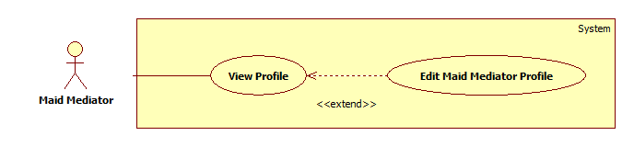

|  |  |  |  |  |
| --- | --- | --- | --- | --- |
| **USE CASE SPECIFICATION** | | | | |
| **Use-case No.** | UC042 | **Use-case Version** | | 1.0 |
| **Use-case Name** | Edit Maid Mediator Profile | | | |
| **Author** | TuyenMQ | | | |
| **Date** | 21/09/2014 | **Priority** | High | |
| **Actor:** Staff, Maid Mediator  **Summary:** This use case allow staff or maid mediator to edit profile  **Goal:** Staff or maid mediator can edit profile  **Trigger:** User clicks “Sửa thông tin cá nhân” link in personal profile page  **Pre-conditions:**   * Page is loaded successfully * User login as staff or maid mediator successful   **Post conditions:**   * Success: Edit profile successfully, profile detail is updated in database * Failure: Show error message   **Main Success Scenario:**   |  |  | | --- | --- | | Actor Action | System Response | | 1. Login as a staff or maid mediator 2. Click the name link 3. Click “Sửa thông tin cá nhân” link 4. Fill all the fields 5. Click “Cập nhật thông tin” button | 1. System redirects to homepage 2. System redirects to personal profile page 3. System redirects to profile editing page displaying following fields with info of the job request accordingly:  * Họ và tên [FullName: textbox] * Số điện thoại [Phone: textbox] * Email [Email: textbox] * Ảnh đại diện [Image uploading] * “Cập nhật thông tin” button  1. System redirects to personal profile page with updated info |   **Alternative Scenario:**   |  |  | | --- | --- | | Actor Action | System Response | | 1. Click on the “Đăng xuất” button. | 1. Clear session and back to home page |   **Exceptions:**   |  |  | | --- | --- | | Actor Action | System Response | | 1. “Họ và tên” is empty 2. “Số điện thoại” is empty or char inputted 3. “Email” is empty or wrong format | 1. Show message “Vui lòng nhập tên người quản lý” 2. Show message “Vui lòng nhập số” 3. Show message “Vui lòng nhập đúng định dạng abc@abc.ab” |   **Relationships:** Is an extension of View Profile  **Business Rules:** This use caseis only available for maid mediator and staff since staff is also a maid mediator, so user must log in as one of these two roles. After logging in, user clicks the name link to go to personal profile page. User clicks “Sửa thông tin cá nhân” link to go to profile editing page. User edit the info then click “Cập nhật thông tin” button to complete the editing process. Data is updated in database, system redirects back to personal profile page and the info are updated. | | | | |

##### <Staff, MaidMediator> Post JobRequest

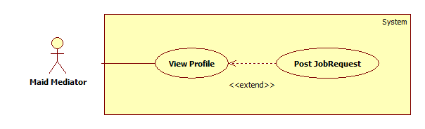

|  |  |  |  |  |
| --- | --- | --- | --- | --- |
| **USE CASE SPECIFICATION** | | | | |
| **Use-case No.** | UC043 | **Use-case Version** | | 1.0 |
| **Use-case Name** | Post JobRequest | | | |
| **Author** | TuyenMQ | | | |
| **Date** | 21/09/2014 | **Priority** | High | |
| **Actor:** Staff, Maid Mediator  **Summary:** This use case allow staff or maid mediator to post job request  **Goal:** Staff or maid mediator can post job request  **Trigger:** User clicks “Đăng yêu cầu tìm việc” link in personal profile page  **Pre-conditions:**   * Page is loaded successfully * User login as staff or maid mediator successful   **Post conditions:**   * Success: Post job request successfully, new job request and skill reference are added to database * Failure: Show error message   **Main Success Scenario:**   |  |  | | --- | --- | | Actor Action | System Response | | 1. Login as a staff or maid mediator 2. Click the name link 3. Click “Đăng yêu cầu công việc” link 4. Fill all the fields 5. Click “Đăng yêu cầu” button | 1. System redirects to homepage 2. System redirects to personal profile page 3. System redirect post jobrequest page with following fields:  * Đăng cho [MaidName: textbox] * Tiêu đề [Title: dropdownlist] * Các kỹ năng [SkillRefId: textbox] * Thời hạn đăng [PostTime: textbox] * “Đăng yêu cầu” button  1. System redirects to new job request’s detail page |   **Alternative Scenario:**   |  |  | | --- | --- | | Actor Action | System Response | | 1. Click on the “Đăng xuất” button. | 1. Clear session and back to home page |   **Exceptions:**   |  |  | | --- | --- | | Actor Action | System Response | | 1. “Đăng cho” is empty 2. “Tiêu đề” is empty 3. “Các kỹ năng” is empty | 1. Show message “Vui lòng chọn người giúp việc” 2. Show message “Vui lòng nhập tiêu đề” 3. Show message “Vui lòng chọn kĩ năng” |   **Relationships:** Is an extension of View Profile  **Business Rules:** This use caseis only available for maid mediator and staff, so user must log in as one of these two roles. After logging in, user clicks the name link to go to personal profile page. User clicks on “Đăng yêu cầu công việc” link to go to request adding page which displays all required fields for a job request to be created. There are 3 mandatory fields: “Đăng cho” (User must choose a maid from the managed maids list to post this job request for that maid), “Tiêu đề”, “Các kĩ năng” (User must choose at least a skill from the skills list). After completing all the fields, user can click “Đăng yêu cầu” button to complete posting a new job request. New job request is added to JobRequest table and new skill reference is added to SkillReference table in database. The system redirects to new added job request’s detail page. | | | | |

##### <Staff> Manage JobRequest and Recruitment

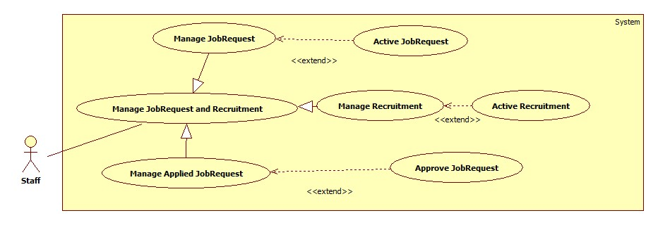

###### <Staff> Active JobRequest

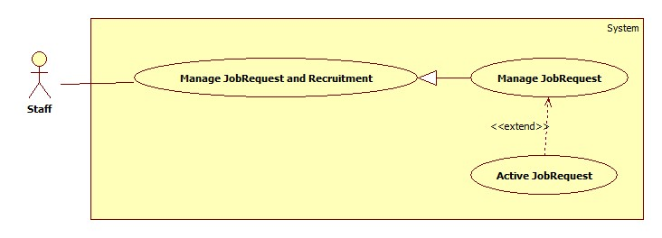

|  |  |  |  |  |
| --- | --- | --- | --- | --- |
| **USE CASE SPECIFICATION** | | | | |
| **Use-case No.** | UC044 | **Use-case Version** | | 1.0 |
| **Use-case Name** | Active JobRequest | | | |
| **Author** | CongNT | | | |
| **Date** | 21/09/2014 | **Priority** | High | |
| **Actor:** Staff  **Summary:** This use case allow staff to active job request to public it on website  **Goal:** Staff can allow job request to public on website  **Trigger:** User choose a job request then click “Chấp nhận” button  **Pre-conditions:**   * Page is loaded successfully * User login as staff successful   **Post conditions:**   * Success: Login successfully, the job request will be allowed to public on website * Failure:   **Main Success Scenario:**   |  |  | | --- | --- | | Actor Action | System Response | | 1. Login as a staff 2. Choose a job request, click “Kích hoạt” button 3. Click “Chấp nhận” button. | 1. System redirect to list of job request 2. System show a “Xác nhận kích hoạt” pop up. 3. Change IsActive(false) to IsActive(true) and save change to database |   **Alternative Scenario:**   |  |  | | --- | --- | | Actor Action | System Response | | 1. Click on the “Đăng xuất” button. 2. Click on maid service icon | 1. Clear session and back to home page 2. Redirect to home page |   **Exceptions:**   |  |  | | --- | --- | | Actor Action | System Response | | 1. System fail to load data | 1. Show message “Hệ thống đang bảo trì” |   **Relationships:** Active JobRequest is extended to ManageJobRequest and Manage JobRequest is generated to Manage JobRequest and Recruitment.  **Business Rules:** User login as a staff. | | | | |

###### <Staff> Active Recruitment

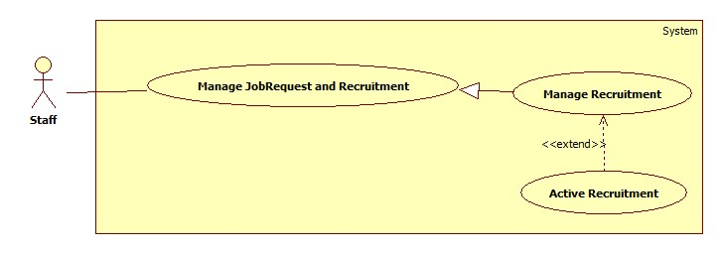

|  |  |  |  |  |
| --- | --- | --- | --- | --- |
| **USE CASE SPECIFICATION** | | | | |
| **Use-case No.** | UC045 | **Use-case Version** | | 1.0 |
| **Use-case Name** | Active Recruitment | | | |
| **Author** | CongNT | | | |
| **Date** | 21/09/2014 | **Priority** | High | |
| **Actor:** Staff  **Summary:** This use case allow staff to active job request to public it on website  **Goal:** Staff can allow job request to public on website  **Trigger:** User choose a recruitment then click “Chấp nhận” button  **Pre-conditions:**   * Page is loaded successfully * User login as staff successful   **Post conditions:**   * Success: Login successfully, the job request will be allowed to public on website * Failure:   **Main Success Scenario:**   |  |  | | --- | --- | | Actor Action | System Response | | 1. Login as a staff 2. Click “Xác nhận hoàn tất công việc” link 3. Choose a recruitment, click “Hoàn tất” button 4. Click “Chấp nhận” button. | 1. System redirect to list of job request 2. System redirect to list of applied job requests 3. System show a “Xác nhận kích hoạt” pop up. 4. Change IsActive(false) to IsActive(true) and save change to database |   **Alternative Scenario:**   |  |  | | --- | --- | | Actor Action | System Response | | 1. Click on the “Đăng xuất” button. 2. Click on maid service icon | 1. Clear session and back to home page 2. Redirect to home page |   **Exceptions:**   |  |  | | --- | --- | | Actor Action | System Response | | 1. System fail to load data | 1. Show message “Hệ thống đang bảo trì” |   **Relationships:** Active Recruitment is extended to Manage Recruitment and Manage Recruitment is generated to Manage JobRequest and Recruitment.  **Business Rules:** User login as a staff and the website load all | | | | |

###### <Staff> Approve JobRequest

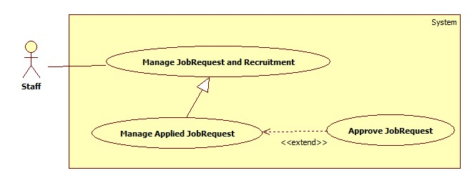

|  |  |  |  |  |
| --- | --- | --- | --- | --- |
| **USE CASE SPECIFICATION** | | | | |
| **Use-case No.** | UC046 | **Use-case Version** | | 1.0 |
| **Use-case Name** | Approve JobRequest | | | |
| **Author** | CongNT | | | |
| **Date** | 21/09/2014 | **Priority** | High | |
| **Actor:** Staff  **Summary:** This use case allow staff to active job request to public it on website  **Goal:** Staff can allow job request to public on website  **Trigger:** User choose a jobrequest then click “Kích hoạt” button  **Pre-conditions:**   * Page is loaded successfully * User login as staff successful   **Post conditions:**   * Success: Login successfully, the job request will be allowed to public on website * Failure:   **Main Success Scenario:**   |  |  | | --- | --- | | Actor Action | System Response | | 1. Login as a staff 2. Click “Kích hoạt yêu cầu tìm người” link 3. Choose a recruitment, click “Kích hoạt” button 4. Click “Chấp nhận” button. | 1. System redirect to list of job request 2. System redirect to list of recruitments 3. System show a “Xác nhận kích hoạt” pop up. 4. Change IsActive(false) to IsActive(true) and save change to database |   **Alternative Scenario:**   |  |  | | --- | --- | | Actor Action | System Response | | 1. Click on the “Đăng xuất” button. 2. Click on maid service icon | 1. Clear session and back to home page 2. Redirect to home page |   **Exceptions:**   |  |  | | --- | --- | | Actor Action | System Response | | 1. System fail to load data | 1. Show message “Hệ thống đang bảo trì” |   **Relationships:** Approve JobRequest is extended to Manage Applied JobRequest and Manage Applied JobRequest is generated to Manage JobRequest and Recruitment.  **Business Rules:** User login as a staff and the website load all | | | | |

###### <Staff> Manage JobRequest

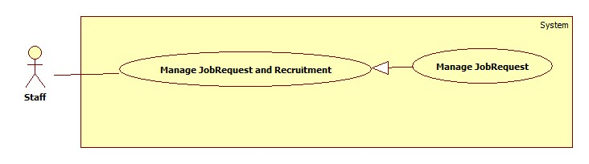

|  |  |  |  |  |
| --- | --- | --- | --- | --- |
| **USE CASE SPECIFICATION** | | | | |
| **Use-case No.** | UC047 | **Use-case Version** | | 1.0 |
| **Use-case Name** | Manage jobrequest | | | |
| **Author** | CongNT | | | |
| **Date** | 21/09/2014 | **Priority** | High | |
| **Actor:** Staff  **Summary:** This use case allow staff view all jobrequests that is not active  **Goal:** Staff can view all jobrequests that is not active  **Trigger:** User click “Quản lý” link  **Pre-conditions:**   * Page is loaded successfully * User login as staff successful   **Post conditions:**   * Success: Login successfully, the job request will be allowed to public on website * Failure:   **Main Success Scenario:**   |  |  | | --- | --- | | Actor Action | System Response | | 1. Login as a staff | 1. System redirect to list of job request |   **Alternative Scenario:**   |  |  | | --- | --- | | Actor Action | System Response | | 1. Click on the “Đăng xuất” button. 2. Click on maid service icon | 1. Clear session and back to home page 2. Redirect to home page |   **Exceptions:**   |  |  | | --- | --- | | Actor Action | System Response | | 1. System fail to load data | 1. Show message “Hệ thống đang bảo trì” |   **Relationships:** Manage JobRequest if generated to Manage JobRequest and Recruitment  **Business Rules:** User login as a staff. The website load all jobrequests that is not active. Staff choose a jobrequest. When user choose post time for jobrequest to post on website, after that time if jobrequest is not active, it will be remove from database. | | | | |

###### <Staff> Manage Recruitment

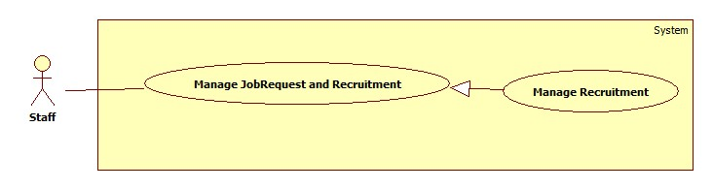

|  |  |  |  |  |
| --- | --- | --- | --- | --- |
| **USE CASE SPECIFICATION** | | | | |
| **Use-case No.** | UC048 | **Use-case Version** | | 1.0 |
| **Use-case Name** | Manage recruitment | | | |
| **Author** | CongNT | | | |
| **Date** | 21/09/2014 | **Priority** | High | |
| **Actor:** Staff  **Summary:** This use case allow staff view all recruitments that is not active  **Goal:** Staff can view all recruitments that is not active  **Trigger:** User click “Quản lý” link, then click “Kích hoạt yêu cầu tìm việc” link  **Pre-conditions:**   * Page is loaded successfully * User login as staff successful   **Post conditions:**   * Success: Login successfully, the recruitments will be allowed to public on website * Failure:   **Main Success Scenario:**   |  |  | | --- | --- | | Actor Action | System Response | | 1. Login as a staff 2. Click “Kích hoạt yêu cầu tìm người” link | 1. System redirect to list of job request 2. System redirect to list of recruitment |   **Alternative Scenario:**   |  |  | | --- | --- | | Actor Action | System Response | | 1. Click on the “Đăng xuất” button. 2. Click on maid service icon | 1. Clear session and back to home page 2. Redirect to home page |   **Exceptions:**   |  |  | | --- | --- | | Actor Action | System Response | | 1. System fail to load data | 1. Show message “Hệ thống đang bảo trì” |   **Relationships: :** Manage Recruitment if generated to Manage JobRequest and Recruitment  **Business Rules:** User login as a staff. The website load all recruitments that is not active. Staff choose a recruitment. When user choose post time for recruitment to post on website, after that time if recruitment is not active, it will be remove from database. | | | | |

###### <Staff> Manage Applied JobRequest

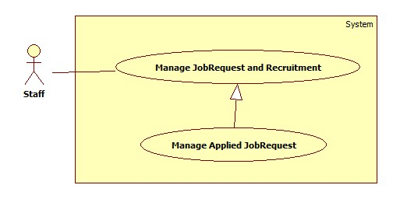

|  |  |  |  |  |
| --- | --- | --- | --- | --- |
| **USE CASE SPECIFICATION** | | | | |
| **Use-case No.** | UC049 | **Use-case Version** | | 1.0 |
| **Use-case Name** | Manage applied jobrequest | | | |
| **Author** | CongNT | | | |
| **Date** | 21/09/2014 | **Priority** | High | |
| **Actor:** Staff  **Summary:** This use case allow staff view all applied jobrequests  **Goal:** Staff can view all applied jobrequests  **Trigger:** User click “Quản lý” link, then click “Xác nhận hoàn tất công việc” link  **Pre-conditions:**   * Page is loaded successfully * User login as staff successful   **Post conditions:**   * Success: Login successfully, the recruitments will be allowed to public on website * Failure:   **Main Success Scenario:**   |  |  | | --- | --- | | Actor Action | System Response | | 1. Login as a staff 2. Click “Hoàn tất yêu cầu” link | 1. System redirect to list of job request 2. System redirect to list of applied jobrequest |   **Alternative Scenario:**   |  |  | | --- | --- | | Actor Action | System Response | | 1. Click on the “Đăng xuất” button. 2. Click on maid service icon | 1. Clear session and back to home page 2. Redirect to home page |   **Exceptions:**   |  |  | | --- | --- | | Actor Action | System Response | | 1. System fail to load data | 1. Show message “Hệ thống đang bảo trì” |   **Relationships: :** Manage Applied JobRequest if generated to Manage JobRequest and Recruitment  **Business Rules:** User login as a staff. The website load all applied jobrequests. | | | | |

##### <Staff, MaidMediator> View Maid Manager Statistic

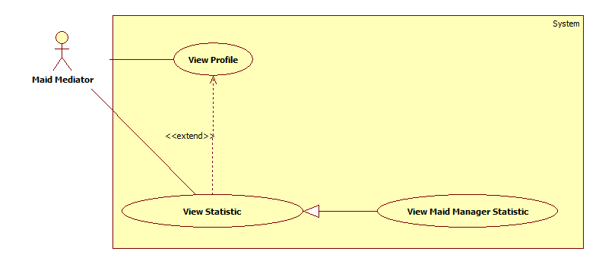

|  |  |  |  |  |
| --- | --- | --- | --- | --- |
| **USE CASE SPECIFICATION** | | | | |
| **Use-case No.** | UC050 | **Use-case Version** | | 1.0 |
| **Use-case Name** | View Maid Manager Statistic | | | |
| **Author** | TuyenMQ | | | |
| **Date** | 21/09/2014 | **Priority** | High | |
| **Actor:** Staff, Maid Mediator  **Summary:** This use case allow staff or maid mediator to view personal statistic as maid mediator  **Goal:** Staff or maid mediator can view personal statistic  **Trigger:** User clicks “Thống kê” link in personal profile page  **Pre-conditions:**   * Page is loaded successfully * User login as staff or maid mediator successful   **Post conditions:**   * Success: Personal Statistic page is loaded successfully * Failure: Show error message   **Main Success Scenario:**   |  |  | | --- | --- | | Actor Action | System Response | | 1. Login as a staff or maid mediator 2. Click the name link 3. Click “Thống kê” link | 1. System redirects to homepage 2. System redirects to personal profile page 3. System redirects to personal statistic page |   **Alternative Scenario:**   |  |  | | --- | --- | | Actor Action | System Response | | 1. Click on the “Đăng xuất” button. | 1. Clear session and back to home page |   **Exceptions:**   |  |  | | --- | --- | | Actor Action | System Response | | 1. User hasn’t posted any job request | 1. The statistic diagram is not displayed |   **Relationships:** Is a generalization of View Statistic  **Business Rules:** This use caseis only available for maid mediator and staff, so user must log in as one of these two roles. After logging in, user clicks the name link to go to personal profile page. User clicks “Thống kê” link to go to personal statistic page. The statistic circle diagram is displayed and is divided into parts according to the number of job requests of each status (Each status has one color). When user moves the mouse to a part of he diagram, the number of job requests of that status will be displayed. If the user hasn’t post any job request yet, the diagram will not appear. | | | | |

##### <Webmaster> Manage Number of Kmean

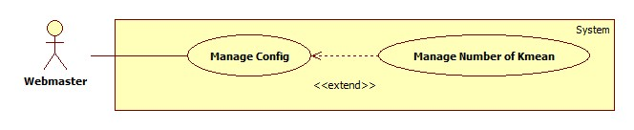

|  |  |  |  |  |
| --- | --- | --- | --- | --- |
| **USE CASE SPECIFICATION** | | | | |
| **Use-case No.** | UC051 | **Use-case Version** | | 1.0 |
| **Use-case Name** | Manage Number of Kmean | | | |
| **Author** | TuanBT | | | |
| **Date** | 24/09/2014 | **Priority** | High | |
| **Actor:** Webmaster  **Summary:** Change number K of Kmean algorithm. K same number of group.  **Goal:**  Change value.  **Trigger:** Webmaster click “Quản lý cấu hình”  **Pre-conditions:**   * User must login with Admin role * Manage config page will be shown   **Post conditions:**   * Success: Reload page and change value. * Failure: Show error.   **Main Success Scenario:**   |  |  | | --- | --- | | Actor Action | System Response | | 1. Webmaster click “Quản lý cấu hình” menu, then fill input “Gợi ý số K” | 2. Show notification “Cập nhập số K thành công.”.  [Exception 1] |   **Alternative Scenario:**   |  |  | | --- | --- | | Actor Action | System Response | |  |  |   **Exceptions:**   |  |  | | --- | --- | | Actor Action | System Response | | [Exception 1]  1. Fill input not a digit. | 2. Show error “Phải nhập số nguyên!” |   **Relationships:** Manage Number of Kmean is extend of Manage config.  **Business Rules:** Number of K must smaller than total of Jobrequest or Recruitment. | | | | |

##### <Webmaster> Manage Number Of Weeks

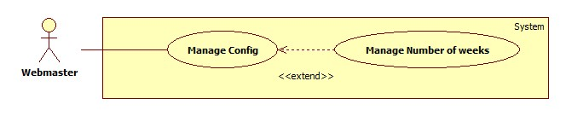

|  |  |  |  |  |
| --- | --- | --- | --- | --- |
| **USE CASE SPECIFICATION** | | | | |
| **Use-case No.** | UC052 | **Use-case Version** | | 1.0 |
| **Use-case Name** | Manage Number of weeks | | | |
| **Author** | TuanBT | | | |
| **Date** | 24/09/2014 | **Priority** | High | |
| **Actor:** Webmaster  **Summary:** Change maximum week when user post a JoRequest or Recruiment in to MS-Website.  **Goal:**  Change value.  **Trigger:** Webmaster click “Quản lý cấu hình”  **Pre-conditions:**   * User must login with Admin role * Manage config page will be shown   **Post conditions:**   * Success: Reload page and change value. * Failure: Show error.   **Main Success Scenario:**   |  |  | | --- | --- | | Actor Action | System Response | | 1. Webmaster click “Quản lý cấu hình” menu, then fill input “Số mới” | 2. Show notification “Cập nhập số tuần thành công.”  [Exception 1] |   **Alternative Scenario:**   |  |  | | --- | --- | | Actor Action | System Response | |  |  |   **Exceptions:**   |  |  | | --- | --- | | Actor Action | System Response | | [Exception 1]  1. Fill input not a digit. | 2. Show error “Phải nhập số nguyên!” |   **Relationships:** Manage Number of weeks is extend of Manage config.  **Business Rules:** Webmaster must enter an integer number. | | | | |
|  | | | | |

##### <Webmaster> Manage JobRequest Price

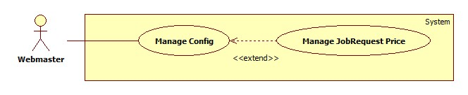

|  |  |  |  |  |
| --- | --- | --- | --- | --- |
| **USE CASE SPECIFICATION** | | | | |
| **Use-case No.** | UC053 | **Use-case Version** | | 1.0 |
| **Use-case Name** | Manage JobRequest Price | | | |
| **Author** | TuanBT | | | |
| **Date** | 24/09/2014 | **Priority** | High | |
| **Actor:** Webmaster  **Summary:** Change price when a new JobRequest post to MS-Website.  **Goal:**  Change value.  **Trigger:** Webmaster click “Quản lý cấu hình”  **Pre-conditions:**   * User must login with Admin role * Manage config page will be shown   **Post conditions:**   * Success: Reload page and change value. * Failure: Show error.   **Main Success Scenario:**   |  |  | | --- | --- | | Actor Action | System Response | | 1. Webmaster click “Quản lý cấu hình” menu, then fill input “Giá mới” | 2. Show notification “Cập nhập đơn giá cho yêu cầu công việc thành công.”  [Exception 1] |   **Alternative Scenario:**   |  |  | | --- | --- | | Actor Action | System Response | |  |  |   **Exceptions:**   |  |  | | --- | --- | | Actor Action | System Response | | [Exception 1]  1. Fill input not a digit. | 2. Show error “Phải nhập số nguyên!” |   **Relationships:** Manage JobRequest Price is extend of Manage config.  **Business Rules:** Webmaster must enter a integer number. | | | | |

##### <Webmaster> Manage Recruitment Price

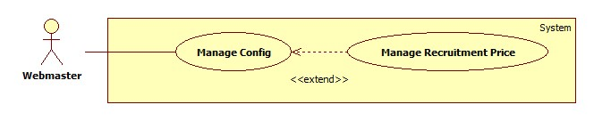

|  |  |  |  |  |
| --- | --- | --- | --- | --- |
| **USE CASE SPECIFICATION** | | | | |
| **Use-case No.** | UC054 | **Use-case Version** | | 1.0 |
| **Use-case Name** | Manage Recruitment Price | | | |
| **Author** | TuanBT | | | |
| **Date** | 24/09/2014 | **Priority** | High | |
| **Actor:** Webmaster  **Summary:** Change price when a new Recruitment post to MS-Website.  **Goal:**  Change value.  **Trigger:** Webmaster click “Quản lý cấu hình”  **Pre-conditions:**   * User must login with Admin role * Manage config page will be shown   **Post conditions:**   * Success: Reload page and change value. * Failure: Show error.   **Main Success Scenario:**   |  |  | | --- | --- | | Actor Action | System Response | | 1. Webmaster click “Quản lý cấu hình” menu, then fill input “Giá mới” | 2. Show notification “Cập nhập đơn giá cho yêu cầu tìm người thành công.”  [Exception 1] |   **Alternative Scenario:**   |  |  | | --- | --- | | Actor Action | System Response | |  |  |   **Exceptions:**   |  |  | | --- | --- | | Actor Action | System Response | | [Exception 1]  1. Fill input not a digit. | 2. Show error “Phải nhập số nguyên!” |   **Relationships:** Manage Recruitment Price is extend of Manage config.  **Business Rules:** Webmaster must enter a integer number. | | | | |

### Non-functional Requirement

#### Usability

##### Graphic User Interface

* All the text, label and image in user page should be in Vietnamese.
* All the text, label and image in admin page should be Vietnamese.

##### Usability

* Website admin, supervisor and roundman only need more than one hour to train.

##### Installation

* The system must be easy to deploy. Customer can deploy successfully and learn to configure, maintain the system within one day of training.
* The attached manual guide must be clear. User can read and do themselves without developer’s help.

#### Reliability

* There is no requirement for system maintenance task from the user.
* Mean Time Between Failures (MTBF): more than 6 months.
* Accuracy: 100%.
* Maximum Bugs and Defect Rate: 0.3 bugs per thousand lines of code (0.3bugs/KLOC).
* Critical bugs:
* Loss of data: not any

#### Availability

* The server shall be working 24 hours per day and 7 days per week.

#### Security

* *All sensitive* information (password, etc.) must be hashed when storing in database and during transmission over networks using MD5 hash.
* Validate input data in SQL query before execute to avoid SQL Injection, XSS
* The role of user and member is clearly.

#### Maintainability

* All code shall fully document. All program files shall include comments concerning authorship and date of last change.
* The code shall be modular to permit future modifications.

#### Portability

* N/A

#### Performance

* Large tables and indexes must be partitioned data into smaller, more manageable sections by using partition in SQL Server 2008 R2

## Entity Relationship Diagram

### Diagram

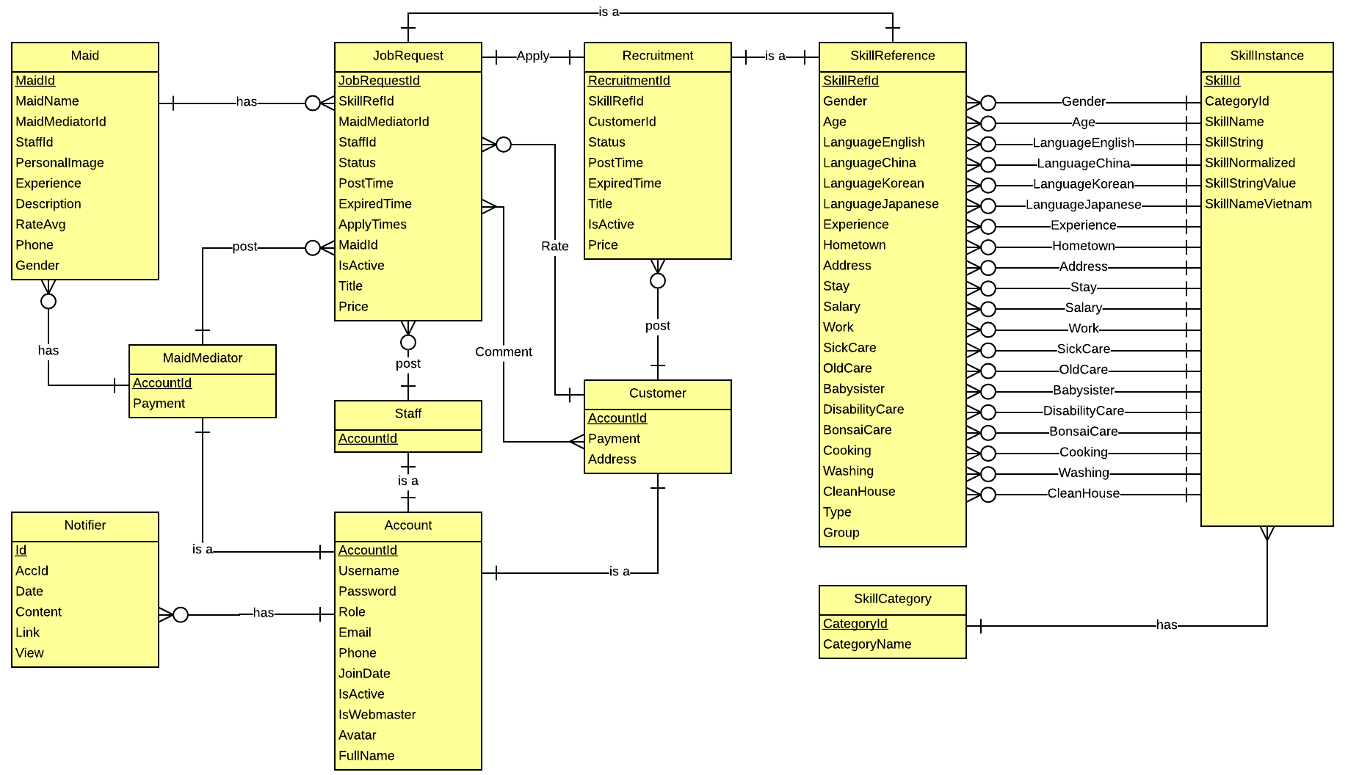

### Data Dictionary

|  |  |
| --- | --- |
| **Entity Data dictionary: describe content of all entities** | |
| Entity Name | Description |
| Account | Describe all account of MS - Website system. |
| Staff | Describe all staff of website. |
| Customer | Describe all customer of website. |
| MaidMediator | Describe all maid mediator of website. |
| Maid | Describe all maid of website. |
| JobRequest | Describe all job request, with was posted by staff and maid mediator. |
| Recruitment | Describe all recruitment, withc was posted by customer. |
| SkillCategory | Describe all category of skill. |
| SkillInstance | Describe all instance of skill. |
| SkillReferent | Describe all referent of skill, use all job request and recruitment. |

# Software Design Description

## Design Overview

* This document describes the technical and UI design of the MS Wesite. It includes the architectural design and the detailed design of common functions and business functions. It also includes the design of database model.
* The architectural design describes the overall architecture of the system, and the architecture of each main component and subsystem. It will describe the patterns being used, the role of each component and the role of the system in the working environment.
* The detailed design describes static and dynamic structure for each component and function. It includes class diagrams, class explanations, and sequence diagrams of the main use cases. The detailed design uses notations of .NET framework 4.5 and C#, as they are the framework and language for developing this system.
* The database design describes the relationship between entities, and details of each entity. It uses notations of SQL Server 2008 R2 as it is the database server for developing the system.
* The user interface design describes the layout of the system, and some design for the screens.

## System Architectural Design

In MVC pattern, the functions of model, view, and controller are defined as in following figure.

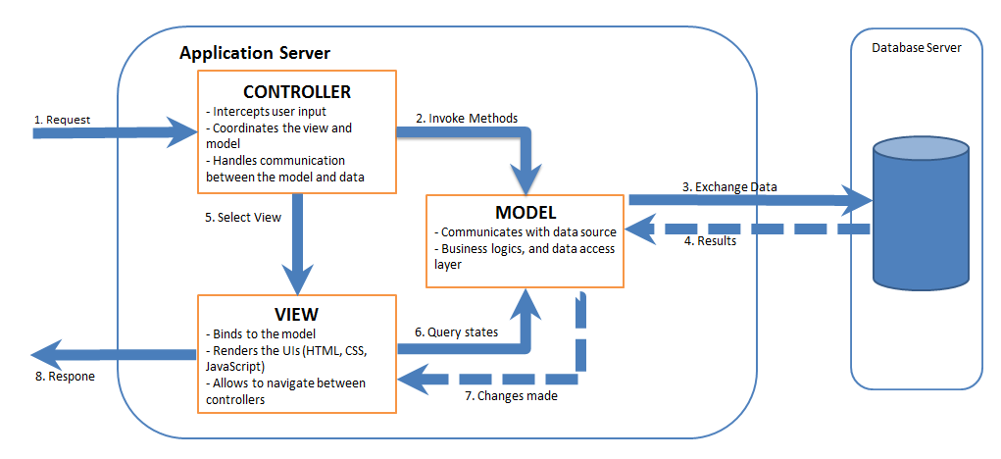

Figure 4-2 MVC Pattern

## Component Diagram

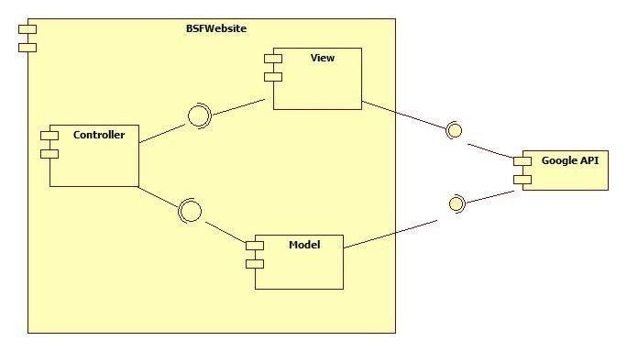

Figure 88: Component Diagram

## Detailed Description of Components

### Class Diagram

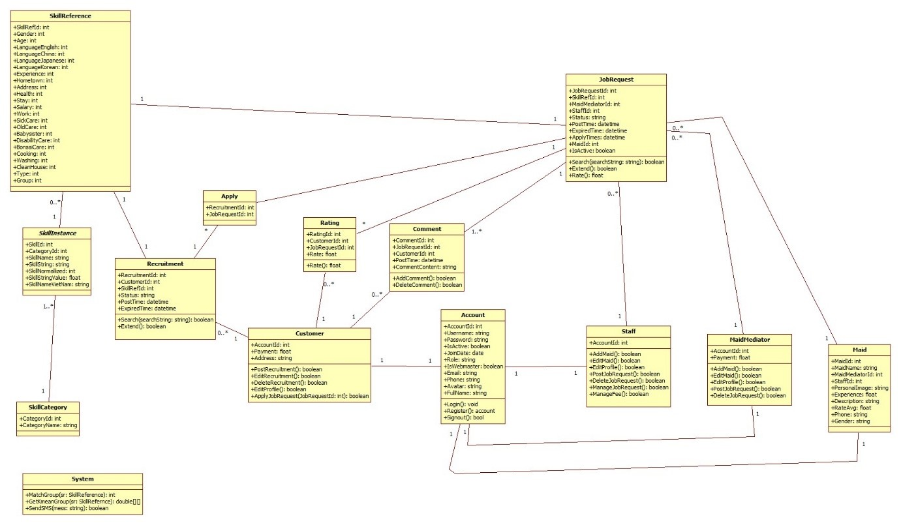

Figure 89: Class Diagram

### Class Diagram Explanation

#### Class Diagram – Entity Framework Model

##### Account

* **Attributes**

|  |  |  |  |
| --- | --- | --- | --- |
| **Name** | **Type** | **Visibility** | **Description** |
| AccountId | Integer | Public | Id of Account |
| Username | String | Public | Username of user |
| Password | String | Public | Password of user |
| IsActive | Boolean | Public | Check account is active |
| JoinDate | Date | Public | Date that user create an account |
| Role | String | Public | Role of User |
| IsWebmaster | Boolean | Public | Check account is an admin |
| Avatar | String | Public | Image of user |
| Email | String | Public | Email of user |
| Phone | String | Public | Phone of user |
| FullName | String | Public | Fullname of user |

* **Methods**

|  |  |  |  |
| --- | --- | --- | --- |
| **Name** | **Return Type** | **Visibility** | **Description** |
| Login(Account acc) | ActionResult | Public | Login to website |
| Register(Account acc) | ActionResult | Public | Create an account |
| Log out() | ActionResult | Public | Log out account |
| Search(string searchString) | ActionResult | Public | Search skills |
| AdvancedSearch(string gender, string age, string salary, string sickCare, string oldCare, string babySister, string disabilityCare, string BonsaiCare, string cooking, string washing, string cleanHouse, string time) | ActionResult | Public | Advance search skills |
| Statistic() | ActionResult | Public | Statistic |

##### Apply

* **Attributes**

|  |  |  |  |
| --- | --- | --- | --- |
| **Name** | **Type** | **Visibility** | **Description** |
| RecruitmentId | Integer | Public | Id of recruitment |
| JobRequestId | Integer | Public | Id of job request |

* **Methods** None

##### Comment

* **Attributes**

|  |  |  |  |
| --- | --- | --- | --- |
| **Name** | **Type** | **Visibility** | **Description** |
| CommentId | Integer | Public | Id of comment |
| CustomerId | Integer | Public | Id of customer |
| JobRequestId | Integer | Public | Id of job request |
| PostTime | Datetime | Public | Time that comment was posted |
| CommentContent | String | Public | Content of comment |

* **Methods**

|  |  |  |  |
| --- | --- | --- | --- |
| **Name** | **Return Type** | **Visibility** | **Description** |
| CommentJobRequest() | JsonResult | Public | Comment jobrequest |

##### Customer

* **Attributes**

|  |  |  |  |
| --- | --- | --- | --- |
| **Name** | **Type** | **Visibility** | **Description** |
| AccountId | Integer | Public | Id of field |
| Address | String | Public | Address of customer |

* **Methods**

|  |  |  |  |
| --- | --- | --- | --- |
| **Name** | **Return Type** | **Visibility** | **Description** |
| StatisticRequestCustomer() | ActionResult | Public | Statistic requests of customer |
| GetCustomer(int custId) | ActionResult | Public | Get information of customer |
| EditCustProfile(string CustId, string fullname, string phone, string email, string address) | ActionResult | Public | Edit customer profile |
| HideRecruitment(int recruitId) | ActionResult | Public | Hide recruitment |
| PublicRecruitment(int recruitId) | ActionResult | Public | Public recruitment |
| PostRecruitment() | ActionResult | Public | Post recruitment |
| AddRecruitment(string title, string gender, string age, string LanguageEnglish, string LanguageChinese, string LanguageJapanese, string LanguageKorean, string exp, string hometown, string addr, string married, string stay, string salary, string work, string sickCare, string oldCare, string babySister, string disabilityCare, string bonsaiCare, string cooking, string washing, string cleanHouse, string time) | ActionResult | Public | Add recruitment |
| RecruitmentEdit(int recruitId) | ActionResult | Public | Load recruitment information |
| EditRecruitment(int recruitId, string title, string gender, string age, string LanguageEnglish, string LanguageChinese, string LanguageJapanese, string LanguageKorean, string exp, string hometown, string addr, string married, string stay, string salary, string work, string sickCare, string oldCare, string babySister, string disabilityCare, string bonsaiCare, string cooking, string washing, string cleanHouse, string time) | ActionResult | Public | Edit recruitment |
| ExtendRecruitment(int recruitId, int extend) | ActionResult | Public | Extend recruitment |
| LoadItems(MSEntities db) | Void | Public | Load items |
| ApplyJobRequest(int jobRequestId, string recruitIdStr) | ActionResult | Public | Apply jobrequest |

##### JobRequest

* **Attributes**

|  |  |  |  |
| --- | --- | --- | --- |
| **Name** | **Type** | **Visibility** | **Description** |
| JobRequestId | Integer | Public | Id of job request |
| SkillRefId | Integer | Public | Id of skill reference |
| MaidMediatorId | Integer | Public | Id of maid mediator |
| StaffId | Integer | Public | Id of staff |
| Status | String | Public | Status of job request |
| PostTime | Datetime | Public | Time that job request was post |
| ExpiredTime | Datetime | Public | Time that job request was expired |
| ApplyTime | Datetime | Public | Time that job request was applied |
| MaidId | Integer | Public | Id of maid |
| IsActive | Boolean | Public | Check that job request is active |
| Price | Integer | Public | Price of jobrequest |
| Title | String | Public | Name of jobrequest |

* **Methods**

|  |  |  |  |
| --- | --- | --- | --- |
| **Name** | **Return Type** | **Visibility** | **Description** |
| GetJobRquest(string recruitId, int jobId) | ActionResult | Public | Get jobrequest |
| LoadSkillList(List<skillList>, SkillReference skillRef, MSEntities db) | skillList | Public | Load all skill list |
| GetGroup(SkillReference sr) | Kmean | Public | Choose group for jobrequest |
| GetDistance(SkillReference sr) | Kmean | Public | Check distance from jobrequest to mean |

##### Maid

* **Attributes**

|  |  |  |  |
| --- | --- | --- | --- |
| **Name** | **Type** | **Visibility** | **Description** |
| MaidId | Integer | Public | Id of maid |
| MaidName | String | Public | Name of maid |
| MaidMediatorId | Integer | Public | Id of maid mediator |
| StaffId | Integer | Public | Id of staff |
| PersonalImage | String | Public | Image of maid |
| Experience | Float | Public | Experience of maid |
| Description | String | Public | Description of maid |
| BirthDate | Date | Public | Birthdate of maid |
| Phone | String | Public | Phone of maid |
| Gender | String | Public | Gender of maid |
| English | Bit | Public | English |
| Korean | Bit | Public | Korean |
| Japanese | Bit | Public | Japanese |
| Chinese | Bit | Public | Chinese |
| Married | Bit | Public | Married |
| Address | String | Public | Address of maid |

* **Methods** None

##### MaidManager

* **Attributes**

|  |  |  |  |
| --- | --- | --- | --- |
| **Name** | **Type** | **Visibility** | **Description** |
| AccountId | Integer | Public | Id of maid manager |

* **Methods**

|  |  |  |  |
| --- | --- | --- | --- |
| **Name** | **Return Type** | **Visibility** | **Description** |
| ManageJobRequest() | ActionResult | Public | Manage jobrequests is not active |
| ManageRecruitment() | ActionResult | Public | Manage recruitments is not active |
| ManageAppliedJobRequest() | ActionResult | Public | Manage applied jobrequests |
| MarkActiveJobRequest() | ActionResult | Public | Active jobrequest |
| MarkActiveRecruitment() | ActionResult | Public | Active recruitment |
| ApproveJobRequest() | ActionResult | Public | Change jobrequest’s status(“Applied”) to jobrequest’s status(“Approved”) |
| MarkActiveRecruitmentOnRCPage() | ActionResult | Public | Active recruitment on recruitment page |
| GetMaidManager(int accId, string role) | ActionResult | Public | Get maid manager information |
| MaidManagerEdit() | ActionResult | Public | Load information of maid manager |
| EditMaidMedProfile(string maidMedId, string fullname, string phone, string email) | ActionResult | Public | Edit maid manager profile |
| LoadAddMaid() | ActionResult | Public | Load maids |
| AddMaid(string fullname, Nullable<double> exp, string phone, string birthdate, bool gender,  string english, string jap, string chinese, string korean, string hometown, string addr, bool married, string desc, string avatar) | ActionResult | Public | Add maid |
| EditMaidProfile(string maidId, string fullname, double exp, string phone, string birthdate, bool gender, string english, string jap, string chinese, string korean, string hometown, string addr, bool married, string desc) | ActionResult | Public | Edit maid profile |
| ManageMaidProfile(int maidId) | ActionResult | Public | Get maid |
| HideJobRequest(int jobId) | ActionResult | Public | Hide jobrequest |
| PublicJobRequest(int jobId) | ActionResult | Public | Publicjobrequest |
| PostRequest() | ActionResult | Public | Post jobrequest |
| AddRequest(string title, string stay, string salary, string work, string SickCare, string oldCare,  string babySister, string disabilityCare, string bonsaiCare, string cooking, string washing, string cleanHouse, string time, int maidId) | ActionResult | Public | Add jobrequest |
| JobRequestEdit(int jobId) | ActionResult | Public | Get jobrequest information |
| EditJobRequest(int jobId, string title, string stay, string salary, string work, string sickCare, string oldCare, string babySister, string disabilityCare, string bonsaiCare, string cooking, string washing, string cleanHouse, int maidId) | ActionResult | Public | Edit jobrequest |
| ExtendJobRequest(int jobId, int extend) | ActionResult | Public | Extend jobrequest |
| LoadItems(MSEntities db) | Void | Public | Load information |
| StatisticRequestMaid() | ActionResult | Public | Statistic personal requests |
| StatisticRequest() | ActionResult | Public | Statistic requests |
| StatisticIncome() | ActionResult | Public | Statistic income |

##### Notifier

* **Attributes**

|  |  |  |  |
| --- | --- | --- | --- |
| **Name** | **Type** | **Visibility** | **Description** |
| Id | Integer | Public | Id of notifier |
| AccId | Integer | Public | Id of account |
| Date | Datetime | Public | Date of notifier |
| Content | String | Public | Content of notifier |
| Link | String | Public | Link notify |
| View | Bool | Public | Confirm that view yet |

* **Methods**

|  |  |  |  |
| --- | --- | --- | --- |
| **Name** | **Return Type** | **Visibility** | **Description** |
| NotiPaypal(string content, string link) | JsonResult | Public | Notify paypal |
| Notifier() | ActionResult | Public | Save information to database |
| HideNotifier(string notiId) | JsonResult | Public | Hide notification |

##### Rating

* **Attributes**

|  |  |  |  |
| --- | --- | --- | --- |
| **Name** | **Type** | **Visibility** | **Description** |
| RatingId | Integer | Public | Id of rating |
| CustomerId | Integer | Public | Id of customer |
| JobRequestId | Integer | Public | Id of job request |
| Rate | String | Public | Rate |

* **Methods**

|  |  |  |  |
| --- | --- | --- | --- |
| **Name** | **Return Type** | **Visibility** | **Description** |
| RatingJobRequest(string rate, string jrId) | ActionResult | Public | Rate jobrequest |

##### Recruitment

* **Attributes**

|  |  |  |  |
| --- | --- | --- | --- |
| **Name** | **Type** | **Visibility** | **Description** |
| RecruitmentId | Integer | Public | Id of recruitment |
| SkillRefId | Integer | Public | Id of skill reference |
| CustomerId | Integer | Public | Id of customer |
| Status | String | Public | Status of recruitment |
| PostTime | Datetime | Public | Time that recruitment was posted |
| ExpiredTime | Datetime | Public | Time that recruitment was expired |
| Title | String | Public | Name of recruitment |
| Price | Int | Public | Price of recruitment |
| IsActive | Bool | Public | Check recruitment is active yet |

* **Methods**

|  |  |  |  |
| --- | --- | --- | --- |
| **Name** | **Return Type** | **Visibility** | **Description** |
| GetRecruitment(int recruitmentId) | ActionResult | Public | Get recruitment |
| ReturnPaypal(int recruitmentId) | ActionResult | Public | Return paypal |

##### SkillCategory

* **Attributes**

|  |  |  |  |
| --- | --- | --- | --- |
| **Name** | **Type** | **Visibility** | **Description** |
| CategoryId | Integer | Public | Id of category |
| CategoryName | String | Public | Name of category |

* **Methods** None

##### SkillInstance

* **Attributes**

|  |  |  |  |
| --- | --- | --- | --- |
| **Name** | **Type** | **Visibility** | **Description** |
| SkillId | Integer | Public | Id of skill |
| CategoryId | Integer | Public | Id of category |
| SkillName | String | Public | Name of skill |
| SkillString | String | Public | The charater value of skill |
| SkillNormallied | Int | Public | The range value of skill |
| SkillStringValue | Float | Public | The number value of skill name |
| SkillNameVietNam | String | Public | The name of skill in Vietnamese |

* **Methods** None

##### SkillReference

* **Attributes**

|  |  |  |  |
| --- | --- | --- | --- |
| **Name** | **Type** | **Visibility** | **Description** |
| SkillRefId | Integer | Public | Id of Skill reference |
| Gender | Integer | Public | The value gender of skill |
| Age | Integer | Public | The value age of skill |
| LaguageEnglish | Integer | Public | The value language english of skill |
| LanguageChina | Integer | Public | The value language china of skill |
| LanguageJapanese | Integer | Public | The value language japanese of skill |
| LanguageKorean | Integer | Public | The value language korean of skill |
| Experience | Integer | Public | The value experience of skill |
| Hometown | Integer | Public | The value hometown of skill |
| Address | Integer | Public | The value address of skill |
| Health | Integer | Public | The value health of skill |
| Stay | Integer | Public | The value stay of skill |
| Salary | Integer | Public | The value salary of skill |
| Work | Integer | Public | The value work of skill |
| SickCare | Integer | Public | The value sickcare of skill |
| OldCare | Integer | Public | The value oldcare of skill |
| BabySister | Integer | Public | The value babysister of skill |
| DisabilityCare | Integer | Public | The value disabilitycare of skill |
| BonsaiCare | Integer | Public | The value bonsaicare of skill |
| Cooking | Integer | Public | The value cooking of skill |
| Washing | Integer | Public | The value washing of skill |
| Cleanhouse | Integer | Public | The value cleanhouse of skill |
| Type | Integer | Public | Skill of job request or skill of recruitment |
| Group | Integer | Public | Divide group in algorithm |

* **Methods** None

##### System

* **Methods**

|  |  |  |  |
| --- | --- | --- | --- |
| **Name** | **Parameter** | **Return Type** | **Description** |
| MatchGroup | All atributes of SkillReference | Boolean | Match job request group with recruitment group |
| GetKmeanGroup | All atributes of SkillReferencr | Double [][] | Choose the best couple group to suggest |
| SendSMS | N/A | Boolean | Send SMS |

##### WebMaster

* **Attributes**

|  |  |  |  |
| --- | --- | --- | --- |
| **Name** | **Type** | **Visibility** | **Description** |
| AccountId | Integer | Public | Id of account |

* **Methods**

|  |  |  |  |
| --- | --- | --- | --- |
| **Name** | **Return Type** | **Visibility** | **Description** |
| RunKMean(string numCluterKStr) | JsonResult | Public | Run Kmean algorithm |
| AdminConfig() | ActionResult | Public | Configuration of website |
| AddStaff(Account acc) | ActionResult | Public | Add staff |
| BanAccount() | ActionResult | Public | List of all accounts |
| ActiveAccount() | ActionResult | Public | Active banned account |
| MarkActive() | ActionResult | Public | Ban account |
| ManageComment() | ActionResult | Public | List of all comments |
| DeleteComment(int commentId) | ActionResult | Public | Delete comment |
| ManageFeeJR(string SpriceJR) | JsonResult | Public | Manage jobrequest fee |
| ManageFeeRC(string SpriceRC) | JsonResult | Public | Manage recruitment fee |
| ManageFeeSPW(string SSPW) | JsonResult | Public | Manage fee subtract per week |
| ManageMaxWeek(string sMaxWeek) | JsonResult | Public | Manage max week to payment |

### Sequence Diagram

#### Player Sequence Diagram

##### <Player> Map

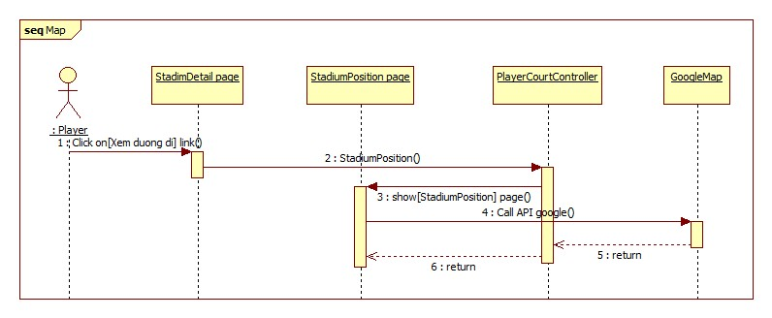

Figure 94: <Player> Map diagram

## User Interface Design

### Webmaster Interface Design

#### Webmaster Home Page

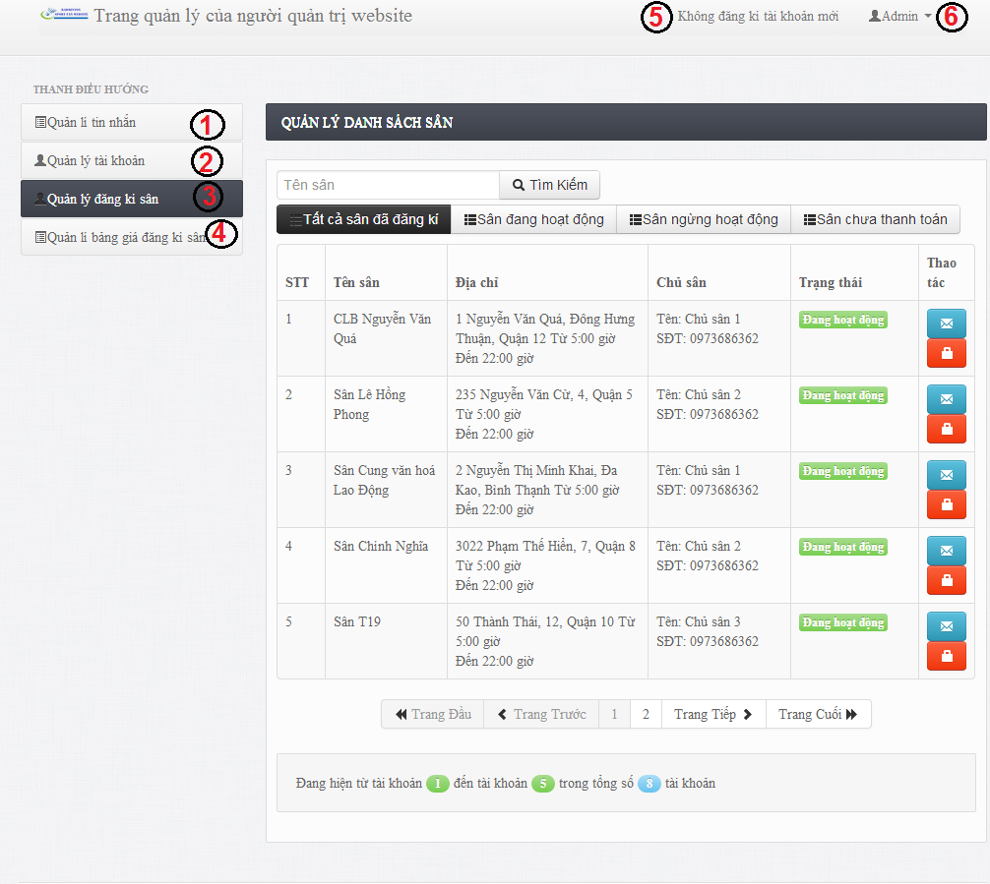

Figure 153: Webmaster Home Page

**Button/ Hyperlink**

|  |  |  |  |  |
| --- | --- | --- | --- | --- |
| **No** | **Function** | **Description** | **Validation** | **Outcome** |
| 1 | Message Management | Link to Message management page | No | List Message page. |
| 2 | Account Management | Link to Account Management page. | No | List Account Page. |
| 3 | Stadium Register Management | Link to Stadium register Management page. | No | List Stadium Register Page. |
| 4 | Stadium Register Pricelist Management | Link to Stadium Register Pricelist Management page. | No | List Stadium Register Pricelist Event Page. |
| 5 | Account Notification | Account Notification. | No | List of account notification. |
| 6 | Log out | Log out. | No | Home Page |

#### Manage Stadium Register Price

## Database Design

### Physical Database Design

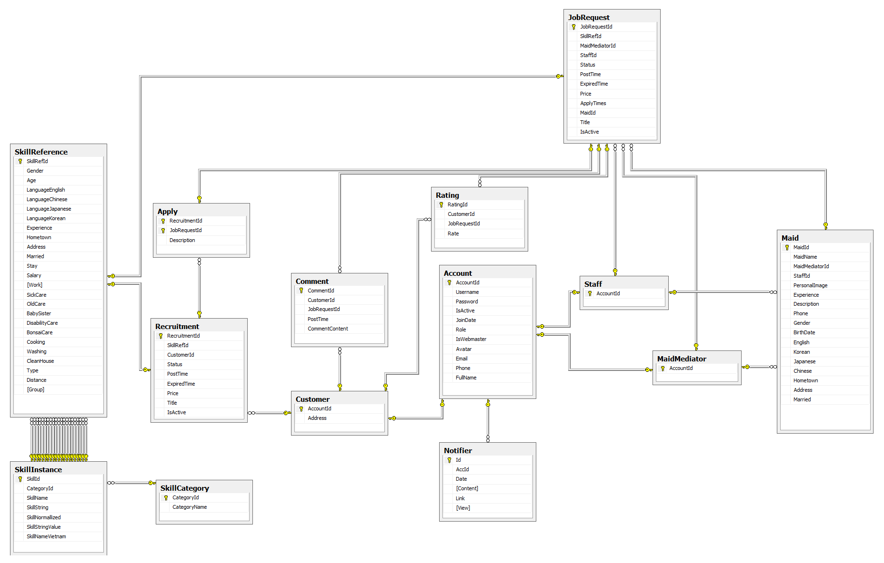

Figure 154: Physcial Database Diagram

### Data Dictionary

|  |  |  |
| --- | --- | --- |
| **No.** | **Table name** | **Description** |
| 1 | Account | Describe about users in system |
| 2 | Apply | Describe Apply |
| 3 | Comment | Describe all comment |
| 5 | Customer | Describe all customers informations |
| 6 | JobRequest | Describe all job requests |
| 5 | MaidMediator | Describe all maid mediators information |
| 7 | Maid | Describe all maids information |
| 8 | Rating | Describe all rating |
| 9 | Recruitment | Describe all recruitments |
| 10 | SkillCategory | Describe all SkillCategory |
| 11 | SkillIntance | Describe all SkillIntance |
| 12 | SkillReference | Describe all SkillReference |
| 13 | Staff | Describe all staffs information |
| 14 | Notifier | Describe all notifications |

Table 5: Entity Data Dictionary

#### Acount

|  |  |  |  |  |  |  |
| --- | --- | --- | --- | --- | --- | --- |
| **Field name** | **Type** | **Null** | **Unique** | **P/F key** | **Default** | **Description** |
| AccountId | int |  |  | PK |  | The index of this account |
| Username | nvarchar(50) |  |  |  |  | The username of the account |
| Password | nvarchar(50) |  |  |  |  | The password of the password |
| IsActive | bit |  |  |  |  | Admin can ban account |
| JoinDate | date |  |  |  |  | The date when this user join |
| Role | nvarchar(50) |  |  |  |  | The role of the user |
| IsWebmaster | bit |  |  |  |  | Check acount is admin |
| Avatar | nvarchar(50) | Yes |  |  |  | The link refers to an image, present for a user |
| Email | nvarchar(50) | Yes |  |  |  | The email of user |
| Phone | nvarchar(50) | Yes |  |  |  | Phone of user |
| Fullname | nvarchar(50) | Yes |  |  |  | The fullname of user |

#### Apply

|  |  |  |  |  |  |  |
| --- | --- | --- | --- | --- | --- | --- |
| **Field name** | **Type** | **Null** | **Unique** | **P/F key** | **Default** | **Description** |
| RecruitmentId | int |  |  | PK |  | The index of this recruitment |
| JobRequestId | Int |  |  | PK |  | The index of this job request |

#### Comment

|  |  |  |  |  |  |  |
| --- | --- | --- | --- | --- | --- | --- |
| **Field name** | **Type** | **Null** | **Unique** | **P/F key** | **Default** | **Description** |
| CommentId | int |  |  | PK |  | The index of this comment |
| CustomerId | int |  |  | FK |  | The index of customer which contain this comment |
| JobRequestId | int |  |  | FK |  | The index of job request which is contain this comment |
| PostTime | datetime |  |  |  |  | The time when the comment posted |
| CommentContent | nvarchar(500) |  |  |  |  | The content of the comment |

#### Customer

|  |  |  |  |  |  |  |
| --- | --- | --- | --- | --- | --- | --- |
| **Field name** | **Type** | **Null** | **Unique** | **P/F key** | **Default** | **Description** |
| AccountId | int |  |  | PK |  | The index of user |
| Address | nvarchar(100) |  |  |  |  | The address of customer |

#### JobRequest

|  |  |  |  |  |  |  |
| --- | --- | --- | --- | --- | --- | --- |
| **Field name** | **Type** | **Null** | **Unique** | **P/F key** | **Default** | **Description** |
| JobRequestId | int |  |  | PK |  | The index of this job request |
| SkillRefId | int |  |  | FK |  | The SkillRef of this job request |
| MaidMediatorId | int | Yes |  | FK |  | The maid mediator of this job request |
| StaffId | int | Yes |  | FK |  | The staff of this job request |
| Status | nvarchar(50) |  |  |  |  | The status of this job request |
| PostTime | datetime |  |  |  |  | The time that this job request is posted |
| ExpiredTime | datetime |  |  |  |  | The time that this job request is expired |
| ApplyTimes | datetime |  |  |  |  | The time that this job request is applied |
| MaidId | int |  |  | FK |  | The maid of this job request |
| IsActive | bit |  |  |  |  | Check that this job request has payment |
| Title | nvarchar(100) |  |  |  |  | Name of jobrequest |
| Price | int |  |  |  |  | Price of jobrequest |

#### Maid

|  |  |  |  |  |  |  |
| --- | --- | --- | --- | --- | --- | --- |
| **Field name** | **Type** | **Null** | **Unique** | **P/F key** | **Default** | **Description** |
| MaidId | int |  |  | PK |  | The index of maid |
| MaidName | nvarchar(50) |  |  |  |  | The name of maid |
| MaidMediator | int |  |  | FK |  | The maid mediator of maid |
| StaffId | Int |  |  | FK |  | The staff mediator of maid |
| PersonalImage | nvarchar(50) |  |  |  |  | The image of maid |
| Experience | float |  |  |  |  | The years experience of maid |
| Description | nvarchar(500) |  |  |  |  | The description of maid |
| Birthdate | date |  |  |  |  | Birthdate of maid |
| Phone | nvarchar(50) |  |  |  |  | The phone of maid |
| Gender | nvarchar(10) |  |  |  |  | The gender of maid |
| English | bit |  |  |  |  | Skill english of maid |
| Korean | bit |  |  |  |  | Skill korean of maid |
| Chinese | bit |  |  |  |  | Skill chinese of maid |
| Japanese | bit |  |  |  |  | Skill japanese of maid |
| Married | bit |  |  |  |  | Marital status of maid |
| Address | nvarchar(100) |  |  |  |  | Address of maid |

#### MaidMediator

|  |  |  |  |  |  |  |
| --- | --- | --- | --- | --- | --- | --- |
| **Field name** | **Type** | **Null** | **Unique** | **P/F key** | **Default** | **Description** |
| AccountId | int |  |  | PK |  | The index of this maid mediator |

#### Notifier

|  |  |  |  |  |  |  |
| --- | --- | --- | --- | --- | --- | --- |
| **Field name** | **Type** | **Null** | **Unique** | **P/F key** | **Default** | **Description** |
| Id | int |  |  | PK |  | The index of notification |
| AccId | int |  |  |  |  | The index of account which has notification |
| Date | datetime |  |  |  |  | Date of notification |
| Content | nvarchar(500) |  |  |  |  | Content of notification |
| Link | nvarchar(100) | Yes |  |  |  | Link notify |
| View | bit |  |  |  |  | Confirm that view yet |

#### Rating

|  |  |  |  |  |  |  |
| --- | --- | --- | --- | --- | --- | --- |
| **Field name** | **Type** | **Null** | **Unique** | **P/F key** | **Default** | **Description** |
| RatingId | int |  |  | PK |  | The index of this rating |
| CustomerId | int |  |  | FK |  | The customer who rate |
| JobRequestId | int |  |  | FK |  | The job request which is rated |
| Rate | float |  |  |  |  | The value of this rate |

#### Recruitment

|  |  |  |  |  |  |  |
| --- | --- | --- | --- | --- | --- | --- |
| **Field name** | **Type** | **Null** | **Unique** | **P/F key** | **Default** | **Description** |
| RecruitmentId | int |  |  | PK |  | The index of this recruitment |
| SkillRefId | int |  |  | FK |  | The index of skill which contains in this recruitment |
| CustomerId | int |  |  | FK |  | The customer who posts this recruitment |
| Status | nvarchar(50) |  |  |  |  | The status of the recruitment |
| PostTime | datetime |  |  |  |  | The time when the recruitment is posted |
| ExpiredTime | datetime |  |  |  |  | The time when the recruitment is expired |
| Price | int |  |  |  |  | Price of recruitment |
| Title | nvarchar(100) |  |  |  |  | Name of recruitment |
| IsActive | bit |  |  |  |  | Check that this recruitment has payment |

#### SkillCategory

|  |  |  |  |  |  |  |
| --- | --- | --- | --- | --- | --- | --- |
| **Field name** | **Type** | **Null** | **Unique** | **P/F key** | **Default** | **Description** |
| CategoryId | int |  |  | PK |  | The index of this category |
| CategoryName | nvarchar(50) |  |  |  |  | The name of category |

#### SkillInstance

|  |  |  |  |  |  |  |
| --- | --- | --- | --- | --- | --- | --- |
| **Field name** | **Type** | **Null** | **Unique** | **P/F key** | **Default** | **Description** |
| SkillId | int |  |  | PK |  | The index of this skill |
| CategoryId | int |  |  | FK |  | The category which contains this skill |
| SkillName | nvarchar(50) |  |  |  |  | The name of skill |
| SkillString | nvarchar(50) | Yes |  |  |  | The character value of skill name |
| SkillNormallized | int |  |  |  |  | The range value of skill |
| SkillStringValue | float |  |  |  |  | The number value of skill name |
| SkillNameVietnam | nvarchar(50) |  |  |  |  | The name of skill in Vietnamese |

#### SkillReference

|  |  |  |  |  |  |  |
| --- | --- | --- | --- | --- | --- | --- |
| **Field name** | **Type** | **Null** | **Unique** | **P/F key** | **Default** | **Description** |
| SkillRefId | int |  |  | PK |  | The index of this skill reference |
| Gender | int | Yes |  |  |  | The value gender of skill |
| Age | int | Yes |  |  |  | The value age of skill |
| LaguageEnglish | int | Yes |  |  |  | The value language english of skill |
| LanguageChina | int | Yes |  |  |  | The value language china of skill |
| LanguageJapanese | int | Yes |  |  |  | The value language japanese of skill |
| LanguageKorean | int | Yes |  |  |  | The value language korean of skill |
| Experience | int | Yes |  |  |  | The value experience of skill |
| Hometown | int | Yes |  |  |  | The value hometown of skill |
| Address | int | Yes |  |  |  | The value address of skill |
| Health | int | Yes |  |  |  | The value health of skill |
| Stay | int | Yes |  |  |  | The value stay of skill |
| Salary | int | Yes |  |  |  | The value salary of skill |
| Work | int | Yes |  |  |  | The value work of skill |
| SickCare | int | Yes |  |  |  | The value sickcare of skill |
| OldCare | int | Yes |  |  |  | The value oldcare of skill |
| BabySister | int | Yes |  |  |  | The value babysister of skill |
| DisabilityCare | int | Yes |  |  |  | The value disabilitycare of skill |
| BonsaiCare | int | Yes |  |  |  | The value bonsaicare of skill |
| Cooking | int | Yes |  |  |  | The value cooking of skill |
| Washing | int | Yes |  |  |  | The value washing of skill |
| Cleanhouse | int | Yes |  |  |  | The value cleanhouse of skill |
| Type | int |  |  |  |  | Skill of job request or skill of recruitment |
| Group | int | Yes |  |  |  | Divide group in algorithm |

#### Staff

|  |  |  |  |  |  |  |
| --- | --- | --- | --- | --- | --- | --- |
| **Field name** | **Type** | **Null** | **Unique** | **P/F key** | **Default** | **Description** |
| AccountId | int |  |  | PK |  | The index of this staff |

## Algorithms

### Overview

This is automatically function, help system classify each job request and recruitment from maid and customer. Function give all request become n-group. From there, system can be suggest for user about:

* Job requests same Recruitment

### Implement

**K-Mean**

* Web master feel need create new group for Job request and recruitment. Because each group should have maximum 10 element.
* When web master click run classify, all job request and recruitment has been calculate by algorithm, and make new group.
* New group based on similar of value from column Normalize of data.
* A file contain k mean, with k is number of group. This file will be save on server of website.
* After run algorithm, in database, all job request and recruitment is “Watting” status will be classify k group.

**KNN**

* User login with customer role.
* They post a recruitment on website.
* System automatic analysis and choose group for this recruitment.
* From there, system can suggest for customer all job request same group with this recruitment.

### Detail

**K-Mean**

* Normalize value. This step help return value same distant.
* Random group for value.
* Choose a number k. In MS-Website, system suggest each group at job request and recruitment should have 10 element. Therefore, if job request have 100 rows we should choose k equal 10. Choose random k mean.
* Calculate the distance between the objects (objects) to K center (usually Euclidean distance).
* Group objects to the nearest group.
* Define the new mean for the group.
* Repeat until no change in any group of objects.
* Write mean to file and save this file in sever.

**KNN**

* Witch input value, calculate distance from this to k mean of mean file on sever.
* Find minimum distance form this point to means. This value will belong minimum mean group.

Start

Number of cluster K

Centroid

Distance object to centroids

Grouping based on minimum distance

No object move group?

End

# System Implementation & Test

## Introduction

### System Overview

* This document describes the approach and methodologies used by the testing group to plan, organize and manage the testing of this system. It describes implementation details of test cases or technical details of how the product features should work.
* The system will be tested is also the system our team are currently developing. This system developed based on MVC4 framework.

### Test Approach

* Test goals: the testing aims to identify the remaining bugs in the system before releasing and confirm the consistency in design and implementation.
* Test type: black box testing.
* Test level: system and integration test.

## Test Plan

The purpose of this section is to verify and ensure that BUSG meets its design specification and other requirements from user. The following part will describe which features will be tested and which will not.

### Features to be tested

We will test the entire system based on the following core workflow

Based on the workflow, all following features will be tested, which can include one or more functions. These features will be focused and tested thoroughly during the test phase.

* Search: Normal Search , Advance Search
* Recruitment: Post, Hide, Delete.
* JobRequest: Post, Hide, Delete, Apply.
* Payment: Payment

These remaining feature will be tested as individual module:

* Job Request Management: View, Add, Edit, Delete job request.
* Profile Management : View, Add, Delete contest
* Recruitment Management: View, Edit, Add.
* Apply JobRequest Management: View, Apply.
* Profile Management: View, Edit.
* Maid Management:View, Add, Edit.
* Config Management: Edit.
* Manage Account: View, Add.

### Features not to be tested

* Logout
* User – Login, Change Edit profile

## Module Test Case

#### Role ‘Guest’

|  |  |  |  |  |  |
| --- | --- | --- | --- | --- | --- |
| **Login** | | | | | |
| TC_01 | Test Login Successfully | 1. Click “Đăng nhập” button  2. Input correct username and password  3. Click “Đăng nhập” button | Redirect to homepage  The “Đăng nhập” button is replaced by the link with the full name of the logged account | Tested |  |
| TC_02 | Test Login with blank username | 1. Click “Đăng nhập” button  2. Leave the username field blank  3. Click “Đăng nhập” button | The message “Vui lòng nhập tên đăng nhập” is displayed | Tested |  |
| TC_03 | Test Login with blank password | 1. Click “Đăng nhập” button  2. Leave the “Mật khẩu” field blank  3. Click “Đăng nhập” button | The message “Vui lòng nhập mật khẩu” is displayed | Tested |  |
| TC_04 | Test Login with incorrect username | 1. Click “Đăng nhập” button  2. Input incorrect username  3. Click “Đăng nhập” button | The message “Tên đăng nhập hoặc mật khẩu không đúng” is displayed | Tested |  |
| TC_05 | Test Login with incorrect password | 1. Click “Đăng nhập” button  2. Input incorrect password  3. Click “Đăng nhập” button | The message “Tên đăng nhập hoặc mật khẩu không đúng” is displayed | Tested |  |

|  |  |  |  |  |  |
| --- | --- | --- | --- | --- | --- |
| TC_06 | Test Login with banned account | 1. Click “Đăng nhập” button  2. Input banned account  3. Click “Đăng nhập” button | The message “Tài khoản đã bị khóa” is displayed |  |  |
| **Register** | | | | | |
| TC_07 | Test Register with customer role successfully | 1. Click “Đăng kí” button  2. Input all fields correctly  3. Choose “Khách hàng” at the dropdown list  4. Click “Đăng kí” button | New row is added to table Account in database  New row is added to table Customer in databse  The system logins with the new account | Tested |  |
| TC_08 | Test Register with maid mediator role successfully | 1. Click “Đăng kí” button  2. Input all fields successfully  3. Choose “Đại diện người giúp việc” at dropdown list  3. Click “Đăng kí” button | New row is added to table Account in database  New row is added to table MaidMediator in databse  The system logins with the new account | Tested |  |
| TC_09 | Test Register with blank “Họ và tên” | 1. Click “Đăng kí” button  2. Leave “Họ và tên” field blank  3. Click “Đăng kí” button | The message “Vui lòng nhập tên đầy đủ” is displayed | Tested |  |
| TC_10 | Test Register with blank “Email” | 1. Click “Đăng kí” button  2. Leave “Email” field blank  3. Click “Đăng kí” button | The message “Vui lòng nhập đúng định dạng abc@abc.abc” is displayed | Tested |  |
| TC_11 | Test Register with incorrect “Email” | 1. Click “Đăng kí” button  2. Input incorrect email  3. Click “Đăng kí” button | The message “Vui lòng nhập số” is displayed | Tested |  |
| TC_12 | Test Register with existed username | 1. Click “Đăng kí” button  2. Input existed username  3. Click “Đăng kí” button | The message “Tên đăng nhập đã tồn tại” is displayed | Tested |  |
| TC_13 | Test Register with blank username | 1. Click “Đăng kí” button  2. Leave “Tên đăng nhập” field blank  3. Click “Đăng kí” button | The message “Vui lòng nhập tên đăng nhập” is displayed | Tested |  |
| TC_14 | Test Register with blank password | 1. Click “Đăng kí” button  2. Leave “Mật khẩu” field blank  3. Click “Đăng kí” button | The message “Vui lòng nhập mật khẩu” is displayed | Tested |  |
| TC_15 | Test Register with blank confirmed password | 1. Click “Đăng kí” button  2. Leave “Nhập lại mật khẩu” field blank  3. Click “Đăng kí” button | The message “Mật khẩu không trùng khớp” is displayed | Tested |  |
| TC_16 | Test Register with blank password | 1. Click “Đăng kí” button  2. Leave “Mật khẩu” field blank  3. Click “Đăng kí” button | The message “Vui lòng nhập mật khẩu” is displayed | Tested |  |
| **Search** | | | | | |
| TC_17 | Test Search with existed skill value in database | 1. Input “Nam” in “Tìm kiếm công việc” field  2. Click “Tìm kiếm” button | Redirect to search page which displays all the job requests and recruitments with “Giới tính - Nam” | Tested |  |
| TC_18 | Test Search with non-existed skill value in database | 1. Input “aaa” in “Tìm kiếm công việc” field  2. Click “Tìm kiếm” button | Redirect to search page displaying nothing | Tested |  |
| **Advanced Search** | | | | | |
| TC_19 | Test Advanced Search with gender male | 1. In search page check “Nam” in box “Giới tính” | Search page reloads and displays all the job requests and recruitments with “Giới tính - Nam” | Tested |  |
| TC_20 | Test Advanced Search with age range 15-20 | 1. In search page check “15-20” in box “Tuổi” | Search page reloads and displays all the job requests and recruitments with “Tuổi – 15-20” | Tested |  |
| TC_21 | Test Advanced Search with salary under 3 millions | 1. In search page check “Dưới 3 triệu” in box “Lương” | Search page reloads and displays all the job requests and recruitments with “Mức lương – Dưới 3 triệu” | Tested |  |
| TC_22 | Test Advanced Search with old care skill | 1. In search page check “Chăm sóc người già” in box “Loại công việc” | Search page reloads and displays all the job requests and recruitments with “Chăm sóc người già” | Tested |  |
| TC_23 | Test Advanced Search with old care skill and babysister skill | 1. In search page check “Chăm sóc người già” and “Chăm sóc trẻ em” in box “Loại công việc” | Search page reloads and displays all the job requests and recruitments with “Chăm sóc người già” and “Chăm sóc trẻ em” | Tested |  |
| TC_24 | Test Advanced Search with gender male and age range 15-20 and old care skill | 1. In search page check “Nam” in box “Giới tính” and “15-20” in box “Tuổi” and “Chăm sóc người già” in box “Loại công việc” | Search page reloads and displays all the job requests and recruitments with “Giới tính - Nam” and “Tuổi – 15-20” and “Chăm sóc người già” | Tested |  |
| TC_25 | Test Advanced Search with posting time isprior to today 7 days | 1. In search page check “Cách đây 7 ngày” in box “Thời gian đăng bài” | Search page reloads and displays all the job requests and recruitments with posting time is prior to today 7 days | Tested |  |
| TC_26 | Test Advanced Search with “Tất cả” is checked in each box | 1. In search page check “Tất cả” in each box | Search page reloads and displays nothing | Tested |  |
| TC_27 | Test Advanced Search with “Tất cả” is checked in box “Lương” and “Nam” is checked in box “Giới tính” | 1. In search page check “Nam” in box “Giới tính” and “Tất cả” in box “Lương” | Search page reloads and displays all the job requests and recruitments with “Giới tính - Nam” only | Tested |  |
| **View job request detail** | | | | | |
| TC_28 | Test view job request detail | 1. Click a job request link in tab “Việc tìm người” | Redirect to job request page which displays job request detail | Tested |  |
| TC_29 | Test view recruitment detail | 1. Login with customer role  2. Click a recruitment link in tab “Người tìm việc” | Redirect to recruitment page which displays job recruitment detail | Tested |  |

#### Role ‘Admin’

##### Manage Account

|  |  |  |  |  |  |
| --- | --- | --- | --- | --- | --- |
| **Test case No** | **Test case** | **Input** | **Expected Result** | **Status** | **Note** |
| **View Account** | | | | | |
| TC_30 | Test View Account List | 1. Login the system as Admin. 2. Click “Username” link. | “Quản lý tài khoản” page is displayed with the following informations:  - STT  - Tên đang nhập - Xử lý | Tested |  |
| **Ban Account** | | | | | |
| TC_31 | Test Ban Account | 1. Login the system as Admin. 2. Click “username” link.  3. Click “Khóa” button. | “Xác nhận” popup is displayed with the information “Bạn thực sự muốn khóa tên đăng nhập này?” | Tested |  |
| TC_32 | Test Ban Account Successfully | 1. Login the system as Admin. 2. Click “username” link.  3. Click “Khóa” button.  4. Click “Chấp nhận” button | Change attribute IsActive(true) to IsActive(false)  Redirect to “Quản lý tài khoản” page | Tested |  |
| TC_33 | Test Active Account Successfully | 1. Login the system as Admin. 2. Click “username” link.  3. Click “Kích hoạt” button.  4. Click “Chấp nhận” button | Change attribute IsActive(false) to IsActive(true)  Redirect to “Quản lý tài khoản” page | Tested |  |
| **Add Staff** | | | | | |
| TC_34 | Test View Add Staff | 1. Login the system as Admin.  2. Click “Thêm nhân viên” link | “Thêm nhân viên” page is displayed with the following fields:  - Tên đăng nhập - Mật khẩu  - “Đăng kí” button | Tested |  |
| TC_35 | Test Add Staff Successfully | 1. Login the system as Admin.  2. Click “Thêm nhân viên” link  3. Insert staff’s username and password  4. Click “Đăng kí” button | Redirect to “Khóa tài khoản” page | Tested |  |
| TC_36 | Test Add Staff With Blank Password Field | 1. Login the system as Admin.  2. Click “Thêm nhân viên” link  3. Insert staff’s username  4. Leave empty password field  5. Click “Đăng kí” button | Error message will be displayed: “Vui lòng nhập mật khẩu”. | Tested |  |
| TC_37 | Test Add Staff With Blank Username Field | 1. Login the system as Admin.  2. Click “Thêm nhân viên” link  3. Insert staff’s password  4. Leave empty username field  5. Click “Đăng kí” button | Error message will be displayed: “Vui lòng nhập tên đăng nhập”. | Tested |  |

##### Manage Comment

|  |  |  |  |  |  |
| --- | --- | --- | --- | --- | --- |
| **Test case No** | **Test case** | **Input** | **Expected Result** | **Status** | **Note** |
| **View Comment Management** | | | | | |
| TC_38 | Test Manage Comment View | 1. Login the system as Admin. 2. Click “Xóa bình luận” link. | “Xóa bình luận” page is displayed with the following fields:  - STT - Người bình luận  - Tiêu đề  - Nội dung  - Thời gian đăng  - Xử lý  - “Xóa” button | Tested |  |
| **Delete Comment** | | | | | |
| TC_39 | Test Delete Comment | 1. Login the system as Admin. 2. Click “Xóa bình luận” link.  3. Click “Xóa” button. | “Xác nhận” popup is displayed with the information “Bạn thực sự muốn xóa lời bình này?” | Tested |  |
| TC_40 | Test Delete Comment Successfully | 1. Click “Xóa” button | Delete comment out of database  Redirect to “Xóa bình luận” page | Tested |  |

##### Config Management

|  |  |  |  |  |  |
| --- | --- | --- | --- | --- | --- |
| **Test case No** | **Test case** | **Input** | **Expected Result** | **Status** | **Note** |
| **View Config** | | | | | |
| TC_41 | Test View Config Management | 1. Login the system as Admin. 2. Click “Quản lý cấu hình” link. | “Quản lý cấu hình” page is displayed with the following informations:  - Gợi ý số K - Giá mới (yêu cầu công việc)  - Giá mới (yêu cầu tìm người)  - Số mới (tuần đăng tối đa) | Tested |  |
| **Edit Config** | | | | | |
| TC_42 | Test Kmean Successfully | 1. Login the system as Admin. 2. Click “Quản lý cấu hình” link.  3. Edit a number in “Gợi ý số K” field  4. Click “Chạy Kmean” button | Edit Distance column and Group column in SkillReference table in database.  Redirect to “Quản lý cấu hình” page | Tested |  |
| TC_43 | Test Kmean with incorrect input | 1. Login the system as Admin. 2. Click “Quản lý cấu hình” link.  3. Edit character in “Gợi ý số K” field  4. Click “Chạy Kmean” button | Error message will be displayed: “Phải nhập số nguyên”. | Tested |  |
| TC_44 | Test Kmean with blank “Gợi ý số K” field | 1. Login the system as Admin. 2. Click “Quản lý cấu hình” link.  3. Leave blank “Gợi ý số K” field  4. Click “Chạy Kmean” button | Error message will be displayed: “Phải nhập số nguyên”. | Tested |  |
| TC_45 | Test Edit “Giá mới”(yêu cầu công việc) Successfully | 1. Login the system as Admin. 2. Click “Quản lý cấu hình” link.  3. Edit a number in “Giá mới”(yêu cầu công việc) field  4. Click “Chạy Kmean” button | Redirect to “Quản lý cấu hình” page | Tested |  |
| TC_46 | Test “Giá mới”(yêu cầu công việc) field with incorrect input | 1. Login the system as Admin. 2. Click “Quản lý cấu hình” link.  3. Edit character in “Giá mới”(yêu cầu công việc) field  4. Click “Sửa giá”(yêu cầu công việc) button | Error message will be displayed: “Phải nhập số nguyên”. | Tested |  |
| TC_47 | Test “Giá mới”(yêu cầu công việc) field with blank field | 1. Login the system as Admin. 2. Click “Quản lý cấu hình” link.  3. Leave blank “Giá mới”(yêu cầu công việc) field  4. Click “Sửa giá”(yêu cầu công việc) button | Error message will be displayed: “Phải nhập số nguyên”. | Tested |  |
| TC_48 | Test Edit “Giá mới”(yêu cầu tìm người) Successfully | 1. Login the system as Admin. 2. Click “Quản lý cấu hình” link.  3. Edit a number in “Giá mới”(yêu cầu tìm người) field  4. Click “Chạy Kmean” button | Redirect to “Quản lý cấu hình” page | Tested |  |
| TC_49 | Test “Giá mới”(yêu cầu công việc) field with incorrect input | 1. Login the system as Admin. 2. Click “Quản lý cấu hình” link.  3. Edit character in “Giá mới”(yêu cầu tìm người) field  4. Click “Sửa giá”(yêu cầu công việc) button | Error message will be displayed: “Phải nhập số nguyên”. | Tested |  |
| TC_50 | Test “Giá mới”(yêu cầu công việc) field with blank field | 1. Login the system as Admin. 2. Click “Quản lý cấu hình” link.  3. Leave blank “Giá mới”(yêu cầu tìm người) field  4. Click “Sửa giá”(yêu cầu công việc) button | Error message will be displayed: “Phải nhập số nguyên”. | Tested |  |
| TC_51 | Test Edit “Số mới”(tuần đăng tối đa) Successfully | 1. Login the system as Admin. 2. Click “Quản lý cấu hình” link.  3. Edit a number in “Giá mới”(yêu cầu tìm người) field  4. Click “Chạy Kmean” button | Redirect to “Quản lý cấu hình” page | Tested |  |
| TC_52 | Test “Số mới”(tuần đăng tối đa) field with incorrect input | 1. Login the system as Admin. 2. Click “Quản lý cấu hình” link.  3. Edit character in “Số mới”(tuần đăng tối đa) field  4. Click “Sửa số tuần” button | Error message will be displayed: “Phải nhập số nguyên”. | Tested |  |
| TC_53 | Test “Số mới”(tuần đăng tối đa) field with blank field | 1. Login the system as Admin. 2. Click “Quản lý cấu hình” link.  3. Leave blank “Số mới”(tuần đăng tối đa) field  4. Click “Sửa số tuần” button | Error message will be displayed: “Phải nhập số nguyên”. | Tested |  |

#### Role ‘Staff’

##### Profile Management

|  |  |  |  |  |  |
| --- | --- | --- | --- | --- | --- |
| **Test case No** | **Test case** | **Input** | **Expected Result** | **Status** | **Note** |
| **View Profile** | | | | | |
| TC_54 | Test View Profile | 1. Login the system as Staff | “Thông tin” page is displayed with the following informations:  *“Cá nhân” tab:*  - Information table with:   * JoinDate * Owner maid * “Thêm người giúp việc” button   - Staff name  - Role “Nhân viên”  - Personal Image  *“Sửa thông tin cá nhân” tab with following informations:*  - “Họ và tên” field  - “Số điện thoại” field  - “Email” field  - Personal Image  - “Cập nhật thông tin” button | Tested |  |
| **Edit Profile** | | | | | |
| TC_55 | Test Edit Profile View | 1. Login the system as Staff  2. Click “Sửa thông tin cá nhân” link | “Sửa thông tin” page is displayed with the following fields:  - Họ và tên - Số điện thoại  - Email  - Ảnh đại diện  - “Cập nhật thông tin” button  - “Chọn hình” button | Tested |  |
| TC_56 | Test Edit Profile Successfully | 1. Login the system as Staff  2. Click “Sửa thông tin cá nhân” link  3. Edit fullname, phone, email, personal image  4. Click “Cập nhật thông tin” button | Redirect to “Cá nhân” page | Tested |  |
| TC_57 | Test Edit Profile with blank phone field | 1. Login the system as Staff  2. Click “Sửa thông tin cá nhân” link  3. Edit fullname, email, personal image  4. Leave empty blank “Số điện thoại” field  4. Click “Cập nhật thông tin” button | Error message will be displayed: “Vui lòng nhập số”. | Tested |  |
| TC_58 | Test Edit Profile with incorrect phone field | 1. Login the system as Staff  2. Click “Sửa thông tin cá nhân” link  3. Edit fullname, email, personal image  4. Edit “Số điện thoại” field with incorrect information.  5. Click “Cập nhật thông tin” button | Error message will be displayed: “Vui lòng nhập số”. | Tested |  |
| TC_59 | Test Edit Profile with blank email field | 1. Login the system as Staff  2. Click “Sửa thông tin cá nhân” link  3. Edit fullname, email, personal image  4. Leave empty blank “email” field  5. Click “Cập nhật thông tin” button | Error message will be displayed: “Vui lòng nhập đúng định dạng abc@abc.abc”. | Tested |  |
| TC_60 | Test Edit Profile with incorrect email field | 1. Login the system as Staff  2. Click “Sửa thông tin cá nhân” link  3. Edit fullname, email, personal image  4. Edit “email” field with incorrect information.  5. Click “Cập nhật thông tin” button | Error message will be displayed: “Vui lòng nhập đúng định dạng abc@abc.abc”. | Tested |  |

##### Maid Management

|  |  |  |  |  |  |
| --- | --- | --- | --- | --- | --- |
| **Test case No** | **Test case** | **Input** | **Expected Result** | **Status** | **Note** |
| **View Add Maid** | | | | | |
| TC_61 | Test Add Maid View | 1. Login the system as Staff  2. Click “Thêm người giúp việc” link | “Thêm người giúp việc” page is displayed with the following fields:  - Họ và tên  - Kinh nghiệm - Số điện thoại  - Ngày sinh  - Giới tính  - Biết tiếng:   * Tiếng Anh * Tiếng Nhật * Tiếng Hàn * Tiếng Trung   - Nguyên quán  - Đang sống tại  - Kết hôn  - Giới thiệu bản thân | Tested |  |
| **Add Maid** | | | | | |
| TC_62 | Test Add Maid Successfully | 1. Login the system as Staff  2. Click “Sửa thông tin cá nhân” link  3. Add all fields with correct information  4. Click “Hoàn tất thêm người giúp việc” button | Add information to database  Redirect to “Thông tin người giúp việc” page | Tested |  |
| TC_63 | Test Add maid with blank MaidName field | 1. Login the system as Staff  2. Click “Thêm người giúp việc” link  3. Add all fields with correct information  4. Leave empty blank “Họ và tên” field  5. Click “Hoàn tất thêm người giúp việc” button | Error message will be displayed:  - “Vui lòng nhập tên người giúp việc”. | Tested |  |
| TC_64 | Test Edit Maid with blank BirthDate field | 1. Login the system as Staff  2. Click maid name link  3. Click “Sửa thông tin người giúp việc” link  4. Edit all fields with correct information  5. Leave empty blank “Ngày sinh” field  6. Click “Cập nhật thông tin” button | Error message will be displayed:  - “Vui lòng chọn ngày sinh”. | Tested |  |
| TC_65 | Test Edit Maid with blank Maid Name field | 1. Login the system as Staff  2. Click maid name link  3. Click “Sửa thông tin người giúp việc” link  4. Edit all fields with correct information  5. Leave empty blank “Họ và tên” field  6. Click “Cập nhật thông tin” button | Error message will be displayed:  - “Vui lòng nhập tên người giúp việc”. | Tested |  |
| TC_66 | Test Edit Maid with incorrect Phone field | 1. Login the system as Staff  2. Click maid name link  3. Click “Sửa thông tin người giúp việc” link  4. Edit all fields with correct information  5. Edit incorrect “Số điện thoại” field  6. Click “Cập nhật thông tin” button | Error message will be displayed:  - “Vui lòng nhập số”. | Tested |  |
| **Edit Maid** | | | | | |
| TC_67 | Test Edit Maid View | 1. Login the system as Staff  2. Click maid name link  3. Click “Sửa thông tin người giúp việc” link | Redirect to “Sửa thông tin người giúp việc” page | Tested |  |
| TC_68 | Test Edit Maid Successfully | 1. Login the system as Staff  2. Click maid name link  3. Click “Sửa thông tin người giúp việc” link  4. Edit all fields with correct information  5. Click “Cập nhật thông tin” button | Update successfully  Redirect to “Thông tin người giúp việc” page | Tested |  |
| TC_69 | Test Edit Maid with blank Maid Name field | 1. Login the system as Staff  2. Click maid name link  3. Click “Sửa thông tin người giúp việc” link  4. Edit all fields with correct information  5. Leave empty blank “Họ và tên” field  6. Click “Cập nhật thông tin” button | Error message will be displayed:  - “Vui lòng nhập tên người giúp việc”. | Tested |  |
| TC_70 | Test Edit Maid with blank Phone field | 1. Login the system as Staff  2. Click maid name link  3. Click “Sửa thông tin người giúp việc” link  4. Edit all fields with correct information  5. Leave empty blank “Số điện thoại” field  6. Click “Cập nhật thông tin” button | Error message will be displayed:  - Vui lòng nhập số”. | Tested |  |
| TC_71 | Test Edit Maid with incorrect Phone field | 1. Login the system as Staff  2. Click maid name link  3. Click “Sửa thông tin người giúp việc” link  4. Edit all fields with correct information  5. Edit incorrect “Số điện thoại” field  6. Click “Cập nhật thông tin” button | Error message will be displayed:  - “Vui lòng nhập số”. | Tested |  |

##### Job Request and Recruitment Management

|  |  |  |  |  |  |
| --- | --- | --- | --- | --- | --- |
| **Test case No** | **Test case** | **Input** | **Expected Result** | **Status** | **Note** |
| **View Post JobRequest** | | | | | |
| TC_72 | Test Post JobRequest View | 1. Login the system as Staff  2. Click “Đăng yêu cầu công việc” link | “Đăng yêu cầu công việc” page is displayed with the following information fields:  - “Đăng cho” - “Tiêu đề”  - “Các kĩ năng”  - “Thời hạn đăng”  - “Đăng yêu cầu” button | Tested |  |
| **Create JobRequest** | | | | | |
| TC_73 | Test Create JobRequest Successfully | 1. Login the system as Staff  2. Click “Đăng yêu cầu công việc” link  3. Add all fields with correct information  4. Click “Đăng yêu cầu” button | Add information to database  Redirect to “Chi tiết yêu cầu công việc” page | Tested |  |
| TC_74 | Test Create JobRequest with blank MaidId field | 1. Login the system as Staff  2. Click “Đăng yêu cầu công việc” link  3. Leave empty blank “Đăng cho” field  4. Click “Đăng yêu cầu” button | Error message will be displayed:  - “Vui lòng chọn người giúp việc”. | Tested |  |
| TC_75 | Test Create JobRequest with blank Title field | 1. Login the system as Staff  2. Click “Đăng yêu cầu công việc” link  3. Leave empty blank “Tiêu đề” field  4. Click “Đăng yêu cầu” button | Error message will be displayed:  - “Vui lòng nhập tiêu đề”. | Tested |  |
| TC_76 | Test Create JobRequest with blank Skills field | 1. Login the system as Staff  2. Click “Đăng yêu cầu công việc” link  3. Leave empty blank “Các kỹ năng” field  4. Click “Đăng yêu cầu” button | Error message will be displayed:  - “Vui lòng chọn kĩ năng”. |  |  |
| **Edit JobRequest** | | | | | |
| TC_77 | Test Create JobRequest Successfully | 1. Login the system as Staff  2. Click MaidName link  3. Click “Chờ nhận” tab or “Tạm ẩn” tab or “Chưa kích hoạt” tab  4. Click Title link  5. Click “Sửa thông tin yêu cầu công việc” link  6. Add all fields with correct information  7. Click “Sửa yêu cầu” button | Edit information to database  Redirect to “Chi tiết yêu cầu công việc” page | Tested |  |
| TC_78 | Test Create JobRequest with blank MaidId field | 1. Login the system as Staff  2. Click MaidName link  3. Click “Chờ nhận” tab or “Tạm ẩn” tab or “Chưa kích hoạt” tab  4. Click Title link  5. Click “Sửa thông tin yêu cầu công việc” link  6. Leave empty blank “Đăng cho” field  7. Click “Sửa yêu cầu” button | Error message will be displayed:  - “Vui lòng chọn người giúp việc”. | Tested |  |
| TC_79 | Test Create JobRequest with blank Title field | 1. Login the system as Staff  2. Click MaidName link  3. Click “Chờ nhận” tab or “Tạm ẩn” tab or “Chưa kích hoạt” tab  4. Click Title link  5. Click “Sửa thông tin yêu cầu công việc” link  6. Leave empty blank “Tiêu đề” field  7. Click “Sửa yêu cầu” button | Error message will be displayed:  - “Vui lòng nhập tiêu đề”. | Tested |  |
| TC_80 | Test Create JobRequest with blank Skills field | 1. Login the system as Staff  2. Click MaidName link  3. Click “Chờ nhận” tab or “Tạm ẩn” tab or “Chưa kích hoạt” tab  4. Click Title link  5. Click “Sửa thông tin yêu cầu công việc” link  6. Leave empty blank “Các kỹ năng” field  7. Click “Sửa yêu cầu” button | Error message will be displayed:  - “Vui lòng chọn kĩ năng”. |  |  |
| **Manage JobRequest List** | | | | | |
| TC_81 | Test View JobRequest list | 1. Login the system as Staff  2. Click “Quản lý” link | Redirect to “Quản lý yêu cầu công việc” page with information:  - “STT”  - “Tiêu đề”  - “Người đại diện”  - “Thời gian đăng”  - “Xử lý” | Tested |  |
| **Active JobRequest** | | | | | |
| TC_82 | Test Active JobRequest Successfully | 1. Login the system as Staff  2. Click “Quản lý” link  3. Choose a job request then click “Kích hoạt” button  4. Click “Chấp nhận” button | Change IsActive(false) to IsActive(true) and update to database  Redirect to “Quản lý yêu cầu công việc” with new database | Tested |  |
| **Active Recruitment** | | | | | |
| TC_83 | Test Active JobRequest Successfully | 1. Login the system as Staff  2. Click “Quản lý” link  3. Click “Yêu cầu tìm người giúp việc” link  4. Choose a recruitment then click “Kích hoạt” button  5. Click “Chấp nhận” button | Change IsActive(false) to IsActive(true) and update to database  Redirect to “Quản lý yêu cầu tìm người giúp việc” with new database | Tested |  |
| **Change Status JobRequest** | | | | | |
| TC_84 | Test Active JobRequest Successfully | 1. Login the system as Staff  2. Click “Quản lý” link  3. Click “Xác nhận hoàn tất công việc” link  4. Choose a job request then click “Kích hoạt” button  5. Click “Xác nhận” button | Change Status(“Applied”) to Status(“Approved”) and update to database  Redirect to “Xác nhận hoàn tất công việc” page with new database | Tested |  |
| **Hide JobRequest** | | | | | |
| TC_85 | Test Hide JobRequest Successfully | 1. Login the system as Staff  2. Click maid name link  3. Choose “Chờ nhận” tab  4. Choose a job request then click “Tạm ẩn” button | Change Status(“Waiting”)to Status(“Hide”) and update to database  Redirect to “Chi tiết yêu cầu công việc” page with new database  Change “Tạm ẩn” button to “Công khai” button |  |  |
| **Public JobRequest** | | | | | |
| TC_86 | Test Public JobRequest Successfully | 1. Login the system as Staff  2. Click maid name link  3. Choose “Tạm ẩn” tab  4. Choose a job request and click title link | Change Status(“Hide”)to Status(“Waiting”) and update to database  Redirect to “Chi tiết yêu cầu công việc” page with new database  Change “Công khai” button to “Tạm ẩn” button |  |  |
| **Extend JobRequest** | | | | | |
| TC_87 | Test Extend JobRequest Successfully | 1. Login the system as Staff  2. Click maid name link  3. Choose “Tạm ẩn” tab or “Chờ nhận” tab or “Hết hạn” tab  4. Choose a job request then click “Gia hạn” button  5. Choose time extend  6. Click “Đồng ý” button | Extend time and save to database  Redirect to “Chi tiết yêu cầu công việc” page. |  |  |

##### Statistic

|  |  |  |  |  |  |
| --- | --- | --- | --- | --- | --- |
| **Statistic** | | | | | |
| TC_88 | Test Personal Statistic | 1. Login the system as Staff  2. Click “Thống kê” link | Redirect to “Thống kê các yêu cầu cá nhân”page with personal statistic chart | Tested |  |
| TC_89 | Test Request Statistic | 1. Login the system as Staff  2. Click “Thống kê” link  3. Click “Các yêu cầu” link | Redirect to “Thống kê các yêu cầu”page with request statistic chart | Tested |  |
| TC_90 | Test Income Statistic | 1. Login the system as Staff  2. Click “Thống kê” link  2. Click “Doanh thu” link | Redirect to “Thống kê doanh thu”page with income statistic chart | Tested |  |

#### Role ‘Maid Mediator’

##### Profile Management

|  |  |  |  |  |  |
| --- | --- | --- | --- | --- | --- |
| **Test case No** | **Test case** | **Input** | **Expected Result** | **Status** | **Note** |
| **View Profile** | | | | | |
| TC_91 | Test View Profile | 1. Login the system as Maid Mediator | “Thông tin” page is displayed with the following informations:  *“Cá nhân” tab:*  - Information table with:   * JoinDate * Owner maid * “Thêm người giúp việc” button   - Staff name  - Role “Nhân viên”  - Personal Image  *“Sửa thông tin cá nhân” tab with following informations:*  - “Họ và tên” field  - “Số điện thoại” field  - “Email” field  - Personal Image  - “Cập nhật thông tin” button | Tested |  |
| **Edit Profile** | | | | | |
| TC_92 | Test Edit Profile View | 1. Login the system as Maid Mediator  2. Click “Sửa thông tin cá nhân” link | “Xóa bình luận” page is displayed with the following fields:  - Họ và tên - Số điện thoại  - Email  - Ảnh đại diện  - “Cập nhật thông tin” button  - “Chọn hình” button | Tested |  |
| TC_93 | Test Edit Profile Successfully | 1. Login the system as Maid Mediator  2. Click “Sửa thông tin cá nhân” link  3. Edit fullname, phone, email, personal image  4. Click “Cập nhật thông tin” button | Redirect to “Cá nhân” page | Tested |  |
| TC_94 | Test Edit Profile with blank phone field | 1. Login the system as Maid Mediator  2. Click “Sửa thông tin cá nhân” link  3. Edit fullname, email, personal image  4. Leave empty blank “Số điện thoại” field  4. Click “Cập nhật thông tin” button | Error message will be displayed: “Vui lòng nhập số”. | Tested |  |
| TC_95 | Test Edit Profile with incorrect phone field | 1. Login the system as Maid Mediator  2. Click “Sửa thông tin cá nhân” link  3. Edit fullname, email, personal image  4. Edit “Số điện thoại” field with incorrect information.  5. Click “Cập nhật thông tin” button | Error message will be displayed: “Vui lòng nhập số”. | Tested |  |
| TC_96 | Test Edit Profile with blank email field | 1. Login the system as Maid Mediator  2. Click “Sửa thông tin cá nhân” link  3. Edit fullname, email, personal image  4. Leave empty blank “email” field  5. Click “Cập nhật thông tin” button | Error message will be displayed: “Vui lòng nhập đúng định dạng abc@abc.abc”. | Tested |  |
| TC_97 | Test Edit Profile with incorrect email field | 1. Login the system as Maid Mediator  2. Click “Sửa thông tin cá nhân” link  3. Edit fullname, email, personal image  4. Edit “email” field with incorrect information.  5. Click “Cập nhật thông tin” button | Error message will be displayed: “Vui lòng nhập đúng định dạng abc@abc.abc”. | Tested |  |

##### Maid Management

|  |  |  |  |  |  |
| --- | --- | --- | --- | --- | --- |
| **Test case No** | **Test case** | **Input** | **Expected Result** | **Status** | **Note** |
| **View Add Maid** | | | | | |
| TC_98 | Test Add Maid View | 1. Login the system as Maid Mediator  2. Click “Thêm người giúp việc” link | “Thêm người giúp việc” page is displayed with the following fields:  - Họ và tên  - Kinh nghiệm - Số điện thoại  - Ngày sinh  - Giới tính  - Biết tiếng:   * Tiếng Anh * Tiếng Nhật * Tiếng Hàn * Tiếng Trung   - Nguyên quán  - Đang sống tại  - Kết hôn  - Giới thiệu bản thân | Tested |  |
| **Add Maid** | | | | | |
| TC_99 | Test Add Maid Successfully | 1. Login the system as Maid Mediator  2. Click “Sửa thông tin cá nhân” link  3. Add all fields with correct information  4. Click “Hoàn tất thêm người giúp việc” button | Add information to database  Redirect to “Thông tin người giúp việc” page | Tested |  |
| TC_100 | Test Add maid with blank MaidName field | 1. Login the system as Maid Mediator  2. Click “Thêm người giúp việc” link  3. Add all fields with correct information  4. Leave empty blank “Họ và tên” field  5. Click “Hoàn tất thêm người giúp việc” button | Error message will be displayed:  - “Vui lòng nhập tên người giúp việc”. | Tested |  |
| TC_101 | Test Add maid with blank Phone field | 1. Login the system as Maid Mediator  2. Click “Thêm người giúp việc” link  3. Add all fields with correct information  4. Leave empty blank “Số điện thoại” field  5. Click “Hoàn tất thêm người giúp việc” button | Error message will be displayed:  - “Vui lòng nhập số”. | Tested |  |
| TC_102 | Test Add maid with blank Birthdate field | 1. Login the system as Maid Mediator  2. Click “Thêm người giúp việc” link  3. Add all fields with correct information  4. Leave empty blank “Ngày sinh” field  5. Click “Hoàn tất thêm người giúp việc” button | Error message will be displayed:  - “Vui lòng chọn ngày sinh”. | Tested |  |
| **Edit Maid** | | | | | |
| TC_103 | Test Edit Maid View | 1. Login the system as Maid Mediator  2. Click maid name link  3. Click “Sửa thông tin người giúp việc” link | Redirect to “Sửa thông tin người giúp việc” page | Tested |  |
| TC_104 | Test Edit Maid Successfully | 1. Login the system as Maid Mediator  2. Click maid name link  3. Click “Sửa thông tin người giúp việc” link  4. Edit all fields with correct information  5. Click “Cập nhật thông tin” button | Update successfully  Redirect to “Thông tin người giúp việc” page | Tested |  |
| TC_105 | Test Edit Maid with blank Maid Name field | 1. Login the system as Maid Mediator  2. Click maid name link  3. Click “Sửa thông tin người giúp việc” link  4. Edit all fields with correct information  5. Leave empty blank “Họ và tên” field  6. Click “Cập nhật thông tin” button | Error message will be displayed:  - “Vui lòng nhập tên người giúp việc”. | Tested |  |
| TC_106 | Test Edit Maid with blank Phone field | 1. Login the system as Maid Mediator  2. Click maid name link  3. Click “Sửa thông tin người giúp việc” link  4. Edit all fields with correct information  5. Leave empty blank “Số điện thoại” field  6. Click “Cập nhật thông tin” button | Error message will be displayed:  - Vui lòng nhập số”. | Tested |  |
| TC_107 | Test Edit Maid with incorrect Phone field | 1. Login the system as Maid Mediator  2. Click maid name link  3. Click “Sửa thông tin người giúp việc” link  4. Edit all fields with correct information  5. Edit incorrect “Số điện thoại” field  6. Click “Cập nhật thông tin” button | Error message will be displayed:  - “Vui lòng nhập số”. | Tested |  |

##### Job Request Management

|  |  |  |  |  |  |
| --- | --- | --- | --- | --- | --- |
| **Test case No** | **Test case** | **Input** | **Expected Result** | **Status** | **Note** |
| **View Post JobRequest** | | | | | |
| TC_108 | Test Post JobRequest View | 1. Login the system as Maid Mediator  2. Click “Đăng yêu cầu công việc” link | “Đăng yêu cầu công việc” page is displayed with the following information fields:  - “Đăng cho” - “Tiêu đề”  - “Các kĩ năng”  - “Thời hạn đăng”  - “Đăng yêu cầu” button | Tested |  |
| **Create JobRequest** | | | | | |
| TC_109 | Test Create JobRequest Successfully | 1. Login the system as Maid Mediator  2. Click “Đăng yêu cầu công việc” link  3. Add all fields with correct information  5. Leave empty blank “Số điện thoại” field  4. Click “Đăng yêu cầu” button | Add information to database  Redirect to “Chi tiết yêu cầu công việc” page | Tested |  |
| TC_110 | Test Create JobRequest with blank MaidId field | 1. Login the system as Maid Mediator  2. Click “Đăng yêu cầu công việc” link  3. Leave empty blank “Đăng cho” field  4. Click “Đăng yêu cầu” button | Error message will be displayed:  - “Vui lòng chọn người giúp việc”. | Tested |  |
| TC_111 | Test Create JobRequest with blank Title field | 1. Login the system as Maid Mediator  2. Click “Đăng yêu cầu công việc” link  3. Leave empty blank “Tiêu đề” field  4. Click “Đăng yêu cầu” button | Error message will be displayed:  - “Vui lòng nhập tiêu đề”. | Tested |  |
| TC_112 | Test Create JobRequest with blank Skills field | 1. Login the system as Maid Mediator  2. Click “Đăng yêu cầu công việc” link  3. Leave empty blank “Các kỹ năng” field  4. Click “Đăng yêu cầu” button | Error message will be displayed:  - “Vui lòng chọn kĩ năng”. |  |  |
| **Edit JobRequest** | | | | | |
| TC_113 | Test Create JobRequest Successfully | 1. Login the system as Maid Mediator  2. Click MaidName link  3. Click “Chờ nhận” tab or “Tạm ẩn” tab or “Chưa kích hoạt” tab  4. Click Title link  5. Click “Sửa thông tin yêu cầu công việc” link  6. Add all fields with correct information  7. Click “Sửa yêu cầu” button | Edit information to database  Redirect to “Chi tiết yêu cầu công việc” page | Tested |  |
| TC_114 | Test Create JobRequest with blank MaidId field | 1. Login the system as Maid Mediator  2. Click MaidName link  3. Click “Chờ nhận” tab or “Tạm ẩn” tab or “Chưa kích hoạt” tab  4. Click Title link  5. Click “Sửa thông tin yêu cầu công việc” link  6. Leave empty blank “Đăng cho” field  7. Click “Sửa yêu cầu” button | Error message will be displayed:  - “Vui lòng chọn người giúp việc”. | Tested |  |
| TC_115 | Test Create JobRequest with blank Title field | 1. Login the system as Maid Mediator  2. Click MaidName link  3. Click “Chờ nhận” tab or “Tạm ẩn” tab or “Chưa kích hoạt” tab  4. Click Title link  5. Click “Sửa thông tin yêu cầu công việc” link  6. Leave empty blank “Tiêu đề” field  7. Click “Sửa yêu cầu” button | Error message will be displayed:  - “Vui lòng nhập tiêu đề”. | Tested |  |
| TC_116 | Test Create JobRequest with blank Skills field | 1. Login the system as Maid Mediator  2. Click MaidName link  3. Click “Chờ nhận” tab or “Tạm ẩn” tab or “Chưa kích hoạt” tab  4. Click Title link  5. Click “Sửa thông tin yêu cầu công việc” link  6. Leave empty blank “Các kỹ năng” field  7. Click “Sửa yêu cầu” button | Error message will be displayed:  - “Vui lòng chọn kĩ năng”. |  |  |

#### Role ‘Customer’

##### Profile Management

|  |  |  |  |  |  |
| --- | --- | --- | --- | --- | --- |
| **Test case No** | **Test case** | **Input** | **Expected Result** | **Status** | **Note** |
| **View Profile** | | | | | |
| TC_117 | Test View Profile | 1. Login the system as Customer | “Thông tin” page is displayed with the following informations:  *“Cá nhân” tab:*  - Information table with:   * JoinDate   - Staff name  - Role “Khách hàng”  - Personal Image  *“Sửa thông tin” tab with following informations:*  - “Họ và tên” field  - “Số điện thoại” field  - “Email” field  - “Địa chỉ” field  - Personal Image  - “Cập nhật thông tin” button | Tested |  |
| **Edit Profile** | | | | | |
| TC_118 | Test Edit Profile View | 1. Login the system as Staff  2. Click “Sửa thông tin” link | “Sửa thông tin khách hàng” page is displayed with the following fields:  - Họ và tên - Số điện thoại  - Email  - Địa chỉ  - Ảnh đại diện  - “Cập nhật thông tin” button  - “Chọn hình” button | Tested |  |
| TC_119 | Test Edit Profile Successfully | 1. Login the system as Customer  2. Click “Sửa thông tin” link  3. Edit fullname, phone, email, personal image  4. Click “Cập nhật thông tin” button | Redirect to “Cá nhân” page | Tested |  |
| TC_120 | Test Edit Profile with blank phone field | 1. Login the system as Staff  2. Click “Sửa thông tin” link  3. Edit fullname, email, personal image  4. Leave empty blank “Số điện thoại” field  5. Click “Cập nhật thông tin” button | Error message will be displayed: “Vui lòng nhập số”. | Tested |  |
| TC_121 | Test Edit Profile with incorrect phone field | 1. Login the system as Staff  2. Click “Sửa thông tin cá nhân” link  3. Edit fullname, email, personal image  4. Edit “Số điện thoại” field with incorrect information.  5. Click “Cập nhật thông tin” button | Error message will be displayed: “Vui lòng nhập số”. | Tested |  |
| TC_122 | Test Edit Profile with blank email field | 1. Login the system as Staff  2. Click “Sửa thông tin” link  3. Edit fullname, email, personal image  4. Leave empty blank “email” field  5. Click “Cập nhật thông tin” button | Error message will be displayed: “Vui lòng nhập đúng định dạng abc@abc.abc”. | Tested |  |
| TC_123 | Test Edit Profile with incorrect email field | 1. Login the system as Staff  2. Click “Sửa thông tin” link  3. Edit fullname, email, personal image  4. Edit “email” field with incorrect information.  5. Click “Cập nhật thông tin” button | Error message will be displayed: “Vui lòng nhập đúng định dạng abc@abc.abc”. | Tested |  |

##### Recruitment Management

|  |  |  |  |  |  |
| --- | --- | --- | --- | --- | --- |
| **Test case No** | **Test case** | **Input** | **Expected Result** | **Status** | **Note** |
| **View Post JobRequest** | | | | | |
| TC_124 | Test Post Recruitmnet View | 1. Login the system as Customer  2. Click “Đăng yêu cầu tuyển việc” link | “Đăng yêu cầu tuyển việc” page is displayed with the following information fields:  - “Tiêu đề”  - “Các kĩ năng”  - “Thời hạn đăng”  - “Đăng yêu cầu” button | Tested |  |
| **Create Recruitment** | | | | | |
| TC_125 | Test Create Recruitment Successfully | 1. Login the system as Customer  2. Click “Đăng yêu cầu tuyển việc” link  3. Add all fields with correct information  4. Click “Đăng yêu cầu” button | Add information to database  Redirect to “Tin tìm người giúp việc” page | Tested |  |
| TC_126 | Test Create Recruitment with blank Title field | 1. Login the system as Customer  2. Click “Đăng yêu cầu tuyển việc” link  3. Leave empty blank “Tiêu đề” field  4. Click “Đăng yêu cầu” button | Error message will be displayed:  - “Vui lòng nhập tiêu đề”. | Tested |  |
| TC_127 | Test Create Recruitment with blank Skills field | 1. Login the system as Customer  2. Click “Đăng yêu cầu tuyển việc” link  3. Leave empty blank “Các kỹ năng” field  4. Click “Đăng yêu cầu” button | Error message will be displayed:  - “Vui lòng chọn kĩ năng”. |  |  |
| **Edit Recruitment** | | | | | |
| TC_128 | Test Create Recruitment Successfully | 1. Login the system as Customer  2. Click CustomerName link  3. Click “Chờ thuê” tab or “Tạm ẩn” tab or “Chưa kích hoạt” tab  4. Click Title link  5. Click “Sửa thông tin yêu cầu công việc” link  6. Add all fields with correct information  7. Click “Sửa yêu cầu” button | Edit information to database  Redirect to “Chi tiết tuyển người giúp việc” page | Tested |  |
| TC_129 | Test Create Recruitment with blank Title field | 1. Login the system as Staff  2. Click MaidName link  3. Click “Chờ thuê” tab or “Tạm ẩn” tab or “Chưa kích hoạt” tab  4. Click Title link  5. Click “Sửa thông tin tuyển người giúp việc” link  6. Leave empty blank “Tiêu đề” field  7. Click “Sửa yêu cầu” button | Error message will be displayed:  - “Vui lòng nhập tiêu đề”. | Tested |  |
| TC_130 | Test Create Recruitment with blank Skills field | 1. Login the system as Staff  2. Click MaidName link  3. Click “Chờ thuê” tab or “Tạm ẩn” tab or “Chưa kích hoạt” tab  4. Click Title link  5. Click “Sửa thông tin tuyển người giúp việc” link  6. Leave empty blank “Các kỹ năng” field  7. Click “Sửa yêu cầu” button | Error message will be displayed:  - “Vui lòng chọn kĩ năng”. |  |  |
| **Statistic** | | | | | |
| TC_131 | Test Personal Statistic | 1. Login the system as Staff  2. Click “Thống kê” link | Redirect to “Thống kê các yêu cầu cá nhân”page with personal statistic chart | Tested |  |

##### Payment

|  |  |  |  |  |  |
| --- | --- | --- | --- | --- | --- |
| **Test case No** | **Test case** | **Input** | **Expected Result** | **Status** | **Note** |
|  | | | | | |
| TC_132 | Test Active by payment | 1. Login the system as Customer  2. Click CustomerName Link  3. Click Recruitment in “Chưa kích hoạt” tab.  4. Click “PayPal” button. | Redirect to “Paypal”page | Tested |  |
| TC_133 | Test Renewal recruitment | 1. Login the system as Customer  2. Click CustomerName box  3. Click Recruitment in “Hết hạn” tab.  4. Click “Gia hạn” button.  5. Click “PayPal” button on Modal | Redirect to “Paypal”page | Tested |  |
| TC_134 | Test Renewal recruitment on Recruitment detail page | 1. Login the system as Customer  2. Click CustomerName link  3. Click Recruitment in “Hết hạn” tab.  4. Click “Gia hạn” button.  5. Click “PayPal” button on Modal | Redirect to “Paypal”page | Tested |  |
| TC_135 | Test Renewal recruitment on Recruitment detail page | 1. Login the system as Customer  2. Click CustomerName link  3. Click Recruitment in “Chờ thuê” tab.  4. Click “Gia hạn” button.  5. Click “PayPal” button on Modal | Redirect to “Paypal”page | Tested |  |

##### Apply JobRequest Management

|  |  |  |  |  |  |
| --- | --- | --- | --- | --- | --- |
| **Test case No** | **Test case** | **Input** | **Expected Result** | **Status** | **Note** |
| **View Apply JobRequest** | | | | | |
| TC_136 | Test Apply JobRequest View from Index | 1. Login the system as Customer  2. Click JobRequestName link in “Việc tìm người” tab.  3. Click “Thuê” button.  4. Choose a Recruitment type Radio button. Click “Đồng ý” button. | Redirect to “Chi tiết yêu cầu công việc”page | Tested |  |
| TC_137 | Test Apply JobRequest View from Profile | 1. Login the system as Customer  2. Click CustomerName link  3. Click RecruitmentName in “Chờ thuê” tab  4. Click Recruitment in “Những việc có thể hợp”  5. Click “Thuê” button.  6. Choose a Recruitment type Radio button. Click “Đồng ý” button. | Redirect to “Chi tiết yêu cầu công việc”page | Tested |  |
| TC_138 | Test Apply JobRequest with not choose Recruitment | 1. Login the system as Customer  2. Click JobRequestName link in “Việc tìm người” tab.  3. Click “Thuê” button.  4. Click “Đồng ý” button. | Redirect to “Chi tiết yêu cầu công việc”page with notifier “Chú ý! Chưa chọn đơn tuyển việc!” | Tested |  |

# Software User’s Manual

## Installation Guide

### Setting up environment at server site

The following software must be installed into the server machine:

#### Hardware requirements

Personal computers for developing with the minimum configuration:

* CPU Core 2 Duo 2.0GHz.
* 4GB of RAM.
* 300GB of hard disk.
* Wifi Internet (> 2Mbps).

#### Software requirements

* Web Server: Internet Information System – IIS 7.5
* Microsoft Windows 7: operating system and platform for development
* SQL Server 2008 R2: used to create and manage the database for web application

#### Prepare deployment package

* Extract the deployment package to a folder on the server.

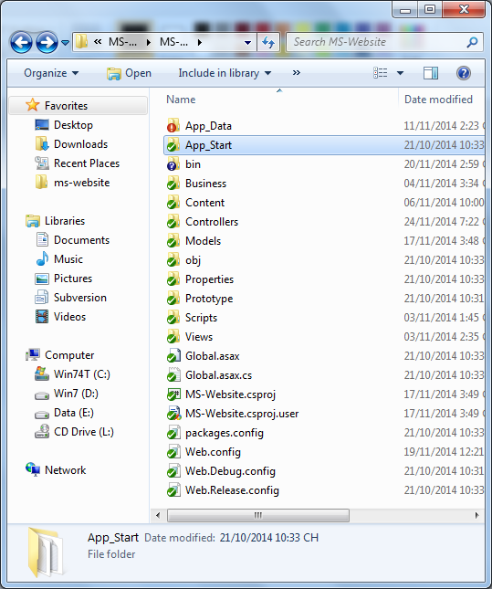

Figure 158: Prepare deployment package

#### Deploy database

* Open Microsoft SQL Server Management Studio

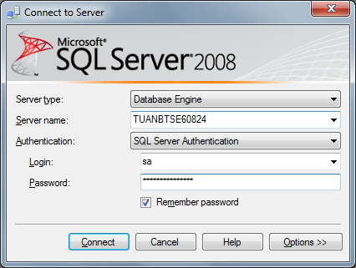

Figure 159: Deploy database – 1

* Open the script.sql file

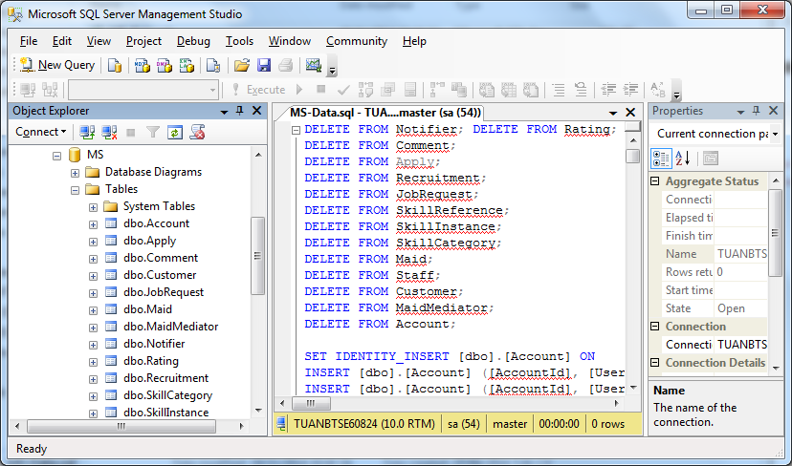

Figure 160: Deploy database - 2

#### Configure Server before deploy

* Open the Internet Information System Manager
* Change the .NET Framework version to 4.0

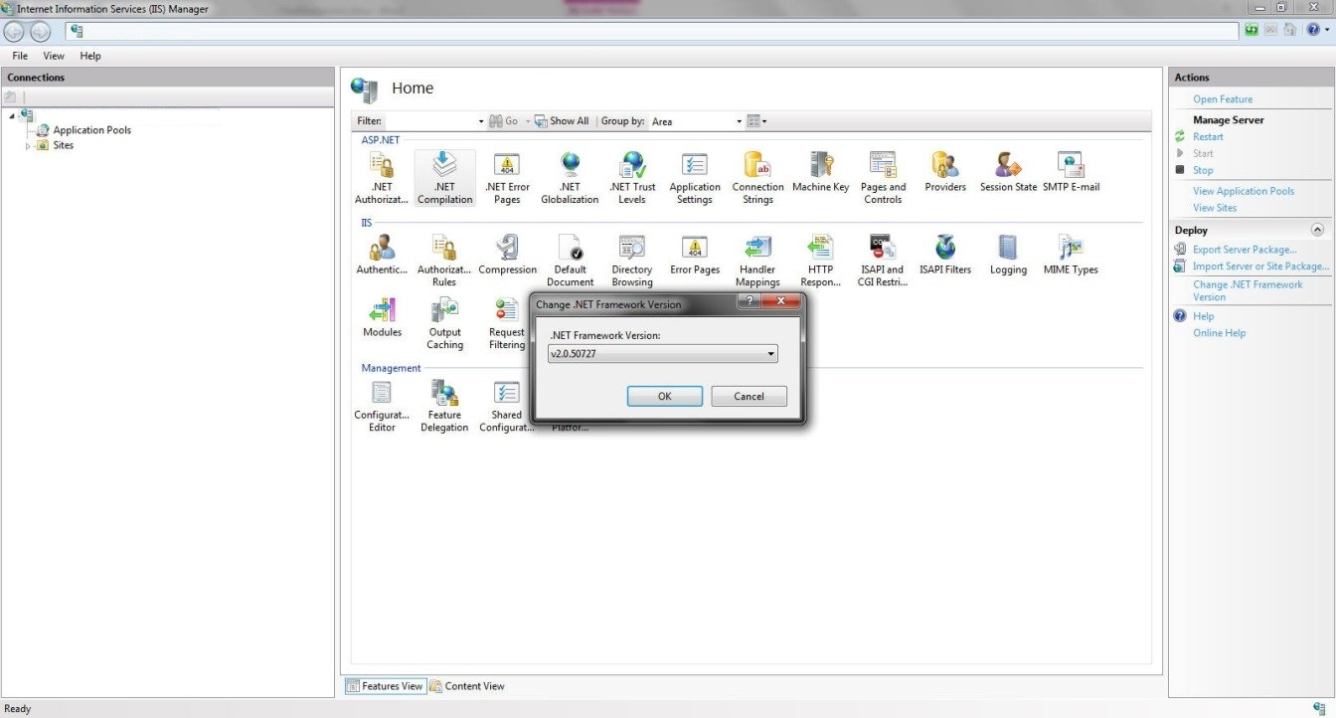

Figure 162: Configure Server before deploy – 1

* Click the Application Pool

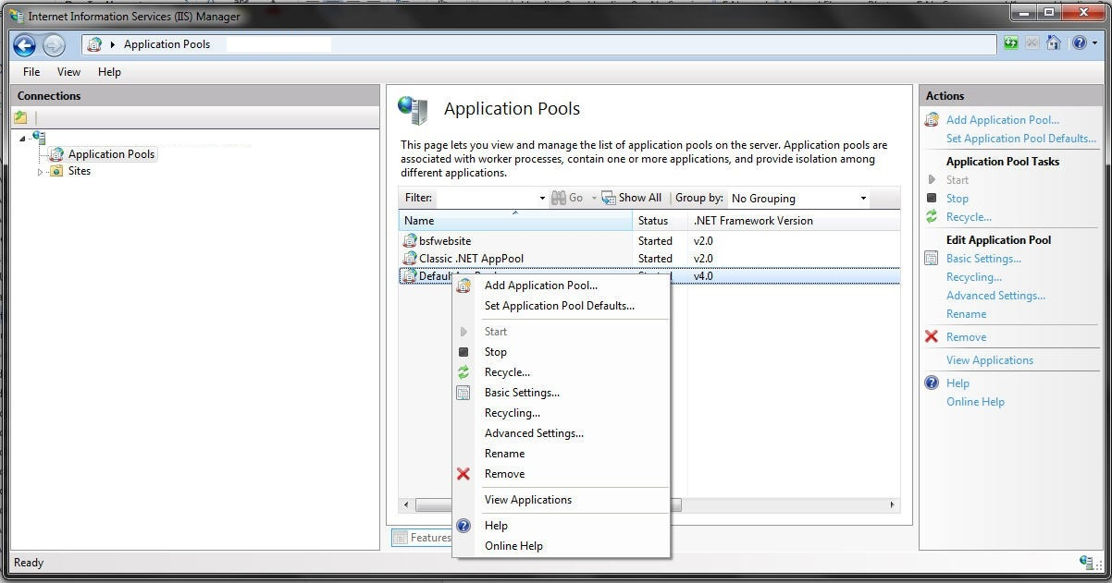

Figure 163: Configure Server before deploy – 2

* Right click the ASP.NET 4.0 Pool, select “Advance Settings”.
* Set “Enable 32-bit Applications” to True.

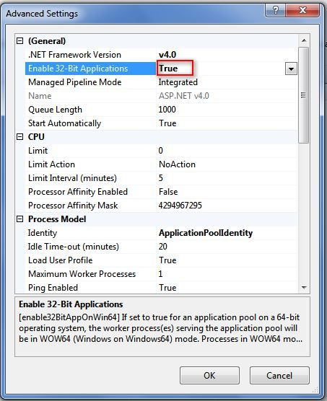

Figure 164: Configure Server before deploy - 3

#### Deploy web application on server

* Change the connection string in Web.config
* Replace the “integrated security” with your own username and password

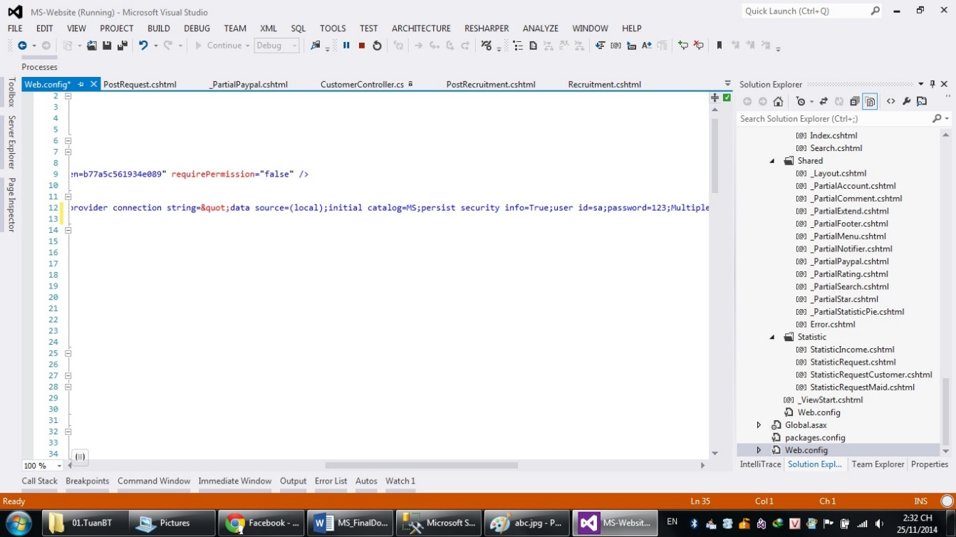

Figure 165: Deploy web application on server

* Right click as Sites. Choose “Add Web Site”.

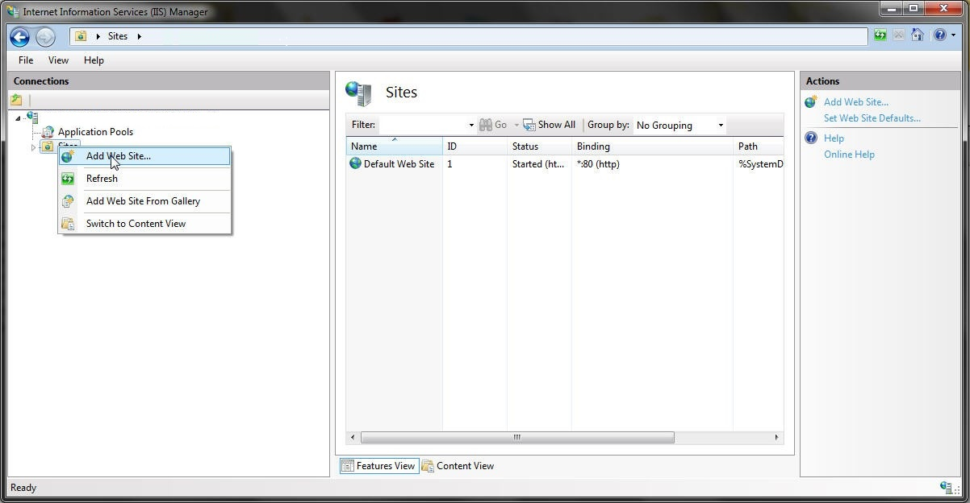

Figure 167: Deploy web application on server – 3

* Enter site name. Choose Application Pool as ASP.NET 4.0
* Select the path as the folder in step 1. Enter port other than 80.

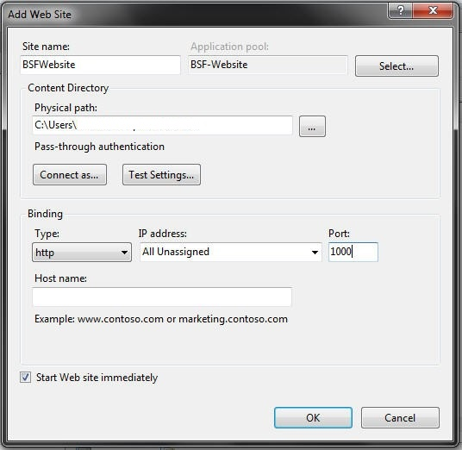

Figure 168: Deploy web application on server – 4

* Press ok to finish the process

Figure 169: Deploy web application on server – 5

## User Guide

### <All User> Login

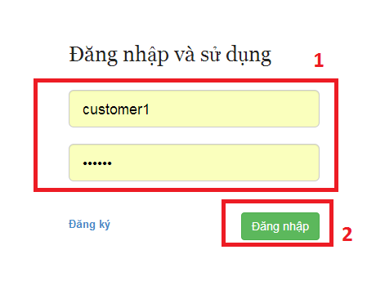

Figure 170: Login Image

|  |  |
| --- | --- |
| **Step** | **Description** |
| 1 | Fill Username and Password  (Sample admin account:  Username: admin. Password: 123456) |
| 2 | Click “Đăng Nhập” button to login  Click “Đăng ký” button to Register. |

Table 6: Login

### < Staff, MaidMediator> Add Maid

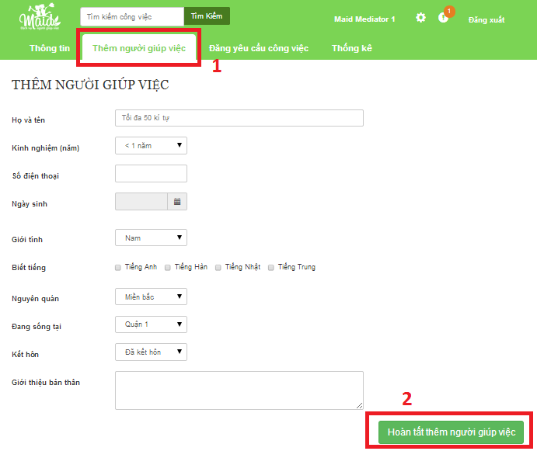

Figure 170: Add Maid Image

|  |  |
| --- | --- |
| **Step** | **Description** |
| 1 | Click “Thêm người giúp việc”  Fill all |
| 2 | Click “Hoàn tất thêm người giúp việc” button |

Table 6: Add maid

### <Staff, MaidMediator> Post Job Request

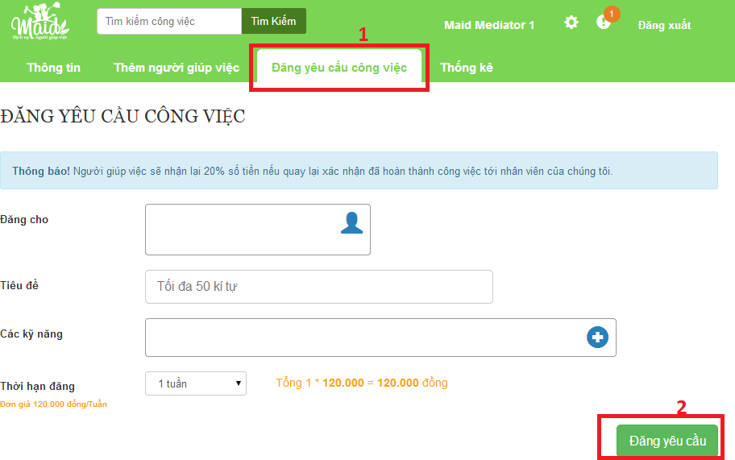

Figure 170: Post job request Image

|  |  |
| --- | --- |
| **Step** | **Description** |
| 1 | **Click “Đăng yêu cầu công việc” link**  **Fill all** |
| 2 | **Click “Đăng yêu cầu” button** |

Table 6: Post job request

### <Staff> Active job request

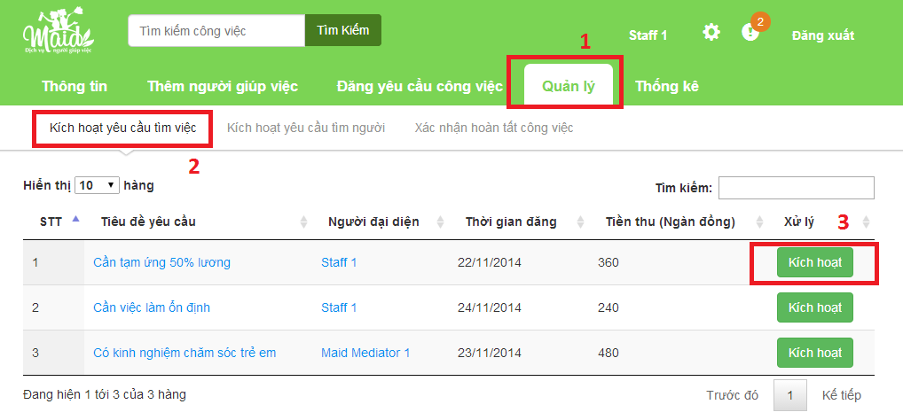

Figure 170: Active job request Image

|  |  |
| --- | --- |
| **Step** | **Description** |
| 1 | Click “Quản lý” |
| 2 | Click “Kích hoạt yêu cầu tìm việc” |
| 3 | Choose one job request.  Click “Kích hoạt” |

Table 6: Active job request

### <Staff> Active Recruitment

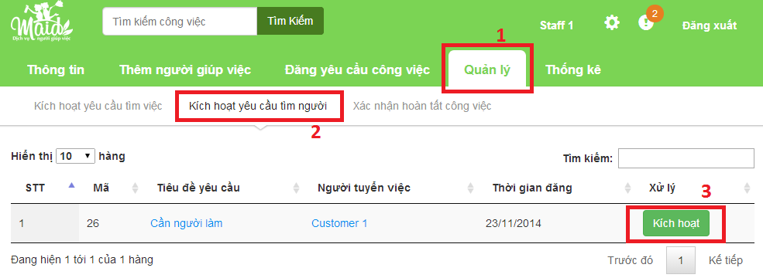

Figure 170: Active Recruitment Image

|  |  |
| --- | --- |
| **Step** | **Description** |
| 1 | Click “Quản lý” |
| 2 | Click “Kích hoạt yêu cầu tìm việc” |
| 3 | Choose one job request.  Click “Kích hoạt” |

Table 6: Active Recruitment

### <Staff> Approve job request

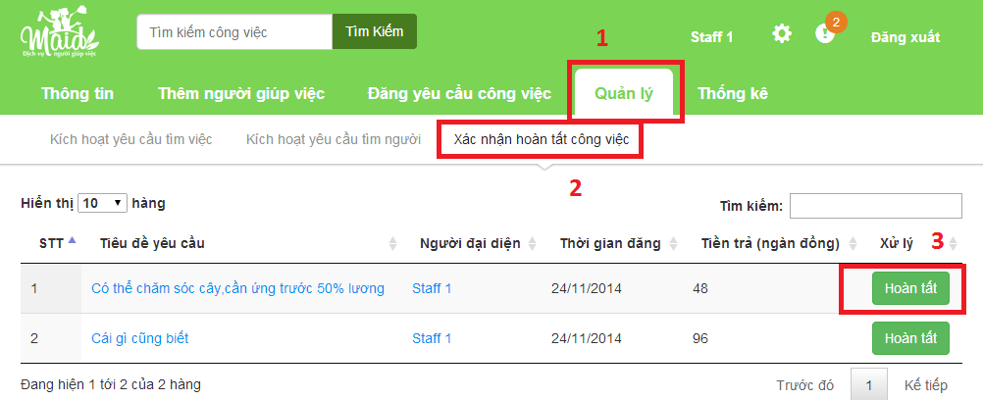

Figure 170: Approve job request Image

|  |  |
| --- | --- |
| **Step** | **Description** |
| 1 | Click “Quản lý” |
| 2 | Click “Kích hoạt yêu cầu tìm việc” |
| 3 | Choose one job request.  Click “Kích hoạt” |

Table 6: Approve job request

### <Customer> Post Recruitment

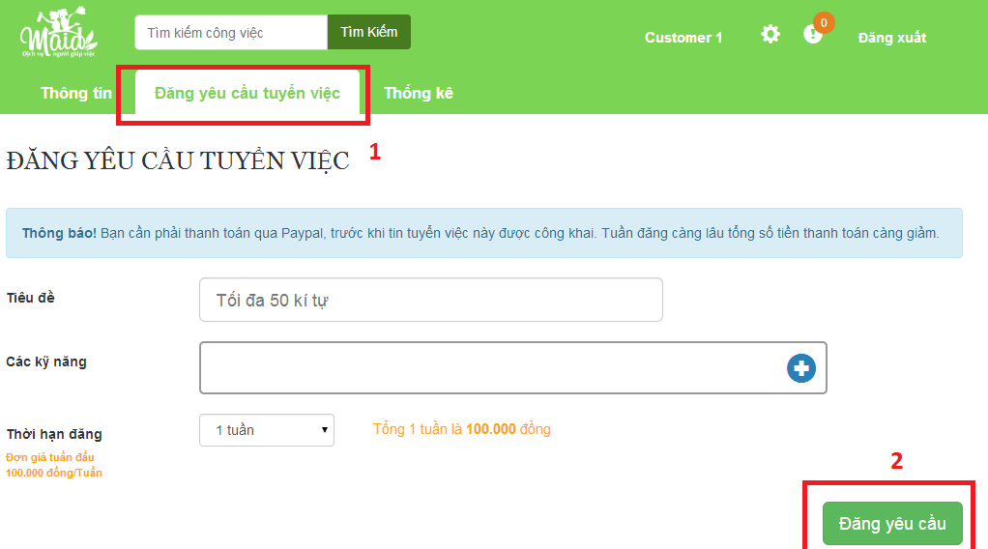

Figure 170: Post Recruitment Image

|  |  |
| --- | --- |
| **Step** | **Description** |
| 1 | Click “Đăng yêu cầu tuyển việc”  Fill all |
| 2 | Click “Đăng yêu cầu” |

Table 6: Post Recruitment

### <Admin> Ban account

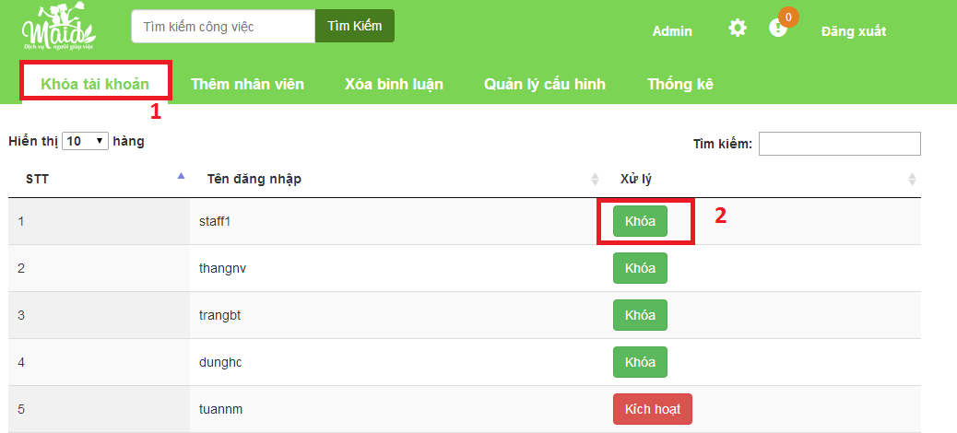

Figure 170: Ban account Image

|  |  |
| --- | --- |
| **Step** | **Description** |
| 1 | Click “Khóa tài khoản” |
| 2 | Click “Khóa” |

Table 6: Ban account

### <Admin> Add staff

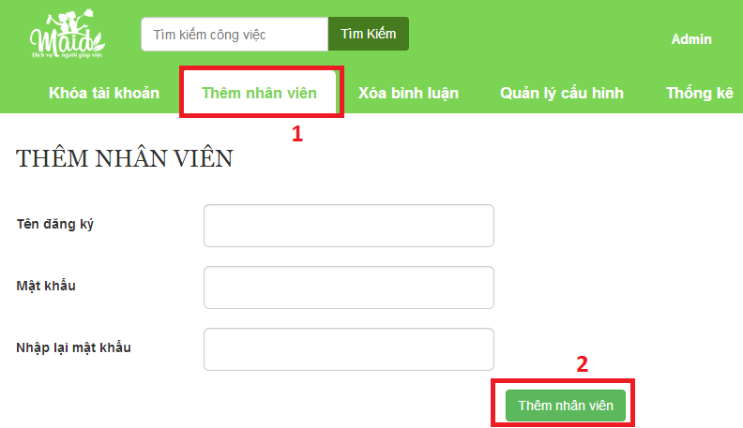

Figure 170: Add staff Image

|  |  |
| --- | --- |
| **Step** | **Description** |
| 1 | Click “Thêm nhân viên” |
| 2 | Click “Thêm nhân viên” |

Table 6: Add staff

### <Admin> Manage comment

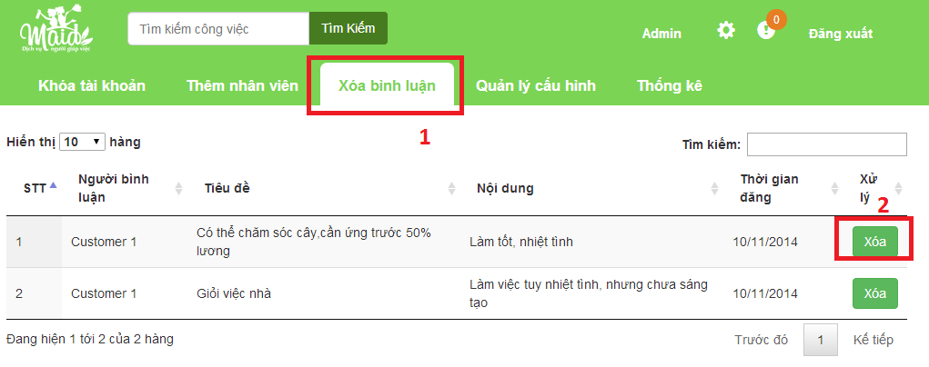

Figure 170: Manage comment Image

|  |  |
| --- | --- |
| **Step** | **Description** |
| 1 | Click “Xóa bình luận” |
| 2 | Click “Xóa” |

Table 6: Manage comment

### <Admin>Manage config

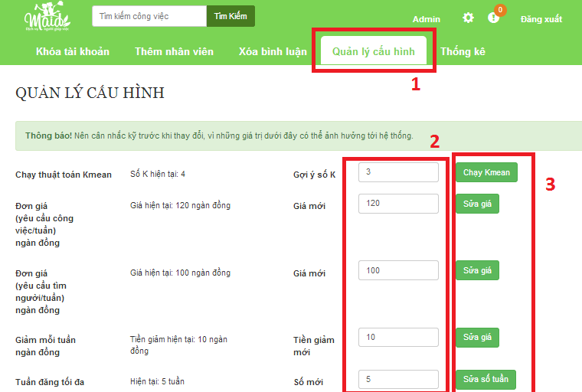

Figure 170: Manage config Image

|  |  |
| --- | --- |
| **Step** | **Description** |
| 1 | Click “Quản lý cấu hình” |
| 2 | Chang a number in field |
| 3 | Click button to finish |

Table 6: Manage config