**MINISTRY OF EDUCATION AND TRAINING**

**FPT UNIVERSITY**

Capstone Project Document

**Building a web-based application that manages activities of the maid service**

|  |  |
| --- | --- |
| **Group 6** | |
| **Group member** | Bùi Tiến Tuân - Leader - SE60824  Mạnh Quang Tuyến - Member - SE60890  Trương Hải Đăng - Member - SE60841 (Droped out)  Nguyễn Tấn Công - Member - SE60920 |
| **Supervisor** | Mr. Nguyễn Trọng Tài |
| **Ext. Supervisor** | N/A |
| **Capstone Project code** | MS-Website |

- Ho Chi Minh City, December 2014-

***ACKNOWLEDGEMENTS***

After three exhausted months of so many hardships and challenges with capstone project, we finally finish the trial to reach this moment of happiness. There are a lot of feelings we would like to express.

Firstly, our best gratitude to our capstone project's supervisor Mr.Nguyễn Trọng Tài for his support and guidance during this project work. Not only did he give us many technical supports but also he gave us mental supports as well. There were also hard times when all of us felt down and despair due to our incompetence but Mr.Tài gave us encouragement and the ways to solve our problem. We all love and respect him as much as we want to pass this course.

Next, we would like to give our thanks to other teacher who have been teaching us for four years of our university life. We cannot make it here today without useful knownledges they have taught us. We wish them the best of luck in life to keep working as educators who bring students like us to a bright future.

Our gratitude also expands to all the FPT University Committee and Department staff who provided us the best environment to study and develop ourself. It contributes important parts for us to improve our skill and knowledge as well as boost our creativity to the utmost.

We also want to give our grateful thanks to our fellow friends who have been with us during four years of studying and especially the capstone project's time to support us as well as disturb our work a lot too but thank to that, we have the enthusiasm and spirit to keep trying our best.

Lastly, we wish to thank our parents for their caring and supporting during our studying time generally and capstone project particularly. With this work, we have somehow repaid them partially with our growing up.

In conclusion, we are very proud of our work and we wish for its success in Capstone Project Defense Ceremony so that we will have nothing to regret.

# Table of Contents

[Table of Contents 4](#_Toc407026808)

[List of Tables 7](#_Toc407026809)

[List of Figures 8](#_Toc407026810)

[Definitions, Acronyms, and Abbreviations 11](#_Toc407026811)

[1 Introduction 12](#_Toc407026812)

[1.1 Project Information 12](#_Toc407026813)

[1.2 Introduction 12](#_Toc407026814)

[1.3 Current Existence Method 12](#_Toc407026815)

[1.4 System Overview 12](#_Toc407026816)

[1.5 Role and Responsibility 12](#_Toc407026817)

[2 Software Project Management Plan 13](#_Toc407026818)

[2.1 Problem Definition 13](#_Toc407026819)

[2.1.1 Name of this Capstone Project 13](#_Toc407026820)

[2.1.2 Problem Abstract 13](#_Toc407026821)

[2.1.3 Project Overview 13](#_Toc407026822)

[2.2 Project organization 14](#_Toc407026823)

[2.2.1 Software Process Model 14](#_Toc407026824)

[2.2.2 Roles and responsibilities 15](#_Toc407026825)

[2.2.3 Tools and Techniques 16](#_Toc407026826)

[2.3 Project Management Plan 17](#_Toc407026827)

[2.3.1 Task 17](#_Toc407026828)

[2.3.2 All Meeting Minutes 21](#_Toc407026829)

[2.4 Coding Convention 21](#_Toc407026830)

[3 Software Requirement Specification 21](#_Toc407026831)

[3.1 User Requirement Specification 21](#_Toc407026832)

[3.1.1 Guest requirement 21](#_Toc407026833)

[3.1.2 Authenticated User requirement 21](#_Toc407026834)

[3.1.3 Staff requirement 21](#_Toc407026835)

[3.1.4 Customer requirement 22](#_Toc407026836)

[3.1.5 Maid mediator requirement 22](#_Toc407026837)

[3.1.6 Webmaster requirement 23](#_Toc407026838)

[3.1.7 System requirement 23](#_Toc407026839)

[3.2 System Requirement Specification 23](#_Toc407026840)

[3.2.1 External Interface Requirement 23](#_Toc407026841)

[3.2.2 Functional Requirement 25](#_Toc407026842)

[3.2.3 Non-functional Requirement 119](#_Toc407026843)

[3.3 Entity Relationship Diagram 121](#_Toc407026844)

[3.3.1 Diagram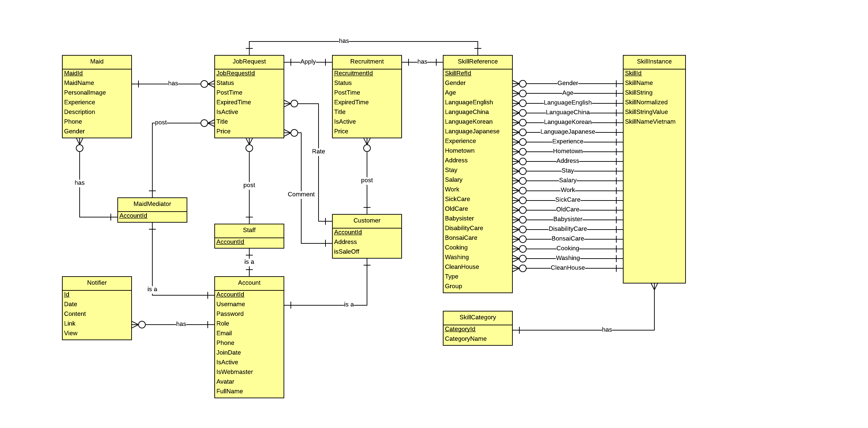 121](#_Toc407026845)

[3.3.2 Data Dictionary 121](#_Toc407026846)

[4 Software Design Description 123](#_Toc407026847)

[4.1 Design Overview 123](#_Toc407026848)

[4.2 System Architectural Design 123](#_Toc407026849)

[4.3 Component Diagram 123](#_Toc407026850)

[4.4 Detailed Description of Components 125](#_Toc407026851)

[4.4.1 Class Diagram 125](#_Toc407026852)

[4.4.2 Sequence Diagram 136](#_Toc407026853)

[4.5 User Interface Design 151](#_Toc407026854)

[4.5.1 User Interface Design 151](#_Toc407026855)

[4.5.2 Webmaster Interface Design 153](#_Toc407026856)

[4.7 Database Design 156](#_Toc407026857)

[4.7.1 Physical Database Design 156](#_Toc407026858)

[4.7.2 Data Dictionary 157](#_Toc407026859)

[4.8 Algorithms 163](#_Toc407026860)

[4.8.1 Overview 163](#_Toc407026861)

[4.8.2 Detail 164](#_Toc407026862)

[5 System Implementation & Test 165](#_Toc407026863)

[5.1 Introduction 165](#_Toc407026864)

[5.1.1 System Overview 165](#_Toc407026865)

[5.1.2 Test Approach 165](#_Toc407026866)

[5.2 Test Plan 165](#_Toc407026867)

[5.2.1 Features to be tested 165](#_Toc407026868)

[5.2.2 Features not to be tested 166](#_Toc407026869)

[5.3 Module Test Case 167](#_Toc407026870)

[6 Software User’s Manual 190](#_Toc407026871)

[6.1 Installation Guide 190](#_Toc407026872)

[6.1.1 Setting up environment at server site 190](#_Toc407026873)

[6.2 User Guide 190](#_Toc407026874)

[6.2.1 < Staff, MaidMediator> Add Maid 190](#_Toc407026875)

[6.2.2 <Staff, MaidMediator> Post Job Request 191](#_Toc407026876)

[6.2.3 <Customer> Post Recruitment 191](#_Toc407026877)

[6.2.4 <Admin>Manage config 192](#_Toc407026878)

# List of Tables

[Table 1: Roles and Responsibility Details 16](#_Toc405747807)

[Table 2: Task 20](#_Toc405747808)

[Table 3: Data Dictionary 162](#_Toc405747809)

# List of Figures

[Figure 1: Waterfall model 14](#_Toc405747704)

[Figure 2: System Overview Use Case 25](#_Toc405747705)

[Figure 3: <Guest> Register 26](#_Toc405747706)

[Figure 4: <Guest> Login 28](#_Toc405747707)

[Figure 5: <Authenticated user > Search 30](#_Toc405747708)

[Figure 6: < Authenticated user >Advance Search 31](#_Toc405747709)

[Figure 7: <Authenticated user> Search by Age 32](#_Toc405747710)

[Figure 8: <Authenticated user> Search by Skill 33](#_Toc405747711)

[Figure 9: <Authenticated user> Search by Gender 35](#_Toc405747712)

[Figure 10: <Authenticated user> Search by Salary 37](#_Toc405747713)

[Figure 11: <Authenticated user> Search by Salary 38](#_Toc405747714)

[Figure 13: <Authenticated user> View JobRequest 40](#_Toc405747715)

[Figure 14: <Authenticated user> View Recruitment 42](#_Toc405747716)

[Figure 15: <Authenticated user> View Profile 43](#_Toc405747717)

[Figure 16: <Authenticated user> Log out 45](#_Toc405747718)

[Figure 17: <Authenticated user> View Notifications 46](#_Toc405747719)

[Figure 18: <Webmaster> Add Staff 48](#_Toc405747720)

[Figure 19: <Staff> View Staff Statistic 50](#_Toc405747721)

[Figure 20: <Staff> View Requests Statistic 50](#_Toc405747722)

[Figure 21: <Staff> View Income Statistic 52](#_Toc405747723)

[Figure 22: <Webmaster> Banned Account 53](#_Toc405747724)

[Figure 23: <Webmaster> Active Account 55](#_Toc405747725)

[Figure 24: <Webmaster> View Request Statistic 56](#_Toc405747726)

[Figure 25: <Webmaster> View Income Statistic 57](#_Toc405747727)

[Figure 26: <System> Suggest JobRequest 59](#_Toc405747728)

[Figure 27: <System> Send SMS 60](#_Toc405747729)

[Figure 28: <System> Send Notifications 62](#_Toc405747730)

[Figure 29: <Customer> View JobRequest 63](#_Toc405747731)

[Figure 30: <Customer> Apply JobRequest 64](#_Toc405747732)

[Figure 31: <Customer> Comment JobRequest 65](#_Toc405747733)

[Figure 32: <Customer> Rate JobRequest 67](#_Toc405747734)

[Figure 33: <Customer> View Profile 69](#_Toc405747735)

[Figure 34: <Customer> Edit Customer Profile 69](#_Toc405747736)

[Figure 35: <Customer> Extend Recruitment 71](#_Toc405747737)

[Figure 36: <Customer> Hide Recruitment 74](#_Toc405747738)

[Figure 37: <Customer> Public Recruitment 76](#_Toc405747739)

[Figure 38: <Customer> Post Recruitment 78](#_Toc405747740)

[Figure 39: <Customer> Edit Recruitment 80](#_Toc405747741)

[Figure 40: <Customer> Pay 82](#_Toc405747742)

[Figure 41: <Customer> View Customer Statistic 84](#_Toc405747743)

[Figure 42: <Staff, Maid Mediator> Manage Maid 86](#_Toc405747744)

[Figure 43: <Staff, Maid Mediator> Add Maid 86](#_Toc405747745)

[Figure 44: <Authenticated user> View Maid 88](#_Toc405747746)

[Figure 45: <Staff, Maid Mediator> Edit Maid 89](#_Toc405747747)

[Figure 46: <Staff, Maid Mediator> Public Job Request 92](#_Toc405747748)

[Figure 47: <Staff, Maid Mediator> Hide Job Request 94](#_Toc405747749)

[Figure 48: <Staff, MaidMediator> Extend Job Request 96](#_Toc405747750)

[Figure 49: <Staff, MaidMediator> Edit JobRequest 98](#_Toc405747751)

[Figure 50: <Staff, MaidMediator> Edit Maid Mediator Profile 100](#_Toc405747752)

[Figure 51: <Staff, MaidMediator> Post JobRequest 102](#_Toc405747753)

[Figure 52: <Staff> Manage JobRequest and Recruitment 104](#_Toc405747754)

[Figure 53: <Staff> Active JobRequest 104](#_Toc405747755)

[Figure 54: <Staff> Active Recruitment 106](#_Toc405747756)

[Figure 55: <Staff> Approve JobRequest 108](#_Toc405747757)

[Figure 56: <Staff> Manage JobRequest 109](#_Toc405747758)

[Figure 57: <Staff> Manage Recruitment 111](#_Toc405747759)

[Figure 58: <Staff> Manage Applied JobRequest 112](#_Toc405747760)

[Figure 59: <Staff, MaidMediator> View Maid Manager Statistic 114](#_Toc405747761)

[Figure 60: <Webmaster> Manage Number of Kmean 115](#_Toc405747762)

[Figure 61: <Webmaster> Manage Number Of Weeks 117](#_Toc405747763)

[Figure 62: <Webmaster> Manage JobRequest Price 118](#_Toc405747764)

[Figure 63: <Webmaster> Manage Recruitment Price 120](#_Toc405747765)

[Figure 64: Entity Relationship Diagram 126](#_Toc405747766)

[Figure 65: MVC Pattern 128](#_Toc405747767)

[Figure 66: Component Diagram 129](#_Toc405747768)

[Figure 67: Class Diagram 130](#_Toc405747769)

[Figure 68: <Admin> Add Staff 142](#_Toc405747770)

[Figure 69: <Admin> Delete Comment 142](#_Toc405747771)

[Figure 70: <All User> View Job Request 143](#_Toc405747772)

[Figure 71: <All User> View Recruitment 143](#_Toc405747773)

[Figure 72: <All User> Search 144](#_Toc405747774)

[Figure 73: <Authenticated user> View Customer 144](#_Toc405747775)

[Figure 74: <Authenticated user> View Maid 145](#_Toc405747776)

[Figure 75: <Customer> Apply Job Request 146](#_Toc405747777)

[Figure 76: <Customer> Comment Job Request 147](#_Toc405747778)

[Figure 77: <Customer> Edit Recruitment 147](#_Toc405747779)

[Figure 78: <Customer> Extend Recruitment 148](#_Toc405747780)

[Figure 79: <Customer> Hide Recruitment 148](#_Toc405747781)

[Figure 80: <Customer> Post Recruitment 149](#_Toc405747782)

[Figure 81: <Customer> Public Recruitment 149](#_Toc405747783)

[Figure 82: <Customer> Rate Job Request 150](#_Toc405747784)

[Figure 82: <Customer> Rate Job Request 150](#_Toc405747785)

[Figure 82: <Customer> Rate Job Request 151](#_Toc405747786)

[Figure 83: <Staff> Activate Job Request 151](#_Toc405747787)

[Figure 84: <Staff> Activate Recruitment 152](#_Toc405747788)

[Figure 85: <Staff> Mark Approved Job Request 152](#_Toc405747789)

[Figure 86: <Staff, Maid Mediator> Add Maid 153](#_Toc405747790)

[Figure 87: <Staff, Maid Mediator> Edit Job Request 153](#_Toc405747791)

[Figure 88: <Staff, Maid Mediator> Edit Maid 154](#_Toc405747792)

[Figure 89: <Staff, Maid Mediator> Extend Job Request 154](#_Toc405747793)

[Figure 90: <Staff, Maid Mediator> Hide Job Request 155](#_Toc405747794)

[Figure 91: <Staff, Maid Mediator> Post Job Request 155](#_Toc405747795)

[Figure 92: <Staff, Maid Mediator> Public Job Request 156](#_Toc405747796)

[Figure 93: Manager Home Page 157](#_Toc405747797)

[Figure 95: Ban/Active Account Page 158](#_Toc405747798)

[Figure 96: Add Staff Page 159](#_Toc405747799)

[Figure 97: Manage Comment Page 159](#_Toc405747800)

[Figure 98: Manage Config Page 160](#_Toc405747801)

[Figure 99: Physcial Database Diagram 161](#_Toc405747802)

[Figure 100: Add Maid Image 195](#_Toc405747803)

[Figure 101: Post job request Image 196](#_Toc405747804)

[Figure 102: Post Recruitment Image 197](#_Toc405747805)

[Figure 129: Manage config Image 198](#_Toc405747806)

# Definitions, Acronyms, and Abbreviations

|  |  |  |
| --- | --- | --- |
| **No.** | **Abbreviation & Acronym** | **Definition** |
| 1 | MS | Maid Service |
| 2 | OS | Operation System |
| 3 | Admin | Administrator |
| 4 | HTTP | Hyper Text Transfer Protocol |

# Introduction

## Project Information

* **Project name:** Maid Services
* **Project Code:** MS-Website
* **Product Type:** Web-based Application
* **Start Date:** September 9, 2014
* **End Date:** December 20, 2014

## Introduction

The main goal of MS Website is to help users to easily find suitable person for taking care of household chores as well as help maids to quickly find a suitable job.

## Current Existence Method

Currently, most of job centers are supplying maid service with many functions such as posting maid’s information, maid searching by criteria (expected salary, age, experiences …) but the customers can’t post their private requests and give rating, comment about the maid that they have recruited. Moreover, maid’s information is not detailed and complete. The system can’t match and suggest the maid to the customer, negotiation and signing the contract are time-consuming.

## System Overview

The system has two main targets:

* **Customer:** busy with works and want to find people who can take care of houseworks for them. Customer can post a recruitment with demanded skills and the system will automatically match that recruitment with suitable job requests. Customer can choose one of them to apply.
* **Maid:** has experience in doing houseworks and want to find a job but doesn’t have knownledge about IT. They can come to talk directly with staff to post a job request or ask a person with knownledge about IT to become a mediator. The mediator can post new job request but still has to pay staff directly to active the posted job request.

## Role and Responsibility

|  |  |  |
| --- | --- | --- |
| **Role and Responsibilities** | **Full name** | **E-mail** |
| Instructor | Nguyễn Trọng Tài | taint@fpt.edu.vn |
| Leader | Bùi Tiến Tuân | tuanbtse60824@fpt.edu.vn |
| Member | Mạnh Quang Tuyến | tuyenmqse60890@fpt.edu.vn |
| Member | Trương Hải Đăng (drop out) | dangthse60841@fpt.edu.vn |
| Member | Nguyễn Tấn Công | congntse60920@fpt.edu.vn |

# Software Project Management Plan

## Problem Definition

### Name of this Capstone Project

* The system is for maid and the people who are searching for maid.
* The language is Vietnamese.
* The end product includes: the website and documents involved with the system.

### Problem Abstract

Nowadays, the maid services aim to two main characters: customer and maid.

* *Customer:* they can search maid, apply maid and payment.
* *Maid:* they can search customer and post job request to apply themselves to the job.

Moreover, there are not many websites can automatic suggest suitable maid for customer, and those websites require that the maids have to have knowledge about information technology.

So, this website system is developed and focus on using algorithsm to automatic suggest suitable maid for customer. This website also not require maids have knowledge about informatioon technology because this website has a role call “maid mediator”, they can post job request for maid.

### Project Overview

#### The Current System

There are have many website about work such as http://timviec.com, timviecnhanh.com, vietnamworks.com …. But they have some problem:

* **Advantages:** Provider many information about works in Vietnam.
* **Disadvantages:**
  + There is so much information.
  + There is no centralized information about Maid.

#### The Proposed System

Our site focuses on those who are busy with their works so they need to find maids to help them with household chores and the maids who are searching for jobs. Maids can quickly find job for themselves and it also makes it easy for people who are in need of finding maids to choose and recruit. With small amount of money, the website can connect those two together. The maids are people who don’t have much knowledge about IT, so our purpose is to create a website with ease of use and simple.

There are three main users whom the website interacts with including:

* **Maid representation:** Because of the lack of knowledge in IT, they can ask someone has knowledge to become their representation and register for them. Manage requested job, Search jobs, Apply job, View maid statistic.
* **Customer:** Manage recruitment, View customer statistic, Comment, Search maids, Rating, Apply maid.
* **Staff:** Can help maid to register and post info in place of them. Manage post time, Confirm request, Manage fee.

#### Boundaries of the System

* The system is for maid and the people who are searching for maid.
* The language is Vietnamese.
* The end product includes: the website and documents involved with the system.

#### Development Environment

##### Hardware requirements

**For Server**

|  |  |  |
| --- | --- | --- |
| Windows | Minimum Requirements | Recommended |
| Internet Connection | 512Kbs | 1Mbs |
| Operating System | Window 7 | Window 8 |
| Computer Processor | Intel® Core 2 Duo | Intel® Core(TM) i5 CPU , M 460 @ 2.53GHz |
| Computer Memory | 2GB RAM | 3GB or more |

##### Software requirements

* Microsoft Windows 7: Operating System.
* SQL Server 2008 R2: used for managing the database for system.
* StarUML 5.0: designing models and diagrams tools.
* Visual Studio 2012: used to implement website and web service.
* Google Code & TortoiseSVN: used for source control.

## Project organization

### Software Process Model

With the schedule of weekly reports for every stage, the software will be developed by using waterfall model it is very simple and require minimal resource for implementation. With waterfall model, developing process will include six main phases:

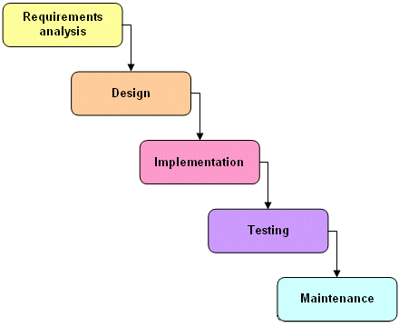

Figure 1: Waterfall model

* **Requirement analysis and software definition**: The first phase is also the most important phase of the process which may cause great effect to other phases. This phase includes gathering as much as possible requirements from customer, or other information source like World Wide Web, and producing a most detail and accurate software definition.
* **System design**: This phase is fundamental for implementation phase. Based on customer’s requirements to create logical modules, and definite their inter relations. Using algorithm and diagram to describe implementation of those modules.
* **Implementation**: This phase consists of actually constructing the product as per the design specification(s) developed in the previous step. Typically, this step is performed by a development team consisting of programmers, interface designers and other specialists, using tools such as compilers, debuggers, interpreters and media editors.
* Testing:
  + **System implementation and Unit testing**: Developing software modules follow detail designs, and doing unit testing for each module.
  + **Integration and System testing**: Testing output, performance in modules integrating process, and retests all functions of whole system.
  + **User acceptance testing**: A proper execution of all the preceding stages ensures an application as per the provided requirements and most importantly, it ensures a satisfied client.
* **System deployment and maintenance**: After testing completely, the software is handle over client, developing team will respond for maintenance of the system.

### Roles and responsibilities

|  |  |  |  |
| --- | --- | --- | --- |
| **No** | **Full name** | **Role in Group** | **Responsibilities** |
| **1** | Nguyễn Trọng Tài | Project manager | * Specify user requirement * Control the development process * Give out technique and business analysis support |
| **2** | Bùi Tiến Tuân | Team Leader, BA, DEV, Tester | * Managing process * Assign task for team member * Designing database * Clarifying requirements * Prepare documents * GUI Design * Create test plan * Coding * Testing |
| **3** | Mạnh Quang Tuyến | Team Member, BA, DEV, Tester | * Designing database * Clarifying requirements * Prepare documents * GUI Design * Create test plan * Coding * Testing |
| **4** | Trương Hải Đăng | Team Member, BA, DEV, Tester | * Designing database * Clarifying requirements * Prepare documents * GUI Design * Create test plan * Coding * Testing |
| **5** | Nguyễn Tấn Công | Team Member, BA, DEV, Tester | * Designing database * Clarifying requirements * Prepare documents * GUI Design * Create test plan * Coding * Testing |

Table 1: Roles and Responsibility Details

### Tools and Techniques

#### For Development

* Front-end technologies: HTML5, CSS3, JavaScript, jQuery, AJAX.
* Back-end: ASP .NET MVC4, Entity Framework.
* Data Management System: SQL Server 2008 R2.
* IDE: Visual Studio 2012
* System design tool: StartUML
* IIS: web server

#### For Management

-Process and code tracking: Team Foundation Server.

-Tortoise SVN: Document version control and tracking.

## Project Management Plan

### Task

|  |  |  |  |  |  |  |  |
| --- | --- | --- | --- | --- | --- | --- | --- |
| **#** | **Task** | **Description** | **Output** | **Deliverables** | **Resource Needed** | **Dependencies and Constraints** | **Risk** |
| 1 | Creating Software Requirements Specification (SRS) | Creating SRS | SRS document | SRS document before 18/09/2014 | 4 people for 4 days |  | Lack of experience in getting requirement. |
| 2 | Designing Database | Creating conceptual, logical and physical database. | Database Design and Database script | Design Database before 25/09/2014 | 3 person for 3 days | Depends on the completion of SRS | May not cover all business rules, causing the database design to be inappropriate or must be changed by customers’ requirements. |
| 3 | Creating Software Design Description (SDD) | Design the system in an Object Oriendted Programming. | Architecture design, detailed design, diagrams and design specification | SDD before 30/09/2014 | 4 people for 4 days | Depends on the completion of SRS | Choosing inappropriate architecture and design patterns, causing the system hard to maintain, or wasting coding efforts. |
| 4 | Layout Designing | Create the main GUI for layout | HTML layout, Javascript and CSS files | Complete before 30/09/2013 | 2 person for 1 week |  | There is no professional designers in team. |
| 5 | Create Coding | Map the architecture design into source code, create the project solution files and common classes, and implement common functions. | .Net MVC4 project and solution file contain coding |  | 1 person for 3 days | Dependent on Architecture design and SRS |  |
| 6 | Coding | Implement the system based on the requirements. | Source code of the project, unit test reports | Executable programs and source code before 03/11/2014 | 4 people for 5 weeks | Depends on the completion of SRS, SDD, Database design, Coding framework | Unit test may not be performed thoroughly, it draws needing more efforts in system test phase. |
| 7 | Test Plan | Make a plan for testing | Test plan document | Test plan before 10/11/2014 |  |  |  |
| 8 | System Test | Perform system test for the system. | System test report | Software Test Documentation before 20/11/2014 | 3 people for 4 days | When Coding is finished | There is no professional testers in team. Developers are also do system testing, this may draws compromise. |
| 9 | User Guide | Create User manual document | Report 6 | Report 6 before 06/12/2014 | 3 people for 1 days |  | Unclear document may cause ambigious understanding. |
| 10 | Input Initial Data | Collect and input initial data for the system before release. | Initial data |  | 3 people for 3 days | When coding and system test are finished |  |
| 11 | Deployment | Deploy the system on server. | Running website with domain and hosting | Full Project | 2 people for 3 days | When Coding and system test are finished, initial data is inputted. | The owner host lacks of supporting in some components such as database engine. |

Table 2: Task

### All Meeting Minutes

Refer to Meeting Minutes folder.

## Coding Convention

C#: Using to develop MS-website.

Summary:

* Naming Convention.
* Indentation.
* Declaration.
* Code Examples.

All “Code Conventions for the C# Programming Language, by Microsoft

<http://msdn.microsoft.com/en-us/library/ff926074.aspx>

# Software Requirement Specification

## User Requirement Specification

### Guest requirement

To satisfy the demand of guest, system has these functions:

* **Register Account:** guest need to register to become member.
* **Login:** when guest have account they can login with username and password.
* **Search:** guest can search information about jobs, before they determine become a member.
* **View JobRequest:** view JobRequest details.
* **View Recruitment:** view Recruitment details.

### Authenticated User requirement

After logging in, user becomes authenticated user and has these functions:

* **View Profile:** user can view profile.
* **Log out:** user can log out.
* **View JobRequest:** view JobRequest details.
* **View Recruitment:** view Recruitment details.
* **View Notifications:** view Notifications when system sends.

### Staff requirement

A person: to manage the maid’s request, fee and allow maid to post request.

* **Manage post time**: staff manage maid’s request post time.
* **View post time**: staff can allow customer and maid the time that maid’s request posted.
* **Manage fee**: staff can manage the customer’s fee, maid’s fee
* **Confirm request**: staff can allow the maid’s request to post to the website.
* **View Requests Statistic:** User can view all statistic of request in year.
* **View Income Statistic:** User can view all statistic of income in year.
* **Active Job Request:** Staff can choose of list job request not active, Staff choose one of them was paid money by maid.
* **Active Recruitment:** Staff can choose of list recruitment not active, staff choose one of them was paid money online by paypal from customer.
* **Approve Job Request:** staff to approve job request to public it on website
* **Manage Job Request:** staff view all jobrequests that is not active
* **Manage Recruitment:** staff view all recruitments that is not active
* **Manage Applied Job Request:** staff view all applied jobrequests
* **View Maid Manager Statistic:** staff to view personal statistic as maid
* **Add Maid:** User add maid for management
* **View Maid:** User to view a maid’s detail
* **Edit Maid:** Useredit a maid’s info
* **Public Job Request:** User to public a job request for customer to apply.
* **Hide Job Request:** User to hide a job request and can’t be applied by any customer.
* **Extend Job Request:** User to extend job request.
* **Edit Job Request:** User to edit job request.
* **Post Job Request:** User to post job request.

### Customer requirement

A person: They can hire maid and do all function by Customer roll.

* **Apply Job Request:** Customer use a them Recruitment have status “Waiting” to Apply a JobRequest have status “Waiting” too.
* **Comment Job Request:** When customer applied a JobRequest, they can comment for this JobRequest if Maid come back and tell to staff Approved this Job**.**
* **Rate Job Request:** When customer applied a JobRequest, they can rate for this JobRequest if Maid come back and tell to staff Approved this Job.
* **Edit Customer Profile:** customer to edit profile.
* **Extend Recruitment:** customer to extend recruitment.
* **Hide Recruitment:** Customer to hide a recruitment and can’t be seen by any one.
* **Public Recruitment:** Customer to public a job request for customer to apply.
* **Post Recruitment:** Customer to post job request
* **Edit Recruitment:** Customer to edit recruitment
* **Pay:** Customer will pay online by Paypal for them Recruitment
* **View Customer Statistic:** Customer to view personal statistic as customer.

### Maid mediator requirement

A person: This is a role mediator of maid. They help maid post job request and add Maid.

* **View Maid Manager Statistic**: User to view personal statistic as maid.
* **Add Maid:** User add maid for management
* **View Maid:** User to view a maid’s detail
* **Edit Maid:** Useredit a maid’s info
* **Public Job Request:** User to public a job request for customer to apply.
* **Hide Job Request:** User to hide a job request and can’t be applied by any customer.
* **Extend Job Request:** User to extend job request.
* **Edit Job Request:** User to edit job request.
* **Post Job Request:** User to post job request.

### Webmaster requirement

A person: This is admin of system. They can mange user, config and run algorithm.

* **Add Staff:** User to add maid for management.
* **Manage User:** user to view a maid’s detail
* **Ban Account:** User will ban account
* **Unban Account:** User will active account
* **View Requests Statistic:** View statistic of all request of MS-Website in year
* **View Income Statistic:** View statistic of all income of MS-Website in year
* **Manage Number of Kmean:** Change number K of Kmean algorithm. K same number of group.
* **Manage Number of Weeks:** Change maximum week when user post a JoRequest or Recruiment in to MS-Website.
* **Manage Job Request Price:** Change price when a new JobRequest post to MS-Website.
* **Manage Recruitment Price:** Change price when a new Recruitment post to MS-Website.

### System requirement

A person: this is a system, automatic run some function.

* **Suggests:** system automatically suggest JobRequest for customer when they post a recruitment on MS-Website
* **Send SMS:** Notify for Maid, Customer, Maid Mediator or Staff when Customer apply JobRequest of Maid
* **Send Notifications:** Notify for Maid, Customer, Maid Mediator or Staff when Customer apply JobRequest of Maid. Notify for all Staff when customer report about payment.

## System Requirement Specification

### External Interface Requirement

#### User Interface

* The general interface of website is simple and simplifies user interfaces.
* The design is simple and monochrome is more prefer.
* The layout of information in page is showing simple but full of functions.
* The error, warning and notification messages must be simple, neat, and easy to understand. Error warning does not discomfort to the user.
* The working layout of user is spacious.
* Member can contact with manager and admin easily.

#### Hardware Interface

There is no extra hardware interfaces are needed. The system will use the standard hardware and data communications resources of a standard computer.

#### Software Interface

Browser: Chrome, Firefox

#### Communication Protocol

MS website uses HTTP/HTTPS protocol for communication with the web browser and the web server. In addition, TCP/IP network protocol for communication with HTTP protocol.

### Functional Requirement

#### System Overview Use Case

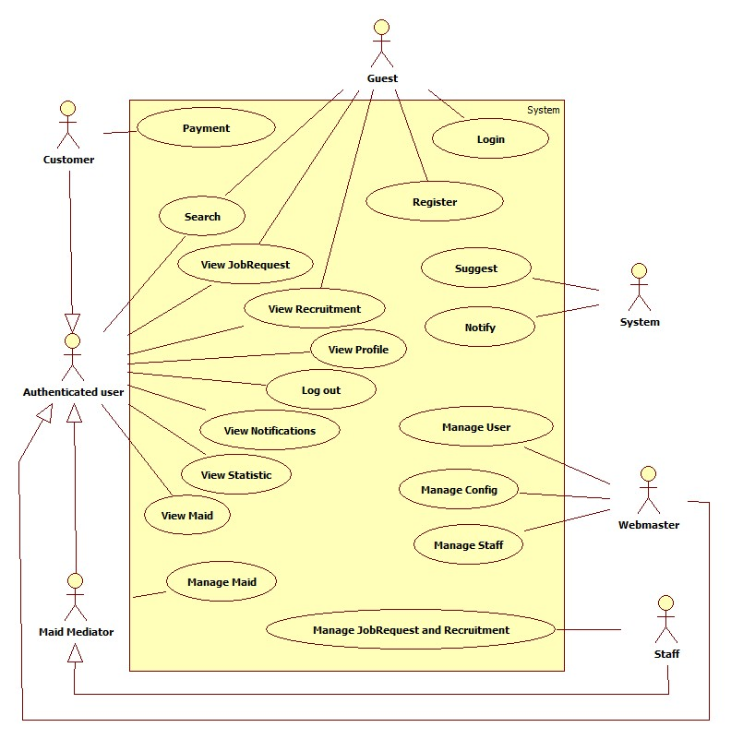

Figure 2: System Overview Use Case

#### List of Use Case

##### <Guest> Register

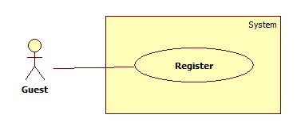

Figure 3: <Guest> Register

|  |  |  |  |  |
| --- | --- | --- | --- | --- |
| **USE CASE SPECIFICATION** | | | | |
| **Use-case No.** | UC001 | **Use-case Version** | | 1.0 |
| **Use-case Name** | Register | | | |
| **Author** | CongNT | | | |
| **Date** | 21/09/2014 | **Priority** | High | |
| **Actor:** Guest  **Summary:** This use case allows guest to create an account in website system.  **Goal:**  It helps guest to create an account on website.  **Trigger:** Click on the “Đăng ký” button to register on home page  **Pre-conditions: N/A**  **Post conditions:**   * Success: Register successfully, guest will have an account in system and will be logged into system. * Failure: Show message error.   **Main Success Scenario:**   |  |  | | --- | --- | | Actor Action | System Response | | 1. Click on “Đăng ký” button home page 2. Input right information about username, email, password, full name, phone, role 3. Click on the “Đăng ký” button | 2. System redirect to register page for guest, contain a register form :   * Tên tài khoản [Username: textbox ] * Mật khẩu [Password : textbox] * Nhập lại mật khẩu [Repassword : textbox] * Địa chỉ email [Email: textbox] * Họ và tên [Fullname : textbox] * Điện thoại[Phone : textbox] * Vai trò[Role : dropdownlist] * Đăng ký[button]   [Exception 1]   1. Validate valid username, password, email, phone 2. Redirect to login page |   **Alternative Scenario: N/A**  **Exceptions:**   |  |  | | --- | --- | | Actor Action | System Response | | [Exception 1]   1. “Tên đăng nhập” is emtpy 2. “”Mật khẩu” is empty 3. “Nhập lại mật khẩu” if different with “Mật khẩu” 4. “Điện thoại” is empty or not a numberic value 5. “Họ và tên” is empty 6. “Email” is empty or not correct type [abc@abc.abc](mailto:abc@abc.abc) 7. “Tên đăng nhập” is already have in database | 1. Display message: “Vui lòng nhập tên đăng nhập” 2. Display message: “Vui lòng nhập mật khẩu” 3. Display message: “Mật khẩu không trùng khớp” 4. Display message: “Vui lòng nhập số” 5. Display message: “Vui lòng nhập họ và tên” 6. Display message: “Vui lòng nhập đúng định dạng [abc@abc.abc](mailto:abc@abc.abc)” 7. Display message: “Tên đăng nhập đã tồn tại” |   **Relationships: N/A**  **Business Rules:** When register an account, users have to input username, email, password, phone.   * If username, email is already have in database, an error message will be displayed. | | | | |

##### <Guest> Login

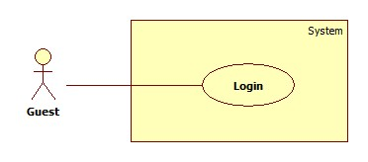

Figure 4: <Guest> Login

|  |  |  |  |  |
| --- | --- | --- | --- | --- |
| **USE CASE SPECIFICATION** | | | | |
| **Use-case No.** | UC002 | **Use-case Version** | | 1.0 |
| **Use-case Name** | Login | | | |
| **Author** | CongNT | | | |
| **Date** | 21/09/2014 | **Priority** | High | |
| **Actor:** Guest  **Summary:** This use case allow guest to login the website  **Goal:** Guest become a member of the website  **Trigger:** Click on the “Đăng nhập” button to login on home page  **Pre-conditions: N/A**  **Post conditions:**   * Success: Login successfully, guest will have a role in system and can use more function of system. * Failure: Show message error   **Main Success Scenario:**   |  |  | | --- | --- | | Actor Action | System Response | | 1. Click on “Đăng nhập” button home page 2. Input right information about username, password 3. Click on the “Đăng nhập” button | 1. System redirect to login page for guest, contain a login form :  * Tên tài khoản [Username: textbox ] * Mật khẩu [Password : textbox] * Đăng nhập [button]   [Exception 1]   1. Redirect to login successful page |   **Alternative Scenario: N/A**  **Exceptions:**   |  |  | | --- | --- | | Actor Action | System Response | | [Exception 1]   1. “Tên đăng nhập”,”Mật khẩu” ,” is empty 2. “Tên đăng nhập” is IsActive(false) | 1. Display message “Vui lòng nhập tên đăng nhập” or “Vui lòng nhập mật khẩu” 2. Display message “Tên đăng nhập đã bị khóa” |   **Relationships: N/A**  **Business Rules:** User must input username, password. The username and password must unique and have in database and the username is not blocked. If the username is blocked or not unique or not have in database, an error message is displayed. | | | | |

##### <Authenticated user > Search

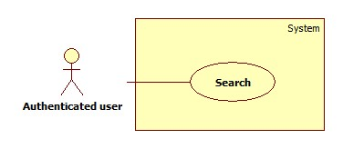

Figure 5: <Authenticated user > Search

|  |  |  |  |  |
| --- | --- | --- | --- | --- |
| **USE CASE SPECIFICATION** | | | | |
| **Use-case No.** | UC003 | **Use-case Version** | | 1.0 |
| **Use-case Name** | Search | | | |
| **Author** | CongNT | | | |
| **Date** | 21/09/2014 | **Priority** | High | |
| **Actor:** Guest, Customer, Maid Mediator, Staff, Webmaster.  **Summary:** This use case allow guest can search information on the website  **Goal:** Guest can search information by search job  **Trigger:** Fill in “Tìm kiếm” textbox, then click on “Tìm kiếm” button  **Pre-conditions: N/A**  **Post conditions:**   * Success: Search successfully, the system will shown search result * Failure: Show message error   **Main Success Scenario:**   |  |  | | --- | --- | | Actor Action | System Response | | 1. Fill in “Tìm kiếm” text box 2. Click on “Tìm kiếm” button | 1. System redirect to search page for guest and show search results.   [Exception 1] |   **Alternative Scenario: N/A**  **Exceptions:**   |  |  | | --- | --- | | Actor Action | System Response | | [Exception 1]   1. System fail to load data | 1. Show message error “Hệ thống đang bảo trì” |   **Relationships: N/A**  **Business Rules:** User can only search job request or recruitment that is in status “Waiting” and active. | | | | |

##### C:\Users\USER\Desktop\AdvanceSearch.jpg< Authenticated user >Advance Search

Figure 6: < Authenticated user >Advance Search

###### <Authenticated user> Search by Age

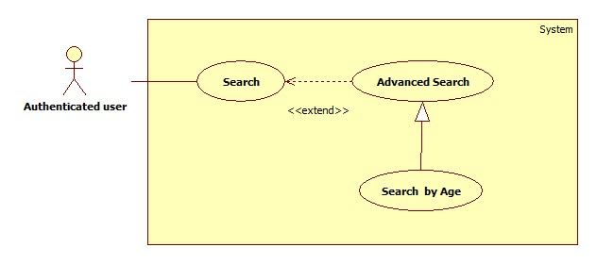Figure 7: <Authenticated user> Search by Age

|  |  |  |  |  |
| --- | --- | --- | --- | --- |
| **USE CASE SPECIFICATION** | | | | |
| **Use-case No.** | UC004 | **Use-case Version** | | 1.0 |
| **Use-case Name** | Search by age | | | |
| **Author** | CongNT | | | |
| **Date** | 21/09/2014 | **Priority** | High | |
| **Actor:** Guest, Customer, Maid Mediator, Staff, Webmaster.  **Summary:** This use case allow guest can search information by age  **Goal:** Guest can search information by search age  **Trigger:** Click on age radio button on website  **Pre-conditions:** User have to search  **Post conditions:**   * Success: Search successfully, the system will shown search result * Failure: Fail to load data, the system will show message error   **Main Success Scenario:**   |  |  | | --- | --- | | Actor Action | System Response | | 1. Fill in “Tìm kiếm” text box 2. Click on “Tìm kiếm” button 3. Click on “25-30” or “30-35” or “35-40” radio button | 1. System redirect to search page for guest 2. Show the search by age result.   [Exception 1] |   **Alternative Scenario:**   |  |  | | --- | --- | | Actor Action | System Response | | [Alternative 1]   1. Click on skill radio button   [Alternative 2]   1. Click on “Nam” or “Nữ” radio button.   [Alternative 3]   1. Click on “Dưới 3 triệu” or “3-5 triệu” or “trên 5 triệu” radio button.   [Alternative 4]   1. Click on “Cách đây 1 ngày” or “Cách đây 3 ngày” or “Cách đây 7 ngày” or “Cách đây 14 ngày” or “Cách đây 30 ngày” radio button. | 1. Show the search by skill result.   [Exception 1]   1. Show the search by gender result.   [Exception 1]   1. Show the search by salary result   [Exception 1]   1. Show the search by time result   [Exception 1] |   **Exceptions:**   |  |  | | --- | --- | | Actor Action | System Response | | [Exception 1]   1. System fail to load data | 1. Show message error “Hệ thống đang bảo trì” |   **Relationships:** Search by age is generated with AdvancedSearch and AdvancedSearch is extended to Search  **Business Rules:** User can only search job request or recruitment that is in status “Waiting” and active. | | | | |

##### C:\Users\USER\Desktop\ViewJR.jpg<Authenticated user> View JobRequest

Figure 12: <Authenticated user> View JobRequest

|  |  |  |  |  |
| --- | --- | --- | --- | --- |
| **USE CASE SPECIFICATION** | | | | |
| **Use-case No.** | UC009 | **Use-case Version** | | 1.0 |
| **Use-case Name** | View jobrequest | | | |
| **Author** | CongNT | | | |
| **Date** | 21/09/2014 | **Priority** | High | |
| **Actor:** Staff, Customer, Maid Mediator, Webmaster  **Summary:** This use case allow to view jobrequest  **Goal:** User can view jobrequest detail  **Trigger:** Click on title jobrequest link  **Pre-conditions:** N/A  **Post conditions:**   * Success: View job request successfully * Failure: Fail to load data   **Main Success Scenario:**   |  |  | | --- | --- | | Actor Action | System Response | | 1. Click title jobrequest link | 1. System redirect jobrequest detail page with information.  * “Tiêu đề”: Title * “Tình trạng”: Status * “Kĩ năng”: Skill * “Tên người giúp việc”: MaidName   [Exception 1] |   **Alternative Scenario: N/A**  **Exceptions:**   |  |  | | --- | --- | | Actor Action | System Response | | [Exception 1]   1. System fail to load data | 1. Show message error “Hệ thống đang bảo trì” |   **Relationships:** N/A  **Business Rules:** N/A | | | | |

##### <Authenticated user> View Recruitment

Figure 13: <Authenticated user> View Recruitment 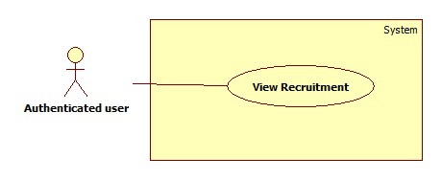

|  |  |  |  |  |
| --- | --- | --- | --- | --- |
| **USE CASE SPECIFICATION** | | | | |
| **Use-case No.** | UC010 | **Use-case Version** | | 1.0 |
| **Use-case Name** | View recruitment | | | |
| **Author** | CongNT | | | |
| **Date** | 21/09/2014 | **Priority** | High | |
| **Actor:** Staff, Customer, Maid Mediator, Webmaster, Guest  **Summary:** This use case allow to view jobrequest  **Goal:** User can view recruitment detail  **Trigger:** Click on title recruitment link  **Pre-conditions:** N/A  **Post conditions:**   * Success: View recruitment successfully * Failure: Fail to load data   **Main Success Scenario:**   |  |  | | --- | --- | | Actor Action | System Response | | 1. Click title recruitment link | 1. System redirect jobrequest detail page with information.  * “Tiêu đề”: Title * “Tình trạng”: Status * “Kĩ năng”: Skill * “Tên người giúp việc”: MaidName   [Exception 1] |   **Alternative Scenario: N/A**  **Exceptions:**   |  |  | | --- | --- | | Actor Action | System Response | | [Exception 1]   1. System fail to load data | 1. Show message error “Hệ thống đang bảo trì” |   **Relationships:** N/A  **Business Rules:** N/A | | | | |

##### <Authenticated user> View Profile

Figure 14: <Authenticated user> View Profile 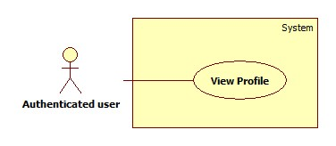

|  |  |  |  |  |
| --- | --- | --- | --- | --- |
| **USE CASE SPECIFICATION** | | | | |
| **Use-case No.** | UC011 | **Use-case Version** | | 1.0 |
| **Use-case Name** | View Profile | | | |
| **Author** | CongNT | | | |
| **Date** | 21/09/2014 | **Priority** | High | |
| **Actor:** Staff, Customer, Maid Mediator, Webmaster  **Summary:** This use case allow user to see his/her profile  **Goal:** User can see his/her profile  **Trigger:** Click on their name link  **Pre-conditions:** User must login to website  **Post conditions:**   * Success: Login successfully, user can see his/her profile * Failure: Fail to load data   **Main Success Scenario:**   |  |  | | --- | --- | | Actor Action | System Response | | 1. Click name link | 1. System redirect personal profile page   [Exception 1] |   **Alternative Scenario: N/A**  **Exceptions:**   |  |  | | --- | --- | | Actor Action | System Response | | [Exception 1]   1. System fail to load data | 1. Show message error “Hệ thống đang bảo trì” |   **Relationships:** N/A  **Business Rules:**   * If login as a staff, then click name link, website will redirect to staff’s profile page. Staff could see profile of all members. * If login as a maid mediator, then click name link, website will redirect to maid mediator’s profile page. * If login as a customer, then click name link, website will redirect to customer’s profile page. * If login as a webmaster, then click name link, website will redirect to config page. | | | | |

##### <Authenticated user> Log out

Figure 15: <Authenticated user> Log out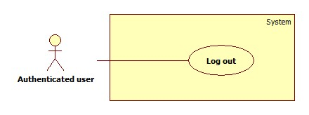

|  |  |  |  |  |
| --- | --- | --- | --- | --- |
| **USE CASE SPECIFICATION** | | | | |
| **Use-case No.** | UC012 | **Use-case Version** | | 1.0 |
| **Use-case Name** | Log out | | | |
| **Author** | CongNT | | | |
| **Date** | 21/09/2014 | **Priority** | High | |
| **Actor:** Staff, Customer, Maid Mediator, Webmaster  **Summary:** This use case allow to log out website  **Goal:** User can log out website  **Trigger:** Click on log out button  **Pre-conditions:** N/A  **Post conditions:**   * Success: Log out successfully * Failure: N/A   **Main Success Scenario:**   |  |  | | --- | --- | | Actor Action | System Response | | 1. Login to website 2. Click log out | 1. System redirect home page 2. System redirect home page and clear session. |   **Alternative Scenario: N/A**  **Exceptions: N/A**  **Relationships**: N/A  **Business Rules:** User must log in to website. | | | | |

##### <Authenticated user> View Notifications

Figure 16: <Authenticated user> View Notifications 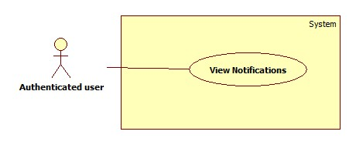

|  |  |  |  |  |
| --- | --- | --- | --- | --- |
| **USE CASE SPECIFICATION** | | | | |
| **Use-case No.** | UC013 | **Use-case Version** | | 1.0 |
| **Use-case Name** | View notifications | | | |
| **Author** | CongNT | | | |
| **Date** | 21/09/2014 | **Priority** | High | |
| **Actor:** Staff, Customer, Maid Mediator, Webmaster  **Summary:** This use case allow to view notifications  **Goal:** User can view notifications  **Trigger:** Click on title icon notifications link  **Pre-conditions:**   * Page is loaded successfully * User login to website successful   **Post conditions:**   * Success: Login successfully * Failure: N/A   **Main Success Scenario:**   |  |  | | --- | --- | | Actor Action | System Response | | 1. Login to website 2. Click icon notifications link | 1. System redirect home page 2. System redirect notifications page. |   **Alternative Scenario:**   |  |  | | --- | --- | | Actor Action | System Response | | [Alternaive 1]   1. If user login as a staff   [Alternaive 2]   1. If user login as a maid or maid mediator | 1. System send message “Kiểm tra lại thanh toán” link 2. System send message “Có người đã thuê yêu cầu của bạn” |   **Exceptions: N/A**  **Relationships:** N/A  **Business Rules:**   * If user log in as a staff, notifications show that jobrequests or recruitments is not active or is not paid, so staff have to active those jobrequests or recruitments. * If user log in as a customer or maid mediator, notifications show that your recruitmenst or jobrequests are applied. | | | | |

##### <Webmaster> Add Staff

Figure 17: <Webmaster> Add Staff 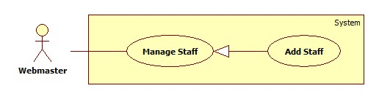

|  |  |  |  |  |
| --- | --- | --- | --- | --- |
| **USE CASE SPECIFICATION** | | | | |
| **Use-case No.** | UC014 | **Use-case Version** | | 1.0 |
| **Use-case Name** | Add staff | | | |
| **Author** | TuanBT | | | |
| **Date** | 24/09/2014 | **Priority** | High | |
| **Actor:** Webmaster  **Summary:** Webmaster add a user role Staff. A new staff only have username and password.  **Goal:** Make a new user directive.  **Trigger:**Webmater click on “Thêm nhân viên”  **Pre-conditions:**   * User must login with Admin role.   **Post conditions:**   * Success: Reload this page * Failure: Show message error   **Main Success Scenario:**   |  |  | | --- | --- | | Actor Action | System Response | | 1. Webmaster click “Thêm nhân viên” at his profile page.  3. Webmaster fill and click “Thêm nhân viên” button. | 2. The page show 3 input username, password, confirm password.  4. Page is reload.  [Exception 1] [Exception 2] |   **Alternative Scenario: N/A**  **Exceptions:**   |  |  | | --- | --- | | Actor Action | System Response | | [Exception 1]  1. Input “Tên đăng ký” is missing  [Exception 2]  1. Input “Mật khẩu” is missing or password not match with input “Nhập lại mật khẩu” | 2. Show error “Vui lòng nhập tên đăng nhập”  2. Show error “Mật khẩu không trùng khớp” |   **Relationships:** Add staff is generalization of manage staff  **Business Rules:**   * Only Web master can add staff. * After adding staff, new record is added to Staff table in database. | | | | |

##### <Staff> View Staff Statistic

Figure 18: <Staff> View Staff Statistic 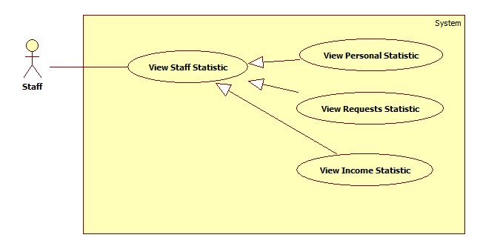

###### <Staff> View Requests Statistic

Figure 19: <Staff> View Requests Statistic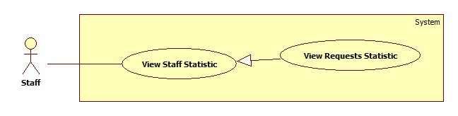

|  |  |  |  |  |
| --- | --- | --- | --- | --- |
| **USE CASE SPECIFICATION** | | | | |
| **Use-case No.** | UC018 | **Use-case Version** | | 1.0 |
| **Use-case Name** | View Requests Statistic | | | |
| **Author** | CongNT | | | |
| **Date** | 21/09/2014 | **Priority** | High | |
| **Actor:** Staff, Webmaster  **Summary:** This use case allow staff see requests statistic  **Goal:** Staff can see requests statistic  **Trigger:** Click on “Các yêu cầu” link  **Pre-conditions:** N/A  **Post conditions:**   * Success: Login successfully, the statistic will be shown * Failure: System fail to load data   **Main Success Scenario:**   |  |  | | --- | --- | | Actor Action | System Response | | 1. Login as a staff 2. Click name link 3. Click “Thống kê” link 4. Click “Các yêu cầu” link | 1. System redirect home page 2. System redirect personal profile page 3. System redirect personal statistic page and show personal statistic. 4. System redirect personal statistic page and show personal statistic with pie chart with information.  * “Yêu cầu đã nhận” * “Yêu cầu đang chờ nhận” * “Yêu cầu đang ẩn” * “Yêu cầu chưa kích hoạt”   [Alternaive 1][Exception 1] |   **Alternative Scenario:**   |  |  | | --- | --- | | Actor Action | System Response | | [Alternaive 1]   1. There is no request | 1. Show message “Bạn chưa có yêu cầu nào” |   **Exceptions:**   |  |  | | --- | --- | | Actor Action | System Response | | [Exception 1]   1. System fail to load data | 1. Show message “Không tìm thấy dữ liệu” |   **Relationships:** View Request Statistic is generated with View Staff Statistic  **Business Rules:** User login as a staff. | | | | |

###### <Staff> View Income Statistic

Figure 20: <Staff> View Income Statistic 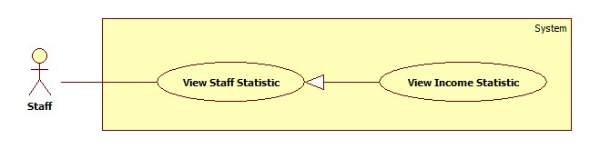

|  |  |  |  |  |
| --- | --- | --- | --- | --- |
| **USE CASE SPECIFICATION** | | | | |
| **Use-case No.** | UC019 | **Use-case Version** | | 1.0 |
| **Use-case Name** | View Income Statistic | | | |
| **Author** | CongNT | | | |
| **Date** | 21/09/2014 | **Priority** | High | |
| **Actor:** Staff, Webmaster  **Summary:** This use case allow staff see income statistic  **Goal:** Staff can see income statistic  **Trigger:** Click on “Doanh thu” link  **Pre-conditions:** N/A  **Post conditions:**   * Success: Login successfully, the income statistic will be shown * Failure: System fail to load data   **Main Success Scenario:**   |  |  | | --- | --- | | Actor Action | System Response | | 1. Login as a staff 2. Click name link 3. Click “Thống kê” link 4. Click “Doanh thu” link | 1. System redirect home page 2. System redirect personal profile page 3. System redirect personal statistic page and show personal statistic. 4. System redirect income statistic page and show income statistic with column chart information.  * “Doanh thu” * “Tháng”   [Alternaive 1][Exception 1] |   **Alternative Scenario:**   |  |  | | --- | --- | | Actor Action | System Response | | [Alternaive 1]   1. There is no request | 1. Show message “Bạn chưa có doanh thu” |   **Exceptions:**   |  |  | | --- | --- | | Actor Action | System Response | | [Exception 1]   1. System fail to load data | 1. Show message “Không tìm thấy dữ liệu” |   **Relationships:** View Income Statistic is generated with View Staff Statistic  **Business Rules:** User login as a staff | | | | |

##### <Webmaster> Banned Account

Figure 21: <Webmaster> Banned Account 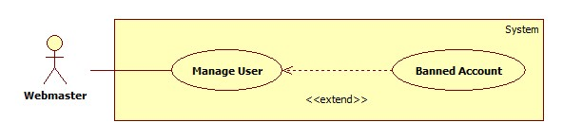

|  |  |  |  |  |
| --- | --- | --- | --- | --- |
| **USE CASE SPECIFICATION** | | | | |
| **Use-case No.** | UC016 | **Use-case Version** | | 1.0 |
| **Use-case Name** | Bannned Account | | | |
| **Author** | TuanBT | | | |
| **Date** | 24/09/2014 | **Priority** | High | |
| **Actor:** Webmaster  **Summary:** Webmaster will banned account.  **Goal:**  Banned Account.  **Trigger:** Webmaster click “Khóa tài khoản”  **Pre-conditions:** N/A  **Post conditions:**   * Success: Reload this page. Button will change to “Kích hoạt” * Failure: Do not reload page   **Main Success Scenario:**   |  |  | | --- | --- | | Actor Action | System Response | | 1. Webmaster click “Khóa tài khoản” menu, then click “Khóa” button. | 2. Reload page and change button to “Kích hoạt” |   **Alternative Scenario: N/A**  **Exceptions:**   |  |  | | --- | --- | | Actor Action | System Response | | 1. Webmaster click “Khóa tài khoản” menu, then click “Khóa” button. | 2. Button not change to “Kích hoạt” |   **Relationships:** Banned Account extend of manage user  **Business Rules:**   * Only Web master can ban an account. * After banning, the account’s isActive changes to False in Account table. * The banned account can’t log in the system anymore until it is unbanned. | | | | |

##### <Webmaster> Active Account

Figure 22: <Webmaster> Active Account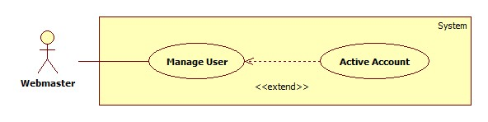

|  |  |  |  |  |
| --- | --- | --- | --- | --- |
| **USE CASE SPECIFICATION** | | | | |
| **Use-case No.** | UC017 | **Use-case Version** | | 1.0 |
| **Use-case Name** | Active Account | | | |
| **Author** | TuanBT | | | |
| **Date** | 24/09/2014 | **Priority** | High | |
| **Actor:** Webmaster  **Summary:** Webmaster will active account.  **Goal:** Active account.  **Trigger:** Webmaster click “Kích hoạt”  **Pre-conditions:** N/A  **Post conditions:**   * Success: Reload this page. Button will change to “Khóa” * Failure: Do not reload page   **Main Success Scenario:**   |  |  | | --- | --- | | Actor Action | System Response | | 1. Webmaster click “Khóa tài khoản” menu, then click “Kích hoạt” button. | 1. Reload page and change button to “Khóa”   [Exception 1] |   **Alternative Scenario: N/A**  **Exceptions:**   |  |  | | --- | --- | | Actor Action | System Response | | [Exception 1]  1. Webmaster click “Khóa tài khoản” menu, then click “Kích hoạt” button. | 2. Not change button to “Khóa” |   **Relationships:** Active Account extend of Manage acount  **Business Rules:**   * Only Web master can unban an account. * After unbanning, the account’s isActive changes to True in Account table. * The unbanned account can log in the system again. | | | | |

##### <System> Suggest JobRequest

Figure 25: <System> Suggest JobRequest 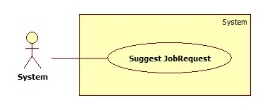

|  |  |  |  |  |
| --- | --- | --- | --- | --- |
| **USE CASE SPECIFICATION** | | | | |
| **Use-case No.** | UC021 | **Use-case Version** | | 1.0 |
| **Use-case Name** | Suggest JobRequest | | | |
| **Author** | TuanBT | | | |
| **Date** | 24/09/2014 | **Priority** | High | |
| **Actor:** System  **Summary:** system automatically suggest JobRequest for customer when they post a recruitment on MS-Website.  **Goal:**  The use case will help MS-Website suggest JobRequest for customer when they post a recruitment.  **Trigger:**   * Click [Đăng yêu cầu tuyển việc] button. * Fill all data. * Click [Đăng yêu cầu] button.   **Pre-conditions:**   * Post an invalid recruitment.   **Post conditions:**   * Success: Suggested JobRequests list will appear. * Failure: Nothing is displayed at suggesting field.   **Main Success Scenario:**   |  |  | | --- | --- | | Actor Action | System Response | | 1. User click on the [Đăng yêu cầu tuyển việc] button. | 1. Show suggested JobRequests list.   [Exception 1] |   **Alternative Scenario: N/A**  **Exceptions:**   |  |  | | --- | --- | | Actor Ation | System Response | | [Exception 1]   1. System fail to load data | 1. Show suggested JobRequests list |   **Relationships:** N/A  **Business Rules:**   * The algorithms runs on only Recruitments with “Waiting” status and isActive is true to suggest suitable Job Requests. * Only 10 Job Requests in the same group with the Recruitment having “Waiting” status and isActive is true in database will be suggested. * Recommended list shows up 10 Job Requests and arranges them in order of pertinence (descending by distance to the center point of that group). | | | | |

##### <System> Send SMS

Figure 26: <System> Send SMS

|  |  |  |  |  |
| --- | --- | --- | --- | --- |
| **USE CASE SPECIFICATION** | | | | |
| **Use-case No.** | UC022 | **Use-case Version** | | 1.0 |
| **Use-case Name** | Send SMS | | | |
| **Author** | TuanBT | | | |
| **Date** | 24/09/2014 | **Priority** | Normal | |
| **Actor:** System  **Summary:** Notify for Maid, Customer, Maid Mediator or Staff when Customer apply JobRequest of Maid.  **Goal:**  Send SMS for Maid, Customer, Maid Mediator or Staff when Customer apply JobRequest of Maid. System know when accept a job.  **Trigger:** Both Customer and Maid post an invalid recruitment and job request. Customer must apply successful JobRequest.  **Pre-conditions:**   * Apply success.   **Post conditions:**   * Success: Send SMS * Failure: Don’t send SMS   **Main Success Scenario:**   |  |  | | --- | --- | | Actor Action | System Response | | 1. Customer apply JobRequest of Maid | 1. Send SMS |   **Alternative Scenario:** N/A  **Exceptions:**   |  |  | | --- | --- | | Actor Action | System Response | | 1. System don’t send SMS | 1. Show message “Không thể gửi tin nhắn” |   **Relationships:** Send SMS is generalization of Notification  **Business Rules:**   * When a Job Request is applied by a Recruitment, the system send SMS messages to the maid, customer, posting person (Staff or Maid Mediator) to let them know. | | | | |

##### <System> Send Notifications

Figure 27: <System> Send Notifications 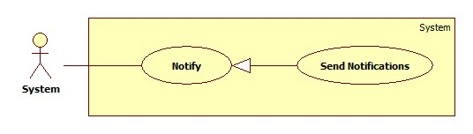

|  |  |  |  |  |
| --- | --- | --- | --- | --- |
| **USE CASE SPECIFICATION** | | | | |
| **Use-case No.** | UC023 | **Use-case Version** | | 1.0 |
| **Use-case Name** | Send Notifications | | | |
| **Author** | TuanBT | | | |
| **Date** | 24/09/2014 | **Priority** | Normal | |
| **Actor:** System  **Summary:** Notify for Maid, Customer, Maid Mediator or Staff when Customer apply JobRequest of Maid. Notify for all Staff when customer report about payment.  **Goal:**  Help user know what happen with them.  **Trigger:** Both Customer and Maid post an invalid recruitment and job request. Customer must apply successful JobRequest.  **Pre-conditions:**   * User must login into MS-Website.   **Post conditions:**   * Success: Notification show at notify page of User was send Notification. * Failure: Do not send notification.   **Main Success Scenario:**   |  |  | | --- | --- | | Actor Action | System Response | | 1. Customer apply JobRequest of Maid | 1. Send notification |   **Alternative Scenario: N/A**  **Exceptions:**   |  |  | | --- | --- | | Actor Action | System Response | | 1. System do not send notification | 1. Show message “Không thể gửi thông báo” |   **Relationships:** Send notificatrion is generalization of Notifier  **Business Rules:**   * When a Job Request is applied by a Recruitment, new record is created in Notify table in database. * The system sends notifications to the customer, posting person (Staff or Maid Mediator) to let them know. | | | | |

##### <Customer> View JobRequest

Figure 28: <Customer> View JobRequest 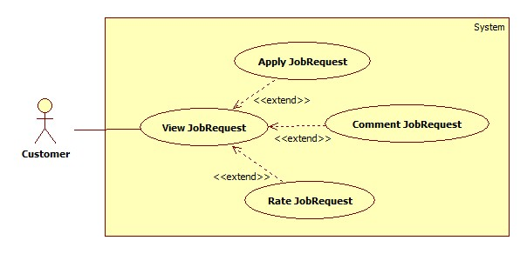

###### <Customer> Apply JobRequest

Figure 29: <Customer> Apply JobRequest 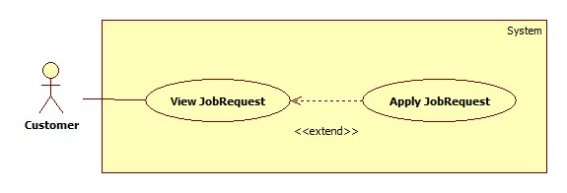

|  |  |  |  |  |
| --- | --- | --- | --- | --- |
| **USE CASE SPECIFICATION** | | | | |
| **Use-case No.** | UC024 | **Use-case Version** | | 1.0 |
| **Use-case Name** | Apply JobRequest | | | |
| **Author** | TuanBT | | | |
| **Date** | 24/09/2014 | **Priority** | High | |
| **Actor:** Customer  **Summary:** Customer use a them Recruitment have status “Waiting” to Apply a JobRequest have status “Waiting” too.  **Goal:**  Apply JobRequest.  **Trigger:** Click button “Thuê"  **Pre-conditions:**   * User must login with Customer role   **Post conditions:**   * Success: Reload page. Name of Customer show at status line. * Failure: Show error “Thuê thất bại”   **Main Success Scenario:**   |  |  | | --- | --- | | Actor Action | System Response | | 1. Customer click a JobRequest have status “Waiting”, then click “Thuê” button.  3. Choose a Recruitment from list Radio button. Then click “Đồng ý” button | 2. Show modal “Xin chọn một đơn tuyển việc”.  4. Show status “Đã được thuê”.  [Exception1] |   **Alternative Scenario: N/A**  **Exceptions:**   |  |  | | --- | --- | | Actor Action | System Response | | [Exception 1]  1. Customer click “Chấp nhận” from modal. | 2. Show error “Công việc đã được thuê bởi khách hàng khác” |   **Relationships:** Apply JobRequest is extend of View JobRequest  **Business Rules:**   * Only Job Request with “Waiting” status and isActive is (True) can be applied. * Only Recruitment with “Waiting” status and isActive is (True) can apply a Job Request. * When applying a random Job Request, customer must choose one of his/her posted Recruitments with “Waiting” status and isActive is true to apply. * After applying, the status of applied Job Request and chosen Recruitment change to “Applied” in database. System sends SMS and Notifications to revelant people. | | | | |

###### <Customer> Comment JobRequest

Figure 30: <Customer> Comment JobRequest 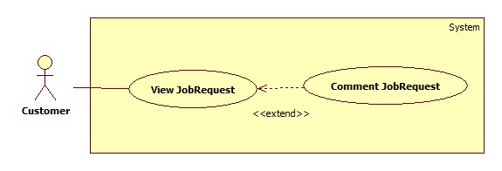

|  |  |  |  |  |
| --- | --- | --- | --- | --- |
| **USE CASE SPECIFICATION** | | | | |
| **Use-case No.** | UC025 | **Use-case Version** | | 1.0 |
| **Use-case Name** | Comment JobRequest | | | |
| **Author** | TuanBT | | | |
| **Date** | 24/09/2014 | **Priority** | High | |
| **Actor:** Customer  **Summary:** When customer applied a JobRequest, they can comment for this JobRequest if Maid come back and tell to staff Approved this Job.  **Goal:**  Comment JobRequest.  **Trigger:** Fill input comment.  **Pre-conditions:**   * User must login with Admin role * Status of JobRequest is Approved   **Post conditions:**   * Success: one line comment show. * Failure: N/A   **Main Success Scenario:**   |  |  | | --- | --- | | Actor Action | System Response | | 1. Click a jobRequest in “Đã nhận” tab. This JobRequest must have status “Đã hoàn tất”  3. Fill comment input, then click “Đăng” button. | 2. Show box “Nhận xét của người đã thuê”.  4. One line comment is show. |   **Alternative Scenario: N/A**  **Exceptions: N/A**  **Relationships:** Comment JobRequest is extend of View JobRequest  **Business Rules:**   * Only customer can comment on a Job Request. * Only Job Request with “Approved” status can be commented. | | | | |

###### <Customer> Rate JobRequest

Figure 31: <Customer> Rate JobRequest 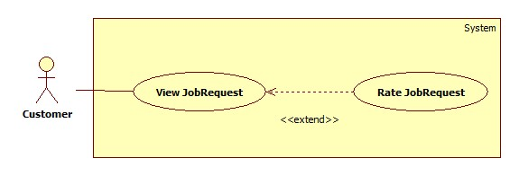

|  |  |  |  |  |
| --- | --- | --- | --- | --- |
| **USE CASE SPECIFICATION** | | | | |
| **Use-case No.** | UC026 | **Use-case Version** | | 1.0 |
| **Use-case Name** | Rate JobRequest | | | |
| **Author** | TuanBT | | | |
| **Date** | 24/09/2014 | **Priority** | High | |
| **Actor:** Customer  **Summary:** When customer applied a JobRequest, they can rate for this JobRequest if Maid come back and tell to staff Approved this Job.  **Goal:**  Rate JobRequest.  **Trigger:** Click choose star. Then click “Chấm điểm” button.  **Pre-conditions:**   * User must login with Admin role * Status of JobRequest is Approved   **Post conditions:**   * Success: Star show in rating line. * Failure: N/A   **Main Success Scenario:**   |  |  | | --- | --- | | Actor Action | System Response | | 1. Click a jobRequest in “Đã nhận” tab. This JobRequest must have status “Đã hoàn tất”  3. Choose number star, then click “Chấm điểm” button. | 2. Show box “Nhận xét của người đã thuê”.  4. Rate of JobRequest be shown. |   **Alternative Scenario: N/A**  **Exceptions: N/A**  **Relationships:** Rate JobRequest is extend of View JobRequest  **Business Rules:**   * Only customer can rate a Job Request. * Only Job Request with “Approved” status can be rated. | | | | |

##### <Customer> View Profile

Figure 32: <Customer> View Profile

###### <Customer> Edit Customer Profile

Figure 33: <Customer> Edit Customer Profile 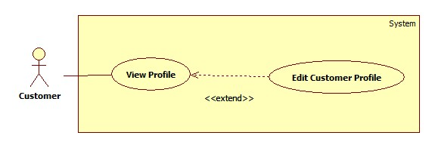

|  |  |  |  |  |
| --- | --- | --- | --- | --- |
| **USE CASE SPECIFICATION** | | | | |
| **Use-case No.** | UC027 | **Use-case Version** | | 1.0 |
| **Use-case Name** | Edit Customer Profile | | | |
| **Author** | TuanBT | | | |
| **Date** | 24/09/2014 | **Priority** | High | |
| **Actor:** Customer  **Summary:** This use case allow customer to edit profile  **Goal:** Customer can edit profile  **Trigger:** User clicks “Sửa thông tin cá nhân” link in personal profile page  **Pre-conditions:**   * Page is loaded successfully * User login as customer successful   **Post conditions:**   * Success: Edit profile successfully, profile detail is updated in database * Failure: Show error message   **Main Success Scenario:**   |  |  | | --- | --- | | Actor Action | System Response | | 1. Login as a customer 2. Click the name link 3. Click “Sửa thông tin cá nhân” link 4. Fill all the fields 5. Click “Cập nhật thông tin” button | 1. System redirects to homepage 2. System redirects to personal profile page 3. System redirects to profile editing page displaying following fields with info of the job request accordingly:  * Họ và tên [FullName: textbox] * Số điện thoại [Phone: textbox] * Email [Email: textbox] * Địa chỉ [Address: textbox] * Ảnh đại diện [Image uploading] * “Cập nhật thông tin” button   [Exception 1]   1. System redirects to personal profile page with updated info |   **Alternative Scenario: N/A**  **Exceptions:**   |  |  | | --- | --- | | Actor Action | System Response | | [Exception 1]   1. “Họ và tên” is empty 2. “Số điện thoại” is empty or char inputted 3. “Email” is empty or wrong format | 1. Show message “Vui lòng nhập tên người quản lý” 2. Show message “Vui lòng nhập số” 3. Show message “Vui lòng nhập đúng định dạng abc@abc.ab” |   **Relationships:** Is an extension of View Profile  **Business Rules:**   * User can only edit his/her own profile. | | | | |

###### <Customer> Extend Recruitment

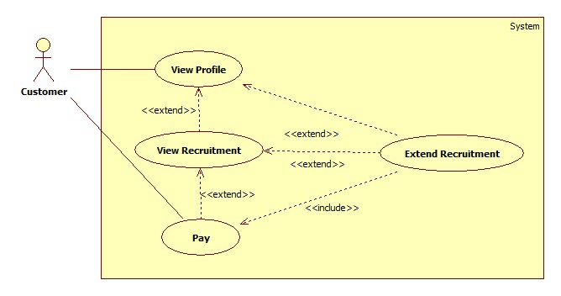 Figure 34: <Customer> Extend Recruitment

|  |  |  |  |  |
| --- | --- | --- | --- | --- |
| **USE CASE SPECIFICATION** | | | | |
| **Use-case No.** | UC028 | **Use-case Version** | | 1.0 |
| **Use-case Name** | Extend Recruitment | | | |
| **Author** | TuanBT | | | |
| **Date** | 24/09/2014 | **Priority** | High | |
| **Actor:** Customer  **Summary:** This use case allow customer to extend recruitment  **Goal:** Customer can extend recruitment  **Trigger:** User clicks “Gia hạn” button  **Pre-conditions:**   * Page is loaded successfully * User login as customer successful   **Post conditions:**   * Success: Extend Recruitment successfully, Recruitment’s expired date is updated in database and status changes from “Expired” to “Waiting” * Failure: Show error message   **Main Success Scenario:**   |  |  | | --- | --- | | Actor Action | System Response | | 1. Login as a customer 2. Click the name link 3. Click a maid name link in maids list 4. Choose a recruitment in tab except “Hết hạn” or “Chờ thuê” tabs. Then click “Gia hạn” button.   [Alternative 1]   1. Choose week, then Click Paypal button. | 1. System redirects to homepage 2. System redirects to personal profile page 3. System redirects to maid profile page 4. A modal pops up with a dropdown list for user to choose the extending time 5. System redirects to Paypal page |   **Alternative Scenario:**   |  |  | | --- | --- | | Actor Action | System Response | | [Alternative 1]   1. Choose a recruitment in tab except “Hết hạn” or “Chờ thuê” tabs. Then click title job request link. 2. Click “Gia hạn” button 3. Choose week, then Click Paypal button. | 1. System redirect to recruitment details page 2. A modal pops up with a dropdown list for user to choose the extending time 3. System redirects to Paypal page |   **Exceptions:**   |  |  | | --- | --- | | Actor Action | System Response | | [Exception 1]   1. Recruitment was applied | 1. Show alert message “Yêu cầu đã thuê” |   **Relationships:** Is an extension of View Profile  **Business Rules:**   * Customer can only extend his/her own posted recruitment. * All recruitments with isActive is true can be extended except recruitment with “Applied” or “Approved” status. * Customer must pay on PayPal to extend a recruitment. * After extending, the expired date of the recruitment is updated in database. | | | | |

###### <Customer> Hide Recruitment

Figure 35: <Customer> Hide Recruitment 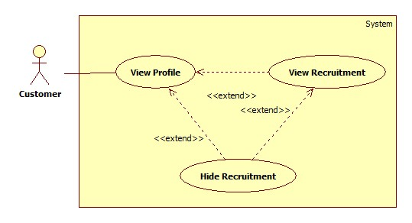

|  |  |  |  |  |
| --- | --- | --- | --- | --- |
| **USE CASE SPECIFICATION** | | | | |
| **Use-case No.** | UC029 | **Use-case Version** | | 1.0 |
| **Use-case Name** | Hide Recruitment | | | |
| **Author** | TuanBT | | | |
| **Date** | 24/09/2014 | **Priority** | High | |
| **Actor:** Customer  **Summary:** This use case allow customer to hide a recruitment and can’t be seen by any one  **Goal:** User can hide a recruitment  **Trigger:** User clicks “Tạm ẩn” button  **Pre-conditions:**   * Page is loaded successfully * User login as cutomer successfully   **Post conditions:**   * Success: Hide recruitment successfully, status of recruitment is changed from “Waiting” to “Hide” * Failure: Show error message   **Main Success Scenario:**   |  |  | | --- | --- | | Actor Action | System Response | | 1. Login as a recruitment 2. Click name link 3. Click a recruitment in tab “Đang chờ” 4. Click “Tạm ẩn” button | 1. System redirect home page 2. System redirect personal profile page 3. System redirects to recruitment detail page and displays “Tình trạng: Tạm ẩn” |   **Alternative Scenario:**   |  |  | | --- | --- | | Actor Action | System Response | | 1. Login as a customer 2. Click the name link 3. Click a maid name link in maids list 4. Choose a job request in tab except “Hết hạn” or “Chờ thuê” tabs. Then click title job request link. 5. Click “Ẩn” button | 1. System redirects to homepage 2. System redirects to personal profile page 3. System redirects to maid profile page 4. System redirect to job request details page 5. Change Status(“Waiting”) to Status(“Hide”) |   **Exceptions:**   |  |  | | --- | --- | | Actor Action | System Response | | 1. Job request does not exist | 1. Show error message |   **Relationships:** Is an extension of View Profile and View Recruitment  **Business Rules:**   * Customer can only hide his/her own posted recruitment. * Only recruitments with “Waiting” status and isActive is true can be hidden. * The status of the recruitment changes to “Hide” in database. * Hidden recruitment can’t be used to apply or view by the others and don’t have the recommend list. | | | | |

###### <Customer> Public Recruitment

Figure 36: <Customer> Public Recruitment 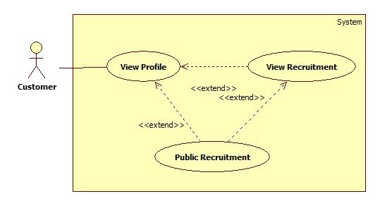

|  |  |  |  |  |
| --- | --- | --- | --- | --- |
| **USE CASE SPECIFICATION** | | | | |
| **Use-case No.** | UC030 | **Use-case Version** | | 1.0 |
| **Use-case Name** | Public Recruitment | | | |
| **Author** | TuanBT | | | |
| **Date** | 24/09/2014 | **Priority** | High | |
| **Actor:** Customer  **Summary:** This use case allow customer to public a job request for customer to apply  **Goal:** User can public a recruitment  **Trigger:** User clicks “Công khai” button  **Pre-conditions:**   * Page is loaded successfully * User login as customer successfully   **Post conditions:**   * Success: Public customer successfully, status of customer is changed from “Hide” to “Waiting” * Failure: Show error message   **Main Success Scenario:**   |  |  | | --- | --- | | Actor Action | System Response | | 1. Login as a customer 2. Click name link 3. Click a Recruitment in tab “Tạm ẩn” 4. Click “Công khai” button | 1. System redirect home page 2. System redirect personal profile page 3. System redirects to Recruitment detail page and displays “Tình trạng: Đang chờ”   [Exception 1] |   **Alternative Scenario:**   |  |  | | --- | --- | | Actor Action | System Response | | [Alternative 1]   1. Click a maid name link in maids list 2. Choose a recruitment in tab “Tạm ẩn”. Then click title job request link. 3. Click “Công khai” button | 1. System redirects to maid profile page 2. System redirect to job request details page 3. Change Status(“Hide”) to Status(“Waiting”) |   **Exceptions:**   |  |  | | --- | --- | | Actor Action | System Response | | [Exception 1]   1. Job request does not exist | 1. Show error message |   **Relationships:** Is an extension of View Profile and View Recruitment  **Business Rules:**   * Customer can only public his/her own posted recruitment. * Only recruitments with “Hide” status and isActive is true can be publicised. * The status of the recruitment changes to “Waiting” in database. | | | | |

###### <Customer> Post Recruitment

Figure 37: <Customer> Post Recruitment 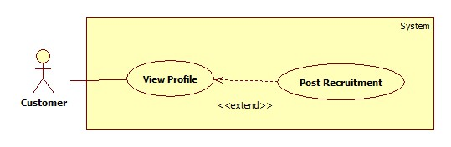

|  |  |  |  |  |
| --- | --- | --- | --- | --- |
| **USE CASE SPECIFICATION** | | | | |
| **Use-case No.** | UC031 | **Use-case Version** | | 1.0 |
| **Use-case Name** | Post Recruitment | | | |
| **Author** | TuanBT | | | |
| **Date** | 24/09/2014 | **Priority** | High | |
| **Actor:** Customer  **Summary:** This use case allow customer to post recruitment  **Goal:** Customer can post recruitment  **Trigger:** User clicks “Đăng yêu cầu tuyển việc” link in personal profile page  **Pre-conditions:**   * Page is loaded successfully * User login as customer successful   **Post conditions:**   * Success: Post recruitment successfully, new recruitment and skill reference are added to database * Failure: Show error message   **Main Success Scenario:**   |  |  | | --- | --- | | Actor Action | System Response | | 1. Login as a customer 2. Click the name link 3. Click “Đăng yêu cầu tuyển việc” link 4. Fill all the fields 5. Click “Đăng yêu cầu” button | 1. System redirects to homepage 2. System redirects to personal profile page 3. System redirect post jobrequest page with following fields  * Tiêu đề [Title: dropdownlist] * Các kỹ năng [SkillRefId: textbox] * Thời hạn đăng [PostTime: textbox] * “Đăng yêu cầu” button   [Exception 1]   1. System redirects to new recruitment’s detail page |   **Alternative Scenario: N/A**  **Exceptions:**   |  |  | | --- | --- | | Actor Action | System Response | | [Exception 1]   1. “Tiêu đề” is empty 2. “Các kỹ năng” is empty | 1. Show message “Vui lòng nhập tiêu đề” 2. Show message “Vui lòng chọn kĩ năng” |   **Relationships:** Is an extension of View Profile  **Business Rules:**   * Only customer can post recruitment. * After posting a recruitment, new record is created in Recruitment and SkillReference table in database, new recruitment has “Waiting” status and isActive is false. * Customer must pay on PayPal to activate the recruitment. * After paying, the isActive of recruitment changes to True. * If the paying process fails by whatever reason, customer can contact Staff through Contact link in Recruitment page. After that, staff goes to PayPal page to check if the recruitment is paid or not to activate the recruitment directly. | | | | |

###### <Customer> Edit Recruitment

Figure 38: <Customer> Edit Recruitment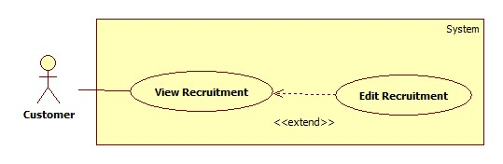

|  |  |  |  |  |
| --- | --- | --- | --- | --- |
| **USE CASE SPECIFICATION** | | | | |
| **Use-case No.** | UC032 | **Use-case Version** | | 1.0 |
| **Use-case Name** | Edit Recruitment | | | |
| **Author** | TuanBT | | | |
| **Date** | 24/09/2014 | **Priority** | High | |
| **Actor:** Customer  **Summary:** This use case allow customer to edit recruitment  **Goal:** Customer can edit recruiment  **Trigger:** User click “Sửa thông tin tuyển người giúp việc” link in recruitment detail page  **Pre-conditions:**   * Page is loaded successfully * User login as customer successful   **Post conditions:**   * Success: Edit recruitment successfully, job request’s detail and skill reference’s detail are updated in database * Failure: Show error message   **Main Success Scenario:**   |  |  | | --- | --- | | Actor Action | System Response | | 1. Login as a customer  3. Click the name link  5. Click a job request link in “Chưa kích hoạt” tab  7. Click “Sửa thông tin tuyển người giúp việc” link  9. Fill all the fields  11. Click “Sửa yêu cầu” button | 2. System redirects to homepage  4. System redirects to personal profile page  6. System redirects to job request detail page  8. System redirects to job request editing page displaying following fields with info of the job request accordingly:   * Tiêu đề [Title: dropdownlist] * Các kỹ năng [SkillRefId: textbox] * “Sửa yêu cầu” button   [Exception 1]  10. System redirects to edited job request’s detail page |   **Alternative Scenario: N/A**  **Exceptions:**   |  |  | | --- | --- | | Actor Action | System Response | | 1. Recruitment is active  [Exception 1]  3. “Tiêu đề” is empty  5. “Các kỹ năng” is empty | 2. Show alert message “Yêu cầu đã hết hạn cho sửa”  4. Show message “Vui lòng nhập tiêu đề”  6. Show message “Vui lòng chọn kĩ năng” |   **Relationships:** Is an extension of View Recruitment  **Business Rules:**   * Only customer who posted the recruitment can edit the recruitment. * Only recruitment with isActive is false can be edited. | | | | |

##### <Customer> Pay

Figure 39: <Customer> Pay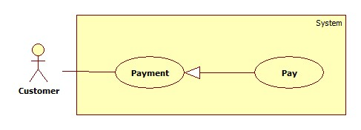

|  |  |  |  |  |
| --- | --- | --- | --- | --- |
| **USE CASE SPECIFICATION** | | | | |
| **Use-case No.** | UC033 | **Use-case Version** | | 1.0 |
| **Use-case Name** | Pay | | | |
| **Author** | TuanBT | | | |
| **Date** | 24/09/2014 | **Priority** | High | |
| **Actor:** Customer  **Summary:** Customer will pay online by Paypal for their recruitment.  **Goal:**  Pay online by Paypal.  **Trigger:** Post success a recruitment.  **Pre-conditions:**   * User must login with customer role * Paypal button will be shown   **Post conditions:**   * Success: Status of recruitment change to Watting mean “Đang chờ người làm”. * Failure: Button Paypal not hide.   **Main Success Scenario:**   |  |  | | --- | --- | | Actor Action | System Response | | 1. Click Paypal button.  3. Do pay money. | 2. System redirect to Paypal Page.  4. Button Paypal hide, status of Recruitment change to “Đang chờ người làm”.  [Exception 1] |   **Alternative Scenario:**   |  |  | | --- | --- | | Actor Action | System Response | | [Alternative 1]  1. Customer click a Recruitment form “Hết hạn” tab in Profile page. Then Click “Gia hạn” button.  3. Click Paypal button.  5. Do pay money.  [Alternative 2]  1. Customer click title a Recruitment from “Hết hạn” tab in Profile page.  3. Click “Gia hạn” button.  5. Do pay money. | 2. System show “Gia hạn đơn tuyển việc” modal.  4. System redirect to Paypal page.  6. Button Paypal hide, status of Recruitment change to “Đang chờ người làm”.  [Exception 1]  2. System redirect to “Tin tìm người giúp việc” page.  4. System redirect to Paypal page.  6. Button Paypal hide, status of Recruitment change to “Đang chờ người làm”.  [Exception 1] |   **Exceptions:**   |  |  | | --- | --- | | Actor Action | System Response | | [Exception 1]  1. Paypal page not return MS-Website. | 2. Paypal button not Hide. |   **Relationships:** Pay is generalization Payment  **Business Rules:**   * Only customer must pay on PayPal when posting or extending a recruitment. * The email of the account on PayPal must be the same as the email of the account in MS Website in order for Staff to check when the paying process fails. | | | | |

##### <Customer> View Customer Statistic

Figure 40: <Customer> View Customer Statistic

|  |  |  |  |  |
| --- | --- | --- | --- | --- |
| **USE CASE SPECIFICATION** | | | | |
| **Use-case No.** | UC034 | **Use-case Version** | | 1.0 |
| **Use-case Name** | View Customer Statistic | | | |
| **Author** | TuanBT | | | |
| **Date** | 24/09/2014 | **Priority** | High | |
| **Actor:** Customer  **Summary:** This use case allow customer to view personal statistic as customer  **Goal:** Customer can view personal statistic  **Trigger:** User clicks “Thống kê” link in personal profile page  **Pre-conditions:**   * Page is loaded successfully * User login as customer successful   **Post conditions:**   * Success: Personal Statistic page is loaded successfully * Failure: Show error message   **Main Success Scenario:**   |  |  | | --- | --- | | Actor Action | System Response | | 1. Login as a customer  3. Click the name link  5. Click “Thống kê” link | 2. System redirects to homepage  4. System redirects to personal profile page  6. System redirects to personal statistic page  [Exception 1] |   **Alternative Scenario: N/A**  **Exceptions:**   |  |  | | --- | --- | | Actor Action | System Response | | [Exception 1]   1. System fail to load data | 1. Show message error “Hệ thống đang bảo trì” |   **Relationships:** Is a generalization of View Statistic  **Business Rules:** User login as customer. | | | | |

##### <Staff, Maid Mediator> Manage Maid

Figure 41: <Staff, Maid Mediator> Manage Maid

###### <Staff, Maid Mediator> Add Maid

Figure 42: <Staff, Maid Mediator> Add Maid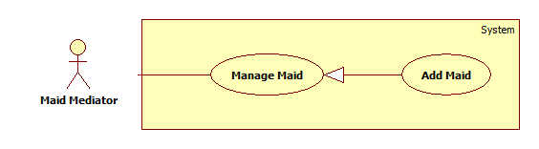

|  |  |  |  |  |
| --- | --- | --- | --- | --- |
| **USE CASE SPECIFICATION** | | | | |
| **Use-case No.** | UC035 | **Use-case Version** | | 1.0 |
| **Use-case Name** | Add maid | | | |
| **Author** | TuyenMQ | | | |
| **Date** | 21/09/2014 | **Priority** | High | |
| **Actor:** Staff, Maid Mediator  **Summary:** This use case allow maid mediator or staff to add maid for management.  **Goal:** Maid mediator orstaff can add maid  **Trigger:** User clicks button “Thêm người giúp việc” at the top of maids list in profile page  **Pre-conditions:**   * Page is loaded successfully * User login as maid mediator or staff successful   **Post conditions:**   * Success: Add maid successfully, new maid is added to database * Failure: Show error message   **Main Success Scenario:**   |  |  | | --- | --- | | Actor Action | System Response | | 1. Login as a maid mediator or staff 2. Click name link 3. Click “Thêm người giúp việc” button 4. Fill all the fields 5. Click “Hoàn tất thêm người giúp việc” button | 1. System redirects to home page 2. System redirects to personal profile page 3. System redirects to add maid page with following fields:  * Họ và tên [MaidName: textbox] * Kinh nghiệm [Experience: dropdownlist] * Số điện thoại [Phone: textbox] * Ngày sinh [BirthDate: textbox] * Giới tính [Gender: dropdownlist] * Biết tiếng [LanguageEnglish: checkbox, LanguageChina: checkbox, LanguageJapanese: checkbox, LanguageKorean: checkbox] * Nguyên quán [Hometown: dropdownlist] * Đang sống tại [Address: dropdownlist] * Kết hôn [Married: dropdownlist] * Giới thiệu bản thân [Description: textbox] * “Hoàn tất thêm người giúp việc” button.   [Exception 1]   1. System redirects to personal profile page |   **Alternative Scenario: N/A**  **Exceptions:**   |  |  | | --- | --- | | Actor Action | System Response | | [Exception 1]   1. “Họ và tên” is empty 2. “Số điện thoại” is empty or not a numberic value 3. “Ngày sinh” is empty | 1. Show message “Vui lòng nhập tên người giúp việc” 2. Show message “Vui lòng nhập số” 3. Show message “Vui lòng chọn ngày sinh” |   **Relationships:** Is a generalization of Manage Maid  **Business Rules:**   * Only Staff and Maid Mediator can add maid to manage. * After adding, new record is created in Maid table in database. | | | | |

###### <Authenticated user> View Maid

Figure 43: <Authenticated user> View Maid

|  |  |  |  |  |
| --- | --- | --- | --- | --- |
| **USE CASE SPECIFICATION** | | | | |
| **Use-case No.** | UC036 | **Use-case Version** | | 1.0 |
| **Use-case Name** | View maid | | | |
| **Author** | TuyenMQ | | | |
| **Date** | 21/09/2014 | **Priority** | High | |
| **Actor:** Authenticated user (Staff, Maid Mediator, Customer, Admin)  **Summary:** This use case allow logged user to view a maid’s detail.  **Goal:** User can view a maid’s detail.  **Trigger:** User clicks the name link of a maid.  **Pre-conditions:**   * Page is loaded successfully * User login successfully   **Post conditions:**   * Success: Maid detail page is displayed * Failure: Show error message   **Main Success Scenario:**   |  |  | | --- | --- | | Actor Action | System Response | | 1. Login as Staff 2. Click the name link 3. Click a maid name in maids list | 1. System redirects to personal page 2. System redirects to maid profile page   [Exception 1] |   **Alternative Scenario: N/A**  **Exceptions:**   |  |  | | --- | --- | | Actor Action | System Response | | [Exception 1]   1. System fail to load data | 1. Show message error “không tìm thấy người giúp việc này” |   **Relationships:** Is a generalization of Manage Maid  **Business Rules:**   * Only logged user can view maid’s profile. | | | | |

###### <Staff, Maid Mediator> Edit Maid

Figure 44: <Staff, Maid Mediator> Edit Maid

|  |  |  |  |  |
| --- | --- | --- | --- | --- |
| **USE CASE SPECIFICATION** | | | | |
| **Use-case No.** | UC037 | **Use-case Version** | | 1.0 |
| **Use-case Name** | Edit maid | | | |
| **Author** | TuyenMQ | | | |
| **Date** | 21/09/2014 | **Priority** | High | |
| **Actor:** Staff, Maid Mediator  **Summary:** This use case allow staff edit a maid’s info  **Goal:** User can edit info of a maid  **Trigger:** User clicks “Sửa thông tin người giúp việc” link in maid profile page  **Pre-conditions:**   * Page is loaded successfully * User login as staff or maid mediator successful   **Post conditions:**   * Success: Edit maid’s info successfully and save to database * Failure: Show error message   **Main Success Scenario:**   |  |  | | --- | --- | | Actor Action | System Response | | 1. Login as a staff or maid mediator 2. Click name link 3. Click maid name link in maids list 4. Click “Sửa thông tin người giúp việc” link 5. Fill all the field 6. Click “Cập nhật thông tin” button | 1. System redirect home page 2. System redirect personal profile page 3. System redirect maid profile page 4. System redirect add maid page with following fields which displays the maid’s info accordingly:  * Họ và tên [MaidName: textbox] * Kinh nghiệm [Experience: dropdownlist] * Số điện thoại [Phone: textbox] * Ngày sinh [BirthDate: textbox] * Giới tính [Gender: dropdownlist] * Biết tiếng [LanguageEnglish: checkbox, LanguageChina: checkbox, LanguageJapanese: checkbox, LanguageKorean: checkbox] * Nguyên quán [Hometown: dropdownlist] * Đang sống tại [Address: dropdownlist] * Kết hôn [Married: dropdownlist] * Giới thiệu bản thân [Description: textbox] * Ảnh đại diện [Image uploading] * “Cập nhật thông tin” button.   [Exception 1]   1. System redirects to maid profile page |   **Alternative Scenario: N/A**  **Exceptions:**   |  |  | | --- | --- | | Actor Action | System Response | | [Exception 1]   1. “Họ và tên” is empty 2. “Số điện thoại” is empty or not a numberic value 3. “Ngày sinh” is empty | 1. Show message “Vui lòng nhập tên người giúp việc” 2. Show message “Vui lòng nhập số” 3. Show message “Vui lòng chọn ngày sinh” |   **Relationships:** Is an extension of View Maid  **Business Rules:**   * Only Staff or Maid Mediator who manages the maid can edit maid’s profile. * After editing, maid’s info is updated in Maid table in database. | | | | |

##### <Staff, Maid Mediator> Public Job Request

Figure 45: <Staff, Maid Mediator> Public Job Request

|  |  |  |  |  |
| --- | --- | --- | --- | --- |
| **USE CASE SPECIFICATION** | | | | |
| **Use-case No.** | UC038 | **Use-case Version** | | 1.0 |
| **Use-case Name** | Public Job Request | | | |
| **Author** | TuyenMQ | | | |
| **Date** | 21/09/2014 | **Priority** | High | |
| **Actor:** Staff, Maid Mediator  **Summary:** This use case allow staff or maid mediator to public a job request for customer to apply  **Goal:** User can public a job request  **Trigger:** User clicks “Công khai” button  **Pre-conditions:**   * Page is loaded successfully * User login as staff or maid mediator successfully   **Post conditions:**   * Success: Public job request successfully, status of job request is changed from “Hide” to “Waiting” * Failure: Show error message   **Main Success Scenario:**   |  |  | | --- | --- | | Actor Action | System Response | | 1. Login as a staff or maid mediator 2. Click name link 3. Click a job request in tab “Tạm ẩn”   [Alternative 1]   1. Click “Công khai” button | 1. System redirect home page 2. System redirect personal profile page 3. System redirects to job request detail page and displays “Tình trạng: Đang chờ”   [Exception 1] |   **Alternative Scenario:**   |  |  | | --- | --- | | Actor Action | System Response | | [Alternative 1]   1. Choose a job request in tab “Tạm ẩn”. Then click title job request link. 2. Click “Công khai” button | 1. System redirect to job request details page 2. Change Status(“Hide”) to Status(“Waiting”) |   **Exceptions:**   |  |  | | --- | --- | | Actor Action | System Response | | [Exception 1]   1. System fail to change data | 1. Show message error “không thể công khai yêu cầu này” |   **Relationships:** Is an extension of View Maid and View Job Request  **Business Rules:**   * Staff or Maid Mediator can only public his/her own posted recruitment. * Only Job Requests with “Hide” status and isActive is true can be publicised. * The status of the Job Request changes to “Waiting” in database. | | | | |

##### <Staff, Maid Mediator> Hide Job Request

Figure 46: <Staff, Maid Mediator> Hide Job Request 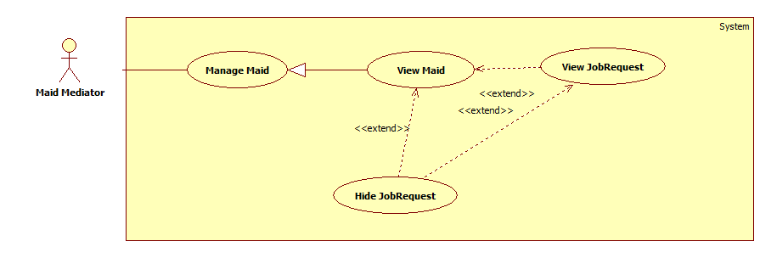

|  |  |  |  |  |
| --- | --- | --- | --- | --- |
| **USE CASE SPECIFICATION** | | | | |
| **Use-case No.** | UC039 | **Use-case Version** | | 1.0 |
| **Use-case Name** | Hide Job Request | | | |
| **Author** | TuyenMQ | | | |
| **Date** | 21/09/2014 | **Priority** | High | |
| **Actor:** Staff, Maid Mediator  **Summary:** This use case allow staff or maid mediator to hide a job request and can’t be applied by any customer  **Goal:** User can hide a job request  **Trigger:** User clicks “Tạm ẩn” button  **Pre-conditions:**   * Page is loaded successfully * User login as staff or maid mediator successfully   **Post conditions:**   * Success: Hide job request successfully, status of job request is changed from “Waiting” to “Hide” * Failure: Show error message   **Main Success Scenario:**   |  |  | | --- | --- | | Actor Action | System Response | | 1. Login as a staff or maid mediator  2. Click name link  4. Click a job request in tab “Đang chờ”  [Alternative 1]  6. Click “Tạm ẩn” button | 3. System redirect home page  5. System redirect personal profile page  7. System redirects to job request detail page and displays “Tình trạng: Tạm ẩn”  [Exception 1] |   **Alternative Scenario:**   |  |  | | --- | --- | | Actor Action | System Response | | [Alternative 1]   1. Click a maid name link in maids list 2. Choose a job request in tab except “Đang chờ” or “Hết hạn” or “Hoàn tất” tab. Then click title job request link. 3. Click “Tạm ẩn” button | 1. System redirects to maid profile page 2. System redirect to job request details page 3. Change Status(“Waiting”) to Status(“Hide”) |   **Exceptions:**   |  |  | | --- | --- | | Actor Action | System Response | | [Exception 1]   1. Job request does not exist | 1. Show error message |   **Relationships:** Is an extension of View Maid and View Job Request  **Business Rules:**   * Customer can only hide his/her own posted Job Requests. * Only Job Requests with “Waiting” status and isActive is true can be hidden. * The status of the Job Request changes to “Hide” in database. * Hidden Job Request can’t be applied or view by the others. | | | | |

##### <Staff, MaidMediator> Extend Job Request

Figure 47: <Staff, MaidMediator> Extend Job Request 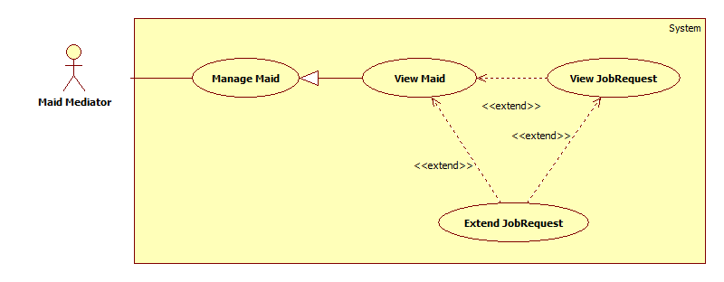

|  |  |  |  |  |
| --- | --- | --- | --- | --- |
| **USE CASE SPECIFICATION** | | | | |
| **Use-case No.** | UC040 | **Use-case Version** | | 1.0 |
| **Use-case Name** | Extend Job Request | | | |
| **Author** | TuyenMQ | | | |
| **Date** | 21/09/2014 | **Priority** | High | |
| **Actor:** Staff, Maid Mediator  **Summary:** This use case allow staff or maid mediator to extend job request  **Goal:** Staff or maid mediator can extend job request  **Trigger:** User clicks “Gia hạn” button  **Pre-conditions:**   * Page is loaded successfully * User login as staff or maid mediator successful   **Post conditions:**   * Success: Extend job request successfully, job request’s expired date is updated in database and status changes from “Expired” to “Waiting” * Failure: Show error message   **Main Success Scenario:**   |  |  | | --- | --- | | Actor Action | System Response | | [Alternative 1]   1. Login as a staff or maid mediator 2. Click the name link 3. Click a maid name link in maids list 4. Choose a job request in any tab except “Được nhận” and “Hoàn tất” tabs 5. Click “Gia hạn” button 6. Click “Đồng ý” button | 1. System redirects to homepage 2. System redirects to personal profile page 3. System redirects to maid profile page 4. A modal pops up with a dropdown list for user to choose the extending time 5. System redirects to extended job request’s detail page   [Exception 1] |   **Alternative Scenario:**   |  |  | | --- | --- | | Actor Action | System Response | | [Alternative 1]   1. Login as a customer 2. Click the name link 3. Click a maid name link in maids list 4. Choose a recruitment in tab except “Hết hạn” tab. Then click title job request link. 5. Click “Gia hạn” button | 1. System redirects to homepage 2. System redirects to personal profile page 3. System redirects to maid profile page 4. System redirect to recruitment details page 5. A modal pops up with a dropdown list for user to choose the extending time   [Exception 1] |   **Exceptions:**   |  |  | | --- | --- | | Actor Action | System Response | | 1. Job request was applied | 1. Show alert message “Công việc đã được thuê” |   **Relationships:** Is an extension of View Profile  **Business Rules:**   * Only Staff can extend a Job Request. * If a maid mediator or maid want to extend a Job Request, he/she must pay to Staff directly in order for Staff to extend it. * After extending, the expired date of the job request is updated in database and the status is set to “Waiting”. | | | | |

##### <Staff, MaidMediator> Edit JobRequest

Figure 48: <Staff, MaidMediator> Edit JobRequest 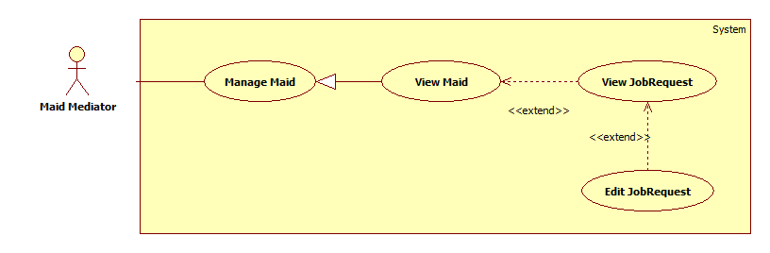

|  |  |  |  |  |
| --- | --- | --- | --- | --- |
| **USE CASE SPECIFICATION** | | | | |
| **Use-case No.** | UC041 | **Use-case Version** | | 1.0 |
| **Use-case Name** | Edit JobRequest | | | |
| **Author** | TuyenMQ | | | |
| **Date** | 21/09/2014 | **Priority** | High | |
| **Actor:** Staff, Maid Mediator  **Summary:** This use case allow staff or maid mediator to edit job request  **Goal:** Staff or maid mediator can edit job request  **Trigger:** User click “Sửa yêu cầu công việc” link in job request detail page  **Pre-conditions:**   * Page is loaded successfully * User login as staff or maid mediator successful   **Post conditions:**   * Success: Edit job request successfully, job request’s detail and skill reference’s detail are updated in database * Failure: Show error message   **Main Success Scenario:**   |  |  | | --- | --- | | Actor Action | System Response | | 1. Login as a staff or maid mediator 2. Click the name link 3. Click a maid name link in maids list 4. Click a job request link in “Chưa kích hoạt” tab 5. Click “Sửa thông tin yêu cầu công việc” link 6. Fill all the fields 7. Click “Sửa yêu cầu” button | 1. System redirects to homepage 2. System redirects to personal profile page 3. System redirects to job request detail page 4. System redirects to job request editing page displaying following fields with info of the job request accordingly:  * Đăng cho [MaidName: textbox] * Tiêu đề [Title: dropdownlist] * Các kỹ năng [SkillRefId: textbox] * “Sửa yêu cầu” button   [Exception 1]   1. System redirects to edited job request’s detail page |   **Alternative Scenario: N/A**  **Exceptions:**   |  |  | | --- | --- | | Actor Action | System Response | | [Exception 1]   1. Job request is active 2. “Đăng cho” is empty 3. “Tiêu đề” is empty 4. “Các kỹ năng” is empty | 1. Show alert message “Công việc đã hết hạn cho sửa” 2. Show message “Vui lòng chọn người giúp việc” 3. Show message “Vui lòng nhập tiêu đề” 4. Show message “Vui lòng chọn kĩ năng” |   **Relationships:** Is an extension of View Job Request  **Business Rules:**   * Only Staff or Maid Mediator can edit his/her own posted Job Requests. * Only Job Request with isActive is false can be edited. * After editing, the Job Request’s detail is updated in database. | | | | |

##### <Staff, MaidMediator> Edit Maid Mediator Profile

Figure 49: <Staff, MaidMediator> Edit Maid Mediator Profile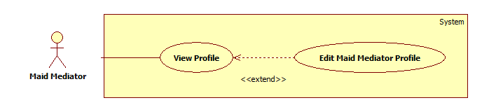

|  |  |  |  |  |
| --- | --- | --- | --- | --- |
| **USE CASE SPECIFICATION** | | | | |
| **Use-case No.** | UC042 | **Use-case Version** | | 1.0 |
| **Use-case Name** | Edit Maid Mediator Profile | | | |
| **Author** | TuyenMQ | | | |
| **Date** | 21/09/2014 | **Priority** | High | |
| **Actor:** Staff, Maid Mediator  **Summary:** This use case allow staff or maid mediator to edit profile  **Goal:** Staff or maid mediator can edit profile  **Trigger:** User clicks “Sửa thông tin cá nhân” link in personal profile page  **Pre-conditions:**   * Page is loaded successfully * User login as staff or maid mediator successful   **Post conditions:**   * Success: Edit profile successfully, profile detail is updated in database * Failure: Show error message   **Main Success Scenario:**   |  |  | | --- | --- | | Actor Action | System Response | | 1. Login as a staff or maid mediator 2. Click the name link 3. Click “Sửa thông tin cá nhân” link 4. Fill all the fields 5. Click “Cập nhật thông tin” button | 1. System redirects to homepage 2. System redirects to personal profile page 3. System redirects to profile editing page displaying following fields with info of the job request accordingly:  * Họ và tên [FullName: textbox] * Số điện thoại [Phone: textbox] * Email [Email: textbox] * Ảnh đại diện [Image uploading] * “Cập nhật thông tin” button   [Exception 1]   1. System redirects to personal profile page with updated info |   **Alternative Scenario: N/A**  **Exceptions:**   |  |  | | --- | --- | | Actor Action | System Response | | [Exception 1]   1. “Họ và tên” is empty 2. “Số điện thoại” is empty or char inputted 3. “Email” is empty or wrong format | 1. Show message “Vui lòng nhập tên người quản lý” 2. Show message “Vui lòng nhập số” 3. Show message “Vui lòng nhập đúng định dạng abc@abc.ab” |   **Relationships:** Is an extension of View Profile  **Business Rules:** User can only edit his/her own profile. | | | | |

##### <Staff, MaidMediator> Post JobRequest

Figure 50: <Staff, MaidMediator> Post JobRequest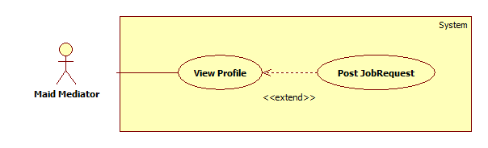

|  |  |  |  |  |
| --- | --- | --- | --- | --- |
| **USE CASE SPECIFICATION** | | | | |
| **Use-case No.** | UC043 | **Use-case Version** | | 1.0 |
| **Use-case Name** | Post JobRequest | | | |
| **Author** | TuyenMQ | | | |
| **Date** | 21/09/2014 | **Priority** | High | |
| **Actor:** Staff, Maid Mediator  **Summary:** This use case allow staff or maid mediator to post job request  **Goal:** Staff or maid mediator can post job request  **Trigger:** User clicks “Đăng yêu cầu tìm việc” link in personal profile page  **Pre-conditions:**   * Page is loaded successfully * User login as staff or maid mediator successful   **Post conditions:**   * Success: Post job request successfully, new job request and skill reference are added to database * Failure: Show error message   **Main Success Scenario:**   |  |  | | --- | --- | | Actor Action | System Response | | 1. Login as a staff or maid mediator 2. Click the name link 3. Click “Đăng yêu cầu công việc” link 4. Fill all the fields 5. Click “Đăng yêu cầu” button | 1. System redirects to homepage 2. System redirects to personal profile page 3. System redirect post jobrequest page with following fields:  * Đăng cho [MaidName: textbox] * Tiêu đề [Title: dropdownlist] * Các kỹ năng [SkillRefId: textbox] * Thời hạn đăng [PostTime: textbox] * “Đăng yêu cầu” button   [Exception 1]   1. System redirects to new job request’s detail page |   **Alternative Scenario: N/A**  **Exceptions:**   |  |  | | --- | --- | | Actor Action | System Response | | [Exception 1]   1. “Đăng cho” is empty 2. “Tiêu đề” is empty 3. “Các kỹ năng” is empty | 1. Show message “Vui lòng chọn người giúp việc” 2. Show message “Vui lòng nhập tiêu đề” 3. Show message “Vui lòng chọn kĩ năng” |   **Relationships:** Is an extension of View Profile  **Business Rules:**   * Only Staff or Maid Mediator can post Job Request. * User must choose a maid who is under his/her management to post the Job Request for. * After posting, new record is created in Job Request table and SkillReference table in database, the Job Request has “Waiting” status and isActive is false. * If the Job Request is posted by Maid Mediator, the Maid Mediator or Maid must pay to Staff directly in order for Staff to activate it. After that, the Job Request’s isActive changes to True in database. | | | | |

##### <Staff> Manage JobRequest and Recruitment

Figure 51: <Staff> Manage JobRequest and Recruitment 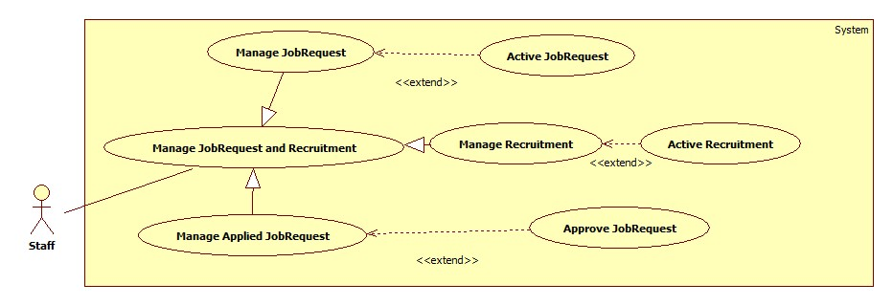

###### <Staff> Active JobRequest

Figure 52: <Staff> Active JobRequest 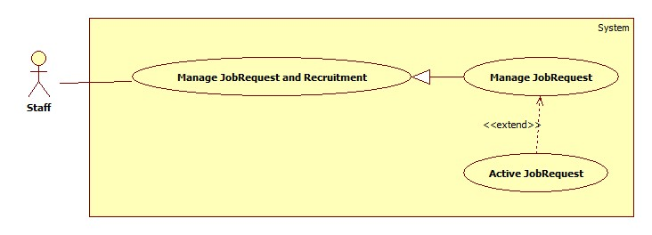

|  |  |  |  |  |
| --- | --- | --- | --- | --- |
| **USE CASE SPECIFICATION** | | | | |
| **Use-case No.** | UC044 | **Use-case Version** | | 1.0 |
| **Use-case Name** | Active JobRequest | | | |
| **Author** | CongNT | | | |
| **Date** | 21/09/2014 | **Priority** | High | |
| **Actor:** Staff  **Summary:** This use case allow staff to active job request to public it on website  **Goal:** Staff can allow job request to public on website  **Trigger:** User choose a job request then click “Chấp nhận” button  **Pre-conditions:**   * Page is loaded successfully * User login as staff successful   **Post conditions:**   * Success: Login successfully, the job request will be allowed to public on website * Failure:   **Main Success Scenario:**   |  |  | | --- | --- | | Actor Action | System Response | | 1. Login as a staff 2. Choose a job request, click “Kích hoạt” button 3. Click “Chấp nhận” button. | 1. System redirect to list of job request 2. System show a “Xác nhận kích hoạt” pop up. 3. Change IsActive(false) to IsActive(true) and save change to database   [Exception 1] |   **Alternative Scenario: N/A**  **Exceptions:**   |  |  | | --- | --- | | Actor Action | System Response | | 1. System fail to load data | 1. Show message “Hệ thống đang bảo trì” |   **Relationships:** Active JobRequest is extended to ManageJobRequest and Manage JobRequest is generated to Manage JobRequest and Recruitment.  **Business Rules:** User login as a staff. | | | | |

###### <Staff> Active Recruitment

Figure 53: <Staff> Active Recruitment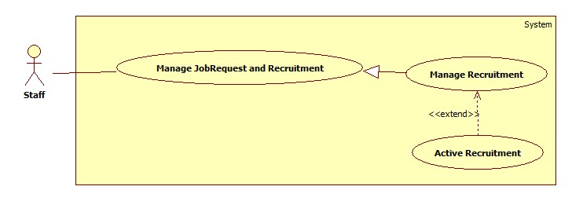

|  |  |  |  |  |
| --- | --- | --- | --- | --- |
| **USE CASE SPECIFICATION** | | | | |
| **Use-case No.** | UC045 | **Use-case Version** | | 1.0 |
| **Use-case Name** | Active Recruitment | | | |
| **Author** | CongNT | | | |
| **Date** | 21/09/2014 | **Priority** | High | |
| **Actor:** Staff  **Summary:** This use case allow staff to active job request to public it on website  **Goal:** Staff can allow job request to public on website  **Trigger:** User choose a recruitment then click “Chấp nhận” button  **Pre-conditions:**   * Page is loaded successfully * User login as staff successful   **Post conditions:**   * Success: Login successfully, the job request will be allowed to public on website * Failure: Cannot active recruitment   **Main Success Scenario:**   |  |  | | --- | --- | | Actor Action | System Response | | 1. Login as a staff 2. Click “Xác nhận hoàn tất công việc” link 3. Choose a recruitment, click “Hoàn tất” button 4. Click “Chấp nhận” button. | 1. System redirect to list of job request 2. System redirect to list of applied job requests 3. System show a “Xác nhận kích hoạt” pop up. 4. Change IsActive(false) to IsActive(true) and save change to database   [Exception 1] |   **Alternative Scenario: N/A**  **Exceptions:**   |  |  | | --- | --- | | Actor Action | System Response | | [Exception 1]   1. System fail to change data | 1. Show message “Không thể kích hoạt yêu cầu này” |   **Relationships:** Active Recruitment is extended to Manage Recruitment and Manage Recruitment is generated to Manage JobRequest and Recruitment.  **Business Rules:**   * Staff can activate the recruitment directly if the paying process of customer failed. | | | | |

###### C:\Users\USER\Desktop\ApproveJR.jpg<Staff> Approve JobRequest

Figure 54: <Staff> Approve JobRequest

|  |  |  |  |  |
| --- | --- | --- | --- | --- |
| **USE CASE SPECIFICATION** | | | | |
| **Use-case No.** | UC046 | **Use-case Version** | | 1.0 |
| **Use-case Name** | Approve JobRequest | | | |
| **Author** | CongNT | | | |
| **Date** | 21/09/2014 | **Priority** | High | |
| **Actor:** Staff  **Summary:** This use case allow staff to active job request to public it on website  **Goal:** Staff can allow job request to public on website  **Trigger:** User choose a jobrequest then click “Kích hoạt” button  **Pre-conditions:**   * Page is loaded successfully * User login as staff successful   **Post conditions:**   * Success: Login successfully, the job request will be allowed to public on website * Failure: Cannot approve job request   **Main Success Scenario:**   |  |  | | --- | --- | | Actor Action | System Response | | 1. Login as a staff 2. Click “Kích hoạt yêu cầu tìm người” link 3. Choose a recruitment, click “Kích hoạt” button 4. Click “Chấp nhận” button. | 1. System redirect to list of job request 2. System redirect to list of recruitments 3. System show a “Xác nhận kích hoạt” pop up. 4. Change IsActive(false) to IsActive(true) and save change to database   [Exception 1] |   **Alternative Scenario: N/A**  **Exceptions:**   |  |  | | --- | --- | | Actor Action | System Response | | [Exception 1]   1. System fail to change data | 1. Show message “Không thể xác nhận hoàn tất yêu cầu này” |   **Relationships:** Approve JobRequest is extended to Manage Applied JobRequest and Manage Applied JobRequest is generated to Manage JobRequest and Recruitment.  **Business Rules:**   * Only Job Requests with “Applied” status can be marked “Approved”. * The status of the Job Request changes to “Approved”. * After the Job Request is applied, the Maid or Maid Mediator can come back to confirm it to get some money back. Staff marks the Job Request “Approved” after returning the money. | | | | |

###### C:\Users\USER\Desktop\ManageJR.jpg<Staff> Manage JobRequest

Figure 55: <Staff> Manage JobRequest

|  |  |  |  |  |
| --- | --- | --- | --- | --- |
| **USE CASE SPECIFICATION** | | | | |
| **Use-case No.** | UC047 | **Use-case Version** | | 1.0 |
| **Use-case Name** | Manage jobrequest | | | |
| **Author** | CongNT | | | |
| **Date** | 21/09/2014 | **Priority** | High | |
| **Actor:** Staff  **Summary:** This use case allow staff view all jobrequests that is not active  **Goal:** Staff can view all jobrequests that is not active  **Trigger:** User click “Quản lý” link  **Pre-conditions:**   * Page is loaded successfully * User login as staff successful   **Post conditions:**   * Success: Login successfully, the job request will be allowed to public on website * Failure: Fail to load data   **Main Success Scenario:**   |  |  | | --- | --- | | Actor Action | System Response | | 1. Login as a staff | 1. System redirect to list of job request   [Exception 1] |   **Alternative Scenario: N/A**  **Exceptions:**   |  |  | | --- | --- | | Actor Action | System Response | | [Exception 1]   1. System fail to load data | 1. Show message “Hệ thống đang bảo trì” |   **Relationships:** Manage JobRequest if generated to Manage JobRequest and Recruitment  **Business Rules:** User login as a staff. The website load all jobrequests that is not active. Staff choose a jobrequest. When user choose post time for jobrequest to post on website, after that time if jobrequest is not active, it will be remove from database. | | | | |

###### <Staff> Manage Recruitment

Figure 56: <Staff> Manage Recruitment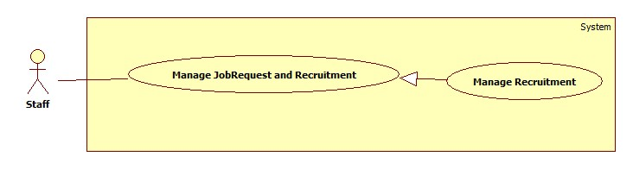

|  |  |  |  |  |
| --- | --- | --- | --- | --- |
| **USE CASE SPECIFICATION** | | | | |
| **Use-case No.** | UC048 | **Use-case Version** | | 1.0 |
| **Use-case Name** | Manage recruitment | | | |
| **Author** | CongNT | | | |
| **Date** | 21/09/2014 | **Priority** | High | |
| **Actor:** Staff  **Summary:** This use case allow staff view all recruitments that is not active  **Goal:** Staff can view all recruitments that is not active  **Trigger:** User click “Quản lý” link, then click “Kích hoạt yêu cầu tìm việc” link  **Pre-conditions:**   * Page is loaded successfully * User login as staff successful   **Post conditions:**   * Success: Login successfully, the recruitments will be allowed to public on website * Failure: Fail to load data   **Main Success Scenario:**   |  |  | | --- | --- | | Actor Action | System Response | | 1. Login as a staff 2. Click “Kích hoạt yêu cầu tìm người” link | 1. System redirect to list of job request 2. System redirect to list of recruitment   [Exception 1] |   **Alternative Scenario: N/A**  **Exceptions:**   |  |  | | --- | --- | | Actor Action | System Response | | [Exception 1]   1. System fail to load data | 1. Show message “Hệ thống đang bảo trì” |   **Relationships: :** Manage Recruitment if generated to Manage JobRequest and Recruitment  **Business Rules:** User login as a staff. The website load all recruitments that is not active. Staff choose a recruitment. When user choose post time for recruitment to post on website, after that time if recruitment is not active, it will be remove from database. | | | | |

###### C:\Users\USER\Desktop\ManageAJR.jpg<Staff> Manage Applied JobRequest

Figure 57: <Staff> Manage Applied JobRequest

|  |  |  |  |  |
| --- | --- | --- | --- | --- |
| **USE CASE SPECIFICATION** | | | | |
| **Use-case No.** | UC049 | **Use-case Version** | | 1.0 |
| **Use-case Name** | Manage applied jobrequest | | | |
| **Author** | CongNT | | | |
| **Date** | 21/09/2014 | **Priority** | High | |
| **Actor:** Staff  **Summary:** This use case allow staff view all applied jobrequests  **Goal:** Staff can view all applied jobrequests  **Trigger:** User click “Quản lý” link, then click “Xác nhận hoàn tất công việc” link  **Pre-conditions:**   * Page is loaded successfully * User login as staff successful   **Post conditions:**   * Success: Login successfully, the recruitments will be allowed to public on website * Failure:   **Main Success Scenario:**   |  |  | | --- | --- | | Actor Action | System Response | | 1. Login as a staff 2. Click “Hoàn tất yêu cầu” link | 1. System redirect to list of job request 2. System redirect to list of applied jobrequest   [Exception 1] |   **Alternative Scenario: N/A**  **Exceptions:**   |  |  | | --- | --- | | Actor Action | System Response | | [Exception 1]   1. System fail to load data | 1. Show message “Hệ thống đang bảo trì” |   **Relationships: :** Manage Applied JobRequest if generated to Manage JobRequest and Recruitment  **Business Rules:** User login as a staff. The website load all applied jobrequests. | | | | |

##### <Staff, MaidMediator> View Maid Manager Statistic

Figure 58: <Staff, MaidMediator> View Maid Manager Statistic

|  |  |  |  |  |
| --- | --- | --- | --- | --- |
| **USE CASE SPECIFICATION** | | | | |
| **Use-case No.** | UC050 | **Use-case Version** | | 1.0 |
| **Use-case Name** | View Maid Manager Statistic | | | |
| **Author** | TuyenMQ | | | |
| **Date** | 21/09/2014 | **Priority** | High | |
| **Actor:** Staff, Maid Mediator  **Summary:** This use case allow staff or maid mediator to view personal statistic as maid mediator  **Goal:** Staff or maid mediator can view personal statistic  **Trigger:** User clicks “Thống kê” link in personal profile page  **Pre-conditions:**   * Page is loaded successfully * User login as staff or maid mediator successful   **Post conditions:**   * Success: Personal Statistic page is loaded successfully * Failure: Show error message   **Main Success Scenario:**   |  |  | | --- | --- | | Actor Action | System Response | | 1. Login as a staff or maid mediator 2. Click the name link 3. Click “Thống kê” link | 1. System redirects to homepage 2. System redirects to personal profile page 3. System redirects to personal statistic page   [Exception 1] |   **Alternative Scenario: N/A**  **Exceptions:**   |  |  | | --- | --- | | Actor Action | System Response | | [Exception 1]   1. User hasn’t posted any job request | 1. The statistic diagram is not displayed |   **Relationships:** Is a generalization of View Statistic  **Business Rules:** User logins as Maid Mediator or Staff. | | | | |

##### <Webmaster> Manage Number of Kmean

Figure 59: <Webmaster> Manage Number of Kmean

|  |  |  |  |  |
| --- | --- | --- | --- | --- |
| **USE CASE SPECIFICATION** | | | | |
| **Use-case No.** | UC051 | **Use-case Version** | | 1.0 |
| **Use-case Name** | Manage Number of Kmean | | | |
| **Author** | TuanBT | | | |
| **Date** | 24/09/2014 | **Priority** | High | |
| **Actor:** Webmaster  **Summary:** Change number K of Kmean algorithm. K same number of group.  **Goal:**  Change value.  **Trigger:** Webmaster click “Quản lý cấu hình”  **Pre-conditions:**   * User must login with Admin role * Manage config page will be shown   **Post conditions:**   * Success: Reload page and change value. * Failure: Show error.   **Main Success Scenario:**   |  |  | | --- | --- | | Actor Action | System Response | | 1. Webmaster click “Quản lý cấu hình” menu, then fill input “Gợi ý số K” | 2. Show notification “Cập nhập số K thành công”.  [Exception 1] |   **Alternative Scenario: N/A**  **Exceptions:**   |  |  | | --- | --- | | Actor Action | System Response | | [Exception 1]  1. Fill input not a digit. | 2. Show error “Phải nhập số nguyên!” |   **Relationships:** Manage Number of Kmean is extend of Manage config.  **Business Rules:** Number of K must smaller than total of Jobrequest or Recruitment. | | | | |

##### <Webmaster> Manage Number of Weeks

Figure 60: <Webmaster> Manage Number Of Weeks 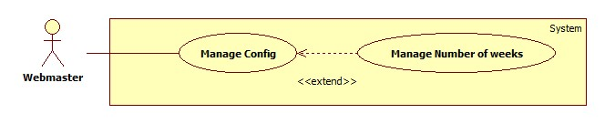

|  |  |  |  |  |
| --- | --- | --- | --- | --- |
| **USE CASE SPECIFICATION** | | | | |
| **Use-case No.** | UC052 | **Use-case Version** | | 1.0 |
| **Use-case Name** | Manage Number of weeks | | | |
| **Author** | TuanBT | | | |
| **Date** | 24/09/2014 | **Priority** | High | |
| **Actor:** Webmaster  **Summary:** Change maximum week when user post a JoRequest or Recruiment in to MS-Website.  **Goal:**  Change value.  **Trigger:** Webmaster click “Quản lý cấu hình”  **Pre-conditions:**   * User must login with Admin role * Manage config page will be shown   **Post conditions:**   * Success: Reload page and change value. * Failure: Show error.   **Main Success Scenario:**   |  |  | | --- | --- | | Actor Action | System Response | | 1. Webmaster click “Quản lý cấu hình” menu, then fill input “Số mới” | 2. Show notification “Cập nhập số tuần thành công.”  [Exception 1] |   **Alternative Scenario: N/A**  **Exceptions:**   |  |  | | --- | --- | | Actor Action | System Response | | [Exception 1]  1. Fill input not a digit. | 2. Show error “Phải nhập số nguyên!” |   **Relationships:** Manage Number of weeks is extend of Manage config.  **Business Rules:**   * Webmaster must enter an integer number. * This is the max number of weeks when posting or extend a Job Request or Recruitment. | | | | |

##### <Webmaster> Manage JobRequest Price

Figure 61: <Webmaster> Manage JobRequest Price

|  |  |  |  |  |
| --- | --- | --- | --- | --- |
| **USE CASE SPECIFICATION** | | | | |
| **Use-case No.** | UC053 | **Use-case Version** | | 1.0 |
| **Use-case Name** | Manage JobRequest Price | | | |
| **Author** | TuanBT | | | |
| **Date** | 24/09/2014 | **Priority** | High | |
| **Actor:** Webmaster  **Summary:** Change price when a new JobRequest post to MS-Website.  **Goal:**  Change value.  **Trigger:** Webmaster click “Quản lý cấu hình”  **Pre-conditions:**   * User must login with Admin role * Manage config page will be shown   **Post conditions:**   * Success: Reload page and change value. * Failure: Show error.   **Main Success Scenario:**   |  |  | | --- | --- | | Actor Action | System Response | | 1. Webmaster click “Quản lý cấu hình” menu, then fill input “Giá mới” | 2. Show notification “Cập nhập đơn giá cho yêu cầu công việc thành công.”  [Exception 1] |   **Alternative Scenario: N/A**  **Exceptions:**   |  |  | | --- | --- | | Actor Action | System Response | | [Exception 1]  1. Fill input not a digit. | 2. Show error “Phải nhập số nguyên!” |   **Relationships:** Manage JobRequest Price is extend of Manage config.  **Business Rules:** Webmaster must enter integer number. | | | | |

##### <Webmaster> Manage Recruitment Price

Figure 62: <Webmaster> Manage Recruitment Price 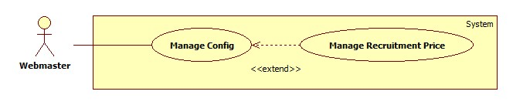

|  |  |  |  |  |
| --- | --- | --- | --- | --- |
| **USE CASE SPECIFICATION** | | | | |
| **Use-case No.** | UC054 | **Use-case Version** | | 1.0 |
| **Use-case Name** | Manage Recruitment Price | | | |
| **Author** | TuanBT | | | |
| **Date** | 24/09/2014 | **Priority** | High | |
| **Actor:** Webmaster  **Summary:** Change price when a new Recruitment post to MS-Website.  **Goal:**  Change value.  **Trigger:** Webmaster click “Quản lý cấu hình”  **Pre-conditions:**   * User must login with Admin role * Manage config page will be shown   **Post conditions:**   * Success: Reload page and change value. * Failure: Show error.   **Main Success Scenario:**   |  |  | | --- | --- | | Actor Action | System Response | | 1. Webmaster click “Quản lý cấu hình” menu, then fill input “Giá mới” | 2. Show notification “Cập nhập đơn giá cho yêu cầu tìm người thành công.”  [Exception 1] |   **Alternative Scenario: N/A**  **Exceptions:**   |  |  | | --- | --- | | Actor Action | System Response | | [Exception 1]  1. Fill input not a digit. | 2. Show error “Phải nhập số nguyên!” |   **Relationships:** Manage Recruitment Price is extend of Manage config.  **Business Rules:** Webmaster must enter an integer number. | | | | |

##### <Customer>Report Maid

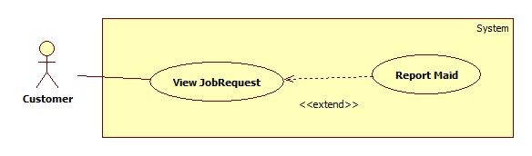

|  |  |  |  |  |
| --- | --- | --- | --- | --- |
| **USE CASE SPECIFICATION** | | | | |
| **Use-case No.** | UC055 | **Use-case Version** | | 1.0 |
| **Use-case Name** | Report Maid | | | |
| **Author** | TuyenMQ | | | |
| **Date** | 24/09/2014 | **Priority** | High | |
| **Actor:** Customer  **Summary:** Report bad maid  **Goal:**  Report bad maid  **Trigger:** Customer click “Báo xấu” button  **Pre-conditions:**   * User must login with customer role * Manage config page will be shown   **Post conditions:**   * Success: Reload page and change value. * Failure: Show error.   **Main Success Scenario:**   |  |  | | --- | --- | | Actor Action | System Response | | 1. Login as a customer 2. Click name link 3. Click a job request in tab “Hoàn thành” 4. Click “Báo xấu” button   [Alternative 1] | 1. System redirect home page 2. System redirect job request details page 3. System show pop ups confirm then redirects to job request page   [Exception 1] |   **Alternative Scenario:**   |  |  | | --- | --- | | Actor Action | System Response | | [Alternative 1]  1.Click “Báo xấu” button  3.Click outside pop up | 2.Show pops up  4.Close pop up |   **Exceptions:**   |  |  | | --- | --- | | Actor Action | System Response | | [Exception 1]   1. System fail to load data | 1. Show message “Hệ thống đang bảo trì” |   **Relationships:** Report Maid is extended to View Job Request  **Business Rules:**   * Only Customer can report a maid. * Customer can only report a maid on a Job Request with “Approved” status and that Job Request must be applied by that customer before. * After reporting, the reported maid’s name will be colored red in any page of the web site. * The reportDate in Maid table in database is updated with the current date. * After one week from that day, the report is cancelled, the reportDate is set to null and the maid name’s color is set to default. | | | | |

##### <Customer>Approve Recruitment

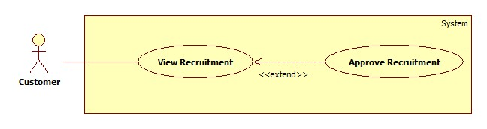

|  |  |  |  |  |
| --- | --- | --- | --- | --- |
| **USE CASE SPECIFICATION** | | | | |
| **Use-case No.** | UC056 | **Use-case Version** | | 1.0 |
| **Use-case Name** | Approve Recruitment | | | |
| **Author** | TuyenMQ | | | |
| **Date** | 24/09/2014 | **Priority** | High | |
| **Actor:** Customer  **Summary:** Approve recruitment  **Goal:**  Approve recruitment  **Trigger:** Customer click “Hoàn tất” button  **Pre-conditions:**   * User must login with customer role * Manage config page will be shown   **Post conditions:**   * Success: Reload page and change value. * Failure: Show error.   **Main Success Scenario:**   |  |  | | --- | --- | | Actor Action | System Response | | 1. Login as a customer 2. Click name link 3. Click a recruitment in tab “Đã nhận” 4. Click “Hoàn tất” button 5. Click “Chấp nhận” button   [Alternative 1] | 1. System redirect home page 2. System redirect recruitment details page 3. Show pop up confirm 4. System redirect recruitment details page   [Exception 1] |   **Alternative Scenario:**   |  |  | | --- | --- | | Actor Action | System Response | | [Alternative 1]  1.Click “Báo xấu” button  3.Click outside pop up | 2.Show pops up  4.Close pop up |   **Exceptions:**   |  |  | | --- | --- | | Actor Action | System Response | | [Exception 1]   1. System fail to change data | 1. Show message “Không thể hoàn tất yêu cầu này” |   **Relationships:** Report Maid is extended to View Job Request  **Business Rules:**   * Customer can only mark “Approve” his/her own Recruitments with “Applied” status. * The status of Recruitment changes to “Approve” in Recruitment table and isSaleOff is set to True in Customer table in database. * After approving a recruitment, the cost of next posting or extending a Recruitment is lowered by 10% (Only 1 time). After that, the value of isSaleOff is set to False again. | | | | |

### Non-functional Requirement

#### Usability

##### Graphic User Interface

* All the text, label and image in user page should be in Vietnamese.
* All the text, label and image in admin page should be Vietnamese.

##### Usability

* Website admin, supervisor and roundman only need more than one hour to train.

##### Installation

* The system must be easy to deploy. Customer can deploy successfully and learn to configure, maintain the system within one day of training.
* The attached manual guide must be clear. User can read and do themselves without developer’s help.

#### Reliability

* There is no requirement for system maintenance task from the user.
* Mean Time Between Failures (MTBF): more than 6 months.
* Accuracy: 100%.
* Maximum Bugs and Defect Rate: 0.3 bugs per thousand lines of code (0.3bugs/KLOC).
* Critical bugs:
* Loss of data: not any

#### Availability

* The server shall be working 24 hours per day and 7 days per week.

#### Security

* *All sensitive* information (password, etc.) must be hashed when storing in database and during transmission over networks using MD5 hash.
* Validate input data in SQL query before execute to avoid SQL Injection, XSS
* The role of user and member is clearly.

#### Maintainability

* All code shall fully document. All program files shall include comments concerning authorship and date of last change.
* The code shall be modular to permit future modifications.

#### Portability

* N/A

#### Performance

* Large tables and indexes must be partitioned data into smaller, more manageable sections by using partition in SQL Server 2008 R2.

## Entity Relationship Diagram

### DiagramC:\Users\USER\Desktop\MS-ERD_0.6.png

Figure 63: Entity Relationship Diagram

### Data Dictionary

|  |  |
| --- | --- |
| **Entity Data dictionary: describe content of all entities** | |
| Entity Name | Description |
| Account | Describe all account of MS - Website system. |
| Staff | Describe all staff of website. |
| Customer | Describe all customer of website. |
| MaidMediator | Describe all maid mediator of website. |
| Maid | Describe all maid of website. |
| JobRequest | Describe all job request, with was posted by staff and maid mediator. |
| Recruitment | Describe all recruitment, withc was posted by customer. |
| SkillCategory | Describe all category of skill. |
| SkillInstance | Describe all instance of skill. |
| SkillReference | Describe all reference of skill of all job requests and recruitments. One job request or recruitment refers to one skill reference and that reference have all informations of that recruitment or job request. Each column of skill in skill reference is a skill instance. |

# Software Design Description

## Design Overview

* This document describes the technical and UI design of the MS Wesite. It includes the architectural design and the detailed design of common functions and business functions. It also includes the design of database model.
* The architectural design describes the overall architecture of the system, and the architecture of each main component and subsystem. It will describe the patterns being used, the role of each component and the role of the system in the working environment.
* The detailed design describes static and dynamic structure for each component and function. It includes class diagrams, class explanations, and sequence diagrams of the main use cases.UML 2.0.
* The database design describes the relationship between entities, and details of each entity.
* The user interface design describes the layout of the system, and some design for the screens.

## System Architectural Design

In MVC pattern, the functions of model, view, and controller are defined as in following figure.

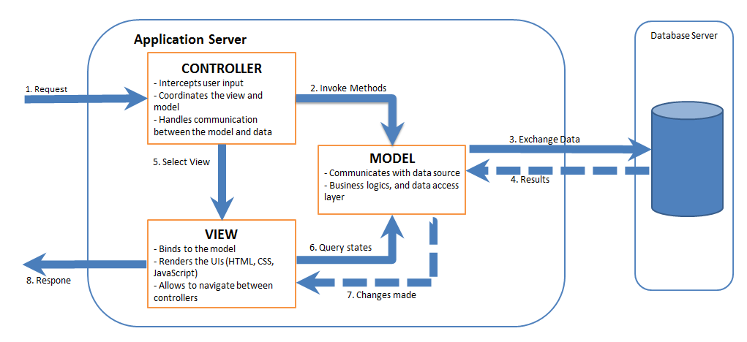

Figure 64: MVC Pattern

## Component Diagram

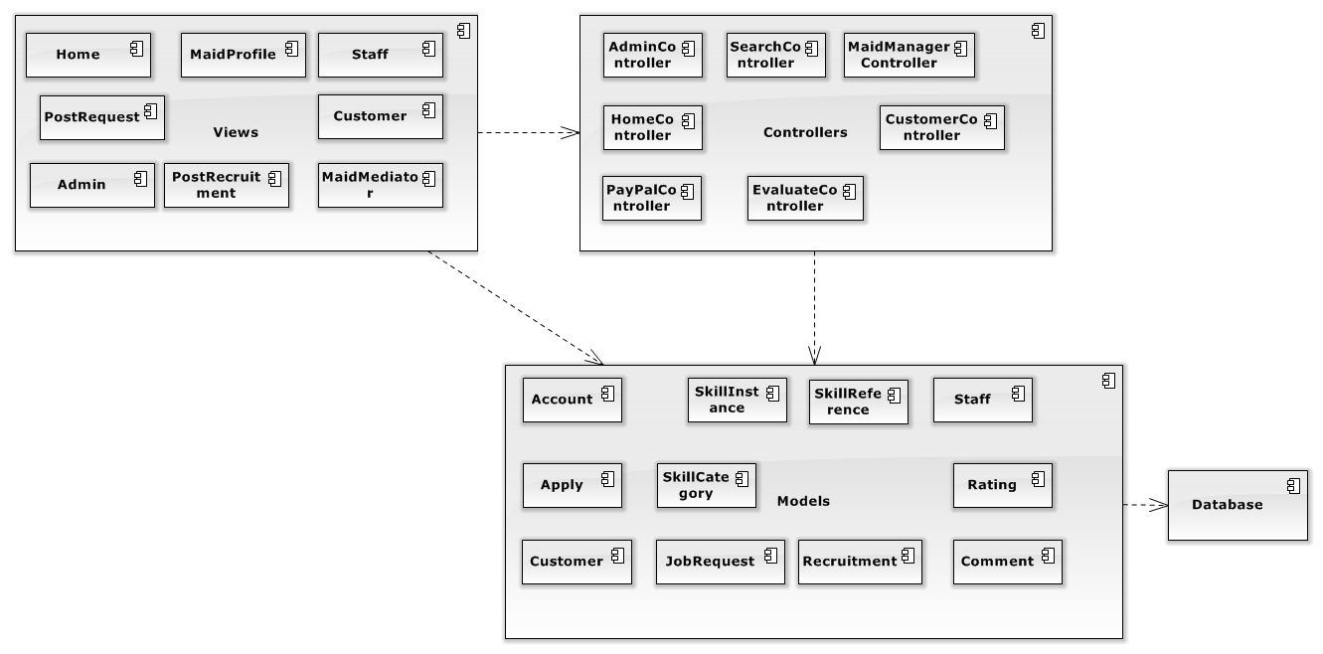

Figure 65: Component Diagram

## Detailed Description of Components

### Class Diagram

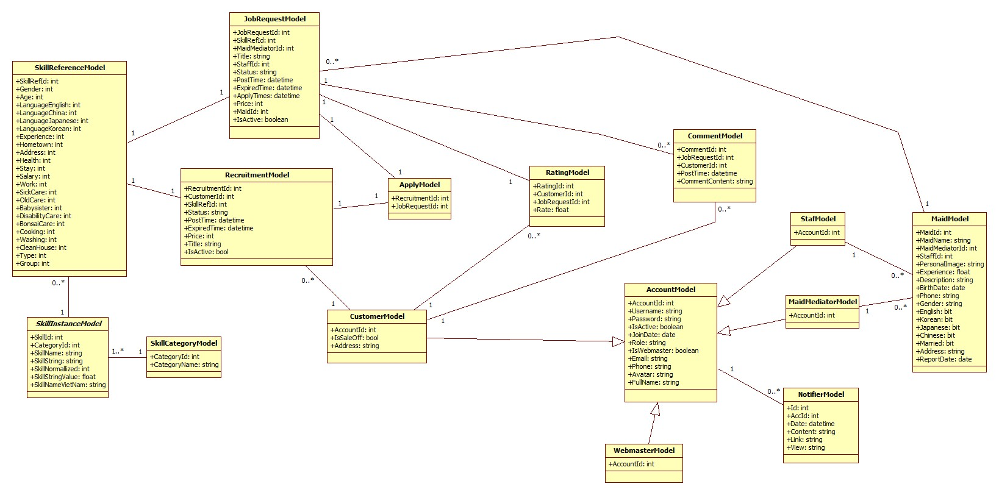

Figure 66: Class Diagram

#### Class Diagram – Entity Framework Model

##### AccountModel

This class is mapped with entity Account

* **Attributes**

|  |  |  |  |
| --- | --- | --- | --- |
| **Name** | **Type** | **Visibility** | **Description** |
| AccountId | Integer | Public | Id of Account |
| Username | String | Public | Username of user |
| Password | String | Public | Password of user |
| IsActive | Boolean | Public | Check account is active |
| JoinDate | Date | Public | Date that user create an account |
| Role | String | Public | Role of User |
| IsWebmaster | Boolean | Public | Check account is an admin |
| Avatar | String | Public | Image of user |
| Email | String | Public | Email of user |
| Phone | String | Public | Phone of user |
| FullName | String | Public | Fullname of user |

* **Methods** None

##### ApplyModel

This class is mapped with relation Apply

* **Attributes**

|  |  |  |  |
| --- | --- | --- | --- |
| **Name** | **Type** | **Visibility** | **Description** |
| RecruitmentId | Integer | Public | Id of recruitment |
| JobRequestId | Integer | Public | Id of job request |

* **Methods** None

##### CommentModel

This class is mapped with relation Comment

* **Attributes**

|  |  |  |  |
| --- | --- | --- | --- |
| **Name** | **Type** | **Visibility** | **Description** |
| CommentId | Integer | Public | Id of comment |
| CustomerId | Integer | Public | Id of customer |
| JobRequestId | Integer | Public | Id of job request |
| PostTime | Datetime | Public | Time that comment was posted |
| CommentContent | String | Public | Content of comment |

* **Methods** None

##### CustomerModel

This class is mapped with entity Customer

* **Attributes**

|  |  |  |  |
| --- | --- | --- | --- |
| **Name** | **Type** | **Visibility** | **Description** |
| AccountId | Integer | Public | Id of field |
| Address | String | Public | Address of customer |
| IsSaleOff | Bool | Public | Sale off |

* **Methods** None

##### JobRequestModel

This class is mapped with entity JobRequest

* **Attributes**

|  |  |  |  |
| --- | --- | --- | --- |
| **Name** | **Type** | **Visibility** | **Description** |
| JobRequestId | Integer | Public | Id of job request |
| SkillRefId | Integer | Public | Id of skill reference |
| MaidMediatorId | Integer | Public | Id of maid mediator |
| StaffId | Integer | Public | Id of staff |
| Status | String | Public | Status of job request |
| PostTime | Datetime | Public | Time that job request was post |
| ExpiredTime | Datetime | Public | Time that job request was expired |
| ApplyTime | Datetime | Public | Time that job request was applied |
| MaidId | Integer | Public | Id of maid |
| IsActive | Boolean | Public | Check that job request is active |
| Price | Integer | Public | Price of jobrequest |
| Title | String | Public | Name of jobrequest |

* **Methods** None

##### MaidModel

This class is mapped with entity Maid

* **Attributes**

|  |  |  |  |
| --- | --- | --- | --- |
| **Name** | **Type** | **Visibility** | **Description** |
| MaidId | Integer | Public | Id of maid |
| MaidName | String | Public | Name of maid |
| MaidMediatorId | Integer | Public | Id of maid mediator |
| StaffId | Integer | Public | Id of staff |
| PersonalImage | String | Public | Image of maid |
| Experience | Float | Public | Experience of maid |
| Description | String | Public | Description of maid |
| BirthDate | Date | Public | Birthdate of maid |
| Phone | String | Public | Phone of maid |
| Gender | String | Public | Gender of maid |
| English | Bit | Public | English |
| Korean | Bit | Public | Korean |
| Japanese | Bit | Public | Japanese |
| Chinese | Bit | Public | Chinese |
| Married | Bit | Public | Married |
| Address | String | Public | Address of maid |
| ReportDate | Date | Public | Date report |

* **Methods** None

##### StaffModel

This class is mapped with entity Staff

* **Attributes**

|  |  |  |  |
| --- | --- | --- | --- |
| **Name** | **Type** | **Visibility** | **Description** |
| AccountId | Integer | Public | Id of maid manager |

* **Methods** None

##### MaidMediatorModel

This class is mapped with entity MaidMediator

* **Attributes**

|  |  |  |  |
| --- | --- | --- | --- |
| **Name** | **Type** | **Visibility** | **Description** |
| AccountId | Integer | Public | Id of maid manager |

* **Methods** None

##### NotifierModel

This class is mapped with entity Notifier

* **Attributes**

|  |  |  |  |
| --- | --- | --- | --- |
| **Name** | **Type** | **Visibility** | **Description** |
| Id | Integer | Public | Id of notifier |
| AccId | Integer | Public | Id of account |
| Date | Datetime | Public | Date of notifier |
| Content | String | Public | Content of notifier |
| Link | String | Public | Link notify |
| View | Bool | Public | Confirm that view yet |

* **Methods** None

##### RatingModel

This class is mapped with relation Rate

* **Attributes**

|  |  |  |  |
| --- | --- | --- | --- |
| **Name** | **Type** | **Visibility** | **Description** |
| RatingId | Integer | Public | Id of rating |
| CustomerId | Integer | Public | Id of customer |
| JobRequestId | Integer | Public | Id of job request |
| Rate | String | Public | Rate |

* **Methods** None

##### RecruitmentModel

This class is mapped with entity Recruitment

* **Attributes**

|  |  |  |  |
| --- | --- | --- | --- |
| **Name** | **Type** | **Visibility** | **Description** |
| RecruitmentId | Integer | Public | Id of recruitment |
| SkillRefId | Integer | Public | Id of skill reference |
| CustomerId | Integer | Public | Id of customer |
| Status | String | Public | Status of recruitment |
| PostTime | Datetime | Public | Time that recruitment was posted |
| ExpiredTime | Datetime | Public | Time that recruitment was expired |
| Title | String | Public | Name of recruitment |
| Price | Int | Public | Price of recruitment |
| IsActive | Bool | Public | Check recruitment is active yet |

* **Methods** None

##### SkillCategoryModel

This class is mapped with entity SkillCategory

* **Attributes**

|  |  |  |  |
| --- | --- | --- | --- |
| **Name** | **Type** | **Visibility** | **Description** |
| CategoryId | Integer | Public | Id of category |
| CategoryName | String | Public | Name of category |

* **Methods** None

##### SkillInstanceModel

This class is mapped with entity SkillIntance

* **Attributes**

|  |  |  |  |
| --- | --- | --- | --- |
| **Name** | **Type** | **Visibility** | **Description** |
| SkillId | Integer | Public | Id of skill |
| CategoryId | Integer | Public | Id of category |
| SkillName | String | Public | Name of skill |
| SkillString | String | Public | The charater value of skill |
| SkillNormallied | Int | Public | The range value of skill |
| SkillStringValue | Float | Public | The number value of skill name |
| SkillNameVietNam | String | Public | The name of skill in Vietnamese |

* **Methods** None

##### SkillReferenceModel

This class is mapped with entity SkillReference

* **Attributes**

|  |  |  |  |
| --- | --- | --- | --- |
| **Name** | **Type** | **Visibility** | **Description** |
| SkillRefId | Integer | Public | Id of Skill reference |
| Gender | Integer | Public | The value gender of skill |
| Age | Integer | Public | The value age of skill |
| LaguageEnglish | Integer | Public | The value language english of skill |
| LanguageChina | Integer | Public | The value language china of skill |
| LanguageJapanese | Integer | Public | The value language japanese of skill |
| LanguageKorean | Integer | Public | The value language korean of skill |
| Experience | Integer | Public | The value experience of skill |
| Hometown | Integer | Public | The value hometown of skill |
| Address | Integer | Public | The value address of skill |
| Health | Integer | Public | The value health of skill |
| Stay | Integer | Public | The value stay of skill |
| Salary | Integer | Public | The value salary of skill |
| Work | Integer | Public | The value work of skill |
| SickCare | Integer | Public | The value sickcare of skill |
| OldCare | Integer | Public | The value oldcare of skill |
| BabySister | Integer | Public | The value babysister of skill |
| DisabilityCare | Integer | Public | The value disabilitycare of skill |
| BonsaiCare | Integer | Public | The value bonsaicare of skill |
| Cooking | Integer | Public | The value cooking of skill |
| Washing | Integer | Public | The value washing of skill |
| Cleanhouse | Integer | Public | The value cleanhouse of skill |
| Type | Integer | Public | Skill of job request or skill of recruitment |
| Group | Integer | Public | Divide group in algorithm |

* **Methods** None

##### WebMasterModel

This class is mapped with entity WebMaster

* **Attributes**

|  |  |  |  |
| --- | --- | --- | --- |
| **Name** | **Type** | **Visibility** | **Description** |
| AccountId | Integer | Public | Id of account |

* **Methods** None

### Sequence Diagram

#### Admin Sequence Diagram

##### <Admin> Add Staff

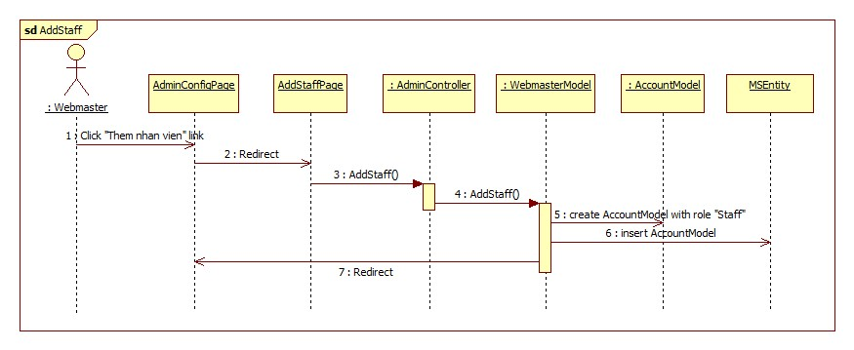

Figure 67: <Admin> Add Staff

##### <Admin> Delete Comment

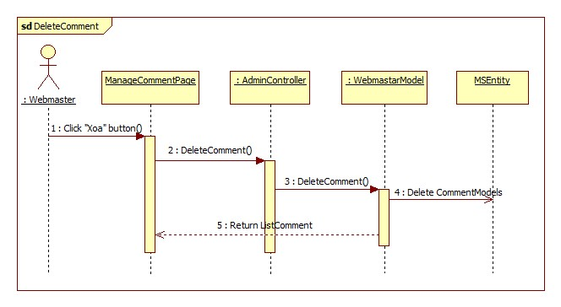

Figure 68: <Admin> Delete Comment

#### All User Sequence Diagram

##### <All User> View Job Request

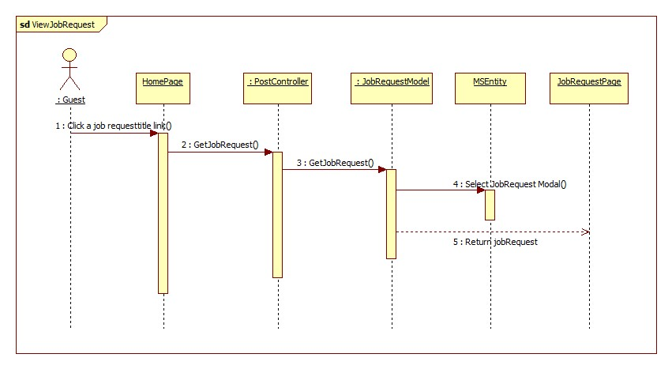

Figure 69: <All User> View Job Request

##### <All User> View Recruitment

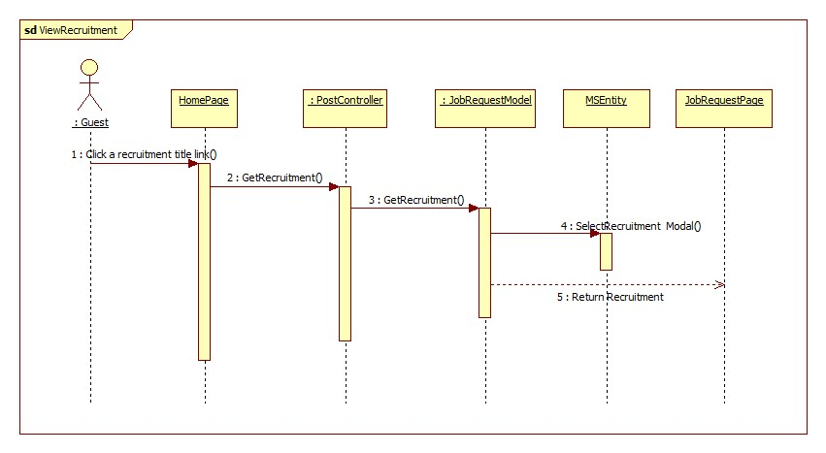

Figure 70: <All User> View Recruitment

##### <All User> Search

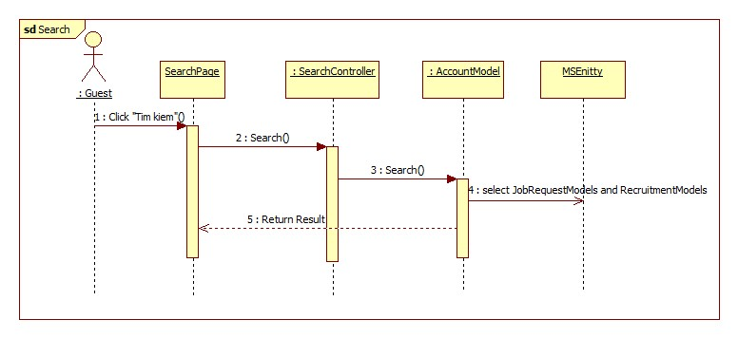

Figure 71: <All User> Search

#### Authenticated user Sequence Diagram

##### <Authenticated user> View Customer

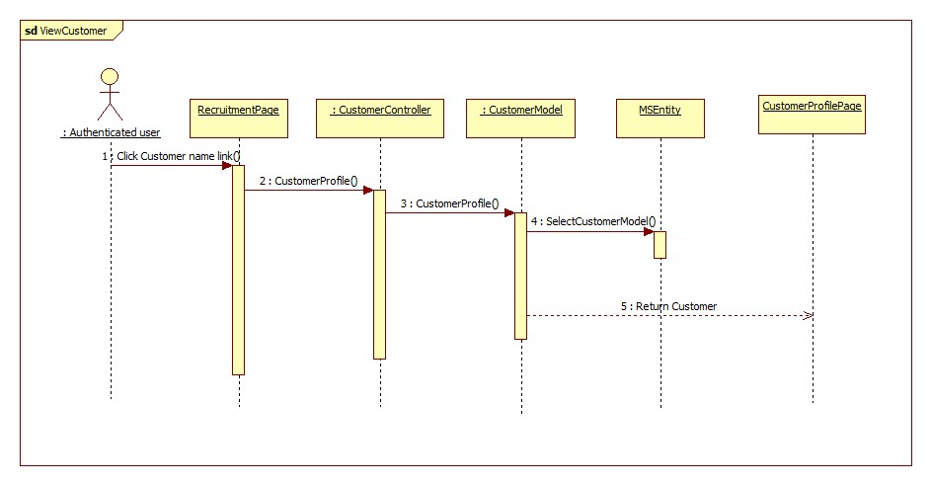

Figure 72: <Authenticated user> View Customer

##### <Authenticated user> View Maid

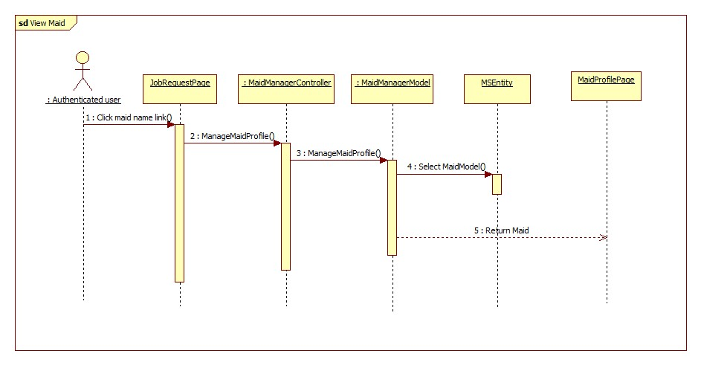

Figure 73: <Authenticated user> View Maid

#### Customer Sequence Diagram

##### <Customer> Apply Job Request

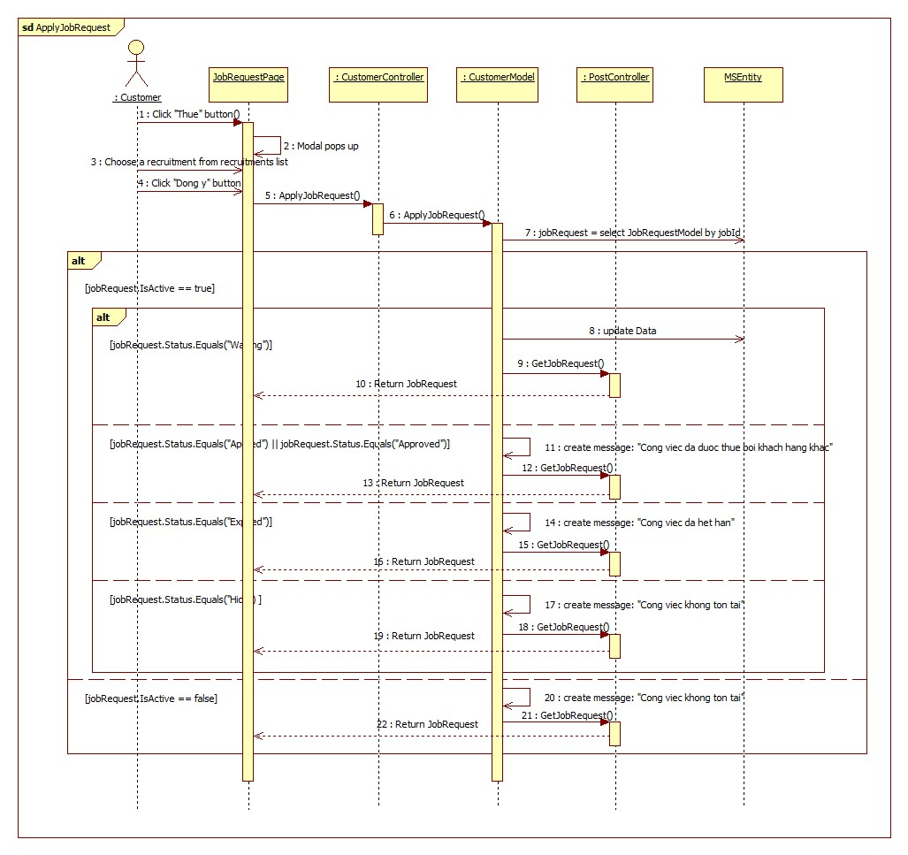

Figure 74: <Customer> Apply Job Request

##### <Customer> Comment Job Request

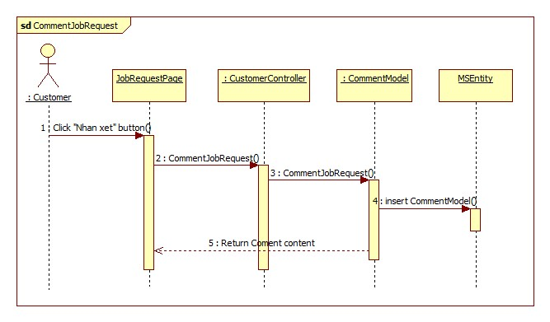

Figure 75: <Customer> Comment Job Request

##### <Customer> Edit Recruitment

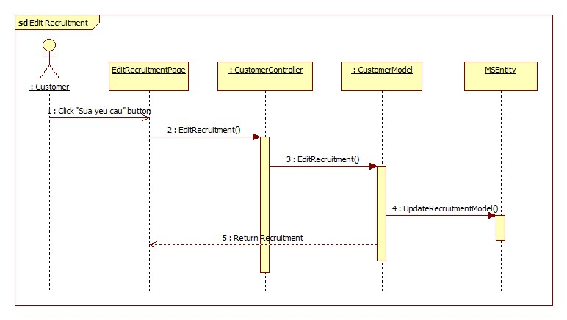

Figure 76: <Customer> Edit Recruitment

##### <Customer> Extend Recruitment

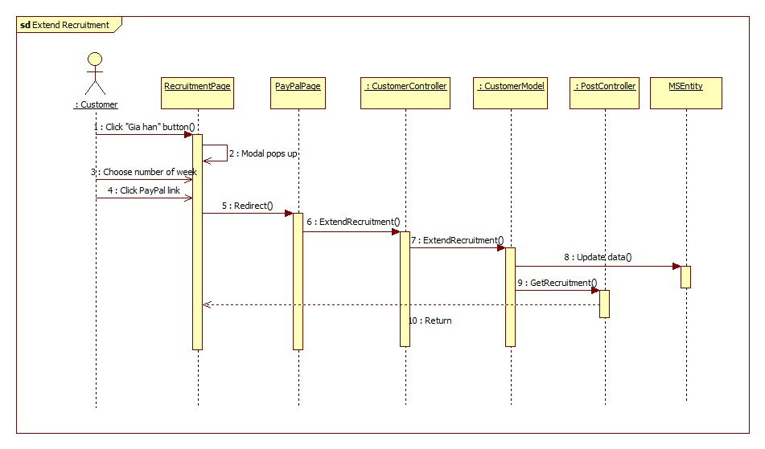

Figure 77: <Customer> Extend Recruitment

##### <Customer> Hide Recruitment

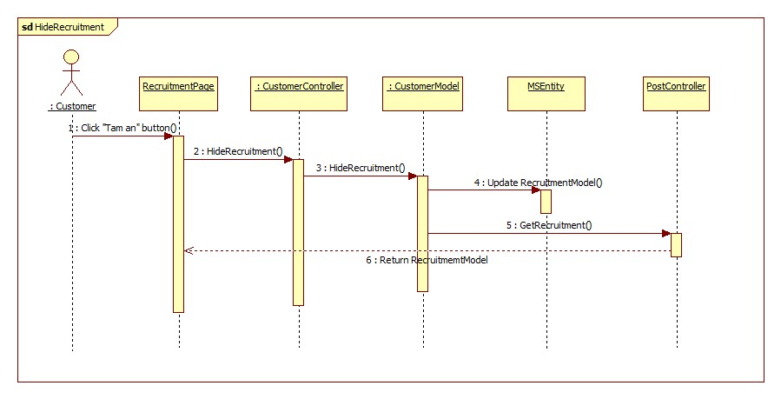

Figure 78: <Customer> Hide Recruitment

##### <Customer> Post Recruitment

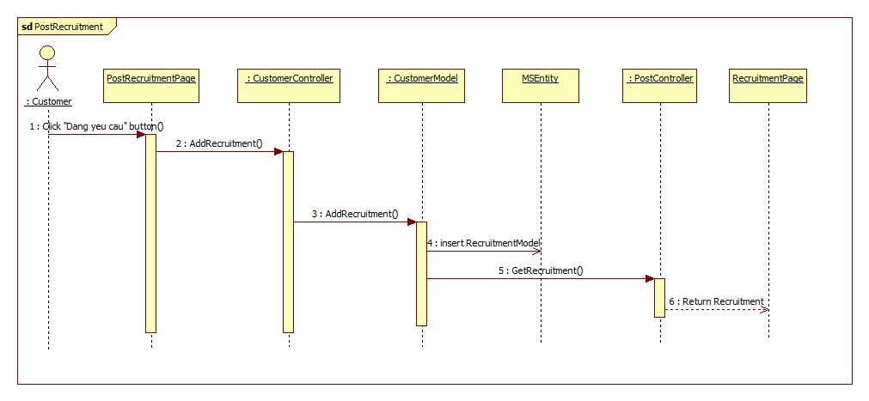

Figure 79: <Customer> Post Recruitment

##### <Customer> Public Recruitment

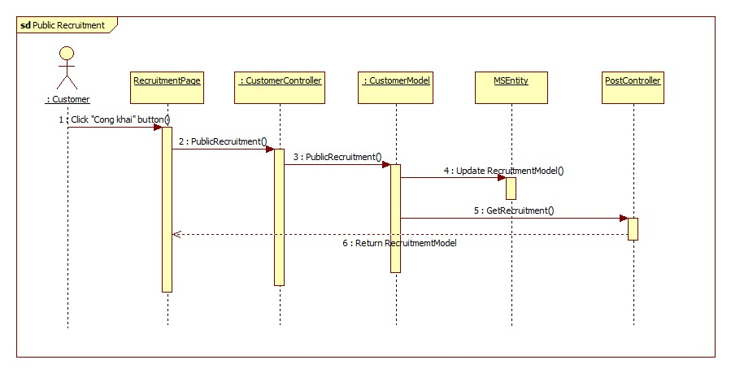

Figure 80: <Customer> Public Recruitment

##### <Customer> Rate Job Request

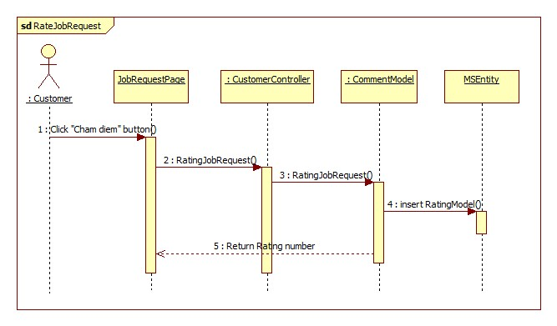

Figure 81: <Customer> Rate Job Request

##### <Customer> Report Maid

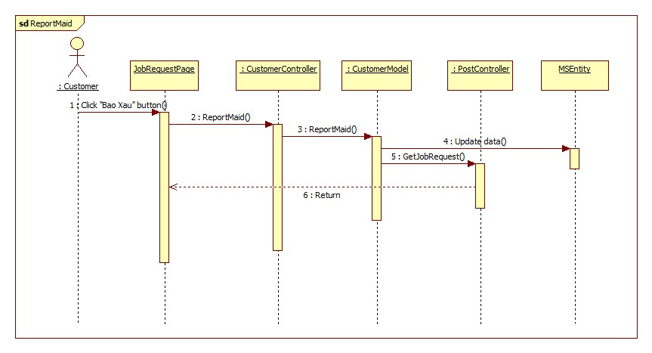

Figure 82: <Customer> Rate Job Request

##### <Customer> Approve Recruitment

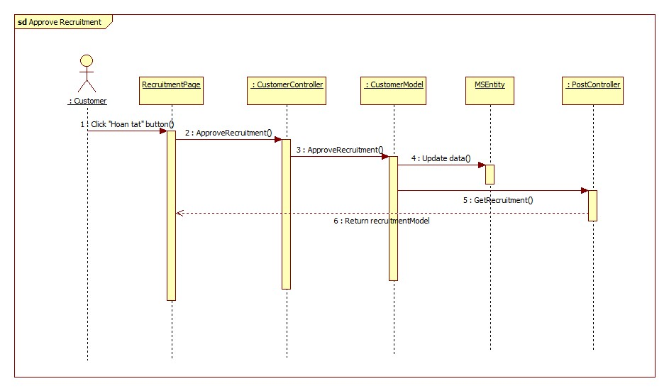

Figure 83: <Customer> Rate Job Request

#### Staff Sequence Diagram

##### <Staff> Activate Job Request

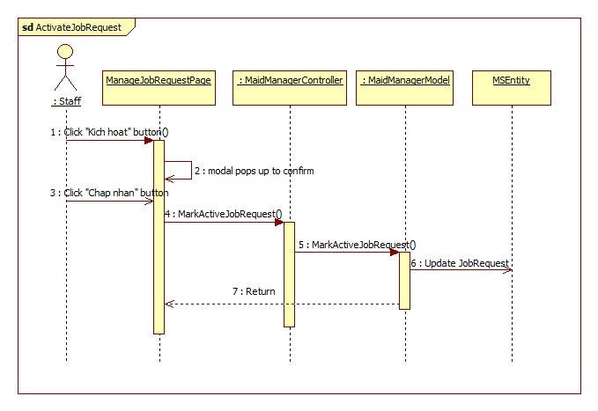

Figure 84: <Staff> Activate Job Request

##### <Staff> Activate Recruitment

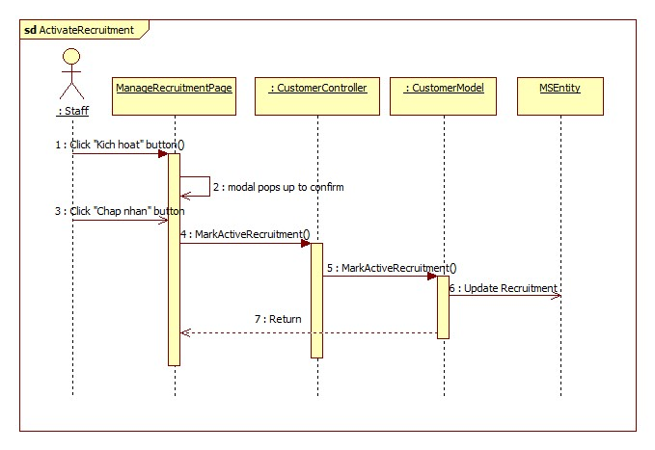

Figure 85: <Staff> Activate Recruitment

##### <Staff> Mark Approved Job Request

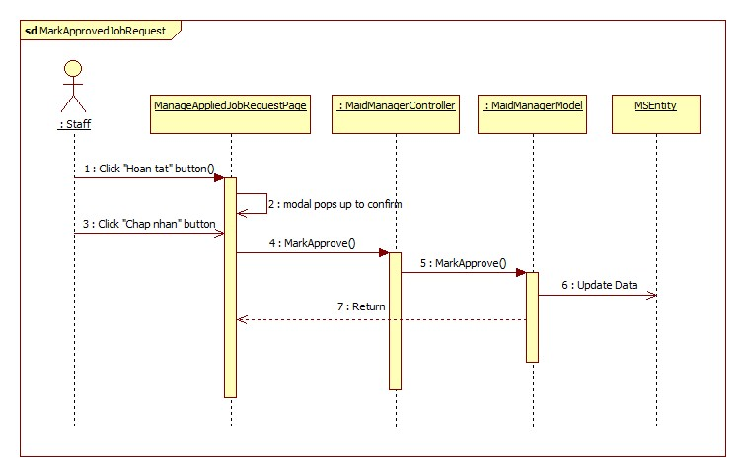

Figure 86: <Staff> Mark Approved Job Request

#### Staff, Maid Mediator Sequence Diagram

##### <Staff, Maid Mediator> Add Maid

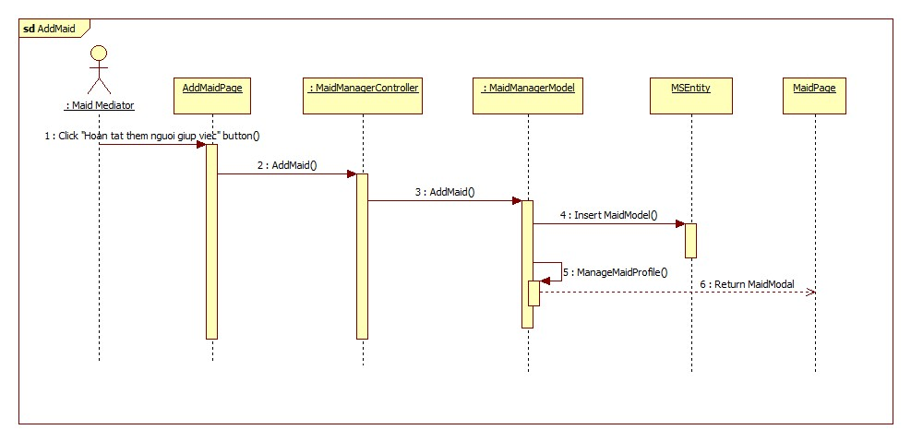

Figure 87: <Staff, Maid Mediator> Add Maid

##### <Staff, Maid Mediator> Edit Job Request

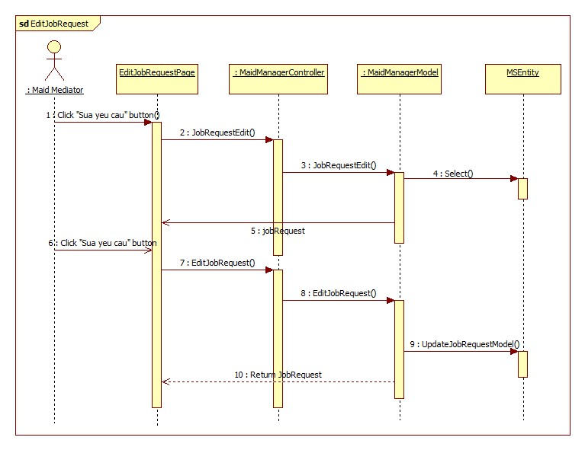

Figure 88: <Staff, Maid Mediator> Edit Job Request

##### <Staff, Maid Mediator> Edit Maid

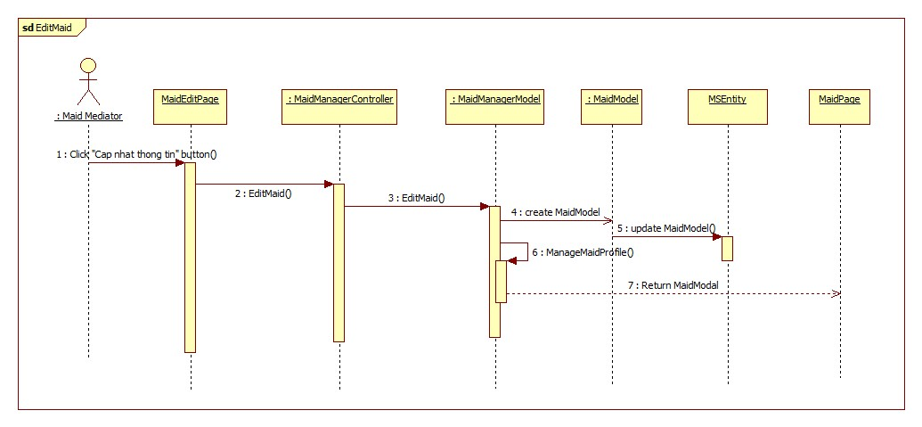

Figure 89: <Staff, Maid Mediator> Edit Maid

##### <Staff, Maid Mediator> Extend Job Request

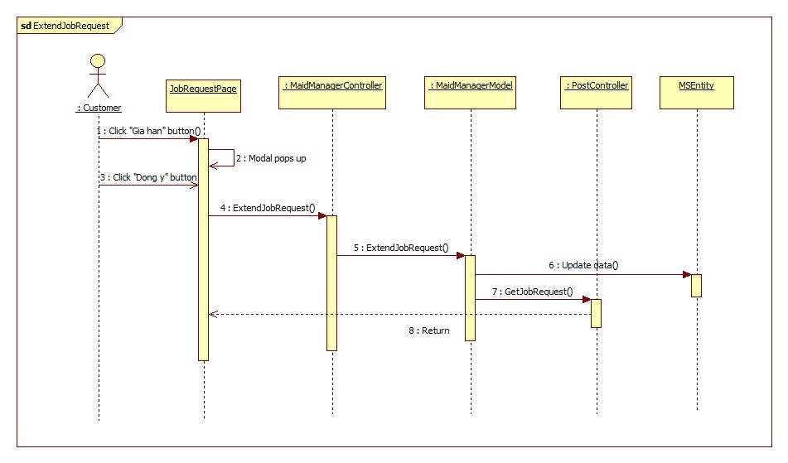

Figure 90: <Staff, Maid Mediator> Extend Job Request

##### <Staff, Maid Mediator> Hide Job Request

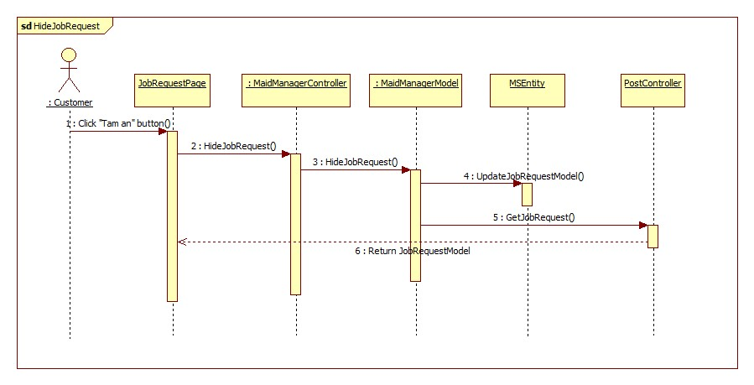

Figure 91: <Staff, Maid Mediator> Hide Job Request

##### <Staff, Maid Mediator> Post Job Request

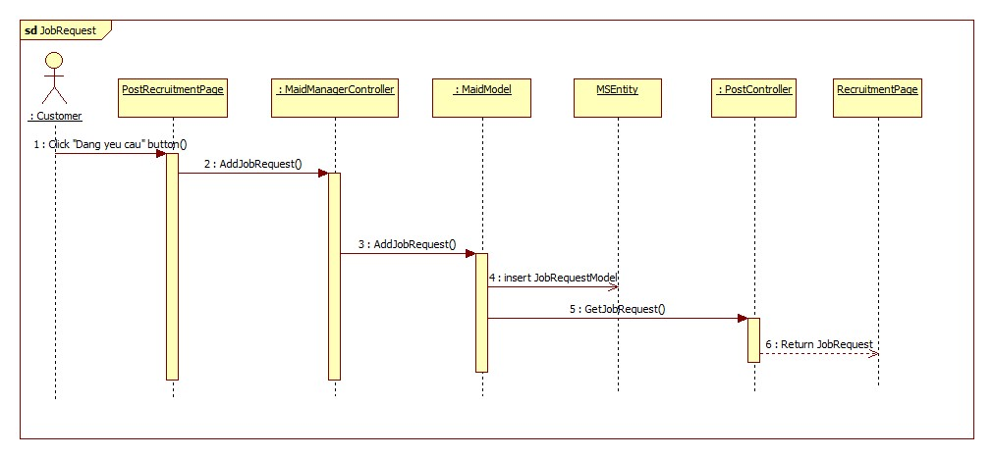

Figure 92: <Staff, Maid Mediator> Post Job Request

##### <Staff, Maid Mediator> Public Job Request

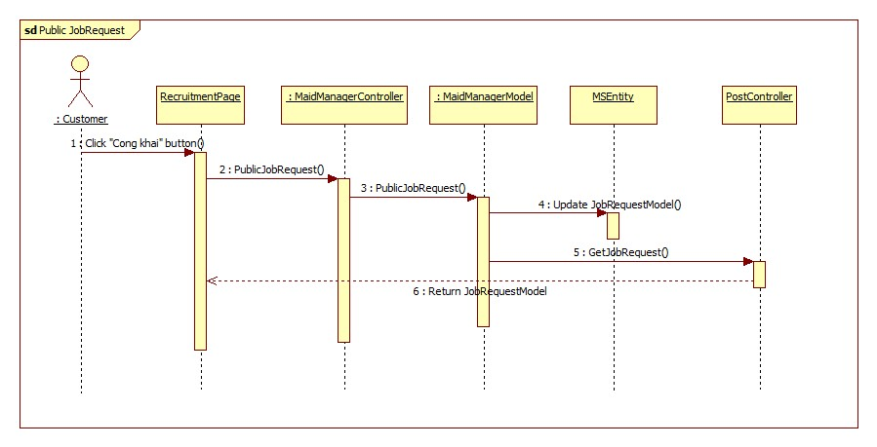

Figure 93: <Staff, Maid Mediator> Public Job Request

## User Interface Design

### User Interface Design

#### MS-Website Home Page

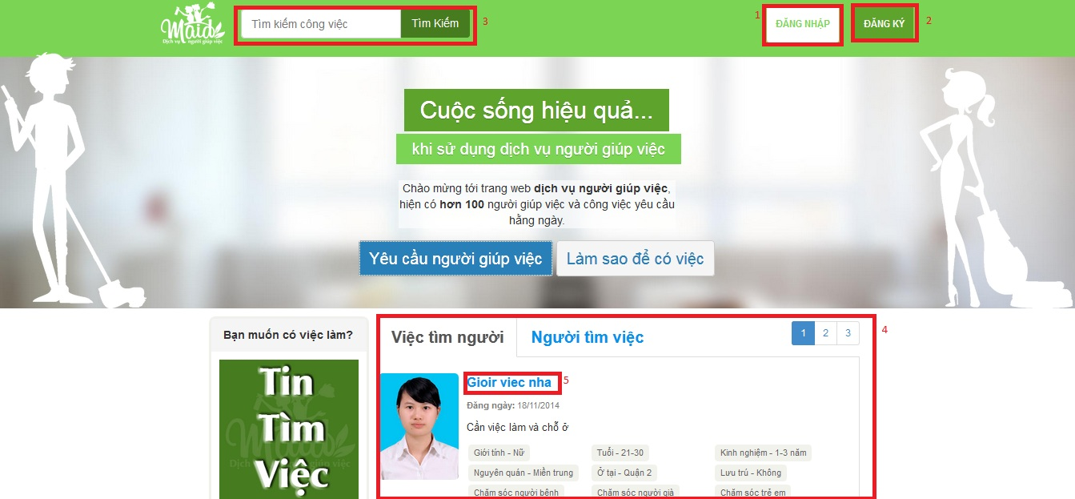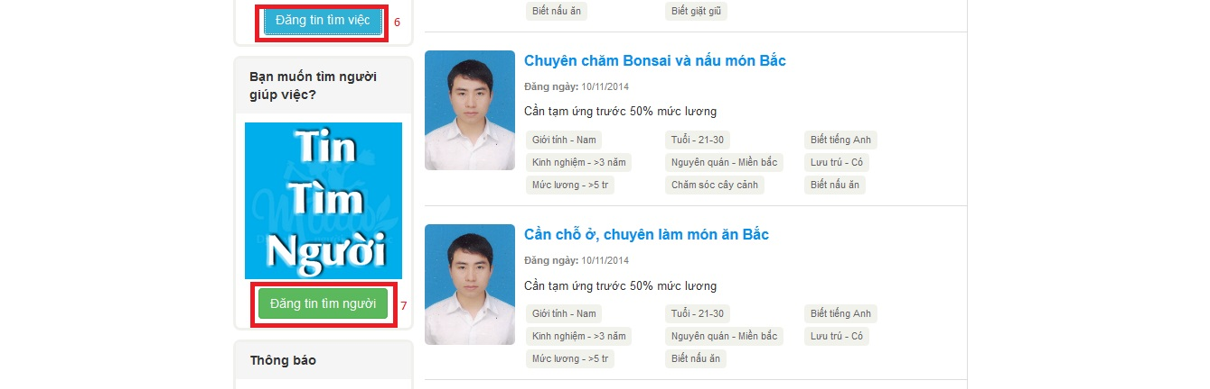Figure 94: Manager Home Page

**Button/ Hyperlink**

|  |  |  |  |  |
| --- | --- | --- | --- | --- |
| **No** | **Function** | **Description** | **Validation** | **Outcome** |
| 1 | Login | Login | No | Login page |
| 2 | Register | Register | No | Register page |
| 3 | Search | Search and advanced search | No | Search page |
| 4 | Job Request and Recruitment List | List of job requests or recruitments | No | List of jobrequest or recruitment |
| 5 | Jobrequest or recruitment title | Link to jobrequest detail or recruitment detail | No | Jobrequest detail page or recruitment detail page |
| 6 | Post jobrequest | Post job request | Yes | Post jobrequest page |
| 7 | Post recruitment | Post recruitment | Yes | Post recruitment page |

### Webmaster Interface Design

#### Ban/Active Account

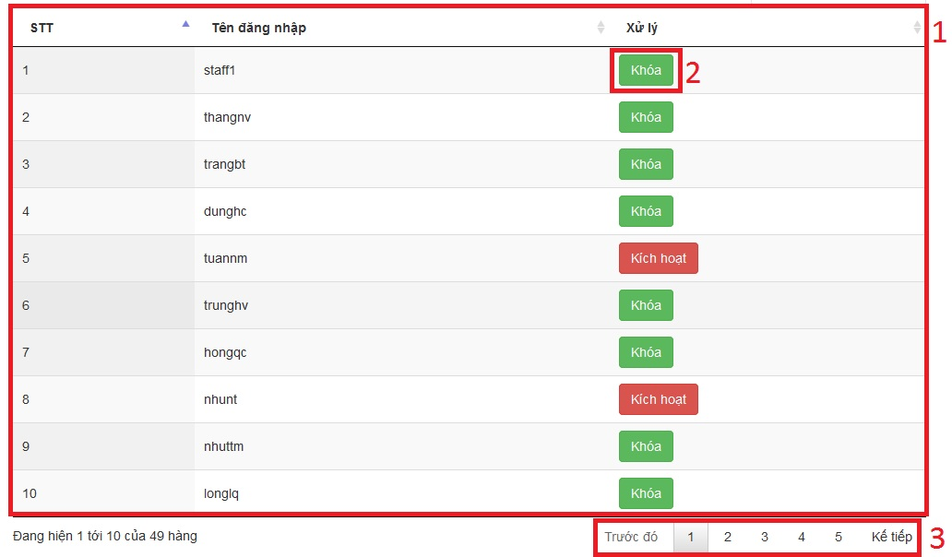

Figure 95: Ban/Active Account Page

**Fields**

|  |  |  |  |  |  |  |  |
| --- | --- | --- | --- | --- | --- | --- | --- |
| **No** | **Field Name** | **Description** | **Read only** | **Mand-atory** | **Control Type** | **Data Type** | **Length** |
| 1 | Account table | Show list accounts | Y | Y | N/A |  | N/A |

**Table Stadium list includes**

|  |  |  |  |  |  |
| --- | --- | --- | --- | --- | --- |
| **Field Name** | **Description** | **Read only** | **Control Type** | **Data Type** | **Length** |
| STT | Count number | Y | Label | String | N/A |
| Tên đăng nhập | Username | Y | Label | String | N/A |
| Xử lý | Approve jobrequest | N |  | Button | N/A |

**Button/ Hyperlink**

|  |  |  |  |  |
| --- | --- | --- | --- | --- |
| **No** | **Function** | **Description** | **Validation** | **Outcome** |
| 2 | BanAccount | Lock account | No | N/A |
| 3 | Paging | Paging | No | N/A |

#### Add Staff

**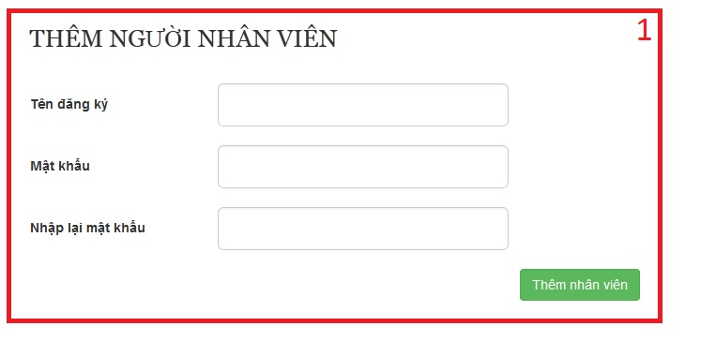**

Figure 96: Add Staff Page

**Fields**

|  |  |  |  |  |  |  |  |
| --- | --- | --- | --- | --- | --- | --- | --- |
| **No** | **Field Name** | **Description** | **Read only** | **Mand-atory** | **Control Type** | **Data Type** | **Length** |
| 1 | Add staff form | Form add staff | N | Y | N/A |  | N/A |

#### Manage Comment

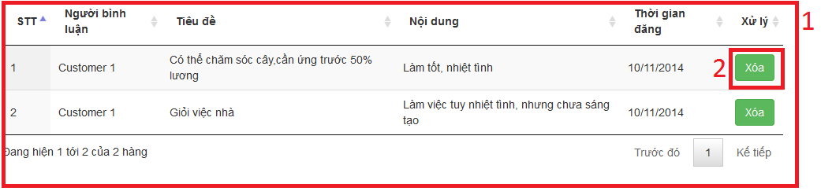

Figure 97: Manage Comment Page

**Fields**

|  |  |  |  |  |  |  |  |
| --- | --- | --- | --- | --- | --- | --- | --- |
| **No** | **Field Name** | **Description** | **Read only** | **Mand-atory** | **Control Type** | **Data Type** | **Length** |
| 1 | Comment table | Show list comment | Y | Y | N/A |  | N/A |

**Table Stadium list includes**

|  |  |  |  |  |  |
| --- | --- | --- | --- | --- | --- |
| **Field Name** | **Description** | **Read only** | **Control Type** | **Data Type** | **Length** |
| STT | Count number | Y | Label | String | N/A |
| Người bình luận | FullName | Y | Label | String | N/A |
| Tiêu đề | Title | Y | Label | String | N/A |
| Nội dung | Comment Content | Y | Label | String | N/A |

**Button/ Hyperlink**

|  |  |  |  |  |
| --- | --- | --- | --- | --- |
| **No** | **Function** | **Description** | **Validation** | **Outcome** |
| 2 | Delete Comment | Delete comment | No | N/A |

#### Manage Config

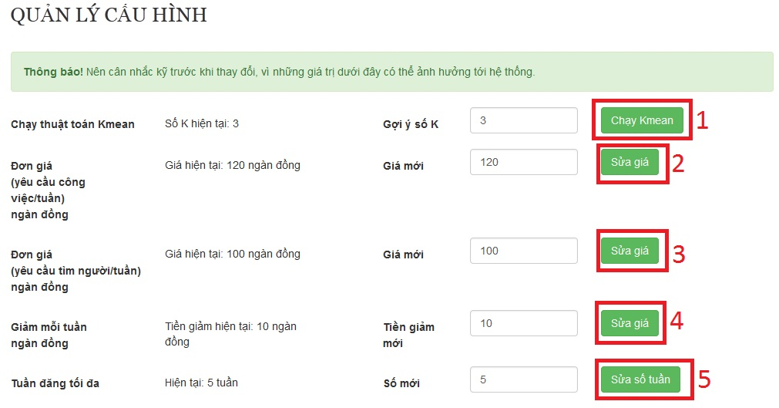

Figure 98: Manage Config Page

**Button/ Hyperlink**

|  |  |  |  |  |
| --- | --- | --- | --- | --- |
| **No** | **Function** | **Description** | **Validation** | **Outcome** |
| 1 | Run Kmean | Run kmean | Yes | N/A |
| 2 | Edit Price (job request) | Edit job request’s price | Yes | N/A |
| 3 | Edit Price (recruitment) | Edit recruitment’s price | Yes | N/A |
| 4 | Edit SubPrice | Edit sub price | Yes | N/A |
| 5 | Edit MaxWeek | Edit max week | Yes | N/A |

## Database Design

### Physical Database Design

Figure 99: Physcial Database Diagram

### Data Dictionary

|  |  |  |
| --- | --- | --- |
| **No.** | **Table name** | **Description** |
| 1 | Account | Describe about users in system |
| 2 | Apply | Describe Apply |
| 3 | Comment | Describe all comment |
| 5 | Customer | Describe all customers informations |
| 6 | JobRequest | Describe all job requests |
| 5 | MaidMediator | Describe all maid mediators information |
| 7 | Maid | Describe all maids information |
| 8 | Rating | Describe all rating |
| 9 | Recruitment | Describe all recruitments |
| 10 | SkillCategory | Describe all SkillCategory |
| 11 | SkillIntance | Describe all SkillIntance |
| 12 | SkillReference | Describe all SkillReference |
| 13 | Staff | Describe all staffs information |
| 14 | Notifier | Describe all notifications |

Table 3: Data Dictionary

#### Acount

|  |  |  |  |  |  |
| --- | --- | --- | --- | --- | --- |
| **Field name** | **Type** | **Null** | **P/F key** | **Default** | **Description** |
| AccountId | int |  | PK |  | The index of this account |
| Username | nvarchar(50) |  |  |  | The username of the account |
| Password | nvarchar(50) |  |  |  | The password of the password |
| IsActive | bit |  |  |  | Admin can ban account |
| JoinDate | date |  |  |  | The date when this user join |
| Role | nvarchar(50) |  |  |  | The role of the user |
| IsWebmaster | bit |  |  |  | Check acount is admin |
| Avatar | nvarchar(50) | Yes |  |  | The link refers to an image, present for a user |
| Email | nvarchar(50) | Yes |  |  | The email of user |
| Phone | nvarchar(50) | Yes |  |  | Phone of user |
| Fullname | nvarchar(50) | Yes |  |  | The fullname of user |
| Unique: Username, Email, Avatar | | | | | |

#### Apply

|  |  |  |  |  |  |
| --- | --- | --- | --- | --- | --- |
| **Field name** | **Type** | **Null** | **P/F key** | **Default** | **Description** |
| RecruitmentId | int |  | PK |  | The index of this recruitment |
| JobRequestId | Int |  | PK |  | The index of this job request |

#### Comment

|  |  |  |  |  |  |
| --- | --- | --- | --- | --- | --- |
| **Field name** | **Type** | **Null** | **P/F key** | **Default** | **Description** |
| CommentId | int |  | PK |  | The index of this comment |
| CustomerId | int |  | FK |  | The index of customer which contain this comment |
| JobRequestId | int |  | FK |  | The index of job request which is contain this comment |
| PostTime | datetime |  |  |  | The time when the comment posted |
| CommentContent | nvarchar(500) |  |  |  | The content of the comment |
| FK: CustomerId REF Customer (CustomerId), JobRequestId REF JobRequest(JobRequestId) | | | | | |

#### Customer

|  |  |  |  |  |  |
| --- | --- | --- | --- | --- | --- |
| **Field name** | **Type** | **Null** | **P/F key** | **Default** | **Description** |
| AccountId | int |  | PK |  | The index of user |
| Address | nvarchar(100) |  |  |  | The address of customer |

#### JobRequest

|  |  |  |  |  |  |
| --- | --- | --- | --- | --- | --- |
| **Field name** | **Type** | **Null** | **P/F key** | **Default** | **Description** |
| JobRequestId | int |  | PK |  | The index of this job request |
| SkillRefId | int |  | FK |  | The SkillRef of this job request |
| MaidMediatorId | int | Yes | FK |  | The maid mediator of this job request |
| StaffId | int | Yes | FK |  | The staff of this job request |
| Status | nvarchar(50) |  |  |  | The status of this job request |
| PostTime | datetime |  |  |  | The time that this job request is posted |
| ExpiredTime | datetime |  |  |  | The time that this job request is expired |
| ApplyTimes | datetime |  |  |  | The time that this job request is applied |
| MaidId | int |  | FK |  | The maid of this job request |
| IsActive | bit |  |  |  | Check that this job request has payment |
| Title | nvarchar(100) |  |  |  | Name of jobrequest |
| Price | int |  |  |  | Price of jobrequest |
| FK: SkillRefId REF SkillReference(SkillRefId)  MaidMediatorId REF MaidMediator(MaidMediatorId)  StaffId REF Staff(StaffId) | | | | | |

#### Maid

|  |  |  |  |  |  |
| --- | --- | --- | --- | --- | --- |
| **Field name** | **Type** | **Null** | **P/F key** | **Default** | **Description** |
| MaidId | int |  | PK |  | The index of maid |
| MaidName | nvarchar(50) |  |  |  | The name of maid |
| MaidMediatorId | int |  | FK |  | The maid mediator of maid |
| StaffId | Int |  | FK |  | The staff mediator of maid |
| PersonalImage | nvarchar(50) |  |  |  | The image of maid |
| Experience | float |  |  |  | The years experience of maid |
| Description | nvarchar(500) |  |  |  | The description of maid |
| Birthdate | date |  |  |  | Birthdate of maid |
| Phone | nvarchar(50) |  |  |  | The phone of maid |
| Gender | nvarchar(10) |  |  |  | The gender of maid |
| English | bit |  |  |  | Skill english of maid |
| Korean | bit |  |  |  | Skill korean of maid |
| Chinese | bit |  |  |  | Skill chinese of maid |
| Japanese | bit |  |  |  | Skill japanese of maid |
| Married | bit |  |  |  | Marital status of maid |
| Address | nvarchar(100) |  |  |  | Address of maid |
| FK: MaidMediatorId REF MaidMediator(MaidMediatorId)  StaffId REF Staff(StaffId) | | | | | |

#### MaidMediator

|  |  |  |  |  |  |
| --- | --- | --- | --- | --- | --- |
| **Field name** | **Type** | **Null** | **P/F key** | **Default** | **Description** |
| AccountId | int |  | PK |  | The index of this maid mediator |

#### Notifier

|  |  |  |  |  |  |
| --- | --- | --- | --- | --- | --- |
| **Field name** | **Type** | **Null** | **P/F key** | **Default** | **Description** |
| Id | int |  | PK |  | The index of notification |
| AccId | int |  |  |  | The index of account which has notification |
| Date | datetime |  |  |  | Date of notification |
| Content | nvarchar(500) |  |  |  | Content of notification |
| Link | nvarchar(100) | Yes |  |  | Link notify |
| View | bit |  |  |  | Confirm that view yet |

#### Rating

|  |  |  |  |  |  |
| --- | --- | --- | --- | --- | --- |
| **Field name** | **Type** | **Null** | **P/F key** | **Default** | **Description** |
| RatingId | int |  | PK |  | The index of this rating |
| CustomerId | int |  | FK |  | The customer who rate |
| JobRequestId | int |  | FK |  | The job request which is rated |
| Rate | float |  |  |  | The value of this rate |
| FK: CustomerId REF Customer(CustomerId)  JobRequestId REF JobRequest(JobRequestId) | | | | | |

#### Recruitment

|  |  |  |  |  |  |
| --- | --- | --- | --- | --- | --- |
| **Field name** | **Type** | **Null** | **P/F key** | **Default** | **Description** |
| RecruitmentId | int |  | PK |  | The index of this recruitment |
| SkillRefId | int |  | FK |  | The index of skill which contains in this recruitment |
| CustomerId | int |  | FK |  | The customer who posts this recruitment |
| Status | nvarchar(50) |  |  |  | The status of the recruitment |
| PostTime | datetime |  |  |  | The time when the recruitment is posted |
| ExpiredTime | datetime |  |  |  | The time when the recruitment is expired |
| Price | int |  |  |  | Price of recruitment |
| Title | nvarchar(100) |  |  |  | Name of recruitment |
| IsActive | bit |  |  |  | Check that this recruitment has payment |
| FK: CustomerId REF Customer(CustomerId)  SkillRefId REF SkillReference(SkillRefId) | | | | | |

#### SkillCategory

|  |  |  |  |  |  |
| --- | --- | --- | --- | --- | --- |
| **Field name** | **Type** | **Null** | **P/F key** | **Default** | **Description** |
| CategoryId | int |  | PK |  | The index of this category |
| CategoryName | nvarchar(50) |  |  |  | The name of category |

#### SkillInstance

|  |  |  |  |  |  |
| --- | --- | --- | --- | --- | --- |
| **Field name** | **Type** | **Null** | **P/F key** | **Default** | **Description** |
| SkillId | int |  | PK |  | The index of this skill |
| CategoryId | int |  | FK |  | The category which contains this skill |
| SkillName | nvarchar(50) |  |  |  | The name of skill |
| SkillString | nvarchar(50) | Yes |  |  | The character value of skill name |
| SkillNormallized | int |  |  |  | The range value of skill |
| SkillStringValue | float |  |  |  | The number value of skill name |
| SkillNameVietnam | nvarchar(50) |  |  |  | The name of skill in Vietnamese |
| FK: CategoryId REF SkillCategory(CategoryId) | | | | | |

#### SkillReference

|  |  |  |  |  |  |
| --- | --- | --- | --- | --- | --- |
| **Field name** | **Type** | **Null** | **P/F key** | **Default** | **Description** |
| SkillRefId | int |  | PK |  | The index of this skill reference |
| Gender | int | Yes |  |  | The value gender of skill |
| Age | int | Yes |  |  | The value age of skill |
| LaguageEnglish | int | Yes |  |  | The value language english of skill |
| LanguageChina | int | Yes |  |  | The value language china of skill |
| LanguageJapanese | int | Yes |  |  | The value language japanese of skill |
| LanguageKorean | int | Yes |  |  | The value language korean of skill |
| Experience | int | Yes |  |  | The value experience of skill |
| Hometown | int | Yes |  |  | The value hometown of skill |
| Address | int | Yes |  |  | The value address of skill |
| Health | int | Yes |  |  | The value health of skill |
| Stay | int | Yes |  |  | The value stay of skill |
| Salary | int | Yes |  |  | The value salary of skill |
| Work | int | Yes |  |  | The value work of skill |
| SickCare | int | Yes |  |  | The value sickcare of skill |
| OldCare | int | Yes |  |  | The value oldcare of skill |
| BabySister | int | Yes |  |  | The value babysister of skill |
| DisabilityCare | int | Yes |  |  | The value disabilitycare of skill |
| BonsaiCare | int | Yes |  |  | The value bonsaicare of skill |
| Cooking | int | Yes |  |  | The value cooking of skill |
| Washing | int | Yes |  |  | The value washing of skill |
| Cleanhouse | int | Yes |  |  | The value cleanhouse of skill |
| Type | int |  |  |  | Skill of job request or skill of recruitment |
| Group | int | Yes |  |  | Divide group in algorithm |

#### Staff

|  |  |  |  |  |  |
| --- | --- | --- | --- | --- | --- |
| **Field name** | **Type** | **Null** | **P/F key** | **Default** | **Description** |
| AccountId | int |  | PK |  | The index of this staff |

## Algorithms

### Overview

* k-means clustering is a method of vector quantization, originally from signal processing, that is popular for cluster analysis in data mining. k-means clustering aims to partition n observations into k clusters in which each observation belongs to the cluster with the nearest mean, serving as a prototype of the cluster. This results in a partitioning of the data space into Voronoi cells.
* The problem is computationally difficult (NP-hard); however, there are efficient heuristic algorithms that are commonly employed and converge quickly to a local optimum. These are usually similar to the expectation-maximization algorithm for mixtures of Gaussian distributions via an iterative refinement approach employed by both algorithms. Additionally, they both use cluster centers to model the data; however, k-means clustering tends to find clusters of comparable spatial extent, while the expectation-maximization mechanism allows clusters to have different shapes.
* This is automatically function, help system classify each job request and recruitment from maid and customer. Function give all request become n-group. From there, system can be suggest for user about: Job requests same RecruitmentApply.

#### K-Mean

* System feel need create new group for Job request and recruitment. Because each group should have maximum 10 element.
* When web master click run classify, all job request and recruitment has been calculate by algorithm, and make new group.
* New group based on similar of value from column Normalize of data.
* A file contain k mean, with k is number of group. This file will be save on server of website.
* After run algorithm, in database, all SkillReferent job request and recruitment is “Watting” status will be divided into k group.

#### KNN

* User login with customer role.
* They post a recruitment or job request on website.
* System automatic analysis and choose group for this recruitment or job request.
* From there, system can suggest for customer all job request same group with this recruitment.

### Detail

#### K-Mean

* Normalize value. This step help return value same distant.
* Random group for value.
* Choose a number k. In MS-Website, system suggest each group at job request and recruitment should have 10 element. Therefore, if job request have 100 rows we should choose k equal 10. Choose random k mean.
* Calculate the distance between the objects (objects) to K center (usually Euclidean distance).
* Group objects to the nearest group.
* Define the new mean for the group.
* Repeat until no change in any group of objects.
* Write mean to file and save this file in server.

#### KNN

* With input value, system calculate distance from this to k mean of mean file on sever.
* Find minimum distance from this point to means. This value will belong minimum mean group.

Start

Number of cluster K

Centroid

Distance object to centroids

Grouping based on minimum distance

No object move group?

End

# System Implementation & Test

## Introduction

### System Overview

* This document describes the approach and methodologies used by the testing group to plan, organize and manage the testing of this system. It describes implementation details of test cases or technical details of how the product features should work.
* The system will be tested is also the system our team are currently developing. This system developed based on MVC4 framework.

### Test Approach

* Test goals: the testing aims to identify the remaining bugs in the system before releasing and confirm the consistency in design and implementation.
* Test type: black box testing.
* Test level: system and integration test.

## Test Plan

The purpose of this section is to verify and ensure that BUSG meets its design specification and other requirements from user. The following part will describe which features will be tested and which will not.

### Features to be tested

We will test the entire system based on the following core workflow

Based on the workflow, all following features will be tested, which can include one or more functions. These features will be focused and tested thoroughly during the test phase.

* Search: Normal Search , Advance Search
* Recruitment: Post, Hide, Delete.
* JobRequest: Post, Hide, Delete, Apply.
* Payment: Payment

These remaining feature will be tested as individual module:

* Job Request Management: View, Add, Edit, Delete job request.
* Profile Management : View, Add, Delete contest
* Recruitment Management: View, Edit, Add.
* Apply JobRequest Management: View, Apply.
* Profile Management: View, Edit.
* Maid Management:View, Add, Edit.
* Config Management: Edit.
* Manage Account: View, Add.

### Features not to be tested

* Logout
* User – Login, Change Edit profile

## Module Test Case

#### Role ‘Guest’

|  |  |  |  |  |  |  |  |
| --- | --- | --- | --- | --- | --- | --- | --- |
| **Test case No** | **Test case** | | **Input** | **Expected Result** | **Status** | **Test date** | **Note** |
| **Login** | | | | | | | |
| TC\_01 | Test Login Successfully | | 1. Click “Đăng nhập” button  2. Input correct username and password  3. Click “Đăng nhập” button | Redirect to homepage  The “Đăng nhập” button is replaced by the link with the full name of the logged account | Tested | 17/11/2014 |  |
| TC\_02 | Test Login with blank username | | 1. Click “Đăng nhập” button  2. Leave the username field blank  3. Click “Đăng nhập” button | The message “Vui lòng nhập tên đăng nhập” is displayed | Tested | 17/11/2014 |  |
| TC\_03 | Test Login with blank password | | 1. Click “Đăng nhập” button  2. Leave the “Mật khẩu” field blank  3. Click “Đăng nhập” button | The message “Vui lòng nhập mật khẩu” is displayed | Tested | 17/11/2014 |  |
| TC\_04 | Test Login with incorrect username | | 1. Click “Đăng nhập” button  2. Input incorrect username  3. Click “Đăng nhập” button | The message “Tên đăng nhập hoặc mật khẩu không đúng” is displayed | Tested | 17/11/2014 |  |
| TC\_05 | Test Login with incorrect password | | 1. Click “Đăng nhập” button  2. Input incorrect password  3. Click “Đăng nhập” button | The message “Tên đăng nhập hoặc mật khẩu không đúng” is displayed | Tested | 17/11/2014 |  |
| TC\_06 | | Test Login with banned account | 1. Click “Đăng nhập” button  2. Input banned accounts  3. Click “Đăng nhập” button | The message “Tài khoản đã bị khóa” is displayed |  | 17/11/2014 |  |
| **Register** | | | | | | | |
| TC\_07 | | Test Register with customer role successfully | 1. Click “Đăng kí” button  2. Input all fields correctly  3. Choose “Khách hàng” at the dropdown list  4. Click “Đăng kí” button | New row is added to table Account in database  New row is added to table Customer in databse  The system logins with the new account | Tested | 17/11/2014 |  |
| TC\_08 | | Test Register with maid mediator role successfully | 1. Click “Đăng kí” button  2. Input all fields successfully  3. Choose “Đại diện người giúp việc” at dropdown list  3. Click “Đăng kí” button | New row is added to table Account in database  New row is added to table MaidMediator in databse  The system logins with the new account | Tested | 17/11/2014 |  |
| TC\_09 | | Test Register with blank “Họ và tên” | 1. Click “Đăng kí” button  2. Leave “Họ và tên” field blank  3. Click “Đăng kí” button | The message “Vui lòng nhập tên đầy đủ” is displayed | Tested | 17/11/2014 |  |
| TC\_10 | | Test Register with blank “Email” | 1. Click “Đăng kí” button  2. Leave “Email” field blank  3. Click “Đăng kí” button | The message “Vui lòng nhập đúng định dạng abc@abc.abc” is displayed | Tested | 17/11/2014 |  |
| TC\_11 | | Test Register with incorrect “Email” | 1. Click “Đăng kí” button  2. Input incorrect email  3. Click “Đăng kí” button | The message “Vui lòng nhập số” is displayed | Tested | 17/11/2014 |  |
| TC\_12 | | Test Register with existed username | 1. Click “Đăng kí” button  2. Input existed username  3. Click “Đăng kí” button | The message “Tên đăng nhập đã tồn tại” is displayed | Tested | 17/11/2014 |  |
| TC\_13 | | Test Register with blank username | 1. Click “Đăng kí” button  2. Leave “Tên đăng nhập” field blank  3. Click “Đăng kí” button | The message “Vui lòng nhập tên đăng nhập” is displayed | Tested | 17/11/2014 |  |
| TC\_14 | | Test Register with blank password | 1. Click “Đăng kí” button  2. Leave “Mật khẩu” field blank  3. Click “Đăng kí” button | The message “Vui lòng nhập mật khẩu” is displayed | Tested | 17/11/2014 |  |
| TC\_15 | | Test Register with blank confirmed password | 1. Click “Đăng kí” button  2. Leave “Nhập lại mật khẩu” field blank  3. Click “Đăng kí” button | The message “Mật khẩu không trùng khớp” is displayed | Tested | 17/11/2014 |  |
| TC\_16 | | Test Register with blank password | 1. Click “Đăng kí” button  2. Leave “Mật khẩu” field blank  3. Click “Đăng kí” button | The message “Vui lòng nhập mật khẩu” is displayed | Tested | 17/11/2014 |  |
| **Search** | | | | | | | |
| TC\_17 | | Test Search with existed skill value in database | 1. Input “Nam” in “Tìm kiếm công việc” field  2. Click “Tìm kiếm” button | Redirect to search page which displays all the job requests and recruitments with “Giới tính - Nam” | Tested | 17/11/2014 |  |
| TC\_18 | | Test Search with non-existed skill value in database | 1. Input “aaa” in “Tìm kiếm công việc” field  2. Click “Tìm kiếm” button | Redirect to search page displaying nothing | Tested | 17/11/2014 |  |
| **Advanced Search** | | | | | | | |
| TC\_19 | | Test Advanced Search with gender male | 1. In search page check “Nam” in box “Giới tính” | Search page reloads and displays all the job requests and recruitments with “Giới tính - Nam” | Tested | 17/11/2014 |  |
| TC\_20 | | Test Advanced Search with age range 15-20 | 1. In search page check “15-20” in box “Tuổi” | Search page reloads and displays all the job requests and recruitments with “Tuổi – 15-20” | Tested | 17/11/2014 |  |
| TC\_21 | | Test Advanced Search with salary under 3 millions | 1. In search page check “Dưới 3 triệu” in box “Lương” | Search page reloads and displays all the job requests and recruitments with “Mức lương – Dưới 3 triệu” | Tested | 17/11/2014 |  |
| TC\_22 | | Test Advanced Search with old care skill | 1. In search page check “Chăm sóc người già” in box “Loại công việc” | Search page reloads and displays all the job requests and recruitments with “Chăm sóc người già” | Tested | 17/11/2014 |  |
| TC\_23 | | Test Advanced Search with old care skill and babysister skill | 1. In search page check “Chăm sóc người già” and “Chăm sóc trẻ em” in box “Loại công việc” | Search page reloads and displays all the job requests and recruitments with “Chăm sóc người già” and “Chăm sóc trẻ em” | Tested | 17/11/2014 |  |
| TC\_24 | | Test Advanced Search with gender male and age range 15-20 and old care skill | 1. In search page check “Nam” in box “Giới tính” and “15-20” in box “Tuổi” and “Chăm sóc người già” in box “Loại công việc” | Search page reloads and displays all the job requests and recruitments with “Giới tính - Nam” and “Tuổi – 15-20” and “Chăm sóc người già” | Tested | 17/11/2014 |  |
| TC\_25 | | Test Advanced Search with posting time isprior to today 7 days | 1. In search page check “Cách đây 7 ngày” in box “Thời gian đăng bài” | Search page reloads and displays all the job requests and recruitments with posting time is prior to today 7 days | Tested | 17/11/2014 |  |
| TC\_26 | | Test Advanced Search with “Tất cả” is checked in each box | 1. In search page check “Tất cả” in each box | Search page reloads and displays nothing | Tested | 17/11/2014 |  |
| TC\_27 | | Test Advanced Search with “Tất cả” is checked in box “Lương” and “Nam” is checked in box “Giới tính” | 1. In search page check “Nam” in box “Giới tính” and “Tất cả” in box “Lương” | Search page reloads and displays all the job requests and recruitments with “Giới tính - Nam” only | Tested | 17/11/2014 |  |
| **View job request detail** | | | | | | | |
| TC\_28 | | Test view job request detail | 1. Click a job request link in tab “Việc tìm người” | Redirect to job request page which displays job request detail | Tested | 17/11/2014 |  |
| TC\_29 | | Test view recruitment detail | 1. Login with customer role  2. Click a recruitment link in tab “Người tìm việc” | Redirect to recruitment page which displays job recruitment detail | Tested | 17/11/2014 |  |

#### Role ‘Admin’

##### Config Management

|  |  |  |  |  |  |  |
| --- | --- | --- | --- | --- | --- | --- |
| **Test case No** | **Test case** | **Input** | **Expected Result** | **Status** |  | **Note** |
| **View Config** | | | | | | |
| TC\_41 | Test View Config Management | 1. Login the system as Admin. 2. Click “Quản lý cấu hình” link. | “Quản lý cấu hình” page is displayed with the following informations:  - Gợi ý số K - Giá mới (yêu cầu công việc)  - Giá mới (yêu cầu tìm người)  - Số mới (tuần đăng tối đa) | Tested | 17/11/2014 |  |
| **Edit Config** | | | | | | |
| TC\_42 | Test Kmean Successfully | 1. Login the system as Admin. 2. Click “Quản lý cấu hình” link.  3. Edit a number in “Gợi ý số K” field  4. Click “Chạy Kmean” button | Edit Distance column and Group column in SkillReference table in database.  Redirect to “Quản lý cấu hình” page | Tested | 17/11/2014 |  |
| TC\_43 | Test Kmean with incorrect input | 1. Login the system as Admin. 2. Click “Quản lý cấu hình” link.  3. Edit character in “Gợi ý số K” field  4. Click “Chạy Kmean” button | Error message will be displayed: “Phải nhập số nguyên”. | Tested | 17/11/2014 |  |
| TC\_44 | Test Kmean with blank “Gợi ý số K” field | 1. Login the system as Admin. 2. Click “Quản lý cấu hình” link.  3. Leave blank “Gợi ý số K” field  4. Click “Chạy Kmean” button | Error message will be displayed: “Phải nhập số nguyên”. | Tested | 17/11/2014 |  |
| TC\_45 | Test Edit “Giá mới”(yêu cầu công việc) Successfully | 1. Login the system as Admin. 2. Click “Quản lý cấu hình” link.  3. Edit a number in “Giá mới”(yêu cầu công việc) field  4. Click “Chạy Kmean” button | Redirect to “Quản lý cấu hình” page | Tested | 17/11/2014 |  |
| TC\_46 | Test “Giá mới”(yêu cầu công việc) field with incorrect input | 1. Login the system as Admin. 2. Click “Quản lý cấu hình” link.  3. Edit character in “Giá mới”(yêu cầu công việc) field  4. Click “Sửa giá”(yêu cầu công việc) button | Error message will be displayed: “Phải nhập số nguyên”. | Tested | 17/11/2014 |  |
| TC\_47 | Test “Giá mới”(yêu cầu công việc) field with blank field | 1. Login the system as Admin. 2. Click “Quản lý cấu hình” link.  3. Leave blank “Giá mới”(yêu cầu công việc) field  4. Click “Sửa giá”(yêu cầu công việc) button | Error message will be displayed: “Phải nhập số nguyên”. | Tested | 17/11/2014 |  |
| TC\_48 | Test Edit “Giá mới”(yêu cầu tìm người) Successfully | 1. Login the system as Admin. 2. Click “Quản lý cấu hình” link.  3. Edit a number in “Giá mới”(yêu cầu tìm người) field  4. Click “Chạy Kmean” button | Redirect to “Quản lý cấu hình” page | Tested | 17/11/2014 |  |
| TC\_49 | Test “Giá mới”(yêu cầu công việc) field with incorrect input | 1. Login the system as Admin. 2. Click “Quản lý cấu hình” link.  3. Edit character in “Giá mới”(yêu cầu tìm người) field  4. Click “Sửa giá”(yêu cầu công việc) button | Error message will be displayed: “Phải nhập số nguyên”. | Tested | 17/11/2014 |  |
| TC\_50 | Test “Giá mới”(yêu cầu công việc) field with blank field | 1. Login the system as Admin. 2. Click “Quản lý cấu hình” link.  3. Leave blank “Giá mới”(yêu cầu tìm người) field  4. Click “Sửa giá”(yêu cầu công việc) button | Error message will be displayed: “Phải nhập số nguyên”. | Tested | 17/11/2014 |  |
| TC\_51 | Test Edit “Số mới”(tuần đăng tối đa) Successfully | 1. Login the system as Admin. 2. Click “Quản lý cấu hình” link.  3. Edit a number in “Giá mới”(yêu cầu tìm người) field  4. Click “Chạy Kmean” button | Redirect to “Quản lý cấu hình” page | Tested | 17/11/2014 |  |
| TC\_52 | Test “Số mới”(tuần đăng tối đa) field with incorrect input | 1. Login the system as Admin. 2. Click “Quản lý cấu hình” link.  3. Edit character in “Số mới”(tuần đăng tối đa) field  4. Click “Sửa số tuần” button | Error message will be displayed: “Phải nhập số nguyên”. | Tested | 17/11/2014 |  |
| TC\_53 | Test “Số mới”(tuần đăng tối đa) field with blank field | 1. Login the system as Admin. 2. Click “Quản lý cấu hình” link.  3. Leave blank “Số mới”(tuần đăng tối đa) field  4. Click “Sửa số tuần” button | Error message will be displayed: “Phải nhập số nguyên”. | Tested | 17/11/2014 |  |

#### Role ‘Staff’

##### Job Request and Recruitment Management

|  |  |  |  |  |  |  |
| --- | --- | --- | --- | --- | --- | --- |
| **Test case No** | **Test case** | **Input** | **Expected Result** | **Status** | **Test date** | **Note** |
| **View Post JobRequest** | | | | | | |
| TC\_72 | Test Post JobRequest View | 1. Login the system as Staff  2. Click “Đăng yêu cầu công việc” link | “Đăng yêu cầu công việc” page is displayed with the following information fields:  - “Đăng cho” - “Tiêu đề”  - “Các kĩ năng”  - “Thời hạn đăng”  - “Đăng yêu cầu” button | Tested | 17/11/2014 |  |
| **Create JobRequest** | | | | | | |
| TC\_73 | Test Create JobRequest Successfully | 1. Login the system as Staff  2. Click “Đăng yêu cầu công việc” link  3. Add all fields with correct information  4. Click “Đăng yêu cầu” button | Add information to database  Redirect to “Chi tiết yêu cầu công việc” page | Tested | 17/11/2014 |  |
| TC\_74 | Test Create JobRequest with blank MaidId field | 1. Login the system as Staff  2. Click “Đăng yêu cầu công việc” link  3. Leave empty blank “Đăng cho” field  4. Click “Đăng yêu cầu” button | Error message will be displayed:  - “Vui lòng chọn người giúp việc”. | Tested | 17/11/2014 |  |
| TC\_75 | Test Create JobRequest with blank Title field | 1. Login the system as Staff  2. Click “Đăng yêu cầu công việc” link  3. Leave empty blank “Tiêu đề” field  4. Click “Đăng yêu cầu” button | Error message will be displayed:  - “Vui lòng nhập tiêu đề”. | Tested | 17/11/2014 |  |
| TC\_76 | Test Create JobRequest with blank Skills field | 1. Login the system as Staff  2. Click “Đăng yêu cầu công việc” link  3. Leave empty blank “Các kỹ năng” field  4. Click “Đăng yêu cầu” button | Error message will be displayed:  - “Vui lòng chọn kĩ năng”. | Tested | 17/11/2014 |  |
| **Edit JobRequest** | | | | | | |
| TC\_77 | Test Create JobRequest Successfully | 1. Login the system as Staff  2. Click MaidName link  3. Click “Chờ nhận” tab or “Tạm ẩn” tab or “Chưa kích hoạt” tab  4. Click Title link  5. Click “Sửa thông tin yêu cầu công việc” link  6. Add all fields with correct information  7. Click “Sửa yêu cầu” button | Edit information to database  Redirect to “Chi tiết yêu cầu công việc” page | Tested | 17/11/2014 |  |
| TC\_78 | Test Create JobRequest with blank MaidId field | 1. Login the system as Staff  2. Click MaidName link  3. Click “Chờ nhận” tab or “Tạm ẩn” tab or “Chưa kích hoạt” tab  4. Click Title link  5. Click “Sửa thông tin yêu cầu công việc” link  6. Leave empty blank “Đăng cho” field  7. Click “Sửa yêu cầu” button | Error message will be displayed:  - “Vui lòng chọn người giúp việc”. | Tested | 17/11/2014 |  |
| TC\_79 | Test Create JobRequest with blank Title field | 1. Login the system as Staff  2. Click MaidName link  3. Click “Chờ nhận” tab or “Tạm ẩn” tab or “Chưa kích hoạt” tab  4. Click Title link  5. Click “Sửa thông tin yêu cầu công việc” link  6. Leave empty blank “Tiêu đề” field  7. Click “Sửa yêu cầu” button | Error message will be displayed:  - “Vui lòng nhập tiêu đề”. | Tested | 17/11/2014 |  |
| TC\_80 | Test Create JobRequest with blank Skills field | 1. Login the system as Staff  2. Click MaidName link  3. Click “Chờ nhận” tab or “Tạm ẩn” tab or “Chưa kích hoạt” tab  4. Click Title link  5. Click “Sửa thông tin yêu cầu công việc” link  6. Leave empty blank “Các kỹ năng” field  7. Click “Sửa yêu cầu” button | Error message will be displayed:  - “Vui lòng chọn kĩ năng”. | Tested | 17/11/2014 |  |
| **Manage JobRequest List** | | | | | | |
| TC\_81 | Test View JobRequest list | 1. Login the system as Staff  2. Click “Quản lý” link | Redirect to “Quản lý yêu cầu công việc” page with information:  - “STT”  - “Tiêu đề”  - “Người đại diện”  - “Thời gian đăng”  - “Xử lý” | Tested | 17/11/2014 |  |
| **Active JobRequest** | | | | | | |
| TC\_82 | Test Active JobRequest Successfully | 1. Login the system as Staff  2. Click “Quản lý” link  3. Choose a job request then click “Kích hoạt” button  4. Click “Chấp nhận” button | Change IsActive(false) to IsActive(true) and update to database  Redirect to “Quản lý yêu cầu công việc” with new database | Tested | 17/11/2014 |  |
| **Active Recruitment** | | | | | | |
| TC\_83 | Test Active JobRequest Successfully | 1. Login the system as Staff  2. Click “Quản lý” link  3. Click “Yêu cầu tìm người giúp việc” link  4. Choose a recruitment then click “Kích hoạt” button  5. Click “Chấp nhận” button | Change IsActive(false) to IsActive(true) and update to database  Redirect to “Quản lý yêu cầu tìm người giúp việc” with new database | Tested | 17/11/2014 |  |
| **Change Status JobRequest** | | | | | | |
| TC\_84 | Test Active JobRequest Successfully | 1. Login the system as Staff  2. Click “Quản lý” link  3. Click “Xác nhận hoàn tất công việc” link  4. Choose a job request then click “Kích hoạt” button  5. Click “Xác nhận” button | Change Status(“Applied”) to Status(“Approved”) and update to database  Redirect to “Xác nhận hoàn tất công việc” page with new database | Tested | 17/11/2014 |  |
| **Hide JobRequest** | | | | | | |
| TC\_85 | Test Hide JobRequest Successfully | 1. Login the system as Staff  2. Click maid name link  3. Choose “Chờ nhận” tab  4. Choose a job request then click “Tạm ẩn” button | Change Status(“Waiting”)to Status(“Hide”) and update to database  Redirect to “Chi tiết yêu cầu công việc” page with new database  Change “Tạm ẩn” button to “Công khai” button | Tested | 17/11/2014 |  |
| **Public JobRequest** | | | | | | |
| TC\_86 | Test Public JobRequest Successfully | 1. Login the system as Staff  2. Click maid name link  3. Choose “Tạm ẩn” tab  4. Choose a job request and click title link | Change Status(“Hide”)to Status(“Waiting”) and update to database  Redirect to “Chi tiết yêu cầu công việc” page with new database  Change “Công khai” button to “Tạm ẩn” button | Tested | 17/11/2014 |  |
| **Extend JobRequest** | | | | | | |
| TC\_87 | Test Extend JobRequest Successfully | 1. Login the system as Staff  2. Click maid name link  3. Choose “Tạm ẩn” tab or “Chờ nhận” tab or “Hết hạn” tab  4. Choose a job request then click “Gia hạn” button  5. Choose time extend  6. Click “Đồng ý” button | Extend time and save to database  Redirect to “Chi tiết yêu cầu công việc” page. | Tested | 17/11/2014 |  |

##### Statistic

|  |  |  |  |  |  |  |  |
| --- | --- | --- | --- | --- | --- | --- | --- |
| **Test case No** | **Test case** | **Input** | **Expected Result** | **Status** | **Test date** | | **Note** |
| **Statistic** | | | | | | | |
| TC\_88 | Test Personal Statistic | 1. Login the system as Staff  2. Click “Thống kê” link | Redirect to “Thống kê các yêu cầu cá nhân”page with personal statistic chart | Tested | | 17/11/2014 |  |
| TC\_89 | Test Request Statistic | 1. Login the system as Staff  2. Click “Thống kê” link  3. Click “Các yêu cầu” link | Redirect to “Thống kê các yêu cầu”page with request statistic chart | Tested | | 17/11/2014 |  |
| TC\_90 | Test Income Statistic | 1. Login the system as Staff  2. Click “Thống kê” link  2. Click “Doanh thu” link | Redirect to “Thống kê doanh thu”page with income statistic chart | Tested | | 17/11/2014 |  |

#### Role ‘Maid Mediator’

##### Job Request Management

|  |  |  |  |  |  |  |
| --- | --- | --- | --- | --- | --- | --- |
| **Test case No** | **Test case** | **Input** | **Expected Result** | **Status** | **Test date** | **Note** |
| **View Post JobRequest** | | | | | | |
| TC\_108 | Test Post JobRequest View | 1. Login the system as Maid Mediator  2. Click “Đăng yêu cầu công việc” link | “Đăng yêu cầu công việc” page is displayed with the following information fields:  - “Đăng cho” - “Tiêu đề”  - “Các kĩ năng”  - “Thời hạn đăng”  - “Đăng yêu cầu” button | Tested | 17/11/2014 |  |
| **Create JobRequest** | | | | | | |
| TC\_109 | Test Create JobRequest Successfully | 1. Login the system as Maid Mediator  2. Click “Đăng yêu cầu công việc” link  3. Add all fields with correct information  5. Leave empty blank “Số điện thoại” field  4. Click “Đăng yêu cầu” button | Add information to database  Redirect to “Chi tiết yêu cầu công việc” page | Tested | 17/11/2014 |  |
| TC\_110 | Test Create JobRequest with blank MaidId field | 1. Login the system as Maid Mediator  2. Click “Đăng yêu cầu công việc” link  3. Leave empty blank “Đăng cho” field  4. Click “Đăng yêu cầu” button | Error message will be displayed:  - “Vui lòng chọn người giúp việc”. | Tested | 17/11/2014 |  |
| TC\_111 | Test Create JobRequest with blank Title field | 1. Login the system as Maid Mediator  2. Click “Đăng yêu cầu công việc” link  3. Leave empty blank “Tiêu đề” field  4. Click “Đăng yêu cầu” button | Error message will be displayed:  - “Vui lòng nhập tiêu đề”. | Tested | 17/11/2014 |  |
| TC\_112 | Test Create JobRequest with blank Skills field | 1. Login the system as Maid Mediator  2. Click “Đăng yêu cầu công việc” link  3. Leave empty blank “Các kỹ năng” field  4. Click “Đăng yêu cầu” button | Error message will be displayed:  - “Vui lòng chọn kĩ năng”. | Tested | 17/11/2014 |  |
| **Edit JobRequest** | | | | | | |
| TC\_113 | Test Create JobRequest Successfully | 1. Login the system as Maid Mediator  2. Click MaidName link  3. Click “Chờ nhận” tab or “Tạm ẩn” tab or “Chưa kích hoạt” tab  4. Click Title link  5. Click “Sửa thông tin yêu cầu công việc” link  6. Add all fields with correct information  7. Click “Sửa yêu cầu” button | Edit information to database  Redirect to “Chi tiết yêu cầu công việc” page | Tested | 17/11/2014 |  |
| TC\_114 | Test Create JobRequest with blank MaidId field | 1. Login the system as Maid Mediator  2. Click MaidName link  3. Click “Chờ nhận” tab or “Tạm ẩn” tab or “Chưa kích hoạt” tab  4. Click Title link  5. Click “Sửa thông tin yêu cầu công việc” link  6. Leave empty blank “Đăng cho” field  7. Click “Sửa yêu cầu” button | Error message will be displayed:  - “Vui lòng chọn người giúp việc”. | Tested | 17/11/2014 |  |
| TC\_115 | Test Create JobRequest with blank Title field | 1. Login the system as Maid Mediator  2. Click MaidName link  3. Click “Chờ nhận” tab or “Tạm ẩn” tab or “Chưa kích hoạt” tab  4. Click Title link  5. Click “Sửa thông tin yêu cầu công việc” link  6. Leave empty blank “Tiêu đề” field  7. Click “Sửa yêu cầu” button | Error message will be displayed:  - “Vui lòng nhập tiêu đề”. | Tested | 17/11/2014 |  |
| TC\_116 | Test Create JobRequest with blank Skills field | 1. Login the system as Maid Mediator  2. Click MaidName link  3. Click “Chờ nhận” tab or “Tạm ẩn” tab or “Chưa kích hoạt” tab  4. Click Title link  5. Click “Sửa thông tin yêu cầu công việc” link  6. Leave empty blank “Các kỹ năng” field  7. Click “Sửa yêu cầu” button | Error message will be displayed:  - “Vui lòng chọn kĩ năng”. | Tested | 17/11/2014 |  |

#### Role ‘Customer’

##### Recruitment Management

|  |  |  |  |  |  |  |
| --- | --- | --- | --- | --- | --- | --- |
| **Test case No** | **Test case** | **Input** | **Expected Result** | **Status** |  | **Note** |
| **View Post JobRequest** | | | | | | |
| TC\_124 | Test Post Recruitmnet View | 1. Login the system as Customer  2. Click “Đăng yêu cầu tuyển việc” link | “Đăng yêu cầu tuyển việc” page is displayed with the following information fields:  - “Tiêu đề”  - “Các kĩ năng”  - “Thời hạn đăng”  - “Đăng yêu cầu” button | Tested | 17/11/2014 |  |
| **Create Recruitment** | | | | | | |
| TC\_125 | Test Create Recruitment Successfully | 1. Login the system as Customer  2. Click “Đăng yêu cầu tuyển việc” link  3. Add all fields with correct information  4. Click “Đăng yêu cầu” button | Add information to database  Redirect to “Tin tìm người giúp việc” page | Tested | 17/11/2014 |  |
| TC\_126 | Test Create Recruitment with blank Title field | 1. Login the system as Customer  2. Click “Đăng yêu cầu tuyển việc” link  3. Leave empty blank “Tiêu đề” field  4. Click “Đăng yêu cầu” button | Error message will be displayed:  - “Vui lòng nhập tiêu đề”. | Tested | 17/11/2014 |  |
| TC\_127 | Test Create Recruitment with blank Skills field | 1. Login the system as Customer  2. Click “Đăng yêu cầu tuyển việc” link  3. Leave empty blank “Các kỹ năng” field  4. Click “Đăng yêu cầu” button | Error message will be displayed:  - “Vui lòng chọn kĩ năng”. | Tested | 17/11/2014 |  |
| **Edit Recruitment** | | | | | | |
| TC\_128 | Test Create Recruitment Successfully | 1. Login the system as Customer  2. Click CustomerName link  3. Click “Chờ thuê” tab or “Tạm ẩn” tab or “Chưa kích hoạt” tab  4. Click Title link  5. Click “Sửa thông tin yêu cầu công việc” link  6. Add all fields with correct information  7. Click “Sửa yêu cầu” button | Edit information to database  Redirect to “Chi tiết tuyển người giúp việc” page | Tested | 17/11/2014 |  |
| TC\_129 | Test Create Recruitment with blank Title field | 1. Login the system as Staff  2. Click MaidName link  3. Click “Chờ thuê” tab or “Tạm ẩn” tab or “Chưa kích hoạt” tab  4. Click Title link  5. Click “Sửa thông tin tuyển người giúp việc” link  6. Leave empty blank “Tiêu đề” field  7. Click “Sửa yêu cầu” button | Error message will be displayed:  - “Vui lòng nhập tiêu đề”. | Tested | 17/11/2014 |  |
| TC\_130 | Test Create Recruitment with blank Skills field | 1. Login the system as Staff  2. Click MaidName link  3. Click “Chờ thuê” tab or “Tạm ẩn” tab or “Chưa kích hoạt” tab  4. Click Title link  5. Click “Sửa thông tin tuyển người giúp việc” link  6. Leave empty blank “Các kỹ năng” field  7. Click “Sửa yêu cầu” button | Error message will be displayed:  - “Vui lòng chọn kĩ năng”. | 17/11/2014 | 17/11/2014 |  |
| **Statistic** | | | | | | |
| TC\_131 | Test Personal Statistic | 1. Login the system as Staff  2. Click “Thống kê” link | Redirect to “Thống kê các yêu cầu cá nhân”page with personal statistic chart | Tested | 17/11/2014 |  |

##### Payment

|  |  |  |  |  |  |  |
| --- | --- | --- | --- | --- | --- | --- |
| **Test case No** | **Test case** | **Input** | **Expected Result** | **Status** | **Test date** | **Note** |
| **Payment** | | | | | | |
| TC\_132 | Test Active by payment | 1. Login the system as Customer  2. Click CustomerName Link  3. Click Recruitment in “Chưa kích hoạt” tab.  4. Click “PayPal” button. | Redirect to “Paypal”page | Tested | 17/11/2014 |  |
| TC\_133 | Test Renewal recruitment | 1. Login the system as Customer  2. Click CustomerName box  3. Click Recruitment in “Hết hạn” tab.  4. Click “Gia hạn” button.  5. Click “PayPal” button on Modal | Redirect to “Paypal”page | Tested | 17/11/2014 |  |
| TC\_134 | Test Renewal recruitment on Recruitment detail page | 1. Login the system as Customer  2. Click CustomerName link  3. Click Recruitment in “Hết hạn” tab.  4. Click “Gia hạn” button.  5. Click “PayPal” button on Modal | Redirect to “Paypal”page | Tested | 17/11/2014 |  |
| TC\_135 | Test Renewal recruitment on Recruitment detail page | 1. Login the system as Customer  2. Click CustomerName link  3. Click Recruitment in “Chờ thuê” tab.  4. Click “Gia hạn” button.  5. Click “PayPal” button on Modal | Redirect to “Paypal”page | Tested | 17/11/2014 |  |

##### Apply JobRequest Management

|  |  |  |  |  |  |  |
| --- | --- | --- | --- | --- | --- | --- |
| **Test case No** | **Test case** | **Input** | **Expected Result** | **Status** | **Test date** | **Note** |
| **View Apply JobRequest** | | | | | | |
| TC\_136 | Test Apply JobRequest View from Index | 1. Login the system as Customer  2. Click JobRequestName link in “Việc tìm người” tab.  3. Click “Thuê” button.  4. Choose a Recruitment type Radio button. Click “Đồng ý” button. | Redirect to “Chi tiết yêu cầu công việc”page | Tested | 17/11/2014 |  |
| TC\_137 | Test Apply JobRequest View from Profile | 1. Login the system as Customer  2. Click CustomerName link  3. Click RecruitmentName in “Chờ thuê” tab  4. Click Recruitment in “Những việc có thể hợp”  5. Click “Thuê” button.  6. Choose a Recruitment type Radio button. Click “Đồng ý” button. | Redirect to “Chi tiết yêu cầu công việc”page | Tested | 17/11/2014 |  |
| TC\_138 | Test Apply JobRequest with not choose Recruitment | 1. Login the system as Customer  2. Click JobRequestName link in “Việc tìm người” tab.  3. Click “Thuê” button.  4. Click “Đồng ý” button. | Redirect to “Chi tiết yêu cầu công việc”page with notifier “Chú ý! Chưa chọn đơn tuyển việc!” | Tested | 17/11/2014 |  |

# Software User’s Manual

## Installation Guide

### Setting up environment at server site

The following software must be installed into the server machine:

#### Hardware requirements

Personal computers for developing with the minimum configuration:

* CPU Core 2 Duo 2.0GHz.
* 1GB of RAM.
* 20GB of hard disk.
* Wifi Internet (> 2Mbps).

#### Software requirements

* Web Server: Internet Information System – IIS 7.5.
* Microsoft Windows Server 2008: operating system.
* SQL Server 2008 R2: used to create and manage the database for web application.
* Other library:
* Microsoft Visual C++ 2010 SP1 Redistributable Package (x86)(<http://www.microsoft.com/en-us/download/details.aspx?id=8328>)

## User Guide

### < Staff, MaidMediator> Add Maid

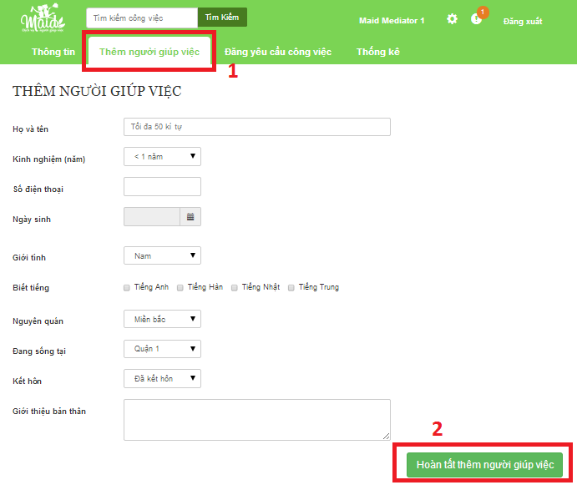

Figure 100: Add Maid Image

|  |  |
| --- | --- |
| **Step** | **Description** |
| 1 | Click “Thêm người giúp việc”  Fill all |
| 2 | Click “Hoàn tất thêm người giúp việc” button |

### <Staff, MaidMediator> Post Job Request

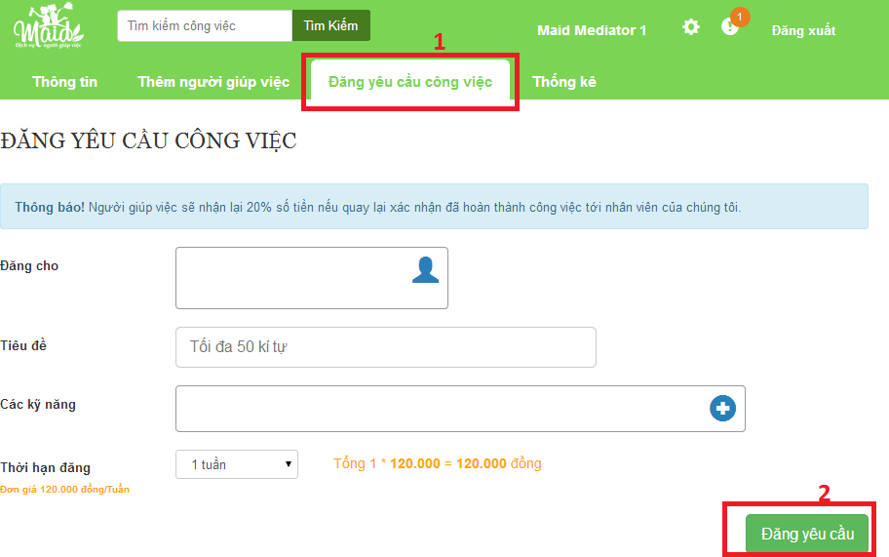

Figure 101: Post job request Image

|  |  |
| --- | --- |
| **Step** | **Description** |
| 1 | **Click “Đăng yêu cầu công việc” link**  **Fill all** |
| 2 | **Click “Đăng yêu cầu” button** |

### <Customer> Post Recruitment

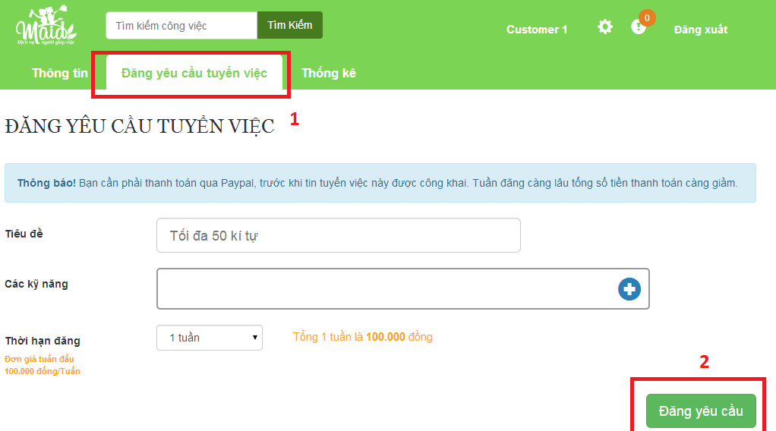

Figure 102: Post Recruitment Image

|  |  |
| --- | --- |
| **Step** | **Description** |
| 1 | Click “Đăng yêu cầu tuyển việc”  Fill all |
| 2 | Click “Đăng yêu cầu” |

### <Admin>Manage config

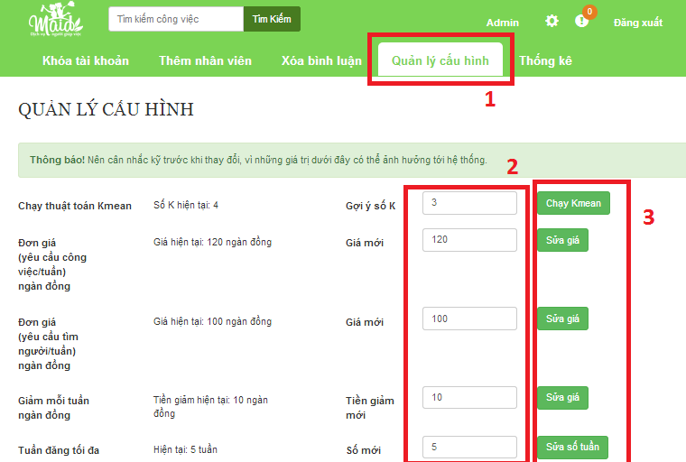

Figure 103: Manage config Image

|  |  |
| --- | --- |
| **Step** | **Description** |
| 1 | Click “Quản lý cấu hình” |
| 2 | Chang a number in field |
| 3 | Click button to finish |