OptiSigns – OptiBot Mini-Clone Take-Home Test
— ship it in ~ 10 focused hours. Everything else is extra credit.

0 . Warm-up (15 min)
- Create a free optisigns.com trial account and chat with OptiBot so you know what you’re cloning.
- Open a free account on your chosen AI platform: OpenAI (platform.openai.com) or Google Gemini (aistudio.google.com).
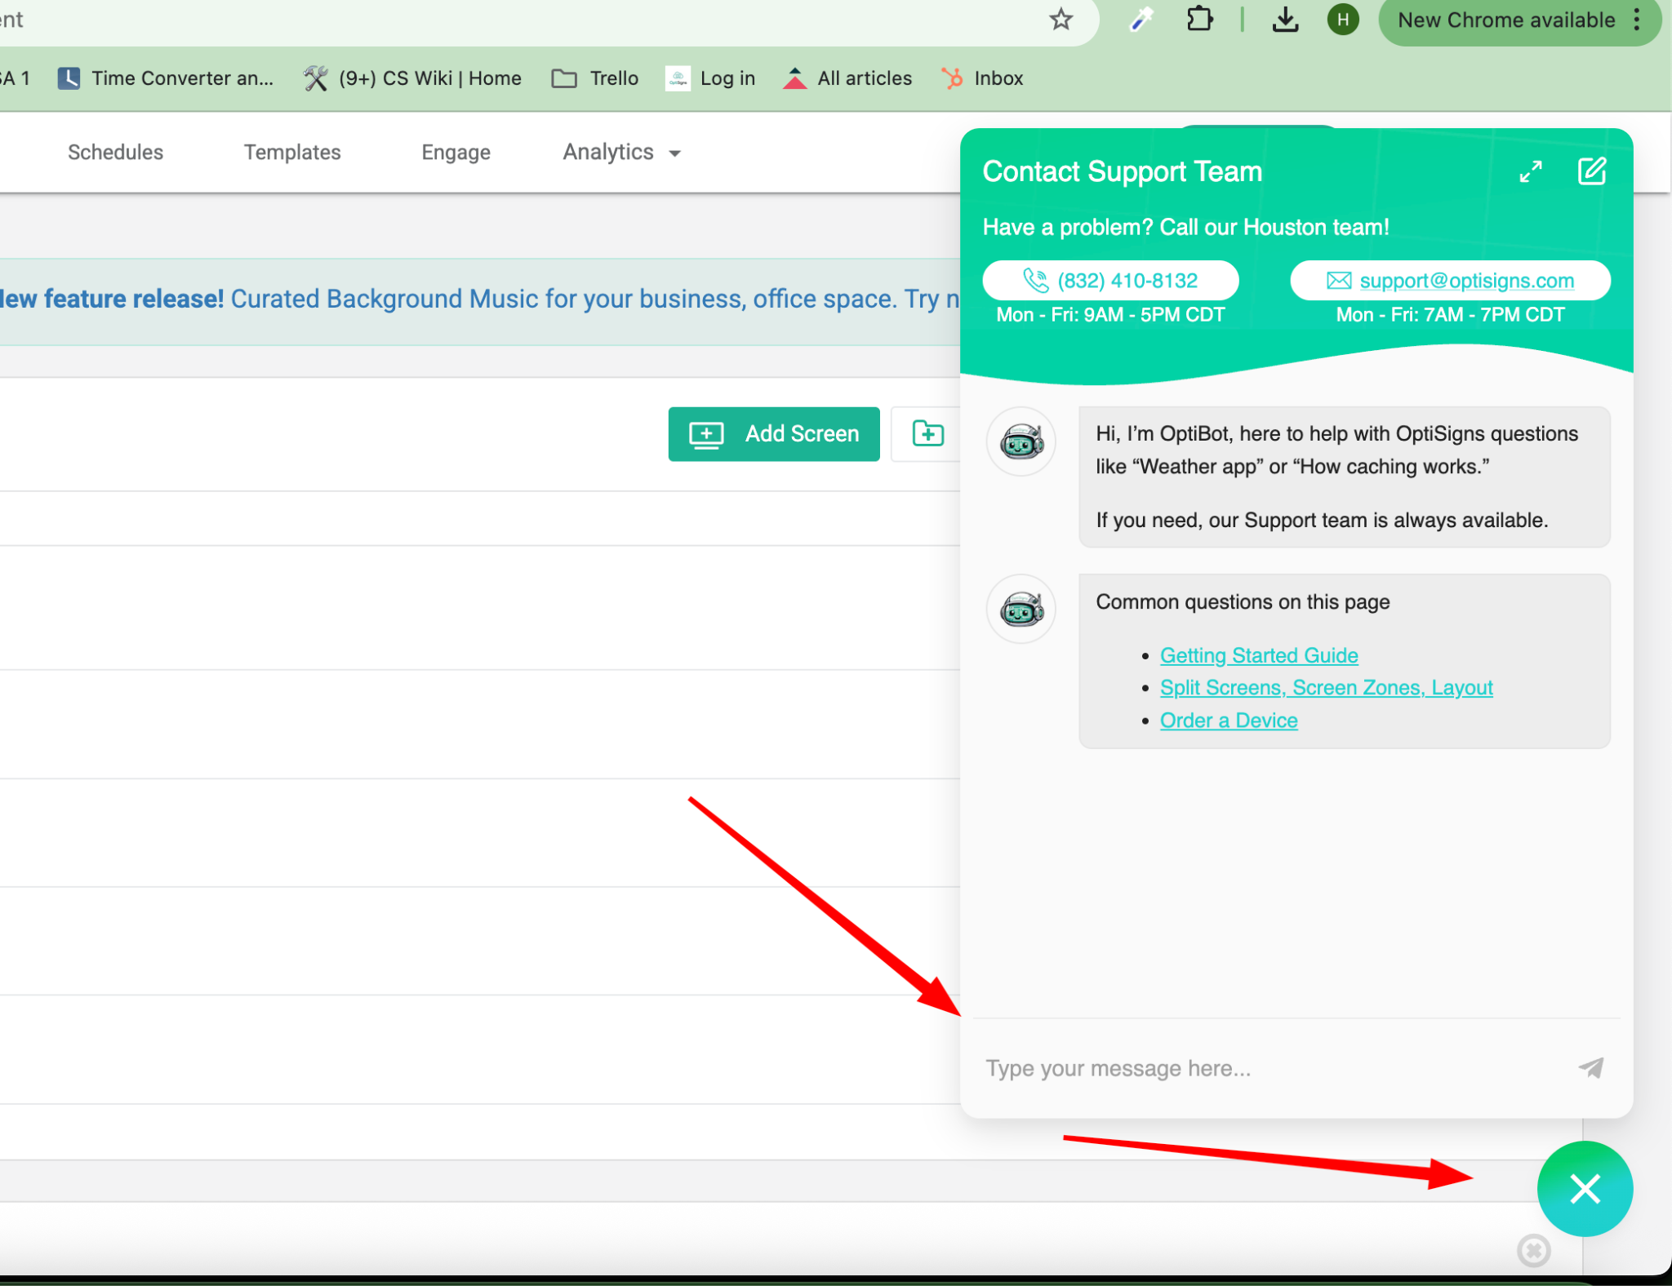

1 . Scrape ⇒ Markdown (~3 h)
Goal: prove you can ingest messy web content and normalize it.
- Pull ≥ 30 articles from support.optisigns.com.
- Convert each article to clean Markdown.
- Save each file as <slug>.md (or whatever scheme you like).
- Preserve relative links, code blocks, and headings. Remove nav/ads.
Hint: you can use Zendesk API to read the article,

2 . Build AI Assistant & Programmatically Load Vector Store (~2 h)
API upload is mandatory—no UI drag-and-drop here.
Create the Assistant – Use OpenAI Playground UI or Google AI Studio to set up your assistant.
System prompt (verbatim):
You are OptiBot, the customer-support bot for OptiSigns.com.
• Tone: helpful, factual, concise.
• Only answer using the uploaded docs.
• Max 5 bullet points; else link to the doc.
• Cite up to 3 "Article URL:" lines per reply.
- Via Python script, upload Markdown files to your chosen AI service’s vector store/knowledge base via API (OpenAI Vector Store or Google Gemini equivalent).
  - Upload files to OpenAI | Gemini API docs
  - Attach files to Vector Stores
  - Chunking strategy is up to you; just explain it in the README.
  - Log how many files and chunks were embedded.
- Quick sanity check – Test your assistant in the Playground (OpenAI) or AI Studio (Gemini), and ask:
“How do I add a YouTube video?”
Take a screenshot showing a correct answer with citations.
You can learn more about the overall OpenAI Agent or Google Gemini API approach.

3 . Deploy Scraper as Daily Job (~2 h)
- Wrap your scraper-uploader in main.py.
- Dockerize (Dockerfile).
- Schedule it to run once per day on DigitalOcean or any cloud/public hosting platform (e.g. Railway, Render, Fly.io, AWS, GCP).
- Job must:
  - Re-scrape.
  - Detects new/updated articles (hash, Last-Modified, etc.).
  - Upload only the delta.
Log counts: added, updated, skipped. Provide a link to job logs or last run artefact.

Deliverables
Item | Must Have
GitHub repo | Please DO NOT name your github repo “optisigns” something, just give it cryptic name so future candidate not easy to find when search optisigns  Clear commits; no hard-coded keys (use .env.sample).
Dockerfile | docker run -e API_KEY=... main.py runs once and exits 0.
README (≤ 1 page) | • setup• how to run locally• link to daily job logs• screenshot of assistant answering a sample question
Screenshot | Assistant correctly answers sample questions with cited URLs.

Grading (70 pts pass bar)
Area | Pts
Scrape & clean quality | 25
API-based vector-store upload works | 20
Daily job deployment & logs | 15
Code clarity + README | 10
(Bonus tests) | +5

Set up 1h Project Reviews:
We will discuss
- Your overall concept understanding of the project
- Your approach, solution
- How do you learn something new like this if you haven’t learned it before
- Your thoughts, suggestions on how OptiBots can be improved, what potential challenges you think we will be facing

