|  |
| --- |
|  |
|  |

**BAKERY STORE**

Report #2 – Class Design

|  |  |  |
| --- | --- | --- |
| **Bakery Store** | | |
| **Group member** | Phạm Thị Minh Phương | SE03773 |
| Cao Anh Tuấn | SE03737 |
| Hoàng Anh Phương | SE03715 |
| Ngô Trung Kiên | SE03736 |
| Nguyễn Xuân Hà | SE03484 |
| **Supervisor** | Mr. Nguyễn Văn Sang | |
| **Project code** | BSO | |

**- Hanoi, 10/2017**

# SIGNATURE PAGE

AUTHOR: Nguyễn Xuân Hà 11/10/2017

Project Technical Leader

REVIEWERS: Phạm Thị Minh Phương 12/10/2017

Team member

APPROVAL: Nguyễn Văn Sang --/--/--17

Supervisor

Record of change

*A - Added M - Modified D – Deleted

|  |  |  |  |  |  |
| --- | --- | --- | --- | --- | --- |
| Effective Date | Changed Item | A,M,D | Change Description | Reason for Change | Rev. Number |
| 14/10/2017 | Create Class Design | A | First version | Create Class Design | 1.0 |
|  |  |  |  |  |  |
|  |  |  |  |  |  |
|  |  |  |  |  |  |
|  |  |  |  |  |  |
|  |  |  |  |  |  |
|  |  |  |  |  |  |
|  |  |  |  |  |  |
|  |  |  |  |  |  |
|  |  |  |  |  |  |
|  |  |  |  |  |  |
|  |  |  |  |  |  |

Contents

SIGNATURE PAGE 2

1. INTRODUCTION 8

1.1 Purpose 8

1.2 Definitions, Acronyms and Abbreviations 8

2. SYSTEM ARCHITECTURAL 8

3. DETAIL DESIGN 10

3.1 Admin Login 10

3.1.1 Class Diagram 10

3.1.2 Class Diagram Explanation 10

3.2 Staff Login 11

3.2.1 Class Diagram 11

3.2.2 Class Diagram Explanation 11

3.3 User Login 12

3.3.1 Class Diagram 12

3.3.2 Class Diagram Explanation 12

3.4 Check Login Admin 13

3.4.1 Class Diagram 13

3.4.2 Class Diagram Explanation 13

3.5 Check Login Staff 14

3.5.1 Class Diagram 14

3.5.2 Class Diagram Explanation 14

3.6 Check Login User 15

3.6.1 Class Diagram 15

3.6.2 Class Diagram Explanation 15

3.7 Logout 16

3.7.1 Class Diagram 16

3.7.2 Class Diagram Explanation 16

3.8 View Account 17

3.8.1 Class Diagram 17

3.8.2 Class Diagram Explanation 17

3.9 Update Account 18

3.9.1 Class Diagram 18

3.9.2 Class Diagram Explanation 18

3.10 Insert Account 19

3.10.1 Class Diagram 19

3.10.2 Class Diagram Explanation 19

3.11 Search Human 20

3.11.1 Class Diagram 20

3.11.2 Class Diagram Explanation 20

3.12 Change Password 21

3.12.1 Class Diagram 21

3.12.2 Class Diagram Explanation 21

3.13 Forgot Password 22

3.13.1 Class Diagram 22

3.13.2 Class Diagram Explanation 22

3.14 Lock Account 23

3.14.1 Class Diagram 23

3.14.2 Class Diagram Explanation 23

3.15 Unlock Account 24

3.15.1 Class Diagram 24

3.15.2 Class Diagram Explanation 24

3.16 Add Cake 25

3.16.1 Class Diagram 25

3.16.2 Class Diagram Explanation 25

3.17 View Cake 26

3.17.1 Class Diagram 26

3.17.2 Class Diagram Explanation 26

3.18 Search Cake 27

3.18.1 Class Diagram 27

3.18.2 Class Diagram Explanation 27

3.19 Update Cake 28

3.19.1 Class Diagram 28

3.19.2 Class Diagram Explanation 28

3.20 Lock Cake 29

3.20.1 Class Diagram 29

3.20.2 Class Diagram Explanation 29

3.21 Unlock cake 30

3.21.1 Class Diagram 30

3.21.2 Class Diagram Explanation 30

3.22 Insert category 31

3.22.1 Class Diagram 31

3.22.2 Class Diagram Explanation 31

3.23 View Category 32

3.23.1 Class Diagram 32

3.23.2 Class Diagram Explanation 32

3.24 Lock Category 33

3.24.1 Class Diagram 33

3.24.2 Class Diagram Explanation 33

3.25 Unlock Category 34

3.25.1 Class Diagram 34

3.25.2 Class Diagram Explanation 34

3.26 Insert Event 35

3.26.1 Class Diagram 35

3.26.2 Class Diagram Explanation 35

3.27 View Event 36

3.27.1 Class Diagram 36

3.27.2 Class Diagram Explanation 36

3.28 Lock Event 37

3.28.1 Class Diagram 37

3.28.2 Class Diagram Explanation 37

3.29 Unlock Event 38

3.29.1 Class Diagram 38

3.29.2 Class Diagram Explanation 38

3.30 Search Event 39

3.30.1 Class Diagram 39

3.30.2 Class Diagram Explanation 39

3.31 Insert Blog 40

3.31.1 Class Diagram 40

3.31.2 Class Diagram Explanation 40

3.32 View Blog 41

3.32.1 Class Diagram 41

3.32.2 Class Diagram Explanation 41

3.33 Search Blog 42

3.33.1 Class Diagram 42

3.33.2 Class Diagram Explanation 42

3.34 Blog Detail 43

3.34.1 Class Diagram 43

3.34.2 Class Diagram Explanation 43

3.35 Lock Blog 44

3.35.1 Class Diagram 44

3.35.2 Class Diagram Explanation 44

3.36 UnLock Blog 45

3.36.1 Class Diagram 45

3.36.2 Class Diagram Explanation 45

3.37 Insert Bill 46

3.37.1 Class Diagram 46

3.37.2 Class Diagram Explanation 46

3.38 Seach Bill 47

3.38.1 Class Diagram 47

3.38.2 Class Diagram Explanation 47

3.39 View Bill 48

3.39.1 Class Diagram 48

3.39.2 Class Diagram Explanation 48

3.40 Confirm Bill 49

3.40.1 Class Diagram 49

3.40.2 Class Diagram Explanation 49

3.41 Unconfirm Bill 50

3.41.1 Class Diagram 50

3.41.2 Class Diagram Explanation 50

3.42 Note 51

3.42.1 Class Diagram 51

3.42.2 Class Diagram Explanation 51

3.43 View Human 52

3.43.1 Class Diagram 52

3.43.2 Class Diagram Explanation 52

3.44 View Human 52

3.44.1 Class Diagram 52

3.44.2 Class Diagram Explanation 52

4. Sequence diagram 52

4.1 Login 52

4.1.1 Login Admin 52

4.1.2 Login Staff 53

4.1.3 Login User 54

4.1.4 Logout 55

4.1.5 Login Register 56

4.1.6 Forgot Password 57

4.2 Manage Account 57

4.2.1 Insert Staff 58

4.2.2 Update Staff 59

4.2.3 Lock Account 59

4.2.4 UnLock Account 60

4.3 Manage Cake 60

4.3.1 Insert Cake 60

4.3.2 Search Cake 61

4.3.3 Update Cake 61

4.3.4 Lock Cake 62

4.3.5 UnLock Cake 62

4.4 Manage Blog 63

4.4.1 Insert Blog 63

4.4.2 Search Blog 63

4.4.3 Lock Blog 64

4.4.4 UnLock Blog 64

4.5 Manage Event 65

4.5.1 Insert Event 65

4.5.2 Search Event 65

4.5.3 Lock Event 66

4.5.4 Unlock Event 66

4.6 Manage Category 67

4.6.1 Insert Category 67

4.6.2 Lock Category 67

4.6.3 UnLock Category 68

4.7 Check Out 68

4.8 Manage Bill 69

4.8.1 Search Bill 69

4.8.2 Confirm Bill 69

4.8.3 Unconfirm Bill 70

4.9 Search revenue 70

4.10 Change Password 71

4.11 Update Information 72

# 

# **INTRODUCTION**

## **Purpose**

Bakery store online class design document contains description of all class of the Bakery Store . It include : Class diagram that describe the static relation of all classes in the system.

## **Definitions, Acronyms and Abbreviations**

|  |  |  |
| --- | --- | --- |
| Abbreviations | Description | Comment |
| BSO | Bakery Store Online |  |
| FAQ | Frequently Asked Question |  |

# **SYSTEM ARCHITECTURAL**

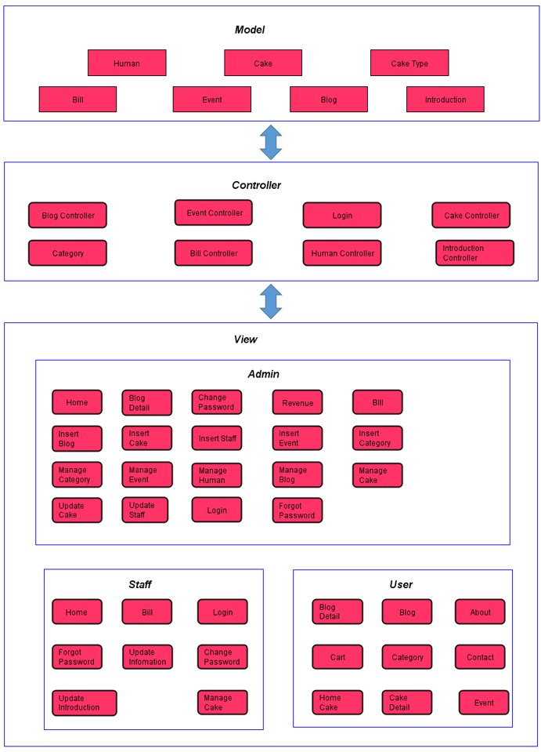

# **DETAIL DESIGN**

## **Admin Login**

### Class Diagram

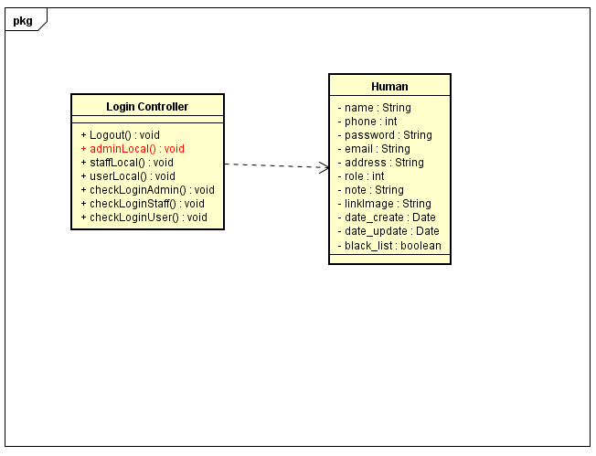

### Class Diagram Explanation

|  |  |  |
| --- | --- | --- |
| **Class** | LoginController | |
| **Description** | Admin Login | |
| **Base Class** | Controller | |
| **Source File** | LoginController.js | |
| **Namespace** | Controllers | |
| **Attributes** | **N/A** | |
| **Methods** | **Name** | **Description** |
| adminLocal() | Admin login to website |

## **Staff Login**

### Class Diagram

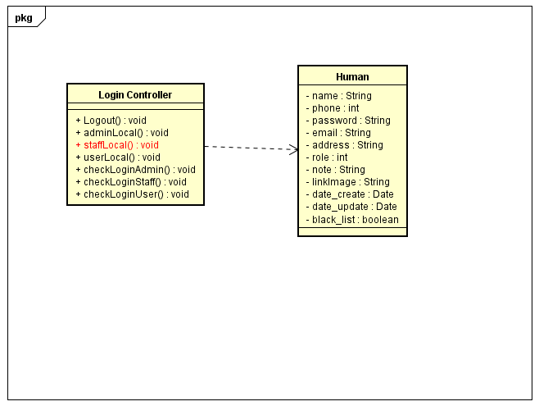

### Class Diagram Explanation

|  |  |  |
| --- | --- | --- |
| **Class** | LoginController | |
| **Description** | Staff Login | |
| **Base Class** | Controller | |
| **Source File** | LoginController.js | |
| **Namespace** | Controllers | |
| **Attributes** | **N/A** | |
| **Methods** | **Name** | **Description** |
| staffLocal() | Staff login to website |

## **User Login**

### Class Diagram

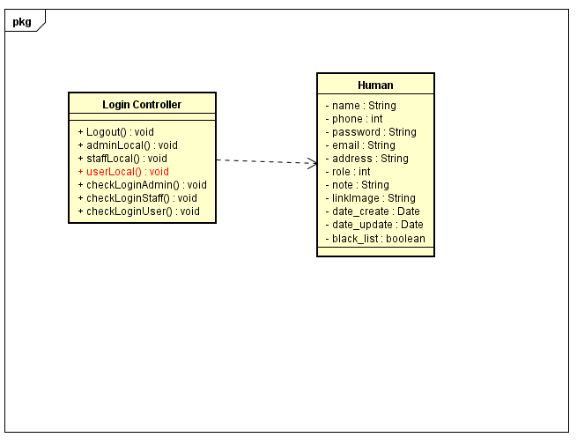

### Class Diagram Explanation

|  |  |  |
| --- | --- | --- |
| **Class** | LoginController | |
| **Description** | User Login | |
| **Base Class** | Controller | |
| **Source File** | LoginController.js | |
| **Namespace** | Controllers | |
| **Attributes** | **N/A** | |
| **Methods** | **Name** | **Description** |
| userLocal() | User normal login to website |

## **Check Login Admin**

### Class Diagram

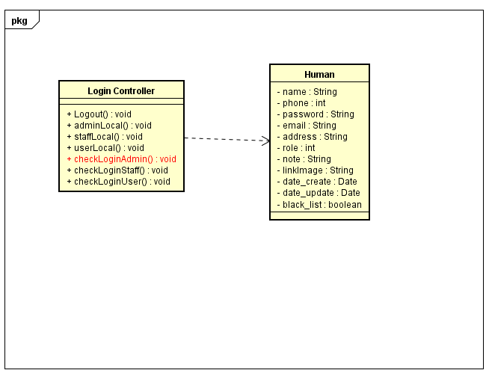

### Class Diagram Explanation

|  |  |  |
| --- | --- | --- |
| **Class** | LoginController | |
| **Description** | Check Status Login of Admin | |
| **Base Class** | Controller | |
| **Source File** | LoginController.js | |
| **Namespace** | Controllers | |
| **Attributes** | **N/A** | |
| **Methods** | **Name** | **Description** |
| isLoggedAdmin() | Check Status Login of Admin |

## **Check Login Staff**

### Class Diagram

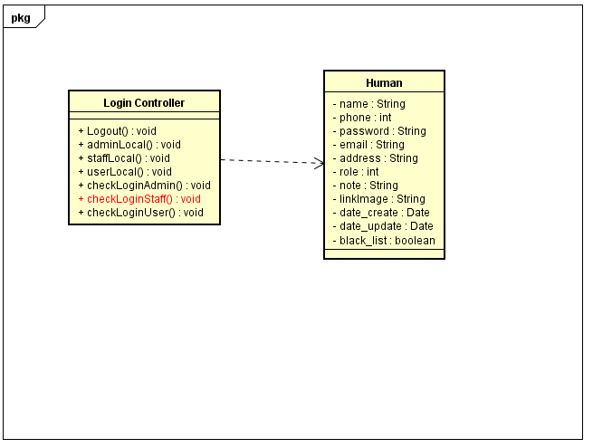

### Class Diagram Explanation

|  |  |  |
| --- | --- | --- |
| **Class** | LoginController | |
| **Description** | Check Status Login of Staff | |
| **Base Class** | Controller | |
| **Source File** | LoginController.js | |
| **Namespace** | Controllers | |
| **Attributes** | **N/A** | |
| **Methods** | **Name** | **Description** |
| isLoggedStaff() | Check Status Login of Staff |

## **Check Login User**

### Class Diagram

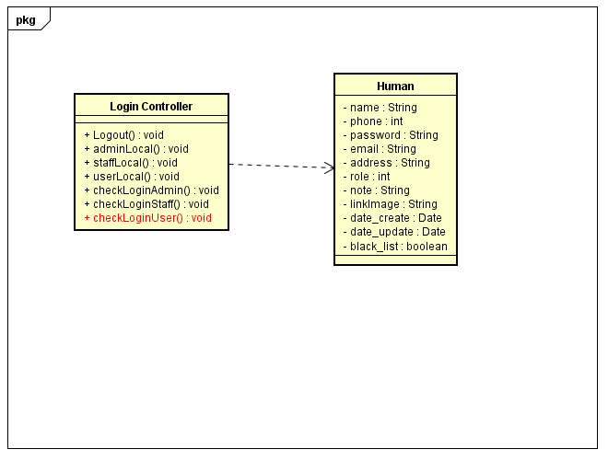

### Class Diagram Explanation

|  |  |  |
| --- | --- | --- |
| **Class** | LoginController | |
| **Description** | Check Status Login of User | |
| **Base Class** | Controller | |
| **Source File** | LoginController.js | |
| **Namespace** | Controllers | |
| **Attributes** | **N/A** | |
| **Methods** | **Name** | **Description** |
| isLoggedUser() | Check Status Login of User |

## **Logout**

### Class Diagram

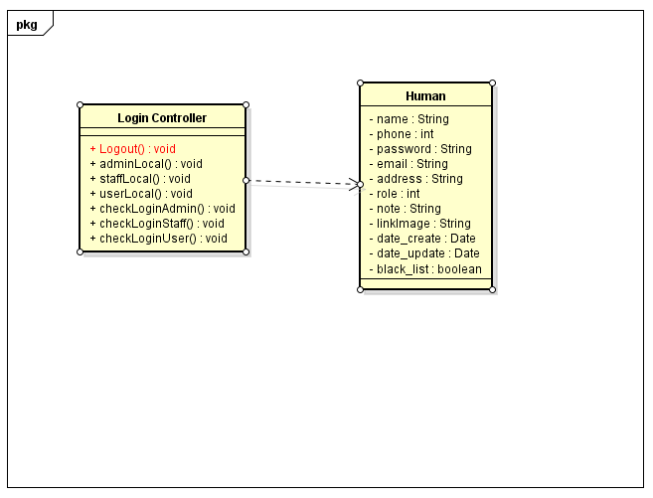

### Class Diagram Explanation

|  |  |  |
| --- | --- | --- |
| **Class** | LoginController | |
| **Description** | Log Out Account | |
| **Base Class** | Controller | |
| **Source File** | LoginController.js | |
| **Namespace** | Controllers | |
| **Attributes** | **N/A** | |
| **Methods** | **Name** | **Description** |
| Logout() | Log out Account |

## **View Account**

### Class Diagram

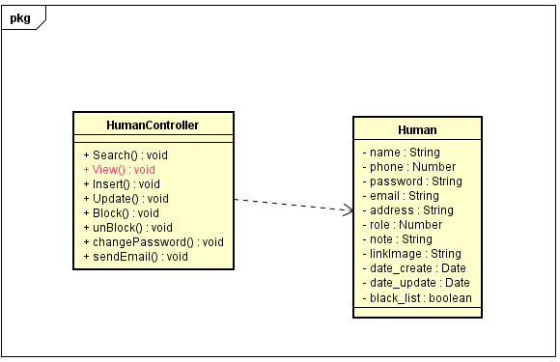

### Class Diagram Explanation

|  |  |  |
| --- | --- | --- |
| **Class** | HumanController | |
| **Description** | Show all details of account had exist for admin | |
| **Base Class** | Controller | |
| **Source File** | HumanController.js | |
| **Namespace** | Controllers | |
| **Attributes** | **N/A** | |
| **Methods** | **Name** | **Description** |
| View() | Show all details of account had exist for Admin |

## **Update Account**

### Class Diagram

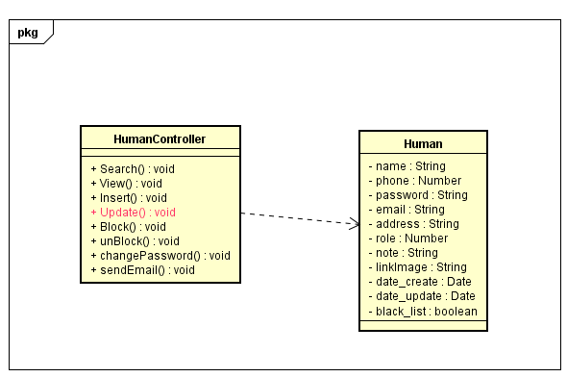

### Class Diagram Explanation

|  |  |  |
| --- | --- | --- |
| **Class** | HumanController | |
| **Description** | update information for account | |
| **Base Class** | Controller | |
| **Source File** | HumanController.js | |
| **Namespace** | Controllers | |
| **Attributes** | **N/A** | |
| **Methods** | **Name** | **Description** |
| Update() | Update information for account |

## **Insert Account**

### Class Diagram

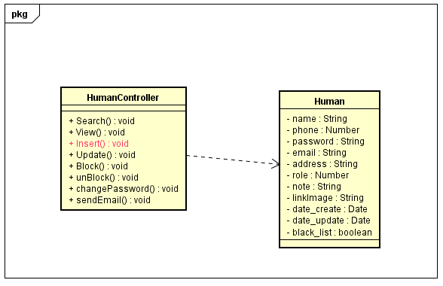

### Class Diagram Explanation

|  |  |  |
| --- | --- | --- |
| **Class** | HumanController | |
| **Description** | Insert new account | |
| **Base Class** | Controller | |
| **Source File** | HumanController.js | |
| **Namespace** | Controllers | |
| **Attributes** | **N/A** | |
| **Methods** | **Name** | **Description** |
| Insert() | User sign up or admin add new a Staff |

## **Search Human**

### Class Diagram

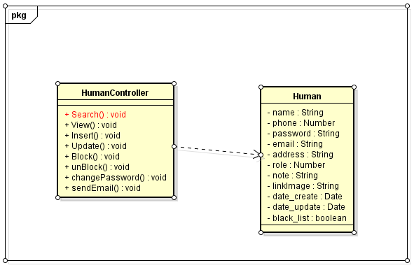

### Class Diagram Explanation

|  |  |  |
| --- | --- | --- |
| **Class** | HumanController | |
| **Description** | Search information of Account | |
| **Base Class** | Controller | |
| **Source File** | HumanController.js | |
| **Namespace** | Controllers | |
| **Attributes** | **N/A** | |
| **Methods** | **Name** | **Description** |
| Search() | Search information of Account |

## **Change Password**

### Class Diagram

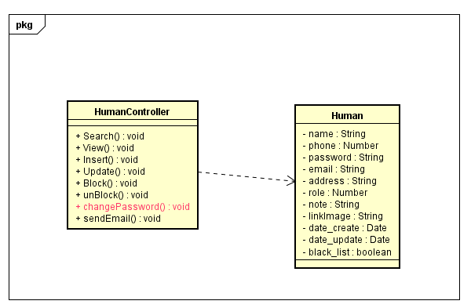

### Class Diagram Explanation

|  |  |  |
| --- | --- | --- |
| **Class** | HumanController | |
| **Description** | Change Password of Account | |
| **Base Class** | Controller | |
| **Source File** | HumanController.js | |
| **Namespace** | Controllers | |
| **Attributes** | **N/A** | |
| **Methods** | **Name** | **Description** |
| changePassword() | Change Password of Account |

## **Forgot Password**

### Class Diagram

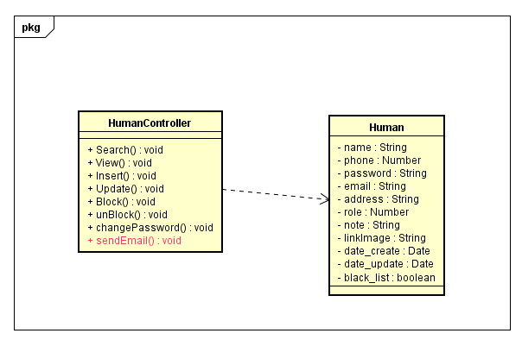

### Class Diagram Explanation

|  |  |  |
| --- | --- | --- |
| **Class** | HumanController | |
| **Description** | Send new Password to Email | |
| **Base Class** | Controller | |
| **Source File** | HumanController.js | |
| **Namespace** | Controllers | |
| **Attributes** | **N/A** | |
| **Methods** | **Name** | **Description** |
| sendEmail() | Send new password to email when forgot password |

## **Lock Account**

### Class Diagram

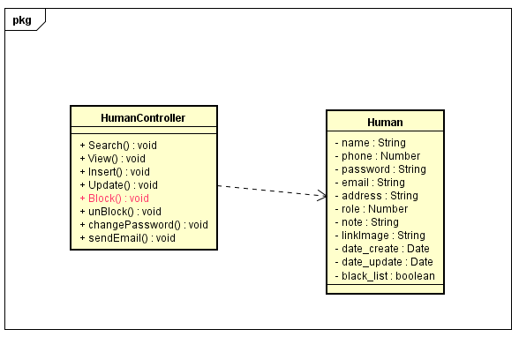

### Class Diagram Explanation

|  |  |  |
| --- | --- | --- |
| **Class** | HumanController | |
| **Description** | Admin can lock account of customer and staff | |
| **Base Class** | Controller | |
| **Source File** | HumanController.js | |
| **Namespace** | Controllers | |
| **Attributes** | **N/A** | |
| **Methods** | **Name** | **Description** |
| Block() | Admin can lock account of customer and staff |

## **Unlock Account**

### Class Diagram

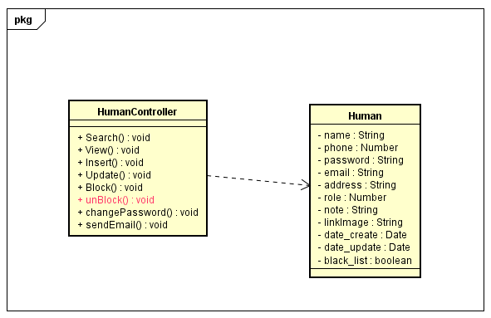

### Class Diagram Explanation

|  |  |  |
| --- | --- | --- |
| **Class** | HumanController | |
| **Description** | Admin can unlock account of customer and staff | |
| **Base Class** | Controller | |
| **Source File** | HumanController.js | |
| **Namespace** | Controllers | |
| **Attributes** | **N/A** | |
| **Methods** | **Name** | **Description** |
| unBlock() | Admin can lock account of customer and staff |

## **Add Cake**

### Class Diagram

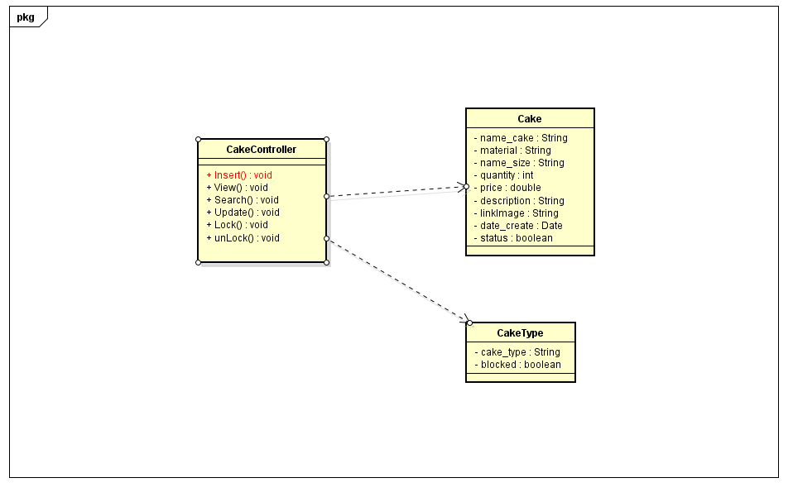

### Class Diagram Explanation

|  |  |  |
| --- | --- | --- |
| **Class** | CakeController | |
| **Description** | Add new Cake | |
| **Base Class** | Controller | |
| **Source File** | CakeController.js | |
| **Namespace** | Controllers | |
| **Attributes** | **N/A** | |
| **Methods** | **Name** | **Description** |
| Insert() | Add new cake |

## **View Cake**

### Class Diagram

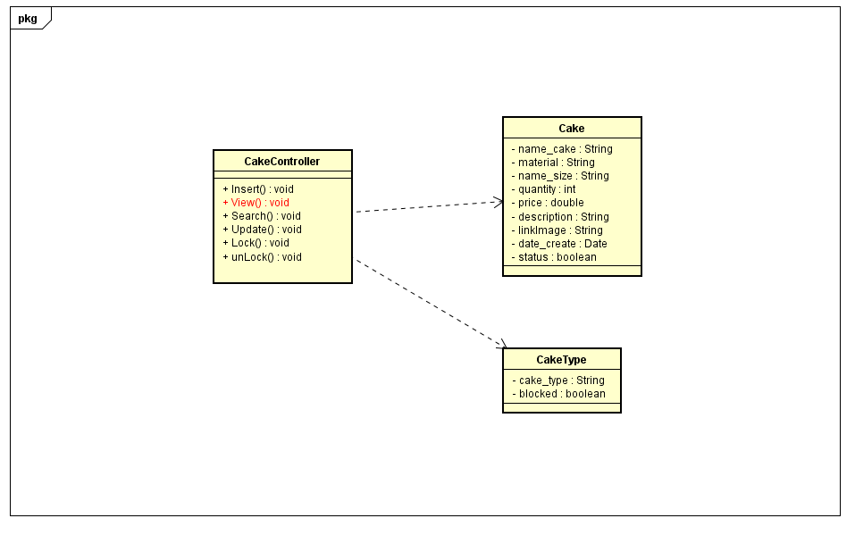

### Class Diagram Explanation

|  |  |  |
| --- | --- | --- |
| **Class** | CakeController | |
| **Description** | View information of Cakes | |
| **Base Class** | Controller | |
| **Source File** | CakeController.js | |
| **Namespace** | Controllers | |
| **Attributes** | **N/A** | |
| **Methods** | **Name** | **Description** |
| Insert() | View information of Cake |

## **Search Cake**

### Class Diagram

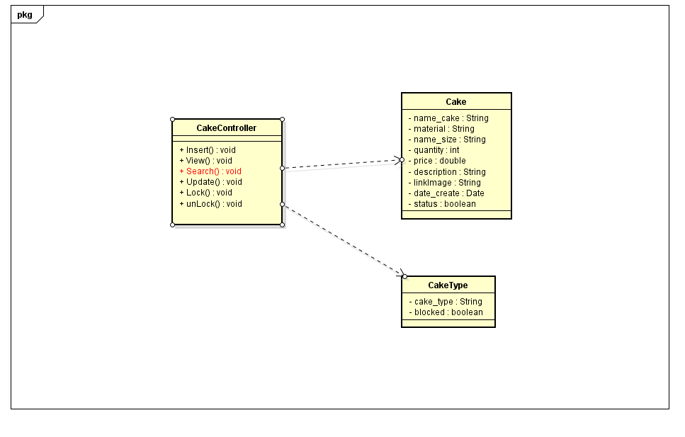

### Class Diagram Explanation

|  |  |  |
| --- | --- | --- |
| **Class** | CakeController | |
| **Description** | Search cake by name or category | |
| **Base Class** | Controller | |
| **Source File** | CakeController.js | |
| **Namespace** | Controllers | |
| **Attributes** | **N/A** | |
| **Methods** | **Name** | **Description** |
| Search() | Search cake by name or category |

## **Update Cake**

### Class Diagram

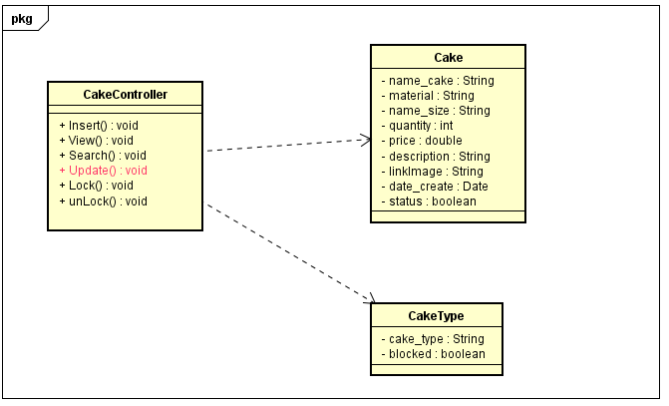

### Class Diagram Explanation

|  |  |  |
| --- | --- | --- |
| **Class** | CakeController | |
| **Description** | Update information cake | |
| **Base Class** | Controller | |
| **Source File** | CakeController.js | |
| **Namespace** | Controllers | |
| **Attributes** | **N/A** | |
| **Methods** | **Name** | **Description** |
| Update() | Update information cake |

## **Lock Cake**

### Class Diagram

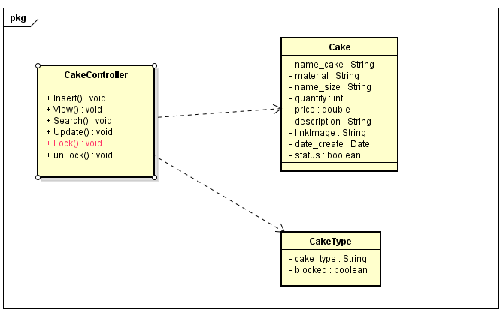

### Class Diagram Explanation

|  |  |  |
| --- | --- | --- |
| **Class** | CakeController | |
| **Description** | Update Status of cake not sell | |
| **Base Class** | Controller | |
| **Source File** | CakeController.js | |
| **Namespace** | Controllers | |
| **Attributes** | **N/A** | |
| **Methods** | **Name** | **Description** |
| Lock() | Update Status cake not sell |

## **Unlock cake**

### Class Diagram

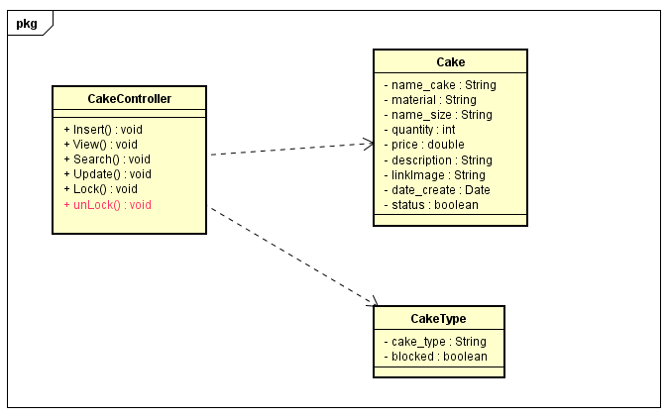

### Class Diagram Explanation

|  |  |  |
| --- | --- | --- |
| **Class** | CakeController | |
| **Description** | Update status of cake (sell again ) | |
| **Base Class** | Controller | |
| **Source File** | CakeController.js | |
| **Namespace** | Controllers | |
| **Attributes** | **N/A** | |
| **Methods** | **Name** | **Description** |
| unLock() | Update status of cake (sell again ) |

## **Insert category**

### Class Diagram

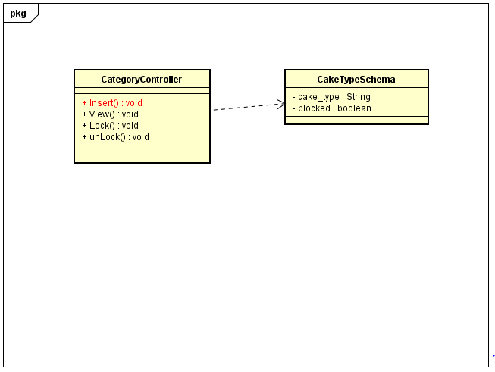

### Class Diagram Explanation

|  |  |  |
| --- | --- | --- |
| **Class** | CategoryController | |
| **Description** | Insert new category | |
| **Base Class** | Controller | |
| **Source File** | CategoryController.js | |
| **Namespace** | Controllers | |
| **Attributes** | **N/A** | |
| **Methods** | **Name** | **Description** |
| Insert() | Insert new category |

## **View Category**

### Class Diagram

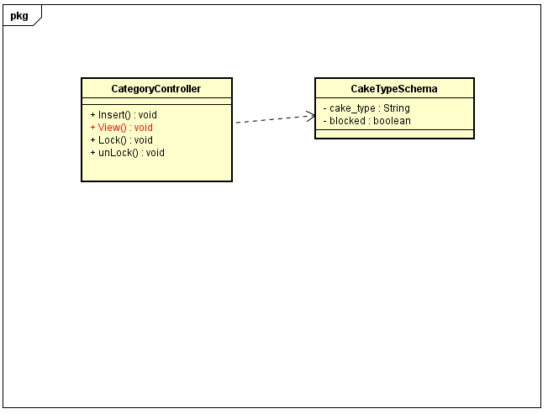

### Class Diagram Explanation

|  |  |  |
| --- | --- | --- |
| **Class** | CategoryController | |
| **Description** | View all category | |
| **Base Class** | Controller | |
| **Source File** | CategoryController.js | |
| **Namespace** | Controllers | |
| **Attributes** | **N/A** | |
| **Methods** | **Name** | **Description** |
| View() | View all category |

## **Lock Category**

### Class Diagram

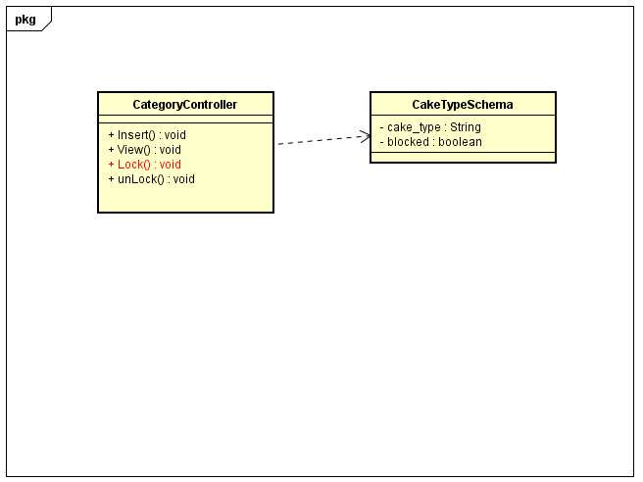

### Class Diagram Explanation

|  |  |  |
| --- | --- | --- |
| **Class** | CategoryController | |
| **Description** | Update status of category | |
| **Base Class** | Controller | |
| **Source File** | CategoryController.js | |
| **Namespace** | Controllers | |
| **Attributes** | **N/A** | |
| **Methods** | **Name** | **Description** |
| Lock() | Update status of category |

## **Unlock Category**

### Class Diagram

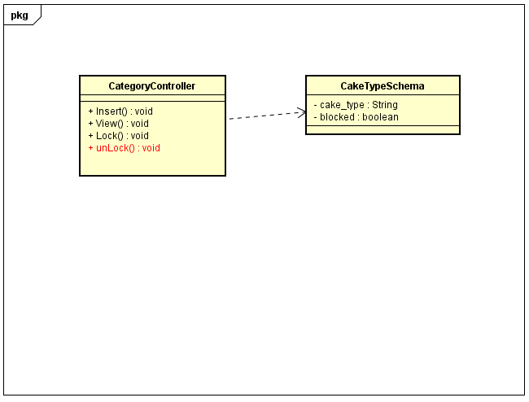

### Class Diagram Explanation

|  |  |  |
| --- | --- | --- |
| **Class** | CategoryController | |
| **Description** | Update status of category | |
| **Base Class** | Controller | |
| **Source File** | CategoryController.js | |
| **Namespace** | Controllers | |
| **Attributes** | **N/A** | |
| **Methods** | **Name** | **Description** |
| unLock() | Update status of category |

## **Insert Event**

### Class Diagram

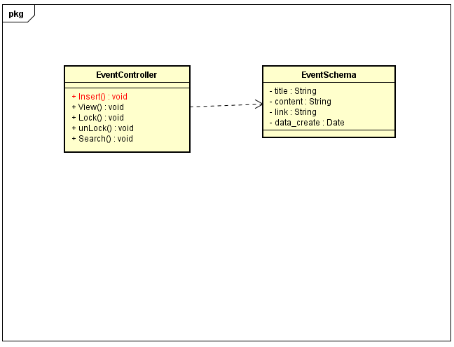

### Class Diagram Explanation

|  |  |  |
| --- | --- | --- |
| **Class** | EventController | |
| **Description** | Insert new event | |
| **Base Class** | Controller | |
| **Source File** | EventController.js | |
| **Namespace** | Controllers | |
| **Attributes** | **N/A** | |
| **Methods** | **Name** | **Description** |
| Insert() | Insert new event |

## **View Event**

### Class Diagram

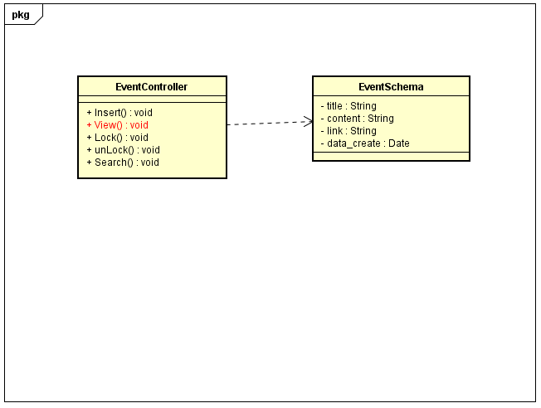

### Class Diagram Explanation

|  |  |  |
| --- | --- | --- |
| **Class** | EventController | |
| **Description** | View all Event | |
| **Base Class** | Controller | |
| **Source File** | EventController.js | |
| **Namespace** | Controllers | |
| **Attributes** | **N/A** | |
| **Methods** | **Name** | **Description** |
| View() | View all event exist |

## **Lock Event**

### Class Diagram

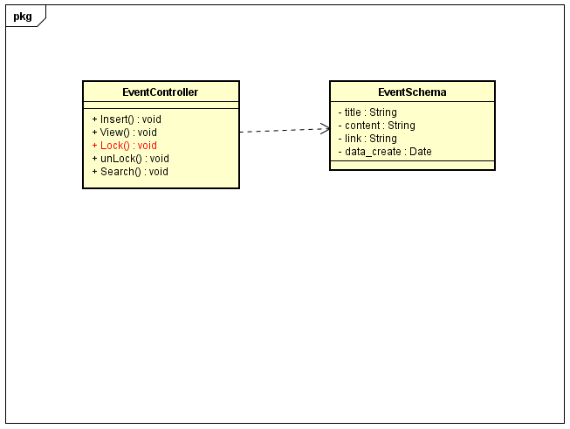

### Class Diagram Explanation

|  |  |  |
| --- | --- | --- |
| **Class** | EventController | |
| **Description** | Update status of event (close) | |
| **Base Class** | Controller | |
| **Source File** | EventController.js | |
| **Namespace** | Controllers | |
| **Attributes** | **N/A** | |
| **Methods** | **Name** | **Description** |
| Lock() | Update status of event (close) |

## **Unlock Event**

### Class Diagram

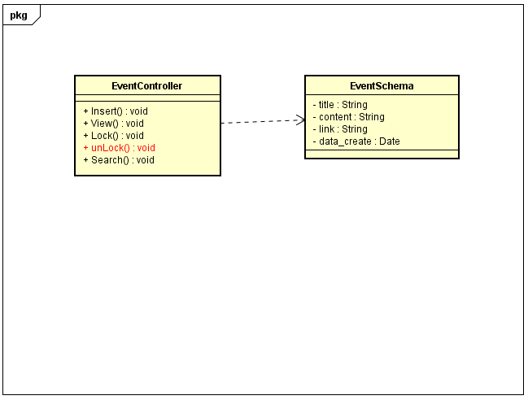

### Class Diagram Explanation

|  |  |  |
| --- | --- | --- |
| **Class** | EventController | |
| **Description** | Update status of event (open) | |
| **Base Class** | Controller | |
| **Source File** | EventController.js | |
| **Namespace** | Controllers | |
| **Attributes** | **N/A** | |
| **Methods** | **Name** | **Description** |
| Unlock() | Update status of event (open) |

## **Search Event**

### Class Diagram

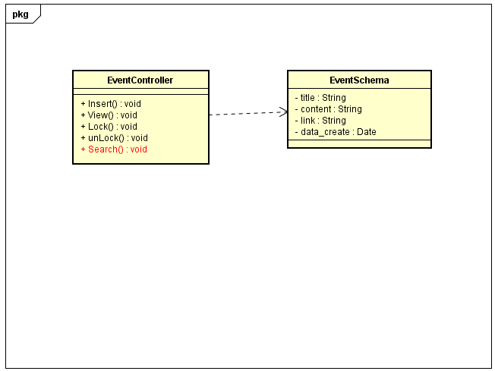

### Class Diagram Explanation

|  |  |  |
| --- | --- | --- |
| **Class** | EventController | |
| **Description** | Find information an event | |
| **Base Class** | Controller | |
| **Source File** | EventController.js | |
| **Namespace** | Controllers | |
| **Attributes** | **N/A** | |
| **Methods** | **Name** | **Description** |
| Search() | Find information an event |

## **Insert Blog**

### Class Diagram

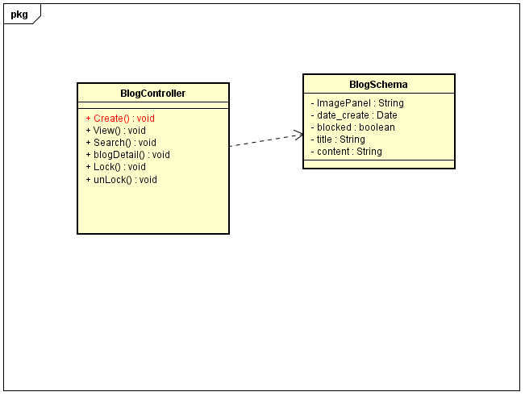

### Class Diagram Explanation

|  |  |  |
| --- | --- | --- |
| **Class** | BlogController | |
| **Description** | Insert new blog | |
| **Base Class** | Controller | |
| **Source File** | BlogController.js | |
| **Namespace** | Controllers | |
| **Attributes** | **N/A** | |
| **Methods** | **Name** | **Description** |
| Create() | Insert new blog |

## **View Blog**

### Class Diagram

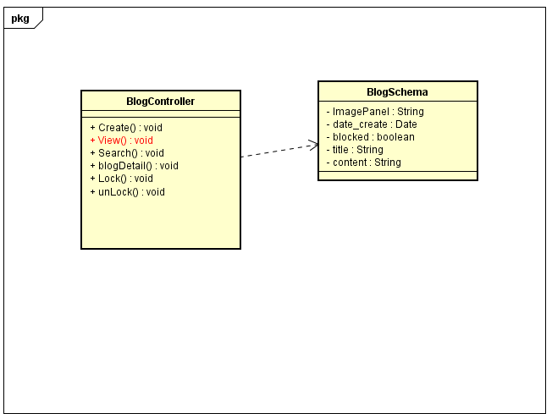

### Class Diagram Explanation

|  |  |  |
| --- | --- | --- |
| **Class** | BlogController | |
| **Description** | View all blog | |
| **Base Class** | Controller | |
| **Source File** | BlogController.js | |
| **Namespace** | Controllers | |
| **Attributes** | **N/A** | |
| **Methods** | **Name** | **Description** |
| View() | View all blog |

## **Search Blog**

### Class Diagram

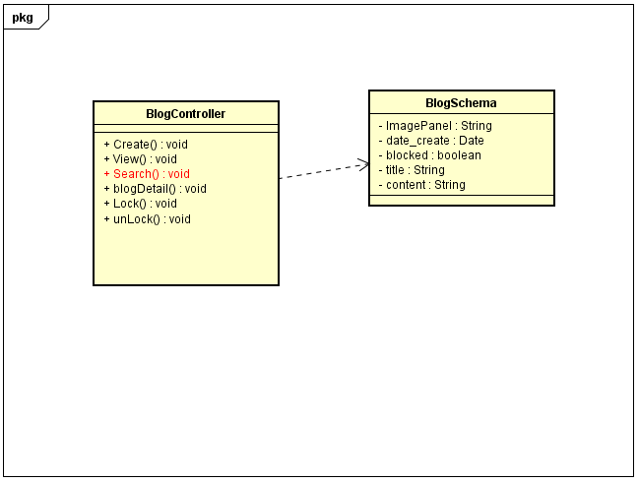

### Class Diagram Explanation

|  |  |  |
| --- | --- | --- |
| **Class** | BlogController | |
| **Description** | Seach blog by title | |
| **Base Class** | Controller | |
| **Source File** | BlogController.js | |
| **Namespace** | Controllers | |
| **Attributes** | **N/A** | |
| **Methods** | **Name** | **Description** |
| Search() | Search blog by title |

## **Blog Detail**

### Class Diagram

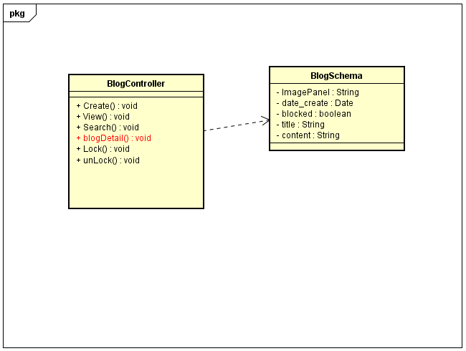

### Class Diagram Explanation

|  |  |  |
| --- | --- | --- |
| **Class** | BlogController | |
| **Description** | Show detail information of blog | |
| **Base Class** | Controller | |
| **Source File** | BlogController.js | |
| **Namespace** | Controllers | |
| **Attributes** | **N/A** | |
| **Methods** | **Name** | **Description** |
| blogDetail() | Show detail information of blog |

## **Lock Blog**

### Class Diagram

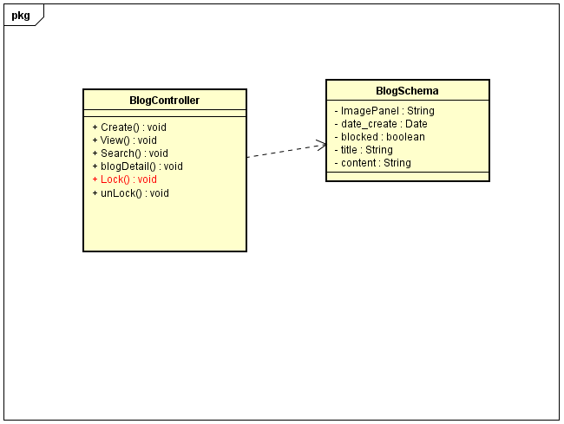

### Class Diagram Explanation

|  |  |  |
| --- | --- | --- |
| **Class** | BlogController | |
| **Description** | Update status of blog (lock) | |
| **Base Class** | Controller | |
| **Source File** | BlogController.js | |
| **Namespace** | Controllers | |
| **Attributes** | **N/A** | |
| **Methods** | **Name** | **Description** |
| Lock() | Update status of blog(lock) |

## **UnLock Blog**

### Class Diagram

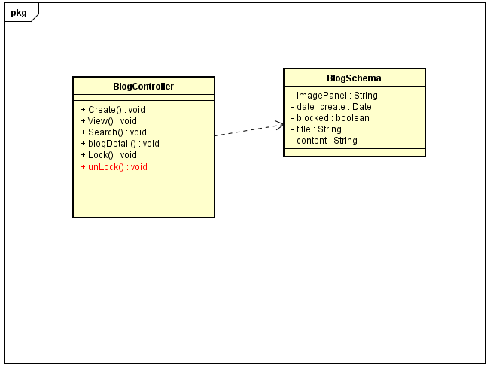

### Class Diagram Explanation

|  |  |  |
| --- | --- | --- |
| **Class** | BlogController | |
| **Description** | Update status of blog(open) | |
| **Base Class** | Controller | |
| **Source File** | BlogController.js | |
| **Namespace** | Controllers | |
| **Attributes** | **N/A** | |
| **Methods** | **Name** | **Description** |
| unLock() | Update status of blog(open) |

## **Insert Bill**

### Class Diagram

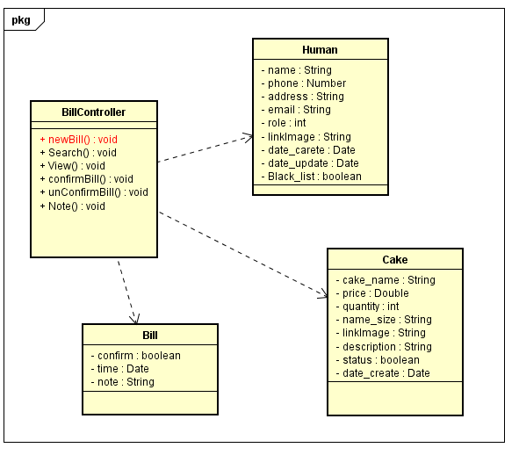

### Class Diagram Explanation

|  |  |  |
| --- | --- | --- |
| **Class** | BillController | |
| **Description** | Insert new bill | |
| **Base Class** | Controller | |
| **Source File** | BillController.js | |
| **Namespace** | Controllers | |
| **Attributes** | **N/A** | |
| **Methods** | **Name** | **Description** |
| newBill() | Insert new bill |

## **Seach Bill**

### Class Diagram

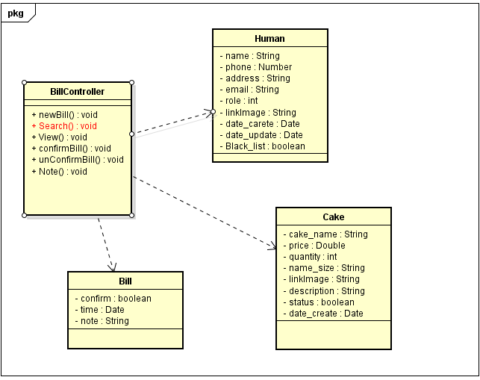

### Class Diagram Explanation

|  |  |  |
| --- | --- | --- |
| **Class** | BillController | |
| **Description** | Find bill | |
| **Base Class** | Controller | |
| **Source File** | BillController.js | |
| **Namespace** | Controllers | |
| **Attributes** | **N/A** | |
| **Methods** | **Name** | **Description** |
| Search() | Find bill |

## **View Bill**

### Class Diagram

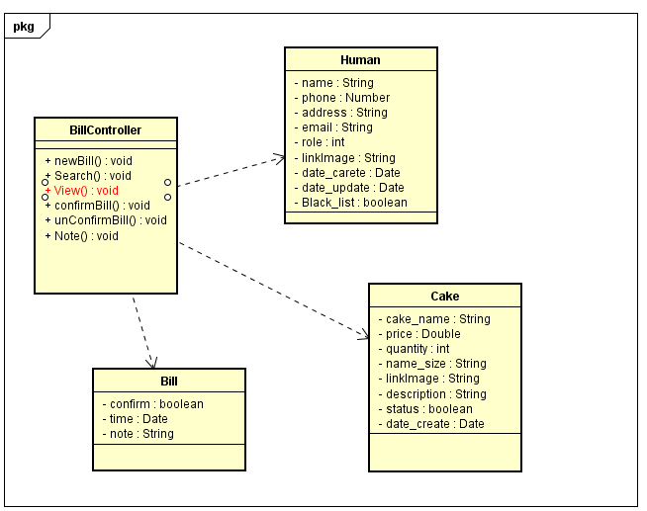

### Class Diagram Explanation

|  |  |  |
| --- | --- | --- |
| **Class** | BillController | |
| **Description** | View information of bill | |
| **Base Class** | Controller | |
| **Source File** | BillController.js | |
| **Namespace** | Controllers | |
| **Attributes** | **N/A** | |
| **Methods** | **Name** | **Description** |
| View() | View information of bill |

## **Confirm Bill**

### Class Diagram

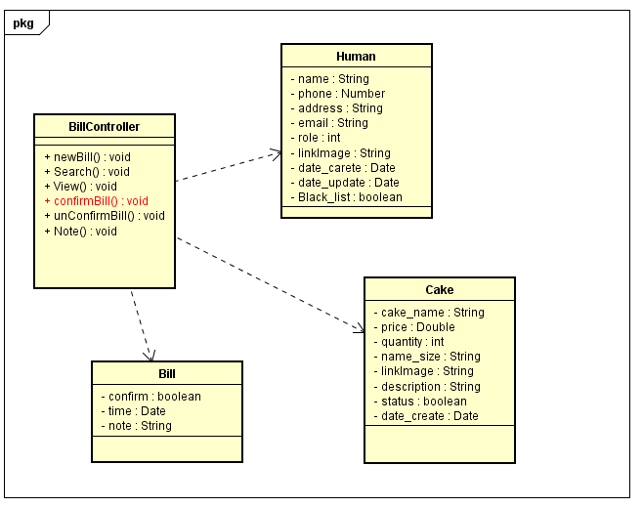

### Class Diagram Explanation

|  |  |  |
| --- | --- | --- |
| **Class** | BillController | |
| **Description** | Confirm bill | |
| **Base Class** | Controller | |
| **Source File** | BillController.js | |
| **Namespace** | Controllers | |
| **Attributes** | **N/A** | |
| **Methods** | **Name** | **Description** |
| confirmBill() | Confirm bill |

## **Unconfirm Bill**

### Class Diagram

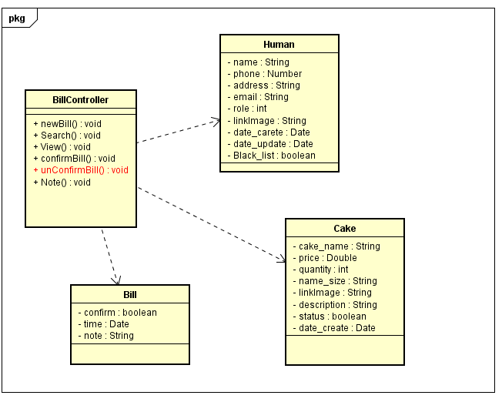

### Class Diagram Explanation

|  |  |  |
| --- | --- | --- |
| **Class** | BillController | |
| **Description** | Unconfirm bill | |
| **Base Class** | Controller | |
| **Source File** | BillController.js | |
| **Namespace** | Controllers | |
| **Attributes** | **N/A** | |
| **Methods** | **Name** | **Description** |
| unconfirmBill() | Unconfirm bill |

## **Note**

### Class Diagram

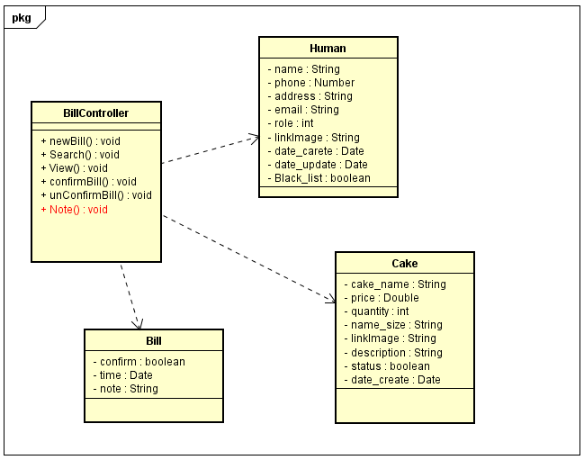

### Class Diagram Explanation

|  |  |  |
| --- | --- | --- |
| **Class** | BillController | |
| **Description** | Note information of bill | |
| **Base Class** | Controller | |
| **Source File** | BillController.js | |
| **Namespace** | Controllers | |
| **Attributes** | **N/A** | |
| **Methods** | **Name** | **Description** |
| Note() | Note information of bill |

## **View Human**

### Class Diagram

### Class Diagram Explanation

## **View Human**

### Class Diagram

### Class Diagram Explanation

# **Sequence diagram**

## Login

### Login Admin

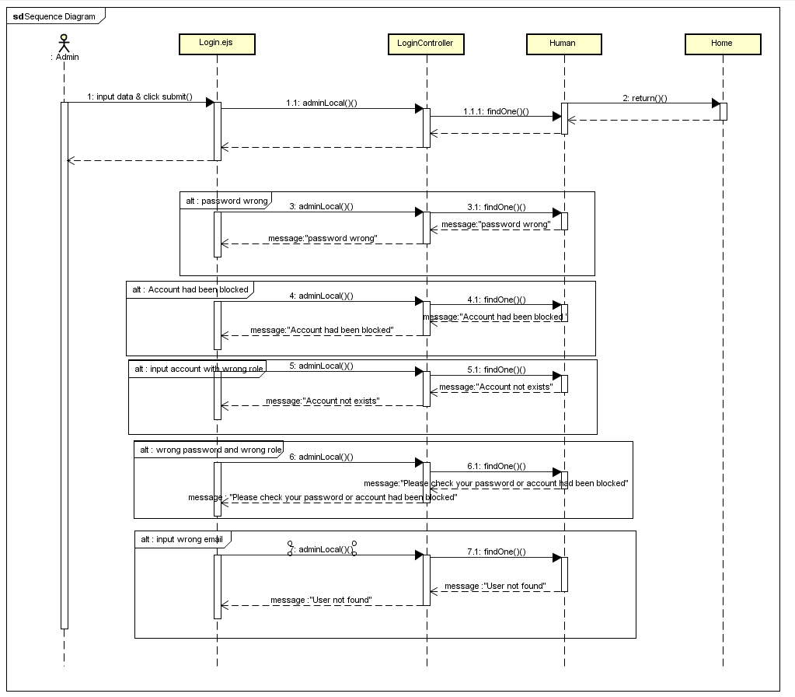

### Login Staff

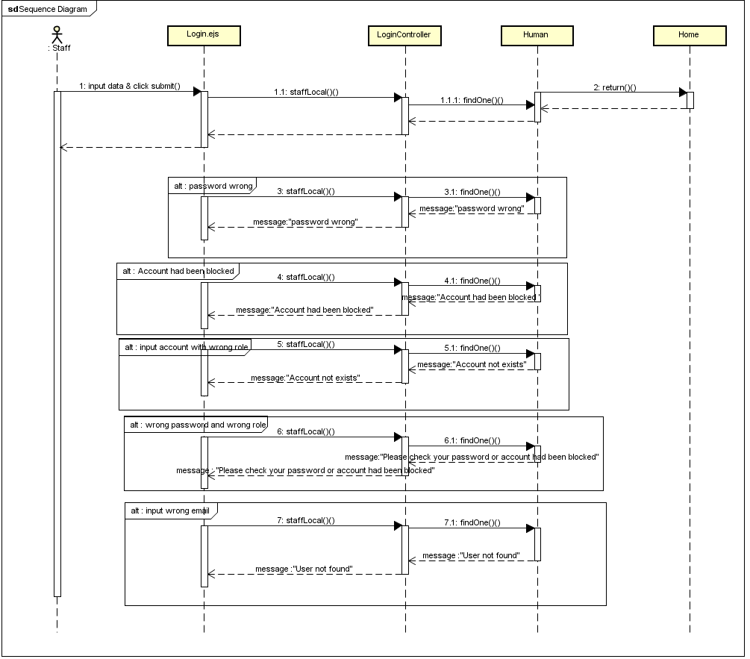

### Login User

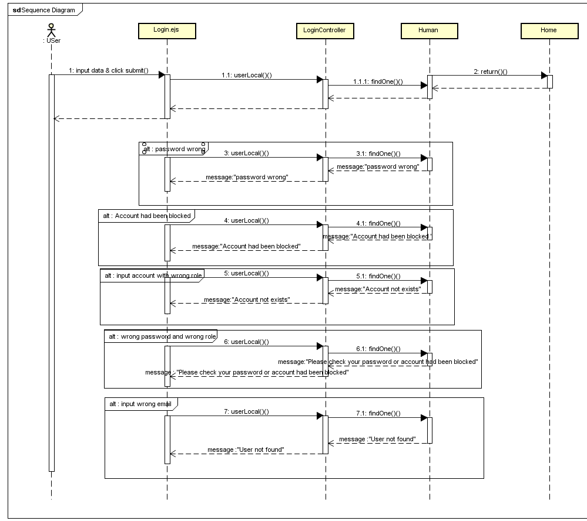

### Logout

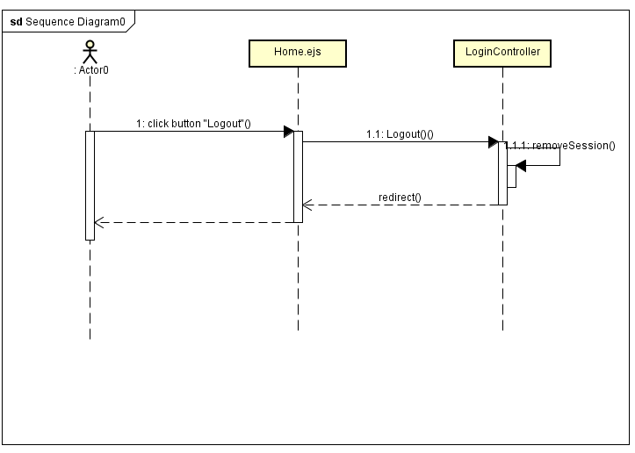

### Login Register

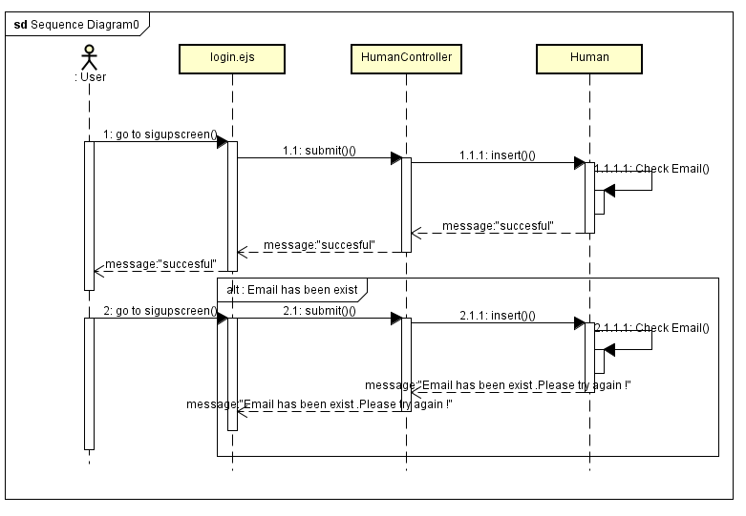

### Forgot Password

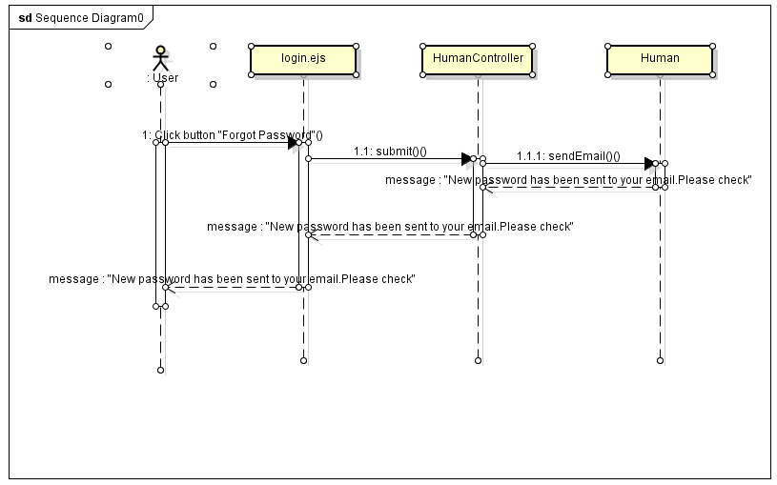

## Manage Account

### Insert Staff

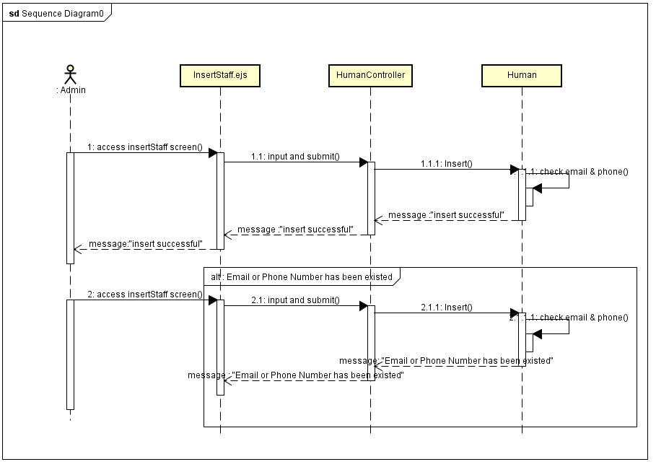

### Update Staff

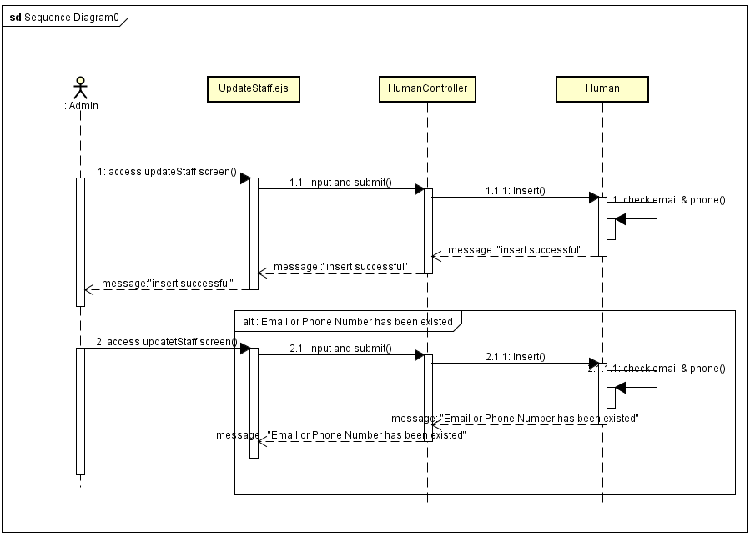

### Lock Account

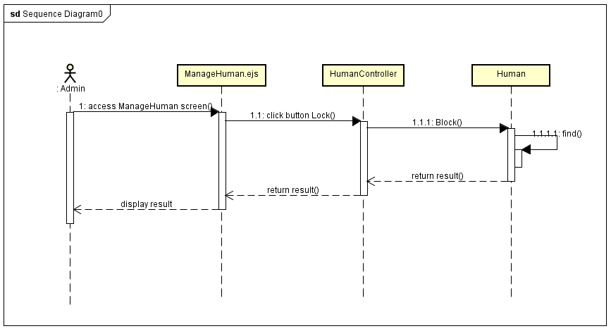

### UnLock Account

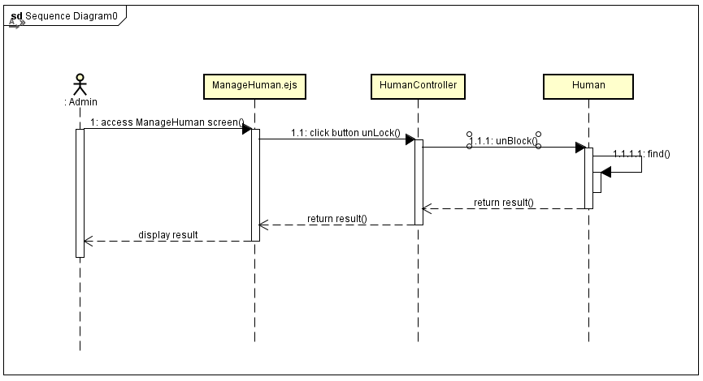

## Manage Cake

### Insert Cake

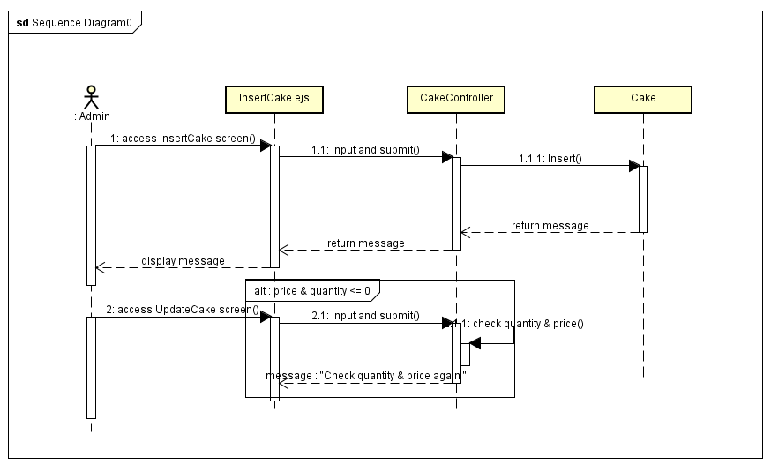

### Search Cake

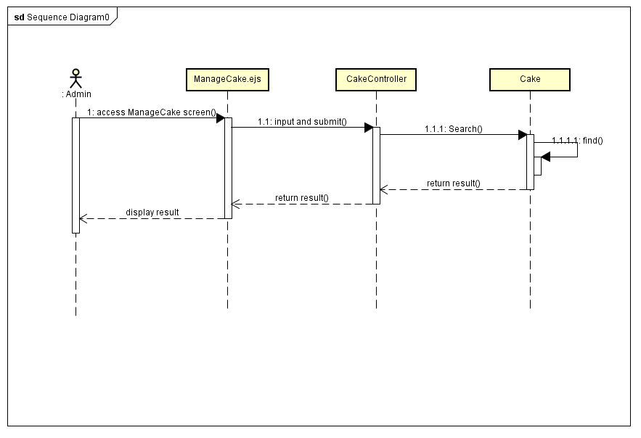

### Update Cake

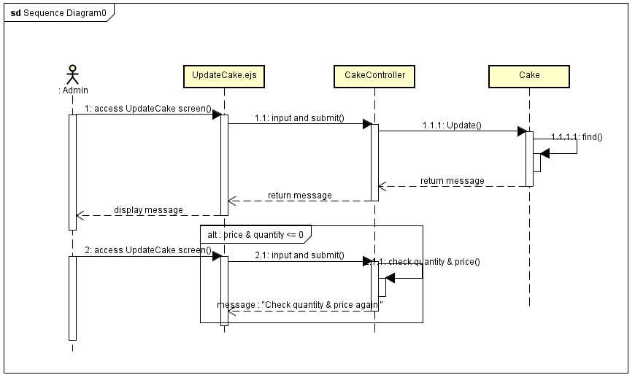

### Lock Cake

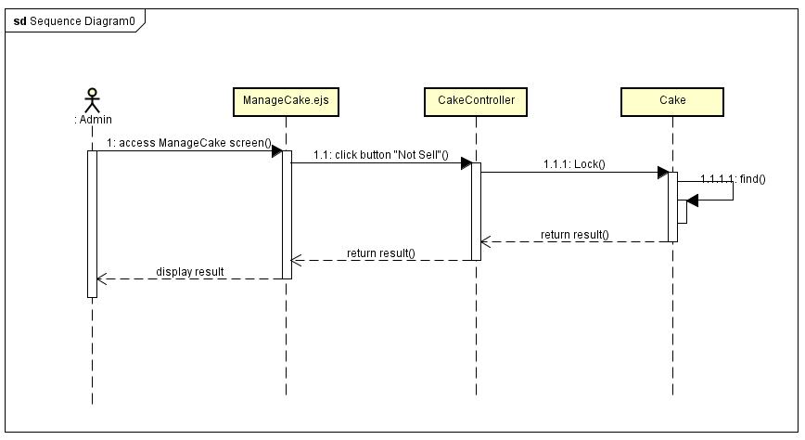

### UnLock Cake

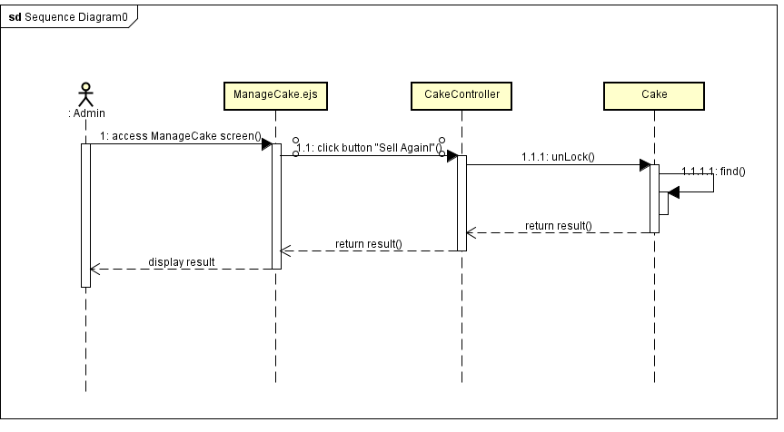

## Manage Blog

### Insert Blog

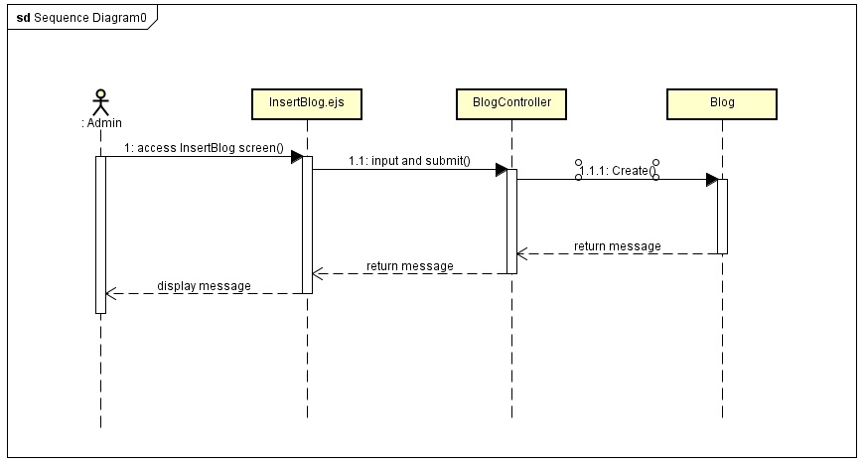

### Search Blog

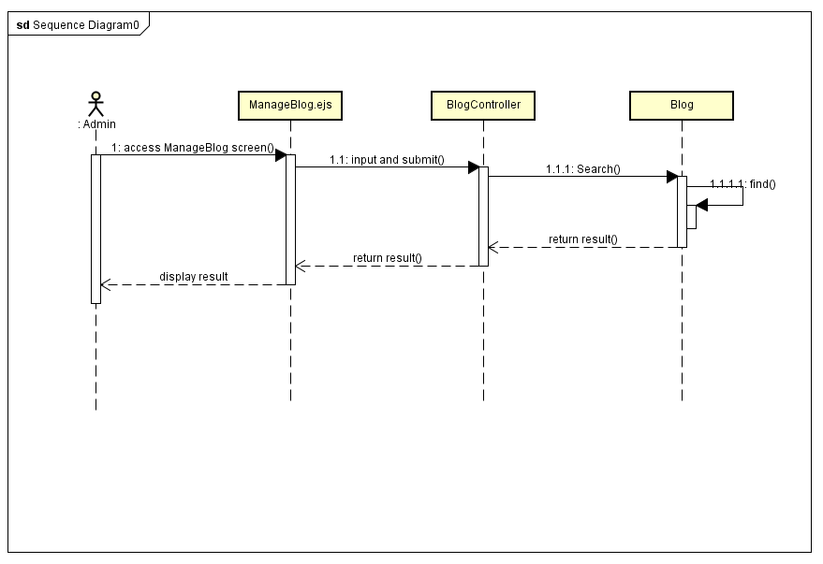

### Lock Blog

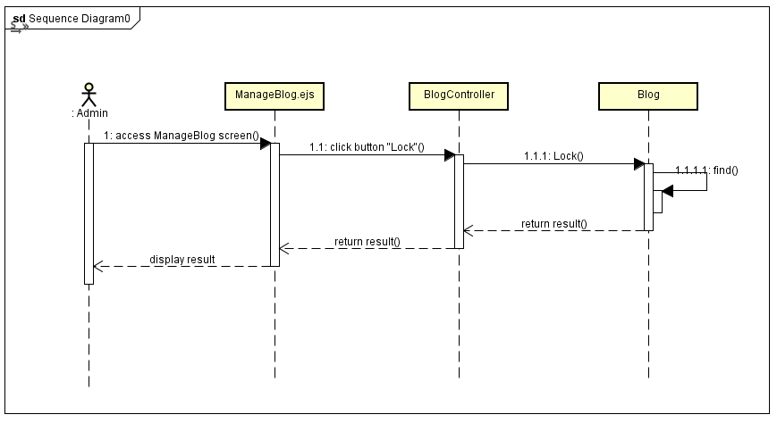

### UnLock Blog

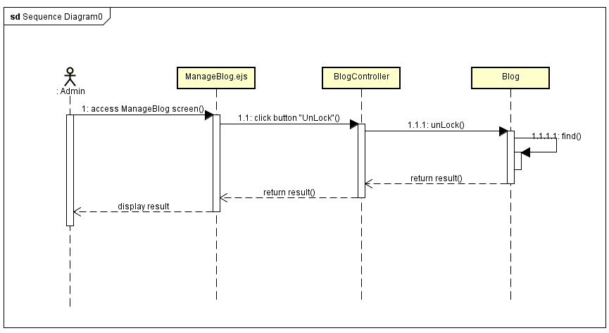

## Manage Event

### Insert Event

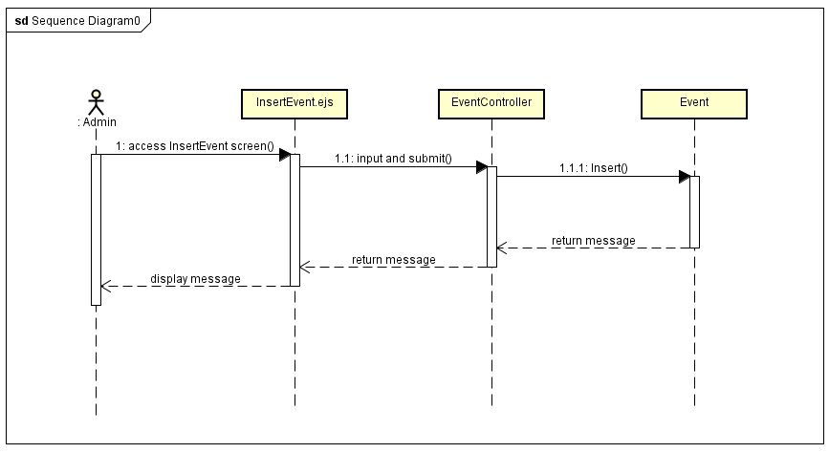

### Search Event

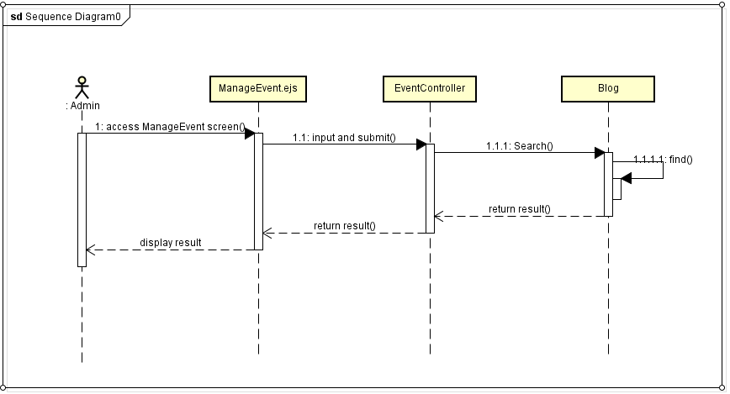

### Lock Event

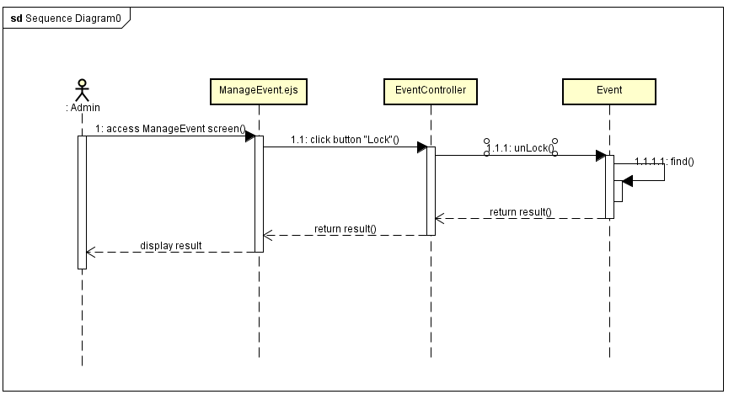

### Unlock Event

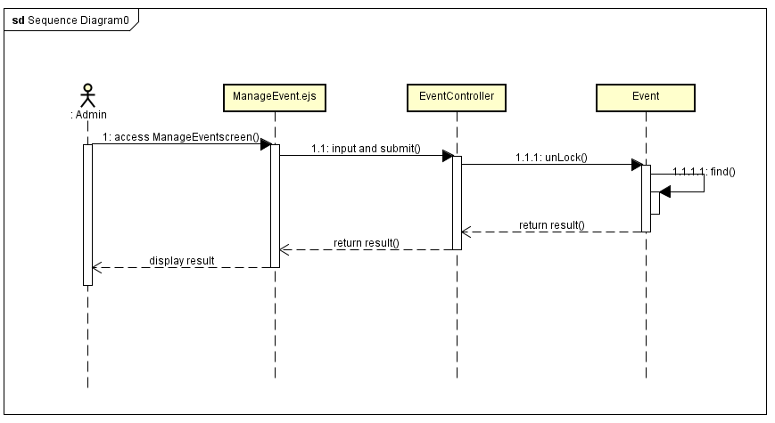

## Manage Category

### Insert Category

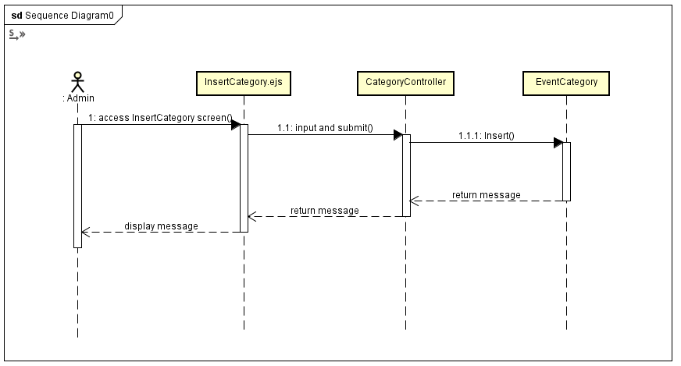

### Lock Category

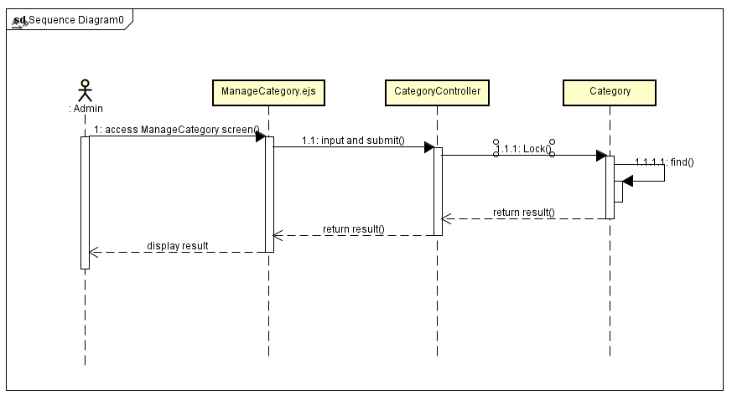

### UnLock Category

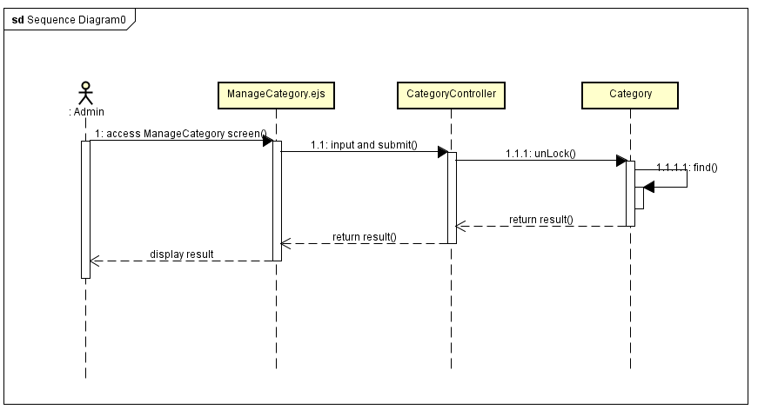

## Check Out

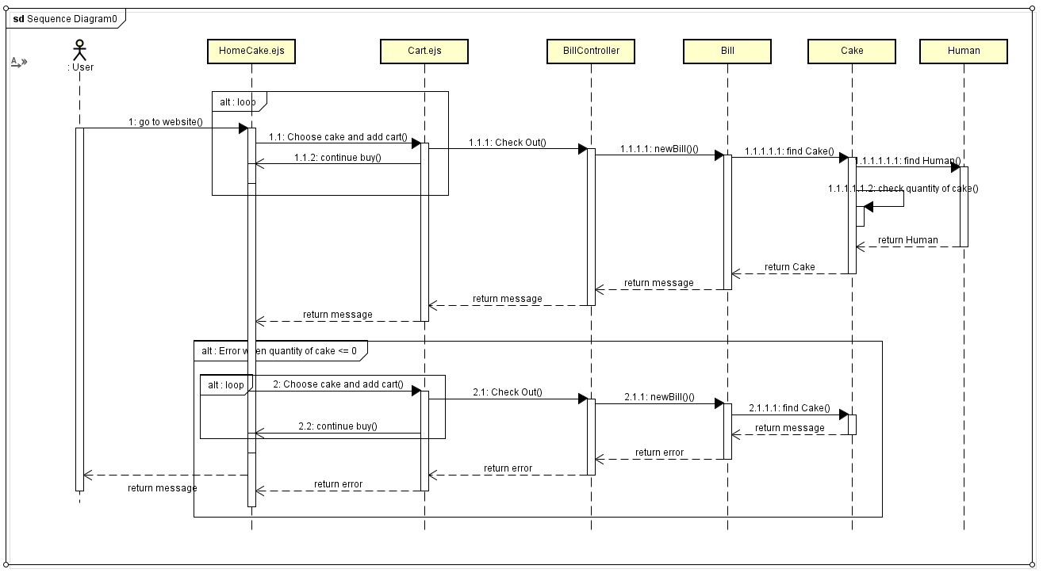

## Manage Bill

### Search Bill

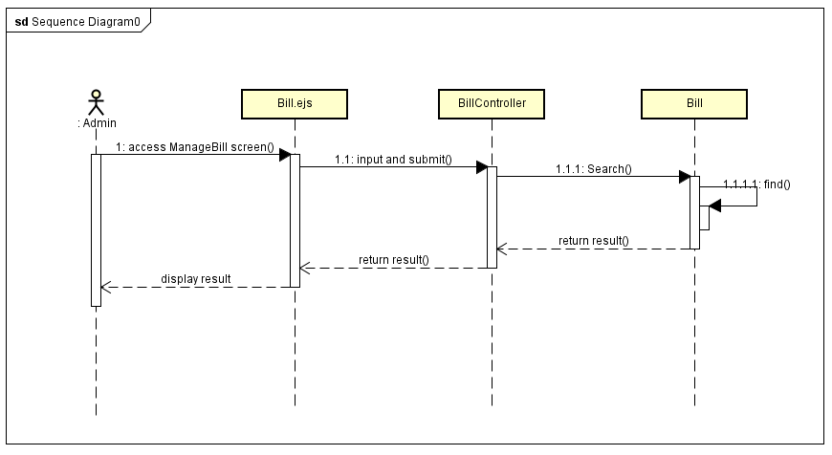

### Confirm Bill

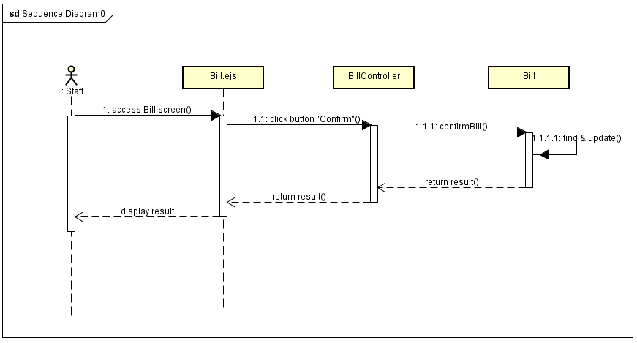

### Unconfirm Bill

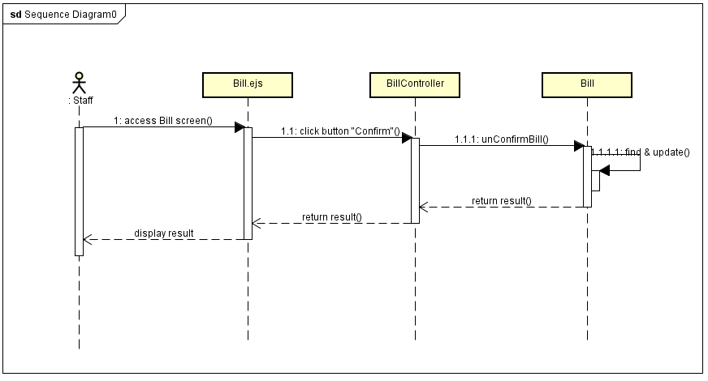

## Search revenue

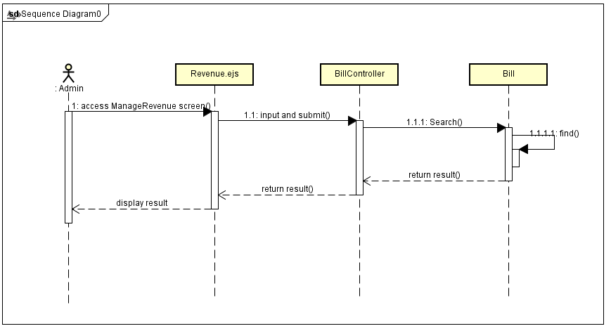

## Change Password

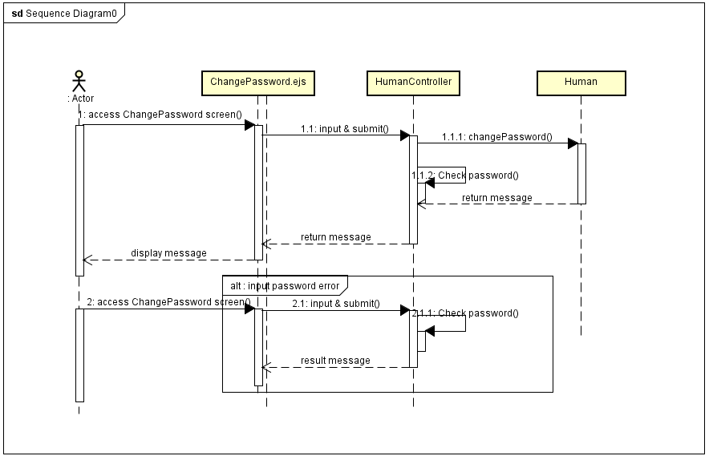

## Update Information

