

**BAKERY STORE ONLINE**

Report #2 – Software Requirement Specification

|  |  |  |
| --- | --- | --- |
| **Bakery Store** | | |
| **Group member** | Phạm Thị Minh Phương | SE03773 |
| Cao Anh Tuấn | SE03737 |
| Hoàng Anh Phương | SE03715 |
| Ngô Trung Kiên | SE03736 |
| Nguyễn Xuân Hà | SE03484 |
| **Supervisor** | Mr. Nguyễn Văn Sang | |
| **Project code** | BS | |

**Hà Nội, 09/2017**

Record of change

**\*A - Added M - Modified D – Deleted**

|  |  |  |  |  |  |
| --- | --- | --- | --- | --- | --- |
| **Effective Date** | **Changed Items** | **A* M, D** | **Change Description** | **Reason for change** | **Rev.**  **Number** |
| 20/09/2017 | Create Software Requirement Specifications | A | First version | Create Software Requirement Specifications | 1.0 |
|  |  |  |  |  |  |
|  |  |  |  |  |  |
|  |  |  |  |  |  |
|  |  |  |  |  |  |
|  |  |  |  |  |  |
|  |  |  |  |  |  |
|  |  |  |  |  |  |
|  |  |  |  |  |  |
|  |  |  |  |  |  |
|  |  |  |  |  |  |
|  |  |  |  |  |  |
|  |  |  |  |  |  |
|  |  |  |  |  |  |
|  |  |  |  |  |  |
|  |  |  |  |  |  |
|  |  |  |  |  |  |
|  |  |  |  |  |  |
|  |  |  |  |  |  |
|  |  |  |  |  |  |
|  |  |  |  |  |  |

SIGNATURE PAGE

AUTHOR: Phạm Thị Minh Phương 15/09/2017

Project Manager

REVIEWERS: Cao Anh Tuấn 16/09/2017

Team member

APPROVAL: Nguyễn Văn Sang --/--/--17

Supervisor

TABLE OF CONTENTS

1 Introduction 5

1.1 Purpose 5

1.2 Definitions, Acronyms and Abbreviations 5

2 OVERALL DESCRIPTION 6

2.1 System Overview 6

2.2 Use case diagram 7

2.3 Product Features 7

3 SPECIFIC REQUIREMENTS 11

3.1 Administrator Group Function 11

3.2 Staff Group Function 44

3.3 Customer Group Function 59

4 NON-FUNCTIONAL SPECIFICATION 73

4.1 Reliability 73

4.2 Perfomance Requirements 73

4.3 Customer Code 75

5 Other considerations 76

6 Appendix 77

6.1 Data format symbol 77

# Introduction

## Purpose

This document is created as the introduction for project BS – our Capstone Project at FPT University. In this document, we provide the describing of general requirement and non-functional requirements. These requirements will assure that the system will correctly and reliably perform its intended functionality. This specification will provide general, as well as specific requirements to be used in the design, testing and validation of the system. It is intended for both stakeholders and the project team of the system.

## Definitions, Acronyms and Abbreviations

|  |  |  |
| --- | --- | --- |
| **Acronym** | **Definition** | **Note** |
| BS | Bakery Store |  |
| SRS | Software Requirements Specifications |  |

# OVERALL DESCRIPTION

## System Overview

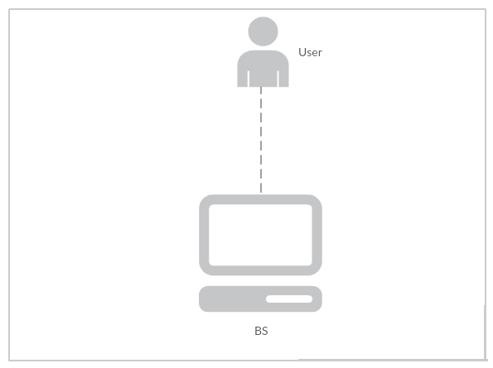

## Use case diagram

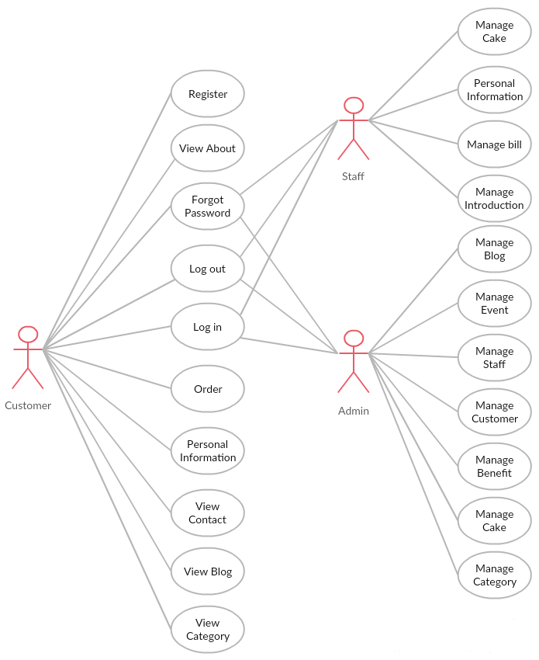

## Product Features

|  |  |  |
| --- | --- | --- |
| UC No. | **Group Of Functions** | **Function** |
| **Administrator** | | |
| UC001 | Common | Admin Login |
| UC002 | Admin Logout |
| UC003 | Admin Forgot Password |
| UC004 | Manage Staff | View list staff |
| UC005 | View staff profile |
| UC006 | Activate staff account |
| UC007 | Deactivate staff account |
| UC008 | Search staff account |
| UC009 | Update staff account |
| UC010 | Insert a new staff account |
| UC011 | Manage Customer | View list customer |
| UC012 | Activate customer account |
| UC013 | Deactivate customer account |
| UC014 | View customer profile |
| UC015 | Search customer account |
| UC016 | Manage Benefit | Search benefit |
| UC017 | View benefit |
| UC018 | Manage Cake | Search cake |
| UC019 | Add cake |
| UC020 | Update cake |
| UC021 | Block Cake |
| UC022 | Unblock Cake |
| UC023 | View information cake |
| UC024 | Manage blog | View list blog |
| UC025 | Search blog |
| UC026 | Add blog |
| UC027 | Block blog |
| UC028 | Unblock blog |
| UC029 | Manage Event | Search event |
| UC030 | Add event |
| UC031 | Block event |
| UC032 | Unblock event |
| UC033 | Manage Category | Add Category |
| UC034 | Block Category |
| UC035 | Unblock Category |
| **Staff** | | |
| UC036 | Common | Log in |
| UC037 | Log out |
| UC038 | Forgot Password |
| UC039 | Manage Bill | Search order |
| UC040 | Confirm Order |
| UC041 | Unconfirm Order |
| UC042 | Manage Cake | View Cake |
| UC043 | Search Cake |
| UC044 | Personal information | Update Information |
| UC045 | Change Password |
| UC046 | Manage Introduction | Create Introduction |
| UC047 | Update Introduction |
| **Customer** | | |
| UC048 | Common Module | Register |
| UC049 | Login |
| UC050 | Logout |
| UC051 | Forgot Password |
| UC052 | View About |
| UC053 | View Contact |
| UC054 | View Blog |
| UC055 | View Catgory |
| UC056 | Order | Order Cake |
| UC057 | Check Out |
| UC058 | Personal Information | Edit Profile |
| UC059 | Change Password |
| UC060 | Purchase History |

### User Characteristic

BS website is the site sell cake online. The website requires users to have the ability to use a browser with an internet connection. Use can easy use the functions in website, but if they want to use all function, they must be login. BS has three objective users:

* Administrator: They can manage all information of BS.
* Staff: They can manage information about order, contact,...
* Customer: they can use functions of BS like Login, Logout, Order,...

### User Documentation

|  |  |
| --- | --- |
| **Name** | **Description** |
| User Manual | Provide detailed explanation about the system, screens and guide users how to use all features of BS website. |

### Assumption

* Receive the guidance and good support of teacher.
* No one of member got sick in the software development process.
* In the development process, no device got fail.
* Every report meets the deadline.
* Team member do not conflict in the work process.

# SPECIFIC REQUIREMENTS

## Administrator Group Function

### Common Module

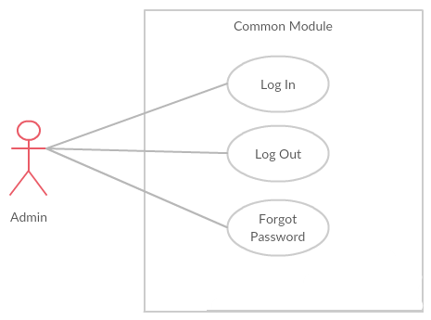

* + - 1. UC001 – Admin login

|  |  |  |  |  |
| --- | --- | --- | --- | --- |
| **Use Case ID** | | UC001 | **Version** | 1.0 |
| **Use Case Name** | | Admin login | | |
| **Created by:** | | PhuongPTM | **Date Created:** | 28/09/2017 |
| **Primary Actor** | | Administrator(Admin) | **Secondary Actor** |  |
| **Description:** | | This function allows Admin logins into website | | |
| **Preconditions:** | | 1. BS website is available 2. Admin browsed BS website 3. Admin are viewing Login page for admin | | |
| **Trigger:** | | Admin clicks on Login button | | |
| **Post conditions:** | | 1. Log Admin into system 2. Redirect Admin to Admin home page | | |
| **Normal Flow** | | | | |
| **Step** | **Actor** | **Action** | | |
| 1 | BS | Display Admin Login page. If Admin choose Remember Me function before, fill all needed information | | |
| 2 | Admin | Type email address and password if Admin does not choose Remember Me function before | | |
| 3 | BS | Verify:  Email address  Password | | |
| 4 | BS | * Log Admin into system * Redirect Admin to Admin home page | | |
| **Alternative Flows: N/A** | | | | |
| **Exceptions:** | | | | |
| **EC1** | At step 2 in main flow, if Admin entered wrong Email address or Password | | | |
| **Step** | **Actor** | **Action** | | |
| 2.1 | BS | Display Login popup message point out error field | | |
| 2.2 | BS | Mark error fields | | |
| **Priority** | | High | | |
| **Frequency of Use:** | | High | | |
| **Business Rules:** | | B1 | | |
| **Other Information:** | | N/A | | |

* + - 1. UC002 – Admin logout

|  |  |  |  |  |
| --- | --- | --- | --- | --- |
| **Use Case ID** | | UC002 | **Version** | 1.0 |
| **Use Case Name** | | Admin logout | | |
| **Created by:** | | PhuongPTM | **Date Created:** | 28/09/2017 |
| **Primary Actor** | | Administrator(Admin) | **Secondary Actor** |  |
| **Description:** | | This function allows Admin logout website | | |
| **Preconditions:** | | Admin logged website as Administrator | | |
| **Trigger:** | | Admin clicks on Sign out button | | |
| **Post conditions:** | | Admin logged out from BS website | | |
| **Normal Flow** | | | | |
| **Step** | **Actor** | **Action** | | |
| 1 | Admin | Choose sign out button | | |
| 2 | BS | Sign out Admin  Redirect to Admin Sign in page | | |
| **Alternative Flows: N/A** | | | | |
| **Exceptions: N/A** | | | | |
| **Priority** | | High | | |
| **Frequency of Use:** | | High | | |
| **Business Rules:** | | B1 | | |
| **Other Information:** | | N/A | | |

* + - 1. UC003 – Admin Forgot Password

|  |  |  |  |  |
| --- | --- | --- | --- | --- |
| **Use Case ID** | | UC003 | **Version** | 1.0 |
| **Use Case Name** | | Admin forgot password | | |
| **Created by:** | | PhuongPTM | **Date Created:** | 28/09/2017 |
| **Primary Actor** | | Administrator(Admin) | **Secondary Actor** |  |
| **Description:** | | This function allows Admin receiving her/his password to mail | | |
| **Preconditions:** | | 1. BS website is available 2. Admin browsed BS website 3. Admin are viewing Sign in page for admin | | |
| **Trigger:** | | Click Forgot password in Sign in page | | |
| **Post conditions:** | | Admin get new password on her/his email | | |
| **Normal Flow** | | | | |
| **Step** | **Actor** | **Action** | | |
| 1 | Admin | Click Forgot password in Sign in page | | |
| 2 | BS | Display Email text box | | |
| 3 | Admin | Enter registered email | | |
| 4 | Admin | Click Forgot Password | | |
| **Alternative Flows: N/A** | | | | |
| **Exceptions: N/A** | | | | |
| **Priority** | | High | | |
| **Frequency of Use:** | | High | | |
| **Business Rules:** | | B1 | | |
| **Other Information:** | | N/A | | |

### Manage customer’s account

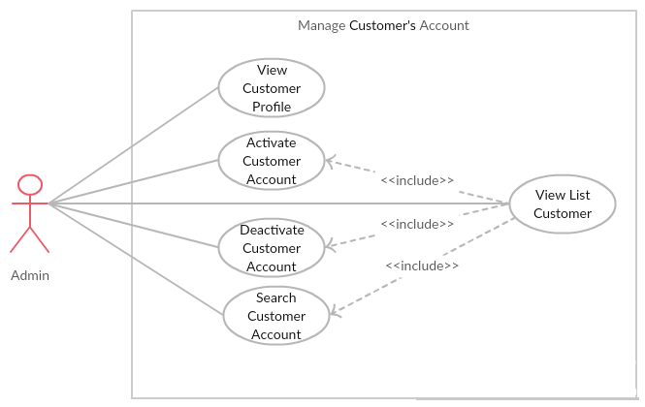

* + - 1. UC004 – View List Customer

|  |  |  |  |  |
| --- | --- | --- | --- | --- |
| **Use Case ID** | | UC004 | **Version** | 1.0 |
| **Use Case Name** | | View list customer | | |
| **Created by:** | | PhuongPTM | **Date Created:** | 28/09/2017 |
| **Primary Actor** | | Administrator(Admin) | **Secondary Actor** |  |
| **Description:** | | This function allows Administrator to view list customer | | |
| **Preconditions:** | | 1. BS website is available 2. Admin browsed BS website 3. Admin are viewing Login page for admin | | |
| **Trigger:** | | Admin click on Manage Account | | |
| **Post conditions:** | | Customer List is displayed | | |
| **Normal Flow** | | | | |
| **Step** | **Actor** | **Action** | | |
| 1 | Admin | * Click on “Choose role you want” drop down list * Click on Customer | | |
| 2 | BS | Display list of customer | | |
| **Alternative Flows: N/A** | | | | |
| **Exceptions: N/A** | | | | |
| **Priority** | | High | | |
| **Frequency of Use:** | | High | | |
| **Business Rules:** | | B1 | | |
| **Other Information:** | | N/A | | |

* + - 1. UC005 – View Customer Profile

|  |  |  |  |  |
| --- | --- | --- | --- | --- |
| **Use Case ID** | | UC005 | **Version** | 1.0 |
| **Use Case Name** | | View customer profile | | |
| **Created by:** | | PhuongPTM | **Date Created:** | 28/09/2017 |
| **Primary Actor** | | Administrator(Admin) | **Secondary Actor** |  |
| **Description:** | | This function allows Administrator to view profile of a customer | | |
| **Preconditions:** | | 1. BS website is available 2. Admin browsed BS website 3. Admin are viewing Login page for admin | | |
| **Trigger:** | | Admin click on Manage Account | | |
| **Post conditions:** | | Profile of this customer is displayed | | |
| **Normal Flow** | | | | |
| **Step** | **Actor** | **Action** | | |
| 1 | Admin | * Click on “Choose role you want” drop down list * Click on Customer | | |
| 2 | BS | Display profile of this customer | | |
| **Alternative Flows: N/A** | | | | |
| **Exceptions: N/A** | | | | |
| **Priority** | | High | | |
| **Frequency of Use:** | | High | | |
| **Business Rules:** | | B1 | | |
| **Other Information:** | | N/A | | |

* + - 1. UC006 – Activate Customer Account

|  |  |  |  |  |
| --- | --- | --- | --- | --- |
| **Use Case ID** | | UC006 | **Version** | 1.0 |
| **Use Case Name** | | Activate customer’s account | | |
| **Created by:** | | PhuongPTM | **Date Created:** | 28/09/2017 |
| **Primary Actor** | | Administrator(Admin) | **Secondary Actor** |  |
| **Description:** | | This function allows Administrator to active a customer’s account | | |
| **Preconditions:** | | * Admin is viewing Customers List * Status of this customer is Lock | | |
| **Trigger:** | | Admin click on Unlock button | | |
| **Post conditions:** | | Customer’s account is activated | | |
| **Normal Flow** | | | | |
| **Step** | **Actor** | **Action** | | |
| 1 | Admin | Click on Unlock button at Status column of the customer whom want to activate | | |
| 2 | BS | * Change displayed status from Lock to Unlock * Change status of this customer’s account to Unlock on database | | |
| **Alternative Flows: N/A** | | | | |
| **Exceptions: N/A** | | | | |
| **Priority** | | High | | |
| **Frequency of Use:** | | High | | |
| **Business Rules:** | | B1 | | |
| **Other Information:** | | N/A | | |

* + - 1. UC007 – Deactivate Customer Account

|  |  |  |  |  |
| --- | --- | --- | --- | --- |
| **Use Case ID** | | UC007 | **Version** | 1.0 |
| **Use Case Name** | | Deactivate customer’s account | | |
| **Created by:** | | PhuongPTM | **Date Created:** | 28/09/2017 |
| **Primary Actor** | | Administrator(Admin) | **Secondary Actor** |  |
| **Description:** | | This function allows Administrator to deactivate a customer’s account | | |
| **Preconditions:** | | * Admin is viewing Customers List * Status of this customer is Unlock | | |
| **Trigger:** | | Admin click on Lock button | | |
| **Post conditions:** | | Customer’s account is deactivated | | |
| **Normal Flow** | | | | |
| **Step** | **Actor** | **Action** | | |
| 1 | Admin | Click on Lock button at Status column of the customer whom want to deactivate | | |
| 2 | BS | * Change displayed status from Unlock to Lock * Change status of this customer’s account to Lock on database | | |
| **Alternative Flows: N/A** | | | | |
| **Exceptions: N/A** | | | | |
| **Priority** | | High | | |
| **Frequency of Use:** | | High | | |
| **Business Rules:** | | B1 | | |
| **Other Information:** | | N/A | | |

* + - 1. UC008 – Search Customer Account

|  |  |  |  |  |
| --- | --- | --- | --- | --- |
| **Use Case ID** | | UC008 | **Version** | 1.0 |
| **Use Case Name** | | Search customer’s account | | |
| **Created by:** | | PhuongPTM | **Date Created:** | 28/09/2017 |
| **Primary Actor** | | Administrator(Admin) | **Secondary Actor** |  |
| **Description:** | | This function allows Administrator to search a customer’s account | | |
| **Preconditions:** | | Admin is viewing Customers List | | |
| **Trigger:** | | Admin types phone number of customer at Search textbox | | |
| **Post conditions:** | | Display list of searched customer | | |
| **Normal Flow** | | | | |
| **Step** | **Actor** | **Action** | | |
| 1 | Admin | Type phone number of customer whom want to search | | |
| 2 | BS | Display list of customer who have the phone number is typed | | |
| **Alternative Flows: N/A** | | | | |
| **Exceptions: N/A** | | | | |
| **Priority** | | High | | |
| **Frequency of Use:** | | High | | |
| **Business Rules:** | | B1 | | |
| **Other Information:** | | N/A | | |

### Manage Staff’s Account

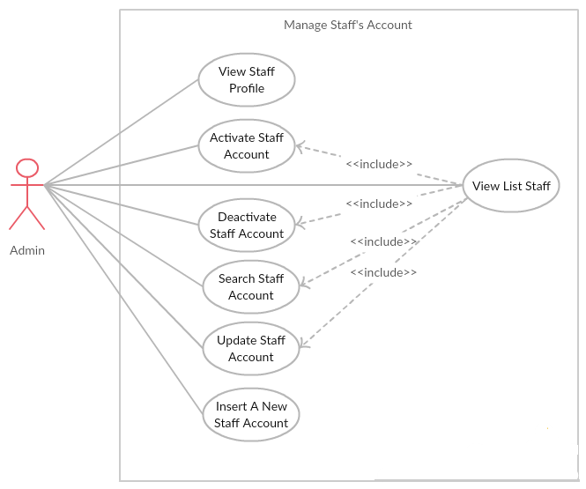

* + - 1. UC009 – View List Staff

|  |  |  |  |  |
| --- | --- | --- | --- | --- |
| **Use Case ID** | | UC009 | **Version** | 1.0 |
| **Use Case Name** | | View list staff | | |
| **Created by:** | | PhuongPTM | **Date Created:** | 28/09/2017 |
| **Primary Actor** | | Administrator(Admin) | **Secondary Actor** |  |
| **Description:** | | This function allows Administrator to view list staff | | |
| **Preconditions:** | | 1. BS website is available 2. Admin browsed BS website 3. Admin are viewing Login page for admin | | |
| **Trigger:** | | Admin click on Manage Account | | |
| **Post conditions:** | | Staff List is displayed | | |
| **Normal Flow** | | | | |
| **Step** | **Actor** | **Action** | | |
| 1 | Admin | * Click on “Choose role you want” drop down list * Click on Staff | | |
| 2 | BS | Display list of staff | | |
| **Alternative Flows: N/A** | | | | |
| **Exceptions: N/A** | | | | |
| **Priority** | | High | | |
| **Frequency of Use:** | | High | | |
| **Business Rules:** | | B1 | | |
| **Other Information:** | | N/A | | |

* + - 1. UC010 – View Staff Profile

|  |  |  |  |  |
| --- | --- | --- | --- | --- |
| **Use Case ID** | | UC010 | **Version** | 1.0 |
| **Use Case Name** | | View staff profile | | |
| **Created by:** | | PhuongPTM | **Date Created:** | 28/09/2017 |
| **Primary Actor** | | Administrator(Admin) | **Secondary Actor** |  |
| **Description:** | | This function allows Administrator to view profile of a staff | | |
| **Preconditions:** | | Admin is viewing Staff List | | |
| **Trigger:** | | Admin click on Manage Account | | |
| **Post conditions:** | | Profile of this staff is displayed | | |
| **Normal Flow** | | | | |
| **Step** | **Actor** | **Action** | | |
| 1 | Admin | Click on Manage Account button at action column of the staff whom want to see profile | | |
| 2 | BS | Display profile of this staff | | |
| **Alternative Flows: N/A** | | | | |
| **Exceptions: N/A** | | | | |
| **Priority** | | High | | |
| **Frequency of Use:** | | High | | |
| **Business Rules:** | | B1 | | |
| **Other Information:** | | N/A | | |

* + - 1. UC011 – Activate Staff Account

|  |  |  |  |  |
| --- | --- | --- | --- | --- |
| **Use Case ID** | | UC011 | **Version** | 1.0 |
| **Use Case Name** | | Activate staff’s account | | |
| **Created by:** | | PhuongPTM | **Date Created:** | 28/09/2017 |
| **Primary Actor** | | Administrator(Admin) | **Secondary Actor** |  |
| **Description:** | | This function allows Administrator to active a staff’s account | | |
| **Preconditions:** | | * Admin is viewing Staff List * Status of this staff is Lock | | |
| **Trigger:** | | Admin click on Unlock button | | |
| **Post conditions:** | | Staff’s account is activated | | |
| **Normal Flow** | | | | |
| **Step** | **Actor** | **Action** | | |
| 1 | Admin | Click on Unlock button at Status column of the staff whom want to activate | | |
| 2 | BS | * Change displayed status from Lock to Unlock * Change status of this staff’s account to Unlock on database | | |
| **Alternative Flows: N/A** | | | | |
| **Exceptions: N/A** | | | | |
| **Priority** | | High | | |
| **Frequency of Use:** | | High | | |
| **Business Rules:** | | B1 | | |
| **Other Information:** | | N/A | | |

* + - 1. UC012 – Deactivate Staff Account

|  |  |  |  |  |
| --- | --- | --- | --- | --- |
| **Use Case ID** | | UC012 | **Version** | 1.0 |
| **Use Case Name** | | Deactivate staff’s account | | |
| **Created by:** | | PhuongPTM | **Date Created:** | 28/09/2017 |
| **Primary Actor** | | Administrator(Admin) | **Secondary Actor** |  |
| **Description:** | | This function allows Administrator to deactivate a staff’s account | | |
| **Preconditions:** | | * Admin is viewing Staff List * Status of this staff is Unlock | | |
| **Trigger:** | | Admin click on Lock button | | |
| **Post conditions:** | | Staff’s account is deactivated | | |
| **Normal Flow** | | | | |
| **Step** | **Actor** | **Action** | | |
| 1 | Admin | Click on Lock button at Status column of the staff whom want to deactivate | | |
| 2 | BS | * Change displayed status from Unlock to Lock * Change status of this staff’s account to Lock on database | | |
| **Alternative Flows: N/A** | | | | |
| **Exceptions: N/A** | | | | |
| **Priority** | | High | | |
| **Frequency of Use:** | | High | | |
| **Business Rules:** | | B1 | | |
| **Other Information:** | | N/A | | |

* + - 1. UC013 – Search Staff Account

|  |  |  |  |  |
| --- | --- | --- | --- | --- |
| **Use Case ID** | | UC013 | **Version** | 1.0 |
| **Use Case Name** | | Search staff’s account | | |
| **Created by:** | | PhuongPTM | **Date Created:** | 28/09/2017 |
| **Primary Actor** | | Administrator(Admin) | **Secondary Actor** |  |
| **Description:** | | This function allows Administrator to search a staff’s account | | |
| **Preconditions:** | | Admin is viewing Staff List | | |
| **Trigger:** | | Admin types name of staff at Search textbox | | |
| **Post conditions:** | | Display list of searched staff | | |
| **Normal Flow** | | | | |
| **Step** | **Actor** | **Action** | | |
| 1 | Admin | Type name of staff whom want to search | | |
| 2 | BS | Display list of staff who have the name is typed | | |
| **Alternative Flows: N/A** | | | | |
| **Exceptions: N/A** | | | | |
| **Priority** | | High | | |
| **Frequency of Use:** | | High | | |
| **Business Rules:** | | B1 | | |
| **Other Information:** | | N/A | | |

* + - 1. UC014 – Update Staff Account

|  |  |  |  |  |
| --- | --- | --- | --- | --- |
| **Use Case ID** | | UC014 | **Version** | 1.0 |
| **Use Case Name** | | Update staff’s account | | |
| **Created by:** | | PhuongPTM | **Date Created:** | 28/09/2017 |
| **Primary Actor** | | Administrator(Admin) | **Secondary Actor** |  |
| **Description:** | | This function allows Administrator to update a staff’s account | | |
| **Preconditions:** | | Admin is viewing Staff List | | |
| **Trigger:** | | Admin click on Update button | | |
| **Post conditions:** | | Update staff’s account page is displayed | | |
| **Normal Flow** | | | | |
| **Step** | **Actor** | **Action** | | |
| 1 | Admin | Choose the staff who want to change information | | |
| 2 | Admin | Click on Update button | | |
| 3 | Admin | Update information | | |
| 4 | Admin | Click on Save button | | |
| 5 | BS | Save change | | |
| **Alternative Flows: N/A** | | | | |
| **Exceptions:** | | | | |
| **EC1** | At step 3 in the main flows, if user miss fill 1 or more information | | | |
| **Step** | **Actor** | **Action** | | |
| **3.1** | **BS** | Display Dialog to remind user | | |
|  | | | | |
| **Priority** | | High | | |
| **Frequency of Use:** | | High | | |
| **Business Rules:** | | B1 | | |
| **Other Information:** | | N/A | | |

* + - 1. UC015 – Insert A New Staff Account

|  |  |  |  |  |
| --- | --- | --- | --- | --- |
| **Use Case ID** | | UC015 | **Version** | 1.0 |
| **Use Case Name** | | Insert a new staff’s account | | |
| **Created by:** | | PhuongPTM | **Date Created:** | 28/09/2017 |
| **Primary Actor** | | Administrator(Admin) | **Secondary Actor** |  |
| **Description:** | | This function allows Administrator to insert a new staff’s account | | |
| **Preconditions:** | | 1. BS website is available 2. Admin browsed BS website 3. Admin are viewing Login page for admin | | |
| **Trigger:** | | Admin click on Insert Staff | | |
| **Post conditions:** | | Insert staff page is displayed | | |
| **Normal Flow** | | | | |
| **Step** | **Actor** | **Action** | | |
| 1 | Admin | Click on Insert Staff | | |
| 2 | BS | Insert staff page is displayed | | |
| 3 | Admin | * Type Staff name * Type Password * Type Address * Type Phone number * Type Email * Choose image * Click Add button | | |
| **Alternative Flows: N/A** | | | | |
| **Exceptions:** | | | | |
| **EC1** | At step 3 in the main flows, if user miss fill 1 or more information | | | |
| **Step** | **Actor** | **Action** | | |
| **3.1** | **BS** | Display Dialog to remind user | | |
|  | | | | |
| **Priority** | | High | | |
| **Frequency of Use:** | | High | | |
| **Business Rules:** | | B1 | | |
| **Other Information:** | | N/A | | |

### Manage Cake

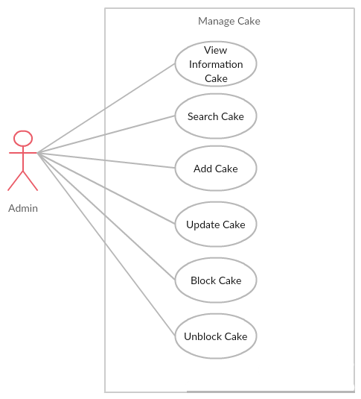

* + - 1. UC016 – View Information Cake

|  |  |  |  |  |
| --- | --- | --- | --- | --- |
| **Use Case ID** | | UC016 | **Version** | 1.0 |
| **Use Case Name** | | View information cake | | |
| **Created by:** | | PhuongPTM | **Date Created:** | 28/09/2017 |
| **Primary Actor** | | Administrator(Admin) | **Secondary Actor** |  |
| **Description:** | | This function allows Administrator to view list cake | | |
| **Preconditions:** | | 1. BS website is available 2. Admin browsed BS website 3. Admin are viewing Login page for admin | | |
| **Trigger:** | | Admin click on Manage Cake | | |
| **Post conditions:** | | Cake List is displayed | | |
| **Normal Flow** | | | | |
| **Step** | **Actor** | **Action** | | |
| 1 | Admin | Click on Manage Cake | | |
| 2 | BS | Display list of cake | | |
| **Alternative Flows: N/A** | | | | |
| **Exceptions: N/A** | | | | |
| **Priority** | | High | | |
| **Frequency of Use:** | | High | | |
| **Business Rules:** | | B1 | | |
| **Other Information:** | | N/A | | |

* + - 1. UC017 – Search Cake

|  |  |  |  |  |
| --- | --- | --- | --- | --- |
| **Use Case ID** | | UC017 | **Version** | 1.0 |
| **Use Case Name** | | Search cake | | |
| **Created by:** | | PhuongPTM | **Date Created:** | 28/09/2017 |
| **Primary Actor** | | Administrator(Admin) | **Secondary Actor** |  |
| **Description:** | | This function allows Administrator to search cake | | |
| **Preconditions:** | | Admin is viewing Cake List | | |
| **Trigger:** | | Admin types name of cake at Search textbox | | |
| **Post conditions:** | | Display list of searched cake | | |
| **Normal Flow** | | | | |
| **Step** | **Actor** | **Action** | | |
| 1 | Admin | Click on Manage Cake | | |
| 2 | BS | List cake is displayed | | |
| 3 | Admin | Type name of cake what admin want to search | | |
| 4 | BS | Display list of cake what have the name is typed | | |
| **Alternative Flows: N/A** | | | | |
| **Exceptions: N/A** | | | | |
| **Priority** | | High | | |
| **Frequency of Use:** | | High | | |
| **Business Rules:** | | B1 | | |
| **Other Information:** | | N/A | | |

* + - 1. UC018 – Add Cake

|  |  |  |  |  |
| --- | --- | --- | --- | --- |
| **Use Case ID** | | UC018 | **Version** | 1.0 |
| **Use Case Name** | | Add cake | | |
| **Created by:** | | PhuongPTM | **Date Created:** | 28/09/2017 |
| **Primary Actor** | | Administrator(Admin) | **Secondary Actor** |  |
| **Description:** | | This function allows Administrator to add a new cake | | |
| **Preconditions:** | | 1. BS website is available 2. Admin browsed BS website 3. Admin are viewing Login page for admin | | |
| **Trigger:** | | Admin click on Insert Cake | | |
| **Post conditions:** | | Insert cake page is displayed | | |
| **Normal Flow** | | | | |
| **Step** | **Actor** | **Action** | | |
| 1 | Admin | Click on Insert Cake | | |
| 2 | BS | Insert cake page is displayed | | |
| 3 | Admin | * Choose Cake type * Type Cake name * Type Material * Type Description * Type Size * Type Price * Type Quantity * Choose image * Click Add button | | |
| **Alternative Flows: N/A** | | | | |
| **Exceptions:** | | | | |
| **EC1** | At step 3 in the main flows, if user miss fill 1 or more information | | | |
| **Step** | **Actor** | **Action** | | |
| **3.1** | **BS** | Display Dialog to remind user | | |
|  | | | | |
| **Priority** | | High | | |
| **Frequency of Use:** | | High | | |
| **Business Rules:** | | B1 | | |
| **Other Information:** | | N/A | | |

* + - 1. UC019 – Update Cake

|  |  |  |  |  |
| --- | --- | --- | --- | --- |
| **Use Case ID** | | UC019 | **Version** | 1.0 |
| **Use Case Name** | | Update cake | | |
| **Created by:** | | PhuongPTM | **Date Created:** | 28/09/2017 |
| **Primary Actor** | | Administrator(Admin) | **Secondary Actor** |  |
| **Description:** | | This function allows Administrator to update a cake | | |
| **Preconditions:** | | Admin is viewing Cake List | | |
| **Trigger:** | | Admin click on Update button | | |
| **Post conditions:** | | Update cake page is displayed | | |
| **Normal Flow** | | | | |
| **Step** | **Actor** | **Action** | | |
| 1 | Admin | Choose the cake what admin want to change information | | |
| 2 | Admin | Click on Update button | | |
| 3 | Admin | Update information | | |
| 4 | Admin | Click on Save button | | |
| 5 | BS | Save change | | |
| **Alternative Flows: N/A** | | | | |
| **Exceptions:** | | | | |
| **EC1** | At step 3 in the main flows, if user miss fill 1 or more information | | | |
| **Step** | **Actor** | **Action** | | |
| **3.1** | **BS** | Display Dialog to remind user | | |
|  | | | | |
| **Priority** | | High | | |
| **Frequency of Use:** | | High | | |
| **Business Rules:** | | B1 | | |
| **Other Information:** | | N/A | | |

* + - 1. UC020 – Block Cake

|  |  |  |  |  |
| --- | --- | --- | --- | --- |
| **Use Case ID** | | UC020 | **Version** | 1.0 |
| **Use Case Name** | | Block cake | | |
| **Created by:** | | PhuongPTM | **Date Created:** | 28/09/2017 |
| **Primary Actor** | | Administrator(Admin) | **Secondary Actor** |  |
| **Description:** | | This function allows Administrator to block cake when the cake was not sold | | |
| **Preconditions:** | | * Admin is viewing Cake List * Status of this cake is Selling | | |
| **Trigger:** | | Admin click on Not Sell button | | |
| **Post conditions:** | | Cake is block | | |
| **Normal Flow** | | | | |
| **Step** | **Actor** | **Action** | | |
| 1 | Admin | Click on Not Sell button at Status column of the cake what want to block | | |
| 2 | BS | * Change displayed status from Selling to Not Sell * Change status of this cake to Not Sell on database | | |
| **Alternative Flows: N/A** | | | | |
| **Exceptions: N/A** | | | | |
| **Priority** | | High | | |
| **Frequency of Use:** | | High | | |
| **Business Rules:** | | B1 | | |
| **Other Information:** | | N/A | | |

* + - 1. UC021 – Unblock Cake

|  |  |  |  |  |
| --- | --- | --- | --- | --- |
| **Use Case ID** | | UC021 | **Version** | 1.0 |
| **Use Case Name** | | Unblock cake | | |
| **Created by:** | | PhuongPTM | **Date Created:** | 28/09/2017 |
| **Primary Actor** | | Administrator(Admin) | **Secondary Actor** |  |
| **Description:** | | This function allows Administrator to unblock cake when the cake is selling | | |
| **Preconditions:** | | * Admin is viewing Cake List * Status of this cake is Not Sell | | |
| **Trigger:** | | Admin click on Sell Again button | | |
| **Post conditions:** | | Cake is unblock | | |
| **Normal Flow** | | | | |
| **Step** | **Actor** | **Action** | | |
| 1 | Admin | Click on Sell Again button at Status column of the cake what want to unblock | | |
| 2 | BS | * Change displayed status from Not Sell to Selling * Change status of this cake to Selling on database | | |
| **Alternative Flows: N/A** | | | | |
| **Exceptions: N/A** | | | | |
| **Priority** | | High | | |
| **Frequency of Use:** | | High | | |
| **Business Rules:** | | B1 | | |
| **Other Information:** | | N/A | | |

### Manage Blog

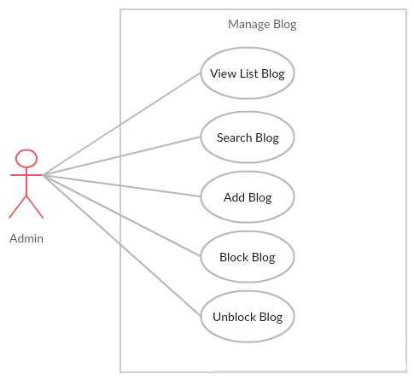

* + - 1. UC022 – View List Blog

|  |  |  |  |  |
| --- | --- | --- | --- | --- |
| **Use Case ID** | | UC022 | **Version** | 1.0 |
| **Use Case Name** | | View list blog | | |
| **Created by:** | | PhuongPTM | **Date Created:** | 28/09/2017 |
| **Primary Actor** | | Administrator(Admin) | **Secondary Actor** |  |
| **Description:** | | This function allows Administrator to view list blog | | |
| **Preconditions:** | | 1. BS website is available 2. Admin browsed BS website 3. Admin are viewing Login page for admin | | |
| **Trigger:** | | Admin click on Manage Blog | | |
| **Post conditions:** | | Blog List is displayed | | |
| **Normal Flow** | | | | |
| **Step** | **Actor** | **Action** | | |
| 1 | Admin | Click on Manage Blog | | |
| 2 | BS | Display list of blog | | |
| **Alternative Flows: N/A** | | | | |
| **Exceptions: N/A** | | | | |
| **Priority** | | High | | |
| **Frequency of Use:** | | High | | |
| **Business Rules:** | | B1 | | |
| **Other Information:** | | N/A | | |

* + - 1. UC023 – Add Blog

|  |  |  |  |  |
| --- | --- | --- | --- | --- |
| **Use Case ID** | | UC023 | **Version** | 1.0 |
| **Use Case Name** | | Add blog | | |
| **Created by:** | | PhuongPTM | **Date Created:** | 28/09/2017 |
| **Primary Actor** | | Administrator(Admin) | **Secondary Actor** |  |
| **Description:** | | This function allows Administrator to add a new blog | | |
| **Preconditions:** | | 1. BS website is available 2. Admin browsed BS website 3. Admin are viewing Login page for admin | | |
| **Trigger:** | | Admin click on Insert Blog | | |
| **Post conditions:** | | Insert blog page is displayed | | |
| **Normal Flow** | | | | |
| **Step** | **Actor** | **Action** | | |
| 1 | Admin | Click on Insert Blog | | |
| 2 | BS | Insert blog page is displayed | | |
| 3 | Admin | * Type title * Type Content * Choose image * Click Post button | | |
| **Alternative Flows: N/A** | | | | |
| **Exceptions:** | | | | |
| **EC1** | At step 3 in the main flows, if user miss fill 1 or more information | | | |
| **Step** | **Actor** | **Action** | | |
| **3.1** | **BS** | Display Dialog to remind user | | |
|  | | | | |
| **Priority** | | High | | |
| **Frequency of Use:** | | High | | |
| **Business Rules:** | | B1 | | |
| **Other Information:** | | N/A | | |

* + - 1. UC024 – Block Blog

|  |  |  |  |  |
| --- | --- | --- | --- | --- |
| **Use Case ID** | | UC024 | **Version** | 1.0 |
| **Use Case Name** | | Block blog | | |
| **Created by:** | | PhuongPTM | **Date Created:** | 28/09/2017 |
| **Primary Actor** | | Administrator(Admin) | **Secondary Actor** |  |
| **Description:** | | This function allows Administrator to block blog | | |
| **Preconditions:** | | * Admin is viewing Blog List * Status of this blog is Unlock | | |
| **Trigger:** | | Admin click on Lock button | | |
| **Post conditions:** | | Blog is block | | |
| **Normal Flow** | | | | |
| **Step** | **Actor** | **Action** | | |
| 1 | Admin | Click on Lock button at Status column of the blog what want to block | | |
| 2 | BS | * Change displayed status from Unlock to Lock * Change status of this blog to Lock on database | | |
| **Alternative Flows: N/A** | | | | |
| **Exceptions: N/A** | | | | |
| **Priority** | | High | | |
| **Frequency of Use:** | | High | | |
| **Business Rules:** | | B1 | | |
| **Other Information:** | | N/A | | |

* + - 1. UC025 – Unblock Blog

|  |  |  |  |  |
| --- | --- | --- | --- | --- |
| **Use Case ID** | | UC025 | **Version** | 1.0 |
| **Use Case Name** | | Unblock blog | | |
| **Created by:** | | PhuongPTM | **Date Created:** | 28/09/2017 |
| **Primary Actor** | | Administrator(Admin) | **Secondary Actor** |  |
| **Description:** | | This function allows Administrator to unblock blog | | |
| **Preconditions:** | | * Admin is viewing Blog List * Status of this blog is Lock | | |
| **Trigger:** | | Admin click on Unlock button | | |
| **Post conditions:** | | Blog is unblock | | |
| **Normal Flow** | | | | |
| **Step** | **Actor** | **Action** | | |
| 1 | Admin | Click on Unlock button at Status column of the blog what want to unblock | | |
| 2 | BS | * Change displayed status from Lock to Unlock * Change status of this blog to Unlock on database | | |
| **Alternative Flows: N/A** | | | | |
| **Exceptions: N/A** | | | | |
| **Priority** | | High | | |
| **Frequency of Use:** | | High | | |
| **Business Rules:** | | B1 | | |
| **Other Information:** | | N/A | | |

* + - 1. UC026 – Search Blog

|  |  |  |  |  |
| --- | --- | --- | --- | --- |
| **Use Case ID** | | UC026 | **Version** | 1.0 |
| **Use Case Name** | | Search blog | | |
| **Created by:** | | PhuongPTM | **Date Created:** | 28/09/2017 |
| **Primary Actor** | | Administrator(Admin) | **Secondary Actor** |  |
| **Description:** | | This function allows Administrator to search blog | | |
| **Preconditions:** | | Admin is viewing Blog List | | |
| **Trigger:** | | Admin types name of blog at Search textbox | | |
| **Post conditions:** | | Display list of searched blog | | |
| **Normal Flow** | | | | |
| **Step** | **Actor** | **Action** | | |
| 1 | Admin | Click on Manage blog | | |
| 2 | BS | List blog is displayed | | |
| 3 | Admin | Type name of blog what admin want to search | | |
| 4 | BS | Display list of blog what have the name is typed | | |
| **Alternative Flows: N/A** | | | | |
| **Exceptions: N/A** | | | | |
| **Priority** | | High | | |
| **Frequency of Use:** | | High | | |
| **Business Rules:** | | B1 | | |
| **Other Information:** | | N/A | | |

### Manage Event

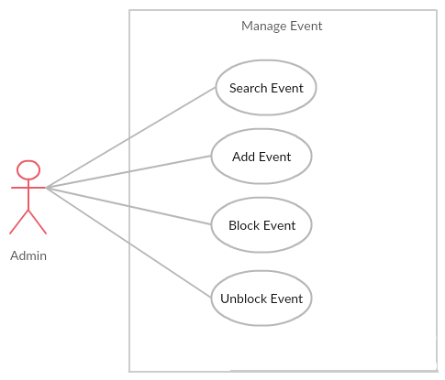

* + - 1. UC027 – Search Event

|  |  |  |  |  |
| --- | --- | --- | --- | --- |
| **Use Case ID** | | UC027 | **Version** | 1.0 |
| **Use Case Name** | | Search event | | |
| **Created by:** | | PhuongPTM | **Date Created:** | 28/09/2017 |
| **Primary Actor** | | Administrator(Admin) | **Secondary Actor** |  |
| **Description:** | | This function allows Administrator to search event | | |
| **Preconditions:** | | Admin is viewing Event List | | |
| **Trigger:** | | Admin types name of event at Search textbox | | |
| **Post conditions:** | | Display list of searched event | | |
| **Normal Flow** | | | | |
| **Step** | **Actor** | **Action** | | |
| 1 | Admin | Click on Manage event | | |
| 2 | BS | List event is displayed | | |
| 3 | Admin | Type name of event what admin want to search | | |
| 4 | BS | Display list of event what have the name is typed | | |
| **Alternative Flows: N/A** | | | | |
| **Exceptions: N/A** | | | | |
| **Priority** | | High | | |
| **Frequency of Use:** | | High | | |
| **Business Rules:** | | B1 | | |
| **Other Information:** | | N/A | | |

* + - 1. UC028 – Add Event

|  |  |  |  |  |
| --- | --- | --- | --- | --- |
| **Use Case ID** | | UC028 | **Version** | 1.0 |
| **Use Case Name** | | Add event | | |
| **Created by:** | | PhuongPTM | **Date Created:** | 28/09/2017 |
| **Primary Actor** | | Administrator(Admin) | **Secondary Actor** |  |
| **Description:** | | This function allows Administrator to add a new event | | |
| **Preconditions:** | | 1. BS website is available 2. Admin browsed BS website 3. Admin are viewing Login page for admin | | |
| **Trigger:** | | Admin click on Insert Event | | |
| **Post conditions:** | | Insert event page is displayed | | |
| **Normal Flow** | | | | |
| **Step** | **Actor** | **Action** | | |
| 1 | Admin | Click on Insert Event | | |
| 2 | BS | Insert event page is displayed | | |
| 3 | Admin | * Type title * Type Content * Choose image * Click Add button | | |
| **Alternative Flows: N/A** | | | | |
| **Exceptions:** | | | | |
| **EC1** | At step 3 in the main flows, if user miss fill 1 or more information | | | |
| **Step** | **Actor** | **Action** | | |
| **3.1** | **BS** | Display Dialog to remind user | | |
|  | | | | |
| **Priority** | | High | | |
| **Frequency of Use:** | | High | | |
| **Business Rules:** | | B1 | | |
| **Other Information:** | | N/A | | |

* + - 1. UC029 – Block Event

|  |  |  |  |  |
| --- | --- | --- | --- | --- |
| **Use Case ID** | | UC029 | **Version** | 1.0 |
| **Use Case Name** | | Block event | | |
| **Created by:** | | PhuongPTM | **Date Created:** | 28/09/2017 |
| **Primary Actor** | | Administrator(Admin) | **Secondary Actor** |  |
| **Description:** | | This function allows Administrator to block event | | |
| **Preconditions:** | | * Admin is viewing Event List * Status of this event is Unlock | | |
| **Trigger:** | | Admin click on Lock button | | |
| **Post conditions:** | | Event is block | | |
| **Normal Flow** | | | | |
| **Step** | **Actor** | **Action** | | |
| 1 | Admin | Click on Lock button at Status column of the event what want to block | | |
| 2 | BS | * Change displayed status from Unlock to Lock * Change status of this event to Lock on database | | |
| **Alternative Flows: N/A** | | | | |
| **Exceptions: N/A** | | | | |
| **Priority** | | High | | |
| **Frequency of Use:** | | High | | |
| **Business Rules:** | | B1 | | |
| **Other Information:** | | N/A | | |

* + - 1. UC030 – Unblock Event

|  |  |  |  |  |
| --- | --- | --- | --- | --- |
| **Use Case ID** | | UC030 | **Version** | 1.0 |
| **Use Case Name** | | Unblock event | | |
| **Created by:** | | PhuongPTM | **Date Created:** | 28/09/2017 |
| **Primary Actor** | | Administrator(Admin) | **Secondary Actor** |  |
| **Description:** | | This function allows Administrator to unblock event | | |
| **Preconditions:** | | * Admin is viewing Event List * Status of this event is Lock | | |
| **Trigger:** | | Admin click on Unlock button | | |
| **Post conditions:** | | Event is unblock | | |
| **Normal Flow** | | | | |
| **Step** | **Actor** | **Action** | | |
| 1 | Admin | Click on Unlock button at Status column of the event what want to unblock | | |
| 2 | BS | * Change displayed status from Lock to Unlock * Change status of this event to Unlock on database | | |
| **Alternative Flows: N/A** | | | | |
| **Exceptions: N/A** | | | | |
| **Priority** | | High | | |
| **Frequency of Use:** | | High | | |
| **Business Rules:** | | B1 | | |
| **Other Information:** | | N/A | | |

### Manage Benefit

* + - 1. UC030 – Search Benefit
      2. UC031 – View Benefit

### Manage Categories

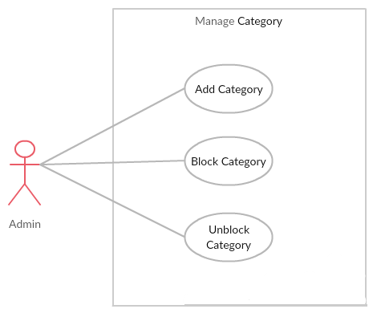

* + - 1. UC033 – Add Category

|  |  |  |  |  |
| --- | --- | --- | --- | --- |
| **Use Case ID** | | UC033 | **Version** | 1.0 |
| **Use Case Name** | | Add category | | |
| **Created by:** | | PhuongPTM | **Date Created:** | 28/09/2017 |
| **Primary Actor** | | Administrator(Admin) | **Secondary Actor** |  |
| **Description:** | | This function allows Administrator to add a new category | | |
| **Preconditions:** | | 1. BS website is available 2. Admin browsed BS website 3. Admin are viewing Login page for admin | | |
| **Trigger:** | | Admin click on Insert Category | | |
| **Post conditions:** | | Insert category page is displayed | | |
| **Normal Flow** | | | | |
| **Step** | **Actor** | **Action** | | |
| 1 | Admin | Click on Insert Category | | |
| 2 | BS | Insert category page is displayed | | |
| 3 | Admin | * Type category name * Click Post button | | |
| **Alternative Flows: N/A** | | | | |
| **Exceptions:** | | | | |
| **EC1** | At step 3 in the main flows, if user miss fill 1 or more information | | | |
| **Step** | **Actor** | **Action** | | |
| **3.1** | **BS** | Display Dialog to remind user | | |
|  | | | | |
| **Priority** | | High | | |
| **Frequency of Use:** | | High | | |
| **Business Rules:** | | B1 | | |
| **Other Information:** | | N/A | | |

* + - 1. UC034 – Block Category

|  |  |  |  |  |
| --- | --- | --- | --- | --- |
| **Use Case ID** | | UC034 | **Version** | 1.0 |
| **Use Case Name** | | Block category | | |
| **Created by:** | | PhuongPTM | **Date Created:** | 28/09/2017 |
| **Primary Actor** | | Administrator(Admin) | **Secondary Actor** |  |
| **Description:** | | This function allows Administrator to block category | | |
| **Preconditions:** | | * Admin is viewing Category List * Status of this category is Unlock | | |
| **Trigger:** | | Admin click on Lock button | | |
| **Post conditions:** | | Category is block | | |
| **Normal Flow** | | | | |
| **Step** | **Actor** | **Action** | | |
| 1 | Admin | Click on Lock button at Status column of the category what want to block | | |
| 2 | BS | * Change displayed status from Unlock to Lock * Change status of this category to Lock on database | | |
| **Alternative Flows: N/A** | | | | |
| **Exceptions: N/A** | | | | |
| **Priority** | | High | | |
| **Frequency of Use:** | | High | | |
| **Business Rules:** | | B1 | | |
| **Other Information:** | | N/A | | |

* + - 1. UC035 – Unblock Category

|  |  |  |  |  |
| --- | --- | --- | --- | --- |
| **Use Case ID** | | UC035 | **Version** | 1.0 |
| **Use Case Name** | | Unblock category | | |
| **Created by:** | | PhuongPTM | **Date Created:** | 28/09/2017 |
| **Primary Actor** | | Administrator(Admin) | **Secondary Actor** |  |
| **Description:** | | This function allows Administrator to unblock category | | |
| **Preconditions:** | | * Admin is viewing Category List * Status of this category is Lock | | |
| **Trigger:** | | Admin click on Unlock button | | |
| **Post conditions:** | | Category is unblock | | |
| **Normal Flow** | | | | |
| **Step** | **Actor** | **Action** | | |
| 1 | Admin | Click on Unlock button at Status column of the category what want to unblock | | |
| 2 | BS | * Change displayed status from Lock to Unlock * Change status of this category to Unlock on database | | |
| **Alternative Flows: N/A** | | | | |
| **Exceptions: N/A** | | | | |
| **Priority** | | High | | |
| **Frequency of Use:** | | High | | |
| **Business Rules:** | | B1 | | |
| **Other Information:** | | N/A | | |

## Staff Group Function

### Common Module

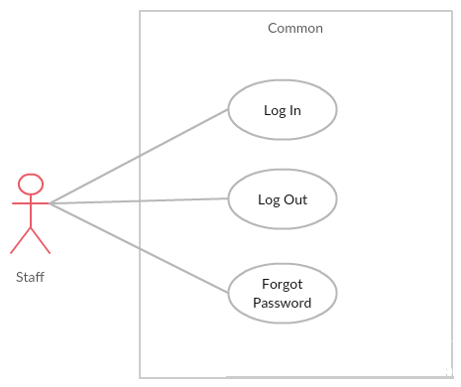

* + - 1. UC036 – Staff login

|  |  |  |  |  |
| --- | --- | --- | --- | --- |
| **Use Case ID** | | UC036 | **Version** | 1.0 |
| **Use Case Name** | | Staff login | | |
| **Created by:** | | PhuongPTM | **Date Created:** | 28/09/2017 |
| **Primary Actor** | | Staff | **Secondary Actor** |  |
| **Description:** | | This function allows Staff logins into website | | |
| **Preconditions:** | | 1. BS website is available 2. Staff browsed BS website 3. Staff are viewing Login page for staff | | |
| **Trigger:** | | Staff clicks on Login button | | |
| **Post conditions:** | | 1. Log Staff into system 2. Redirect Staff to Staff home page | | |
| **Normal Flow** | | | | |
| **Step** | **Actor** | **Action** | | |
| 1 | BS | Display Staff Login page. If Staff choose Remember Me function before, fill all needed information | | |
| 2 | Admin | Type email address and password if Staff does not choose Remember Me function before | | |
| 3 | BS | Verify:  Email address  Password | | |
| 4 | BS | * Log Staff into system * Redirect Staff to Staff home page | | |
| **Alternative Flows: N/A** | | | | |
| **Exceptions:** | | | | |
| **EC1** | At step 2 in main flow, if Staff entered wrong Email address or Password | | | |
| **Step** | **Actor** | **Action** | | |
| 2.1 | BS | Display Login popup message point out error field | | |
| 2.2 | BS | Mark error fields | | |
| **Priority** | | High | | |
| **Frequency of Use:** | | High | | |
| **Business Rules:** | | B1 | | |
| **Other Information:** | | N/A | | |

* + - 1. UC037 – Staff logout

|  |  |  |  |  |
| --- | --- | --- | --- | --- |
| **Use Case ID** | | UC0337 | **Version** | 1.0 |
| **Use Case Name** | | Staff logout | | |
| **Created by:** | | PhuongPTM | **Date Created:** | 28/09/2017 |
| **Primary Actor** | | Staff | **Secondary Actor** |  |
| **Description:** | | This function allows Staff logout website | | |
| **Preconditions:** | | Staff logged website | | |
| **Trigger:** | | Staff clicks on Sign out button | | |
| **Post conditions:** | | Staff logged out from BS website | | |
| **Normal Flow** | | | | |
| **Step** | **Actor** | **Action** | | |
| 1 | Admin | Choose sign out button | | |
| 2 | BS | Sign out Staff  Redirect to Staff Sign in page | | |
| **Alternative Flows: N/A** | | | | |
| **Exceptions: N/A** | | | | |
| **Priority** | | High | | |
| **Frequency of Use:** | | High | | |
| **Business Rules:** | | B1 | | |
| **Other Information:** | | N/A | | |

* + - 1. UC038 – Forgot Password

|  |  |  |  |  |
| --- | --- | --- | --- | --- |
| **Use Case ID** | | UC038 | **Version** | 1.0 |
| **Use Case Name** | | Staff forgot password | | |
| **Created by:** | | PhuongPTM | **Date Created:** | 28/09/2017 |
| **Primary Actor** | | Staff | **Secondary Actor** |  |
| **Description:** | | This function allows Staff receiving her/his password to mail | | |
| **Preconditions:** | | 1. BS website is available 2. Staff browsed BS website 3. Staff are viewing Sign in page for staff | | |
| **Trigger:** | | Click Forgot password in Sign in page | | |
| **Post conditions:** | | Staff get new password on her/his email | | |
| **Normal Flow** | | | | |
| **Step** | **Actor** | **Action** | | |
| 1 | Admin | Click Forgot password in Sign in page | | |
| 2 | BS | Display Email text box | | |
| 3 | Admin | Enter registered email | | |
| 4 | Admin | Click Forgot Password | | |
| **Alternative Flows: N/A** | | | | |
| **Exceptions: N/A** | | | | |
| **Priority** | | High | | |
| **Frequency of Use:** | | High | | |
| **Business Rules:** | | B1 | | |
| **Other Information:** | | N/A | | |

### Manage Order

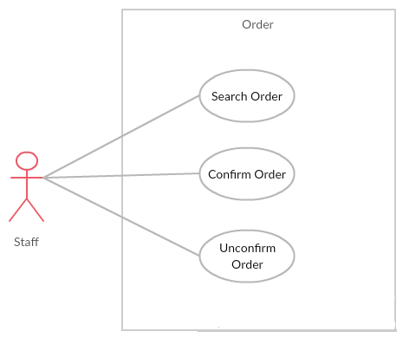

* + - 1. UC039 – Search Order

|  |  |  |  |  |
| --- | --- | --- | --- | --- |
| **Use Case ID** | | UC039 | **Version** | 1.0 |
| **Use Case Name** | | Search order | | |
| **Created by:** | | PhuongPTM | **Date Created:** | 28/09/2017 |
| **Primary Actor** | | Staff | **Secondary Actor** |  |
| **Description:** | | This function allows Staff to search order by date | | |
| **Preconditions:** | | Staff is viewing Manage Bills | | |
| **Trigger:** | | Staff choose date | | |
| **Post conditions:** | | Display list of searched order | | |
| **Normal Flow** | | | | |
| **Step** | **Actor** | **Action** | | |
| 1 | Admin | Click on Manage Bills | | |
| 2 | BS | List order is displayed | | |
| 3 | Admin | Staff choose date | | |
| 4 | BS | Display list of order what have the date is choose | | |
| **Alternative Flows: N/A** | | | | |
| **Exceptions: N/A** | | | | |
| **Priority** | | High | | |
| **Frequency of Use:** | | High | | |
| **Business Rules:** | | B1 | | |
| **Other Information:** | | N/A | | |

* + - 1. UC040 – Confirm Order

|  |  |  |  |  |
| --- | --- | --- | --- | --- |
| **Use Case ID** | | UC040 | **Version** | 1.0 |
| **Use Case Name** | | Confirm order | | |
| **Created by:** | | PhuongPTM | **Date Created:** | 28/09/2017 |
| **Primary Actor** | | Staff | **Secondary Actor** |  |
| **Description:** | | This function allows Staff to confirm order when order was completed | | |
| **Preconditions:** | | * Staff is viewing Manage Bills * Status of this order is Uncofirm | | |
| **Trigger:** | | Staff click Confirm button | | |
| **Post conditions:** | | Display order is confirm | | |
| **Normal Flow** | | | | |
| **Step** | **Actor** | **Action** | | |
| 1 | Admin | Click on Confirm button at Status column of the order what want to confirm | | |
| 2 | BS | * Change displayed status from Unconfirm to Confirm * Change status of this cake to Confirm on database | | |
| **Alternative Flows: N/A** | | | | |
| **Exceptions: N/A** | | | | |
| **Priority** | | High | | |
| **Frequency of Use:** | | High | | |
| **Business Rules:** | | B1 | | |
| **Other Information:** | | N/A | | |

* + - 1. UC041 – Unconfirm Order

|  |  |  |  |  |
| --- | --- | --- | --- | --- |
| **Use Case ID** | | UC040 | **Version** | 1.0 |
| **Use Case Name** | | Unconfirm order | | |
| **Created by:** | | PhuongPTM | **Date Created:** | 28/09/2017 |
| **Primary Actor** | | Staff | **Secondary Actor** |  |
| **Description:** | | This function allows Staff to unconfirm order when order was not completed | | |
| **Preconditions:** | | * Staff is viewing Manage Bills | | |
| **Trigger:** | | Staff click Unconfirm button | | |
| **Post conditions:** | | Display order is unconfirm | | |
| **Normal Flow** | | | | |
| **Step** | **Actor** | **Action** | | |
| 1 | Admin | Click on Unconfirm button at Status column of the order what want to unconfirm | | |
| 2 | BS | Change status of this cake to Unconfirm on database | | |
| **Alternative Flows: N/A** | | | | |
| **Exceptions: N/A** | | | | |
| **Priority** | | High | | |
| **Frequency of Use:** | | High | | |
| **Business Rules:** | | B1 | | |
| **Other Information:** | | N/A | | |

### Manage Introduction

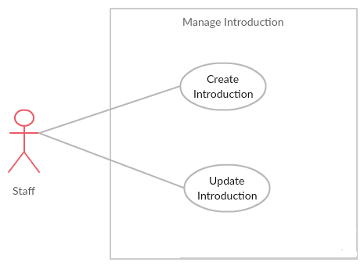

* + - 1. UC042 – Create Introduction

|  |  |  |  |  |
| --- | --- | --- | --- | --- |
| **Use Case ID** | | UC042 | **Version** | 1.0 |
| **Use Case Name** | | Create introduction | | |
| **Created by:** | | PhuongPTM | **Date Created:** | 28/09/2017 |
| **Primary Actor** | | Staff | **Secondary Actor** |  |
| **Description:** | | This function allows Staff to add information about BS website | | |
| **Preconditions:** | | 1. BS website is available 2. Staff browsed BS website 3. Staff are viewing Sign in page for staff | | |
| **Trigger:** | | Staff click on Create Introduction | | |
| **Post conditions:** | | Create introduction page is displayed | | |
| **Normal Flow** | | | | |
| **Step** | **Actor** | **Action** | | |
| 1 | Admin | Click on Create Introduction | | |
| 2 | BS | Create Introduction page is displayed | | |
| 3 | Admin | * Type Address * Type Phone number * Choose image * Click Save button | | |
| **Alternative Flows: N/A** | | | | |
| **Exceptions:** | | | | |
| **EC1** | At step 3 in the main flows, if user miss fill 1 or more information | | | |
| **Step** | **Actor** | **Action** | | |
| **3.1** | **BS** | Display Dialog to remind user | | |
|  | | | | |
| **Priority** | | High | | |
| **Frequency of Use:** | | High | | |
| **Business Rules:** | | B1 | | |
| **Other Information:** | | N/A | | |

* + - 1. UC043 – Update Introduction

|  |  |  |  |  |
| --- | --- | --- | --- | --- |
| **Use Case ID** | | UC043 | **Version** | 1.0 |
| **Use Case Name** | | Create introduction | | |
| **Created by:** | | PhuongPTM | **Date Created:** | 28/09/2017 |
| **Primary Actor** | | Staff | **Secondary Actor** |  |
| **Description:** | | This function allows Staff to update information about BS website | | |
| **Preconditions:** | | 1. BS website is available 2. Staff browsed BS website 3. Staff are viewing Sign in page for staff | | |
| **Trigger:** | | Staff click on Update Introduction | | |
| **Post conditions:** | | Update introduction page is displayed | | |
| **Normal Flow** | | | | |
| **Step** | **Actor** | **Action** | | |
| 1 | Admin | Click on Update Introduction | | |
| 2 | Admin | Update information | | |
| 3 | Admin | Click on Save button | | |
| 4 | BS | Save change | | |
| **Alternative Flows: N/A** | | | | |
| **Exceptions:** | | | | |
| **EC1** | At step 3 in the main flows, if user miss fill 1 or more information | | | |
| **Step** | **Actor** | **Action** | | |
| **3.1** | **BS** | Display Dialog to remind user | | |
|  | | | | |
| **Priority** | | High | | |
| **Frequency of Use:** | | High | | |
| **Business Rules:** | | B1 | | |
| **Other Information:** | | N/A | | |

### Manage Cake

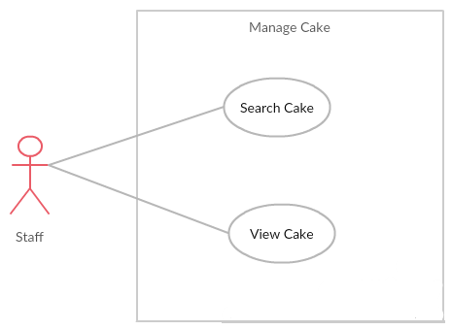

* + - 1. UC044 – View Cake

|  |  |  |  |  |
| --- | --- | --- | --- | --- |
| **Use Case ID** | | UC044 | **Version** | 1.0 |
| **Use Case Name** | | View cake | | |
| **Created by:** | | PhuongPTM | **Date Created:** | 28/09/2017 |
| **Primary Actor** | | Staff | **Secondary Actor** |  |
| **Description:** | | This function allows Staff to check information about cake | | |
| **Preconditions:** | | 1. BS website is available 2. Staff browsed BS website 3. Staff are viewing Sign in page for staff | | |
| **Trigger:** | | Staff click on Manage Cake | | |
| **Post conditions:** | | Cake list is displayed | | |
| **Normal Flow** | | | | |
| **Step** | **Actor** | **Action** | | |
| 1 | Admin | Click on Manage Cake | | |
| 2 | BS | Display list of cake | | |
| **Alternative Flows: N/A** | | | | |
| **Exceptions: N/A** | | | | |
| **Priority** | | High | | |
| **Frequency of Use:** | | High | | |
| **Business Rules:** | | B1 | | |
| **Other Information:** | | N/A | | |

* + - 1. UC045 – Search Cake

|  |  |  |  |  |
| --- | --- | --- | --- | --- |
| **Use Case ID** | | UC045 | **Version** | 1.0 |
| **Use Case Name** | | Search cake | | |
| **Created by:** | | PhuongPTM | **Date Created:** | 28/09/2017 |
| **Primary Actor** | | Staff | **Secondary Actor** |  |
| **Description:** | | This function allows Staff to search cake | | |
| **Preconditions:** | | Staff is viewing Cake List | | |
| **Trigger:** | | Staff types name of cake at Search textbox | | |
| **Post conditions:** | | Display list of searched cake | | |
| **Normal Flow** | | | | |
| **Step** | **Actor** | **Action** | | |
| 1 | Admin | Click on Manage Cake | | |
| 2 | BS | List cake is displayed | | |
| 3 | Admin | Type name of cake what admin want to search | | |
| 4 | BS | Display list of cake what have the name is typed | | |
| **Alternative Flows: N/A** | | | | |
| **Exceptions: N/A** | | | | |
| **Priority** | | High | | |
| **Frequency of Use:** | | High | | |
| **Business Rules:** | | B1 | | |
| **Other Information:** | | N/A | | |

### Personal Information

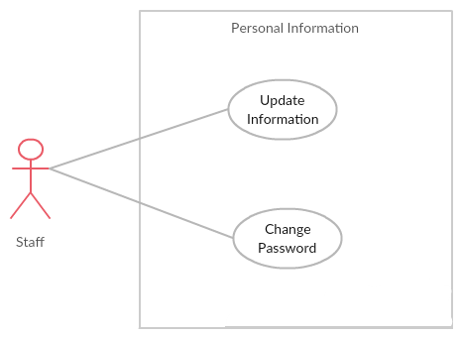

* + - 1. UC046 – Update Information

|  |  |  |  |  |
| --- | --- | --- | --- | --- |
| **Use Case ID** | | UC046 | **Version** | 1.0 |
| **Use Case Name** | | Update information | | |
| **Created by:** | | PhuongPTM | **Date Created:** | 28/09/2017 |
| **Primary Actor** | | Staff | **Secondary Actor** |  |
| **Description:** | | This function allows Staff to update profile | | |
| **Preconditions:** | | 1. BS website is available 2. Staff browsed BS website 3. Staff are viewing Sign in page for staff | | |
| **Trigger:** | | Staff click on Update Information | | |
| **Post conditions:** | | Update information page is displayed | | |
| **Normal Flow** | | | | |
| **Step** | **Actor** | **Action** | | |
| 1 | Admin | Click on Update Information | | |
| 2 | Admin | Update information | | |
| 3 | Admin | Click on Save button | | |
| 4 | BS | Save change | | |
| **Alternative Flows: N/A** | | | | |
| **Exceptions:** | | | | |
| **EC1** | At step 3 in the main flows, if user miss fill 1 or more information | | | |
| **Step** | **Actor** | **Action** | | |
| **3.1** | **BS** | Display Dialog to remind user | | |
|  | | | | |
| **Priority** | | High | | |
| **Frequency of Use:** | | High | | |
| **Business Rules:** | | B1 | | |
| **Other Information:** | | N/A | | |

* + - 1. UC047 – Change Password

|  |  |  |  |  |
| --- | --- | --- | --- | --- |
| **Use Case ID** | | UC047 | **Version** | 1.0 |
| **Use Case Name** | | Change password | | |
| **Created by:** | | PhuongPTM | **Date Created:** | 28/09/2017 |
| **Primary Actor** | | Staff | **Secondary Actor** |  |
| **Description:** | | This function allows Staff to want change new password | | |
| **Preconditions:** | | 1. BS website is available 2. Staff browsed BS website 3. Staff are viewing Sign in page for staff | | |
| **Trigger:** | | Staff click on Change password | | |
| **Post conditions:** | | Change password page is displayed | | |
| **Normal Flow** | | | | |
| **Step** | **Actor** | **Action** | | |
| 1 | Admin | Click on Change password | | |
| 2 | Admin | Fill information:   * Old password * New password * Repeat password | | |
| 3 | Admin | Click on Save button | | |
| 4 | BS | Save change | | |
| **Alternative Flows: N/A** | | | | |
| **Exceptions:** | | | | |
| **EC1** | At step 3 in the main flows, if user miss fill 1 or more information | | | |
| **Step** | **Actor** | **Action** | | |
| **3.1** | **BS** | Display Dialog to remind user | | |
|  | | | | |
| **Priority** | | High | | |
| **Frequency of Use:** | | High | | |
| **Business Rules:** | | B1 | | |
| **Other Information:** | | N/A | | |

## Customer Group Function

### Common Module

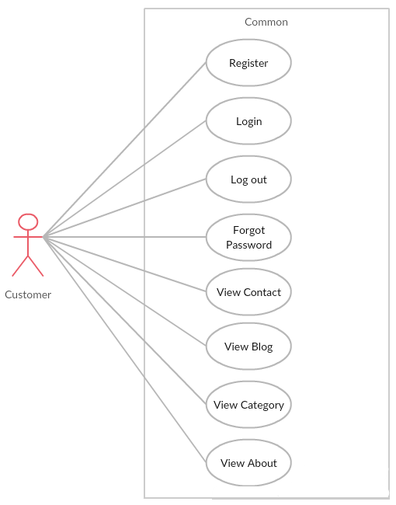

* + - 1. UC048 – Register

|  |  |  |  |  |
| --- | --- | --- | --- | --- |
| **Use Case ID** | | UC048 | **Version** | 1.0 |
| **Use Case Name** | | Register | | |
| **Created by:** | | PhuongPTM | **Date Created:** | 28/09/2017 |
| **Primary Actor** | | Customer | **Secondary Actor** |  |
| **Description:** | | Visitor can create new account to use more function | | |
| **Preconditions:** | | * BSO must be connected to the Internet * User browsed BSO website | | |
| **Trigger:** | | Click on sign up link on the website | | |
| **Post conditions:** | | 1. Add account information to database 2. Send confirm email 3. Logs user into system 4. Redirect user to Homepage and display as Member | | |
| **Normal Flow** | | | | |
| **Step** | **Actor** | **Action** | | |
| 1 | Customer | Click Sign up in header | | |
| 2 | Customer | Display Register page includes:   * User name text box * Password text box * Repeat Password text box * Email address text box * Sign up button | | |
| 3 | Customer | Enter data in fields | | |
| 4 | Customer | Click on Sign up button | | |
| 5 | BS | Send confirm email | | |
| 6 | BS | Logs user into system | | |
| 7 | BS | Display Homepage as Member | | |
| **Alternative Flows: N/A** | | | | |
| **Exceptions:** | | | | |
| **EC1** | At step 3, required fields are not entered | | | |
| **Step** | **Actor** | **Action** | | |
| **3.1** | **BS** | Display Dialog to remind user | | |
|  | | | | |
| **Priority** | | High | | |
| **Frequency of Use:** | | High | | |
| **Business Rules:** | | B1 | | |
| **Other Information:** | | N/A | | |

* + - 1. UC049 – Log In

|  |  |  |  |  |
| --- | --- | --- | --- | --- |
| **Use Case ID** | | UC049 | **Version** | 1.0 |
| **Use Case Name** | | Login | | |
| **Created by:** | | PhuongPTM | **Date Created:** | 28/09/2017 |
| **Primary Actor** | | Customer | **Secondary Actor** |  |
| **Description:** | | This function allows Customer logins into website | | |
| **Preconditions:** | | 1. BSO must be connected to the Internet 2. User browsed BSO website | | |
| **Trigger:** | | Customer click sign in button | | |
| **Post conditions:** | | 1. Log Customer into system 2. Redirect Customer to home page | | |
| **Normal Flow** | | | | |
| **Step** | **Actor** | **Action** | | |
| 1 | BS | Display Customer Login page. If Customer choose Remember Me function before, fill all needed information | | |
| 2 | Admin | Type email address and password if Customer does not choose Remember Me function before | | |
| 3 | BS | Verify:  Email address  Password | | |
| 4 | BS | * Log Customer into system * Redirect Customer to home page | | |
| **Alternative Flows: N/A** | | | | |
| **Exceptions:** | | | | |
| **EC1** | At step 2 in main flow, if Customer entered wrong Email address or Password | | | |
| **Step** | **Actor** | **Action** | | |
| 2.1 | BS | Display Login popup message point out error field | | |
| 2.2 | BS | Mark error fields | | |
| **Priority** | | High | | |
| **Frequency of Use:** | | High | | |
| **Business Rules:** | | B1 | | |
| **Other Information:** | | N/A | | |

* + - 1. UC050 – Log Out

|  |  |  |  |  |
| --- | --- | --- | --- | --- |
| **Use Case ID** | | UC050 | **Version** | 1.0 |
| **Use Case Name** | | Logout | | |
| **Created by:** | | PhuongPTM | **Date Created:** | 28/09/2017 |
| **Primary Actor** | | Customer | **Secondary Actor** |  |
| **Description:** | | This function allows Customer logout website | | |
| **Preconditions:** | | Customer logged website | | |
| **Trigger:** | | Customer clicks on Sign out button | | |
| **Post conditions:** | | Customer logged out from BS website | | |
| **Normal Flow** | | | | |
| **Step** | **Actor** | **Action** | | |
| 1 | Admin | Choose sign out button | | |
| 2 | BS | Sign out Customer  Redirect to Homepage | | |
| **Alternative Flows: N/A** | | | | |
| **Exceptions: N/A** | | | | |
| **Priority** | | High | | |
| **Frequency of Use:** | | High | | |
| **Business Rules:** | | B1 | | |
| **Other Information:** | | N/A | | |

* + - 1. UC051 – Forgot Password

|  |  |  |  |  |
| --- | --- | --- | --- | --- |
| **Use Case ID** | | UC051 | **Version** | 1.0 |
| **Use Case Name** | | Forgot password | | |
| **Created by:** | | PhuongPTM | **Date Created:** | 28/09/2017 |
| **Primary Actor** | | Staff | **Secondary Actor** |  |
| **Description:** | | This function allows Customer receiving her/his password to mail | | |
| **Preconditions:** | | 1. BSO must be connected to the Internet 2. User browsed BSO website | | |
| **Trigger:** | | Click Forgot password in Sign in page | | |
| **Post conditions:** | | Customer get new password on her/his email | | |
| **Normal Flow** | | | | |
| **Step** | **Actor** | **Action** | | |
| 1 | Admin | Click Forgot password in Sign in page | | |
| 2 | BS | Display Email text box | | |
| 3 | Admin | Enter registered email | | |
| 4 | Admin | Click Forgot Password | | |
| **Alternative Flows: N/A** | | | | |
| **Exceptions: N/A** | | | | |
| **Priority** | | High | | |
| **Frequency of Use:** | | High | | |
| **Business Rules:** | | B1 | | |
| **Other Information:** | | N/A | | |

* + - 1. UC052 – View Blog

|  |  |  |  |  |
| --- | --- | --- | --- | --- |
| **Use Case ID** | | UC052 | **Use Case ID** | UC051 |
| **Use Case Name** | | View blog | | |
| **Created by:** | | PhuongPTM | **Created by:** | PhuongPTM |
| **Primary Actor** | | Customer | **Secondary Actor** |  |
| **Description:** | | This function allows Customer can view blog | | |
| **Preconditions:** | | 1. BSO must be connected to the Internet 2. User browsed BSO website | | |
| **Trigger:** | | Click on the blog button on menu bar | | |
| **Post conditions:** | | User will go to Detail Blog page | | |
| **Normal Flow** | | | | |
| **Step** | **Actor** | **Action** | | |
| 1 | Admin | Click on the blog button on menu bar | | |
| 2 | BS | Display Blog page | | |
| **Alternative Flows: N/A** | | | | |
| **Exceptions: N/A** | | | | |
| **Priority** | | High | | |
| **Frequency of Use:** | | High | | |
| **Business Rules:** | | B1 | | |
| **Other Information:** | | N/A | | |

* + - 1. UC053 – View Category

|  |  |  |  |  |
| --- | --- | --- | --- | --- |
| **Use Case ID** | | UC053 | **Use Case ID** | UC051 |
| **Use Case Name** | | View category | | |
| **Created by:** | | PhuongPTM | **Created by:** | PhuongPTM |
| **Primary Actor** | | Customer | **Secondary Actor** |  |
| **Description:** | | This function allows Customer can view category | | |
| **Preconditions:** | | 1. BSO must be connected to the Internet 2. User browsed BSO website | | |
| **Trigger:** | | Click on the category button on menu bar | | |
| **Post conditions:** | | User will go to category page | | |
| **Normal Flow** | | | | |
| **Step** | **Actor** | **Action** | | |
| 1 | Admin | Click on the category button on menu bar | | |
| 2 | BS | Display Category page | | |
| **Alternative Flows: N/A** | | | | |
| **Exceptions: N/A** | | | | |
| **Priority** | | High | | |
| **Frequency of Use:** | | High | | |
| **Business Rules:** | | B1 | | |
| **Other Information:** | | N/A | | |

* + - 1. UC054 – View Contact

|  |  |  |  |  |
| --- | --- | --- | --- | --- |
| **Use Case ID** | | UC053 | **Use Case ID** | UC051 |
| **Use Case Name** | | View contact | | |
| **Created by:** | | PhuongPTM | **Created by:** | PhuongPTM |
| **Primary Actor** | | Customer | **Secondary Actor** |  |
| **Description:** | | This function allows Customer can view contact of BS website | | |
| **Preconditions:** | | 1. BSO must be connected to the Internet 2. User browsed BSO website | | |
| **Trigger:** | | Click on the contact button on menu bar | | |
| **Post conditions:** | | User will go to contact page | | |
| **Normal Flow** | | | | |
| **Step** | **Actor** | **Action** | | |
| 1 | Admin | Click on the contact button on menu bar | | |
| 2 | BS | Display contact page | | |
| **Alternative Flows: N/A** | | | | |
| **Exceptions: N/A** | | | | |
| **Priority** | | High | | |
| **Frequency of Use:** | | High | | |
| **Business Rules:** | | B1 | | |
| **Other Information:** | | N/A | | |

* + - 1. UC055 – View About

|  |  |  |  |  |
| --- | --- | --- | --- | --- |
| **Use Case ID** | | UC055 | **Use Case ID** | UC051 |
| **Use Case Name** | | View about | | |
| **Created by:** | | PhuongPTM | **Created by:** | PhuongPTM |
| **Primary Actor** | | Customer | **Secondary Actor** |  |
| **Description:** | | This function allows Customer can view information aout BS website | | |
| **Preconditions:** | | 1. BSO must be connected to the Internet 2. User browsed BSO website | | |
| **Trigger:** | | Click on the about button on menu bar | | |
| **Post conditions:** | | User will go to about page | | |
| **Normal Flow** | | | | |
| **Step** | **Actor** | **Action** | | |
| 1 | Admin | Click on the about button on menu bar | | |
| 2 | BS | Display about page | | |
| **Alternative Flows: N/A** | | | | |
| **Exceptions: N/A** | | | | |
| **Priority** | | High | | |
| **Frequency of Use:** | | High | | |
| **Business Rules:** | | B1 | | |
| **Other Information:** | | N/A | | |

### Order

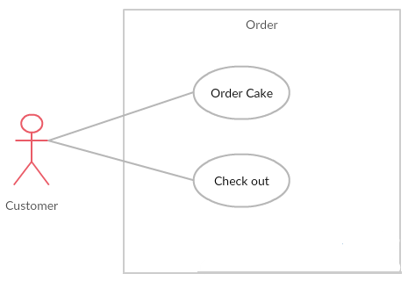

* + - 1. UC056 – Order Cake

|  |  |  |  |  |
| --- | --- | --- | --- | --- |
| **Use Case ID** | | UC056 | **Use Case ID** | UC051 |
| **Use Case Name** | | Order Cake | | |
| **Created by:** | | PhuongPTM | **Created by:** | PhuongPTM |
| **Primary Actor** | | Customer | **Secondary Actor** |  |
| **Description:** | | This function allows Customer can order cake | | |
| **Preconditions:** | | 1. BSO must be connected to the Internet 2. User browsed BSO website | | |
| **Trigger:** | | Click on Add to cart | | |
| **Post conditions:** | | Display screen order | | |
| **Normal Flow** | | | | |
| **Step** | **Actor** | **Action** | | |
| 1 | Admin | Choose a cake | | |
| 2 | Admin | Click Add to cart | | |
| 3 | BS | Display screen order | | |
| **Alternative Flows: N/A** | | | | |
| **Exceptions: N/A** | | | | |
| **Priority** | | High | | |
| **Frequency of Use:** | | High | | |
| **Business Rules:** | | B1 | | |
| **Other Information:** | | N/A | | |

* + - 1. UC057 – Check Out

|  |  |  |  |  |
| --- | --- | --- | --- | --- |
| **Use Case ID** | | UC057 | **Use Case ID** | UC051 |
| **Use Case Name** | | Check Out | | |
| **Created by:** | | PhuongPTM | **Created by:** | PhuongPTM |
| **Primary Actor** | | Customer | **Secondary Actor** |  |
| **Description:** | | This function allows Customer can check information about order | | |
| **Preconditions:** | | 1. BSO must be connected to the Internet 2. User browsed BSO website | | |
| **Trigger:** | | Click on shopping cart | | |
| **Post conditions:** | | Display shopping cart screen | | |
| **Normal Flow** | | | | |
| **Step** | **Actor** | **Action** | | |
| 1 | Admin | Click Cart | | |
| 2 | BS | Display shopping cart screen | | |
| **Alternative Flows: N/A** | | | | |
| **Exceptions: N/A** | | | | |
| **Priority** | | High | | |
| **Frequency of Use:** | | High | | |
| **Business Rules:** | | B1 | | |
| **Other Information:** | | N/A | | |

### Personal Information

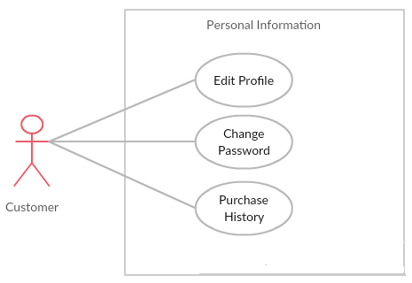

* + - 1. UC058 – Edit Profile

|  |  |  |  |  |
| --- | --- | --- | --- | --- |
| **Use Case ID** | | UC058 | **Version** | 1.0 |
| **Use Case Name** | | Update information | | |
| **Created by:** | | PhuongPTM | **Date Created:** | 28/09/2017 |
| **Primary Actor** | | Customer | **Secondary Actor** |  |
| **Description:** | | This function allows Customer to update profile | | |
| **Preconditions:** | | 1. BSO must be connected to the Internet 2. User browsed BSO website | | |
| **Trigger:** | | Click to Account Information | | |
| **Post conditions:** | | Update information page is displayed | | |
| **Normal Flow** | | | | |
| **Step** | **Actor** | **Action** | | |
| 1 | Customer | Click to Account Information | | |
| 2 | Customer | Update information | | |
| 3 | Customer | Click on Save button | | |
| 4 | BS | Save change | | |
| **Alternative Flows: N/A** | | | | |
| **Exceptions:** | | | | |
| **EC1** | At step 3 in the main flows, if user miss fill 1 or more information | | | |
| **Step** | **Actor** | **Action** | | |
| **3.1** | **BS** | Display Dialog to remind user | | |
|  | | | | |
| **Priority** | | High | | |
| **Frequency of Use:** | | High | | |
| **Business Rules:** | | B1 | | |
| **Other Information:** | | N/A | | |

* + - 1. UC059 – Change Password

|  |  |  |  |  |
| --- | --- | --- | --- | --- |
| **Use Case ID** | | UC059 | **Version** | 1.0 |
| **Use Case Name** | | Change password | | |
| **Created by:** | | PhuongPTM | **Date Created:** | 28/09/2017 |
| **Primary Actor** | | Customer | **Secondary Actor** |  |
| **Description:** | | This function allows Staff to want change new password | | |
| **Preconditions:** | | 1. BSO must be connected to the Internet 2. User browsed BSO website | | |
| **Trigger:** | | Customer click on Change password | | |
| **Post conditions:** | | Change password page is displayed | | |
| **Normal Flow** | | | | |
| **Step** | **Actor** | **Action** | | |
| 1 | Customer | Click on Change password | | |
| 2 | Customer | Fill information:   * Old password * New password * Repeat password | | |
| 3 | Customer | Click on Save button | | |
| 4 | BS | Save change | | |
| **Alternative Flows: N/A** | | | | |
| **Exceptions:** | | | | |
| **EC1** | At step 3 in the main flows, if user miss fill 1 or more information | | | |
| **Step** | **Actor** | **Action** | | |
| **3.1** | **BS** | Display Dialog to remind user | | |
|  | | | | |
| **Priority** | | High | | |
| **Frequency of Use:** | | High | | |
| **Business Rules:** | | B1 | | |
| **Other Information:** | | N/A | | |

* + - 1. UC060 – Purchase History

|  |  |  |  |  |
| --- | --- | --- | --- | --- |
| **Use Case ID** | | UC060 | **Version** | 1.0 |
| **Use Case Name** | | Change password | | |
| **Created by:** | | PhuongPTM | **Date Created:** | 28/09/2017 |
| **Primary Actor** | | Customer | **Secondary Actor** |  |
| **Description:** | | This function allows Staff to want change new password | | |
| **Preconditions:** | | 1. BSO must be connected to the Internet 2. User browsed BSO website | | |
| **Trigger:** | | Customer click on Purchase History | | |
| **Post conditions:** | | Purchase History page is displayed | | |
| **Normal Flow** | | | | |
| **Step** | **Actor** | **Action** | | |
| 1 | Customer | Click on Purchase History | | |
| 2 | Customer | Purchase History page is displayed | | |
| 3 | BS | User can view all the has bought. | | |
| **Alternative Flows: N/A** | | | | |
| **Exceptions:N/A** | | | | |
| **Priority** | | High | | |
| **Frequency of Use:** | | High | | |
| **Business Rules:** | | B1 | | |
| **Other Information:** | | N/A | | |

# NON-FUNCTIONAL SPECIFICATION

## Reliability

1. Mean time between failures: The mean time between each failure is expected to be about 480 hours of using.
2. The maximum bugs per function are 2 bugs/a function when user uses software within 2 months. The average number of bugs in the software during system testing is about to be around 1 bugs/KLOC.
3. The database must be backed up daily and can be recovered if necessary.

## Perfomance Requirements

### Availability

* The application must be available 95% of time. Users can access to it everywhere from their
* Web browser with internet connection.

### Response time

In term of response time, waiting time of processing will be 2 to 5 seconds; time to process any functions will not exceed 7 seconds.

### Maintainability

* **Coding standards and naming conventions**
  + Output of the project must include coding standards and naming conventions documentations. Implementation code must be easy to maintain.
  + If some components are reused, the documentations of those components must also be included.
* **Design**
  + The design of the system must be loosely coupled that chances on some module will not affect others.
* **Logging**
  + All the errors should be logged, supporting for bug fixing and maintenance.
  + All strange or sensitive situations should also be logged.
* **Mean time to repair:** Immediately when Administrator finds out problem or website is attacked/ hacked by someone. Average 1 day.

### Usability

Usability Requirements support the following from the perspective of its primary users:

* **Efficiency of use:** user can complete each function in less than 12 actions
* **Intuitiveness:** User can understand approximately 90% help/ error messages

### Security Requirements

In order to avoid unwanted access by strangers, the security implemented in various ways:

* **User authorize**: Each function must be distributed system access and manipulate the individual parts. To edit information, user must declare their username and password before the operation. Functions will be show after users login dependencies user’s role and permission of each user.
* **Manage Data Layer**: Only Administrator can modify database system.

## Customer Code

# Other considerations

**[This section provides a description of other design elements that were considered as alternatives in selection process for the above database design, i.e. a brief explanation of advantages and disadvantages of the selected entity relationships and/or database implementation in comparison with others. It should be a clear answer to the question why the above data design is selected for this system, not the others.]**

# Appendix

## Data format symbol

**Following symbols are used to describe format of data field in files as well as in tables.**

|  |  |
| --- | --- |
| Symbol | Description |
| **#** | **Digit placeholder.** |
| **.** | **Decimal placeholder.** |
| **,** | **Thousands separator.** |
| **:** | **Time separator.** |
| **/** | **Date separator.** |
| **\** | **Treat the next character in the mask string as a literal. This allows you to include the '#', '&', 'A', and '?' characters in the mask. This character is treated as a literal for masking purposes.** |
| **>** | **Convert all the characters that follow to uppercase.** |
| **<** | **Convert all the characters that follow to lowercase.** |
| **A** | **Alphanumeric character placeholder (entry required). For example: a – z, A – Z, or 0 – 9.** |
| **a** | **Alphanumeric character placeholder (entry optional).** |
| **9** | **Digit placeholder (entry optional). For example: 0 – 9.** |
| **0** | **Digit placeholder (entry required). For example: 0 – 9.** |
| **C** | **Character or space placeholder (entry optional). Valid values for this placeholder are ANSI characters in the following ranges: 32-126 and 128-255.** |
| **&** | **Character placeholder (entry required). Valid values for this placeholder are ANSI characters in the following ranges: 32-126 and 128-255.** |
| **?** | **Letter placeholder. For example: a – z or A – Z.** |
| **Literal** | **All other symbols are displayed as literals; that is, as themselves. bound in “” like “ABC”** |