|  |
| --- |
|  |
|  |

**BAKERY STORE ONLINE**

Report #2 – Data Design

|  |  |  |
| --- | --- | --- |
| **Bakery Store Online** | | |
| **Group member** | Phạm Thị Minh Phương | SE03773 |
| Cao Anh Tuấn | SE03737 |
| Hoàng Anh Phương | SE03715 |
| Ngô Trung Kiên | SE03736 |
| Nguyễn Xuân Hà | SE03484 |
| **Supervisor** | Mr. Nguyễn Văn Sang | |
| **Project code** | BSO | |

**- Hanoi, 09/2017 –**

# SIGNATURE PAGE

AUTHOR: Ngô Trung Kiên 29/09/2017

Team member

REVIEWERS: Phạm Thị Minh Phương 30/09/2017

Project manager

APPROVAL: Nguyễn Văn Sang --/--/--17

Supervisor

Record of change

*A - Added M - Modified D – Deleted

|  |  |  |  |  |  |
| --- | --- | --- | --- | --- | --- |
| **Effective Date** | **Changed Item** | **A,M,D** | **Change Description** | **Reason for Change** | **Rev. Number** |
| 29**/**Sep/2017 | Create Data Design | A | Create Data Design | First version | 1.0 |
|  |  |  |  |  |  |
|  |  |  |  |  |  |
|  |  |  |  |  |  |
|  |  |  |  |  |  |
|  |  |  |  |  |  |
|  |  |  |  |  |  |
|  |  |  |  |  |  |
|  |  |  |  |  |  |
|  |  |  |  |  |  |
|  |  |  |  |  |  |
|  |  |  |  |  |  |
|  |  |  |  |  |  |
|  |  |  |  |  |  |
|  |  |  |  |  |  |
|  |  |  |  |  |  |
|  |  |  |  |  |  |
|  |  |  |  |  |  |
|  |  |  |  |  |  |
|  |  |  |  |  |  |
|  |  |  |  |  |  |
|  |  |  |  |  |  |
|  |  |  |  |  |  |
|  |  |  |  |  |  |

Table Contents

SIGNATURE PAGE 1

1 INTRODUCTION 2

1.1 Purpose 2

1.2 Acronyms and Definitions 2

1.3 References 3

1.4 Overview 3

2 Database 4

2.1 Entity Relationship Diagram 4

2.2 Table Diagram 7

# INTRODUCTION

## Purpose

Fly Away Plus data design document describes structure of database and file structure of system including internal file structure as well as interface file structure.

## Acronyms and Definitions

|  |  |
| --- | --- |
| **Acronym & Abbreviation** | **Definition** |
| BSO | Bakery Store |
| FU | FPT University |
| Q&A | Question and Answer |

Table 1‑1: Acronyms and Definitions

## References

|  |  |
| --- | --- |
| **Document** | **Title** |
| Class Design Document | BSO_Class Design_v1.0_EN |
| Architecture Design | BSO_Architecture Design_v1.0_EN |
| Software Requirement Specification | BSO_Software Requirement Specification_v1.0_EN |

Table 1‑2: References

## Overview

This document describes relationship between entities and properties of each entity.

# Database

## Entity Relationship Diagram

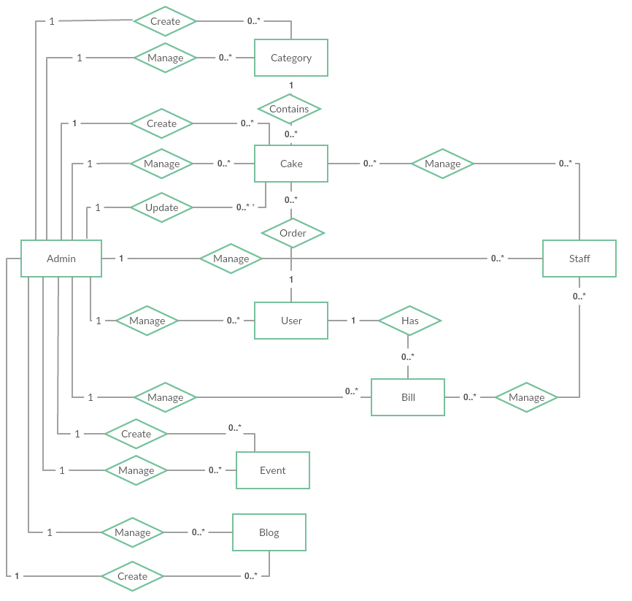

**Figure 2‑1:** Entity Relationship Diagram

### Entity description

|  |  |  |
| --- | --- | --- |
| **No** | **Entity** | **Description** |
|  | Admin | Manager of the store |
|  | Staff | Shop staff |
|  | User | User is all people who using BSO |
|  | Event | An event created by the manager includes the image content to describe |
|  | Cake | Cake is a kind of item |
|  | Blog | An blog created by the manager includes the image content to describe |
|  | Category | A category which users use to filter cake |
|  | Bill | Managers and users use to review transaction history |

**Table 2-3:** Entity description

### Relationship

|  |  |  |  |  |  |
| --- | --- | --- | --- | --- | --- |
| **No** | **Relation** | **Properties** | **From** | **To** | **Description** |
|  | CONTAINS | None | Category | Cake | A category contains many cakes |
|  | MANAGE | None | Staff | Cake | The staff used to check information about the cake |
|  | MANAGE | None | Staff | Bill | Staff to check their order |
|  | MANAGE | None | Admin | Category | The manager used to manage information about the category |
|  | MANAGE | UserID  ProjectID | Admin | Staff | The manager used to manage information about the staff |
|  | MANAGE | UserID  ProjectID | Admin | Cake | The manager used to manage information about the cake |
|  | MANAGE | UserID  ProjectID | Admin | User | The manager used to check information about the user |
|  | MANAGE | UserID  ProjectID | Admin | Bill | The manager used to manage information about the bill |
|  | MANAGE | None | Admin | Event | The manager used to manage information about the event |
|  | MANAGE | ReportUseID  ReportedUseID | Admin | Blog | The manager used to manage information about the blog |
|  | CREATE | None | Admin | Category | Manager adds new category |
|  | CREATE | None | Admin | Cake | Manager adds new cake |
|  | CREATE | None | Admin | Event | Manager adds new event |
|  | CREATE |  | Admin | Blog | Manager adds new blog |
|  | UPDATE |  | Admin | Cake | Manager update information of cake |
|  | ORDER |  | User | Cake | Users use to order cake |
|  | HAS |  | User | Bill | User to view transaction history |

Table 2‑1: Relationship description

## Table Diagram

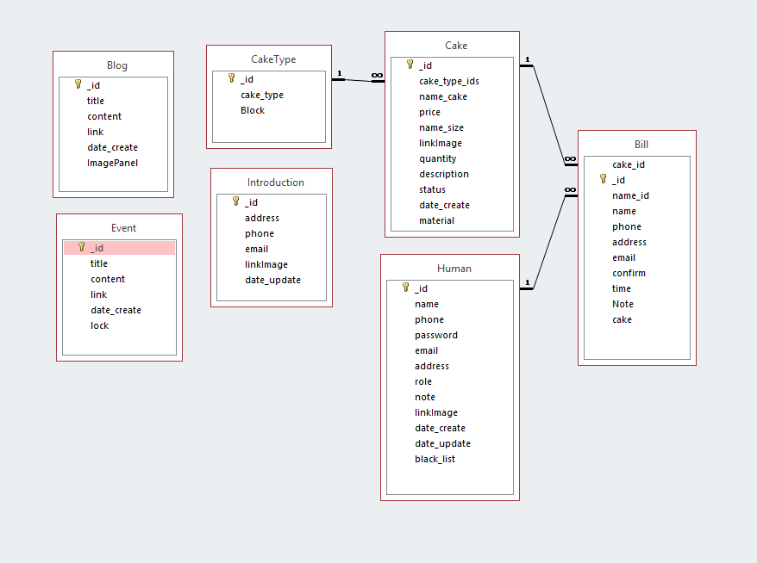

**Figure 2‑2:** Table Diagram

### Bill table

|  |  |  |  |  |
| --- | --- | --- | --- | --- |
| **No** | **Field Name** | **Type** | **Allow Null** | **Description** |
| 1 | _id | ObjectId | No | id of Bill |
| 2 | cake_id | ObjectId |  | id of Cake |
| 3 | name_id | ObjectId |  | id of Customer |
| 4 | name | String | No | name of Customer |
| 5 | phone | String | No | phone number of Customer |
| 6 | address | String | No | shipping address for Cusomer |
| 7 | email | String |  | email of Customer |
| 8 | confirm | Boolean |  | confirm has been shipped |
| 9 | time | Date | No | time order cake |
| 10 | Note | String |  | note for staff |
| 11 | cake | Array | No | information of order detail |

Table 2‑2: Bill table

### Blog table

|  |  |  |  |  |
| --- | --- | --- | --- | --- |
| **No** | **Field Name** | **Type** | **Allow Null** | **Description** |
| 1 | _id | ObjectId | No | id of Blog |
| 2 | title | String | No | title of Blog |
| 3 | content | String | No | content of Blog |
| 4 | link | String | No | image link of content's Blog |
| 5 | date_create | Date | No | time create blog |
| 6 | ImagePanel | String | NO | imge link of panel's Blog |

Table 2‑2: Blog table

### Cake table

|  |  |  |  |  |
| --- | --- | --- | --- | --- |
| **No** | **Field Name** | **Type** | **Allow Null** | **Description** |
| 1 | _id | ObjectId | No | id of Cake |
| 2 | cake_type_ids | ObjectId | No | id of Category |
| 3 | name_cake | String | No | name of Cake |
| 4 | price | String | No | price of Cake |
| 5 | name_size | String | No | size of Cake |
| 6 | linkImage | String | No | link Image of Cake |
| 7 | quantity | String | No | quantity of Cake exist |
| 8 | description | String | No | description about Cake |
| 9 | status | Boolean | No | status of Cake sell |
| 10 | date_create | Date | No | time create Cake |
| 11 | material | Array | No | material of Cake |

Table 2‑3: Cake table

### CakeType table

|  |  |  |  |  |
| --- | --- | --- | --- | --- |
| **No** | **Field Name** | **Type** | **Allow Null** | **Description** |
| 1 | _id | ObjectId | No | id of Category |
| 2 | cake_type | String | No | name of Category |
| 3 | Blocked | Boolean | No | status of Category |

Table 2‑4: CakeType table

### Event table

|  |  |  |  |  |
| --- | --- | --- | --- | --- |
| **No** | **Field Name** | **Type** | **Allow Null** | **Description** |
| 1 | _id | ObjectId | No | id of event |
| 2 | title | String | No | title of event |
| 3 | content | String | No | content of event |
| 4 | link | String | No | link image of event |
| 5 | date_create | Date | No | time create event |
| 6 | lock | Boolean | No | status of event |

Table 2‑5: Event table

### Human table

|  |  |  |  |  |
| --- | --- | --- | --- | --- |
| **No** | **Field Name** | **Type** | **Allow Null** | **Description** |
| 1 | _id | ObjectId | No | id of User |
| 2 | name | String | No | name of User |
| 3 | phone | String | No | phone number of User |
| 4 | password | String | No | password of User |
| 5 | email | String | No | email of User |
| 6 | address | String | No | address of User |
| 7 | role | Int | No | role of User |
| 8 | note | String |  | note for Manage |
| 9 | linkImage | String | No | link Image of User |
| 10 | date_create | Date | No | time create Account |
| 11 | date_update | Date | No | time update Account |
| 12 | black_list | Boolean | No | blocked Account |

Table 2‑6: Human table

### Introduction

|  |  |  |  |  |
| --- | --- | --- | --- | --- |
| **No** | **Field Name** | **Type** | **Allow Null** | **Description** |
| 1 | _id | ObjectId | No | id of store |
| 2 | address | String | No | name of store |
| 3 | phone | String | No | phone number of store |
| 4 | email | String | No | password of store |
| 5 | linkImage | String | No | linkImage map of store |
| 10 | date_update | Date | No | time update Introduction |

**Table 2‑7:** Introductiontable