Testing results:

**CRUD on Customer:**

* Add:

* Update:

* Search by name or phone number and order results:

**CRUD on ItemOrder:**

* Add:

* Update:

* Delete by id:

* Search by id or created date and order results:

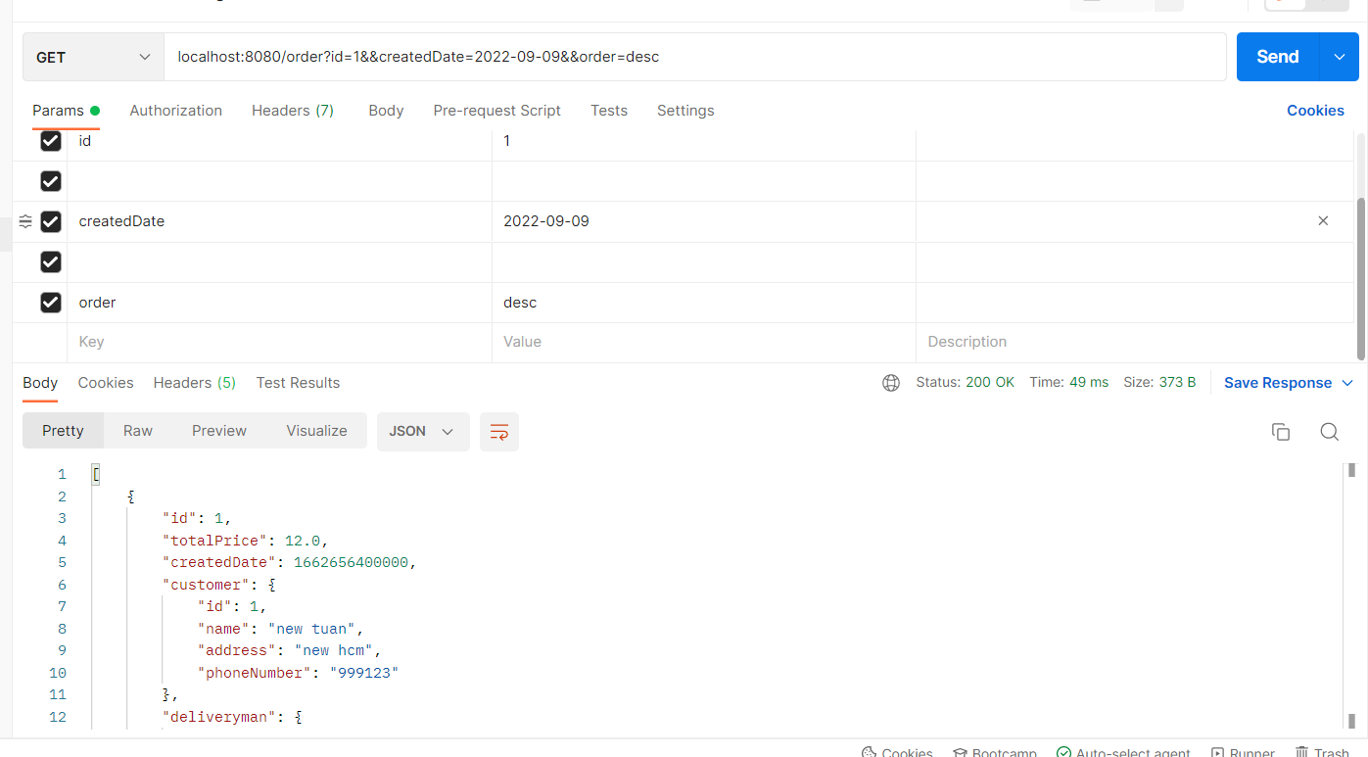

**CRUD on Item:**

* Add:

* Update:

* Delete by id:

* Search by name or price and order results:

**CRUD on Deliveryman:**

* Add:

* Update:

* Delete by id:Graphical user interface, text, application, email

  Description automatically generated
* Search by name, phone number and order results:

