1. Download and install GitHub – <https://github.com>
2. Download and install GitBash – <https://git-scm.com/downloads>
3. Download and install
4. Recommend to use GitHub at the command line rather GUI
5. Tick on initialize the repository with a README

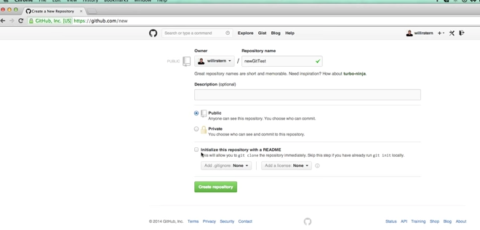

1. Before using gut commands like commit, push… we need to configure

Git configuration file

I cannot do commit

$ git commit -m "Develop Dockerfile for shopContainer"

*** Please tell me who you are.

Run

git config --global user.email "you@example.com"

git config --global user.name "Your Name"

to set your account's default identity.

Omit --global to set the identity only in this repository.

fatal: unable to auto-detect email address (got 'vagrant@vagrant-ubuntu-trusty-64.(none)')

Run  
git config --global user.email "you@example.com"  
git config --global user.name "Your Name"

**Note:** You are authenticated successfully but git needs your username & email to do a commit.

It is not related to authentication. Your username/email can be **different from your GitHub Account.**

You need to run the following commands for a **single time**.

$ git config --global user.email "you@example.com"

$ git config --global user.name "Your Name"

$ git config --list # see if the 'name' & 'email' are set correctly

This user.name & user.email will be set globally in ~/.gitconfig file.

$ cat ~/.gitconfig # see global config file

Type the same name that you have in your GitHub account.

GitHub account name:

[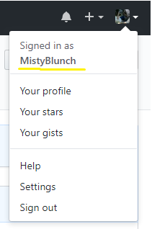](https://i.stack.imgur.com/mWIS1.png)

git user.name:

[git user.name](https://i.stack.imgur.com/qan0S.png)

1. git clone <https://github.com/TuanHDo/GitTest.git>

This will take the repository down to the local location

e.g. C:\GitTest\GitTest

8. Add files to the folder c:\Gittest\Gittest\test.txt

9. Do above on two different users (PCs) – Can have different parent folder name

10. git status – This will show the different between us (local) to the GitHub

Untracked files: files that does not exist in GitHub and it does not know

anything about it

11. git add <file name> - This to add new/change files to GitHub

git add -A

12. git status – This should show changes to be committed

13. git commit -m “added new file” – This means to lock the file to the repository with message

It will commit it, but the file is still on local PC

14. git push – this will sync to GitHub

15. git pull – this will download files from GitHub to your local folder

Work Flow

1. git pull
2. Make changes to files
3. git add -A
4. git commit -m “made changes”
5. git push

Merge Conflict

1. Sometime git detects there is conflict on the same line the file

e.g. line 7 – test (PC 1)

line 7 – more test (PC2)

Git is showing

7 <<<<< HEAD

8 test

9 ========

10 more test

1. Correct file
2. git add -A
3. git commit -m “more changes”

[master f0d99979] Merge branch “master” of https://

1. get push

Ref: https://www.youtube.com/watch?v=0fKg7e37bQE