KPI performance review
  - YTD May 2026, compared with April 2026

1. Overall picture
May delivered clear business growth. Revenue reached €14.7M, +33.6% from April. GM rose to €2.3M, while CM reached €1.9M, +32.1%.
The quality of that growth should be monitored. Manager Cost increased +41.1%, compared with Revenue growth of +33.6%. CM margin moved from 13.2% to 13.1%.
The biggest gap sits in Bonus performance. Due increased +6.9%, while Target increased +25.1%. Due/Target moved from 88.4% to 75.5%, leaving a May shortfall of €464.5K.
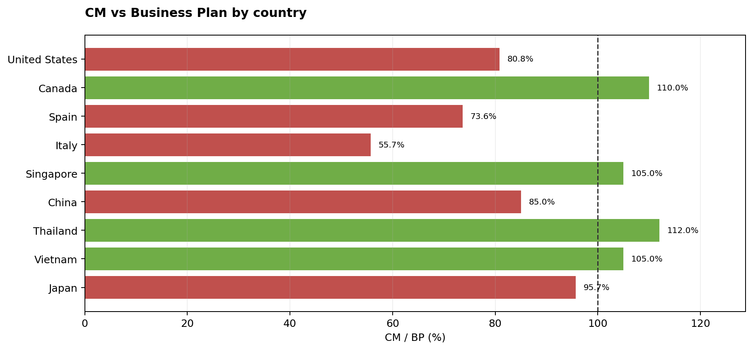
Figure 1. CM versus Business Plan by country, May 2026

1.1 Why country CM/BP can fall below manager performance
Under normal conditions, Country CM/BP would be expected to be at least as high as weighted manager performance. The countries below have Due/Target above CM/BP, which indicates that Bonus attainment is not translating into comparable CM after PnL and Manager Cost.
Italy is the clearest gap. Country CM/BP is 55.7%, while weighted manager performance is 78.5%, a difference of 22.8 percentage points. Italy generates €193.6K CM against €347.5K BP. The country has 13 managers, so BP is €26.7K per manager, while CM is €14.9K per manager. The main issue is the BP level relative to CM delivered, not necessarily weak margin: CM margin is 13.9% and Manager Cost/GM is 11.4%.
Spain is the clearest gap. Country CM/BP is 73.6%, while weighted manager performance is 77.6%, a difference of 4.0 percentage points. Spain generates €229.3K CM against €311.4K BP. The country has 23 managers, so BP is €13.5K per manager, while CM is €10.0K per manager. The main issue is the BP level relative to CM delivered, not necessarily weak margin: CM margin is 12.9% and Manager Cost/GM is 20.5%.
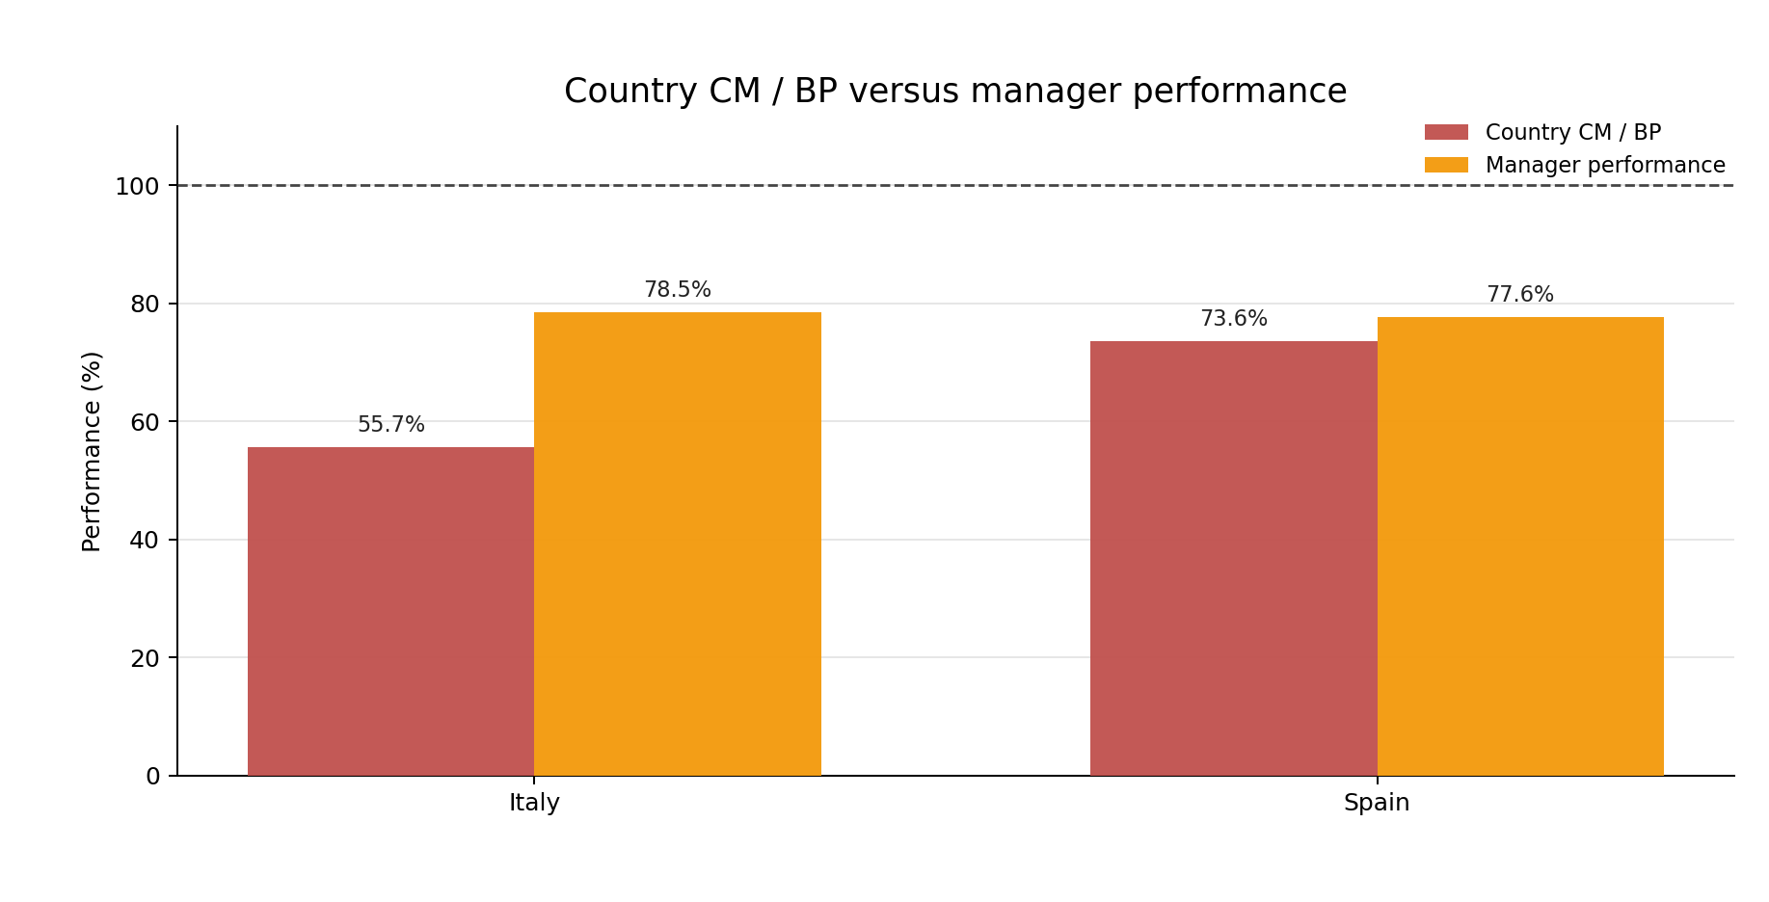
Figure 2. Country CM/BP versus manager-performance gap

2. Country trends
United States is a major CM contributor at €445.2K, or 23.2% of total CM. CM increased 33.4%, reached 80.8% of BP, and country Due/Target was 74.0%. Cost/GM was 24.0%.
Canada is a major CM contributor at €356.7K, or 18.6% of total CM. CM increased 27.1%, reached 110.0% of BP, and country Due/Target was 70.5%. Cost/GM was 4.4%.
Spain is a major CM contributor at €229.3K, or 12.0% of total CM. CM increased 39.7%, reached 73.6% of BP, and country Due/Target was 77.6%. Cost/GM was 20.5%.
Italy is a major CM contributor at €193.6K, or 10.1% of total CM. CM increased 29.3%, reached 55.7% of BP, and country Due/Target was 78.5%. Cost/GM was 11.4%.
Singapore is a major CM contributor at €186.4K, or 9.7% of total CM. CM increased 51.0%, reached 105.0% of BP, and country Due/Target was 86.1%. Cost/GM was 22.1%.
China is a major CM contributor at €178.5K, or 9.3% of total CM. CM increased 26.4%, reached 85.0% of BP, and country Due/Target was 74.4%. Cost/GM was 12.4%.
Thailand is a major CM contributor at €116.3K, or 6.1% of total CM. CM increased 27.6%, reached 112.0% of BP, and country Due/Target was 72.4%. Cost/GM was 16.8%.
Vietnam is a major CM contributor at €110.8K, or 5.8% of total CM. CM increased 26.8%, reached 105.0% of BP, and country Due/Target was 67.5%. Cost/GM was 21.7%.
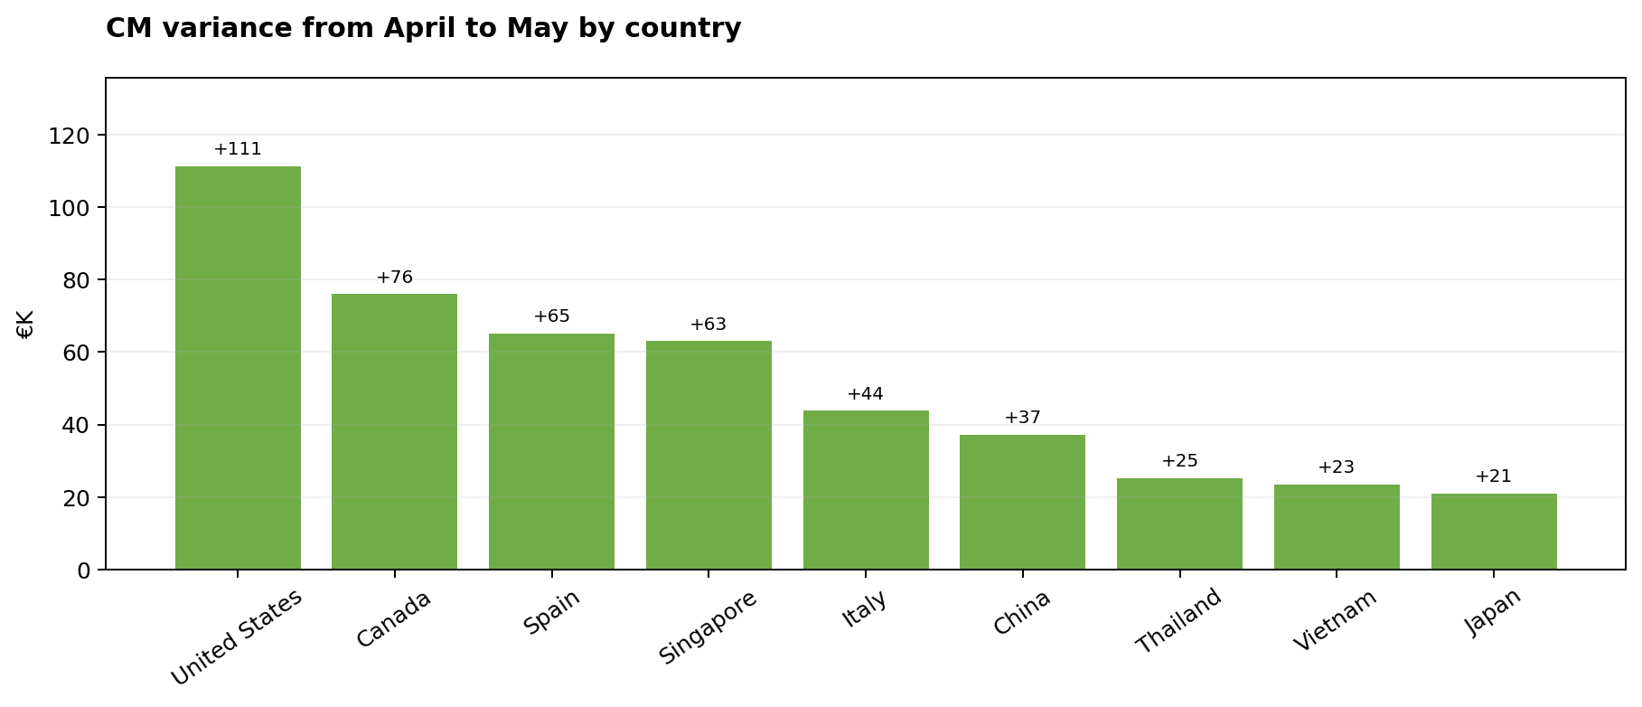
Figure 3. CM variance from April to May by country

3. Function trends
Manager generated €1.1M of CM. Due/Target was 76.6%, compared with 89.7% in April, while CM changed by €281.3K. CM margin was 13.0%.
Experienced manager generated €652.0K of CM. Due/Target was 75.2%, compared with 87.0% in April, while CM changed by €134.9K. CM margin was 13.2%.
Senior manager generated €167.5K of CM. Due/Target was 71.3%, compared with 88.5% in April, while CM changed by €50.1K. CM margin was 12.5%.
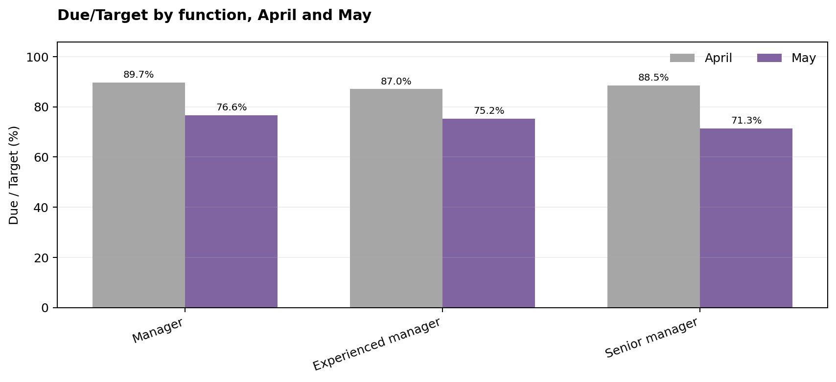
Figure 4. Due/Target by function, April and May

4. Top performers and CM contribution
Top performers are ranked by Due/Target. The ranking changes when CM contribution is added. Due/Target shows who is ahead of Target; CM contribution shows who is creating the financial result.
The leading performers were CHEN Ming at 144.8% Due/Target, HERNANDEZ Carlos at 142.5% Due/Target, ORTEGA Hugo at 141.6% Due/Target, SATO Haruto at 137.4% Due/Target, WATANABE Ren at 120.5% Due/Target.
CHEN Ming reached 144.8% Due/Target and created 2.8% of China CM. China reached 85.0% of BP.
HERNANDEZ Carlos reached 142.5% Due/Target and created 2.2% of Spain CM. Spain reached 73.6% of BP.
ORTEGA Hugo reached 141.6% Due/Target and created 8.8% of Spain CM. Spain reached 73.6% of BP.
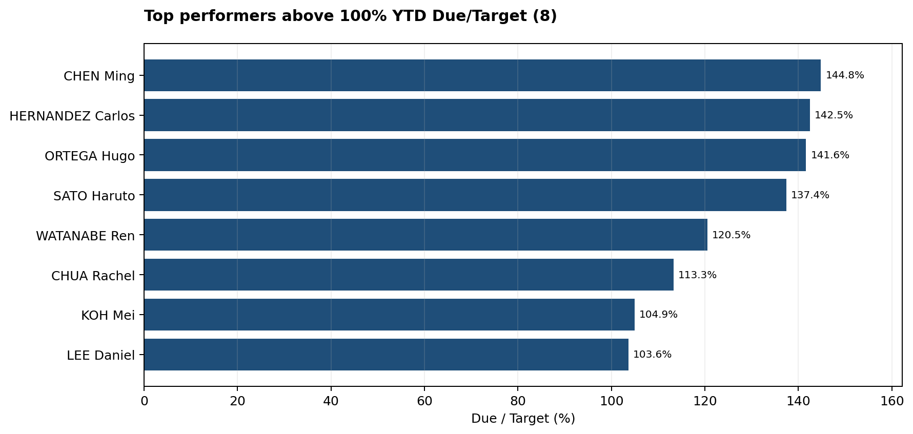
Figure 5. Top performers above 100% YTD Due/Target

5. Manager performance by country
Across several countries, the Bonus leader is different from the largest CM contributor. That gap points to target design, Manager Cost, or portfolio mix as the next area to review.
United States: JONES William led Due/Target at 82.8%; CAMPBELL Chloe created the most CM at €48.8K, or 11.0% of country CM.
Canada: TREMBLAY Laurent led Due/Target at 80.1%; LEBLANC Marc created the most CM at €42.1K, or 11.8% of country CM.
Spain: HERNANDEZ Carlos led Due/Target at 142.5%; RAMOS Natalia created the most CM at €25.7K, or 11.2% of country CM.
Italy: FERRARO Stefano led Due/Target at 87.6%; MARINO Chiara created the most CM at €17.2K, or 8.9% of country CM.
Singapore: CHUA Rachel led Due/Target at 113.3%; TAN Wei Ming created the most CM at €20.3K, or 10.9% of country CM.
China: CHEN Ming led Due/Target at 144.8%; XU Li created the most CM at €23.0K, or 12.9% of country CM.
Thailand: PIMCHANOK Narin led Due/Target at 76.2%; PIMCHANOK Narin created the most CM at €23.4K, or 20.1% of country CM.
Vietnam: TA Minh led Due/Target at 74.2%; HUYNH Lan created the most CM at €11.8K, or 10.7% of country CM.
Japan: SATO Haruto led Due/Target at 137.4%; SATO Haruto created the most CM at €24.6K, or 24.5% of country CM.

6. Variance versus April
The check starts with Bonus variance. Across the population, Bonus Due changed by €92.3K, while Target changed by €381.4K. The review below focuses on managers whose Bonus in May was more than 70% above April.
7 managers crossed the 70% Bonus threshold: CHUA Rachel (Singapore, Bonus +106.5%, CM +25.6%); CHEN Ming (China, Bonus +89.8%, CM +26.4%); HERNANDEZ Carlos (Spain, Bonus +87.5%, CM +25.1%); KOH Mei (Singapore, Bonus +83.0%, CM +109.1%); ONG Wei (Singapore, Bonus +77.8%, CM +25.9%); SATO Haruto (Japan, Bonus +76.1%, CM +26.0%); ORTEGA Hugo (Spain, Bonus +73.5%, CM +26.8%).
7 of these managers also increased CM. The test should be used to separate Bonus timing from cases where Bonus rises while CM falls.
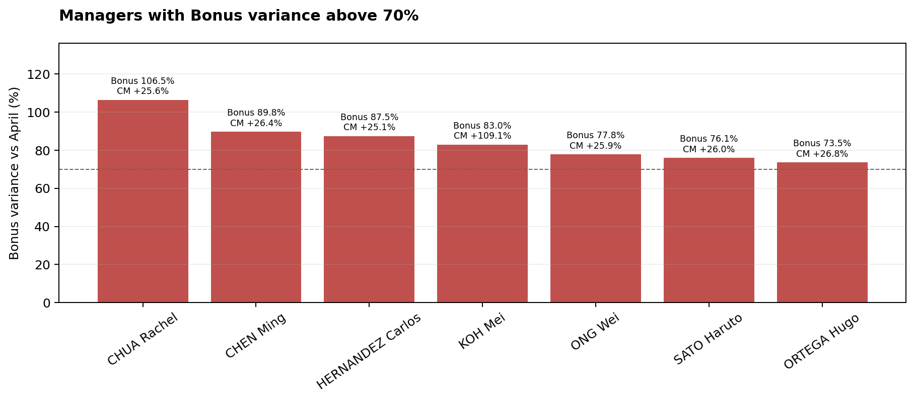
Figure 6. Managers with Bonus variance above 70%, with their CM variance shown above each bar

7. Conclusion
May was a strong month for Revenue, GM and CM. United States has the largest CM base, while the country comparison identifies the strongest BP achievement and the clearest weakness.
Top performers should be assessed alongside CM contribution. A high Due/Target result does not automatically mean the manager created the largest financial contribution in the country.
The next steps are to review the largest negative CM variances at manager and project level, explain the largest BP gaps, revisit targets where Bonus and PnL diverge, and check Manager Cost in the countries with the highest Cost/GM.

