

VIETNAM – KOREA UNIVERSITY OF INFORMATION AND
COMMUNICATION TECHNOLOGY
FACULTY OF COMPUTER SCIENCE
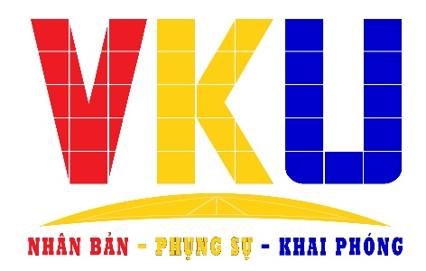

GRADUATION THESIS
BUILDING AND DEVELOPING EDUCHAIN
WITH INTERGRATED BLOCKCHAIN

Students perform: Truong Tuan Khue
Class: 21SE3
Major: Information Technology
Specialization: Software Engineering
Supervisor: M.Sc. Pham Tuan Anh

Da Nang, Dec - 2025

VIETNAM – KOREA UNIVERSITY OF INFORMATION AND
COMMUNICATION TECHNOLOGY
FACULTY OF COMPUTER SCIENCE
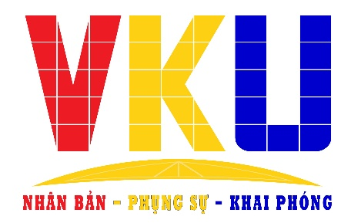

GRADUATION THESIS
BUILDING AND DEVELOPING EDUCHAIN
WITH INTERGRATED BLOCKCHAIN

Students perform: Truong Tuan Khue
Class: 21SE3
Major: Information Technology
Specialization: Software Engineering
Supervisor: M.Sc. Pham Tuan Anh

Da Nang, Dec - 2025
SUPERVISOR'S COMMENTS

Danang, Dec 27th, 2025
M.Sc. Pham Tuan Anh

CONTENTS
Table of Contents
Type chapter title (level 1) 1
Type chapter title (level 2) 2
Type chapter title (level 3) 3
Type chapter title (level 1) 4
Type chapter title (level 2) 5
Type chapter title (level 3) 6

LISTS OF FIGURES
Figure 1: Product Overview 17
Figure 2: Product Overview 19
Figure 3: Actor 21
Figure 4: Common use cases 22
Figure 5: Student use case 23
Figure 6: Teacher use case 24
Figure 7: Staff use case 25
Figure 8: Admin use case 26
Figure 9: Screen flow – Admin 28
Figure 10: Screen flow – Student 28
Figure 11: Screen flow – Teacher 29
Figure 12: Screen flow - Staff 30
Figure 13: ERD Diagram 33
Figure 14 34
Figure 15: Logo SQL server Management studio 34
Figure 16: Logo Docker 35
Figure 17: Logo .NET 36
Figure 18: Logo Next.js 36
Figure 19: Logo Solidity 37
Figure 20: RESTful API model 37
Figure 21: Logo Github 38
Figure 22: Logo Hostinger 38
Figure 23: System Architecture 39
Figure 24: Backend package diagram 40
Figure 25: Frontend package diagram 42
Figure 26: Database design 43
Figure 27: Class diagram Auth & User Management 45
Figure 28: Sequence Login 46
Figure 29: Sequence change password 47
Figure 30: Class diagram get student 48
Figure 31: Sequence diagram get student 49
Figure 32: Class diagram edit student 50
Figure 33: Sequence diagram edit student 51
Figure 34: Class diagram create teacher 52
Figure 35: Sequence diagram create teacher 53
Figure 36: Class diagram edit information teacher 54
Figure 37: Sequence diagram edit information teacher 55
Figure 38: Class diagram create staff 56
Figure 39: Sequence create staff 57
Figure 40: Class diagram create semester 58
Figure 41: Sequence diagram edit semester 59
Figure 42: Class diagram edit semester 60
Figure 43: Sequence diagram edit semester 61
Figure 44: Class diagram create course 62
Figure 45: Sequence diagram create course 63
Figure 46: Class diagram edit course 64
Figure 47: Sequence diagram edit course 65
Figure 48: Class diagram create offering course 66
Figure 49: Sequence create offering course 67
Figure 50: Class diagram edit offering course 68
Figure 51: Sequence diagram edit offering course 69
Figure 52: Class diagram management information parent 70
Figure 53: Sequence diagram add information parent 71
Figure 54: Sequence diagram edit information parent 72
Figure 55: Class diagram get timetable 74
Figure 56: Sequence diagram get timetable 74
Figure 57: Class diagram get profile 75
Figure 58: Sequence diagram get profile 76
Figure 59: Class diagram add information of parent 77
Figure 60: Sequence diagram add information of parent 78
Figure 61: Class diagram temporary residence declaration 79
Figure 62: Sequence diagram temporary residence declaration 80
Figure 63: Class diagram registration course 81
Figure 64: Sequence diagram registration course 82
Figure 65: Class diagram get activity 83
Figure 66: Sequence diagram get activity 84
Figure 67: Class diagram registration join to activity 87
Figure 68: Sequence diagram registration join to activity 87
Figure 69: Class diagram receive vku coin 87
Figure 70: Sequence diagram receive vku coin 88
Figure 71: Class diagram get product 89
Figure 72: Sequence diagram get product 90
Figure 73: Class diagram add product into cart 90
Figure 74: Sequence add product into cart 91
Figure 75: Class diagram checkout 91
Figure 76: Sequence diagram checkout 92
Figure 77: Class diagram change password 92
Figure 78: Sequence diagram change password 93
Figure 79: Class diagram get teacher offerings 95
Figure 80: Sequence diagram get teacher offerings= 95
Figure 81: Class diagram get student in offerings 97
Figure 82: Sequence diagram get student in offerings 97
Figure 83: Class diagram get teacher timetable 98
Figure 84: Sequence diagram get teacher timetable 99
Figure 85: Class diagram get attendance 100
Figure 86: Sequence diagram get attendance 101
Figure 87: Class diagram update grades 101
Figure 88: Sequence diagram update grades 102
Figure 89: Class diagram get product list 103
Figure 90: Sequence diagram get product list 104
Figure 91: Class diagram create product 104
Figure 92: Sequence diagram create product 105
Figure 93: Class diagram update product 105
Figure 94: Sequence diagram update product 106
Figure 95: Class diagram delete product 106
Figure 96: Sequence diagram delete product 107
Figure 97: Class diagram get dashboard starts 108
Figure 98: Sequence diagram get dashboard starts 109

LISTS OF TABLE
Table 1: Actors 21
Table 2: Descriptions 28
Table 3: Screen Descriptions 34
Table 4: System design 41
Table 5: Backend package descriptions 43
Table 6: Frontend package description 45
Table 7: Database design 46

Acknowledgment
We would like to express our sincere gratitude to all those who have contributed to the successful completion of this project. Our journey from inception to completion has been a collaborative effort, and we are grateful for the support, guidance, and encouragement we received along the way.
First and foremost, we extend our heartfelt thanks to our project advisor, Pham Tuan Anh, for their invaluable guidance and mentorship. Their expertise, insights, and continuous feedback have been instrumental in shaping our project and ensuring its successful execution.
We would also like to thank the faculty members of Information and Communication Technology – Vietnam Korea University for their valuable inputs and suggestions before the course of this project. Their knowledge and constructive criticism have greatly enriched our work.
Our sincere appreciation goes to our teammates, who have contributed their time, effort, and expertise to make this project a reality. Each team member played a unique role, and together we overcame challenges, celebrated milestones, and worked tirelessly to achieve our goals.
We are indebted to our friends and families for their unwavering support, understanding, and encouragement during this journey. Their belief in us and their constant encouragement provided the motivation to overcome obstacles and persevere.
Last but not least, we are truly grateful to everyone who played a part, no matter how big or small, in bringing this project to fruition. Your support and collaboration have been the driving force behind our success.
Thank you.
Truong Tuan Khue
10/12/2025

Definition and Acronyms
Acronym | Definition
PWM | Psychology website
AWS | Amazon Web Services
BA | Business Analysis
BR | Business Rule
ERD | Entity Relationship Diagram
GUI | Graphical User Interface
PM | Project Manager
SDD | Software Design Description
SPMP | Software Requirement Specification
SRS | Software Requirement Specification
UAT | User Acceptance Test
UC | Use Case
API | Application Program Interface

Project Introduction

Overview

Project information
1 Project name: Educhain
2 Project code: EduC
3 Software type: Website

Project Team
Full Name | Role | Email | Mobile
Truong Tuan Khue | Leader | khuett.21it@vku.udn.vn | 0342291355
Table 1: Project Team

Product Background
In the context of rapid digital transformation, universities are increasingly adopting modern technologies to optimize management processes and enhance the overall student experience. At the University of Information and Communication Technology – Vietnam Korea (VKU), student evaluation activities such as attendance tracking, participation in extracurricular programs, training assessment, and reward distribution are still largely carried out manually. This leads to several limitations, including a lack of transparency, difficulties in monitoring, time-consuming procedures, and a higher risk of errors or fraudulent modifications.
In addition, the university currently lacks a digitized mechanism that encourages students to participate in academic and extracurricular activities proactively. Student rewards—such as training points or on-campus service privileges—are not centrally managed and do not provide clear historical records.
The global trend in educational institutions today is to adopt digital platforms that support transparent, real-time tracking and reward systems for learners. From this practical need, the Educhain system is proposed as an innovative solution that applies blockchain technology to create an internal token, enabling the following benefits:
- Recording and rewarding students for participating in activities or completing academic tasks.
- Ensuring data transparency and preventing unauthorized manual alterations.
- Allowing students to exchange tokens for training points or various on-campus services.
Educhain is not a cryptocurrency used for external trading; rather, it is a closed, school-specific tokenization system designed for educational purposes. It aims to automate management processes and motivate students to be more active and engaged in their learning and university activities.

Existing Systems
Domestically and internationally, several student activity management and training evaluation systems have been implemented in universities. However, the majority of these systems have not adopted blockchain technology and lack a tokenization mechanism to incentivize students through digital rewards. Surveying existing systems helps clearly identify their strengths, weaknesses, and opportunities for innovation for the Educhain solution.

The Student Training Evaluation System (or Conduct Score Management System) at Vietnamese Universities
Most universities in Vietnam are currently using internal systems such as:
- Online training evaluation forms (Google Forms, Microsoft Forms)
- Academic portals (Portal)
- Student management applications
Advantages

Familiar and Simple Process for Students: Current training evaluation systems primarily utilize platforms that students are already familiar with, such as academic portals, Google Forms, or internal LMS applications. Consequently, students require virtually no time for familiarization or additional training. Actions like attendance check, activity declaration, or evidence submission only require a few simple steps, such as logging in, filling in information, and submitting the form. This simplicity allows activities to be carried out quickly and does not cause difficulties for students during use.

Easy to Deploy and Low Cost: The current systems do not require complex infrastructure or specialized software. Universities can use free or very low-cost platforms and avoid major investments in a technical operations team. Setting up evaluation forms, attendance sheets, or management modules on the internal system is quick, significantly saving resources and deployment costs.

Centralized Data Storage, Convenient for Aggregation and Reporting:Information regarding students, classes, activities, and training scores is stored in a centralized system, making it easy for lecturers and administrators to extract reports. Data aggregation by class, faculty, or the entire university can be done quickly without much manual processing. This supports more efficient management and tracking, especially at the end of the semester when training scores need to be summarized.

Disadvantages

Attendance Taking and Activity Confirmation Remain Manual, Prone to Fraud: The majority of current activity logging and attendance processes still rely on signatures, paper confirmations, or manual data entry by the instructor. This creates opportunities for fraudulent activities such as proxy attendance, modification of participation times, or inaccurate reporting. The dependence on human intervention means the fairness and accuracy of the system are not fully guaranteed.

Inability to Track Detailed History of Each Activity: Current systems often only store final results, such as the total training score or number of participations, but do not fully record detailed developments like the exact time of participation, number of check-ins, or the progress of each activity. This lack of detailed data makes verification and cross-checking difficult in case of disputes or discrepancies. Furthermore, it hinders the university's ability to assess the actual level of student engagement.

Lack of a Reward/Point Exchange Mechanism to Encourage Positive Behavior: The platforms currently in use primarily focus on recording and scoring based on fixed criteria, lacking an immediate reward mechanism for students who participate or achieve success in studies and training. This limits the appeal and fails to create motivation for students to proactively speak up, join activities, or complete tasks in class. The absence of specific rewards makes these activities less attractive.

Lack of Transparency, Data is Susceptible to Modification: Since data is stored on a centralized system and dependent on the administrator, the possibility of unintended modification is high. In case of data conflict, it is very difficult to determine the original information because the system lacks an immutability mechanism. This lack of transparency sometimes makes students feel that their training scores or evaluation results are not entirely fair and objective.Blackboard Badges / Achievements

Blackboard is one of the popular Learning Management Systems (LMS) used by many universities worldwide. Its Blackboard Badges or Achievements feature allows instructors to award symbolic badges and rewards to students whenever they complete an activity, pass a test, or participate in a course. The system helps to motivate students through a visual and accessible reward mechanism.

Advantages

The feature is integrated directly into the Blackboard LMS, meaning students and instructors can use it immediately without installing additional software.

The interface is user-friendly, and the badges are visually intuitive, which helps increase engagement.

It provides good support for tracking learning progress, helping instructors quickly acknowledge student achievements.

Disadvantages

The system is limited to "symbolic badges" and lacks a mechanism for tokens or digital rewards that hold value within the system.

It does not support transactions or transaction history, thus it cannot be used for exchange, redemption, or advanced statistical analysis.

It does not utilize blockchain technology, meaning the data can be altered or lack transparency in certain cases.

Business Opportunity
The robust development of digital transformation in educational institutions today has created a critical demand for systems capable of optimizing management, enhancing operational efficiency, and supporting students in a transparent and intuitive manner. In this context, building a digital platform that automates the processes of attendance taking, activity logging, training evaluation, and student rewards is becoming an inevitable trend in the "Smart University" model. Educhain emerges as a solution that precisely meets this need by combining student activity management with blockchain technology to address issues that traditional systems have failed to resolve.
The development opportunity for Educhain can be clearly seen in the practical needs of universities. Institutions require a system that can both digitize workflows and reduce the workload for lecturers and administrators through the automation of attendance, participation confirmation, and report generation. Simultaneously, students desire a transparent environment where all achievements and contributions are accurately and immutably recorded. What traditional systems struggle to guarantee, blockchain can effectively deliver.
Furthermore, Educhain opens up an opportunity to create genuine learning motivation for students, as rewards are not just symbolic notes or scores but can be converted into internal tokens with usable value within the school. As a result, students will be more proactive in participating in student movements, classroom discussions, and completing academic tasks. This is a major step forward in encouraging proactive spirit and building a positive learning environment.
Beyond that, the deployment of Educhain also opens up the possibility of building a comprehensive digital ecosystem in the future. The system could integrate with internal services such as parking, the canteen, vending machines, or extracurricular activities and events. This allows the university to expand the scope of application and create a long-term technology platform serving various needs.
In the context where few models in Vietnamese education have applied blockchain to student management, Educhain has the potential to become a pioneering solution, creating a competitive advantage and opening up opportunities for collaboration with technology enterprises. Applying new technology to the educational environment not only enhances the quality of management but also contributes to the institution's innovation, giving the system strong potential for future expansion.

Software Product Vision
The vision of the Educhain system is to build a modern, transparent, and automated digital platform to effectively assist universities in managing student activities while simultaneously creating a direct incentive mechanism through coin rewards for students. Educhain applies blockchain technology to ensure that all transactions and activities are accurately recorded, immutable, and transparent throughout the entire usage process. The system is designed based on an internal token model, where each student will possess a personal digital wallet to receive coins upon participating in school-organized activities. This is not only a way to record participation levels but also a form of motivation to help students be more proactive in academic events, student movements, and extracurricular activities.
The long-term vision for Educhain is to establish an internal payment ecosystem within the school campus. The coins that students earn from activities can be used directly to pay for items or services at the canteen, creating a closed-loop value cycle within the school. Thus, Educhain serves dual roles: both as an activity management tool and as a convenient, secure, and transparent payment support platform. The university can expand the system in the future by integrating the coin into various other internal services, moving towards a "Smart Campus" model, where blockchain technology contributes to enhancing the student experience and optimizing university operations.

Project Scope & Limitations
The scope of the Educhain project is expanded to meet the comprehensive management needs for student academic and extracurricular activities within the campus. The system does not solely focus on activity logging and coin rewards but also integrates academic affairs management and internal operations. Specifically, the system allows for the management of semesters, courses, and students through the instructor's account, enabling lecturers to track classes, assign tasks, take attendance, and confirm student participation in course-related activities. Concurrently, the system also supports the management of accounts for lecturers, students, and staff within the school, ensuring each user has appropriate access rights corresponding to their role. At the administrative level, the admin can manage semesters, courses, the user directory, as well as school activities, including creating, approving, or monitoring events and movements for students.
Furthermore, the system provides dedicated functions for staff (employees), such as managing products at the canteen or internal services, allowing staff to post, update, or discontinue products. Students can use the coins received after participating in activities to purchase products at the canteen, creating a closed-loop and modern transaction environment within the campus. Additionally, the system supports students in credit registration, tracking enrolled courses, participating in school activities, and receiving corresponding coins upon confirmation. The synchronized integration between academic affairs, extracurricular activities, and internal payment makes the system a multi-functional platform, fully meeting the needs of lecturers, students, staff, and the administration.
Despite the significant expansion of the system's scope, the project still has limitations in its current development phase. Educhain currently focuses only on core functions such as basic academic affairs management, activity management, the internal coin wallet, and canteen payments. Several advanced functions such as learning data analysis, in-depth statistical reports, online learning systems (LMS), mobile applications, or campus-wide service integration have not yet been implemented. The system also operates strictly within the school's internal network and does not support external transactions; simultaneously, the coin cannot be exchanged for real money or market cryptocurrency. These limitations are set to ensure the system focuses on developing a stable operational platform before expanding to more complex features in the future.

Major Features
The Educhain system is designed as a comprehensive management platform, addressing the operational needs of multiple stakeholders within the school, including administrators, teachers, students, and service staff. Each user group is assigned appropriate permissions corresponding to their roles and responsibilities, ensuring the system operates synchronously, transparently, and efficiently.
The system provides Admins with comprehensive management capabilities over the core components of the university. Admins have the authority to create, edit, lock, or delete user accounts, including teachers, students, staff, and parents. Furthermore, the system supports importing user lists from Excel files and allows password resets when needed. In the area of training management, administrators can create and adjust semesters, update course information, assign lecturers to class sections, and organize the school's extracurricular activities. Each activity is managed throughout its lifecycle, from event creation and student registration approval to the distribution of token rewards. Additionally, the Admin holds the authority to monitor the entire transaction history on the system via the integrated Blockchain Explorer, and manage the system's wallet to ensure the platform's financial activities are secure and transparent.
For Teachers, the system provides a set of tools directly serving teaching activities and student evaluation. Teachers can view the list of assigned class sections, access student rosters, and facilitate attendance taking or assessment of the learning process. They can also input scores, update gradebooks, and manage their personal information on the system, ensuring data remains accurate and complete.
Students are the central user group of the system, supported by numerous functions related to academics, activities, and digital utilities. Students can view their timetable, track grade reports and academic progress, and access the list of enrolled classes. In the area of extracurricular activities, students can view open activities, register for participation, and receive reward tokens upon activity completion. The system also provides a personal digital wallet for students to track their token balance, view transaction history, and use tokens to purchase products or services at the on-campus canteen or convenience store. Every transaction or attendance check can be processed via a QR code, making the process quick and modern.
Canteen or Store Staff are provided with product management tools, including adding new items, updating information, adjusting prices, and managing inventory. They also support sales by scanning the student's QR code to authenticate token payment and process orders directly on the system. This helps internal services run smoothly and reduces manual work.
Additionally, the system offers several general functions for all users, such as login, logout, password change, and viewing notifications from the school. These functions ensure that every user can access and use the system safely, securely, and conveniently.
With this rich set of features distributed according to specific roles, Educhain becomes a unified management system, comprehensively supporting training, student life, and service operations within the school, while creating a modern interactive environment based on blockchain technology.
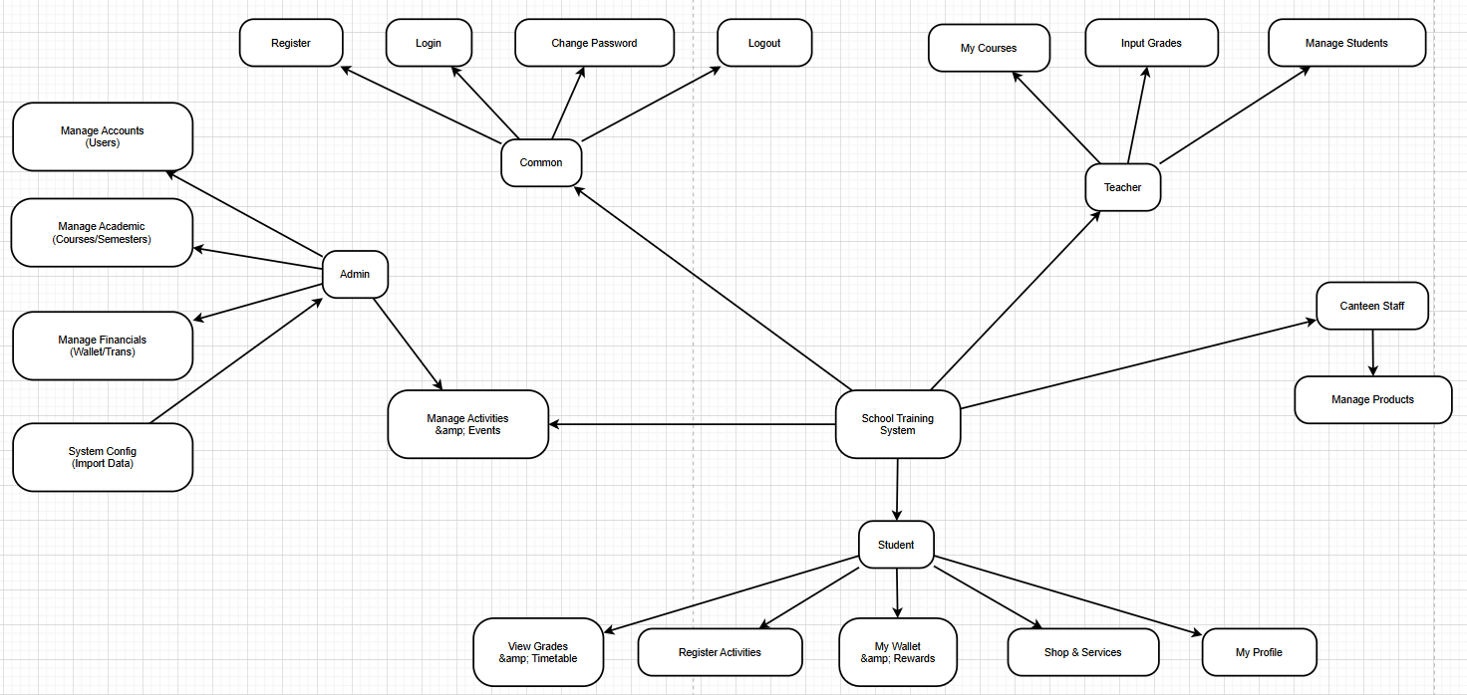
Figure 1: Product Overview

Limitation & Exclusions
Although Educhain is built as an integrated management platform based on blockchain technology, the system still operates with several limitations in its current development phase to ensure stability and feasibility when implemented in a university setting.
First and foremost, the system only supports core functions related to basic academic affairs management, activity management, token reward distribution, and internal payments at the on-campus canteen or store. Advanced functions such as training conduct score evaluation, learning data analysis, in-depth statistics, or integration with major school-wide training systems (LMS/ERP) are excluded from the scope of the first version deployment.
The tokens issued within the system are only valuable for internal use and are strictly prohibited from being traded, redeemed, or exchanged in any form outside the school environment. This is to ensure compliance with legal principles and avoid the risk of being misunderstood as a commercial cryptocurrency.
Additionally, the payment mechanism in the system is currently only applicable to the canteen area and retail points managed by the school, and has not been expanded to cover all campus facilities or services. The system also does not yet support a dedicated mobile application, requiring users to access the platform via the web, which may limit usability in certain situations.
Modules related to club management, large-scale event registration, online learning support, lecture management, or complex administrative procedures are also not yet integrated and will be considered in subsequent development phases. Although the use of blockchain enhances transparency, the system still relies on the school's server infrastructure to operate the traditional backend, meaning it requires regular maintenance and cybersecurity management from the technical team.
Finally, to ensure simplicity and stability during practical implementation, Educhain has not deployed mechanisms such as complex smart contracts, staking models, or peer-to-peer (P2P) transactions. These features could pose security risks or create legal burdens in the educational environment, and are thus completely excluded from the development scope.
These limitations and exclusions allow the system to maintain focus on its core objective—managing student activities and supporting internal payments—while building a solid foundation for future upgrades.

Software Requirement Specification

Product Overview
In the context of increasing digitalization within educational institutions, the need for modern, transparent, and automated management systems is becoming more essential than ever. Universities not only manage academic activities but also a wide range of extracurricular programs, student services, and campus operations. Traditional methods such as manual attendance, paper-based confirmation, and fragmented data systems are no longer suitable for the scale and complexity of today’s educational environments.
For that reason, the Educhain system is designed to provide a unified platform that manages student activities, rewards participation, and supports internal transactions through blockchain technology. The system allows students to receive tokens when participating in school events or activities, and later use these tokens to purchase items or services at the campus canteen or internal shop. Educhain also supports academic management functionalities such as semester management, course management, class offerings, and student enrollment. In addition, teachers can manage their classes, update grades, and track student progress, while staff members can manage products, process payments, and operate services efficiently
.
By integrating blockchain, Educhain ensures transparency, immutability of transactions, and accurate reward distribution. The system aims to enhance student engagement, simplify administrative procedures, and contribute to the development of a modern “Smart Campus,” where learning, activities, and services are seamlessly connected in a secure and efficient digital ecosystem.

Figure 2: Product Overview

User Requirements
# | Actor | Description
1 | Admin | The user logs into the system with the function of managing all students, teachers, staff, courses, semesters, and system configurations.
2 | Teacher | Users logged into the system to manage assigned courses, grade students, and track academic progress.
3 | Student | Users logged into the system to view timetables, check grades, register for activities, and manage their personal wallet/rewards
4 | Staff | Users logged into the system with the function of managing shop products and processing payments

Actors
Table 1: Actors

Use Cases

Diagram(s)

Actors
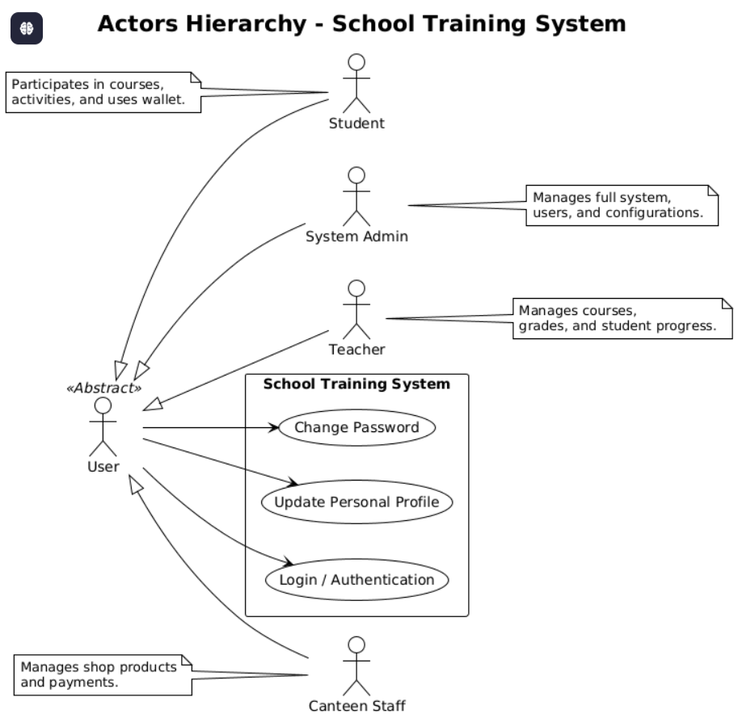
Figure 3: Actor

Common use cases
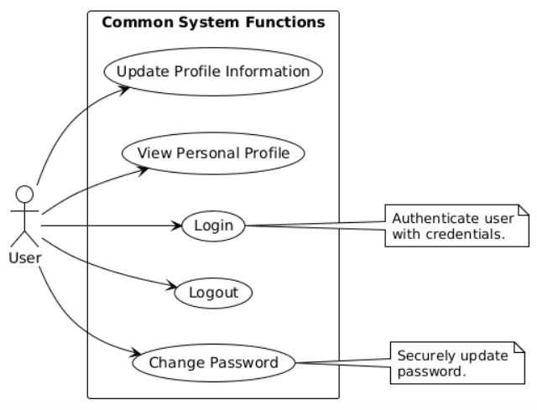
Figure 4: Common use cases

Student use cases
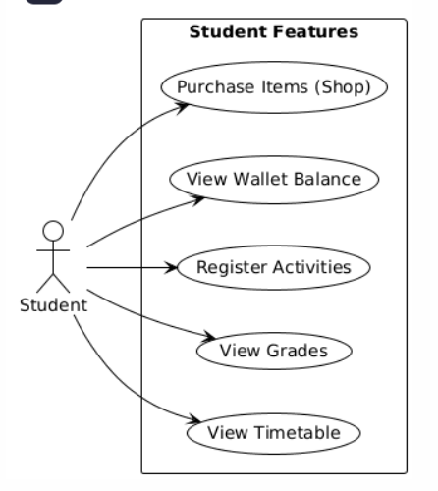
Figure 5: Student use case

Teacher use cases
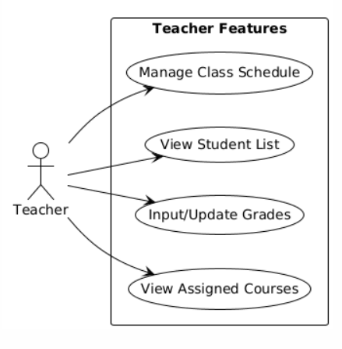
Figure 6: Teacher use case

Staff use cases
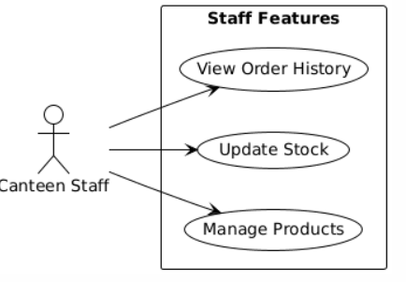
Figure 7: Staff use case

Admin use cases
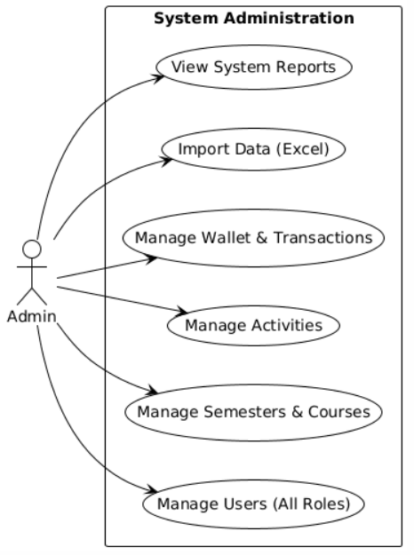
Figure 8: Admin use case

Descriptions
ID | Use Case | Actors | Use Cases Description
UC01 | Login | All Users | Allows users to authenticate into the system using their credentials (username/email and password).
UC02 | Change Password | All Users | Allows authenticated users to change their current password for security purposes.
UC03 | View Profile | All Users | Allows users to view their personal information and account details.
UC04 | Manage Users | Admin | Allows Admin to create, update, delete, or block user accounts (Teachers, Students, Staff).
UC05 | Manage Academic | Admin | Allows Admin to configure semesters, courses, and assign teachers to course offerings.
UC06 | Manage Activities | Admin | Allows Admin to create extracurricular activities and manage student registrations.
UC07 | Manage Financials | Admin | Allows Admin to view system-wide transactions and manage the system wallet.
UC08 | View Timetable | Student | Allows Students to view their weekly class schedule and activity times.
UC09 | View Grades | Student | Allows Students to view their academic results and GPA for enrolled courses.
UC10 | Register Activity | Student | Allows Students to sign up for available extracurricular activities.
UC11 | Use Wallet | Student | Allows Students to view their token balance and transaction history.
UC12 | Purchase Items | Student | Allows Students to buy items from the school shop using tokens
UC13 | Manage Courses | Teacher | Allows Teachers to view the courses they are assigned to teach.
UC14 | Input Grades | Teacher | Allows Teachers to enter or update grades for students in their classes.
UC15 | Manage Products | Canteen Staff | Allows Staff to add, edit, or remove products and update stock in the canteen/shop system.
Table 2: Descriptions

Functional Requirements

Screen Descriptions

Screen Flow
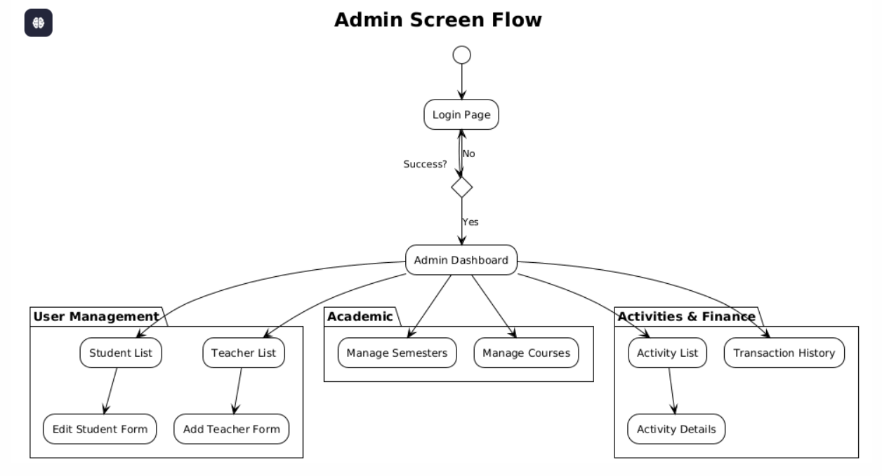
Figure 9: Screen flow – Admin
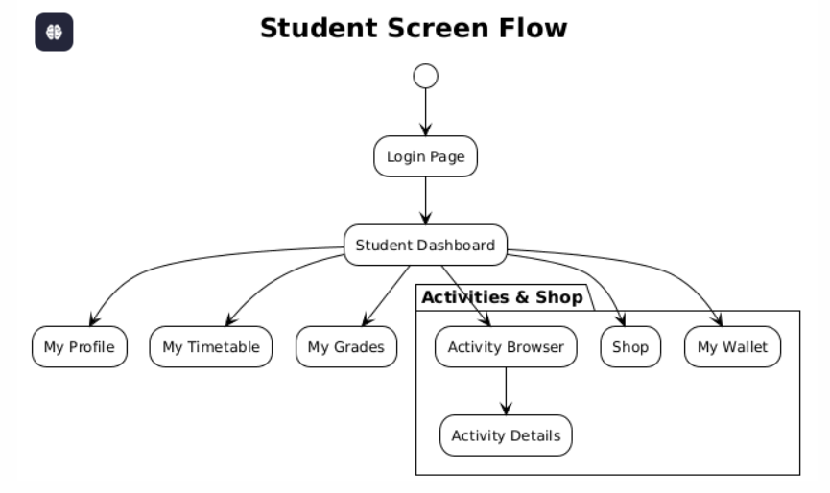
Figure 10: Screen flow – Student
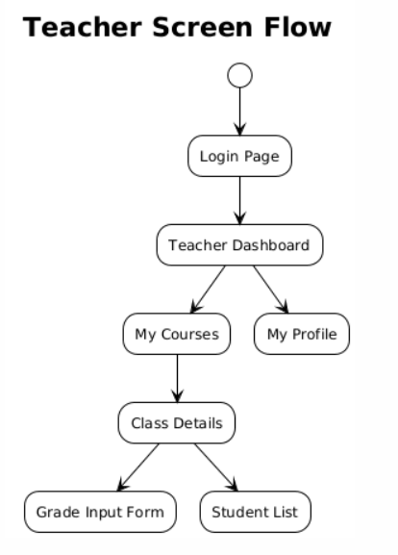
Figure 11: Screen flow – Teacher
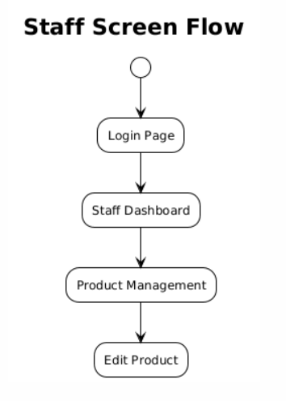
Figure 12: Screen flow - Staff

Screen Description

ID | Feature | Screen | Description
SCR01 | Authentication | Login Page | The entry point for all users to enter credentials and access the system.
SCR02 | Authentication | Change Password | Allows logged-in users to update their password for security.
SCR03 | Admin Dashboard | General Dashboard | Overview page for Admins displaying system statistics and quick links.
SCR04 | User Mgmt | Student List | Displays a paginated list of all students; allows searching and filtering.
SCR05 | User Mgmt | Edit Student | Form to view and modify details of a specific student account.
SCR06 | User Mgmt | Teacher List | Displays a list of all teachers in the system.
SCR07 | User Mgmt | Add Teacher | Form to register a new teacher into the system.
SCR08 | Academic Mgmt | Semesters | Management interface for creating and activating academic semesters.
SCR09 | Academic Mgmt | Courses | Catalog view of all available subjects/courses in the curriculum.
SCR10 | Activity Mgmt | Activity List | Admin view of extracurricular activities; allows creating new events.
SCR11 | Activity Mgmt | Activity Details | Detailed view of an activity showing descriptions and registered students.
SCR12 | Financial Mgmt | Transactions | Ledger view showing all blockchain token transactions within the system.
SCR13 | Student Portal | Student Dashboard | Main landing page for students showing upcoming classes and summary info.
SCR14 | Student Portal | My Profile | info page displaying the student's personal and academic details.
SCR15 | Student Portal | My Timetable | Calendar view of the student's class schedule.
SCR16 | Student Portal | My Grades | Academic results page showing grades for enrolled courses.
SCR17 | Student Portal | Wallet | Digital wallet interface showing token balance and transaction history.
SCR18 | Student Portal | Shop | E-commerce interface for students to browse items and purchase with tokens.
SCR19 | Teacher Portal | Teacher Dashboard | Landing page for instructors to access their classes and grading tools.
SCR20 | Teacher Portal | My Courses | List of courses the teacher is currently assigned to instruct.
SCR21 | Teacher Portal | Grade Input | Interface for teachers to enter scores for students in a specific class.
SCR22 | Staff Portal | Product Management | Dashboard for canteen staff to add/edit products and manage stock.
Table 3: Screen Descriptions

Entity Relationship Diagram
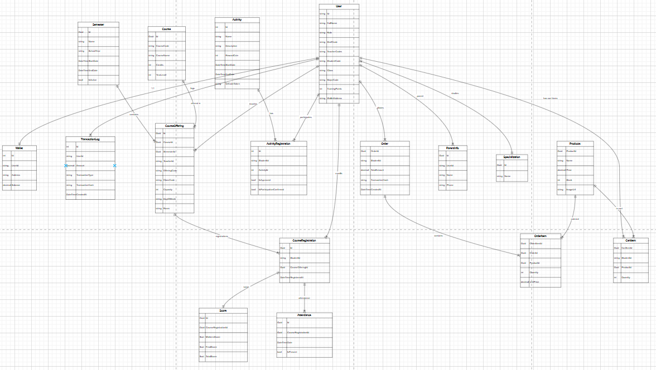
Figure 13: ERD Diagram
Link Detail: Entity Diagram

Technology and Tools
This chapter presents the technologies and tools used in the development of the Educhain system. The selected technologies aim to ensure system stability, scalability, security, and ease of maintenance throughout the development and deployment process.

Visual Studio Code
Visual Studio Code is used as the primary source code editor for both backend and frontend development. It provides a lightweight yet powerful development environment with extensive support for programming languages such as C#, JavaScript, and Solidity. Visual Studio Code supports intelligent code completion, debugging, and extension integration, which significantly improves developer productivity and code quality.
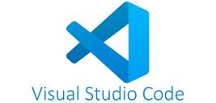
Figure 14: Logo Visual Studio Code

SQL Server Management Studio 20
SQL Server Management Studio (SSMS) 20 is used to manage, query, and maintain the Microsoft SQL Server database. It allows developers to design database schemas, manage tables, execute SQL queries, and monitor database performance. SSMS ensures efficient management of academic data, user information, transaction records, and system logs within the Educhain platform.

Figure 15: Logo SQL server Management studio

Docker
Docker is used to containerize the Educhain application and its related services. By using Docker, the system ensures consistency between development, testing, and deployment environments. Containerization simplifies dependency management, improves scalability, and enables faster deployment on VPS or cloud servers.
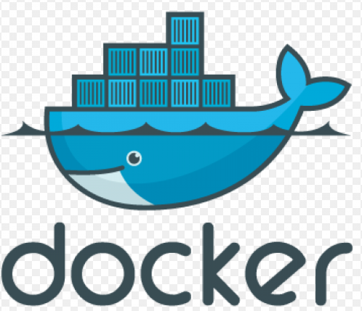
Figure 16: Logo Docker

.NET Framework ( Backend API)
The backend of the Educhain system is developed using the .NET framework to build RESTful APIs. .NET provides high performance, strong security features, and excellent support for enterprise-level applications. It is responsible for handling business logic, user authentication, role-based authorization, academic management, and blockchain interactions.

Figure 17: Logo .NET

Next.js Framework ( Frontend )
Next.js is used to develop the frontend of the system, providing a modern and responsive user interface. Built on top of React, Next.js supports server-side rendering and optimized routing, enhancing application performance and user experience. It enables users to interact seamlessly with the system through web browsers.
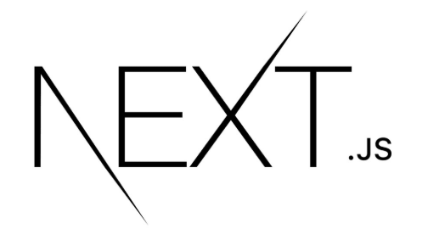
Figure 18: Logo Next.js

Solidity ( Smart Contract Blockchain )
Solidity is the programming language used to develop smart contracts deployed on the Ethereum blockchain. In the Educhain system, Solidity is used to define token logic, wallet interactions, and transaction validation. Smart contracts ensure transparency, immutability, and trust in the reward distribution and payment processes.
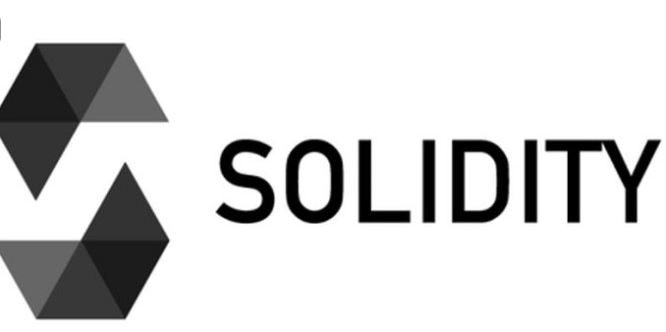
Figure 19: Logo Solidity

RESTful API
RESTful API architecture is applied to facilitate communication between the frontend, backend, and blockchain services. It ensures standardized data exchange using HTTP methods such as GET, POST, PUT, and DELETE. This approach allows flexible integration and scalability across system components.
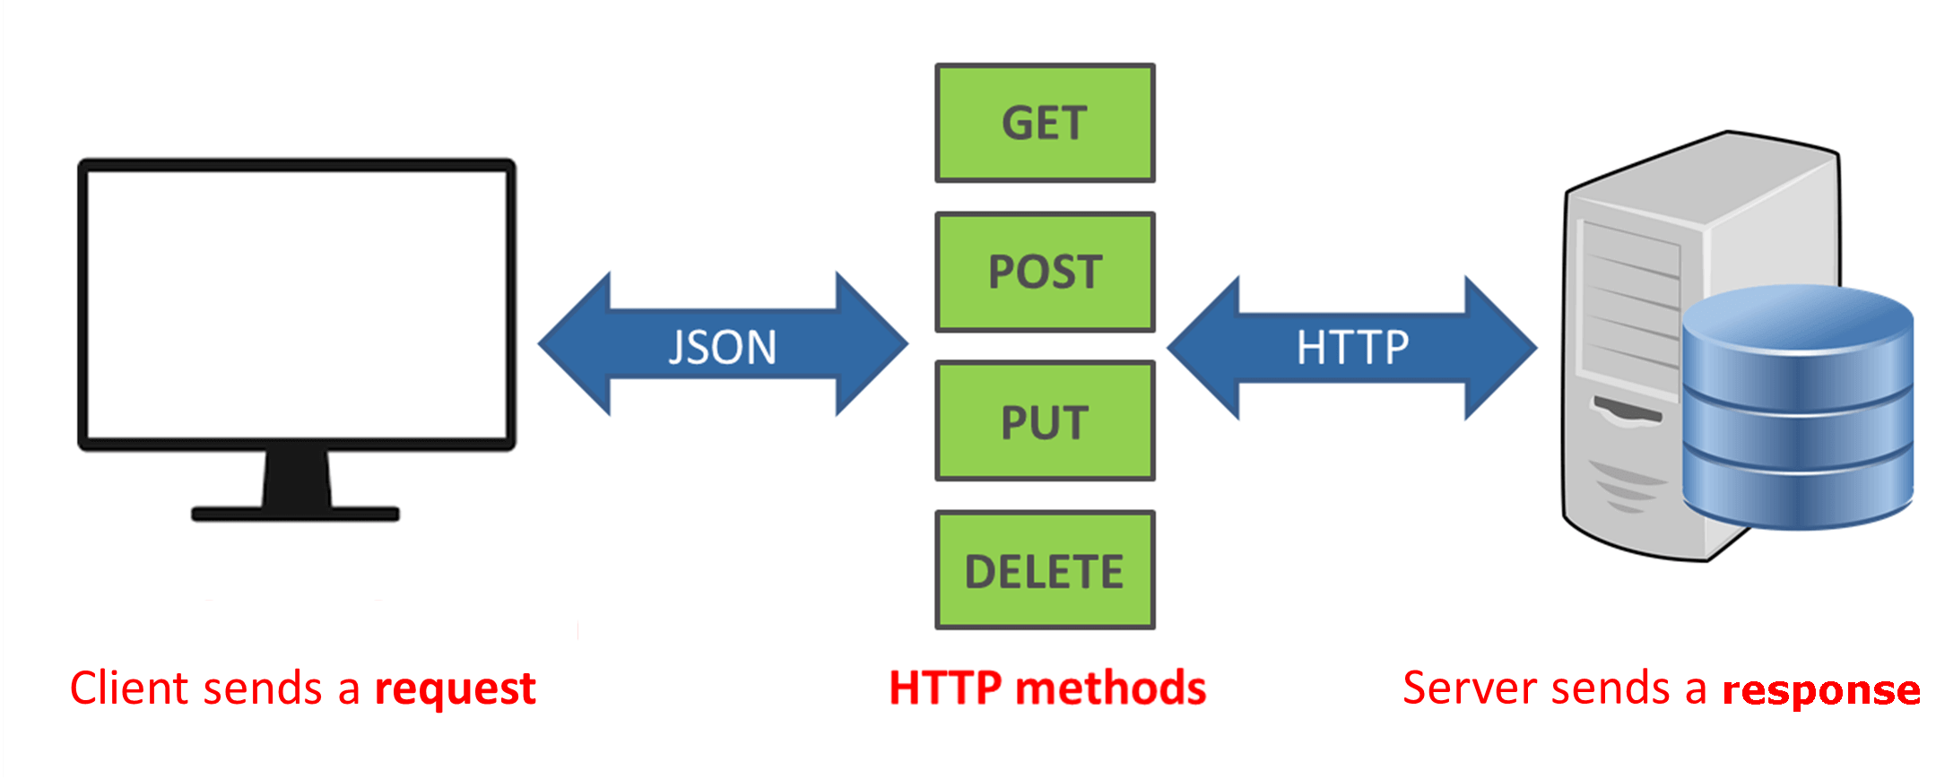
Figure 20: RESTful API model

Github
GitHub is used as the version control and collaboration platform for the Educhain project. It allows team members to manage source code, track changes, and collaborate efficiently. GitHub also supports issue tracking and project documentation, contributing to effective project management.

Figure 21: Logo Github

Hostinger ( VPS, Domain )
Hostinger is used to provide Virtual Private Server (VPS) hosting and domain services for deploying the Educhain system. The VPS environment ensures stable performance, full control over server configuration, and secure deployment of Dockerized services. Domain services allow the system to be accessed conveniently through the internet.
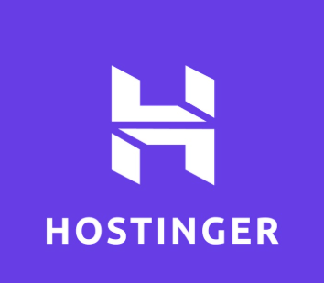
Figure 22: Logo Hostinger

Software Design Description

System Design

System Architecture
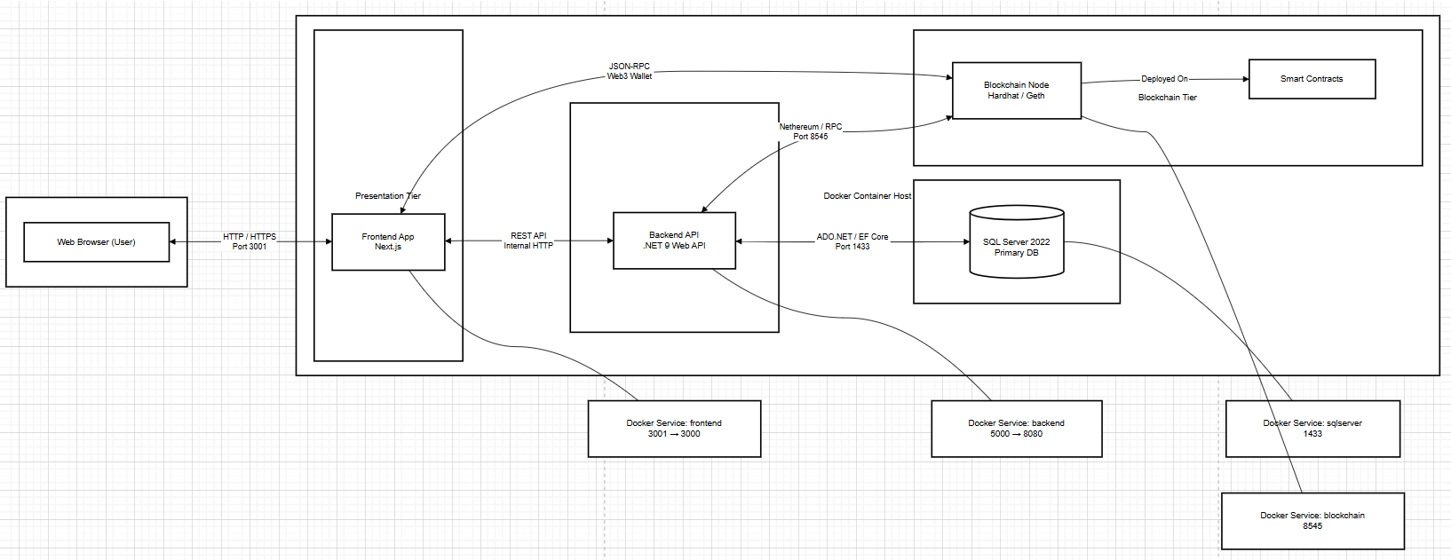
Figure 23: System Architecture
Link Detail: System Architecture

System Description
No | Package | Description
1 | Client Layer | Represents the end-users (Admin, Teacher, Student, Staff) accessing the system via standard web browsers.
2 | Presentation Tier | Contains the Frontend Application developed with Next.js, responsible for rendering the User Interface and managing client-side state.
3 | Application Tier | Host the Backend ASP.NET Core Web API, which handles business logic, authentication, and data processing.
4 | Data Tier | Consists of SQL Server 2022, serving as the primary relational database for storing user data, courses, and academic records.
5 | Blockchain Tier | Comprises the Blockchain Node (Hardhat/Geth) and Smart Contracts, handling decentralized features like token wallets and transaction logs.
Table 4: System design

Package Diagram
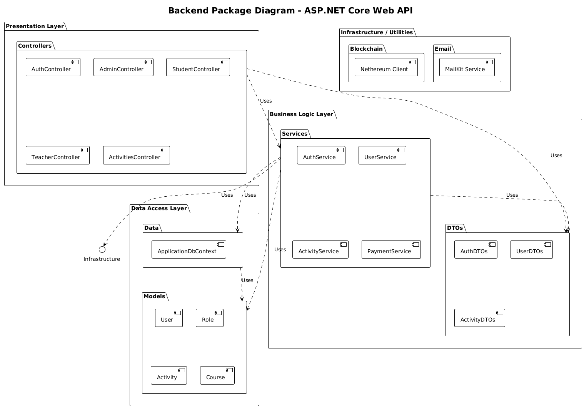
Figure 24: Backend package diagram

Backend Package Description
No | Package | Description
1 | Controllers | Handlers in the Presentation Layer responsible for receiving HTTP requests, validating inputs, and calling relevant Services.
2 | Services | Core Business Logic components that implement the application's rules, process data, and interact with the Data Layer.
3 | DTOs (Data Transfer Objects) | Objects used to transfer data between the Presentation Layer and Business Logic Layer, decoupling internal models from API contracts.
4 | Data (DbContext) | The Data Access Layer component wrapping Entity Framework Core, managing database connections and transactions.
5 | Models (Entities) | Represents the persistent domain objects mapping directly to database tables (e.g., User, Course, Activity).
6 | Infrastructure / Utilities | Contains external integrations and helper libraries, such as Blockchain clients (Nethereum) and Email services (MailKit).
Table 5: Backend package descriptions
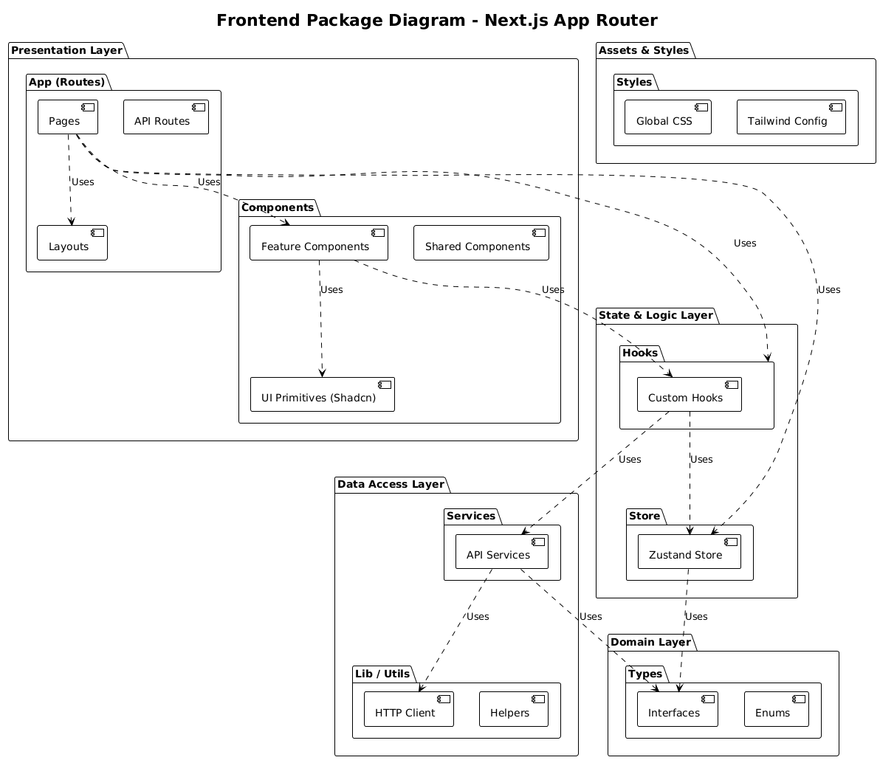
Figure 25: Frontend package diagram

Frontend Package Descriptions
No | Package | Description
1 | App (Routes) | The main entry point using Next.js App Router, containing Pages, Layouts, and routing logic for the application.
2 | Components | Reusable UI building blocks, including atomic design elements (Shadcn UI) and feature-specific components.
3 | Services | Modules responsible for making HTTP requests to the Backend API and handling data fetching logic.
4 | Hooks | Custom React Hooks encapsulating reusable stateful features and side-effects.
5 | Store | Global state management using Zustand, holding application-wide data like shared tokens or user session.
6 | Lib / Utils | Utility functions and core configurations, such as the configured HTTP Client (Axios/Fetch wrapper).
7 | Types | TypeScript definitions identifying data structures, interfaces, and types used across the application.
8 | Styles | Global stylesheets and CSS configurations, including Tailwind CSS setups.
Table 6: Frontend package description
  - Database Design
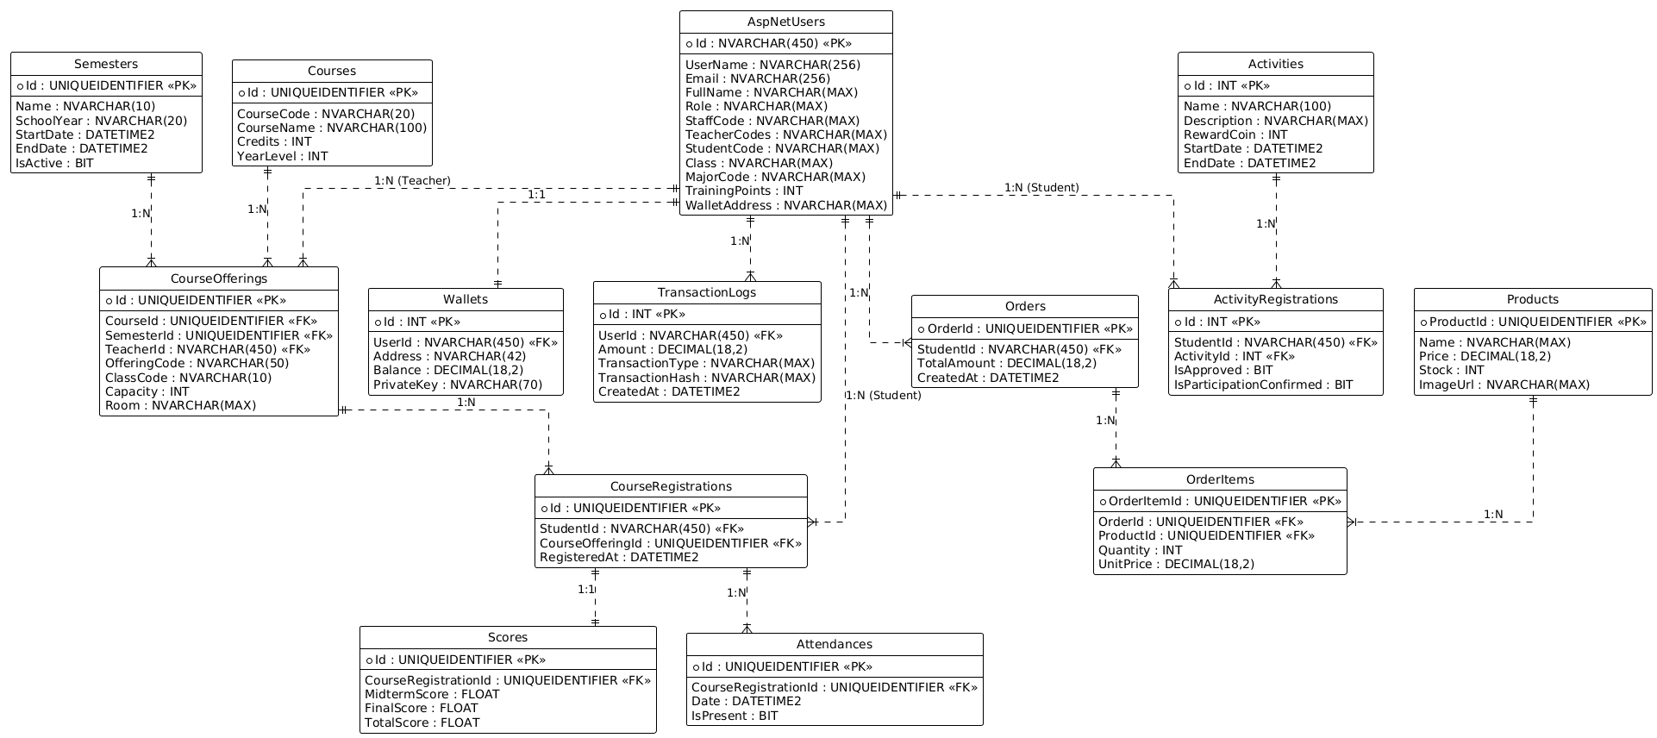
Figure 26: Database design
Link raw image: Database design

Table Description
No | Table | Description
1 | AspNetUsers | Stores all user accounts (Admin, Teacher, Student, Staff) extending IdentityUser, including profile info like StudentCode, Role, and Class.
2 | Wallets | Manages cryptocurrency wallets for users, storing blockchain addresses, private keys (encrypted), and current balances.
3 | TransactionLogs | Records history of financial transactions (token rewards, payments, transfers) for auditing and display purposes.
4 | Semesters | Defines academic terms (e.g., "HK1 2024-2025") with start/end dates to organize course offerings.
5 | Courses | Catalog of subjects/courses (e.g., "Introduction to Programming") with metadata like credits and year level.
6 | CourseOfferings | Specific instances of courses taught in a semester, assigned to a teacher and a classroom.
7 | CourseRegistrations | Links students to course offerings, tracking enrollment status and registration time.
8 | Scores | specific academic results (Midterm, Final) associated with a student's course registration.
9 | Attendances | Tracks daily attendance status (Present/Absent) for students in their registered courses.
10 | Activities | Manages extracurricular activities, including details like descriptions, reward coins, and schedules.
11 | ActivityRegistrations | Tracks student participation in activities, including approval status and evidence validation.
12 | Products | Inventory of items available for sale in the canteen or campus shop.
13 | Orders | Records purchase orders made by students, including total amount and transaction references.
14 | OrderItems | Detail lines within an order, specifying the product, quantity, and unit price at the time of purchase.
15 | ParentInfo | Stores contact information for students' parents associated with the user account.
16 | Specializations | Defines academic majors or specializations available for students to enroll in.
Table 7: Database design

  - Detail Design
    - Auth & User Management Class Diagram
      - Class Diagram
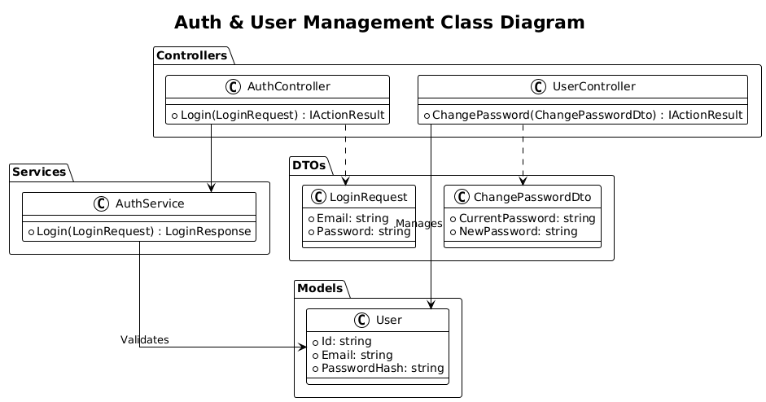
Figure 27: Class diagram Auth & User Management

      - Sequence diagram
        - Auth Module
          - Login
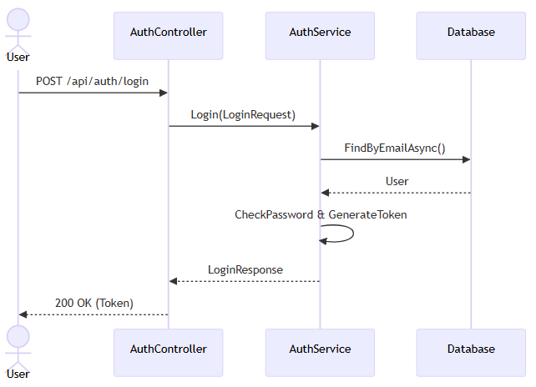
Figure 28: Sequence Login

          - Change Password
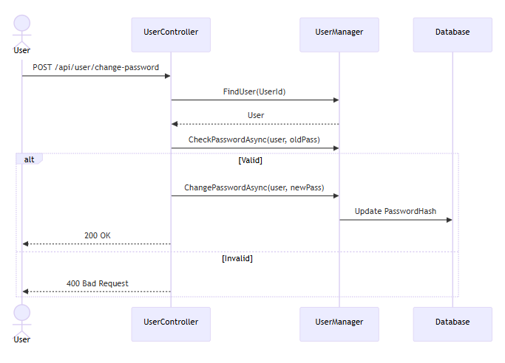
Figure 29: Sequence change password
    - Function of Admin
      - Import User from Excel
        - Class Diagram
        - Sequence Diagram
      - Get Student List
        - Class Diagram
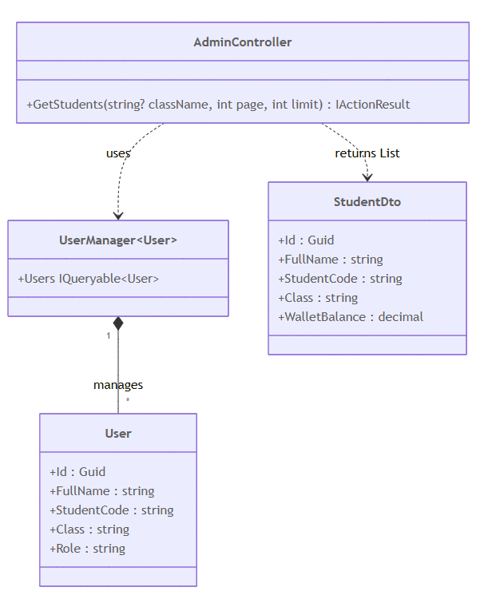
Figure 30: Class diagram get student

        - Sequence Diagram
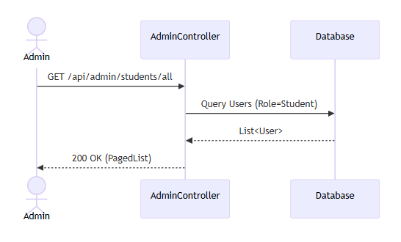
Figure 31: Sequence diagram get student

      - Edit Information Student
        - Class Diagram
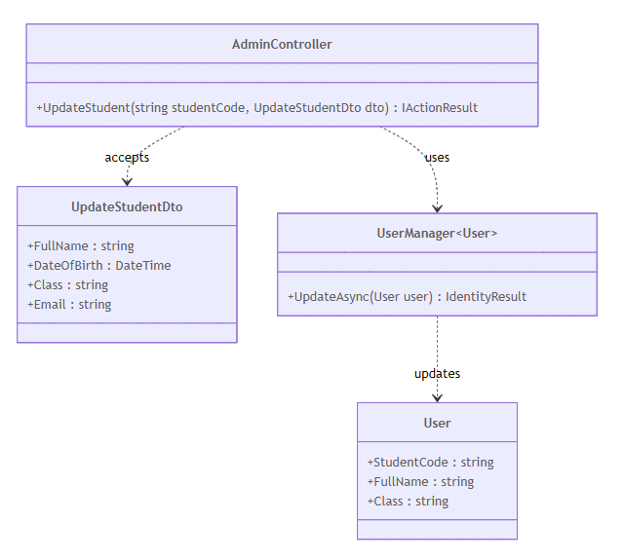
Figure 32: Class diagram edit student

        - Sequence Diagram
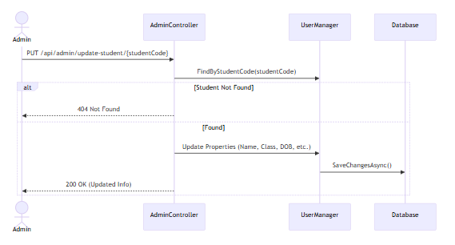
Figure 33: Sequence diagram edit student

      - Create Teacher
        - Class Diagram
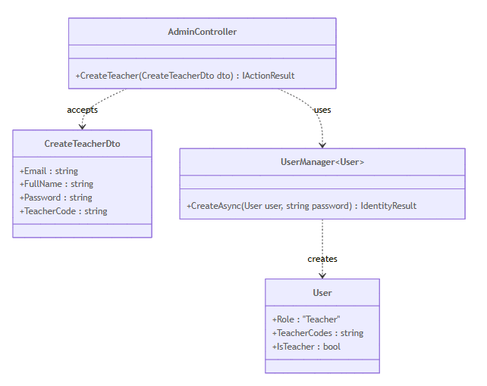
Figure 34: Class diagram create teacher

        - Sequence Diagram
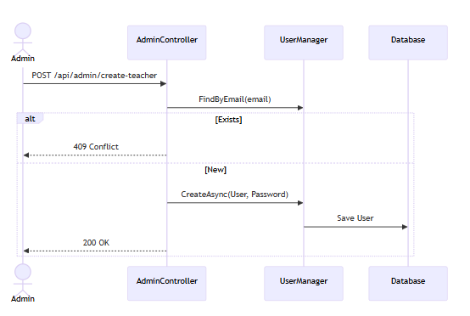
Figure 35: Sequence diagram create teacher

      - Edit Information Teacher
        - Class Diagram
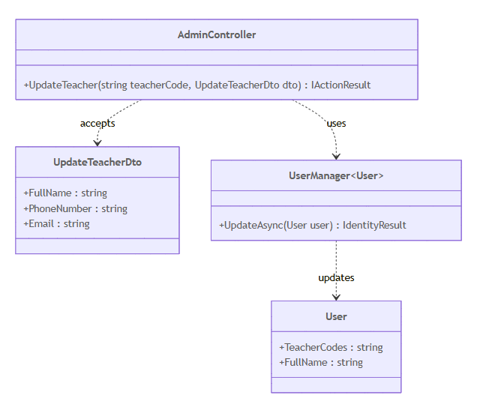
Figure 36: Class diagram edit information teacher

        - Sequence Diagram
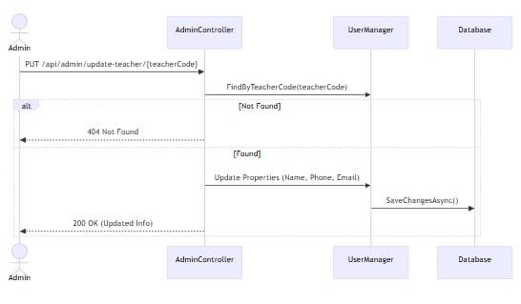
Figure 37: Sequence diagram edit information teacher
      - Create Staff
        - Class Diagram
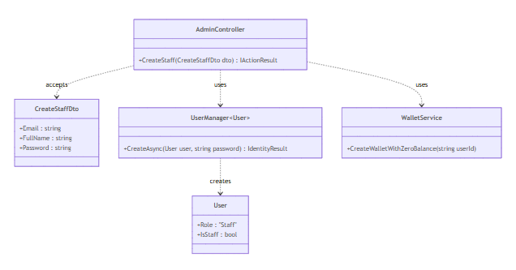
Figure 38: Class diagram create staff

        - Sequence Diagram
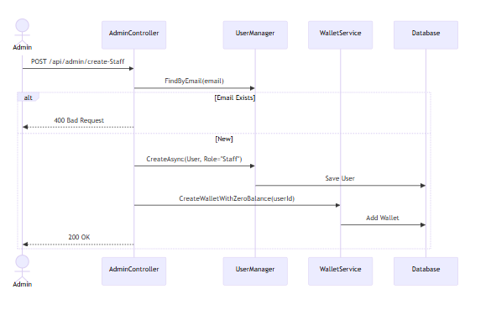
Figure 39: Sequence create staff

      - Create Semester
        - Class Diagram
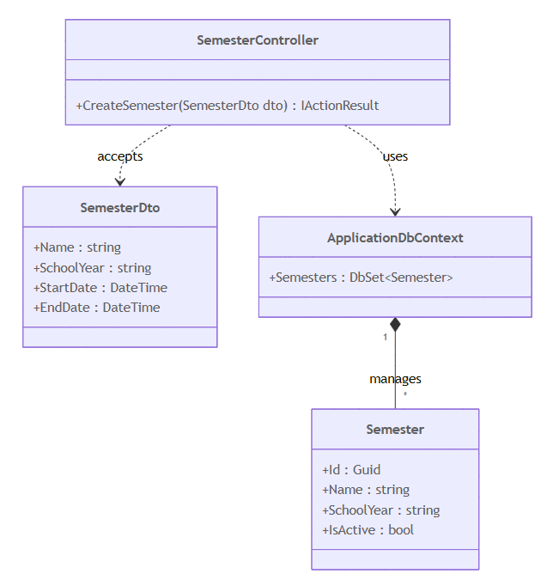
Figure 40: Class diagram create semester

        - Sequence Diagram
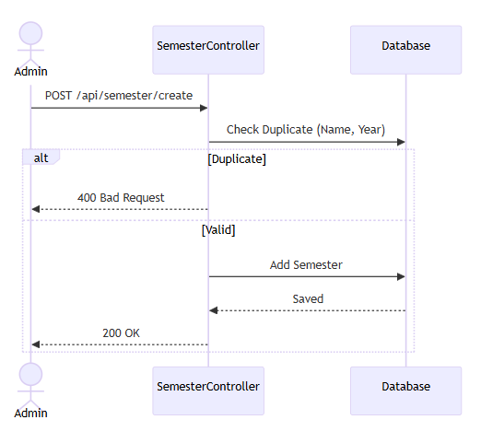
Figure 41: Sequence diagram edit semester

      - Edit Semester
        - Class Diagram
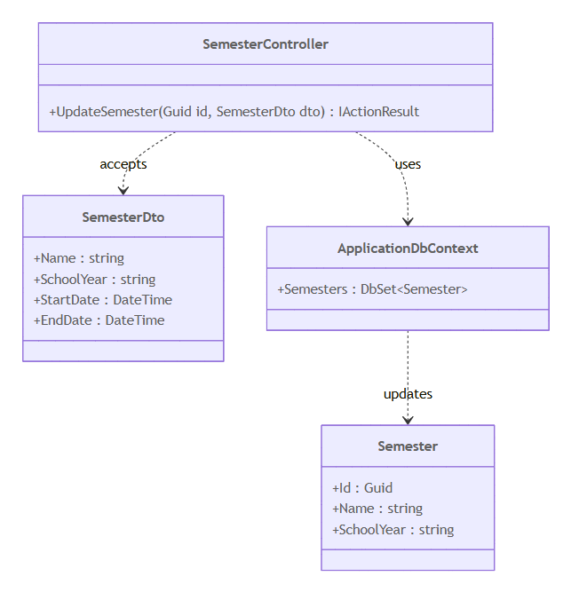
Figure 42: Class diagram edit semester

        - Sequence Diagram
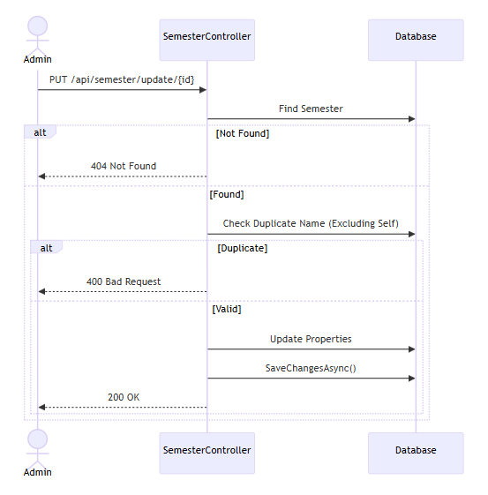
Figure 43: Sequence diagram edit semester

      - Create Course
        - Class Diagram
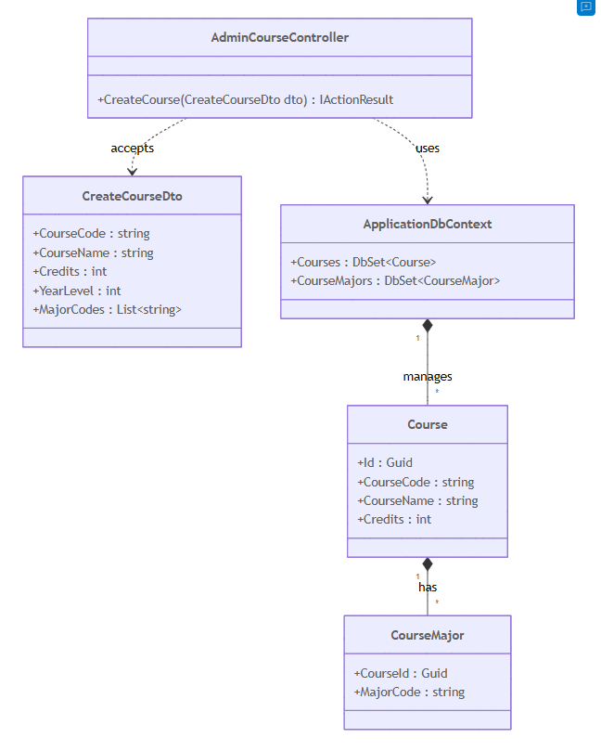
Figure 44: Class diagram create course

        - Sequence Diagram
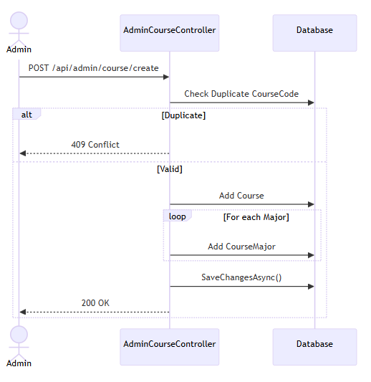
Figure 45: Sequence diagram create course

      - Edit Course
        - Class Diagram
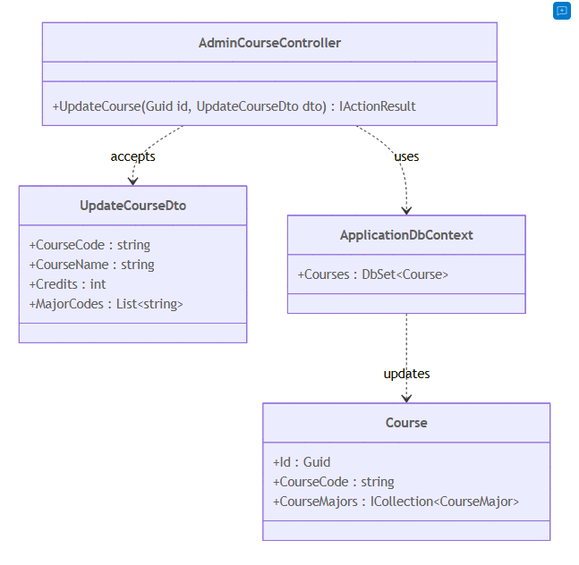
Figure 46: Class diagram edit course

        - Sequence Diagram
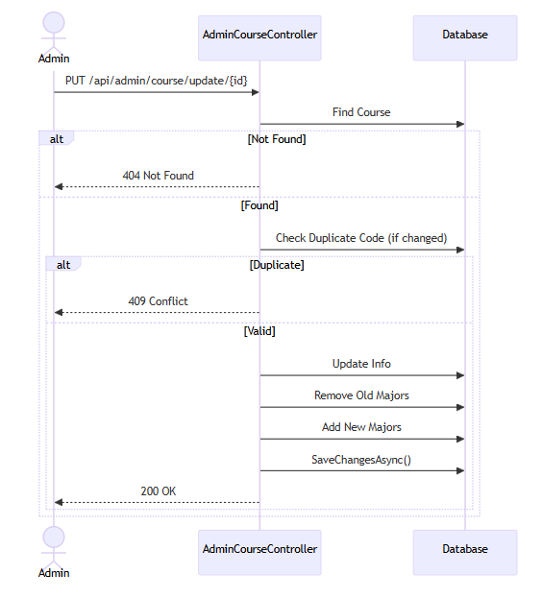
Figure 47: Sequence diagram edit course
      - Create Offering Course
        - Class Diagram
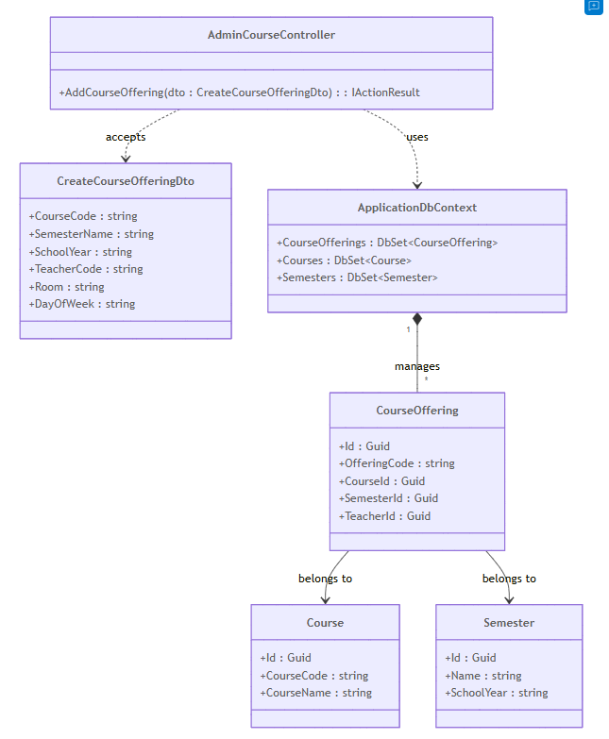
Figure 48: Class diagram create offering course

        - Sequence Diagram
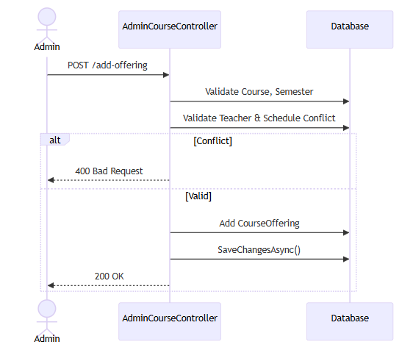
Figure 49: Sequence create offering course

      - Edit Offering Course
      - Class Diagram
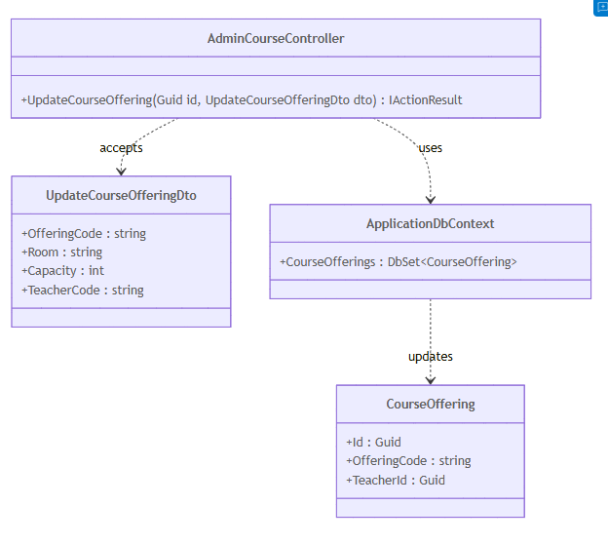
Figure 50: Class diagram edit offering course

        - Sequence Diagram
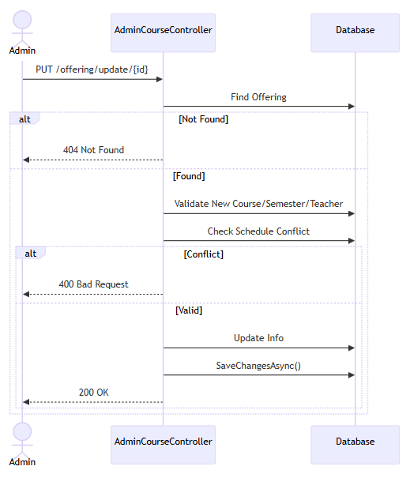
Figure 51: Sequence diagram edit offering course

      - Management Information Parent
        - Class Diagram
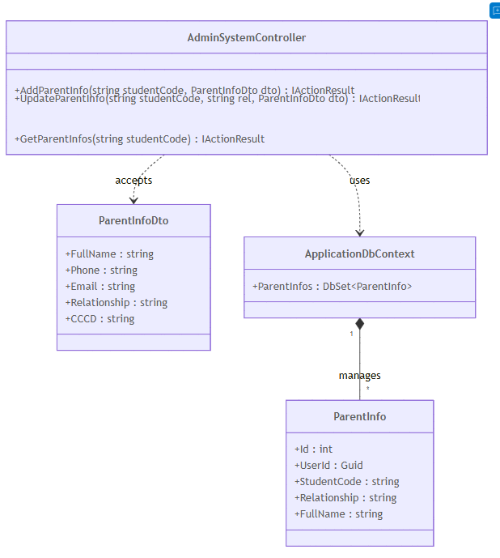
Figure 52: Class diagram management information parent

        - Sequence Diagram
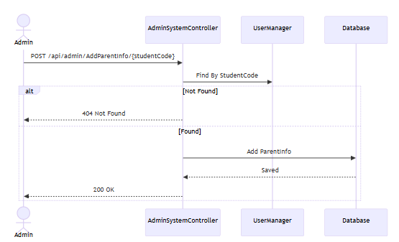
Figure 53: Sequence diagram add information parent

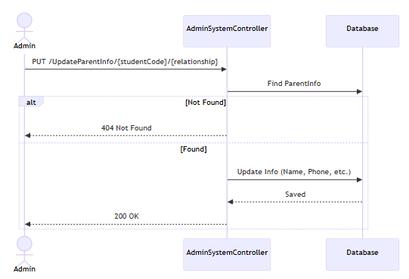
Figure 54: Sequence diagram edit information parent

    - Function of Student
      - Get Timetable in Semester
        - Class Diagram
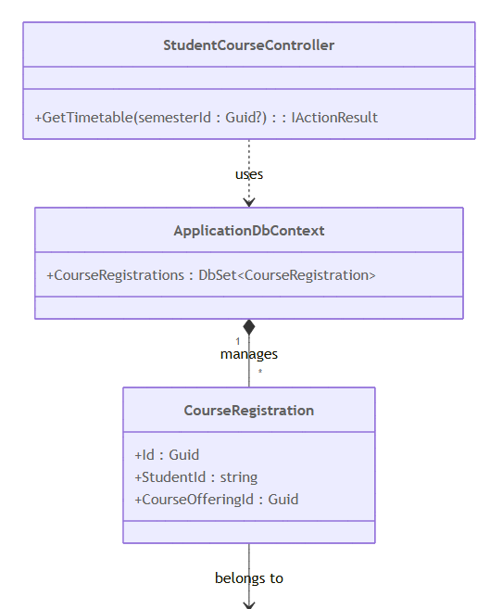
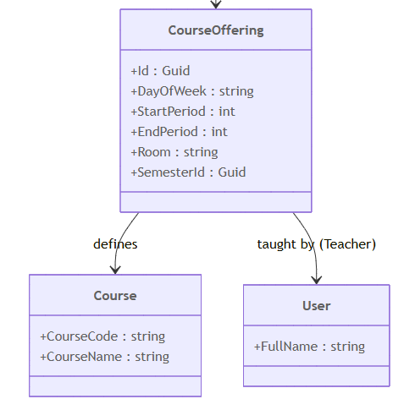
Figure 55: Class diagram get timetable
        - Sequence Diagram
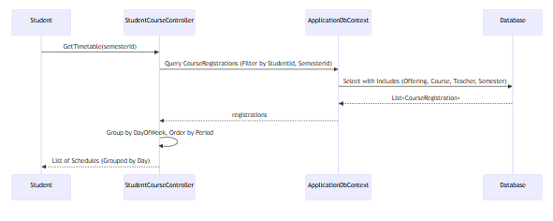
Figure 56: Sequence diagram get timetable

      - Get Profile
        - Class Diagram
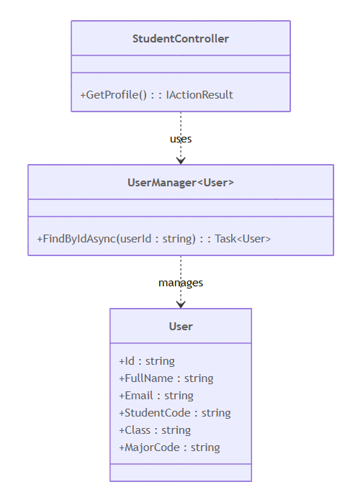
Figure 57: Class diagram get profile

        - Sequence Diagram
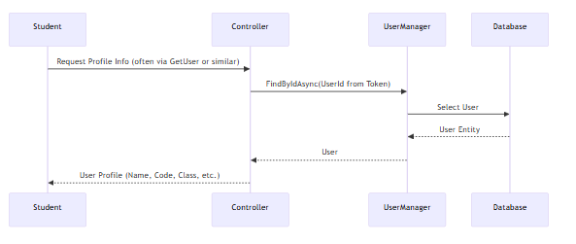
Figure 58: Sequence diagram get profile

      - Add Information of Parent
        - Class Diagram
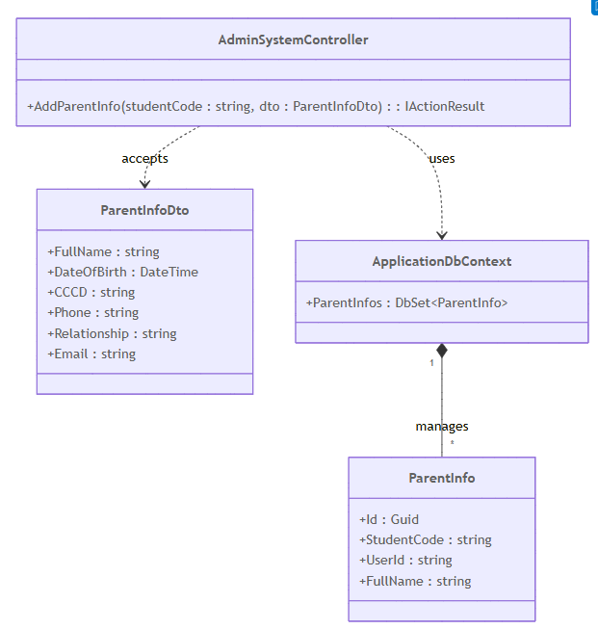
Figure 59: Class diagram add information of parent

        - Sequence Diagram
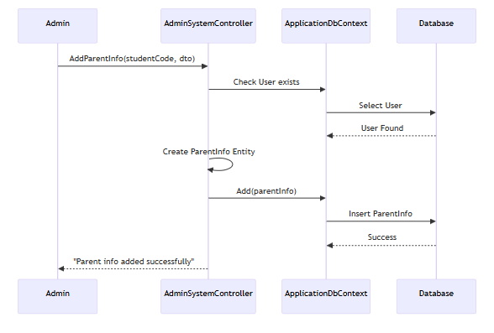
Figure 60: Sequence diagram add information of parent

      - Temporary Residence Declaration
        - Class Diagram
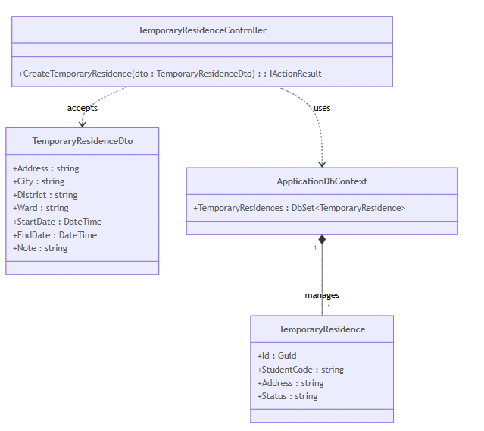
Figure 61: Class diagram temporary residence declaration

        - Sequence Diagram
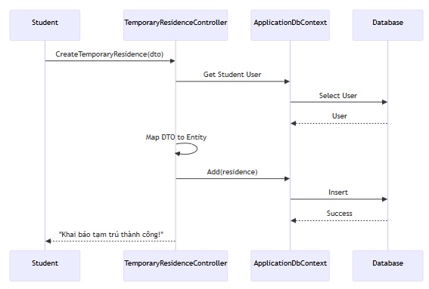
Figure 62: Sequence diagram temporary residence declaration

      - Registration Course
        - Class Diagram
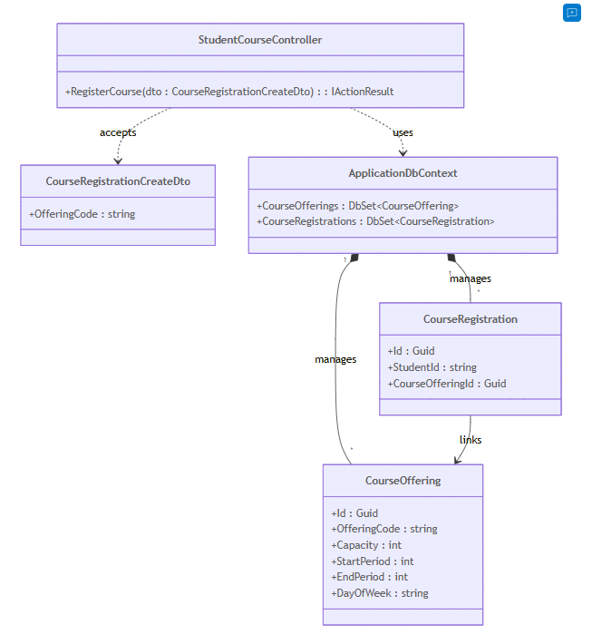
Figure 63: Class diagram registration course

        - Sequence Diagram
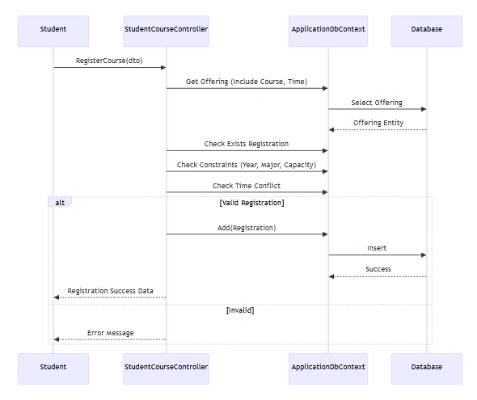
Figure 64: Sequence diagram registration course

      - Get Activity
        - Class Diagram
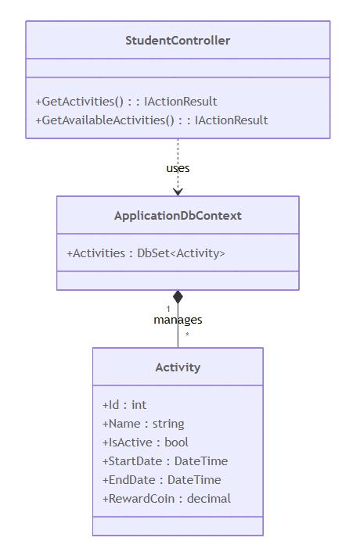
Figure 65: Class diagram get activity

        - Sequence Diagram
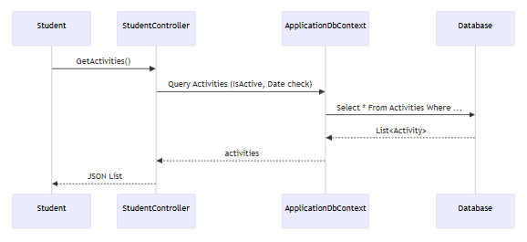
Figure 66: Sequence diagram get activity

      - Registration Join to Activity
        - Class Diagram
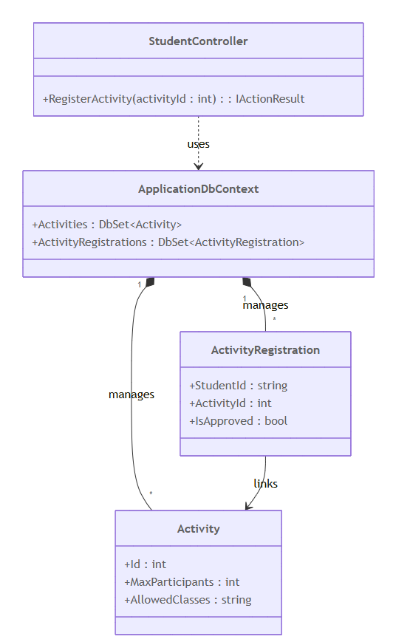
Figure 67: Class diagram registration join to activity
        - Sequence Diagram
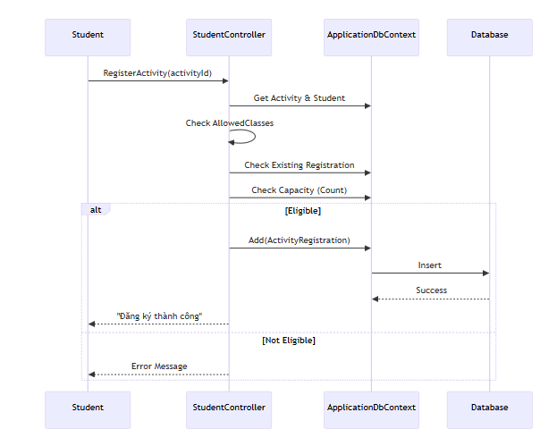
Figure 68: Sequence diagram registration join to activity
      - Receive VKU
        - Class Diagram
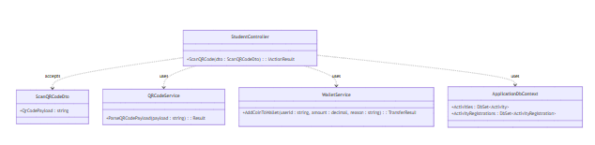
Figure 69: Class diagram receive vku coin
        - Sequence Diagram
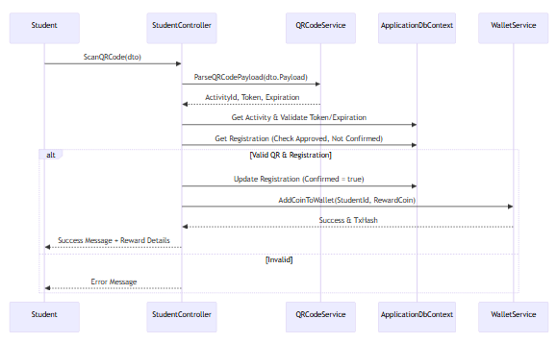
Figure 70: Sequence diagram receive vku coin
      - Get Product
        - Class Diagram
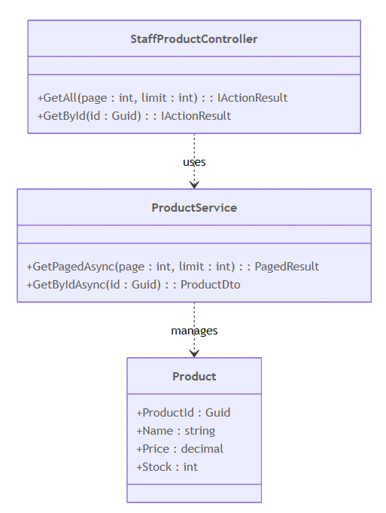
Figure 71: Class diagram get product
        - Sequence Diagram
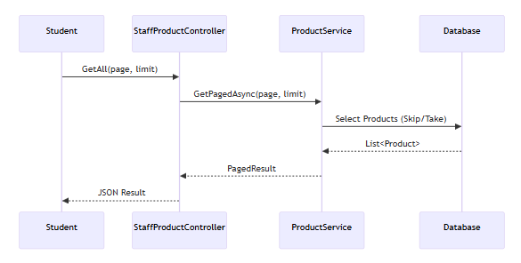
Figure 72: Sequence diagram get product
      - Add Product into Cart
        - Class Diagram
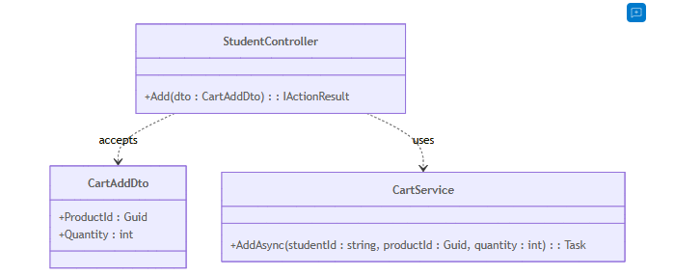
Figure 73: Class diagram add product into cart
        - Sequence Diagram
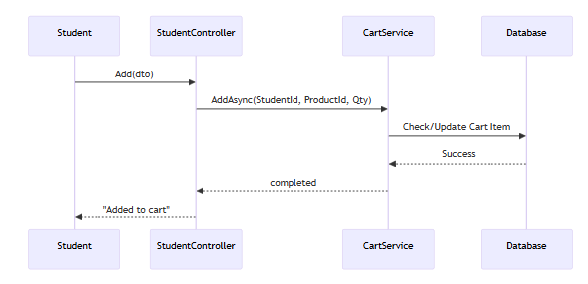
Figure 74: Sequence add product into cart
      - Checkout
        - Class Diagram
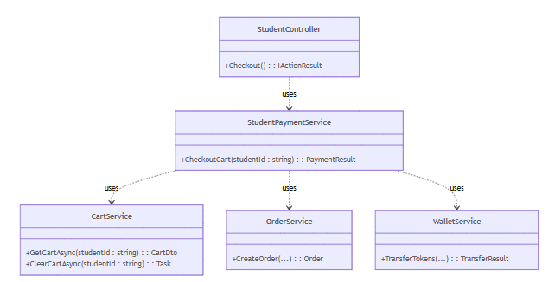
Figure 75: Class diagram checkout
        - Sequence Diagram
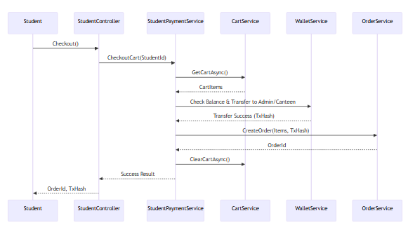
Figure 76: Sequence diagram checkout
      - Change Password
        - Class Diagram
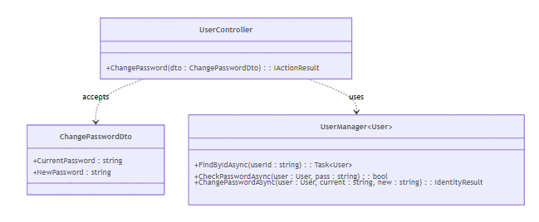
Figure 77: Class diagram change password
        - Sequence Diagram
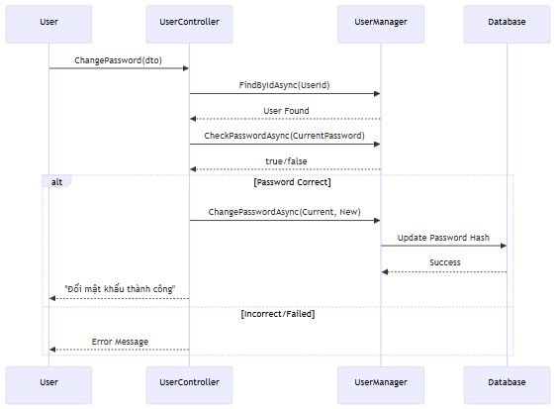
Figure 78: Sequence diagram change password

    - Function of Teacher
      - Get Teacher Offerings
        - Class Diagram
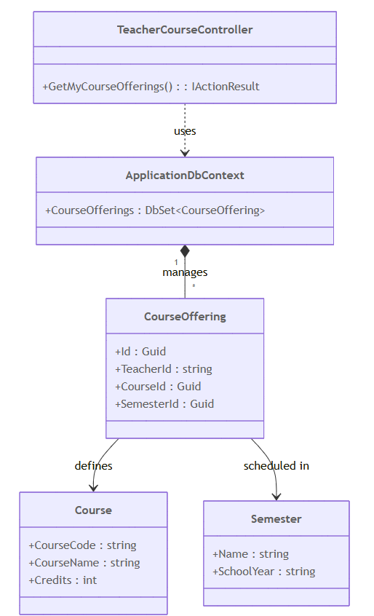
Figure 79: Class diagram get teacher offerings
        - Sequence Diagram
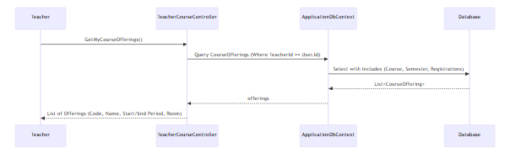
Figure 80: Sequence diagram get teacher offerings=
      - Get Student in Offerings
        - Class Diagram
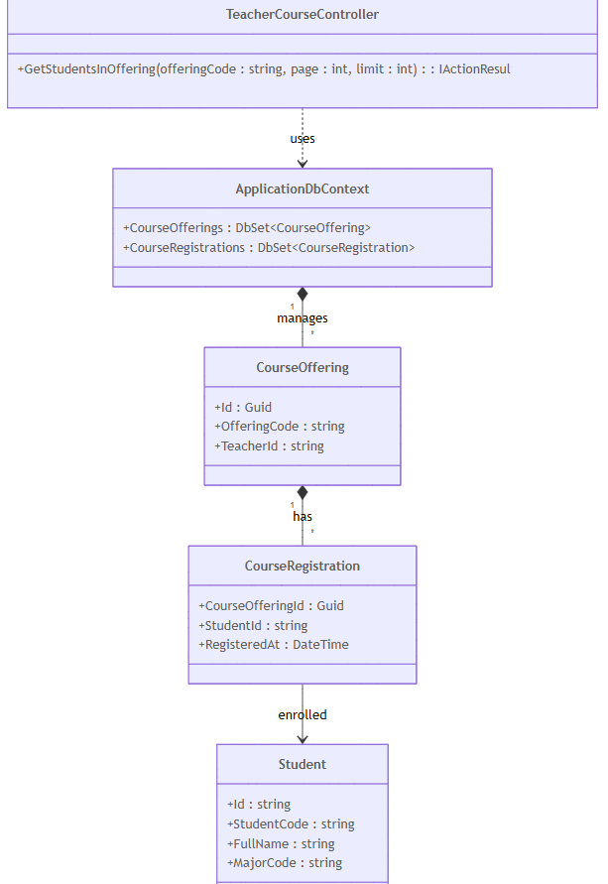
Figure 81: Class diagram get student in offerings
        - Sequence Diagram
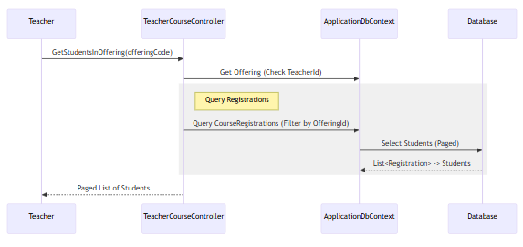
Figure 82: Sequence diagram get student in offerings
      - Get Teacher Timetable
        - Class Diagram
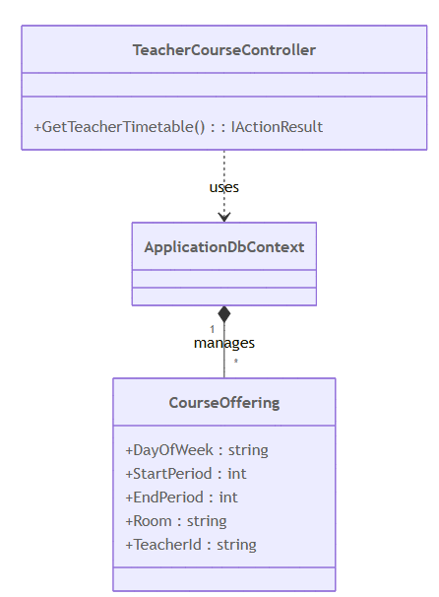
Figure 83: Class diagram get teacher timetable

        - Sequence Diagram
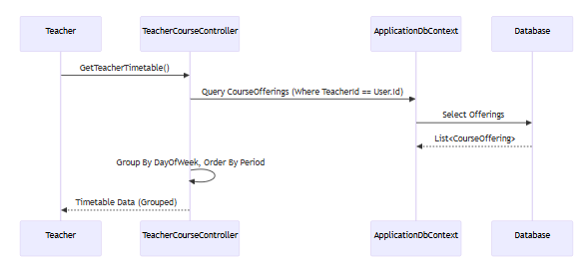
Figure 84: Sequence diagram get teacher timetable

      - Get Attendance
        - Class Diagram
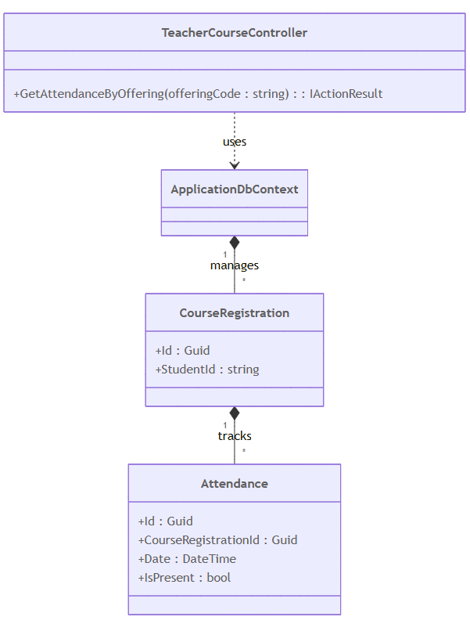
Figure 85: Class diagram get attendance

        - Sequence Diagram
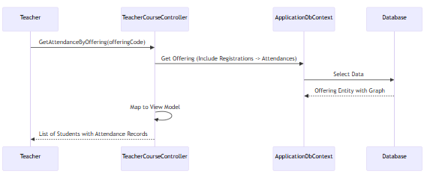
Figure 86: Sequence diagram get attendance
      - Update Grades
        - Class Diagram
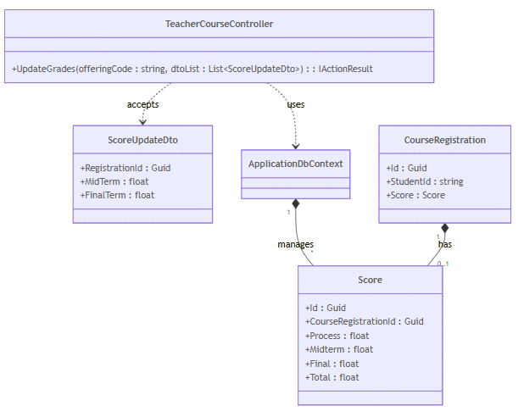
Figure 87: Class diagram update grades
        - Sequence Diagram
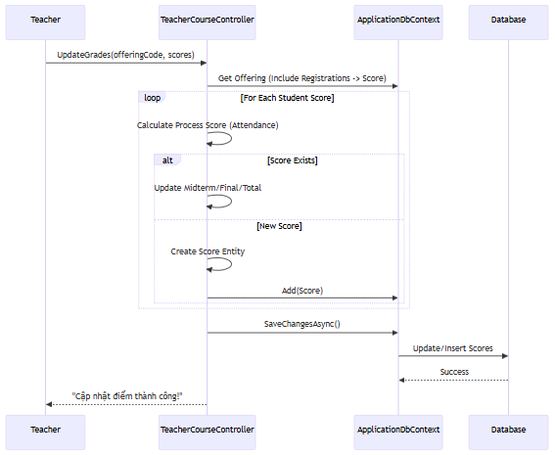
Figure 88: Sequence diagram update grades

    - Function of Staff
      - Get Product List
        - Class Diagram
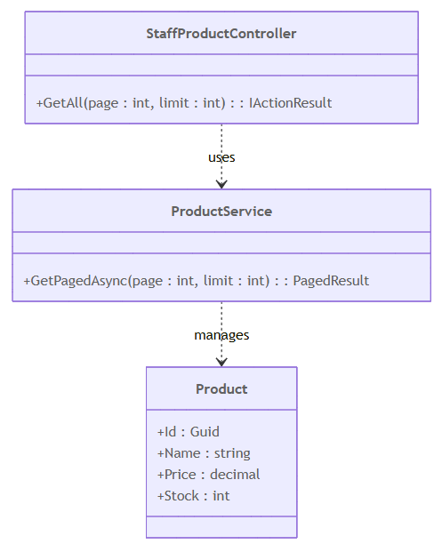
Figure 89: Class diagram get product list

        - Sequence Diagram
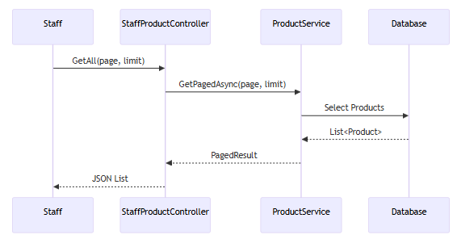
Figure 90: Sequence diagram get product list
      - Create Product
        - Class Diagram
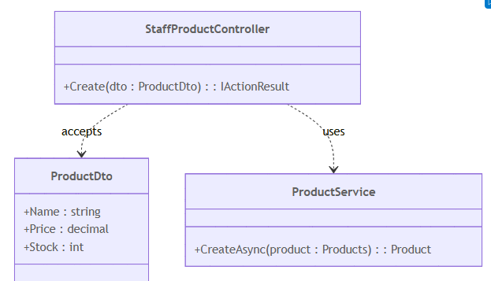
Figure 91: Class diagram create product
        - Sequence Diagram
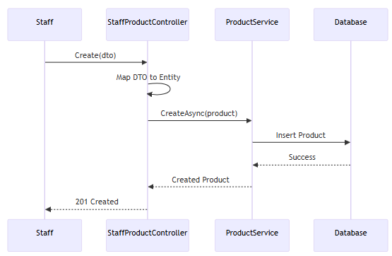
Figure 92: Sequence diagram create product
      - Update Product
        - Class Diagram
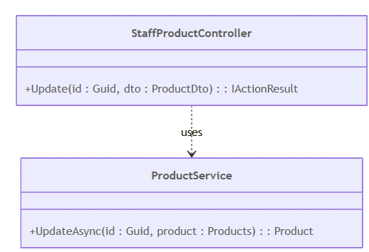
Figure 93: Class diagram update product
        - Sequence Diagram
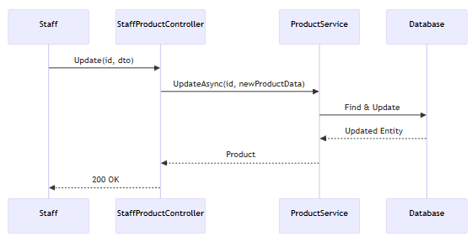
Figure 94: Sequence diagram update product
      - Delete Product
        - Class Diagram
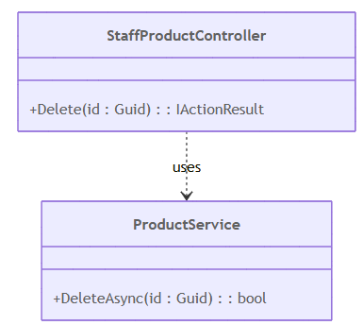
Figure 95: Class diagram delete product
        - Sequence Diagram
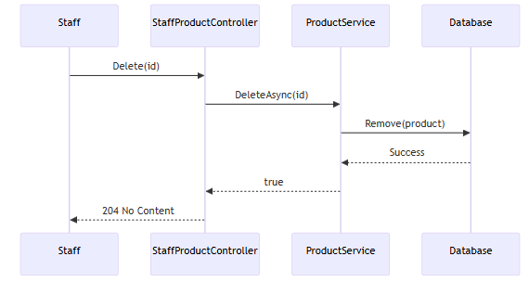
Figure 96: Sequence diagram delete product

      - Get Staff Dashboard Starts
        - Class Diagram
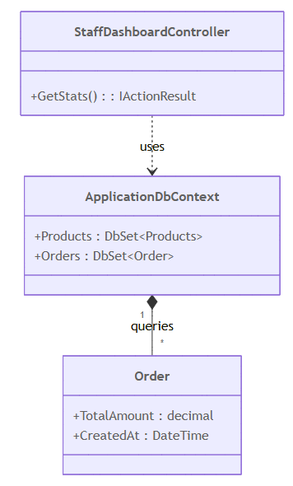
Figure 97: Class diagram get dashboard starts
        - Sequence Diagram
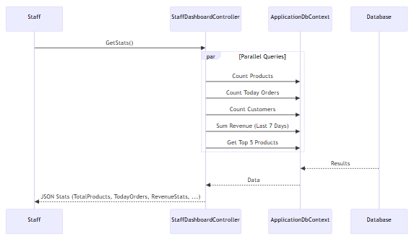
Figure 98: Sequence diagram get dashboard starts
- BLOCKCHAIN-RELATED FUNCTIONALITIES
  - Overview of Blockchain Usage in Educhain
Blockchain technology is integrated into the Educhain system as a core component to enhance transparency, security, and trust in reward distribution and internal transactions. Instead of replacing the entire traditional system, blockchain is selectively applied to handle critical operations related to token issuance, wallet management, and transaction recording. This hybrid approach combines the efficiency of centralized systems with the immutability and transparency of blockchain technology. In Educhain, blockchain is used to record token rewards granted to students after participating in academic or extracurricular activities and to support token-based payments at internal services such as the campus canteen. All blockchain-related operations are designed to function within a closed educational environment, ensuring controlled usage and regulatory safety.
  - Blockchain Architecture and Network Selection
The Educhain system adopts a layered blockchain architecture consisting of the application layer, service layer, and blockchain network layer. The backend application communicates with the blockchain through a dedicated blockchain service module using the Nethereum library. For development and testing purposes, an Ethereum test network is selected instead of the mainnet to minimize operational costs and avoid financial risks. This network provides an environment that closely resembles real blockchain behavior while allowing free testing of smart contracts and transactions. The selected architecture ensures flexibility, scalability, and easy replacement or upgrade of blockchain components in future system versions.
  - Wallet Management Mechanism
Each student in the Educhain system is associated with a unique blockchain wallet that is automatically created upon account initialization or user import. The wallet consists of a public address and a private key, which are securely managed by the backend system. Wallet addresses are used to identify users on the blockchain and to receive or transfer tokens. The system allows students to view their wallet balance and transaction history through the application interface, while sensitive wallet credentials are encrypted and never exposed to end users. This approach ensures usability while maintaining a high level of security for blockchain assets.
  - Token Issuance and Reward Distribution
Token issuance in Educhain is strictly controlled and initiated only through predefined academic or extracurricular activities. When a student successfully completes an activity and the participation is verified by an administrator, the system triggers a reward mechanism that transfers a predefined number of tokens to the student’s wallet. The token serves as a digital representation of rewards and incentives rather than a tradable cryptocurrency. The reward distribution process is automated, transparent, and recorded on the blockchain, ensuring that all issued tokens can be traced and audited at any time.
  - Blockchain Transaction Flow
The blockchain transaction flow in Educhain begins with an action initiated from the application layer, such as rewarding a student or processing a purchase at the canteen. The backend validates the request, checks user permissions, and prepares the transaction data. This data is then sent to the blockchain network through the smart contract interface. Once the transaction is confirmed on the blockchain, the system updates the internal database to reflect the latest wallet balance and transaction status. This dual-record mechanism ensures both blockchain integrity and application-level performance, while providing users with real-time feedback on their transactions.
  - Smart Contract Design
Smart contracts in Educhain are developed using the Solidity programming language and deployed on the Ethereum test network. These contracts define the rules for token creation, transfer, and balance management. The smart contract logic ensures that tokens can only be issued by authorized system accounts and transferred according to predefined rules. By embedding these rules into smart contracts, the system eliminates the possibility of unauthorized token manipulation. The smart contract design focuses on simplicity, security, and efficiency to reduce deployment complexity and potential vulnerabilities.
  - Security and Data Integrity
Security and data integrity are fundamental objectives of blockchain integration in Educhain. Blockchain ensures that all token-related transactions are immutable and cannot be altered once confirmed. In addition, the system applies multiple security layers, including encrypted wallet storage, role-based access control, and secure API authentication using JSON Web Tokens (JWT). Only authorized administrators and system services are permitted to initiate blockchain transactions. This combination of blockchain immutability and application-level security mechanisms helps protect the system from fraud, unauthorized access, and data tampering.
  - Limitations of Blockchain Integration
Despite its advantages, blockchain integration in Educhain has certain limitations. The system currently relies on an Ethereum test network, which may not reflect all performance characteristics of a production environment. Transaction confirmation times can vary depending on network conditions, potentially affecting real-time user experience. Additionally, the system does not support advanced blockchain features such as peer-to-peer token trading, staking, or decentralized governance, as these features are beyond the scope of an educational environment. The management of private keys by the backend also introduces dependency on centralized infrastructure, which requires strict security controls and regular maintenance. These limitations will be considered in future system enhancements.

