E-Supermarket

Mini-Supermarket Management System

**Installation Guide**

## 

## Software Requirement

* + Java JDK 8 and JRE 8
  + MySQL Community 8.0.26

## Installation Requirements

* + Windows 10 x64 (64-bit)
  + MySQL Installer requires Microsoft .NET Framework 4.5.2 or later

## Configuration

### MySQL Community 8.0.26.0 Installation Guide

### 1.1. Open the MySQL website on a browser. Click on the following link: <https://dev.mysql.com/downloads/>

### 1.2. Select the Downloads option.1.3. Select MySQL Installer for Windows.1.4. Choose to download mysql-installer-community-8.0.26.0.msi.

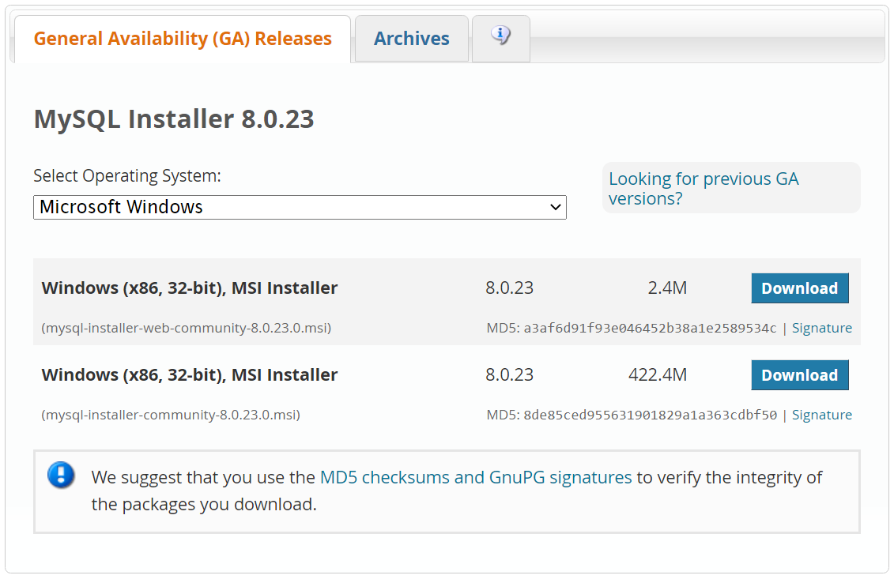

1.5. After the download, open the installer.

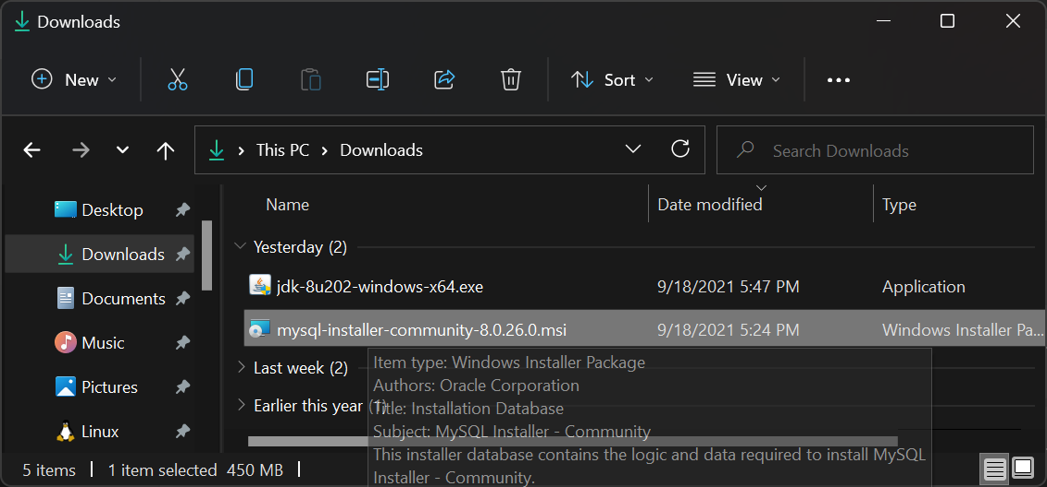

1.6. It will ask for permission; when it does, click “**Yes**”. The installer will then open. Now, it will ask to choose the setup type. Here, select “**Custom**”

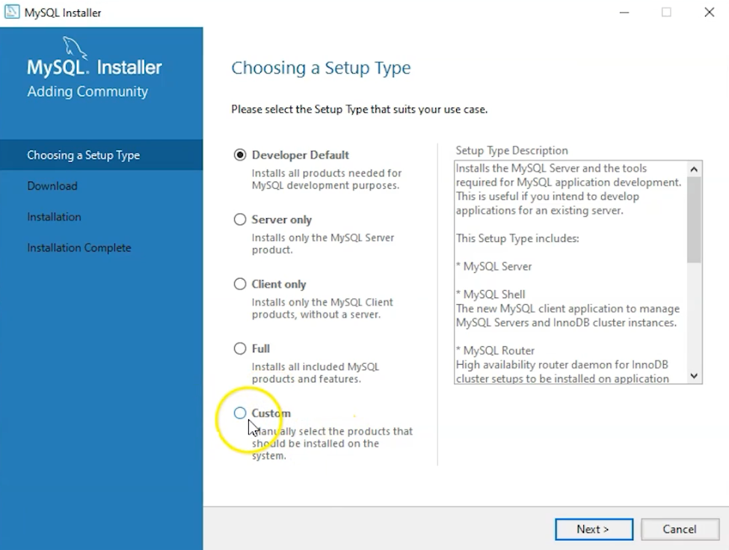

1.7. Click on Next. With this, you will install **MySQL server**, **MySQL Workbench**, and **Connector/J**.

1.8. Open MySQL Servers, select the server you want to install, and move it to the Products/Features to be installed window section. Now, expand Applications, choose MySQL Workbench and Connector/J. Move both of them to ‘Products/Features to be installed’.

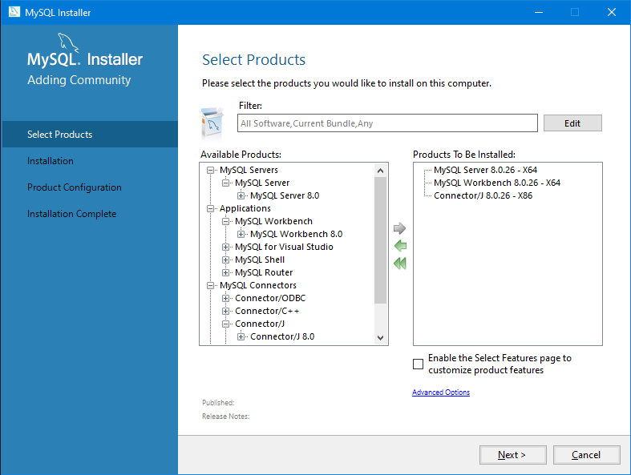

1.9. Click on the Next button. Now, click on [...] to choose folder install and click Next to continue.

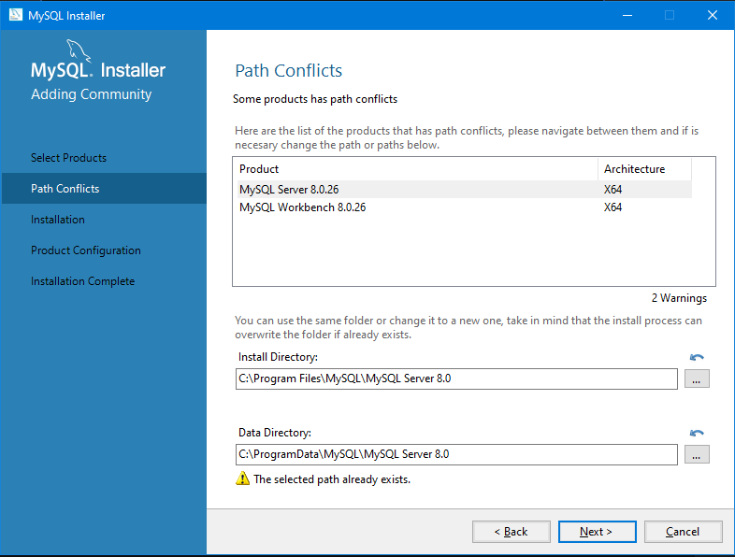

1.10. Now, click on the Execute button to download and install the MySQL server, MySQL Workbench, and the Connector/J.

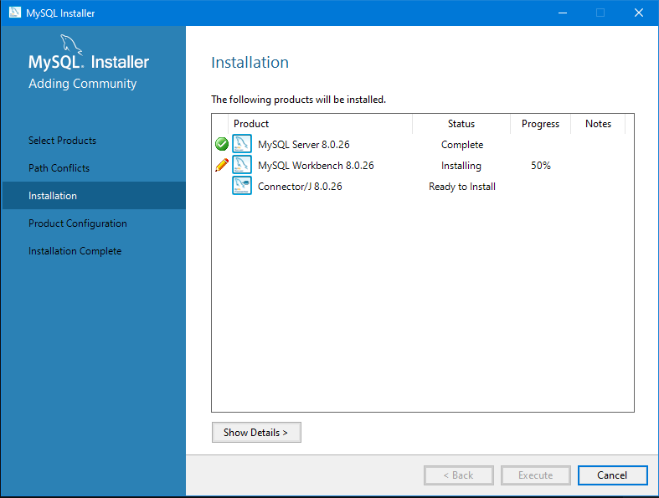

1.11. Once the product is ready to configure, click on Next. Under Type and Networking, go with the default settings and select Next.

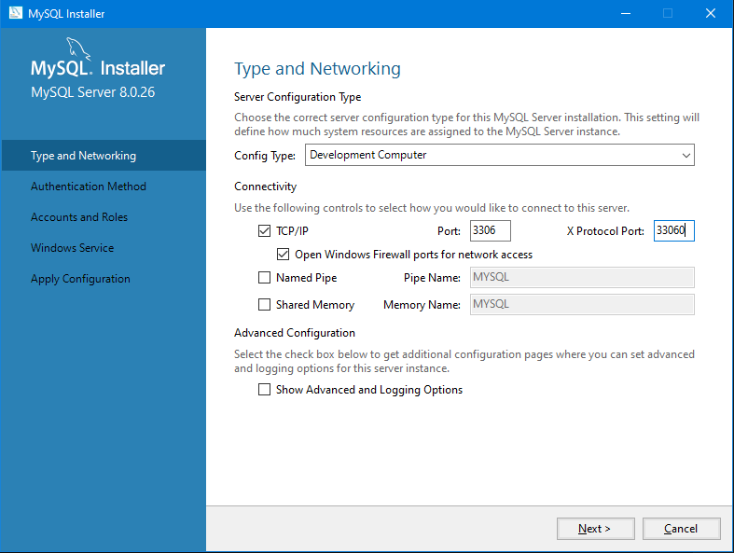

1.12. For authentication, use the recommended strong password encryption.

1.13. Set your MySQL Root password and click on next.

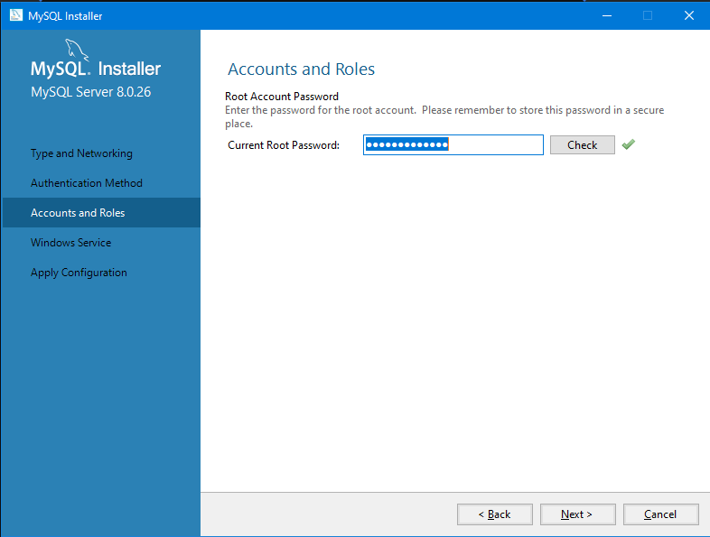

1.14. Go for the default windows service settings and under apply configuration, click on execute. Once the configuration is complete, click on finish.

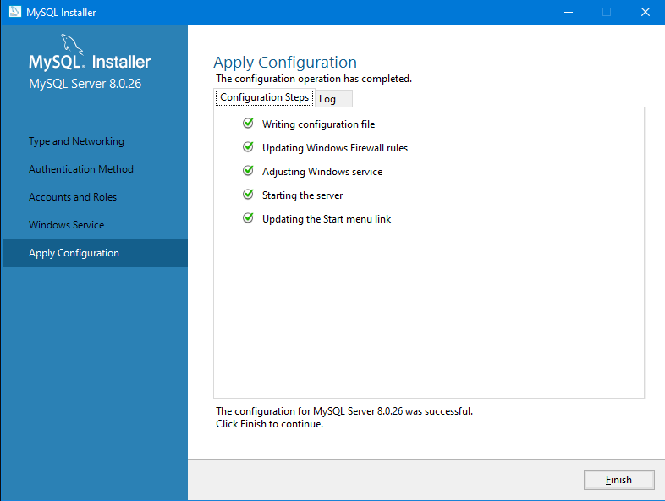

1.15. Complete the installation. This will now launch the MySQL Workbench and the Connector/J.

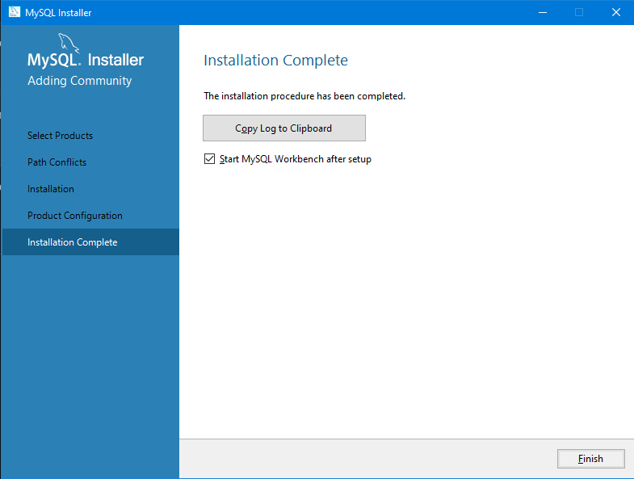

Once MySQL Workbench is installed, select the Local instance and enter the password.

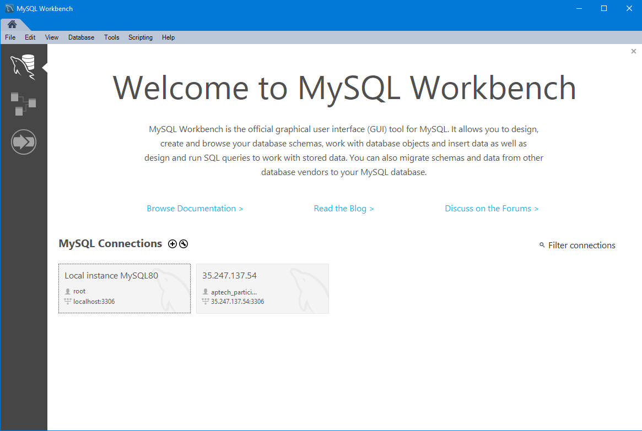

Now, you can use the MySQL query tab to write your SQL queries.

### JDK Installation Guide

The file has the name **jdk-8u202-windows-x64.exe**.  
Remember that you can click on each of the images on this page to see a full-size version.

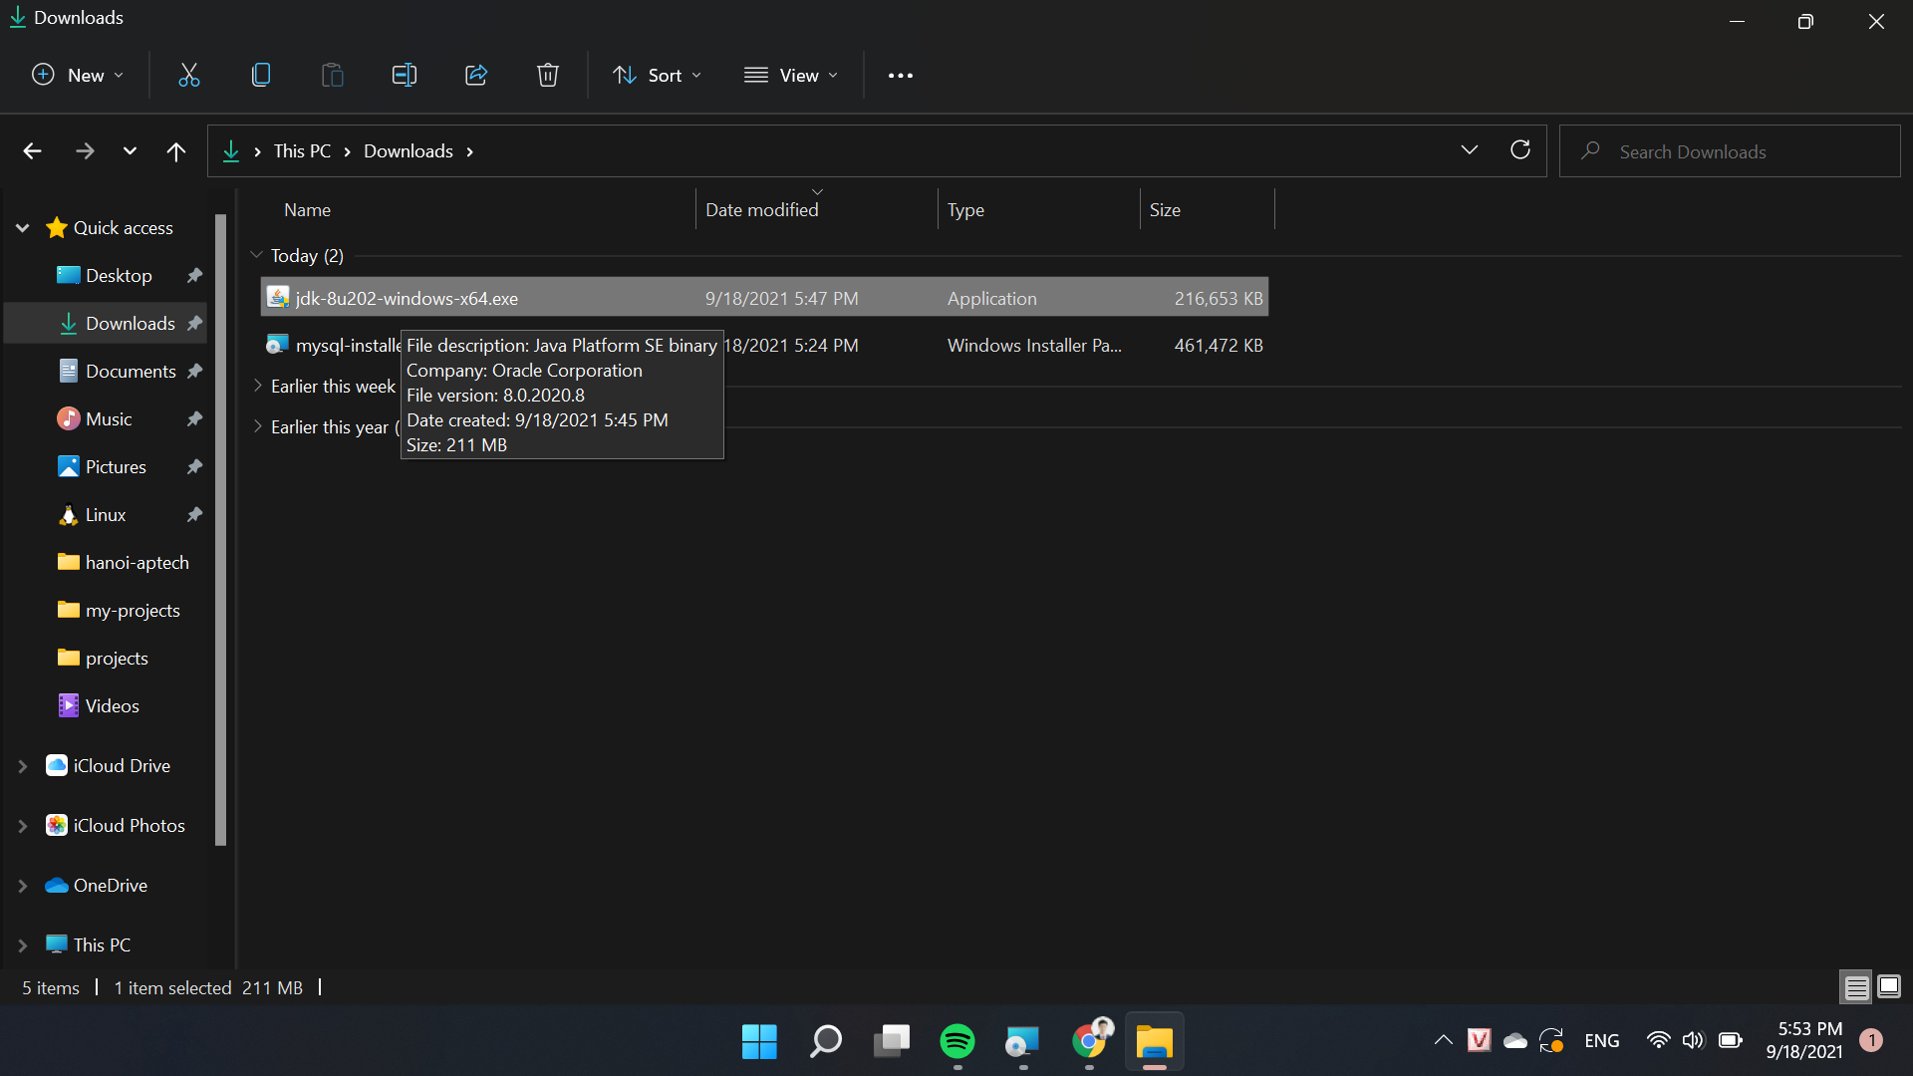

Double-click the file to begin installation. The splash screen will display for a while and then you will see the Setup screen.

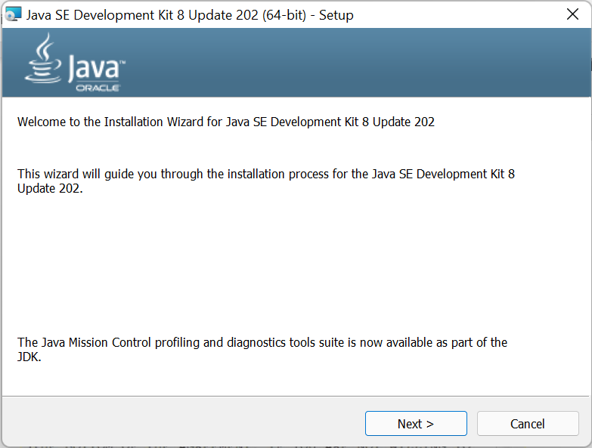

Click “*Next >*”

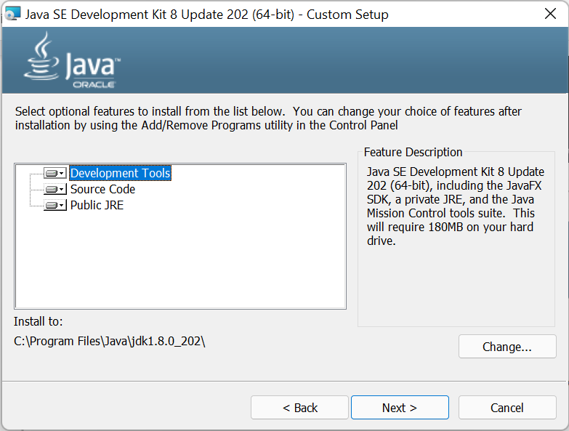

Double-click the file to begin installation. A splash screen will show for a while and then you'll be shown a licence agreement. If you want to learn Java, you must click  accept.

This screen allows you to customize your installation.

The defaults shown in the upper part of the dialog box are all OK.

Change the installation directory so that all of your Java-related programs are together, as follows:

* + Click on the ”*Change…”* button.

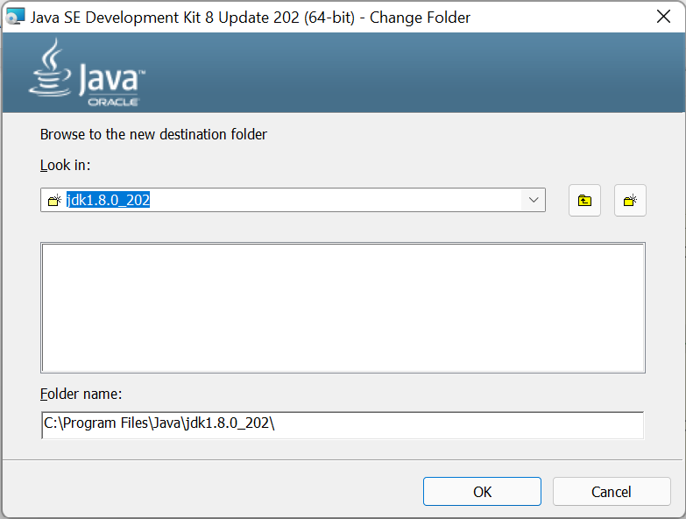

* + In the Change Folder screen, type *C:\Program Files\Java\jdk1.8.0_202* in the space for the Folder name:.
  + Click ”*OK*”.

You should now see the previous dialog box, shown above. Check the Install to: information to verify that it says *C:\Program Files\Java\jdk1.8.0_202*.

Click “*Next*”

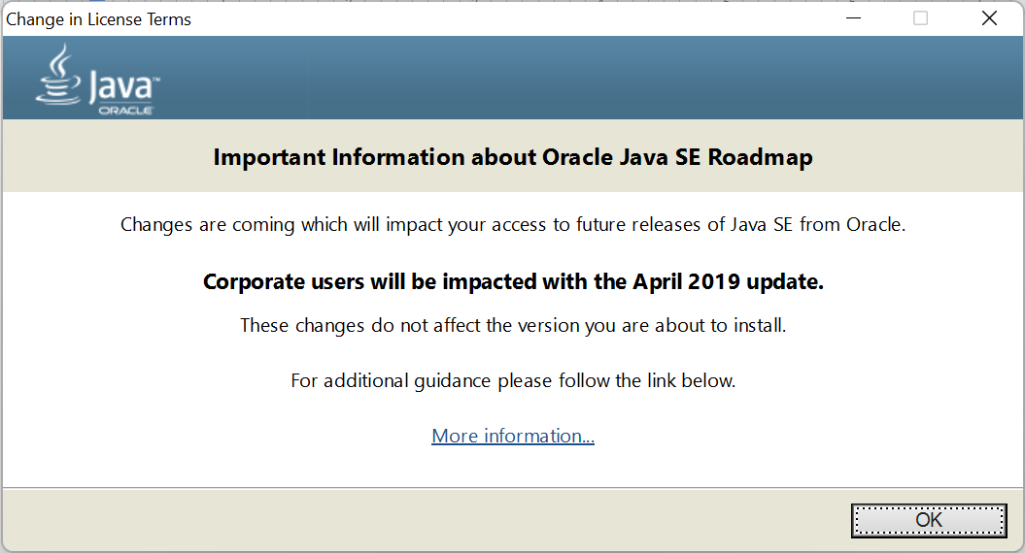

Click “*OK*”

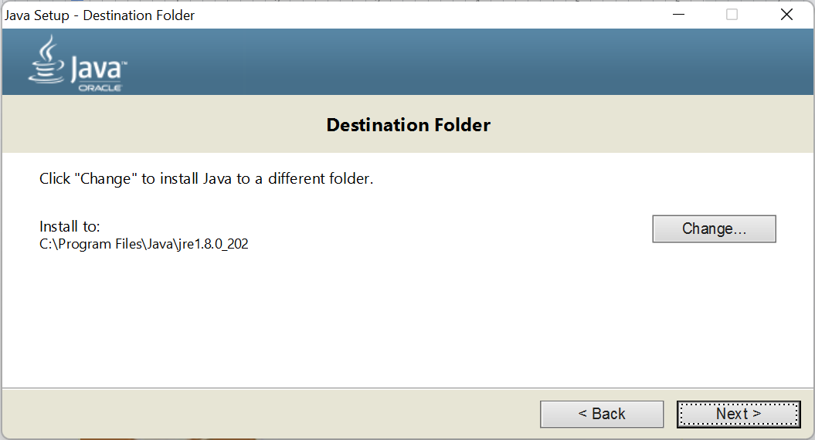

Click “*Next >*”

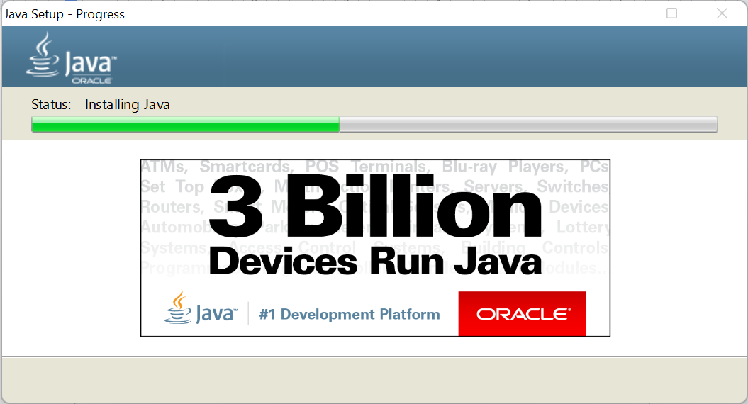

Eventually, you will be shown a completion screen. Click ”*Close*”.

