User Guide

Run the Main Project to launch the application. Language selection screen appears.

Enter *vi* or *en*; then press enter to continue to the login screen



* Admin, Cashier, Inventory enter Username, Password and press enter to log in.
* Username and password must be valid.

If login fail

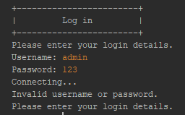

If login success

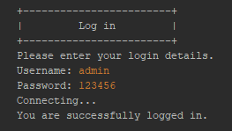

To connect with the administrator. Username: admin, password: 123456. When you select the Sign-out option, you will return to the Login menu

# User Roles

## Admin

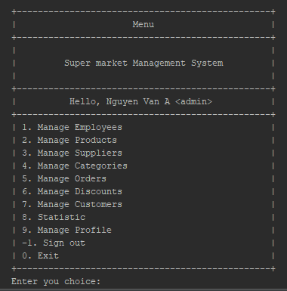

Administrator main menu

### Manage Employees

To manage Employees, enter option number 1 and then press enter.

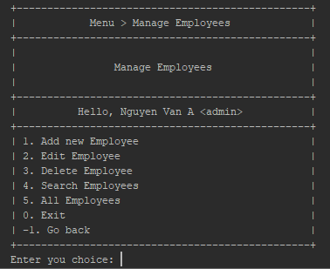

#### Add New Employee

To add a new Employee, enter option 1, and you will have to enter these following values:

* Name: 3-50 characters
* Address: 3-255 characters
* Phone: Valid phone numbers of 4 carriers Viettel, Vinaphone, Mobifone
* Department: 1, 2 or 3
* Username: Must have first letter, length 3-29 characters. Characters are allowed . And _ and digits
* Password: Have at least 6 characters

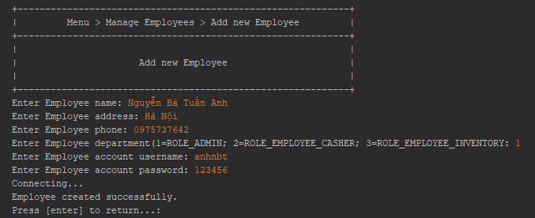

#### Edit Employee

To edit an employee's information, enter option 2. Fill in the employee ID and all information fields. Just like adding new employees. But omitting the username field can't be changed.

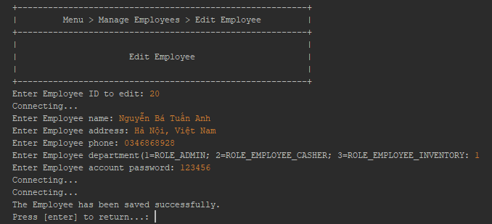

#### Delete Employee

You are only able to delete an Employee which is not linked to any Order.

Please follow these steps to look up Employee detail:

1. Enter Employee ID: positive integer value only.
2. Press [enter] to find the Employee
3. Enter value “y” to confirm to delete.

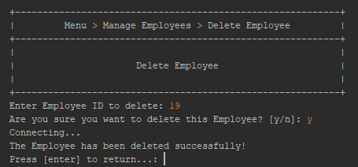

#### Search Employees

Search of Employees by name

1. Enter search name keyword
2. Press [enter] to submit searching
3. Employees that match the approximate name will be displayed in the table

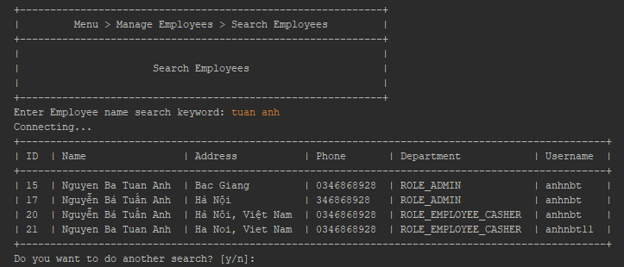

#### All Employees

View all Employees that exists on system

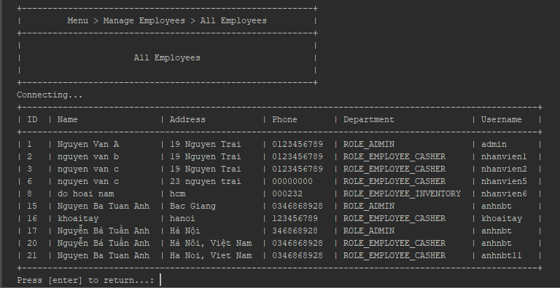

### Manage Products

#### All Products

See usage in here

#### Search Products

See usage in here

#### Product Detail

See usage in here

#### Products by Category

See usage in here

### Manage Suppliers

#### Add new Supplier

See usage in here

#### Edit Supplier

See usage in here

#### Delete Supplier

See usage in here

#### Search Suppliers

See usage in here

#### Supplier detail

See usage in here

#### All Suppliers

See usage in here

### Manage Categories

#### Search Category

See usage in here

#### Category detail

See usage in here

#### All Category

See usage in here

### Manage Orders

#### Order detail

See usage in here

#### All Orders

See usage in here

#### Search of Orders by Customer

See usage in here

#### Search Orders by Date

See usage in here

### Manage Discounts

#### All Discounts

See usage in here

#### Discount detail

See usage in here

#### Add new Discount

See usage in here

#### Edit Discount

See usage in here

#### Delete Discount

See usage in here

### Statistic

#### Out of stock Products

<content>

#### Best Sale Products

<content>

#### Revenue

<content>

### Manage Profile

#### Change Password

<content>

#### Update Profile

<content>

## Cashier

* This is Cashier Menu

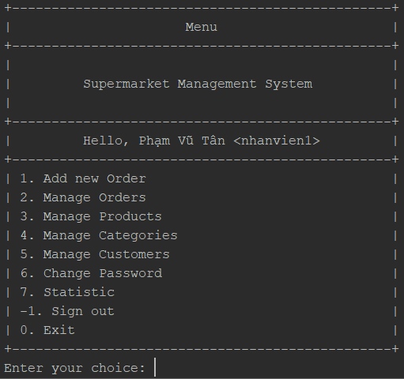

**1.2.1. Add new Order**

* This is a way to create new Order
* Enter Product’s ID and quantity
* You need to choose to add more Product or not, “Y” if you want to add more, “N” if not.
* Now, if the Customer is a Member Customer, you need to choose “Y”, “N” if not.

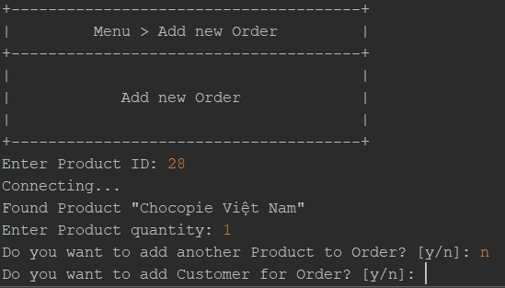

*) Case 1 : Choose “No”

- And, this is your Order’s detail for Customer not a Member

- You’ll be asked “Do you want to save the Order?”, “Y” if you want to save to cache, “N” if not.

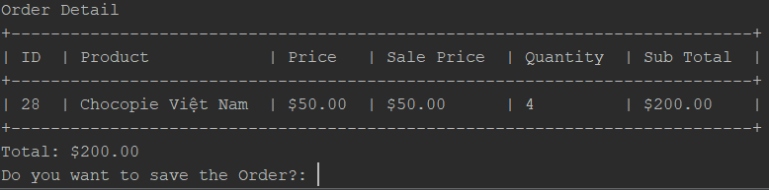

*) Case 2 : Choose “Yes”

* You’ll be asked to enter Customer’s ID
* After entering, Systems will show you Order’s detail of Customer Member

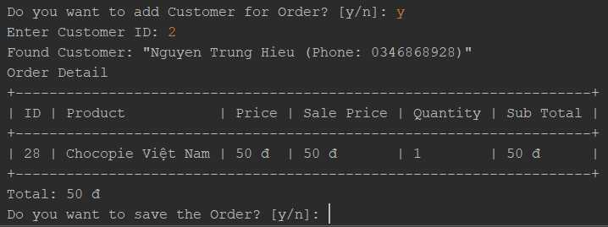

- Again, you’ll be asked “Do you want to save the Order?”, “Y” if you want to save to cache, “N” if not.

**1.2.3. Manage Orders**

* You can choose “1” to go to PHAM VU TAN ’s (nhanvien1) today Orders
* Choose “2” to find Order by ID saved in cache
* And “0” to Exit or “-1” to Go back

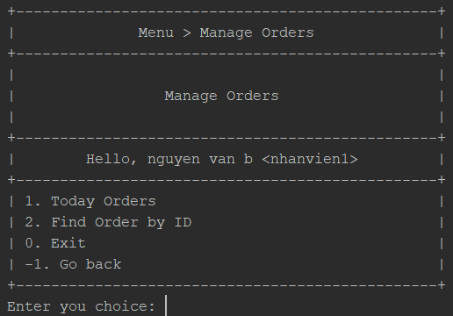

**1.2.3.1. Today Orders**

* After choosing “1”, the System will show you all orders you created today, so cool, isn’t it?

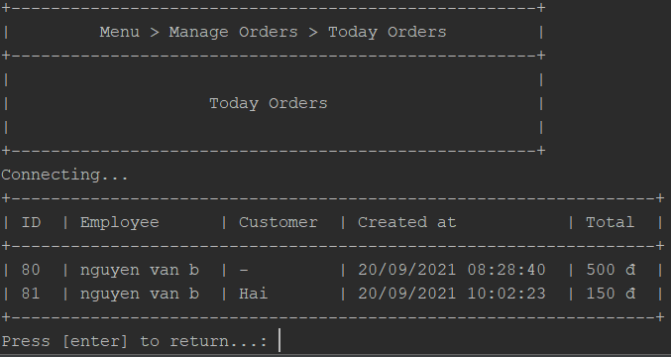- Press “Enter” to return Manage Orders Menu

**1.2.3.2. Find Order by ID created by currently account – PHAM VU TAN (nhanvien1)**

* Enter Order’s ID of Order created by PHAM VU TAN (nhanvien1) in history
* If Order’s ID valid, it’ll show you Order’s detail about that Order
* And you’ll be asked “Do you want to search another order?”, “Y” if you want to search more, “N” if not.

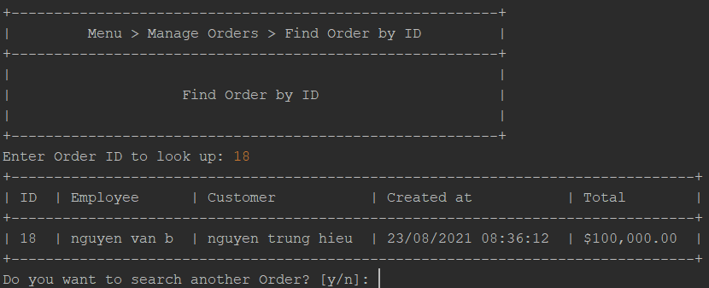

-It’s done with Manage Order, you can click “Enter” and choose “-1” to Go back to Main menu

**1.2.4. Manage Products**

* You can choose “1” to Search some Product’s by their Name
* Choose “2” to find Order by ID saved in cache
* And <0> to Exit or “-1” to Go back

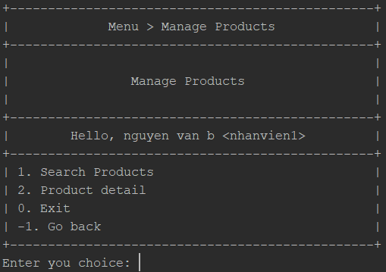

**1.2.4.1. Search Products**

* Enter some characters in Product’s name you are looking for and “Enter”
* Now, it’ll show you all Product with the characters you entered

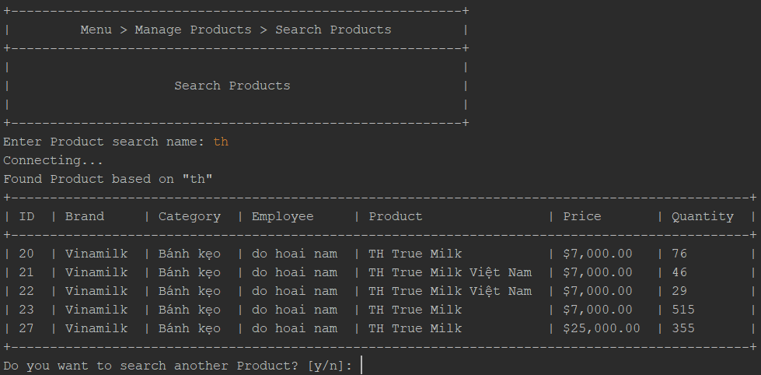

* And you’ll be asked “Do you want to search other Products?”, “Y” if you want to search more, “N” if not.

**1.2.4.2. Product Detail**

* Enter Product’s ID you want to check
* And it’ll show you info about Product you are looking for

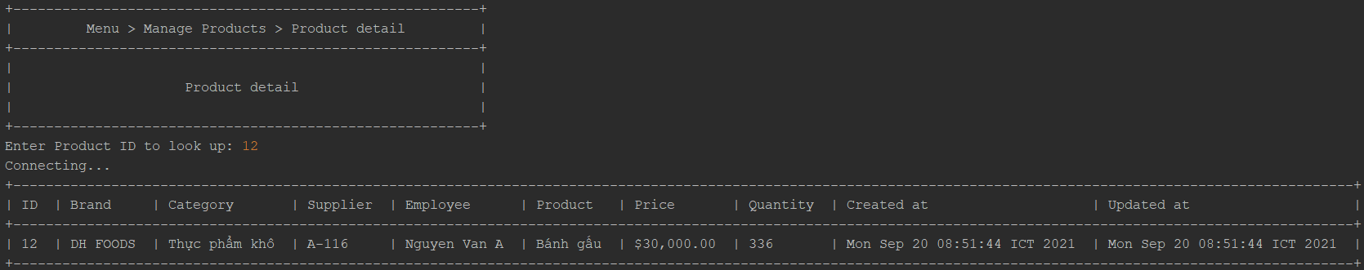

* Press “Enter” to return to Manage Product Menu, and enter “-1” to return to the Main Menu.

**1.2.5. Manage Categories**

* You can choose “1” to Search all Categories
* Choose “2” to Search some Categories by name
* Choose “3” to Search Category’s detail
* And “0” to Exit or “-1” to Go back

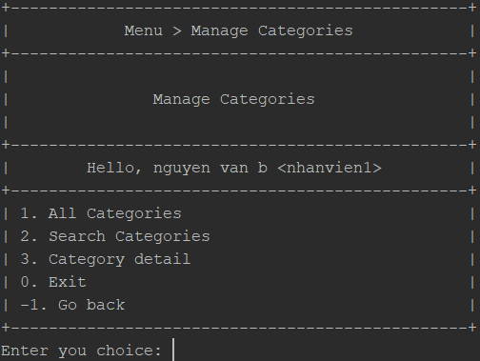

**1.2.5.1. All Categories**

* After choose “1”, it’ll show you all Categories in System

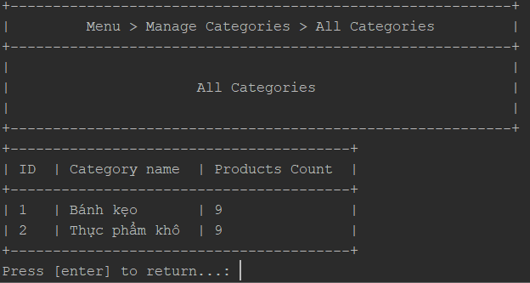

-It’s done, now ,Press “Enter” to return to Manage Categories Menu

**1.2.5.2. Search Categories**

-in this page, Enter some characters to search for Categories, and wait few seconds

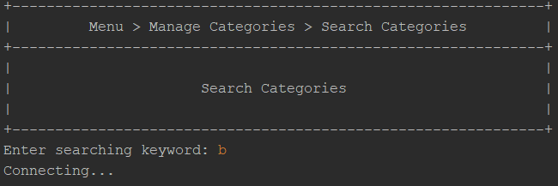

-Now, it’ll show you all Categories searched by name or characters you entered, like below

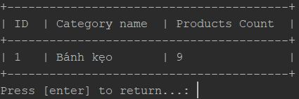

-Okay, now, Press “Enter” to go back Manage Categories Menu

**1.2.5.3. Search Category’s Detail**

-You need to enter Category’s ID to search Category’s Detail

-If that ID valid, it’ll show you all information of the Category

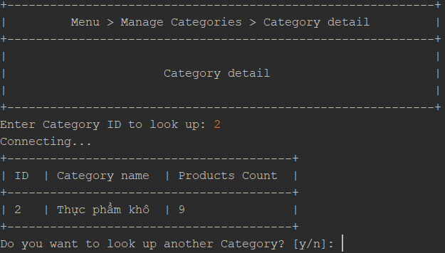

- Again, choose “Y” if you want to look up another Category, “N” if not.

- Return to Manage Categories Menu and choose “-1” to go back to Main Menu

**1.2.6. Manage Customers**

- You can choose “1” to Add a Customer to Member

- Choose “2” to edit information of the Customer Member

- Choose “3” to Search a Customer by their ID

- Choose “4” to Search a Customer by their Phone

- Choose “5” to Search all Customer Member in System

- And “0” to Exit or “-1” to Go back

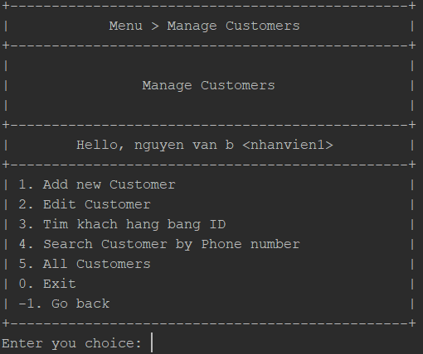

**1.2.6.1. Add new Customer**

-Enter their Name, phone number and Address and Press “Enter”, now, there's a Member to get some discount in the future.

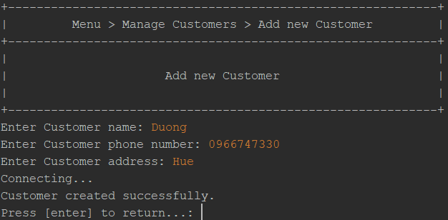

-Now,You can check their information in 1.2.6.3 or 1.2.6.4 and Edit their information in 1.2.6.2

-Press “Enter” to return to Manage Customer Menu

**1.2.6.2. Edit Customer**

- Enter Customer’s ID need to edit

- Enter new information for this Customer, like Name, Phone number, Address, then press “Enter”

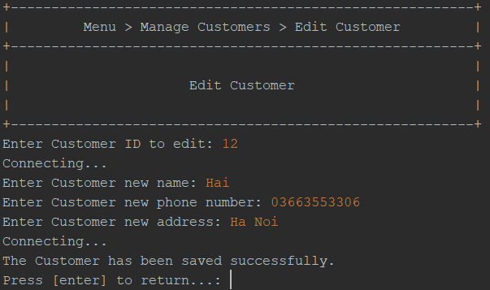

-Okay, now it’s done, you can recheck their information in Search Customer

**1.2.6.3. Search Customer by Customer’s ID**

-So now, you can enter Customer’s ID to search their information like Name, Phone number, Address, …

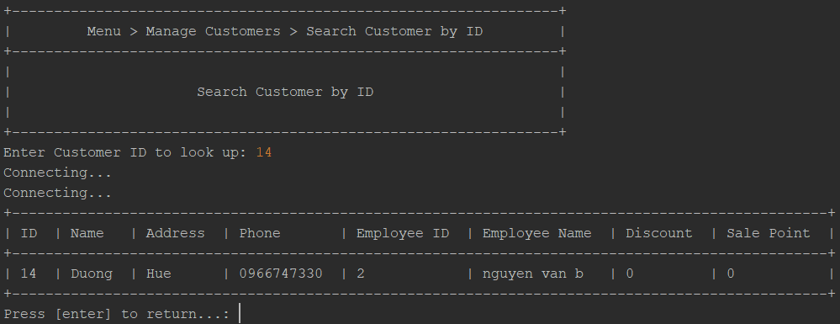

- Press “Enter” to return Manage Customers Menu

**1.2.6.4. Search Customer by Customer’s Phone number**

-in this part, you need to enter Customer’s Phone to search their information

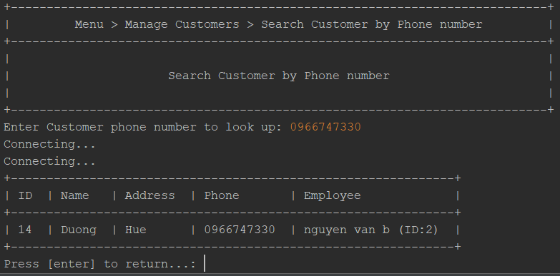

- Press “Enter” to return Manage Customers Menu

**1.2.6.5. Search all Customer in System**

- If you added their to Member, you’ll see all of them in this page

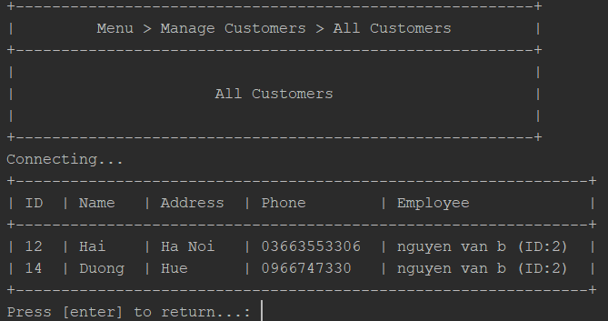

- Press “Enter” to return Manage Customers Menu

- It’s done now, you can choose “-1” to go back to Main Menu

**1.2.7. Change Password**

- you can’t edit your info, sounds bad, right? However, you still can change your password to keep your secret.

-Now, in this page, you need to enter your current Password, new Password and repeat new Password then Press “Enter”

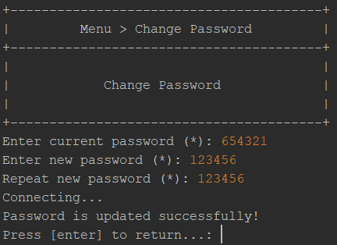

- It’s done, easy, isn't it?

- Now, you can Press “Enter” to return to Main Menu

**1.2.8. Statistics**

- you need to choose “start date” and “end date” you want to check, then press “Enter”

* Note : remember to enter “end date” not more than today

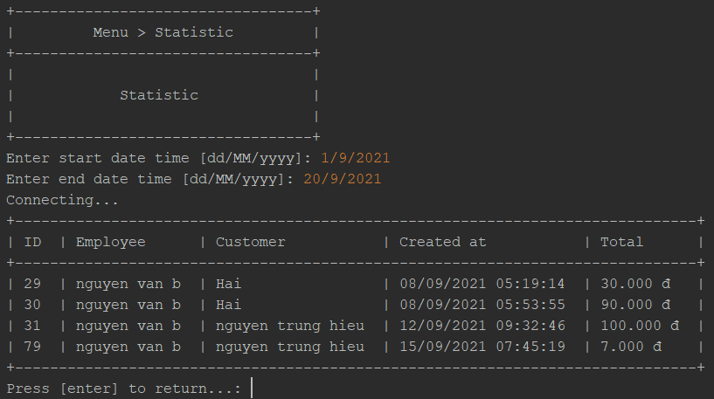

- see? It’s showed all orders in period of time you entered. Press “Enter” to return to Main Menu

- Okay, Everything is done now, you can choose “-1” to log out and Login with another account or choose “0” to Exit Program. Hope you enjoy our program.

## Inventory

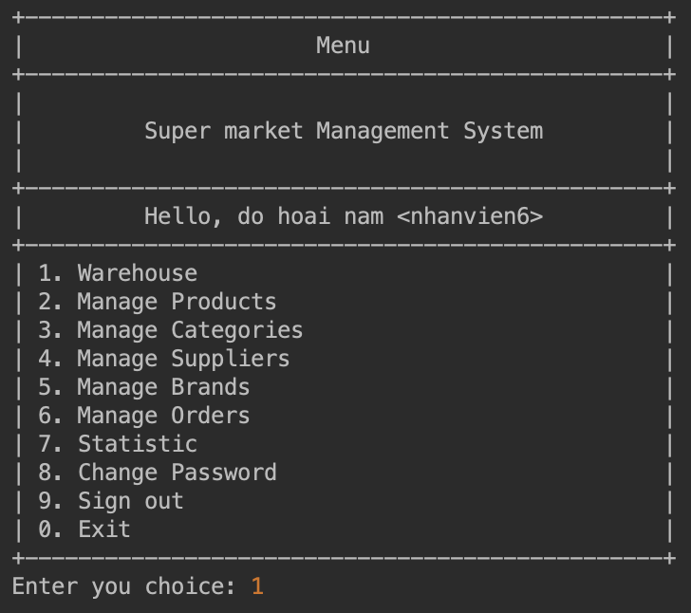Inventory Main Menu

### Warehouse management

#### Import Product A

See usage in here

#### Import Product History

See usage in here

### Manage Products

#### All Products

See usage in here

#### Search Products

See usage in here

#### Product detail

See usage in here

#### Products by Category

See usage in here

#### Add new Product

See usage in here

#### Edit Product

See usage in here

#### Delete Product

See usage in here

#### Out of stock products

See usage in here

#### 

### Manage Categories

#### Add new Category

See usage in here

#### Edit Category

See usage in here

#### Delete Category

See usage in here

#### All Categories

See usage in here

#### Search Categories

See usage in here

#### Category Detail

See usage in here

### Manage Suppliers

#### Add new Supplier

See usage in here

#### Edit Supplier

See usage in here

#### Delete Supplier

See usage in here

#### Search Suppliers

See usage in here

#### Supplier detail

See usage in here

#### All Suppliers

See usage in here

### Manage Brands

#### All Brands

See usage in here

#### Add new Brand

See usage in here

#### Edit Brand

See usage in here

#### Delete Brand

See usage in here

#### Search Brands

See usage in here

### Manage Orders

#### Order detail

See usage in here

#### All Orders

See usage in here

#### Search Orders by Customer

See usage in here

#### Search Orders by Date

See usage in here

### Statistic

#### Out of stock Products

See usage in here

#### Best Sale Products

See usage in here

#### Revenue

See usage in here

## Features

### Product

#### Add New Product

To add a new Product, you will have to enter these following values:

* Brand ID: ID of Brand for Product, enter positive integer only.
* Category ID: ID of Category for Product, enter positive integer only.
* Supplier ID: ID of Supplier for Product, enter positive integer only.
* Product Name
* Product Quantity: Enter positive integer bigger than 0
* Product Price: Enter positive integer bigger than 100

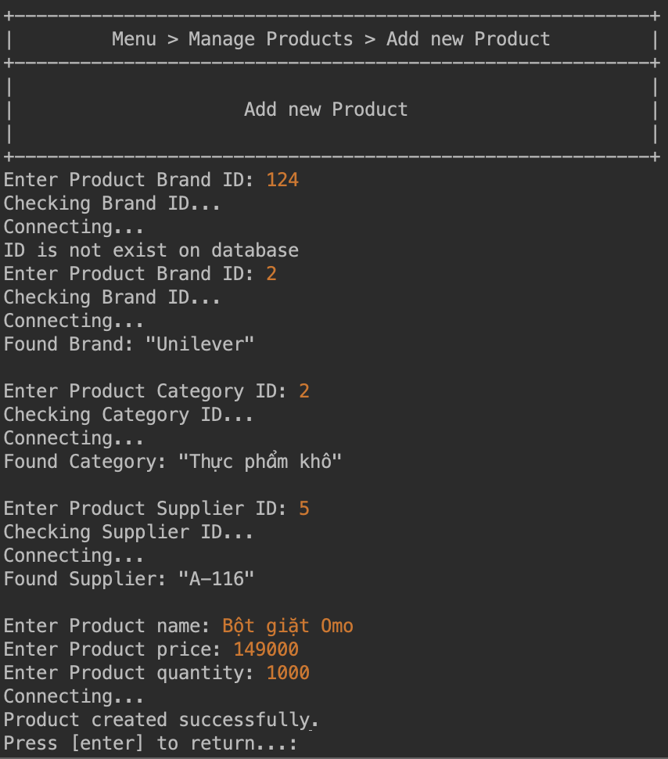

#### View All Products

View all Products that exists on system

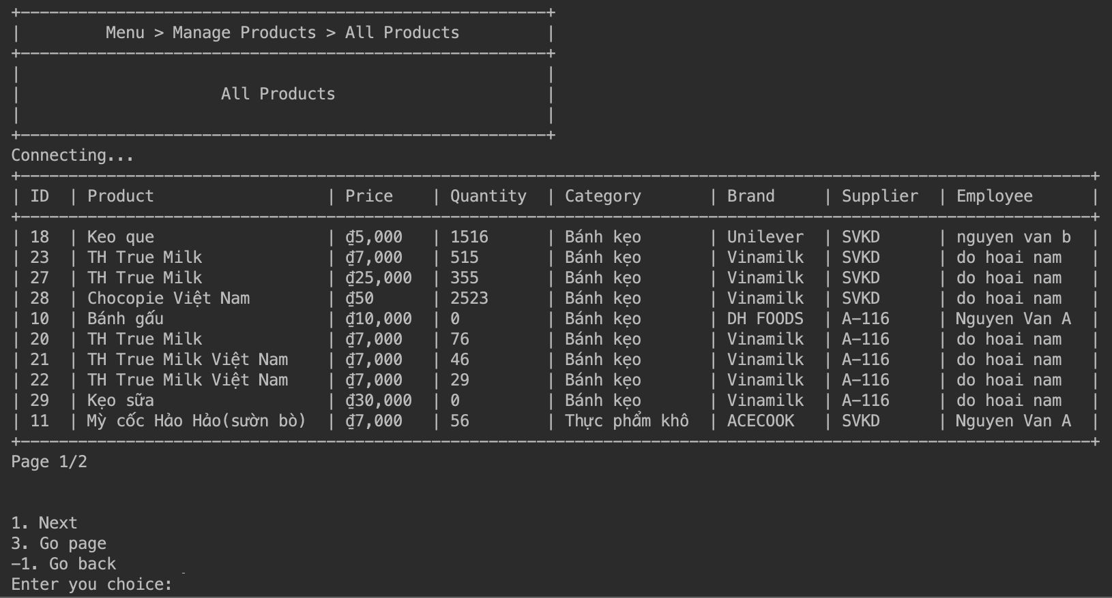

#### Search Products

Search of Products by name

1. Enter search name keyword
2. Press [enter] to submit searching
3. Matched Products will be shown in the table

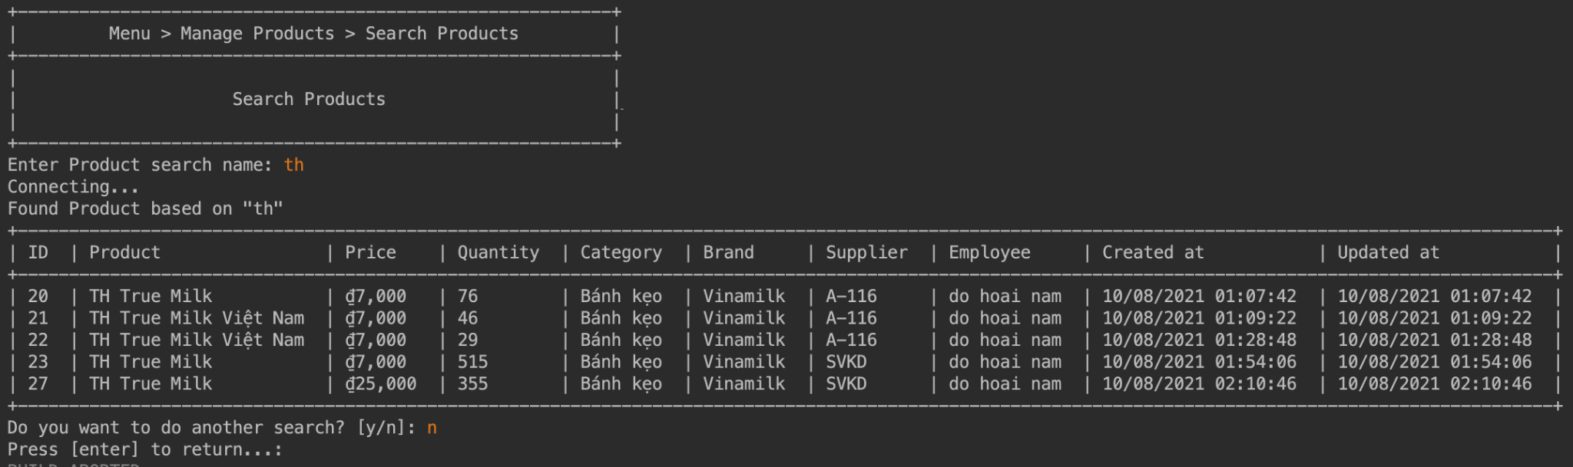

#### View Product Detail

Please follow these steps to look up Product detail:

1. Enter Product ID: positive integer value only.
2. Press [enter] to get result
3. Enter value “y” then press [enter] to do another search.

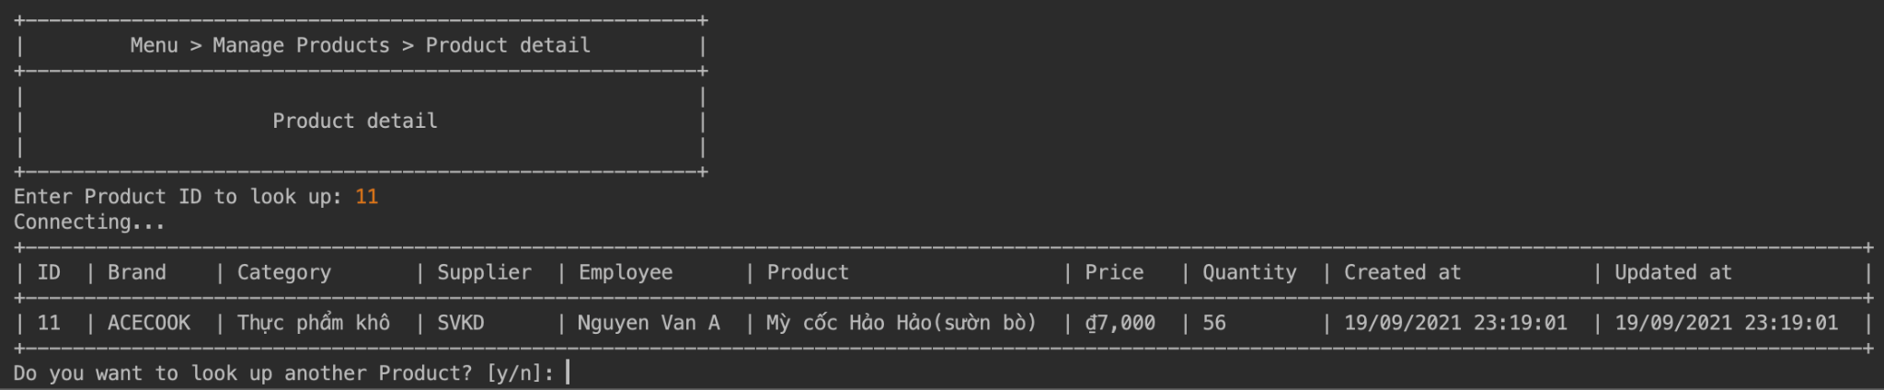

#### Products by Category

Please follow these steps to look up Product detail by Category:

1. Enter Category ID: positive integer value only.
2. Press [enter] to get result
3. Enter value “y” then press [enter] to do another search.

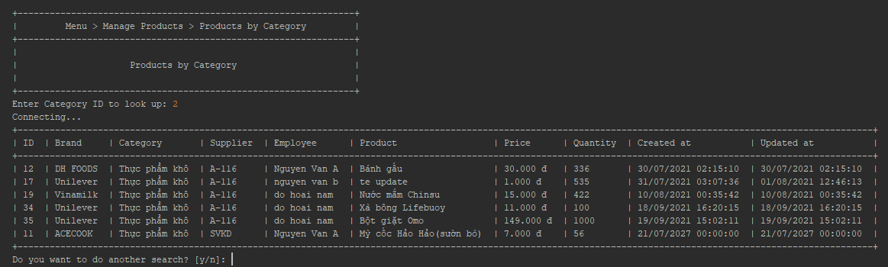

#### Edit Product

Please follow these steps to Edit Product detail:

1. Enter Product ID: positive integer value only.
2. Once you add a valid Product ID, the application will print the details of the matched Product.
3. Confirm if you want to update the Product name (y/n). If you choose “y”, you will be asked for a new Name of the Product.
4. Confirm if you want to update the Product price (y/n). If you choose “y”, you will be asked for a new Price of Product.
5. Confirm if you want to update the Product quantity (y/n). If you choose “y”, you will be asked for a new Quantity of Product.
6. Finally, Product will be updated.

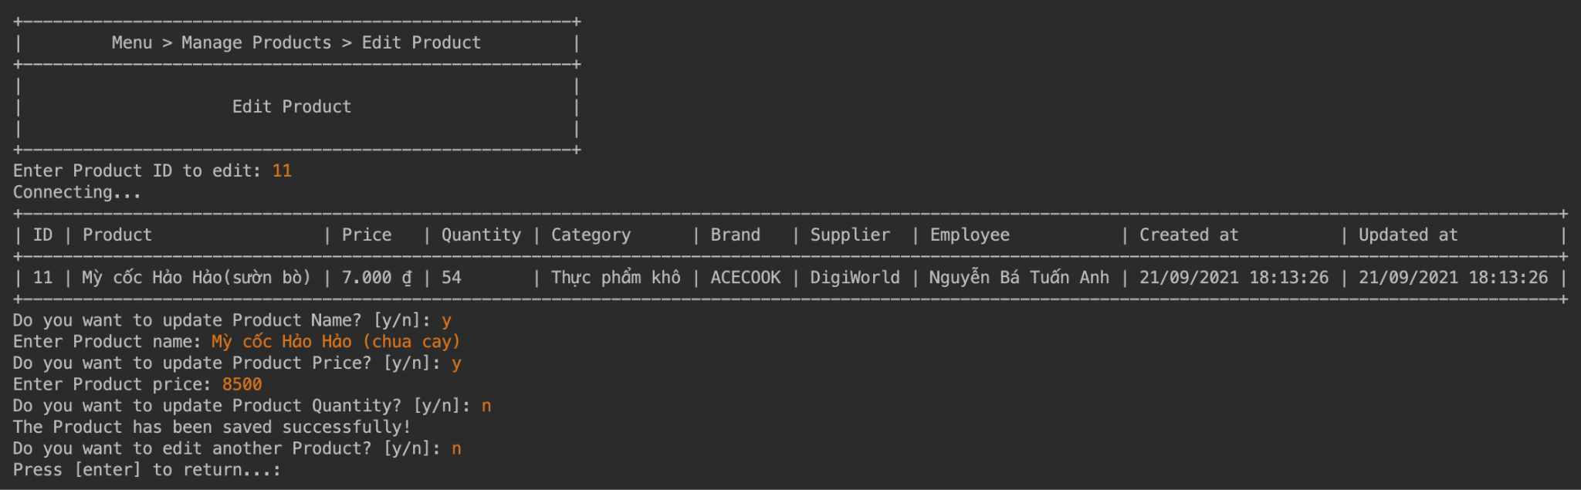

#### Delete Product

Please follow these steps to delete a Product:

1. Enter Product ID: positive integer value only.
2. Once you add a valid Product ID, the application will show you the name of the matched Product.
3. Confirm if you are sure to delete the Product (y/n)

Notice: You cannot delete a Product that is already Order related.

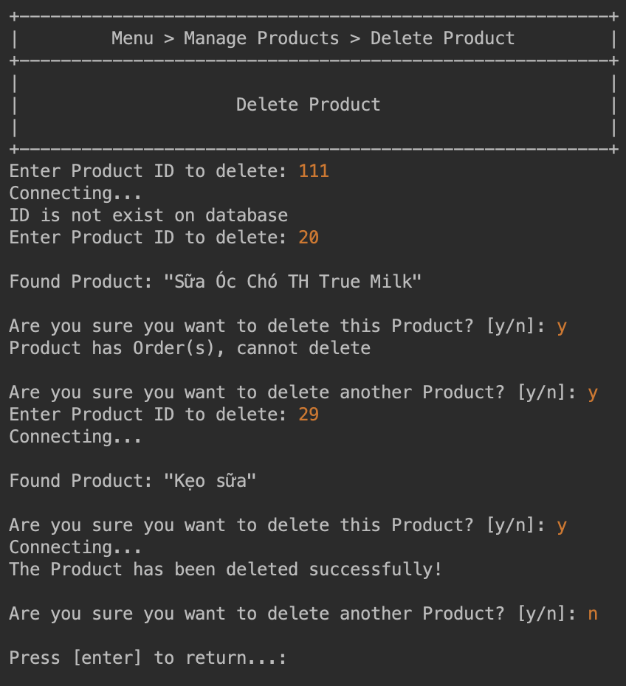

#### Out of stock Products

Show all out of stock Products

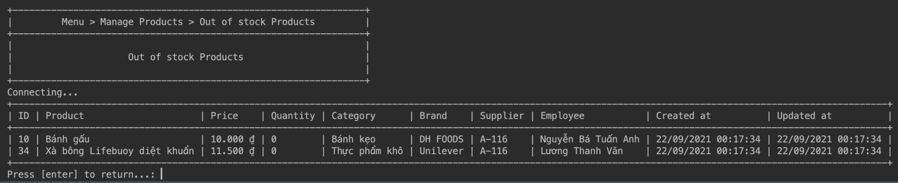

#### Best Sale Products

View the best sale Products by time range

1. Enter start date in format [dd/MM/yyyy]
2. Enter end date in format [dd/MM/yyyy], must be later than start date
3. Press [enter] to submit the searching time range
4. Best sold Products will be listed in descending of total sold quantity

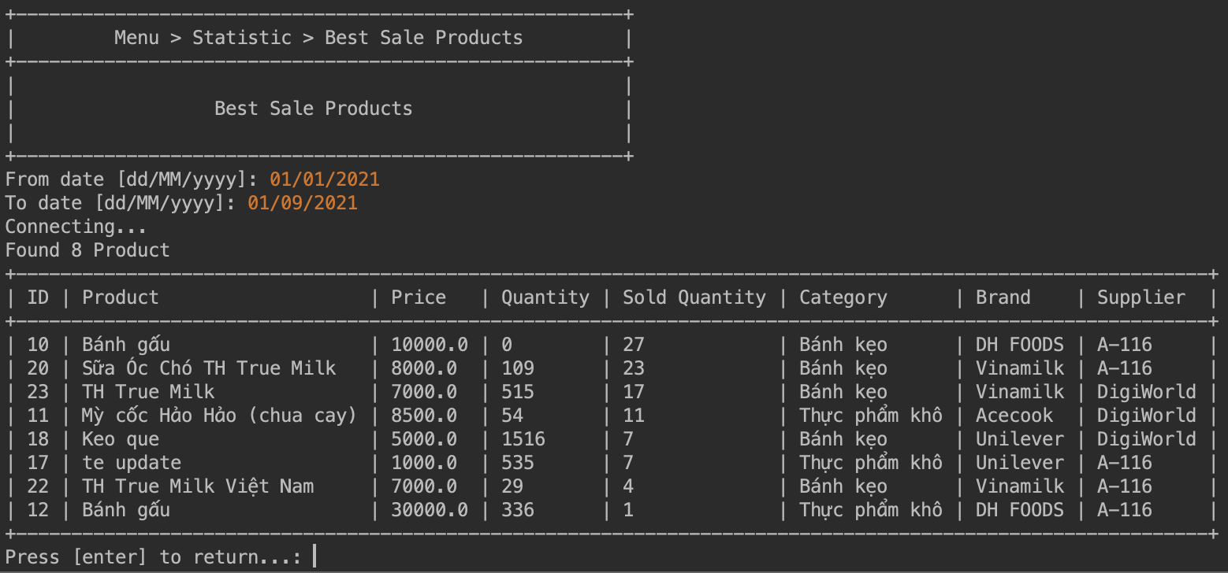

#### Import Product

Only the Inventory role account has access to this page.

Please follow these steps to import a Product:

1. Confirm if you want to check the list of all brands (y/n). If you choose “y”, the application will show a list of all brands.

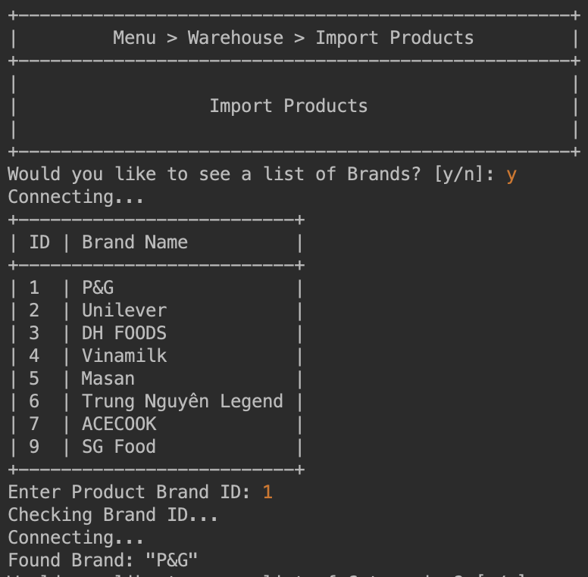

1. Enter Brand ID for new Product
2. The same flow in step 1 and 2 will be repeated for Category and Supplier

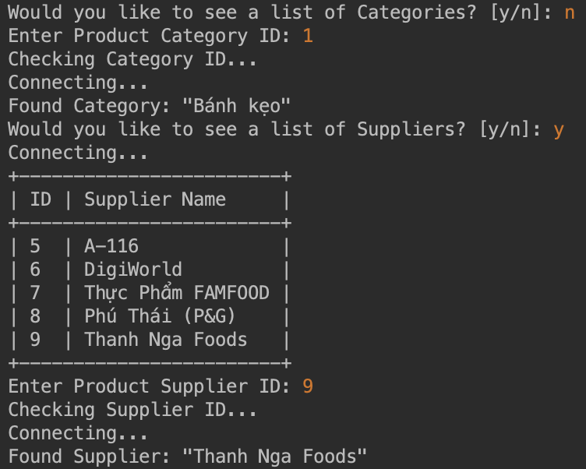

1. After entering Brand, Category and Supplier ID, you will need to enter product information such as name, price and quantity.

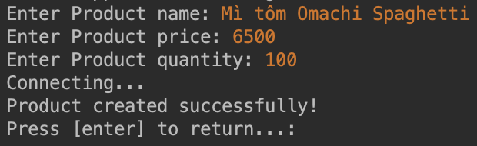

#### Import Products History

View recent import of Product

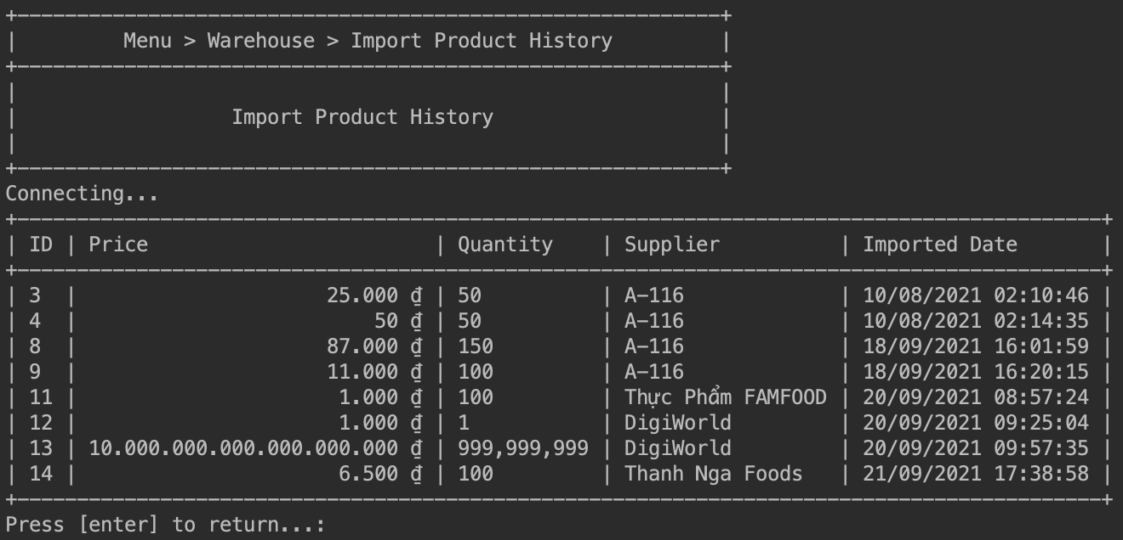

### Order

#### Order detail

Please follow these steps to look up Order detail:

1. Enter Order ID: positive integer value only.
2. Press [enter] to get result
3. Enter value “y” then press [enter] to do another search.

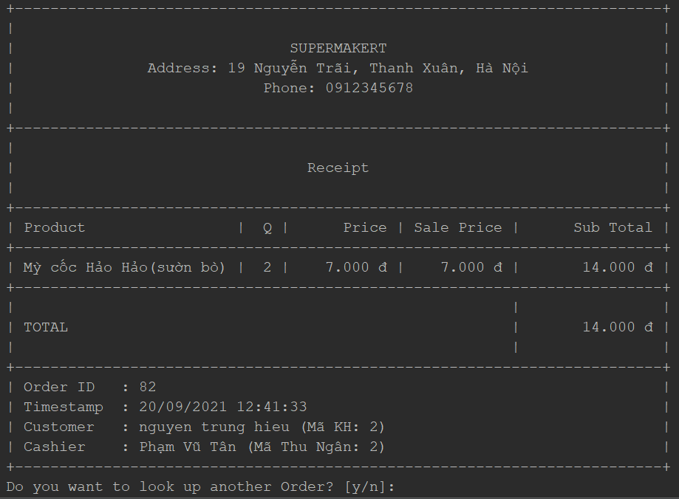

#### All Orders

View all Orders that exists on system

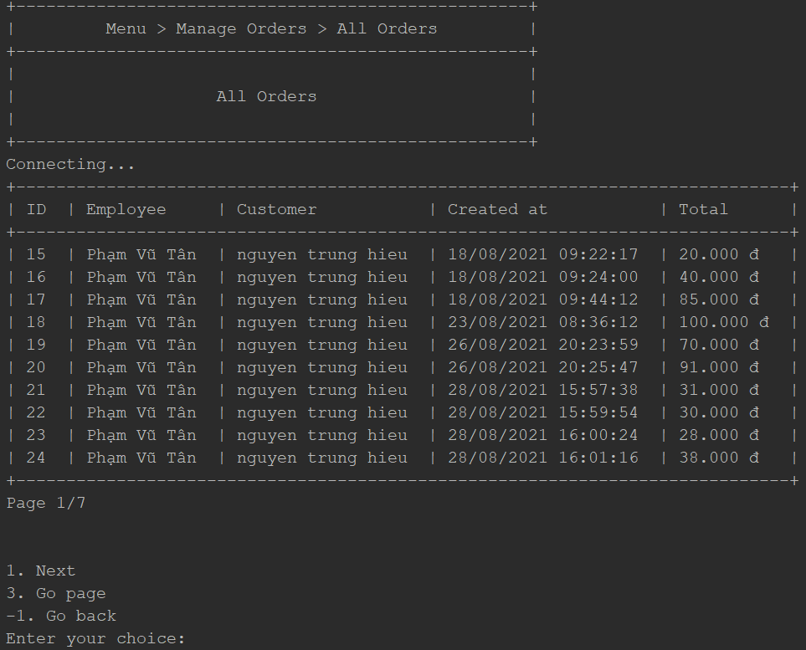

#### Search of Orders by Customer

Search of Orders by Customer phone

1. Enter the customer's phone search keyword
2. Press [enter] to submit searching
3. Matched Orders will be shown in the table

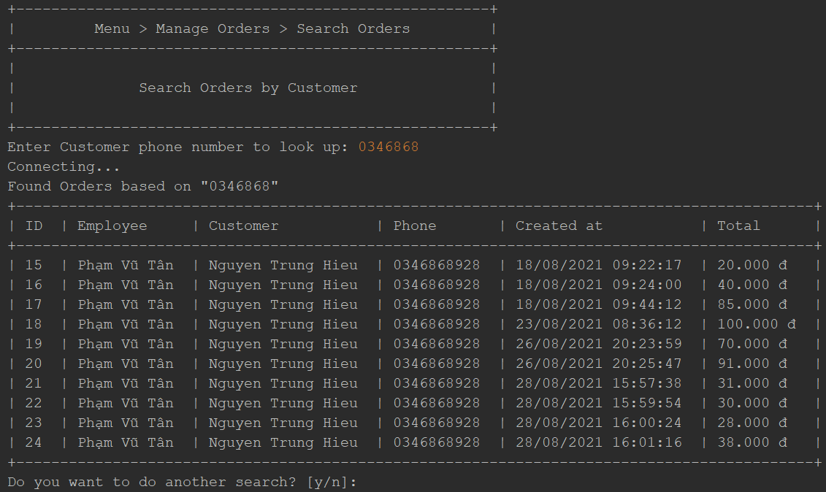

#### Search Orders By Date

Search of Orders by date

1. Enter date format dd/MM/yyyy
2. Press [enter] to submit searching
3. Matched Orders will be shown in the table

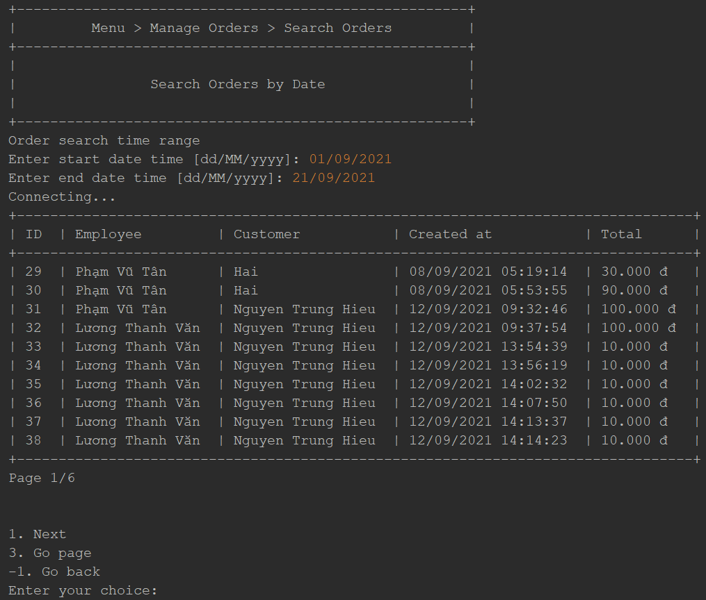

### Category

#### Add new Category

Enter Category name to create a new Category

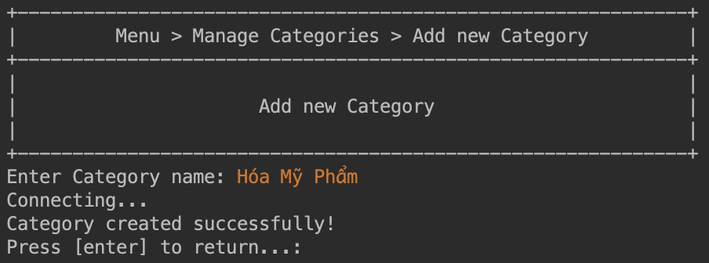

#### View all Categories

View all Categories that exists on system

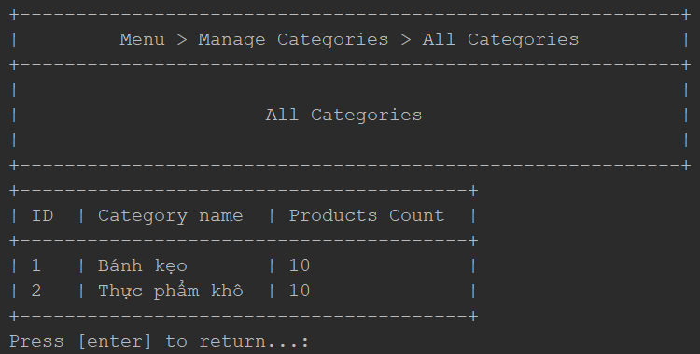

#### Search Categories

Search of Categories by name

1. Enter search name keyword
2. Press [enter] to submit searching
3. Matched Categories will be shown in the table

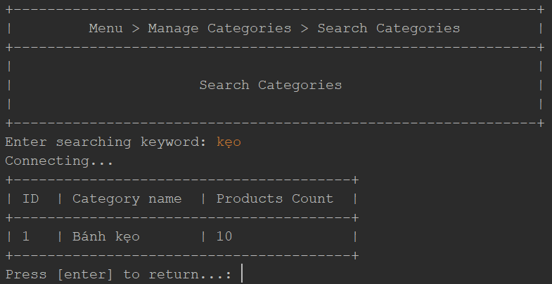

#### Category Detail

Please follow these steps to look up Category detail:

1. Enter Category ID: positive integer value only.
2. Press [enter] to get result
3. Enter value “y” then press [enter] to do another search.

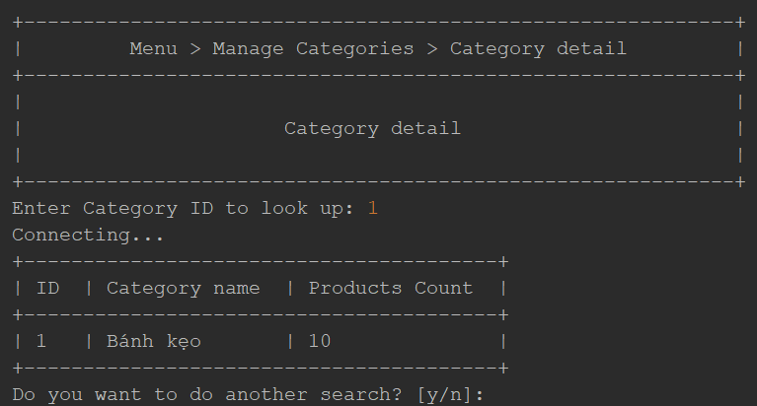

#### Edit Category

Please follow these steps to edit a Category:

1. Enter Category ID: positive integer value only.
2. Enter Category new name
3. Press [enter] to submit the change

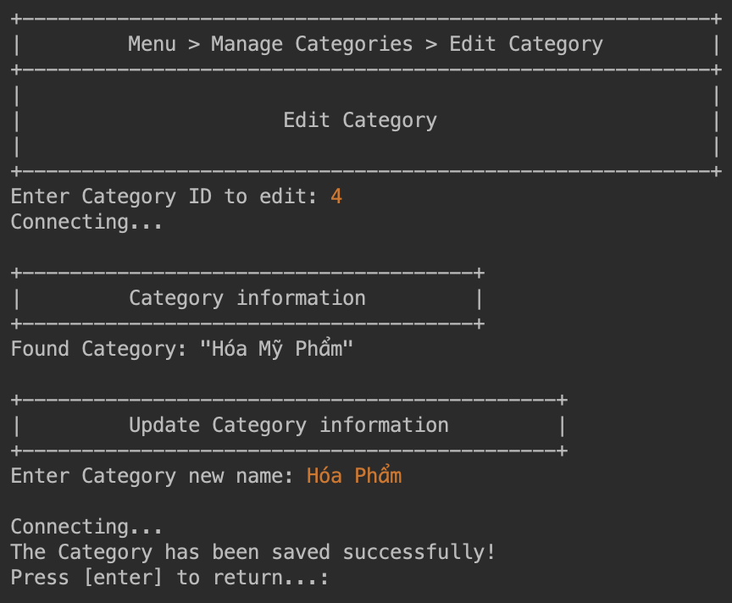

#### Delete Category

You are only able to delete a Category which is not linked to any Product.

Please follow these steps to look up Product detail:

1. Enter Category ID: positive integer value only.
2. Press [enter] to find the Category
3. Enter value “y” to confirm to delete.

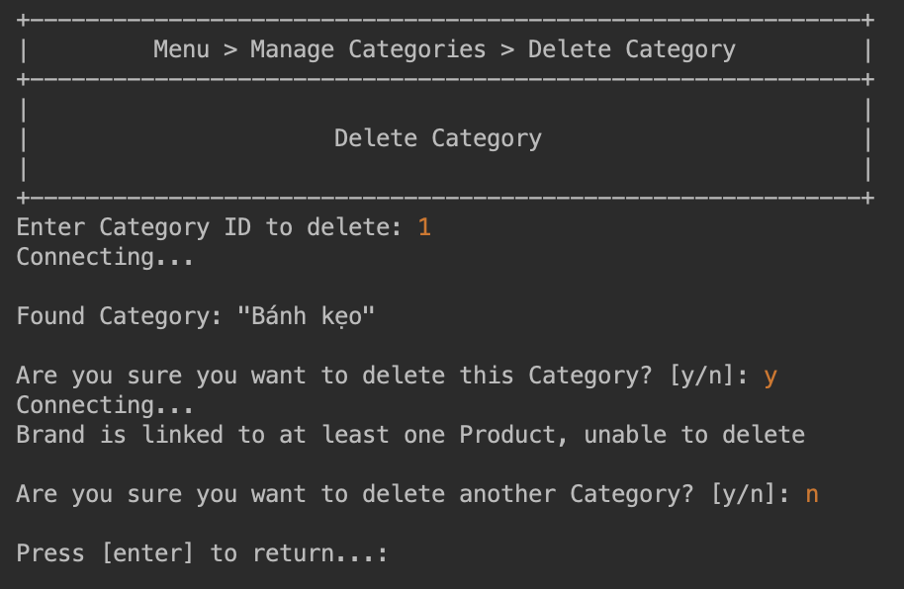

### Brand

#### Add new Brand

To add a new Brand, you will have to enter these values:

1. Enter Brand Name
2. Enter Brand Address
3. Press [enter] to submit the creation

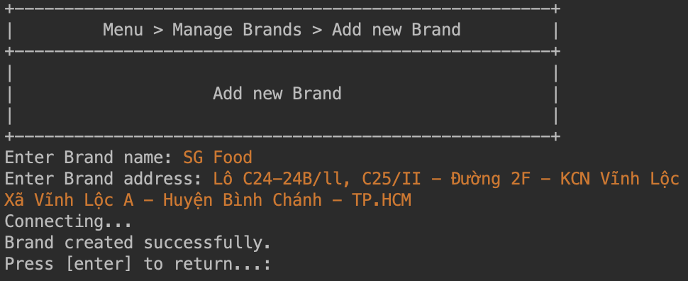

#### View all Brands

View all Brands on system

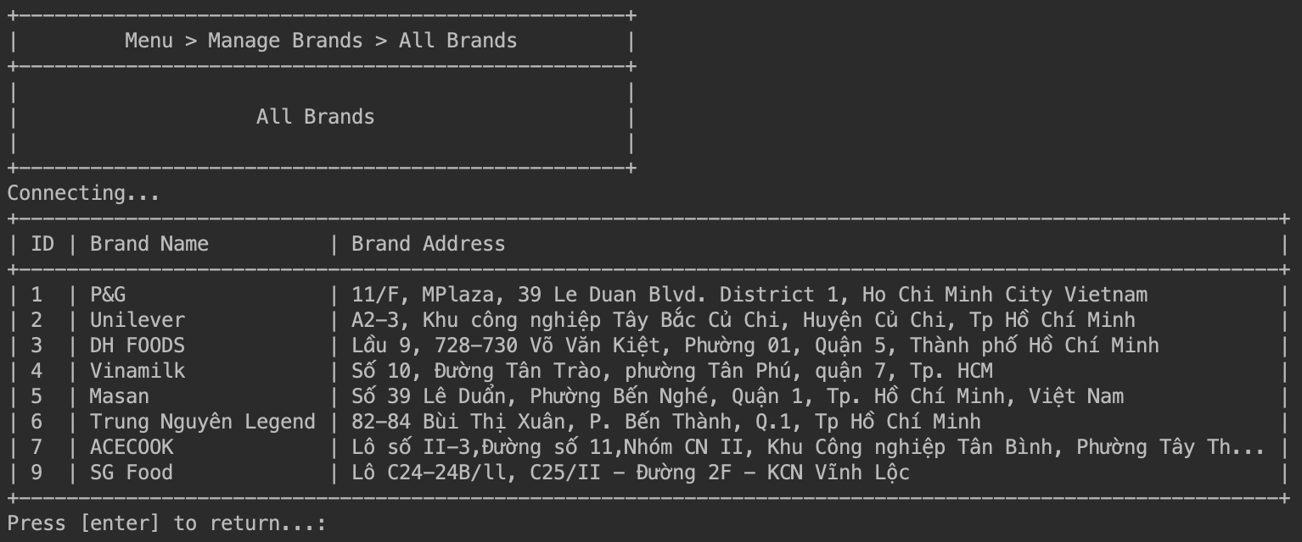

#### Search Brands

Search Brand by name

1. Enter search name keyword
2. Press [enter] to submit
3. Application will show all matched Brand that name contains the keyword

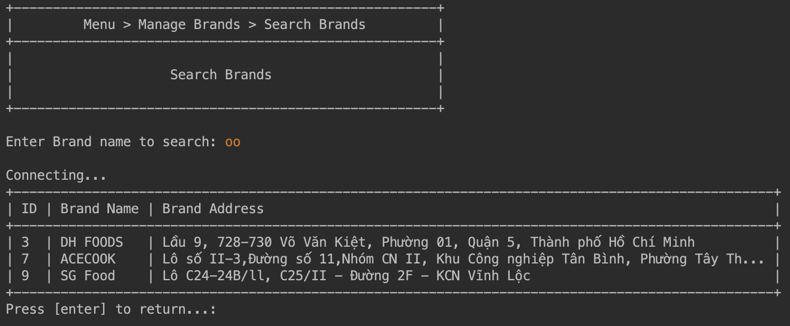

#### Edit Brand

Please follow these steps to update Brand information:

1. Enter Brand ID: positive integer value only.
2. Enter Brand name, leave empty to skip
3. Enter Brand address, leave empty to skip
4. Press [enter] to submit the changes

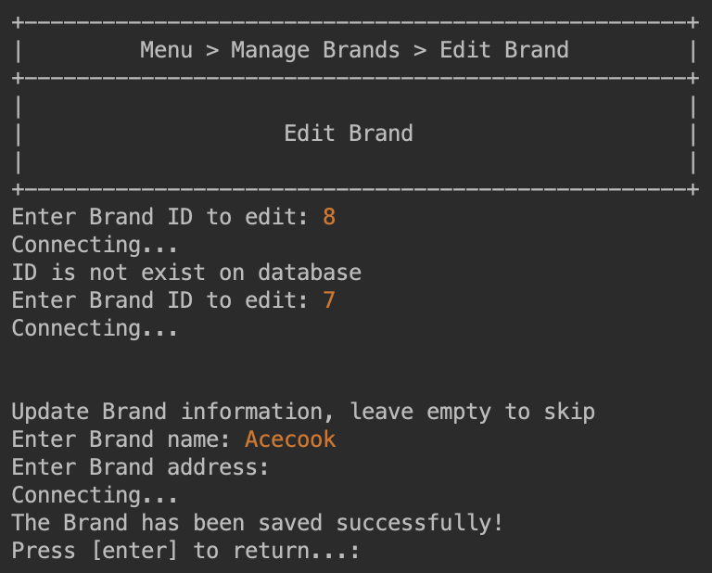

#### Delete Brand

You are only able to delete a Brand which is not linked to any Product.

Please follow these steps to look up Product detail:

1. Enter Brand ID: positive integer value only.
2. Press [enter] to find the Brand
3. Enter value “y” to confirm to delete.

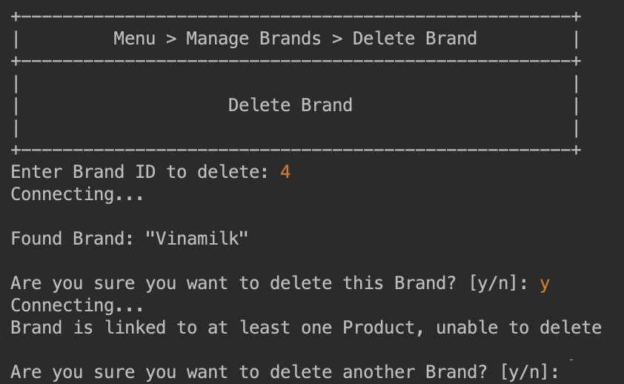

### Supplier

#### Add new Supplier

To add a new Supplier, enter option 1, and you will have to enter these following values:

* + - 1. Name: 3-100 characters
      2. Address: 3-255 characters

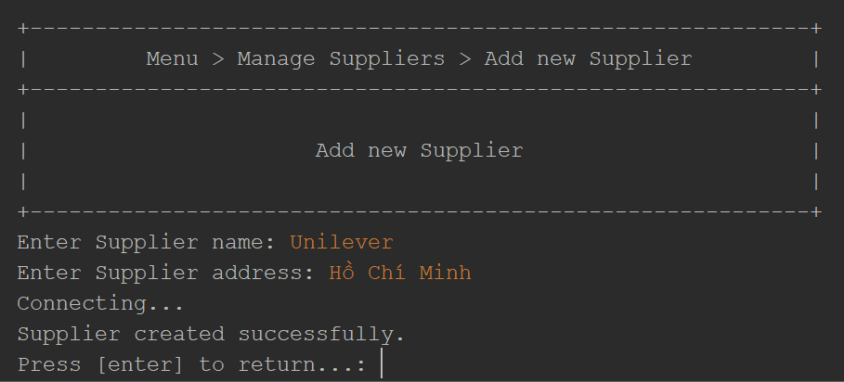

#### View all Suppliers

View all Suppliers that exists on system

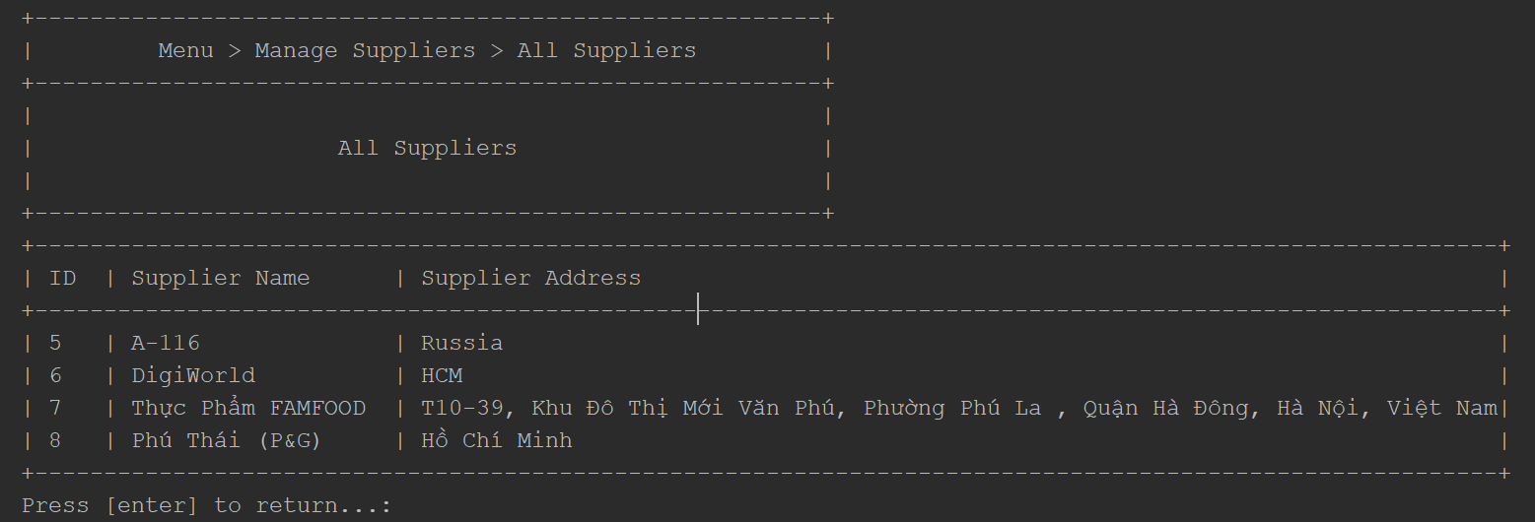

#### Search Suppliers

Search of Suppliers by name

1. Enter search name keyword
2. Press [enter] to submit searching
3. Suppliers that match the approximate name will be displayed in the table

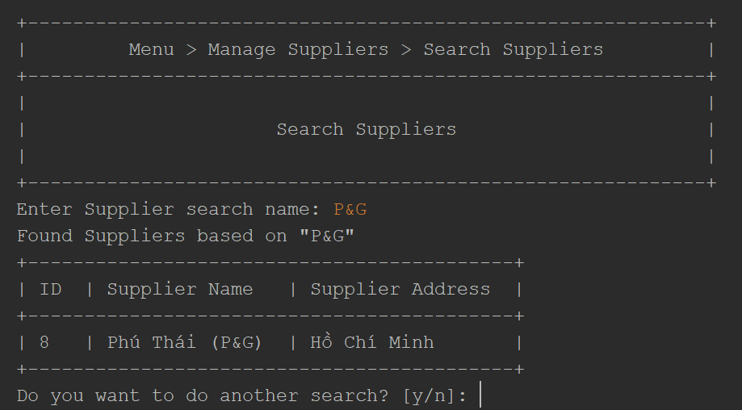

#### Supplier detail

Please follow these steps to look up Supplier detail:

1. Enter Supplier ID: positive integer value only.
2. Press [enter] to get result
3. Enter value “y” then press [enter] to do another search.

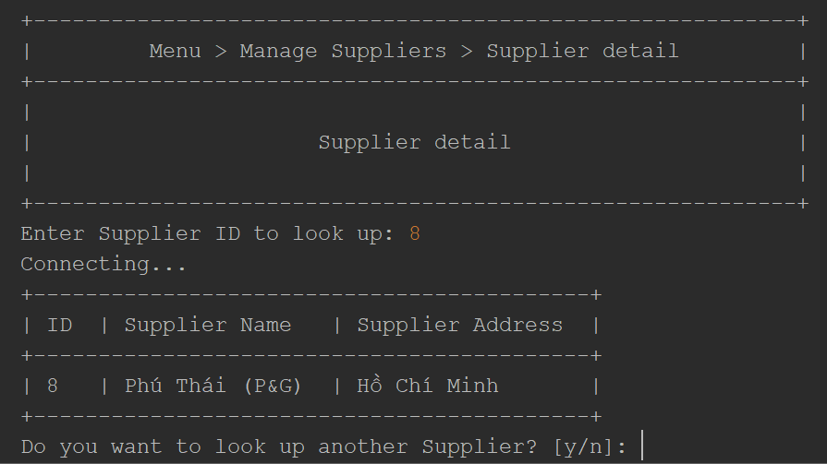

#### Edit Supplier

To edit a supplier's information, enter option 2. Fill in the Supplier ID and all information fields. Just like adding a new supplier.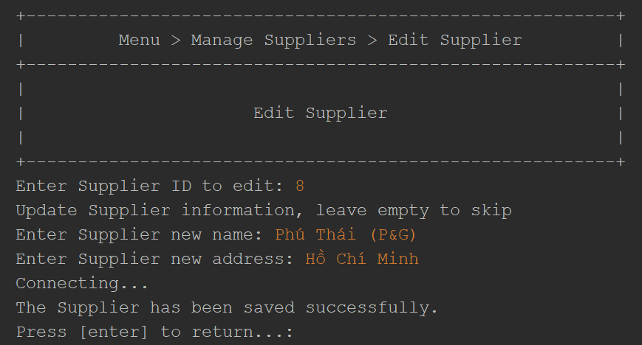

#### Delete Supplier

You are only able to delete a Supplier which is not linked to any Product.

Please follow these steps to look up Product detail:

* + - 1. Enter Supplier ID: positive integer value only.
      2. Press [enter] to find the Supplier
      3. Enter value “y” to confirm to delete.

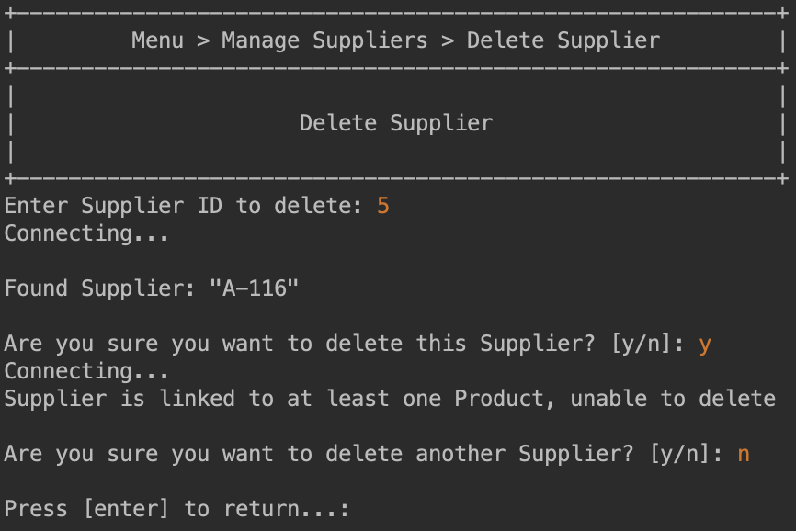

### Discounts

#### All Discounts

View all Discounts that exists on system

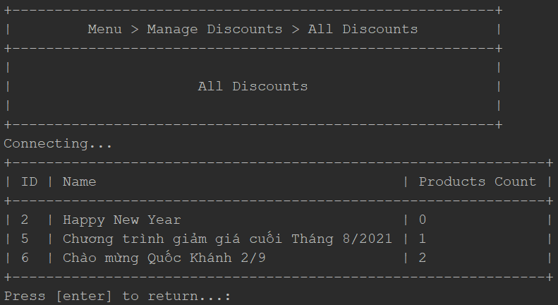

#### Discount detail

Please follow these steps to look up discount detail:

1. Enter Discount ID: positive integer value only.
2. Press [enter] to get result
3. Enter value “y” then press [enter] to do another search.

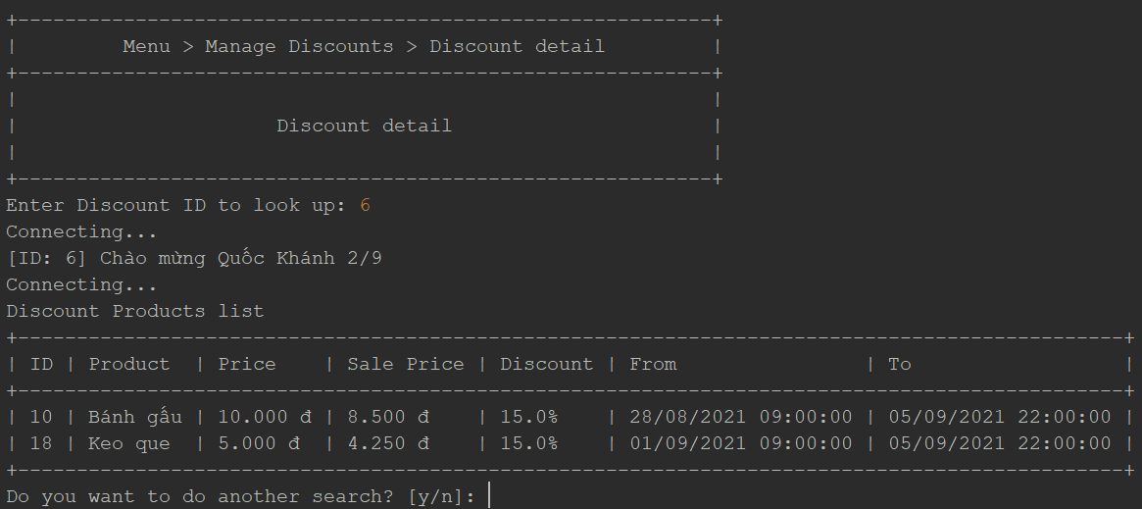

#### Add new Discount

To add a new Discount, enter option 1, and you will have to enter these following values:

* Name: 3-100 characters

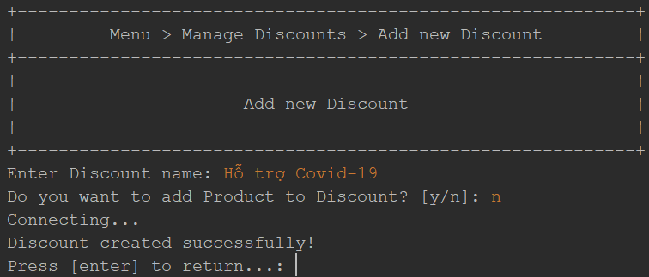

#### Edit Discount

To edit the Discount information, enter option 2. Fill in the Discount ID and select the items you want to edit

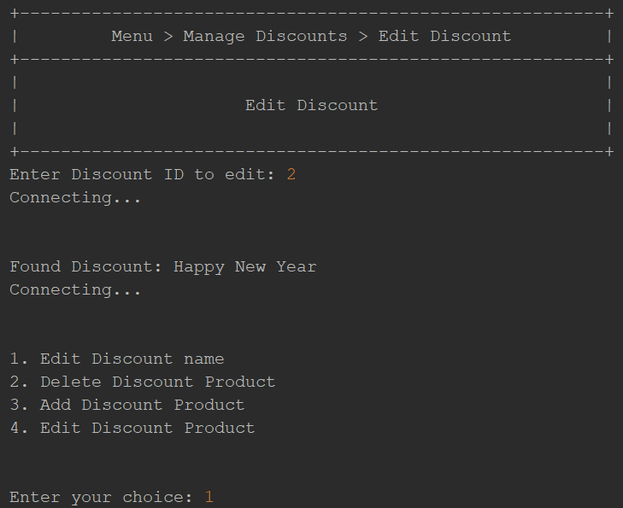

Edit Discount name: 3-100 characters

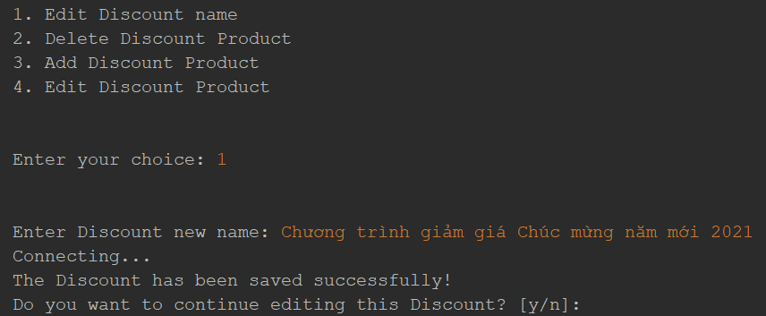

Delete Discount Product: Enter Product ID: positive integer value only.

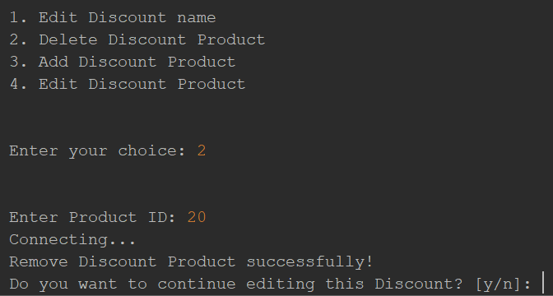

Add Discount Product:

* Enter Product ID: positive integer value only.
* Enter discount percentage
* Enter start time: dd/MM/yyyy HH:mm
* Enter end time: dd/MM/yyyy HH:mm

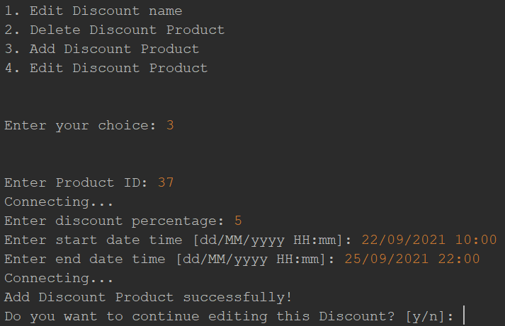

#### Delete Discount

You are only able to delete a Discount which is not linked to any Product.

Please follow these steps to look up discount detail:

1. Enter Discount ID: positive integer value only.
2. Press [enter] to find the Discount
3. Enter value “y” to confirm to delete.

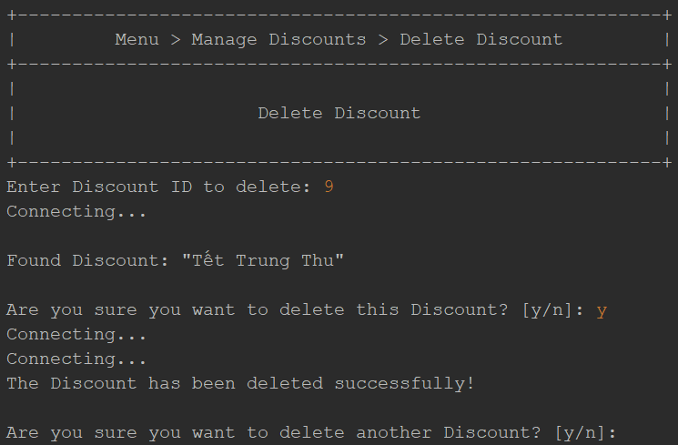

### Employee

* + 1. Add New Employee  
       See usage in here
    2. Edit Employee  
       See usage in here
    3. Delete Employee  
       See usage in here
    4. Search Employees  
       See usage in here
    5. All Employees  
       See usage in here

### Revenue

Show the revenues of:

* Today revenue
* Yesterday revenue
* Last 7 days revenue
* Last 30 days revenue
* This month revenue
* Last month revenue
* Revenue by custom time range

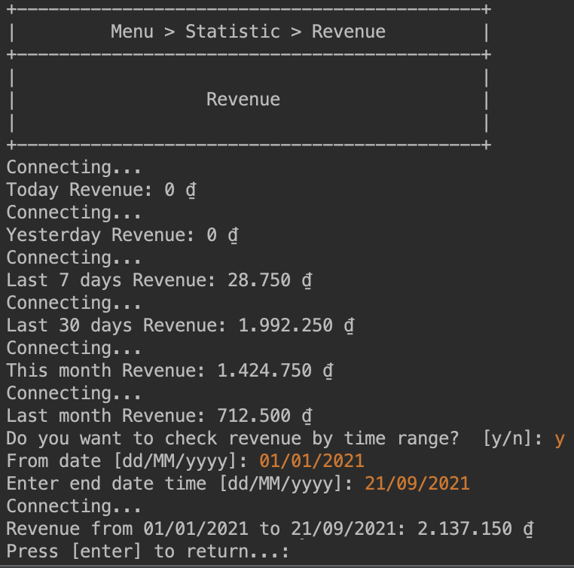

### Change password

Every employee account can be able to change passwords. Please follow these steps to change the employee account password.

1. Enter account current password
2. Enter account new password
3. Repeat the new password in step 2
4. Press [enter] to submit the change

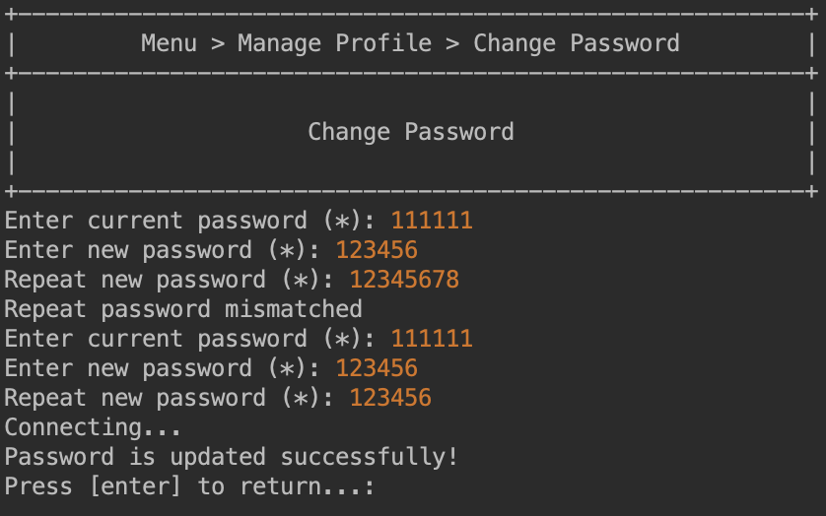

### Change Profile

Only admin accounts have the abilities to update their profile, includes account name, address and phone number.

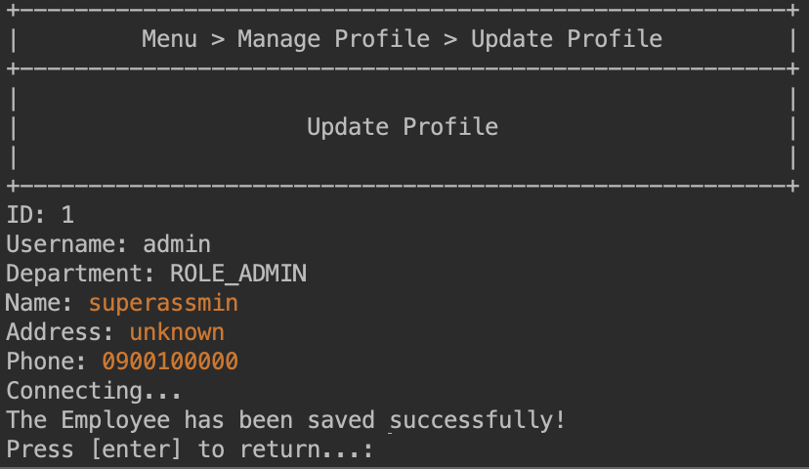

## Usage

### Navigation

#### Choose Sub Menu/Page

Whenever a Menu is printed, the application will ask you for a choice, enter the number in front of the Menu item title that you want to go to, then press the [enter] button.

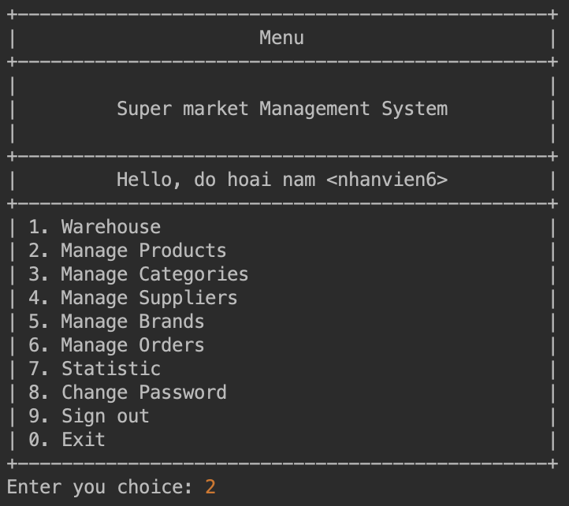

Example for Menu choice selection

#### Go Back on Sub Menu

On every sub menu, you will be able to see and choose Menu item “-1. Go back” to go back to the latest Menu upper

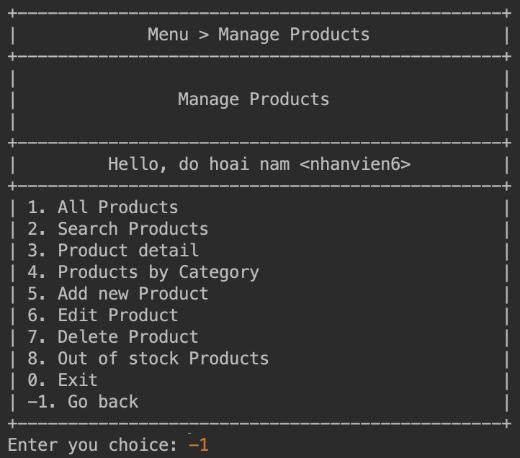

Example for choose Go back Menu item

#### Go Back on Page

At the end of any regular Page, when all the actions are taken and done, you will be able to see an instruction letting you know that you can press the [enter] button to return to the parent menu.

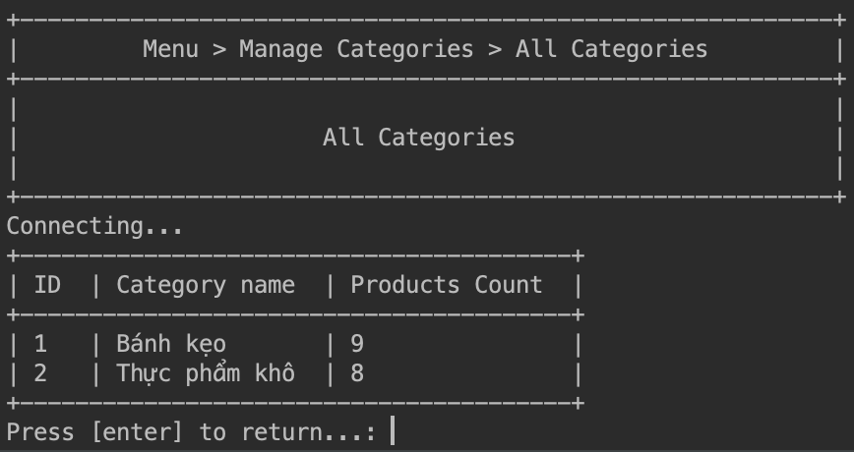

Example for Going back on Page

#### Exit

On every Menu, you will be able to see and choose “0” as Exit from the application.

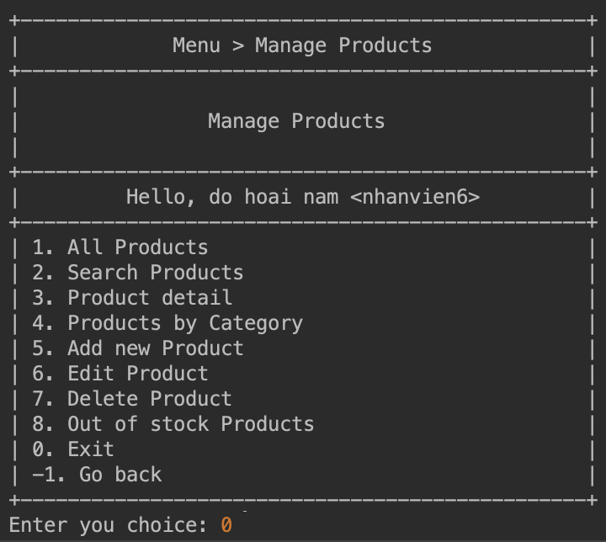

Example for choose Exit Menu item

### Pagination

When the table has Pagination, you can navigate between pages to view more records.

Page index will be shown in the bottom left of the table, which indicates the current page and total pages that are available.

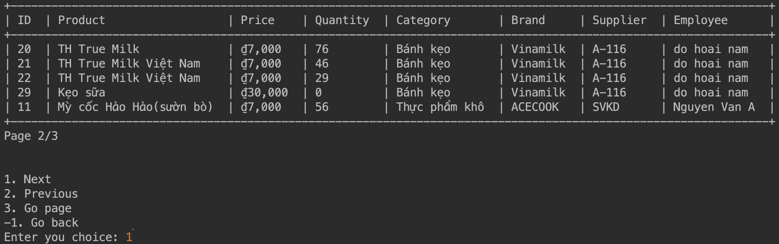

You can either choose one of these options:

1. **Next**: Go to next page (only available if there is next page)
2. **Previous**: Go to previous page (only available if there is previous page)
3. **Go page**: Go to specific page
4. **Go back**: Go back to the parent menu.