**Technology Review Assignment: Heart Rate Monitoring System**

**Garrett Clay**

**ECE 441**

**10.19.2013**

* 1. **Project Introduction**

The American dream of prosperity and success is also a silent advocate for living an unhealthy lifestyle. Too often the concept of hard work is associate with forgoing basic bodily needs like rest, relaxation and physical exercise. As a society, we need to put greater emphasis on living healthy, balanced lifestyles or we will give the phrase, “worked to death” a morbid connotation.

The leading cause of death for both men and women is heart disease. About 600,000 Americans die from heart disease each year.[1] “While there have been no conclusive studies that stress alone is enough to cause heart disease, one thing is known, the effect of chronic stress on your mind, body, and heart are detrimental enough to warrant as much attention as confirmed risk factors like high blood pressure and high cholesterol. The more you can do to find healthy ways of managing stress today, the better your life (and heart) will be.” [2]

The first step in living healthier is understanding what daily practices contribute negatively to your health. Almost everyone has a general sense of what is healthy and what isn’t. For example, its generally agreed upon that consistently getting too little sleep is unhealthy. But how can we put numbers to health to determine just how bad or good a particular practice is? Currently this is being done through medical equipment doctors use to check your vitals. It’s common practice for your doctor to check your blood pressure and heart rate every time you go in for a checkup. However, one data point each doctor visit hardly seems like an adequate way to predict someone’s health. In order to get a more accurate representation of ones health, data needs to be collected much more frequently.

This project aims to create a device that will improve the health of its users by constantly monitoring their heart rate and by making that data easily accessible. Careful consideration will be given to being nonintrusive and simplistic in use. By being in the form factor of a watch, the user won’t be annoyed by a foreign wearable device. To keep the device simplistic, it will be battery powered and have the ability to transmit data wirelessly to a mobile device.

After speaking with a former student who successfully designed and built a similar heart rate monitoring device, we recognize that having basic watch features, such as the ability to tell time or set an alarm, are what set products apart in consumer space. There are many mobile devices in the market that monitor heart rate but not many have the features that are common in other mobile devices. That being said, in order to keep the scope of this project realistic and timely, potential features have been ranked in order of importance. The five most important features to this project are reliable heart rate monitoring, battery powered, communication with a mobile device, intuitive user interface and a practical form factor.

After careful consideration, our design group has created the table below to show the order of importance of potential features. It should be noted that not all of the features listed in Table 1 will be part of this project. They are merely being considered during our research phase.

|  |  |  |
| --- | --- | --- |
| **T1 – Required** | **T2 – Desired** | **T3 – Optional** |
| HR monitor | tell time | stopwatch |
| communication with mobile device | display | timer |
| intuitive UI | application | alarm clock |
| practical form factor | motion monitoring | solenoid (vibrate) |
| battery powered | data interpretation | user profile |
|  | data logging | GPS |
|  | HR range warning | real time HR |
|  | battery charge indicator | charging circuit |
|  |  | music control |
|  |  | skin temp |
|  |  | ambient temp |
|  |  | as cost efficient to customer as possible |

Table

* 1. **Technology Table**

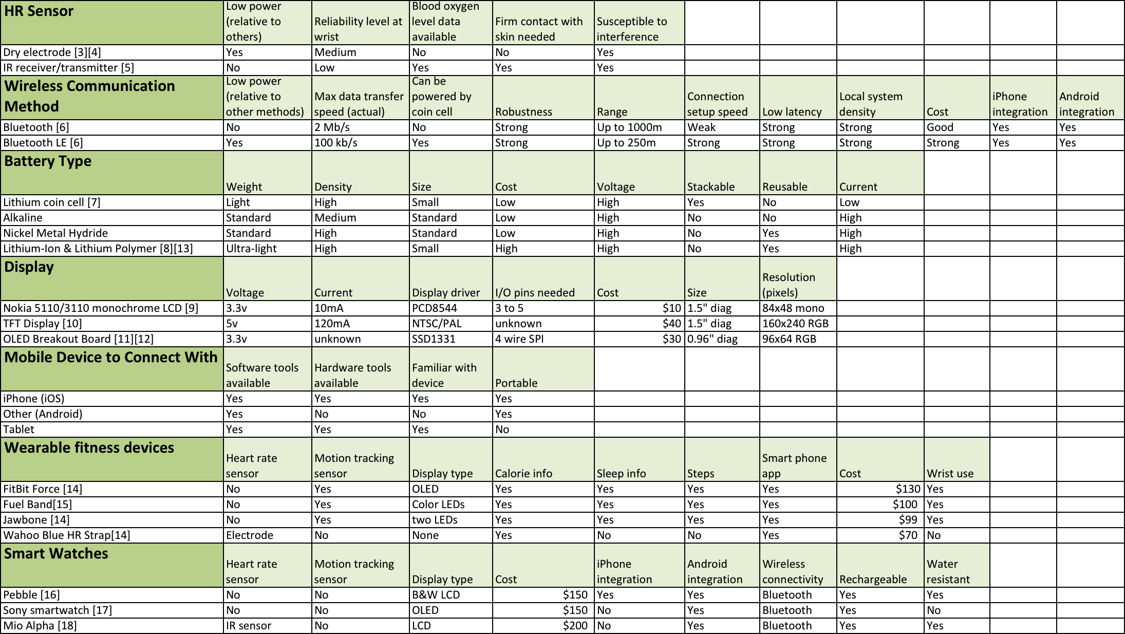

Table

* 1. **Technology Analysis**

1. HR Sensor

There are two predominate heart rate sensors on the market today; electrodes and IR packages. As with most things, they each have their pros and cons. See the Table 2 for side-by-side comparisons. After reviewing the advantages electrodes have over IR packages it was clear that electrodes are the more suitable choice for this project.

Electrodes, specifically the dry electrode, consumes less power, gives a more reliable heart rate reading from the wrist and doesn’t necessarily need direct skin contact where the IR package is the opposite.[3][5] The first level of features listed in Table 1 establish that this project needs to provide heart rate data and be battery powered. Because of these constraints, using an IR package as the heart rate doesn’t meet the requirements as well as a dry electrode does.

However, IR packages can provide heart rate readings and blood oxygen level data simultaneously where electrodes can’t. [5] Although this added feature would provide the user with more data, it is outside the scope of this project and therefore disqualified. This leaves with the dry electrode with multiple advantages over the IR package making it the clear choice for heart rate sensor.

1. Wireless Communication Method

Although there are many forms of wireless communication, Bluetooth was the clear choice for this project because of its wide usage and support groups, its common usage with mobile computing devices and because it was the form of wireless communication our group was most familiar with. Two of the project leads have used Bluetooth but never Bluetooth LE. For this reason, both were evaluated. Ultimately, Bluetooth LE seems like a better fit for this project. This is primarily due to the face that Bluetooth LE consumes less power than traditional Bluetooth. [6]

Other considerations were the signal strength, speed and robustness. In each of the aforementioned categories, traditional Bluetooth is better than Bluetooth LE. Upon further investigation, it was determined that Bluetooth LE has a signal strength, speed and robustness that is satisfactory for the requirements of this project. [6]

1. Battery Type

As is evident in Table 2, Lithium-Ion/Lithium Polymer or Lithium coin cell are the only battery types that meet the practical form factor requirement from Table 1. When comparing these two you can see that the main differences lie in cost and current. [7][8] Since cost is not one of the more pivotal criteria and current demanding features are (display, wireless communication system, etc..), the Lithium-Ion/Lithium Polymer battery is the better choice.

1. Display

It is important to note that inclusion of a display on the heart rate monitoring system is desired but not required according to Table 1. One option not listed in Table 2 is the option to not have a display. The following evaluation of displays assumes at least one display will be chosen.

Based on Table 1, low power and practical form factor are the two most constraining factors to consider when choosing a display. When evaluating from power consumption, the TFT display is disqualified since it consumes the most power of the three. [10] Due to the form factor restraints, the OLED Breakout Board is the best option. [11] Being only 0.96” diagonally, it is reasonably sized to we worn on a wrist.

1. Mobile Device to Connect With

The primary consideration as to what mobile device to connect was derived from a practical desire to use what resources are readily available. Given that iPhone software and hardware was the most used and available, it was chosen to be the mobile device to connect with.

1. Wearable Fitness Devices

This project aims to bridge the gap between smart watches and wearable fitness devices. Surprisingly, few products exist today that have the common smart watch features with fitness functionality. That being said, the primary objective is to create a heart rate monitoring system. The secondary objective is to integrate smart watch features.

Of the wearable fitness devices that can be worn on your wrist, the FitBit Force was arguably the best engineered project.[14] It’s sleek design and simple use make it friendly for all users. Its OLED screen is a particularly popular feature. It seems as though most wearable fitness devices provide the same data yet none of them have heart rate sensors that can be used on your wrist. The only exception to this rule is the Mio Alpha that is classified as a smart watch in Table 2.

1. Smart Watches

Although many of the smart watches offer the same features, the Mio Alpha is the only smart watch to offer heart rate data based off of a heart rate sensor. The Mio uses two high-powered LEDs to measure the users heart rate using an IR package. [18] The downside to the Mio that products like the Pebble and Sony smart watch do have include timers, alarm clocks and many other common smart phone technologies. This solidifies there are few smart watches on the market that also feature heart rate sensors.

* 1. **Possible Design Requirements**

Customer requirements:

1. Must measure heart rate
2. Must have practical form factor
3. Must have intuitive user interface
4. Must be battery powered
5. Must communicate with a mobile device
6. Must display data
7. Must function under expected conditions

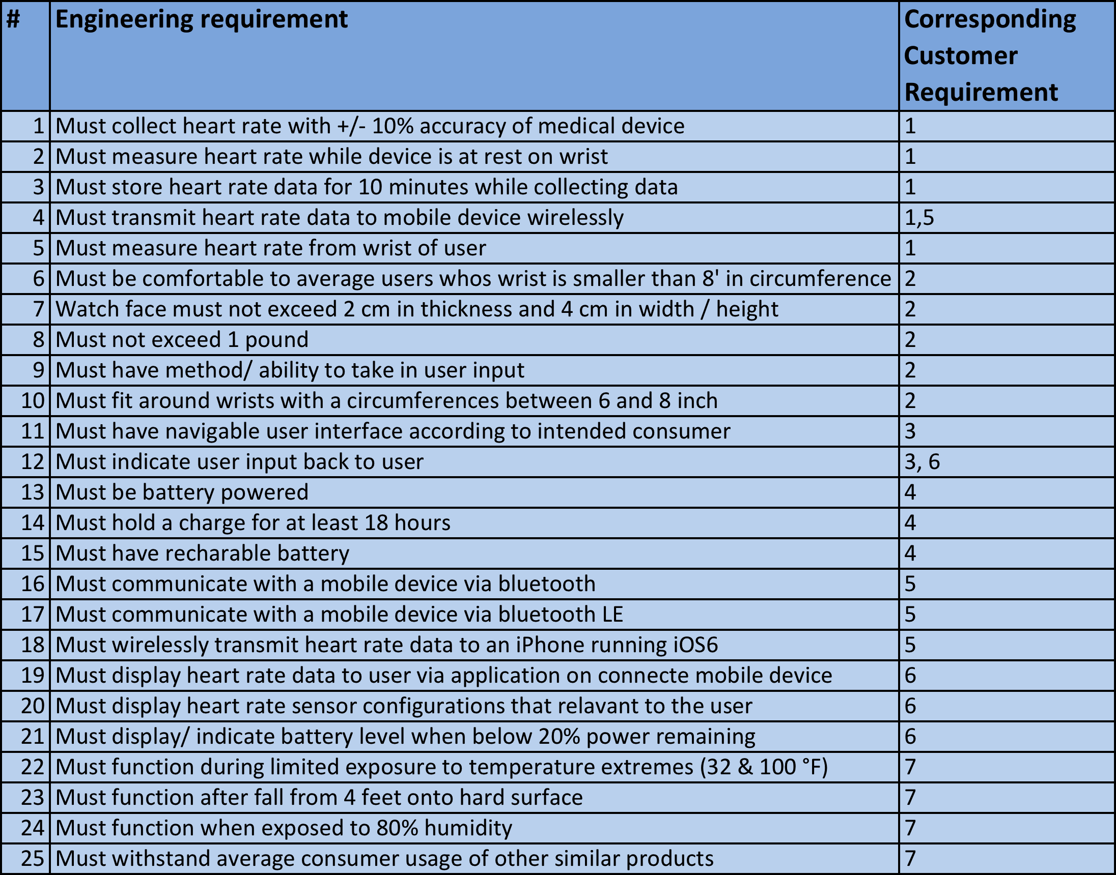

The intent of this project is to create a wearable heart rate monitoring system in the form factor of a watch. This watch will have the ability to wirelessly communicate with a mobile device, be powered by a battery and display the heart rate data it collects. Special attention will be given to making sure the device is user friendly and intuitive to use. This device will improve the health of its user by constantly monitoring their heart rate and making that data easily accessible.

**Bibliography**

[1] K. D. Kochanek et al., “Deaths: final data for 2009,” National vital statistics reports. 2011;60(3)

[2] R. Martin. (2004) *Effects of Stress on the Heart* [Online]. Available FTP: hearthealthyonline.com Directory: Heart Disease Overview File: Stress Management

[3] Y. M. Chi et all., “Dry-Contact and Noncontact Biopotential Electrodes: Methodological Review,” *IEEE Trans. Biomed. Eng.*, vol. 3, pp. 106-119. 2010.

[4] A. Gruetzmann et all., “Novel dry electrodes for ECG monitoring,” *IOP Publishing Physiological Measurement*, vol. 28, pp. 1375-1390. 2007.

[5] D. Torres. (2013). *Build a Wrist Heart-Rate Monitor Using An Ultra-Low-Power MCU* [Online]. Available FTP: electronicdesign.com Directory: Technologies File: Digital ICS

[6] R. Nilsson, B. Saltzstein. (2012, June 8). *Bluetooth Low Energy vs. Classic Bluetooth: Choose the Best Wireless Technology For Your Application (1st ed.)* [Online]. Available: http://www.medicaleletronicsdesign.com

[7] L. Fried. (2013, February 16). *Lithium Batteries & Coin Cells* [Online]. Available: http://www.learn.adafruit.com

[8] L. Fried. (2013, February 16). *Li-Ion (Lithium-Ion) and LiPoly (Lithium Polymer)* [Online]. Available: http://www.learn.adafruit.com

[9] L. Fried. (2013, February 16). *Nokia 5110/3310 monochrome LCD + extras* [Online]. Available: http://www.learn.adafruit.com

[10] L. Fried. (2013, February 16). *NTSC/PAL (Television) TFT Display* [Online]. Available: http://www.learn.adafruit.com

[11] L. Fried. (2013, February 16). *OLED Breakout Board* [Online]. Available: http://www.learn.adafruit.com

[12] M. E. Miller, “OLED display device,” U.S. Patent 7 142 179, Nov. 28, 2006

[13] W. G. Howard, “Lithium-ion battery,” U.S. Patent 7 582 387, Sept. 1, 2009

[14] B. Bennett. (2013, Oct. 10). *A fitness tracker tour de force* [Online]. Available: http://www. reviews.cnet.com

[15] A. Boxall. (2013, Oct. 15). *New Nike Fuelband SE Gets Better Movement and Sleep tracking, but still no Android support* [Online]. Available: http://www.digitaltrends.com

[16] S. Stein. (2013, Apr. 5). *Smartwatch in Progress* [Online]. Available: http://www.reviews.cnet.com

[17] B. Bennett. (2013, Apr. 3). *Smartwatch clocks in with better software* [Online]. Available: http://www. reviews.cnet.com

[18] B. Rose. (2013, Feb. 7). Mio Alpha Review: One Giant Leap for Heart Rate monitors [Online]. Available: http://www.gizmodo.com