

Pharmacy Management System
Software Requirement Specification
Project Code: PMS
Document Code: PMS– v1.0

– Hanoi, August 2026 –
Table of Contents
I. Record of Changes 3
II. Software Requirement Specification 4
1. Product Overview 4
1.2 Main Workflow 5
2. User Requirements 9
2.1 Actors 9
2.2 Use Cases 11
3. Software Features 24
3.1 Functional Overview 24
3.2 Authentication 53
3.3 User & Security Management 65
3.4 Product Management 81
3.5 Category Management 94
3.6 Shift Management 104
3.7 Sales Management 110
3.8 Customer Management 125
3.9 Store Inventory Management 139
3.10 Warehouse Inventory 157
3.11 Store Replenishment & Goods Issue 178
3.12 Warehouse Purchase Receipt 189
3.13 Supplier Management 193
3.14 RFQ & Quotation Management 205
3.16 Reporting 222
4. Non-Functional Requirements 230
5. Requirement Appendix 234
5.1 Business Rules 234
5.2 Common Requirements 235
5.3 Application Messages List 235
5.4 Other Requirements 236

I. Record of Changes
Date | A*  M, D | In charge | Change Description
*A - Added M - Modified D - Deleted

II. Software Requirement Specification

1. Product Overview
The Pharmacy Management System (PMS) is a new, centralized information system that supports the daily operations of a pharmacy chain, including retail sales, inventory control, procurement, warehouse operations, and management reporting. It replaces manual, paper-based processes with a single shared database, so stores, the warehouse, the purchasing department, and management all work from the same data. The system provides functions such as account and catalog administration, shift and sales handling, stock requisition and replenishment, purchase proposals and orders, goods receipt and issue, inventory audits and adjustments, and profit and activity reporting.
The context diagram shows PMS as a single process interacting with nine external entities. Seven are human actors: Administrator, Store Manager, Pharmacist, Purchasing Staff, General Manager, Warehouse Manager, and Warehouse Staff. Two are external systems: the VNPay Payment Service, which handles online payment requests and results, and the SMTP Gmail Service, which delivers email notifications. Data flows between these entities and the system cover configuration data, sales and customer records, requisitions, purchase documents, goods receipt and issue data, audit results, and reports.
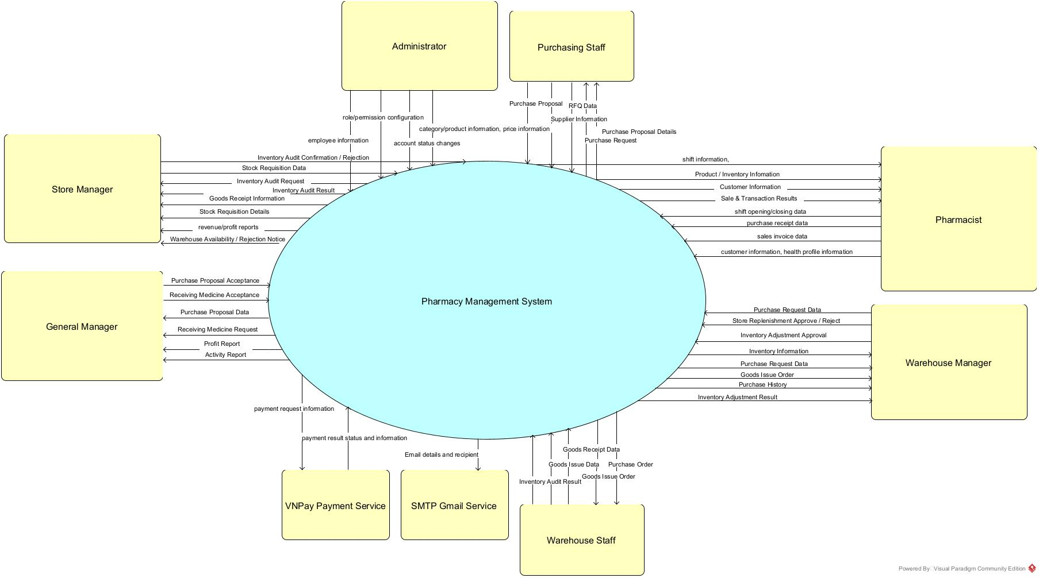

1.2 Main Workflow

1.2.1 Purchasing Process
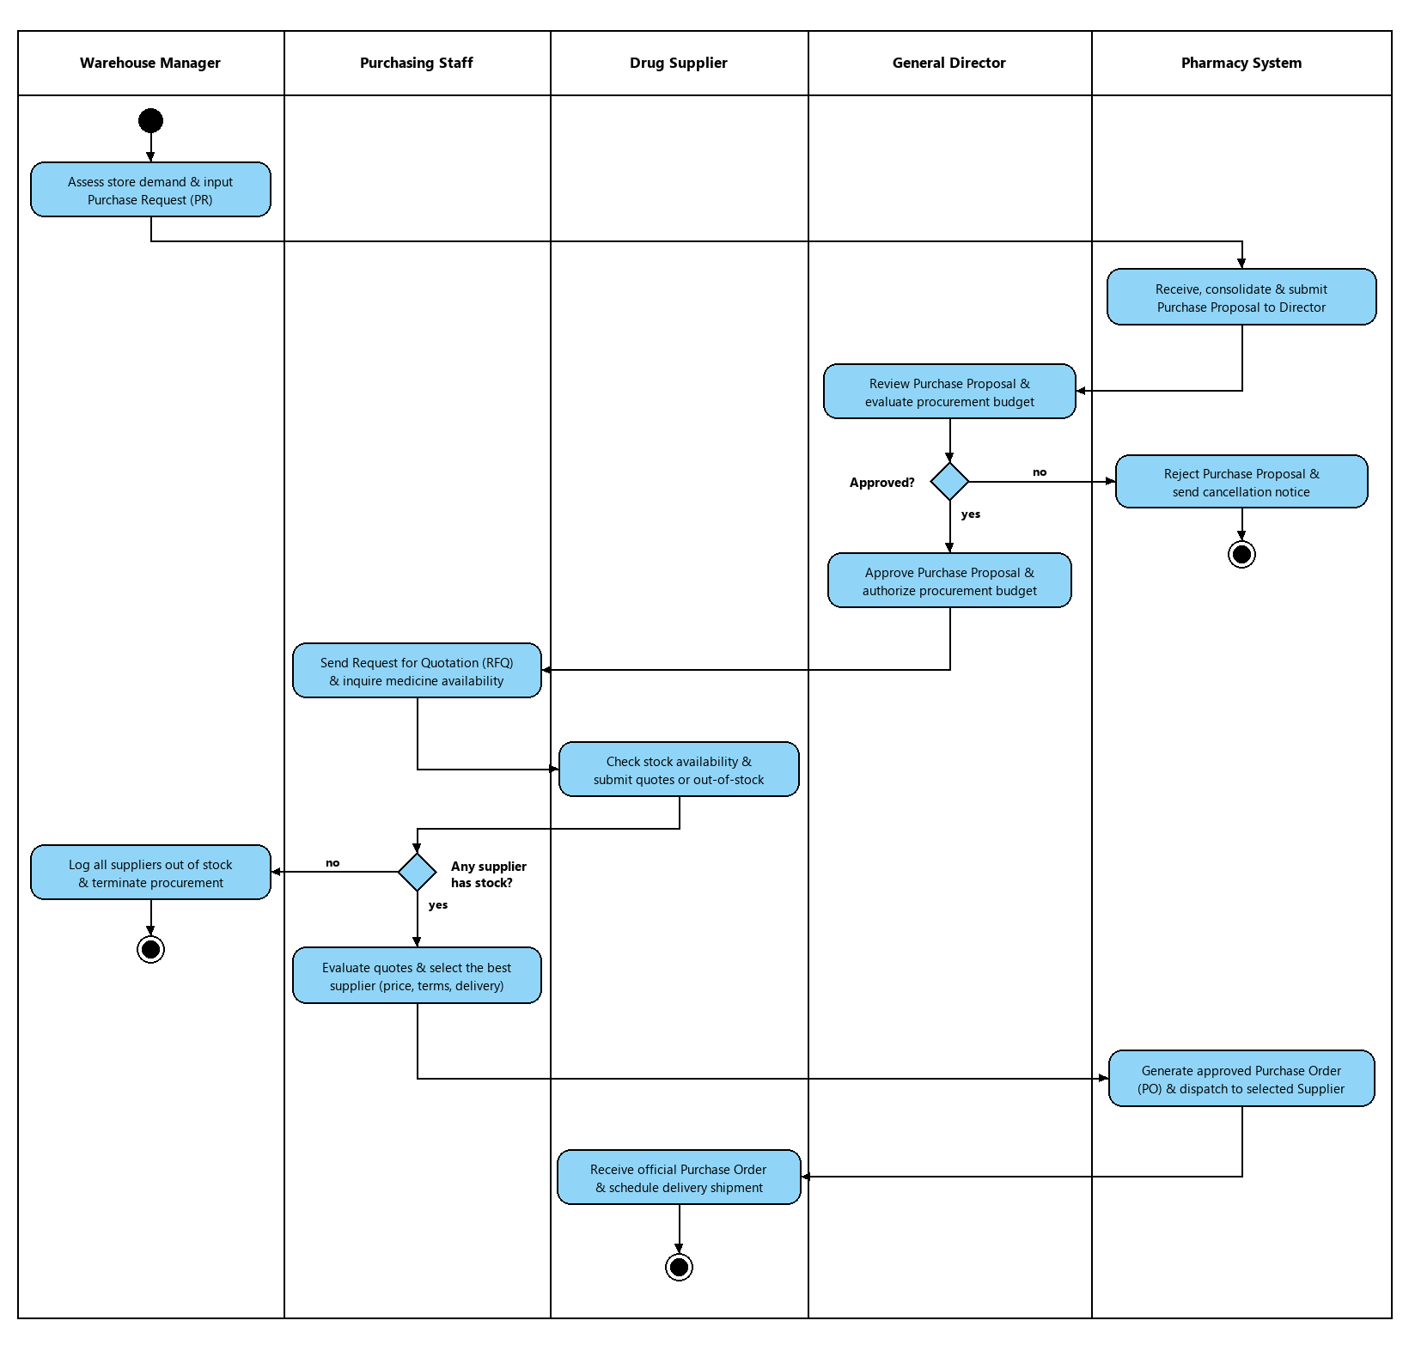

1.2.2 Product Import Process
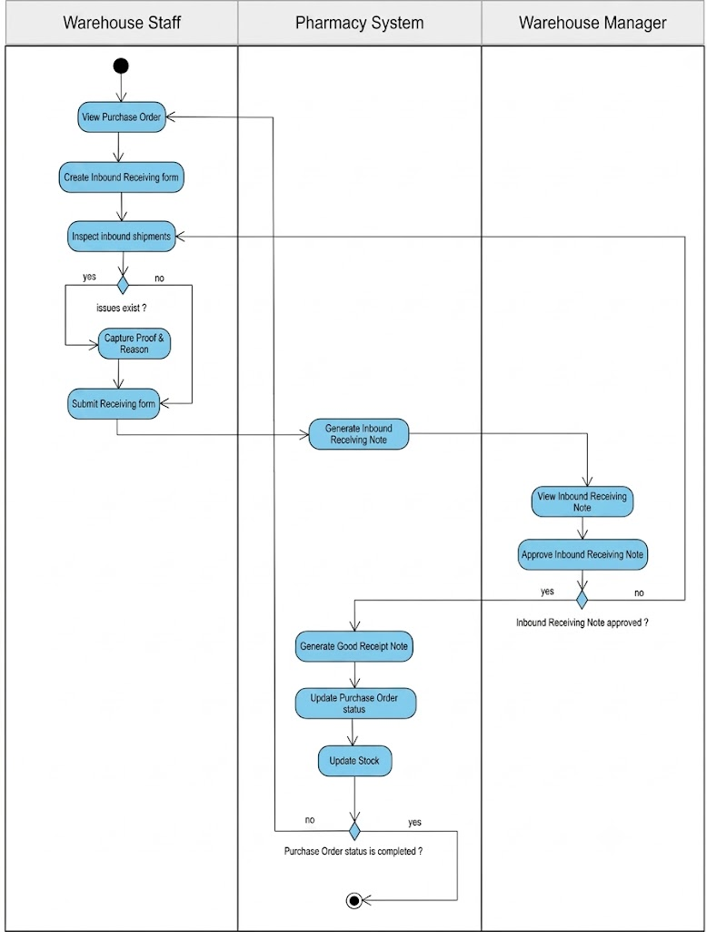

1.2.3 Product Export Process
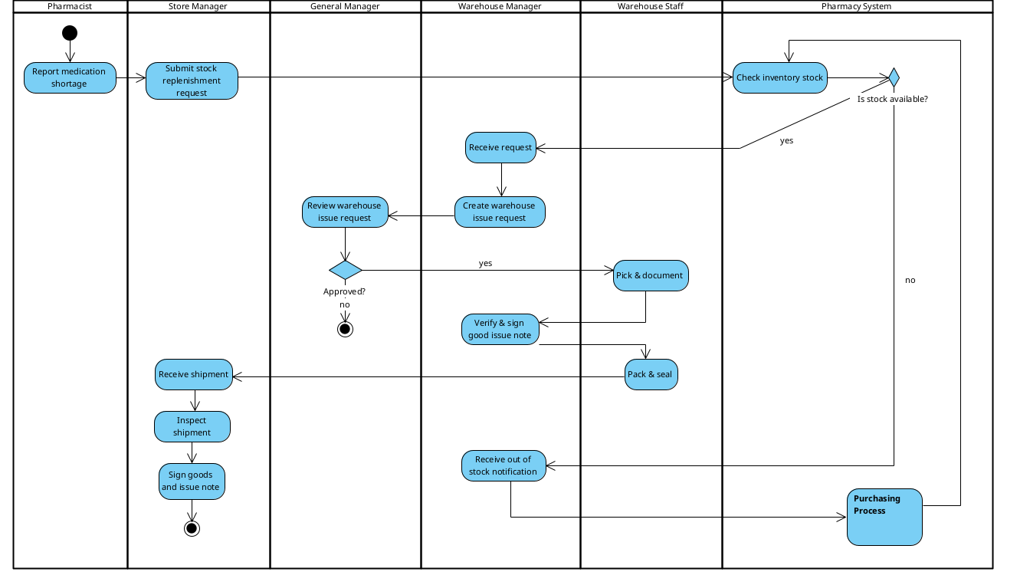

1.2.4 Inventory Audit Process
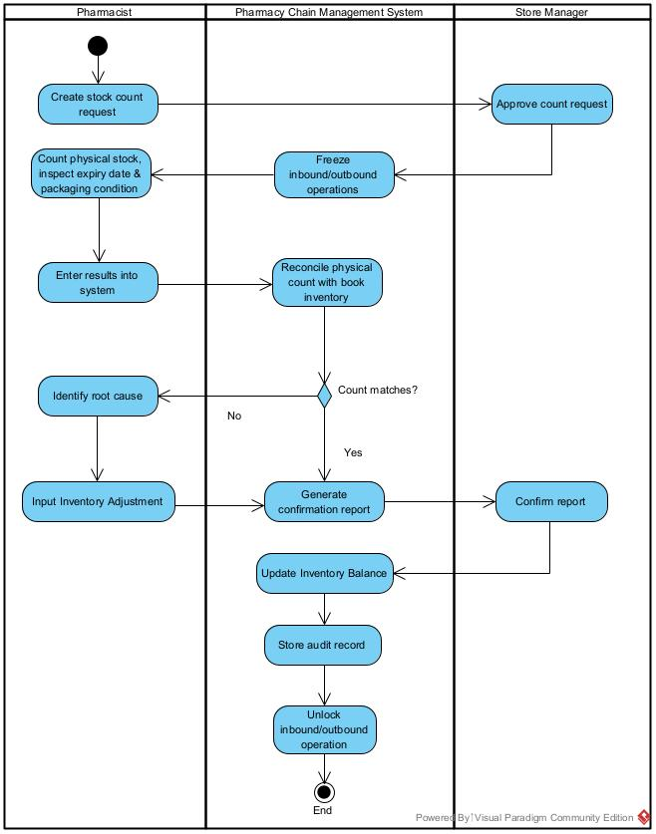

1.2.5 Medicine Sales process
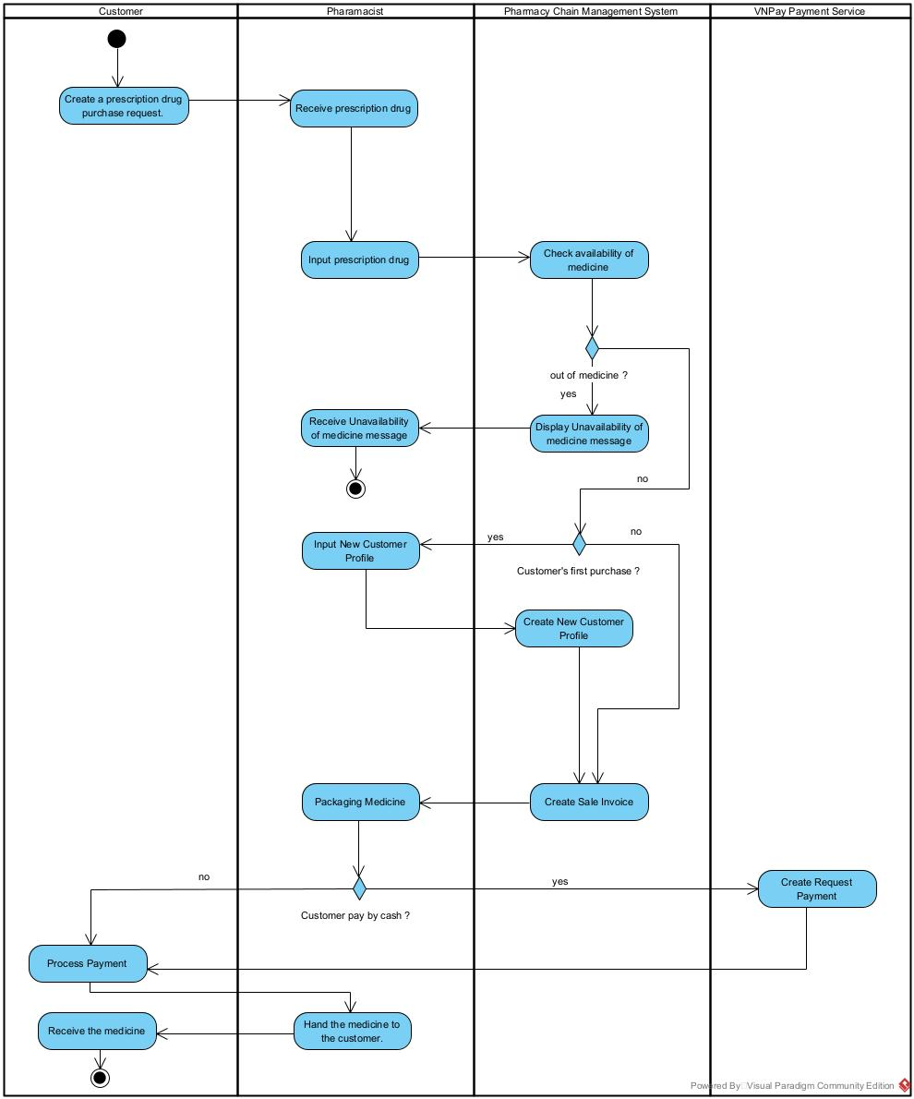

2. User Requirements

2.1 Actors

# | Actor | Description
1 | Administrator | System administrator responsible for platform configuration, managing employee accounts and account status, setting up roles and access permissions, and maintaining the category, product, and price catalog.
2 | Store Manager | Manager responsible for store-level operations, including creating stock requisitions, requesting and confirming inventory audits, receiving goods, and reviewing store revenue/profit reports.
3 | Pharmacist | Store employee who handles day-to-day sales, opens and closes shifts, issues sales invoices, records purchase receipts, and manages customer information and health profiles.
4 | Purchasing Staff | Staff member responsible for procurement activities, including creating purchase proposals and purchase requests, managing supplier information, and handling RFQ data.
5 | General Manager | Senior manager who approves purchase proposals and the receiving of medicine, and monitors overall business performance through profit and activity reports.
6 | Warehouse Manager | Manager in charge of the warehouse who reviews purchase requests, approves or rejects store replenishment requests, approves inventory adjustments, and issues goods to stores.
7 | Warehouse Staff | Warehouse employee who carries out physical operations such as recording goods receipts and goods issues, handling purchase and goods issue orders, and performing inventory audits.

2.2 Use Cases

2.2.1 Diagram(s)

2.2.1.2 UCs for Admin
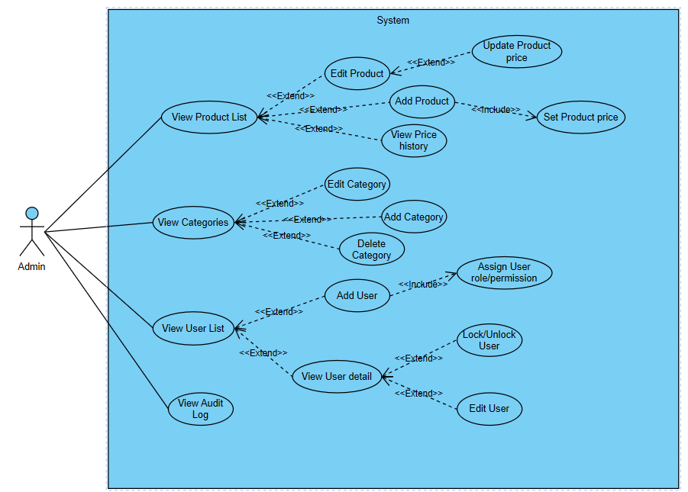

2.2.1.3 UCs for Store Manager
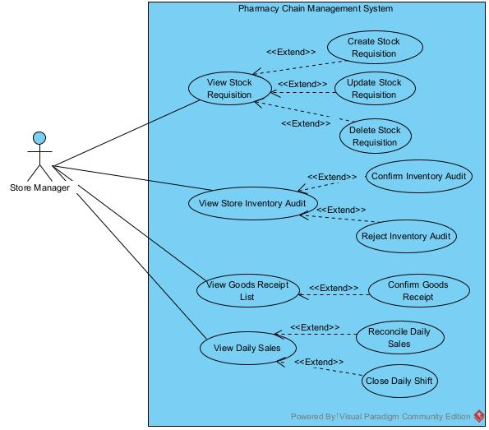
Figure 2.2.1.3: Use case diagram of Store Manager

2.2.1.4 UCs for Pharmacist

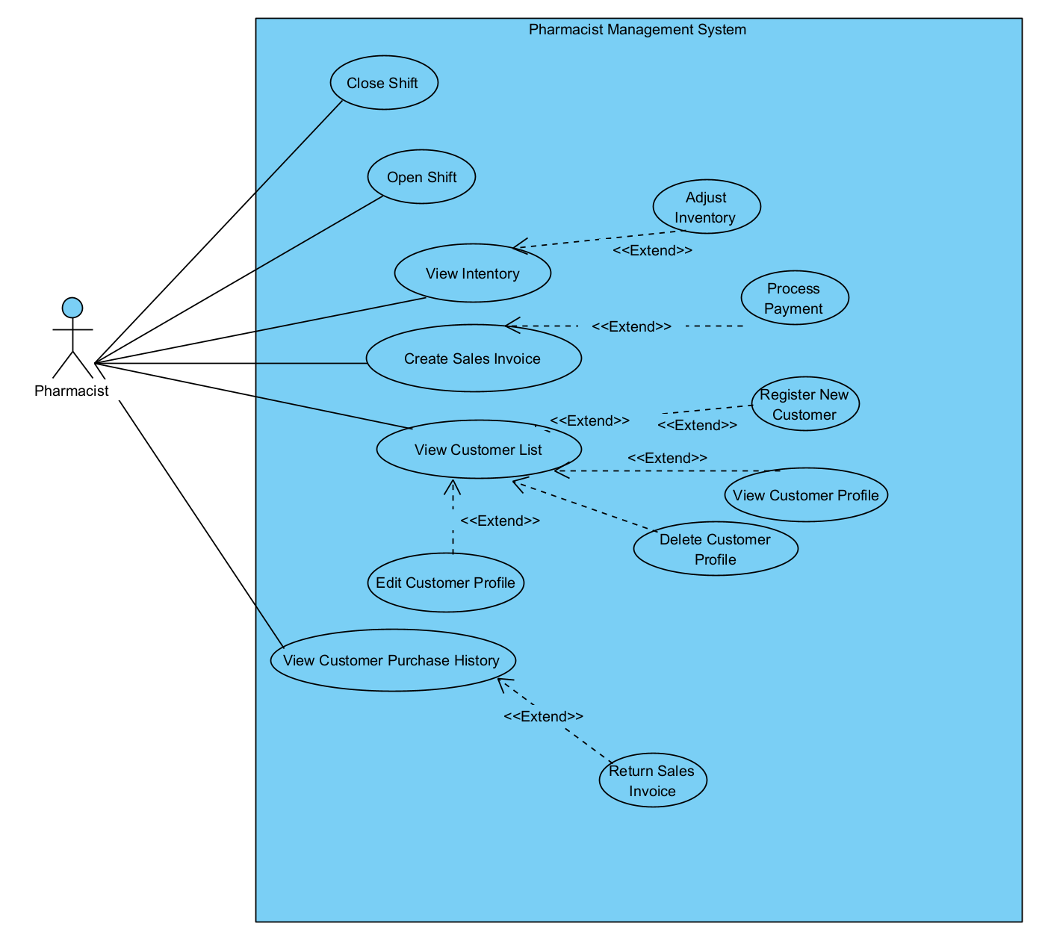
Figure 2.2.1.4: Use case diagram of Pharmacist

2.2.1.5 UCs for General Manager

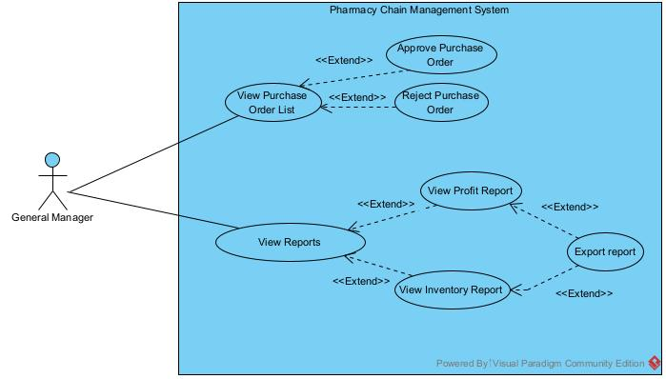
Figure 2.2.1.5: Use case diagram of General Manager

2.2.1.6 UCs for Warehouse Manager
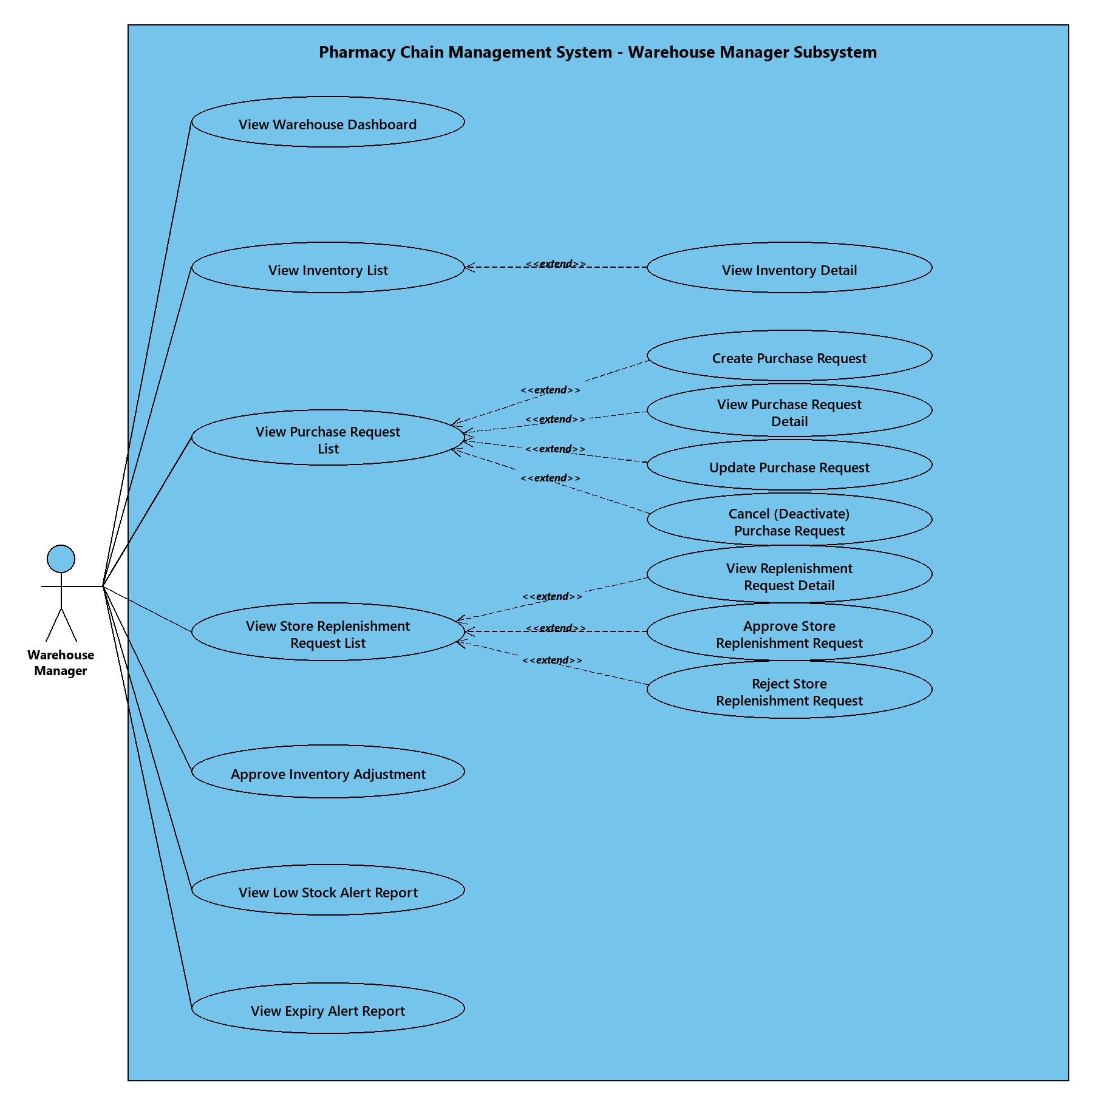

2.2.1.7 UCs for Purchasing Staff
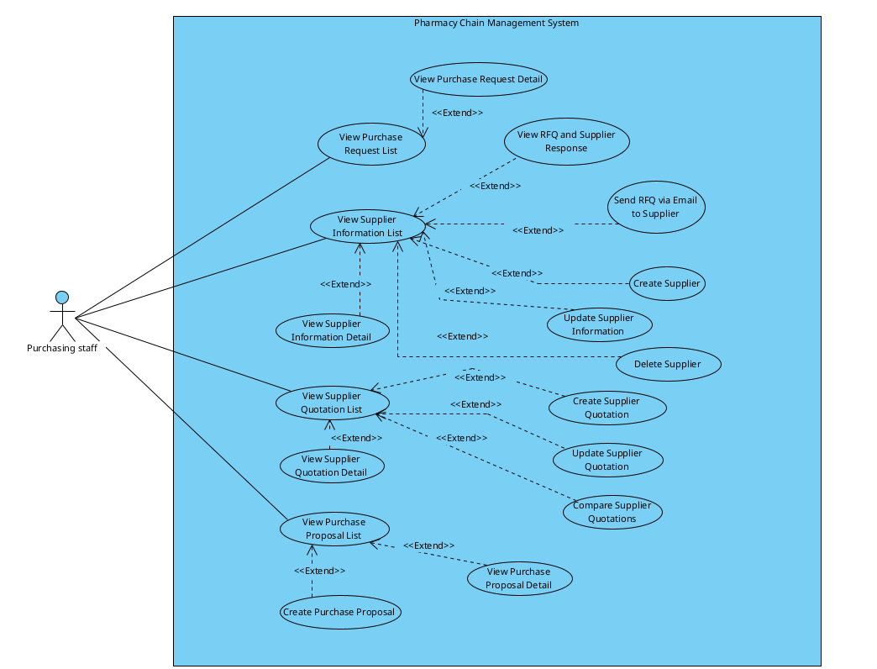

2.2.2 Descriptions
ID | Group Function | Use Case | Actors | Use Case Description & Main Flow
01 | Authentication | Login | All | Allows a user to authenticate with the system using a username and password in order to access features according to their role.
02 | Authentication | Logout | All | Allows a logged-in user to end their session and securely leave the system.
03 | Authentication | Change Password | All | Allows a logged-in user to change their account password by providing the current password and a new one.
04 | Authentication | Manage Personal Information | All | Allows a logged-in user to view and update their own personal information.
05 | Authentication | Forgot Password | All | Allows a user who cannot remember their password to verify their identity via email and set a new password.
06 | User & Security Management | View User List & Detail | Admin | Allows admin to browse, search, and filter the user directory, and view detailed profile information, assigned roles, contact details, and account status of a specific user.
07 | User & Security Management | Add User | Admin | Allows admin to create new user profiles with personal information and system credentials.
08 | User & Security Management | Assign User role/permission | Admin | Allows admin to grant specific roles or custom feature permissions to individual users.
09 | User & Security Management | Edit User | Admin | Allows admin to update existing user records, work statuses, and contact details.
10 | User & Security Management | Lock/Unlock User | Admin | Allows admin to activate or deactivate user accounts to control system access.
11 | User & Security Management | View Audit Log | Admin | Allows admin to inspect system activity logs, tracking user actions, timestamps, and data changes for security and auditing purposes.
12 | Product Management | View Product List | Admin | Allows users to browse, search, filter the product catalog, and view comprehensive master details of a specific product/medicine.
13 | Product Management | Add Product | Admin | Allows the Administrator to create a new medicine/product master record with details such as category, unit of measure, barcode, active ingredient, and stock threshold levels.
14 | Product Management | Edit Product | Admin | Allows the Administrator to update existing master data for a product (such as name, category, barcode, stock thresholds, or status).
15 | Product Management | View Price History | Admin | Allows administrators to review the history of selling price changes for a product, including the effective date, the person who made the change, and the reason.
16 | Product Management | Manage Product Price | Admin | Allows the Administrator to set the initial cost price and selling price for a new product, and update the prices of an existing product. Each change is recorded as a new price version in history without modifying historical transaction prices.
17 | Category Management | View Categories | Admin | Allows admin to browse and view the list and details of product categories.
18 | Category Management | Add Category | Admin | Allows admin to create a new product category to organize products in the store.
19 | Category Management | Edit Category | Admin | Allows admin to update the name, description, or status of an existing product category.
20 | Category Management | Delete Category | Admin | Allows admin to remove a product category that is no longer used.
21 | Shift Management | Open Shift | Pharmacist | Allows pharmacists to initiate a work shift by verifying the starting timestamp and opening cash balance.
22 | Shift Management | Close Shift | Pharmacist | Allows pharmacists to end a work shift, reconcile closing cash balances, and generate handover reports.
23 | Sales Management | Create Sales Invoice | Pharmacist | The Pharmacist creates a sales invoice by searching or scanning products, adding them one by one with quantity and dosage instructions (e.g., frequency per day), optionally selecting a customer, applying a discount if needed, and then proceeding to the payment step.
24 | Sales Management | Process Payment | Pharmacist | The Pharmacist processes payment for a pending sales invoice. The system supports Cash, Bank Transfer, and VNPay QR. Once payment is confirmed, inventory is automatically deducted and a receipt can be printed.
25 | Sales Management | Cancel/Return Sales Invoice | Pharmacist | The Pharmacist can cancel or return a sales invoice (fully or partially) when the customer has not used the products. The system restocks the returned quantities, records the refund, and stores the reason for audit purposes.
26 | Sales Management | View Customer Purchase History | Pharmacist | The Pharmacist views a system-wide list of all sales invoices. Each record shows the buyer's name (customer), phone number, total amount, status, and cashier. The list supports search and filtering by date range and status.
27 | Sales Management | View Daily Sales | Store Manager | Allows the Store Manager to view daily sales records and transactions.
28 | Sales Management | Reconcile Daily Sales | Store Manager | Allows the Store Manager to balance and reconcile sales figures against physical cash/payments.
29 | Customer Management | Register New Customer | Pharmacist | The Pharmacist registers a new customer by entering personal information (name, phone number, email) and, optionally, the customer's health profile (height, weight, allergies, medical conditions, and notes) on the same registration form.
30 | Customer Management | Edit Customer | Pharmacist | The Pharmacist updates an existing customer's personal information and health profile on the same edit form.
31 | Customer Management | View Customer | Pharmacist | The Pharmacist views the detailed health profile of a customer together with basic personal information.
32 | Customer Management | View Customer List | Pharmacist | The Pharmacist displays all of the customers in the system and searches for customers by name, phone number, or email on the customer list screen.
33 | Customer Management | Delete Customer | Pharmacist | The Pharmacist deletes an existing customer's personal information and health profile on the same edit form.
33 | Store Inventory Management | View Inventory | Pharmacist, Store Manager | Allows pharmacists and managers to view real-time branch stock levels, batch numbers, expiry dates, and warning indicators for low stock and near-expiry medicines.
34 | Store Inventory Management | View Store Inventory Audit | Store Manager | Allows the Store Manager to view the results and records of store inventory audits, then confirm and accept the results, or reject them and request a recount.
35 | Store Inventory Management | Create Stock Requisition | Store Manager | Allows the Store Manager to create and submit a drug replenishment request to the central warehouse when store stock levels fall below thresholds.
36 | Store Inventory Management | View Stock Requisition | Store Manager | Allows the Store Manager to view and track the status, details, and delivery progress of submitted internal stock requisitions.
37 | Store Inventory Management | Update Stock Requisition | Store Manager | Allows the Store Manager to modify requested items or quantities of a draft or pending requisition, or cancel an unapproved requisition that is no longer required, before it is processed by the warehouse.
38 | Store Inventory Management | View Goods Receipt List | Store Manager | Allows the Store Manager to browse and view the goods receipt notes.
39 | Store Inventory Management | Confirm Goods Receipt | Store Manager | Allows the Store Manager to confirm that delivered goods have been received.
40 | Warehouse Inventory | View Inventory | Warehouse Manager, Warehouse Staff | Allows warehouse users to browse and search real-time inventory balances, stock valuation, batch details, lot numbers, expiration dates, and shelf/bin location mappings across warehouse zones, filtering by medicine name, barcode/SKU, active ingredient, or storage category.
41 | Warehouse Inventory | View Purchase History | Warehouse Manager, Warehouse Staff | Allows warehouse users to look up historical purchase receipts, supplier deliveries, receiving dates, and lot traceability logs.
42 | Warehouse Inventory | Assign Shelf/Bin Location | Warehouse Staff | Allows Warehouse Staff to perform put-away management by scanning batch barcodes and assigning received medicine packages to specific warehouse aisles, shelves, and bins.
43 | Warehouse Inventory | Create Inventory Adjustment | Warehouse Staff | Allows Warehouse Staff to record physical stocktake count discrepancies (damage, breakage, count variance) and submit adjustment proposals for Manager review.
44 | Warehouse Inventory | Approve Inventory Adjustment | Warehouse Manager | Allows the Warehouse Manager to review stocktake audit discrepancies submitted by staff and approve or reject balance adjustments and financial write-offs.
45 | Warehouse Inventory | View Low Stock Alert Report | Warehouse Manager | Allows the Warehouse Manager to view, filter, and export reports of medicines reaching safety stock thresholds (Quantity < 20 units) to prevent stockouts and support purchasing decisions.
46 | Warehouse Inventory | View Expiry Alert Report | Warehouse Manager | Allows the Warehouse Manager to view and analyze medicines nearing expiration (< 6 months) or already expired to prioritize FEFO store dispatch or initiate supplier returns.
47 | Warehouse Inventory | Manage Purchase Requests | Warehouse Manager | Allows the Warehouse Manager to view, create, update, and cancel Purchase Requests (PR) for medicines reaching safety stock thresholds or consolidating store replenishment demands.
48 | Store Replenishment & Goods Issue | Manage Store Replenishment Requests | Warehouse Manager | Allows the Warehouse Manager to review, evaluate, and track drug replenishment requests submitted by retail pharmacy stores against warehouse inventory availability.
49 | Store Replenishment & Goods Issue | Approve Store Replenishment Request | Warehouse Manager | Allows the Warehouse Manager to approve an eligible store replenishment request (enforcing Business Rule BR-P38: mandatory Manager consent for warehouse dispatch) and generate a Goods Issue Order (extends from Manage Store Replenishment Requests).
50 | Store Replenishment & Goods Issue | Reject Store Replenishment Request | Warehouse Manager | Allows the Warehouse Manager to reject a store replenishment request in case of central warehouse inventory shortage, invalid store quota, or priority conflict (extends from Manage Store Replenishment Requests).
52 | Store Replenishment & Goods Issue | Confirm Goods Dispatch | Warehouse Staff | Allows Warehouse Staff to finalize the handover of packed medicine packages to the delivery carrier, print delivery notes, and officially deduct central warehouse inventory.
53 | Warehouse Purchase Receipt | Manage Purchase Receipt | Warehouse Staff | Allows Warehouse Staff to browse inbound deliveries, create draft Goods Receipt notes against approved Purchase Orders (PO), update shipment details, and cancel invalid receiving records.
54 | Warehouse Purchase Receipt | Confirm Purchase Receipt | Warehouse Staff | Allows Warehouse Staff to finalize and confirm goods receipt after physical inspection (supporting both Full and Partial Delivery) and officially update inventory balances (extends from Manage Purchase Receipt).
55 | Warehouse Purchase Receipt | View Purchase Request List | Purchasing Staff | Allows the Purchasing Staff to browse, filter, and view details of approved purchase requests submitted by the Warehouse Manager.
56 | Warehouse Purchase Receipt | View Purchase Request Detail | Purchasing Staff | Enables the Purchasing Staff to inspect the comprehensive details of a specific Purchase Request selected from the Purchase Request list.
57 | Supplier Management | Create Supplier | Purchasing Staff | Enables the Purchasing Staff to register a newly approved Drug Supplier into the system.
58 | Supplier Management | View Supplier Information | Purchasing Staff | Enables the Purchasing Staff to search and view the supplier directory, including contact details and registered pharmaceutical catalogs/distribution capabilities, and view in-depth profile information of a selected supplier.
59 | Supplier Management | Update Supplier Information | Purchasing Staff | Allows the Purchasing Staff to modify and update existing supplier profile records.
60 | Supplier Management | Delete Supplier | Purchasing Staff | Allows the Purchasing Staff to deactivate an existing vendor profile from the active supplier list if the supplier is no longer eligible, blacklisted, or ceased pharmaceutical operations.
61 | RFQ & Quotation Management | Send RFQ via Email to Supplier | Purchasing Staff | Allows the Purchasing Staff to generate a Request for Quotation for the required medicines from selected purchase requests and dispatch it via automated email to chosen suppliers.
62 | RFQ & Quotation Management | View RFQ and Supplier Response | Purchasing Staff | Enables the Purchasing Staff to monitor the transmission status of sent RFQs and access incoming responses from suppliers.
63 | RFQ & Quotation Management | Manage Supplier Quotation | Purchasing Staff | Allows the Purchasing Staff to enter structured quotation data received from suppliers, view the quotation list and itemized details, and update entries if errors are identified, provided the quotation has not yet been included in an approved or finalized Purchase Proposal.
64 | RFQ & Quotation Management | Compare Supplier Quotations | Purchasing Staff | Provides a side-by-side comparative matrix of valid supplier quotations within the same RFQ round.
65 | Purchase Proposal Management | Create Purchase Proposal | Purchasing Staff | Allows the Purchasing Staff to generate a formal Purchase Proposal by linking the initial Purchase Request with the selected optimal supplier quotation.
66 | Purchase Proposal Management | View Purchase Proposal | Purchasing Staff | Enables the Purchasing Staff to view the list of submitted Purchase Proposals and review the contents of a selected proposal in read-only mode.
67 | Purchase Proposal Management | View Purchase Order List | General Manager | Allows the General Manager to view incoming purchase orders requiring approval.
68 | Purchase Proposal Management | Approve Purchase Order | General Manager | Allows the General Manager to approve a submitted purchase order.
69 | Purchase Proposal Management | Reject Purchase Order | General Manager | Allows the General Manager to reject a purchase order with reasons.
70 | Reporting | View Profit Report | General Manager | Allows the General Manager to view detailed financial profit, revenue, and margin reports.
71 | Reporting | View Inventory Report | General Manager | Allows the General Manager to view current stock levels, inventory valuation, and stock movement reports.
72 | Reporting | Export Report | General Manager | Allows the General Manager to export generated reports and data into external file formats (e.g., Excel, PDF, CSV).

3. Software Features

3.1 Functional Overview

3.1.1 Screens Flow
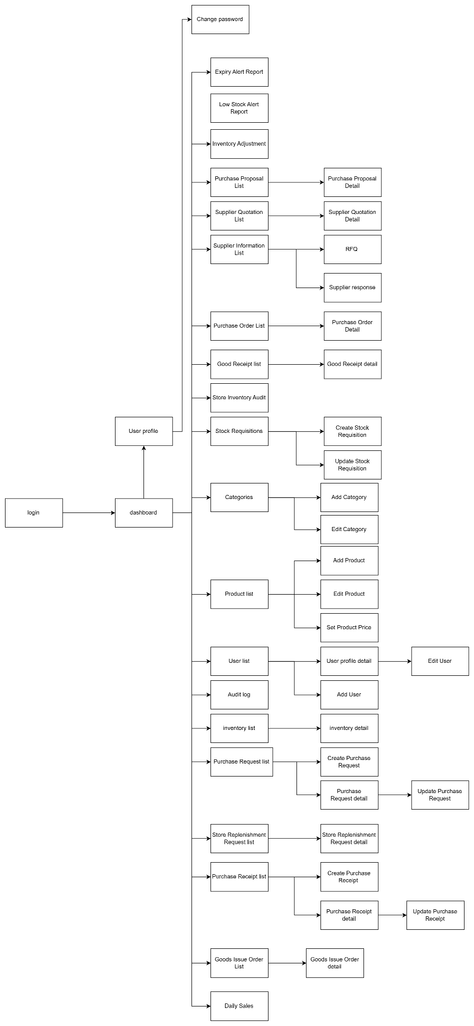

3.1.2 Screen Descriptions

# | Feature | Screen | Description
1 | Authentication | login | System login screen for user authentication across all roles.
2 | Common | dashboard | Main overview dashboard screen displayed after successful login.
3 | User Profile | User profile | Screen displaying current user profile information and settings.
4 | User Profile | Change password | Form/Screen for users to update their personal account password.
5 | Report & Alert | Expiry Alert Report | Screen displaying alerts and reports for medicines nearing or past expiry dates.
6 | Report & Alert | Low Stock Alert Report | Screen displaying alerts for inventory items falling below minimum stock thresholds.
7 | Inventory Management | Inventory Adjustment | Screen to record stock adjustments and approve or reject inventory adjustments.
8 | Procurement Management | Purchase Proposal List | Screen displaying the list of all procurement purchase proposals.
9 | Procurement Management | Purchase Proposal Detail | Screen displaying purchase proposal details and creating new purchase proposals.
10 | Procurement Management | Supplier Quotation List | Screen displaying the list of received supplier quotations.
11 | Procurement Management | Supplier Quotation Detail | Screen displaying quotation details, editing data, and comparing supplier quotations.
12 | Supplier Management | Supplier Information List | Screen displaying supplier list with options to create, update, and delete suppliers.
13 | Procurement Management | RFQ | Screen/Form to prepare and send Request for Quotation (RFQ) to suppliers via email.
14 | Procurement Management | Supplier response | Screen displaying supplier RFQ responses and price quotes.
15 | Purchase Order Management | Purchase Order List | Screen displaying the list of purchase orders for executive review.
16 | Purchase Order Management | Purchase Order Detail | Screen displaying purchase order details with actions to approve or reject the PO.
17 | Store Inventory | Good Receipt list | Screen displaying store inbound goods receipts sent from the warehouse.
18 | Store Inventory | Good Receipt detail | Screen displaying detailed store goods receipt information and confirming receipt.
19 | Store Inventory | Store Inventory Audit | Screen to view store inventory audit records with actions to confirm or reject audits.
20 | Stock Requisition | Stock Requisitions | Screen displaying the list of stock requisitions submitted by stores.
21 | Stock Requisition | Create Stock Requisition | Form/Screen for store managers to request additional stock from the warehouse.
22 | Stock Requisition | Update Stock Requisition | Form/Screen to modify and update an existing stock requisition request.
23 | Category Management | Categories | Screen to browse, add, edit, and delete product/medicine categories.
24 | Category Management | Add Category | Form/Screen to add a new product or medicine category.
25 | Category Management | Edit Category | Form/Screen to update an existing product or medicine category.
26 | Product Management | Product list | Screen displaying product catalog and initiating creation of new products.
27 | Product Management | Add Product | Form/Screen to create and register a new product in the system.
28 | Product Management | Edit Product | Form/Screen to update general information and attributes of an existing product.
29 | Price Management | Set Product Price | Screen to set initial price, update selling price, and view price history logs.
30 | User Administration | User list | Screen displaying registered users and adding new users with assigned roles/permissions.
31 | User Administration | User profile detail | Screen to view user details, edit account info, and lock or unlock user accounts.
32 | User Administration | Edit User | Form/Screen to edit user account details and permissions.
33 | User Administration | Add User | Form/Screen to create and assign roles for a new system user.
34 | System Audit | Audit log | Screen displaying system audit logs and user activity tracking history.
35 | Inventory Management | Inventory list | Screen to monitor real-time stock levels across warehouse and store locations.
36 | Inventory Management | Inventory detail | Screen displaying product stock breakdown, batch numbers, and shelf/bin locations.
37 | Purchase Request | Purchase Request list | Screen displaying internal stock purchase requests.
38 | Purchase Request | Create Purchase Request | Form/Screen to draft and submit a new stock purchase request.
39 | Purchase Request | Purchase Request detail | Screen displaying purchase request details with option to cancel the request.
40 | Purchase Request | Update Purchase Request | Form/Screen to edit and update details of an existing purchase request.
41 | Store Replenishment | Store Replenishment Requisition | Screen displaying store replenishment requests for warehouse distribution.
42 | Store Replenishment | Store Replenishment Req detail | Screen displaying details of a specific store replenishment request.
43 | Purchase Receipt | Purchase Receipt list | Screen displaying the list of all purchase receipts.
44 | Purchase Receipt | Create Purchase Receipt | Form/Screen to record new inbound purchase goods receipts.
45 | Purchase Receipt | Purchase Receipt detail | Screen displaying purchase receipt details and verification items.
46 | Purchase Receipt | Update Purchase Receipt | Form/Screen to modify details of an existing purchase receipt.
47 | Return Order | Cancel Return Order List | Screen displaying the list of return orders requested for cancellation.
48 | Return Order | Cancel Return Order Detail | Screen displaying detailed information of a canceled return order.
49 | Sales Management | Daily Sales | Screen displaying daily sales transactions and revenue summary.

3.1.3 Screen Authorization

- ADM: Administrator
- SM: Store Manager
- WM: Warehouse Manager
- WS: Warehouse Staff
- PO: Purchasing Staff
- GM: General Manager
- P: Pharmacist
# | Feature | Screen | ADM | SM | WM | WS | PO | GM | P
1 | Authentication | login | X | X | X | X | X | X | X
2 | Common | dashboard | X | X | X | X | X | X | X
3 | User Profile | User profile | X | X | X | X | X | X | X
4 | User Profile | Change password | X | X | X | X | X | X | X
5 | Report & Alert | Expiry Alert Report | X | X | X | X | X | X | X
6 | Report & Alert | Low Stock Alert Report | X | X | X | X | X | X | X
7 | Inventory Management | Inventory Adjustment |  | X | X
8 | Procurement Management | Purchase Proposal List |  | X | X |  | X | X
9 | Procurement Management | Purchase Proposal Detail |  | X | X |  | X | X
10 | Procurement Management | Supplier Quotation List |  |  |  |  | X | X
11 | Procurement Management | Supplier Quotation Detail |  |  |  |  | X | X
12 | Supplier Management | Supplier Information List | X | X | X |  | X | X
13 | Procurement Management | RFQ |  |  |  |  | X
14 | Procurement Management | Supplier response |  |  |  |  | X
15 | Purchase Order Management | Purchase Order List | X |  | X |  | X | X
16 | Purchase Order Management | Purchase Order Detail | X |  | X |  | X | X
17 | Store Inventory | Good Receipt list |  | X | X | X | X
18 | Store Inventory | Good Receipt detail |  | X | X | X | X
19 | Store Inventory | Store Inventory Audit |  | X |  |  |  |  | X
20 | Stock Requisition | Stock Requisitions |  | X | X | X
21 | Stock Requisition | Create Stock Requisition |  | X
22 | Stock Requisition | Update Stock Requisition |  | X
23 | Category Management | Categories | X | X | X | X | X | X | X
24 | Category Management | Add Category | X
25 | Category Management | Edit Category | X
26 | Product Management | Product list | X | X | X | X | X | X | X
27 | Product Management | Add Product | X
28 | Product Management | Edit Product | X
29 | Price Management | Set Product Price | X |  |  |  | X | X
30 | User Administration | User list | X
31 | User Administration | User profile detail | X
32 | User Administration | Edit User | X
33 | User Administration | Add User | X
34 | System Audit | Audit log | X
35 | Inventory Management | Inventory list | X | X | X | X | X | X | X
36 | Inventory Management | Inventory detail | X | X | X | X | X | X | X
37 | Purchase Request | Purchase Request list |  | X | X | X | X | X
38 | Purchase Request | Create Purchase Request |  | X | X
39 | Purchase Request | Purchase Request detail |  | X | X | X | X | X
40 | Purchase Request | Update Purchase Request |  | X | X
41 | Store Replenishment | Store Replenishment Requisition |  | X | X | X
42 | Store Replenishment | Store Replenishment Req detail |  | X | X | X
43 | Purchase Receipt | Purchase Receipt list |  |  | X | X | X | X
44 | Purchase Receipt | Create Purchase Receipt |  |  | X | X
45 | Purchase Receipt | Purchase Receipt detail |  |  | X | X | X | X
46 | Purchase Receipt | Update Purchase Receipt |  |  | X | X
47 | Return Order | Cancel Return Order List |  | X | X | X |  | X
48 | Return Order | Cancel Return Order Detail |  | X | X | X |  | X
49 | Sales Management | Daily Sales | X | X |  |  |  | X | X

3.1.4 Non-Screen Functions

# | Feature | System Function | Description
1 | Authentication | Password Encryption Service | Automatically encrypts user passwords using a secure one-way hashing algorithm (e.g., BCrypt) before storing them in the system database.
2 | System Integration | SMTP Gmail Service Integration | Automatically constructs and dispatches emails for password reset requests or transaction receipts via SMTP Gmail Service integration.
3 | Payment Integration | VNPay Gateway API Integration | Handles payload signature encryption (Checksum/Hash), sends payment requests, and processes background response notifications (IPN/Callback API) from the VNPay payment gateway
4 | Inventory Management | Inventory Expiry & Low Stock Alert Job | A scheduled background task (Cron Job) running daily at 08:00 AM to scan for near-expiry products or items below minimum safety stock levels and notify the Manager

3.1.5 Entity Relationship Diagram
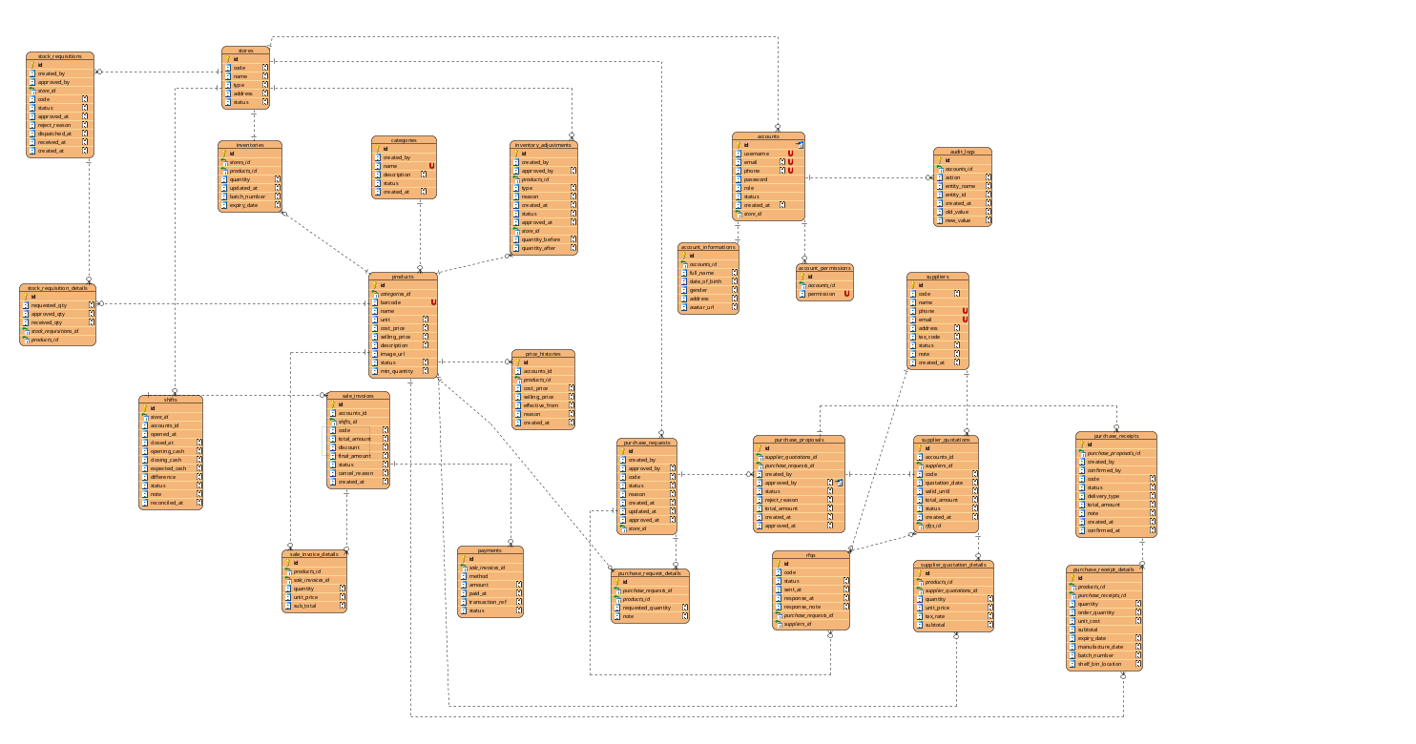
Entities Description
# | Entity | Description
1 | accounts | Stores login credentials and identity of system users .
2 | account_Informations | Stores personal information of an account holder. One-to-one relationship with Account.
3 | account_permissions | Store permissions which allow accounts to take an action.
4 | audit_logs | Store logs created by accounts actions.
5 | shifts | Stores cashier work shifts: opening and closing time, opening cash, closing cash, expected cash calculated by the system, and shift status.
6 | stores | Store pharmacy branches
7 | stock_requisitions | Stores replenishment requests submitted by a store to the central warehouse, including approval, dispatch, and receipt status and timestamps.
8 | stock_requisition_details | Stores the line items of a stock requisition: requested, approved, and received quantity for each product.
9 | categories | Stores product categories used to classify products.
10 | products | Stores products sold in the store. Each product belongs to one category.
11 | price_histories | Stores the history of selling price changes for each product.
12 | suppliers | Stores information about goods suppliers.
13 | purchase_requests | Stores purchase requests created by the Warehouse Manager for medicines that need to be purchased, with approval status.
14 | purchase_request_details | Stores the line items of a purchase request: the products and requested quantities.
15 | purchase_proposals | Stores formal purchase proposals linking a purchase request with the selected supplier quotation, submitted for General Manager approval.
16 | supplier_quotations | Stores quotations received from suppliers in response to an RFQ.
17 | supplier_quotation_details | Stores the line items of a supplier quotation: product, quantity, unit price, and tax rate.
18 | purchase_receipts | Stores purchase receipts for goods received from suppliers.
19 | purchase_receipt_details | Stores the line items of a purchase receipt.
20 | rfqs | Stores requests for quotations sent to suppliers for a purchase request. Each record is sent to one supplier and tracks sending and response status.
21 | inventories | Stores the current stock quantity of each product and its low-stock threshold. One-to-one relationship with Product.
22 | inventory_adjustments | Stores the history of stock adjustments for traceability.
23 | sales_invoices | Stores sales invoices.
24 | sales_invoice_details | Stores the line items of a sales invoice.
25 | payments | Stores payments made for an invoice. One invoice can have multiple payments.

3.1.6 Entity Details
- accounts
# | Attribute name | PK | Type | Mandatory | Description
1 | id | x | BigInt | Yes | Unique identifier of the account
2 | store_id |  | BigInt | Yes
3 | username |  | Varchar | No | Login name, must be unique
4 | email |  | Varchar | No | Account email address, used for contact and password recovery
5 | phone |  | Varchar | No | Account phone number
6 | password |  | Varchar | No | Hashed password
7 | role |  | Integer | No | Authorization role
8 | status |  | Integer | No | Account status
9 | created_at |  | Timestamp | No | Time the account was created

- account_Informations
# | Attribute name | PK | Type | Mandatory | Description
1 | id | x | BigInt | Yes | Unique identifier of the account information record
2 | account_id |  | BigInt | Yes | The account which information depended.
3 | full_name |  | Varchar | No | Full name of the user
4 | date_of_birth |  | Date | No | Date of birth
5 | gender |  | Integer | No | Gender
6 | address |  | Text | No | Contact address
7 | avatar_url |  | Varchar | No | URL of the profile picture

- Account_permissions
# | Attribute name | PK | Type | Mandatory | Description
1 | id | x | BigInt | Yes | Unique identifier of the account information record
2 | account_id |  | BigInt | Yes | The account which information depended.
3 | permission |  | Integer | No | Permissions of account

- audit_logs
# | Attribute name | PK | Type | Mandatory | Description
1 | id | x | BigInt | Yes | Unique identifier of the audit log record
2 | account_id |  | BigInt | Yes | The account which audit logs depended on.
3 | action |  | Integer | No | Permissions of account
4 | entity_name |  | Varchar | No | The name of the entity affected by the action
5 | entity_id |  | BigInt | No | The unique identifier of the affected entity
6 | created_at |  | Timestamp | No | The date and time when the action was recorded
7 | old_value |  | Varchar | No | The value of the affected attribute before the action was performed
8 | new_value |  | Varchar | No | The value of the affected attribute after the action was performed

- Shifts
# | Attribute name | PK | Type | Mandatory | Description
1 | id | x | BigInt | Yes | Unique identifier of the work shift
2 | store_id |  | BigInt | Yes | The store where the shift takes place
3 | account_id |  | BigInt | Yes | The manager who opened the shift
4 | opened_at |  | Timestamp | No | Time the shift was opened
5 | closed_at |  | Timestamp | No | Time the shift was closed
6 | opening_cash |  | Decimal | No | Cash in the register when the shift was opened
7 | closing_cash |  | Decimal | No | Actual cash counted when the shift was closed
8 | expected_cash |  | Decimal | No | Cash expected by the system (opening cash + cash sales)
9 | status |  | Integer | No | Shift status
10 | note |  | Text | No | Shift note
11 | difference |  | Decimal | No | Difference between the actual closing cash and the expected cash
12 | reconciled_at |  | Timestamp | No | Time when the cash difference was reconciled

- stores
# | Attribute name | PK | Type | Mandatory | Description
1 | id | x | BigInt | Yes | Unique identifier of the store
2 | code |  | Varchar | Yes | Unique code used to identify the store
3 | name |  | Varchar | Yes | Store name
4 | type |  | Integer | No | Type of store
5 | address |  | Text | No | Physical address of the store
6 | status |  | Integer | No | Current status of the store
- categories
# | Attribute name | PK | Type | Mandatory | Description
1 | id | x | BigInt | Yes | Unique identifier of the category
2 | created_by |  | BigInt | Yes | The account that created the category
3 | name |  | Varchar | No | Product category name
4 | description |  | Text | No | Category description
5 | status |  | Integer | No | Category status
6 | created_at |  | Timestamp | No | Date and time when the category was created
- products
# | Attribute name | PK | Type | Mandatory | Description
1 | id | x | BigInt | Yes | Unique identifier of the product
2 | category_id |  | BigInt | Yes | Category of product
3 | barcode |  | Varchar | No | Product barcode
4 | name |  | Varchar | No | Product name
5 | unit |  | Varchar | No | Unit of measure
6 | cost_price |  | Decimal | No | Purchase cost of the product
7 | selling_price |  | Decimal |  | Selling price of the product
8 | description |  | Text | No | Product description
9 | image_url |  | Varchar | No | URL of the product image
10 | status |  | Integer | No | Product status
11 | min_quantity |  | Integer | No | Minimum quantity of the product that should be maintained in stock
- price_histories
# | Attribute name | PK | Type | Mandatory | Description
1 | id | x | BigInt | Yes | Unique identifier of the price history record
2 | product_id |  | BigInt | Yes | Product of the price history record
3 | account_id |  | BigInt | Yes | Foreign key referencing Account.Id, the user who changed the price
4 | cost_price |  | Decimal | No | Product cost price after the change
5 | selling_price |  | Decimal | No | Product selling price after the change
5 | effective_from |  | Timestamp | No | Time the new price takes effect
6 | reason |  | Text | No | Reason for the price change
7 | created_at |  | Timestamp | No | Time the record was created
- suppliers
# | Attribute name | PK | Type | Mandatory | Description
1 | id | x | BigInt | Yes | Unique identifier of the supplier
2 | code |  | Varchar | No | Unique code used to identify the supplier
3 | name |  | Varchar | No | Supplier name
4 | phone |  | Varchar | No | Contact phone number
5 | email |  | Varchar | No | Contact email
6 | address |  | Text | No | Supplier address
7 | tax_code |  | Varchar | No | Tax identification number
8 | status |  | Integer | No | Partnership status
9 | note |  | Text | No | Additional notes or remarks about the supplier
10 | created_at |  | Timestamp | No | Date and time when the supplier was created
- purchase_receipts
# | Attribute name | PK | Type | Mandatory | Description
1 | id | x | BigInt | Yes | Unique identifier of the purchase receipt
2 | purchase_proposal_id |  | BigInt | Yes | The purchase proposal associated with the receipt
3 | code |  | String | No | User-facing receipt code
4 | created_by |  | Bigint | Yes | The user who created the receipt
5 | confirmed_by |  | Bigint | Yes | The user who confirmed the receipt
6 | supplier_id |  | Bigint | Yes | The supplier which collaboration
7 | delivery_type |  | Integer | No | Type of delivery used for the purchase
8 | status |  | Integer | No | Receipt status
9 | total_amount |  | Decimal | No | Total value of the purchase receipt
10 | note |  | Text | No | Receipt note
11 | created_at |  | Timestamp | No | Time the receipt was created
12 | confirmed_at |  | Timestamp | No | Time the receipt was confirmed
- purchase_receipt_details
# | Attribute name | PK | Type | Mandatory | Description
1 | id | x | BigInt | Yes | Unique identifier of the purchase receipt detail line
2 | product_id |  | BigInt | Yes | Purchased product
3 | purchase_receipt_id |  | BigInt | Yes | Purchase receipt of this detail
4 | quantity |  | Integer | No | Quantity received
 | order_quantity |  | Integer | No
5 | unit_cost |  | Decimal | No | Purchase cost per unit
6 | subtotal |  | Decimal | No | Line total (Quantity × Unit_cost)
7 | expiry_date |  | Date | No | Expiration date of the product batch
8 | manufacture_date |  | Date | No | Manufacturing date of the product batch
9 | batch_number |  | Varchar | No | Batch number of the received product
10 | shelf_bin_location |  | Varchar | No | Shelf or bin location where the product is stored
- inventories
# | Attribute name | PK | Type | Mandatory | Description
1 | id | x | BigInt | Yes | Unique identifier of the inventory record
2 | store_id |  | BigInt | Yes | The store where the inventory is held
3 | product_id |  | BigInt | Yes | Products in inventory
4 | quantity |  | Integer | No | Current stock quantity
5 | batch_number |  | Varchar | No | Batch number of the product in inventory
6 | expiry_date |  | Date | No | Expiration date of the product batch
7 | updated_at |  | Timestamp | No | Time of the most recent stock update
- Inventory_adjustment
# | Attribute name | PK | Type | Mandatory | Description
1 | id | x | BigInt | Yes | Unique identifier of the inventory adjustment
2 | product_id |  | BigInt | Yes | Products which are affected quantity
3 | created_by |  | BigInt | Yes | The user who made the adjustment
4 | store_id |  | BigInt | Yes | The store where the inventory adjustment takes place
5 | approved_by |  | BigInt | No | The user who approved the inventory adjustment
6 | type |  | Integer | No | Type of inventory adjustment
7 | status |  | Integer | No | Current status of the inventory adjustment
8 | quantity_before |  | Integer | No | Stock quantity before the adjustment
9 | quantity_after |  | Integer | No | Stock quantity after the adjustment
10 | approved_at |  | Integer | No | Difference
11 | reason |  | Text | No | Reason for the adjustment
12 | created_at |  | Timestamp | No | Time of the adjustment
- stock_requisitions
# | Attribute name | PK | Type | Mandatory | Description
1 | id | x | BigInt | Yes | Unique identifier of the stock issue request
2 | created_by |  | BigInt | Yes | The user who created the stock issue request
3 | approved_by |  | BigInt | Yes | The user who approved the stock issue request
4 | store_id |  | BigInt | Yes | The store associated with the stock issue request
5 | code |  |  | No | User-facing code used to identify the stock issue request
6 | status |  | Integer | No | Current status of the stock issue request
7 | approved_at |  | Timestamp | No | Date and time when the stock issue request was approved
8 | created_at |  | Timestamp | No | Date and time when the stock issue request was created
9 | dispatched_at |  | Timestamp | No | Date and time when the requested goods were dispatched
10 | received_at |  | Timestamp | No | Date and time when the requested goods were received
11 | reject_reason |  | Text | No | Reason why the stock issue request was rejected
- stock_requisition_details
# | Attribute name | PK | Type | Mandatory | Description
1 | id | x | BigInt | Yes | Unique identifier of the stock requisition detail
2 | requested_qty |  | Integer |  | Quantity of the product requested
3 | approved_qty |  | Integer |  | Quantity of the product approved for requisition
4 | received_qty |  | Integer |  | Quantity of the product actually received
5 | stock_requisition_id |  | BigInt | Yes | The stock requisition associated with this detail
6 | product_id |  | BigInt | Yes | The product requested in the stock requisition
- sales_invoices
# | Attribute name | PK | Type | Mandatory | Description
1 | Id | x | BigInt | Yes | Unique identifier of the sales invoice
2 | code |  | Varchar | No | User-facing invoice code
3 | shift_id |  | BigInt | Yes | The shift in which the invoice was created
4 | account_id |  | BigInt | Yes | The salesperson
5 | total_amount |  | Decimal | No | Total amount before discount
6 | discount |  | Decimal | No | Discount amount
7 | final_amount |  | Decimal | No | Amount payable by the customer
8 | status |  | Integer | No | Invoice status
9 | cancel_reason |  | Text | No | Reason for cancellation
10 | created_at |  | Timestamp | No | Time the invoice was created
- sales_invoice_details
# | Attribute name | PK | Type | Mandatory | Description
1 | Id | x | BigInt | Yes | Unique identifier of the invoice detail line
2 | product_id |  | BigInt | Yes | Sold products
3 | sale_invoice_id |  | BigInt | Yes | Sale invoice of this detail
4 | quantity |  | Integer | No | Quantity sold
5 | unit_price |  | Decimal | No | Unit price at the time of sale
6 | sub_total |  | Decimal | No | Line total
- Payments
# | Attribute name | PK | Type | Mandatory | Description
1 | Id | x | BigInt | Yes | Unique identifier of the payment transaction
2 | sale_invoice_id |  | BigInt | Yes | The invoice which will be paid
3 | method |  | Integer | No | Payment method
4 | amount |  | Decimal | No | Amount paid
5 | paid_at |  | Timestamp | No | Time of payment
6 | transaction_ref |  | Varchar | No | Transaction reference from the gateway/bank
7 | status |  | Integer | No | Payment status

- purchase_requests
# | Attribute name | PK | Type | Mandatory | Description
1 | Id | x | BigInt | Yes | Unique identifier of the purchase request
2 | created_by |  | BigInt | Yes | The user who created the purchase request
3 | approved_by |  | BigInt | No | The user who approved the purchase request
4 | code |  | Varchar | No | User-facing code used to identify the purchase request
5 | status |  | Integer | No | Current status of the purchase request
6 | reason |  | Text | No | Reason for creating the purchase request
7 | created_at |  | Timestamp | No | Date and time when the purchase request was created
8 | updated_at |  | Timestamp | No | Date and time when the purchase request was last updated
9 | approved_at |  | Timestamp | No | Date and time when the purchase request was approved
10 | store_id |  | BigInt | Yes | The store for which the purchase request is created

- purchase_request_details
# | Attribute name | PK | Type | Mandatory | Description
1 | Id | x | BigInt | Yes | Unique identifier of the purchase request detail
2 | purchase_request_id |  | BigInt | Yes | The purchase request associated with this detail
3 | product_id |  | Integer | No | The product requested for purchase
4 | requested_quantity |  | Decimal | No | Quantity of the product requested
5 | note |  | Timestamp | No | Additional note about the purchase request detail

- purchase_proposals
# | Attribute name | PK | Type | Mandatory | Description
1 | Id | x | BigInt | Yes | Unique identifier of the purchase proposal
2 | supplier_quotations_id |  | BigInt | Yes | The supplier quotation used to create the purchase proposal
3 | purchase_request_id |  | BigInt | Yes | The purchase request associated with the purchase proposal
4 | created_by |  | BigInt | Yes | The user who created the purchase proposal
5 | approved_by |  | BigInt | No | The user who approved the purchase proposal
6 | status |  | Integer | No | Current status of the purchase proposal
7 | reject_reason |  | Text | No | Reason why the purchase proposal was rejected
8 | total_amount |  | Decimal | No | Total value of the purchase proposal
9 | created_at |  | Timestamp | No | Date and time when the purchase proposal was created
10 | approved_at |  | Timestamp | No | Date and time when the purchase proposal was approved

- rfqs
# | Attribute name | PK | Type | Mandatory | Description
1 | Id | x | BigInt | Yes | Unique identifier of the request for quotation
2 | supplier_id |  | BigInt | Yes | The supplier to whom the quotation request is sent
3 | code |  | Varchar | No | User-facing code used to identify the quotation request
4 | sent_at |  | Timestamp | No | Date and time when the quotation request was sent to the supplier
5 | response_at |  | Timestamp | No | Date and time when the supplier responded to the quotation request
6 | response_note |  | Text | No | Additional note provided by the supplier in response to the quotation request
7 | status |  | Integer | No | Current status of the quotation request
8 | purchase_request_id |  | BigInt | Yes | The purchase request associated with the quotation request

- supplier_quotations
# | Attribute name | PK | Type | Mandatory | Description
1 | Id | x | BigInt | Yes | Unique identifier of the supplier quotation
2 | account_id |  | BigInt | Yes | The account that created the supplier quotation
3 | supplier_id |  | BigInt | Yes | The supplier that submitted the quotation
4 | code |  | Varchar | No | User-facing code used to identify the supplier quotation
5 | quotation_date |  | Date | No | Date when the quotation was issued
6 | valid_until |  | Date | No | Date until which the quotation remains valid
7 | total_amount |  | Decimal | No | Total value of the supplier quotation
8 | status |  | Integer | No | Current status of the supplier quotation
9 | created_at |  | Timestamp | No | Date and time when the supplier quotation was created
10 | rfqs_id |  | BigInt | Yes | The request for quotation associated with the supplier quotation

- supplier_quotation_details
# | Attribute name | PK | Type | Mandatory | Description
1 | Id | x | BigInt | Yes | Unique identifier of the supplier quotation detail
2 | product_id |  | BigInt | Yes | The product included in the supplier quotation
3 | supplier_quotation_id |  | BigInt | Yes | The supplier quotation associated with this detail
4 | quantity |  | Integer | No | Quantity of the product offered by the supplier
5 | unit_price |  | Decimal | No | Price offered by the supplier per unit
6 | tax_rate |  | Decimal | No | Tax rate applied to the product
7 | subtotal |  | Decimal | No | Total value of the detail line before or including tax, based on the system's pricing rules

3.2 Authentication

3.2.1 Login

3.2.1.1 Mock-up
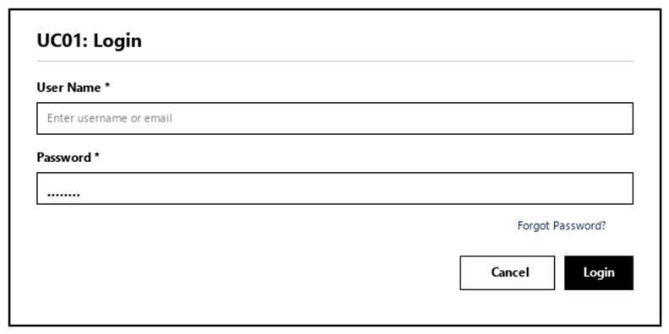
Figure 3-1: Screen Design of Login
Table 3-1: Screen Definition
# | Field Name | Type | Mandatory | Max Length | Description
1 | User Name | Text | Yes | 50 | User's registered account username or email address.
2 | Password | Text | Yes | 32 | User's account password. Displayed as * characters.
3 | Login | Button |  |  | Validates user credentials and logs into the system.
4 | Cancel | Button |  |  | Clears entered input fields or returns to default state.
5 | Forgot Password? | Hyperlink

3.2.1.2 Use Case Description
Use Case ID |  | UC01 | Use Case Name |  | Login
Author |  | NamNT | Version | 1.0 | Date | 4/10/2026
Actor |  | ALL
Description |  | Allows a user to authenticate into the Pharmacy Management System using their registered username/email and password to access authorized system features.
Precondition |  | PRE-01: The user has an active account in the system.  PRE-02: The login feature is accessible.
Trigger |  | TRG-01: User opens the application URL or launches the login page.
Post-Condition |  | POS-01: User is authenticated successfully and redirected to the Dashboard corresponding to their assigned role.  POS-02: A user login session is established.
Main flows
Step | Actor | Action
1 | User | Access the login function
2 | System | Display the login form
3 | User | Enter Username and Password, then submit
4 | System | Validate input fields
5 | System | Authenticate user credentials and check account status
6 | System | Establish user session and navigate to the respective Dashboard

Alternative flows
AT01 | Empty Mandatory Fields (At Step 4)
Sub step | Actor | Action
4.1 | System | Display validation error message indicating required fields.
4.2 | System | Keep the user on the login form with entered input preserved.
AT02 | Incorrect Username or Password (At Step 5)
Sub step | Actor | Action
5.1 | System | Display error message indicating invalid credentials.
5.2 | System | Clear the Password field and prompt the user to try again.
AT03 | Account Locked or Inactive (At Step 5)
Sub step | Actor | Action
5.1 | System | Display error message indicating the account is locked/deactivated and to contact Administrator.
5.2 | System | Abort the login process and remain on the login form.

Business Rules
# | Rule Description
BR-01 | Passwords must be hashed using a secure algorithm before verification. Plain text passwords must never be stored or logged.
BR-02 | Username is case-insensitive; Password is strictly case-sensitive.
BR-03 | Only accounts with Active status are permitted to log in.
BR-04 | If a user inputs an incorrect password 5 consecutive times, the system will automatically lock the account.
BR-05 | An active session will automatically expire after 30 minutes of inactivity, requiring the user to re-authenticate.

3.2.2 Logout
3.2.2.1 Mock-up
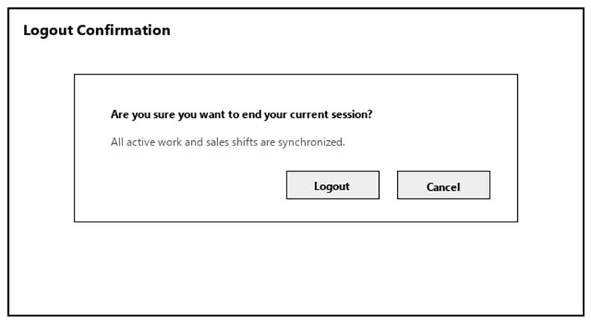
Figure 3-2: Screen Design of Logout
Table 3-2: Screen Definition
# | Field Name | Type | Mandatory | Max Length | Description
1 | Search / Filter | Text / Dropdown | No | 50 | Search records by code, name, or keyword.
2 | Data Table / Form | Grid / Input | Yes | -- | Primary data table or input fields for Logout.
3 | Action Buttons | Button | Yes | -- | Action buttons (Confirm / Submit / Save) to execute Logout.
4 | Cancel / Reset | Button | No | -- | Cancels active modification and returns to previous view.

3.2.2.2 Use Case Description
Use Case ID |  | UC02 | Use Case Name |  | Logout
Author |  | NamNT | Version | 1.0 | Date | 4/10/2026
Actor |  | All
Description |  | Allows a logged-in user to end their session and securely leave the system.
Precondition |  | PRE-01: User is logged in as All.  PRE-02: System registers and network services are operational.
Trigger |  | TRG-01: User navigates to 'Logout' menu.
Post-Condition |  | POS-01: 'Logout' completed successfully and transaction logged in database.  POS-02: System state updated and reflected across integrated modules.
Main flows
Step | Actor | Action
1 | All | Access Logout interface from main navigation menu.
2 | System | Display interface showing current data and controls for Logout.
3 | All | Enter required parameters / select items and click confirm.
4 | System | Validate operational inputs against business constraints.
5 | System | Commit transaction, record audit trail, and display success message.

Alternative flows
AT01 | Validation failure or missing fields (At Step 4)
Sub step | Actor | Action
4.1 | System | Display error alert highlighting invalid entries.
4.2 | System | Retain current form entries and prompt user to correct data.
AT02 | User cancels operation (At Step 3)
Sub step | Actor | Action
3.1 | System | Discard uncommitted changes and return to previous list screen.

Business Rules
# | Rule Description
BR-01 | All operations in 'Logout' must be performed under an active, authorized user session.
BR-02 | Every modification or execution must generate an immutable audit log record with user ID and timestamp.
BR-03 | Data integrity and role-based access rules must be strictly validated prior to saving changes.

3.2.3 Change Password
3.2.3.1 Mock-up
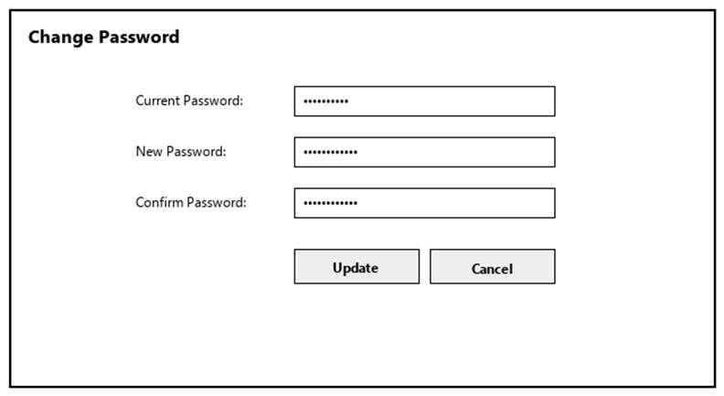
Figure 3-3: Screen Design of Change Password
Table 3-3: Screen Definition
# | Field Name | Type | Mandatory | Max Length | Description
1 | Search / Filter | Text / Dropdown | No | 50 | Search records by code, name, or keyword.
2 | Data Table / Form | Grid / Input | Yes | -- | Primary data table or input fields for Change Password.
3 | Action Buttons | Button | Yes | -- | Action buttons (Confirm / Submit / Save) to execute Change Password.
4 | Cancel / Reset | Button | No | -- | Cancels active modification and returns to previous view.

3.2.3.2 Use Case Description
Use Case ID |  | UC03 | Use Case Name |  | Change Password
Author |  | NamNT | Version | 1.0 | Date | 4/10/2026
Actor |  | All
Description |  | Allows a logged-in user to change their account password by providing the current password and a new one.
Precondition |  | PRE-01: User is logged in as All.  PRE-02: System registers and network services are operational.
Trigger |  | TRG-01: User navigates to 'Change Password' menu.
Post-Condition |  | POS-01: 'Change Password' completed successfully and transaction logged in database.  POS-02: System state updated and reflected across integrated modules.
Main flows
Step | Actor | Action
1 | All | Access Change Password interface from main navigation menu.
2 | System | Display interface showing current data and controls for Change Password.
3 | All | Enter required parameters / select items and click confirm.
4 | System | Validate operational inputs against business constraints.
5 | System | Commit transaction, record audit trail, and display success message.

Alternative flows
AT01 | Validation failure or missing fields (At Step 4)
Sub step | Actor | Action
4.1 | System | Display error alert highlighting invalid entries.
4.2 | System | Retain current form entries and prompt user to correct data.
AT02 | User cancels operation (At Step 3)
Sub step | Actor | Action
3.1 | System | Discard uncommitted changes and return to previous list screen.

Business Rules
# | Rule Description
BR-01 | All operations in 'Change Password' must be performed under an active, authorized user session.
BR-02 | Every modification or execution must generate an immutable audit log record with user ID and timestamp.
BR-03 | Data integrity and role-based access rules must be strictly validated prior to saving changes.

3.2.4 Manage Personal Information
3.2.4.1 Mock-up
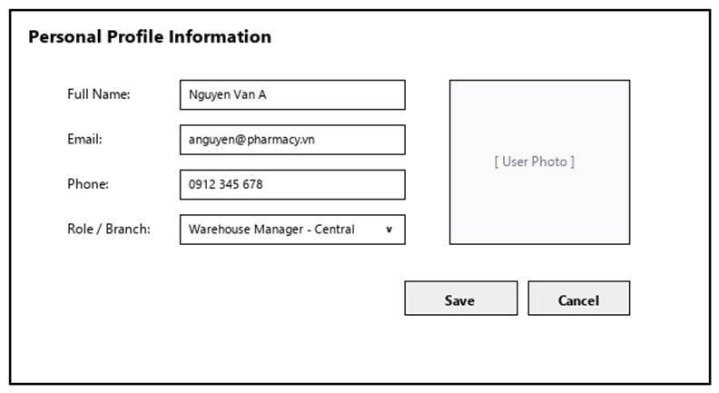
Figure 3-4: Screen Design of Manage Personal Information
Table 3-4: Screen Definition
# | Field Name | Type | Mandatory | Max Length | Description
1 | Search / Filter | Text / Dropdown | No | 50 | Search records by code, name, or keyword.
2 | Data Table / Form | Grid / Input | Yes | -- | Primary data table or input fields for Manage Personal Information.
3 | Action Buttons | Button | Yes | -- | Action buttons (Confirm / Submit / Save) to execute Manage Personal Information.
4 | Cancel / Reset | Button | No | -- | Cancels active modification and returns to previous view.

3.2.4.2 Use Case Description
Use Case ID |  | UC04 | Use Case Name |  | Manage Personal Information
Author |  | Group 5 | Version | 1.0 | Date | 04/10/2026
Actor |  | All
Description |  | Allows a logged-in user to view and update their own personal information.
Precondition |  | PRE-01: User is logged in as All.  PRE-02: System registers and network services are operational.
Trigger |  | TRG-01: User navigates to 'Manage Personal Information' menu.
Post-Condition |  | POS-01: 'Manage Personal Information' completed successfully and transaction logged in database.  POS-02: System state updated and reflected across integrated modules.
Main flows
Step | Actor | Action
1 | All | Access Manage Personal Information interface from main navigation menu.
2 | System | Display interface showing current data and controls for Manage Personal Information.
3 | All | Enter required parameters / select items and click confirm.
4 | System | Validate operational inputs against business constraints.
5 | System | Commit transaction, record audit trail, and display success message.

Alternative flows
AT01 | Validation failure or missing fields (At Step 4)
Sub step | Actor | Action
4.1 | System | Display error alert highlighting invalid entries.
4.2 | System | Retain current form entries and prompt user to correct data.
AT02 | User cancels operation (At Step 3)
Sub step | Actor | Action
3.1 | System | Discard uncommitted changes and return to previous list screen.

Business Rules
# | Rule Description
BR-01 | All operations in 'Manage Personal Information' must be performed under an active, authorized user session.
BR-02 | Every modification or execution must generate an immutable audit log record with user ID and timestamp.
BR-03 | Data integrity and role-based access rules must be strictly validated prior to saving changes.

3.2.5 Forgot Password
3.2.5.1 Mock-up
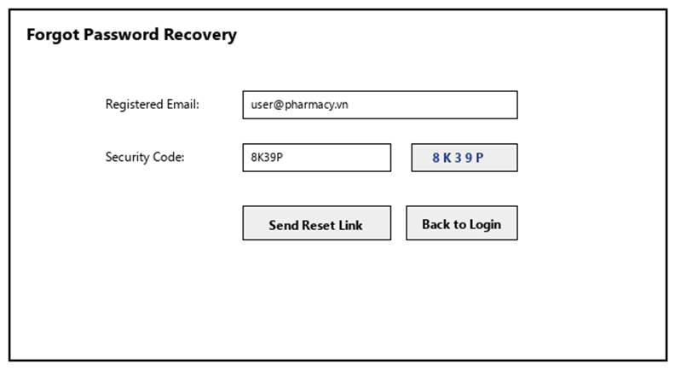
Figure 3-5: Screen Design of Forgot Password
Table 3-5: Screen Definition
# | Field Name | Type | Mandatory | Max Length | Description
1 | Search / Filter | Text / Dropdown | No | 50 | Search records by code, name, or keyword.
2 | Data Table / Form | Grid / Input | Yes | -- | Primary data table or input fields for Forgot Password.
3 | Action Buttons | Button | Yes | -- | Action buttons (Confirm / Submit / Save) to execute Forgot Password.
4 | Cancel / Reset | Button | No | -- | Cancels active modification and returns to previous view.

3.2.5.2 Use Case Description
Use Case ID |  | UC05 | Use Case Name |  | Forgot Password
Author |  | NamNT | Version | 1.0 | Date | 4/10/2026
Actor |  | All
Description |  | Allows a user who cannot remember their password to verify their identity via email and set a new password.
Precondition |  | PRE-01: User is logged in as All.  PRE-02: System registers and network services are operational.
Trigger |  | TRG-01: User navigates to 'Forgot Password' menu.
Post-Condition |  | POS-01: 'Forgot Password' completed successfully and transaction logged in database.  POS-02: System state updated and reflected across integrated modules.
Main flows
Step | Actor | Action
1 | All | Access Forgot Password interface from main navigation menu.
2 | System | Display interface showing current data and controls for Forgot Password.
3 | All | Enter required parameters / select items and click confirm.
4 | System | Validate operational inputs against business constraints.
5 | System | Commit transaction, record audit trail, and display success message.

Alternative flows
AT01 | Validation failure or missing fields (At Step 4)
Sub step | Actor | Action
4.1 | System | Display error alert highlighting invalid entries.
4.2 | System | Retain current form entries and prompt user to correct data.
AT02 | User cancels operation (At Step 3)
Sub step | Actor | Action
3.1 | System | Discard uncommitted changes and return to previous list screen.

Business Rules
# | Rule Description
BR-01 | All operations in 'Forgot Password' must be performed under an active, authorized user session.
BR-02 | Every modification or execution must generate an immutable audit log record with user ID and timestamp.
BR-03 | Data integrity and role-based access rules must be strictly validated prior to saving changes.

3.3 User & Security Management

3.3.1 View User List & Detail
3.3.1.1 Mock-up
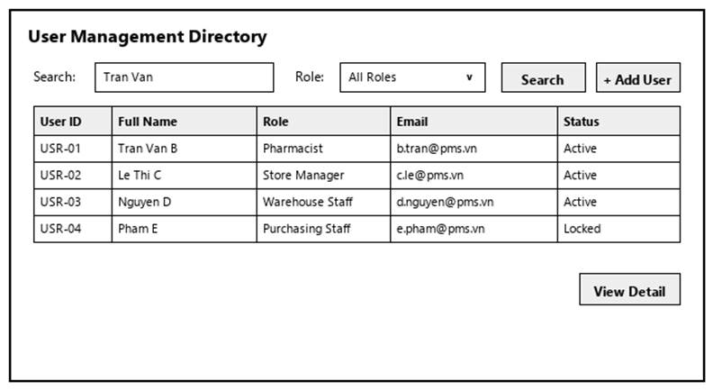
Figure 3-6: Screen Design of View User List & Detail
Table 3-6: Screen Definition
# | Field Name | Type | Mandatory | Max Length | Description
1 | Search / Filter | Text / Dropdown | No | 50 | Search records by code, name, or keyword.
2 | Data Table / Form | Grid / Input | Yes | -- | Primary data table or input fields for View User List & Detail.
3 | Action Buttons | Button | Yes | -- | Action buttons (Confirm / Submit / Save) to execute View User List & Detail.
4 | Cancel / Reset | Button | No | -- | Cancels active modification and returns to previous view.

3.3.1.2 Use Case Description
Use Case ID |  | UC06 | Use Case Name |  | View User List & Detail
Author |  | VinhDK | Version | 1.0 | Date | 04/10/2026
Actor |  | Admin
Description |  | Allows the Administrator to search, filter, and browse the system-wide user directory, as well as view comprehensive profile details, assigned roles, and assigned branch/store for a selected user.
Precondition |  | PRE-01: The Administrator is authenticated in the system.  PRE-02: The Administrator possesses user management privileges.
Trigger |  | TRG-01: The Administrator requests to access the user directory.
Post-Condition |  | POS-01: The system presents the user directory or detailed user profile according to the active query parameters.  POS-02: No system data is modified.
Main flows
Step | Actor | Action
1 | Admin | The Administrator requests to view the user directory.
2 | System | The System verifies Administrator privileges and retrieves the list of user accounts sorted by creation timestamp descending.
3 | System | The System presents the user directory alongside available search and filter controls (by name, phone number, email, assigned role, and account status).
4 | Admin | The Administrator inputs search keywords or selects filter criteria.
5 | System | The System validates the query parameters, retrieves matching database records, and presents the updated user directory.
6 | Admin | The Administrator selects a specific user to view detailed profile information.
7 | System | The System retrieves and presents the comprehensive profile of the selected user (including full name, contact information, assigned role, assigned store/branch, and account status).

Alternative flows
AT01 | No Matching Records Found (At Step 5)
Sub step | Actor | Action
5.1 | System | The System identifies no user records matching the specified search/filter criteria.
5.2 | System | The System presents an informational message indicating no records were found and displays an empty list.
AT02 | User Profile Not Found (At Step 7)
Sub step | Actor | Action
7.1 | System | The System fails to retrieve data for the selected user (e.g., record deleted or query failure).
7.2 | System | The System presents an error message indicating the profile is unavailable and returns the Administrator to the user directory.

Business Rules
# | Rule Description
BR-01 | Only active accounts with the Administrator role are authorized to access and view the system-wide user directory.
BR-02 | The default display limit is 10 user records per data retrieval page.
BR-03 | Encrypted user passwords must never be exposed or displayed in user profile views under any circumstances.

3.3.2 Add User
3.3.2.1 Mock-up
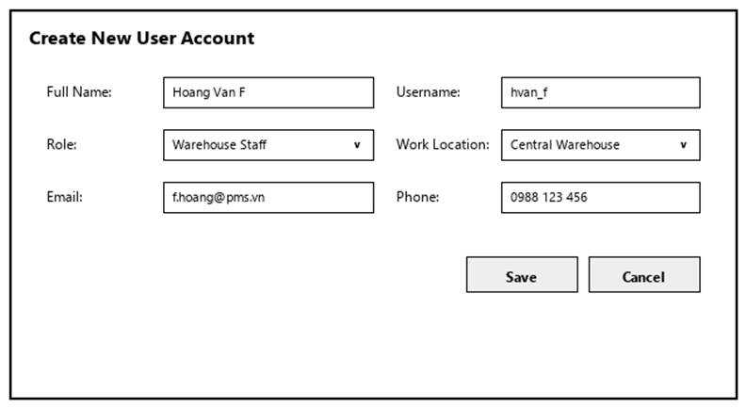
Figure 3-7: Screen Design of Add User
Table 3-7: Screen Definition
# | Field Name | Type | Mandatory | Max Length | Description
1 | Search / Filter | Text / Dropdown | No | 50 | Search records by code, name, or keyword.
2 | Data Table / Form | Grid / Input | Yes | -- | Primary data table or input fields for Add User.
3 | Action Buttons | Button | Yes | -- | Action buttons (Confirm / Submit / Save) to execute Add User.
4 | Cancel / Reset | Button | No | -- | Cancels active modification and returns to previous view.

3.3.2.2 Use Case Description
Use Case ID |  | UC07 | Use Case Name |  | Add User
Author |  | VinhDK | Version | 1.0 | Date | 04/10/2026
Actor |  | Admin
Description |  | Allows the Administrator to create a new user account, record personal details, define system login credentials, set an initial password, and assign an operational system role.
Precondition |  | PRE-01: The Administrator is authenticated with user management privileges.  PRE-02: User creation services and database network connections are operational.
Trigger |  | TRG-01: The Administrator requests to create a new user account.
Post-Condition |  | POS-01: The new user account is persisted in the database with an Active status.  POS-02: The account creation event is recorded in the System Audit Log.
Main flows
Step | Actor | Action
1 | Admin | The Administrator requests to initiate new user creation.
2 | System | The System prompts for required account and personal information (Full Name, Phone Number, Email Address, Username, Initial Password, and Assigned Role).
3 | Admin | The Administrator provides all required information and confirms account creation.
4 | System | The System validates that all mandatory fields contain complete data.
5 | System | The System verifies the uniqueness of the provided Username, Email Address, and Phone Number against existing system records.
6 | System | The System hashes the initial password, creates the new user record with Active status, logs the event in the System Audit Log, and confirms successful account creation.
7 | System | The System updates system state and returns the Administrator to the user directory.

Alternative flows
AT01 | Missing Mandatory Fields (At Step 4)
Sub step | Actor | Action
4.1 | System | The System identifies missing mandatory information (e.g., unselected role or missing phone number).
4.2 | System | The System highlights incomplete data fields and prompts the Administrator to complete all required information.
AT02 | Duplicate Unique Identifier (At Step 5)
Sub step | Actor | Action
5.1 | System | Discard uncommitted changes and return to previous list screen.
5.2 | System | The System presents a duplicate entry error and prompts for unique identifier values.
AT03 | Cancel User Creation (At Step 3)
Sub step | Actor | Action
3.1 | Admin | The Administrator chooses to abort the creation process.
3.2 | System | The System prompts for confirmation to discard unsaved data.
3.3 | System | Upon confirmation, the System discards all entered inputs and returns to the user directory without saving.

Business Rules
# | Rule Description
BR-01 | Username, Email Address, and Phone Number must be unique across all system users.
BR-02 | Initial passwords must meet minimum complexity requirements (at least 8 characters) and must be encrypted using a secure one-way hashing algorithm (BCrypt) prior to persistence.

3.3.3 Assign User role/permission
3.3.3.1 Mock-up
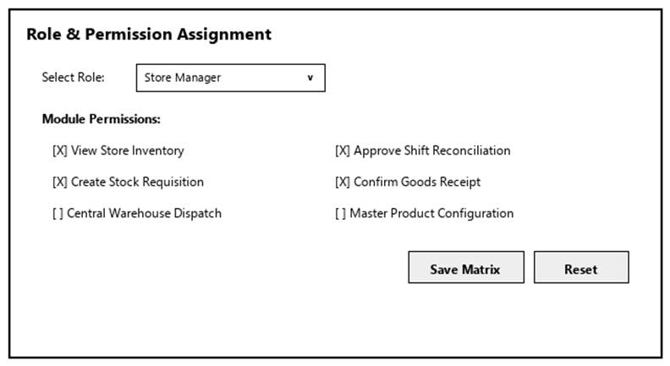
Figure 3-8: Screen Design of Assign User role/permission
Table 3-8: Screen Definition
# | Field Name | Type | Mandatory | Max Length | Description
1 | Search / Filter | Text / Dropdown | No | 50 | Search records by code, name, or keyword.
2 | Data Table / Form | Grid / Input | Yes | -- | Primary data table or input fields for Assign User role/permission.
3 | Action Buttons | Button | Yes | -- | Action buttons (Confirm / Submit / Save) to execute Assign User role/permission.
4 | Cancel / Reset | Button | No | -- | Cancels active modification and returns to previous view.

3.3.3.2 Use Case Description
Use Case ID |  | UC08 | Use Case Name |  | Assign User role/permission
Author |  | VinhDK | Version | 1.0 | Date | 04/10/2026
Actor |  | Admin
Description |  | Allows the Administrator to grant, modify, or customize functional roles and feature access permissions for an individual user account to enforce access control.
Precondition |  | PRE-01: The Administrator is authenticated with user management privileges.  PRE-02: The target user account exists in the system database.
Trigger |  | TRG-01: The Administrator requests to modify permissions for a specific user.
Post-Condition |  | POS-01: The user's role assignment and permission matrix are updated in the database.  POS-02: The permission modification action is recorded in the System Audit Log.
Main flows
Step | Actor | Action
1 | Admin | The Administrator selects a user account and requests to update role or permission assignments.
2 | System | The System retrieves and displays the user's currently assigned role along with available system feature permissions.
3 | Admin | The Administrator modifies the primary role or selects/deselects specific feature permissions, then confirms the update.
4 | System | The System validates permission assignment rules (verifying the operation is not a self-demotion of Administrator privileges).
5 | System | The System updates the permission matrix for the user account, logs the event in the System Audit Log, and confirms successful permission update.

Alternative flows
AT01 | Self-Role Demotion Prevention (At Step 4)
Sub step | Actor | Action
4.1 | System | The System detects that the Administrator is attempting to revoke the Administrator role from their own active session account.
4.2 | System | The System blocks the operation and presents an error indicating self-demotion of top-level administrative privileges is forbidden.
AT02 | Abort Permission Changes (At Step 3)
Sub step | Actor | Action
3.1 | Admin | The Administrator chooses to cancel the modification.
3.2 | System | The System discards pending changes, retains the existing permission matrix, and returns to the user directory.

Business Rules
# | Rule Description
BR-01 | Role and permission updates take effect immediately on the user's next system interaction or API request.
BR-02 | Every user account must possess at least one primary operational role within the system.

3.3.4 Edit User
3.3.4.1 Mock-up
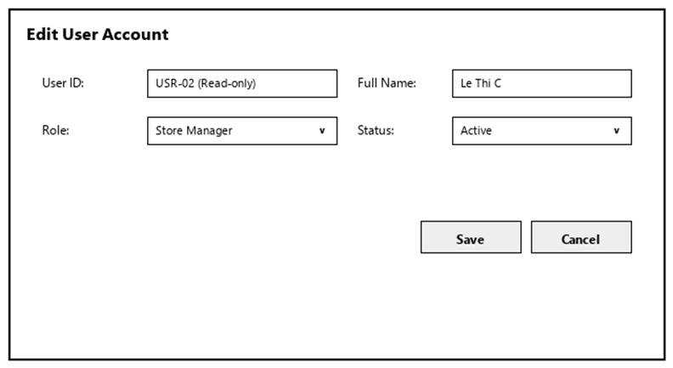
Figure 3-9: Screen Design of Edit User
Table 3-9: Screen Definition
# | Field Name | Type | Mandatory | Max Length | Description
1 | Search / Filter | Text / Dropdown | No | 50 | Search records by code, name, or keyword.
2 | Data Table / Form | Grid / Input | Yes | -- | Primary data table or input fields for Edit User.
3 | Action Buttons | Button | Yes | -- | Action buttons (Confirm / Submit / Save) to execute Edit User.
4 | Cancel / Reset | Button | No | -- | Cancels active modification and returns to previous view.

3.3.4.2 Use Case Description
Use Case ID |  | UC09 | Use Case Name |  | Edit User
Author |  | VinhDK | Version | 1.0 | Date | 04/10/2026
Actor |  | Admin
Description |  | Allows the Administrator to update personal profile details, contact information, work attributes, or reset the password for an existing user account.
Precondition |  | PRE-01: The Administrator is authenticated with user management privileges.  PRE-02: The target user account exists in the system database.
Trigger |  | TRG-01: The Administrator requests to edit an existing user account.
Post-Condition |  | POS-01: The updated user details are persisted in the database.  POS-02: The profile editing action is recorded in the System Audit Log.
Main flows
Step | Actor | Action
1 | Admin | The Administrator selects a user account and requests to edit profile details.
2 | System | The System retrieves and displays current user details (locking primary identifier fields against modification).
3 | Admin | The Administrator modifies editable attributes (e.g., Full Name, Phone Number, Email Address, or provides a new password) and confirms the updates.
4 | System | The System validates data completeness and format requirements for mandatory fields.
5 | System | The System checks uniqueness constraints if Email Address or Phone Number has been modified.
6 | System | The System persists the modifications to the database (hashing any new password provided), records the activity in the System Audit Log, and confirms successful profile update.
7 | System | The System returns the Administrator to the user directory.

Alternative flows
AT01 | Contact Data Conflict (At Step 5)
Sub step | Actor | Action
5.1 | System | The System detects that the modified Email Address or Phone Number conflicts with another active user account.
5.2 | System | The System presents a duplicate contact error and prompts for correction.
AT02 | Abort Profile Edit (At Step 3)
Sub step | Actor | Action
3.1 | Admin | The Administrator chooses to cancel the edit process.
3.2 | System | The System discards uncommitted changes and returns to the user directory.

Business Rules
# | Rule Description
BR-01 | User Code and Username are immutable primary identifiers and cannot be altered after account creation.
BR-02 | If the new password input is left blank, the existing password remains unchanged. If a new password is provided, it must be encrypted using BCrypt prior to storage.

3.3.5 Lock/Unlock User
3.3.5.1 Mock-up
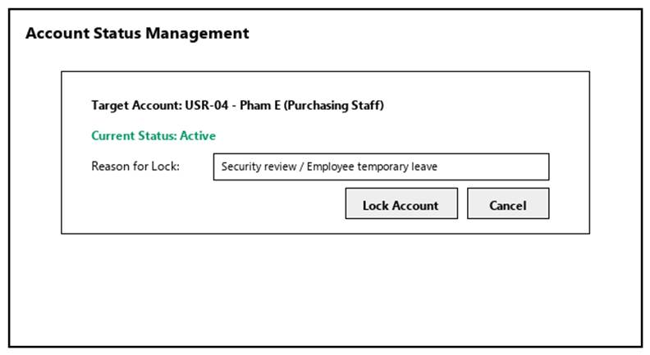
Figure 3-10: Screen Design of Lock/Unlock User
Table 3-10: Screen Definition
# | Field Name | Type | Mandatory | Max Length | Description
1 | Search / Filter | Text / Dropdown | No | 50 | Search records by code, name, or keyword.
2 | Data Table / Form | Grid / Input | Yes | -- | Primary data table or input fields for Lock/Unlock User.
3 | Action Buttons | Button | Yes | -- | Action buttons (Confirm / Submit / Save) to execute Lock/Unlock User.
4 | Cancel / Reset | Button | No | -- | Cancels active modification and returns to previous view.

3.3.5.2 Use Case Description
Use Case ID |  | UC10 | Use Case Name |  | Lock/Unlock User
Author |  | VinhDK | Version | 1.0 | Date | 04/10/2026
Actor |  | Admin
Description |  | Allows the Administrator to deactivate (lock) or reactivate (unlock) a user account to control system access and maintain security.
Precondition |  | PRE-01: The Administrator is authenticated with user management privileges.  PRE-02: The target user account exists in the system database.
Trigger |  | TRG-01: The Administrator requests to lock or unlock a specific user account.
Post-Condition |  | POS-01: The account status is toggled between Active and Locked in the database.  POS-02: All active session tokens associated with a locked account are immediately invalidated.  POS-03: The status change action and reason are recorded in the System Audit Log.
Main flows
Step | Actor | Action
1 | Admin | The Administrator selects a user account and requests to change its access status (Lock or Unlock).
2 | System | The System validates the request (verifying the target account is not the active session account of the executing Administrator).
3 | Admin | The System prompts for confirmation and requires an administrative reason (when locking an account).
4 | System | The Administrator confirms the action and provides a reason if applicable.
5 | System | The System updates the account status, immediately invalidates all active session tokens associated with the locked account (if being locked), records the event in the System Audit Log, and confirms status change completion.

Alternative flows
AT01 | Self-Lock Action Restriction (At Step 2)
Sub step | Actor | Action
4.1 | System | Display error alert highlighting invalid entries.
4.2 | System | Retain current form entries and prompt user to correct data.
AT02 | Cancel Status Change (At Step 4)
Sub step | Actor | Action
4.1 | Admin | The Administrator chooses not to confirm the status change.
4.2 | System | The System aborts the request and preserves the existing account status.

Business Rules
# | Rule Description
BR-01 | Administrators are strictly prohibited from locking or deactivating their own active session account.
BR-02 | When an account status is set to Locked, the system must immediately revoke and invalidate all active user sessions/tokens associated with that account to block unauthorized access.

3.3.6 View Audit Log
3.3.6.1 Mock-up
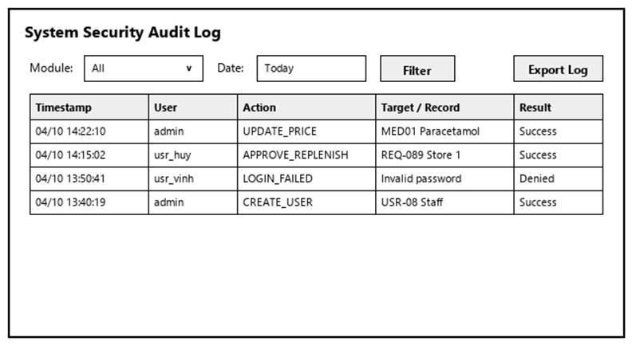
Figure 3-11: Screen Design of View Audit Log
Table 3-11: Screen Definition
# | Field Name | Type | Mandatory | Max Length | Description
1 | Search / Filter | Text / Dropdown | No | 50 | Search records by code, name, or keyword.
2 | Data Table / Form | Grid / Input | Yes | -- | Primary data table or input fields for View Audit Log.
3 | Action Buttons | Button | Yes | -- | Action buttons (Confirm / Submit / Save) to execute View Audit Log.
4 | Cancel / Reset | Button | No | -- | Cancels active modification and returns to previous view.

3.3.6.2 Use Case Description
Use Case ID |  | UC11 | Use Case Name |  | View Audit Log
Author |  | VinhDK | Version | 1.0 | Date | 04/10/2026
Actor |  | Admin
Description |  | Allows the Administrator to inspect, filter, and trace system-wide user activities, security events, master data modifications, price changes, and inventory stock adjustments for security monitoring and regulatory compliance.
Precondition |  | PRE-01: The Administrator is authenticated with system administration privileges.  PRE-02: The system automated audit logging middleware is operational.
Trigger |  | TRG-01: The Administrator requests to access the system audit log.
Post-Condition |  | POS-01: The system presents the audit log entries matching the specified filter criteria.  POS-02: No system data is modified.
Main flows
Step | Actor | Action
1 | Admin | The Administrator requests to access the system audit log.
2 | System | The System verifies Administrator authorization and retrieves audit log records for the default period (last 30 days) sorted by timestamp descending.
3 | System | The System presents the audit log entries along with available filter parameters (date range, target module, action type, user identity, and client IP address).
4 | Admin | The Administrator specifies filter criteria or search keywords and requests a refined query.
5 | System | The System validates the query parameters, queries the immutable audit log storage, and presents the filtered audit entries (including timestamp, executing user, user role, client IP address, action type, target entity, and change summary).
6 | Admin | The Administrator requests an export of the filtered audit trail.
7 | System | The System compiles the filtered audit records and generates a secure export file for compliance archiving.

Alternative flows
AT01 | No Audit Logs Found (At Step 5)
Sub step | Actor | Action
5.1 | System | The System detects no audit entries matching the specified filter criteria or date range.
5.2 | System | The System presents an informational message stating no audit log records were found and displays an empty audit trail.
AT02 | User cancels operation (At Step 3)
Sub step | Actor | Action
5.1 | System | The System detects that the specified start timestamp is later than the end timestamp.
5.2 | System | The System presents a query error and prompts for a valid date range.
AT03 | Unauthorized Access Attempt (At Step 2)
Sub step | Actor | Action
2.1 | System | The System detects a non-administrative user attempting to access the audit log.
2.2 | System | The System blocks the request, records an unauthorized access attempt event in the background audit log, and denies access.

Business Rules
# | Rule Description
BR-01 | Audit log entries are strictly read-only and immutable. No user, including the Administrator, can modify, tamper with, or delete audit records.
BR-02 | The system must automatically capture log details (Timestamp, User ID, Role, IP Address, Module Name, Action Code, and Before/After State) whenever any user performs sensitive actions (Authentication, Role Assignment, Account Lock, Price Change, Inventory Adjustment, Data Export).
BR-03 | Audit log records must be retained in the system for a minimum of 365 days to comply with Ministry of Health pharmaceutical compliance standards.
BR-04 | Every logged audit event must record the originating client IP address to ensure complete network traceability.

3.4 Product Management

3.4.1 View Product List
3.4.1.1 Mock-up
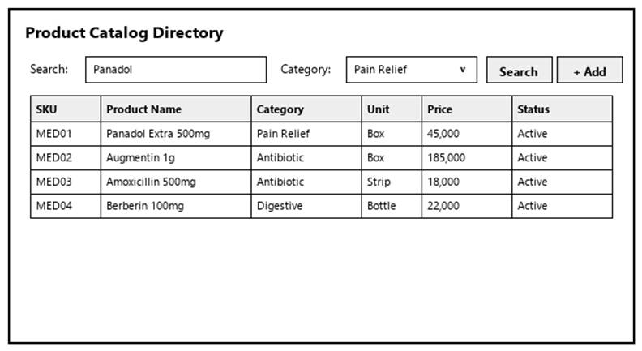
Figure 3-12: Screen Design of View Product List
Table 3-12: Screen Definition
# | Field Name | Type | Mandatory | Max Length | Description
1 | Search / Filter | Text / Dropdown | No | 50 | Search records by code, name, or keyword.
2 | Data Table / Form | Grid / Input | Yes | -- | Primary data table or input fields for View Product List.
3 | Action Buttons | Button | Yes | -- | Action buttons (Confirm / Submit / Save) to execute View Product List.
4 | Cancel / Reset | Button | No | -- | Cancels active modification and returns to previous view.

3.4.1.2 Use Case Description
Use Case ID |  | UC12 | Use Case Name |  | View Product List
Author |  | VinhDK | Version | 1.0 | Date | 04/10/2026
Actor |  | Administrator, Store Manager, Pharmacist, Warehouse Manager, Warehouse Staff
Description |  | Allows internal pharmacy staff to search, filter, and view the master pharmaceutical product catalog, including active ingredients, dosage forms, packaging specifications, unit conversion structures, and prescription requirements.
Precondition |  | PRE-01: The user is authenticated in the system.  PRE-02: The product catalog database is accessible.
Trigger |  | TRG-01: The user requests to access the product catalog.
Post-Condition |  | POS-01: The product catalog or detailed product master profile is presented according to active query parameters.  POS-02: No system data is modified.
Main flows
Step | Actor | Action
1 | User | The user requests to access the product catalog.
2 | System | The System verifies user authentication and retrieves default product master records sorted by product code ascending.
3 | System | The System presents the product list alongside available search and filter controls (by commercial name, active ingredient, barcode/SKU, category, and prescription status).
4 | User | The user inputs search keywords or selects filter criteria.
5 | System | The System validates the query parameters, searches the database, and presents the matching product records.
6 | User | The user selects a specific product to inspect detailed master information.
7 | System | The System retrieves and presents the complete product master profile (including commercial name, generic active ingredient, dosage strength, manufacturer, registration number, category, base unit of measure, packaging specifications, and prescription requirement status).

Alternative flows
AT01 | Validation failure or missing fields (At Step 4)
Sub step | Actor | Action
5.1 | System | The System detects no products matching the specified search or filter criteria.
5.2 | System | The System presents an informational message indicating no product records match the query.
AT02 | Product Record Unavailable (At Step 7)
Sub step | Actor | Action
7.1 | System | The System fails to retrieve the selected product record (e.g., archived or database connection error).
7.2 | System | The System presents an error message and returns the user to the product catalog list.

Business Rules
# | Rule Description
BR-01 | Search filters must support querying by both Commercial Brand Name and Generic Active Ingredient to assist dispensing operations.
BR-02 | All authenticated internal actors have read-only access to the product master catalog.

3.4.2 Add Product
3.4.2.1 Mock-up
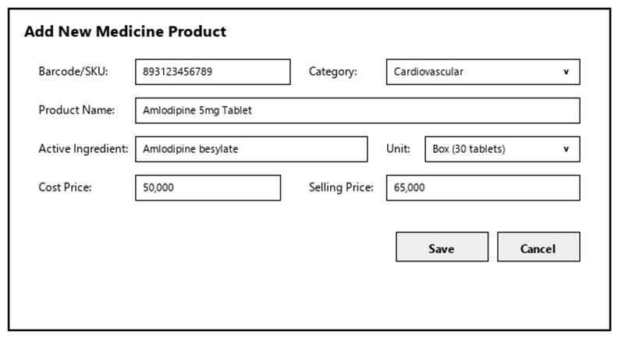
Figure 3-13: Screen Design of Add Product
Table 3-13: Screen Definition
# | Field Name | Type | Mandatory | Max Length | Description
1 | Search / Filter | Text / Dropdown | No | 50 | Search records by code, name, or keyword.
2 | Data Table / Form | Grid / Input | Yes | -- | Primary data table or input fields for Add Product.
3 | Action Buttons | Button | Yes | -- | Action buttons (Confirm / Submit / Save) to execute Add Product.
4 | Cancel / Reset | Button | No | -- | Cancels active modification and returns to previous view.

3.4.2.2 Use Case Description
Use Case ID |  | UC13 | Use Case Name |  | Add Product
Author |  | VinhDK | Version | 1.0 | Date | 04/10/2026
Actor |  | Admin
Description |  | Allows the Administrator to register a new pharmaceutical item or medical product into the master catalog according to National Drug Database standards.
Precondition |  | PRE-01: The Administrator is authenticated with product management privileges.  PRE-02: Target Product Category and Base Unit of Measure exist in the system database.
Trigger |  | TRG-01: The Administrator requests to register a new product.
Post-Condition |  | POS-01: The new product master record is persisted in the database with Active status.  POS-02: The product registration event is recorded in the System Audit Log.
Main flows
Step | Actor | Action
1 | Admin | The Administrator requests to initiate new product registration.
2 | System | The System prompts for required product master attributes (Product Code, Commercial Name, Generic Active Ingredient, Dosage/Strength, Category, Base Unit of Measure, Barcode/National Drug Code, Registration Number, Manufacturer, Packaging Specification, and Prescription Required Flag).
3 | Admin | The Administrator provides the required product details and confirms submission.
4 | System | The System validates that all mandatory pharmaceutical attributes contain complete and correctly formatted data.
5 | System | The System verifies the uniqueness of the Product Code, Barcode, and Ministry of Health Registration Number against existing catalog records.
6 | System | The System persists the product master record with Active status, logs the event in the System Audit Log, and confirms successful product creation.
7 | System | The System updates system state and returns the Administrator to the product catalog.

Alternative flows
AT01 | Missing Mandatory Attributes (At Step 4)
Sub step | Actor | Action
4.1 | System | The System identifies missing mandatory fields (e.g., blank active ingredient for prescription drugs or missing base unit).
4.2 | System | The System highlights incomplete fields and prompts the Administrator to supply required data.
AT02 | Duplicate Product Code, Barcode, or Registration Code (At Step 5)
Sub step | Actor | Action
5.1 | System | The System detects that the Product Code, Barcode, or Registration Number is already assigned to another catalog item.
5.2 | System | The System presents a duplicate identifier error and prompts for unique values.
AT02 | User cancels operation (At Step 3)
Sub step | Actor | Action
3.1 | Admin | The Administrator chooses to cancel the product creation process.
3.2 | System | The System prompts for confirmation to discard unsaved entries.
3.3 | System | Upon confirmation, the System discards all inputs and returns to the product catalog without saving.

Business Rules
# | Rule Description
BR-01 | Product Code, Barcode, and Ministry of Health Registration Number must be unique across all system products.
BR-02 | Product registration only establishes technical and pharmaceutical master specifications. Selling price setup and margin configuration must be performed separately via Price Management.
BR-03 | Products flagged as Prescription Required = Yes (Rx) strictly enforce prescription code verification at POS sales.

3.4.3 Edit Product
3.4.3.1 Mock-up
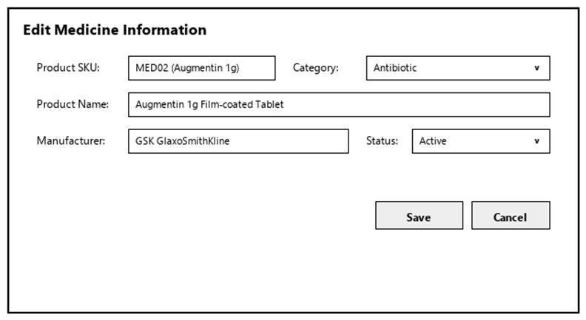
Figure 3-14: Screen Design of Edit Product
Table 3-14: Screen Definition
# | Field Name | Type | Mandatory | Max Length | Description
1 | Search / Filter | Text / Dropdown | No | 50 | Search records by code, name, or keyword.
2 | Data Table / Form | Grid / Input | Yes | -- | Primary data table or input fields for Edit Product.
3 | Action Buttons | Button | Yes | -- | Action buttons (Confirm / Submit / Save) to execute Edit Product.
4 | Cancel / Reset | Button | No | -- | Cancels active modification and returns to previous view.

3.4.3.2 Use Case Description
Use Case ID |  | UC14 | Use Case Name |  | Edit Product
Author |  | VinhDK | Version | 1.0 | Date | 04/10/2026
Actor |  | Admin
Description |  | Allows the Administrator to update master details, active ingredient specifications, category classifications, or operational status for an existing product record.
Precondition |  | PRE-01: The Administrator is authenticated with product management privileges.  PRE-02: The target product master record exists in the database.
Trigger |  | TRG-01: The Administrator requests to edit an existing product master record.
Post-Condition |  | POS-01: Updated product master attributes are persisted in the database.  POS-02: The product editing event is recorded in the System Audit Log.
Main flows
Step | Actor | Action
1 | Admin | The Administrator selects a product master record and requests to edit its details.
2 | System | The System retrieves and displays current product master attributes (locking immutable primary keys against editing).
3 | Admin | The Administrator modifies editable attributes (e.g., Commercial Name, Active Ingredient, Dosage, Category, Manufacturer, Registration Number, Prescription Flag, or Status) and confirms submission.
4 | System | The System validates attribute completeness and formatting.
5 | System | The System checks uniqueness constraints for modified Barcode or Registration Number if altered.
6 | System | The System validates operational status changes (checking if deactivating a product affects active branch inventory).
7 | System | The System persists the updated master details in the database, logs the activity in the System Audit Log, and confirms successful product update.
8 | System | The System returns the Administrator to the product catalog.

Alternative flows
AT01 | Duplicate Barcode/Registration Number Conflict (At Step 5)
Sub step | Actor | Action
5.1 | System | The System detects that the modified Barcode or Registration Number is assigned to another active product.
5.2 | System | The System presents a duplicate error and prompts for correction.
AT02 | Deactivating Product with Active Inventory (At Step 6)
Sub step | Actor | Action
6.1 | System | The Administrator sets the product status to Inactive for an item currently holding active stock on pharmacy shelves.
6.2 | System | The System prompts a warning indicating that active inventory exists and that deactivation will restrict POS sales.
6.3a | Admin | The Administrator confirms The System proceeds with setting status to Inactive.
6.3b | Admin | The Administrator cancels The System aborts status update and retains Active status.
AT03 | Cancel Product Edit (At Step 3)
Sub step | Actor | Action
3.1 | Admin | The Administrator chooses to cancel the editing process.
3.2 | System | The System discards uncommitted modifications and returns to the product catalog.

Business Rules
# | Rule Description
BR-01 | Product Code is an immutable system key and cannot be modified after creation to preserve transaction history integrity.
BR-02 | The Base Unit of Measure cannot be altered if the product has recorded historical stock intakes or POS sales transactions.

3.4.4 View Price History
3.4.4.1 Mock-up
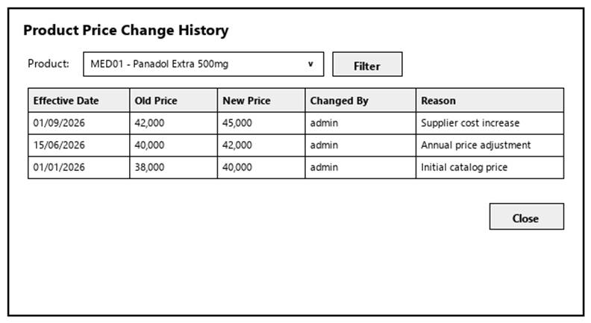
Figure 3-15: Screen Design of View Price History
Table 3-15: Screen Definition
# | Field Name | Type | Mandatory | Max Length | Description
1 | Search / Filter | Text / Dropdown | No | 50 | Search records by code, name, or keyword.
2 | Data Table / Form | Grid / Input | Yes | -- | Primary data table or input fields for View Price History.
3 | Action Buttons | Button | Yes | -- | Action buttons (Confirm / Submit / Save) to execute View Price History.
4 | Cancel / Reset | Button | No | -- | Cancels active modification and returns to previous view.

3.4.4.2 Use Case Description
Use Case ID |  | UC15 | Use Case Name |  | View Price History
Author |  | VinhDK | Version | 1.0 | Date | 04/10/2026
Actor |  | Admin
Description |  | Allows authorized users to inspect historical selling price and cost price modifications for a product, tracking effective dates, price versions, modifying actors, and reasons for change.
Precondition |  | PRE-01: The user is authenticated with price view permissions.  PRE-02: Target product record exists in the database.
Trigger |  | TRG-01: The user requests to view price history for a specific product.
Post-Condition |  | POS-01: The chronological price version history for the selected product is presented.  POS-02: No system data is modified.
Main flows
Step | Actor | Action
1 | Admin | The user selects a product and requests to view its price history.
2 | System | The System retrieves all price history records associated with the product sorted by effective timestamp descending.
3 | Admin | The System presents the historical price ledger (including Price Version ID, Cost Price, Selling Price, Margin Percentage, Effective From Timestamp, Executing User, and Change Reason).
4 | System | (Optional) The user specifies a date range filter to narrow down historical price versions.
5 | System | The System applies the filter and presents the matching price history records.

Alternative flows
AT01 | No Price History Records Found (At Step 2)
Sub step | Actor | Action
2.1 | System | The System detects no historical price changes recorded for the selected product.
2.2 | System | The System presents a message indicating only initial registration price data exists.

Business Rules
# | Rule Description
BR-01 | Price history records are permanent historical audit logs and cannot be edited or deleted by any user.
BR-02 | Modifying a product price creates a new price version record in history without altering historical sales invoice prices.

3.4.5 Manage Product Price
3.4.5.1 Mock-up
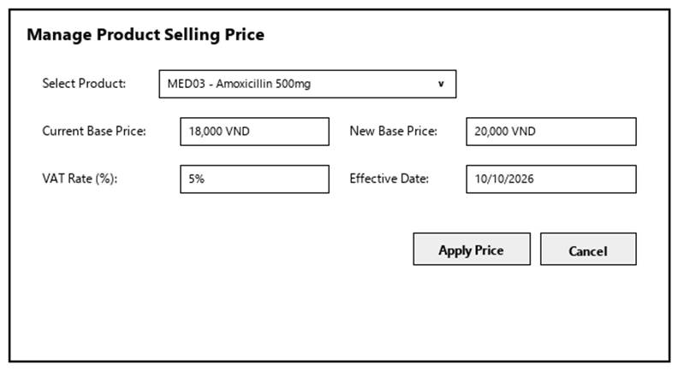
Figure 3-16: Screen Design of Manage Product Price
Table 3-16: Screen Definition
# | Field Name | Type | Mandatory | Max Length | Description
1 | Search / Filter | Text / Dropdown | No | 50 | Search records by code, name, or keyword.
2 | Data Table / Form | Grid / Input | Yes | -- | Primary data table or input fields for Manage Product Price.
3 | Action Buttons | Button | Yes | -- | Action buttons (Confirm / Submit / Save) to execute Manage Product Price.
4 | Cancel / Reset | Button | No | -- | Cancels active modification and returns to previous view.

3.4.5.2 Use Case Description
Use Case ID |  | UC16 | Use Case Name |  | Manage Product Price
Author |  | VinhDK | Version | 1.0 | Date | 04/10/2026
Actor |  | Administrator, Store Manager
Description |  | Allows authorized managers to set initial cost and selling prices for new products, update selling prices for existing items, and configure effective activation dates.
Precondition |  | PRE-01: The user is authenticated with price management privileges.  PRE-02: Target product master record exists in the system database.
Trigger |  | TRG-01: The user requests to configure or update prices for a product.
Post-Condition |  | POS-01: The new price version is saved and set as active in the database.  POS-02: A new record is created in the Price History ledger.  POS-03: The price update action is recorded in the System Audit Log.
Main flows
Step | Actor | Action
1 | User | The user selects a product and requests to manage its price.
2 | System | The System retrieves and displays current pricing details (Current Cost Price, Current Selling Price, Current Margin, and Effective Date).
3 | User | The user inputs new pricing parameters (New Cost Price, New Selling Price, Effective Activation Timestamp, and Mandatory Reason for Change) and confirms submission.
4 | System | The System validates that input values are positive numeric amounts and that Selling Price is greater than or equal to Cost Price.
5 | System | The System creates a new price version entry in the Price History ledger, updates the active product price, logs the action in the System Audit Log, and confirms successful price update.
6 | System | The System synchronizes the updated selling price across branch POS terminals upon activation timestamp.

Alternative flows
AT01 | Negative Profit Margin Warning / Block (At Step 4)
Sub step | Actor | Action
4.1 | System | The System detects that the proposed Selling Price is lower than the Cost Price (Negative Margin).
4.2 | System | The System blocks submission and presents an error stating Selling Price must be greater than or equal to Cost Price.
AT02 | Missing Reason for Change (At Step 4)
Sub step | Actor | Action
4.1 | System | Discard uncommitted changes and return to previous list screen.
4.2 | System | The System prompts the user to provide a mandatory justification for adjusting product prices.
AT03 | Cancel Price Setup (At Step 3)
Sub step | Actor | Action
3.1 | User | The user chooses to cancel the price configuration.
3.2 | System | The System discards uncommitted inputs and retains current product prices.

Business Rules
# | Rule Description
BR-01 | Cost Price and Selling Price must be strictly positive numeric values (> 0).
BR-02 | Price updates take effect globally across all retail branches upon reaching the specified effective timestamp.
BR-03 | Every price adjustment requires a mandatory explanatory reason for audit tracking.

3.5 Category Management

3.5.1 View Categories
3.5.1.1 Mock-up
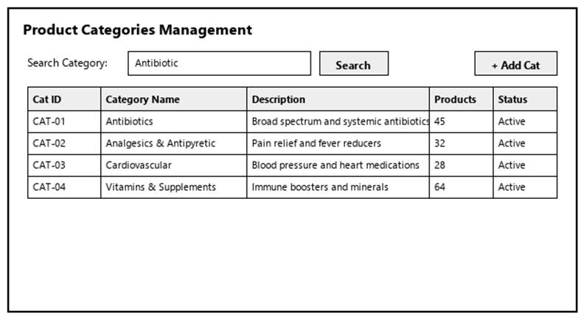
Figure 3-17: Screen Design of View Categories
Table 3-17: Screen Definition
# | Field Name | Type | Mandatory | Max Length | Description
1 | Search / Filter | Text / Dropdown | No | 50 | Search records by code, name, or keyword.
2 | Data Table / Form | Grid / Input | Yes | -- | Primary data table or input fields for View Categories.
3 | Action Buttons | Button | Yes | -- | Action buttons (Confirm / Submit / Save) to execute View Categories.
4 | Cancel / Reset | Button | No | -- | Cancels active modification and returns to previous view.

3.5.1.2 Use Case Description
Use Case ID |  | UC17 | Use Case Name |  | View Categories
Author |  | VinhDK | Version | 1.0 | Date | 04/10/2026
Actor |  | Admin
Description |  | Allows admin to browse and view the list and details of product categories.
Precondition |  | PRE-01: User is logged in as Admin.  PRE-02: System registers and network services are operational.
Trigger |  | TRG-01: User navigates to 'View Categories' menu.
Post-Condition |  | POS-01: 'View Categories' completed successfully and transaction logged in database.  POS-02: System state updated and reflected across integrated modules.
Main flows
Step | Actor | Action
1 | Admin | Access View Categories interface from main navigation menu.
2 | System | Display interface showing current data and controls for View Categories.
3 | Admin | Enter required parameters / select items and click confirm.
4 | System | Validate operational inputs against business constraints.
5 | System | Commit transaction, record audit trail, and display success message.

Alternative flows
AT01 | Validation failure or missing fields (At Step 4)
Sub step | Actor | Action
4.1 | System | Display error alert highlighting invalid entries.
4.2 | System | Retain current form entries and prompt user to correct data.
AT02 | User cancels operation (At Step 3)
Sub step | Actor | Action
3.1 | System | Discard uncommitted changes and return to previous list screen.

Business Rules
# | Rule Description
BR-01 | All operations in 'View Categories' must be performed under an active, authorized user session.
BR-02 | Every modification or execution must generate an immutable audit log record with user ID and timestamp.
BR-03 | Data integrity and role-based access rules must be strictly validated prior to saving changes.

3.5.2 Add Category
3.5.2.1 Mock-up
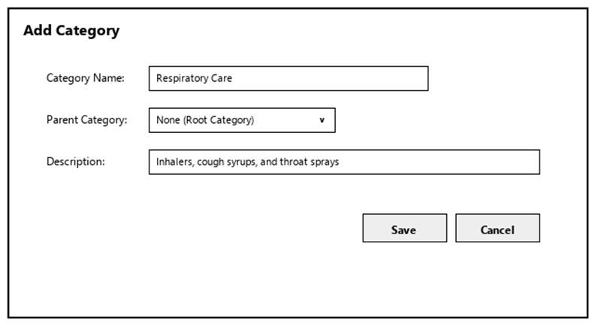
Figure 3-18: Screen Design of Add Category
Table 3-18: Screen Definition
# | Field Name | Type | Mandatory | Max Length | Description
1 | Search / Filter | Text / Dropdown | No | 50 | Search records by code, name, or keyword.
2 | Data Table / Form | Grid / Input | Yes | -- | Primary data table or input fields for Add Category.
3 | Action Buttons | Button | Yes | -- | Action buttons (Confirm / Submit / Save) to execute Add Category.
4 | Cancel / Reset | Button | No | -- | Cancels active modification and returns to previous view.

3.5.2.2 Use Case Description
Use Case ID |  | UC18 | Use Case Name |  | Add Category
Author |  | VinhDK | Version | 1.0 | Date | 04/10/2026
Actor |  | Admin
Description |  | Allows admin to create a new product category to organize products in the store.
Precondition |  | PRE-01: User is logged in as Admin.  PRE-02: System registers and network services are operational.
Trigger |  | TRG-01: User navigates to 'Add Category' menu.
Post-Condition |  | POS-01: 'Add Category' completed successfully and transaction logged in database.  POS-02: System state updated and reflected across integrated modules.
Main flows
Step | Actor | Action
1 | Admin | Access Add Category interface from main navigation menu.
2 | System | Display interface showing current data and controls for Add Category.
3 | Admin | Enter required parameters / select items and click confirm.
4 | System | Validate operational inputs against business constraints.
5 | System | Commit transaction, record audit trail, and display success message.

Alternative flows
AT01 | Validation failure or missing fields (At Step 4)
Sub step | Actor | Action
4.1 | System | Display error alert highlighting invalid entries.
4.2 | System | Retain current form entries and prompt user to correct data.
AT02 | User cancels operation (At Step 3)
Sub step | Actor | Action
3.1 | System | Discard uncommitted changes and return to previous list screen.

Business Rules
# | Rule Description
BR-01 | All operations in 'Add Category' must be performed under an active, authorized user session.
BR-02 | Every modification or execution must generate an immutable audit log record with user ID and timestamp.
BR-03 | Data integrity and role-based access rules must be strictly validated prior to saving changes.

3.5.3 Edit Category
3.5.3.1 Mock-up
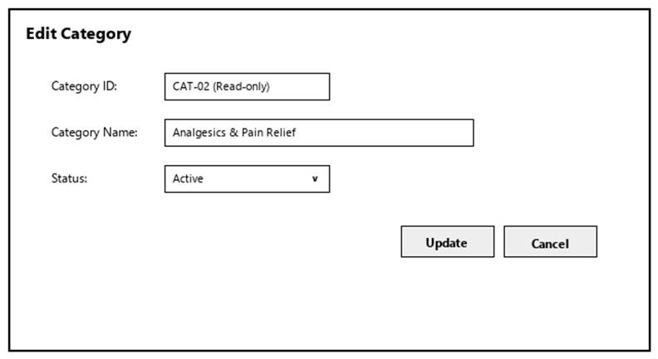
Figure 3-19: Screen Design of Edit Category
Table 3-19: Screen Definition
# | Field Name | Type | Mandatory | Max Length | Description
1 | Search / Filter | Text / Dropdown | No | 50 | Search records by code, name, or keyword.
2 | Data Table / Form | Grid / Input | Yes | -- | Primary data table or input fields for Edit Category.
3 | Action Buttons | Button | Yes | -- | Action buttons (Confirm / Submit / Save) to execute Edit Category.
4 | Cancel / Reset | Button | No | -- | Cancels active modification and returns to previous view.

3.5.3.2 Use Case Description
Use Case ID |  | UC19 | Use Case Name |  | Edit Category
Author |  | VinhDK | Version | 1.0 | Date | 04/10/2026
Actor |  | Admin
Description |  | Allows admin to update the name, description, or status of an existing product category.
Precondition |  | PRE-01: User is logged in as Admin.  PRE-02: System registers and network services are operational.
Trigger |  | TRG-01: User navigates to 'Edit Category' menu.
Post-Condition |  | POS-01: 'Edit Category' completed successfully and transaction logged in database.  POS-02: System state updated and reflected across integrated modules.
Main flows
Step | Actor | Action
1 | Admin | Access Edit Category interface from main navigation menu.
2 | System | Display interface showing current data and controls for Edit Category.
3 | Admin | Enter required parameters / select items and click confirm.
4 | System | Validate operational inputs against business constraints.
5 | System | Commit transaction, record audit trail, and display success message.

Alternative flows
AT01 | Validation failure or missing fields (At Step 4)
Sub step | Actor | Action
4.1 | System | Display error alert highlighting invalid entries.
4.2 | System | Retain current form entries and prompt user to correct data.
AT02 | User cancels operation (At Step 3)
Sub step | Actor | Action
3.1 | System | Discard uncommitted changes and return to previous list screen.

Business Rules
# | Rule Description
BR-01 | All operations in 'Edit Category' must be performed under an active, authorized user session.
BR-02 | Every modification or execution must generate an immutable audit log record with user ID and timestamp.
BR-03 | Data integrity and role-based access rules must be strictly validated prior to saving changes.

3.5.4 Delete Category
3.5.4.1 Mock-up
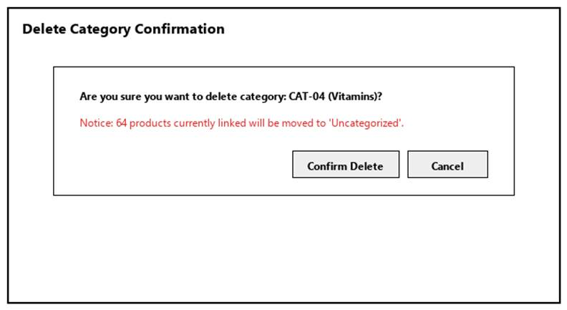
Figure 3-20: Screen Design of Delete Category
Table 3-20: Screen Definition
# | Field Name | Type | Mandatory | Max Length | Description
1 | Search / Filter | Text / Dropdown | No | 50 | Search records by code, name, or keyword.
2 | Data Table / Form | Grid / Input | Yes | -- | Primary data table or input fields for Delete Category.
3 | Action Buttons | Button | Yes | -- | Action buttons (Confirm / Submit / Save) to execute Delete Category.
4 | Cancel / Reset | Button | No | -- | Cancels active modification and returns to previous view.

3.5.4.2 Use Case Description
Use Case ID |  | UC20 | Use Case Name |  | Delete Category
Author |  | VinhDK | Version | 1.0 | Date | 04/10/2026
Actor |  | Admin
Description |  | Allows admin to remove a product category that is no longer used.
Precondition |  | PRE-01: User is logged in as Admin.  PRE-02: System registers and network services are operational.
Trigger |  | TRG-01: User navigates to 'Delete Category' menu.
Post-Condition |  | POS-01: 'Delete Category' completed successfully and transaction logged in database.  POS-02: System state updated and reflected across integrated modules.
Main flows
Step | Actor | Action
1 | Admin | Access Delete Category interface from main navigation menu.
2 | System | Display interface showing current data and controls for Delete Category.
3 | Admin | Enter required parameters / select items and click confirm.
4 | System | Validate operational inputs against business constraints.
5 | System | Commit transaction, record audit trail, and display success message.

Alternative flows
AT01 | Validation failure or missing fields (At Step 4)
Sub step | Actor | Action
4.1 | System | Display error alert highlighting invalid entries.
4.2 | System | Retain current form entries and prompt user to correct data.
AT02 | User cancels operation (At Step 3)
Sub step | Actor | Action
3.1 | System | Discard uncommitted changes and return to previous list screen.

Business Rules
# | Rule Description
BR-01 | All operations in 'Delete Category' must be performed under an active, authorized user session.
BR-02 | Every modification or execution must generate an immutable audit log record with user ID and timestamp.
BR-03 | Data integrity and role-based access rules must be strictly validated prior to saving changes.

3.6 Shift Management

3.6.1 Open Shift
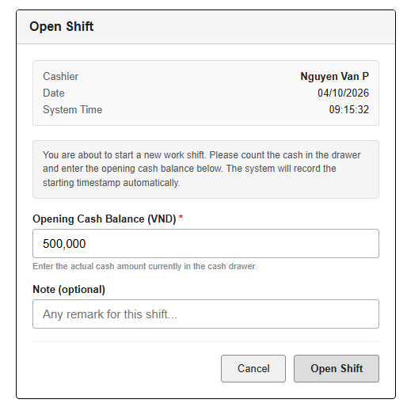
Table 3-1: Screen Definition
# | Field Name | Type | Mandatory | Max Length | Description
1 | Cashier | Text |  |  | Display current logged-in  Pharmacist name
2 | System Time | Button |  |  | Current date and system  timestamp (auto)
3 | Opening Cash Balance | Number | Yes | 15 | Actual cash amount in the drawer  at shift start (VND)
4 | Note | Text | No | 255 | Optional remark for this shift
5 | Open Shift | Button |  |  | Validate and create a new Shift record with status = Open
6 | Cancel | Button |  |  | Discard and return to previous screen

3.2.1.2 Use Case Description
Use Case ID |  | UC01 | Use Case Name |  | Open Shift
Author |  | NamNT | Version | 1.0 | Date | 04/10/2026
Actor |  | Pharmacist
Description |  | The function allows a Pharmacist to initiate a work shift by recording the starting timestamp and the opening cash balance in the cash drawer.
Precondition |  | PRE-01: User has successfully logged in with a Pharmacist role.  PRE-02: There is no currently open Shift for this user.
Trigger |  | TRG-01: User selects "Open Shift" from the menu or is prompted when accessing POS without an open shift.
Post-Condition |  | POS-01: A new Shift record is created with status = Open, opening_time = current timestamp, opening_cash = entered amount.  POS-02: User can now create sales invoices under this shift.
Main flows
Step | Actor | Action
1 | Pharmacist | Select Open Shift
2 | System | Display Open Shift screen with cashier name, current date/time, and Opening Cash Balance input
3 | Pharmacist | Count cash in drawer, enter Opening Cash Balance, optionally add a note, then click “Open Shift”
4 | System | Validate input. Create a Shift record (status=Open, opening_time=now, opening_cash=value). Navigate to the POS Dashboard.

Alternative flows
AT1 | At step 4, Opening Cash Balance is empty or invalid (negative / non-numeric):
Sub step | Actor | Action
4.1 | System | The system highlights the field and shows an error "Please enter a valid opening cash balance."
AT1 | User already has an open shift:
Sub step | Actor | Action
1.1 | System | System blocks opening a new shift and displays "You already have an open shift. Please close it first."

Business Rules
# | Rule Description
BR-01 | A Pharmacist can have only one Open shift at a time.
BR-02 | Opening timestamp is automatically set by the system at the moment the shift is opened.
BR-03 | Opening Cash Balance must be ≥ 0.
BR-04 | Sales invoices can only be created when the user has an active (Open) shift.

3.6.2 Close Shift
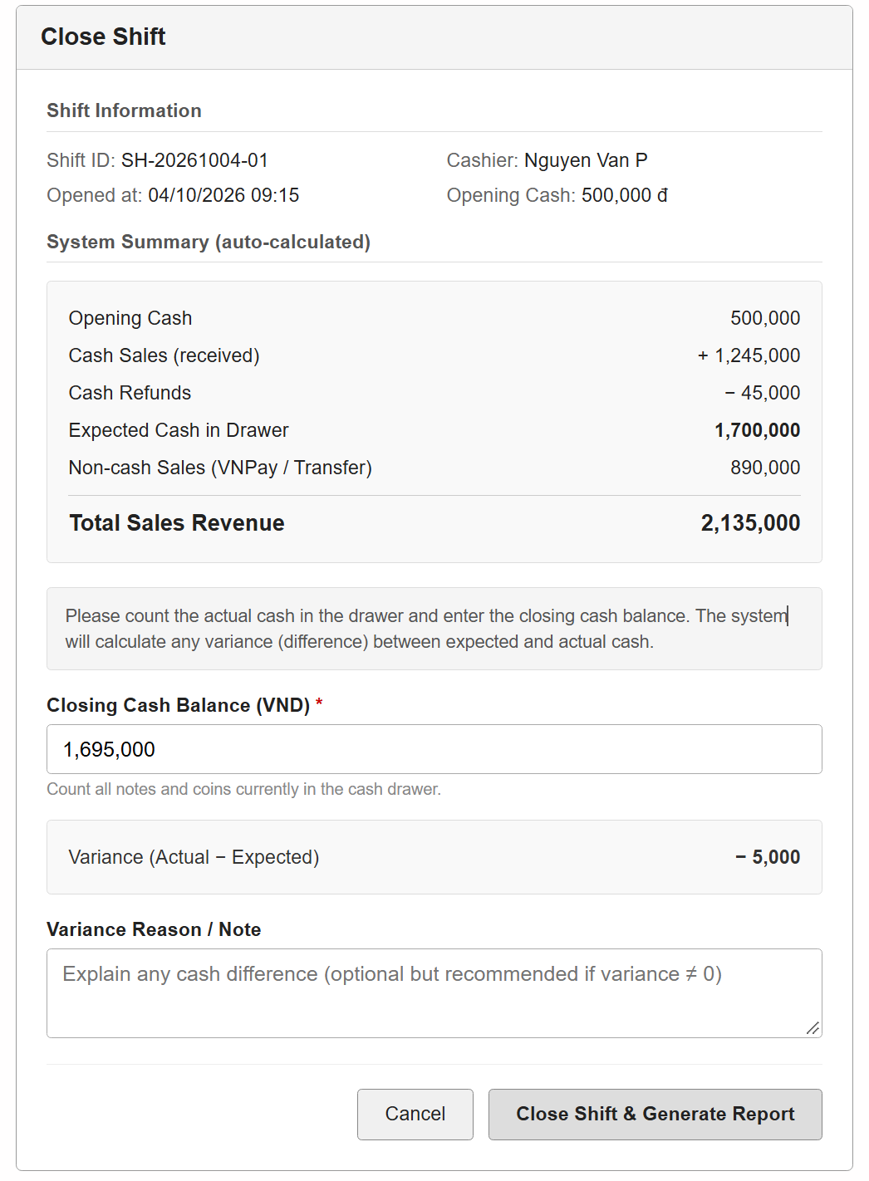
Table 3-1: Screen Definition
# | Field Name | Type | Mandatory | Max Length | Description
1 | Shift Information | Label |  |  | Shift ID, Cashier, Opened at,  Opening Cash (read-only)
2 | System Summary | Label |  |  | Opening cash, cash sales, refunds, expected cash, non-cash sales, total revenue
3 | Closing Cash Balance | Number | Yes | 15 | Actual cash amount in the drawer  at shift start (VND)
4 | Variance | Label |  |  | Actual Closing Cash − Expected  Cash. Positive = surplus,  Negative = shortage
5 | Variance Reason / Note | Textarea | No | 500 | Explanation for any cash difference (recommended if  variance ≠ 0)
6 | Close Shift & Generate  Report | Button |  |  | Close the shift, save closing data, generate handover / shift  summary report
7 | Cancel | Button |  |  | Return without closing the shift

3.2.1.2 Use Case Description
Use Case ID |  | UC01 | Use Case Name |  | Close Shift
Author |  | NamNT | Version | 1.0 | Date | 04/10/2026
Actor |  | Pharmacist
Description |  | The function allows a Pharmacist to end the current work shift by declaring the closing cash balance, reconciling it against the system-calculated expected cash, and generating a shift handover / summary report.
Precondition |  | PRE-01: User has successfully logged in with a Pharmacist role.  PRE-02: User has an active (Open) Shift.
Trigger |  | TRG-01: User selects "Close Shift" from the menu or POS Dashboard.
Post-Condition |  | POS-01: Shift status is updated to Closed. closing_time, closing_cash, expected_cash, and variance are saved.  POS-02: A shift summary / handover report is generated.  POS-03: Users can no longer create sales invoices until a new shift is opened.
Main flows
Step | Actor | Action
1 | Pharmacist | Select Close Shift
2 | System | Load current open shift. Calculate and display system summary: opening cash, cash sales, refunds, expected cash, non-cash sales, total revenue
3 | Pharmacist | Count actual cash in drawer, enter Closing Cash Balance. System shows Variance.  Optionally enter reason/note. Click Close Shift & Generate Report
4 | System | Validate. Update Shift (status=Closed, closing_time=now, closing_cash, expected_cash, variance, note). Generate shift summary report. Return to main screen.

Alternative flows
AT1 | At step 4, Closing Cash Balance is empty or invalid:
Sub step | Actor | Action
4.1 | System | System shows error "Please enter a valid closing cash balance."
AT1 | There are still Pending invoices under this shift:
Sub step | Actor | Action
2.1 | System | System warns "There are unpaid invoices. Please process or cancel them before closing the shift."  and blocks close (or allows with confirmation, depending on policy).

Business Rules
# | Rule Description
BR-01 | Expected Cash = Opening Cash + Cash Sales − Cash Refunds (only payments with method = Cash).
BR-02 | Variance = Closing Cash (actual) − Expected Cash. Stored for audit and handover report.
BR-03 | After closing, the shift cannot be reopened. A new shift must be opened for further sales.
BR-04 | Shift summary report includes: shift duration, opening/closing cash, variance, total sales by payment method, number of invoices, and cashier name
BR-05 | It is recommended (or required by policy) to enter a reason when variance ≠ 0.

3.7 Sales Management

3.7.1 Create Sales Invoice
3.7.1.1 Screen Mock-up
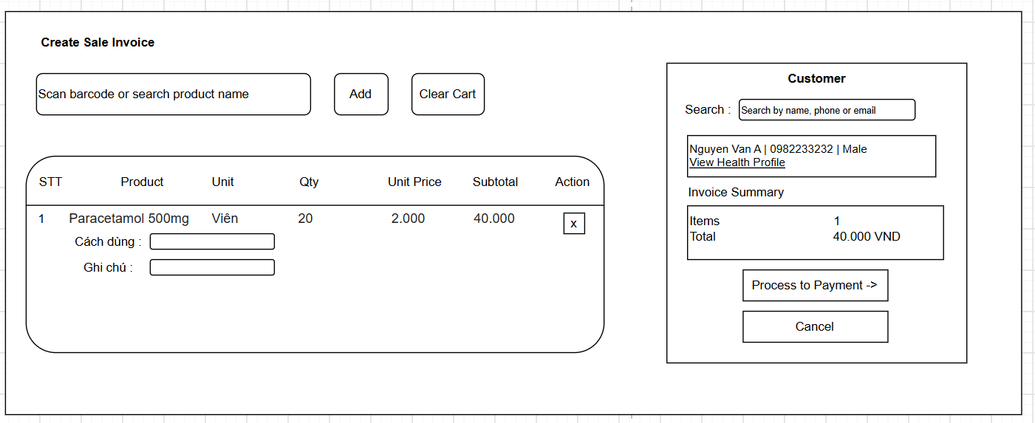
Figure 3-1: Screen Design

Table 3-1: Screen Definition

# | Field Name | Type | Mandatory | Max Length | Description
1 | Product Search | Text |  | 100 | Scan barcode or type product name to  add item
2 | Cart Items | Table | Yes |  | List of products: name, unit, qty, unit  price, subtotal, dosage instruction
3 | Quantity | Number |  | 5 | Quantity of product. Must be > 0 and ≤  available stock
4 | Dosage / Frequency | Dropdown List | Yes |  | Usage instruction: e.g. 1 viên × 2  lần/ngày + optional note
5 | Proceed to Payment | Text |  |  | Create invoice (status=Pending) and  navigate to Process Payment
6 | Cancel | Text |  | 255 | Discard cart and return to POS Dashboard

3.2.1.2 Use Case Description
Use Case ID |  | UC01 | Use Case Name |  | Create Sales Invoice
Author |  | NamNT | Version | 1.0 | Date | 25/09/2026
Actor |  | Pharmacist
Description |  | The function allows a Pharmacist to create a sales invoice by adding products one by one (via barcode/search), specifying quantity and dosage/frequency instructions, optionally linking a customer, then proceeding to payment.
Precondition |  | PRE-01: User logged in as Pharmacist.  PRE-02: An open Shift exists for the current user.  PRE-03: Products have sufficient stock.
Trigger |  | TRG-01: User selects "New Sale" / "Create Invoice" from POS Dashboard.
Post-Condition |  | POS-01: A Sales_invoice record is created (status = Pending or Draft).  POS-02: Sales invoice detail records are created for each line item.  POS-03: System navigates to Process Payment screen (if Proceed).
Main flows
Step | Actor | Action
1 | Pharmacist | Open Create Sales Invoice screen from POS Dashboard
2 | System | Display empty cart, product search box, customer search, and summary panel
3 | Pharmacist | Scan barcode or search product name → select product → enter quantity → (optional) set dosage frequency & note → Add to cart. Repeat for more items.
4 | System | Validate stock availability. Add line to cart with unit price (from Product.current_price),  calculate subtotal. Update total.
5 | Pharmacist | (Optional) Search and select customer.
6 | Pharmacist | Click "Proceed to Payment"
7 | System | Create Sales_invoice (status=Pending) + Sales invoice detail records. Navigate to Process Payment screen.

Alternative flows
AT1 | At step 4, if requested quantity > available stock:
Sub step | Actor | Action
4.1 | System | System displays error "Insufficient stock. Available: X". Do not add item.
AT2 | At step 6, if cart is empty:
Sub step | Actor | Action
3.1 | System | System displays message "Please add at least one product."
AT2 | User clicks Cancel:
Sub step | Actor | Action
3.1 | System | System discards data and returns to POS Dashboard.

Business Rules
# | Rule Description
BR-01 | An open Shift is required. Invoice is linked to the current Shift and Cashier (Account).
BR-02 | Quantity must not exceed current Inventory stock for that product.
BR-03 | Customer is optional (walk-in allowed). If selected, invoice is linked to Customer record.

3.7.2 Process Payment
3.2.1.1 Screen Mock-up
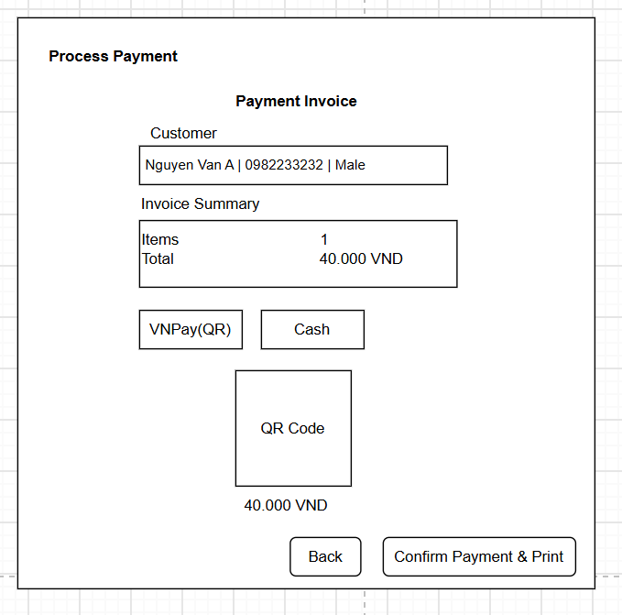
Figure 3-1: Screen Design

Table 3-1: Screen Definition

# | Field Name | Type | Mandatory | Max Length | Description
1 | Customer | Label |  |  | Customer full name (pre-filled)
2 | Invoice Summary | Label |  |  | Display invoice code, items  count, total amount
3 | QR Code | Image |  |  | Dynamic VNPAY-QR generated via  VNPay API (shown when VNPay  selected)
4 | Cancel | Button |  |  | Return to Create Sale Invoice screen
5 | Confirm Payment | Button |  |  | Confirm payment, update invoice  status to Paid, print receipt

3.2.1.2 Use Case Description
Use Case ID |  | UC01 | Use Case Name |  | Process Payment
Author |  | NamNT | Version | 1.0 | Date | 25/09/2026
Actor |  | Pharmacist
Description |  | The function allows a Pharmacist to collect payment for a sales invoice via Cash, BankTransfer, or VNPay (QR code). Upon success, invoice status becomes Paid, inventory is deducted, and receipt is printed.
Precondition |  | PRE-01: A Sales Invoice exists with status = Pending.  PRE-02: User is the cashier of the open Shift linked to the invoice.
Trigger |  | TRG-01: User clicks "Proceed to Payment" from Create Sales Invoice, or opens a Pending invoice.
Post-Condition |  | POS-01: Payment record is created.  POS-02: Sales_invoice status = Paid.  POS-03: Inventory stock is decreased for each product.  POS-04: Receipt is printed.
Main flows
Step | Actor | Action
1 | System | Display invoice summary and payment method options (Cash / Bank Transfer / VNPay)
2 | Pharmacist | Select payment method VNPAY (QR)
3 | System | Display QR + amount + "Waiting for payment..."
4 | System | System receives IPN/callback or user clicks Confirm after seeing success
5 | System | Create Payment record, update Invoice status to Paid, deduct Inventory, print receipt, return to POS Dashboard.

Alternative flows
AT1 | VNPay payment timeout or failure:
Sub step | Actor | Action
4.1 | System | System shows "Payment failed / expired. Please try again or choose another method." QR can be regenerated.
AT2 | Cash: Amount Received < Total:
Sub step | Actor | Action
3.1 | System | System blocks Confirm and shows "Insufficient amount received."
AT3 | Step 2 : Select payment method Cash
Sub step | Actor | Action
3.1 | Pharmacist | clicks Confirm Payment.
3.2 | System | Create Payment record, update Invoice status to Paid, deduct Inventory, print receipt, return to POS Dashboard.

Business Rules
# | Rule Description
BR-01 | One Invoice can have multiple Payment records (partial payments supported if needed); total paid must equal invoice total to mark as Paid.
BR-02 | VNPay: System integrates with VNPay API (Create QR / IPN). Payment status is updated automatically on successful callback.
BR-03 | Inventory deduction occurs only when payment is confirmed (status → Paid).

3.7.3 Cancel/Return Sales Invoice
3.2.1.1 Screen Mock-up
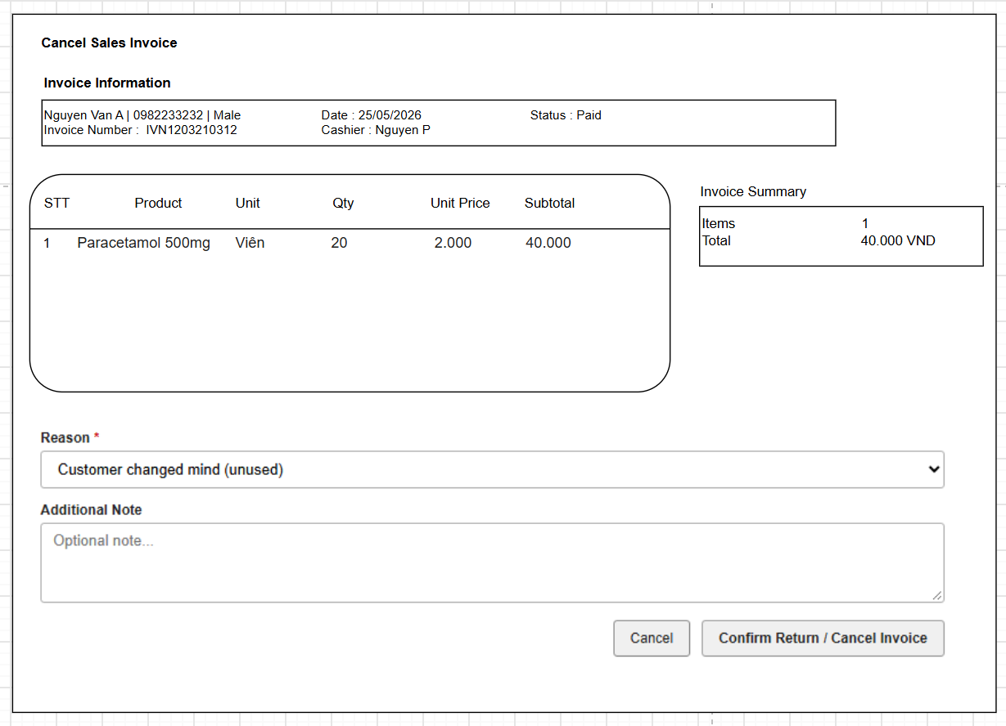
Figure 3-1: Screen Design

Table 3-1: Screen Definition

# | Field Name | Type | Mandatory | Max Length | Description
1 | Reason | Select | Yes |  | Mandatory reason: Customer  changed mind / Wrong product /  Duplicate / Other
2 | Note | Text | No |  | Additional note
3 | Confirm Return | Button |  |  | Process return: restock, refund,  update invoice status
4 | Cancel | Button |  |  | Click to return View Purchase History screen

3.2.1.2 Use Case Description
Use Case ID |  | UC01 | Use Case Name |  | Cancel / Return Sales Invoice
Author |  | NamNT | Version | 1.0 | Date | 25/09/2026
Actor |  | Pharmacist
Description |  | The function allows a Pharmacist to cancel or return a sales invoice when the customer has not used the products. The system restocks inventory and processes cash refunds
Precondition |  | PRE-01: User logged in as Pharmacist.  PRE-02: Target Sales Invoice exists and status is Paid or Pending.  PRE-03: Products are assumed unused (business rule enforced by staff).
Trigger |  | TRG-01: User selects "Cancel/Return Invoice" from Purchase History List screen
Post-Condition |  | POS-01: Selected quantities are returned to Inventory.  POS-02: Invoice status updated (Cancelled or Returned).  POS-03: Cancellation reason is stored for audit.
Main flows
Step | Actor | Action
1 | System | Display invoice header info and list of line items with sold qty, unit price, checkbox + return qty input
2 | Pharmacist | select Reason, optionally enter note → click Confirm Return
3 | System | Increase Inventory for returned quantities. Update invoice status. Record refund & reason. Show success message.

Alternative flows
AT1 | Reason not selected or return qty invalid:
Sub step | Actor | Action
4.1 | System | System highlights errors and blocks confirmation.

Business Rules
# | Rule Description
BR-01 | Return is allowed only when products are unused
BR-02 | Inventory is increased by the returned quantities immediately upon confirmation.
BR-03 | Refund method follows cash

3.7.4 View Customer Purchase History
3.2.1.1 Screen Mock-up
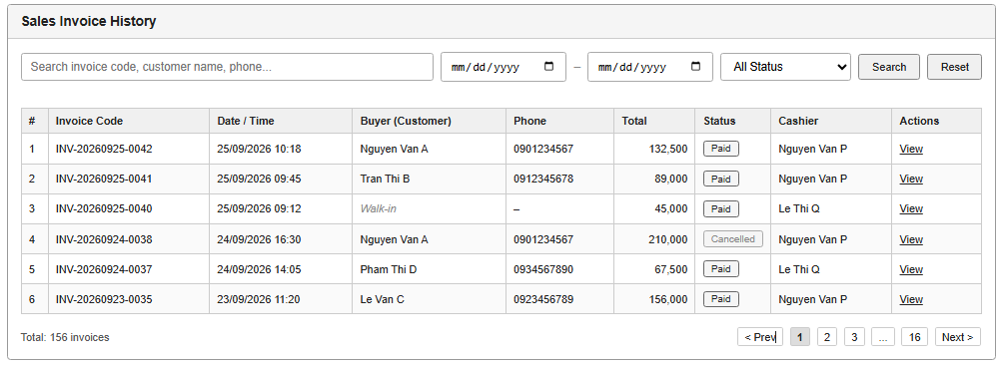
Figure 3-1: Screen Design

Table 3-1: Screen Definition

# | Field Name | Type | Mandatory | Max Length | Description
1 | Search Keyword | Text |  | 100 | Search by invoice code, customer  name, or phone
2 | From Date | Date |  |  | Filter invoices from this date
3 | To Date | Date |  |  | Filter invoices until this date
4 | Status Filter | Dropdown List |  |  | All / Paid / Pending / Cancelled
5 | Buyer (Customer) | Label |  |  | Display customer full name. Show  "Walk-in" if no customer linked
6 | Invoice List | Table |  |  | Columns: STT, Invoice Code,  Date/Time, Buyer (Customer Name),  Phone, Total, Status, Cashier,  Actions
7 | Cancel/Return Sale Invoices | Button |  |  | Click to process return or cancel sale invoices
8 | View | Button |  |  | View invoice detail (items, payment,  etc.)
9 | Pagination | Control |  |  | Navigate pages (default 10–20  records per page)

3.2.1.2 Use Case Description
Use Case ID |  | UC01 | Use Case Name |  | View Purchase History
Author |  | NamNT | Version | 1.0 | Date | 25/09/2026
Actor |  | Pharmacist
Description |  | The function displays a paginated list of all Sales Invoices in the system. Each row shows the buyer (customer name), phone, total amount, status, and cashier. Users can search and filter by keyword, date range, and status.
Precondition |  | PRE-01: User has successfully logged in with Pharmacist role. PRE-02: User has permission to view sales invoices / CRM module.
Trigger |  | TRG-01: User selects Purchase History List in sidebar.
Post-Condition |  | POS-01: System displays the list of sales invoices matching the current filters (or all invoices if no filter).
Main flows
Step | Actor | Action
1 | Pharmacist | Open Purchase History / Sales Invoice List from menu (or from Customer Detail)
2 | System | Display paginated list of all Sales Invoices with columns: Invoice Code, Date/Time,  Buyer (Customer Name), Phone, Total, Status, Cashier, Actions
3 | Pharmacist | (Optional) Enter search keyword, select date range, status filter → click Search
4 | System | Filter and refresh the list according to criteria

Alternative flows
AT1 | At step 4, no invoices match the filter:
Sub step | Actor | Action
4.1 | System | System displays message "No invoices found matching your criteria."
AT2 | Accessed from Customer Detail with pre-filter:
Sub step | Actor | Action
2.1 | System | System automatically filters the list by the selected customer ID / name. User can clear the filter to  see all invoices.

Business Rules
# | Rule Description
BR-01 | The "Buyer" column displays the linked Customer full name. If no customer is linked (walk-in), display "Walk-in".
BR-02 | Only users with appropriate permission (Pharmacist / Manager) can access this list.

3.7.5 View Daily Sales
3.7.5.1 Mock-up
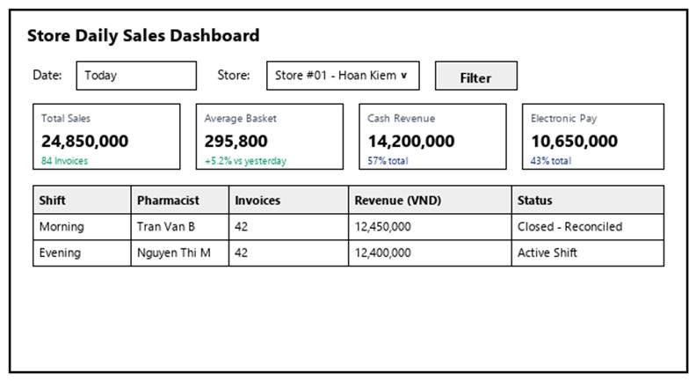
Figure 3-27: Screen Design of View Daily Sales
Table 3-27: Screen Definition
# | Field Name | Type | Mandatory | Max Length | Description
1 | Search / Filter | Text / Dropdown | No | 50 | Search records by code, name, or keyword.
2 | Data Table / Form | Grid / Input | Yes | -- | Primary data table or input fields for View Daily Sales.
3 | Action Buttons | Button | Yes | -- | Action buttons (Confirm / Submit / Save) to execute View Daily Sales.
4 | Cancel / Reset | Button | No | -- | Cancels active modification and returns to previous view.

3.7.5.2 Use Case Description
Use Case ID |  | UC27 | Use Case Name |  | View Daily Sales
Author |  | DangPT | Version | 1.0 | Date | 04/10/2026
Actor |  | Store Manager
Description |  | Allows the Store Manager to view daily sales records and transactions.
Precondition |  | PRE-01: User is logged in as Store Manager.  PRE-02: System registers and network services are operational.
Trigger |  | TRG-01: User navigates to 'View Daily Sales' menu.
Post-Condition |  | POS-01: 'View Daily Sales' completed successfully and transaction logged in database.  POS-02: System state updated and reflected across integrated modules.
Main flows
Step | Actor | Action
1 | Store Manager | Access View Daily Sales interface from main navigation menu.
2 | System | Display interface showing current data and controls for View Daily Sales.
3 | Store Manager | Enter required parameters / select items and click confirm.
4 | System | Validate operational inputs against business constraints.
5 | System | Commit transaction, record audit trail, and display success message.

Alternative flows
AT01 | Validation failure or missing fields (At Step 4)
Sub step | Actor | Action
4.1 | System | Display error alert highlighting invalid entries.
4.2 | System | Retain current form entries and prompt user to correct data.
AT02 | User cancels operation (At Step 3)
Sub step | Actor | Action
3.1 | System | Discard uncommitted changes and return to previous list screen.

Business Rules
# | Rule Description
BR-01 | All operations in 'View Daily Sales' must be performed under an active, authorized user session.
BR-02 | Every modification or execution must generate an immutable audit log record with user ID and timestamp.
BR-03 | Data integrity and role-based access rules must be strictly validated prior to saving changes.

3.7.6 Reconcile Daily Sales
3.7.6.1 Mock-up
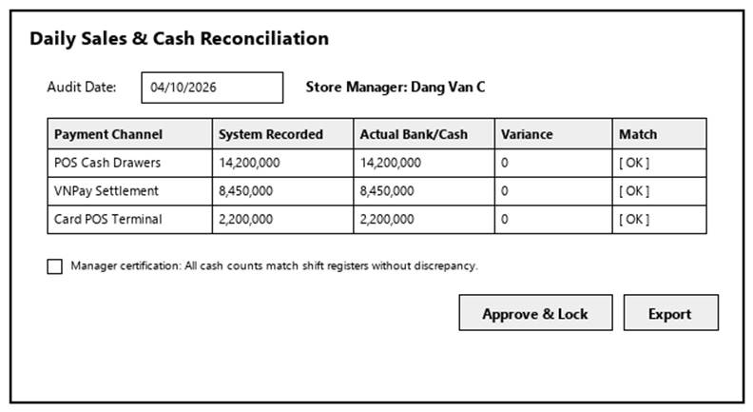
Figure 3-28: Screen Design of Reconcile Daily Sales
Table 3-28: Screen Definition
# | Field Name | Type | Mandatory | Max Length | Description
1 | Search / Filter | Text / Dropdown | No | 50 | Search records by code, name, or keyword.
2 | Data Table / Form | Grid / Input | Yes | -- | Primary data table or input fields for Reconcile Daily Sales.
3 | Action Buttons | Button | Yes | -- | Action buttons (Confirm / Submit / Save) to execute Reconcile Daily Sales.
4 | Cancel / Reset | Button | No | -- | Cancels active modification and returns to previous view.

3.7.6.2 Use Case Description
Use Case ID |  | UC28 | Use Case Name |  | Reconcile Daily Sales
Author |  | DangPT | Version | 1.0 | Date | 04/10/2026
Actor |  | Store Manager
Description |  | Allows the Store Manager to balance and reconcile sales figures against physical cash/payments.
Precondition |  | PRE-01: User is logged in as Store Manager.  PRE-02: System registers and network services are operational.
Trigger |  | TRG-01: User navigates to 'Reconcile Daily Sales' menu.
Post-Condition |  | POS-01: 'Reconcile Daily Sales' completed successfully and transaction logged in database.  POS-02: System state updated and reflected across integrated modules.
Main flows
Step | Actor | Action
1 | Store Manager | Access Reconcile Daily Sales interface from main navigation menu.
2 | System | Display interface showing current data and controls for Reconcile Daily Sales.
3 | Store Manager | Enter required parameters / select items and click confirm.
4 | System | Validate operational inputs against business constraints.
5 | System | Commit transaction, record audit trail, and display success message.

Alternative flows
AT01 | Validation failure or missing fields (At Step 4)
Sub step | Actor | Action
4.1 | System | Display error alert highlighting invalid entries.
4.2 | System | Retain current form entries and prompt user to correct data.
AT02 | User cancels operation (At Step 3)
Sub step | Actor | Action
3.1 | System | Discard uncommitted changes and return to previous list screen.

Business Rules
# | Rule Description
BR-01 | All operations in 'Reconcile Daily Sales' must be performed under an active, authorized user session.
BR-02 | Every modification or execution must generate an immutable audit log record with user ID and timestamp.
BR-03 | Data integrity and role-based access rules must be strictly validated prior to saving changes.

3.8 Customer Management

3.8.1 Register New Customer
3.8.1.1 Screen Mock-up
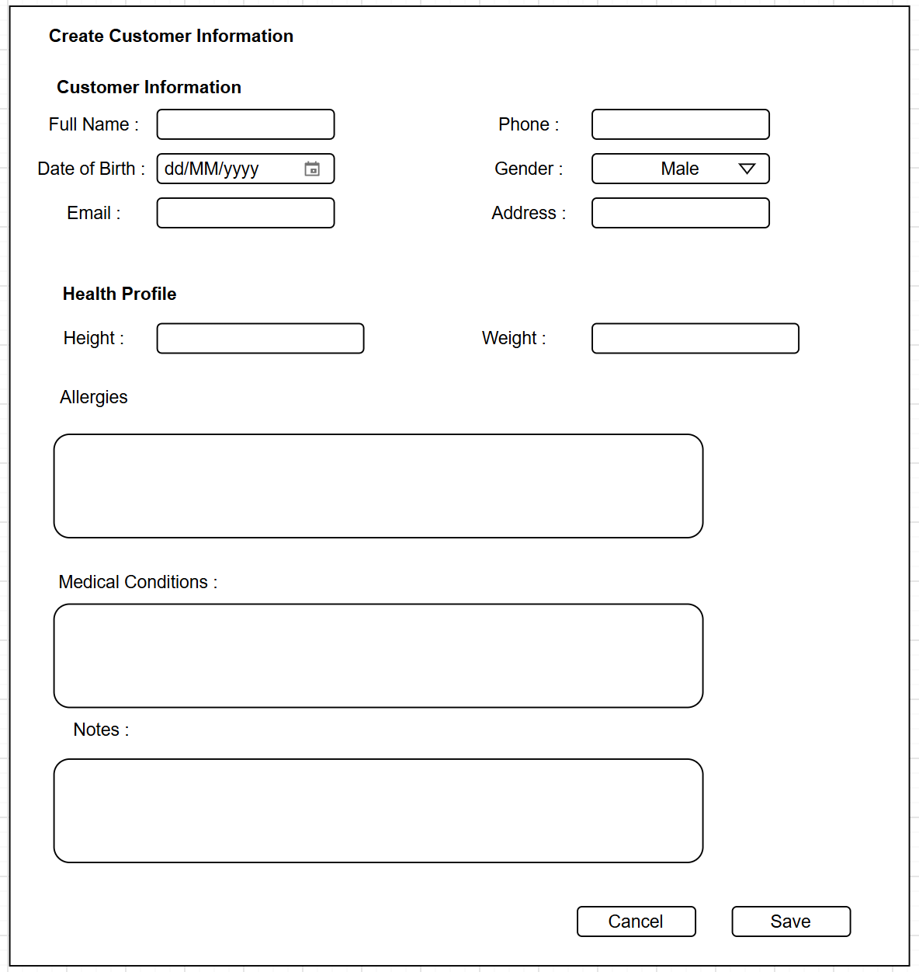
Figure 3-1: Screen Design

Table 3-1: Screen Definition

# | Field Name | Type | Mandatory | Max Length | Description
1 | Full Name | Text | Yes | 100 | Customer full name
2 | Phone | Text | Yes | 15 | Phone number (unique). Used for  search and identification
3 | Date of Birth | Text |  | 100 | Customer date of birth
4 | Gender | Dropdown List | Yes |  | Male / Female / Other
5 | Email | Text |  |  | Email address
6 | Address | Text |  | 255 | Residential address
7 | Height | Number |  | 3 | Height in cm (50–500). Part of Health  Profile
8 | Weight | Number |  | 3 | Weight in kg (10–300). Part of Health  Profile
9 | Allergies | Text |  | 500 | Known allergies
10 | Medical Conditions | Text |  | 500 | Chronic / existing medical conditions
11 | Notes | Text |  | 500 | Additional health notes
12 | Save | Button |  |  | Validate and create Customer and  Customer health profile in system
13 | Cancel | Button |  |  | Return to previous Customer Detail or Customer List screen

3.8.1.2 Use Case Description
Use Case ID |  | UC01 | Use Case Name |  | Update Customer Health Profile
Author |  | NamNT | Version | 1.0 | Date | 25/09/2026
Actor |  | Pharmacist
Description |  | The function allows a Pharmacist to register a new customer. Customer personal information and Health Profile are entered on the same form and saved together in one step
Precondition |  | PRE-01: User has successfully logged in with Pharmacist role. PRE-02: User has permission to manage customers.
Trigger |  | TRG-01: User clicks "+ Register New Customer" from Customer List
Post-Condition |  | POS-01: A new Customer record is created.  POS-02: A related Customer health profile record is created (even if health fields are left empty).  POS-03: System returns to Customer List screen with success message.
Main flows
Step | Actor | Action
1 | Pharmacist | Click "Register New Customer"
2 | System | Display Create Customer form with two sections: (1) Customer Information, (2) Health Profile
3 | Pharmacist | Fill mandatory fields (Full Name, Phone) and optional fields (Email, DOB, Gender,Address, Height, Weight, Allergies, Medical Conditions, Notes). Click Save Customer.
4 | System | Validate data. If valid: create Customer and Customer health profile into system. Show success and navigate back to Customer List screen with success message.

Alternative flows
AT1 | At step 4, Full Name or Phone is empty:
Sub step | Actor | Action
4.1 | System | System highlights required fields and shows "Full Name and Phone are required."
AT2 | At step 4, Phone already exists:
Sub step | Actor | Action
4.1 | System | System shows "This phone number is already registered." and blocks save.
AT3 | User clicks Cancel:
3.1 | System | System discards data and returns to Customer List.

Business Rules
# | Rule Description
BR-01 | Customer Information and Health Profile are entered and saved on the same form in a single operation.
BR-02 | Phone number must be unique across all customers.
BR-03 | Health Profile fields are optional. Even if all health fields are empty, a Customer_health_profile record is still created (linked 1-1 to Customer).
BR-04 | Height range: 50–500 cm. Weight range: 10–300 kg

3.8.2 Edit Customer
3.8.2.1 Screen Mock-up
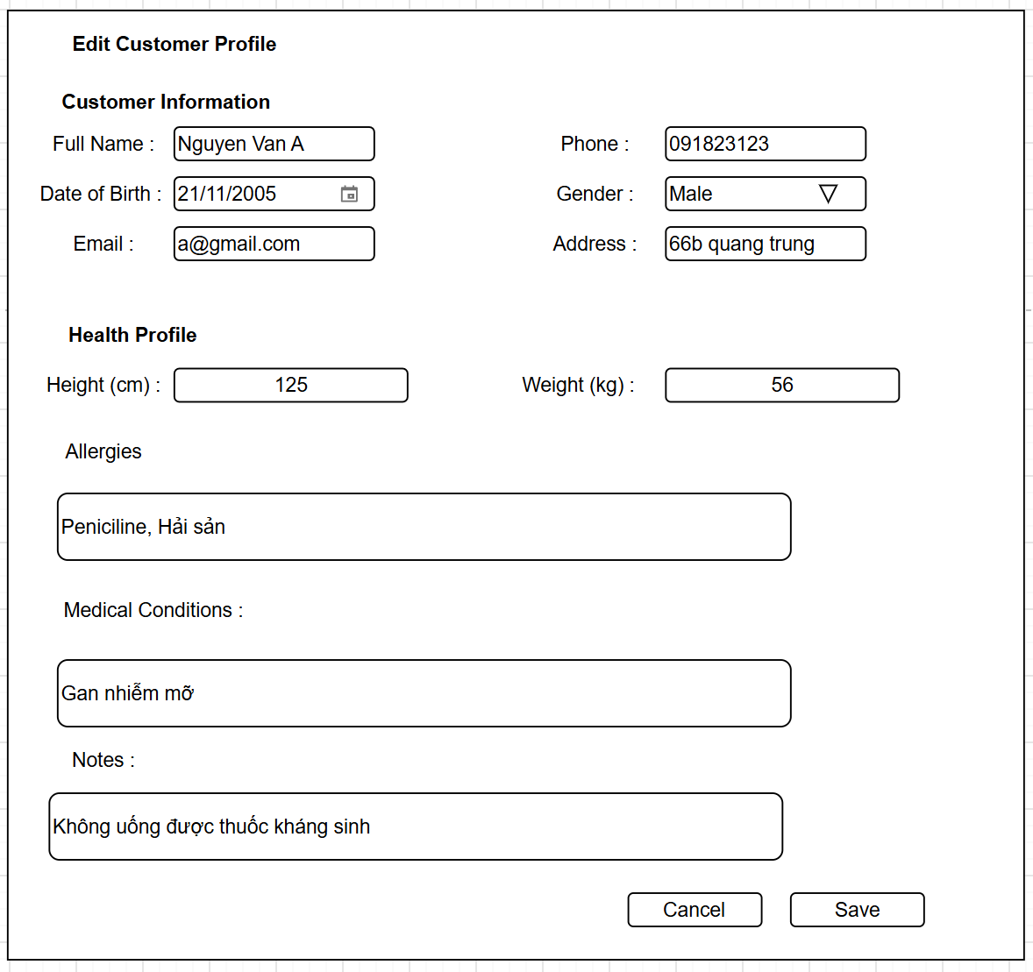
Figure 3-1: Screen Design

Table 3-1: Screen Definition

# | Field Name | Type | Mandatory | Max Length | Description
1 | Full Name | Text | Yes | 100 | Customer full name (pre-filled)
2 | Phone | Text | Yes | 15 | Phone number (pre-filled). Must remain  unique
3 | Date of Birth | Text |  | 100 | Date of birth (pre-filled)
4 | Gender | Dropdown List | Yes |  | Male / Female / Other(pre-filled)
5 | Email | Text |  |  | Email (pre-filled)
6 | Address | Text |  | 255 | Residential address
7 | Height | Number |  | 3 | Height in cm (50–500). Part of Health  Profile(pre-filled)
8 | Weight | Number |  | 3 | Weight in kg (10–300). Part of Health  Profile(pre-filled)
9 | Allergies | Text |  | 500 | Known allergies(pre-filled)
10 | Medical Conditions | Text |  | 500 | Chronic / existing medical conditions(pre-filled)
11 | Notes | Text |  | 500 | Additional health notes(pre-filled)
12 | Save | Button |  |  | Validate and update Customer and  Customer health profile in system
13 | Cancel | Button |  |  | Return to previous Customer Detail or Customer List screen

3.8.2.2 Use Case Description
Use Case ID |  | UC01 | Use Case Name |  | Update Customer
Author |  | NamNT | Version | 1.0 | Date | 25/09/2026
Actor |  | Pharmacist
Description |  | The function allows a Pharmacist to update an existing customer's personal information and Health Profile on the same form. Both records are updated together.
Precondition |  | PRE-01: User has successfully logged in with Pharmacist role. PRE-02: The target Customer exists in the system
Trigger |  | TRG-01: User clicks "Edit" from Customer Detail screen.
Post-Condition |  | POS-01: Customer record is updated.  POS-02: Related Customer health profile record is updated.  POS-03: System returns to previous screen with success message
Main flows
Step | Actor | Action
1 | Pharmacist | Click “Edit” on a customer detail screen
2 | System | Load Customer + Health Profile data and display pre-filled form
3 | Pharmacist | Modify any fields in Customer Information and/or Health Profile sections. Click Save Changes.
4 | System | Validate data. If valid: update Customer and Customer health profile into system. Show success and navigate back to Customer List screen with success message.

Alternative flows
AT1 | At step 4, mandatory fields empty or Phone conflicts with another customer:
Sub step | Actor | Action
4.1 | System | System shows validation error and keeps the form open.
AT2 | User clicks Cancel:
Sub step | Actor | Action
3.1 | System | System discards data and returns to Customer List.

Business Rules
# | Rule Description
BR-01 | Customer Information and Health Profile are always edited and saved together on the same form.
BR-02 | Phone number must be unique across all customers.

3.8.3 View Customer Detail
3.8.3.1 Screen Mock-up
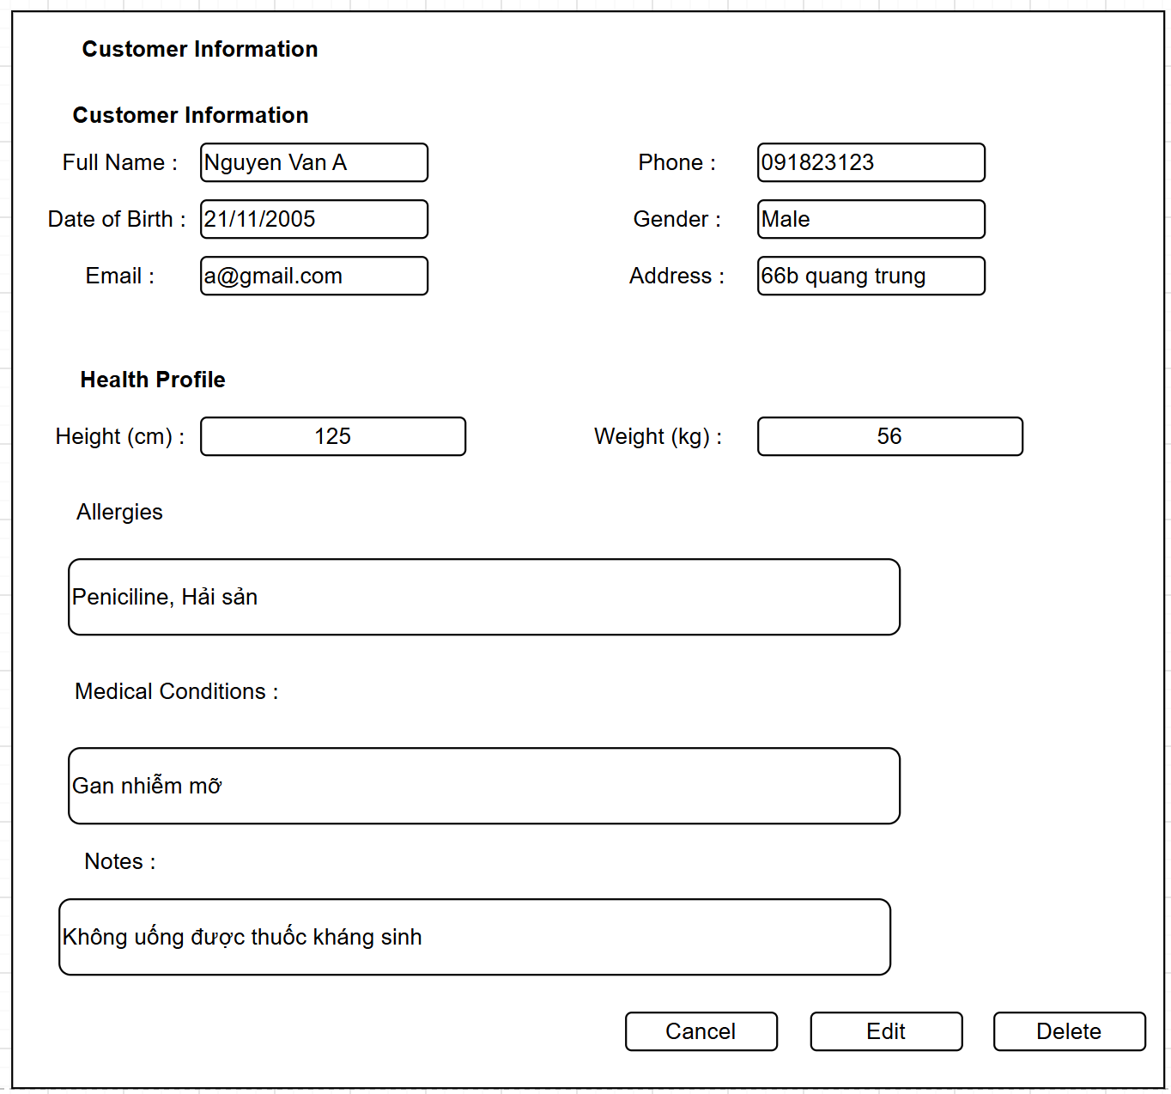
Figure 3-1: Screen Design

Table 3-1: Screen Definition

# | Field Name | Type | Mandatory | Max Length | Description
1 | Full Name | Label |  |  | Display customer full name
2 | Phone | Label |  |  | Display customer phone
3 | Date of Birth | Label |  |  | Display customer date of birth
4 | Gender | Label |  |  | Display customer gender
5 | Email | Label |  |  | Display customer email
6 | Address | Label |  |  | Display customer address
7 | Height | Label |  |  | Display height in cm
8 | Weight | Label |  |  | Display weight in kg
9 | BMI | Label |  |  | Display calculated BMI and status: Underweight, Normal, Overweight or Obese
10 | Allergies | Label |  |  | Display list of customer allergies
11 | Medical Conditions | Label |  |  | Display customer medical conditions
12 | Notes | Label |  |  | Display additional health-related notes
13 | Last Updated | Label |  |  | Display last update timestamp and updater name
14 | Edit | Button |  |  | Navigate to Edit Customer Health Profile screen
15 | Delete | Button |  |  | Open Delete confirmation modal
16 | Back | Button |  |  | Return to previous Customer Detail or Customer List screen

3.8.3.2 Use Case Description
Use Case ID |  | UC01 | Use Case Name |  | View Customer Health Profile
Author |  | NamNT | Version | 1.0 | Date | 25/09/2026
Actor |  | Pharmacist
Description |  | The function allows a Pharmacist to view the detailed health profile of a selected customer, including height, weight, allergies, medical conditions and notes.
Precondition |  | PRE-01: User has successfully logged into the system with Pharmacist role. PRE-02: The selected customer has an existing health profile.
Trigger |  | TRG-01: User selects "View" from the Customer List
Post-Condition |  | POS-01: System displays the complete health profile of the selected customer.
Main flows
Step | Actor | Action
1 | Pharmacist | User selects "Health" from the Customer List Screen
2 | System | Retrieve and display customer basic information together with health profile data including Height, Weight, Allergies, Medical Conditions, Note.

Alternative flows
AT1 | At step 2, if the customer does not have a health profile yet:
Sub step | Actor | Action
2.1 | System | The system displays the message "This customer does not have a health profile yet." and provides an "Add Health Profile" button.

Business Rules
# | Rule Description
BR-01 | If no health profile exists for the selected customer, the system provides a quick action to create a new health profile.

3.8.4 View Customer List
3.8.4.1 Screen Mock-up
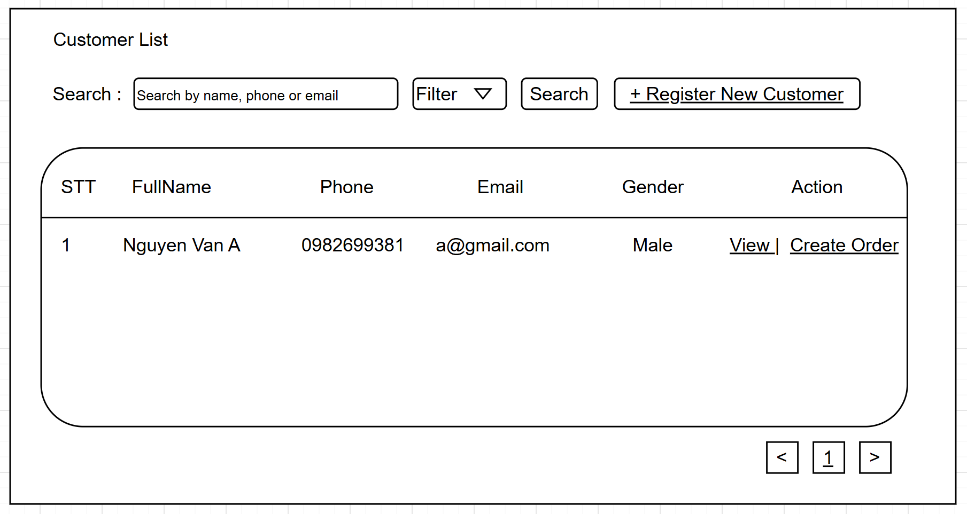
Figure 3-1: Screen Design

Table 3-1: Screen Definition
# | Field Name | Type | Mandatory | Max Length | Description
1 | Search Keyword | Text | No | 100 | Search by customer name, phone or email
2 | Search | Button |  |  | Execute search with entered keyword
3 | Register New Customer | Button |  |  | Navigate to Register New Customer screen
4 | Customer List | Table |  |  | Display list of customers: #, Full Name, Phone, Email, Gender, Actions
5 | View | Button |  |  | View customer detail information
6 | Create Order | Button |  |  | Create new invoice for this customer
7 | Pagination | Control |  |  | Navigate between pages of customer list
8 | Filter | Dropdown List | No |  | To filter and display the list increasing with selected field choice

3.8.4.2 Use Case Description
Use Case ID |  | UC01 | Use Case Name |  | View Customer List
Author |  | NamNT | Version | 1.0 | Date | 25/09/2026
Actor |  | Pharmacist
Description |  | The function allows a Pharmacist to view and search the list of registered customers in the system.
Precondition |  | PRE-01: User has successfully logged into the system.  PRE-02: User has Pharmacist role with permission to access CRM module.
Trigger |  | TRG-01: User select Customer List in Sidebar
Post-Condition |  | POS-01: System displays the list of customers matching the search criteria (or all customers if no keyword).
Main flows
Step | Actor | Action
1 | Pharmacist | User select Customer List in Sidebar
2 | System | Display Customer List screen with  Search box,  Register New Customer button,  Paginated list of customers (Full Name, Phone, Email, Gender, Actions)
3 | Pharmacist | Enter keyword into Search field and click Search button
4 | System | Filter and display customers matching the keyword (search by name, phone or email).

Alternative flows
AT1 | At step 4, if no customer matches the search keyword:
Sub step | Actor | Action
4.1 | System | The system displays message "No customer found matching your search criteria."

Business Rules
# | Rule Description
BR-01 | Only customers with active status are displayed in the list.

3.8.5 Delete Customer
3.8.5.1 Screen Mock-up
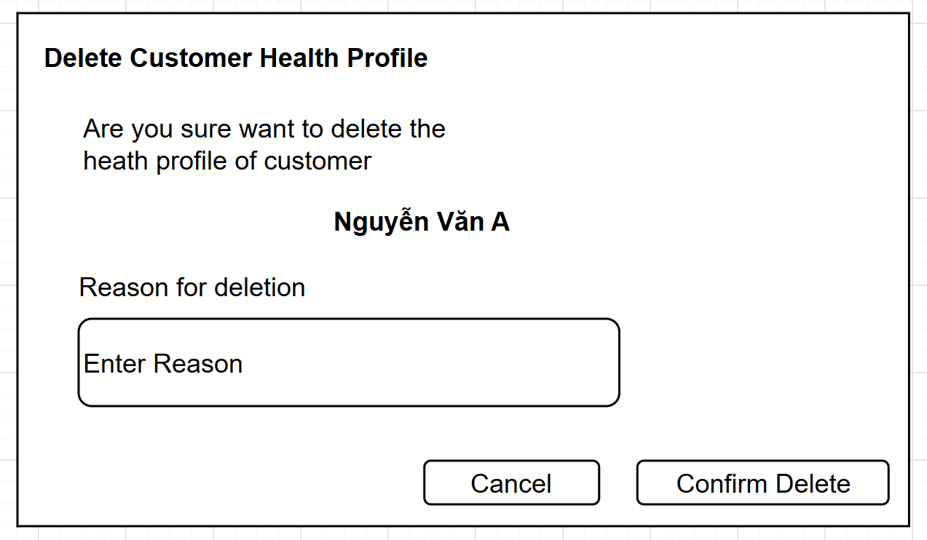
Figure 3-1: Screen Design

Table 3-1: Screen Definition

# | Field Name | Type | Mandatory | Max Length | Description
1 | Confirmation  Message | Label |  |  | Display confirmation text with customer  name
2 | Reason | Textarea | Yes | 255 | Reason for deleting the health profile
3 | Confirm Delete | Button |  |  | Confirm and permanently delete the  health profile.
4 | Cancel | Button |  |  | Close modal without deleting

3.8.5.2 Use Case Description
Use Case ID |  | UC01 | Use Case Name |  | Delete Customer Health Profile
Author |  | NamNT | Version | 1.0 | Date | 25/09/2026
Actor |  | Pharmacist
Description |  | The function allows a Pharmacist to delete an existing health profile of a customer. A confirmation modal with mandatory reason is displayed before deletion.
Precondition |  | PRE-01: User has successfully logged into the system with Pharmacist role.  PRE-02: The selected customer has an existing health profile
Trigger |  | TRG-01: User clicks "Delete" button on View Customer Health Profile screen.
Post-Condition |  | POS-01: The Customer_health_profile record is soft-deleted.  POS-02: System returns to Customer Detail or Customer List screen with success message.
Main flows
Step | Actor | Action
1 | Pharmacist | Click "Delete" button on View Customer Health Profile screen
2 | System | Display confirmation modal with customer name and Reason input field
3 | Pharmacist | Enter reason for deletion and click "Confirm Delete"
4 | System | Validate reason. Delete the customer profile, log the reason & actor, close modal and show success message

Alternative flows
AT1 | At step 4, if Reason field is empty:
Sub step | Actor | Action
4.1 | System | System displays error message "Please enter reason for deletion." and keeps the modal open.
AT2 | User clicks Cancel:
Sub step | Actor | Action
3.1 | System | System discards data and returns to Customer List.

Business Rules
# | Rule Description
BR-01 | Deletion is permanent if Customer don’t have any transactions and Deletion is soft-deleted if customer have transactions in system. After deletion, user can create a new health profile for the same customer.
BR-02 | Reason for deletion is mandatory and will be stored for audit trail.

3.9 Store Inventory Management

3.9.1 View Inventory
3.9.1.1 Mock-up
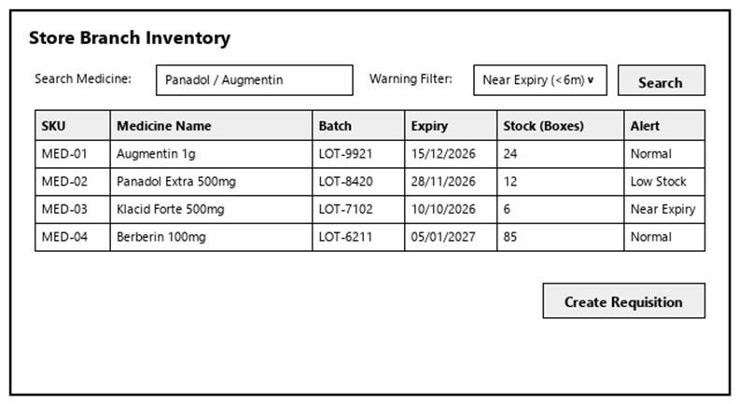
Figure 3-33: Screen Design of View Inventory
Table 3-33: Screen Definition
# | Field Name | Type | Mandatory | Max Length | Description
1 | Search / Filter | Text / Dropdown | No | 50 | Search records by code, name, or keyword.
2 | Data Table / Form | Grid / Input | Yes | -- | Primary data table or input fields for View Inventory.
3 | Action Buttons | Button | Yes | -- | Action buttons (Confirm / Submit / Save) to execute View Inventory.
4 | Cancel / Reset | Button | No | -- | Cancels active modification and returns to previous view.

3.9.1.2 Use Case Description
Use Case ID |  | UC33 | Use Case Name |  | View Inventory
Author |  | DangPT | Version | 1.0 | Date | 04/10/2026
Actor |  | Pharmacist, Store Manager
Description |  | Allows pharmacists and managers to view real-time branch stock levels, batch numbers, expiry dates, and warning indicators for low stock and near-expiry medicines.
Precondition |  | PRE-01: User is logged in as Pharmacist, Store Manager.  PRE-02: System registers and network services are operational.
Trigger |  | TRG-01: User navigates to 'View Inventory' menu.
Post-Condition |  | POS-01: 'View Inventory' completed successfully and transaction logged in database.  POS-02: System state updated and reflected across integrated modules.
Main flows
Step | Actor | Action
1 | Pharmacist, Store Manager | Access View Inventory interface from main navigation menu.
2 | System | Display interface showing current data and controls for View Inventory.
3 | Pharmacist, Store Manager | Enter required parameters / select items and click confirm.
4 | System | Validate operational inputs against business constraints.
5 | System | Commit transaction, record audit trail, and display success message.

Alternative flows
AT01 | Validation failure or missing fields (At Step 4)
Sub step | Actor | Action
4.1 | System | Display error alert highlighting invalid entries.
4.2 | System | Retain current form entries and prompt user to correct data.
AT02 | User cancels operation (At Step 3)
Sub step | Actor | Action
3.1 | System | Discard uncommitted changes and return to previous list screen.

Business Rules
# | Rule Description
BR-01 | All operations in 'View Inventory' must be performed under an active, authorized user session.
BR-02 | Every modification or execution must generate an immutable audit log record with user ID and timestamp.
BR-03 | Data integrity and role-based access rules must be strictly validated prior to saving changes.

3.9.2 Review Store Inventory Audit
3.9.2.1 Mock-up
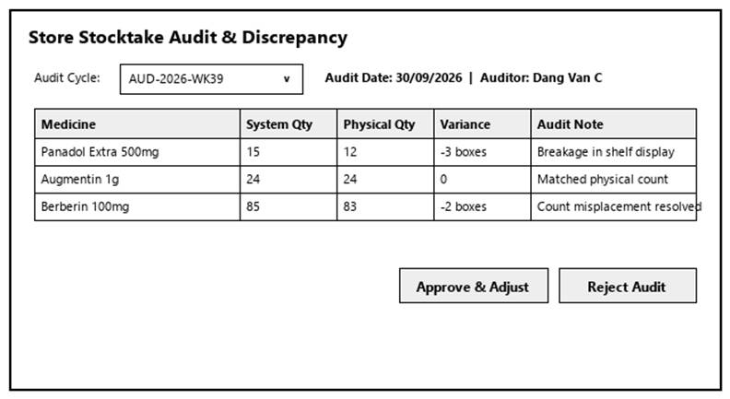
Figure 3-34: Screen Design of Review Store Inventory Audit
Table 3-34: Screen Definition
# | Field Name | Type | Mandatory | Max Length | Description
1 | Search / Filter | Text / Dropdown | No | 50 | Search records by code, name, or keyword.
2 | Data Table / Form | Grid / Input | Yes | -- | Primary data table or input fields for Review Store Inventory Audit.
3 | Action Buttons | Button | Yes | -- | Action buttons (Confirm / Submit / Save) to execute Review Store Inventory Audit.
4 | Cancel / Reset | Button | No | -- | Cancels active modification and returns to previous view.

3.9.2.2 Use Case Description
Use Case ID |  | UC34 | Use Case Name |  | Review Store Inventory Audit
Author |  | DangPT | Version | 1.0 | Date | 04/10/2026
Actor |  | Store Manager
Description |  | Allows the Store Manager to view the results and records of store inventory audits, then confirm and accept the results, or reject them and request a recount.
Precondition |  | PRE-01: User is logged in as Store Manager.  PRE-02: System registers and network services are operational.
Trigger |  | TRG-01: User navigates to 'Review Store Inventory Audit' menu.
Post-Condition |  | POS-01: 'Review Store Inventory Audit' completed successfully and transaction logged in database.  POS-02: System state updated and reflected across integrated modules.
Main flows
Step | Actor | Action
1 | Store Manager | Access Review Store Inventory Audit interface from main navigation menu.
2 | System | Display interface showing current data and controls for Review Store Inventory Audit.
3 | Store Manager | Enter required parameters / select items and click confirm.
4 | System | Validate operational inputs against business constraints.
5 | System | Commit transaction, record audit trail, and display success message.

Alternative flows
AT01 | Validation failure or missing fields (At Step 4)
Sub step | Actor | Action
4.1 | System | Display error alert highlighting invalid entries.
4.2 | System | Retain current form entries and prompt user to correct data.
AT02 | User cancels operation (At Step 3)
Sub step | Actor | Action
3.1 | System | Discard uncommitted changes and return to previous list screen.

Business Rules
# | Rule Description
BR-01 | All operations in 'Review Store Inventory Audit' must be performed under an active, authorized user session.
BR-02 | Every modification or execution must generate an immutable audit log record with user ID and timestamp.
BR-03 | Data integrity and role-based access rules must be strictly validated prior to saving changes.

3.9.3 Create Stock Requisition
3.9.3.1 Mock-up
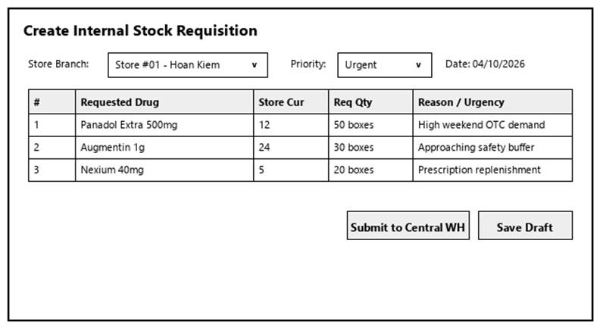
Figure 3-35: Screen Design of Create Stock Requisition
Table 3-35: Screen Definition
# | Field Name | Type | Mandatory | Max Length | Description
1 | Search / Filter | Text / Dropdown | No | 50 | Search records by code, name, or keyword.
2 | Data Table / Form | Grid / Input | Yes | -- | Primary data table or input fields for Create Stock Requisition.
3 | Action Buttons | Button | Yes | -- | Action buttons (Confirm / Submit / Save) to execute Create Stock Requisition.
4 | Cancel / Reset | Button | No | -- | Cancels active modification and returns to previous view.

3.9.3.2 Use Case Description
Use Case ID |  | UC35 | Use Case Name |  | Create Stock Requisition
Author |  | DangPT | Version | 1.0 | Date | 04/10/2026
Actor |  | Store Manager
Description |  | Allows the Store Manager to create and submit a drug replenishment request to the central warehouse when store stock levels fall below thresholds.
Precondition |  | PRE-01: User is logged in as Store Manager.  PRE-02: System registers and network services are operational.
Trigger |  | TRG-01: User navigates to 'Create Stock Requisition' menu.
Post-Condition |  | POS-01: 'Create Stock Requisition' completed successfully and transaction logged in database.  POS-02: System state updated and reflected across integrated modules.
Main flows
Step | Actor | Action
1 | Store Manager | Access Create Stock Requisition interface from main navigation menu.
2 | System | Display interface showing current data and controls for Create Stock Requisition.
3 | Store Manager | Enter required parameters / select items and click confirm.
4 | System | Validate operational inputs against business constraints.
5 | System | Commit transaction, record audit trail, and display success message.

Alternative flows
AT01 | Validation failure or missing fields (At Step 4)
Sub step | Actor | Action
4.1 | System | Display error alert highlighting invalid entries.
4.2 | System | Retain current form entries and prompt user to correct data.
AT02 | User cancels operation (At Step 3)
Sub step | Actor | Action
3.1 | System | Discard uncommitted changes and return to previous list screen.

Business Rules
# | Rule Description
BR-01 | All operations in 'Create Stock Requisition' must be performed under an active, authorized user session.
BR-02 | Every modification or execution must generate an immutable audit log record with user ID and timestamp.
BR-03 | Data integrity and role-based access rules must be strictly validated prior to saving changes.

3.9.4 View Stock Requisition
3.9.4.1 Mock-up
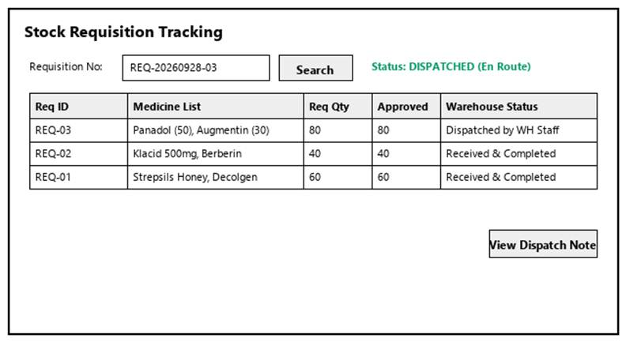
Figure 3-36: Screen Design of View Stock Requisition
Table 3-36: Screen Definition
# | Field Name | Type | Mandatory | Max Length | Description
1 | Search / Filter | Text / Dropdown | No | 50 | Search records by code, name, or keyword.
2 | Data Table / Form | Grid / Input | Yes | -- | Primary data table or input fields for View Stock Requisition.
3 | Action Buttons | Button | Yes | -- | Action buttons (Confirm / Submit / Save) to execute View Stock Requisition.
4 | Cancel / Reset | Button | No | -- | Cancels active modification and returns to previous view.

3.9.4.2 Use Case Description
Use Case ID |  | UC36 | Use Case Name |  | View Stock Requisition
Author |  | DangPT | Version | 1.0 | Date | 04/10/2026
Actor |  | Store Manager
Description |  | Allows the Store Manager to view and track the status, details, and delivery progress of submitted internal stock requisitions.
Precondition |  | PRE-01: User is logged in as Store Manager.  PRE-02: System registers and network services are operational.
Trigger |  | TRG-01: User navigates to 'View Stock Requisition' menu.
Post-Condition |  | POS-01: 'View Stock Requisition' completed successfully and transaction logged in database.  POS-02: System state updated and reflected across integrated modules.
Main flows
Step | Actor | Action
1 | Store Manager | Access View Stock Requisition interface from main navigation menu.
2 | System | Display interface showing current data and controls for View Stock Requisition.
3 | Store Manager | Enter required parameters / select items and click confirm.
4 | System | Validate operational inputs against business constraints.
5 | System | Commit transaction, record audit trail, and display success message.

Alternative flows
AT01 | Validation failure or missing fields (At Step 4)
Sub step | Actor | Action
4.1 | System | Display error alert highlighting invalid entries.
4.2 | System | Retain current form entries and prompt user to correct data.
AT02 | User cancels operation (At Step 3)
Sub step | Actor | Action
3.1 | System | Discard uncommitted changes and return to previous list screen.

Business Rules
# | Rule Description
BR-01 | All operations in 'View Stock Requisition' must be performed under an active, authorized user session.
BR-02 | Every modification or execution must generate an immutable audit log record with user ID and timestamp.
BR-03 | Data integrity and role-based access rules must be strictly validated prior to saving changes.

3.9.5 Manage Stock Requisition
3.9.5.1 Mock-up
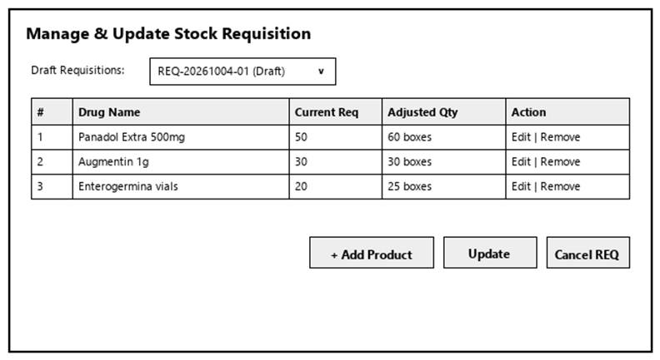
Figure 3-37: Screen Design of Manage Stock Requisition
Table 3-37: Screen Definition
# | Field Name | Type | Mandatory | Max Length | Description
1 | Search / Filter | Text / Dropdown | No | 50 | Search records by code, name, or keyword.
2 | Data Table / Form | Grid / Input | Yes | -- | Primary data table or input fields for Manage Stock Requisition.
3 | Action Buttons | Button | Yes | -- | Action buttons (Confirm / Submit / Save) to execute Manage Stock Requisition.
4 | Cancel / Reset | Button | No | -- | Cancels active modification and returns to previous view.

3.9.5.2 Use Case Description
Use Case ID |  | UC37 | Use Case Name |  | Manage Stock Requisition
Author |  | DangPT | Version | 1.0 | Date | 04/10/2026
Actor |  | Store Manager
Description |  | Allows the Store Manager to modify requested items or quantities of a draft or pending requisition, or cancel an unapproved requisition that is no longer required, before it is processed by the warehouse.
Precondition |  | PRE-01: User is logged in as Store Manager.  PRE-02: System registers and network services are operational.
Trigger |  | TRG-01: User navigates to 'Manage Stock Requisition' menu.
Post-Condition |  | POS-01: 'Manage Stock Requisition' completed successfully and transaction logged in database.  POS-02: System state updated and reflected across integrated modules.
Main flows
Step | Actor | Action
1 | Store Manager | Access Manage Stock Requisition interface from main navigation menu.
2 | System | Display interface showing current data and controls for Manage Stock Requisition.
3 | Store Manager | Enter required parameters / select items and click confirm.
4 | System | Validate operational inputs against business constraints.
5 | System | Commit transaction, record audit trail, and display success message.

Alternative flows
AT01 | Validation failure or missing fields (At Step 4)
Sub step | Actor | Action
4.1 | System | Display error alert highlighting invalid entries.
4.2 | System | Retain current form entries and prompt user to correct data.
AT02 | User cancels operation (At Step 3)
Sub step | Actor | Action
3.1 | System | Discard uncommitted changes and return to previous list screen.

Business Rules
# | Rule Description
BR-01 | All operations in 'Manage Stock Requisition' must be performed under an active, authorized user session.
BR-02 | Every modification or execution must generate an immutable audit log record with user ID and timestamp.
BR-03 | Data integrity and role-based access rules must be strictly validated prior to saving changes.

3.9.6 View Goods Receipt List
3.9.6.1 Mock-up
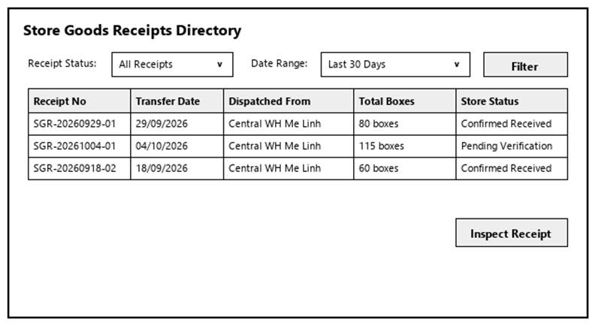
Figure 3-38: Screen Design of View Goods Receipt List
Table 3-38: Screen Definition
# | Field Name | Type | Mandatory | Max Length | Description
1 | Search / Filter | Text / Dropdown | No | 50 | Search records by code, name, or keyword.
2 | Data Table / Form | Grid / Input | Yes | -- | Primary data table or input fields for View Goods Receipt List.
3 | Action Buttons | Button | Yes | -- | Action buttons (Confirm / Submit / Save) to execute View Goods Receipt List.
4 | Cancel / Reset | Button | No | -- | Cancels active modification and returns to previous view.

3.9.6.2 Use Case Description
Use Case ID |  | UC38 | Use Case Name |  | View Goods Receipt List
Author |  | DangPT | Version | 1.0 | Date | 04/10/2026
Actor |  | Store Manager
Description |  | Allows the Store Manager to browse and view the goods receipt notes.
Precondition |  | PRE-01: User is logged in as Store Manager.  PRE-02: System registers and network services are operational.
Trigger |  | TRG-01: User navigates to 'View Goods Receipt List' menu.
Post-Condition |  | POS-01: 'View Goods Receipt List' completed successfully and transaction logged in database.  POS-02: System state updated and reflected across integrated modules.
Main flows
Step | Actor | Action
1 | Store Manager | Access View Goods Receipt List interface from main navigation menu.
2 | System | Display interface showing current data and controls for View Goods Receipt List.
3 | Store Manager | Enter required parameters / select items and click confirm.
4 | System | Validate operational inputs against business constraints.
5 | System | Commit transaction, record audit trail, and display success message.

Alternative flows
AT01 | Validation failure or missing fields (At Step 4)
Sub step | Actor | Action
4.1 | System | Display error alert highlighting invalid entries.
4.2 | System | Retain current form entries and prompt user to correct data.
AT02 | User cancels operation (At Step 3)
Sub step | Actor | Action
3.1 | System | Discard uncommitted changes and return to previous list screen.

Business Rules
# | Rule Description
BR-01 | All operations in 'View Goods Receipt List' must be performed under an active, authorized user session.
BR-02 | Every modification or execution must generate an immutable audit log record with user ID and timestamp.
BR-03 | Data integrity and role-based access rules must be strictly validated prior to saving changes.

3.9.7 Confirm Goods Receipt
3.9.7.1 Mock-up
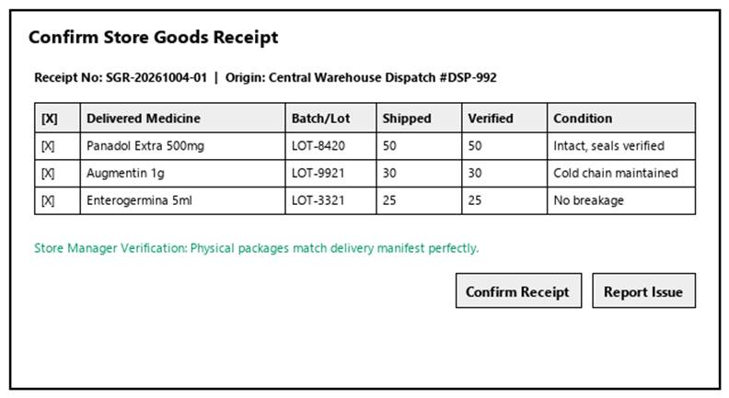
Figure 3-39: Screen Design of Confirm Goods Receipt
Table 3-39: Screen Definition
# | Field Name | Type | Mandatory | Max Length | Description
1 | Search / Filter | Text / Dropdown | No | 50 | Search records by code, name, or keyword.
2 | Data Table / Form | Grid / Input | Yes | -- | Primary data table or input fields for Confirm Goods Receipt.
3 | Action Buttons | Button | Yes | -- | Action buttons (Confirm / Submit / Save) to execute Confirm Goods Receipt.
4 | Cancel / Reset | Button | No | -- | Cancels active modification and returns to previous view.

3.9.7.2 Use Case Description
Use Case ID |  | UC39 | Use Case Name |  | Confirm Goods Receipt
Author |  | DangPT | Version | 1.0 | Date | 04/10/2026
Actor |  | Store Manager
Description |  | Allows the Store Manager to confirm that delivered goods have been received.
Precondition |  | PRE-01: User is logged in as Store Manager.  PRE-02: System registers and network services are operational.
Trigger |  | TRG-01: User navigates to 'Confirm Goods Receipt' menu.
Post-Condition |  | POS-01: 'Confirm Goods Receipt' completed successfully and transaction logged in database.  POS-02: System state updated and reflected across integrated modules.
Main flows
Step | Actor | Action
1 | Store Manager | Access Confirm Goods Receipt interface from main navigation menu.
2 | System | Display interface showing current data and controls for Confirm Goods Receipt.
3 | Store Manager | Enter required parameters / select items and click confirm.
4 | System | Validate operational inputs against business constraints.
5 | System | Commit transaction, record audit trail, and display success message.

Alternative flows
AT01 | Validation failure or missing fields (At Step 4)
Sub step | Actor | Action
4.1 | System | Display error alert highlighting invalid entries.
4.2 | System | Retain current form entries and prompt user to correct data.
AT02 | User cancels operation (At Step 3)
Sub step | Actor | Action
3.1 | System | Discard uncommitted changes and return to previous list screen.

Business Rules
# | Rule Description
BR-01 | All operations in 'Confirm Goods Receipt' must be performed under an active, authorized user session.
BR-02 | Every modification or execution must generate an immutable audit log record with user ID and timestamp.
BR-03 | Data integrity and role-based access rules must be strictly validated prior to saving changes.

3.10 Warehouse Inventory

3.10.1 View Inventory
3.10.1.1 Mock-up
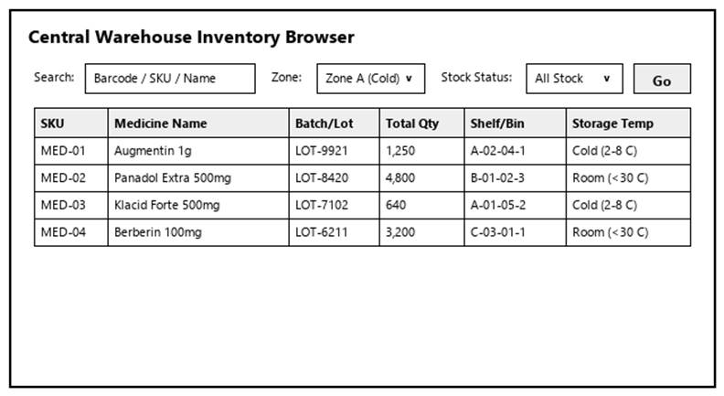
Figure 3-40: Screen Design of View Inventory
Table 3-40: Screen Definition
# | Field Name | Type | Mandatory | Max Length | Description
1 | Search / Filter | Text / Dropdown | No | 50 | Search records by code, name, or keyword.
2 | Data Table / Form | Grid / Input | Yes | -- | Primary data table or input fields for View Inventory.
3 | Action Buttons | Button | Yes | -- | Action buttons (Confirm / Submit / Save) to execute View Inventory.
4 | Cancel / Reset | Button | No | -- | Cancels active modification and returns to previous view.

3.10.1.2 Use Case Description
Use Case ID |  | UC40 | Use Case Name |  | View Inventory
Author |  | HuyTDN | Version | 1.0 | Date | 04/10/2026
Actor |  | Warehouse Manager, Warehouse Staff
Description |  | Allows warehouse users to browse and search real-time inventory balances, stock valuation, batch details, lot numbers, expiration dates, and shelf/bin location mappings across warehouse zones, filtering by medicine name, barcode/SKU, active ingredient, or storage category.
Precondition |  | PRE-01: User is logged in as Warehouse Manager, Warehouse Staff.  PRE-02: System registers and network services are operational.
Trigger |  | TRG-01: User navigates to 'View Inventory' menu.
Post-Condition |  | POS-01: 'View Inventory' completed successfully and transaction logged in database.  POS-02: System state updated and reflected across integrated modules.
Main flows
Step | Actor | Action
1 | Warehouse Manager, Warehouse Staff | Access View Inventory interface from main navigation menu.
2 | System | Display interface showing current data and controls for View Inventory.
3 | Warehouse Manager, Warehouse Staff | Enter required parameters / select items and click confirm.
4 | System | Validate operational inputs against business constraints.
5 | System | Commit transaction, record audit trail, and display success message.

Alternative flows
AT01 | Validation failure or missing fields (At Step 4)
Sub step | Actor | Action
4.1 | System | Display error alert highlighting invalid entries.
4.2 | System | Retain current form entries and prompt user to correct data.
AT02 | User cancels operation (At Step 3)
Sub step | Actor | Action
3.1 | System | Discard uncommitted changes and return to previous list screen.

Business Rules
# | Rule Description
BR-01 | All operations in 'View Inventory' must be performed under an active, authorized user session.
BR-02 | Every modification or execution must generate an immutable audit log record with user ID and timestamp.
BR-03 | Data integrity and role-based access rules must be strictly validated prior to saving changes.

3.10.2 View Purchase History
3.10.2.1 Mock-up
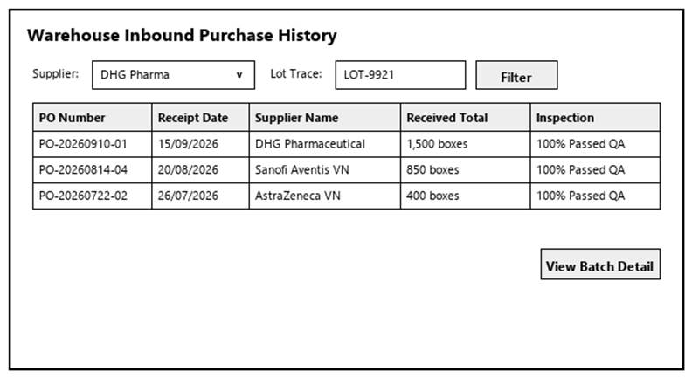
Figure 3-41: Screen Design of View Purchase History
Table 3-41: Screen Definition
# | Field Name | Type | Mandatory | Max Length | Description
1 | Search / Filter | Text / Dropdown | No | 50 | Search records by code, name, or keyword.
2 | Data Table / Form | Grid / Input | Yes | -- | Primary data table or input fields for View Purchase History.
3 | Action Buttons | Button | Yes | -- | Action buttons (Confirm / Submit / Save) to execute View Purchase History.
4 | Cancel / Reset | Button | No | -- | Cancels active modification and returns to previous view.

3.10.2.2 Use Case Description
Use Case ID |  | UC41 | Use Case Name |  | View Purchase History
Author |  | HuyTDN | Version | 1.0 | Date | 04/10/2026
Actor |  | Warehouse Manager, Warehouse Staff
Description |  | Allows warehouse users to look up historical purchase receipts, supplier deliveries, receiving dates, and lot traceability logs.
Precondition |  | PRE-01: User is logged in as Warehouse Manager, Warehouse Staff.  PRE-02: System registers and network services are operational.
Trigger |  | TRG-01: User navigates to 'View Purchase History' menu.
Post-Condition |  | POS-01: 'View Purchase History' completed successfully and transaction logged in database.  POS-02: System state updated and reflected across integrated modules.
Main flows
Step | Actor | Action
1 | Warehouse Manager, Warehouse Staff | Access View Purchase History interface from main navigation menu.
2 | System | Display interface showing current data and controls for View Purchase History.
3 | Warehouse Manager, Warehouse Staff | Enter required parameters / select items and click confirm.
4 | System | Validate operational inputs against business constraints.
5 | System | Commit transaction, record audit trail, and display success message.

Alternative flows
AT01 | Validation failure or missing fields (At Step 4)
Sub step | Actor | Action
4.1 | System | Display error alert highlighting invalid entries.
4.2 | System | Retain current form entries and prompt user to correct data.
AT02 | User cancels operation (At Step 3)
Sub step | Actor | Action
3.1 | System | Discard uncommitted changes and return to previous list screen.

Business Rules
# | Rule Description
BR-01 | All operations in 'View Purchase History' must be performed under an active, authorized user session.
BR-02 | Every modification or execution must generate an immutable audit log record with user ID and timestamp.
BR-03 | Data integrity and role-based access rules must be strictly validated prior to saving changes.

3.10.3 Assign Shelf/Bin Location
3.10.3.1 Mock-up
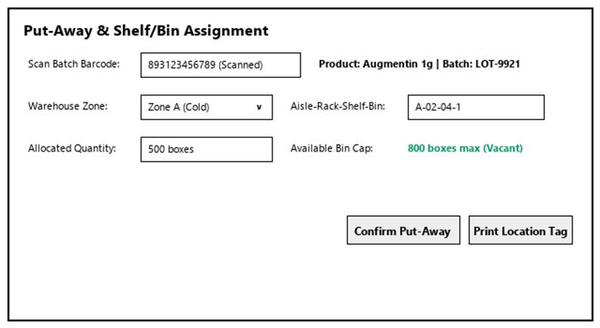
Figure 3-42: Screen Design of Assign Shelf/Bin Location
Table 3-42: Screen Definition
# | Field Name | Type | Mandatory | Max Length | Description
1 | Search / Filter | Text / Dropdown | No | 50 | Search records by code, name, or keyword.
2 | Data Table / Form | Grid / Input | Yes | -- | Primary data table or input fields for Assign Shelf/Bin Location.
3 | Action Buttons | Button | Yes | -- | Action buttons (Confirm / Submit / Save) to execute Assign Shelf/Bin Location.
4 | Cancel / Reset | Button | No | -- | Cancels active modification and returns to previous view.

3.10.3.2 Use Case Description
Use Case ID |  | UC42 | Use Case Name |  | Assign Shelf/Bin Location
Author |  | HuyTDN | Version | 1.0 | Date | 04/10/2026
Actor |  | Warehouse Staff
Description |  | Allows Warehouse Staff to perform put-away management by scanning batch barcodes and assigning received medicine packages to specific warehouse aisles, shelves, and bins.
Precondition |  | PRE-01: User is logged in as Warehouse Staff.  PRE-02: System registers and network services are operational.
Trigger |  | TRG-01: User navigates to 'Assign Shelf/Bin Location' menu.
Post-Condition |  | POS-01: 'Assign Shelf/Bin Location' completed successfully and transaction logged in database.  POS-02: System state updated and reflected across integrated modules.
Main flows
Step | Actor | Action
1 | Warehouse Staff | Access Assign Shelf/Bin Location interface from main navigation menu.
2 | System | Display interface showing current data and controls for Assign Shelf/Bin Location.
3 | Warehouse Staff | Enter required parameters / select items and click confirm.
4 | System | Validate operational inputs against business constraints.
5 | System | Commit transaction, record audit trail, and display success message.

Alternative flows
AT01 | Validation failure or missing fields (At Step 4)
Sub step | Actor | Action
4.1 | System | Display error alert highlighting invalid entries.
4.2 | System | Retain current form entries and prompt user to correct data.
AT02 | User cancels operation (At Step 3)
Sub step | Actor | Action
3.1 | System | Discard uncommitted changes and return to previous list screen.

Business Rules
# | Rule Description
BR-01 | All operations in 'Assign Shelf/Bin Location' must be performed under an active, authorized user session.
BR-02 | Every modification or execution must generate an immutable audit log record with user ID and timestamp.
BR-03 | Data integrity and role-based access rules must be strictly validated prior to saving changes.

3.10.4 Create Inventory Adjustment
3.10.4.1 Mock-up
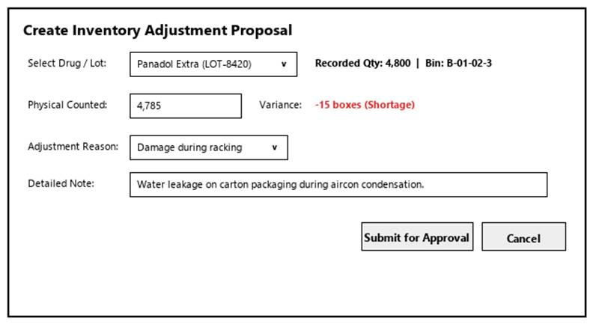
Figure 3-43: Screen Design of Create Inventory Adjustment
Table 3-43: Screen Definition
# | Field Name | Type | Mandatory | Max Length | Description
1 | Search / Filter | Text / Dropdown | No | 50 | Search records by code, name, or keyword.
2 | Data Table / Form | Grid / Input | Yes | -- | Primary data table or input fields for Create Inventory Adjustment.
3 | Action Buttons | Button | Yes | -- | Action buttons (Confirm / Submit / Save) to execute Create Inventory Adjustment.
4 | Cancel / Reset | Button | No | -- | Cancels active modification and returns to previous view.

3.10.4.2 Use Case Description
Use Case ID |  | UC43 | Use Case Name |  | Create Inventory Adjustment
Author |  | HuyTDN | Version | 1.0 | Date | 04/10/2026
Actor |  | Warehouse Staff
Description |  | Allows Warehouse Staff to record physical stocktake count discrepancies (damage, breakage, count variance) and submit adjustment proposals for Manager review.
Precondition |  | PRE-01: User is logged in as Warehouse Staff.  PRE-02: System registers and network services are operational.
Trigger |  | TRG-01: User navigates to 'Create Inventory Adjustment' menu.
Post-Condition |  | POS-01: 'Create Inventory Adjustment' completed successfully and transaction logged in database.  POS-02: System state updated and reflected across integrated modules.
Main flows
Step | Actor | Action
1 | Warehouse Staff | Access Create Inventory Adjustment interface from main navigation menu.
2 | System | Display interface showing current data and controls for Create Inventory Adjustment.
3 | Warehouse Staff | Enter required parameters / select items and click confirm.
4 | System | Validate operational inputs against business constraints.
5 | System | Commit transaction, record audit trail, and display success message.

Alternative flows
AT01 | Validation failure or missing fields (At Step 4)
Sub step | Actor | Action
4.1 | System | Display error alert highlighting invalid entries.
4.2 | System | Retain current form entries and prompt user to correct data.
AT02 | User cancels operation (At Step 3)
Sub step | Actor | Action
3.1 | System | Discard uncommitted changes and return to previous list screen.

Business Rules
# | Rule Description
BR-01 | All operations in 'Create Inventory Adjustment' must be performed under an active, authorized user session.
BR-02 | Every modification or execution must generate an immutable audit log record with user ID and timestamp.
BR-03 | Data integrity and role-based access rules must be strictly validated prior to saving changes.

3.10.5 Approve Inventory Adjustment
3.10.5.1 Mock-up
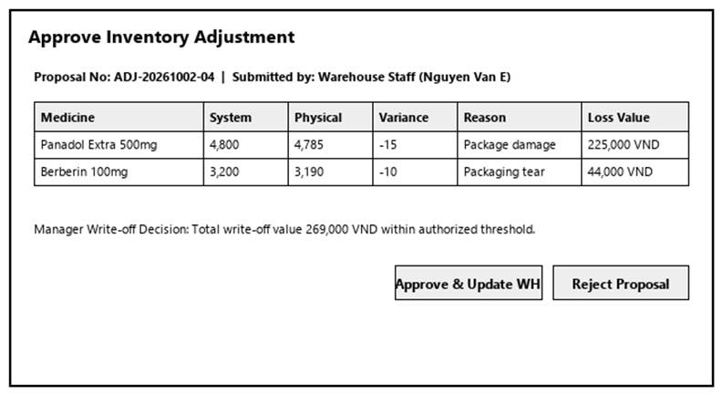
Figure 3-44: Screen Design of Approve Inventory Adjustment
Table 3-44: Screen Definition
# | Field Name | Type | Mandatory | Max Length | Description
1 | Search / Filter | Text / Dropdown | No | 50 | Search records by code, name, or keyword.
2 | Data Table / Form | Grid / Input | Yes | -- | Primary data table or input fields for Approve Inventory Adjustment.
3 | Action Buttons | Button | Yes | -- | Action buttons (Confirm / Submit / Save) to execute Approve Inventory Adjustment.
4 | Cancel / Reset | Button | No | -- | Cancels active modification and returns to previous view.

3.10.5.2 Use Case Description
Use Case ID |  | UC44 | Use Case Name |  | Approve Inventory Adjustment
Author |  | HuyTDN | Version | 1.0 | Date | 04/10/2026
Actor |  | Warehouse Manager
Description |  | Allows the Warehouse Manager to review stocktake audit discrepancies submitted by staff and approve or reject balance adjustments and financial write-offs.
Precondition |  | PRE-01: User is logged in as Warehouse Manager.  PRE-02: System registers and network services are operational.
Trigger |  | TRG-01: User navigates to 'Approve Inventory Adjustment' menu.
Post-Condition |  | POS-01: 'Approve Inventory Adjustment' completed successfully and transaction logged in database.  POS-02: System state updated and reflected across integrated modules.
Main flows
Step | Actor | Action
1 | Warehouse Manager | Access Approve Inventory Adjustment interface from main navigation menu.
2 | System | Display interface showing current data and controls for Approve Inventory Adjustment.
3 | Warehouse Manager | Enter required parameters / select items and click confirm.
4 | System | Validate operational inputs against business constraints.
5 | System | Commit transaction, record audit trail, and display success message.

Alternative flows
AT01 | Validation failure or missing fields (At Step 4)
Sub step | Actor | Action
4.1 | System | Display error alert highlighting invalid entries.
4.2 | System | Retain current form entries and prompt user to correct data.
AT02 | User cancels operation (At Step 3)
Sub step | Actor | Action
3.1 | System | Discard uncommitted changes and return to previous list screen.

Business Rules
# | Rule Description
BR-01 | All operations in 'Approve Inventory Adjustment' must be performed under an active, authorized user session.
BR-02 | Every modification or execution must generate an immutable audit log record with user ID and timestamp.
BR-03 | Data integrity and role-based access rules must be strictly validated prior to saving changes.

3.10.6 View Low Stock Alert Report
3.10.6.1 Mock-up
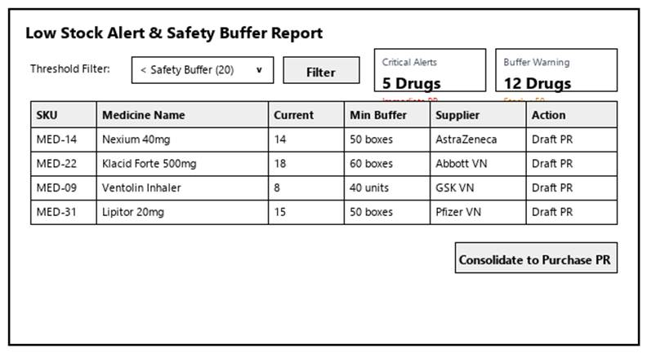
Figure 3-45: Screen Design of View Low Stock Alert Report
Table 3-45: Screen Definition
# | Field Name | Type | Mandatory | Max Length | Description
1 | Search / Filter | Text / Dropdown | No | 50 | Search records by code, name, or keyword.
2 | Data Table / Form | Grid / Input | Yes | -- | Primary data table or input fields for View Low Stock Alert Report.
3 | Action Buttons | Button | Yes | -- | Action buttons (Confirm / Submit / Save) to execute View Low Stock Alert Report.
4 | Cancel / Reset | Button | No | -- | Cancels active modification and returns to previous view.

3.10.6.2 Use Case Description
Use Case ID |  | UC45 | Use Case Name |  | View Low Stock Alert Report
Author |  | HuyTDN | Version | 1.0 | Date | 04/10/2026
Actor |  | Warehouse Manager
Description |  | Allows the Warehouse Manager to view, filter, and export reports of medicines reaching safety stock thresholds (Quantity < 20 units) to prevent stockouts and support purchasing decisions.
Precondition |  | PRE-01: User is logged in as Warehouse Manager.  PRE-02: System registers and network services are operational.
Trigger |  | TRG-01: User navigates to 'View Low Stock Alert Report' menu.
Post-Condition |  | POS-01: 'View Low Stock Alert Report' completed successfully and transaction logged in database.  POS-02: System state updated and reflected across integrated modules.
Main flows
Step | Actor | Action
1 | Warehouse Manager | Access View Low Stock Alert Report interface from main navigation menu.
2 | System | Display interface showing current data and controls for View Low Stock Alert Report.
3 | Warehouse Manager | Enter required parameters / select items and click confirm.
4 | System | Validate operational inputs against business constraints.
5 | System | Commit transaction, record audit trail, and display success message.

Alternative flows
AT01 | Validation failure or missing fields (At Step 4)
Sub step | Actor | Action
4.1 | System | Display error alert highlighting invalid entries.
4.2 | System | Retain current form entries and prompt user to correct data.
AT02 | User cancels operation (At Step 3)
Sub step | Actor | Action
3.1 | System | Discard uncommitted changes and return to previous list screen.

Business Rules
# | Rule Description
BR-01 | All operations in 'View Low Stock Alert Report' must be performed under an active, authorized user session.
BR-02 | Every modification or execution must generate an immutable audit log record with user ID and timestamp.
BR-03 | Data integrity and role-based access rules must be strictly validated prior to saving changes.

3.10.7 View Expiry Alert Report
3.10.7.1 Mock-up
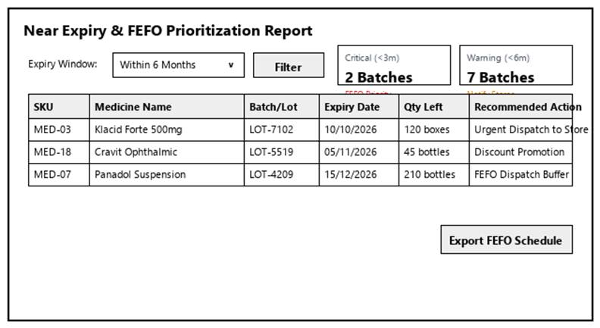
Figure 3-46: Screen Design of View Expiry Alert Report
Table 3-46: Screen Definition
# | Field Name | Type | Mandatory | Max Length | Description
1 | Search / Filter | Text / Dropdown | No | 50 | Search records by code, name, or keyword.
2 | Data Table / Form | Grid / Input | Yes | -- | Primary data table or input fields for View Expiry Alert Report.
3 | Action Buttons | Button | Yes | -- | Action buttons (Confirm / Submit / Save) to execute View Expiry Alert Report.
4 | Cancel / Reset | Button | No | -- | Cancels active modification and returns to previous view.

3.10.7.2 Use Case Description
Use Case ID |  | UC46 | Use Case Name |  | View Expiry Alert Report
Author |  | HuyTDN | Version | 1.0 | Date | 04/10/2026
Actor |  | Warehouse Manager
Description |  | Allows the Warehouse Manager to view and analyze medicines nearing expiration (< 6 months) or already expired to prioritize FEFO store dispatch or initiate supplier returns.
Precondition |  | PRE-01: User is logged in as Warehouse Manager.  PRE-02: System registers and network services are operational.
Trigger |  | TRG-01: User navigates to 'View Expiry Alert Report' menu.
Post-Condition |  | POS-01: 'View Expiry Alert Report' completed successfully and transaction logged in database.  POS-02: System state updated and reflected across integrated modules.
Main flows
Step | Actor | Action
1 | Warehouse Manager | Access View Expiry Alert Report interface from main navigation menu.
2 | System | Display interface showing current data and controls for View Expiry Alert Report.
3 | Warehouse Manager | Enter required parameters / select items and click confirm.
4 | System | Validate operational inputs against business constraints.
5 | System | Commit transaction, record audit trail, and display success message.

Alternative flows
AT01 | Validation failure or missing fields (At Step 4)
Sub step | Actor | Action
4.1 | System | Display error alert highlighting invalid entries.
4.2 | System | Retain current form entries and prompt user to correct data.
AT02 | User cancels operation (At Step 3)
Sub step | Actor | Action
3.1 | System | Discard uncommitted changes and return to previous list screen.

Business Rules
# | Rule Description
BR-01 | All operations in 'View Expiry Alert Report' must be performed under an active, authorized user session.
BR-02 | Every modification or execution must generate an immutable audit log record with user ID and timestamp.
BR-03 | Data integrity and role-based access rules must be strictly validated prior to saving changes.

3.10.8 Manage Purchase Requests
3.10.8.1 Mock-up
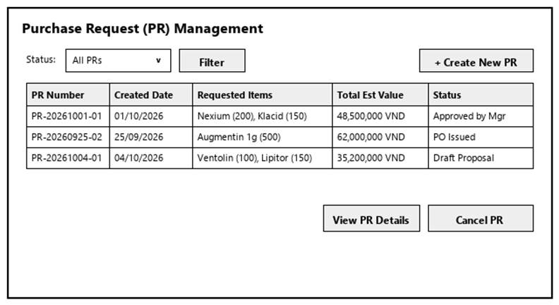
Figure 3-47: Screen Design of Manage Purchase Requests
Table 3-47: Screen Definition
# | Field Name | Type | Mandatory | Max Length | Description
1 | Search / Filter | Text / Dropdown | No | 50 | Search records by code, name, or keyword.
2 | Data Table / Form | Grid / Input | Yes | -- | Primary data table or input fields for Manage Purchase Requests.
3 | Action Buttons | Button | Yes | -- | Action buttons (Confirm / Submit / Save) to execute Manage Purchase Requests.
4 | Cancel / Reset | Button | No | -- | Cancels active modification and returns to previous view.

3.10.8.2 Use Case Description
Use Case ID |  | UC47 | Use Case Name |  | Manage Purchase Requests
Author |  | HuyTDN | Version | 1.0 | Date | 04/10/2026
Actor |  | Warehouse Manager
Description |  | Allows the Warehouse Manager to view, create, update, and cancel Purchase Requests (PR) for medicines reaching safety stock thresholds or consolidating store replenishment demands.
Precondition |  | PRE-01: User is logged in as Warehouse Manager.  PRE-02: System registers and network services are operational.
Trigger |  | TRG-01: User navigates to 'Manage Purchase Requests' menu.
Post-Condition |  | POS-01: 'Manage Purchase Requests' completed successfully and transaction logged in database.  POS-02: System state updated and reflected across integrated modules.
Main flows
Step | Actor | Action
1 | Warehouse Manager | Access Manage Purchase Requests interface from main navigation menu.
2 | System | Display interface showing current data and controls for Manage Purchase Requests.
3 | Warehouse Manager | Enter required parameters / select items and click confirm.
4 | System | Validate operational inputs against business constraints.
5 | System | Commit transaction, record audit trail, and display success message.

Alternative flows
AT01 | Validation failure or missing fields (At Step 4)
Sub step | Actor | Action
4.1 | System | Display error alert highlighting invalid entries.
4.2 | System | Retain current form entries and prompt user to correct data.
AT02 | User cancels operation (At Step 3)
Sub step | Actor | Action
3.1 | System | Discard uncommitted changes and return to previous list screen.

Business Rules
# | Rule Description
BR-01 | All operations in 'Manage Purchase Requests' must be performed under an active, authorized user session.
BR-02 | Every modification or execution must generate an immutable audit log record with user ID and timestamp.
BR-03 | Data integrity and role-based access rules must be strictly validated prior to saving changes.

3.11 Store Replenishment & Goods Issue

3.11.1 Manage Store Replenishment Requests
3.11.1.1 Mock-up
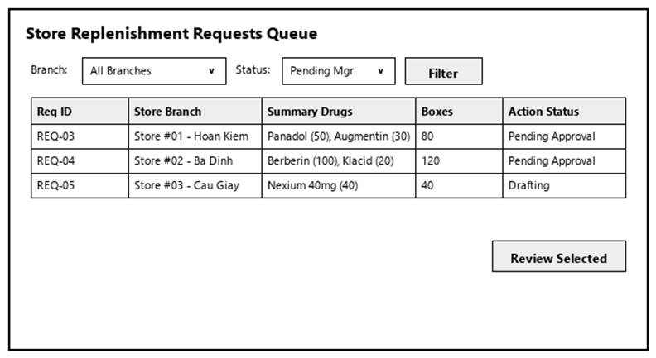
Figure 3-48: Screen Design of Manage Store Replenishment Requests
Table 3-48: Screen Definition
# | Field Name | Type | Mandatory | Max Length | Description
1 | Search / Filter | Text / Dropdown | No | 50 | Search records by code, name, or keyword.
2 | Data Table / Form | Grid / Input | Yes | -- | Primary data table or input fields for Manage Store Replenishment Requests.
3 | Action Buttons | Button | Yes | -- | Action buttons (Confirm / Submit / Save) to execute Manage Store Replenishment Requests.
4 | Cancel / Reset | Button | No | -- | Cancels active modification and returns to previous view.

3.11.1.2 Use Case Description
Use Case ID |  | UC48 | Use Case Name |  | Manage Store Replenishment Requests
Author |  | HuyTDN | Version | 1.0 | Date | 04/10/2026
Actor |  | Warehouse Manager
Description |  | Allows the Warehouse Manager to review, evaluate, and track drug replenishment requests submitted by retail pharmacy stores against warehouse inventory availability.
Precondition |  | PRE-01: User is logged in as Warehouse Manager.  PRE-02: System registers and network services are operational.
Trigger |  | TRG-01: User navigates to 'Manage Store Replenishment Requests' menu.
Post-Condition |  | POS-01: 'Manage Store Replenishment Requests' completed successfully and transaction logged in database.  POS-02: System state updated and reflected across integrated modules.
Main flows
Step | Actor | Action
1 | Warehouse Manager | Access Manage Store Replenishment Requests interface from main navigation menu.
2 | System | Display interface showing current data and controls for Manage Store Replenishment Requests.
3 | Warehouse Manager | Enter required parameters / select items and click confirm.
4 | System | Validate operational inputs against business constraints.
5 | System | Commit transaction, record audit trail, and display success message.

Alternative flows
AT01 | Validation failure or missing fields (At Step 4)
Sub step | Actor | Action
4.1 | System | Display error alert highlighting invalid entries.
4.2 | System | Retain current form entries and prompt user to correct data.
AT02 | User cancels operation (At Step 3)
Sub step | Actor | Action
3.1 | System | Discard uncommitted changes and return to previous list screen.

Business Rules
# | Rule Description
BR-01 | All operations in 'Manage Store Replenishment Requests' must be performed under an active, authorized user session.
BR-02 | Every modification or execution must generate an immutable audit log record with user ID and timestamp.
BR-03 | Data integrity and role-based access rules must be strictly validated prior to saving changes.

3.11.2 Approve Store Replenishment Request
3.11.2.1 Mock-up
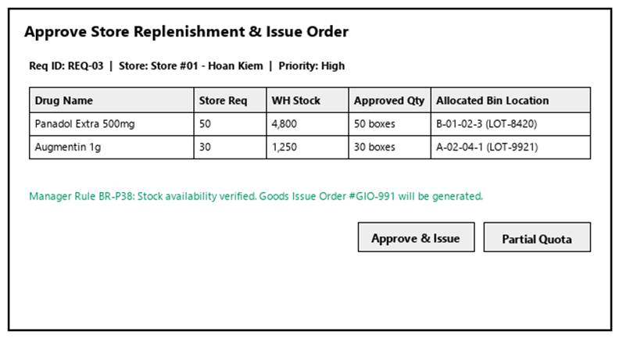
Figure 3-49: Screen Design of Approve Store Replenishment Request
Table 3-49: Screen Definition
# | Field Name | Type | Mandatory | Max Length | Description
1 | Search / Filter | Text / Dropdown | No | 50 | Search records by code, name, or keyword.
2 | Data Table / Form | Grid / Input | Yes | -- | Primary data table or input fields for Approve Store Replenishment Request.
3 | Action Buttons | Button | Yes | -- | Action buttons (Confirm / Submit / Save) to execute Approve Store Replenishment Request.
4 | Cancel / Reset | Button | No | -- | Cancels active modification and returns to previous view.

3.11.2.2 Use Case Description
Use Case ID |  | UC49 | Use Case Name |  | Approve Store Replenishment Request
Author |  | HuyTDN | Version | 1.0 | Date | 04/10/2026
Actor |  | Warehouse Manager
Description |  | Allows the Warehouse Manager to approve an eligible store replenishment request (enforcing Business Rule BR-P38: mandatory Manager consent for warehouse dispatch) and generate a Goods Issue Order.
Precondition |  | PRE-01: User is logged in as Warehouse Manager.  PRE-02: System registers and network services are operational.
Trigger |  | TRG-01: User navigates to 'Approve Store Replenishment Request' menu.
Post-Condition |  | POS-01: 'Approve Store Replenishment Request' completed successfully and transaction logged in database.  POS-02: System state updated and reflected across integrated modules.
Main flows
Step | Actor | Action
1 | Warehouse Manager | Access Approve Store Replenishment Request interface from main navigation menu.
2 | System | Display interface showing current data and controls for Approve Store Replenishment Request.
3 | Warehouse Manager | Enter required parameters / select items and click confirm.
4 | System | Validate operational inputs against business constraints.
5 | System | Commit transaction, record audit trail, and display success message.

Alternative flows
AT01 | Validation failure or missing fields (At Step 4)
Sub step | Actor | Action
4.1 | System | Display error alert highlighting invalid entries.
4.2 | System | Retain current form entries and prompt user to correct data.
AT02 | User cancels operation (At Step 3)
Sub step | Actor | Action
3.1 | System | Discard uncommitted changes and return to previous list screen.

Business Rules
# | Rule Description
BR-01 | All operations in 'Approve Store Replenishment Request' must be performed under an active, authorized user session.
BR-02 | Every modification or execution must generate an immutable audit log record with user ID and timestamp.
BR-03 | Data integrity and role-based access rules must be strictly validated prior to saving changes.

3.11.3 Reject Store Replenishment Request
3.11.3.1 Mock-up
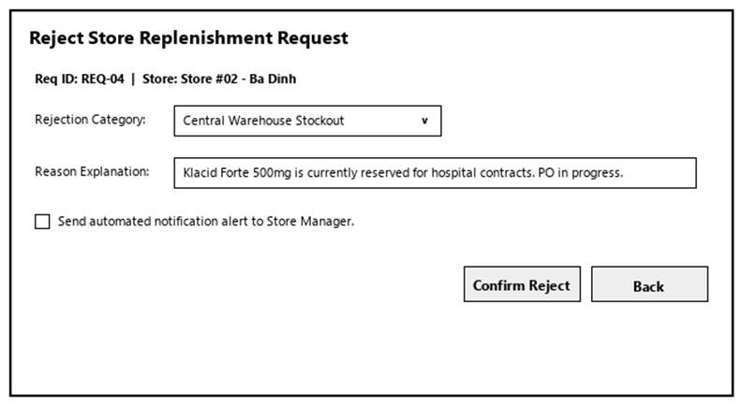
Figure 3-50: Screen Design of Reject Store Replenishment Request
Table 3-50: Screen Definition
# | Field Name | Type | Mandatory | Max Length | Description
1 | Search / Filter | Text / Dropdown | No | 50 | Search records by code, name, or keyword.
2 | Data Table / Form | Grid / Input | Yes | -- | Primary data table or input fields for Reject Store Replenishment Request.
3 | Action Buttons | Button | Yes | -- | Action buttons (Confirm / Submit / Save) to execute Reject Store Replenishment Request.
4 | Cancel / Reset | Button | No | -- | Cancels active modification and returns to previous view.

3.11.3.2 Use Case Description
Use Case ID |  | UC50 | Use Case Name |  | Reject Store Replenishment Request
Author |  | HuyTDN | Version | 1.0 | Date | 04/10/2026
Actor |  | Warehouse Manager
Description |  | Allows the Warehouse Manager to reject a store replenishment request in case of central warehouse inventory shortage, invalid store quota, or priority conflict.
Precondition |  | PRE-01: User is logged in as Warehouse Manager.  PRE-02: System registers and network services are operational.
Trigger |  | TRG-01: User navigates to 'Reject Store Replenishment Request' menu.
Post-Condition |  | POS-01: 'Reject Store Replenishment Request' completed successfully and transaction logged in database.  POS-02: System state updated and reflected across integrated modules.
Main flows
Step | Actor | Action
1 | Warehouse Manager | Access Reject Store Replenishment Request interface from main navigation menu.
2 | System | Display interface showing current data and controls for Reject Store Replenishment Request.
3 | Warehouse Manager | Enter required parameters / select items and click confirm.
4 | System | Validate operational inputs against business constraints.
5 | System | Commit transaction, record audit trail, and display success message.

Alternative flows
AT01 | Validation failure or missing fields (At Step 4)
Sub step | Actor | Action
4.1 | System | Display error alert highlighting invalid entries.
4.2 | System | Retain current form entries and prompt user to correct data.
AT02 | User cancels operation (At Step 3)
Sub step | Actor | Action
3.1 | System | Discard uncommitted changes and return to previous list screen.

Business Rules
# | Rule Description
BR-01 | All operations in 'Reject Store Replenishment Request' must be performed under an active, authorized user session.
BR-02 | Every modification or execution must generate an immutable audit log record with user ID and timestamp.
BR-03 | Data integrity and role-based access rules must be strictly validated prior to saving changes.

3.11.4 Confirm Goods Dispatch
3.11.4.1 Mock-up
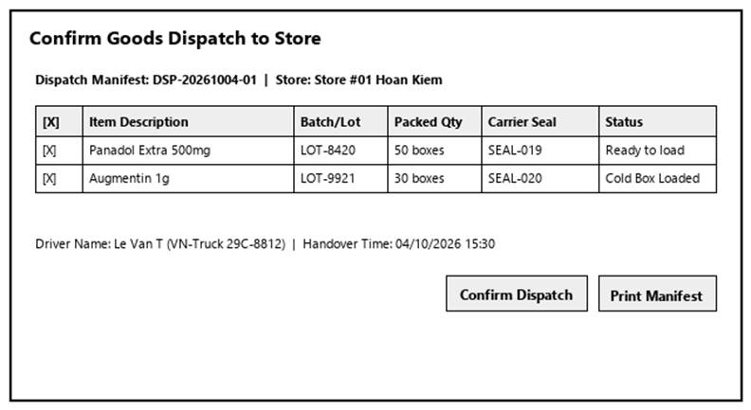
Figure 3-51: Screen Design of Confirm Goods Dispatch
Table 3-51: Screen Definition
# | Field Name | Type | Mandatory | Max Length | Description
1 | Search / Filter | Text / Dropdown | No | 50 | Search records by code, name, or keyword.
2 | Data Table / Form | Grid / Input | Yes | -- | Primary data table or input fields for Confirm Goods Dispatch.
3 | Action Buttons | Button | Yes | -- | Action buttons (Confirm / Submit / Save) to execute Confirm Goods Dispatch.
4 | Cancel / Reset | Button | No | -- | Cancels active modification and returns to previous view.

3.11.4.2 Use Case Description
Use Case ID |  | UC52 | Use Case Name |  | Confirm Goods Dispatch
Author |  | HuyTDN | Version | 1.0 | Date | 04/10/2026
Actor |  | Warehouse Staff
Description |  | Allows Warehouse Staff to finalize the handover of packed medicine packages to the delivery carrier, print delivery notes, and officially deduct central warehouse inventory.
Precondition |  | PRE-01: User is logged in as Warehouse Staff.  PRE-02: System registers and network services are operational.
Trigger |  | TRG-01: User navigates to 'Confirm Goods Dispatch' menu.
Post-Condition |  | POS-01: 'Confirm Goods Dispatch' completed successfully and transaction logged in database.  POS-02: System state updated and reflected across integrated modules.
Main flows
Step | Actor | Action
1 | Warehouse Staff | Access Confirm Goods Dispatch interface from main navigation menu.
2 | System | Display interface showing current data and controls for Confirm Goods Dispatch.
3 | Warehouse Staff | Enter required parameters / select items and click confirm.
4 | System | Validate operational inputs against business constraints.
5 | System | Commit transaction, record audit trail, and display success message.

Alternative flows
AT01 | Validation failure or missing fields (At Step 4)
Sub step | Actor | Action
4.1 | System | Display error alert highlighting invalid entries.
4.2 | System | Retain current form entries and prompt user to correct data.
AT02 | User cancels operation (At Step 3)
Sub step | Actor | Action
3.1 | System | Discard uncommitted changes and return to previous list screen.

Business Rules
# | Rule Description
BR-01 | All operations in 'Confirm Goods Dispatch' must be performed under an active, authorized user session.
BR-02 | Every modification or execution must generate an immutable audit log record with user ID and timestamp.
BR-03 | Data integrity and role-based access rules must be strictly validated prior to saving changes.

3.12 Warehouse Purchase Receipt

3.12.1 Manage Purchase Receipt
3.12.1.1 Mock-up
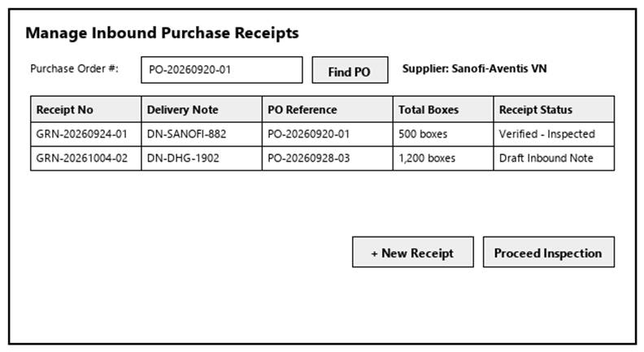
Figure 3-52: Screen Design of Manage Purchase Receipt
Table 3-52: Screen Definition
# | Field Name | Type | Mandatory | Max Length | Description
1 | Search / Filter | Text / Dropdown | No | 50 | Search records by code, name, or keyword.
2 | Data Table / Form | Grid / Input | Yes | -- | Primary data table or input fields for Manage Purchase Receipt.
3 | Action Buttons | Button | Yes | -- | Action buttons (Confirm / Submit / Save) to execute Manage Purchase Receipt.
4 | Cancel / Reset | Button | No | -- | Cancels active modification and returns to previous view.

3.12.1.2 Use Case Description
Use Case ID |  | UC53 | Use Case Name |  | Manage Purchase Receipt
Author |  | Group 5 | Version | 1.0 | Date | 04/10/2026
Actor |  | Warehouse Staff
Description |  | Allows Warehouse Staff to browse inbound deliveries, create draft Goods Receipt notes against approved Purchase Orders (PO), update shipment details, and cancel invalid receiving records.
Precondition |  | PRE-01: User is logged in as Warehouse Staff.  PRE-02: System registers and network services are operational.
Trigger |  | TRG-01: User navigates to 'Manage Purchase Receipt' menu.
Post-Condition |  | POS-01: 'Manage Purchase Receipt' completed successfully and transaction logged in database.  POS-02: System state updated and reflected across integrated modules.
Main flows
Step | Actor | Action
1 | Warehouse Staff | Access Manage Purchase Receipt interface from main navigation menu.
2 | System | Display interface showing current data and controls for Manage Purchase Receipt.
3 | Warehouse Staff | Enter required parameters / select items and click confirm.
4 | System | Validate operational inputs against business constraints.
5 | System | Commit transaction, record audit trail, and display success message.

Alternative flows
AT01 | Validation failure or missing fields (At Step 4)
Sub step | Actor | Action
4.1 | System | Display error alert highlighting invalid entries.
4.2 | System | Retain current form entries and prompt user to correct data.
AT02 | User cancels operation (At Step 3)
Sub step | Actor | Action
3.1 | System | Discard uncommitted changes and return to previous list screen.

Business Rules
# | Rule Description
BR-01 | All operations in 'Manage Purchase Receipt' must be performed under an active, authorized user session.
BR-02 | Every modification or execution must generate an immutable audit log record with user ID and timestamp.
BR-03 | Data integrity and role-based access rules must be strictly validated prior to saving changes.

3.12.2 Confirm Purchase Receipt
3.12.2.1 Mock-up
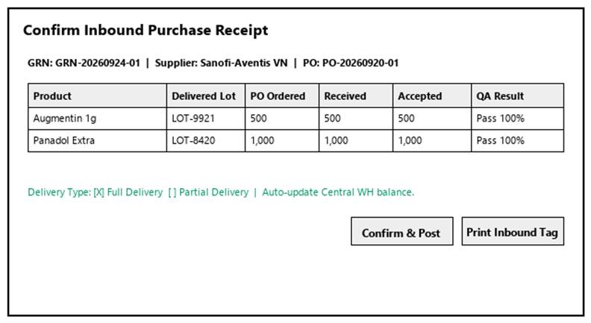
Figure 3-53: Screen Design of Confirm Purchase Receipt
Table 3-53: Screen Definition
# | Field Name | Type | Mandatory | Max Length | Description
1 | Search / Filter | Text / Dropdown | No | 50 | Search records by code, name, or keyword.
2 | Data Table / Form | Grid / Input | Yes | -- | Primary data table or input fields for Confirm Purchase Receipt.
3 | Action Buttons | Button | Yes | -- | Action buttons (Confirm / Submit / Save) to execute Confirm Purchase Receipt.
4 | Cancel / Reset | Button | No | -- | Cancels active modification and returns to previous view.

3.12.2.2 Use Case Description
Use Case ID |  | UC54 | Use Case Name |  | Confirm Purchase Receipt
Author |  | Group 5 | Version | 1.0 | Date | 04/10/2026
Actor |  | Warehouse Staff
Description |  | Allows Warehouse Staff to finalize and confirm goods receipt after physical inspection (supporting both Full and Partial Delivery) and officially update inventory balances.
Precondition |  | PRE-01: User is logged in as Warehouse Staff.  PRE-02: System registers and network services are operational.
Trigger |  | TRG-01: User navigates to 'Confirm Purchase Receipt' menu.
Post-Condition |  | POS-01: 'Confirm Purchase Receipt' completed successfully and transaction logged in database.  POS-02: System state updated and reflected across integrated modules.
Main flows
Step | Actor | Action
1 | Warehouse Staff | Access Confirm Purchase Receipt interface from main navigation menu.
2 | System | Display interface showing current data and controls for Confirm Purchase Receipt.
3 | Warehouse Staff | Enter required parameters / select items and click confirm.
4 | System | Validate operational inputs against business constraints.
5 | System | Commit transaction, record audit trail, and display success message.

Alternative flows
AT01 | Validation failure or missing fields (At Step 4)
Sub step | Actor | Action
4.1 | System | Display error alert highlighting invalid entries.
4.2 | System | Retain current form entries and prompt user to correct data.
AT02 | User cancels operation (At Step 3)
Sub step | Actor | Action
3.1 | System | Discard uncommitted changes and return to previous list screen.

Business Rules
# | Rule Description
BR-01 | All operations in 'Confirm Purchase Receipt' must be performed under an active, authorized user session.
BR-02 | Every modification or execution must generate an immutable audit log record with user ID and timestamp.
BR-03 | Data integrity and role-based access rules must be strictly validated prior to saving changes.

3.12.3 View Purchase Request List
3.12.3.1 Mock-up

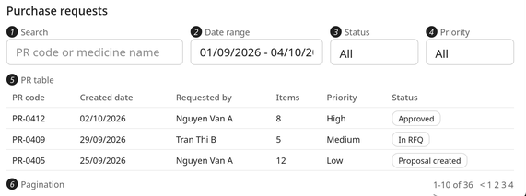
Figure 3-51: Screen Design of Purchase Request List

Table 3-11: Screen Definition

# | Field Name | Type | Mandatory | Max Length | Description
1 | Search | Text | No | 100 | Keyword: PR code or medicine name.
2 | Date Range | Date picker | No |  | Filters PRs by created date (from – to).
3 | Status | Dropdown | No |  | Filters by status (Approved, In RFQ, Proposal Created...).
4 | Priority | Dropdown | No |  | Filters by priority (High, Medium, Low).
5 | PR Table | Grid |  |  | Lists approved PRs (PR Code, Created Date, Requested By, Number of Items, Priority, Status), newest first. Clicking a row opens PR detail. Shows "No purchase requests found." if no result.
6 | Pagination | Control |  |  | Navigates pages; default 10 records per page.

3.12.3.2 Use Case Description
Use Case ID |  | UC55 | Use Case Name |  | View Purchase Request List
Author |  | Group 5 | Version | 1.0 | Date | 04/10/2026
Actor |  | Purchasing Staff
Description |  | Allows the Purchasing Staff to browse, filter, and view details of approved purchase requests submitted by the Warehouse Manager.
Precondition |  | PRE-01: User is logged in as Purchasing Staff.  PRE-02: System registers and network services are operational.
Trigger |  | TRG-01: User navigates to 'View Purchase Request List' menu.
Post-Condition |  | POS-01: 'View Purchase Request List' completed successfully and transaction logged in database.  POS-02: System state updated and reflected across integrated modules.
Main flows
Step | Actor | Action
1 | Purchasing Staff | Access View Purchase Request List interface from main navigation menu.
2 | System | Display interface showing current data and controls for View Purchase Request List.
3 | Purchasing Staff | Enter required parameters / select items and click confirm.
4 | System | Validate operational inputs against business constraints.
5 | System | Commit transaction, record audit trail, and display success message.

Alternative flows
AT01 | Validation failure or missing fields (At Step 4)
Sub step | Actor | Action
4.1 | System | Display error alert highlighting invalid entries.
4.2 | System | Retain current form entries and prompt user to correct data.
AT02 | User cancels operation (At Step 3)
Sub step | Actor | Action
3.1 | System | Discard uncommitted changes and return to previous list screen.

Business Rules
# | Rule Description
BR-01 | All operations in 'View Purchase Request List' must be performed under an active, authorized user session.
BR-02 | Every modification or execution must generate an immutable audit log record with user ID and timestamp.
BR-03 | Data integrity and role-based access rules must be strictly validated prior to saving changes.

3.12.3.2 Use Case Description
Use Case ID | UC55 | Use Case Name: View Purchase Request List
Author: QuangDN | Version: 1.0 | Date: 4/10/2026
Actor | Purchasing Staff
Description | Allows the Purchasing Staff to browse, search, and filter the list of approved Purchase Requests submitted by the Warehouse Manager in order to prepare the sourcing process.
Precondition | PRE-01: The administrator has logged in to the system successfully.  PRE-02: The system is connected to the database.
Trigger | TRG-01: User selects "Purchase Requests" from the main navigation menu.
Post-Condition | POS-01: The list of approved Purchase Requests matching the criteria is displayed.  POS-02: No data is modified.
Main flows
Step | Actor | Action
1 | Purchasing Staff | Selects "Purchase Requests" from the navigation menu.
2 | System | Retrieves approved PRs and displays them in a paginated table
3 | Purchasing Staff | Enters a keyword and/or selects filters
4 | System | Applies search/filter and refreshes the list.
Alternative flows
Sub step | Actor | Action
Business Rules
# | Rule Description
BR-01 | Only Purchase Requests with status Approved (or later sourcing statuses) by the Warehouse Manager are visible to the Purchasing Staff. Draft/Cancelled PRs are hidden.
BR-02 | Default sort is Created Date descending; default page size is 10 records.

3.12.4 View Purchase Request Detail
3.12.4.1 Mock-up
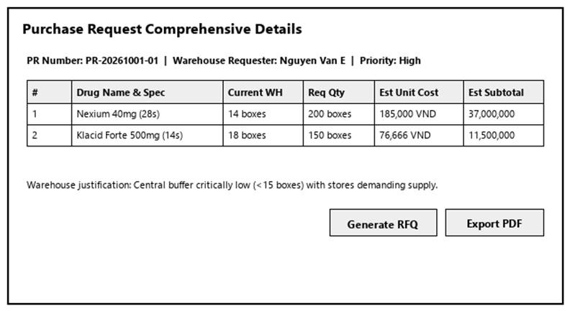
Figure 3-55: Screen Design of View Purchase Request Detail
Table 3-55: Screen Definition
# | Field Name | Type | Mandatory | Max Length | Description
1 | Search / Filter | Text / Dropdown | No | 50 | Search records by code, name, or keyword.
2 | Data Table / Form | Grid / Input | Yes | -- | Primary data table or input fields for View Purchase Request Detail.
3 | Action Buttons | Button | Yes | -- | Action buttons (Confirm / Submit / Save) to execute View Purchase Request Detail.
4 | Cancel / Reset | Button | No | -- | Cancels active modification and returns to previous view.

3.12.4.2 Use Case Description
Use Case ID |  | UC56 | Use Case Name |  | View Purchase Request Detail
Author |  | Group 5 | Version | 1.0 | Date | 04/10/2026
Actor |  | Purchasing Staff
Description |  | Enables the Purchasing Staff to inspect the comprehensive details of a specific Purchase Request selected from the Purchase Request list.
Precondition |  | PRE-01: User is logged in as Purchasing Staff.  PRE-02: System registers and network services are operational.
Trigger |  | TRG-01: User navigates to 'View Purchase Request Detail' menu.
Post-Condition |  | POS-01: 'View Purchase Request Detail' completed successfully and transaction logged in database.  POS-02: System state updated and reflected across integrated modules.
Main flows
Step | Actor | Action
1 | Purchasing Staff | Access View Purchase Request Detail interface from main navigation menu.
2 | System | Display interface showing current data and controls for View Purchase Request Detail.
3 | Purchasing Staff | Enter required parameters / select items and click confirm.
4 | System | Validate operational inputs against business constraints.
5 | System | Commit transaction, record audit trail, and display success message.

Alternative flows
AT01 | Validation failure or missing fields (At Step 4)
Sub step | Actor | Action
4.1 | System | Display error alert highlighting invalid entries.
4.2 | System | Retain current form entries and prompt user to correct data.
AT02 | User cancels operation (At Step 3)
Sub step | Actor | Action
3.1 | System | Discard uncommitted changes and return to previous list screen.

Business Rules
# | Rule Description
BR-01 | All operations in 'View Purchase Request Detail' must be performed under an active, authorized user session.
BR-02 | Every modification or execution must generate an immutable audit log record with user ID and timestamp.
BR-03 | Data integrity and role-based access rules must be strictly validated prior to saving changes.

3.13 Supplier Management

3.13.1 Create Supplier
3.13.1.1 Mock-up
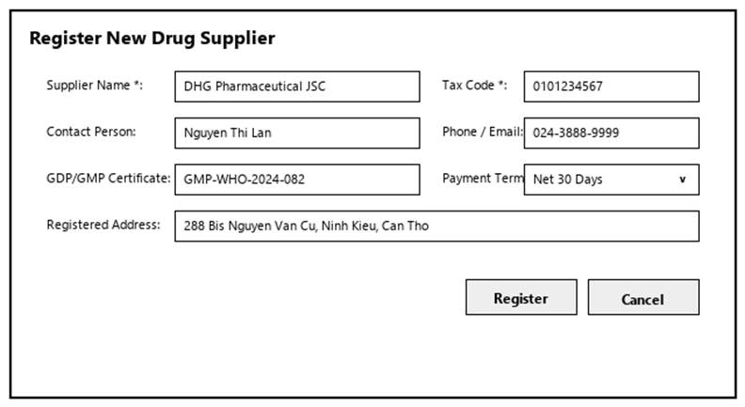
Figure 3-13-1: Screen Design of Create Supplier
3-12: Screen Definition
# | Field Name | Type | Mandatory | Max Length | Description
1 | Supplier Code | Text (read-only) |  | 20 | System-generated; cannot be edited.
2 | Supplier Name | Text | Yes | 150 | Registered name of the supplier.
3 | Tax Code | Text | Yes | 20 | Tax code of the supplier. Must be unique across all suppliers, including inactive ones.
4 | Contact Person | Text | Yes | 100 | Primary contact at the supplier.
5 | Phone | Text | Yes | 15 | Contact phone number. Must follow a valid phone format.
6 | Email | Text | Yes | 100 | Contact email. Must follow a valid email format and must not duplicate another supplier.
7 | Address | Text | Yes | 255 | Supplier address.
8 | Payment Terms | Dropdown | No |  | Default payment terms (e.g., Net 30).
9 | Product Categories/Catalog | Text / multi-select | No | 255 | Medicine categories the supplier can provide.
10 | Notes | Text | No | 500 | Additional remarks.
11 | Save | Button |  |  | Validates mandatory fields and formats, checks for duplicate Tax Code/Email, saves the supplier with status Active, writes the audit log, shows "Supplier created successfully", then opens Supplier Detail.
12 | Cancel | Button |  |  | Discards the entered data and returns to the Supplier List.

Use Case ID | UC57 | Use Case Name: Create Supplier
Author: QuangDN | Version: 1.0 | Date: 4/10/2026
Actor | Purchasing Staff
Description | Enables the Purchasing Staff to register a newly approved Drug Supplier into the system.
Precondition | PRE-01: User is logged in with the Purchasing Staff role.  PRE-02: The supplier has been approved by the company for cooperation.
Trigger | TRG-01: User clicks the "Add Supplier" button on the Supplier list.
Post-Condition | POS-01: A new supplier record is created with status Active.  POS-02: The action is recorded in the audit log.  POS-03: The new supplier appears in the supplier list and can be selected for RFQs.
Main flows
Step | Actor | Action
1 | Purchasing Staff | Clicks "Add Supplier" on the Supplier list.
2 | System | Displays the supplier registration form (Supplier Code auto-generated, Supplier Name, Tax Code, Contact Person, Phone, Email, Address, Payment Terms, Product Categories/Catalog, Notes).
3 | Purchasing Staff | Fills in the required information and clicks "Save".
4 | System | Validates mandatory fields and data formats.
5 | System | Checks that the Tax Code and Email are not already registered.
6 | System | Saves the supplier with status Active, writes the audit log, and displays "Supplier created successfully".
7 | System | Redirects to the supplier detail screen.
Alternative flows
AT1: At step 3 in the main flow, if the Purchasing Staff clicks the Cancel button:
Sub step | Actor | Action
3.1 | System | Discard the entered data and return to the Supplier List screen without saving.
Business Rules
# | Rule Description
BR-01 | Mandatory fields: Supplier Name, Tax Code, Contact Person, Phone, Email, Address. Email and phone must follow valid formats.
BR-02 | Tax Code must be unique across all suppliers (including inactive ones).

3.13.2 View Supplier Information
3.13.2.1 Screen Mock-up
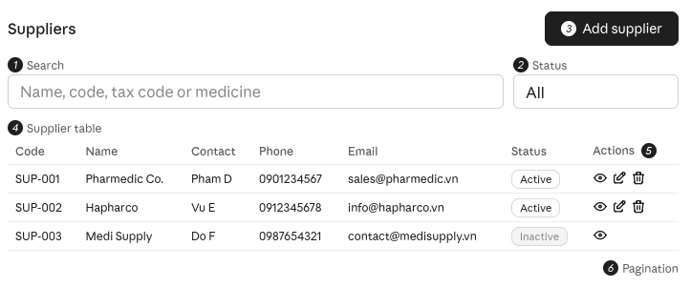Table 3-12: Screen Definition

# | Field Name | Type | Mandatory | Max Length | Description
1 | Search | Text | No | 100 | Searches by supplier name, code, tax code, or medicine catalog.
2 | Status | Dropdown | No |  | Filters the list by status (All, Active, Inactive).
3 | Add Supplier | Button |  |  | Opens the supplier registration form.
4 | Supplier Table | Grid |  |  | Lists suppliers (Supplier Code, Name, Contact Person, Phone, Email, Status). Inactive suppliers show an "Inactive" badge. Clicking a row opens Supplier Detail. Shows "No suppliers found." if no result.
5 | Actions | Icon buttons |  |  | View (Supplier Detail), Edit, Delete/Deactivate. Edit and Delete are available for Active suppliers only.
6 | Pagination | Control |  |  | Navigates pages of the supplier list.

Use Case ID | UC58 | Use Case Name: View Supplier Information
Author: QuangDN | Version: 1.0 | Date: 4/10/2026
Actor | Purchasing Staff
Description | Enables the Purchasing Staff to search and view the supplier directory, including contact details and registered pharmaceutical catalogs/distribution capabilities, and view in-depth profile information of a selected supplier.
Precondition | PRE-01: User is logged in with the Purchasing Staff role.
Trigger | TRG-01: User selects "Suppliers" from the main navigation menu.
Post-Condition | POS-01: Supplier list and/or selected supplier profile is displayed.  POS-02: No data is modified.
Main flows
Step | Actor | Action
1 | Purchasing Staff | Selects "Suppliers" from the navigation menu.
2 | System | Displays the paginated supplier list (Supplier Code, Name, Contact Person, Phone, Email, Status).
3 | Purchasing Staff | Searches by name/code/tax code/medicine catalog and/or filters by status.
4 | System | Applies the criteria and refreshes the list.
5 | Purchasing Staff | Click a supplier to view its profile.
6 | System | Displays supplier details: general information, contact details, payment terms, registered catalog/distribution capabilities, status, and history of RFQs/quotations/purchase orders.
Alternative flows
Sub step | Actor | Action
Business Rules
# | Rule Description
BR-01 | Inactive suppliers are shown with an "Inactive" badge and are excluded from selection in new RFQs, but remain viewable for history/audit.

3.13.3 Update Supplier Information
3.13.3.1 Screen Mock-up
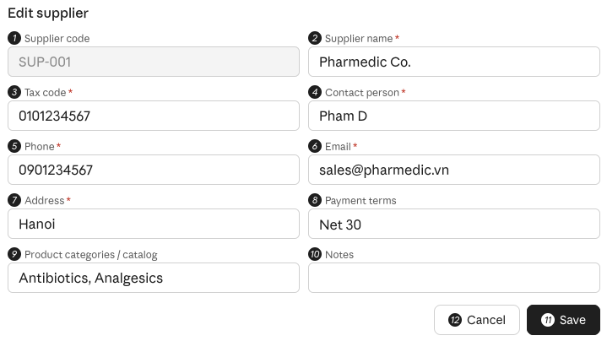
Table 3-13-4: Screen Definition

# | Field Name | Type | Mandatory | Max Length | Description
1 | Supplier Code | Text (read-only) |  | 20 | System-generated; cannot be edited.
2 | Supplier Name | Text | Yes | 150 | Pre-filled with the current name of the supplier.
3 | Tax Code | Text | Yes | 20 | Must remain unique across all suppliers; cannot conflict with another supplier.
4 | Contact Person | Text | Yes | 100 | Primary contact at the supplier.
5 | Phone | Text | Yes | 15 | Must follow a valid phone format.
6 | Email | Text | Yes | 100 | Must follow a valid email format and must not conflict with another supplier.
7 | Address | Text | Yes | 255 | Supplier address.
8 | Payment Terms | Dropdown | No |  | Payment terms (e.g., Net 30).
9 | Product Categories/Catalog | Text / multi-select | No | 255 | Medicine categories the supplier can provide.
10 | Notes | Text | No | 500 | Additional remarks.
11 | Save | Button |  |  | Validates mandatory fields and formats, checks Tax Code/Email conflicts, saves changes, writes old/new values to the audit log, and shows "Supplier updated successfully".
12 | Cancel | Button |  |  | Discards changes and returns to Supplier List.

Use Case ID | UC59 | Use Case Name: Update Supplier Information
Author: QuangDN | Version: 1.0 | Date: 4/10/2026
Actor | Purchasing Staff
Description | Allows the Purchasing Staff to modify and update existing supplier profile records.
Precondition | PRE-01: User is logged in with the Purchasing Staff role.  PRE-02: The supplier record exists.
Trigger | TRG-01: User clicks "Edit" on the supplier detail screen.
Post-Condition | POS-01: Supplier information is updated.  POS-02: The change (old/new values) is recorded in the audit log.
Main flows
Step | Actor | Action
1 | Purchasing Staff | Click "Edit" on the supplier detail screen.
2 | System | Displays the edit form pre-filled with current data (Supplier Code is read-only).
3 | Purchasing Staff | Modifies the information and clicks "Save".
4 | System | Validates mandatory fields and formats.
5 | System | Checks that the Tax Code/Email do not conflict with another supplier.
6 | System | Saves changes, writes the audit log, and displays "Supplier updated successfully".
Alternative flows
AT1: At step 3 in the main flow, if the Purchasing Staff clicks the Cancel button:
Sub step | Actor | Action
3.1 | System | Discard the entered data and return to the Supplier List screen without saving.
Business Rules
# | Rule Description
BR-01 | Supplier Code cannot be changed.
BR-02 | Tax Code must remain unique across suppliers.

3.13.4 Delete Supplier
3.13.4.1 Screen Mock-up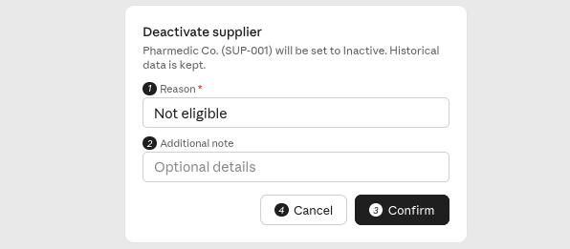
Figure 3-51: Screen Design of Purchase Request List

Table 3-11: Screen Definition

# | Field Name | Type | Mandatory | Max Length | Description
1 | Reason | Dropdown | Yes |  | Reason for deactivation: Not eligible / Blacklisted / Ceased operations / Other. Mandatory and recorded in the audit log.
2 | Supplier Name | Text | No | 255 | Extra details about the deactivation, recorded in the audit log.
3 | Confirm | Button | Yes |  | Sets the supplier status to Inactive (soft delete), removes the supplier from active selections, writes the audit log, shows "Supplier deactivated successfully", and refreshes the list.
4 | Cancel | Button | Yes |  | Closes the dialog; no change is made.

3.13.4.2 Use Case Description

Use Case ID | UC60 | Use Case Name: Delete Supplier
Author: QuangDN | Version: 1.0 | Date: 4/10/2026
Actor | Purchasing Staff
Description | Allows the Purchasing Staff to deactivate an existing vendor profile from the active supplier list if the supplier is no longer eligible, blacklisted, or ceased pharmaceutical operations.
Precondition | PRE-01: User is logged in with the Purchasing Staff role.  PRE-02: The supplier exists and is currently Active.
Trigger | TRG-01: User clicks "Delete/Deactivate" on the supplier list or detail screen.
Post-Condition | POS-01: Supplier status is set to Inactive (soft delete); historical data is preserved.  POS-02: The action and reason are recorded in the audit log.
Main flows
Step | Actor | Action
1 | Purchasing Staff | Clicks "Delete" on a supplier.
2 | System | Checks whether the supplier has open transactions (RFQs awaiting response, quotations in an unfinalized proposal, pending POs).
3 | System | Displays a confirmation modal asking for the reason (Not eligible / Blacklisted / Ceased operations / Other) with Confirm and Cancel buttons.
4 | Purchasing Staff | Selects/enters the reason and clicks Confirm.
5 | System | Sets the supplier status to Inactive, removes it from active supplier selections, and writes the audit log.
6 | System | Displays "Supplier deactivated successfully" and refreshes the list.
Alternative flows
AT1: At step 4 in the main flow, if the Purchasing Staff clicks the Cancel button:
Sub step | Actor | Action
4.1 | System | Discard the entered data and return to the Supplier List screen without saving.
Business Rules
# | Rule Description
BR-01 | A supplier with open RFQs, quotations in an unfinalized proposal, or pending purchase orders cannot be deactivated.
BR-02 | Deletion is a soft delete: historical RFQs, quotations, proposals, and receipts remain linked to the supplier.
BR-03 | A deactivation reason is mandatory and recorded in the audit log.

3.14 RFQ & Quotation Management

3.14.1 Send RFQ via Email to Supplier
3.14.1.1 Mock-up
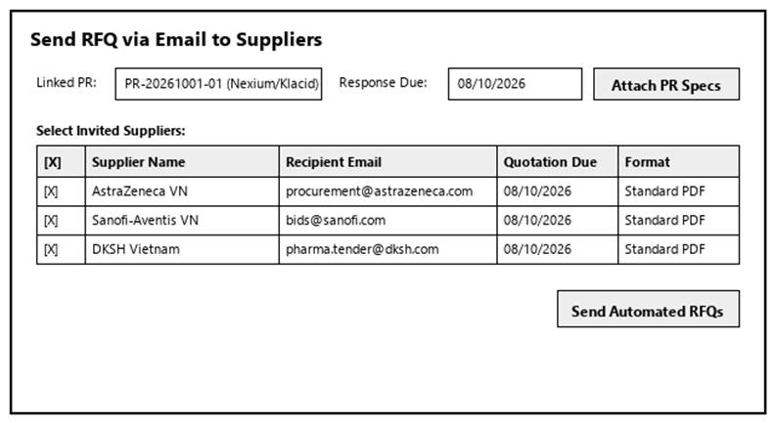
Figure 3-60: Screen Design of Send RFQ via Email to Supplier
Table 3-60: Screen Definition
# | Field Name | Type | Mandatory | Max Length | Description
1 | Search / Filter | Text / Dropdown | No | 50 | Search records by code, name, or keyword.
2 | Data Table / Form | Grid / Input | Yes | -- | Primary data table or input fields for Send RFQ via Email to Supplier.
3 | Action Buttons | Button | Yes | -- | Action buttons (Confirm / Submit / Save) to execute Send RFQ via Email to Supplier.
4 | Cancel / Reset | Button | No | -- | Cancels active modification and returns to previous view.

3.14.1.2 Use Case Description
Use Case ID |  | UC61 | Use Case Name |  | Send RFQ via Email to Supplier
Author |  | Group 5 | Version | 1.0 | Date | 04/10/2026
Actor |  | Purchasing Staff
Description |  | Allows the Purchasing Staff to generate a Request for Quotation for the required medicines from selected purchase requests and dispatch it via automated email to chosen suppliers.
Precondition |  | PRE-01: User is logged in as Purchasing Staff.  PRE-02: System registers and network services are operational.
Trigger |  | TRG-01: User navigates to 'Send RFQ via Email to Supplier' menu.
Post-Condition |  | POS-01: 'Send RFQ via Email to Supplier' completed successfully and transaction logged in database.  POS-02: System state updated and reflected across integrated modules.
Main flows
Step | Actor | Action
1 | Purchasing Staff | Access Send RFQ via Email to Supplier interface from main navigation menu.
2 | System | Display interface showing current data and controls for Send RFQ via Email to Supplier.
3 | Purchasing Staff | Enter required parameters / select items and click confirm.
4 | System | Validate operational inputs against business constraints.
5 | System | Commit transaction, record audit trail, and display success message.

Alternative flows
AT01 | Validation failure or missing fields (At Step 4)
Sub step | Actor | Action
4.1 | System | Display error alert highlighting invalid entries.
4.2 | System | Retain current form entries and prompt user to correct data.
AT02 | User cancels operation (At Step 3)
Sub step | Actor | Action
3.1 | System | Discard uncommitted changes and return to previous list screen.

Business Rules
# | Rule Description
BR-01 | All operations in 'Send RFQ via Email to Supplier' must be performed under an active, authorized user session.
BR-02 | Every modification or execution must generate an immutable audit log record with user ID and timestamp.
BR-03 | Data integrity and role-based access rules must be strictly validated prior to saving changes.

3.14.2 View RFQ and Supplier Response
3.14.2.1 Mock-up
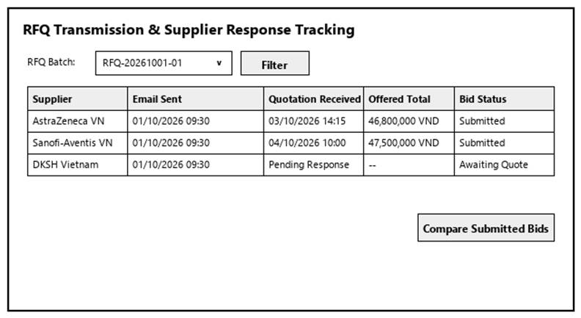
Figure 3-61: Screen Design of View RFQ and Supplier Response
Table 3-61: Screen Definition
# | Field Name | Type | Mandatory | Max Length | Description
1 | Search / Filter | Text / Dropdown | No | 50 | Search records by code, name, or keyword.
2 | Data Table / Form | Grid / Input | Yes | -- | Primary data table or input fields for View RFQ and Supplier Response.
3 | Action Buttons | Button | Yes | -- | Action buttons (Confirm / Submit / Save) to execute View RFQ and Supplier Response.
4 | Cancel / Reset | Button | No | -- | Cancels active modification and returns to previous view.

3.14.2.2 Use Case Description
Use Case ID |  | UC62 | Use Case Name |  | View RFQ and Supplier Response
Author |  | Group 5 | Version | 1.0 | Date | 04/10/2026
Actor |  | Purchasing Staff
Description |  | Enables the Purchasing Staff to monitor the transmission status of sent RFQs and access incoming responses from suppliers.
Precondition |  | PRE-01: User is logged in as Purchasing Staff.  PRE-02: System registers and network services are operational.
Trigger |  | TRG-01: User navigates to 'View RFQ and Supplier Response' menu.
Post-Condition |  | POS-01: 'View RFQ and Supplier Response' completed successfully and transaction logged in database.  POS-02: System state updated and reflected across integrated modules.
Main flows
Step | Actor | Action
1 | Purchasing Staff | Access View RFQ and Supplier Response interface from main navigation menu.
2 | System | Display interface showing current data and controls for View RFQ and Supplier Response.
3 | Purchasing Staff | Enter required parameters / select items and click confirm.
4 | System | Validate operational inputs against business constraints.
5 | System | Commit transaction, record audit trail, and display success message.

Alternative flows
AT01 | Validation failure or missing fields (At Step 4)
Sub step | Actor | Action
4.1 | System | Display error alert highlighting invalid entries.
4.2 | System | Retain current form entries and prompt user to correct data.
AT02 | User cancels operation (At Step 3)
Sub step | Actor | Action
3.1 | System | Discard uncommitted changes and return to previous list screen.

Business Rules
# | Rule Description
BR-01 | All operations in 'View RFQ and Supplier Response' must be performed under an active, authorized user session.
BR-02 | Every modification or execution must generate an immutable audit log record with user ID and timestamp.
BR-03 | Data integrity and role-based access rules must be strictly validated prior to saving changes.

3.14.3 Manage Supplier Quotation
3.14.3.1 Mock-up
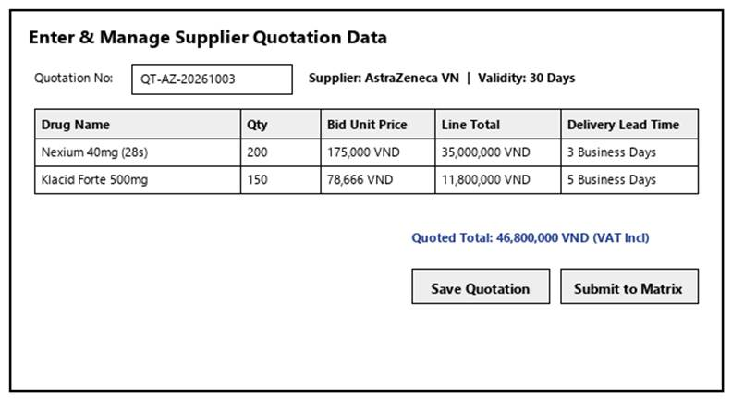
Figure 3-62: Screen Design of Manage Supplier Quotation
Table 3-62: Screen Definition
# | Field Name | Type | Mandatory | Max Length | Description
1 | Search / Filter | Text / Dropdown | No | 50 | Search records by code, name, or keyword.
2 | Data Table / Form | Grid / Input | Yes | -- | Primary data table or input fields for Manage Supplier Quotation.
3 | Action Buttons | Button | Yes | -- | Action buttons (Confirm / Submit / Save) to execute Manage Supplier Quotation.
4 | Cancel / Reset | Button | No | -- | Cancels active modification and returns to previous view.

3.14.3.2 Use Case Description
Use Case ID |  | UC63 | Use Case Name |  | Manage Supplier Quotation
Author |  | Group 5 | Version | 1.0 | Date | 04/10/2026
Actor |  | Purchasing Staff
Description |  | Allows the Purchasing Staff to enter structured quotation data received from suppliers, view the quotation list and itemized details, and update entries if errors are identified, provided the quotation has not yet been included in an approved or finalized Purchase Proposal.
Precondition |  | PRE-01: User is logged in as Purchasing Staff.  PRE-02: System registers and network services are operational.
Trigger |  | TRG-01: User navigates to 'Manage Supplier Quotation' menu.
Post-Condition |  | POS-01: 'Manage Supplier Quotation' completed successfully and transaction logged in database.  POS-02: System state updated and reflected across integrated modules.
Main flows
Step | Actor | Action
1 | Purchasing Staff | Access Manage Supplier Quotation interface from main navigation menu.
2 | System | Display interface showing current data and controls for Manage Supplier Quotation.
3 | Purchasing Staff | Enter required parameters / select items and click confirm.
4 | System | Validate operational inputs against business constraints.
5 | System | Commit transaction, record audit trail, and display success message.

Alternative flows
AT01 | Validation failure or missing fields (At Step 4)
Sub step | Actor | Action
4.1 | System | Display error alert highlighting invalid entries.
4.2 | System | Retain current form entries and prompt user to correct data.
AT02 | User cancels operation (At Step 3)
Sub step | Actor | Action
3.1 | System | Discard uncommitted changes and return to previous list screen.

Business Rules
# | Rule Description
BR-01 | All operations in 'Manage Supplier Quotation' must be performed under an active, authorized user session.
BR-02 | Every modification or execution must generate an immutable audit log record with user ID and timestamp.
BR-03 | Data integrity and role-based access rules must be strictly validated prior to saving changes.

3.14.4 Compare Supplier Quotations
3.14.4.1 Mock-up
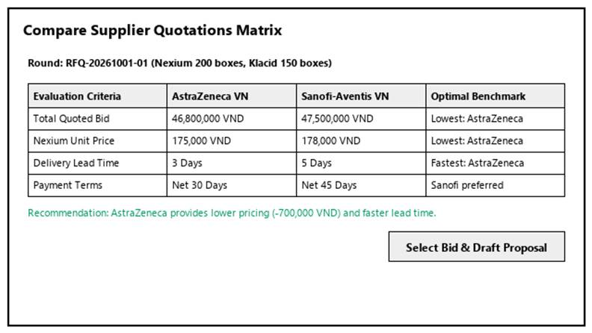
Figure 3-63: Screen Design of Compare Supplier Quotations
Table 3-63: Screen Definition
# | Field Name | Type | Mandatory | Max Length | Description
1 | Search / Filter | Text / Dropdown | No | 50 | Search records by code, name, or keyword.
2 | Data Table / Form | Grid / Input | Yes | -- | Primary data table or input fields for Compare Supplier Quotations.
3 | Action Buttons | Button | Yes | -- | Action buttons (Confirm / Submit / Save) to execute Compare Supplier Quotations.
4 | Cancel / Reset | Button | No | -- | Cancels active modification and returns to previous view.

3.14.4.2 Use Case Description
Use Case ID |  | UC64 | Use Case Name |  | Compare Supplier Quotations
Author |  | Group 5 | Version | 1.0 | Date | 04/10/2026
Actor |  | Purchasing Staff
Description |  | Provides a side-by-side comparative matrix of valid supplier quotations within the same RFQ round.
Precondition |  | PRE-01: User is logged in as Purchasing Staff.  PRE-02: System registers and network services are operational.
Trigger |  | TRG-01: User navigates to 'Compare Supplier Quotations' menu.
Post-Condition |  | POS-01: 'Compare Supplier Quotations' completed successfully and transaction logged in database.  POS-02: System state updated and reflected across integrated modules.
Main flows
Step | Actor | Action
1 | Purchasing Staff | Access Compare Supplier Quotations interface from main navigation menu.
2 | System | Display interface showing current data and controls for Compare Supplier Quotations.
3 | Purchasing Staff | Enter required parameters / select items and click confirm.
4 | System | Validate operational inputs against business constraints.
5 | System | Commit transaction, record audit trail, and display success message.

Alternative flows
AT01 | Validation failure or missing fields (At Step 4)
Sub step | Actor | Action
4.1 | System | Display error alert highlighting invalid entries.
4.2 | System | Retain current form entries and prompt user to correct data.
AT02 | User cancels operation (At Step 3)
Sub step | Actor | Action
3.1 | System | Discard uncommitted changes and return to previous list screen.

Business Rules
# | Rule Description
BR-01 | All operations in 'Compare Supplier Quotations' must be performed under an active, authorized user session.
BR-02 | Every modification or execution must generate an immutable audit log record with user ID and timestamp.
BR-03 | Data integrity and role-based access rules must be strictly validated prior to saving changes.

3.15 Purchase Proposal Management

3.15.1 Create Purchase Proposal
3.15.1.1 Mock-up
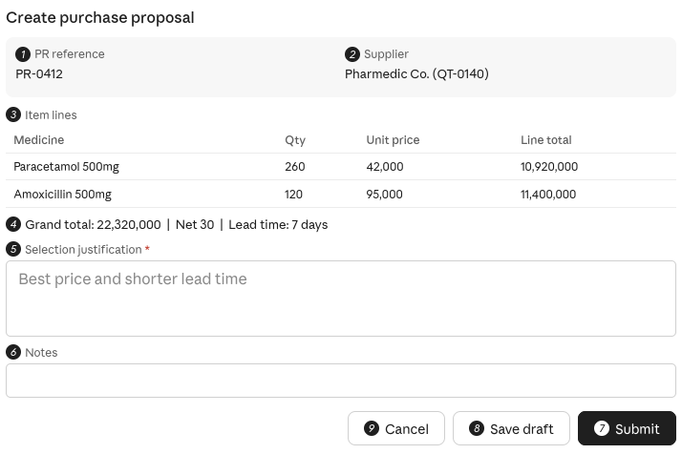
Figure 3-64: Screen Design of Create Purchase Proposal

Table 3-64: Screen Definition

# | Field Name | Type | Mandatory | Max Length | Description
1 | PR Reference | Label |  |  | Linked approved Purchase Request, auto-filled.
2 | Supplier / Quotation | Label |  |  | Supplier and quotation selected auto-filled. The quotation must not be expired or already used in another proposal.
3 | Item Lines | Grid |  |  | Auto-filled: Medicine, Quantity, Unit Price, Line Total. The proposal must cover items from the linked PR, and quantities cannot exceed the approved PR quantities.
4 | Totals and Terms | Label group |  |  | Auto-filled: Grand Total, Payment Terms, Lead Time.
5 | Selection Justification | Text area | Yes |  | Reason for choosing this quotation (e.g., best price, shorter lead time). *Mandatory when the selected quotation is not the lowest-priced one.
6 | Notes | Text | No |  | Optional remarks.
7 | Submit | Button |  |  | Validates the data, generates the Proposal Code, saves with status Submitted, locks the linked quotation against edits, notifies the General Manager, updates the PR sourcing status, and shows "Purchase proposal submitted successfully".
8 | Save Draft | Button |  |  | Saves the proposal with status Draft; the quotation remains editable until submission.
9 | Cancel | Button |  |  | Discards the input and returns to the comparison screen.

3.15.1.2 Use Case Description

Use Case ID | UC65 | Use Case Name: Create Purchase Proposal
Author: QuangDN | Version: 1.0 | Date: 4/10/2026
Actor | Purchasing Staff
Description | Allows the Purchasing Staff to generate a formal Purchase Proposal by linking the initial Purchase Request with the selected optimal supplier quotation.
Precondition | PRE-01: User is logged in with the Purchasing Staff role.  PRE-02: An approved Purchase Request and a valid supplier quotation exist for the same RFQ round.  PRE-03: The selected quotation is not expired and not yet used in another proposal.
Trigger | TRG-01: User clicks "Create Purchase Proposal" from the comparison screen or from the Purchase Proposal list.
Post-Condition | POS-01: A Purchase Proposal is created and linked to the PR and the selected quotation.  POS-02: The proposal is submitted for General Manager review  POS-03: The action is recorded in the audit log.
Main flows
Step | Actor | Action
1 | Purchasing Staff | Clicks "Create Purchase Proposal" with a selected quotation.
2 | System | Auto-fills the proposal: PR reference, supplier information, item lines (Medicine, Quantity, Unit Price, Line Total), Grand Total, Payment Terms, Lead Time.
3 | Purchasing Staff | Reviews the data and enters the selection justification (e.g., best price, shorter lead time) and optional notes.
4 | System | Validates the data.
5 | Purchasing Staff | Clicks "Submit".
6 | System | Generates the Proposal Code, saves the proposal with status Submitted, locks the linked quotation against edits (BR-03), and notifies the General Manager.
7 | System | Updates the PR sourcing status and displays "Purchase proposal submitted successfully".
Alternative flows
AT1: At step 5 in the main flow, if the Purchasing Staff clicks the Cancel button:
Sub step | Actor | Action
5.1 | System | Discard the entered data and return to the Purchase Proposal List screen without saving.
Business Rules
# | Rule Description
BR-01 | A justification is mandatory when the selected quotation is not the lowest-priced one.
BR-02 | The proposal must cover items from the linked PR; quantities cannot exceed the approved PR quantities.
BR-03 | Once a proposal is submitted/approved, the linked quotation can no longer be edited.

3.15.2 View Purchase Proposal
3.15.2.1 Mock-up

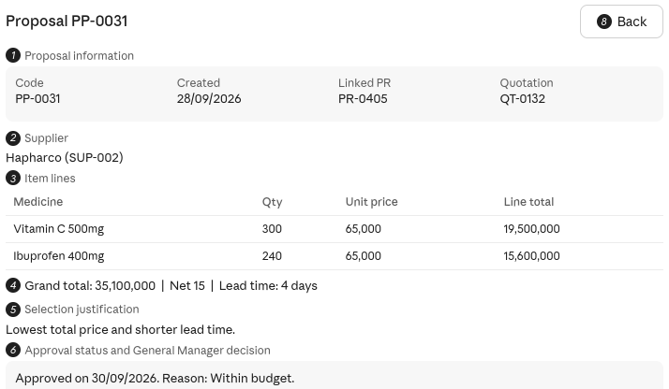
Figure 3-65: Screen Design of View Purchase Proposal
Table 3-64: Screen Definition

# | Field Name | Type | Mandatory | Max Length | Description
1 | Proposal Information | Label group |  |  | Read-only: Proposal Code, Created Date, Linked PR, Selected Quotation.
2 | Supplier | Label |  |  | Supplier of the selected quotation.
3 | Item Lines | Grid |  |  | Read-only: Medicine, Quantity, Unit Price, Line Total.
4 | Totals and Terms | Label group |  |  | Read-only: Grand Total, Payment Terms, Lead Time.
5 | Selection Justification | Label |  |  | Justification entered when the proposal was created.
6 | Approval Status and Decision | Label group |  |  | Approval status and the General Manager's decision/reason, if any.
7 | Back | Button |  |  | Returns to the Purchase Proposal List.

3.15.1.2 Use Case Description

Use Case ID | UC66 | Use Case Name: View Purchase Proposal
Author: QuangDN | Version: 1.0 | Date: 4/10/2026
Actor | Purchasing Staff
Description | View Purchase Proposal Enables the Purchasing Staff to view the list of submitted Purchase Proposals and review the contents of a selected proposal in read-only mode.
Precondition | PRE-01: User is logged in with the Purchasing Staff role. PRE-02: At least one approved Purchase Request exists in the system (otherwise an empty list is shown).
Trigger | TRG-01: User selects "Purchase Proposals" from the main navigation menu.
Post-Condition | POS-01: Proposal list and/or selected proposal detail is displayed in read-only mode.  POS-02: No data is modified.
Main flows
Step | Actor | Action
1 | Purchasing Staff | Selects "Purchase Proposals" from the navigation menu.
2 | System | Displays the paginated proposal list (Proposal Code, Related PR, Supplier, Grand Total, Created Date, Status).
3 | Purchasing Staff | Searches/filters by code, supplier, date range, or status.
4 | System | Applies the criteria and refreshes the list.
5 | Purchasing Staff | Click a proposal to view its details.
6 | System | Displays the read-only detail: linked PR, selected quotation, supplier, item lines, totals, justification, approval status and General Manager decision/reason (if any).
Alternative flows
AT1: At step 3 in the main flow, if the administrator clicks the Cancel button:
Sub step | Actor | Action
3.1 | System | Discard the entered data and return to the Category List screen without saving.
Business Rules
# | Rule Description
BR-01 | Purchase Proposal detail is read-only in this use case

3.15.3 View Purchase Order List
3.15.3.1 Mock-up
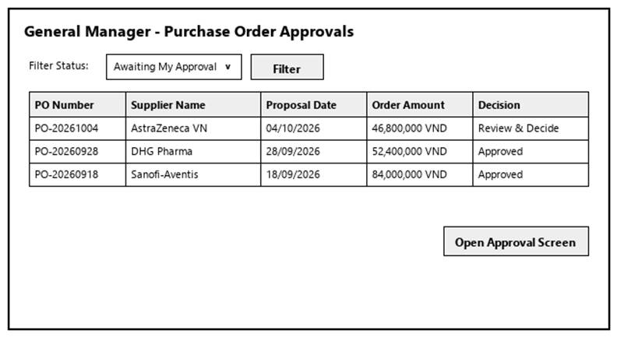
Figure 3-66: Screen Design of View Purchase Order List
Table 3-66: Screen Definition
# | Field Name | Type | Mandatory | Max Length | Description
1 | Search / Filter | Text / Dropdown | No | 50 | Search records by code, name, or keyword.
2 | Data Table / Form | Grid / Input | Yes | -- | Primary data table or input fields for View Purchase Order List.
3 | Action Buttons | Button | Yes | -- | Action buttons (Confirm / Submit / Save) to execute View Purchase Order List.
4 | Cancel / Reset | Button | No | -- | Cancels active modification and returns to previous view.

3.15.3.2 Use Case Description
Use Case ID |  | UC67 | Use Case Name |  | View Purchase Order List
Author |  | DangPT | Version | 1.0 | Date | 04/10/2026
Actor |  | General Manager
Description |  | Allows the General Manager to view incoming purchase orders requiring approval.
Precondition |  | PRE-01: User is logged in as General Manager.  PRE-02: System registers and network services are operational.
Trigger |  | TRG-01: User navigates to 'View Purchase Order List' menu.
Post-Condition |  | POS-01: 'View Purchase Order List' completed successfully and transaction logged in database.  POS-02: System state updated and reflected across integrated modules.
Main flows
Step | Actor | Action
1 | General Manager | Access View Purchase Order List interface from main navigation menu.
2 | System | Display interface showing current data and controls for View Purchase Order List.
3 | General Manager | Enter required parameters / select items and click confirm.
4 | System | Validate operational inputs against business constraints.
5 | System | Commit transaction, record audit trail, and display success message.

Alternative flows
AT01 | Validation failure or missing fields (At Step 4)
Sub step | Actor | Action
4.1 | System | Display error alert highlighting invalid entries.
4.2 | System | Retain current form entries and prompt user to correct data.
AT02 | User cancels operation (At Step 3)
Sub step | Actor | Action
3.1 | System | Discard uncommitted changes and return to previous list screen.

Business Rules
# | Rule Description
BR-01 | All operations in 'View Purchase Order List' must be performed under an active, authorized user session.
BR-02 | Every modification or execution must generate an immutable audit log record with user ID and timestamp.
BR-03 | Data integrity and role-based access rules must be strictly validated prior to saving changes.

3.15.4 Approve Purchase Order
3.15.4.1 Mock-up
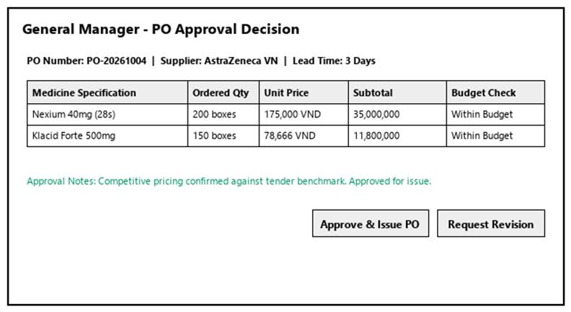
Figure 3-67: Screen Design of Approve Purchase Order
Table 3-67: Screen Definition
# | Field Name | Type | Mandatory | Max Length | Description
1 | Search / Filter | Text / Dropdown | No | 50 | Search records by code, name, or keyword.
2 | Data Table / Form | Grid / Input | Yes | -- | Primary data table or input fields for Approve Purchase Order.
3 | Action Buttons | Button | Yes | -- | Action buttons (Confirm / Submit / Save) to execute Approve Purchase Order.
4 | Cancel / Reset | Button | No | -- | Cancels active modification and returns to previous view.

3.15.4.2 Use Case Description
Use Case ID |  | UC68 | Use Case Name |  | Approve Purchase Order
Author |  | DangPT | Version | 1.0 | Date | 04/10/2026
Actor |  | General Manager
Description |  | Allows the General Manager to approve a submitted purchase order.
Precondition |  | PRE-01: User is logged in as General Manager.  PRE-02: System registers and network services are operational.
Trigger |  | TRG-01: User navigates to 'Approve Purchase Order' menu.
Post-Condition |  | POS-01: 'Approve Purchase Order' completed successfully and transaction logged in database.  POS-02: System state updated and reflected across integrated modules.
Main flows
Step | Actor | Action
1 | General Manager | Access Approve Purchase Order interface from main navigation menu.
2 | System | Display interface showing current data and controls for Approve Purchase Order.
3 | General Manager | Enter required parameters / select items and click confirm.
4 | System | Validate operational inputs against business constraints.
5 | System | Commit transaction, record audit trail, and display success message.

Alternative flows
AT01 | Validation failure or missing fields (At Step 4)
Sub step | Actor | Action
4.1 | System | Display error alert highlighting invalid entries.
4.2 | System | Retain current form entries and prompt user to correct data.
AT02 | User cancels operation (At Step 3)
Sub step | Actor | Action
3.1 | System | Discard uncommitted changes and return to previous list screen.

Business Rules
# | Rule Description
BR-01 | All operations in 'Approve Purchase Order' must be performed under an active, authorized user session.
BR-02 | Every modification or execution must generate an immutable audit log record with user ID and timestamp.
BR-03 | Data integrity and role-based access rules must be strictly validated prior to saving changes.

3.15.5 Reject Purchase Order
3.15.5.1 Mock-up
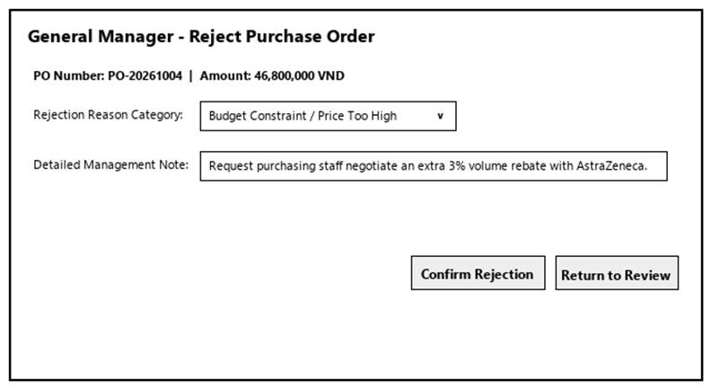
Figure 3-68: Screen Design of Reject Purchase Order
Table 3-68: Screen Definition
# | Field Name | Type | Mandatory | Max Length | Description
1 | Search / Filter | Text / Dropdown | No | 50 | Search records by code, name, or keyword.
2 | Data Table / Form | Grid / Input | Yes | -- | Primary data table or input fields for Reject Purchase Order.
3 | Action Buttons | Button | Yes | -- | Action buttons (Confirm / Submit / Save) to execute Reject Purchase Order.
4 | Cancel / Reset | Button | No | -- | Cancels active modification and returns to previous view.

3.15.5.2 Use Case Description
Use Case ID |  | UC69 | Use Case Name |  | Reject Purchase Order
Author |  | DangPT | Version | 1.0 | Date | 04/10/2026
Actor |  | General Manager
Description |  | Allows the General Manager to reject a purchase order with reasons.
Precondition |  | PRE-01: User is logged in as General Manager.  PRE-02: System registers and network services are operational.
Trigger |  | TRG-01: User navigates to 'Reject Purchase Order' menu.
Post-Condition |  | POS-01: 'Reject Purchase Order' completed successfully and transaction logged in database.  POS-02: System state updated and reflected across integrated modules.
Main flows
Step | Actor | Action
1 | General Manager | Access Reject Purchase Order interface from main navigation menu.
2 | System | Display interface showing current data and controls for Reject Purchase Order.
3 | General Manager | Enter required parameters / select items and click confirm.
4 | System | Validate operational inputs against business constraints.
5 | System | Commit transaction, record audit trail, and display success message.

Alternative flows
AT01 | Validation failure or missing fields (At Step 4)
Sub step | Actor | Action
4.1 | System | Display error alert highlighting invalid entries.
4.2 | System | Retain current form entries and prompt user to correct data.
AT02 | User cancels operation (At Step 3)
Sub step | Actor | Action
3.1 | System | Discard uncommitted changes and return to previous list screen.

Business Rules
# | Rule Description
BR-01 | All operations in 'Reject Purchase Order' must be performed under an active, authorized user session.
BR-02 | Every modification or execution must generate an immutable audit log record with user ID and timestamp.
BR-03 | Data integrity and role-based access rules must be strictly validated prior to saving changes.

3.16 Reporting

3.16.1 View Profit Report
3.16.1.1 Mock-up
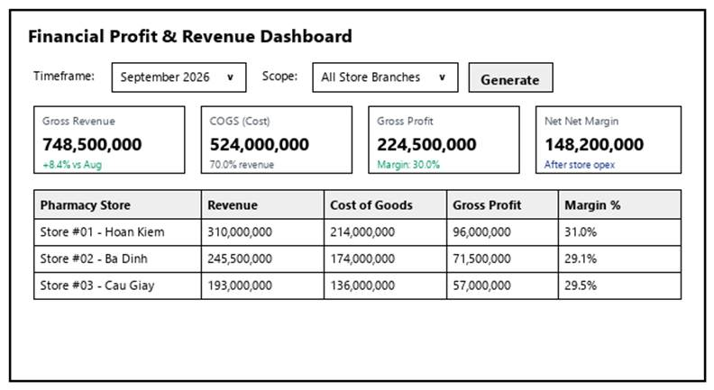
Figure 3-69: Screen Design of View Profit Report
Table 3-69: Screen Definition
# | Field Name | Type | Mandatory | Max Length | Description
1 | Search / Filter | Text / Dropdown | No | 50 | Search records by code, name, or keyword.
2 | Data Table / Form | Grid / Input | Yes | -- | Primary data table or input fields for View Profit Report.
3 | Action Buttons | Button | Yes | -- | Action buttons (Confirm / Submit / Save) to execute View Profit Report.
4 | Cancel / Reset | Button | No | -- | Cancels active modification and returns to previous view.

3.16.1.2 Use Case Description
Use Case ID |  | UC70 | Use Case Name |  | View Profit Report
Author |  | DangPT | Version | 1.0 | Date | 04/10/2026
Actor |  | General Manager
Description |  | Allows the General Manager to view detailed financial profit, revenue, and margin reports.
Precondition |  | PRE-01: User is logged in as General Manager.  PRE-02: System registers and network services are operational.
Trigger |  | TRG-01: User navigates to 'View Profit Report' menu.
Post-Condition |  | POS-01: 'View Profit Report' completed successfully and transaction logged in database.  POS-02: System state updated and reflected across integrated modules.
Main flows
Step | Actor | Action
1 | General Manager | Access View Profit Report interface from main navigation menu.
2 | System | Display interface showing current data and controls for View Profit Report.
3 | General Manager | Enter required parameters / select items and click confirm.
4 | System | Validate operational inputs against business constraints.
5 | System | Commit transaction, record audit trail, and display success message.

Alternative flows
AT01 | Validation failure or missing fields (At Step 4)
Sub step | Actor | Action
4.1 | System | Display error alert highlighting invalid entries.
4.2 | System | Retain current form entries and prompt user to correct data.
AT02 | User cancels operation (At Step 3)
Sub step | Actor | Action
3.1 | System | Discard uncommitted changes and return to previous list screen.

Business Rules
# | Rule Description
BR-01 | All operations in 'View Profit Report' must be performed under an active, authorized user session.
BR-02 | Every modification or execution must generate an immutable audit log record with user ID and timestamp.
BR-03 | Data integrity and role-based access rules must be strictly validated prior to saving changes.

3.16.2 View Inventory Report
3.16.2.1 Mock-up
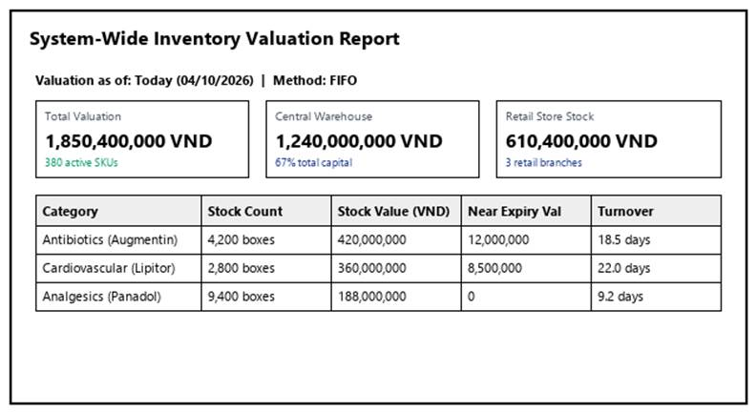
Figure 3-70: Screen Design of View Inventory Report
Table 3-70: Screen Definition
# | Field Name | Type | Mandatory | Max Length | Description
1 | Search / Filter | Text / Dropdown | No | 50 | Search records by code, name, or keyword.
2 | Data Table / Form | Grid / Input | Yes | -- | Primary data table or input fields for View Inventory Report.
3 | Action Buttons | Button | Yes | -- | Action buttons (Confirm / Submit / Save) to execute View Inventory Report.
4 | Cancel / Reset | Button | No | -- | Cancels active modification and returns to previous view.

3.16.2.2 Use Case Description
Use Case ID |  | UC71 | Use Case Name |  | View Inventory Report
Author |  | DangPT | Version | 1.0 | Date | 04/10/2026
Actor |  | General Manager
Description |  | Allows the General Manager to view current stock levels, inventory valuation, and stock movement reports.
Precondition |  | PRE-01: User is logged in as General Manager.  PRE-02: System registers and network services are operational.
Trigger |  | TRG-01: User navigates to 'View Inventory Report' menu.
Post-Condition |  | POS-01: 'View Inventory Report' completed successfully and transaction logged in database.  POS-02: System state updated and reflected across integrated modules.
Main flows
Step | Actor | Action
1 | General Manager | Access View Inventory Report interface from main navigation menu.
2 | System | Display interface showing current data and controls for View Inventory Report.
3 | General Manager | Enter required parameters / select items and click confirm.
4 | System | Validate operational inputs against business constraints.
5 | System | Commit transaction, record audit trail, and display success message.

Alternative flows
AT01 | Validation failure or missing fields (At Step 4)
Sub step | Actor | Action
4.1 | System | Display error alert highlighting invalid entries.
4.2 | System | Retain current form entries and prompt user to correct data.
AT02 | User cancels operation (At Step 3)
Sub step | Actor | Action
3.1 | System | Discard uncommitted changes and return to previous list screen.

Business Rules
# | Rule Description
BR-01 | All operations in 'View Inventory Report' must be performed under an active, authorized user session.
BR-02 | Every modification or execution must generate an immutable audit log record with user ID and timestamp.
BR-03 | Data integrity and role-based access rules must be strictly validated prior to saving changes.

3.16.3 Export Report
3.16.3.1 Mock-up
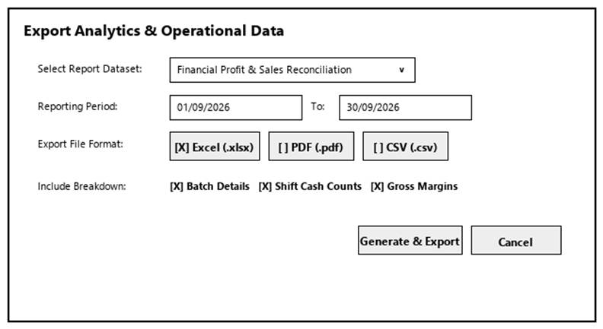
Figure 3-71: Screen Design of Export Report
Table 3-71: Screen Definition
# | Field Name | Type | Mandatory | Max Length | Description
1 | Search / Filter | Text / Dropdown | No | 50 | Search records by code, name, or keyword.
2 | Data Table / Form | Grid / Input | Yes | -- | Primary data table or input fields for Export Report.
3 | Action Buttons | Button | Yes | -- | Action buttons (Confirm / Submit / Save) to execute Export Report.
4 | Cancel / Reset | Button | No | -- | Cancels active modification and returns to previous view.

3.16.3.2 Use Case Description
Use Case ID |  | UC72 | Use Case Name |  | Export Report
Author |  | DangPT | Version | 1.0 | Date | 04/10/2026
Actor |  | General Manager
Description |  | Allows the General Manager to export generated reports and data into external file formats (e.g., Excel, PDF, CSV).
Precondition |  | PRE-01: User is logged in as General Manager.  PRE-02: System registers and network services are operational.
Trigger |  | TRG-01: User navigates to 'Export Report' menu.
Post-Condition |  | POS-01: 'Export Report' completed successfully and transaction logged in database.  POS-02: System state updated and reflected across integrated modules.
Main flows
Step | Actor | Action
1 | General Manager | Access Export Report interface from main navigation menu.
2 | System | Display interface showing current data and controls for Export Report.
3 | General Manager | Enter required parameters / select items and click confirm.
4 | System | Validate operational inputs against business constraints.
5 | System | Commit transaction, record audit trail, and display success message.

Alternative flows
AT01 | Validation failure or missing fields (At Step 4)
Sub step | Actor | Action
4.1 | System | Display error alert highlighting invalid entries.
4.2 | System | Retain current form entries and prompt user to correct data.
AT02 | User cancels operation (At Step 3)
Sub step | Actor | Action
3.1 | System | Discard uncommitted changes and return to previous list screen.

Business Rules
# | Rule Description
BR-01 | All operations in 'Export Report' must be performed under an active, authorized user session.
BR-02 | Every modification or execution must generate an immutable audit log record with user ID and timestamp.
BR-03 | Data integrity and role-based access rules must be strictly validated prior to saving changes.

4. Non-Functional Requirements

4.1 External Interfaces

4.1.1 User Interfaces (UI)
ID | Interface Requirement | Description
UI-01 | Responsive Web Interface | The web application shall be fully responsive across desktop resolutions (1920 × 1080 to 1366 × 768) for internal staff and mobile viewports (minimum width 375px).
UI-02 | Initial Page Rendering | Initial page render (First Contentful Paint - FCP) for public interfaces shall complete within 1.5 seconds over standard 4G connections.
UI-03 | Client-side Validation | All client-side form validation errors shall be displayed within 100 ms of user input.

4.1.2 Hardware Interfaces
ID | Hardware Interface | Description
HW-01 | Thermal Barcode & Label Printers | Supports industrial thermal transfer barcode label printers (Zebra, TSC - 203/300 DPI) via LAN or USB to print bin location labels, medicine batch identification stickers, and store dispatch shipping labels with QR tracking codes.

4.1.3 Software Interfaces
ID | Software Interface | Description
SW-01 | Database Interface | The system shall interface with MySQL 8.0 using a relational database architecture with ACID compliance, supporting batch tracking and row-level locking for inventory allocation.

4.1.4 Communication Interfaces
ID | Communication Interface | Description
COM-01 | Encrypted Transport Protocol (HTTPS / TLS 1.3) | 100% of data transferred between warehouse client devices, store terminals, and backend servers must be encrypted using TLS 1.3 with SHA-256 cipher suites to protect proprietary supplier costs and stock records.
COM-02 | Data Interchange Standard (UTF-8 JSON) | All API payloads for purchase requests, receipts, dispatch manifests, and inventory queries shall use UTF-8 encoded standard JSON format.

4.2 Quality Attributes

4.2.1 Usability
ID | Quality Attribute | Description
USA-01 | Staff Training Time | • Warehouse Staff: A new warehouse staff member with basic digital literacy shall master goods receiving, barcode scanning, bin put-away, and pick-and-pack workflows within 2 to 3 hours of guided training.  • Warehouse Manager: Shall learn purchase request generation, store replenishment quota approval, stocktake audit reconciliation, and expiry reporting within 3 to 4 hours.
USA-02 | Receiving Workflow Efficiency | Creating and logging a purchase receipt against a standard 10-line approved PO via barcode scanning: <= 90 seconds.
USA-03 | Store Dispatch Confirmation Speed | Completing pick verification and confirming a 15-item store replenishment dispatch: <= 60 seconds.
USA-04 | Low-Stock Item Identification Speed | Locating and filtering items below the 20-unit safety threshold via filtered view: <= 2 seconds.
USA-05 | Critical Action Safeguards & Error Prevention | Explicit confirmation modals with audit reason requirements before executing irreversible actions: Rejecting Store Replenishment Request, Cancelling Purchase Receipt, or Submitting Stock Discrepancy Adjustments.

4.2.2 Reliability
ID | Quality Attribute | Description
REL-01 | Operational Availability | The warehouse subsystem shall maintain 99.5% operational uptime during warehouse operating hours (06:00 to 22:00, 7 days/week). Scheduled maintenance windows are restricted to 00:00 - 04:00 AM off-peak hours.
REL-02 | Strict ACID Inventory Transactions | All central warehouse stock mutations (Inbound receipt increment, Store dispatch decrement, Audit variance correction) must be strictly atomic. Zero phantom stock or partially committed inventory writes allowed.
REL-03 | Offline Scanner Tolerance & Sync | If Wi-Fi connection drops in deep warehouse aisles during picking or physical count, handheld devices shall cache scans locally and automatically synchronize upon reconnecting without data duplication.
REL-04 | Disaster Recovery & Data Backup | Automated daily incremental backups and weekly full backups of inventory ledgers and lot traceability tables, with Recovery Time Objective (RTO) <= 30 minutes and Recovery Point Objective (RPO) <= 5 minutes.

4.2.3 Performance
ID | Quality Attribute | Description
PERF-01 | Real-Time Stock Query Latency | Querying real-time stock balances across all product categories or checking item availability during store replenishment review: Average latency < 0.8 s, Maximum latency < 1.5 s.
PERF-02 | Barcode Scanning Response Time | Scanning a product barcode or bin tag to validate against an order line: Average response time < 300 ms.
PERF-03 | Purchase Receipt Confirmation Latency | Processing receipt confirmation, updating PO remaining quantities, and committing batch lots to warehouse inventory: Average latency < 1.0 s, Maximum latency < 2.0 s.
PERF-04 | Goods Dispatch Commit Latency | Deducting central stock balances and generating in-transit manifest for store delivery: Average latency < 1.0 s, Maximum latency < 2.0 s.
PERF-05 | Nightly Alert Cron Job Throughput | Automated background evaluation of 50,000 SKUs for safety stock (< 20 units) and near-expiry grouping (< 6 months) must complete within 3 minutes.
PERF-06 | Concurrent Warehouse Throughput | System shall support at least 20 concurrent warehouse staff and 15 simultaneous store replenishment requests without latency degradation.
PERF-07 | Database Capacity & Scaling | The database architecture shall handle up to 100,000 active medicine SKUs, 500,000 unique batch lot records, and 1,000,000 historical transaction logs with sub-second index search performance.

5. Requirement Appendix

5.1 Business Rules
ID | Rule Definition
BR-01 | Prescription medicines (Rx) require a valid doctor's prescription code to dispense.
BR-02 | Medicine sales must strictly follow FEFO (First Expired, First Out).
BR-03 | Imported medicine batches must have an expiry date at least 6 months after receipt.
BR-04 | Expired medicine batches are automatically locked from sale at POS.
BR-05 | Inventory stock is deducted only after payment is fully completed.
BR-06 | Returned medicines are accepted only within 24 hours with an original receipt.
BR-07 | Shift cash discrepancies over 50,000 VND require an explanatory note from the cashier.
BR-08 | Stock adjustments with variance over 5,000,000 VND require Store Manager approval.
BR-09 | Confirmed purchase receipts cannot be edited or deleted.
BR-10 | Medicine retail prices are set centrally and synchronized across all branches.

5.2 Common Requirements

5.3 Application Messages List
# | Message code | Message Type | Context | Content
1 | MSG01 | In line | No search results found | No search results.
2 | MSG02 | In red, under input | Required field is empty | The * field is required.
3 | MSG03 | Toast message | Update successful | Updated successfully.
4 | MSG04 | Toast message | Add new record successful | Added successfully.
5 | MSG05 | Toast message | Delete record successful | Deleted successfully.
6 | MSG06 | In red, under input | Input length exceeds limit | Exceed max length of {max_length}.
7 | MSG07 | In line | Invalid login credentials | Incorrect username or password. Please check again.
8 | MSG08 | In red, under input | Value is negative or zero | Value must be greater than 0.
9 | MSG09 | Modal dialog | Item out of stock | Insufficient stock. Only {qty} left.
10 | MSG10 | Modal dialog | Batch has expired | Batch {batch_no} is expired. Cannot sell.

5.4 Other Requirements

