Design for class “BaseController”
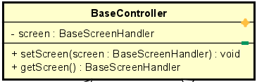
Table 1. Attribute Design
# | Name | Data type | Default value | Description
1 | screen | BaseScreenHandler | null | The boundary (UI) screen associated with this controller.

Table 2. Operation Design
# | Name | Return type | Description
1 | setScreen(screen) | void | Assign the UI screen that this controller manages.
2 | getScreen() | BaseScreenHandler | Return the currently assigned screen.

Method Design:
- setScreen
- Parameter:
  - screen: BaseScreenHandler - the UI screen that this controller will manage.

- Exception:

- Method:
  - Assign the provided screen to the internal attribute.
  - Ensure the UI can request controller actions through this reference.
- getScreen
- Parameter:

- Exception:

- Method:
  - Return the screen currently associated with this controller.

