Design for class “Cart”
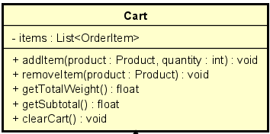
Table 1. Attribute Design
# | Name | Data type | Default value | Description
1 | items | List | empty list | The collection of order items currently in the cart

Table 2. Operation Design
# | Name | Return type | Description / Purpose
1 | addItem(product, quantity) | void | Add a product with specified quantity to the cart
2 | removeItem(productId) | void | Remove an item from the cart using its product ID
3 | updateQuantity(productId, qty) | void | Update the quantity of an item in the cart
4 | getItems() | Collection | Return all items currently in the cart

Method Design:
- addItem
- Parameter:
  - product: Product - the product to be added
  - quantity: int - the number of units to add

- Exception:

- Method:
  - Check if an OrderItem with the same product already exists.
  - If yes, increase its quantity by the input amount.
  - Otherwise, create a new OrderItem and add it to items.
  - No value is returned.
- removeItem
- Parameter:
  - productId: String - the identifier of the product to remove

- Exception:

- Method:
  - Find the OrderItem whose product ID matches productId.
  - Remove that OrderItem from the items list.
- getDeliveryInfo
- Parameter:
  - productId: String - the identifier of the product to update
  - qty: int - the new quantity

- Exception:
  - InvalidQuantityException if qty ≤ 0

- Method:
  - Con Find the OrderItem whose product ID matches productId.
  - If qty is invalid (≤0), throw InvalidQuantityException.
  - Else update the OrderItem’s quantity.
- showInvalidInfoError
- Parameter:

- Exception:

- Method:

  - Return the internal list of OrderItem objects.

