Design for class “CartScreen”
Inheritance of class “CustomerScreen”
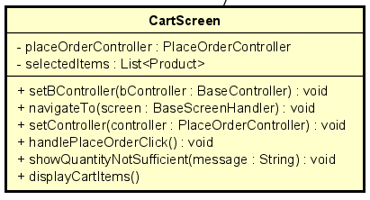
Table 1. Attribute Design
# | Name | Data type | Default value | Description
1 | placeOrderController | PlaceOrderController | null | Controller managing the Place Order flow.
2 | selectedItems | List<Product> | empty list | The list of products currently in the cart.

Table 2. Operation Design
# | Name | Return type | Description
1 | setController(controller) | void | Assign the PlaceOrderController to the screen.
2 | handlePlaceOrderClick() | void | Trigger placing order when the user clicks the button.
3 | showQuantityNotSufficient  (message) | void | Display an error when one or more items have insufficient stock.
4 | displayCartItems() | void | Load and render all selected cart items on screen.

Method Design:
- setController
- Parameter:
  - controller: PlaceOrderController

- Exception:

- Method:
  - Assigns the controller to this screen.
- handlePlaceOrderClick
- Parameter:

- Exception:

- Method:
  - Collect items in the cart.
  - Call placeOrderController.requestToPlaceOrder(cart).
  - Navigate to the DeliveryInfoScreen if successful.
- showQuantityNotSufficient
- Parameter:
  - message: String - error to display.
- Exception:

- Method:
  - Opens an error dialog or inline alert.
- displayCartItems
- Parameter:

- Exception:

- Method:
  - Retrieve items from the cart entity.
  - Render them in UI.

