Design for class “EmailSender”
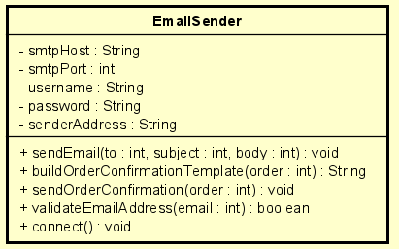
Table 1. Attribute Design
# | Name | Data type | Default value | Description
1 | smtpHost | String | "" | SMTP server host
2 | smtpPort | int | 587 | SMTP server port
3 | username | String | "" | Sender email account
4 | password | String | "" | Sender password/token
5 | senderAddress | String | "" | “From” email address

Table 2. Operation Design
# | Name | Return type | Description
1 | sendEmail(to, subject, body) | void | Low-level method to send email
2 | buildOrderConfirmationBody(order) | String | Build email body from Order
3 | sendOrderConfirmation(order) | void | High-level method called by controller

Method Design:
- sendEmail
- Parameter:
  - to: String - recipient
  - subject: String - subject
  - body: String - email content

- Exception:
  - EmailException — if sending fails

- Method:
  - Connect to SMTP using smtpHost, smtpPort
  - Authenticate using username + password
  - Send the email
  - Throw EmailException if any step fails
- buildOrderConfirmationBody
- Parameter:
  - order: Order

- Exception:

- Method:
  - Construct message with order ID, items, total amount
- sendOrderConfirmation
- Parameter:
  - order: Order

- Exception:

- Method:
  - Call buildOrderConfirmationBody()
  - Call sendEmail(order.customer.email, subject, body)

