Design for class “CustomerScreen”
Inheritance of class “BaseScreenHandler”
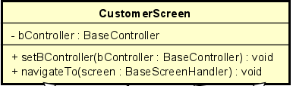
Table 1. Attribute Design
# | Name | Data type | Default value | Description
1 | bController | BaseController | null | The controller responsible for handling user actions in this screen.

Table 2. Operation Design
# | Name | Return type | Description / Purpose
1 | setBController(bController) | void | Assign the controller used by this screen.
2 | navigateTo(screen) | void | Switch from the current screen to another screen in the UI flow.

Method Design:
- setBController(bController: BaseController)
- Parameter:
  - bController: BaseController - the controller for this screen.

- Exception:

- Method:
  - Assign the given controller to this screen instance.
- navigateTo(screen: BaseScreenHandler)
- Parameter: screen:
  - BaseScreenHandler - the destination screen.

- Exception:

- Method:
  - Hide the current screen.
  - Display the destination screen.
  - Pass required context if needed.

