Design for class “DeliveryInfo”
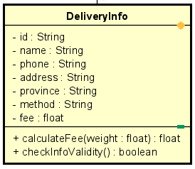
Table 1. Attribute Design
# | Name | Data type | Default value | Description
1 | id | String | "" | Unique id of the delivery info
2 | name | String | "" | Receiver’s name
3 | phone | String | "" | Receiver’s phone number
4 | address | String | "" | Detailed home address
5 | province | String | "" | Receiver's province
6 | method | String | "" | Delivery method (express, standard…)
7 | fee | float | 0.0 | Calculated shipping fee

Table 2. Operation Design
# | Name | Return type | Description / Purpose
1 | calculateFee(weight) | float | Compute the delivery fee based on weight
2 | checkInfoValidity() | boolean | Validate delivery info fields

Method Design:
- calculateFee
- Parameter:
  - weight: float

- Exception:

- Method:
  - Use a shipping formula (e.g., base + weight × unit price).
  - Store resulting fee into attribute fee.
  - Return the fee.
- checkInfoValidity
- Parameter:

- Exception:

- Method:
  - Check non-empty fields: name, phone, address, province.
  - Validate phone number format.
  - If any field is invalid → return false.
  - Else → return true.

