Design for class “DeliveryInfoScreen”
Inheritance of class “CustomerScreen”
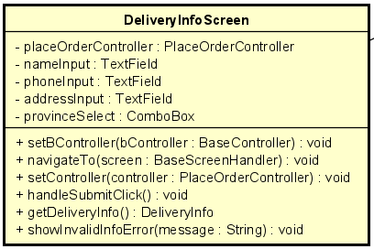
Table 1. Attribute Design
# | Name | Data type | Default value | Description
1 | placeOrderController | PlaceOrderController | null | Controller that processes delivery information.
2 | nameInput | TextField | "" | Customer’s full name field.
3 | phoneInput | TextField | "" | Customer’s phone number field.
4 | addressInput | TextField | "" | Customer’s address field.
5 | provinceSelect | ComboBox | null | Dropdown selection for province/city.

Table 2. Operation Design
# | Name | Return type | Description
1 | setController(controller) | void | Assign the controller for delivery processing.
2 | handleSubmitClick() | void | Triggered when the user submits delivery info.
3 | getDeliveryInfo() | DeliveryInfo | Collect delivery info into an object.
4 | showInvalidInfoError(message) | void | Display validation error(s) for user input.

Method Design:
- setController
- Parameter:
  - controller: PlaceOrderController

- Exception:

- Method:
  - Assigns the controller.
- handleSubmitClick
- Parameter:

- Exception:

- Method:
  - Read all UI fields.
  - Construct a temporary delivery info map.
  - Call placeOrderController.submitDeliveryInfo(info).
  - Redirect to InvoiceScreen if valid. Otherwise call showInvalidInfoError.
- getDeliveryInfo
- Parameter:

- Exception:

- Method:
  - Construct and return a DeliveryInfo object based on user input.
- showInvalidInfoError
- Parameter:
  - message: String

- Exception:

- Method:
  - Display error dialog (ErrorDialog.show).

