Design for class “ErrorDialog”
Inheritance of class “Dialog”
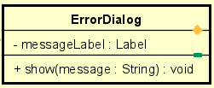
Table 1. Attribute Design
# | Name | Data type | Default value | Description
1 | messageLabel | Label | "" | The label showing the error message.

Table 2. Operation Design
# | Name | Return type | Description
1 | show(message) | void | Display an error popup with the given message.

Method Design:
- show
- Parameter:
  - message: String - the error text to present to the user.

- Exception:

- Method:
  - Set messageLabel.text = message.
  - Display dialog in modal mode (block underlying window until acknowledged).
  - Provide an OK/Close button; on close, return control to caller.
  - Optionally log the error message (call Logger.error(message)).

