Design for class “InvoiceScreen”
Inheritance of class “CustomerScreen”
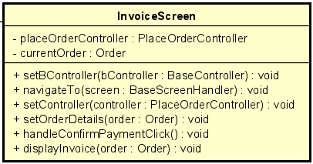
Table 1. Attribute Design
# | Name | Data type | Default value | Description
1 | placeOrderController | PlaceOrderController | null | Controller for finalizing the order.
2 | currentOrder | Order | null | The order waiting for user confirmation.

Table 2. Operation Design
# | Name | Return type | Description
1 | setController(controller) | void | Assign the controller for order confirmation.
2 | setOrderDetails(order) | void | Display subtotal, shipping fee, and total amount.
3 | handleConfirmPaymentClick() | void | Proceed to payment request.
4 | display(invoice) | void | Render invoice information on UI.

Method Design:
- setController
- Parameter:
  - controller: PlaceOrderController - controller that will handle invoice actions.

- Exception:

- Method:
  - Assigns the controller for order confirmation.
- setOrderDetails
- Parameter:
  - order: Order — the order whose invoice details are to be displayed.

- Exception:
  - NullPointerException if order is null (caller should avoid).

- Method:
  - Read order.subtotal, order.deliveryInfo.fee, order.vat, compute total.
  - Populate UI labels: subtotal, shipping fee, VAT, total.
  - Keep a reference to currentOrder = order for later confirmation action.
- handleConfirmPaymentClick
- Parameter:

- Exception:
  - PaymentInitiationException if payment subsystem cannot be reached or parameters invalid.

- Method:
  - Validate currentOrder is present and in correct status.
  - Ask the user to select a payment method (e.g., QR or PayPal).
  - Call placeOrderController.requestPayment(method) with chosen method.
  - If controller reports error, show error via ErrorDialog.show(message).
- display
- Parameter:
  - invoice: Object or invoice: Order (the class using it should pass the rendered invoice object)

- Exception:

- Method:

  - Render the provided invoice object on screen (refresh UI components).
  - Ensure totals and breakdown are consistent with currentOrder.
  - Support re-layout or print-preview if available.

